Warming in the upper San Francisco Estuary: Patterns of water temperature change from 5 decades of data
Running head: Warming in the upper San Francisco Estuary

Samuel M. Bashevkin¹, Brian Mahardja², Larry R. Brown^{3*}

¹Delta Science Program, Delta Stewardship Council, 980 9th St. Suite 1500, Sacramento, CA 95814 USA. ORCID ID: 0000-0001-7406-7089. Corresponding author: sam.bashevkin@deltacouncil.ca.gov
²United States Bureau of Reclamation, 801 I Street, Suite 140, Sacramento, California, 95814 USA. ORCID ID: 0000-0003-0695-3745 bmahardja@usbr.gov
³United States Geological Survey, 6000 J Street, Sacramento, California, 95819 USA. ORCID ID: 0000-0001-6702-4531
*deceased

Author contributions: All authors contributed to study conception and design. SMB conducted analyses with input from BM and LRB and led writing of the manuscript. BM contributed to writing, reviewing, and editing the manuscript. LRB was unable to approve this manuscript.

Key words: Estuary, climate change, temperature, generalized additive model, refugia, restoration

Abstract
Temperature is a key controlling variable from subcellular to ecosystem scales. Thus, climatic warming is expected to have broad impacts, especially in economically and ecologically valuable systems such as estuaries. The heavily managed upper San Francisco Estuary (SFE) supplies water to millions of people and is home to fish species of high conservation, commercial, and recreational interest. Despite a long monitoring record (> 50 years), we do not yet know how water temperatures have already changed or how trends vary spatially or seasonally. We fit generalized additive models on an integrated database of discrete water temperature observations to estimate long-term trends with spatio-seasonal variability. We found that water temperatures have increased 0.017 °C/year on average over the past 50 years. Rates of temperature change have varied over time, but warming was predominant. Temperature increases were most widespread in the late-fall to winter (November to February) and mid-spring (April to June), coinciding with the winter development of juvenile Chinook Salmon and spring spawning window of the endangered Delta Smelt. Warming was fastest in the northern regions, a key fish migration corridor with important tidal wetland habitat. However, no long-term temperature trends were detected in October and were only observed in some regions in May, July, and August. These results can help identify optimal areas for restoration or refugia to buffer the effects of a warming climate, and the methods can be leveraged to understand the spatiotemporal variability in climate warming patterns in other aquatic systems.

Introduction
Temperature has profound impacts on ecosystem functions and biodiversity, from subcellular to community scales (Petchey et al. 1999; Clarke 2006; García et al. 2018; Parain et al. 2018). Thus, as the climate warms both biodiversity and ecosystem functions are expected to change with dramatic consequences, especially in ecosystems with pressing management issues and high human reliance.
A key step in preparing for future temperature changes is understanding how temperatures have already changed. Disentangling the spatio-seasonal variability in rates of temperature change can allow us to identify where and when temperatures are increasing the fastest. Information on the location and timing of strong warming patterns can improve our understanding of biotic changes in the system as well as the planning of management actions meant to mitigate such changes. Identifying patterns of temperature change can also allow us to detect where and when temperatures are increasing more slowly or even decreasing, which may provide refuge for species of concern (Wagner et al. 2011) and serve as ideal locations for long-term habitat restoration projects.
Heavily altered systems that provide vital and high-valued ecosystem services may have little flexibility to continue providing the same services if the underlying communities and ecosystem functions are altered by rising temperatures (Mooney et al. 2009). Estuaries are an example of such systems. Estuaries are among the most anthropogenically transformed and degraded ecosystems on the planet (Edgar et al. 2000). Sitting at the intersection between freshwater, marine, and terrestrial systems, they provide vital biological, hydrological, and geochemical services (Costanza et al. 1997). Furthermore, estuaries are biodiverse, productive, and provide important nursery habitat for many species (Beck et al. 2001), including commercially and culturally important species such as Salmon.
Air temperatures are well-studied and modeled, receiving the primary focus of climate change projections. Less is known about water temperatures and their past and future trends, which are complicated and mediated by hydraulics, mixing, and the higher heat capacity of water. While sea surface temperatures (Casey and Cornillon 2001) and to some extent rivers (Liu et al. 2020) have received a reasonable amount of attention, we know much less about inland estuaries, the convergence of both systems. Sea surface temperature trends have been reconstructed globally back to 1900 (Cane et al. 1997) but only a few river temperatures have been reconstructed for timeseries of this length (European Environment Agency 2007; Kaushal et al. 2010) and most are only for a half century or less. Studies of estuarine warming are generally closer to a half century or less in duration, with large-scale studies often even more limited in timespan, such as a comprehensive survey of Australian estuaries which only had 12 years of data (Scanes et al. 2020). Especially lacking in estuaries are spatially explicit studies of long-term temperature trends, which are necessary to identify optimal areas for refugia and restoration. From previous studies, we know that estuarine warming is a global phenomenon with rates ranging from 0.015 – 0.2 °C/year (Preston 2004; Seekell and Pace 2011; Fulweiler et al. 2015; Scanes et al. 2020).
The upper San Francisco Estuary (SFE) is an ideal place to expand our understanding of estuarine temperature trends due to the wealth of monitoring data collected over five decades and broad spatial scales, as well as the local importance of temperature in driving ecologically and economically important processes. The upper SFE is a highly altered estuary in California, USA formed by the confluence of five major rivers that drain 40% of the land in California (Delta Stewardship Council 2013), which has been dramatically transformed in the past 200 years. The upper SFE was originally a vast swath of marsh with meandering channels and a highly variable salinity field. Since the early 1800s, 97% of wetlands have been lost as they were drained for agriculture and meandering channels were converted to straightened, diked channels protecting those agricultural lands (Whipple et al. 2012). Over the last 80 years, the upper SFE has become a central hub of water conveyance in California, bridging the gap between water supply and demand, and delivering water to millions of acres of farmland and 2/3 of Californians (Delta Stewardship Council 2013). However, the environmental degradation that came with human development became apparent and gained notoriety with the decline and listing of previously abundant fish species (such as the Delta Smelt, Hypomesus transpacificus) under the United States Endangered Species Act (ESA) (Moyle et al. 2018). The SFE is also the most invaded estuary in the world (Cohen and Carlton 1998) with some communities, such as zooplankton (Orsi and Ohtsuka 1999), almost entirely composed of invasive species. The upper SFE is now home to five listed fish species (under the ESA and/or California Endangered Species Act), as well as several commercially and recreationally important fisheries. This system exemplifies the issue of multiple stressors impacting estuaries worldwide (Lotze et al. 2006), including climate change-induced temperature increases.
Efforts to repair the environmental conditions of the SFE have focused on wetland and floodplain restoration to recover ecosystem processes that support native species of concern (Callaway et al. 2011; Herbold et al. 2014). Major restoration efforts are currently underway in the hope that they will provide habitat and food for important fishes. An understanding of the rate of temperature change, and the spatial and seasonal variability of this rate, will help direct habitat restoration and protection efforts toward the best locations for refugia (Ashcroft 2010).
Three past studies were unable to detect significant long-term (1970s to the 2000s or 2010s) water temperature trends in the upper SFE (Jassby 2008; Nobriga et al. 2008; Cloern 2019). One study did detect a significant water temperature increase, but only in one location and over 17 years from 1985-2001 (Shellenbarger and Schoellhamer 2011). A longer time-series would help distinguish true long-term temperature changes (Shellenbarger and Schoellhamer 2011). Furthermore, these prior efforts did not evaluate small-scale spatial effects on temperature trends, which will be important for identifying refugia (Ashcroft 2010; Wagner et al. 2011). In this study, we took advantage of an extensive data record to develop a spatially-explicit modeling framework for assessing the rate of temperature change in the upper SFE.
There is a long history of environmental monitoring in the upper SFE due to its economic and environmental importance. Boat-based surveys have been collecting data in the estuary since the 1950s (Stompe et al. 2020), providing a valuable opportunity to investigate long-term temperature changes. These data were collected by multiple seasonal, regional, or gear-specific fish or water-quality surveys managed by different organizations. A recent data integration effort has combined the water-quality components of many of these surveys, creating a comprehensive record of water temperatures over the past 5 decades (1970 to present) (Bashevkin 2021). We took advantage of this integrated dataset to fit spatially and seasonally explicit generalized additive models to evaluate long-term temperature change in the upper San Francisco Estuary. Our main objectives were to:
- Develop and validate generalized additive models for assessing spatially and seasonally explicit water temperature relationships in the upper SFE,
- Evaluate long-term temperature trends in the upper SFE and their spatial and seasonal variability, and
- Evaluate changes in these temperature trends over time.

Materials

Study area
This analysis was focused on the upper SFE to avoid areas with more marine influence that may have different temperature dynamics than regions upstream. Thus, we focused on areas between Suisun Bay and the upstream extent of the Sacramento-San Joaquin Delta (Delta), a network of interconnected channels where the Sacramento and San Joaquin Rivers meet. This included areas north to the Sacramento River Deepwater Ship Channel, south to Grant Line Canal and Old River (just south of Stockton), and east to just downstream of the Cosumnes-Mokelumne river confluence. The Yolo Bypass seasonal floodplain was excluded since it is only seasonally inundated in wetter years (Takata et al. 2017) (Fig. 1).
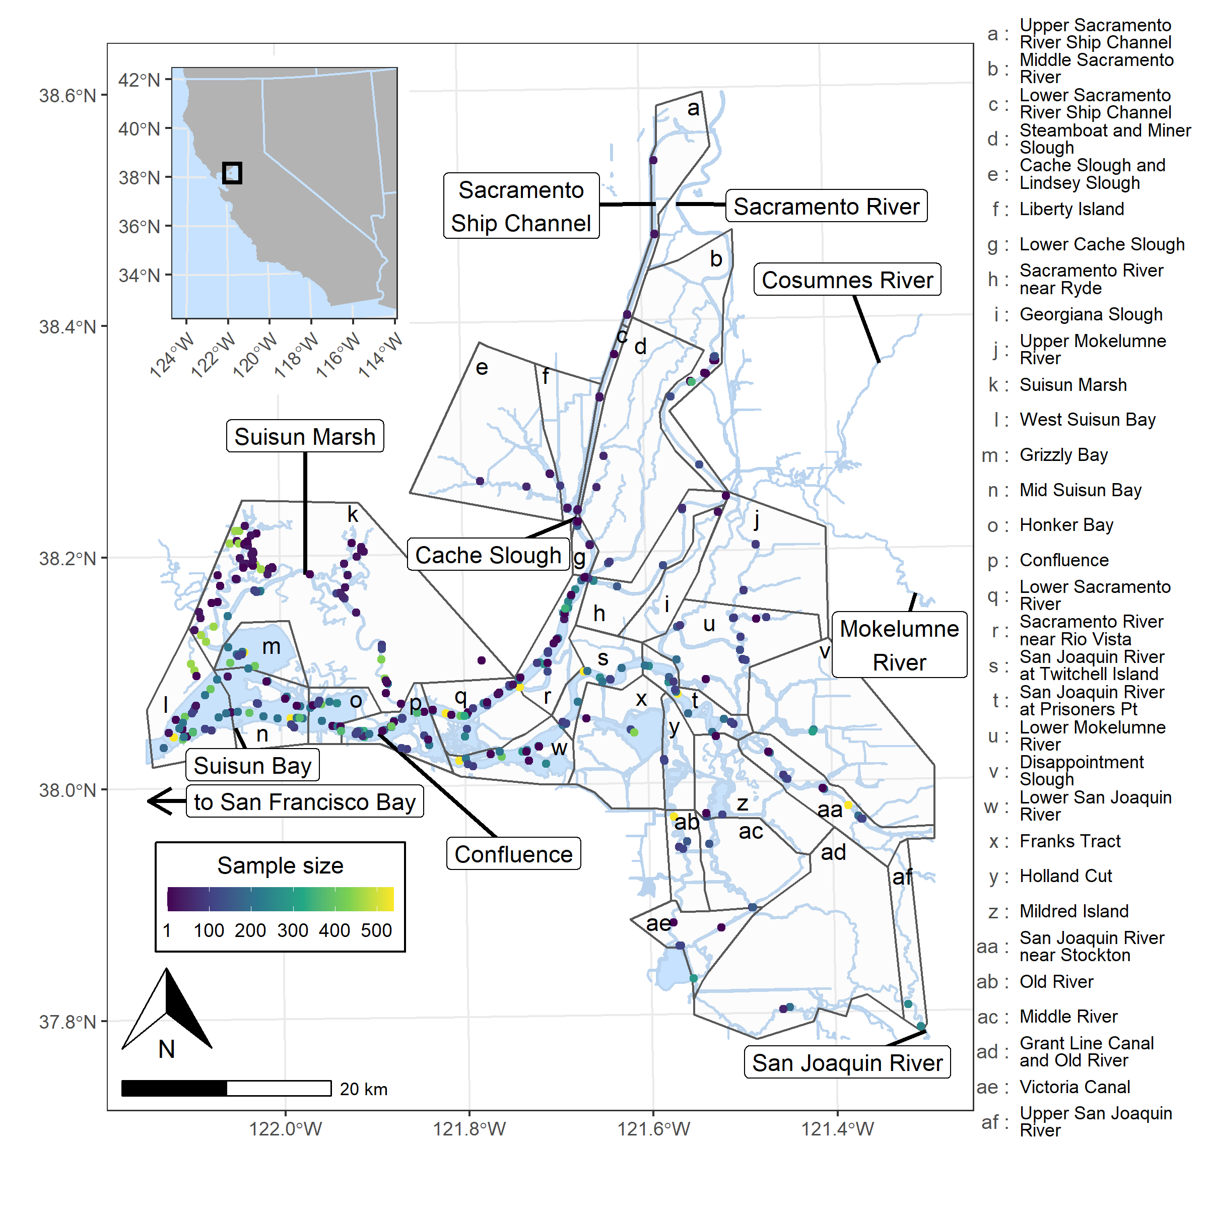
Figure 1. Study area, regional divisions, and sampling locations. The study area is the upstream portion of the San Francisco Estuary (see inset). Regions are divided by black outlines and sampling locations are represented by points colored by the sample size of temperature records used in our analyses. The Sacramento San Joaquin Delta (Delta) includes all areas East of the Confluence. The regional divisions shown in the figure were not used in analyses, only in the data processing step to ensure sufficient data were available from each retained region as well as for data visualizations.
The climate is Mediterranean, characterized by wet, mild winters and hot, dry summers. Seasonal and year-to-year temperature swings are reduced by proximity to the Pacific Ocean, at least in comparison with regions more interior. However, strong heat waves that warm surface waters are still common (Dettinger et al. 2016). Furthermore, interannual variability in precipitation is the highest of any region in the USA, resulting in strong swings between drought years and wet years where the majority of precipitation is driven by intense, transitory storms (Dettinger et al. 2016).
In the upper SFE, water temperatures are primarily controlled by air temperatures and other atmospheric influences (cloud cover and humidity), with localized effects of river inflow temperatures but negligible impacts of ocean temperatures (Wagner et al. 2011; Vroom et al. 2017). River inflow temperatures have the strongest impact near the inflow boundaries where residence times are shortest, while atmospheric influences show the opposite pattern (Vroom et al. 2017). However, atmospheric drivers overwhelm the effects of river inputs over long time periods (Wagner et al. 2011). Ocean temperatures are relatively constant throughout the year, while Delta water temperatures swing from about 10 °C in the winter to over 20 °C in the summer. Air and water temperatures also show wide spatial differences, creating microclimates (Vroom et al. 2017).

Data processing
Surface water temperatures were measured by boat-based monitoring programs throughout the San Francisco Estuary in the upper 0 – 1 m of the water column. We used an integrated dataset of 11 long-term monitoring surveys (Bashevkin 2021), but only retained data for the main analyses from 9 of the monitoring surveys that were over 10 years old (for details on each survey see Table S1). All data processing was performed in the statistical programming language R 4.0.3 (R Core Team 2020). Data records with missing values for temperature, date, time, latitude, or longitude were excluded, as well as data collected outside the normal sampling times (5AM to 8PM). To remove any effects of daylight savings time, times were all converted to Pacific Daylight Time. The full database was then reduced to help account for temporal autocorrelation. Methods to account for temporal autocorrelation require repeated samples at the same location, so non-fixed sampling stations from two monitoring surveys (the Environmental Monitoring Program and Spring Kodiak Trawl) were removed from the database. In addition, the temporal frequency of the database (frequency of sample collection at each station) was reduced to no more than one sample per month per station to further reduce the effects of temporal autocorrelation. This was accomplished by selecting the data points closest to the 15th of each month and, when multiple data points were present per day, closest to noon. Time-of-day corrections were applied later in the modeling framework.

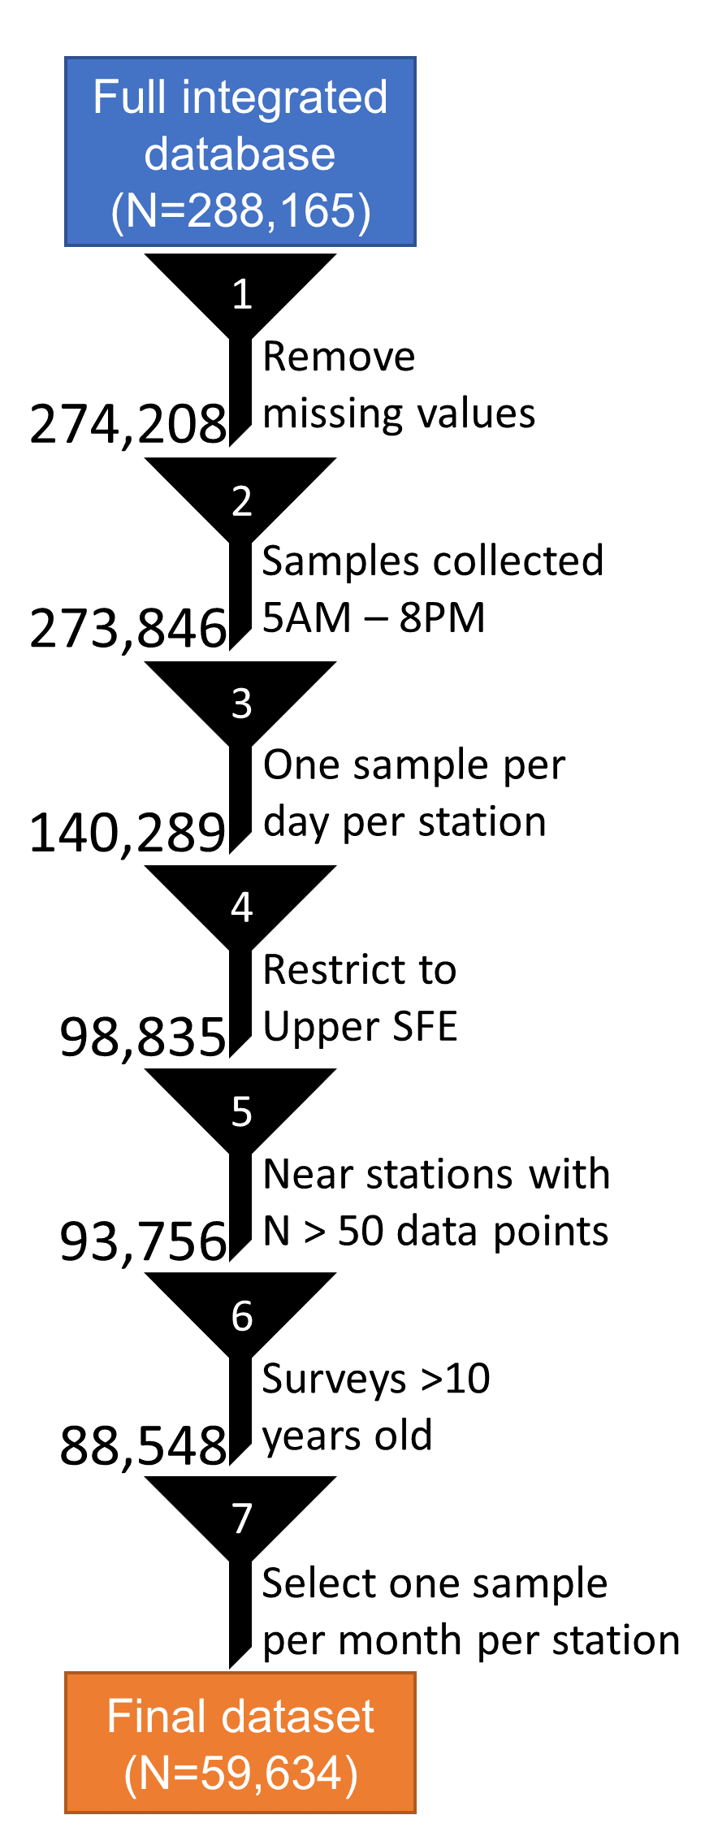
Figure 2. Data processing steps used to create the final dataset for analysis. The dataset was filtered in the following steps 1) data with missing values in key variables were removed, 2) data collected outside 5AM – 8PM were removed, 3) only one sample was retained per day per station, 4) data from outside the upper San Francisco Estuary (SFE) were removed, 5) only data collected near well-studied stations (defined as N > 50 data points) were retained, 6) 9 data sources > 10 years old were selected, and 7) one sample per month per station was selected.
Next, we filtered the dataset to the spatial domain of interest using regional polygons developed by the United States Fish and Wildlife Service Enhanced Delta Smelt Monitoring Program (United States Fish And Wildlife Service et al. 2020). These regions were only used for data processing and visualization, not in the analyses (see below). All spatial vector operations were completed with the R package sf (Pebesma 2018). Since all surveys have had changes to the spatial extent of their sampling effort over time, we took additional steps to ensure that rarely sampled areas outside the heavily sampled spatial domain did not skew our results. To do this, we chose 6 focal surveys with a robust data record throughout our spatial domain: the Fall Midwater Trawl, Summer Townet, Spring Kodiak Trawl, 20-mm Survey, Environmental Monitoring Program, and Suisun Marsh Fish Study (Table S1). From these 6 focal surveys, we selected all sampling locations with more than 50 days of temperature records in the database as robustly sampled locations. We then identified and removed any regions (from the regional polygons described above) from our dataset that did not contain at least one of these robustly sampled locations. The only exception was Georgiana Slough, which we retained since it is a narrow region in the interior of our study area and surrounded by well-sampled regions (Fig. 1). Lastly, we created a convex hull surrounding these robustly sampled locations with the sf function st_convex_hull and removed any datapoints outside this hull. The final dataset included 59,634 temperature records spanning April 1969 – July 2020 from 405 unique locations (Figs. 1, 2, S1).

Long-term temperature trend analysis
To estimate the climate change signal and its spatio-seasonal variability (objectives #1-2), we fit a generalized additive model with the R package mgcv (Wood 2011; Wood et al. 2016). Surface water temperature (°C) was the response variable. All predictor variables (latitude, longitude, Julian day [day-of-year], calendar year, and time-of-day expressed as seconds since midnight) were centered and scaled by their standard deviation prior to model fitting. The model (model 1.1) had 4 main components, described below.
- Background spatio-seasonal signal: a tensor product smooth (function te) of 2 elements:
  - Spatial: an isotropic thin plate spline of the latitude and longitude of the sample location, and
  - Seasonal: a cyclic cubic spline of Julian day.
- Estimated temperature slope over time: a tensor product smooth (function te) of 2 elements (the same as listed under #1), multiplied by the calendar year variable.
- Time-of-day correction: a thin plate smooth (function s) of time-of-day.
- An autoregressive model of order 1 applied to the working residuals.
Represented as a simplified formula of just the response and predictor variables, the model (model 1.1) took the following form:
Eq. 1
$T A+a\left(b\left(Lat,Lon\right),c\left(Julian\right)\right)+d\left(e\left(Lat,Lon\right),f\left(Julian\right)\right)∗Year+g\left(Time\right)+AR\left(1\right)$,
where T represents water temperature (°C), A represents the model intercept, lower-case letters (a-g) represent smoothing functions, a represents the background spatio-seasonal signal, b represents the spatial component of the background signal, c represents the seasonal component of the background signal, d represents the estimated temperature slope, e represents the spatial component of the temperature slope, f represents the seasonal component of the temperature slope, g represents the time-of-day correction, AR(1) represents the autoregressive model of order 1, Lat represents latitude, Lon represents longitude, Julian represents Julian day, Year represents the calendar year, and Time represents the time-of-day. This model structure allowed us to estimate the spatio-seasonal variability of the rate of temperature change, while accounting for background temperature differences driven by spatio-seasonal and time-of-day effects.
The autoregressive component (AR(1)) of model 1.1 was fit to independent time-series constructed from the underlying dataset. These independent time-series were defined as contiguous series of temperature records from a single spatial location with no gaps longer than 60 days to ensure each independent time-series had a roughly monthly frequency. This autocorrelation method requires an estimate of the AR(1) correlation parameter for model fitting. We estimated this parameter by first fitting a model specified exactly as described above, but without the AR(1) component (model 1.0). We then used the start_value_rho function from the R package itsadug (van Rij et al. 2020) to extract the lag-1 correlation of the residuals (0.2109) from model 1.0, which was then supplied to model 1.1 as the required AR(1) correlation parameter.
The spatially explicit components (isotropic thin plate smooths of latitude and longitude) fit patterns to the geography regardless of barriers to water movement. While water temperature may be expected to depend more on the connections between water bodies than geographic distance, we used this approach because water temperatures in the upper SFE are primarily driven by atmospheric influences such as air temperature (Wagner et al. 2011; Vroom et al. 2017), which are connected over land and water.
The model was fit with the mgcv function bam, which is optimized for large datasets, and with the “discrete” option enabled, which further speeds up model fitting by discretizing covariates. To account for outliers in the dataset resulting in a heavy-tailed distribution, we used the scaled-t model family (function scat).
In mgcv, the basis dimension (parameter k) determines the maximum allowed degrees of freedom (or the “wiggliness”) of each smooth. The exact choice of the basis dimension is not critical, it just must be large enough to capture patterns in the data, while small enough to be computationally feasible and avoid overfitting small-scale perturbations that are not of interest. For the cubic splines we fit to the Julian day covariate (the seasonal components of the background spatio-seasonal smooth and the estimated temperature slope smooth), the basis dimension defines the number of knots that separate independent segments of cubic polynomials. For this component, we used a basis dimension of 13 to allow for 12 curve segments, one for each month of the year to mirror the monthly frequency of our dataset. For the two-dimensional thin plate splines we fit to latitude and longitude (the spatial components of the background spatio-seasonal smooth and the estimated temperature slope smooth) we choose a much larger basis dimension of 25 to allow the model to estimate spatial differences throughout the complex region. Lastly, we chose a small basis dimension of 5 for the time-of-day correction (thin plate spline) since we expected that effect to be represented by a simple curve.
Table 1. Descriptions and data sources for each model type used in these analyses. Objective indicates the study objective(s) (see introduction) addressed by each model.
Model | Model description | Data | Objective
1.0 | Long-term trend model without the AR(1) component. This model was used to estimate the lag-1 correlation of the residuals for the AR(1) component of model 1.1. | Data prepared as described in Fig. 2 | 1
1.1 | Long-term trend model | Data prepared as described in Fig. 2 | 1, 2
1.2 | Long-term trend model with increased spatial basis dimension (50) | Data prepared as described in Fig. 2 | 1
2.0 | 25-year sliding window trend models without AR(1) component. These models were used to estimate the lag-1 correlations of the residuals for the AR(1) components of model 2.1. Six models with the same structure as model 1.0 were fit to the six 25-year datasets. | Data prepared as described in Fig. 2, then split into 6 sliding-window time-series spanning the years 1970-1995, 1975-2000, 1980-2005, 1985-2010, 1990-2015, and 1995-2020. | 1
2.1 | 25-year sliding window trend models. Six models with the same structure as model 1.0 were fit to the six 25-year datasets. | Data prepared as described in Fig. 2, then split into 6 sliding-window time-series spanning the years 1970-1995, 1975-2000, 1980-2005, 1985-2010, 1990-2015, and 1995-2020. | 1, 3
3.0 | Background spatio-seasonal model used to estimate these components for the data simulation. Included just components #1 and #3 from model 1.1. | Data filtered through steps 1-4 of Fig. 2, then only 2018 data selected. | 1
4.0 | Long-term trend models fit to the simulated datasets without the AR(1) component. These models were used to estimate the lag-1 correlations of the residuals for the AR(1) components of model 4.1. Same structure as model 1.0 except without a time-of-day component and with the seasonal basis dimension set to 12. | Model fit to 10 replicates each of 4 data simulation scenarios (factorial combinations of climate change scenario [climate change or null] and sampling design [balanced or unbalanced]) | 1
4.1 | Models fit to simulated data to validate model structure. Same structure as model 1.1. except without a time-of-day component and with the seasonal basis dimension set to 12. | Model fit to 10 replicates each of 4 data simulation scenarios (factorial combinations of climate change scenario [climate change or null] and sampling design [balanced or unbalanced]) | 1

We checked our choice of basis dimension with the mgcv function gam.check, which returns diagnostic tests of the basis dimension choices. This function checks for patterns in the residuals that could potentially be captured by specifying a larger basis dimension during model fitting. The function calculates the effective degrees of freedom for the smooth (edf), the maximum possible effective degrees of freedom for the smooth (k’, calculated from the chosen basis dimensions), an estimate of residual variance among data values with close covariate values (k-index), and a simulation-based p-value that tests for patterns in the residuals. A potentially improper choice of basis dimension is indicated by 3 tests: a significant p-value, a k-index below 1, and edf close to k’. These values are calculated for each of the 3 smooth components of the model (#1-3 in the list above; table 2). The time-of-day correction had a proper basis dimension indicated by all 3 tests. The estimated temperature slope had a significant p-value and k-index slightly below 1, but edf was much smaller than k’ so we deemed this basis dimension choice appropriate. The background spatio-seasonal smooth also had a significant p-value and k-index slightly below 1, but edf was closer to k’ so we performed an additional model fit to ensure a higher basis dimension for this smooth would not significantly alter the results. This additional model (model 1.2) was identical to model 1.1 except the basis dimension for the spatial spline component of the background spatio-temporal smooth was increased from 25 to 50 (table 1). The basis dimension of the seasonal component was not altered since it was based off the underlying data structure (maximum monthly frequency of data collection at each location). Model 1.2 was compared to model 1.1 with Akaike information criteria, Bayesian information criteria, and visual comparisons of model-predicted slopes (see “Model predictions and visualizations” below).
Table 2. Diagnostic results of the basis dimension choices returned by the gam.check function on model 1.1. The smooths correspond to components 1-3 of model 1.1, k’ represents the maximum possible effective degrees of freedom as estimated from the basis dimensions provided during model fitting, edf represents the effective degrees of freedom in the final smooths from the fitted model, k-index is an estimate of residual variance among data values with close covariate values, and the p-value is from a simulation-based test of patterns in the residuals. A potentially improper choice of basis dimension is indicated by a significant p-value, k-index below 1, and edf close to k’.
Smooth | k’ | edf | k-index | p-value
Background spatio-seasonal signal | 299.0 | 223.7 | 0.94 | <0.0001
Estimated temperature slope | 300.0 | 81.6 | 0.94 | <0.0001
Time-of-day correction | 4.0 | 3.9 | 1.04 | 1

Model assumptions were verified by inspecting the QQ-plot, residual distribution, relationship between residuals and linear predictor, and the relationship between the fitted values and response. We also calculated the spatio-temporal sample variogram to inspect model residuals for autocorrelation using the variogramST function from the R package gstat (Pebesma 2004; Pebesma and Heuvelink 2016).

Temperature trend changes over time
To investigate whether the strength and direction of temperature change has shifted over the past 50 years (objective #3), we fit multiple models to smaller subsets of the overall timeseries. We created new 25-year timeseries that were initialized every 5 years from 1970-1995 (resulting in 6 timeseries spanning the years 1970-1995, 1975-2000, 1980-2005, 1985-2010, 1990-2015, and 1995-2020). We then fit the exact same model structure as models 1.0 and 1.1 to each of these 6, 25-year timeseries to estimate the 25-year climate change signal for each period (models 2.0, 2.1; table 1).

Data simulation test
We performed data simulations to test our model structure (objective #1) using two scenarios: a climate warming scenario and a null scenario with no directional temperature change over time. We attempted to mirror the structure of our dataset as much as possible in this dataset, but we also evaluated the impact of unbalanced data collection on the ability of model 1.1 to correctly detect a climate change signal.
First, we fit a background spatio-seasonal model (model 3.0) to data from one year (2018) and used it to simulate temperatures for each sampling station in the dataset for the 15th of each month at noon. Model 3.0 contained just elements #1 (background spatio-seasonal smoother) and #3 (time-of-day correction) from model 1.1. We fit model 3.0 to a similar dataset used in model 1.1, but it included data from all 11 monitoring programs included in the original integrated dataset (table 1) (Bashevkin 2021). We used data from all 11 surveys to best capture the spatio-seasonal signal, and we chose to simulate for 2018 because it has a robust data record from all surveys.
Next, we duplicated these estimated temperatures 51 times, once for each year from 1970-2020. Then, to add year-to-year variability to the dataset, we added a normally distributed perturbation to each datapoint, informed by the seasonal and spatial patterns in temperature slope and variability from model 1.1. To do this, we first extracted the slope and its standard error from model 1.1 for each month and region. For the null scenario (no climate change signal), this perturbation was normally distributed with mean 0 and standard deviation equal to the standard error for the month and region of each datapoint. For the climate change scenario, the perturbation was normally distributed with mean equal to the estimated slope from model 1.1 for the month and region of the datapoint, multiplied by the number of years elapsed since 1970, and the same standard deviation as the null scenario. Finally, to add appropriate variability to the data for both scenarios, we generated random draws from the scat (scaled-t) distribution with mean equal to the value calculated in the prior step, and other family parameters (nu and sigma) from model 3.0. This resulted in simulated temperature values for each station, month, and year from 1970-2020 under the null or climate change scenarios.
In the next step, we simulated the data collection process. In our study dataset, not all stations were sampled in every month of every year. Many of the surveys were seasonal (table S1), and the set of stations has changed over time. Thus, we used the data simulations to test whether this unbalanced sampling design may have impacted our ability to accurately detect climate change signals. To do this, we generated balanced and unbalanced datasets for our null and climate change scenarios, resulting in four total scenarios.
For the unbalanced dataset (an accurate representation of the sampling design), we only retained simulated data for months and years in which each station was sampled in our real dataset. This produced null and climate change scenario datasets of the exact same size as the dataset used to fit model 1.1. For the balanced dataset, we created an ideal scenario where each station was sampled every month of every year and approximately the same number of stations were sampled in each region. To ensure the balanced and unbalanced datasets had similar numbers of observations, we limited the balanced datasets to 4 stations per region (the average number sampled each month and region from the original dataset). Thus, we retained all data (every month and year) from 4 randomly-selected stations from each region. For regions with fewer than 4 stations we retained data from all available stations.
Ten replicate datasets of simulated temperature values were created for each scenario. To evaluate the ability of our model structure to accurately detect climate change signals in these four scenarios, we fit the same model structures as models 1.0 and 1.1 to each simulated dataset (4 scenarios x 10 replicates = 40 simulated datasets), but without the time-of-day correction since all data were simulated for noon (models 4.0, 4.1; table 1). We also set the basis dimension to 12 for the seasonal component since data were only simulated for one day per month and the basis dimension cannot be greater than the number of unique values of the variable. We then generated rasterized model-predicted climate change slopes as described below (Model predictions and visualizations). Then, we compared the estimated climate change slopes on the simulated datasets with the “true” slopes and standard errors used in the data simulation, which corresponded to the estimated climate change slope (or 0 for the null scenario) and standard error for each subregion and month from model 1.1.

Model predictions and visualizations
To visualize our results and explore spatio-seasonal variation in the climate change signal, we generated fitted values from our models over our ranges of the covariates. We first generated a 100 x 100 grid of evenly spaced cells over the spatial bounding box of our dataset along the longitudinal and latitudinal axes (10,000 cells total). We removed any cells falling outside the boundary of our dataset, then selected only grid cells that touched water bodies in a spatial vector dataset of waterways in the San Francisco Estuary from the California Department of Fish and Wildlife (Fig. 1). We again removed any points falling outside the convex hull formed by the major survey stations sampled > 50 times. This resulted in 1,698 grid cells, which we transformed into point locations at the midpoint of each cell.
Model predictions were generated for each combination of the 1,698 evenly spaced point locations and 12 values of Julian day corresponding to the 15th of each month. To remove time-of-day effects, all model predictions were generated for noon. We discarded model predictions from regions in months with no underlying data to avoid extrapolation. We used the model prediction capability of mgcv to generate separate estimates of each component of the linear predictor (components 1-3 of model 1.1) with standard errors. We then extracted the predicted values and standard errors for the temperature slope component (component #2 of model 1.1) and converted them to units of °C/year by reversing the covariate standardization (i.e. dividing by the standard deviation of year in the original dataset). Next, 99.9% confidence intervals were calculated as:
Eq. 2
$slope±SE∗qnorm\left(0.9995\right)$,
where slope represents the predicted temperature slope over the years, SE represents the standard error, and qnorm(0.9995) represents the value of the normal quantile function with mean = 0, standard deviation = 1, and p = 0.9995. We used these confidence intervals to select slopes with a p-value < 0.001 as our cutoff for statistical significance. We used 0.001 as our type 1 error rate to account for any residual autocorrelation not captured by the AR(1) model and apply a conservative standard to the identification of climate change signals. Finally, we rasterized the significant slopes for visualization using the R package stars (Pebesma 2021). These model predictions were generated for models 1.1, 1.2, 2.1, and 4.1.

Results

Model validation
In the data simulation test of our model specification, significant climate change signals were detected in most months and locations for all replicate climate change scenarios (model 4.1; Figs. S2, S3), while significant climate change signals were never detected in the null (no climate change) scenario (Fig. S4). Relative to the average slope estimated from model 1.1 (main model), the nonsignificant slope estimates from the null scenario were mostly an order of magnitude smaller (Fig. S3). Some of the climate change slopes estimated from the climate change scenario simulations were not statistically significant. This was expected since we based the simulated slopes on the slopes and standard errors from model 1.1 and not all slopes were significant from model 1.1 either (see below). Nonsignificant slopes in the climate change scenario were associated with low “true” slope magnitude and higher “true” slope standard errors (Fig. S3). The unbalanced sampling design had a few more instances of nonsignificant slopes detected at higher “true” slope magnitudes than the balanced sampling design (Fig. S3), suggesting a slightly higher type 2 error (false negative) and lower type 1 error (false positive) rate. Overall, there was a strong correlation between the estimated slopes and “truth” for both the balanced and unbalanced sampling design in the climate change scenario (Fig. S2).
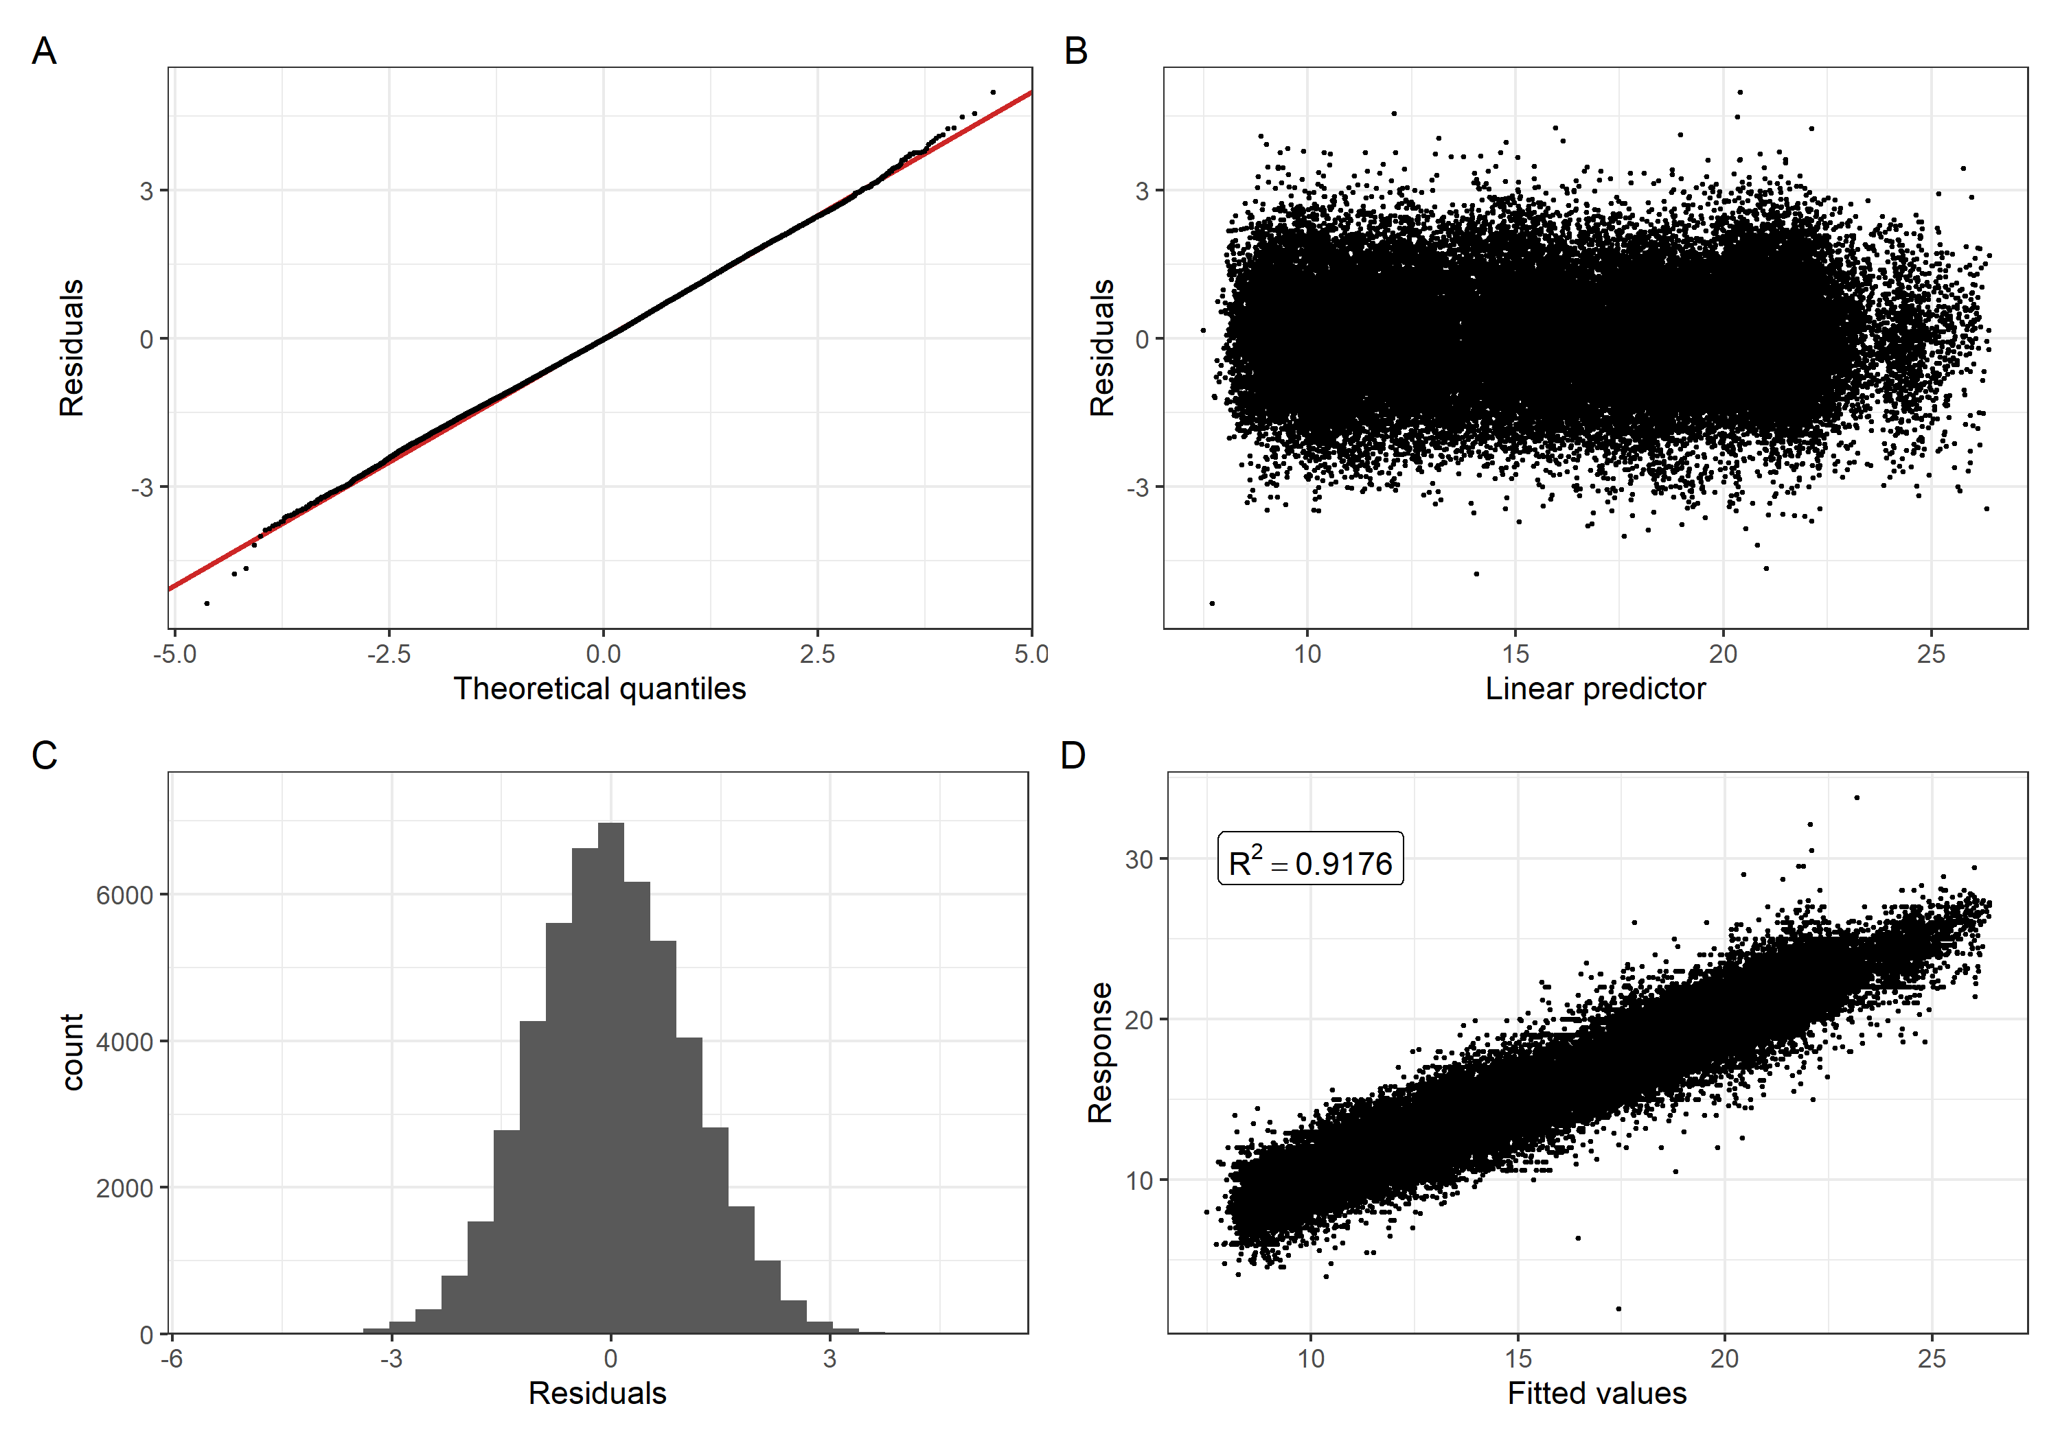
Figure 3. Model diagnostic plots for model 1.1. A) Q-Q plot of theoretical quantiles vs residuals. The red line represents the expected 1:1 relationship. B) Linear predictor vs. residuals C) Histogram of residuals D) Model-predicted fitted values vs measured response values with adjusted R² in an inset.
Model 1.2, which was identical to model 1.1 except for an increased spatial basis dimension, had a lower AIC than model 1.1 (199,626.8 and 199,986.6, respectively) but a higher BIC (203,545 and 202,820.8, respectively) and almost identical model-predicted slopes (Fig. S5), so results are presented for model 1.1. Model diagnostic plots revealed a well-fit model that conformed to linear model assumptions with an adjusted R² of 0.9178 (Fig. 3). The spatiotemporal variogram revealed small residual covariance at temporal lags of 0 – 1 month, but no residual covariance at lags of greater than 1 month and no residual spatial covariance (Fig. S6).
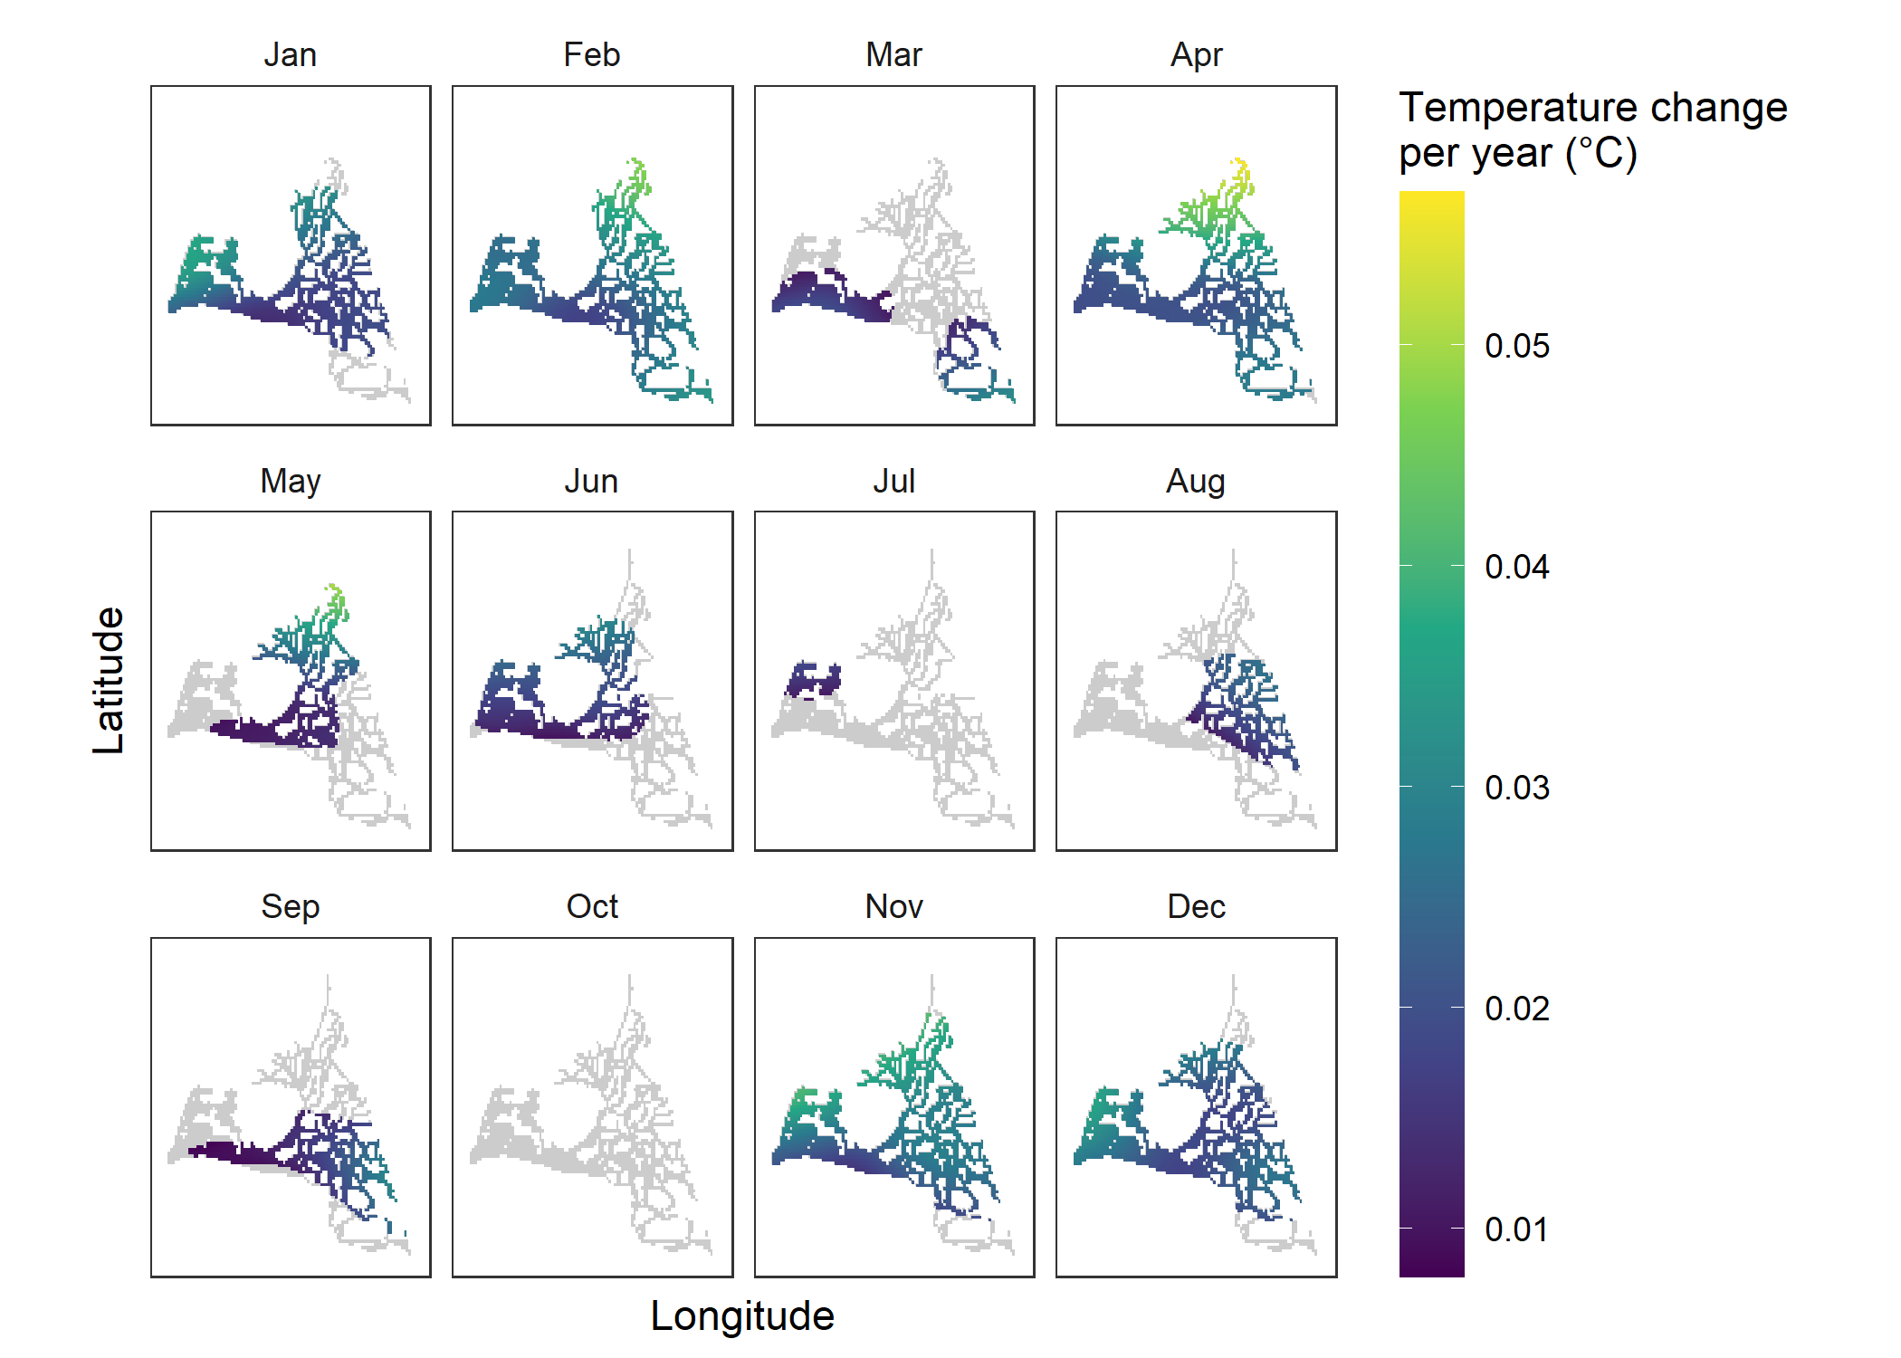
Figure 4. Significant rates of temperature change per year. Only statistically significant temperature changes (p < 0.001) are plotted. Gray areas represent areas with underlying data in the specified month, but no statistically significant temperature change. Note that all temperature trends plotted here were positive (increases) and the color scale is different from Fig. 5.

Long-term temperature trend
Significant rates of temperature increase over time were detected in all months except October (p < 0.001, Figs. 4, S7). The mean rate of temperature increase across all months and locations was 0.017 °C/year, while the mean rate of just the statistically significant (p < 0.001) temperature increases was 0.024 °C/year. The largest spatial extents of significant temperature increases were in November, December, January, February, and April, when close to the entire region of study had significant increases in water temperature (Fig. 4). Temperature increases were strongest in the North Delta, where they reached as high as 0.04 to almost 0.06 °C/year. Temperature increases were also high in Suisun Marsh, the Southern Delta and the Eastern Delta. The central Delta and the confluence of the Sacramento and San Joaquin rivers consistently had the lowest rates of temperature increase: around 0.01 – 0.02 °C/year, but temperature increases were often significant in these regions (Figs. 4, S7).
Estimates of the temperature trend were very close to 0 or slightly negative (although never significant) in October (Fig. S7). Other months had close to no temperature trend, but only in certain regions. Temperature trends were close to 0 in the southern and western regions in May, everywhere except the northern regions in July, and in the western regions in August (Fig. S7).
Temperature trend changes over time
The 25-year temperature trends (model 2.1; Fig. 5) had much higher magnitudes than those detected over the full 50-year dataset (model 1.1; Fig. 4) with both significant increases and decreases. The 25-year sliding window temperature slope generally shifted over time. For example, October, which had no significant temperature slope over the full 50-year dataset, underwent periods of temperature increases in 1970-1995 and 1995-2020 but a period of temperature decreases in 1985-2010. The 1985-2010 period had the most cooling of any 25-year period, but it was only widespread in March, April, and October. The most recent 25-year period, 1995-2020, had the most consistent warming trend with significant warming detected in 10 months (Fig. 5).

Discussion
Although there was a considerable amount of variability in water temperature trends across regions, seasons, and time periods, we found a general warming pattern for the majority of months and areas in the SFE over the past 5 decades (average 0.017 °C/year). Warming was most spatially widespread in the late fall to early winter (November to February), as well as mid spring (April to June). Temperature trends were strongest in the Northern Delta, but above-average warming was also detected in Suisun Marsh, the Southern Delta, and the Eastern Delta. When shorter, 25-year windows were assessed, temperature trends were mostly of higher magnitude and more variable but demonstrated the same general trend of a warming estuary.
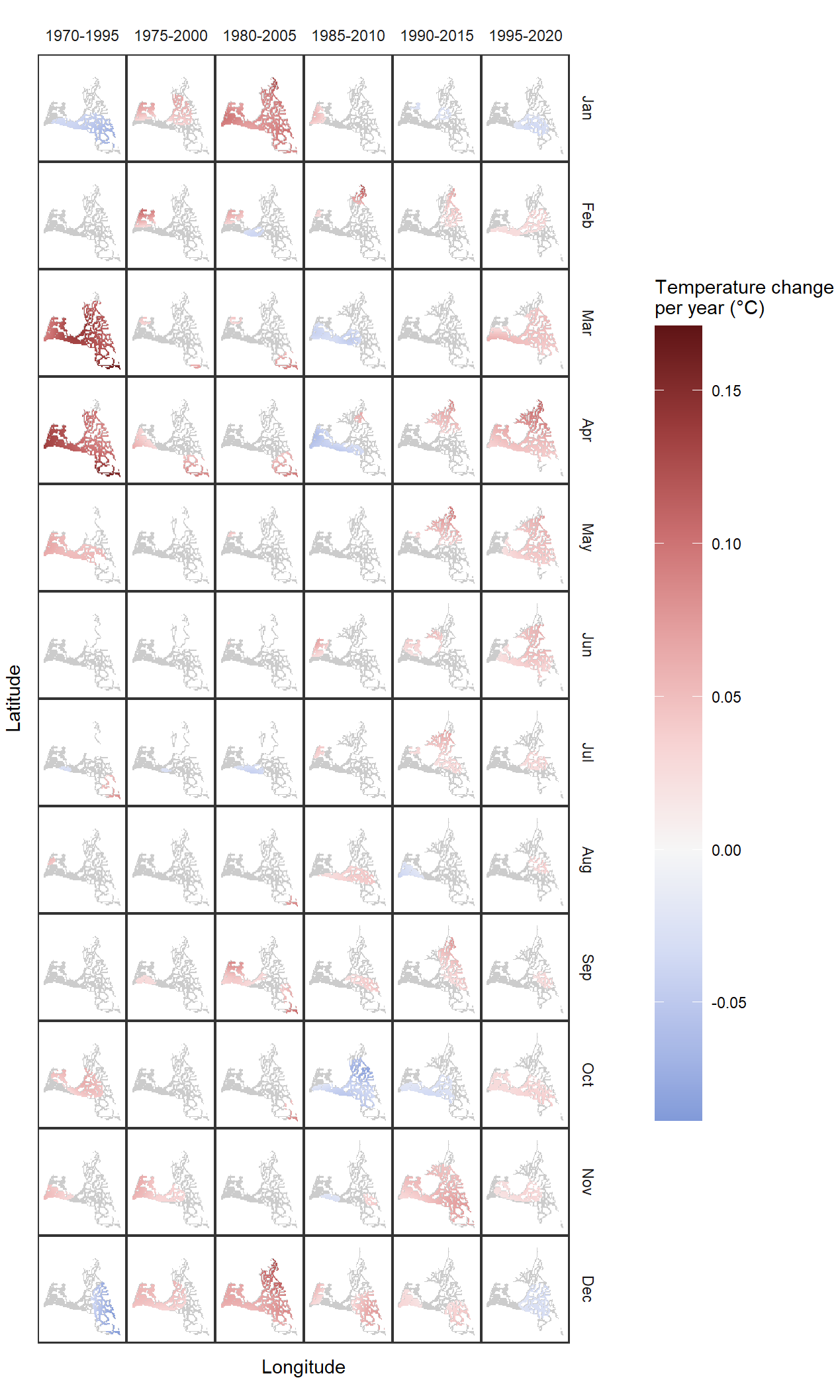
Figure 5. Significant rates of temperature change over six 25-year periods. Only statistically significant temperature changes (p < 0.001) are plotted. Gray areas represent areas with underlying data in the specified month and 25-year period, but no statistically significant temperature change.
The SFE is one of the most well-monitored estuaries in the world, but the various monitoring programs have disparate sets of objectives and designs. Indeed, several of the monitoring programs whose data we used in this study were not originally designed to monitor water quality or climate change. Yet, by integrating these various datasets and accounting for the proper spatial and seasonal temperature patterns (that can often overwhelm interannual variability in this estuary, see Cloern 2019), we were able to identify climate warming signals. Despite the inconsistency in sampling effort and starting date across the survey datasets (table S1), the data simulation test of our model structure demonstrated its ability to accurately estimate long-term temperature changes. No significant temperature slopes were detected in the null scenario (Fig. S4), suggesting that we have sufficiently minimized the type I error (false positive) rate with our choice of p < 0.001 as a significance threshold. Furthermore, the unbalanced sampling design did not result in spurious detections of temperature slopes. Rather, the unbalanced sampling design resulted in an even more conservative threshold for significance since higher-magnitude slopes were more often nonsignificant than in the balanced sampling design (Fig. S3). However, due to our choice of a conservative significance threshold, it is important to consider that the lack of a significant warming signal may be due to either the true absence of such patterns in the data (e.g., for well-sampled regions for October) or insufficient length of data for the region and month (type 2 error).

Comparison to other SFE temperature trends
Results from our study are well within the range of those reported by other studies in the region. Average annual air temperatures in the Southwest USA have warmed 0.008 °C/year from 1901-2010. In the SFE, these rates have ranged from approximately 0.009 – 0.016 °C/year (Hoerling et al. 2013), very close to our average detected rate of 0.017 °C/year. The one prior study to detect a water temperature increase in the upper SFE estimated an increase of 0.007 °C/year from 1985-2001 at Mallard Island in the Confluence region (Shellenbarger and Schoellhamer 2011). This corresponds closely to the lower rates of temperature increase (average 0.011 °C/year) we detected in this region (Figs. 4, S7). This prior study also detected a surface water warming trend of 0.017 °C/year from 1988-1998 at a site about 11 km downstream (West) of our study region (Shellenbarger and Schoellhamer 2011). In the next century (2010-2100), climate change modeling of the SFE estimates that air and water temperatures will both increase 0.014 – 0.042 °C/year, depending on the climate change scenario (Cloern et al. 2011).

Comparison to temperature trends from other regions
Prior analyses of inland estuary temperature trends are rare, but generally of similar magnitude to our results. A study of 116 Australian estuaries detected temperature increases of 0.2 °C/year, but only over a 12-year timeseries (Scanes et al. 2020), which were of similar magnitude to the higher magnitude temperature trends we detected over 25-year timeseries (Fig. 5). Likewise, longer-term analyses of estuarine water temperature trends detected temperature increases similar in magnitude to the average rate of 0.017 °C/year that we detected in our full 50-year timeseries. The Hudson River estuary, New York, USA has warmed 0.015 °C/year from 1945 – 2007, with significant trends in April through August (Seekell and Pace 2011). The Chesapeake Bay, USA has warmed 0.021 – 0.04 °C/year from 1949-2002, mostly driven by winter and spring months (Preston 2004). Lastly, Narragansett Bay, Rhode Island, USA has warmed 0.027 – 0.032 °C/year from 1960 – 2012, with the strongest increases in the winter (Fulweiler et al. 2015).
Other inland aquatic habitats like rivers also have water temperatures driven primarily by air temperatures (Vliet et al. 2011). Results from long-term temperature trend analyses on these systems have revealed temperature increases of a similar magnitude to our results. Major European lakes and rivers have warmed from 0.01 to 0.03 °C/year over the past century (European Environment Agency 2007), although a more detailed look in the UK revealed inter-regional differences in this trend, some regions had a minuscule warming trend and one region (Anglia) had warmed 0.06 °C/year (Whitehead et al. 2009). The Klamath River north of our study region in California, USA has warmed 0.05 °C/year from the 1962 to 2001 (Bartholow 2005). An extensive analysis of timeseries (24 - 100 years long) of 40 streams and rivers in the United States found significant warming trends in half of systems that were evaluated. Of these, warming rates ranged from 0.009 – 0.077 °C/year (Kaushal et al. 2010). A study of mountain river systems in Poland found significant warming trends of 0.033 to 0.092 °C/year from 1984-2018. Warming was strongest in summer and fall and weakest in winter (Kędra 2020).

Upper SFE temperature trends
California has the most extreme interannual precipitation variability of any region in the USA. The vast majority of this precipitation variability is due to the number of warm atmospheric river storms during the winter months (Dettinger et al. 2011, 2016). This variability is predicted to increase with climate change, resulting in more extreme dry and wet years, although the increase in wet extremity is stronger (Swain et al. 2018). We detected some of the strongest patterns of temperature increase in the winter, so altered weather conditions from these storms may be a contributing factor. Spring and early summer (April to June) warming patterns may be partially linked to the declining and earlier snowmelt entering the system (Dettinger and Cayan 1995; Berg and Hall 2017; Mote et al. 2018) in addition to rising air temperature (Bedsworth et al. 2018). In the fall, we found higher variability and weaker trends. Because wildfires are becoming more common in California during these months and widespread smoke may reduce solar radiation and cool water temperatures (David et al. 2018), the interaction between climate warming and wildfire smoke in the SFE may be ripe for future research.
The strongest long-term temperature increases we detected were in the most northern regions. There is an apparent gradient in warming rate from the central regions northward (Figs. 4, S7). The northernmost region, the Upper Sacramento River Ship Channel (Fig. 1), rarely had significant rates of temperature increase, but this is likely due to the short temporal range of data from this region (2009-2019, see Fig. S1). One important region, the southern Delta near the primary water export facilities in the SFE, also has a limited data record (Fig. S1) and we were generally unable to detect temperature trends with high confidence (Fig. S7). A stronger warming pattern in the northern regions than the central and southern regions may reflect conflicting influences of atmospheric forcing and river inflow temperature. Water temperatures in the northern regions near the input of the Sacramento River are much more driven by river inflow temperature than the central and southwest regions, which are more strongly driven by atmospheric forcing (Vroom et al. 2017). These links to river inflow, in addition to the seasonal effects of weather and snowmelt discussed above, suggest that long-term changes in river temperature and inflow may be an important factor driving the temperature trends we observed.
In the shorter 25-year timeseries, both temperature increases and decreases were detected, although the majority of detected changes were increases (Fig. 5). California has exceptional interannual climate variability (Dettinger et al. 2016) so extended timeseries are necessary to evaluate long-term trends (Shellenbarger and Schoellhamer 2011). Our results further emphasize this point, since models based on one 25-year time-series could detect a trend in one direction, while another 25-year timeseries could detect a trend in the opposite direction. One example of this phenomenon is the trend in April which detected negative temperature trends from 1985-2010, but positive temperature trends for the other five 25-year timeseries. Nonsignificant temperature trends were also more common, reflecting the lower statistical power of a 25-year dataset. We detected higher magnitude temperature trends from these shorter time-series, which correspond well with shorter-term temperature trends detected from other systems (see Comparison to temperature trends from other regions). Some of the differences among 25-year periods may be related to long-term climatic cycles such as the El Niño Southern Oscillation, Pacific Decadal Oscillation, or the North Pacific Gyre Oscillation, but further research would be needed to investigate these drivers.

Implications for refugia and restoration
Estuarine species live in a highly dynamic environment and regularly encounter conditions outside of their physiological limits. In the SFE, some species are at the southernmost (i.e., warmest) end of their natural range and a number of native species are already threatened by the current temperature regime (Brown et al. 2016b; Jeffries et al. 2016; Zillig et al. 2021). Rapidly rising winter and spring temperatures in the northern region where the Sacramento River enters the Delta is of particular concern. A large majority of the anadromous fish populations, including listed runs of salmon, spawn in tributaries of the Sacramento River and their juveniles outmigrate to the Delta during the winter and spring months (Williams 2006; Munsch et al. 2019). Furthermore, Suisun Marsh and Cache Slough, two regions that are warming at an above-average rate in most months, contain important remnant tidal wetland habitat and have had higher proportions of native fishes in the past (Brown and May 2006; Moyle et al. 2014, 2016). But despite these trends, our results also highlight regions that may act as temporary refugia in the seasons when they exhibit low or no warming trends. For example, the central region near the Confluence is consistently warming, but at a slower rate compared to other regions, and the western regions have demonstrated a near-negligible temperature trend in the months of May and August (Figs. 4, 5, S7).
The lower rates and smaller spatial extent of warming in summer months may be good news for fish (and other species) near their thermal maxima in those hot months. However, while not reaching lethal levels, temperatures in other seasons are critical for determining life history processes. The endangered Delta Smelt spawn in the spring when temperatures are between 15 and 20 °C (Bennett 2005). Other native fishes in the system also generally spawn in the spring when temperatures are cooler relative to non-native fishes (Meng and Matern 2001). Warming during the spring could change the timing or duration of these spawning windows, with implications for larval food access or reduced fecundity due to a shorter reproductive season. Cool winter temperatures also provide longer residency and growth periods for juvenile salmon, so winter warming could result in smaller out-migrating salmon and therefore lower ocean survival (Munsch et al. 2019). Furthermore, zooplankton seasonal population cycles can be altered by rising temperatures (Winder et al. 2009), which could further shift the timing of food production relative to fish life cycles.
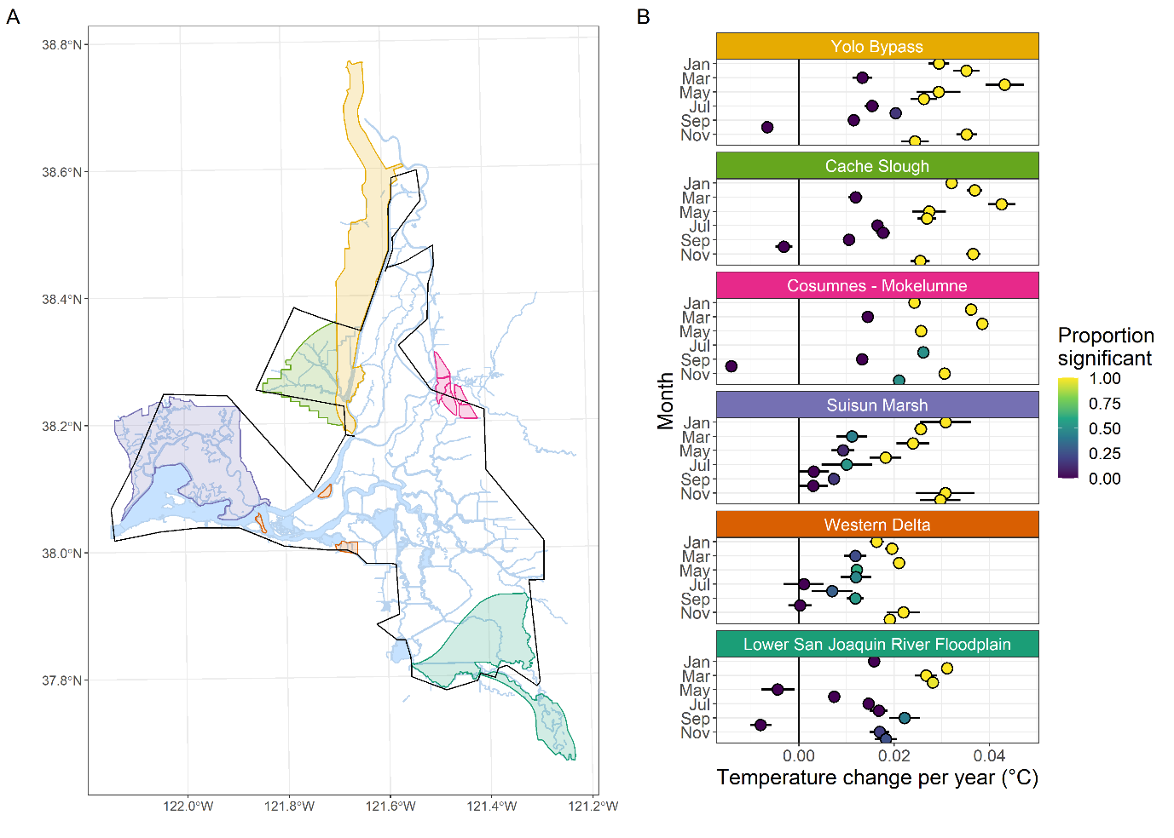
Figure 6. Rates of temperature change in priority habitat restoration areas (PHRAs) from the Delta Plan (Delta Stewardship Council 2013), the state plan for management of the Delta and its resources. A) Map of the PHRAs. The black outline represents our study region. The names of each colored region are indicated in part B. B) Mean and spatial standard deviation (among estimates from each grid cell within the PHRA) of the rate of temperature change. The color of each point represents the proportion of grid cells within the PHRA with significant rates of temperature change. Rates of temperature change are only based off model predictions made within our study region and are thus only representative of those portions of the PHRAs within the black outline in A. The vertical black line denotes a slope of 0. Data were not available for the Cosumnes-Mokelumne region for June and July so estimates are not plotted for those months.
In the upper SFE, habitat restoration is a major priority to improve conditions for native species and restore ecosystem functions (Callaway et al. 2011; Herbold et al. 2014). Currently, sites are prioritized for 6 regions: the Yolo Bypass, Cache Slough Complex, Cosumnes River-Mokelumne River confluence, Lower San Joaquin River floodplain, Suisun Marsh, and Western Delta (Fig. 6A) (Delta Stewardship Council 2013). Of these, the Western Delta generally had the lowest rates of temperature increase, while Cache Slough and the portions of the Yolo Bypass within our study area had the highest rates of temperature increase (Fig. 6B). However, except for the Western Delta and Suisun Marsh, the rest of the priority habitat restoration areas (PHRA) were at the margins of our study region without a large underlying data record, so confidence intervals were wide. These warming trends are based on data mainly collected in open channels, which may not be entirely representative of trends in adjacent wetlands. Water temperatures in our study region are primarily driven by air temperatures (Wagner et al. 2011; Vroom et al. 2017), which should also drive wetland temperatures. However, tidal wetland temperatures are more strongly driven by interactions between tidal dynamics and atmospheric forces. Fluctuating water levels determine the influence of atmospheric drivers and shallow waters can change temperature much more quickly than the deeper waters of diked channels (Enright et al. 2013). This results in complex effects of long-term tidal cycles (the timing of spring tide high-tides) on the temperature of water flushed from tidal wetlands (Enright et al. 2013). Nevertheless, a primary motivation for wetland restoration is to help produce more food for fish (Brown et al. 2016a) and co-locating sites of food production with climate change resilient open-water refugia may provide the highest benefit for fishes.

Conclusions
Quantifying historical warming is a crucial step in the assessment of climate change impacts and our efforts to mitigate them. We detected an average rate of temperature increase of 0.017 °C/year in the upper SFE, with important regional and seasonal differences in the magnitude and statistical significance of that trend. Some of the strongest trends overlapped with key regions and seasons in the life cycles of native fishes. Uncertainties remain in the past and future drivers of spatio-seasonal differences in temperature trends, but evidence points toward river inflow changes and rising air temperature as potential drivers of some of the observed trends. Future studies could investigate contributions from increased wildfire smoke, reduced snowpack, altered inflow, and long-term climatic cycles to water temperature dynamics. If the patterns we observed continue, they will have profound impacts on the estuarine species composition, biodiversity, and ecosystem functions. Disentangling seasonal and spatial differences in climatic changes can provide critical information for the optimization of restoration, protection, and monitoring activities. This study improves our understanding of the spatial and seasonal variability in temperature trends and their potential drivers, which is critical for assessing climate change impacts in estuaries and other aquatic systems worldwide. Furthermore, our modeling framework can be used to harness monitoring data for similar insights in other systems.

Acknowledgements
We dedicate this paper to the memory of Larry Brown. Larry’s guidance, wisdom, and mentorship made this study possible. Unfortunately, Larry was unable to read, review, and approve of this manuscript prior to publication. We thank the monitoring staff from the California Department of Fish and Wildlife, California Department of Water Resources, United States Fish and Wildlife Service, United States Bureau of Reclamation, United States Geological Survey, and the University of California, Davis for producing the data used in these analyses. We thank Fred Feyrer for facilitating the review process prior to the submission of this manuscript. Lastly, we thank Laurel Larsen, J. Louise Conrad, Joshua Israel, Rosemary Hartman, Laura Twardochleb, Dan Constable, Kaylee Griffith, Morgan Chow, and Denise Colombano for comments and suggestions on this manuscript. The findings and conclusions of this study are those of the authors and do not necessarily represent the views of our respective agencies.

Literature cited
Ashcroft, M. B. 2010. Identifying refugia from climate change. Journal of Biogeography 37: 1407–1413. doi:https://doi.org/10.1111/j.1365-2699.2010.02300.x
Bartholow, J. M. 2005. Recent Water Temperature Trends in the Lower Klamath River, California. North American Journal of Fisheries Management 25: 152–162. doi:10.1577/M04-007.1
Bashevkin, S. M. 2021. Six decades (1959-2020) of water quality in the upper San Francisco Estuary: an integrated database of 11 discrete monitoring surveys in the Sacramento San Joaquin Delta, Suisun Bay, and Suisun Marsh. Environmental Data Initiative. doi:10.6073/PASTA/1694EA7F9EF9CC8619B01C3588029683
Beck, M. W., K. L. Heck, K. W. Able, and others. 2001. The Identification, Conservation, and Management of Estuarine and Marine Nurseries for Fish and Invertebrates: A better understanding of the habitats that serve as nurseries for marine species and the factors that create site-specific variability in nursery quality will improve conservation and management of these areas. BioScience 51: 633–641. doi:10.1641/0006-3568(2001)051[0633:TICAMO]2.0.CO;2
Bedsworth, L., D. Cayan, G. Franco, L. Fisher, and S. Ziaja. 2018. Statewide Summary Report. California’s Fourth Climate Change Assessment. Publication number: SUMCCCA4-2018-013. Publication number: SUMCCCA4-2018-013 California Governor’s Ofce of Planning and Research, Scripps Institution of Oceanography, California Energy Commission, California Public Utilities Commission.
Bennett, W. A. 2005. Critical Assessment of the Delta Smelt Population in the San Francisco Estuary, California. San Francisco Estuary and Watershed Science 3. doi:10.15447/sfews.2005v3iss2art1
Berg, N., and A. Hall. 2017. Anthropogenic warming impacts on California snowpack during drought. Geophysical Research Letters 44: 2511–2518. doi:https://doi.org/10.1002/2016GL072104
Brown, L. R., W. Kimmerer, J. L. Conrad, S. Lesmeister, and A. Mueller–Solger. 2016a. Food Webs of the Delta, Suisun Bay, and Suisun Marsh: An Update on Current Understanding and Possibilities for Management. San Francisco Estuary and Watershed Science 14.
Brown, L. R., L. M. Komoroske, R. W. Wagner, T. Morgan-King, J. T. May, R. E. Connon, and N. A. Fangue. 2016b. Coupled Downscaled Climate Models and Ecophysiological Metrics Forecast Habitat Compression for an Endangered Estuarine Fish. PLOS ONE 11: e0146724. doi:10.1371/journal.pone.0146724
Brown, L. R., and J. T. May. 2006. Variation in Spring Nearshore Resident Fish Species Composition and Life Histories in the Lower San Joaquin Watershed and Delta. San Francisco Estuary and Watershed Science 4.
Callaway, J. C., V. T. Parker, M. C. Vasey, L. M. Schile, and E. R. Herbert. 2011. Tidal Wetland Restoration in San Francisco Bay: History and Current Issues. San Francisco Estuary and Watershed Science 9. doi:https://doi.org/10.15447/sfews.2011v9iss3art2
Cane, M. A., A. C. Clement, A. Kaplan, Y. Kushnir, D. Pozdnyakov, R. Seager, S. E. Zebiak, and R. Murtugudde. 1997. Twentieth-Century Sea Surface Temperature Trends. Science 275: 957–960. doi:10.1126/science.275.5302.957
Casey, K. S., and P. Cornillon. 2001. Global and Regional Sea Surface Temperature Trends. Journal of Climate 14: 3801–3818. doi:10.1175/1520-0442(2001)014<3801:GARSST>2.0.CO;2
Clarke, A. 2006. Temperature and the metabolic theory of ecology. Functional Ecology 20: 405–412. doi:https://doi.org/10.1111/j.1365-2435.2006.01109.x
Cloern, J. E. 2019. Patterns, pace, and processes of water-quality variability in a long-studied estuary. Limnology and Oceanography 64: S192–S208. doi:10.1002/lno.10958
Cloern, J. E., N. Knowles, L. R. Brown, and others. 2011. Projected Evolution of California’s San Francisco Bay-Delta-River System in a Century of Climate Change. PLOS ONE 6: e24465. doi:10.1371/journal.pone.0024465
Cohen, A. N., and J. T. Carlton. 1998. Accelerating Invasion Rate in a Highly Invaded Estuary. Science 279: 555–558. doi:10.1126/science.279.5350.555
Costanza, R., R. d’Arge, R. de Groot, and others. 1997. The value of the world’s ecosystem services and natural capital. Nature 387: 253–260. doi:10.1038/387253a0
David, A. T., J. E. Asarian, and F. K. Lake. 2018. Wildfire Smoke Cools Summer River and Stream Water Temperatures. Water Resources Research 54: 7273–7290. doi:https://doi.org/10.1029/2018WR022964
Delta Stewardship Council. 2013. The Delta Plan, Delta Stewardship Council.
Dettinger, M., J. Anderson, M. Anderson, L. R. Brown, D. Cayan, and E. Maurer. 2016. Climate Change and the Delta. San Francisco Estuary and Watershed Science 14. doi:https://doi.org/10.15447/sfews.2016v14iss3art5
Dettinger, M. D., and D. R. Cayan. 1995. Large-Scale Atmospheric Forcing of Recent Trends toward Early Snowmelt Runoff in California. Journal of Climate 8: 606–623. doi:10.1175/1520-0442(1995)008<0606:LSAFOR>2.0.CO;2
Dettinger, M. D., F. M. Ralph, T. Das, P. J. Neiman, and D. R. Cayan. 2011. Atmospheric Rivers, Floods and the Water Resources of California. Water 3: 445–478. doi:10.3390/w3020445
Edgar, G. J., N. S. Barrett, D. J. Graddon, and P. R. Last. 2000. The conservation significance of estuaries: a classification of Tasmanian estuaries using ecological, physical and demographic attributes as a case study. Biological Conservation 92: 383–397. doi:10.1016/S0006-3207(99)00111-1
Enright, C., S. D. Culberson, and J. R. Burau. 2013. Broad Timescale Forcing and Geomorphic Mediation of Tidal Marsh Flow and Temperature Dynamics. Estuaries and Coasts 36: 1319–1339. doi:10.1007/s12237-013-9639-7
European Environment Agency. 2007. Climate change and water adaptation issues. EEA Technical Report 2/2007.
Fulweiler, R. W., A. J. Oczkowski, K. M. Miller, C. A. Oviatt, and M. E. Q. Pilson. 2015. Whole truths vs. half truths – And a search for clarity in long-term water temperature records. Estuarine, Coastal and Shelf Science 157: A1–A6. doi:10.1016/j.ecss.2015.01.021
García, F. C., E. Bestion, R. Warfield, and G. Yvon-Durocher. 2018. Changes in temperature alter the relationship between biodiversity and ecosystem functioning. PNAS 115: 10989–10994. doi:10.1073/pnas.1805518115
Herbold, B., D. M. Baltz, L. Brown, and others. 2014. The Role of Tidal Marsh Restoration in Fish Management in the San Francisco Estuary. San Francisco Estuary and Watershed Science 12. doi:https://doi.org/10.15447/sfews.2014v12iss1art1
Hoerling, M. P., M. Dettinger, K. Wolter, and others. 2013. Present Weather and Climate: Evolving Conditions, p. 74–100. In G. Garfin, A. Jardine, R. Merideth, M. Black, and S. LeRoy [eds.], Assessment of Climate Change in the Southwest United States: A Report Prepared for the National Climate Assessment. Island Press/Center for Resource Economics.
Jassby, A. 2008. Phytoplankton in the Upper San Francisco Estuary: Recent Biomass Trends, Their Causes, and Their Trophic Significance. San Francisco Estuary and Watershed Science 6. doi:https://doi.org/10.15447/sfews.2008v6iss1art2
Jeffries, K. M., R. E. Connon, B. E. Davis, L. M. Komoroske, M. T. Britton, T. Sommer, A. E. Todgham, and N. A. Fangue. 2016. Effects of high temperatures on threatened estuarine fishes during periods of extreme drought. Journal of Experimental Biology 219: 1705–1716. doi:10.1242/jeb.134528
Kaushal, S. S., G. E. Likens, N. A. Jaworski, and others. 2010. Rising stream and river temperatures in the United States. Frontiers in Ecology and the Environment 8: 461–466. doi:https://doi.org/10.1890/090037
Kędra, M. 2020. Regional Response to Global Warming: Water Temperature Trends in Semi-Natural Mountain River Systems. Water 12: 283. doi:10.3390/w12010283
Liu, S., Z. Xie, B. Liu, and others. 2020. Global river water warming due to climate change and anthropogenic heat emission. Global and Planetary Change 193: 103289. doi:10.1016/j.gloplacha.2020.103289
Lotze, H. K., H. S. Lenihan, B. J. Bourque, and others. 2006. Depletion, Degradation, and Recovery Potential of Estuaries and Coastal Seas. Science 312: 1806–1809. doi:10.1126/science.1128035
Meng, L., and S. A. Matern. 2001. Native and Introduced Larval Fishes of Suisun Marsh, California: The Effects of Freshwater Flow. Transactions of the American Fisheries Society 130: 750–765. doi:10.1577/1548-8659(2001)130<0750:NAILFO>2.0.CO;2
Mooney, H., A. Larigauderie, M. Cesario, and others. 2009. Biodiversity, climate change, and ecosystem services. Current Opinion in Environmental Sustainability 1: 46–54. doi:10.1016/j.cosust.2009.07.006
Mote, P. W., S. Li, D. P. Lettenmaier, M. Xiao, and R. Engel. 2018. Dramatic declines in snowpack in the western US. npj Climate and Atmospheric Science 1: 1–6. doi:10.1038/s41612-018-0012-1
Moyle, P. B., L. R. Brown, J. R. Durand, and J. A. Hobbs. 2016. Delta Smelt: life history and decline of a once-abundant species in the San Francisco Estuary. San Francisco Estuary and Watershed Science 14. doi:10.15447/sfews.2016v14iss2art6
Moyle, P. B., J. A. Hobbs, and J. R. Durand. 2018. Delta Smelt and Water Politics in California. Fisheries 43: 42–50. doi:https://doi.org/10.1002/fsh.10014
Moyle, P. B., A. D. Manfree, and P. L. Fiedler. 2014. Suisun Marsh: Ecological History and Possible Futures, University of California Press.
Munsch, S. H., C. M. Greene, R. C. Johnson, W. H. Satterthwaite, H. Imaki, and P. L. Brandes. 2019. Warm, dry winters truncate timing and size distribution of seaward-migrating salmon across a large, regulated watershed. Ecological Applications 29: e01880. doi:https://doi.org/10.1002/eap.1880
Nobriga, M. L., T. R. Sommer, F. Feyrer, and K. Fleming. 2008. Long-Term Trends in Summertime Habitat Suitability for Delta Smelt, Hypomesus transpacificus. San Francisco Estuary and Watershed Science 6. doi:https://doi.org/10.15447/sfews.2008v6iss1art1
Orsi, J. J., and S. Ohtsuka. 1999. Introduction of the Asian copepods Acartiella sinensis, Tortanus dextrilobatus (Copepoda: Calanoida), and Limnoithona tetraspina (Copepoda: Cyclopoida) to the San Francisco Estuary, California, USA. Plankton Biology and Ecology 46: 128–131.
Parain, E. C., R. P. Rohr, S. M. Gray, and L.-F. Bersier. 2018. Increased Temperature Disrupts the Biodiversity–Ecosystem Functioning Relationship. The American Naturalist 193: 227–239. doi:10.1086/701432
Pebesma, E. 2018. Simple Features for R: Standardized Support for Spatial Vector Data. R Journal 10: 439–446. doi:10.32614/RJ-2018-009
Pebesma, E. 2021. stars: Spatiotemporal Arrays, Raster and Vector Data Cubes.,.
Pebesma, E., and G. Heuvelink. 2016. Spatio-temporal interpolation using gstat. RFID Journal 8: 204–218.
Pebesma, E. J. 2004. Multivariable geostatistics in S: the gstat package. Computers & Geosciences 30: 683–691. doi:10.1016/j.cageo.2004.03.012
Petchey, O. L., P. T. McPhearson, T. M. Casey, and P. J. Morin. 1999. Environmental warming alters food-web structure and ecosystem function. Nature 402: 69–72. doi:10.1038/47023
Preston, B. L. 2004. Observed Winter Warming of the Chesapeake Bay Estuary (1949–2002): Implications for Ecosystem Management. Environmental Management 34: 125–139. doi:10.1007/s00267-004-0159-x
R Core Team. 2020. R: A Language and Environment for Statistical Computing, R Foundation for Statistical Computing.
van Rij, J., M. Wieling, and R. Baayen. 2020. itsadug: Interpreting Time Series and Autocorrelated Data Using GAMMs.,.
Scanes, E., P. R. Scanes, and P. M. Ross. 2020. Climate change rapidly warms and acidifies Australian estuaries. Nature Communications 11: 1803. doi:10.1038/s41467-020-15550-z
Seekell, D. A., and M. L. Pace. 2011. Climate change drives warming in the Hudson River Estuary, New York (USA). J. Environ. Monit. 13: 2321–2327. doi:10.1039/C1EM10053J
Shellenbarger, G. G., and D. H. Schoellhamer. 2011. Continuous Salinity and Temperature Data from San Francisco Estuary, 1982–2002: Trends and the Salinity–Freshwater Inflow Relationship. Journal of Coastal Research 27: 1191–1201. doi:10.2112/JCOASTRES-D-10-00113.1
Stompe, D. K., P. B. Moyle, A. Kruger, and J. R. Durand. 2020. Comparing and Integrating Fish Surveys in the San Francisco Estuary: Why Diverse Long-Term Monitoring Programs are Important. San Francisco Estuary and Watershed Science 18. doi:10.15447/sfews.2020v18iss2art4
Swain, D. L., B. Langenbrunner, J. D. Neelin, and A. Hall. 2018. Increasing precipitation volatility in twenty-first-century California. Nature Climate Change 8: 427–433. doi:10.1038/s41558-018-0140-y
Takata, L., T. R. Sommer, J. Louise Conrad, and B. M. Schreier. 2017. Rearing and migration of juvenile Chinook salmon (Oncorhynchus tshawytscha) in a large river floodplain. Environ Biol Fish 100: 1105–1120. doi:10.1007/s10641-017-0631-0
United States Fish And Wildlife Service, C. Johnston, S. Durkacz, and others. 2020. Interagency Ecological Program and US Fish and Wildlife Service: San Francisco Estuary Enhanced Delta Smelt Monitoring Program data, 2016-2020. Environmental Data Initiative. doi:10.6073/PASTA/764F27FF6B0A7B11A487A71C90397084
Vliet, M. T. H. van, F. Ludwig, J. J. G. Zwolsman, G. P. Weedon, and P. Kabat. 2011. Global river temperatures and sensitivity to atmospheric warming and changes in river flow. Water Resources Research 47. doi:https://doi.org/10.1029/2010WR009198
Vroom, J., M. van der Wegen, R. C. Martyr‐Koller, and L. V. Lucas. 2017. What Determines Water Temperature Dynamics in the San Francisco Bay-Delta System? Water Resources Research 53: 9901–9921. doi:10.1002/2016WR020062
Wagner, R. W., M. Stacey, L. R. Brown, and M. Dettinger. 2011. Statistical Models of Temperature in the Sacramento–San Joaquin Delta Under Climate-Change Scenarios and Ecological Implications. Estuaries and Coasts 34: 544–556. doi:10.1007/s12237-010-9369-z
Whipple, A. A., R. M. Grossinger, D. Rankin, B. Stanford, and R. Askevold. 2012. Sacramento-San Joaquin Delta historical ecology investigation: exploring pattern and process. Richmond: San Francisco Estuary Institute-Aquatic Science Center.
Whitehead, P. G., R. L. Wilby, R. W. Batarbee, M. Kernan, and A. J. Wade. 2009. A review of the potential impacts of climate change on surface water quality. Hydrological Sciences Journal 54: 101–123. doi:10.1623/hysj.54.1.101
Williams, J. G. 2006. Central Valley Salmon: A Perspective on Chinook and Steelhead in the Central Valley of California. San Francisco Estuary and Watershed Science 4. doi:10.15447/sfews.2006v4iss3art2
Winder, M., D. E. Schindler, T. E. Essington, and A. H. Litt. 2009. Disrupted seasonal clockwork in the population dynamics of a freshwater copepod by climate warming. Limnology and Oceanography 54: 2493–2505. doi:https://doi.org/10.4319/lo.2009.54.6_part_2.2493
Wood, S. N. 2011. Fast stable restricted maximum likelihood and marginal likelihood estimation of semiparametric generalized linear models. Journal of the Royal Statistical Society: Series B (Statistical Methodology) 73: 3–36. doi:https://doi.org/10.1111/j.1467-9868.2010.00749.x
Wood, S. N., N. Pya, and B. Säfken. 2016. Smoothing Parameter and Model Selection for General Smooth Models. Journal of the American Statistical Association 111: 1548–1563. doi:10.1080/01621459.2016.1180986
Zillig, K. W., R. A. Lusardi, P. B. Moyle, and N. A. Fangue. 2021. One size does not fit all: variation in thermal eco-physiology among Pacific salmonids. Rev Fish Biol Fisheries 31: 95–114. doi:10.1007/s11160-020-09632-w

