Separating the effects of male age and past mating effort on paternity success under sperm competition

Upama Aich*, Megan L. Head, Rebecca J. Fox, Michael D. Jennions

Division of Ecology & Evolution, Research School of Biology, The Australian National University, Canberra, ACT 2601, Australia

*Author for correspondence Upama Aich, e-mail: aich.aich49@gmail.com, Mobile: +61431988924
Abstract

Older males often perform poorly under post-copulatory sexual selection. It is unclear, however, whether reproductive senescence is due to male age itself or the accumulated costs of the higher lifetime mating effort that is usually associated with male age. To date, very few studies have accounted for male mating history when testing for the effect of male age on sperm traits, and none test how age and past mating history influence paternity success under sperm competition. Here, we experimentally manipulate male mating history to tease apart its effects from that of age on ejaculate traits and paternity in the mosquitofish, Gambusia holbrooki. We found that old, naive males had more sperm than old, experienced males, while the reverse was true for young males. In contrast, neither male age nor mating history affected sperm velocity. Finally, using artificial insemination to experimentally control the number of sperm per male, we found that old males sired significantly more offspring than young males independent of their mating history. Our results highlight that the general pattern of male reproductive senescence described in many taxa may often be affected by two naturally confounding factors, male mating history and sperm age, rather than male age itself.

Introduction

For the past three decades, studies have focused on age as a major factor which can influence the magnitude and direction of sexual selection on males [1, 2]. Ageing is usually characterized by a progressive decline in physiological function that results in lower reproductive success [3]. Growing interest in ageing in both humans and other animals has resulted in numerous studies testing the effects of male age on sperm traits and fertility. Since sperm production is costly, any decline in general performance with age is expected to reduce the availability of the resources needed to produce high‐quality ejaculates, resulting in declines in sperm function as males age (reviewed in: [4, 5]). In support of this, studies testing the effect of age on sperm quality in humans have shown a general pattern of senescence, which includes a reduction in sperm velocity, motility and number, and an increase in abnormal morphology (review: [6]). For non-human taxa the results are mixed: some studies report a decline in sperm traits with age [7-12], while others demonstrate no significant change, or even an increase in sperm quality and quantity with age [13-19]. These differences among studies, sometimes even for those on the same species (e.g. [11] and [17]) raise questions about confounding factors that might be correlated with age, and could obscure the direct effect of male age on sperm traits.

The extent of any decline in sperm function with male age could depend on variation in males’ past mating effort [20]. This is because male age and mating history are usually confounded in nature: older males have generally mated, ejaculated and replenished their sperm more often, and have made a greater lifetime reproductive effort [12, 21]. In principle, the costs of reproduction could generate a decline in ejaculate quality [22] that is independent of any effect of male age. Sperm production [23], sperm transfer rates [24], and sperm velocity [12] could be independently affected by male mating history itself. Older males might have fewer and slower sperm due to their greater past mating effort rather than their chronological age. Male mating effort needs to be experimentally controlled for to measure the independent, or interactive, effects of age and past mating effort on male reproductive success [20, 25, 26]. To date, no study has accounted for male mating history when testing whether male age affects paternity success under sperm competition.

The effects of age on sperm traits only has evolutionary relevance if these traits (or age itself) affect male reproductive success (i.e., fitness). Measuring key sperm traits, such as sperm length, is sometimes useful to estimate relative fertilization success, but the actual determinants of paternity success are often numerous or unknown [5, 27]. Direct measures of paternity are therefore required. In polyandrous species, sexual selection occurs both before and after mating: pre-copulatory female choice and male-male competition are followed by post-copulatory sperm competition and cryptic female choice [28]. Pre-copulatory sexual selection can therefore hinder our ability to test for independent effects of sperm traits or male age on success under sperm competition and, ultimately, a male’s share of paternity [29, 30] To test for age-dependent changes in sperm competitiveness it is therefore necessary to control for variation in reproductive success due to pre-copulatory sexual selection [30].

Here we conduct an experimental study to test for independent, and interactive, effects of male age and mating history on sperm traits and sperm competitiveness in eastern mosquitofish, Gambusia holbrooki. We raised fish to create groups of young and old virgin males. We then experimentally manipulated their mating effort by allowing them to either freely interact and mate with females, or by allowing them only visual and olfactory contact with females. We stripped sperm from males before and after they were placed in their mating treatment to test for age-dependent changes in sperm traits in response to past mating effort, and we also partially controlled for variation in post-meiotic sperm age [12, 31]. A recent longitudinal study on mosquitofish showed that sperm velocity declines with male age, and that while older males produce more sperm, males with higher past mating effort produce fewer sperm [12]. These results imply that male age and mating history will interact to determine ejaculate quality in G. holbrooki. Our current study aims to test those finding using cross-sectional data.

Crucially, here we test whether any age-dependent variation in sperm traits translates into fitness by measuring paternity under sperm competition. To do this we artificially inseminated females with equal numbers of sperm from four types of males (young or old with high or low past mating effort). We used artificial insemination to eliminate pre-copulatory sexual selection to ensure that paternity differences reflect male performance under sperm competition. We hypothesised that if the measured sperm traits capture functional changes in sperm performance with age, older males with inferior sperm traits will be weaker sperm competitors and gain less paternity. If, however, age‐related declines in ejaculate quality observed in previous studies are due to greater past mating effort by older males, then older males in our study might even have higher quality ejaculates since we controlled for an effect of past mating effort. Furthermore, if more sexually active males are constantly replenishing their sperm reserves, this could increase the rate of accumulation of germline mutations and damage spermatogenic tissue resulting in a decline in sperm function that is independent of male age, lowering the fertilization success of our high mating effort treatment males [4, 32].

Methods

Origin and Maintenance of the fish

All stock fish were maintained in single-sex 90L tanks at densities of <50 individuals per tank and fed ad libitum twice daily, with commercial fish flakes in the morning, and Artemia salina nauplii in the afternoon. They were kept under a 14:10 h photoperiod at 28 ± 1°C.
Manipulating male age and mating history

To examine the effects of male age and mating history on sperm traits and reproductive success, we bred ‘young’ and ‘old’ males in the laboratory and then assigned males in each age class to one of two mating treatments (full methodological details in [33]). In brief, ‘old and ‘young’ males were bred from laboratory stocks in batches 12 weeks apart. In each batch, up to 10 newborn fish from each stock female (200 females contributed to each batch, 400 females in total) were reared in stock tanks at < 50 fish per 90L. The maximum age difference of fish within a tank was 15 days. After four weeks, offspring were inspected thrice weekly to determine their sex. Immature males were transferred to male-only tanks to ensure virginity. Males were transferred to individual 1L tanks when they reached sexual maturity.

After creating these two male age classes, we then experimentally manipulated male mating effort. ‘Naive’ males were allowed visual and olfactory contact with a female, but physical contact was prevented because she was on the other side of a mesh barrier. Naive males therefore had a low past mating effort. In contrast, ‘mated’ males were housed with a female with whom they could freely interact and mate: these males had higher past mating effort. For both treatments males were housed in 7L tanks, and females were rotated through the tanks every seven days to ensure males retained a sexual interest in prospective mates. Equal numbers of ‘young’ and ‘old’ males were assigned to each mating treatment for two weeks to create four treatments (‘old/mated’; ‘young/mated’; ‘old/naive’; and ‘young/naive’; n = 72*4 treatments = 288 males). Prior to entering the mating treatment, males were anaesthetised in an ice-water slurry, then injected with different coloured elastomer tags for individual identification [see 34]. Four males (one per treatment) were randomly marked with a different coloured elastomer tag to create ‘’blocks” of males that were matched for age and had their traits measured on the same day. This ensured a post-maturity age difference of 12-13 weeks between young and old males in each block.

Sperm traits

We measured sperm traits before and after males were introduced to mating treatment: when the old and young males were approximately 12 then 15 weeks, or 0 then 3 weeks, post-maturity respectively. This age difference was chosen because we recently found a significant decline in sperm traits from weeks 3 to 14 after maturation [12].

Males were stripped of sperm before (Day 0) and after (Day 19) being put in the mating treatment. The collection of sperm on Day 0 helped to standardize post-meiotic sperm age when remeasuring traits on Day 19 (i.e., sperm used in sperm trait and sperm competition trials were a maximum of 19 days old). Prior to sperm collection on day 19 males were isolated for 5 days to replenish their sperm reserves [35]. We stripped sperm following the methods of [36]. Briefly, on Day 0, we collected two separate samples of 3 sperm bundles from a male’s ejaculate for sperm velocity assays. The remainder of the ejaculate was used for sperm counts (Figure 1a). On Day 19 we first collected two separate samples of 10 sperm bundles from each male’s ejaculate for artificial insemination (see below). We then collected sperm bundles for sperm velocity and count assays as described for Day 0 (Figure 1b). Sperm number and velocity were measured following [36]. Full details are in the Supplementary Material.

Paternity success following sperm competition

To determine male reproductive success under sperm competition we artificially inseminated two virgin females with the sperm of a block of four males (one per treatment). In four blocks, we inseminated up to three additional females to increase the likelihood of offspring production. Two sets of 10 sperm bundles per male were collected on Day 19 (Figure 1b). We then combined one set of sperm bundles from the four males (total = 40 sperm bundles) in an Eppendorf tube, which was gently tapped downward so that the sperm mixture settled. To artificially inseminate a female, she was anaesthetized in an ice-slurry, and placed ventral side up in a polystyrene cradle. Using a micropipette, 3 μL of the sperm mixture was then injected into her gonopore (see [37]). This was then repeated to artificially inseminate two females per block. Following the artificial insemination, males were euthanised for later DNA extraction.

Inseminated females were transferred to individual 1L tanks and checked twice daily for offspring. In total, 58 females from 39 blocks produced 210 offspring. Once a female gave birth, she and her offspring were euthanized for paternity testing. DNA was extracted from the tail muscle/caudal ﬁn of adults, and from the whole body (excluding the head and abdomen) of fry. We then genotyped fish using DArTseq [38]. From these SNPs, a Hamming Distance Matrix for all the putative sires and offspring were calculated to determine paternity. Each offspring was lined up against its four potential sires, and Hamming Distance values were compared. The sire with the lowest value was considered a match. See Supplementary Material for details.

Using the SNP data, we also calculated heterozygosity (H) as the number of SNP loci that were scored as heterozygous divided by the total number of successfully classified loci for each male who was a potential sire in the experiment (F_{het:} [37]).

All sperm and paternity data were collected blind to male treatment.

Statistical analysis

To analyse the effect of male age and mating history on sperm traits and sperm competition, we ran linear mixed effect models and generalised linear mixed effect models in R Version 3.6.0 [39] using the lme4 [40] or glmmTMB package [41]. We always checked the distribution of residuals to ensure they met model assumptions. Negative-binomial or quasi-poisson error structure was chosen over Poisson errors if the former gave a better fit to the model. Model terms were tested for significance using the Anova function in the car package specifying Type III Wald chi-square tests. All tests were two-tailed unless otherwise stated. Finally, where relevant, we conducted post-hoc pairwise comparisons between the four male treatments using Tukey's tests.

Effects of male age and mating history on sperm traits

We ran separate models for sperm count and sperm velocity (VCL) for sperm traits on Day 0 and Day 19 respectively to test for the effect of male age alone (Day 0), and then test for effects of both age and mating treatment on sperm traits (Day 19). In the Day 0 model, male age was a fixed factor, male body size (standardized across the full data set; mean=0, s.d. =1) was a fixed covariate, and block ID was a random factor.

On Day 19, we initially treated male age, mating history and whether or not the tag was yellow/red as fixed factors. We initially included the interaction between mating history and tag colour because red/yellow affected male attractiveness in an earlier study [33] and tag colour might therefore affect a male’s mating rate (only possible for mated treatment males), hence sperm traits on day 19. However, we removed the mating history*tag colour from final models as it was always non-significant (see Supplementary Material, Tables S6). We retained the main effect of tag colour in the final model, and added the interaction between male age and mating history. If it was non-significant it too was dropped from the model to test for the main effects of male age and mating history. Male body size was standardized across the full data set and included as a fixed covariate in all models. Block ID was a random factor.

To test for repeatability of sperm velocity between days, we ran a linear model with velocity on Day 19 as the response variable, velocity on Day 0 as a covariate, and male treatment type (four levels) as a fixed effect. We did this as we were interested in whether Day 0 sperm velocity predicted Day 19 sperm velocity after controlling for any effect of male age/mating treatment. We also tested if sperm count on Day 0 predicted that on Day 19 using a linear model, but we added male body size (standardized across the data set) as a covariate: previous studies on Gambusia have shown that male body size is associated with sperm count but sperm velocity is not [10]. By including male size, we are testing for repeatability of sperm count that is not simply attributable to variation in male size.

Effects of male age and mating history on male paternity success following sperm competition

To assess male success under sperm competition, we used the number of offspring sired by each male with each female as the dependent variable in a generalised linear mixed model specifying a negative-binomial distribution of the residuals, accounting for zero-inflation and overdispersion. Similar to the models for sperm traits described above, we initially treated male age, mating history, and whether or not the tag was yellow/red as fixed factors, and included the interaction between tag colour and mating history. Again, this interaction was non-significant (see Supplementary Results) so we excluded it from further analysis. We then included the interaction between male age and mating history. It was not significant and we excluded it from the model to test for the main effects of male age and mating history. We always included block-centred male body size (i.e., male size – mean size of males in block) as a covariate. Male ID, female ID and Block ID were treated as random factors.

To test whether sperm velocity alone predicts a male’s share of paternity under sperm competition, we ran a generalised linear mixed model. The number of offspring sired by each male with each female was the dependent variable, and we assumed a negative-binomial distribution of the residuals, with sperm velocity at Day 19 as the only fixed covariate, and Male ID, female ID and Block ID as random factors. We did not include sperm number as a predictor because our experimental design involved artificially inseminating females with approximately the same number of sperm from each male.

Effects of male gonopodium size and heterozygosity

Given previous findings [37], we were interested to test whether male gonopodium length or heterozygosity affected sperm traits or paternity success after controlling for body size. Given these analyses are tangential to our main hypotheses we report them in the supplementary material (see Supplementary Analysis, Tables S8 and S9).

Results

Sperm number

When measured prior to any mating (i.e., Day 0) older males produced significantly more sperm than younger males (χ²= 180, df=1, p= <0.001; Table S1, Figure 2a). In addition, larger males produced significantly more sperm (χ²=7.828, df=1, p= <0.001). After the mating experience treatment (i.e., Day 19), the interaction between male age and mating history had a significant effect on the number of sperm produced (χ²= 6.502, df=1, p= 0.011; Table S1, Figure 3a). Post-hoc pairwise comparisons revealed that old, naive males with low past mating effort produced significantly more sperm than those with higher past mating effort, or young males regardless of mating treatment (Table S2, Figure 3a). Again, larger males produced significantly more sperm (χ²=15.044, df=1, p <0.001).

Sperm velocity

When stripped prior to any mating (i.e., Day 0), the sperm of younger males had significantly higher velocity than that of older males (Table S1, Figure 2b; χ²= 39.21, df=1, p <0.001). Unlike the case for sperm number, male body size did not affect sperm velocity (χ²= 0.069, df=1, p=0.792).

After the mating experience treatment (i.e., Day 19) there was no significant interaction between male age and their mating history affecting sperm velocity (Table S7, Figure 3b; χ²= 1.467, df=1, p=0.226). Furthermore, neither male age nor mating history affected sperm velocity (χ²= 3.085, p=0.08; χ²= 0.602, p=0.438 respectively, both df=1). There was also no detectable effect of male body size on sperm velocity (χ²= 2.438, df=1, p= 0.118; see Table S1).

Repeatability of sperm traits

Even after controlling for body size, estimates of sperm number were repeatable among males measured on days 0 and 19 (χ²= 15.053, df=1, p <0.001). However, sperm velocity was not repeatable (F_{1, 280} =1.304, p= 0.254; also see Table S3).

Paternity success under sperm competition: artificial insemination

Older males sired significantly more offspring than younger males (Table S4, Figure 4; χ²= 6.24, df=1, p=0.012). However, there was no effect of past mating effort (χ²= 0.804, df=1, p=0.370) and no interaction between male age and their past mating effort (χ²= 0.798, df=1, p=0.372, Table S7) on paternity. Male body size relative to that of his rivals did not affect the number of offspring sired (χ²= 0.16, df=1, p=0.689). This is, perhaps, unsurprising given that all males provided approximately equal amounts of sperm (i.e., ten sperm bundles).

Sperm velocity did not affect a male’s share of paternity under sperm competition (χ²=0.662, df=1, p= 0.416; also see Table S5).

Discussion

Studies testing for an effect of male age on sperm traits and fertilization success have shown a general pattern of decline, but this pattern is not universal [20]. Variation in results among studies could potentially be driven by three major factors that are often overlooked. First, studies testing for age-related changes in sperm traits rarely standardize male mating history (but see: [25], [42-44]). Second, sperm traits can differ between old and young sperm due to post-meiotic ageing of the sperm, independent of male age. This is because sperm quality can be negatively affected when it is stored as oxidative damage increases over time [31]. Third, and most importantly, although testing for age-dependent changes in sperm traits might be a good proxy for relative fertilization success, reported paternity success is often confounded by the potential for pre-copulatory sexual selection [28]. As sexual selection occurs both before and after mating, pre-copulatory selection (e.g., female choice) could hinder the ability to test for independent effects of sperm traits on male fertilization success under sperm competition and, ultimately, their share of paternity [29,30]. Controlling for these three sources of variation is essential if we want to understand the direct effects of male age on sperm traits and fitness.

Given these concerns, we experimentally disentangled male age and mating history in G. holbrooki to test their effects on sperm traits as well as actual fertilization success while controlling for pre-copulatory sexual selection. Moreover, we measured both stored and more recently replenished sperm to reduced variation due to differences in post-meiotic sperm age. We found that older males consistently produced more sperm than younger males. We also found that sperm number was affected by a significant interaction between male age and their past mating effort. For sperm velocity we initially found that prior to mating (Day 0) older males had slower sperm than younger males. However, sperm velocity did not differ between young and old males once we controlled for post-meiotic sperm age by measuring more recently replenished sperm (Day 19) Male mating history also did not affect sperm velocity. Our result for velocity contrasts with previous research on mosquitofish that controlled for sperm age [12]. Most importantly, when sperm age and number were controlled for in our study, older males sired significantly more offspring independent of the males’ mating history. Our results highlight that the general pattern of an age-related decline in male reproductive traits that has been described in many taxa may often result from covariation with two other key factors, namely male mating history and sperm age, rather than male age itself. Future studies should account for this possibility when testing for the causes of male reproductive senescence.

Sperm number

Our results indicate that older males do not show senescence in sperm production. In fact, older males produced significantly more sperm than younger males. This is true even after controlling for greater sperm production by larger males (although there is minimal post-maturation growth of male G. holbrooki so age and size are barely correlated [45]). We also found that male age and mating history had a significant interactive effect on sperm number once we controlled for sperm age. Older males with low past mating effort produced significantly more sperm than those with high past mating effort, or than young males regardless of their past mating effort. This result partly agrees with studies in other taxa showing an increase in sperm production by older males [12, 16, 17, 19, 42], and lower sperm production by males with high past mating effort [23, 44]. There are two possible explanation for the observed interaction between male age and mating history. First, that the longer it is before males mate the more resources they accumulate for sperm production [5, 46]. Second, that older males with low mating effort investment more into sperm production due to their lower residual reproductive value, either because of a higher risk of dying, or because they are less likely to encounter fertile females at the end of the breeding season [14, 47]. Our results for sperm production corroborate our previous research [12], indicating that allocation of resources toward mating subsequently reduces sperm production [29].

Sperm velocity

We recorded lower sperm velocity in older than younger males when measuring sperm on Day 0. It is probable that the sperm of older males at this time had been stored for longer, on average, than that of younger males. Previous studies in poeciliids have shown swimming speed is slower in stored than fresh sperm in guppies (31), although not in mosquitofish [12]. However, after better controlling for sperm age by only examining sperm produced over a 19-day period (Days 0 to 19), we found no difference in sperm velocity among young and old males with either high or low past mating effort. These results suggest that the observed decline in sperm quality with male age that has been recorded in many taxa could result from post-meiotic sperm senescence rather than the production of lower quality sperm by older males [4, 46]. This also aligns with several studies that report no significant effect of male age on sperm velocity (guppies: [16] and zebrafish: [17], horseshoe crab: [48], bluethroat: [49]). However, it contrasts with recent longitudinal studies on fish that have found sperm velocity declines with male age independently of their mating history or sperm age (zebrafish: [11], mosquitofish: [12], guppies: [43]). These differences among studies could be due to how males are treated prior to measurement. In our current study, old males were isolated from females until they were placed in their mating treatments, whereas previous longitudinal studies regularly exposed males to females. Exposure to females for a prolonged period, even in the absence of mating, might be costly for males, because sexually primed males produce more sperm [50]. Therefore, older males with greater exposed to females may show higher post-meiotic sperm senescence due to the accumulation of deleterious mutations in germline cells, which lower sperm velocity [4, 12, 29].

Paternity success

Independent of their mating history, old males sired significantly more offspring under sperm competition than did young males. This result contradicts the pattern seen in the handful of other studies that have also removed the potential for pre-copulatory sexual selection, however, none of these studies disentangled the effect of mating history from that of male age. For example, under artificial insemination younger males sire more offspring in feral fowls [10], bustards [30], while there is no effect of male age in guppies: [16] or salmons [51]. Our finding that older male G. holbrooki had higher fertilization success is intriguing because we controlled for the number of sperm inseminated per male, and there was no effect of male age on sperm velocity. In addition, the absence of a direct correlation between sperm velocity and paternity success might seem surprising [27, 52], but it has been documented in other species too (e.g., bluethroat: [49], guppies: [16]). In an earlier study we also found no correlation between sperm velocity and paternity when investigating inbreeding in G. holbrooki. Inbreeding had no effect on sperm velocity, but outbred males gained more paternity when females were artificially inseminated with a sperm mixture from an inbred and outbred male [37]. One explanation for the higher paternity success of older males in our current study is that these males did not incur the costs of repeatedly mating throughout adulthood. This might reduce the rate of senescence of ejaculate traits that affect sperm competitiveness. Given that we controlled for sperm number per male in our artificial inseminations, and that sperm velocity did not decline with age, differences in other ejaculate traits, namely sperm morphology and seminal fluid content, must explain the higher fertilization success of older males [44,53, 54]. We recommend that future studies measure a greater range of ejaculate traits when testing for the effect of age and mating history on male reproductive senescence.

Conclusion

We provide experimental evidence based on sperm counts, but not sperm velocity, that males invest less into ejaculates when there is more opportunity to mate throughout their lifetime. Our findings also suggest that, in all taxa, post-meiotic sperm age and male mating history should be controlled for when testing for a direct effect of male age on sperm traits. The failure to do so could exaggerate the extent to which old and young males differ in sperm quality. Finally, we found that older male G. holbrooki gained higher paternity success under sperm competition. This suggests that there might be genetic benefits of mating with, and being fertilized by, older males if age is positively correlated with heritable variation in fitness (i.e., due to greater survival of higher quality males; [55]). However, there might also be costs if offspring sired by older males are of lower quality due to non-genetic paternal effects. Although challenging, future studies should also attempt to experimentally test for the independent effects of paternal age and mating history on offspring fitness.

Ethics: Fish were collected under an ACT Government Scientific License. ANU Animal Ethics approvals are #A2015/07 and #A2018/27.

Data accessibility: Data added as a supplementary material.

Competing interests: We declare no competing interests.

Author contributions: MDJ, MLH and UA conceived the project. UA and RJF designed the study and collected the data. UA analysed the data and drafted the manuscript which was revised by MDJ and MLH. All authors contributed to subsequent revisions of the manuscript.

Funding: This work was supported by the Australian Research Council Discovery Project grants (DP160100285, DP190100279) to MDJ.

Figure legends

Figure 1. Schematic diagram of the sperm collection method on (a) Day 0 and (b) Day 19. (a) On Day 0, sperm from individual males were collected for sperm trait assays; 2× 3 bundles were collected for sperm velocity and the rest for the sperm count. (b) On Day 19, 2× 10 bundles sperm per male per block (one per treatment: old-naive, old-mated, young-naïve, young-mated) were collected to test for sperm competition success (paternity) via artificial insemination. 2× 3 bundles were collected for sperm velocity and the rest for the sperm count.

Figure 2. The effect of male age on sperm traits (a) sperm number and (b) sperm velocity before mating treatment (Day 0). Bars represent mean values and the error bars represents standard error (SE) of the raw data (n=72*4=288, 287).

Figure 3. The effect of male age and mating history on sperm traits (a) sperm number and (b) sperm velocity after two weeks in the mating treatment (Day 19). Bar charts represent mean values and the error bars represents standard error (SE) of the raw data. In both cases, mated males with higher past mating effort are denoted with light blue and naïve males with low past mating effort are denoted with dark blue colour. Letters indicate significant differences using Tukey's tests (n=72*4=288, 285).

Figure 4. The effect of male age and mating history on the number of offspring sired under sperm competition after two weeks in mating treatment (Day 19). Bar charts represent mean values and the error bars represents standard error (SE) of the raw data. Here males with higher past mating effort (i.e., mated) are denoted with light blue and males with low past mating effort (i.e., naïve) are denoted with dark blue colour (n=179 offspring, females=55, blocks of males=37).

References

- Bonduriansky R, Maklakov A, Zajitschek F, Brooks R. 2008 Sexual selection, sexual conflict and the evolution of ageing and life span. Funct. Ecol. 22, 443–453. (doi:10.1111/j.1365-2435.2008.01417.x)
- Lemaître J-F, Berger V, Bonenfant C, Douhard M, Gamelon M, Plard F, Gaillard J-M. 2015 Early-late life trade-offs and the evolution of ageing in the wild. Proc. R. Soc. B. 282, 20150209. (doi:10.1098/rspb.2015.0209)
- Ricklefs RE, Finch CE. 1995. Scientific American library series, No. 57.Aging: A natural history. Scientific American Library/Scientific American Books.
- Pizzari T, Dean R, Pacey A, Moore H, Bonsall MB. 2008 The evolutionary ecology of pre- and post-meiotic sperm senescence. Trends Ecol. Evol. 23, 131–140. (doi:10.1016/j.tree.2007.12.003)
- Lemaître J, Gaillard J, Ramm SA. 2020 The hidden ageing costs of sperm competition. Ecol. Lett. 23, 1573–1588. (doi:10.1111/ele.13593)
- Johnson SL, Dunleavy J, Gemmell NJ, Nakagawa S. 2015 Consistent age-dependent declines in human semen quality: A systematic review and meta-analysis. Ageing Res. Rev. 19, 22–33. (doi:10.1016/j.arr.2014.10.007)
- Rijsselaere T, Maes D, Hoflack G, de Kruif A, Van Soom A. 2007 Effect of Body Weight, Age and Breeding History on Canine Sperm Quality Parameters Measured by the Hamilton-Thorne Analyser. Reprod. Domest. Anim. 42, 143–148. (doi:10.1111/j.1439-0531.2006.00743.x)
- Thongtip N, Saikhun J, Mahasawangkul S, Kornkaewrat K, Pongsopavijitr P, Songsasen N, Pinyopummin A. 2008 Potential factors affecting semen quality in the Asian elephant (Elephas maximus). Reprod. Biol. Endocrinol. 6, 9. (doi:10.1186/1477-7827-6-9)
- Møller AP, Mousseau TA, Rudolfsen G, Balbontín J, Marzal A, Hermosell I, De Lope F. 2008 Senescent sperm performance in old male birds. J. Evol. Biol. 22, 334–344. (doi:10.1111/j.1420-9101.2008.01650.x)
- Dean R, Cornwallis CK, Løvlie H, Worley K, Richardson DS, Pizzari T. 2010 Male Reproductive Senescence Causes Potential for Sexual Conflict over Mating. Curr. Biol. 20, 1192–1196. (doi:10.1016/j.cub.2010.04.059)
- Johnson SL, Zellhuber-McMillan S, Gillum J, Dunleavy J, Evans JP, Nakagawa S, Gemmell NJ. 2018 Evidence that fertility trades off with early offspring fitness as males age. Proc. R. Soc. B. 285, 20172174. (doi:10.1098/rspb.2017.2174)
- Vega‐Trejo R, Fox RJ, Iglesias‐Carrasco M, Head ML, Jennions MD. 2019 The effects of male age, sperm age and mating history on ejaculate senescence. Funct. Ecol. 33, 1267–1279. (doi:10.1111/1365-2435.13305)
- Casselman SJ, Montgomerie R. 2004 Sperm traits in relation to male quality in colonial spawning bluegill. J. Fish Biol. 64, 1700–1711. (doi:10.1111/j.0022-1112.2004.00431.x)
- Wedell N, Ritchie MG. 2004 Male age, mating status and nuptial gift quality in a bushcricket. Anim. Behav. 67, 1059–1065. (doi:10.1016/j.anbehav.2003.10.007)
- Garcı́a-González F, Simmons LW. 2005 Sperm Viability Matters in Insect Sperm Competition. Curr. Biol. 15, 271–275. (doi:10.1016/j.cub.2005.01.032)
- Gasparini C, Marino Iam, Boschetto C, Pilastro A. 2010 Effect of male age on sperm traits and sperm competition success in the guppy (Poecilia reticulata). J. Evol. Biol. 23, 124–135. (doi:10.1111/j.1420-9101.2009.01889.x)
- Kanuga MK, Benner MJ, Doble JA, Wilson-Leedy JG, Robison BD, Ingermann RL. 2010 Effect of aging on male reproduction in zebrafish (Danio rerio). J. Exp. Zool. 315A, 156–161. (doi:10.1002/jez.661)
- Curren LJ, Weldele ML, Holekamp KE. 2013 Ejaculate quality in spotted hyenas: intraspecific variation in relation to life-history traits. J. Mammal. 94, 90–99. (doi:10.1644/12-mamm-a-057.1)
- Girndt A, Cockburn G, Sánchez‐Tójar A, Hertel M, Burke T, Schroeder J. 2019 Male age and its association with reproductive traits in captive and wild house sparrows. J. Evol. Biol. 32, 1432–1443. (doi:10.1111/jeb.13542)
- Johnson SL, Gemmell NJ. 2012 Are old males still good males and can females tell the difference? Bioessays 34, 609–619. (doi:10.1002/bies.201100157)
- Monaghan P, Metcalfe NB. 2019 The deteriorating soma and the indispensable germline: gamete senescence and offspring fitness. Proc. Roy. Soc. B. 286, 20192187. (doi: 10.1098/rspb.2019.2187)
- Hooper AK, Lehtonen J, Schwanz LE, Bonduriansky R. 2018 Sexual competition and the evolution of condition-dependent ageing. Evol. Lett. 2, 37–48. (doi:10.1002/evl3.36).
- Kendall M, Wolcott D, Wolcott T, Hines A. 2002 Influence of male size and mating history on sperm content of ejaculates of the blue crab Callinectes sapidus. Mar. Ecol. Prog. Ser. 230, 235–240. (doi:10.3354/meps230235)
- Loose MJ, Koene JM. 2008 Sperm transfer is affected by mating history in the simultaneously hermaphroditic snail Lymnaea stagnalis. Invertebr. Biol. 127, 162–167. (doi:10.1111/j.1744-7410.2007.00121.x)
- Jones TM, Elgar MA. 2004 The role of male age, sperm age and mating history on fecundity and fertilization success in the hide beetle. Proc. R. Soc. Lond. B. 271, 1311–1318. (doi:10.1098/rspb.2004.2723)
- Koppik M, Ruhmann H, Fricke C. 2018 The effect of mating history on male reproductive ageing in Drosophila melanogaster. J. Insect Physiol. 111, 16–24. (doi:10.1016/j.jinsphys.2018.10.003)
- Fitzpatrick JL, Lüpold S. 2014 Sexual selection and the evolution of sperm quality. Molec. Hum. Reprod. 20, 1180–1189. (doi:10.1093/molehr/gau067)
- Firman RC, Gasparini C, Manier MK, Pizzari T. 2017 Postmating Female Control: 20 Years of Cryptic Female Choice. Trends Ecol. Evol. 32, 368–382. (doi:10.1016/j.tree.2017.02.010)
- Simmons LW, Lüpold S, Fitzpatrick JL. 2017 Evolutionary Trade-Off between Secondary Sexual Traits and Ejaculates. Trends Ecol. Evol. 32, 964–976. (doi:10.1016/j.tree.2017.09.011).
- Vuarin P, Bouchard A, Lesobre L, Levêque G, Chalah T, Jalme MS, Lacroix F, Hingrat Y, Sorci G. 2019 Post-copulatory sexual selection allows females to alleviate the fitness costs incurred when mating with senescing males. Proc. R. Soc. B. 286, 20191675. (doi:10.1098/rspb.2019.1675)
- Gasparini C, Dosselli R, Evans JP. 2017 Sperm storage by males causes changes in sperm phenotype and influences the reproductive fitness of males and their sons. Evol. lett. 1, 16-25. (doi: 10.1002/evl3.2)
- Velando A, Noguera JC, Drummond H, Torres R. 2011 Senescent males carry premutagenic lesions in sperm. J. Evol. Biol. 24, 693–697. (doi:10.1111/j.1420-9101.2010.02201.x)
- Aich U, Bonnet T, Fox RJ, Jennions MD. 2020 An experimental test to separate the effects of male age and mating history on female mate choice. Behav. Ecol. 31, 1353–1360. (doi:10.1093/beheco/araa092)
- Booksmythe I, Backwell PRY, Jennions MD. 2013 Competitor size, male mating success and mate choice in eastern mosquitofish, Gambusia holbrooki. Anim. Behav. 85, 371–375. (doi:10.1016/j.anbehav.2012.11.009)
- O’Dea RE, Jennions MD, Head ML. 2014 Male body size and condition affects sperm number and production rates in mosquitofish, Gambusia holbrooki. J. Evol. Biol. 27, 2739–2744. (doi:10.1111/jeb.12534)
- Vega-Trejo R, Jennions MD, Head ML. 2016 Are sexually selected traits affected by a poor environment early in life? BMC Evol. Biol. 16, 263 (doi:10.1186/s12862-016-0838-2)
- Marsh JN, Vega-Trejo R, Jennions MD, Head ML. 2017 Why does inbreeding reduce male paternity? Effects on sexually selected traits. Evol. 71, 2728–2737. (doi:10.1111/evo.13339)
- Kilian A et al. 2012 Diversity Arrays Technology: A Generic Genome Profiling Technology on Open Platforms. In Data Production and Analysis in Population Genomics, 888, 67–89. Humana Press. (doi:10.1007/978-1-61779-870-2_5)
- R Development Core Team. 2019 R: a language and environment for statistical computing. Vienna, Austria: R Foundation for Statistical Computing.
- Bates D, Mächler M, Bolker B, Walker S. 2015 Fitting Linear Mixed-Effects Models Usinglme4. J. Stat. Soft. 67. (doi:10.18637/jss.v067.i01)
- Brooks ME , Kristensen K, van Benthem KJ, Magnusson A, Berg CW, Nielsen A, Skaug HJ, Machler M, Bolker BM. 2017 glmmTMB balances speed and flexibility among packages for zero-inflated generalized linear mixed modeling. R J. 9, 378–400. (doi: 10.3929/ethz-b-000240890)
- Jones TM, Featherston R, Paris DBBP, Elgar MA. 2006 Age-related sperm transfer and sperm competitive ability in the male hide beetle. Behav. Ecol. 18, 251–258. (doi:10.1093/beheco/arl077)
- Gasparini C, Devigili A, Pilastro A. 2019 Sexual selection and ageing: interplay between pre- and post-copulatory traits senescence in the guppy. Proc. R. Soc. B. 286, 20182873. (doi:10.1098/rspb.2018.2873)
- Sepil I, Hopkins BR, Dean R, Bath E, Friedman S, Swanson B, Ostridge HJ, Harper L, Buehner NA, Wolfner MF, Konietzny R. 2020 Male reproductive aging arises via multifaceted mating-dependent sperm and seminal proteome declines, but is postponable in Drosophila. Proc. Natl Acad. Sci. 117, 17094-17103. (https://doi.org/10.1073/pnas.2009053117)
- Pyke GH. 2005 A Review of the Biology of Gambusia affinis and G. holbrooki. Rev. Fish Biol. Fisheries 15, 339–365. (doi:10.1007/s11160-006-6394-x)
- Parker GA, Pizzari T. 2010 Sperm competition and ejaculate economics. Biol. Rev. 85, 897-934. (doi:10.1111/j.1469-185x.2010.00140.x)
- Roff D. (Ed.). 1993 Evolution of life histories: theory and analysis. Springer Science & Business Media.
- Sasson DA, Johnson SL, Brockmann HJ. 2012 The role of age on sperm traits in the American horseshoe crab, Limulus polyphemus. Anim. Behav. 84, 975–981. (doi:10.1016/j.anbehav.2012.07.023)
- Laskemoen T, Fossøy F, Rudolfsen G, Lifjeld JT. 2008 Age-related variation in primary sexual characters in a passerine with male age-related fertilization success, the bluethroat Luscinia svecica. J. Avian Biol. 39, 322–328. (doi:10.1111/j.0908-8857.2008.04178.x)
- Cattelan S, Evans JP, Pilastro A, Gasparini C. 2016The effect of sperm production and mate availability on patterns of alternative mating tactics in the guppy. Anim. Behav. 112, 105-110. (doi:10.1016/j.anbehav.2015.11.024)
- Hoysak DJ, Liley NR, Taylor EB. 2004 Raffles, roles, and the outcome of sperm competition in sockeye salmon. Can. J. Zool. 82, 1017-1026. (doi: 10.1139/z04-073)
- Boschetto C, Gasparini C, Pilastro A. 2010 Sperm number and velocity affect sperm competition success in the guppy (Poecilia reticulata). Behav. Ecol. Sociobiol. 65, 813–821. (doi:10.1007/s00265-010-1085-y)
- Lüpold S, Pitnick S. 2018 Sperm form and function: what do we know about the role of sexual selection? Reprod. 155, R229–R243. (doi:10.1530/rep-17-0536)
- Ramm SA. 2020 Seminal fluid and accessory male investment in sperm competition. Phil. Trans. R. Soc. B. 375, 20200068. (doi:10.1098/rstb.2020.0068)
- Jones AG, Ratterman NL. 2009 Mate choice and sexual selection: what have we learned since Darwin?. Proc. Natl Acad. Sci. 106, 10001-10008. (doi: 10.1073/pnas.0901129106)

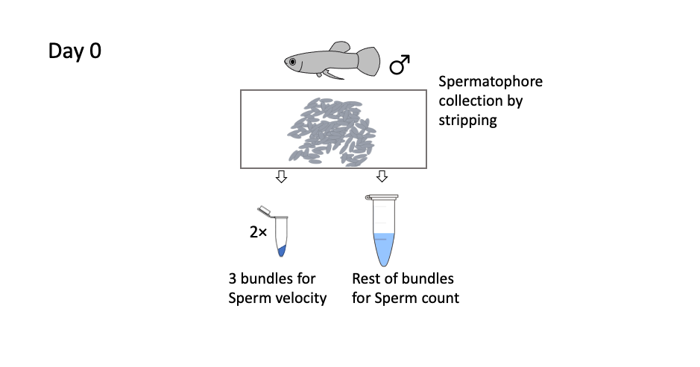
a)

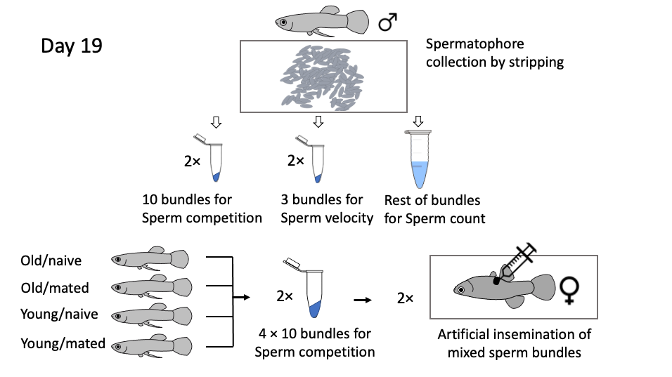
b)

Figure 1. Schematic diagram of the sperm collection method on (a) Day 0 and (b) Day 19. (a) On Day 0, sperm from individual males were collected for sperm trait assays; 2× 3 bundles were collected for sperm velocity and the rest was used for the sperm count. (b) On Day 19, 2× 10 bundles sperm per male per block (one per treatment: old-naive, old-mated, young-naïve, young-mated) were collected to test for sperm competition success (paternity) via artificial insemination. 2× 3 bundles were collected for sperm velocity and the rest was used for the sperm count.

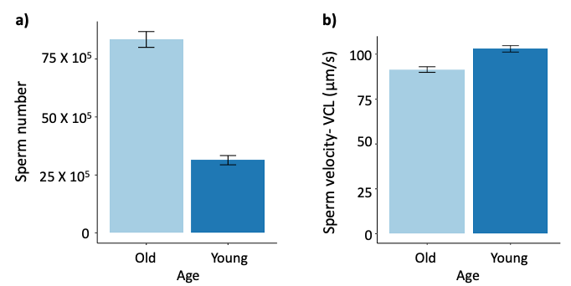

Figure 2. The effect of male age on sperm traits (a) sperm number and (b) sperm velocity before mating treatment (Day 0). Bars represent mean values and the error bars represents standard error (SE) of the raw data (n=72*4=288, 287).

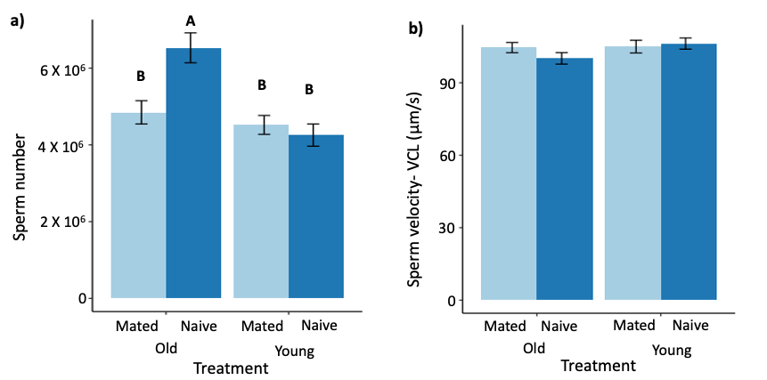

Figure 3. The effect of male age and mating history on sperm traits (a) sperm number and (b) sperm velocity after two weeks in the mating treatment (Day 19). Bar charts represent mean values and the error bars represents standard error (SE) of the raw data. In both cases, mated males with higher past mating effort are denoted with light blue and naïve males with low past mating effort are denoted with dark blue colour. Letters indicate significant differences using Tukey's tests (n=72*4=288, 285).

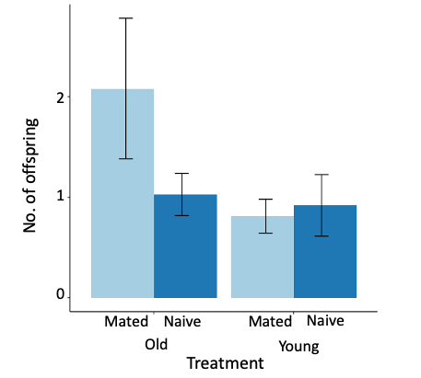
Figure 4. The effect of male age and mating history on the number of offspring sired under sperm competition after two weeks in mating treatment (Day 19). Bar charts represent mean values and the error bars represents standard error (SE) of the raw data. Here males with higher past mating effort (i.e., mated) are denoted with light blue and males with low past mating effort (i.e., naïve) are denoted with dark blue colour (n=220 offspring, females=55, blocks of males=37).

