Title: Global Kelp Forest Restoration: Past lessons, status, and future goals
Running Title: global kelp forest restoration
List of Authors: Aaron Eger^{1*}, Ezequiel M. Marzinelli^{2,3,4}, Hartvig Christie⁵, Camilla W. Fagerli⁵, Daisuke Fujita⁶, Alejandra Paola Gonzalez⁷, Seokwoo Hong8, Jeong Ha Kim⁸, Lynn Chi Lee^{9,10}, Tristin Anoush McHugh^{11,12}, Gregory N. Nishihara¹³, Masayuki Tatsumi¹⁴, Peter D. Steinberg^{1, 3}, Adriana Vergés^{1, 3}
¹ Centre for Marine Science and Innovation & Ecology and Evolution Research Centre, School of Biological, Earth and Environmental Sciences, The University of New South Wales, Sydney, NSW 2052, Australia
² The University of Sydney, School of Life and Environmental Sciences, Sydney, NSW 2006, Australia
³ Sydney Institute of Marine Science, 19 Chowder Bay Rd, Mosman, NSW 2088, Australia
⁴ Singapore Centre for Environmental Life Sciences Engineering, Nanyang Technological University, Singapore 637551, Singapore
⁵ Norwegian Institute for Water Research, Gaustadallèen 21, 0349 Oslo, Norway
⁶ University of Tokyo Marine Science and Technology, School of Marine Bioresources, Applied Phycology, Konan, Minato-ku, Tokyo, Japan
⁷ Departamento de Ciencias Ecológicas, Facultad de Ciencias, Universidad de Chile. Las Palmeras 3425, Ñuñoa, Santiago. Chile
⁸ Department of Biological Sciences, Sungkyunkwan University, Suwon, South Korea
⁹ Gwaii Haanas National Park Reserve, National Marine Conservation Area Reserve, and Haida Heritage Site, 60 Second Beach Road, Skidegate, Haida Gwaii, British Columbia, V0T 1S1, Canada
¹⁰ Canada & School of Environmental Sciences, University of Victoria, 3800 Finnerty Road, Victoria, British Columbia, V8P 5C2, Canada
¹¹ Reef Check Foundation, Long Marine Laboratory, 115 McAllister Road. Santa Cruz, CA 95060
¹² Present address: The Nature Conservancy, 830 S Street, Sacramento, CA 95811
¹³ Organization for Marine Science and Technology, Institute for East China Sea Research, Nagasaki University, 1551-7 Taira-machi, Nagasaki City, 851-2213, Japan
¹⁴ Institute for Marine and Antarctic Studies, University of Tasmania, Hobart, Tasmania 7004, Australia
Contact Information: *aaron.eger@unsw.edu.au, +610487523824
Abstract: Kelp forest ecosystems and their associated ecosystem services are declining around the world. In response, marine managers are working to restore and counteract these declines. Kelp restoration first started in the 1700s in Japan and since then has spread across the globe. Restoration efforts, however, have been largely disconnected, with varying methodologies trialled by different actors in different countries. To distil lessons learned over the last 60 years of kelp restoration, we synthesize the results of nearly 200 projects spanning 1957 to 2020, across 16 countries, five languages, and user groups. Our results show that kelp restoration projects have increased in frequency, have employed 12 different main methodologies, and targeted 17 different kelp genera. Of these projects, the majority have been led by academics (62%), have been conducted at sizes of less than 1 hectare (80%) and over time spans of less than 2 years. We show that projects are most successful when they are located near existing healthy kelp forests. Disturbance events such as sea-urchin grazing are identified as regular causes of project failure. Costs for restoration are historically high, averaging hundreds of thousands of dollars per hectare, but we explore avenues to reduce these costs and suggest pathways for scaling-up future restoration efforts. One key suggestion is the creation of a living database which serves as a platform for recording restoration projects, showcasing and/or re-analyzing the data, and providing updated information. In this way, our work establishes the groundwork to provide adaptive and relevant recommendations on best practices for kelp restoration projects today and into the future.
Keywords: kelp forests, restoration, synthesis, global, marine, Laminariales, Fucales

Introduction
Kelp forests (habitat forming brown algae in the Orders Laminariales and Fucales) are globally distributed habitats with demonstrated declines around the world (Thibaut et al., 2005; Fujita, 2011; Rogers-Bennett & Catton, 2019). The cause of these declines has evolved through the years and range from local stressors such as pollution to global impacts, particularly climate change (Wernberg et al., 2019). Early declines of kelp forests in the 1800s have been linked to population expansion of sea urchins, most often facilitated by the removal of urchin predators from the ecosystem (Roberts, 2007). Subsequent kelp population declines in the 20th century were driven by threats such as direct harvest of kelp or high levels of water pollution from urban areas (Wilson & North, 1983; Tegner & Dayton, 1991; Coleman et al., 2008). These stressors are still relevant to contemporary kelp ecosystem management but are now in addition to climate change, a phenomenon that has multiple consequences for kelp forests (Smale, 2020). Increased water temperatures and marine heatwaves have resulted in large contractions of kelp populations as they are pushed past their physiological limit (Tegner & Dayton, 1991; Kang, 2010; Wernberg et al., 2011). Warmer sea water temperatures have also facilitated the range expansion of herbivorous sea urchins which can overgraze entire forests and create urchin barrens, a phenomenon identified in most countries that contain kelp across the world (Fujita, 2010; Filbee-Dexter & Scheibling, 2014; Ling, Scheibling, & Rass, 2014). More recently, temperature-driven shifts in the ranges of herbivorous fishes are also causing similar declines in kelp forests near the warm edge of their distribution (Vergés et al., 2014a; Verges et al., 2016a). Such extensive losses have caused dramatic ecological and economic impacts. For instance, kelp losses have caused the closure of lobster, abalone, sea urchin, and kelp fisheries in several regions around the globe (Steneck et al., 2013; Bajjouk et al., 2015; Rogers-Bennett & Catton, 2019).
Managing kelp forests and their declines also has a lengthy global history. Traditionally, kelp forest management has been a passive activity whereby managers focused on improving environmental conditions, for instance by improving water quality (Foster & Schiel, 2010), limiting kelp harvest (Fujita, 2011; Frangoudes & Garineaud, 2015), or by protecting species that facilitate kelp forests (Caselle et al., 2015). These methods can be successful, and low level exploitation in Chile and France have ensured that sustainable kelp fisheries continue to exist in those countries (Buschmann et al., 2014; Frangoudes & Garineaud, 2015). Marine protected areas (MPAs) have also worked to increase species that facilitate kelp forests and reduce human pressures (Eger & Baum, 2020). For example New Zealand created the Cape Rodney to Okakari Point Marine Reserve (i.e. “Leigh Reserve”) in 1976 and the MPA now maintains healthy kelp forests (Ecklonia radiata and Fucales species) relative to areas outside the reserve, which are dominated by urchin barrens (Shears & Babcock, 2003).
Despite successes with other conservation objectives such as restoring predator populations, (Lester et al., 2009), many passive measures (i.e. those that don’t manipulate kelp or their consumers) can fail to re-establish lost kelp populations (Wernberg et al., 2019). As an example, improvements in water quality in Sydney, Australia (Scanes & Philip, 1995) did not lead to the re-establishment of the locally extinct fucoid Phyllospora comosa (Coleman et al., 2008; Verges et al., 2020). Transplant experiments demonstrated that while the environment was suitable for P. comosa, propagule supply and/or post-settlement survival was likely insufficient for the species to naturally re-establish populations (Campbell et al., 2014). Other passive approaches, like MPAs, while often successful (Eger & Baum, 2020), can also fail to solely facilitate the recolonization of a kelp forest (Leung, Yeung, & Ang, 2014). As a result, managers are increasingly considering active restoration approaches in combination with removing or mitigating the causes of decline (Layton et al., 2020b; Morris et al., 2020).
Active restoration is attempted by introducing or removing biotic or abiotic materials from the environment. If kelp reproduction is limited, reproductive individuals are introduced, either by adding spores or by transplanting adults that act themselves as the spore source (Campbell et al., 2014). If herbivory is an issue, it can be mitigated by culling, transporting, or harvesting grazers such as urchins or herbivorous fish (Fujita, 2010; Watanuki et al., 2010; Tracey et al., 2015; Strand et al., 2020). Alternatively, installing artificial reefs increases the availability of rocky reef substrate and can enhance the settlement and growth of existent kelp propagules or can act as a base for transplant or seeding efforts (Schroeter, Reed, & Raimondi, 2018). Ultimately, the solution for restoration will depend on the initial cause of kelp decline and potential for reestablishment in a region (Gann et al., 2019; Eger et al., 2020a; Morris et al., 2020).
Motivations for restoring kelp forests in the 21st Century
Restoring kelp forests provides society with many benefits and healthy kelp forests align with United Nations Sustainable Development Goals 2 (zero hunger), 8 (work and economic growth), 13 (climate action), and 14 (life under water Cormier & Elliott, 2017). By conserving and restoring kelp ecosystems, we maintain a foundational marine habitat and ensure access to key ecosystem services such as habitat provisioning (Dayton, 1985), nutrient cycling (Kim, Kraemer, & Yarish, 2015) and carbon sequestration (Chung et al., 2013). Kelp forests also underpin ecosystem services, e.g. supporting fisheries either through direct harvest (Buschmann et al., 2014) or through the fishery species that they support (Smale et al., 2013). The services provided by these underwater forests are currently estimated at millions of dollars per km of coastline and billions of dollars at the country level (Smale et al., 2013; Vasquez et al., 2014; Bennett et al., 2016; Blamey & Bolton, 2018) and provide livelihoods for coastal communities around the world. In addition to their economic value, kelp forests also hold significant cultural and aesthetic value to their local community (Turnbull et al., 2020).
The potential for restoration has not been unnoticed and interest in kelp and marine ecosystem restoration is increasing. Indeed, the United Nations (UN) has declared 2021-2030 as the “Decade of Ecosystem Restoration” as well as the “Decade of Ocean Science for Sustainable Development”. These independent but complementary initiatives are calling for a global focus on renewing marine ecosystems (Waltham et al., 2020) while also providing needed ecosystems services, helping combat climate change, and safeguarding biodiversity, and food security (Claudet et al., 2020). There is also interest in kelp forest restoration as a means for countries to work toward their “Nationally Determined Contribution” (NDC) to mitigate carbon emissions under the Paris Agreement, as well as agreements with the European Union to restore set amount of habitat. Such contributions could also then be commodified as carbon credits. Other services such as nutrient removal could also be commodified and provide further incentive to restore kelp forest (Seddon et al., 2019; Vanderklift et al., 2019; Platjouw, 2019)
The need to restore kelp forests is evident, the interest is accelerating, the potential benefits are significant, but the path forward is uncertain. This uncertainty is in part because, despite similarities in the causes of decline and restoration methodologies, there has been very little information shared between projects within and between countries. The most recent analysis provides a useful qualitative assessment of past restoration projects but focuses on work done in English speaking countries and in the peer reviewed literature (Morris et al., 2020), whereas most restoration projects are not formally published in peer-reviewed journals and occur in non-English speaking countries (Bayraktarov et al., 2020; Eger et al., 2020c). As a result, projects have typically learned and applied methodologies independently. Addressing this limitation will help ensure that lessons learned from 60-300 years of history in kelp restoration is not lost and restoration successes can increase at a faster rate.
This review aims to provide a comprehensive history of kelp forest restoration, assess the current state of the field, and provide recommendations for how the field can advance. We achieve this by reviewing the global history of kelp restoration, analysing past projects, examining the determinants of success, and describing solutions to barriers to future restoration projects. This comprehensive, multi-language project first reviews the history of kelp restoration in independent geographic clusters around the world. Following this qualitative overview, we present the results of a new kelp restoration project database (the Kelp Forest Alliance) and describe the global state of the field, what factors have resulted in success, which in failure. Finally, we discuss the methodologies, costs, motivations, and legal frameworks currently related to kelp restoration and how we can enhance the factors leading to success in restoration and remedy the barriers in the future.

Materials and methods
Literature Search - English
We conducted a published literature search using Web of Science on December 7th, 2018. The search returned 1431 results (Appendix 1). We reviewed the titles and abstracts of the returned results and selected 156 publications that appeared to reference a kelp restoration project for additional screening. These 156 publications were reviewed to determine if they met our study’s inclusion criteria. These criteria were 1) focusing on canopy forming algae from either the Laminariales, Fucales, or Desmarestiales order and 2) the study was working to enhance kelp ecosystems, in-situ, for non-commercial purposes (e.g. not aquaculture or mariculture). Relevant methods included transplanting, seeding, grazer control, installing artificial reefs, and others. While artificial reefs may not be considered true restoration as they replace sandy habitat with rocky substrate, we consider them together with other methods in this paper. Of these 156 publications, 51 were determined to meet the criteria for data extraction. After the initial literature search, a publication alert with the same terms was set up to collect new records up until March 29th, 2021.
We conducted similar searches using the Google Search engine, but we simplified the terms to query only “kelp restor*” and a country or geographic region term (e.g. Norway or California). We included all countries that kelp is known to occur in (Wernberg et al. 2019) and ran searches between 11/10/2019 and 12/12/2019 (Appendix 1). We reviewed between 30 and 100 search results per regional search and compiled a list of groups potentially conducting kelp restoration. We then contacted each group individually to inquire if they could contribute information on their restoration efforts. We supplied each group with a data template for them to complete (Appendix 2).

Literature Search – Japanese
We conducted the Japanese literature search using JStage on November 27th, 2019 and returned 616 results, 150 of which were identified for further screening. The search term was
磯焼け – the Japanese word “isoyake”, a commonly used term for kelp forest degradation in Japan.
A fluent Japanese speaker (MT) then reviewed the documents to assess their eligibility. If a paper met the criteria described above, the relevant information was extracted and translated into English.
We also translated the database used to inform the 2nd Isoyake Guidelines (Fujita, 2019) and obtained descriptive information about restoration projects but the work did not record information about their outcomes. This database was compiled with studies from the Tokyo University of Marine Science and Technology Library and covered the years 1970 – 2014.
Ultimately, the Isoyake Guidelines database contained no information about the outcome of the restoration project and our published Japanese literature search found few studies with quantitative or semi-quantitative data. We therefore considered the Japanese studies separately from a qualitative perspective only and did not use them in the quantitative analyses.
Literature Search – Korean
We conducted the Korean literature search using Google Scholar and RISS on November 27th, 2019 and returned 600 results for Google Scholar and 60 for RISS. The search terms were
회복, 복원, 해조류– the Korean words for “recovery,” “restoration”, and “marine algae”.
A fluent Korean speaker (HSW) then reviewed the pdfs to assess their eligibility. As before, if the paper met the previously described selection criteria, the relevant information was extracted and translated into English.
We extracted data from each paper using the metaDigitise package (Pick et al. 2018) in the R programming language (R Core Team 2019). If the required data was not included in the paper, we contacted the corresponding author to provide the missing information. See the data template (Appendix 2) for the full suite of parameters that were collected.
Finally, we used snowball sampling in all languages to accumulate contacts for other reports, persons, or groups conducting kelp restoration across the world. We compiled 2 language specific project lists using this method in Norway and Chile. A personal contact list is maintained but will not be published for privacy reasons.
Data identifier
We assigned each study a reference number, event number, and an observation number. The reference number was unique to each report or reported project. The event number was unique to a restoration event or action, even if contained in the same report. E.g. entries for two artificial reefs, set in different locations would have different event numbers but the same reference number. Lastly, the same observation number indicates different measurements of the same event, e.g. two species were transplanted together but recorded individually. We used different unique identifiers related to the reference level, project level, and event level when creating the different graphs (Appendix 3).
Cost Data
We collected cost information either directly from the publication or report or through personal communication with the author. As best as possible, we divided costs into capital, operating, construction, in kind, and monitoring categories, and recorded the year currency of the value. To allow for accurate cost comparisons between currencies and years, we converted all dollars into USD for the year 2010. First, using the Penn Table (Feenstra et al. 2015), we converted the local currency to USD based on the exchange rates during the year of reporting. Afterwards, we indexed costs for inflation to year 2010 using the Consumer Price Index (World Bank 2019). These values only consider the costs of the restoration actions, not the planning or monitoring.
Area extent
While most studies that reported area typically gave only the starting size, when possible, we recorded size (area) as the largest measurement given, including expansion after restoration. Therefore, if a study transplanted kelps over 10m² and after monitoring for 2 years discovered the patch had grown to 100m², we recorded 100m² as the area extent. Conversely, if a patch shrank from 10m² to 1m², we recorded 10m² in our database. Area was measured differently depending on the study, including aerial surveys, in water monitoring, and video footage.
Duration
We recorded duration as the day from the first restoration action to the day of the last observation or action recorded. We always used the last available time point to record our data.
Year
We recorded the year in which the first restoration action was initiated, rather than the year of the publication.
Location
We either extracted the geographic coordinates from the reports themselves or obtained approximate coordinates through Google Earth Pro ®.
Group Involved
We classified the groups involved in the restoration process as being either
- Academic (University or research institute)
- Government (Municipal, indigenous, state, or federal management body)
- NGO (Registered non-profit)
- Industry (Environmental consultants, aquaculture, energy development)
- Community (organized local group, not registered as a non-profit)
Motivation
While reading each report, we searched the text to determine the motivation for each restoration project and classified the primary, secondary, or tertiary motivation into one of the following seven categories (Bayraktarov et al. 2019).
- Improve restoration approach, technology, methods
- Restoration after environmental impact (e.g. ship-grounding, mining, oil spill, hurricane)
- Biodiversity enhancement (e.g. native vegetation, habitat creation, ecosystem connectivity, ecological resilience)
- Answer ecological research questions
- Enhance ecosystem services (e.g. fisheries production)
- Biodiversity offset (e.g. threatened species, threatened ecological community)
- Social reasons (e.g. community involvement, job creation, nature education, environmental outreach)
Variables measured
We recorded the project outcomes in several formats (Appendix 2) and several different assessment structures depending on individual project designs. Projects were either assessed as the same site over time, a restored site in comparison to a reference site(s), or a restored site in comparison to a degraded site(s). The variables quantified were area, density, count, growth, survival (1/0), percent survival, percent cover or growth measures. If a project reported on a site over time, we recorded the first measure at the beginning of the project and the last measure as the last available data point. If a project had a reference and/or a degraded (control) site, the comparison was made between (either of) these and the restored site.
Ecological Success Score
The information related to the outcome of the restoration attempt was reported in several different formats using a variety of values (Appendix 2). This mix of reporting standards and units made it difficult to uniformly analyse the success scores all together. We overcame this issue by using the simplest available metric, a binary survival score. The binary success score was set as 1 if any kelp remained at the time of the last report and a 0 if none remained. There were insufficient sample sizes for the other reporting styles (e.g. those with before-after-control-impact designs) to conduct additional analyses using these metrics as well.
Factor analysis
Because some reports contained multiple data points (Appendix 3), we used mixed effects models, with the study/project reference number as the random effect to account for the correlation between data points in the same study. The data generated by the different measures of success required different modelling approaches. Because linear models were inappropriate for the binary success scores and the percent survival data, we used generalized linear mixed effects models with “binomial” distributions to assess each factor individually the two measures of success. The generalized mixed effects models were fitted in R using the lme4 package (Bates et al., 2015) and we used the lmerTest package, which applies Satterthwaite’s degrees of freedom estimations and the F-statistic to assess significance (Kuznetsova, Brockhoff, & Christensen, 2017). We then used these models to predict the probability of success using the predict function in R, while the error was calculated using the predictInterval function in the merTools package in R, which creates a sampling distribution for the fixed and random effects and then draws the range of values from that distribution.
We evaluated each success score against each factor individually as very few projects had data for all the recorded factors. We included the following covariates in our analysis: publication type to test for publication bias, latitude to assess the role of biogeography, genera to determine if some species were easier to restore than others, the method used to test the efficacy of each method, the area of the project to see if larger projects were more successful, if the restored site was in a protected area and benefits from that protection, if a disturbance was reported to assess the impacts of disturbances on restoration projects, whether they had site selection criteria to see if that helped, how close the project was to a kelp bed of the same species as to determine if natural populations assisted restored populations, if the project specifically mitigated a stressor, and the duration.
All analysis and graphing was done in the R programming language (R Core Team, 2013).

Results and Discussion
History of kelp forest restoration
Our review of the history of kelp forest restoration revealed a global field dating back decades to centuries. While many different species have been targeted for restoration, relatively similar approaches to restoration have co-evolved in each region. Despite their methodological similarities, the social contexts in which restoration has occurred have been very different around the globe. To better understand these contexts, we review the past regional histories of restoration individually and later evaluate the global state of the field (Fig. 1).
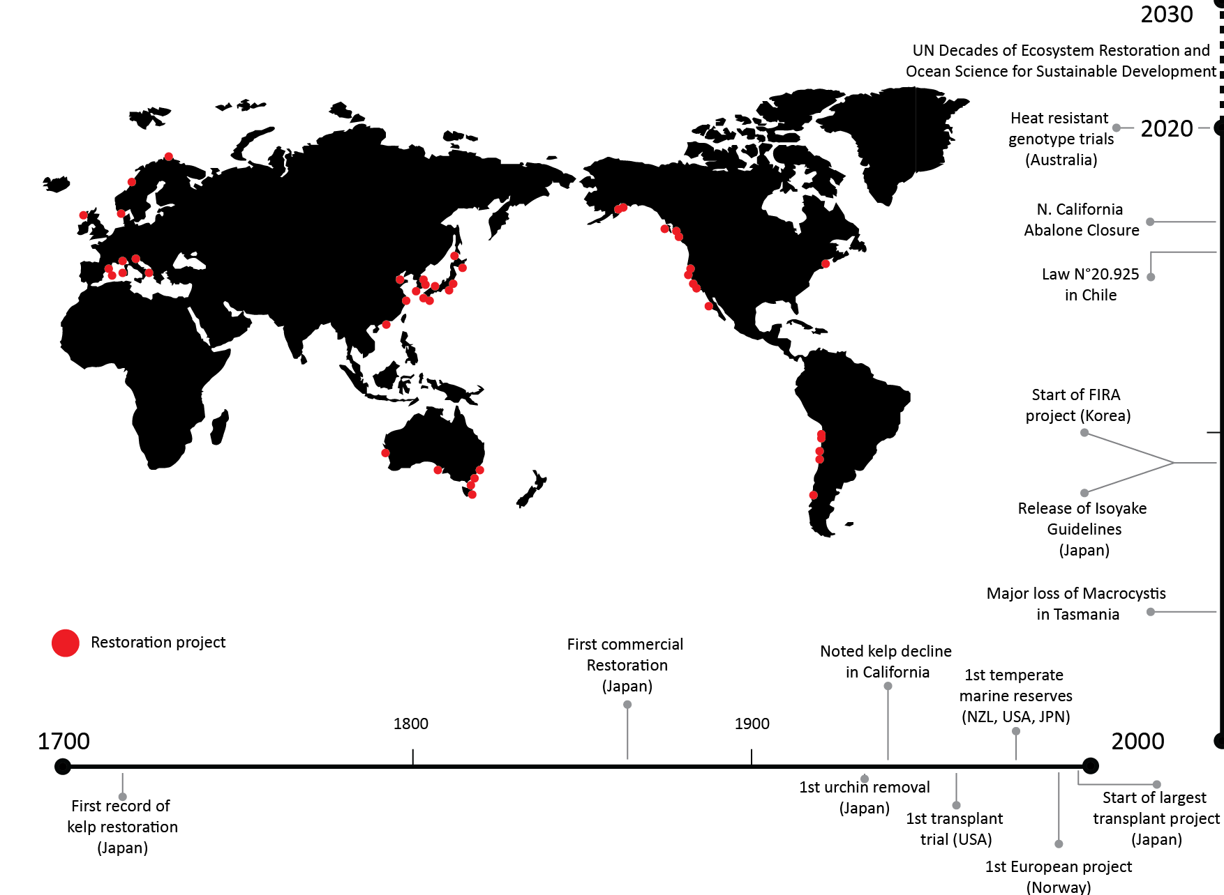
Figure 1: Location and timeline of global kelp restoration projects

Japan history
Japan has the world’s longest and richest history of kelp forest management over hundreds of years and over 700 recorded restoration projects since the 1970s. Saccharina species (Kombu in Japanese) are popular food items and are the most commercially important kelp. This genus is found in the cold temperate waters of Japan (Hokkaido to NE Honshu; Fujita, 2011). Starting in the 14th century, Kombu was harvested by Hokkaidoan fishers and exported by ship to central and southern Japan, then later exported to China. The domestic market persists to this day and Japan produced 79,000 metric tons in 2019 (FishstatJ, 2020). While economically productive, this harvest has previously led to kelp population declines (Fujita, 2011).
The first recorded restoration project was in 1716 when a monk, Saint Teiden, instructed fishers to throw stones into deforested areas to encourage kelp regrowth in NW Honshu (Ueda, Iwamoto, & Miura, 1963). A local fisher led the first industrial restoration project and installed 317,000 stone blocks onto a sandy seabed off SE Hokkaido between 1863-68, increasing his yearly kelp yield from 7 tons to 20 tons (Ueda et al., 1963). Thereafter, reef construction (tsuki-iso) became increasingly common in Northern Japan and an additional 300 ha of reefs were installed from 1921-50 (Kuroda et al., 1957). While these efforts were extensive, they were not always successful, and sedimentation commonly led to restoration failure. The second common method to enhance kelp populations during this time was the clearing of competitors such as turf algae from the benthos, either by hand or mechanical scrapers (170 ha from 1921-1950 (Kuroda et al., 1957).
Fishers in NW Hokkaido also noticed that sea urchins would graze on their stocks and began to remove urchins to protect them. A local cooperative realized these “pests” could be of potential value and started to purchase the removed urchins, process them, and ship them to Honshu (main island of Japan) in 1932 (Kinoshita, 1933). The demand for Kombu as a food and as a feedstock continued to increase and more structured fisheries management systems formed in the 1950s and 60s. National and prefectural governments continued to focus on deploying artificial reefs, now using manufactured concrete blocks. Concurrently, the urchin culling efforts also expanded to NE Honshu and SW Hokkaido as did clearing the benthos of competitors. The first two methodologies have had few changes to their approach. Scraping the benthos, however, has advanced to include chains moved by wave action, boat operated rotators, and even remotely controlled underwater excavators (Japanese Fisheries Agency, 2009).
Restoration attempts for Ecklonia and Eisenia species in Japan’s warmer central and southern waters started in the 1980’s. These genera are locally eaten by humans and are important habitat for abalone and lobster stocks, major coastal fisheries in Japan. Contrary to Northern Japan, these restoration efforts have focused on transplantation and grazer control of not only urchins, but also of herbivorous fishes (Siganus fuscescens, Calotomus japonicus, Kyphosus spp. Fujita, 2011). Managers in NE Kyushu (Southernmost main island) repeatedly found that consistent removal of these grazers was the key to kelp restoration success, as short-term control using cages or gillnets, would result in a period of kelp regrowth but eventually failed when managers removed the cages and the herbivores ate the transplants (Fujita, 2011).
These lessons were all applied in what is now the largest successful kelp restoration project in Japan. Starting in 1999, the Shizuoka Prefectural Government placed small concrete blocks in healthy kelp forests, allowed spores to settle on them, and then transported them to barrens to restore Ecklonia forests in a deforested area (Izu Peninsula, Central-East Japan) (Eger et al., 2020c). Local fisheries cooperatives, municipal, and prefectural government groups joined these actions for a second phase that ran from 2002-2010. As of 2018, ~870 ha of Ecklonia has been restored, leading to such a marked recovery of abalone populations that managers are considering the re-opening of a closed abalone fishery (Eger et al., 2020c).
Given the numerous projects conducted in Japan, there have been many opportunities to learn from their outcomes. Indeed, these efforts were reviewed in 2009 by the federal Fisheries Agency to provide detailed guidelines for future projects. The “Isoyake Taisaku Guidelines” (Japanese Fisheries Agency, 2009, 2015) were launched alongside an ambitious funding initiative to promote reforestation of algae forests. This initiative, known as the Fisheries Multiple-function Demonstration Project (FMDP) funds fishing cooperatives and NGOs to control herbivores, transplant kelp, maintain herbivore exclusions, clear the benthos, remove sediments, and improve upstream water quality (Sekine, 2015). The national government provides half the requested funds, the prefectural government provides a quarter, and applicants pay the last quarter. In addition to funds, the scheme provided access to experts to guide the restoration process. Approximately 300 thousand yen per hectare was invested in this process. Despite 288 groups accessing the funds and support, < 100 ha of algae has been restored since its inception. The limited success of this initiative has been attributed to increased herbivory, raising water temperatures, reduced nutrients, increased frequency and strength of typhoons and flooding, an increasingly armoured and industrialized coastline, and the end of project funding (Fujita, 2019).

United States of America history
Kelp in southern California, notably Macrocystis pyrifera (herein Macrocystis), has been an important source of materials such as alginates, potash, and acetone since the early 1900s (Barksy et al., 2003) and subsequently has an extended management history in the region. When kelp declined due to poor water quality and overharvesting (Wilson, Haaker, & Hanan, 1977), the first restoration trials were motivated by a desire to restore these resources. The first recorded North American trials transplanted Macrocystis in Southern California in 1958 (North, 1958). These efforts were soon combined with the manual or chemically induced death of grazing fishes and urchins (Wilson & North, 1983). Academics, fishery managers, and industry groups led repeated initiatives to restore Macrocystis during the 1960s and 70s. Some projects succeeded in restoring 10s of hectares of kelp while others failed due to heatwaves, urchin incursion, or storms (Wilson et al., 1977; Wilson & North, 1983). Later on, the number of projects remained low until after the year 2000. During this decade, several community groups, notably those under the banner of the California Coast Keepers organization, became interested in restoring their local marine environment. Noticing correlations between increased urchins and decreased kelp forests, these groups led initiatives to remove urchins and transplanted kelp individuals (House et al., 2018).
There has been a notable interest in the installation of artificial reefs in California. Early attempts used available materials (e.g. disused street cars) to attempt to restore kelps (Carlisle, Turner, & Ebert, 1964) but later developed into more robust strategies using rocky materials. In an attempt to increase the stock of sport fish during the mid-80s and early 90s, The California Department of Fish and Wildlife (CDFW (Carter et al., 1985) created a series of artificial reefs throughout California. Later in 1990s, the Californian government mandated the installation of what is now a 172 hectare artificial reef to offset a Macrocystis forest that was destroyed by warm water outflow from a nuclear power plant (Reed et al., 2006). Similarly, municipal governments in Seattle, Washington, and Vancouver, British Columbia have also led efforts to build new reefs to offset industrial projects which destroyed kelp forest habitat (Cheney et al., 1994; Fehr, Thompson, & Barron, 2011).
In northern California recent restoration efforts of bull kelp, Nereocystis luetkeana, forests have ensued due to the rapid and extensive losses of kelp forest habitat (McHugh, Abbott, & Freiwald, 2018; Hohman et al., 2019). Multiple stressors, such as the loss of apex predators, urchin grazer recruitment and prolonged warm water events have resulted in a net loss of >95% of N. luekeana forests, and subsequent lack of recovery, along 350 km of coastline in just under a decade (Rogers-Bennett & Catton, 2019; McPherson et al., 2021). An increase in frequency and duration of conditions that are stressful to kelp, will likely result in localized and regional future forest degradation. As consequence, there is growing interest from California policy makers to develop comprehensive ecosystem-based management and restoration strategies moving forward to safeguard coastal and marine biodiversity and ensure the continued delivery of ecosystem services (Ray pers. comm). The involvement of the state has provided fiscal, regulatory and institutional support for research and pilot kelp restoration projects being led by community members, NGOs, and academics (Esgro pers. comm). Some of the projects currently being explored in northern California include: developing regulatory pathways and methods to reduce urchin grazing pressure through recreational and commercial diver efforts, using occupied and unoccupied aircraft imagery to understand N. luetkeana canopy coverage and variation over time, evaluating a variety of N. luetkeana culturing and out-planting procedures, leveraging conservation genomics and gametophyte banking to preserve the genetic diversity in N. luetkeana, investigation of the dynamics of urchin recruitment and reproduction, development of N. luetkeana spore dispersal model, and exploring the feasibility of predator (the sea star Pycnopodia helianthoides) re-introduction.
Efforts in Washington and Oregon are emerging and groups like The Northwest Straits Alliance and the Oregon Kelp Alliance. These groups are trialling and exploring transplantation, urchin culling, and sea otter reintroduction as restoration strategies.
Canada history
Kelp restoration projects have taken place on a limited scale in recent decades along the west coast in British Columbia (BC), although the anticipated negative impacts of climate change (Krumhansl, Bergman, & Salomon, 2017) and urchin barrens have increased interest in the subject. In response to the urchin barren problem, the A-Tlegay Fisheries Society, Haida Nation, and the Pacific Urchin Harvesting Association are trailing increased quotas and harvest rates for commercially fished red sea urchins (Mesocentrotus franciscanus (Department of Fisheries and Oceans Canada, 2020). Elsewhere there is raising interest in restoring or farming kelp as a climate solution on Vancouver Island (OceanWise Seaforestation Initiative – ocean.org). Prior small-scale Nereocystis species restoration projects have taken place in southern British Columbia (similar for northern Washington State), where they have focused on seeding to start new populations in response to general population declines (Heath, Zielinski, & Zielinski, 2015).
In Haida Gwaii, Parks Canada and the Council of the Haida Nation initiated a larger-scale kelp forest restoration project over 20-hectares of shallow subtidal rocky reef in the cooperatively managed Gwaii Haanas National Park Reserve, National Marine Conservation Area Reserve, and Haida Heritage Site in Haida Gwaii, northern BC (Lee et al. in press). This work was motivated to restore ecosystem balance by mimicking sea otter predation (historically extirpated, see (Bodkin, 2015) on urchins where sea otters have not yet returned. Restoration work was initiated in 2018-19 with pre and post restoration monitoring and research funding over five years. This project involves close collaborations among Gwaii Haanas management partners – the Haida Nation, Parks Canada and Fisheries and Oceans Canada – as well as the commercial urchin fishing industry and multiple academic institutions. Due to this diverse partnership and engagement with Haida Gwaii communities, cultural and social considerations are as important as ecological gains for the project. Provision of urchin roe for food in the communities, working with Haida divers in monitoring and research, as well as employing Haida and commercial divers to remove, crush and maintain low urchin densities at the site, are all key components of the project.
Australia history
The focus on kelp restoration in Australia is a recent interest, and most efforts have either focused on urchin culling and/or removal in forests of Ecklonia radiata, or on restoring giant kelp (Macrocystis) populations in Tasmania or locally extinct species of the fucoid crayweed (Phyllospora comosa). Urchin removals have most often been done by abalone and urchin fishery organizations which are working to restore the kelp habitat and create more biomass of abalone and-or urchin in the states of New South Wales, Victoria, South Australia, and Tasmania (Worthington & Blount, 2003; Gorfine et al., 2012). The Tasmanian government subsidises the urchin fishery to remove invasive urchins, which have expanded their range from the continent (Ling et al., 2009), that might not otherwise be profitable for harvest (Larby, 2020). There have also been two main efforts to restore specific taxa. First, SeaCare Inc. installed small patches of Macrocystis in Tasmania from 1997-2001. However, the efforts were not sustained and they did not achieve long term success (Sanderson, 2003). The other main project is Operation Crayweed which has been working since 2011 to restore P. comosa and associated biota along the coast of the Sydney metropolitan area (Campbell et al., 2014; Marzinelli et al., 2016). Operation Crayweed is notable for their work with community groups, schools, and artists to connect people to their restoration projects (Verges et al., 2020) as well as their work into genetic mixing of transplant populations and the identification of genotypes for future-proofing (Wood et al., 2021).

Korea history
The Korean peninsula is bounded by three seas and has a long history as a maritime nation that harvests fish, invertebrates, and seaweeds. The decline of over 10,000 ha of seaweed forests during the 20th century (Sondak & Chung, 2015) has put this relationship at risk. Following the Korean War (1953), the South Korean government has worked to increase the availability and access to the marine resources within their own Exclusive Economic Zone (EEZ). Their management strategies focus on modifying the ocean with artificial materials while also working to enhance the biomass of harvestable species (Sánchez-Velasco, Oriol, & Valiente, 2020). Construction of these artificial reefs started in 1971 and were targeted at enhancing coastal fisheries in depths of 20-40 meters. Under this initiative, the installation of eight different types of reefs continued until 1990 with a sum cost of $61 million USD. These reefs gave rise to the concept of marine ranching, which cultures species for consumption. A pilot ranching project took place from 1982-1989 and resulted in the Near-shore fisheries Marine Ranching Master plan in 1994. The National Institute of Fisheries Science (NIFS) ran this program from 1998 – 2010 and worked to enhance fisheries and restore kelp forests in multiple areas along the Korean coastline. NIFS decided to work with kelp genera that were amenable to cultivation, focusing on Saccharina japonica, Ecklonia spp., Undaria pinnatifida, and Sargassum spp. Once the kelps were successfully cultivated, they were typically transplanted on the artificial reefs using ropes containing juveniles or seeded using spore bags (Park et al., 2019).
Following initial projects, the Korea Fisheries Resource Agency (FIRA) was established in 2009 and took over marine ranching and kelp restoration projects in Korea. Starting in 2009 FIRA embarked on the world’s largest kelp forest restoration program. The project is running until 2030 with a yearly budget of $29 USD million (FIRA, 2020) and aims to restore 50,000 hectares of kelp forests at, already achieving > 20, 000 hectares at 173 sites as of 2019 (Lee, 2019). At the beginning FIRA followed similar protocols as before, using transplants or seeds on artificial reefs. However, they are now focusing on urchin control and the best ways to restore forests on rocky reefs that once held kelp forests (Yang et al., 2019). The projects in Korea have been largely led by the federal government but there has been considerable input from local universities, which research different restoration techniques, provide historical baselines and targets, and advise ongoing management efforts. For the foreseeable future it appears that most kelp restoration work in Korea will occur under the FIRA Marine afforestation program with input from university researchers. Though community groups do not themselves work to restore kelp forests in Korea, the government projects are generally well supported by Koreans, who are indeed “seafood and seaweed lovers” (Han, 2010). In some instances, projects were initiated in response to public pressure (Kang, 2018). Within Korea there are seaweed festivals and even a day known as “Marine Gardening Day” which celebrates people’s ties with the oceans and encourages responsible stewardship and restoration of the sea.

Europe history
Kelp populations inhabit the coastlines of ~20 countries in the Europe-Mediterranean region but records of kelp restoration have only been identified for Norway, Spain, and Italy.
In Norway, urchin grazing has been a major driver of kelp declines since at least the 1970s. As an experimental study, scientific divers crushed urchins with hammers during 10 diver-days in Central Norway in 1988. While the reduction in urchins allowed the canopy (mainly Saccharina latissima) to recover rapidly (Leinaas & Christie, 1996) and subsist for almost a decade, later surveys showed the urchins had returned and the kelp disappeared (Norderhaug & Christie, 2009). Following these initial trials, suggestions and interests remained high among researchers but government bodies did not fund further projects due to perceived challenges and lack of interest. Kelp restoration work was not initiated again until 2003 when the “Sugar Kelp Project” (2003-2008) trialled different small scale methods including scraping the benthos to remove competitors, transplanting adult and juvenile kelp on either hard substrate or ropes, and seeding (Moy et al., 2008; Moy & Christie, 2012). Though the project failed when turf algae outcompeted the kelps, this project marked the start of a renewed interested by NIVA and similar groups to restore kelp. NIVA then trialled artificial reefs in Northern Norway in 2006 and were successful over a 5-year period, but ultimately failed as urchins overgrazed the kelps. In 2011 – 2018, both NIVA and the Institute of Marine Research (IMR) tested various restoration techniques, focused on either manually crushing and excluding urchins, out-planting or transplanting Saccharina and Laminaria (Fraschetti et al., 2017; Fredriksen et al., 2020) and chemically killing urchins using quicklime (Carlsson & Christie, 2019; Strand et al., 2020). The quicklime efforts are notable because they have lower co-mortality rates than the previous quicklime projects in the early 60s in California (Wilson & North, 1983) and 80s in Eastern Canada (Weinstein 1983). More recently, researchers and entrepreneurs are collaborating to develop market-based solutions to the urchin problem. Starting with a small-scale pilot project in 2018-19, NIVA, a business (Urchinomics®), and a community group have been exploring either directly harvesting urchins or collecting them, transporting them on land, and growing them for the food market.
Interestingly there has been major natural recovery of L. hyperborea and S. latissima populations in mid-Norway over the last couple of decades. Increases in sea surface temperature reduced the survivorship of the urchin Strongylocentrotus droebachiensis and facilitated the expansion of the edible crab (Cancer pagarus), a predatory crab which has reduced urchin populations (Christie et al., 2019). Neither of these actions was intentional but they demonstrate that novel warmer conditions may enhance kelp restoration in some high latitude reefs (Filbee-Dexter et al., 2019), while they may impede restoration and accelerate declines at low latitudes (Wernberg et al., 2016; Verges et al., 2016b; Qiu et al., 2019).
Restoration of kelp in the Mediterranean has focused on populations of the fucoids in the genus Cystoseria. Anthropogenic pressures in the Mediterranean basin are intense with a long and sustained history of coastal development. As a result, populations of Cystoseria have declined throughout the region (Thibaut et al., 2005). Universities and research institutes, primarily in Italy and Spain, worked on the initial restoration efforts. These projects focused on trialling small scale culturing and outplanting (Verdura et al., 2018; De La Fuente et al., 2019; Tamburello et al., 2019) but have also considered urchin removal, which were identified as barriers to success (Guarnieri et al., 2014). Following these initial trials, MERCES project (Marine ecosystem restoration in Changing European seas) was created with European Union funding and ran between 2016-2020 (Fabbrizzi et al., 2020). This project includes kelps among other marine habitats and expands the scope of past restoration efforts and has trialled methods to outplant Cystoseira in Italy, Albania, Tunisia, and Spain (Iveša, Djakovac, & Devescovi, 2016; MERCES, 2020).
Chile history
Macrocystis and Lessonia are foundational species along the Chilean coastline and are important commodities and habitats for fisheries species. Wild harvest of Macrocystis has a long history in Chile and is now one of the few remaining wild kelp harvest fisheries in the world (Buschmann et al., 2014). The fishery annually harvests 400,000 dry tonnes and provides 10% of the world’s alginate. This harvest has reduced portions of wild populations and a reduction of their associated ecosystem services, currently valued at $54 USD million. To help manage the diminishing populations the federal government established a management program (Law N°20.925) that provides funds to encourage the cultivation as well as restoration of seaweeds. The primary focus of projects stemming from the program has been the long-line cultivation of Macrocystis and there has been less work on restoring either genera or cultivating Lessonia.
Lessonia restoration projects in Chile are often supported by regional or national funding agencies. The projects are typically partnerships between academics and fishery cooperatives and usually work with transplants. Transplantation methods include attaching juvenile plants onto existing holdfasts (Westermeier et al., 2016) or adding adults to artificial substrates, which are then secured onto the benthos (Correa et al., 2006). Though these projects have demonstrated that transplants can indeed survive and grow, there has been considerable variation in the density, biomass, and length of plants among projects, both by methodology and by planting season.
Lessonia restoration projects have had limited success in Chile. The first restoration attempts for L. berteroana occurred in response to increases in herbivory and enhanced ENSO cycles in 1990 (Vásquez & Tala, 1995). These projects combined the outplanting of spores, juveniles, and reproductive adults, fixed to the substrate using epoxy and anchored boulders (Vásquez & Tala, 1995; Correa et al., 2006; Westermeier et al., 2016). Early survival rates for these methods averaged around 50% and plants showed similar growth rates to natural populations. However, the projects were only maintained over short time scales and small spatial extents. Building off this work, researchers are now testing whether increasing genetic diversity can increase restoration success rates. Researchers are grafting plants together, creating chimeric individuals of L. berteroana and L. spicata, and transplanting them over larger areas than previously attempts. As a result, the transplanted individuals have the DNA of the two donor plants, ideally improving tolerance to stressors such as temperature. The work has been patented (Patent CL201701827) and has been conducted in collaboration with three universities, governmental funds, and a private company. If this method is successful, it will be an important step in Chilean kelp restoration, as local kelp forests are vulnerable to physiological stress caused by warmer sea temperatures (Vásquez et al., 2014).
Database global results
Our database has collated 196 kelp restoration efforts that provide quantitative insights into the characteristics of restoration projects and determinants of success. Recorded projects first started in 1959 and the number of projects per decade has consistently increased since then (Fig. 2, all data Appendix 4, (Eger et al., 2020b). Of these projects, most of the work has been done in Japan and the United States of America, specifically California (Fig. 1). As a result, there has been a heavy focus on the restoration on the genera within these countries (Macrocystis and Laminaria spp. Fig. 2). While restoration has occurred in 12 other countries, there are some notable exceptions. Countries such as The United Kingdom, Ireland, France, the Netherlands, Iceland, and China have significant kelp populations and management histories, but we recorded few (< 5) or no restoration projects. This result suggests that restoration is not as needed in these countries, that local actors do not prioritize the restoration of kelp ecosystems or that the information regarding previous restoration efforts is difficult to access. Given that restoration projects have not been conducted in many countries that contain kelp, it is not surprising that there are fewer kelp restoration projects than in other marine ecosystems (Saunders et al., 2020).
Scientists and researchers have been most heavily involved in kelp ecosystem restoration. Conversely, relatively few projects outside of Japan and Korea have been led by governments, NGOs, industry, or community groups. This imbalance perhaps reflects the nescient nature of kelp restoration as restorationists are still working to research and refine methodologies as opposed to attempting restoration on a large scale. Further, restoration projects are currently expensive (see finances section) and these costs may prevent large-scale restoration attempts (Eger et al., 2020c). While there have been some partnerships between academic restorationists and other sectors of society (such as the Gwaii Haanas project), they are less common in the English-speaking world. Bridging this gap will be important for future restoration efforts. Academics can provide expert knowledge on kelp ecosystem ecology and advice on the methodology whereas other sectors can provide funding, social license, and the people power required to complete the work at scale (Eger et al., 2020c) . Such partnerships are already common in Japan and Korea and it may be beneficial to replicate them elsewhere.
Perhaps because most restoration efforts have been experiments by academics, we found that 78% percent of projects were less than 1 hectare in size. Indeed, only 36 projects attempted kelp restoration at areas greater than 1 hectares, and only 3 of those were greater than 100 hectares. Further, the main motivation for restoration was to improve the methodologies (41% of recorded responses). These findings further shows that kelp restoration is an emerging field that has mostly focused on experimental and theoretical approaches to restoration. We anticipate this status will change as interest in kelp restoration grows and there is an opportunity to use the information gained from the previous small-scale projects to inform the expected larger scale ecosystem restoration projects.
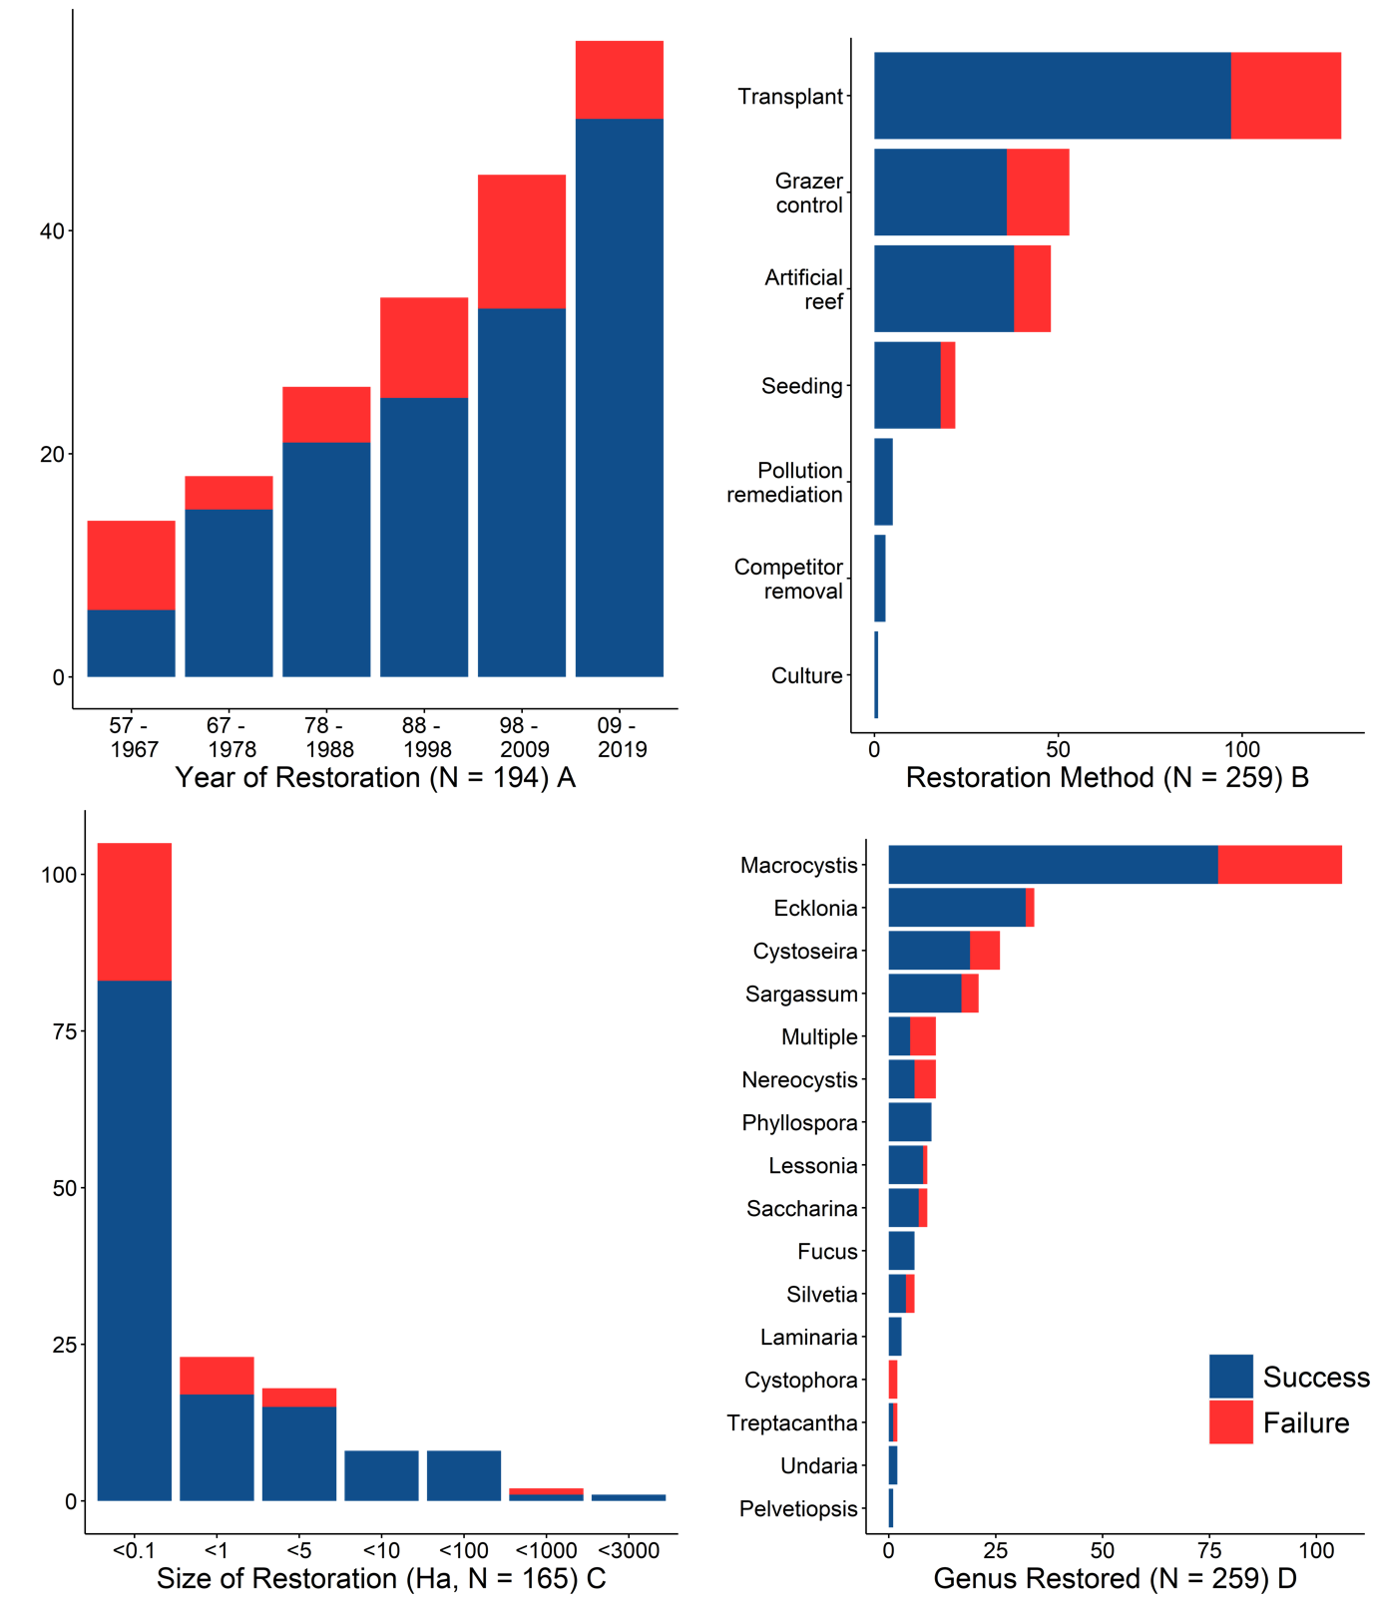
Figure 2: Descriptive results on the kelp restoration projects completed to date a) year the restoration project was commenced b) Main method used for restoration c) size of restoration project d) genus restored. Sample sizes differ as per Appendix 3.

Kelp restoration in Japan: a qualitative assessment
The results of the Japanese literature database lack quantitative information on restoration outcomes but provide insights into the state of restoration within the country (Fig. 3). Restoration work in Japan is heavily focused on culturing programs, modifying the substrate with artificial materials, controlling sea urchins and transplanting (Fig. 3A). Several projects have also experimented with controlling grazing fish populations, a method that is not commonly used elsewhere in the world (Fig. 2B). Restoration in Japan (in addition to Korea) therefore appears to use more manipulative techniques than elsewhere in the world. Few projects outside of Japan used culture or breeding programs to source plants, instead relying on wild harvest of plants. This approach is perhaps logical as Japan is one of the largest producers of seaweed in the world (Nayar & Bott, 2014) and can adapt seaweed farming technology. Similarly, it appears that it is much more common for projects to deploy artificial substrates in Japan, a practice that while also common in Korea is often opposed in other countries (Thierry, 1988; Tickell, Sáenz-Arroyo, & Milner-Gulland, 2019). It should be noted that the Japanese coastline is heavily urbanized already and the reefs are often used to offset this urbanization. As elsewhere (Benabou, 2014), offsetting practices may not truly replace the biodiversity that has been lost and may give license to further, detrimental, development. Taken together, Japan can therefore provide many positive and negative lessons about culturing kelps for restoration, fish control, and substrate manipulation – techniques that are generally not available elsewhere around the world.
Another unique feature of Japanese restoration efforts is that they often focus on Sargassum, a genus targeted in very few other regions (Fig 3c). There was an increase in restoration projects between 2007 and 2014, likely in response to the government program for incentivizing restoration (Fig. 3B), when it was documented that the primary cause of decline was sea urchin and fish grazing. Increased water temperatures, sedimentation, nutrient deficiencies, and low salinity were also responsible for kelp decline in the data base Fig 3D). The greatest number of projects were conducted in Hokkaido, perhaps reflecting its large size but also its long history of marine and kelp management (Appendix 5). Across the rest of the country, no one area had significantly more restoration projects than another. Kelp restoration in Japan appears to have a unique trajectory compared to the rest of the world. In addition to having conducted the most restoration projects of any country, many different species and methods have been trialled in the country. Such a situation poses a unique learning opportunity as kelp restoration practitioners and researchers explore application of these methods elsewhere in the world.
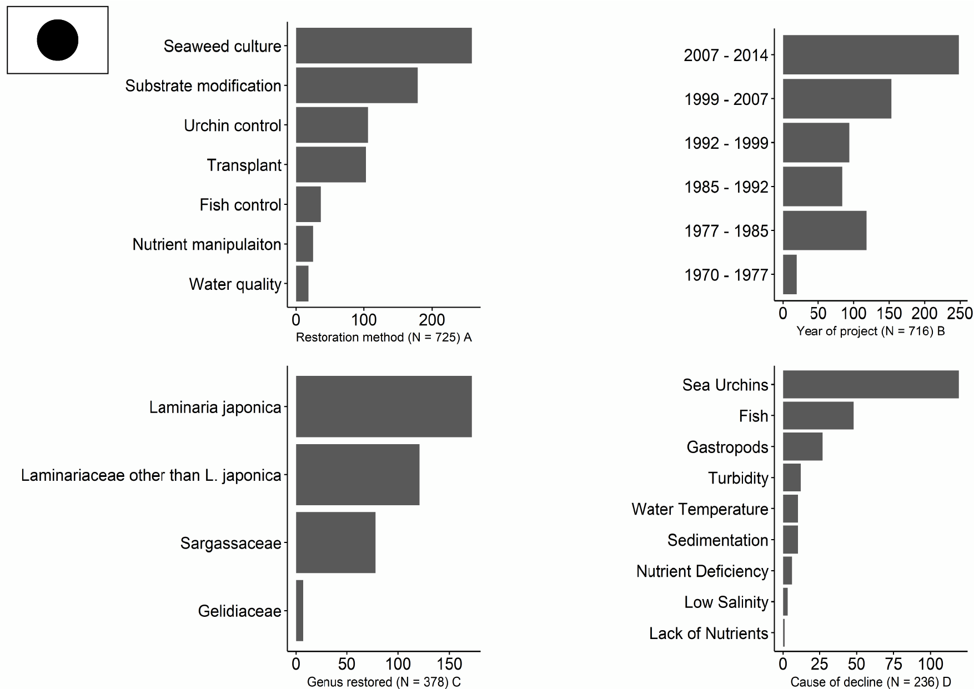
Figure 3: Descriptive results of projects identified in Japanese literature search a) Main method used for restoration b) Year the restoration project was commenced c) Genus restored d) Initial cause of decline. No information about the project outcomes is available. Sample sizes differ as not all data was recorded for each entry.

Defining success in kelp forest restoration
Defining success in ecosystem restoration projects is a consistent challenge and one that we encountered in our analysis. When we examined whether a kelp population was alive at the end of the monitoring period, we found high levels of success across the different categories. These values mask the fact that most projects have been very small scale and have not corresponded to the scale of previous degradation. Therefore while, survival percentage is a tempting metric to use for success, it will poorly track any progress in the field. Other analyses (van Katwijk et al., 2016) have attempted to overcome these barriers by creating subjective metrics of success, or “success scores” but are limited by their qualitative cut offs and confound different variables by combining factors such as survival, size, and project duration, and typically ignore the specific goals of each project. A potential solution to this issue is using effect sizes from replicated, before-after, control-impact research frameworks where goals are clearly defined (Underwood 1992). However, exceptionally few studies in our synthesis used these designs and we were unable to effectively use that analysis. For the field to progress further, future projects should focus on rigorous outcome measurements and work to standardize recording approaches across projects.
Proximity to other kelp forests improves project success
We found that the key predictor of project success was the site’s proximity to an existing kelp population (Fig. 4), which indicates that future restoration efforts should consider this when attempting new projects. This result suggests that restoration projects benefit from a propagule supply from nearby populations, that the environmental conditions are suitable for restoration, and-or that existing populations facilitate the survival of new generations (Eger et al., 2020a). Notably, this finding can be extended to the regional level and the projects which restored kelp at an ecologically meaningful scale have been in locations where the kelp has declined but not disappeared. For example, the large scale FIRA restoration project in Korea has restored ~ 18,000 ha of kelp through a combination of artificial reefs, transplants, and seeding. Kelp decline in Korea has been recorded at 10-30%, which though significant, is much less than the 90-95% declines seen in Tasmania and Northern California. Other large scale successes (Eger et al., 2020c) have similar patterns: restoration projects in Eastern Japan, Northern Norway, and Southern California have all been in regions with remnant kelp populations. Conversely, restoration projects in the Mediterranean, Australia, and Northern California which do not have substantial healthy populations nearby, have not to date resulted in large scale success. Future projects can work to restore areas near existing kelp populations or even work to enhance existing kelp populations before they decline. Past work has shown that once a kelp bed has shifted to an alternate state, it is difficult to reverse that shift (Filbee-Dexter & Wernberg, 2018). Accordingly, enhancing declining but extant kelp populations maybe the most cost-effective approach and receive increased prioritization in future management plans. Managers could achieve this goal by managing urchin populations before they become barrens or by transplanting or seeding into or directly adjacent to existing kelp forests. There will nevertheless be scenarios where restoration is desired, but no nearby populations exist. These projects should perhaps focus on restoring multiple areas to support each other or a single larger area that can become self-sustaining. Such spatial approaches are already common in the design of MPA networks (Palumbi, 2003; Almany et al., 2009) and could be mimicked for restoration.

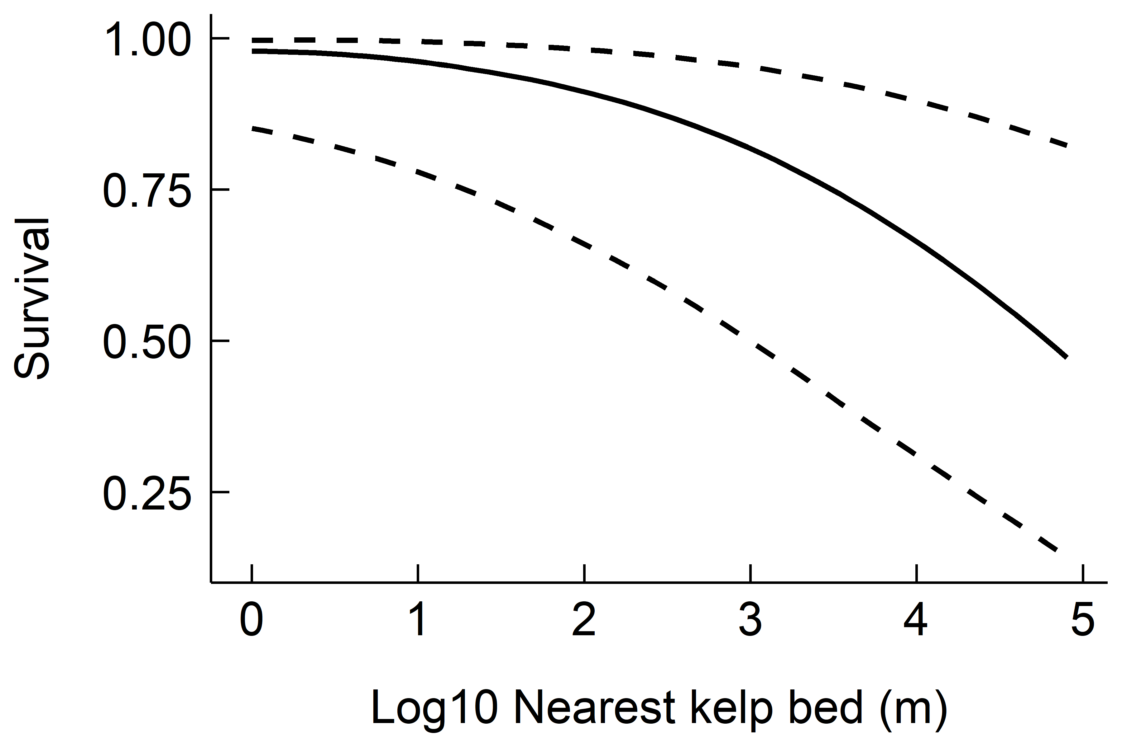
Figure 4: Relationship between kelp survival and the project’s proximity to a healthy kelp bed of the same species.

Environmental Barriers to restoration success
Across projects, we found several reoccurring issues that prevented long term success of kelp restoration. The most common barrier to restoration success was the incursion of grazing species such as sea urchins and herbivorous fishes. Grazing by urchins has hampered restoration projects in Norway, California, Australia, Japan, and Korea. While fish grazing is a less common problem globally, it has been problematic in Australia, Japan, and Korea. Sedimentation and water pollution has caused problems in Southern California and Washington in the USA, and Japan and Korea. Finally, extreme events such as storms, consistently warmer sea temperatures, and marine heat waves have caused transplants to die off in Southern California, Chile, and Australia. Finding the keys to mitigate these barriers to success will be key to progressing the field of kelp restoration.
Review of restoration methodologies
We documented four main methods used to actively restore kelp populations (Fig. 5) and the choice of method appears to be largely dictated by the cause of decline. Since the 20th century, the premise behind each method has not substantially changed but our review revealed different lessons learned.
Transplanting kelp typically involves adhering the holdfast to some artificial material and then adding that to the sea floor with the intention that the holdfast migrates to the benthos or the plant acts as a seed source for new plants. Restorationists have trialled many different methods, including gluing holdfasts to the rock (Susini et al., 2007), attaching them to small concrete blocks (Oyamada et al., 2008), tying them to ropes (North, 1976), attaching them to existing holdfasts (Hernandez-Carmona et al., 2000), and attaching them to mesh mats, themselves anchored to the seafloor (Campbell et al., 2014) or to artificial substrata (Marzinelli et al., 2009). The key limitation with each of these techniques is the scalability and how well the plant can attach to the seafloor. Physical transplantation of kelp is a laborious process and manual installation will likely prove cost prohibitive for large scale restoration projects. The benefit of transplanting is that it immediately introduces plants into the environment and these plants can create conditions more suitable for new recruits (Layton et al., 2019). Transplanting may therefore be a necessary first step that can establish source populations that then self-propagate. However, our results show that these patches need to be close to other existing populations to survive (Eger et al., 2020a; Layton et al., 2020a).
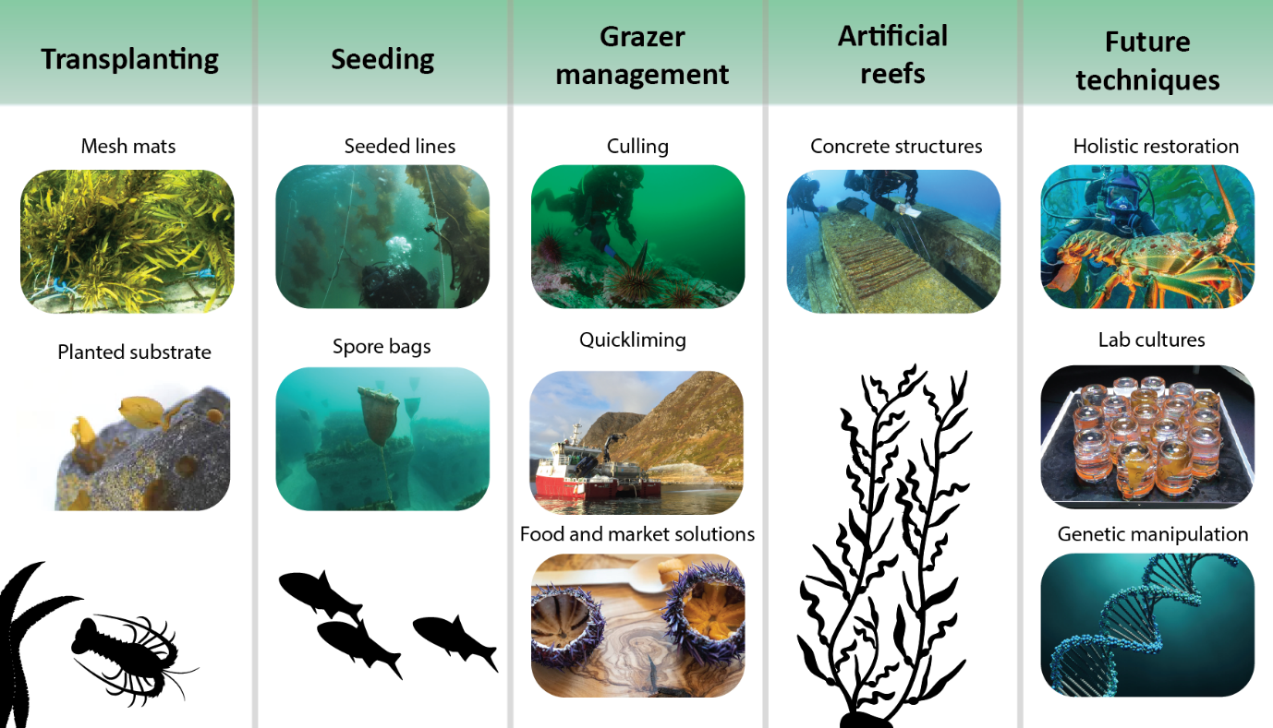
Figure 5: Methods used in kelp forest restoration (Credit left-right, top-bottom: Operation Crayweed, FIRA, Parks Canada, FIRA, NOAA, Green Gravel, FIRA, NIVA, University of Tasmania, Urchinomics, Pixabay)
Controlling grazers relies on manual removal or exclusion of the animal from the targeted restoration area. For sea urchins this can entail crushing them (Leinaas & Christie, 1996), relocating them (Caruso, Pers. Comm), harvesting them (Piazzi & Ceccherelli, 2019), or killing them with quicklime (Bernstein & Welsford, 1982). These processes are restricted by their labour investments (Tracey et al., 2015) and feasibility in a spatially explicit location. Physically killing or removing urchins is labour intensive and requires approximately 13 dive days per hectare (Tracey et al., 2015), though the exact removal rate of urchins is dictated by the urchin density, depth, water conditions, and typography. Though urchin management is more scalable than transplanting, it still requires substantial resources. Urchins have been successfully baited to help congregate their numbers and therefore make removal more efficient (Japanese Fisheries Agency, 2015). Another solution to the scale issue is potentially addressed by using quicklime (CaO) over urchin barrens. Because urchin barrens are relatively depauperate of other species, the collateral damage has been shown to be minimal, though other echinoderms can be damaged or killed (Strand et al., 2020). The ultimate morality of this approach is beyond our consideration, but technically, it works over large areas. The second challenge is to maintain sites that have had urchins removed. Many projects have demonstrated that if sites are not maintained, urchins will often return and remove kelp transplants or recruits. Current evidence suggests that we must keep sea urchins below densities of 1.5 urchins per m² and in some cases, closer to 0 urchins per m² (Ling et al., 2009). As an addition or an alternative to continual site maintenance, restoring healthy predator populations alongside kelp forests that can keep sea urchin numbers low may also help create self-sustaining ecosystems (Eger et al., 2020a). Regardless of the solution, restorationists will need to address this problem to ensure long term viability.
There are three alternative solutions for managing grazer populations. First, the establishment of a fishery or ranching program which removes the animals from the ocean for food and-or profit. These market-based solutions have the added benefit of providing employment and increasing the perceived value of the kelp forests, hopefully spurring further conservation. A limited number of companies are currently exploring these solutions in Norway, California, and Japan. The second option is to work to restore natural predators of the sea urchins, either through marine reserves which may allow them to recover without further intervention (Eger & Baum, 2020) or through planned reintroductions (Eger et al., 2020a). Managers could combine these reserves and reintroductions with active restoration efforts for maximum chances of success. Grazing of kelps by fishes is less common than urchins but is a consistent problem in some areas such as Southern California, Eastern Japan, and some regions of Australia (Vergés et al., 2014b). The same problems and potential solutions apply to controlling grazing fish populations as described above, though we are likely to see an increase in the interaction between kelp and fish as sea temperatures rise (Vergés et al., 2019). Finally, increased kelp population sizes can help mitigate the damage caused by grazers by distributing grazing pressure over many plants as opposed to a few. Similarly, focusing restoration efforts during times of the year when herbivores are less active or less abundant can also enhance survival (Carney et al., 2005). Future restoration projects should therefore aim to create large populations as opposed to small patches where grazing may be concentrated and take into account seasonal variations in herbivory.
Seeding kelp populations has received much less attention than transplantation. This may be due to the extremely high mortality of kelp propagules (Schiel & Foster, 2006) and the perceived advantage of focusing on sporophytes where survival is many orders of magnitude higher. The projects that have used seeding have usually weighted mesh bags filled with fertile kelp material to the bottom on the sea floor (Westermeier et al., 2014). Such projects have had limited success and remain time intensive as divers need to install and remove the bags from the ocean. Restorationists in coral reef ecosystems are trialling the use of ships to disperse propagules into the ocean (Doropoulos et al., 2019) and a similar approach could be trialled, likely more cost effectively (due to extensive cultivation knowledge), for kelp. Nevertheless, there is strong potential in seeding methods, because if successful, they are applicable at a much larger scale and at a much lower cost (Saunders et al., 2020).
Removing kelp competitors from the sea floor has received very little attention outside of Japan, where they have developed a suite of techniques for clearing rock of other primary producers. Some of these methods can be maintained without continued input, e.g. a chain spun around by a wave, but others such as manual or mechanical removal are much more labour intensive. Regardless of the approach, large scale scraping of the benthos is likely to be untenable and this approach is likely limited to small scale transplants.
The last approach, and likely the most common at the global scale is the installation of artificial reefs. Artificial reefs have an extensive history, and the materials used in a reef range from rock, street trolley cars (Carlisle et al., 1964), bombs, ships (Tickell et al., 2019), to materials designed to enhance algae growth (Fujita et al., 2017). It should be noted that artificial reefs, though popular, are not true habitat restoration as they are replacing an existing habitat with a new one. This trade off remains a societal decision and one that may be increasingly considered (Paxton et al., 2020). A key benefit to artificial reefs is that managers can place them where they are easily maintained, and transplants can be more easily attached than on the natural sea floor. New materials for artificial reefs include those that structure the concrete to enhance rugosity and provide additional settlement (Ishii et al., 2013; Bishop et al., 2017) area as well as infusing the concrete with iron, nitrates, and other growth enhancing materials that are slowly excreted over time (Oyamada et al., 2008). The materials required to build artificial reefs are however very expensive (~$593,000 USD, 2010/hectare) and require substantial investment, which has typically been provided by governments.
Most kelp restoration projects use a combination of methodologies which may improve the chances of success. For instance, managers can install a reef with transplants, or clear the benthos and then seed, or as is most common, transplant kelp and work to control grazer populations. None of the methods are mutually exclusive and working with multiple methods may increase positive density dependencies in emerging kelp populations, for example transplanted kelps could make the environment more amenable for the growth of seeded propagules. Removing competitors, controlling grazers, and adding substrate all rely on the availability of propagules: if there is no local population to act as a seed bank, they will be unsuccessful. Therefore, restorationists need to consider local conditions when applying any combination of these methodologies.
Restoration methodologies in the future
Despite a relatively static past, future restoration methods are set to change substantially as the rate of environmental change continues to accelerate (Wood et al., 2019). There may be important advantages to genetically altering transplanted or seeded materials, either through selective breeding or direct genetic manipulation (Coleman et al., 2020). Restorationists could select such individuals for their increased tolerance to warming sea temperatures or ability to ward off grazers, though selection for one trait could lower fitness in another category (e.g. increased thermal tolerance may make individuals more susceptible to grazing, (Coleman & Goold, 2019). Inversely, as populations are being rapidly lost, managers are now considering creating seed banks on land that can preserve genetic material that may disappear otherwise (Stephens, Pers Comm.). Given the critical role microorganisms play on the function of kelp hosts (Egan et al., 2013), enhancing kelp microbiomes with beneficial microorganisms may also increase their resilience to stressors and enhance restoration success (Trevathan-Tackett et al., 2019)
The question of scale maybe addressed by borrowing techniques from the aquaculture industry which culture spores on rope, suspend them in the ocean, and grow kelps free from the pressure of sea urchin grazing. These seeded lines could then be directly installed on the sea floor or suspended mid-water to act as a source population (Camus, Infante, & Buschmann, 2019). Adding any foreign materials in the ocean requires careful consideration but given the scale at which we can grow kelp for food, it is plausible that we can use similar methods to help restore wild populations. Future fisheries for urchins and herbivorous fish offer a potentially powerful long-term solution for assisting in the recovery of overgrazed populations. Such fisheries could be carefully integrated into protective and management zones, allowing for selective removal from the area (Bengtsson et al., 2021). Further, the use of autonomous robots, such as those designed to kill crown of thorn sea stars on the Great Barrier Reef could work to continually remove urchins over large spatial scales (https://balancedoceans.com/). Chemically enhanced reef material could help promote growth in areas that may be nutrient limited or even help balance grazing pressure by increasing growth rates (to an extent). At the policy level, if we are to invest in restoring kelp forests, that means working to address their initial causes of decline. Specifically, future policy must work to reduce overfishing of key species, reduce sedimentation and pollution rates, and ultimately work to slow or even reverse greenhouse gas emissions that would otherwise warm the oceans past species’ physiological tolerances. Each of these restoration steps should be taken with consideration of the potential risks, benefits, and societal willingness to engage with different methodologies (Coleman et al., 2020).
Evaluating the causes of success and failure will be a key step for advancing the field of kelp restoration. We have started this work with this review but believe that the field will rapidly advance soon and there should be an effort to continue to consolidate this information. To this end, we have established a collaborative project – the Kelp Forest Alliance – which includes a website (www.kelpforestalliance.com) that will freely host the database used for this work and provide a framework for future restorationists to lodge the same data about their new projects. The Kelp Forest Alliance will also work as a nexus for information on kelp restoration projects and link together peoples from around the world while also helping to advance the needed research and resources for restoration projects.
Financing restoration
The reported costs of kelp restoration vary substantially between and within methodologies and attempts. Controlling sea urchins was the method with the lowest costs, with quickliming costing an average ~$1,300/ha and manual removal averaging ~$43,800/ha. The other three methods ranged between $440,000/ha and $590,000/ha, with seeding averaging the lowest of the three (Fig. 6, all USD 2010). These values only considered a single methodology being used at a time, but presumably the costs added together would roughly reflect a multi-method approach. An exception to this addition being for transplanting on artificial reefs where the costs can be lower than transplanting on ocean substrate. Interestingly, despite being easier to access the intertidal, intertidal transplants were more costly than subtidal transplants. This result could be due to a longer history of subtidal work and more refined methodology along with the fact that the area restored intertidally is exceptionally small and it is problematic to scale costs per hectare based on a 1m² plot. Presumably, these costs will be reduced as the marginal cost for each additional m² plot should not be linear. These costs are markedly higher than those reported for restoration of other marine ecosystems (coral ~$165,000, seagrass ~$106,000, mangroves ~$9000, saltmarsh ~$67,000, per hectare, USD, 2010). The sample size used to collect the values for kelp restoration was very low as most projects did not report costs, but the magnitude of difference suggests that kelp restoration has cost substantially more than restoration in other marine ecosystems. Not considering Japan, where we had no cost data, there have been relatively few kelp restoration projects compared to other marine systems. Perhaps it is this added experience and refinement of methodology that has resulted in lower costs in other systems. If this reasoning is correct, we can expect the cost for kelp restoration to be reduced as the field gains further experience, refines its methodology, and improves its efficiency. Economies of scale should also mean that we can reduce the cost per hectare as projects get bigger (Turner & Boyer, 1997).

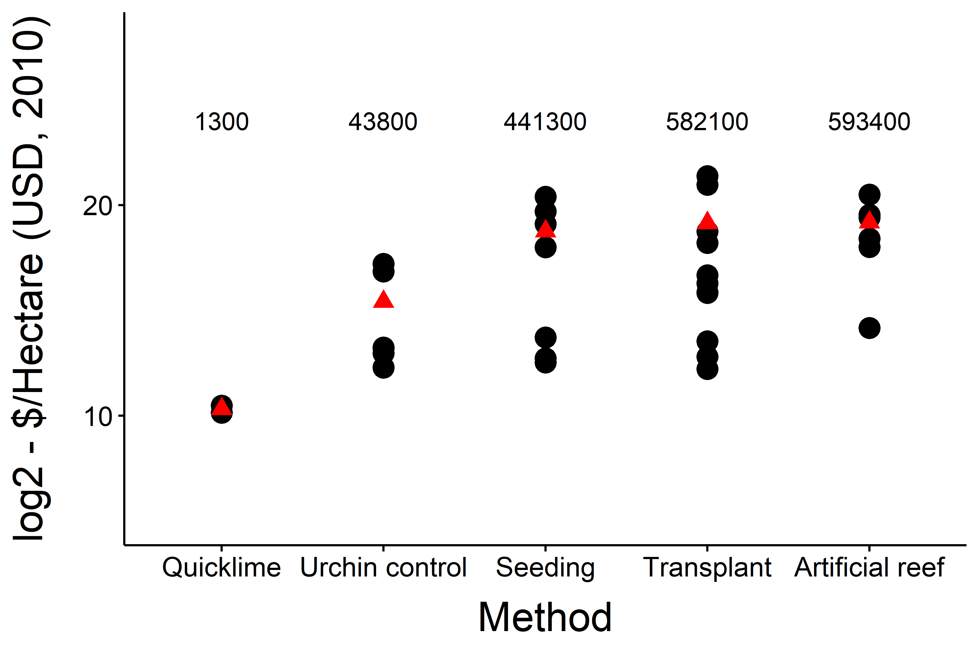
Figure 6: Reported costs per hectare of restoring kelp populations by methodology. Note the logged axis, the labels are unlogged averages, and the red triangles are the log transformed mean values.

Ecological restoration is currently very expensive, but society can likely receive substantial economic benefits by investing in kelp restoration. Preliminary analysis of Ecklonia, Nereocystis, Macrocystis, and Laminaria forests and the services they provide through fisheries, carbon sequestration, and nutrient cycling suggest that each m2 of kelp forest restored results $70 – 230,000 USD 2020/Ha/year of economic benefit (Eger et al., 2021). These benefits would potentially offset the costs of restoration within 2 – 7 years. And although the costs are currently high, as prices drop with improved techniques and larger scales the business case for restoring kelp populations should become stronger. Further, carbon, nitrogen, and phosphorus credits are already being traded on local and global markets and groups that restore kelp populations could be awarded the respective number of credits, which they could then sell to offset and potentially even profit from kelp restoration projects (Rutherford & Cox, 2009; Herr et al., 2017). Because the fate of kelp biomass is often unclear, the values for carbon and nutrient sequestration are still poorly understood in most kelp genera and regions. Early estimates suggest that 5-20% of a species’ yearly net primary production acts as a long term sink (Gouvêa et al., 2020), which though smaller than other marine macrophytes, suggests potential for the use of kelp restoration in such trading schemes. If verified trading schemes are developed for kelp restoration, then projects could contribute towards meeting a country’s commitments to reduce greenhouse gas emissions under the Paris agreement, which would provide a very strong incentive for national governments to invest in kelp restoration. Restoring kelp forests is also expected to increase fishery yields of not only the kelp itself but kelp-associated species (Bertocci et al., 2015). Because so many fisheries have closed due to kelp collapse, investing in restoration would help revitalize these lost industries and should also help governments justify the costs of restoration. For example the now closed abalone fishery in Northern California was valued at $24-44 million USD dollars in 2013 (Reid et al., 2016) and the lobster fishery in Australia was assessed at $700 million AUD ($520 million USD) in 2018 (ABARES, 2020).
Large scale restoration requires significant financial inputs, which can be considered a negative, but could also be viewed as positive. It is common for governments to attempt to revitalize their economies following a recession by increasing spending, often funding large infrastructure projects. Kelp restoration could be viewed as a similar investment, as financing kelp restoration would lead to substantial positive economic and social benefits. Indeed, this approach has already been taken in the USA in 2009, when the Administration included $178 million USD for oyster reef restoration as part of an economic stimulus package (Smaal et al., 2018). Similarly, the Australian government is investing 10s of millions of dollars into coastal restoration and blue carbon as a part of its COVID-19 response spending. Other countries could look to stimulate growth by using similar approaches. The FMDP project in Japan is another good model for how government groups can work together to set aside funding for restoration, provide access to experts, and facilitate collaboration across different sectors of society. This kind of fund and support structure is a promising way to attempt restoration at the national scale.
Finally, another potential source of funding may come from private enterprises. Business groups are increasingly looking to build social capital by “giving back” while remaining profitable. For kelp restoration, companies such as Urchinomics (https://www.urchinomics.com/) and Greenwave (https://www.greenwave.org/) are exploring pathways to not only restore kelp forests but also generate a sustainable revenue and operate outside the not-for-profit space. These alternate pathways could be vital because restoration requires substantial financing (Eger et al., 2020c). For example, government and fisheries groups in Korea are working with budgets of 100s of millions of USD to restore kelp and a proposed project by the US Army Corp of Engineers in Los Angeles, California, USA, has a budget of ~$150 million USD. Budgets of these magnitude are unattainable for many conservation groups and green businesses may help reduce the costs or even create a profit from kelp restoration projects.

Legal frameworks for restoration
Marine management policy has often lagged behind the rapid environmental changes occurring in our oceans (Rilov et al., 2019). As a result, laws initially intended to protect marine resources, could now be hindering restoration efforts. Current environmental laws focus on either prohibiting the removal of resources from the oceans (e.g. fishes) or the addition of unwanted materials into the ocean (e.g. waste dumping). Restoration of kelp forests can require either or both actions. To address over-population of grazers, we must often work to remove or reduce herbivorous species that would otherwise over consume the kelp plants. Conversely, to regrow populations we must insert biogenic material, either transplants or propagules, or create artificial substrate to attach material to, or allow settlement on. Current discussions regarding reforming environmental laws have focused on identifying appropriate baselines and target species (McCormack, 2019), but there is a need to revisit the rules regarding exploitation of “unwanted” or hyperabundant species and the addition of desirable materials. For example, marine reserves often prohibit the removal of sea urchins which can prevent kelp from returning, as happened in Hong Kong (Leung et al., 2014). So while, no-take marine reserves remain the gold standard in marine conservation (Sala & Giakoumi, 2018) we can shift these paradigms to allow for limited removal of grazer species and invasive species to even the addition of habitat into the reserve. The challenges presented by modern restoration projects will therefore require adaptive legislative frameworks that allow for the trialling of environmental interventions, scaling them up when successful, and the alteration of previously held tenants.
Other laws or directives will also be useful in motivating restoration efforts. Specifically, laws that require the offset of habitat destruction such as the one responsible for a 170 hectare project in southern California can at least ensure that there is no net loss of kelp (Bull & Strange, 2018). The United States, Canada, Australia, the EU, Korea, and New Zealand, have offsetting regulations and policies (Niner et al., 2017) which are useful examples for how to create such policies. Interestingly, we only recorded four offsetting projects in our database. This could be because these project reports are not easily accessible or because offsetting for kelp is uncommon. Regardless, future offsetting projects should be reported in public repositories to allow for open consideration of their success. Notably, Norway, Japan, and Chile, do not have offsetting directives, a barrier to future offsetting (i.e. restoration) efforts. Though offsetting policies are important, they can only look to ensure no net loss of kelp and are not effective for increasing kelp cover. Governments can look to increase kelp populations by setting directives such as Law N°20.925 in Chile which legally set aside funds for restoration.

The future of kelp restoration
There is considerable potential for global, ecologically significant kelp restoration, yet it is paired with considerable barriers. We found that most kelp restoration projects are currently very small in scale, geographically and taxonomically clustered, limited in duration, prohibitively expensive, and presented with major legal and permitting barriers. The projects that were most successful were those close to natural kelp forests of conspecifics, a finding that highlights the need to preserve remaining kelp forests as a priority and act quickly to restore adjacent reefs, where possible. Additionally, efforts should work to restore large, well connected patches of kelp forest, and ensure that they are free from further stress events such as overgrazing. In addition to further research into the ecological factors that engender success, it will be important to drive diverse collaborations and investigate future genetic, engineering, and policy advancements that can also help improve these efforts. As marine managers worldwide attempt to apply these lessons it will be important that information is archived and shared amongst restorationists. To achieve long term support, we will need support from governments, businesses, and the larger community who finance the costs of restoration. As kelp restoration grows as a field, there is opportunity to align with the UN Decades for Ecosystems Restoration and Ocean Science for Sustainability to generate greater support, set restoration targets such as those used with MPAs (Convention on Biological Diversity, 2013) or the Bonn Challenge (Dave et al., 2017), incentivize green businesses to restore and grow, and communicate the deep dependency our society has on a healthy ocean. Future efforts must ensure that the best available knowledge is used to make informed decisions about restoration. There may be no universal answers and each project will always need to consider the local conditions, but we can work to ensure any lessons learned are shared with the global restoration community.

Acknowledgements
We would like to thank Molly French and Emma Mellis for working to validate the database. This work was supported by a Scientia PhD scholarship to AE, the Australian Research Council through projects LP160100836 to PDS, EMM and AV, DP180104041 to PSD and EMM and DP190102030 to AV.

References

ABARES (2020) Australian fisheries and aquaculture outlook 2020, Department of Agriculture Water and the Environment. Https://www.agriculture.gov.au/abares/research-topics/fisheries/fisheries-economics/fisheries-forecasts#rock-lobster-demand-impacted-in-short-term [accessed 5 December 2020].
Almany, G.R., Connolly, S.R., Heath, D.D., Hogan, J.D., Jones, G.P., McCook, L.J., Mills, M., Pressey, R.L. & Williamson, D.H. (2009) Connectivity, biodiversity conservation and the design of marine reserve networks for coral reefs. Coral reefs 28, 339–351. Springer.
Bajjouk, T., Rochette, S., Laurans, M., Ehrhold, A., Hamdi, A. & Le Niliot, P. (2015) Multi-approach mapping to help spatial planning and management of the kelp species L. digitata and L. hyperborea: Case study of the Molène Archipelago, Brittany. Journal of Sea Research 100, 2–21. Elsevier.
Barksy, K., Bedford, D., Collier, P., Culver, C., Hankin, D., Kalvass, P., Kuris, A., O’Brien, J., O’Leary, J., Parker, D., Patyten, M., Ryan, C., Vejar, A., Wertz, L. & Wertz, S. (2003) Annual status of the fisheries report through 2003. Belmont, California.
Bates, D., Maechler, M., Bolker, B., Walker, S., Christensen, R.H.B., Singmann, H., Dai, B., Grothendieck, G., Green, P. & Bolker, M. Ben (2015) Package ‘lme4’. Convergence 12, 2.
Bayraktarov, E., Brisbane, S., Hagger, V., Smith, C.S., Wilson, K.A., Lovelock, C.E., Gillies, C., Steven, A.D.L. & Saunders, M.I. (2020) Priorities and Motivations of Marine Coastal Restoration Research. Frontiers in Marine Science 7, 484. Frontiers.
Benabou, S. (2014) Making up for lost nature?: A critical review of the international development of voluntary biodiversity offsets. Environment and Society 5, 103–123. Berghahn Journals.
Bengtsson, J., Angelstam, P., Elmqvist, T., Emanuelsson, U., Folke, C., Ihse, M., Moberg, F. & Nyström, M. (2021) Reserves, resilience and dynamic landscapes 20 years later. Ambio, 1–5. Springer.
Bennett, S., Wernberg, T., Connell, S.D., Hobday, A.J., Johnson, C.R. & Poloczanska, E.S. (2016) The ‘Great Southern Reef’: social, ecological and economic value of Australia’s neglected kelp forests. Marine and Freshwater Research 67, 47–56. CSIRO.
Bernstein, B.B. & Welsford, R.W. (1982) An Assessment of Feasibility of Using High-calcium Quicklime as an Exerimental Tool for Research Into Kelp Bed-Sea Urchin Ecosystems in Nova Scotia. Department of Supply and Services.
Bertocci, I., Araújo, R., Oliveira, P. & Sousa-Pinto, I. (2015) Potential effects of kelp species on local fisheries. Journal of Applied Ecology 52, 1216–1226. Wiley/Blackwell (10.1111).
Bishop, M.J., Mayer-Pinto, M., Airoldi, L., Firth, L.B., Morris, R.L., Loke, L.H.L., Hawkins, S.J., Naylor, L.A., Coleman, R.A. & Chee, S.Y. (2017) Effects of ocean sprawl on ecological connectivity: impacts and solutions. Journal of Experimental Marine Biology and Ecology 492, 7–30. Elsevier.
Blamey, L.K. & Bolton, J.J. (2018) The economic value of South African kelp forests and temperate reefs: Past, present and future. JOURNAL OF MARINE SYSTEMS 188, 172–181.
Bodkin, J.L. (2015) Historic and Contemporary Status of Sea Otters in the North Pacific. Sea Otter Conservation, 43–61. Academic Press.
Bull, J.W. & Strange, N. (2018) The global extent of biodiversity offset implementation under no net loss policies. Nature Sustainability 1, 790–798. Nature Publishing Group.
Buschmann, A.H., Prescott, S., Potin, P., Faugeron, S., Vasquez, J.A., Camus, C., Infante, J., Hernández-González, M.C., Gutierrez, A. & Varela, D.A. (2014) The status of kelp exploitation and marine agronomy, with emphasis on Macrocystis pyrifera, in Chile. In Advances in Botanical Research (ed N. Bourgougnon), pp. 161–188. Elsevier.
Campbell, A.H., Marzinelli, E.M., Vergés, A., Coleman, M.A. & Steinberg, P.D. (2014) Towards restoration of missing underwater forests. PloS one 9, e84106. Public Library of Science.
Camus, C., Infante, J. & Buschmann, A.H. (2019) Revisiting the economic profitability of giant kelp Macrocystis pyrifera (Ochrophyta) cultivation in Chile. Aquaculture 502, 80–86. Elsevier.
Carlisle, J.G., Turner, C.H. & Ebert, E.E. (1964) Artificial habitat in the marine environment. Resources Agency of California, Departament of Fish and Game.
Carlsson, P.M. & Christie, H.C. (2019) Regrowth of kelp after removal of sea urchins (Strongylocentrotus droebachiensis). NIVA-rapport. Norsk insitutt for vannforskning.
Carney, L.T., Waaland, J.R., Klinger, T. & Ewing, K. (2005) Restoration of the bull kelp Nereocystis luetkeana in nearshore rocky habitats. Marine Ecology Progress Series 302, 49–61.
Carter, J.W., Carpenter, A.L., Foster, M.S. & Jessee, W.N. (1985) Benthic Succession on an Artificial Reef Designed to Support a Kelp–Reef Community. Bulletin of Marine Science 37, 86–113. University of Miami-Rosenstiel School of Marine and Atmospheric Science.
Caselle, J.E., Rassweiler, A., Hamilton, S.L. & Warner, R.R. (2015) Recovery trajectories of kelp forest animals are rapid yet spatially variable across a network of temperate marine protected areas. Scientific reports 5, 14102. Nature Publishing Group.
Cheney, D., Oestman, R., Volkhardt, G. & Getz, J. (1994) Creation of rocky intertidal and shallow subtidal habitats to mitigate for the construction of a large marina in Puget Sound, Washington. Bulletin of Marine Science 55, 772–782. University of Miami-Rosenstiel School of Marine and Atmospheric Science.
Christie, H., Gundersen, H., Rinde, E., Filbee‐Dexter, K., Norderhaug, K.M., Pedersen, T., Bekkby, T., Gitmark, J.K. & Fagerli, C.W. (2019) Can multitrophic interactions and ocean warming influence large‐scale kelp recovery? Ecology and evolution 9, 2847–2862. Wiley Online Library.
Chung, I.K., Oak, J.H., Lee, J.A., Shin, J.A., Kim, J.G. & Park, K.-S. (2013) Installing kelp forests/seaweed beds for mitigation and adaptation against global warming: Korean Project Overview. ICES Journal of Marine Science 70, 1038–1044. Oxford University Press.
Claudet, J., Bopp, L., Cheung, W.W.L., Devillers, R., Escobar-Briones, E., Haugan, P., Heymans, J.J., Masson-Delmotte, V., Matz-Lück, N. & Miloslavich, P. (2020) A roadmap for using the UN Decade of Ocean Science for sustainable development in support of science, policy, and action. One Earth 2, 34–42. Elsevier.
Coleman, M.A. & Goold, H. (2019) Harnessing synthetic biology for kelp forest conservation. Journal of phycology. Wiley Online Library.
Coleman, M.A., Kelaher, B.P., Steinberg, P.D. & Millar, A.J.K. (2008) Absence of a large brown macroalga on urbanized rocky reefs around Sydney, Australia, and evidence for historical decline. Journal of phycology 44, 897–901. Wiley Online Library.
Coleman, M.A., Wood, G., Filbee-Dexter, K., Minne, A.J.P., Goold, H.D., Vergés, A., Marzinelli, E.M., Steinberg, P.D. & Wernberg, T. (2020) Restore or redefine: future trajectories for restoration. Frontiers in Marine Science 7, 237. Frontiers.
Convention on Biological Diversity (2013) Quick guide to the Aichi Biodiversity Targets: protected areas increased and improved.
Cormier, R. & Elliott, M. (2017) SMART marine goals, targets and management–is SDG 14 operational or aspirational, is ‘Life Below Water’sinking or swimming? Marine pollution bulletin 123, 28–33. Elsevier.
Correa, J.A., Lagos, N.A., Medina, M.H., Castilla, J.C., Cerda, M., Ramírez, M., Martínez, E., Faugeron, S., Andrade, S., Pinto, R. & Contreras, L. (2006) Experimental transplants of the large kelp Lessonia nigrescens (Phaeophyceae) in high-energy wave exposed rocky intertidal habitats of northern Chile: Experimental, restoration and management applications. Journal of Experimental Marine Biology and Ecology 335, 13–18. Elsevier.
Dave, R., Saint-Laurent, C., Moraes, M., Simonit, S., Raes, L. & Karangwa, C. (2017) Bonn challenge barometer of progress: Spotlight report 2017. Gland, Switzerland: IUCN.
Dayton, P.K. (1985) Ecology of kelp communities. Annual review of ecology and systematics 16, 215–245. Annual Reviews 4139 El Camino Way, PO Box 10139, Palo Alto, CA 94303-0139, USA.
Department of Fisheries and Oceans Canada (2020) Pacific Region Integrated Fisheries Management Plan Red Sea Urchin August 1, 2019 to July 31, 2020.
Doropoulos, C., Elzinga, J., ter Hofstede, R., van Koningsveld, M. & Babcock, R.C. (2019) Optimizing industrial-scale coral reef restoration: comparing harvesting wild coral spawn slicks and transplanting gravid adult colonies. Restoration Ecology 27, 758–767. John Wiley & Sons, Ltd (10.1111).
Egan, S., Harder, T., Burke, C., Steinberg, P., Kjelleberg, S. & Thomas, T. (2013) The seaweed holobiont: understanding seaweed–bacteria interactions. FEMS Microbiology Reviews 37, 462–476. Blackwell Publishing Ltd Oxford, UK.
Eger, A., Marzinelli, E., Baes, R., Blain, C., Blamey, L., Carnell, P., Choi, C.G., Hessing-Lewis, M., Kim, K.Y. & Lorda, J. (2021) The economic value of fisheries, blue carbon, and nutrient cycling in global marine forests. EcoEvoRxiv.
Eger, A.M. & Baum, J.K. (2020) Trophic cascades and connectivity in coastal benthic marine ecosystems: a meta-analysis of experimental and observational research. Marine Ecology Progress Series ITRS, ITRSav3.
Eger, A.M., Marzinelli, E., Gribben, P., Johnson, C.R., Layton, C., Steinberg, P.D., Wood, G., Silliman, B.R. & Vergés, A. (2020a) Playing to the Positives: Using Synergies to Enhance Kelp Forest Restoration. Frontiers in Marine Science 7, 544.
Eger, A.M., Marzinelli, E., Steinberg, P. & Vergés, A. (2020b) Worldwide Synthesis of Kelp Forest Reforestation. Open Science Framework. .
Eger, A.M., Vergés, A., Choi, C.G., Christie, H.C., Coleman, M.A., Fagerli, C.W., Fujita, D., Hasegawa, M., Kim, J.H., Mayer‐Pinto, M., Reed, D.C., Steinberg, P.D. & Marzinelli, E.M. (2020c) Financial and institutional support are important for large-scale kelp forest restoration. Frontiers in Marine Science 7.
Fabbrizzi, E., Scardi, M., Ballesteros, E., Benedetti-Cecchi, L., Cebrian, E., Ceccherelli, G., De Leo, F., Deidun, A., Guarnieri, G. & Falace, A. (2020) Modeling Macroalgal Forest Distribution at Mediterranean Scale: Present Status, Drivers of Changes and Insights for Conservation and Management. Frontiers in Marine Science 7, 20. Frontiers.
Fehr, K., Thompson, M. & Barron, A. (2011) 2010 Subtidal Reefs Compensation Monitoring Project, Deltaport Third Berth Project. Vancouver, British Columbia.
Filbee-Dexter, K. & Scheibling, R.E. (2014) Sea urchin barrens as alternative stable states of collapsed kelp ecosystems. Marine Ecology Progress Series 495, 1–25.
Filbee-Dexter, K. & Wernberg, T. (2018) Rise of Turfs: A New Battlefront for Globally Declining Kelp Forests. BioScience 68, 64–76.
Filbee-Dexter, K., Wernberg, T., Fredriksen, S., Norderhaug, K.M. & Pedersen, M.F. (2019) Arctic kelp forests: Diversity, resilience and future. GLOBAL AND PLANETARY CHANGE 172, 1–14.
FIRA (2020) Statistics of artificial reefs in Korea (1971~2018).
FishstatJ, F.A.O. (2020) FishStatJ-Software for fishery and aquaculture statistical time series. FAO Fisheries Division [online]. Rome. Updated 22.
Foster, M.S. & Schiel, D.R. (2010) Loss of predators and the collapse of southern California kelp forests: alternatives, explanations and generalizations. Journal of Experimental Marine Biology and Ecology 393, 59–70. Elsevier.
Frangoudes, K. & Garineaud, C. (2015) Governability of kelp forest small-scale harvesting in Iroise Sea, France. In Interactive governance for small-scale fisheries pp. 101–115. Springer.
Fraschetti, S., Tamburello, L., Papa, L., Guarnieri, G., Falace, A., Cebrian, E., Verdura, J., Hereu, B., Fagerli, C.W., Garrabou, J., Linares, C., Cerrano, C. & Kipson, S. (2017) Criteria and protocols for restoration of shallow hard bottoms and mesophotic habitats.
Fredriksen, S., Filbee-Dexter, K., Norderhaug, K.M., Steen, H., Bodvin, T., Coleman, M.A., Moy, F. & Wernberg, T. (2020) Green gravel: a novel restoration tool to combat kelp forest decline. Scientific Reports 10, 1–7. Nature Publishing Group.
Fujita, D. (2010) Current status and problems of isoyake in Japan. Bull Fish Res Agen 32, 33–42.
Fujita, D. (2011) Management of kelp ecosystem in Japan. CBM-Cahiers de Biologie Marine 52, 499.
Fujita, D. (2019) Problems in Isoyake Taisaku. Gyokou Gyojou 211, 1–6.
Fujita, D., Ma, R., Akita, S., Kobayashi, M., Hayakawa, Y., Miyatani, T., Seki, Y. & Yamahira, Y. (2017) Use of fertilized molten slags to create Sargassum forests in subtropical shallow waters. Journal of Applied Phycology 29, 2667–2674. Springer.
Gann, G.D., McDonald, T., Walder, B., Aronson, J., Nelson, C.R., Jonson, J., Hallett, J.G., Eisenberg, C., Guariguata, M.R. & Liu, J. (2019) International principles and standards for the practice of ecological restoration. Restor. Ecol 27, S3-46.
Gorfine, H., Bell, J.D., Mills, K. & Lewis, Z. (2012) Removing sea urchins (Centrostephanus rodgersii) to recover abalone (Haliotis rubra) habitat.
Gouvêa, L.P., Assis, J., Gurgel, C.F.D., Serrão, E.A., Silveira, T.C.L., Santos, R., Duarte, C.M., Peres, L.M.C., Carvalho, V.F., Batista, M., Bastos, E., Sissini, M.N. & Horta, P.A. (2020) Golden carbon of Sargassum forests revealed as an opportunity for climate change mitigation. Science of The Total Environment, 138745. Elsevier.
Guarnieri, G., Bevilacqua, S., Vignes, F. & Fraschetti, S. (2014) Grazer removal and nutrient enrichment as recovery enhancers for overexploited rocky subtidal habitats. Oecologia 175, 959–970. Springer.
Han, Y.B. (2010) Edible seaweeds I: the components and physiological activities. Korea University Press.
Heath, W., Zielinski, R. & Zielinski, A. (2015) Technical Report of the Collaborative Bull Kelp Restoration Project.
Hernandez-Carmona, G., García, O., Robledo, D. & Foster, M. (2000) Restoration techniques for Macrocystis pyrifera (Phaeophyceae) populations at the southern limit of their distribution in Mexico. Botanica Marina 43, 273–284. Walter de Gruyter.
Herr, D., von Unger, M., Laffoley, D. & McGivern, A. (2017) Pathways for implementation of blue carbon initiatives. Aquatic Conservation: Marine and Freshwater Ecosystems 27, 116–129. Wiley Online Library.
Hohman, R., Hutto, S., Catton, C.A. & Koe, F. (2019) Sonoma-Mendocino Bull Kelp Recovery Plan. San Francisco.
House, P., Barilotti, A., Burdick, H., Ford, T., Williams, J., Williams, C. & Pondella, D. (2018) Palos Verdes Kelp Forest Restoration Project: Project Year 5: July 2017 - June 2018.
Ishii, M., Yamamoto, T., Nakahara, T., Takeda, K. & Asaoka, S. (2013) Effect of Carbonated Steelmaking Slag on the Growth of Benthic Microalgae. Journal of the Iron and Steel Institute of Japan 99, 260–266.
Iveša, L., Djakovac, T. & Devescovi, M. (2016) Long-term fluctuations in Cystoseira populations along the west Istrian Coast (Croatia) related to eutrophication patterns in the northern Adriatic Sea. Marine Pollution Bulletin 106, 162–173. Elsevier.
Japanese Fisheries Agency (2009) Isoyake Taisaku Guidelines. Tokyo.
Japanese Fisheries Agency (2015) Isoyake Taisaku Guidelines 2nd Edition. Tokyo, Japan.
Kang, R. (2010) A review of destruction of seaweed habitats along the coast of the Korean Peninsula and its consequences. Bulletin of Fisheries Research Agency, 25–31. Fisheries Research Agency.
Kang, S.K. (2018) Economic Value of Marine Forests in Korea. The Journal of Fisheries Business Administration. The Journal of Fisheries Business Administration 49, 17–35.
van Katwijk, M.M., Thorhaug, A., Marbà, N., Orth, R.J., Duarte, C.M., Kendrick, G.A., Althuizen, I.H.J., Balestri, E., Bernard, G., Cambridge, M.L., Cunha, A., Durance, C., Giesen, W., Han, Q., Hosokawa, S., et al. (2016) Global analysis of seagrass restoration: the importance of large-scale planting. Journal of Applied Ecology 53, 567–578. Wiley/Blackwell (10.1111).
Kim, J.K., Kraemer, G.P. & Yarish, C. (2015) Use of sugar kelp aquaculture in Long Island Sound and the Bronx River Estuary for nutrient extraction. Marine Ecology progress series 531, 155–166.
Kinoshita, T. (1933) Unusual damage on Rishiri-kombu. Yoshoku-Kaishi 3, 198*201.
Krumhansl, K.A., Bergman, J.N. & Salomon, A.K. (2017) Assessing the ecosystem‐level consequences of a small‐scale artisanal kelp fishery within the context of climate‐change. Ecological Applications 27, 799–813. Wiley Online Library.
Kuroda, T., Tsuchida, Y., Tanizawa, Y. & Uemoto, H. (1957) Theory and Practice of Stock Enhancement in Shallow Waters. Gyoson Bunka Kyokai, 247.
Kuznetsova, A., Brockhoff, P.B. & Christensen, R.H.B. (2017) lmerTest package: tests in linear mixed effects models. Journal of statistical software 82. The Foundation for Open Access Statistics.
De La Fuente, G., Chiantore, M., Asnaghi, V., Kaleb, S. & Falace, A. (2019) First ex situ outplanting of the habitat-forming seaweed Cystoseira amentacea var. stricta from a restoration perspective. PeerJ 7, e7290. PeerJ Inc.
Larby, S. (2020) ‘Take all’ harvest trial of Longspined sea urchin (Centrostephanus rodgersii). Marion Bay to Cape Hauy.
Layton, C., Cameron, M.J., Tatsumi, M., Shelamoff, V., Wright, J.T. & Johnson, C.R. (2020a) Habitat fragmentation causes collapse of kelp recruitment. Marine Ecology Progress Series 648, 111–123.
Layton, C., Coleman, M.A., Marzinelli, E.M., Steinberg, P.D., Swearer, S.E., Vergés, A., Wernberg, T. & Johnson, C.R. (2020b) Kelp forest restoration in Australia. Frontiers in Marine Science 7.
Layton, C., Shelamoff, V., Cameron, M.J., Tatsumi, M., Wright, J.T. & Johnson, C.R. (2019) Resilience and stability of kelp forests: The importance of patch dynamics and environment-engineer feedbacks. PloS one 14, e0210220. Public Library of Science.
Lee, S.-G. (2019) Marine Stock Enhancement, Restocking, and Sea Ranching in Korea. In Wildlife Management - Failures, Successes and Prospects p. IntechOpen.
Leinaas, H.P. & Christie, H. (1996) Effects of removing sea urchins (Strongylocentrotus droebachiensis): stability of the barren state and succession of kelp forest recovery in the east Atlantic. Oecologia 105, 524–536. Springer.
Lester, S.E., Halpern, B.S., Grorud-Colvert, K., Lubchenco, J., Ruttenberg, B.I., Gaines, S.D., Airamé, S. & Warner, R.R. (2009) Biological effects within no-take marine reserves: a global synthesis. Marine Ecology Progress Series 384, 33–46.
Leung, Y.H., Yeung, C.W. & Ang, P.O. (2014) Assessing the potential for recovery of a Sargassum siliquastrum community in Hong Kong 26, 1097–1106. Springer Science + Business Media.
Ling, S.D., Johnson, C.R., Frusher, S.D. & Ridgway, K.R. (2009) Overfishing reduces resilience of kelp beds to climate-driven catastrophic phase shift. Proceedings of the National Academy of Sciences of the United States of America 106, 22341–22345. National Academy of Sciences.
Ling, S.D., Scheibling, R.E. & Rass (2014) Global regime shift dynamics of catastrophic sea urchin overgrazing.
Marzinelli, E.M., Leong, M.R., Campbell, A.H., Steinberg, P.D. & Vergés, A. (2016) Does restoration of a habitat‐forming seaweed restore associated faunal diversity? Restoration Ecology 24, 81–90. Wiley Online Library.
Marzinelli, E.M., Zagal, C.J., Chapman, M.G. & Underwood, A.J. (2009) Do modified habitats have direct or indirect effects on epifauna? Ecology 90, 2948–2955. Wiley Online Library.
McCormack, P.C. (2019) Reforming restoration law to support climate change adaptation. Ecological Restoration Law: Concepts and Case Studies, 202. Routledge.
McHugh, T., Abbott, D. & Freiwald, J. (2018) Phase shift from kelp forest to urchin barren along California’s North Coast. Western Society of Naturalists.
McPherson, M.L., Finger, D.J.I., Houskeeper, H.F., Bell, T.W., Carr, M.H., Rogers-Bennett, L. & Kudela, R.M. (2021) Large-scale shift in the structure of a kelp forest ecosystem co-occurs with an epizootic and marine heatwave. Communications biology 4, 1–9. Nature Publishing Group.
MERCES (2020) Marine Ecosystem Restoration in Changing European Seas. Http://www.merces-project.eu/ [accessed 5 November 2020].
Morris, R.L., Hale, R., Strain, E.M.A., Reeves, S., Verges, A., Marzinelli, E.M., Layton, C., Shelamoff, V., Graham, T., Chevalier, M. & Swearer, S.E. (2020) Key principles for managing recovery of kelp forests through restoration. BioScience 70, 688–698.
Moy, F., Christie, H., Steen, H., Stålnacke, P., Aksnes, D., Aure, J., Bekkby, T., Fredriksen, S., Gitmark, J., Hackett, B., Magnusson, J., Pengerud, A., Sjøtun, K., Sørensen, K., Tveiten, L., et al. (2008) Sluttrapport fra Sukkertareprosjektet 2005-2008.
Moy, F.E. & Christie, H. (2012) Large-scale shift from sugar kelp (Saccharina latissima) to ephemeral algae along the south and west coast of Norway. Marine Biology Research 8, 309–321. Taylor & Francis.
Nayar, S. & Bott, K. (2014) Current status of global cultivated seaweed production and markets. World Aquaculture 45, 32–37. World Aquaculture Society.
Niner, H.J., Milligan, B., Jones, P.J.S. & Styan, C.A. (2017) A global snapshot of marine biodiversity offsetting policy. Marine Policy 81, 368–374. Elsevier.
Norderhaug, K.M. & Christie, H.C. (2009) Sea urchin grazing and kelp re-vegetation in the NE Atlantic. Marine Biology Research 5, 515–528. Taylor & Francis.
North, W.J. (1958) Experimental Ecology in Kelp Investigations Program - University California Institute of Marine Science.
North, W.J. (1976) Aquacultural Techniques for Creating and Restoring Beds of Giant Kelp, Macrocystis spp. Journal of the Fisheries Research Board of Canada 33, 1015–1023. NRC Research Press.
Oyamada, K., Tsukidate, M., Watanabe, K., Takahashi, T., Isoo, T. & Terawaki, T. (2008) A field test of porous carbonated blocks used as artificial reef in seaweed beds of Ecklonia cava. In Nineteenth International Seaweed Symposium pp. 413–418. Springer.
Palumbi, S.R. (2003) Population genetics, demographic connectivity, and the design of marine reserves. Ecological applications 13, 146–158. Wiley Online Library.
Park, K.-Y., Kim, T.-S., Jang, J.-C. & Kang, J.W. (2019) Marine forest reforestation project of Korea Fisheries Resources Agency (FIRA). In 23rd International Seaweed Symposium p. Jeju, Korea.
Paxton, A.B., Shertzer, K.W., Bacheler, N.M., Kellison, G.T., Riley, K.L. & Taylor, J.C. (2020) Meta-Analysis Reveals Artificial Reefs Can Be Effective Tools for Fish Community Enhancement but Are Not One-Size-Fits-All. Frontiers in Marine Science 7, 282. Frontiers Media S.A.
Piazzi, L. & Ceccherelli, G. (2019) Effect of sea urchin human harvest in promoting canopy forming algae restoration. Estuarine, Coastal and Shelf Science 219, 273–277. Elsevier.
Platjouw, F. (2019) The green financing of ecosystem restoration: Concepts and Case Studies. In pp. 142–164.
Qiu, Z., Coleman, M.A., Provost, E., Campbell, A.H., Kelaher, B.P., Dalton, S.J., Thomas, T., Steinberg, P.D. & Marzinelli, E.M. (2019) Future climate change is predicted to affect the microbiome and condition of habitat-forming kelp. Proceedings of the Royal Society B 286, 20181887. The Royal Society.
R Core Team (2013) R: A language and environment for statistical computing.
Reed, D.C., Schroeter, S.C., Huang, D., Anderson, T.W. & Ambrose, R.F. (2006) Quantitative assessment of different artificial reef designs in mitigating losses to kelp forest fishes. Bulletin of Marine Science 78, 133–150. University of Miami-Rosenstiel School of Marine and Atmospheric Science.
Reid, J., Rogers-Bennett, L., Vasquez, F., Pace, M., Catton, C.A., Kashiwada, J. V & Taniguchi, I.K. (2016) The economic value of the recreational red abalone fishery in northern California. California Fish and Game 102, 119–130.
Rilov, G., Fraschetti, S., Gissi, E., Pipitone, C., Badalamenti, F., Tamburello, L., Menini, E., Goriup, P., Mazaris, A.D. & Garrabou, J. (2019) A fast‐moving target: achieving marine conservation goals under shifting climate and policies. Ecological Applications, e02009. Wiley Online Library.
Roberts, C. (2007) The unnatural history of the sea. Island Press.
Rogers-Bennett, L. & Catton, C.A. (2019) Marine heat wave and multiple stressors tip bull kelp forest to sea urchin barrens. Scientific reports 9, 1–9. Nature Publishing Group.
Rutherford, K. & Cox, T. (2009) Nutrient trading to improve and preserve water quality. Water & Atmosphere 17, 12–13.
Sala, E. & Giakoumi, S. (2018) No-take marine reserves are the most effective protected areas in the ocean. ICES Journal of Marine Science 75, 1166–1168. Oxford University Press.
Sánchez-Velasco, A., Oriol, J.V. & Valiente, G. (2020) South Korean Reef Metropolis. Sustaining Seas: Oceanic Space and the Politics of Care, 261. Rowman & Littlefield Publishers.
Sanderson, C. (2003) Restoration of string kelp (Macrocystis pyrifera) habitats on Tasmania’s east and south coasts. Final Report to Natural Heritage Trust for Seacare. Technical Report. Tasmania, Australia.
Saunders, M.I., Doropoulos, C., Babcock, R.C., Bayraktarov, E., Bustamante, R.H., Eger, A.M., Gilles, C., Gorman, D., Steven, A., Vanderklift, M.A., Vozzo, M. & Silliman, B.R. (2020) Bright spots in the emerging field of coastal marine ecosystem restoration. Current Biology 30.
Scanes, P.R. & Philip, N. (1995) Environmental impact of deepwater discharge of sewage off Sydney, NSW, Australia. Marine Pollution Bulletin 31, 343–346. Elsevier.
Schiel, D.R. & Foster, M.S. (2006) The population biology of large brown seaweeds: ecological consequences of multiphase life histories in dynamic coastal environments. Annu. Rev. Ecol. Evol. Syst. 37, 343–372. Annual Reviews.
Schroeter, S.C., Reed, D.C. & Raimondi, P.T. (2018) Artificial reefs to mitigate human impacts in the marine environmen: The Wheeler North Reef as a test case. In American Fisheries Society Symposium pp. 86:197-213.
Seddon, N., Turner, B., Berry, P., Chausson, A. & Girardin, C.A.J. (2019) Grounding nature-based climate solutions in sound biodiversity science. Nature Climate Change 9, 84–87. Nature Publishing Group.
Sekine, Y. (2015) Conservation effort for seaweed bed by fishermen. Fisheries engineering 51, 233–238.
Shears, N.T. & Babcock, R.C. (2003) Continuing trophic cascade effects after 25 years of no-take marine reserve protection. MARINE ECOLOGY PROGRESS SERIES 246, 1–16.
Smaal, A.C., Ferreira, J.G., Grant, J., Petersen, J.K. & Strand, Ø. (2018) Goods and services of marine bivalves. Springer.
Smale, D.A. (2020) Impacts of ocean warming on kelp forest ecosystems. New Phytologist 225, 1447–1454. Wiley Online Library.
Smale, D.A., Burrows, M.T., Moore, P., O’Connor, N. & Hawkins, S.J. (2013) Threats and knowledge gaps for ecosystem services provided by kelp forests: a northeast A tlantic perspective. Ecology and evolution 3, 4016–4038. Wiley Online Library.
Sondak, C.F.A. & Chung, I.K. (2015) Potential blue carbon from coastal ecosystems in the Republic of Korea. Ocean Science Journal 50, 1–8.
Steneck, R.S., Leland, A., McNaught, D.C. & Vavrinec, J. (2013) Ecosystem flips, locks, and feedbacks: the lasting effects of fisheries on Maine’s kelp forest ecosystem. Bulletin of Marine Science 89, 31–55. University of Miami-Rosenstiel School of Marine and Atmospheric Science.
Strand, H.K., Christie, H.C., Fagerli, C.W., Mengede, M. & Moy, F.E. (2020) Optimizing the use of quicklime (CaO) for sea urchin decimation – a lab and field study. Ecological Engineering In Press.
Susini, M.L., Mangialajo, L., Thibaut, T. & Meinesz, A. (2007) Development of a transplantation technique of Cystoseira amentacea var. stricta and Cystoseira compressa. In Biodiversity in Enclosed Seas and Artificial Marine Habitats pp. 241–244. Springer.
Tamburello, L., Papa, L., Guarnieri, G., Basconi, L., Zampardi, S., Scipione, M.B., Terlizzi, A., Zupo, V. & Fraschetti, S. (2019) Are we ready for scaling up restoration actions? An insight from Mediterranean macroalgal canopies. PloS one 14. Public Library of Science.
Tegner, M.J. & Dayton, P.K. (1991) Sea urchins, El Ninos, and the long term stability of Southern California kelp forest communities. Marine ecology progress series. Oldendorf 77, 49–63.
Thibaut, T., Pinedo, S., Torras, X. & Ballesteros, E. (2005) Long-term decline of the populations of Fucales (Cystoseira spp. and Sargassum spp.) in the Alberes coast (France, North-western Mediterranean). Marine pollution bulletin 50, 1472–1489. Elsevier.
Thierry, J.-M. (1988) Artificial reefs in Japan—a general outline. Aquacultural Engineering 7, 321–348. Elsevier.
Tickell, S.C. y, Sáenz-Arroyo, A. & Milner-Gulland, E.J. (2019) Sunken Worlds: The Past and Future of Human-Made Reefs in Marine Conservation. BioScience 69, 725–735. Oxford University Press.
Tracey, S.R., Baulch, T., Hartmann, K., Ling, S.D., Lucieer, V., Marzloff, M.P. & Mundy, C. (2015) Systematic culling controls a climate driven, habitat modifying invader. Biological Invasions 17, 1885–1896. Springer International Publishing.
Trevathan-Tackett, S.M., Sherman, C.D.H., Huggett, M.J., Campbell, A.H., Laverock, B., Hurtado-McCormick, V., Seymour, J.R., Firl, A., Messer, L.F. & Ainsworth, T.D. (2019) A horizon scan of priorities for coastal marine microbiome research. Nature ecology & evolution 3, 1509–1520. Nature Publishing Group.
Turnbull, J.W., Johnston, E.L., Kajlich, L. & Clark, G.F. (2020) Quantifying local coastal stewardship reveals motivations, models and engagement strategies. Biological Conservation 249, 108714. Elsevier.
Turner, R.E. & Boyer, M.E. (1997) Mississippi River diversions, coastal wetland restoration/creation and an economy of scale. Ecological Engineering 8, 117–128. Elsevier.
Ueda, S., Iwamoto, K. & Miura, A. (1963) Suisan Shokubutusgaku (Botany for Fisheries). In Koseisha-Koseikaku p. Tokyo, Japan.
Vanderklift, M.A., Marcos-Martinez, R., Butler, J.R.A., Coleman, M., Lawrence, A., Prislan, H., Steven, A.D.L. & Thomas, S. (2019) Constraints and opportunities for market-based finance for the restoration and protection of blue carbon ecosystems. Marine Policy 107, 103429. Elsevier.
Vásquez, J.A. & Tala, F. (1995) Repopulation of intertidal areas with Lessonia nigrescens in northern Chile. Journal of Applied Phycology 7, 347–349. Springer.
Vasquez, J.A., Zuniga, S., Tala, F., Piaget, N., Rodriguez, D.C., Alonso Vega, J.M., Vásquez, J.A., Zuñiga, S., Tala, F., Piaget, N., Rodríguez, D.C. & Vega, J.M.A. (2014) Economic valuation of kelp forests in northern Chile: values of goods and services of the ecosystem. Journal of Applied Phycology 26, 1081–1088. Springer.
Vásquez, J.A., Zuñiga, S., Tala, F., Piaget, N., Rodríguez, D.C. & Vega, J.M.A. (2014) Economic valuation of kelp forests in northern Chile: values of goods and services of the ecosystem. Journal of Applied Phycology 26, 1081–1088. Springer.
Verdura, J., Sales, M., Ballesteros, E., Cefalì, M.E. & Cebrian, E. (2018) Restoration of a canopy-forming alga based on recruitment enhancement: methods and long-term success assessment. Frontiers in plant science 9, 1832. Frontiers.
Verges, A., Campbell, A.H., Wood, G., Kajlich, L., Eger, A.M., Cruz, D.O., Langley, M., Bolton, D., Coleman, M.A., Turpin, J., Crawford, M., Coombes, N., Camilleri, A., Steinberg, P.D. & Marzinelli, E.M. (2020) Operation Crayweed – ecological and sociocultural aspects of restoring Sydney’s underwater forests. Ecological Management & Restoration In Press.
Verges, A., Doropoulos, C., Malcolm, H.A., Skye, M., Garcia-Piza, M., Marzinelli, E.M., Campbell, A.H., Ballesteros, E., Hoey, A.S., Vila-Concejo, A., Bozec, Y.-M. & Steinberg, P.D. (2016a) Long-term empirical evidence of ocean warming leading to tropicalization of fish communities, increased herbivory, and loss of kelp. PROCEEDINGS OF THE NATIONAL ACADEMY OF SCIENCES OF THE UNITED STATES OF AMERICA 113, 13791–13796.
Verges, A., Doropoulos, C., Malcolm, H.A., Skye, M., Garcia-Piza, M., Marzinelli, E.M., Campbell, A.H., Ballesteros, E., Hoey, A.S., Vila-Concejo, A., Bozec, Y.-M., Steinberg, P.D., Vergés, A., Doropoulos, C., Malcolm, H.A., et al. (2016b) Long-term empirical evidence of ocean warming leading to tropicalization of fish communities, increased herbivory, and loss of kelp. PROCEEDINGS OF THE NATIONAL ACADEMY OF SCIENCES OF THE UNITED STATES OF AMERICA 113, 13791–13796.
Vergés, A., McCosker, E., Mayer‐Pinto, M., Coleman, M.A., Wernberg, T., Ainsworth, T. & Steinberg, P.D. (2019) Tropicalisation of temperate reefs: Implications for ecosystem functions and management actions. Functional Ecology 33, 1365-2435.13310. John Wiley & Sons, Ltd (10.1111).
Vergés, A., Steinberg, P.D., Hay, M.E., Poore, A.G.B., Campbell, A.H., Ballesteros, E., Heck, K.L., Booth, D.J., Coleman, M.A., Feary, D.A., Figueira, W., Langlois, T., Marzinelli, E.M., Mizerek, T., Mumby, P.J., et al. (2014a) The tropicalization of temperate marine ecosystems : climate-mediated changes in herbivory and community phase shifts The tropicalization of temperate marine ecosystems : climate-mediated changes in herbivory and community phase shifts. Proceedings of the Royal Society B: Biological Sciences 281, 1–10.
Vergés, A., Steinberg, P.D., Hay, M.E., Poore, A.G.B., Campbell, A.H., Ballesteros, E., Heck, K.L., Booth, D.J., Coleman, M.A., Feary, D.A., Figueira, W., Langlois, T., Marzinelli, E.M., Mizerek, T., Mumby, P.J., et al. (2014b) The tropicalization of temperate marine ecosystems: climate-mediated changes in herbivory and community phase shifts. Proceedings of the Royal Society B: Biological Sciences 281, 20140846.
Waltham, N.J., Elliott, M., Lee, S.Y., Lovelock, C., Duarte, C.M., Buelow, C., Simenstad, C., Nagelkerken, I., Claassens, L. & Wen, C.K.C. (2020) UN Decade on Ecosystem Restoration 2021–2030—What Chance for Success in Restoring Coastal Ecosystems? Frontiers in Marine Science 7, 71. Frontiers.
Watanuki, A., Aota, T., Otsuka, E., Kawai, T., Iwahashi, Y., Kuwahara, H. & Fujita, D. (2010) Restoration of kelp beds on an urchin barren: removal of sea urchins by citizen divers in southwestern Hokkaido. Bull. Fish. Res. Agen 32, 83–87.
Wernberg, T., Bennett, S., Babcock, R.C., De Bettignies, T., Cure, K., Depczynski, M., Dufois, F., Fromont, J., Fulton, C.J. & Hovey, R.K. (2016) Climate-driven regime shift of a temperate marine ecosystem. Science 353, 169–172. American Association for the Advancement of Science.
Wernberg, T., Krumhansl, K., Filbee-Dexter, K. & Pedersen, M.F. (2019) Status and trends for the world’s kelp forests. In World seas: An environmental evaluation (ed C. Sheppard), pp. 57–78. Elsevier.
Wernberg, T., Russell, B.D., Moore, P.J., Ling, S.D., Smale, D.A., Campbell, A., Coleman, M.A., Steinberg, P.D., Kendrick, G.A. & Connell, S.D. (2011) Impacts of climate change in a global hotspot for temperate marine biodiversity and ocean warming. Journal of Experimental Marine Biology and Ecology 400, 7–16. Elsevier B.V.
Westermeier, R., Murúa, P., Patiño, D.J., Muñoz, L., Atero, C. & Müller, D.G. (2014) Repopulation techniques for Macrocystis integrifolia (Phaeophyceae: Laminariales) in Atacama, Chile. Journal of applied phycology 26, 511–518. Springer.
Westermeier, R., Murúa, P., Patiño, D.J., Muñoz, L. & Müller, D.G. (2016) Holdfast fragmentation of Macrocystis pyrifera (integrifolia morph) and Lessonia berteroana in Atacama (Chile): a novel approach for kelp bed restoration. Journal of applied phycology 28, 2969–2977. Springer.
Wilson, K.C., Haaker, P.L. & Hanan, D.A. (1977) Kelp Restoration in Southern California. In The Marine Plant Biomass of the Pacific Northwest Coast pp. 183–202. Oregon State University Press.
Wilson, K.C. & North, W.J. (1983) A review of kelp bed management in southern California. Journal of the World Mariculture Society 14, 345–359. Wiley Online Library.
Wood, G., Marzinelli, E.M., Campbell, A.H., Steinberg, P.D., Vergés, A. & Coleman, M.A. (2021) Genomic vulnerability of a dominant seaweed points to future‐proofing pathways for Australia’s underwater forests. Global Change Biology. Wiley Online Library.
Wood, G., Marzinelli, E.M., Coleman, M.A., Campbell, A.H., Santini, N.S., Kajlich, L., Verdura, J., Wodak, J., Steinberg, P.D. & Vergés, A. (2019) Restoring subtidal marine macrophytes in the Anthropocene: trajectories and future-proofing. Marine and Freshwater Research 70, 936–951. CSIRO.
Worthington, D.G. & Blount, C. (2003) Research to develop and manage the sea urchin fisheries of NSW and eastern Victoria. Cronulla Fisheries Centre.
Yang, K.M., Jeon, B.H., Lee, D.S., Ko, Y.W. & Kim, J.H. (2019) Recovery of kelp forest: two case studies in Korea. In 23rd International Seaweed Symposium, Jeju, Korea. p.

