Social capital: an independent dimension of healthy ageing
Cédric Sueur^{1,2}, Martin Quque^{1,3}, Alexandre Naud^{1,4}, Audrey Bergouignan^{1,5}, François Criscuolo¹
¹ Université de Strasbourg, CNRS, IPHC UMR 7178, F-67000 Strasbourg, France
² Institut Universitaire de France, Saint-Michel 103, 75005 Paris, France
³ Center for Nonlinear Phenomena and Complex Systems (Cenoli) - CP 231, Université Libre de Bruxelles (ULB), Campus Plaine, Boulevard du Triomphe, Building NO - level 5, B-1050, Bruxelles, Belgium.
⁴ Ecole de Sante Publique, Centre de Recherche du Centre Hospitalier, Université de Montréal, Canada
⁵ Division of Endocrinology, Metabolism, and Diabetes and Anschutz Health and Wellness Center, University of Colorado, School of Medicine, Aurora, CO 80045, USA

Resources that are embedded in social relationships, such as shared knowledge, access to food, services, social support or cooperation, are all examples of social capital. Social capital is recognized as an important age-related mediator of health in humans and of fitness-related traits in animals. A rich social capital in humans can slow senescence and reverse age-related deficits. Animals have been shown to adjust their social capital at different life stages (i.e., early, reproductive and post-reproductive life), which may promote individual fitness. However, the underlying biological mechanisms remain unknown. We suggest future research avenues to focus on social capital as a modifiable dimension to gain a better understanding of variations in senescence, and thereby provide new approaches to promote healthy ageing.
Keywords
Social capital; ageing; senescence; health; trade-offs; evolution

The key role of social relationships in ageing
Humans are a social species. Any lack of social contact affects both the mental and physical health of individuals [1,2]. Poor social interactions are even known to be a risk factor for all-cause mortality ^{1,3,4}. Although numerous studies report associations between social interactions and health outcomes (see Glossary for definition of health), the underlying mechanisms are largely unknown. The number of animal studies on the physiological (e.g. stress) or ecological (e.g. food access) determinants of ageing has risen sharply over the past ten years ^{3,5}. They suggest that complex and intertwined behavioural, psychological and biological pathways are likely involved (Box 1) ^{1,6}. However, these animal studies gave contrasted results according to species traits (e.g. group size) ⁵ or individual traits (e.g. social status) ³. A large part of the ageing variations at both inter- and intra-specific levels is therefore still unexplained.
Resilience to stress and body energy homeostasis is affected by social resources (i.e. the knowledge, services, social support or cooperation ^{7–11}) an individual has access to or has used ¹², which is called social capital. Individual social capital is a widely used concept in human healthy ageing literature, and recent research on non-human animals seems to show that social capital represents a key set of components (see Box 2 and Table S1) in adjusting senescence and influencing fitness. Based on the fact that social capital varies with individual age and social group characteristics, we propose that it is the main factor that mediates the associations between sociality and healthy ageing. In this perspective, we propose that the mechanisms linking social capital to healthy ageing can be better understood by adopting a comparative approach within individuals and between humans and animals, thus providing greater insight into the observed variation in senescence rates and facilitating the identification of anti-ageing interventions.
Social capital changes with chronological age
The social capital of an individual varies according to its life stage (i.e., early, reproductive or post-reproductive life) ¹³. In humans, non-human mammals and other species with long-lasting mother-offspring bonds, infants focus on a small number of strong relationships with their mother and with individuals who share common traits (e.g. gender, kin). As adolescents, the individuals then expand the quantity and diversity of their social relationships, and become more selective upon reaching adulthood ¹⁴ in order to adjust social capital in favour of resource acquisition (Figure 1).
Macaques (Macaca sp. ^{8,15}), chimpanzees (Pan troglodytes ¹⁶) and elephants (Loxondota africana ¹⁷) show comparable patterns of social changes with chronological age, even if they generally display higher interspecific than intraspecific longevity variation. In chimpanzees, ageing males display more mutual, positive and selective relationships than younger counterparts ^{16,18}. Some authors proposed that the maintenance of social relationships with elders may improve their health status and longevity. Almeiling et al. ¹⁵ reported that old Barbary macaques (Macaca sylvanus) appear to remain valuable alliances for young macaques, who continue grooming them to obtain social resources. These alliances result in a richer social capital with fewer injuries and better transmission of knowledge, all of which give access to resources for animals of all ages ^{15,17}. In mammal societies and many native human societies such as the Māori ¹⁹, knowledge is a key resource provided by older group members. The fitness of both older and younger members increases because of the expertise and leadership of the elders ^{6,17,20}. Social capital also varies in eusocial insects. Throughout ontogenesis, worker ants or bees change from one caste to another ²¹. This is associated with age-related cognitive decline ²² and changes in their social capital; they no longer interact with the same individuals ^{23–25}.
Different theories offer contrasting arguments to explain this change in social capital throughout life, based on ultimate (e.g. reproduction-life trade-off ^{26,27} and kin selection ²⁸) or proximate (e.g. cognitive ^{29,30} or cellular processes ³¹) approaches. Thus, comparing the age-specific changes in social capital between different animal species may help to identify the associations between the timing of these changes and the individual physiological markers of ageing.
Biological age changes with social capital
Social capital fluctuates according to the different stages of life (early-life, reproductive life, post-reproductive life) and may therefore influence individual health and biological age through stress and body energy homeostasis (Figure 2). Social isolation causes death in carpenter ants (Camponotus fellah ³²) by disrupting energy homeostasis. In reproductive fruit flies (Drosophila melanogaster), social isolation induces stress, significantly accelerates the progression of tumour growth and triggers rapid death ³³. Conversely, helping (early-life stage in cooperative breeders) and being helped by others (reproductive stage) increases social capital and positively influences individual health, and ultimately fitness, in all age categories ^{34–36}. In a nutshell, social capital, as early as infancy, could be one of the main determinants of individual long-term fitness prospects.
In old macaques, maintaining an active social life has been suggested to stimulate and maintain brain activity through a good quality of life at both mental and physical levels ¹⁵. Cognitive decline is observed in many non-human primate species ^{37,38}, but the interplay with the components of social capital is underappreciated. For instance, young lab animals who grow up alone may have difficulties developing good relationships when they become adults, which in turn may trigger faster senescence. Remarkably, the longevity of eusocial insect workers ranges from a few weeks to more than two years. This plasticity is largely controlled by social factors ⁵. Although these individuals are closely related genetically, distinct life trajectories can thus emerge as a result of variations in their social capital. Recent studies conducted in honeybees (Apis mellifera ²⁵) and carpenter ants ²⁴ confirm that social capital predicts survival better than chronological age. A high social demand exposes workers to an overload of social stimulations, speeding up senescence and decreasing longevity. Richardson et al. ²⁴ went further and concluded that the transition between castes is not hard wired or age dependent, but rather stochastic and dependent on changes in social capital. Bees and ants are also able to return to their previous caste and modify their interactions if a new demand appears in the colony (e.g. following a nest predation event). This sole change in social capital results in molecular ³⁹ and neuronal modifications ²¹ associated with reversible age-related phenotypes ²² (Box 1) and improved health, cognitive abilities and longevity (Figure 1c). To sum up, a high social capital can reverse biological age.

Future perspectives: the interplay between social capital and biological age matters
Organic (e.g. food) and inorganic (e.g. social) resources influence survival, growth and reproduction. Social resources alone define social capital. Individuals can act on social interactions or social activities to modify social capital and thus decrease stress, balance homeostasis and ultimately improve health. Because social capital can reverse biological age (at least, in insects) and seems to be partly independent of chronological age, we suggest that social capital should be considered as a modifiable dimension (as defined in mathematics, Figure 2) within the health space ⁴⁰, with its own regulatory processes and bidirectional effects on individual senescence. As proposed by Richardson et al. ²⁴, social capital is not directly linked to chronological age but can change with age. This modifiable characteristic involves large intra- and inter-specific variations in social capital, which in turn influence individual ageing rate and fitness. These statements (i.e., the presence of variations in social capital leading to variations in ageing rate and fitness) give rise to future research directions that can be addressed in the three following questions:
1) How can we explain individual and species variations in health and longevity? Among species, environmental factors have shaped age-specific trade-offs between growth, reproduction and survival differently. Some components of the social capital can be influenced by environmental factors but can also attenuate the impact of the latter: future studies should therefore address the co-evolution of inter-specific variances in social capital and senescence rate. Animal species characterised by particular age-specific social capital can emerge as novel behavioural models to address questions in current human ageing research ^{5,35,37}. For instance, such studies may delineate how social capital modulates life period trade-offs (i.e. early-life growth and subsequent young and adult survival, reproductive success) and how adult social capital may have co-evolved with post-reproductive lifespan ⁴¹. For example, female killer whales (Orcinus orca) live twice as long as males, and post-reproductive females have greater knowledge and lead the group, thus enhancing the survival of their grand-offspring ⁶. These old females, like elephant matriarchs ¹⁷, have a rich social capital, live longer and also provide their offspring with a huge social capital. This grandmother hypothesis was primarily proposed in humans ²⁷. In line with these observations, one can hypothesise that variations in social capital in different life stages influence variability in post-reproductive longevity (Figure 1b) and indirectly modulate sex-differences in senescence ²⁶. To understand the mechanistic underpinnings, the biological mechanisms of ageing such as telomere rate of loss ⁴², oxidative stress or mitochondrial dysfunction ⁴³ (Box 1) that are already suspected to be of particular importance would have to be tested in the light of the social capital context. The subject of age-related cognitive processes requires longitudinal neurobiological studies focusing on the ageing brain within the context of social capital ³⁷. Finally, the interaction between social capital and life history traits has certainly been constrained by environmental factors such as predation risks, parasite prevalence or local population density. It is also important to note that non-social species like ctenophores or cnidarians have almost reached immortality ⁴⁴, or may live for centuries like the Galapagos turtle or the Greenland shark. This casts doubt on the incompressible limits of social benefits for longevity (Figure 1a and d). Multi-specific and multigenerational studies will help to discovering the nature of the molecular mechanisms that underlie the relationship of social capital with species life-history and ecology.
2) How is social capital encoded to enhance fitness? Although we know that social capital is related to individual fitness, little is known about how far this relationship depends on species ecology and gender, or whether it is restricted to certain life-history traits. The role of social capital in variations of senescence onset or in senescence rate can be assessed in the context of evolutionary theories of ageing ⁴⁵, for instance by determining how social capital modulates the energy trade-offs that can occur during the life trajectory of individuals (e.g. growth/reproduction and ageing trade-offs ^{35,46,47}). Specific life periods during which selection does not affect senescence (e.g. after adult reproduction) may be of particular interest because they may provide information about co-evolution of sociality and prolonged lifespan. For example, extended sex-specific post-reproductive life in killer whales may have been co-selected with specific social traits and anti-ageing mechanisms that have positive effects on female fitness and their offspring ^{27,48}. Age-related variations in social capital in cooperative breeders have already been linked with the fitness traits of individuals (see ^{34,36}). However, we have yet to elucidate the question of how eusocial reproducers have acquired a specific social capital that probably enables them to successfully face higher reproduction rates and attain a longer lifespan than non-reproducers. How is the impact of social capital on senescence genetically or epigenetically encoded? Understanding the genetics and epigenetics of sociality would be of help in unraveling mechanisms that link sociality to ageing outcomes. In this respect, we propose that the recent development of genomics and proteomics to study ageing ^{21,39}) should be extended to include the study of social capital. Exploring these mechanistic social and ageing interactions may also help us to gain a better understanding of why senescence has different effects on life-history traits, actuarial (i.e. mortality) and reproductive senescence, as shown by the huge variations we observed between individuals ⁴⁹. These investigations will likely extend our knowledge of how evolution has co-selected sociality and longevity ^{5,41}. Furthermore, these new findings could subsequently be leveraged to promote healthy ageing.
3) What is the extent of our knowledge on social capital? Social capital is most certainly a complex concept. This is illustrated by the large number of existing definitions in human sciences ^{2,12,50} but also by the diversity of its potential components. Portes ⁵¹ noted that " the point is approaching at which social capital comes to be applied to so many events and in so many different contexts as to lose any distinct meaning." Because social capital seems to be important for individual fitness and the evolution of sociality, it is crucial to acknowledge and apprehend the complexity of social capital. First, although most of the attention has been focused on the health benefits of social capital so far, the possible health risks associated with social capital also need to be considered, especially in terms of social overloading ^{24,25} or of exposure to pathogens ⁵². Page and collaborators ⁵³, for example, observed that mothers with higher betweenness and closeness centrality show more frequent instances of sickness, which somewhat counteracts other positive fitness effects. Other researchers have begun to acknowledge that social capital ranges across a large spectrum spanning from positive to negative social capital ^{54,55}, the latter being associated with adverse health outcome. We also need to consider other positive resources that can be considered as components of social capital. For example, it has been shown that in addition to providing food ⁵⁶, trophallaxes convey compounds that are essential to individual health and growth in a conserved way across several taxa ⁵⁷, which seems to indicate a selection. Like eusocial insects, mammals share organic compounds through the social transmission of gut microbiome, which is known to influence health outcomes ⁵⁸. This field of study extends to birds, in which the feeding of chicks may allow intergenerational transmission of such compounds ⁵⁹, and thus ensure rapid adaptations to environmental changes ⁶⁰. Whether or not a richer social capital can improve adaptation in social species remains to be evaluated. Finding new components of social capital is a research horizon that needs to be explored. Box 2 shows that social capital may simply be directly related to the number of relationships or could be evaluated in a complex way with the inclusion of social activities and the locations in which these social activities are performed. How social capital should be operationalised also depends on the studied species, the conditions and the scales of the study (temporal scale and subject/social organisation scale, i.e., make interspecific comparisons of individuals that are studied throughout their lifetime). Future research should further explore the potential components of social capital and their independent or additive/synergistic effects on ageing outcomes.
Concluding remarks
Taken together, currently available data suggest that focusing on social capital and markers of senescence throughout life may explain individual health and fitness better than chronological age. The observation that mean lifespan is greater in eusocial than non-eusocial species leads us to question the co-evolution of sociality with senescence ⁵. Social capital adjustment further suggests that the basic assumptions that environmentally driven mortality shapes the selection of senescence may be more complex than we initially thought. Although mean lifespan is influenced by a large number of factors, the respective contribution of social capital versus other biological, ecological and environmental factors in the regulation of senescence and longevity remains an open question. Time is finite for most living animals, but social capital appears to be a promising tool to make senescence an adjustable parameter.
Box 1: Biology of ageing, senescence and longevity in social animals
Please insert Figure I Here
While an individual can have a long life expectancy, it may not attain the same fitness as a conspecific due to an accelerated senescence of the reproductive function. The rate of senescence at the individual level is expected to reflect the lifelong deleterious impact of costly traits such as growth, immunity or reproduction ⁴⁷. Inter-individual variability in the age of senescence onset is also a unique opportunity to investigate the genetic and socio-environmental factors that shape ageing trade-offs within a given population. Social stress has been known to modulate ageing pathways for the last decade ⁶¹. However, interplay between social capital and age may highlight putative loops of intertwined pathways that modulate reproductive success and survival rate in both negative and positive ways ❶. In a resource-based explanation, an initial underlying mechanism relies on the impact of social capital on energy resource acquisition (for instance via the acquisition of knowledge or friendly relationships) ❷. However, variation in social capital may act indirectly through cellular and physiological changes that strengthen resilience to stress ❸ or body energy homeostasis ❹. These effects are currently inferred from previous observations. Social isolation and interactions have been described as having opposite effects on stress hormones ¹⁰, with potentially negative consequences but also adaptive responses observed at the physiological and cellular level (e.g. oxidative stress) ⁶². Another study suggests that social isolation has pervasive effects on stress and energy balance ³². Inflammation is also an important biological mechanism that links social capital to unhealthy states ⁶³. These altered individual performances in the acquisition of energy from the environment will be reflected in the life-history trade-offs for the allocation of energy to individual fitness traits. Social isolation triggers an increased rate of telomere loss (a biological index of ageing) ⁶⁴ and disrupts energy homeostasis. Increased telomerase activity in socially stressed individuals has also been described in the literature ⁶⁵. This suggests that social variables do indeed impact cell-ageing proxies, as previously suggested for social rank and telomere length ^{31,42}. However, as social capital likely varies over time and depends on individual physiological status, a retroaction of physiology is expected on sociality (❺, ❻). For instance, some authors suggest possible causal effects of short telomeres on unhealthy behaviours as smoking in humans ³¹. Another example cited is the accelerated death of ill flies (Drosophila melanogaster) when isolated from conspecifics ³³. These studies confirm that the social capital – fitness relationships have auto-regulating properties, a finding that calls for dedicated studies to identify these causal links.

Box 2: What are the components of social capital?
Although work on social capital abounds across disciplines, there is no consensus on its conceptualization and operationalization ^{4,50,66,67}. Social capital can first be studied in terms of resources or services that are embedded in spatial associations (e.g. proximities, as being close to an individual can provide access to food) or social interactions (e.g. grooming). Although social resources that are embedded in social relationships cannot be directly controlled using behavioural strategies, individuals can choose the individuals with whom they maintain relationships ^{3,7}. Food is primarily an ecological resource, but access to it depends on the social capital of the individual (social support, cooperation, alliances, tolerance).
As social relationships are the basis on which social capital is managed, the notion of social capital is often simplified as these social relationships, in which social resources are exchanged. These relationships can be described from their compositional (e.g., hierarchical position of the individuals) or structural (e.g., distributions of social relationships) properties. In many studies, social network indices such as degree (number of social relationships) are used as a proxy of social capital. Most of the past studies have focused on the direct social relationships between individuals in a network, yet indirect relationships (e.g. friend of our friend) also influence social capital ^{8,56}. These indirect connections affecting information transmission networks may strengthen the cognition and longevity of species, in which cultural behaviour is important ⁵². Furthermore, cultural differences influence social capital in humans ⁶⁸; few studies have been conducted to date on this topic in non-human animals, and further studies should be carried out.
Lastly, social activities and geospatial locations can be studied in relation with social capital, but can also be integrated as components of the latter. Indeed, human social activities are linked to specific locations and both elements can be combined to better understand covariation between social capital and health ⁶⁹. This covariation between social capital, location and task is obvious in eusocial insects ^{24,25}, but evidence is lacking in other species. Both Wild et al. ²⁵ and Richardson et al. ²⁴ used information about social interactions, proximities, social activities and location to calculate a social capital index.
To summarise, the social capital components we need to identify are: resources embedded in social relationships ¹² such as information and services ⁷, the composition and structure of social networks, cultural differences, social activities and geospatial locations. Table S1 summarises the currently considered components of social capital according to the studied species and the level of studies.

Glossary:
- Ageing: the only consensual definition is that it is a heterogeneous process of becoming older.
- Biological age: individual age as determined through different biological markers that change over time, but not necessarily related to chronological age. Biological age is composed of different stages (e.g., ontogeny, reproductive life, and senescence, including post-reproductive life). Contrary to chronological age, biological age considers the individual in relation to to its date of death, while chronological age considers it in relation to its date of birth.
- Cooperative breeding: social system characterized by alloparental care: offspring receives care not only from their parents, but also from additional group members, often called helpers.
- Chronological age (or age): the age of an individual as measured from birth to a given date referring to time, usually based on the Gregorian calendar.
- Eusociality: highest level of sociality defined by cooperative brood care, overlapping generations, and division of labour into reproductive and non-reproductive groups.
- Evolutionary theories of ageing: proposals to explain the persistence of the deleterious process of ageing over several generations, despite the action of natural selection.
- Fitness: defined here as the individual's ability to transmit its genes directly (with offspring) or indirectly (by helping relatives, i.e. inclusive fitness) to future generations.
- Health: state of complete physical and mental independence in activities of daily living ². Being healthy, in practical terms, means having adequate physical and mental independence in activities of daily living. The main three characteristics of the dynamic equilibrium between the occurrence of damage and the processes of maintenance and repair are damage control, stress response and constant remodeling and adaptation. These elements can be studied at different levels of the organism, as described in Box 1.
- Healthy ageing: process of maintaining functionality of a living system as age advances.
- Longevity: mean lifetime duration for a species.
- Ontogeny: development of an organism from fertilization to the adult stage (reproductive stage).
- Senescence: progressive decline of biological functions, eventually leading to death. In evolutionary terms, senescence can be defined as the decrease in the age-specific contribution to fitness over lifetime.
- Social capital: resources embedded in a social structure which are accessed and / or mobilized in purposive action. The resources of an individual vary during its life, meaning that social capital fluctuates with age. In some studies, the number of partners or the connections an individual has within its network ⁸ are a proxy to measure social capital. Differences in social capital implies that group members have differentiated and contrasting relationships with each other ⁷, as observed in cooperative breeding or eusocial species. This means that it is difficult to seek to identify social capital components in communal breeding or gregarious species with few differentiated relationships ⁷. However, in these cases it would be possible to start with the use of simpler indices like group size or kinship size as social capital proxies.
- Social resources: Social resources are defined as any concrete or symbolic item that can be used as an object of exchange among people. Foa and Foa classified social resources into six categories for humans: love/affection, status, information, services, goods, and money ⁷⁰. Money can be replaced by access to food in non-human animals.

References
1. Rook, K. S. Social networks in later life: Weighing positive and negative effects on health and well-being. Curr. Dir. Psychol. Sci. 24, 45–51 (2015).
2. Rattan, S. I. Healthy ageing, but what is health? Biogerontology 14, 673–677 (2013).
3. Snyder-Mackler, N. et al. Social determinants of health and survival in humans and other animals. Science 368, (2020).
4. Kawachi, I., Subramanian, S. V. & Kim, D. Social capital and health. in Social capital and health 1–26 (Springer, 2008).
5. Lucas, E. R. & Keller, L. The co-evolution of longevity and social life. Funct. Ecol. 34, 76–87 (2020).
6. Nattrass, S. et al. Postreproductive killer whale grandmothers improve the survival of their grandoffspring. Proc. Natl. Acad. Sci. 116, 26669–26673 (2019).
7. Moscovice, L. R., Sueur, C. & Aureli, F. How socio-ecological factors influence the differentiation of social relationships: an integrated conceptual framework. Biol. Lett. 16, 20200384 (2020).
8. Brent, L., Semple, S., Dubuc, C., Heistermann, M. & MacLarnon, A. Social capital and physiological stress levels in free-ranging adult female rhesus macaques. Physiol. Behav. 102, 76–83 (2011).
9. Lakon, C. M., Godette, D. C. & Hipp, J. R. Network-based approaches for measuring social capital. in Social capital and health 63–81 (Springer, 2008).
10. Wittig, R. M. et al. Social support reduces stress hormone levels in wild chimpanzees across stressful events and everyday affiliations. Nat. Commun. 7, (2016).
11. Thoits, P. A. Mechanisms Linking Social Ties and Support to Physical and Mental Health. J. Health Soc. Behav. 52, 145–161 (2011).
12. Lin, N., Fu, Y. & Hsung, R.-M. Measurement techniques for investigations of social capital. Soc. Cap. Theory Res. 57–81 (2001).
13. McDonald, S. & Mair, C. A. Social Capital Across the Life Course: Age and Gendered Patterns of Network Resources 1. in vol. 25 335–359 (Wiley Online Library, 2010).
14. Field, D. & Minkler, M. Continuity and Change in Social Support Between Young-old and Old-old or Very-old Age. J. Gerontol. 43, P100–P106 (1988).
15. Almeling, L., Hammerschmidt, K., Sennhenn-Reulen, H., Freund, A. M. & Fischer, J. Motivational shifts in aging monkeys and the origins of social selectivity. Curr. Biol. 26, 1744–1749 (2016).
16. Rosati, A. G. et al. Social selectivity in aging wild chimpanzees. Science 370, 473–476 (2020).
17. McComb, K., Moss, C., Durant, S. M., Baker, L. & Sayialel, S. Matriarchs As Repositories of Social Knowledge in African Elephants. Science 292, 491–494 (2001).
18. Silk, J. The upside of aging. Science 370, 403–404 (2020).
19. Durie, M. Kaumatautanga reciprocity: Maori elderly and whanau. N. Z. J. Psychol. 28, 102 (1999).
20. Migliano, A. B. et al. Hunter-gatherer multilevel sociality accelerates cumulative cultural evolution. Sci. Adv. 6, eaax5913 (2020).
21. Münch, D., Amdam, G. V. & Wolschin, F. Ageing in a eusocial insect: molecular and physiological characteristics of life span plasticity in the honey bee. Funct. Ecol. 22, 407–421 (2008).
22. Baker, N., Wolschin, F. & Amdam, G. V. Age-related learning deficits can be reversible in honeybees Apis mellifera. Exp. Gerontol. 47, 764–772 (2012).
23. Mersch, D. P., Crespi, A. & Keller, L. Tracking individuals shows spatial fidelity is a key regulator of ant social organization. Science 340, 1090–1093 (2013).
24. Richardson, T. O. et al. Ant Behavioral Maturation Is Mediated by a Stochastic Transition between Two Fundamental States. Curr. Biol. 30, 1–8 (2020).
25. Wild, B. et al. Social networks predict the life and death of honey bees. BioRxiv (2020).
26. Lemaître, J.-F. et al. Sex differences in adult lifespan and aging rates of mortality across wild mammals. Proc. Natl. Acad. Sci. 117, 8546–8553 (2020).
27. Lahdenperä, M., Lummaa, V., Helle, S., Tremblay, M. & Russell, A. F. Fitness benefits of prolonged post-reproductive lifespan in women. Nature 428, 178–181 (2004).
28. Abbot, P. et al. Inclusive fitness theory and eusociality. Nature 471, E1–E4 (2011).
29. Carstensen, L. L. The Influence of a Sense of Time on Human Development. Science 312, 1913–1915 (2006).
30. Aartsen, M. J., van Tilburg, T., Smits, C. H. M. & Knipscheer, K. C. P. M. A Longitudinal Study of the Impact of Physical and Cognitive Decline on the Personal Network in Old Age. J. Soc. Pers. Relatsh. 21, 249–266 (2004).
31. Bateson, M. & Nettle, D. Why are there associations between telomere length and behaviour? Philos. Trans. R. Soc. B Biol. Sci. 373, 20160438 (2018).
32. Koto, A., Mersch, D., Hollis, B. & Keller, L. Social isolation causes mortality by disrupting energy homeostasis in ants. Behav. Ecol. Sociobiol. 69, 583–591 (2015).
33. Dawson, E. H. et al. Social environment mediates cancer progression in Drosophila. Nat. Commun. 9, (2018).
34. Berger, V., Lemaître, J.-F., Allainé, D., Gaillard, J.-M. & Cohas, A. Early and adult social environments shape sex-specific actuarial senescence patterns in a cooperative breeder. Am. Nat. 192, 525–536 (2018).
35. Lemaître, J.-F. et al. Early-late life trade-offs and the evolution of ageing in the wild. Proc. R. Soc. B Biol. Sci. 282, 20150209 (2015).
36. Hammers, M. et al. Breeders that receive help age more slowly in a cooperatively breeding bird. Nat. Commun. 10, 1–10 (2019).
37. Lacreuse, A., Raz, N., Schmidtke, D., Hopkins, W. D. & Herndon, J. G. Age-related decline in executive function as a hallmark of cognitive ageing in primates: an overview of cognitive and neurobiological studies. Philos. Trans. R. Soc. B (2020) doi:10.1098/rstb.2019.0618.
38. Emery Thompson, M., Rosati, A. G. & Snyder-Mackler, N. Insights from evolutionarily relevant models for human ageing. Philos. Trans. R. Soc. B Biol. Sci. 375, 20190605 (2020).
39. Quque, M. et al. Division of labour in the black garden ant (Lasius niger) leads to three distinct proteomes. J. Insect Physiol. 103907 (2019) doi:10.1016/j.jinsphys.2019.103907.
40. Sanromà, M. & Adserà, J. M. From electronic medical records to the personal health space: how ICTs will transform healthcare in the next decade. in 473–482 (2010).
41. Vágási, C. I. et al. Is degree of sociality associated with reproductive senescence? A comparative analysis across birds and mammals. bioRxiv 2020.10.29.360636 (2020) doi:10.1101/2020.10.29.360636.
42. Lewin, N., Treidel, L. A., Holekamp, K. E., Place, N. J. & Haussmann, M. F. Socioecological variables predict telomere length in wild spotted hyenas. Biol. Lett. 11, 20140991 (2015).
43. Hood, W. R. et al. The mitochondrial contribution to animal performance, adaptation, and life-history variation. Integr. Comp. Biol. 58, 480–485 (2018).
44. Petralia, R. S., Mattson, M. P. & Yao, P. J. Aging and longevity in the simplest animals and the quest for immortality. Ageing Res. Rev. 16, 66–82 (2014).
45. Reznick, D., Bryant, M. & Holmes, D. The evolution of senescence and post-reproductive lifespan in guppies (Poecilia reticulata). PLoS Biol 4, e7 (2005).
46. Williams, G. C. Pleiotropy, Natural Selection, and the Evolution of Senescence. Evolution 11, 398–411 (1957).
47. Hamilton, W. D. The moulding of senescence by natural selection. J. Theor. Biol. 12, 12–45 (1966).
48. Kirkwood, T. B. Evolution of ageing. Nature 270, 301–304 (1977).
49. Gaillard, J. & Lemaître, J. The Williams’ legacy: A critical reappraisal of his nine predictions about the evolution of senescence. Evolution 71, 2768–2785 (2017).
50. Putnam, R. The prosperous community: Social capital and public life. Am. Prospect 13, (1993).
51. Portes, A. The two meanings of social capital. in vol. 15 1–12 (Springer, 2000).
52. Romano, V., MacIntosh, A. J. J. & Sueur, C. Stemming the Flow: Information, Infection, and Social Evolution. Trends Ecol. Evol. 35, 849–853 (2020).
53. Page, A. E. et al. Hunter-Gatherer Social Networks and Reproductive Success. Sci. Rep. 7, 1153 (2017).
54. Portes, A. & Landolt, P. The downside of social capital. (1996).
55. Wacquant, L. J. Negative social capital: State breakdown and social destitution in America’s urban core. Neth. J. Hous. Built Environ. 13, 25 (1998).
56. Quque, M. et al. Hierarchical networks of food exchange in the black garden ant Lasius niger. Insect Sci. (2020).
57. LeBoeuf, A. C. et al. Oral transfer of chemical cues, growth proteins and hormones in social insects. Elife 5, e20375 (2016).
58. Sarkar, A. et al. Microbial transmission in animal social networks and the social microbiome. Nat. Ecol. Evol. 4, 1020–1035 (2020).
59. Lecomte, N. et al. Alloparental feeding in the king penguin. Anim. Behav. 71, 457–462 (2006).
60. Badyaev, A. V. & Uller, T. Parental effects in ecology and evolution: mechanisms, processes and implications. Philos. Trans. R. Soc. B Biol. Sci. 364, 1169–1177 (2009).
61. Blackburn, E. H. & Epel, E. S. Too toxic to ignore. Nature 490, 169–171 (2012).
62. Katyare, S. S., Balasubramanian, S. & Parmar, D. V. Effect of corticosterone treatment on mitochondrial oxidative energy metabolism in developing rat brain. Exp. Neurol. 183, 241–248 (2003).
63. Uchino, B. N. et al. Social support, social integration, and inflammatory cytokines: A meta-analysis. Health Psychol. 37, 462–471 (2018).
64. Aydinonat, D. et al. Social isolation shortens telomeres in African Grey parrots (Psittacus erithacus erithacus). PloS One 9, e93839 (2014).
65. Beery, A. K. et al. Chronic stress elevates telomerase activity in rats. Biol. Lett. 8, 1063–1066 (2012).
66. Fine, B. Theories of social capital: Researchers behaving badly. (Pluto press, 2010).
67. Bourdieu, P. Le capital social: notes provisoires. Actes Rech. En Sci. Soc. 31, 2–3 (1980).
68. Mulder, M. B. et al. Intergenerational Wealth Transmission and the Dynamics of Inequality in Small-Scale Societies. Science 326, 682–688 (2009).
69. Naud, A., Sueur, C., Chaix, B. & Kestens, Y. Combining social network and activity space data for health research: tools and methods. Health Place 66, 102454 (2020).
70. Foa, E. B. & Foa, U. G. Resource theory. in Social exchange 77–94 (Springer, 1980).

Figure legends
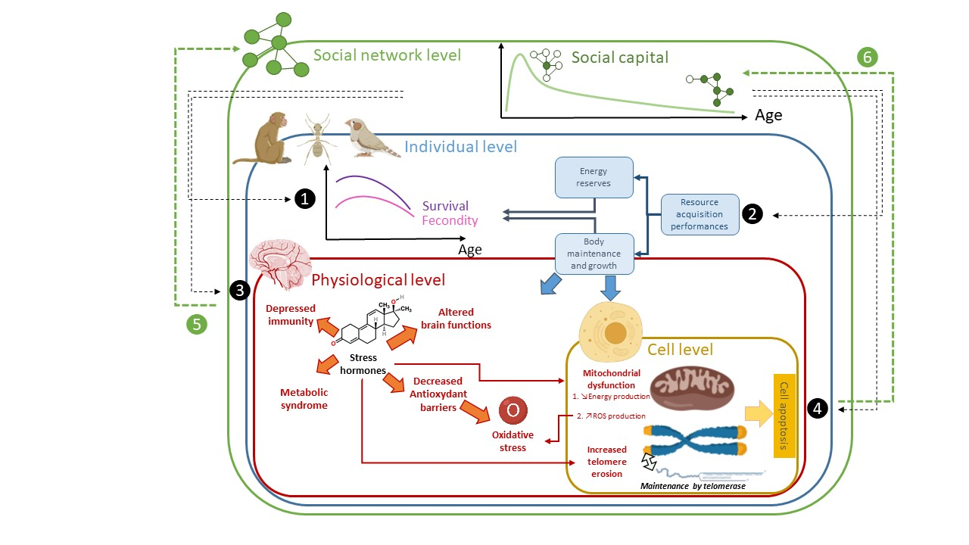
Figure I: Schema of the proposed mutual influence of social capital, chronological age and biological age, from the cell to the network.

Figure 1: Variation (y-axis) of social capital (blue), biological age (green) and health (orange) over chronological age (x-axis) for an individual having access to (a.) life-long high social capital, (b.) only early-life high social capital, (c.) late-life high social capital, and (d.) life-long low social capital. Curves are theoretical and based on past research conducted in different species that are cited in the main text. They represent the global trajectory of the dimensions over the lifetime of an individual. Health is a state of physical, mental and social well-being that depends on internal (senescence) and external (pathogens, pollutants, etc.) factors. Individuals die when health level reaches zero (dashed black line). Biological age is a sum of intrinsic proxies and predicts health and survival prospects. These schematic representations also raise questions pertaining to the limits of social capital influence (both positive and negative) on longevity and health (❶ and ❹), or indeed on the programming of physiological and social processes in early life that may counteract ageing even if social capital evaporates over age (❷, dashed orange and green lines representing how biological age and health would change without these programming effects). Finally, Figure 1 also highlights the reversible interaction with senescence (❸).

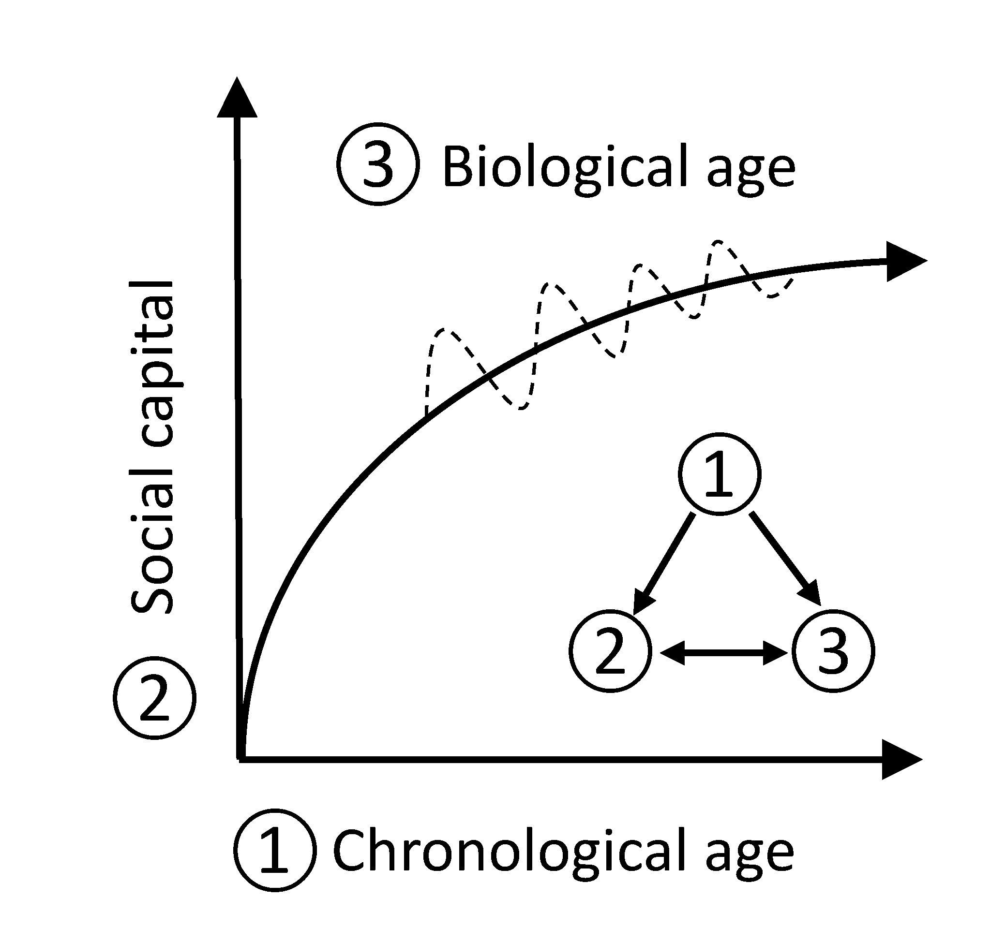
Figure 2: Changes in biological age (③, curved line) according to chronological age (①, x-axis) and social capital (②, y-axis). The dotted line represents variations observed in returning to a previous caste and solicitations in eusocial insects, but may result from intervention on social parameters in humans and other animals. The most recent research in animal species showed that biological age ③ is not only dependent on chronological age ① but also on social capital ② with an interplay between ② and ③. Interplay with ① cannot exist as chronological age cannot be inversed or slowdown.

Table S1: Components of social capital according to the studied species and the level of study.

 | Variations inside a same group/colony | Variations between groups/colonies | Interspecific variations
Eusocial species  (e.g. ants, bees) | Properties of social interactions including number and duration of interactions, type of interactions (e.g., trophallaxes, antenna-to-antenna, grooming), intra-caste or inter-caste interactions.  Spatial distribution of social interactions according to individual mobility patterns  Individual positions within the social system including, not exclusively, individual caste (e.g., male, queen, nest worker) or centrality index | Properties of the colony including, not exclusively, its size, the population distribution by caste (e.g., mono/polygyny, the ratio of individual between caste), and the colony age.  Properties of the whole system of social interactions using network indicators such as community separation and its resilience. | Properties of the colony, including , among others, its size, the caste system specific characterisct (e.g., number of reproductive individuals, marked division of labour, short or long-lived males, worker dimorphism)  Relation with other colonies including the tolerance level and belonging to supercolony.
Cooperative breeding species | Properties of social interactions including number and duration of interactions, type of interactions (e.g., grooming, agression, reproductive behavior)  Properties of social relationship which may include kinship, sex, reproductive status and dominance hierarchy  Individual positions within the social system including, not exclusively, individual status (e.g., reproductive or helpers) and its position between reproductive sub-groups | Properties of the colony, may include its size, the number of helpers and offsprings and the system of interactions between reproductive sub-groups | Properties of cooperative breedings, including if its faculative or systematic and the level of competition for reproduction between helpers and male breeder.  Properties of the social interaction system, including, the distribution of interaction within and between reproductive sub-groups.
Primate societies and similar mammal societies | Properties of social interactions including number and duration of interactions, type of interactions (e.g., grooming, agression, reproductive behavior, exchange of ressources) and their spatial distribution  Properties of social relationships, including, not exclusively, kinship, dominance, direction and reciprocity in conflicts and ressources exchange.  Individual position within the social structure, including, among others, centrality, belonging to certain subgroups and dominance relative to the whole hierarchy | Properties of the group, including their size, and their age/sex distribution  Cultural variation including, among others, tolerance in agression and exchange with non-kin, tool use  Properties of the interaction network, including, among other, the level of community division resulting from non-kin interactions.  Exchange with and tolerance of other groups (between-group competition) | Properties of the group, including, their size, the mating system, the hierarchical structures, and affiliation between non-kin.  Structure of the interaction networks including their size, community structure and efficacity in exchange of information and ressources
Humans | Quantity and quality of social relationships, qualities can include, but not exclusively, relation type (e.g., relatives, colleagues, friends), emotional closeness, relation satisfaction, trust, reciprocity or length of relationship.  Frequency and quality of social Interactions, qualities can include, but not exclusively, what is exchanged (e.g., affection, information, money), its valence (i.e., pleasant or unpleasant), the geospatial locations and the more complex activities in which interactions take place (e.g., weekly meeting at work).  Individual positions within the social structure which can include, not exclusively, centrality index, belonging to certain subgroup, or social status (e.g., employment, ethnicity, gender, age). | Sociodemographic properties, which can include, not exlusively, the distributions of age, gender , ethnicity, education and employment.  Properties of the whole system of social interactions using network indicators such as community division and assortative mixing.  Cultural aspects in terms, among others, of shared values and norms.  Organizationnal structure, from political, institutionnal to smaller collective and associative organization.  Relations and exchange in-between populations. | NA

