Title: Distance decay of community similarity in river networks: a Bayesian approach

Filipe S. Dias*^{1,2}, Michael Betancourt³, Patricia María Rodríguez-González⁴, Luís Borda de Água^{1,2}

Affiliations
1. CIBIO/InBio, Centro de Investigação em Biodiversidade e Recursos Genéticos, Laboratório Associado, Universidade do Porto, Campus Agrário de Vairão, 4485-661 Vairão, Portugal
2. CIBIO/InBio, Centro de Investigação em Biodiversidade e Recursos Genéticos, Laboratório Associado, Instituto Superior de Agronomia, Universidade de Lisboa, Tapada da Ajuda, 1349-017 Lisbon, Portugal
3. Centro de Estudos Florestais, Instituto Superior de Agronomia, Universidade de Lisboa, Tapada da Ajuda, 1349-017 Lisboa, Portugal
4. Symplectomorphic, LLC., New York, USA

Abstract

The distance decay of community similarity (DDCS) is a pattern that is widely observed in terrestrial and aquatic environments. Niche-based theories argue that species are sorted in space according to their ability to adapt to new environmental conditions. The ecological neutral theory argues that community similarity decays due to ecological drift. The continuum hypothesis argues that niche and neutral factors are at the opposite ends of a continuum that ranges from competitive to stochastic exclusion. We assessed the association between niche-based and neutral factors and changes in community similarity measured by Sorensen’s index in riparian plant communities. We considered network distances and flow connection as neutral variables and Strahler order differences and precipitation differences as niche-based variables. We used a hierarchical Bayesian approach to determine which perspective is best supported by the results. We used a high-quality dataset composed of 338 vegetation censuses from eleven river basins in continental Portugal. We observed that changes in Sorensen indices were associated with all covariates but to different degrees. The results suggest that community similarity changes are associated with environmental and neutral factors, supporting the continuum hypothesis.

Keywords: Beta diversity; distance decay rate; hierarchical models; network distance; plant community; riparian ecosystem; Sorensen index

1. Introduction

The distance decay of community similarity (DDCS) states that geographically close communities tend to be more similar than those that are further apart (Nekola and White 1999; Soininen and others 2007). The DDCS is implicit in several ecological phenomena such as species turnover along environmental gradients (e.g., Whittaker 1975), source-sink dynamics (Pulliam 1988, 2000), metapopulations (Hanski and Gilpin 1991), and the theory of island biogeography (MacArthur and Wilson 2001). There are three major perspectives or hypothesis for explaining this ecological pattern (Tuomisto and Ruokolainen 2006; Soininen and others 2007; Astorga and others 2012). Niche-based theories argue that as environmental conditions change, species are sorted according to their ability to adapt to new conditions and habitats (Leibold and others 2004; Nekola and Brown 2007). The ecological neutral theory (Hubbell 2001) argues that community similarity decays due to ecological stochasticity, caused by random births and deaths in a population (i.e., ecological drift) (Fodelianakis and others 2020), random dispersal, and dispersal limitation. The continuum hypothesis provides an intermediate perspective, arguing that niche and neutral factors are, in fact, at the opposite ends of a continuum that ranges from competitive exclusion to stochastic exclusion and can have different relevant importance (Gravel and others 2006). Understanding the ecological mechanisms that underpin the DDCS is crucial for analysing changes in community composition and for correctly identifying the impacts of activities and for developing effective conservation plans (Legendre et al., 2005; Wilson et al., 2009)

The first studies that analysed community composition changes as a function of distance date from the 1960s and focused on characterising its mathematical form (e.g., Whittaker 1960, Preston 1962 Whittaker 1960, Preston 1962). In 1999, Nekola and White (1999) laid the foundations for using distance decay rates to describe, compare and understand biodiversity patterns (Morlon and others 2008). The authors examined distance decay rates in vascular plants and bryophytes of boreal and montane spruce-fir forests in North America and observed negative exponential decay rates. More importantly, they observed that decay rates varied between vascular plants and bryophytes, with growth forms, dispersal methods and the scale of analysis. Subsequent studies built on the framework of Nekola and White (1999) by adding the analysis of how changes on environmental covariates also affect community similarity (e.g. Tuomisto 2003, Soininen et al. 2007, Gómez-Rodríguez and Baselga 2018).

So far few studies analysed the DDCS in riverine ecosystems. Notably, data for riparian plant communities are relatively scarce, and the few available studies revealed mixed evidence. For instance in the UK, Rouquette and others (2013) studied an urban river network and found no significant association between distance and changes in plant community similarity after accounting for environmental differences. In Toronto, Canada, Kuglerová and others (2015) studied riparian vegetation in seven river basins and found that after accounting for environmental differences, the distance was only a significant predictor for community composition changes in three out of seven basins. Finally, in China, Zhang et al. (2019) studied aquatic macrophytes in a large river basin and concluded that community similarity changes were significantly associated with distance, even after accounting for environmental covariates. Despite these studies, there is a significant knowledge gap in the literature concerning analysing the factors that best explain the DDCS in riparian plant communities. Moreover, no studies tried to assess the relative importance of niche-based factors and neutral factors, crucial to understand structure and process in riverine ecosystems.

In this study, we analysed the factors that are associated with the DDCS in riparian plant communities. Specifically, we assessed 1) the relationship between niche-based and neutral factors and changes in community similarity, and 2) determined which of the three following perspectives best supported the results, that is, niche-based theory, neutral theory or the continuum hypothesis. We used a high-quality dataset composed of 338 vegetation censuses conducted in eleven river basins in continental Portugal, covering a wide range of geomorphological, climatic, and hydrological conditions.

2. Methods

2.1 Study area

This study took place in mainland Portugal, southwestern Europe between 37° and 42° N (Fig. 1). The northern half is hilly, with 95% of the area above 400 m, while the south is flatter, with 62% of the area below 200 m. The climate ranges between Temperate in the North and Mediterranean in central and southern Portugal and presents a significant climatic and altitudinal gradient (Olson and others 2001). In general, temperature increases and precipitation decreases when moving from north to south and west to east. Mean annual temperatures range between 7°C in the mountains of central Portugal and 18 °C in the southern coastal region. The highest mean annual precipitation occurs along the highlands in the northwestern region (> 3000 mm/year) and the lowest along the southern coast and the eastern part of the territory (below or around 500 mm). On average, about 42% of the annual precipitation falls during the winter season (December–February), and only 6% during Summer (June–August) (Miranda and others 2002).

2.2 Data collection and processing

The vegetation data were collected between 2003-2006 in 404 sites across 38 river basins in continental Portugal during the pre-assessment surveys conducted to implement the Water Framework Directive (WFD) (CIS-WFD 2003; INAG 2008; Agência Portuguesa do Ambiente 2012). We followed the protocol established for the WFD implementation (INAG 2008 p. 2), which involved establishing a 100-meter plot along the fluvial corridor with a width corresponding to regular floods in each site and identifying all vascular plants. No plant specimens were collected or damaged during fieldwork. We removed all basins with fewer than ten vegetation surveys leaving 11 river basins and 338 sites. We used the river network provided by the CCM River and Catchment Database - Version 2.0 (Vogt and Foisneau 2007).

We calculated the Sorensen similarity index between pairs of sites within the same river basin with:
$$SorensenIndex=\frac{2a}{2a+b+c}$$

where a is the number of species in common between both sites, b is the number of unique species on the first site, and c is the number of unique species on the second site. Therefore, the Sorensen index is the number of species in common between two sites divided by their average number of species. An index value of 1 indicates that communities have the same species composition, while 0 indicates that communities share zero species. We run calculations with the package “vegan” (Oksanen and others 2019) using R 4.0.4 (R Core Team 2021).

To analyse how the Sorensen index changes between vegetation samples, we collected two groups of covariates: neutral and niche-based covariates (Table 1). As neutral covariates, we considered the network distance and flow connection. The concept of distance, however, deserves some considerations. Authors usually measure the distances between communities using the Euclidean distance in terrestrial ecosystems, which is the straight line distance between two sites. However, in riverine ecosystems habitats, the Euclidean distance does not adequately account for the functional link between the species and communities within the river network (Rodríguez-González and others 2019). An alternative is to measure the network distance, which is the distance between two sites along with the river network. Indeed, our data shows that several geographically close samples, as characterised by a small Euclidean distance, were separated by large network distances. These more extreme observations presented more complex behaviours than the rest of the samples, which were not well-modelled by the general linear model. To avoid this modelling difficulty, we excluded these observations (i.e. those distances between pairs of sites) and selected only those where the ratio between the network distance and the Euclidean distance was equal or lower than 2. Consequently, our inferences will not generalise to these more extreme circumstances. As such, the number of observations reduced from 7846 to 3857. In addition to network distances, we also calculated the covariate flow connection, which is a binary variable that denotes whether two vegetation samples are connected by flow (1) or not (0). We calculated the network distance and flow connection with the R package “igraph” (Csardi and Nepusz 2005) and “shp2graph” (Lu and others 2018).

During the initial stage of the analysis, we considered several climate variables such as mean, maximum, and minimum annual temperatures and precipitation as niche-based covariates. However, due to high correlations we only included precipitation in the final model. Annual precipitation is a good proxy for relative humidity, hydrological regime, and potential evapotranspiration. These are good predictors for riparian plant communities' composition in Mediterranean environments (Stella and others 2013). We calculated the absolute value of the difference in mean annual precipitation between two sites using data between 1960 and 1990 (Monteiro-Henriques and others 2016). We also included the Strahler order, a measure of network position and stream size. We consider the Strahler order a niche variable because streams with lower Strahler order tend to be shallower, narrower, and closer to the river source. In comparison, streams with higher Strahler order are deeper, broader, and closer to the river mouth, thus denoting several environmental characteristics of the riverine ecosystem (Vannote and others 1980; Ward and Stanford 1995). We calculated the absolute value of the difference in Strahler order using Strahler order values provided by the CCM River and Catchment Database Version 2.0 (Vogt and Foisneau 2007).

2.3 Data analysis

To analyse the data, we used a hierarchical Bayesian method following the approach developed by Dias et al. (2021). We begin by introducing the model’s formula and then provide a more detailed explanation.

Likelihood
Sorensen index ~ Beta distribution (μ, κ)

logit(μ) = α _{baseline} + α_{s[comm. 1]} + α_{s[comm. 2]}+ α_{c[basin]} + α_{o[strahler]} + β1_{[basin]} Network distance + β2_{[basin]} Flow connection + β3_{[basin]} Precipitation difference

Priors
α _{baseline} ~ Normal (0,0.3)
α_{s} ~ Normal (0,σ_{s})
σ_{s}~ Exponential(1)
α_{c} ~ Normal (0,0.3)
α_{o} ~ Normal (0,σ_{Strahler})
σ_{Strahler} ~ Exponential (2)
β1_{[basin]} ~ Normal (μ_{distance}, σ_{distance})
β2_{[basin]} ~ Normal (μ_{flow}, σ_{flow})
β2_{[basin]} ~ Normal (μ_{precipitation}, σ_{precipitation})
μ_{distance}, μ_{flow ,} μ_{precipitation,} ~ Normal (0,0.3)
σ_{distance}, σ_{flow,} σ_{precipitation} ~ Exponential (2)
κ ~ Normal (0,50)

We modelled Sorensen indices with a Beta distribution using the mean (μ) and sample size (κ) parameterisation" (Stan Development Team 2020a) because similarity indices range between 0 and 1. To make sure location parameter μ is bounded between 0 and 1 we modelled the logit of μ in a linear model of the covariates. The terms α_{s[comm. 1]} and α_{s[comm. 2]} are additive varying intercepts that incorporate the dependence resulting from having Sorensen indices calculated with the same sample (Dias et al 2021). By definition, each Sorensen index is paired comparison between two ecological communities, therefore we need to explicitly model the contributions of both communities that comprise each Sorensen index observation. The term α_{c} is a varying intercept with 11 levels representing each river basin's independent contribution. To capture the influence of the Strahler order difference, we introduced a varying intercept α_{o} with seven levels representing the independent contribution of Strahler order difference. This approach allows the model to capture expected nonlinear correlations between the logit(μ) and Strahler order differences. Flow connection, network distance, and precipitation differences were added as regular covariates to the model. To improve model fit we transformed both covariates. Rather than dividing by the mean and dividing the result by its standard deviation we decided to use values determined by our domain expertise, which improves the interpretability and generalizability of the resulting inferences. We transformed network distance values by subtracting 100 km to observed values and divided the resulting value by 100. We believe that given the study area’s characteristics 100 km is a reasonable threshold beyond which we can expect to find changes in community composition due to ecological drift. Therefore, a slope of, for instance, -0.10 means that an increase of 1 km in the network distance beyond a baseline of 100 km will decrease Sorensen indices by -0.10. Precipitation difference values were log-transformed with log(x+1). Afterwards, we subtracted 5.71 ( log(300 mm +1) = 5.71) and divided the resulting value by 5.71. We selected 300 mm because it is the average minimum precipitation value for Mediterranean climates. A slope of -0.1 indicates that if the precipitation difference increases by 1 mm beyond 300 mm (log(300 mm +1) = 5.71), the Sorensen index will change by - 0.10. The slopes for these three covariates were sampled from a hierachical distribution (i.e., hyper prior) that generates parameters for all eleven river basins. Slope estimates obtained in this fashion are more precise at the river basin level and usually more robust to extreme observations (McElreath 2020). We interpreted the posterior distribution of μ_{distance}, μ_{flow} , and μ_{precipitation} as the average effect of the covariate on Sorensen indices if we were to go out into the field to gather vegetation samples from additional river basins.

We based our prior distribution choices on the work of Rodríguez-González and others (2008) and assumed that most vegetation censuses should share between 25 and 65% of the species. The probability of finding distributions with very few or very high numbers of species in common should be low. To verify this we inspected 1000 Sorensen similarity index distributions. Concerning the covariates, we chose weakly informative priors that permit both positive and negative relationships between Sorensen indices and covariates.

To check that our model captures the data's relevant structure, we compared the observed distribution of the Sorensen indices with the posterior distribution of Sorensen indices. Specifically, we 1) plotted the differences between the posterior distribution and the observed Sorensen indices (i.e., error distributions) conditional on covariates and 2) plotted the posterior distribution of Sorensen indices against the covariates. We checked for systematic deviations that indicated structure in the data that our model was unable to capture. We assessed the relative importance of neutral and niche-based covariates using two criteria: 1) by determining whether 95% of the parameter's posterior distribution was above or below 0 and 2) by assessing the parameter's magnitude.

We used the software Stan via the R package “rstan” version 2.18.3 (Stan Development Team 2020b) and run the models with four independent Markov chains to sample from, with 1000 warmup iterations and 2000 sampling iterations. To check if our Markov chains were stationary and enabled reasonable posterior expectation value estimators, we performed both qualitative and quantitative diagnostics. In addition, to spot-checking traceplots, we checked that the split potential scale reduction factor (Rhat) was consistent with 1 for all functions of interest and verified that there were no divergent transitions or Markov chains that saturated the maximum tree depth.

Throughout the manuscript, we use the term "retrodictive" instead of "predictive" to refer to the process of comparing predicted results with observed data (Betancourt 2020).

3. Results

Prior predictive checks

We obtained 1000 simulations of Sorensen indices from the prior model and observed that most distributions present a high probability mass between 25 to 65% of the species (Fig. 2 left) which is in accordance with our goal.

Model validation

The chains were stationary and well mixing with Rhat values of ~1. No iterations ended with divergences or saturated the maximum tree depth. The posterior retrodictive distribution of Sorensen indices closely matched the observed distribution of Sorensen indices except for values below 0.05, which are slightly overestimated, and for values above 0.62, which are slightly underestimated. We found no systematic deviations between our data and model (Fig. 3 and Appendix 1).

Neutral variables

Network distance was negatively associated with Sorensen similarity indices, with mean slope estimates ranging between -0.16 for the Douro and -0.75 for the Cávado and Vouga basins. In Mira and Minho basins, a small part of the 95% credibility intervals crosses zero, which means a small probability that the slopes are zero or slightly positive (Fig. 3). The mean estimate for μ_{distance} is -0.37 with a 95% credibility interval [-0.55, -0.19], which means that on average, network distance has a negative effect on Sorensen similarity indices.

Vegetation samples connected by streamflow seem to be slightly more similar than those that are not. Mean slope estimates were relatively small but predominantly positive except for Mondego basin's slope, whose estimate was 0. For the remaining basins, mean estimates ranged between 0.02 and 0.06 (Fig. 3). All 95% credibility intervals crossed 0, which means that weakly negative contributions are also consistent with the data. The mean estimate for μ_{flow} is 0.04 [-0.02, 0.10], which suggests flow connection is likely to have an average small positive effect on Sorensen similarity indices. However, there is a small probability that this contribution is weakly positive.

Niche-based variables

Strahler order difference had a negative association with community similarity. Sorensen indices seem to decrease linearly when Strahler order differences change between 0 and 4, but this decrease is steeper when Strahler order increases to 5 and mainly to 6 (Fig. 3).

Higher differences in precipitation are associated with lower levels of community similarity. The mean estimates for precipitation difference slopes were negative, with mean values ranging between -0.53 and -0.12 (Fig. 3). However, in six out of eleven basins, credibility intervals crossed zero, indicating the effect could also be weakly positive with varying degrees of probability. For instance, over 30% of Mira's basin parameter distribution is on the right side of zero.

4. Discussion

In this work, we analysed the influence of neutral and niche-based factors on the distance decay of community similarity (DDCS) in riparian plant communities of eleven river basins in continental Portugal. We considered two neutral covariates, network distance and flow connection, and two niche-based covariates, precipitation difference, and Strahler order difference.

Network distance was positively associated with lower community similarity. The ecological neutral theory argues the DDCS is caused by ecological drift, which consists of random extinctions, species replacement (Hubbell 2001; Muneepeerakul and others 2007), and by random dispersal coupled with dispersal limitations (Thompson and Townsend 2006). As distances increase, the probability of successful seed dispersal decreases (e.g., Steinitz and others 2006; Nilsson and others 2010; Gelmi‐Candusso and others 2019), which can explain why community similarity decreases with distance. Still, we cannot rule out the possibility that an unmeasured covariate correlated with network distance may have caused this result. For instance, drought-related habitat fragmentation could hinder seed dispersal (Rodríguez-González et al., 2019) and cause identical reductions in community similarity. However, we believe that the covariate precipitation difference already captures drought-related effects.

Vegetation samples connected by water flow seem to be more similar than those that are not. Indeed, flow connectivity is responsible for high level of diversity in fluvial ecosystems (Ward and others 2002). Most riparian plant species have the ability to disperse seeds through water (Fraaije and others 2017), explaining why communities connected by streamflow share a higher number of species, and the pattern of increased richness in a downstream direction (Bendix 1997; Kuglerová and others 2016; Wubs and others 2016). This result may be also caused by an association between streamflow and katabatic winds. Air masses that are thermally forced from higher to lower altitudes usually travel along the same pathways that rivers flow on (Carrera and others 2009). These air masses can transport seeds and pollinators along with river networks, thus increasing community similarity (Kuparinen and others 2009; Soomers and others 2013). Another possibility is that pollinators may be more prone to move along river corridors following their foraging preferences (Jones 1997), thus contributing to higher community similarities.

Community similarity was higher between vegetation samples experiencing lower differences in precipitation. Continental Portugal exhibits a high precipitation gradient. This spatial and temporal variability in precipitation results in some regions/periods of the year experiencing frequent droughts during the summer and others experiencing intense floods during the winter (Stella and others 2013). Plant communities have thus adapted to these conditions. In drier areas, riparian ecosystems harbour a higher number of terrestrial plants and proportionally fewer strictly riparian or aquatic species (Ferreira and Aguiar 2005). In wetter regions, the prevalence of species adapted to waterlogged and frequently flooded is considerably higher (Ferreira and Aguiar 2005). This community composition pattern may cause a negative relationship between community similarity and precipitation difference.

Overall, community similarity decreases with increasing Strahler order differences. This result suggests that riparian plant communities located closer to the river's source (lower Strahler order) tend to differ from those closest to the river's mouth (higher Strahler order), even after accounting for network distance. Moreover, this difference increases with increasing separation in river networks, particularly when Strahler order differences increase to five and six. Differences in community composition may be explained by differences in environmental features upstream and downstream (Petts and Amoros, 1996) such as elevation, channel gradient, valley constraints, geomorphic processes, and substrate diversity (Vannote and others 1980; Ward and Stanford 1995, Stella and others, 2006). An alternative explanation for for this result are confluence effects (Benda and others 2004). When two rivers meet, water and sediment influx changes affect channel and floodplain morphology and alter the composition of riparian plant communities, which could produce similar results to those we observed.

In summary, our model results suggest that community similarity changes are associated with both environmental and neutral factors. Both niche-based and neutral variables were associated with non-null changes in Sorensen indices. Network distances and Strahler order differences had the largest effect sizes, followed by precipitation difference and flow connection. Overall, the results are consistent with the continuum hypothesis that states that niche and neutral factors form at opposite ends of a continuum (Gravel et al. 2006). The results from this study contribute to improving our knowledge of the processes that shape riparian ecosystems and underline the importance of considering both environmental and neutral factors when analysing changes in community composition.

5. Acknowledgments

FD, LBA and PMRG were financed by the Fundação para a Ciência e a Tecnologia (FCT).FD through project POCI-01-0145-FEDER-028729, LBA under the Norma Transitória – L57/2016/CP1440/CT0022, and PMRG through Investigador FCT (IF/00059/2015) and CEEC (2020.03356.CEECIND).

6. Author contributions
FD, MB, PRG and LBA conceived the paper and designed methodology. PRG collected the data. FD and MB analysed the data. FD led the writing of the manuscript. All authors contributed critically to the drafts and gave final approval for publication.

7. References
Agência Portuguesa do Ambiente. 2012. Plano de Gestão da Região Hidrográfica do Tejo, Relatório técnico, Versão Extensa Parte 2 – Caracterização e Diagnóstico da Região Hidrográfica. Lisboa: Agência Portuguesa do Ambiente

Astorga A, Oksanen J, Luoto M, Soininen J, Virtanen R, Muotka T. 2012. Distance decay of similarity in freshwater communities: do macro- and microorganisms follow the same rules?: Decay of similarity in freshwater communities. Glob Ecol Biogeogr 21:365–75.

Benda L, Poff NL, Miller D, Dunne T, Reeves G, Pess G, Pollock M. 2004. The Network Dynamics Hypothesis: How Channel Networks Structure Riverine Habitats. BioScience 54:413–27.

Bendix J. 1997. Flood Disturbance and the Distribution of Riparian Species Diversity. Geogr Rev 87:468–83.

Betancourt M. 2020. Hierarchical Modeling. Retrieved from https://github.com/betanalpha/knitr_case_studies/tree/master/hierarchical_modeling, commit 27c1d260e9ceca710465dc3b02f59f59b729ca43

Carrera M, Gyakum J, Lin C. 2009. Observational Study of Wind Channeling within the St. Lawrence River Valley. J Appl Meteorol Climatol 48.

CIS-WFD. 2003. River and lakes – Typology, reference conditions and classification systems, Common Implementation Strategy for the Water Framework Directive (2000/60/EC), Guidance document no 10. Luxembourg: Office for Official Publications of the European Communities

Csardi G, Nepusz T. 2005. The Igraph Software Package for Complex Network Research. InterJournal Complex Systems:1695.

Dias FS, Betancourt M, Rodríguez-González PM, Borda-de-Água L. 2021. A hierarchical Bayesian approach for modeling changes in species composition. https://ecoevorxiv.org/sn5jr/. Last accessed 09/04/2021

Ferreira MT, Aguiar F. 2005. Riparian and aquatic vegetation in Mediterranean-type streams (western Iberia). Limnetica 25:411–24.

Fodelianakis S, Valenzuela-Cuevas A, Barozzi A, Daffonchio D. 2020. Direct quantification of ecological drift at the population level in synthetic bacterial communities. ISME J:1–12.

Fraaije RGA, Moinier S, Gogh I van, Timmers R, Deelen JJ van, Verhoeven JTA, Soons MB. 2017. Spatial patterns of water-dispersed seed deposition along stream riparian gradients. PLOS ONE 12:e0185247.

Gelmi‐Candusso TA, Bialozyt R, Slana D, Gómez RZ, Heymann EW, Heer K. 2019. Estimating seed dispersal distance: A comparison of methods using animal movement and plant genetic data on two primate-dispersed Neotropical plant species. Ecol Evol 9:8965–77.

Gómez-Rodríguez C, Baselga A. 2018. Variation among European beetle taxa in patterns of distance decay of similarity suggests a major role of dispersal processes. Ecography 41:1825–34.

Gravel D, Canham CD, Beaudet M, Messier C. 2006. Reconciling niche and neutrality: the continuum hypothesis: Reconciling niche and neutrality. Ecol Lett 9:399–409.

Hanski I, Gilpin M. 1991. Metapopulation dynamics: brief history and conceptual domain. Biol J Linn Soc 42:3–16.
Hubbell S. 2001. The Unified Neutral Theory of Biodiversity and Biogeography (MPB-32). Princeton University Press https://www.jstor.org/stable/j.ctt7rj8w. Last accessed 16/10/2019

INAG. 2008. Manual para a avaliação biológica da qualidade da água em sistemas fluviais segundo a DQA - Protocolo de amostragem e análise para os macrófitos. Lisboa, Portugal

Jones KN. 1997. Analysis of pollinator foraging: tests for non-random behaviour. Funct Ecol 11:255–9.

Kuglerová L, Jansson R, Sponseller RA, Laudon H, Malm-Renöfält B. 2015. Local and regional processes determine plant species richness in a river-network metacommunity. Ecology 96:381–91.

Kuglerová L, Dynesius M, Laudon H, Jansson R. 2016. Relationships Between Plant Assemblages and Water Flow Across a Boreal Forest Landscape: A Comparison of Liverworts, Mosses, and Vascular Plants. Ecosystems 19:170–84.

Kuparinen A, Katul G, Nathan R, Schurr FM. 2009. Increases in air temperature can promote wind-driven dispersal and spread of plants. Proc R Soc B Biol Sci 276:3081–7.

Legendre P, Borcard D, Peres-Neto PR. 2005. Analyzing Beta Diversity: Partitioning the Spatial Variation of Community Composition Data. Ecol Monogr 75:435–50.
Leibold MA, Holyoak M, Mouquet N, Amarasekare P, Chase JM, Hoopes MF, Holt RD, Shurin JB, Law R, Tilman D, Loreau M, Gonzalez A. 2004. The metacommunity concept: a framework for multi-scale community ecology. Ecol Lett 7:601–13.

Lu B, Sun H, Harris P, Xu M, Charlton M. 2018. Shp2graph: Tools to Convert a Spatial Network into an Igraph Graph in R. ISPRS Int J Geo-Inf 7:293.

MacArthur RH, Wilson EO. 2001. The Theory of Island Biogeography. Princeton University Press

McElreath R. 2020. Statistical Rethinking: A Bayesian Course with Examples in R and Stan. 2 edition. Boca Raton: Chapman and Hall/CRC

Miranda P, Coelho F, Tomé A, Valente M. 2002. Climate Change in Portugal. Scenarios, Impacts and Adaptation Measures - SIAM Project. (Santos F, Forbes K, Moita R, editors.). Lisboa: Gradiva

Monteiro-Henriques T, Martins MJ, Cerdeira JO, Silva P, Arsénio P, Silva Á, Bellu A, Costa JC. 2016. Bioclimatological mapping tackling uncertainty propagation: application to mainland Portugal. Int J Climatol 36:400–11.

Morlon H, Chuyong G, Condit R, Hubbell S, Kenfack D, Thomas D, Valencia R, Green JL. 2008. A general framework for the distance-decay of similarity in ecological communities. Ecol Lett 11:904–17.

Muneepeerakul R, Weitz JS, Levin SA, Rinaldo A, Rodriguez-Iturbe I. 2007. A neutral metapopulation model of biodiversity in river networks. J Theor Biol 245:351–63.

Nekola JC, Brown JH. 2007. The wealth of species: ecological communities, complex systems and the legacy of Frank Preston. Ecol Lett 10:188–96.

Nekola JC, White PS. 1999. The distance decay of similarity in biogeography and ecology. J Biogeogr 26:867–78.

Nilsson C, Brown RL, Jansson R, Merritt DM. 2010. The role of hydrochory in structuring riparian and wetland vegetation. Biol Rev Camb Philos Soc 85:837–58.

Oksanen J, Blanchet FG, Friendly M, Kindt R, Legendre P, McGlinn D, Minchin PR, O’Hara RB, Simpson GL, Solymos P, M. Henry H. Stevens, Szoecs E, Helene Wagner. 2019. vegan: Community Ecology Package. R package version 2.0-10, http://CRAN.R-project.org/package=vegan https://CRAN.R-project.org/package=vegan

Olson DM, Dinerstein E, Wikramanayake ED, Burgess ND, Powell GVN, Underwood EC, D’amico JA, Itoua I, Strand HE, Morrison JC, Loucks CJ, Allnutt TF, Ricketts TH, Kura Y, Lamoreux JF, Wettengel WW, Hedao P, Kassem KR. 2001. Terrestrial Ecoregions of the World: A New Map of Life on Earth. BioScience 51:933.

Preston FW. 1962. The Canonical Distribution of Commonness and Rarity: Part II. Ecology 43:410–32.

Pulliam H. 1988. Sources, Sinks, and Population Regulation. Am Nat 132:652–61.

Pulliam HR. 2000. On the relationship between niche and distribution. Ecol Lett 3:349–61.

R Core Team. 2021. R: A Language and Environment for Statistical Computing. Vienna, Austria: R Foundation for Statistical Computing https://www.R-project.org/

Rodríguez-González PM, Ferreira MT, Albuquerque A, Santo DE, Rego PR. 2008. Spatial variation of wetland woods in the latitudinal transition to arid regions: a multiscale approach. J Biogeogr 35:1498–511.

Rodríguez-González PM, García C, Albuquerque A, Monteiro-Henriques T, Faria C, Guimarães JB, Mendonça D, Simões F, Ferreira MT, Mendes A, Matos J, Almeida MH. 2019. A spatial stream-network approach assists in managing the remnant genetic diversity of riparian forests. Sci Rep 9:6741.

Rouquette JR, Dallimer M, Armsworth PR, Gaston KJ, Maltby L, Warren PH. 2013. Species turnover and geographic distance in an urban river network. Mac Nally R, editor. Divers Distrib 19:1429–39.

Soininen J, McDonald R, Hillebrand H. 2007. The distance decay of similarity in ecological communities. Ecography 30:3–12.

Soomers H, Karssenberg D, Soons M, Verweij PA, Verhoeven J, Wassen M. 2013. Wind and Water Dispersal of Wetland Plants Across Fragmented Landscapes. Ecosystems 16:434–51.
Stan Development Team. 2020a. Stan Functions Reference Version 2.25.

Stan Development Team. 2020b. Stan Modeling Language Users Guide and Reference Manual, Version 2.2.4. http://mc-stan.org

Steinitz O, Heller J, Tsoar A, Rotem D, Kadmon R. 2006. Environment, Dispersal and Patterns of Species Similarity. J Biogeogr 33:1044–54.

Stella JC, Rodríguez-González PM, Dufour S, Bendix J. 2013. Riparian vegetation research in Mediterranean-climate regions: common patterns, ecological processes, and considerations for management. Hydrobiologia.

Thompson R, Townsend C. 2006. A truce with neutral theory: local deterministic factors, species traits and dispersal limitation together determine patterns of diversity in stream invertebrates: Neutral theory and local determinism. J Anim Ecol 75:476–84.

Tuomisto H. 2003. Dispersal, Environment, and Floristic Variation of Western Amazonian Forests. Science 299:241–4.

Tuomisto H, Ruokolainen K. 2006. Analysing or explaining beta diversity? Understanding the targets of different methods of analysis. Ecology 87:2697–708.

Vannote RL, Minshall GW, Cummins KW, Sedell JR, Cushing CE. 1980. The River Continuum Concept. Andersen NR, Zahuranec BJ, editors. Can J Fish Aquat Sci 37:130–7.

Vogt J, Foisneau S. 2007. CCM River and Catchment Database - Version 2.0 Analysis Tools. European Commission, Joint Research Center, Institute for Environment and Sustainability
Ward JV, Stanford JA. 1995. The serial discontinuity concept: Extending the model to floodplain rivers. Regul Rivers Res Manag 10:159–68.

Ward JV, Tockner K, Arscott DB, Claret C. 2002. Riverine landscape diversity. Freshw Biol 47:517–39.

Wilson KA, Cabeza M, Klein CJ. 2009. Fundamental Concepts of Spatial Conservation Prioritization. In: Moilanen A, Wilson KA, Possingham HP, editors. Spatial Conservation Prioritization: Quantitative Methods & Computational Tools. Oxford University Press, USA. Pp 16–27.

Whittaker RH. 1960. Vegetation of the Siskiyou Mountains, Oregon and California. Ecol Monogr 30:279–338.

Whittaker RH. 1975. Communities and ecosystems. New York: MacMillan Publishing

Wubs ERJ, Fraaije RGA, Groot GA de, Erkens RHJ, Garssen AG, Kleyheeg E, Raven BM, Soons MB. 2016. Going against the flow: a case for upstream dispersal and detection of uncommon dispersal events. Freshw Biol 61:580–95.

Zhang Z, Gao J, Cai Y. 2019. The effects of environmental factors and geographic distance on species turnover in an agriculturally dominated river network. Environ Monit Assess 191:201.

Figure 1 –Continental Portugal and the location of the vegetation plots in the eleven river basins studied (red dots).

Figure 2 – Density plots showing prior predictive distribution (left) and the observed
distribution of Sorensen indices (thick line) against 1000 posterior distributions (thin lines)
(right).

Figure 3 – Posterior estimates for the parameters corresponding to the network distance, flow connection, precipitation difference and Strahler order difference. The parameter μ is the mean of the normal distribution where slopes are sampled. Dark blue lines represent 95% credibility intervals. The thin light blue line represents the complete distribution of the parameters. The dot represents the marginal posterior mean.

Table 1- Covariates used in the models

Classification | Variable | Description and units
Neutral | Network distance | Network distance between a pair of vegetation samples (km)
Neutral | Flow connection | 1-samples are flow connected, 0 - samples are not flow connected
Niche-based | Strahler order difference | Strahler order difference between the pair of vegetation samples.
Niche-based | Precipitation difference | Difference in annual precipitation between the pair of vegetation samples.

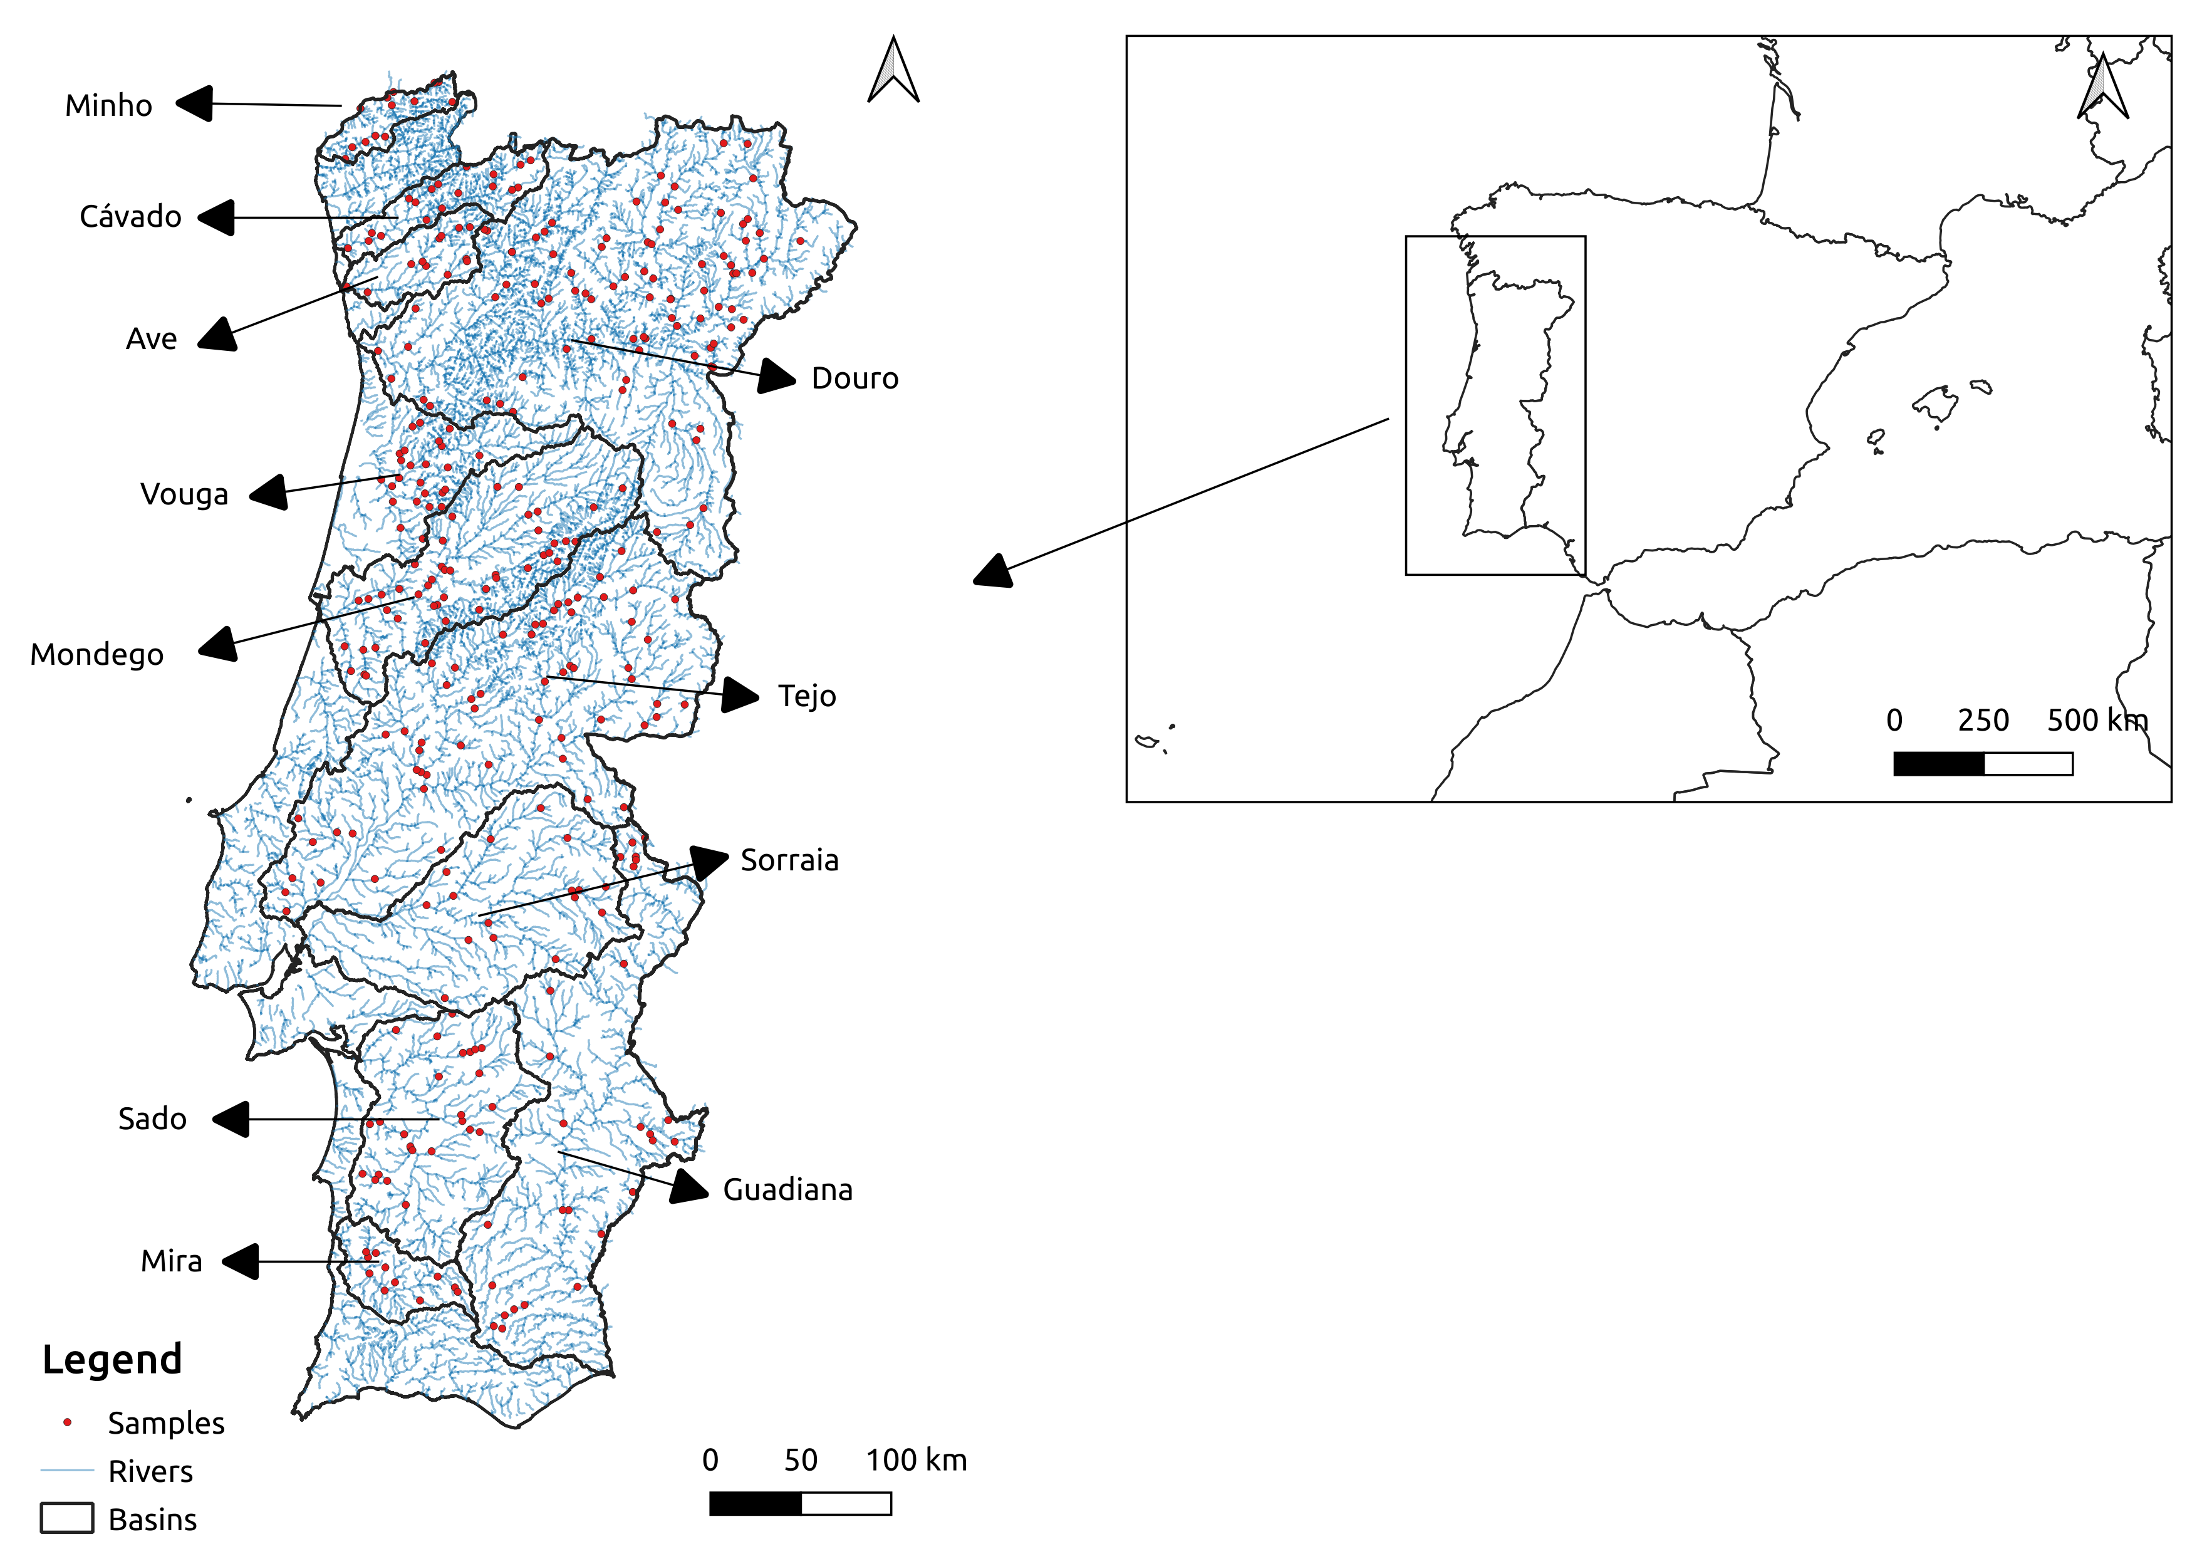

Figure 1 –Continental Portugal and the location of the vegetation plots in the eleven river basins studied (red dots).

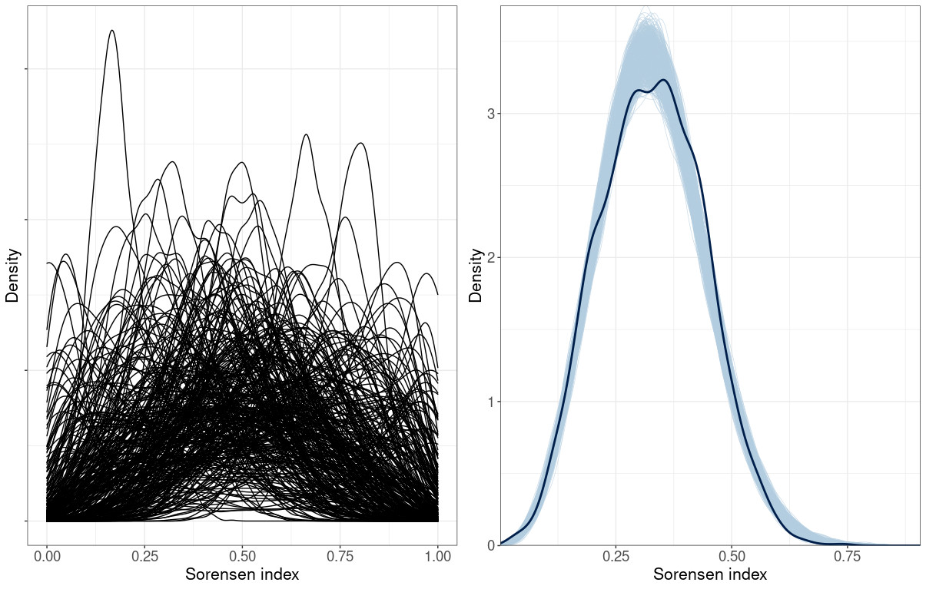

Figure 2 – Density plots showing prior predictive distribution (left) and the observed
distribution of Sorensen indices (thick line) against 1000 posterior distributions (thin lines)
(right).

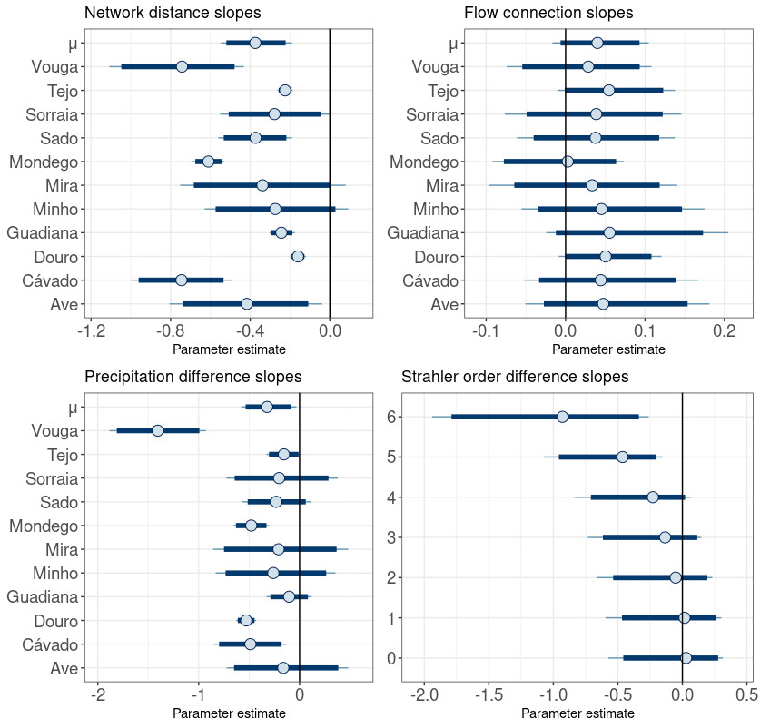

Figure 3 – Posterior estimates for the parameters corresponding to the network distance, flow connection, precipitation difference and Strahler order difference. The parameter μ is the mean of the normal distribution where slopes are sampled. Dark blue lines represent 95% credibility intervals. The thin light blue line represents the complete distribution of the parameters. The dot represents the marginal posterior mean.

