Optimizing stable isotope sampling design in movement ecology research

Contina A¹, Magozzi S ², Vander Zanden HB ³, Bowen GJ ⁴,Wunder MB¹

¹ Dept of Integrative Biology, University of Colorado Denver, 1151 Arapahoe St, Denver, CO 80204, USA.

² Department of Integrative Marine Ecology, Stazione Zoologica Anton Dohrn, Fano Marine Centre, Fano (PU), Italy.

³ Dept. of Biology, University of Florida, PO Box 118525, Gainesville, FL 32611-8525, USA.

⁴ Dept. of Geology and Geophysics, University of Utah, 115 S 1460 E, Salt Lake City, UT 84112, USA.

Correspondence
Andrea Contina
andrea.contina@ucdenver.edu

ABSTRACT
- The recognition of adequate sampling designs is an interdisciplinary topic that has gained popularity over the last decades. In ecology, many research questions involve sampling across extensive and complex environmental gradients. This is the case of stable isotope analyses, which are widely used to characterize large-scale movement patterns and dietary preferences of organisms across taxa. Because natural-abundance stable isotope variation in the environment is incorporated into inert animal tissues, such as feathers or hair, it is possible to draw inferences about the type of food and water resources that individuals consumed and the locations where tissues were synthesized. However, modern stable isotope research can benefit from the implementation of robust statistical analyses and well-designed sampling approaches to improve geographic assignment interpretation.
- We employed hydrogen stable isotope simulations to study inferences regarding the probability of origin of migratory individuals and reveal gaps in sampling efforts while highlighting uncertainties of assignment model extrapolations. We present an integrative approach that explores multiple sampling strategies across species with different geographic ranges to understand advantages and limitations of animal movement inferences based on stable isotope data.
- We show the characteristics of different sampling strategies through geographic and isotopic gradients and establish a set of diagnostic tools that uncover the attributes of these gradients and evaluate uncertainties of model results.
- Our analysis demonstrates that sampling regimes should be evaluated in relation to specific research questions and study constraints, and that adopting a single method across species ranges can lead to a costly but less effective sampling strategy.

Keywords: migration, deuterium, surface probabilities, species range, synthetic data.
Abbreviated title: Spatial sampling design in stable isotope research

1. Introduction
The identification of optimal sampling strategy is a key topic across science disciplines (Delmelle, 2014). Designing an effective sampling scheme is the first step that researchers adopt when managing available resources in relation to target outcomes (Rogerson et al., 2004; Bondesson and Thorburn, 2008). Population ecology studies offer prominent examples of these sampling constraints when a set of individuals, representing a small fraction of the total population, are sampled from selected locations to reconstruct complex species-level dynamics (Moore and McCarthy, 2016; Jin and Yang, 2020). In recent years, the ‘virtual ecologist’ approach has gained traction to address optimal sampling questions through synthetic data generation and evaluation (Wunder et al., 2007; Zurell et al., 2010; Thomas et al., 2018).
Modern ecological analyses that exploit information from molecular markers, such as nucleic acid sequences and stable isotope ratios of common and rare elements (e.g., carbon, nitrogen, strontium), strictly depend on sampling collection efforts and can be heavily affected by biased sampling strategies (Zuur et al., 2007; Lowe et al., 2009). Stable isotope analyses of hydrogen are frequently used to investigate the ecology and migratory behavior of taxa including birds, mammals, and insects (Zenzal et al., 2018; Cryan et al., 2014; Vander Zanden et al., 2018). This method is contingent on latitudinal and altitudinal gradients of hydrogen isotope ratios (δ²H) in precipitation, which can be exploited because inert tissues such as hair, claws, and feathers sampled from migratory individuals incorporate the environmental isotopic signal and provide indirect information on the geographic location at the time of tissue growth (Bowen et al., 2005; Wunder 2010).
Whereas genetic markers are inherited through mating, stable isotope markers in migratory individuals are independent from the genotypic structure of the sampled population. Therefore, development of a well-designed sampling strategy for isotopes should consider environmental, biological, and physiological processes that can alter the isotopic ratios of samples and influence isotope-based inference of location and movement (Soto et al., 2013; Curras et al., 2018). In natural populations, tissue-environment isotopic relationships that link the isotopic composition of the environment with that of biological tissues can be highly variable among animal types and geographic regions. A mechanistic modeling framework demonstrated that the dominant drivers of isotopic variation in tissue-environment relationships are factors that govern the relative contributions of hydrogen sources to the organism’s water budget (e.g., proportion of dietary water, magnitude of drinking water influx; Magozzi et al., 2019). Even for ecologically and physiologically similar taxa, however, differences in tissue-environment relationships among locations may be a function of differences in local environmental variables (e.g., humidity and temperature; Magozzi et al., 2019). These mechanisms can be leveraged to explain among-individual isotopic variation within local populations, where isotopic variance is linked first to isotopic and environmental heterogeneity in the local habitat, and second to how animals sample this habitat during foraging (Magozzi et al., 2020).
In conjunction with considerations of local environmental variability and organismal physiology, sampling designs should account for biases emerging from the geographic distribution of sampling locations used for species-specific isotopic calibrations. This is a crucial consideration because isotope ratios of organic samples become informative only if they are associated with spatial variation in isotope ratios within the environment (Hobson et al., 2004; Vander Zanden et al., 2015). These environmental distributions of isotope ratios, termed isoscapes, are usually described with geostatistical modelling and provide geographical representations of how a given isotopic system varies across space.
Thus, due to the biological and environmental properties described above, stable isotope ratios measured in organic samples can be used to approximate the origins of animals growing their tissues in one area and moving to another. However, it is imperative to choose the adequate sampling strategy to obtain accurate isoscape calibration through tissue-environment isotopic relationships and, consequently, probability of origin. To increase accuracy and repeatability of the analysis we ask: should we take into account the distributions of stable isotope values within and across the sampling area? Would it be more advantageous to focus the collection effort near the extreme isotope values as opposed to sampling proportionately throughout the spatial range?
Most model calibration methods assume unbiased and independent random samples. That is, we define a random sampling scheme as the case where every set of sampling sites can be regarded as equally likely. However, to avoid the risk of estimating values beyond the available data range, the linear calibration across a domain of values would require sampling at the minimum and maximum denominations (i.e., end-points). Thus, even though an extensive random sampling across a given species’ range might represent the ‘gold-standard’ strategy (Fortin et al., 1990), end-point sampling could minimize the effort to train the model in the first place. By contrast, a strategy targeting a restricted sampling space (e.g., cluster sampling) might not capture the minimum and maximum values and force hazardous model extrapolations. Consequently, we reason that ecologists might be interested in exploring the trade-off between ideal sampling conditions (random), strategic (end-points), or easily accessible (cluster) to optimize the use of limited resources while maximizing the retention of meaningful information (Legg and Nagy, 2006; Hauser and McCarthy, 2009).
By generating synthetic data, we investigate the calibration process and origin assignment predictions in four simulated sampling plans across North America and Europe using hydrogen isoscapes. Specifically, we explore how different sampling designs influence the effect of the model calibration and its performance under different assumptions about relatedness to the isoscape. We aim to provide guidelines that will help the scientific community to optimize sampling effort and advance our understanding of the limitations and advantages of stable isotope research in migratory species. We start by acknowledging that sampling across a geographic, environmental, and isotopic gradient might produce different results, and we offer a set of diagnostic tools to define the intrinsic properties of these gradients to improve the interpretability and accuracy of movement ecology studies that exploit stable isotope biogeochemistry in biological systems. In particular, we dissect sampling consideration guidelines from ecological and statistical first principle reasoning. Then, we define a path leading to a better comprehension of how sampling designs can influence stable isotope model calibration relative to the probability of recovering the true-origin of migratory populations.

2. Materials and Methods
2.1 Training data across four sampling plans
The use of stable isotope ratios to determine the origin of individuals and populations is well established across taxa (Hobson et al., 2004; Wunder et at., 2005; Altizer et al., 2015). However, it is not always possible to ground truth inferences of individual geographic origin with direct field observations or miniaturized tracking tags (e.g., geolocators) due to the rarity of migrant re-sightings and technical limitations of tracking devices (Bridge et al., 2013). Here, we created a set of scenarios using synthetic samples with exactly known locations of origin to generate ground truth evaluations for stable isotope analysis accuracy across four artificial sampling plans (SP1-4). Our scenarios were associated with synthetic sampling ranges that mimic natural study-systems of three hypothetical migratory species occurring in North American Boreal Forest (SP1), North American Great Plains (SP2), Gulf Coast Southern U.S. (SP3), and Continental Europe (SP4), facilitating real-life applications and interpretations of our findings. We constructed our sampling plans by using distinctive area sizes and shapes to investigate the extent to which the selection of calibration method depends on the coincidence between sampling extent and hydrogen stable isotope variation across continents. In our simulations, the sampling range corresponded to an area where the synthetic tissue was grown and incorporated the hydrogen stable isotope ratios of the local environment. Once we outlined the geographic distributions for all the sampling plans, we generated a set of calibration training data points within each range and under three different sampling strategies defined as: ‘random’, ‘end-points'’, and ‘cluster’. We report a brief summary of the rationale that we used to choose these sampling strategies in Table 1.

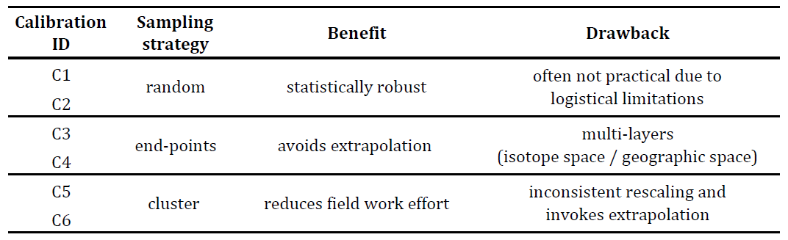

Table 1. Summary of the sampling strategy approaches used to investigate how different training settings affect hydrogen model calibrations and, ultimately, the probabilities to recover the true origin of migratory individuals. Each sampling strategy has two calibrations to account for variation in sampling locations and number of samples per location.

For each sampling design, we manipulated the number of locations and number of samples per location to explore variation in relatedness to the precipitation isoscape (Fig 1, top panel). The ‘random’ sampling strategy is characterized by training data points extracted proportionally to the distribution of latitude and longitude across the entire sampling distribution ranges (Fig 1; C1-C2). We used different number of sampling locations (SL) and number of samples per location (SPL) in each of the two calibrations (C1: SL = 100, SPL = 1; C2: SL = 10, SPL = 10). The ‘end-points'’ sampling strategy is characterized by training data chosen at the maximum and minimum latitudinal or isotopic values of the sampling range (Fig 1; C3-C4). In this case, we used equal number of SL and SPL in each of the two calibrations (SL = 2, SPL = 10). The training data points generated from the ‘cluster’ sampling strategy consists of a set of 100 geographically adjacent locations or 100 locations with consecutive values in a ranked distribution of all isoscape values (Fig 1; C5-C6). In this case, we also used an equal number of SL and SPL in each of the two calibrations but adopted a more comprehensive spatial coverage of SL (SL = 100, SPL = 1). The inclusion of these last four scenarios (C3-C6) was instrumental to isolate the properties of the two distinct sampling domains: geographic (e.g., latitude) and isotopic.
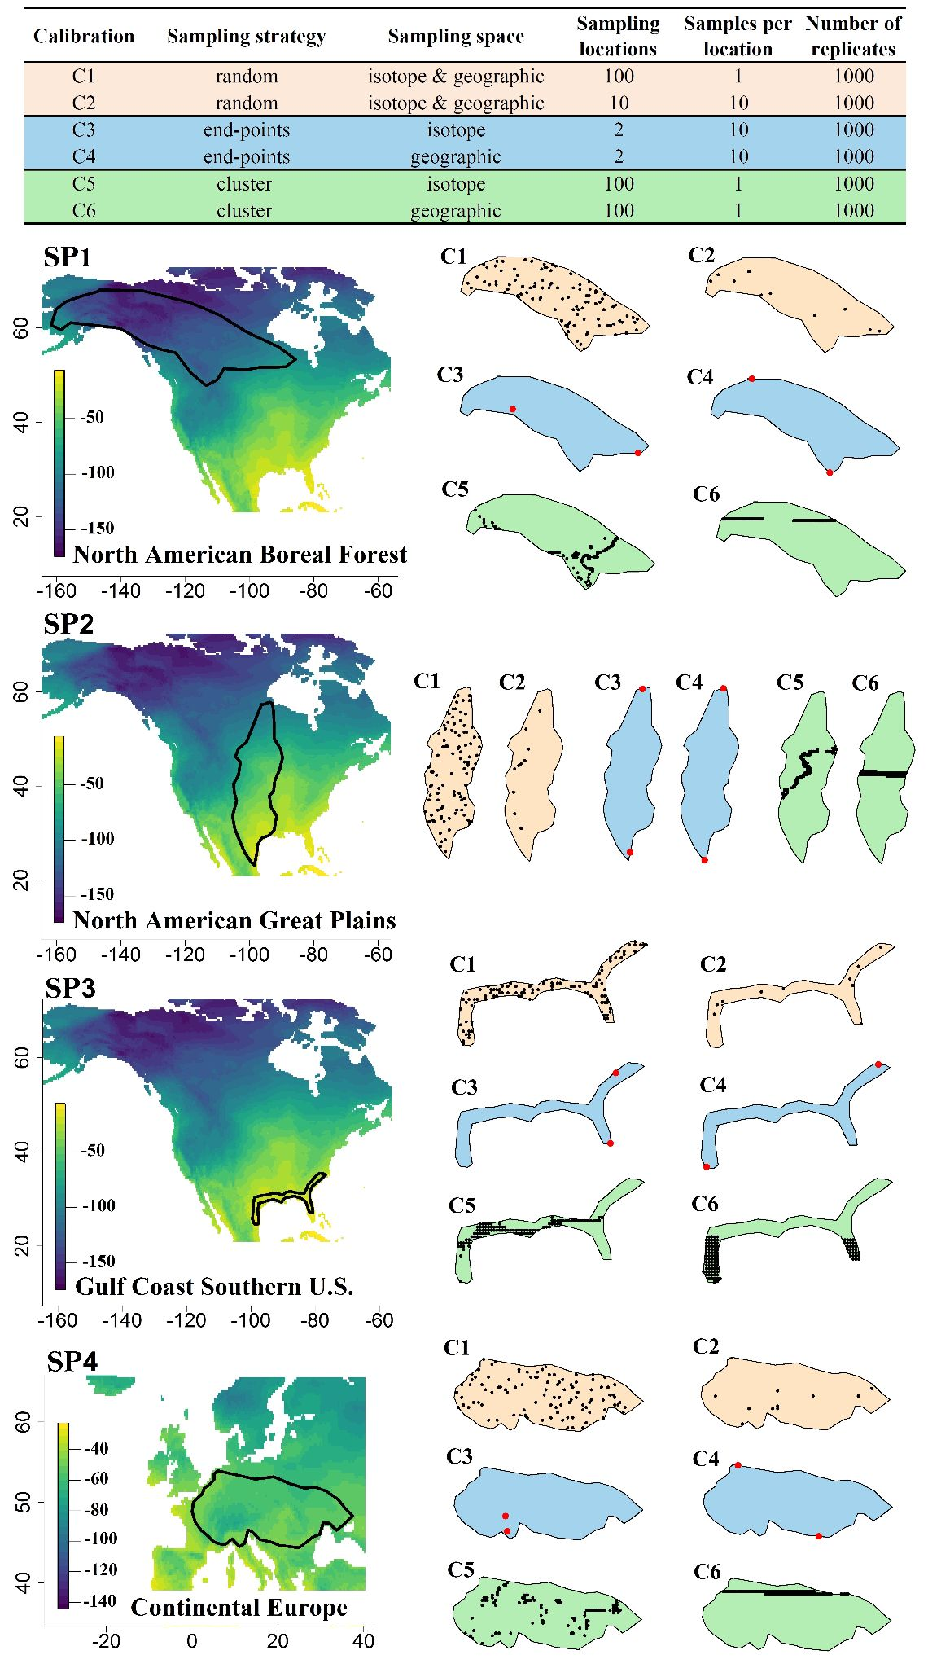
Figure 1 – Top panel. Sampling strategies for calibration training data points within each sampling range and defined as: ‘random’, ‘end-points’, and ‘cluster’. Lower panels. Simulated geographic distributions of four sampling plans in North America (SP1, SP2, and SP3) and northeastern Europe (SP4). Sampling locations for calibrations C3 and C4 are indicated in red for clarity as they often overlap with the black edge of the sampling range.

2.2 Generation of the synthetic data
At each sampling point we extracted precipitation isotope values from an annual average precipitation isoscape commonly used for wildlife and forensics research (Bowen et al., 2005). We then used those hydrogen stable isotope values as inputs for a mechanistic physiology-biogeochemistry model that describes the incorporation of the environmental isotopic signal into proteinaceous tissues (Magozzi et al., 2019), which was used to convert precipitation isotope values from each sampling location into synthetic tissue values. For simplicity, the model version that we used here was parameterized with fixed physiological (Table S1) and environmental (e.g., temperature and humidity) parameters, therefore only the isotopes in precipitation were considered to vary across the environmental domain. The model was run in a deterministic mode, without allowing variation in model parameters or constants, but we applied a random error to each sample drawn from a normal distribution (mean = 0, sd = 10) relative to predicted isotope values. This approach allowed us to predict isotopic compositions of synthetic tissues (e.g., keratin) extracted within each synthetic sampling range, which formed the basis for tissue-environment isoscape calibrations. We used the calRaster function in the R program assignR V.1.2.1 (Ma et al., 2020) to rescale the precipitation isoscape to synthetic keratin values.
2.3 Testing data and probabilities of origin
To test the different calibration methods, we randomly extracted the δ²H precipitation values from test sites from across each sampling range. We used the physiology model (Magozzi et al., 2019) as described above to convert the test site precipitation isotope values into synthetic tissue values of known origin, that we term ‘test samples’. We then implemented the pdRaster function in assignR as detailed in Ma et al. (2020) to compute a probability map of origin for each test sample. Once we obtained a set of posterior probability surfaces across sampling plans, we applied two novel evaluation metrics and implemented a final data validation step in assignR. First, we calculated the percentiles of the posterior probabilities at the site of true-origin across each of the six sampling regimes (C1-C6) and four synthetic sampling ranges (SP1-SP4). That is, we ranked the posterior probabilities of all cells within the analysis region and extracted the percentile of the known origin site within this distribution. Next, we calculated the cumulative posterior probabilities as a function of distance from the known origin. For the computation of the distance between the known origin point and each cell of the probability raster, we followed the haversine method (Sinnott, 1984) implemented through the distHaversine function of the R package geosphere (Hijmans, 2019). This second metric shows how each sampling regime and calibration affects the distribution of the assignment posterior probabilities across geographic space. To study the proportion of test samples that were correctly assigned within a given area percentile, we implemented the quality assignment function (QA) in assignR to randomly withhold 10% of the test sample dataset across five replicate runs and calculated the posterior probability of origin of the validation samples. We then plotted the proportion of samples that were correctly assigned as a function of the proportion of the species area of occurrence included in the assignment area. Analyses were run on a computer cluster with eight gigabytes of allocated memory and four central processor units.

3. Results
3.1 Training data and calibrations
The synthetic analytical approach explored how six different sampling strategies used to calibrate the precipitation isoscape influenced our ability to recover the true origin of a given test sample. The ‘random’ sampling strategy (C1-C2), which extracted data points proportionally across four sampling ranges, recovered similar rescaling relationships for precipitation isotope values and synthetic isotope tissue values among model fits for SP1 and SP2, although the model showed more variation for SP3 and SP4 (Fig 2, Table S2). The ‘end-points’ sampling strategy (C3-C4), characterized by training data chosen at each sampling range maximum and minimum latitudinal or isotopic values, also recovered similar rescaling relationships for precipitation and tissue isotope values, but with higher variation in SP4 (Fig 2, Table S2). The data points generated from the ‘clustered’ sampling strategy (C5-C6), constrained within a narrow subset of latitudinal or isotope values, showed the highest degree of variation across sampling plans (Fig 2, Table S2).

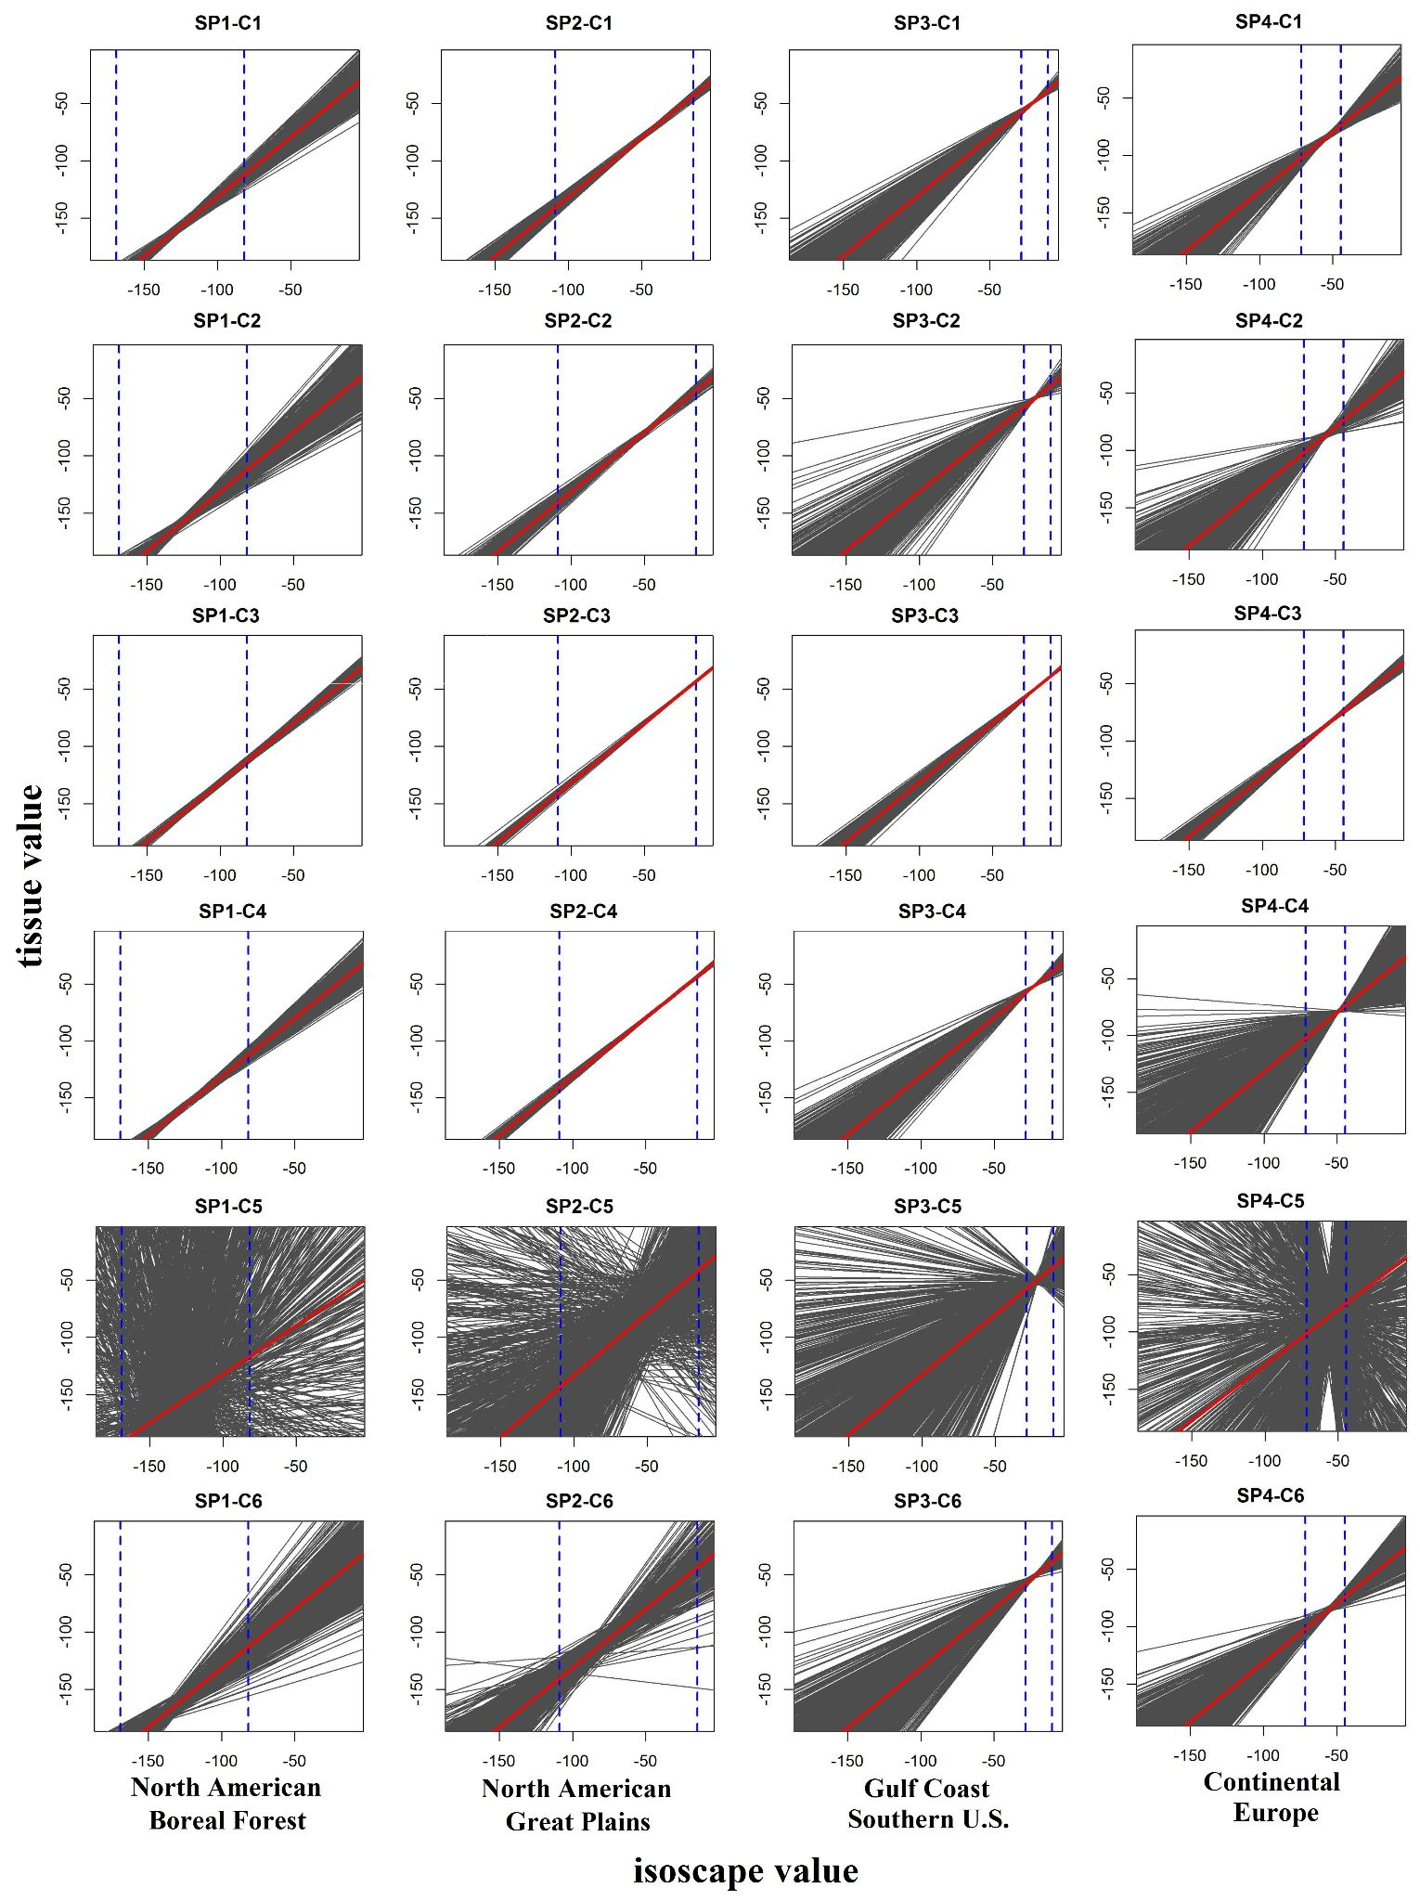
Figure 2. Results of the six (C1-C6) isoscape calibrations across sampling plans (SP1-SP4). The red lines represent mean values computed for 1000 replicates while the grey lines are individual calibration runs. Intercept, slope, and R² values (mean and sd) are reported in Table S2. Distinct sampling strategies affect the distribution of data points in isotope and geographic space, highlighting the importance of comparisons among large data point replicates (≥ 1000), particularly for calibrations C5 and C6 across sampling plans. The blue dashed vertical lines indicate the isotope range within each sampling range.

3.2 Percentiles of true-origin points
The assignment tests generated probability surfaces for each of the 100 synthetic test samples within the four simulated sampling ranges across North America and Europe. Taking advantage of the known origin latitude and longitude coordinates, we calculated the percentile metric, a rank of the posterior probability at the known origin site across four sampling plans and six sampling designs adopted for calibration (C1-C6). Our results show that the mean values obtained from the modeling effort are similar across calibrations (Fig 3, panel A-D). Nevertheless, two important differences involving isotope gradient variation within sampling plan and model performance between sampling ranges and calibrations can be highlighted. First, SP2 is characterized by a geographic distribution that follows variation along the latitudinal stable isotope gradient, and this feature helps the assignment algorithm to perform better relative to the other three sampling plans as indicated by steeper curves across the six calibrations (Fig 3, panel B). Second, the sampling strategy that relies on clustered data points in isotope space (C5) is distinct from the other calibrations and it produces the lowest posterior probabilities at the known origin locations, regardless of sampling range characteristics. While this strategy is somewhat artificial, in that researchers would seldom seek out sampling sites of similar isotope values, the result illustrates how inadvertent failure to design sampling to span a large fraction of the isotopic variation within the sampling range can significantly decrease the strengths of the resulting analyses.

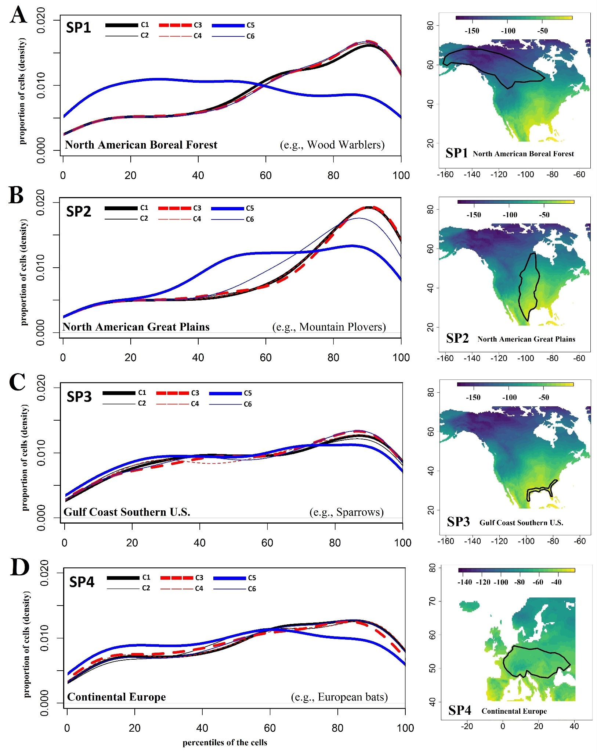
Figure 3. Distribution of posterior probabilities at the 100 known origin validation sites for each sampling plan (SP) and calibration; probabilities (x-axis) are given as the percentile of the known origin location within the ranked distribution of probabilities at all grid cells. SP2 shows the highest probabilities for all six calibrations, indicating the best performance regardless of calibration method. The fifth sampling strategy, based on clustering training points in isotope space (C5, thick blue line), produces the lowest posterior probability densities and performs poorly across all sampling plans. The common taxonomic names on the left panels are for illustration purposes only.

3.3 Cumulative posterior probabilities
The cumulative posterior probabilities relative to the distance from the known origin illustrate the degree to which assignment probability is geographically clustered in proximity to the known sample origin (Fig. 4). The results for the first two sampling simulations, SP1 and particularly SP2, show that most of the posterior probability is relatively close and clustered near the known origin compared to SP3 and SP4. This indicates that both randomized calibration models provided stronger relationships between environmental and tissue values of hydrogen for SP1 and SP2 than for SP3 and SP4. The pattern observed in SP3 and SP4 is likely a consequence of the lack of a strong and uniform isotope gradient throughout the geographic ranges.
Overall, these results corroborate the patterns generated by the ranking of the posterior probabilities at the known origin site (percentile metric). Specifically, the sampling strategy that adopts clustered data points in isotope space (C5) shows, once again, higher variability compared to the other calibrations and it yields highest variability in model performance, particularly in SP1. Interestingly, SP1 also shows multiple ‘stepped’ increases in the accumulation of probability with distance for many samples, and these are seen across 5 of the 6 calibrations (C1-C4, and C6). As shown in Fig 1, this species range includes similar isotope values even at the western and eastern extremes of the range; for individuals originating in these areas some grid cells with high posterior probability will occur at the other extreme, producing two ‘steps’ in the cumulative probability curves. This observation suggests that regardless of the sampling approach adopted to fit the rescaling function (e.g., calibration), the underlying properties of the geographic distribution of isotopes within the species range will lead to large-scale ambiguity in the inferred location of origin of some individuals. In this case, output from this metric may be useful both for planning and executing a calibration sampling strategy but also for identifying fundamental limitations to the information that might be gained from an isotope-based study due to the intersection of the species range and the geographic properties of the environmental isotope distribution.

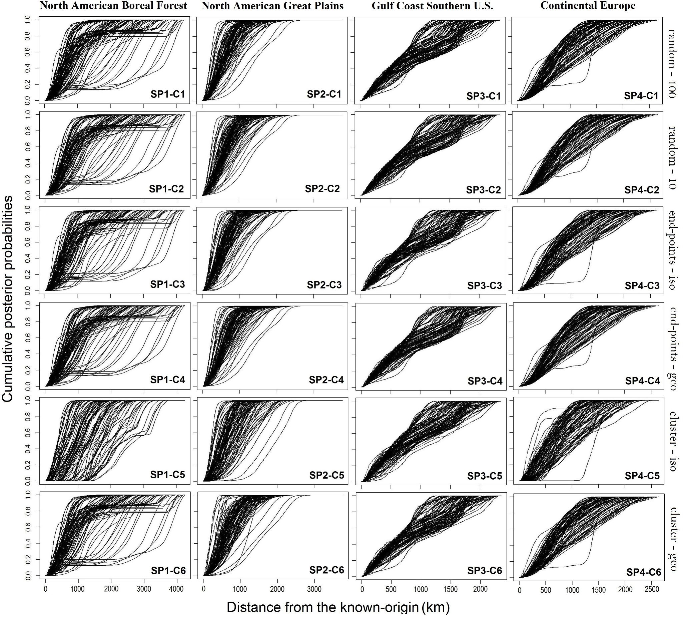
Figure 4. Cumulative posterior probabilities as a function of distance from the known origin. The results of the first two sampling simulations (SP1 and SP2), indicate that the bulk of the posterior probabilities is closer to the known origin compared to SP3 and SP4. This is a consequence of a stronger relationships between environmental and tissue values of hydrogen for SP1 and SP2 provided by the randomized calibration models relative to SP3 and SP4.

3.4 Proportion of Correct Assignments by Area
Overall, the proportion of known origin migrants that were correctly assigned within a specific fraction of the geographic distribution range varied across sampling plans but not calibrations (Fig. 5). For SP1, we obtained nearly 70% of the correct assignments within the first 20% of the geographic range followed by a slow proportional gain and a subsequent rapid increase between 37 and 55% of the area being considered (Fig 5, panel A). In contrast to the bimodal and polytonic curves characterizing SP1, we found strongly smooth monotonic curves for SP2 with about 80% of the correct assignments being captured within the first 20% of the geographic range and almost the entire remaining proportions falling between 20-30% of the total area (Fig 5, panel B). SP3 and SP4 provided results showing low proportions of the correct assignments (~40%) falling within the first 20% of the geographic ranges and continuing to increase slowly throughout their sampling geographic extents (Fig 5, panel C and D). These patterns suggest that isotopic variation in sampling distribution range has a stronger effect on assignment accuracy than different sampling strategies and that some species might need broad range percentiles (e.g., larger areas) to provide high proportions (≥ 80%) of correct assignments.

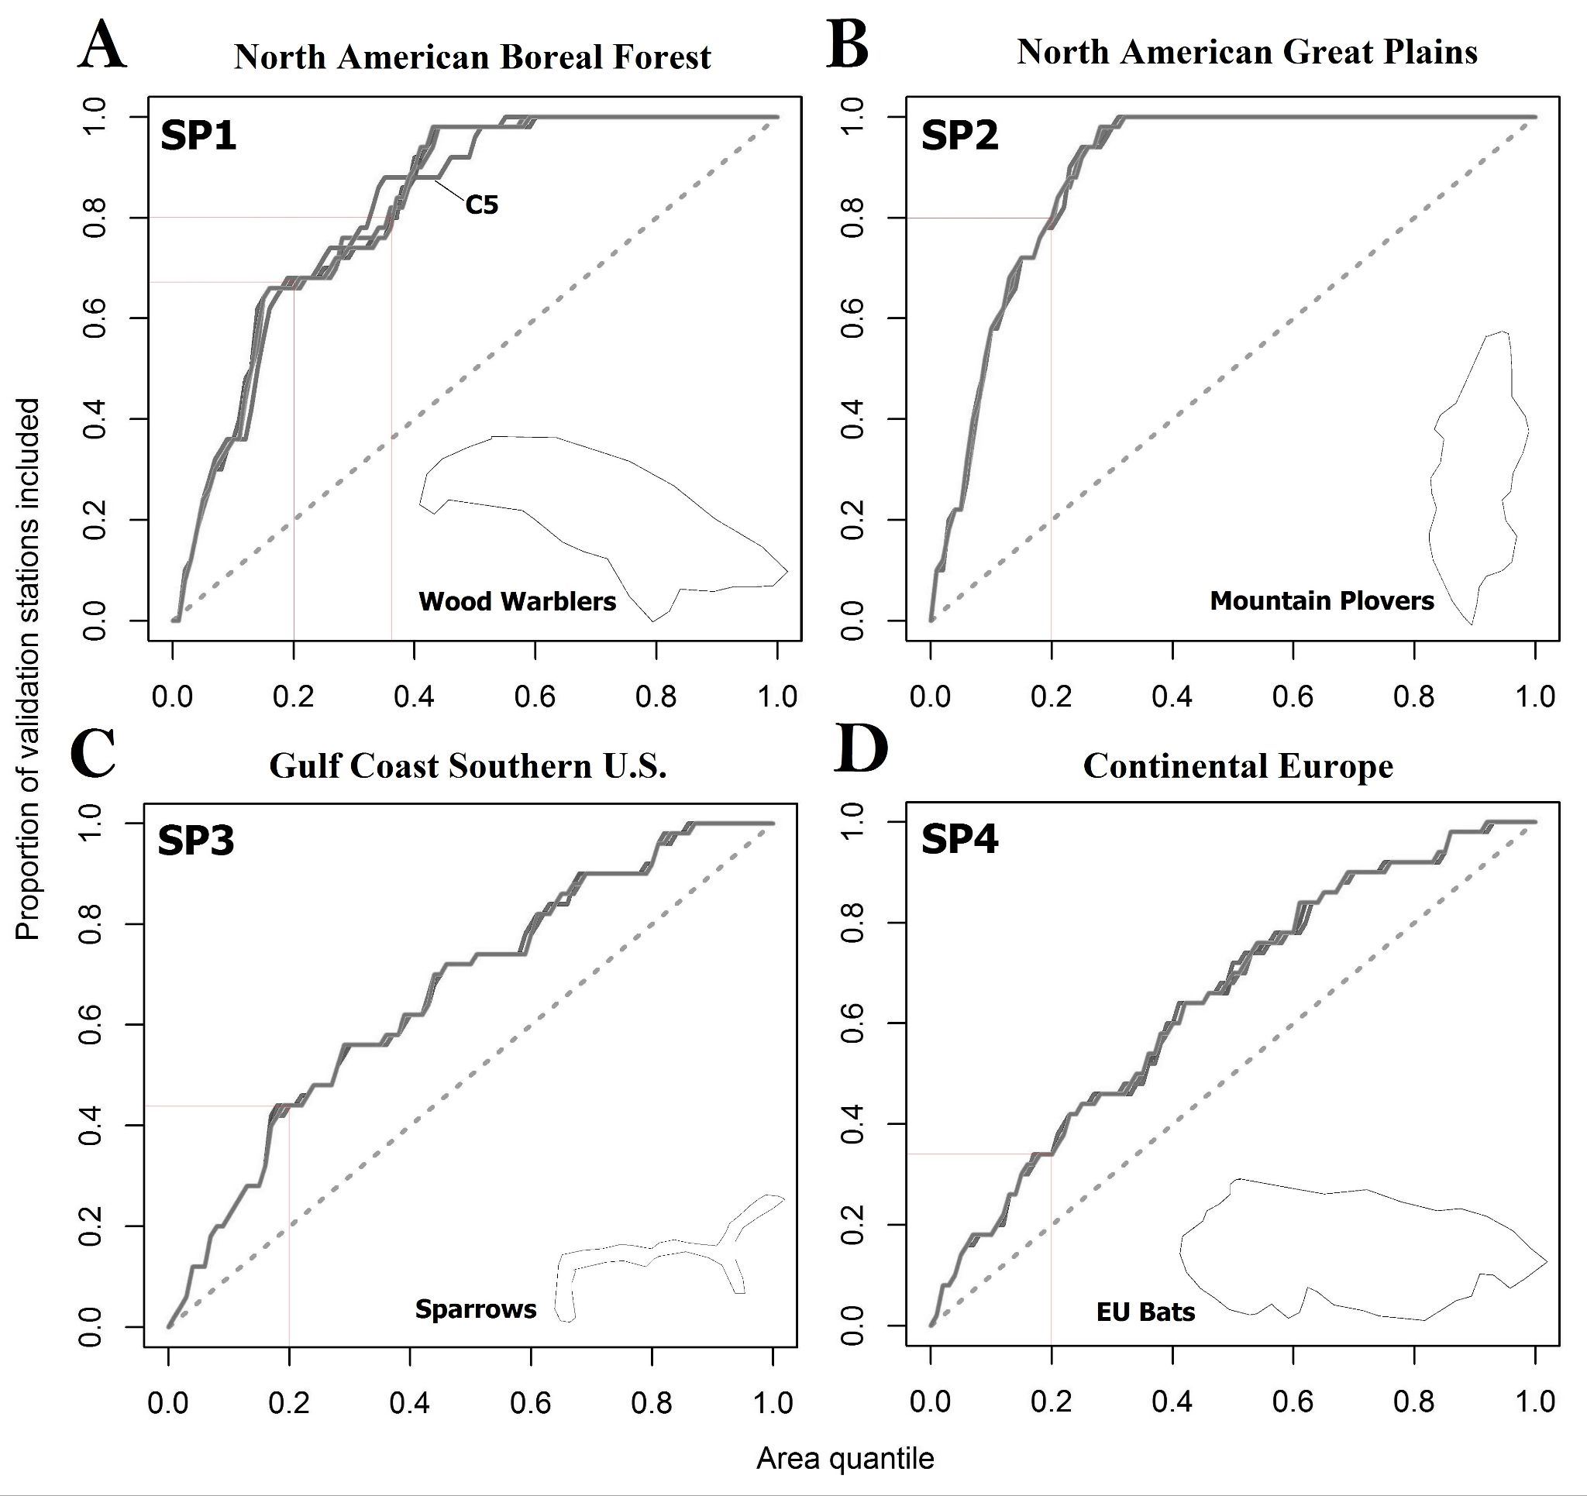
Figure 5. Proportion of known origin test samples correctly assigned by area percentiles across six calibrations (C1-C6) and four synthetic sampling plans (SP1-SP4). The vertical and horizontal lines connect the percentiles of the sampling ranges on the x axis with the proportions of correct assignments for the known origin samples on y axis, respectively. Since the validation datasets are drawn from the sampling strategy used in each model calibration, these examples show that the ‘quality’ of assignments depends only on the geography of the underlying isoscape. The common species names near the area ranges on the bottom right corners are for illustration purposes only.

4. Discussion
4.1 Merits of the synthetic data analysis approach and new evaluation metrics
Building upon the work of Magozzi et al. (2019), which we used to predict tissue values (e.g., keratins) from the precipitation hydrogen isoscape, we present a novel sampling design evaluation framework based on synthetic data generation and validation. Synthetic data have been extensively used in optimal sampling design studies across gradients (Schweiger et al., 2016) and provide an effective approach to investigate the properties of the data and model prediction (Hirzel and Guisan 2002). Thus, we developed two evaluation metrics for planning and optimizing stable isotope sample collection and data analysis and show that there is no universally superior sampling design, and that each scenario should be evaluated individually.
Our evaluation framework has two objectives. First, the percentile metric evaluates assignment model performance by ranking the posterior probability at the known origin site across calibrations. Second, by investigating the degree to which assignment probabilities are geographically clustered near the known origin, the cumulative posterior probabilities metric helps to test the repeatability of the assignment analyses across different regions relative to model performance. Specifically, we note that the range of outcomes emerging in SP1 is much wider compared to other sampling plans, even though the model performance is overall robust, as clearly shown in SP2, while the results for SP3 and SP4 indicate high repeatability but poor assignment model performance. The reason why we observe higher variability in SP1 (e.g., multimodal cumulative posterior probabilities in Fig 4) is partially due to two clusters of isotopic peak values in the neighborhood of -90‰ (δ²H) occurring at the opposite ends of the geographic sampling space.
This is in contrast to the distribution of the isotope gradient in SP2, which follows a north to south slope that matches the geographic extent of the sampling region. Thus, when the distribution of the isotope values within the sampling area covaries with its geographic extent (SP2) it is possible to reduce the range of the test sample probable origin. Our metrics show that in such cases we will likely obtain higher precision in model performance and recover most of the origin probabilities within a narrow distance from the true origin.
Moreover, while the percentile metric summarizes the result of a single cell over all the test samples, the cumulative posterior probabilities metric summarizes multiple data points over all the cells of the probability raster within the sampling range. Therefore, the first and the second metric use distinctive extractions of probabilities to a) rank them at the known origin and b) reveal their spatial structure moving away from the known origin by accounting for probability weights, respectively. However, when these two metrics are used in combination, we discover that, at least in some cases, for similar mean values that are produced from different calibrations the uncertainties of the calibration models might be different (Fig 3) and, therefore, the actual weight assignments might also vary (Fig 4).
4.2 Impact of sampling design on analysis quality and real-world research
Our evaluation framework helps to assess the trade-off between extensive sampling strategies such as acquiring data points proportionately to the occurrence of isotope values (Fig 1 and Fig. 2; C1-C2) versus targeting the domain boundaries, as in the case of the end-point strategy (Fig 1 and Fig. 2; C3-C4), and two strategies representing more opportunistic sampling approaches in restricted geographic and isotopic domains (Fig 1 and Fig 2; C5-C6). Overall, our results suggest that the end-point strategy might reach a balance between reduced sampling effort and reduction of uncertainties due to model extrapolation, at least in some sampling plans (Fig 2-4). However, in cases where both random and end-point sampling strategies are not feasible and a cluster approach is the only option, we highlighted the different effects of sampling in isotopic space versus geographic space and showed two cases where a geographically-restricted sampling cluster might be a better alternative compared to a narrow isotopic cluster (Fig 4; SP1 - C6 and SP2 - C6). Accordingly, we did not identify a distinctive sampling method that consistently yields optimal results but illustrated how different strategies can be explored beforehand to make context-dependent decisions.
We also refrain from extending specific inferences to existing biological systems because our methods are investigative tools tested through a set of simulation analyses and not data gathered from living organisms. However, our approach can be used to explore the effect of different sampling strategies in real-life animal movement estimates that rely on variation in stable isotope values across species ranges. For example, while we showed that the end-point strategy is often useful because it reduces sampling effort and still achieves robust results (Fig 4, SP1-SP2), researchers might not have access to those sampling locations necessary to provide boundary isotope values for the implementation of the end-point calibration design. Thus, these metrics facilitate beforehand exploration of the isotope variation structure within the sampling geographic range to determine where the most valuable sampling sites are located and how alternative sampling strategies (e.g., random, clustered, etc.) will affect calibration reliability. That is, our metrics help researchers to uncover the relations between the geographic and isotope domain so that informed decisions can be made relative to calibration performance.
4.3 Impact of species geographic range on analysis quality and real-world examples
By importing our multiple calibration framework into the quality assessment function (QA) in assignR (Ma et al., 2020), we tested for the sensitivity of the analysis across sampling strategies and geographic ranges. While we did not find different outcomes across calibrations, the sampling geographic distributions strongly affected the proportion of the correct assignments by area (Fig. 5). This finding highlights that variation in sampling range is not the only factor affecting the probability of origin obtained through model assignments. In fact, even sampling plans with extensive geographic ranges (e.g., SP4) might not contain substantial isotopic variation and structure across their extent. That is, assignments and posterior probability surfaces do not directly model geographic response variables (e.g., latitude, longitude), but act on the sampling distribution of the stable isotope values (Wunder, 2010). Thus, when using hydrogen stable isotopes to infer the probability of origin of migratory animals, we recommend exploring the distributions of the stable isotope values within all the cells occurring inside the sampling range as their variation might not be always described and matched by their geography (e.g., following a latitudinal gradient, as exemplified in Fig 6).

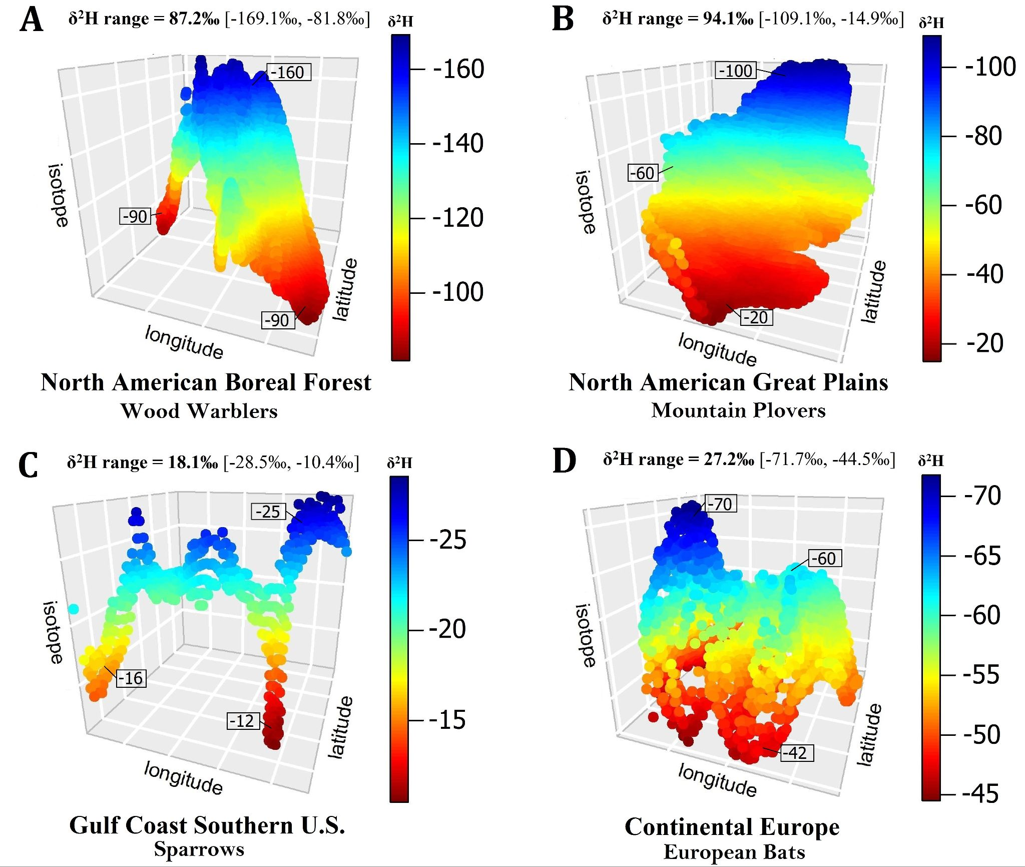
Figure 6. Tridimensional representation of hydrogen stable isotope distributions within the occurrence polygons of the three sampling plans in North America (panels A-C) and Europe (panel D). Note the variation in δ²H range values, spanning 94.1‰ in SP2 (central United States) and 87.2‰ in SP1 (Alaska and Canada) to 27.2‰ in SP4 (Europe) and 18.1‰ in SP3 (southern United States along the Gulf of Mexico). The distributions of δ²H values within the sampling ranges are not always matched by geography. SP1, and to some extent SP3 (panel A and C, respectively), lack a clear and consistent δ²H latitudinal gradient, as shown by the two areas at the far ends of the sampling ranges characterized by similar δ²H values despite extreme geographical distance. The common species names at the bottom of the panels are for illustration purposes only.

Several migratory species of warblers, such as the Wilson's Warbler (Cardellina pusilla) and the Yellow Warbler (Setophaga petechia), breed and molt in the northern United States and Canada along the eastern-western longitudinal gradient conforming to the range distribution of synthetic SP1 (Paxton et al., 2013; Stephenson and Whittle, 2013). Therefore, a good understanding of the different implications that isotopic and geographic space characteristics possess is particularly warranted to reveal the potential confounding effects of the two sampling domains in these species. Other migratory taxa, such the long-billed Curlew (Numenius americanus), the Mountain Plover (Charadrius montanus), the Spotted Bat (Euderma maculatum) and some migratory insect populations of the Common Green Darner (Anax junius), for example, show a spatial distribution generally along a northern-southern axis similar to SP2 (Dugger and Dugger, 2002; Wunder et al., 2005; Geluso, 2008; Hallworth et al., 2018), while the occurrence of the Seaside Sparrow (Ammospiza maritima) resembles the geographic range of SP3 (Ferrato et al., 2017). The examples listed in the heterogeneous group of migratory animals across taxa are probably best suited for exploiting the properties of the hydrogen isotopic gradient whereas the sparrows along the coast of southern United States might be too limited in both geographic and isotopic space to yield robust movement inferences. The Nathusius bat (Pipistrellus nathusii) hibernates in central and eastern Europe showing a winter range comparable to SP4 while it migrates almost 2000 km to southern grounds in the summer (Hutterer et al., 2005). The long-distance movements of these European bats might still be inferred through hydrogen data with the constraints highlighted above, although some populations could improve the limitations of hydrogen-based inferences through a multi-element (δ¹³C, δ¹⁵N, δ²H and δ¹⁸O) stable isotope approach (Hobson et al., 2012; Koehler et al., 2019).

5. Conclusion
We contend that when developing movement ecology studies involving stable isotope analysis, calibrating the species-specific isoscape is the most important element of the sampling design effort. Therefore, a thorough assessment of the sampling strategy relative to the accuracy of the calibration modeling outcome is warranted because this step will strongly affect the probabilities of recovering the true-origin of migratory individuals. Thus, we presented a set of metrics and guidelines that can assist in defining the intrinsic properties of hydrogen stable isotope gradients for stable isotope research planning and calibration to increase analysis interpretability. Importantly, our evaluation metrics are complementary and can be added to the analytical capabilities of other stable isotope analytical packages such as assignR (Ma et al., 2020). Finally, we showed how different training regimes (e.g., calibrations) influence the ability of recovering the true origin of a given test sample (e.g., migrant) and highlighted the properties of different sampling domains in relation to geography and stable isotope distribution. By studying four synthetic sampling plans defined by distinct spatial ranges, our estimates regarding the origin of test samples illustrated the characteristics of the assignments in relation to sampling range size and its underlying hydrogen stable isotope structure. Our analytical approach characterizes the repeatability and interpretation of stable isotope results in natural study systems and assists the development of more informed inferences of where individuals and populations grow their tissues before or during migration.

Acknowledgments
This work was supported by NSF grants DBI-1565128 and DBI-1564947.

AUTHORS' CONTRIBUTIONS
A.C., M.B.W., S.M., H.B.V.Z and G.J.B. conceived the ideas and designed the methodology; S.M. developed the code for precipitation-tissue conversion; A.C., M.B.W., and G.J.B. led the writing of the manuscript. All authors contributed critically to the drafts and gave final approval for publication. All authors declared no conflict of interest.

ORCID
Andrea Contina https://orcid.org/0000-0002-0484-6711
Sarah Magozzi https://orcid.org/0000-0003-4070-9105
Hannah B. Vander Zanden https://orcid.org/0000-0003-3366-5116
Gabriel J. Bowen https://orcid.org/0000-0002-6928-3104
Michael B. Wunder https://orcid.org/0000-0002-8063-2408

References
Altizer, S., Hobson, K.A., Davis, A.K., De Roode, J.C. and Wassenaar, L.I., 2015. Do healthy monarchs migrate farther? Tracking natal origins of parasitized vs. uninfected monarch butterflies overwintering in Mexico. PloS one, 10(11), p.e0141371.
Delmelle, E.M., 2014. Spatial sampling. Handbook of regional science, pp.1385-1399.
Bondesson, L. and Thorburn, D., 2008. A list sequential sampling method suitable for real‐time sampling. Scandinavian Journal of Statistics, 35(3), pp.466-483.

Bowen, G.J., Wassenaar, L.I. and Hobson, K.A., 2005. Global application of stable hydrogen and oxygen isotopes to wildlife forensics. Oecologia, 143(3), pp.337-348.

Bridge, E.S., Kelly, J.F., Contina, A., Gabrielson, R.M., MacCurdy, R.B. and Winkler, D.W., 2013. Advances in tracking small migratory birds: a technical review of light‐level geolocation. Journal of Field Ornithology, 84(2), pp.121-137.

Cryan, P.M., Stricker, C.A. and Wunder, M.B., 2014. Continental‐scale, seasonal movements of a heterothermic migratory tree bat. Ecological Applications, 24(4), pp.602-616.

Curras, M.R., Fogel, M.L. and Newsome, S.D., 2018. Assimilation and discrimination of hydrogen isotopes in a terrestrial mammal. Oecologia, 188(2), pp.381-393.

Dugger, B.D. and Dugger K.M., 2002. Long-billed Curlew (Numenius americanus), version 2.0. In The Birds of North America (P. G. Rodewald, editor). Cornell Lab of Ornithology, Ithaca, New York, USA.
Ferrato, J.R., Simpson, T.R., Small, M.F., Veech, J.A. and Conway, M.H., 2017. Population density and habitat associations of the Seaside Sparrow (Ammodramus maritimus) on Laguna Atascosa National Wildlife Refuge, Cameron County, Texas. The Wilson Journal of Ornithology, 129(1), pp.131-138.

Fortin, M.J., Drapeau, P. and Legendre, P., 1990. Spatial autocorrelation and sampling design in plant ecology. In Progress in theoretical vegetation science (pp. 209-222). Springer, Dordrecht.

Geluso, K., 2008. Spotted Bats (Euderma maculatum) from Mt. Taylor, New Mexico. Western North American Naturalist, 68(1), pp.119-122.

Hallworth, M.T., Marra, P.P., McFarland, K.P., Zahendra, S. and Studds, C.E., 2018. Tracking dragons: stable isotopes reveal the annual cycle of a long-distance migratory insect. Biology letters, 14(12), p.20180741.

Hauser, C. E., and M. A. McCarthy. 2009. Streamlining ‘search and destroy’: cost-effective surveillance for invasive species management. Ecology Letters 12:683–692.

Hijmans, R.J., Williams, E., Vennes, C. and Hijmans, M.R.J., 2017. Package ‘geosphere’. Spherical trigonometry, 1(7).
Hirzel, A. and Guisan, A., 2002. Which is the optimal sampling strategy for habitat suitability modelling. Ecological Modelling, 157(2-3), pp.331-341.
Hobson, K.A., Bowen, G.J., Wassenaar, L.I., Ferrand, Y. and Lormee, H., 2004. Using stable hydrogen and oxygen isotope measurements of feathers to infer geographical origins of migrating European birds. Oecologia, 141(3), pp.477-488.
Hobson, K.A., Van Wilgenburg, S.L., Wassenaar, L.I., Powell, R.L., Still, C.J. and Craine, J.M., 2012. A multi‐isotope (δ13C, δ15N, δ2H) feather isoscape to assign Afrotropical migrant birds to origins. Ecosphere, 3(5), pp.1-20.

Hutterer, R., Ivanova, T., Meyer-Cords, C. and Rodrigues, L., 2005: Bat Migrations in Europe. A Review of Banding Data and Literature. Federal Agency for Nature Conservation, Bonn, 162 pp.

Jin, J. and Yang, J., 2020. Effects of sampling approaches on quantifying urban forest structure. Landscape and Urban Planning, 195, p.103722.

Koehler, G., Kardynal, K.J. and Hobson, K.A., 2019. Geographical assignment of polar bears using multi-element isoscapes. Scientific reports, 9(1), pp.1-9.

Legg, C. J., and L. Nagy. 2006. Why most conservation monitoring is, but need not be, a waste of time. Journal of Environmental Management 78:194–199.

Lowe, A., Harris, S. and Ashton, P., 2009. Ecological genetics: design, analysis, and application. John Wiley & Sons.

Ma, C., Vander Zanden, H.B., Wunder, M.B. and Bowen, G.J., 2020. assignR: An r package for isotope‐based geographic assignment. Methods in Ecology and Evolution, 11(8), pp.996-1001.

Magozzi, S., Vander Zanden, H.B., Wunder, M.B. and Bowen, G.J., 2019. Mechanistic model predicts tissue–environment relationships and trophic shifts in animal hydrogen and oxygen isotope ratios. Oecologia, 191(4), pp.777-789.

Magozzi, S., Vander Zanden, H. B., Wunder, M. B., Trueman, C. N., Pinney, K., Peers, D., Dennison, P. E., Horns, J. J., Sekercioglu, C. H., & Bowen, G. J. 2020. Combining models of environment, behavior, and physiology to predict tissue hydrogen and oxygen isotope variance among individual terrestrial animals. Frontiers in Ecology and Evolution, 8, 536109. https://doi.org/10.3389/fevo.2020.536109

Moore, A. L., and McCarthy, M. A., 2016. Optimizing ecological survey effort over space and time. Methods in Ecology and Evolution 7:891–899.

Paxton, K.L., Yau, M., Moore, F.R. and Irwin, D.E., 2013. Differential migratory timing of western populations of Wilson's Warbler (Cardellina pusilla) revealed by mitochondrial DNA and stable isotopes. The Auk, 130(4), pp.689-698.

R Core Team. 2018. R: A Language and Environment for Statistical Computing. R Foundation for Statistical Computing, Vienna, Austria. Available: http://www.r-project.org.
Rogerson, P.A., Delmelle, E., Batta, R., Akella, M., Blatt, A. and Wilson, G., 2004. Optimal sampling design for variables with varying spatial importance. Geographical Analysis, 36(2), pp.177-194.
Schweiger, A.H., Irl, S.D., Steinbauer, M.J., Dengler, J. and Beierkuhnlein, C., 2016. Optimizing sampling approaches along ecological gradients. Methods in Ecology and Evolution, 7(4), pp.463-471.

Sinnott, R.W., 1984. Virtues of the Haversine. S&T, 68(2), p.158.

Soto, D.X., Hobson, K.A. and Wassenaar, L.I., 2013. The influence of metabolic effects on stable hydrogen isotopes in tissues of aquatic organisms. Isotopes in environmental and health studies, 49(3), pp.305-311.

Stephenson, T. and Whittle S., 2013. The Warbler Guide. Princeton University Press, New Jersey, USA.
Thomas, F.M., Vesk, P.A. and Hauser, C.E., 2018. A field ecologist's adventures in the virtual world: using simulations to design data collection for complex models. Ecological Applications, 28(8), pp.2130-2141.

Vander Zanden, H.B., Wunder, M.B., Hobson, K.A., Van Wilgenburg, S.L., Wassenaar, L.I., Welker, J.M. and Bowen, G.J., 2015. Space‐time tradeoffs in the development of precipitation‐based isoscape models for determining migratory origin. Journal of Avian Biology, 46(6), pp.658-667.

Vander Zanden, H.B., Chaffee, C.L., González-Rodríguez, A., Flockhart, D.T., Norris, D.R. and Wayne, M.L., 2018. Alternate migration strategies of eastern monarch butterflies revealed by stable isotopes. Animal Migration, 5(1), pp.74-83.

Wunder, M.B., Kester, C.L., Knopf, F.L. and Rye, R.O., 2005. A test of geographic assignment using isotope tracers in feathers of known origin. Oecologia, 144(4), pp.607-617.

Wunder, J., B. Reineking, C. Bigler, and H. Bugmann. 2007. Predicting tree mortality from growth data: how virtual ecologists can help real ecologists. Journal of Ecology 96:174–187.

Wunder MB. Using isoscapes to model probability surfaces for determining geographic origins. In: West JB, Bowen GJ, Dawson TE, Tu KP, editors. Isoscapes: Understanding Movement, Pattern and Process on Earth through Isotope Mapping: Springer; 2010. p. 251-70.
Zenzal, T.J., Contina, A.J., Kelly, J.F. and Moore, F.R., 2018. Temporal migration patterns between natal locations of ruby-throated hummingbirds (Archilochus colubris) and their Gulf Coast stopover site. Movement ecology, 6(1), p.2.

Zurell, D., Berger, U., Cabral, J.S., Jeltsch, F., Meynard, C.N., Münkemüller, T., Nehrbass, N., Pagel, J., Reineking, B., Schröder, B. and Grimm, V., 2010. The virtual ecologist approach: simulating data and observers. Oikos, 119(4), pp.622-635.

Zuur, A., E. N. Ieno, and G. M. Smith. 2007. Analyzing ecological data. Springer-Verlag, New York, New York, USA.

Supplementary Material Captions

Table S1. Model parameters to predict tissue values.

Table S2. Intercept, slope, and R² values (mean and sd) resulting from six (C1-C6) isoscape calibration models across sampling plans (SP1-SP4).

Supplementary Material Tables

Parameter | Definition | Value | Units | Source
Waste type | Type of waste product derived from protein metabolism | Uric acid | na | na
P_{carb} | Proportion of carbohydrates in the diet | 0.57 | na | Kohn (1996); for herbivores
P_{prot} | Proportion of protein in the diet | 0.33 | na | Kohn (1996); for herbivores
P_{fat} | Proportion of lipids in the diet | 0.10 | na | Kohn (1996); for herbivores
M | Body mass | 40 | g | na
bT_{C} | Body temperature | 37 | °C | na
P_{w} | Proportion of food mass that is in liquid water form | 0.60 | na | Kohn (1996); for some herbivores and carnivores
eT_{C} | Environmental temperature | 20 | °C | na
Rh | Relative humidity | 0.5 | na | na
δ²H_{dw} (RH_{dw}) | H isotopic composition of drinking water | Isoscape value | ‰ | na
Table S1
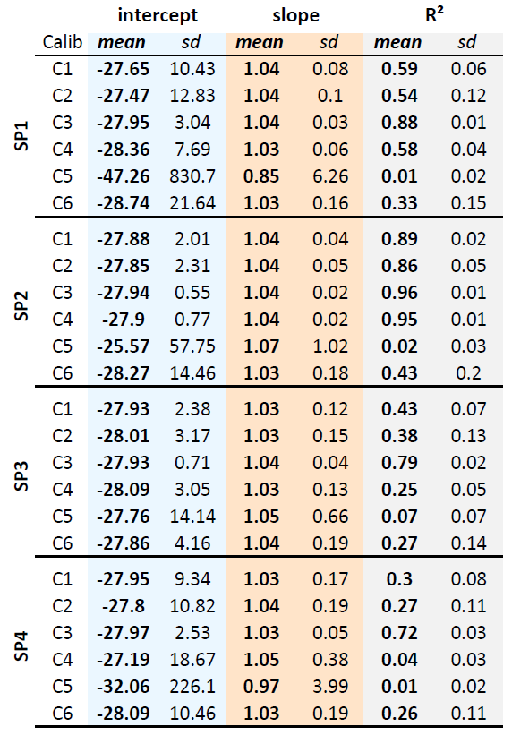
Table S2

