Seasonally variable relationships between surface water temperature and inflow in the upper San Francisco Estuary
Running head: Temperature-inflow relationships in the upper SFE
Samuel M. Bashevkin^{1*}, Brian Mahardja²
¹Delta Science Program, Delta Stewardship Council, 980 9th St. Suite 1500, Sacramento, CA 95814 USA. ORCID ID: 0000-0001-7406-7089. sam.bashevkin@deltacouncil.ca.gov
²United States Bureau of Reclamation, 801 I Street, Suite 140, Sacramento, California, 95814 USA. ORCID ID: 0000-0003-0695-3745 bmahardja@usbr.gov
* Corresponding author: sam.bashevkin@deltacouncil.ca.gov
Key words: Estuaries, temperature, inflow, precipitation, salinity, weather, generalized additive model, climate change
Author contributions: Both authors contributed to study conception and design. SMB conducted analyses with input from BM and led writing of the manuscript. BM contributed to writing, reviewing, and editing the manuscript.

Abstract
Water temperature and inflow are key environmental drivers in aquatic systems that are linked through a causal web of factors including climate, weather, water management, and their downstream linkages. However, we do not yet fully understand the relationship between inflow and water temperature, especially in complex managed systems such as estuaries. The San Francisco Estuary is the center of a critical water supply infrastructure and home to a deteriorating ecosystem with several declining fish species at the warm edge of their thermal range. We used generalized additive modeling of long-term monitoring data to evaluate the relationship between inflow and water temperature along with its spatio-seasonal variability. Most commonly, we found a negative temperature-inflow relationship in which water temperatures increased as inflow decreased, up to 2 °C from high to low-inflow years. However, the opposite (positive) relationship was observed in the winter months, and in the western (downstream) regions from July-September, up to -1.2 °C from high to low-inflow years. These results were upheld by models that included the long-term temperature trend or used salinity as a proxy for location. Upstream factors likely played the biggest role in the summer when local precipitation is negligible, while local precipitation and the related weather conditions may drive much of the winter pattern. Although further mechanistic studies are needed to infer the direct effect of dam releases on water temperatures, these results provide a broader understanding of the impacts of flood and drought dynamics for those tasked with managing estuarine ecosystems.

Introduction
Water temperature and freshwater flow are two key environmental drivers in estuarine ecosystems that define seasonal and interannual variability. Changes in temperature determine the timing and duration of phytoplankton and zooplankton blooms and the survival, spawning, and migration of key fish species (Winder and Schindler 2004; Munsch et al. 2019; Goertler et al. 2021). As the climate continues to warm, temperature will likely play an increasingly important role as metabolic demands increase and high temperature extremes reach lethal levels for cold-water species (Jager et al. 1999; Brown et al. 2016b; Del Rio et al. 2019). Variability in freshwater flow affects the physical, chemical, and biological processes of estuarine systems through various pathways (Kimmerer 2002a; b) and can drive species adaptation at an evolutionary scale through the fluctuations of floods and droughts (Lytle and Poff 2004). However, in many systems, freshwater flow has been altered and diverted for human use, often to the detriment of native biota (Postel 2000; Marchetti and Moyle 2001). The subject of freshwater flow has often been a source of controversy as it is a limited resource with ever-growing competing demands (Poff et al. 2003; Kimmerer 2004; Moyle et al. 2018). Given the sizable role of temperature and freshwater flow in determining the trajectory of aquatic ecosystems, a better understanding of the dynamics between these two fundamental variables can help the management of water resources for threatened and endangered species.
The thermal regime of freshwater ecosystems is determined primarily by the relationship between air and water temperatures more so than freshwater input (Vliet et al. 2011). Nonetheless, the correlation between air and water temperature can be altered through a variety of external flow-related factors such as dam releases, cloud coverage, groundwater inflows, river flows, wastewater inputs, riparian shading, and wind shelters (Webb et al. 2003; Vliet et al. 2011). For streams and rivers at high altitudes, the interaction between water temperature and flow are more apparent, as snowmelt runoff can cause water temperature increases to lag air temperature increases (Webb and Nobilis 1997; Yarnell et al. 2010). Furthermore, air temperature itself can be indirectly linked to changes in flow. Storms that bring rainfall and thus increased inflow also influence air temperatures (Dettinger et al. 2011) (Fig. 1). However, it is less clear how water temperatures change with freshwater flow in large estuarine ecosystems with vast networks of tributaries, reservoirs, water diversion facilities, and a mosaic of habitats. It is also unclear how variable these temperature-inflow relationships may be over space and time.
Estuaries are some of the most heavily impacted ecosystems on the planet. Many human activities and settlements have centered on estuaries due to their wide array of resources and ecosystem services, which has led to extensive changes associated with the decline of key species (Costanza et al. 1997; Edgar et al. 2000). The list of environmental and socioeconomic issues commonly found in estuaries is exemplified by the San Francisco Estuary (SFE) in central California, USA. Freshwater that flows into the SFE serves as drinking water for over 25 million people, irrigation water for a $36 billion/year agricultural industry, wintering habitat for millions of birds on the Pacific Flyway, and home to several endangered fish species (Service 2007; Cloern et al. 2011). There is high variability in precipitation from year to year in California, leading to wild swings between dry and wet years (Dettinger et al. 2016) that are projected to strengthen due to climate change (Swain et al. 2018). Combined with rising temperatures, this precipitation variability poses a complex challenge for water management (Persad et al. 2020). California represents the southernmost (i.e. warmest) range for a number of anadromous fish species such as Chinook Salmon (Oncorhynchus tshawytscha) and White Sturgeon (Acipenser transmontanus) (Schreier et al. 2013; Hecht et al. 2015). The unpredictable and complex nature of the system has made freshwater flow management a difficult balancing act.
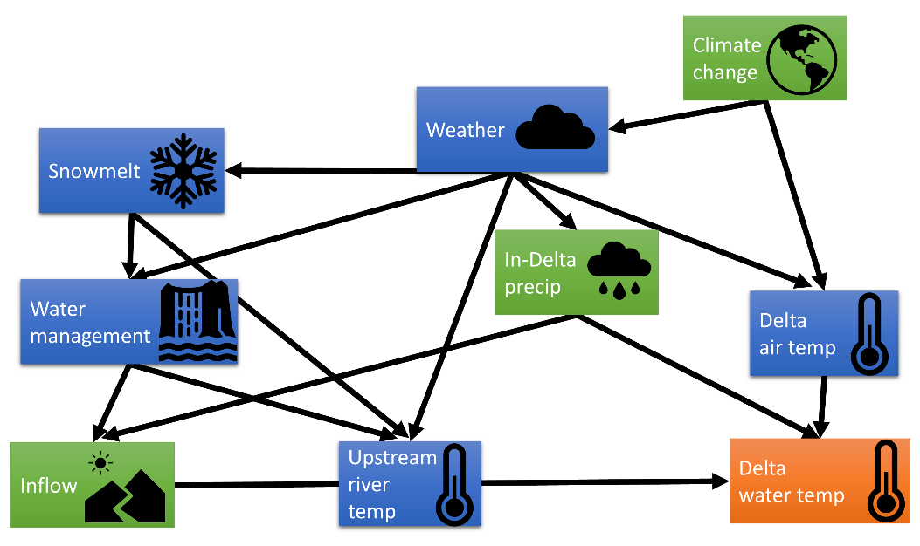
Figure 1. Conceptual diagram of the inflow-associated drivers of upper SFE water temperatures and their causal interconnections. The three drivers we studied (in-delta precipitation, inflow, and climate change) are in green, while our response variable (water temperature) is in orange.
It is no coincidence that the SFE is one of the best studied and well-monitored estuaries in the world, with a considerable amount of research focusing on the effects of freshwater flow and water temperature (Kimmerer 2002a; b, 2004; Wagner et al. 2011; Dettinger et al. 2016; Vroom et al. 2017; Bashevkin et al. 2021). Yet for many studies on the SFE, these two variables have been treated as separate, independent physical properties. The reasoning is that cold water from snowmelt runoff or reservoir releases can be hundreds of kilometers upstream from the SFE, and river temperatures close to the SFE are primarily driven by local conditions (Daniels and Danner 2020). Consequently, there is a general expectation that the amount of precipitation and/or river discharge should have little effect on water temperature in this downstream portion of the watershed (Sommer 2020). Nevertheless, the policy and biological implications of water temperature and inflow are inextricably linked (Yarnell et al. 2010; Munsch et al. 2019; Daniels and Danner 2020), so an understanding of the relationship between these two variables is critical for effective management.
The purpose of our study is to evaluate the relationship (if any) between total inflow, local precipitation, and water temperature in this complex estuarine ecosystem. We used monitoring data that have been collected over the span of five decades and a model framework that allows for concurrent testing of climate change patterns. Causal mechanisms are not explored in our study because freshwater flow is linked to multiple variables which may themselves be drivers of water temperature patterns (e.g., snowmelt, warm winter storms; Fig. 1). We did not assess air temperature effects in these initial analyses because air temperature data of the same spatio-temporal scope as our water temperature data were not available. However, we did assess the spatial and seasonal variability in the correlation between flow and water temperature. Understanding the spatio-seasonal variation in flow and water temperature relationship should help illustrate the contrasting ecosystem conditions between wet and dry years, and its implications for the species that reside in the SFE.

Materials

Study region
The SFE is the largest estuary on the west coast of United States, ranging from the marine-influenced San Francisco Bay to the tidal freshwater Sacramento-San Joaquin Delta (Delta; Fig. 2). Freshwater inflow largely comes from the Sacramento River to the north (85%) and San Joaquin River to the south (11%) (Kimmerer 2002b), with lesser inputs from the Cosumnes and Mokelumne Rivers to the east. All four rivers meet at the Delta, a network of leveed channels and tidal lakes. In the winter and spring of wetter years, the Yolo Bypass floodplain reroutes a considerable portion of the Sacramento River water (Sommer et al. 2001; Kimmerer 2004). The Yolo Bypass is contained within the larger Cache Slough complex, an area with remnant and restored wetlands that supplies important fish habitat (Sommer and Mejia 2013). Downstream of the Delta is Suisun Bay, which leads into another series of bays (San Francisco Bay) that eventually flow into the Pacific Ocean. North of Suisun Bay is the Suisun Marsh, a brackish marsh complex composed of tidal and backwater sloughs, ponds, and diked wetlands managed primarily for overwintering water fowls (Meng and Matern 2001). To minimize the influence of ocean dynamics on water temperature and focus on our study objective, we limited our study area to the upper SFE (the area in Fig. 2), where ocean temperatures have a greatly reduced impact (Vroom et al. 2017).
The SFE has a Mediterranean climate with wet winters and warm, dry summers. Precipitation is highly variable interannually and can occur over relatively few days in a given year (Dettinger and Cayan 2014; Dettinger et al. 2016). Because of this, inflow varies tenfold over both seasonal and annual time scales (Kimmerer 2002b). The upper SFE is the center of a complex water conveyance system linking the high supply in northern California during the winter to the high demand in central and southern California in the summer and fall. There are few undammed tributaries left in the SFE watershed so most inflow comes from reservoir releases (Kimmerer 2004; Brown and Bauer 2010). Water is stored in these upstream reservoirs during the wet season and then released during the summer and fall to flow through the Delta towards two large export pumps in the south Delta, which deliver water into large canals to central and southern California. Reservoir releases are also used to push out encroaching saltwater and keep the Delta fresh. Higher inflow in winter and spring months is often a result of increased releases due to high amounts of precipitation and snowmelt, but moderate amounts of precipitation can also lead to increased releases if there is a relatively high carryover storage from the previous water year. Meanwhile, inflow in the summer and fall is more strictly tied to the conditions in the preceding winter and spring months (higher precipitation in winter-spring leads to higher inflow in the summer-fall). The export rates from the export pumps often exceed flow rates from the nearby San Joaquin River, thus pulling water from the Sacramento River southward through the interconnected Delta channels. There have been no long-term trends in total inflow or outflow rates since the 1950s, but water operations have shifted the seasonal pattern of inflow such that reservoir storage has increased in the spring and releases have increased in the summer (Kimmerer 2002b).
In the upper SFE, water temperatures are primarily driven by atmospheric influences such as air temperature, solar radiation, and cloud cover, although inflowing river temperatures have increasing influence closer to the river inputs (Wagner et al. 2011; Vroom et al. 2017). Over longer time periods (a year or more), atmospheric influences overpower river input effects on water temperatures (Wagner et al. 2011). Ocean temperatures have a negligible influence on water temperatures east (upstream) of the confluence of the Sacramento and San Joaquin Rivers (Confluence) (Vroom et al. 2017). The upper SFE is generally well-mixed. Salinity stratification is uncommon in this region especially upstream of the Confluence and temperature stratification is rare, limited to a few deep locations (e.g., Rough and Ready Island in the San Joaquin River near Stockton and in the Sacramento River near Rio Vista; Fig. 2), and temporary (Kimmerer 2004; Vroom et al. 2017)

Data processing
We used two datasets in this study. The first was an integrated dataset of discrete water quality data from the upper San Francisco Estuary (Bashevkin 2021). This dataset includes surface water temperature measurements (upper 1 m) from 11 long-term boat-based monitoring surveys that sampled at least monthly at several locations throughout the estuary (Fig. 2). The second dataset was the Dayflow model of Delta hydrology produced by the California Department of Water Resources (https://data.cnra.ca.gov/dataset/dayflow). This model calculates daily inflow and in-Delta precipitation (among other quantities) and is used extensively in research and management of the SFE. Inflow is calculated as the sum of the principal surface water, stream, and floodplain flows into the Delta. Precipitation values are based on measurements at the Stockton Fire Station No. 4 (37.999664°, -121.317443°, Fig. 2), which are then converted to a volumetric flow rate assuming the entire Delta experiences the same precipitation and that storm drainage is evenly distributed over 5 days. The watershed area used for this calculation was changed in 1980 so we corrected all pre-1980 precipitation values to conform to the more recent calculation method.
The integrated water quality dataset was processed as in Bashevkin et al. (2021) for the development of five statistical models (Table 1). Briefly, the integrated dataset contains surface water measurements (upper 1 m) from 11 long-term boat-based monitoring surveys. We selected the 9 surveys from this set that were over 10 years old for this analysis as in Bashevkin (2021). Data records with missing values in any of the key variables (water temperature, date, time, latitude, and longitude, plus salinity for model 4 [see below and Table 1]) or collected outside the standard time window of data collection (05:00 to 20:00) were excluded. Next, we converted all times to Pacific Daylight Time to remove the influence of Daylight Savings Time, removed data from non-fixed sampling stations, and selected one data record per month per station. The latter two steps helped account for and reduce the temporal autocorrelation. Then we filtered the dataset to the spatial region of interest (Fig. 2). For the salinity model (model 4), we also removed any observations with extreme salinity values (defined as a deviation from the regional mean over 10 times the regional standard deviation). Lastly, we added back-looking 30-day running mean (mean over the past 30 days) inflow and precipitation from the Dayflow dataset to each data record in the water temperature dataset and removed water temperature data records with no corresponding Dayflow data (October 2019 and later). All data processing was conducted with R 4.0.3 (R Core Team 2020). The final datasets spanned April 1969 to September 2019 and contained 58,900 water temperature observations for all models except for the salinity model (model 4), which used a dataset with 55,941 observations due to the removal of observations with missing or anomalous salinity values.
Table 1. Model descriptions and components. C1, C2, etc. represent numbered model components; “T-I” represents temperature-inflow; “T-P” represents temperature-precipitation; “precip” represents precipitation; “NM” indicates a component was not modified from the description; “Absent” indicates the model component was not included; and other designations indicate the modification of the model component used in the specified model. “Global” or “monthly” are used to indicate whether the variable standardization was performed at the global or monthly scale for precipitation and inflow. All other variables were standardized by the global mean and standard deviation.
 | Model 1 | Model 2 | Model 3 | Model 4 | Model 5
Data observations | 58,900 | 58,900 | 58,900 | 55,941 | 58,900
Model purpose | Evaluate the T-I relationship spatially and seasonally | Evaluate the T-I relationship and verify that monthly standardizing inflow will not impact results | Evaluate the T-I relationship while accounting for long-term temperature trends | Evaluate the T-I relationship along the salinity continuum | Evaluate the T-P relationship spatially and seasonally
C1: Background temperature pattern: Tensor product smooth of 2 elements | NM | NM | NM | NM | NM
C1A: Spatial: Isotropic thin plate spline of latitude and longitude | NM | NM | NM | NM | NM
C1B: Seasonal: Cyclical cubic spline of ordinal date | NM | NM | NM | NM | NM
C2: Effect of inflow on temperature: Tensor product smooth of 2 elements, multiplied by the inflow or precipitation variable | Inflow (monthly standardized) | Inflow (global standardized) | Inflow (monthly standardized) | Inflow (monthly standardized) | Precip (monthly standardized)
C2A: Spatial: Isotropic thin plate spline of latitude and longitude or salinity | Lat/Lon | Lat/Lon | Lat/Lon | Salinity | Lat/Lon
C2B: Seasonal: Cyclical cubic spline of ordinal date | NM | NM | NM | NM | NM
C3: Long-term temperature trend: Tensor product smooth of 2 elements, multiplied by the water year | Absent | Absent | NM | Absent | Absent
C3A: Spatial: Isotropic thin plate spline of latitude and longitude | Absent | Absent | NM | Absent | Absent
C3B: Seasonal: Cyclical cubic spline of ordinal date | Absent | Absent | NM | Absent | Absent
C4: Time-of-day correction: Thin plate smooth of time-of-day | NM | NM | NM | NM | NM
C5: Autocorrelation: Autoregressive model of order 1 on the working residuals | NM | NM | NM | NM | NM

Model structure
To evaluate the relationships between hydrologic inputs (total inflow or in-Delta precipitation) and surface water temperature, and how those relationships vary seasonally, spatially, and along the salinity continuum, we used generalized additive models fit with the R package mgcv (Wood 2011; Wood et al. 2016). Models were constructed similarly to Bashevkin et al. (2021) and further details on model construction can be found there. The response variable was surface water temperature (°C), and predictor variables included latitude, longitude, salinity (for model 4), ordinal date (day of year), 30-day mean inflow (for models 1-4), 30-day mean precipitation (for model 5), year (for model 3), and time-of-day expressed as time since midnight. All predictor variables were centered by their mean and scaled by their standard deviation prior to model fitting (i.e., standard score). The models each contained at least four of five major components outlined in Table 1.
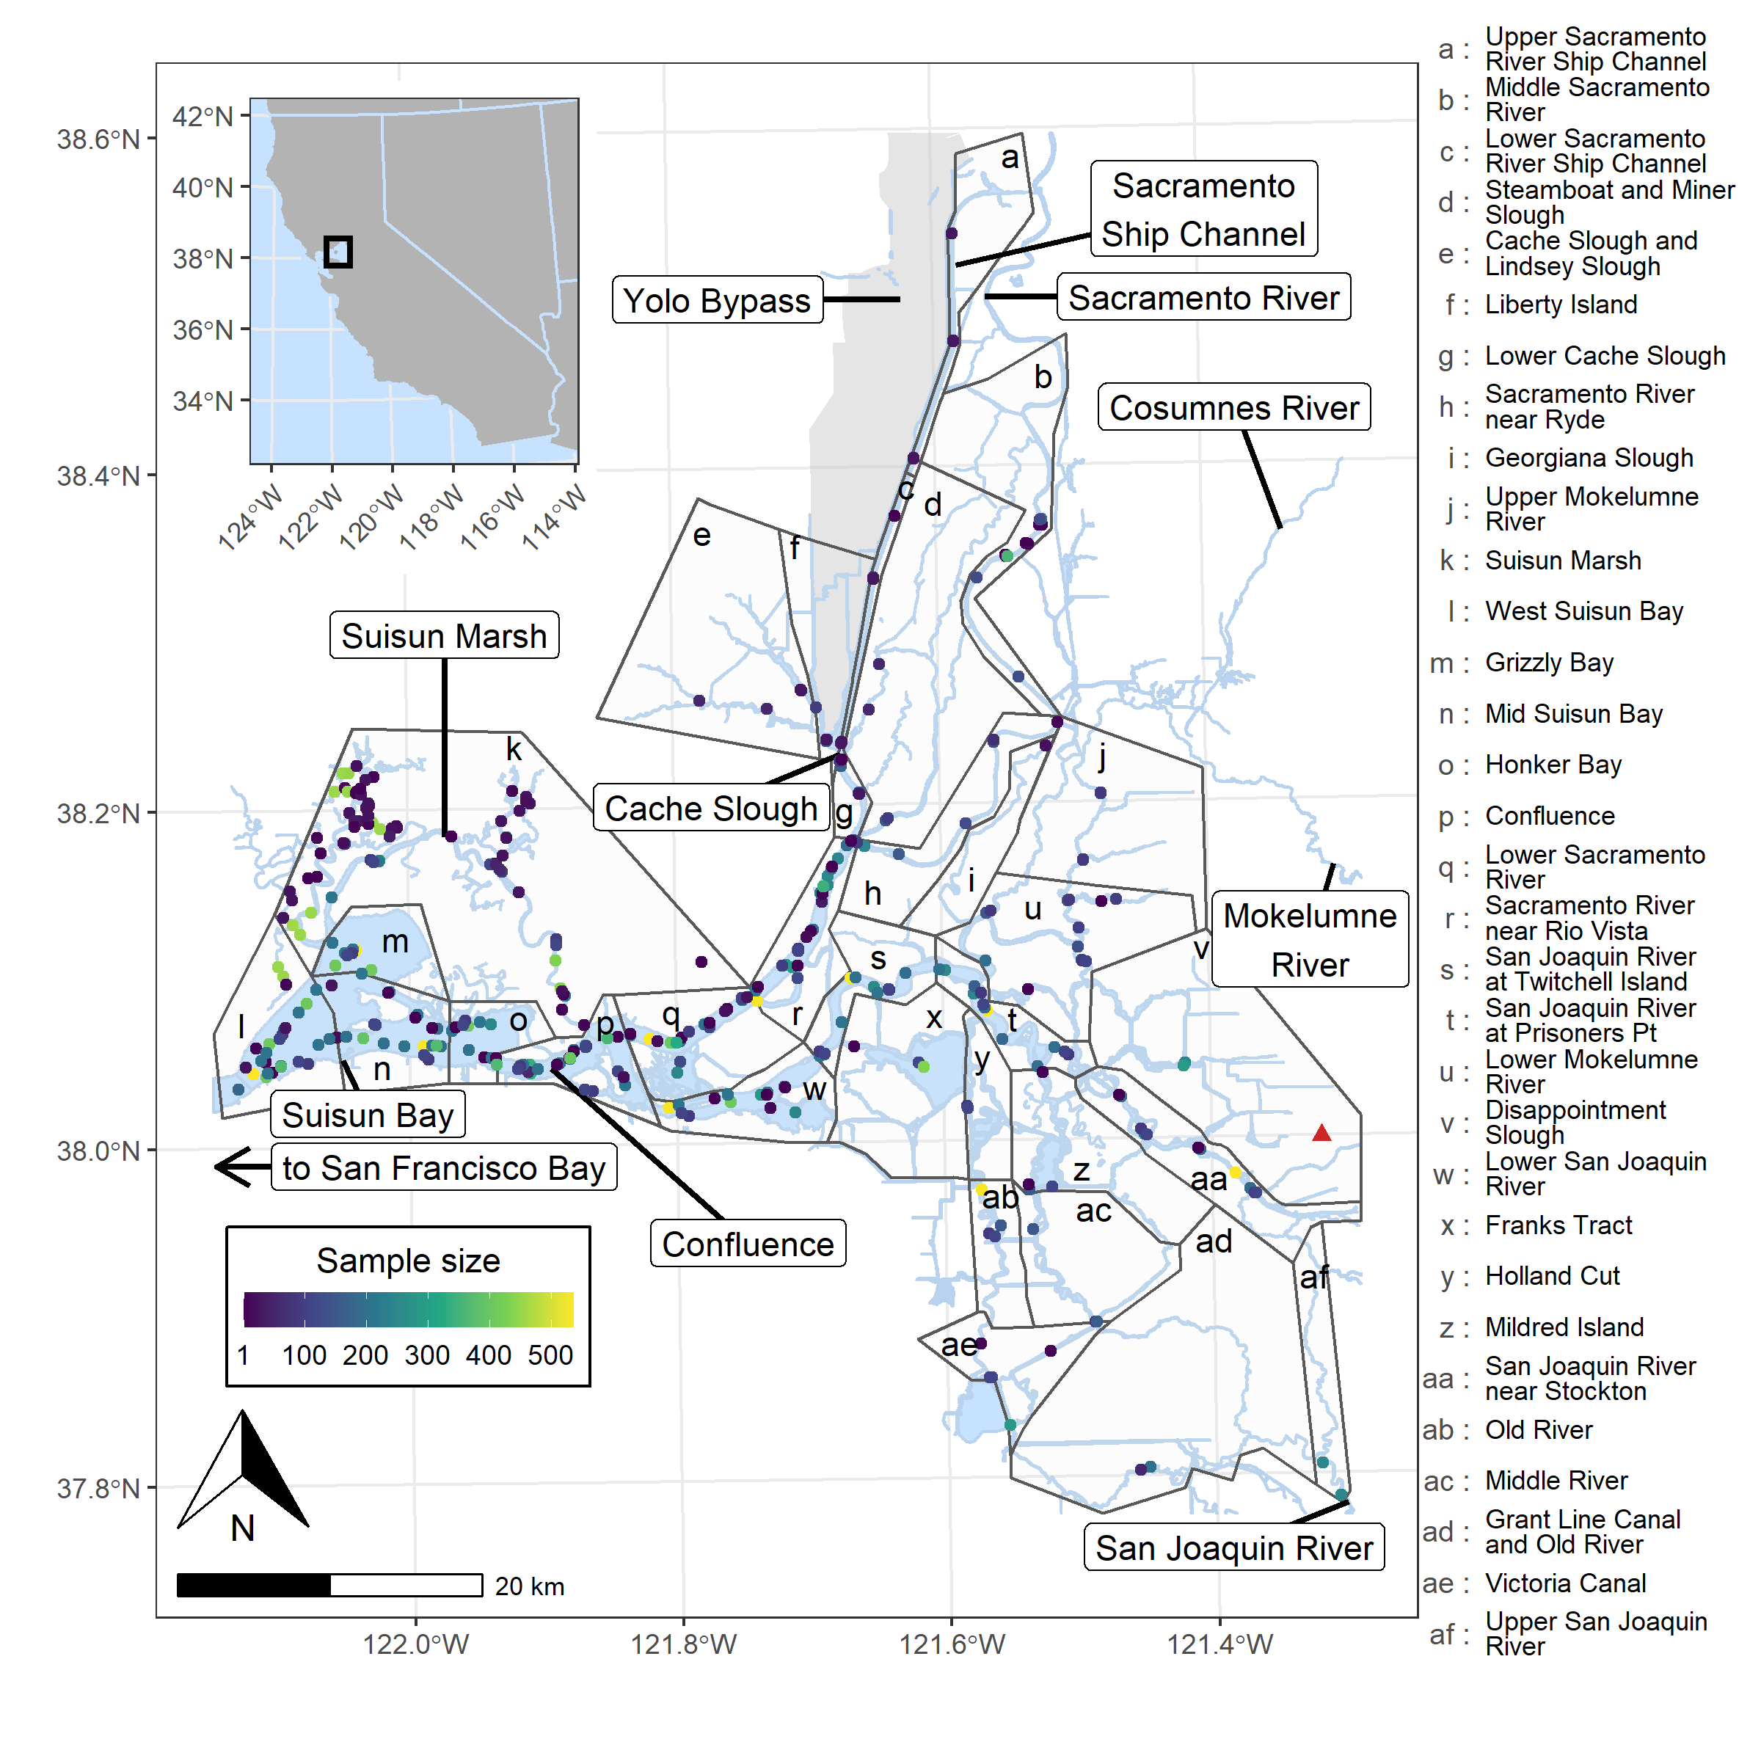
Figure 2. Map of the study area (upper San Francisco Estuary) and regions. Each point represents a station and the color denotes the number of observations. Data shown in the figure is the larger dataset used to fit models 1-3 and 5. The red triangle represents the Stockton fire station #4 where precipitation was measured. The Yolo Bypass floodplain is represented with gray shading and it extends a farther 20 km north of our study region. The Sacramento San Joaquin Delta includes all regions East (upstream) of the Confluence.
Model fitting was performed with the mgcv function bam, which is built for large datasets, and with the “discrete” option enabled to speed up computation. The scaled-t model family (function scat) was used to account for outliers in the dataset. Basis dimensions of smooth terms were assessed first with the gam.check function. If any smooths looked potentially problematic from this assessment, models were refit with a higher basis dimension and compared to the original with the Akaike Information Criterion (AIC) and whether model predictions were changed. To assess the degree of residual spatiotemporal autocorrelation, we calculated the spatiotemporal variogram on the model residuals using the R package gstat (Pebesma 2004; Pebesma and Heuvelink 2016).

Models 1 & 2: Spatio-seasonal trends in the temperature-total inflow relationship
To determine the spatial and seasonal patterns in the relationship between water temperature and total inflow (T-I relationship), we fit model 1 with all model components except C3 (Table 1), and with the inflow variable centered and scaled by the monthly means and standard deviations (Table 2). We used this monthly scaling to produce interpretable results despite the wide seasonal variability in inflow and ensure T-I relationships were based on among rather than within-year inflow differences. However, to ensure that this monthly standardization didn’t overly influence the results, we fit another model (model 2) exactly the same as model 1 but with the inflow variable centered and standardized by the global mean and standard deviation from the Dayflow dataset (Table 1).
Table 2. Mean and standard deviation of 30-day mean inflow and precipitation from Dayflow, for each month of the year. For each day of the month, the inflow and precipitation over the prior 30 days was averaged into the 30-day mean. Then, these 30-day mean values for each day of the month were aggregated into the mean and standard deviations (SD) shown in this table, which were used to center and scale, respectively, the variables prior to fitting models 1 and 3-5. All values are in cubic feet per second (cfs; 1 cubic foot = 0.028 m³).
Month | Mean inflow | SD inflow | Mean precipitation | SD precipitation
Jan | 45,280 | 46,404 | 2,694 | 1,974
Feb | 58,652 | 52,357 | 2,941 | 2,003
Mar | 63,369 | 55,253 | 2,475 | 1,732
Apr | 50,350 | 43,159 | 1,756 | 1,588
May | 35,889 | 31,207 | 807 | 790
Jun | 28,681 | 21,372 | 289 | 498
Jul | 21,462 | 12,444 | 60 | 151
Aug | 18,675 | 6,328 | 30 | 119
Sep | 18,092 | 5,784 | 99 | 273
Oct | 16,770 | 6,383 | 445 | 613
Nov | 15,906 | 7,561 | 1,221 | 1,088
Dec | 25,152 | 19,905 | 2,104 | 1,516

Model 3: Incorporating long-term temperature change
Water temperature in the upper San Francisco Estuary has risen over the past five decades (Bashevkin et al. 2021), which may confound our results because dry years were more frequent in the latter half of our time series (Mahardja et al. 2021). To assess whether long-term underlying temperature changes could affect our results, we fit model 3, which was identical to model 1 but with an additional component to estimate the long-term water temperature trend. This component (C3) was identical to component C2 but instead of multiplying the smooth by inflow, it was multiplied by the water year (centered and scaled; Table 1). Water years begin in October and end in the following September. This component was identical to that used in Bashevkin et al. (2021) except in this case, we used water years instead of calendar years to better match the structure of the dataset.

Model 4: Salinity-seasonal trends in the temperature-total inflow relationship
Since salinity is often used as a proxy for estuarine position and is an important indicator for species occupancy (Sommer et al. 2011; Feyrer et al. 2015), we fit model 4 with a thin plate smooth of salinity (centered and scaled) substituted for the spatial element of model component C2. The spatial element of component C1 was retained to continue correcting for spatial autocorrelation (Table 1).

Model 5: Spatio-seasonal trends in the temperature-precipitation relationship
To determine the influence of in-Delta precipitation on water temperatures, we fit model 5 with the in-Delta precipitation values from Dayflow. This model was identical to model 1 but with the inflow variable replaced with an analogous 30-day mean precipitation variable (Table 1).

Model predictions
Model predictions were used to assess the interdependent impacts of our covariates on water temperature. For the spatially explicit models (models 1-3, 5), we generated these predictions on an evenly spaced grid of 100 x 100 cells over the spatial domain of our dataset, which was then filtered to just those cells that contained water, resulting in 1,698 cells. We chose the midpoint of each cell as a point location for model predictions. For model 3, in which salinity was used as a proxy for estuarine position, we used an evenly spaced sequence of 100 salinity values from the 5th to the 95th percentile salinity value in the base dataset.
We then created a dataset with all combinations of the evenly spaced point locations (or salinity values for model 4) and the ordinal dates corresponding to the 15th of each month. The time of day was set to noon. To avoid extrapolation, we removed any covariate combinations that were not present in the underlying dataset. To assess the relationship between inflow and water temperature, we extracted the predicted value of model component C2 (effect of inflow [or precipitation] on water temperature represented as a smooth of spatial position [or salinity] and ordinal date) and its standard error. The standard errors were converted to 99.9% confidence intervals, representing a p-value of 0.001 as our cutoff for statistical significance. This conservative cutoff was used to account for any residual autocorrelation unaccounted for by the AR(1) structure.

Results

Model validation
All models conformed to linear model assumptions (Fig. 3). The adjusted R² values for models 1 - 5 were 0.9225, 0.9226, 0.9245, 0.9232, and 0.9186 respectively. The spatiotemporal variograms revealed some temporal autocorrelation at a lag of 1 month but none at later months or along the spatial dimension (Figs. S5-S9).
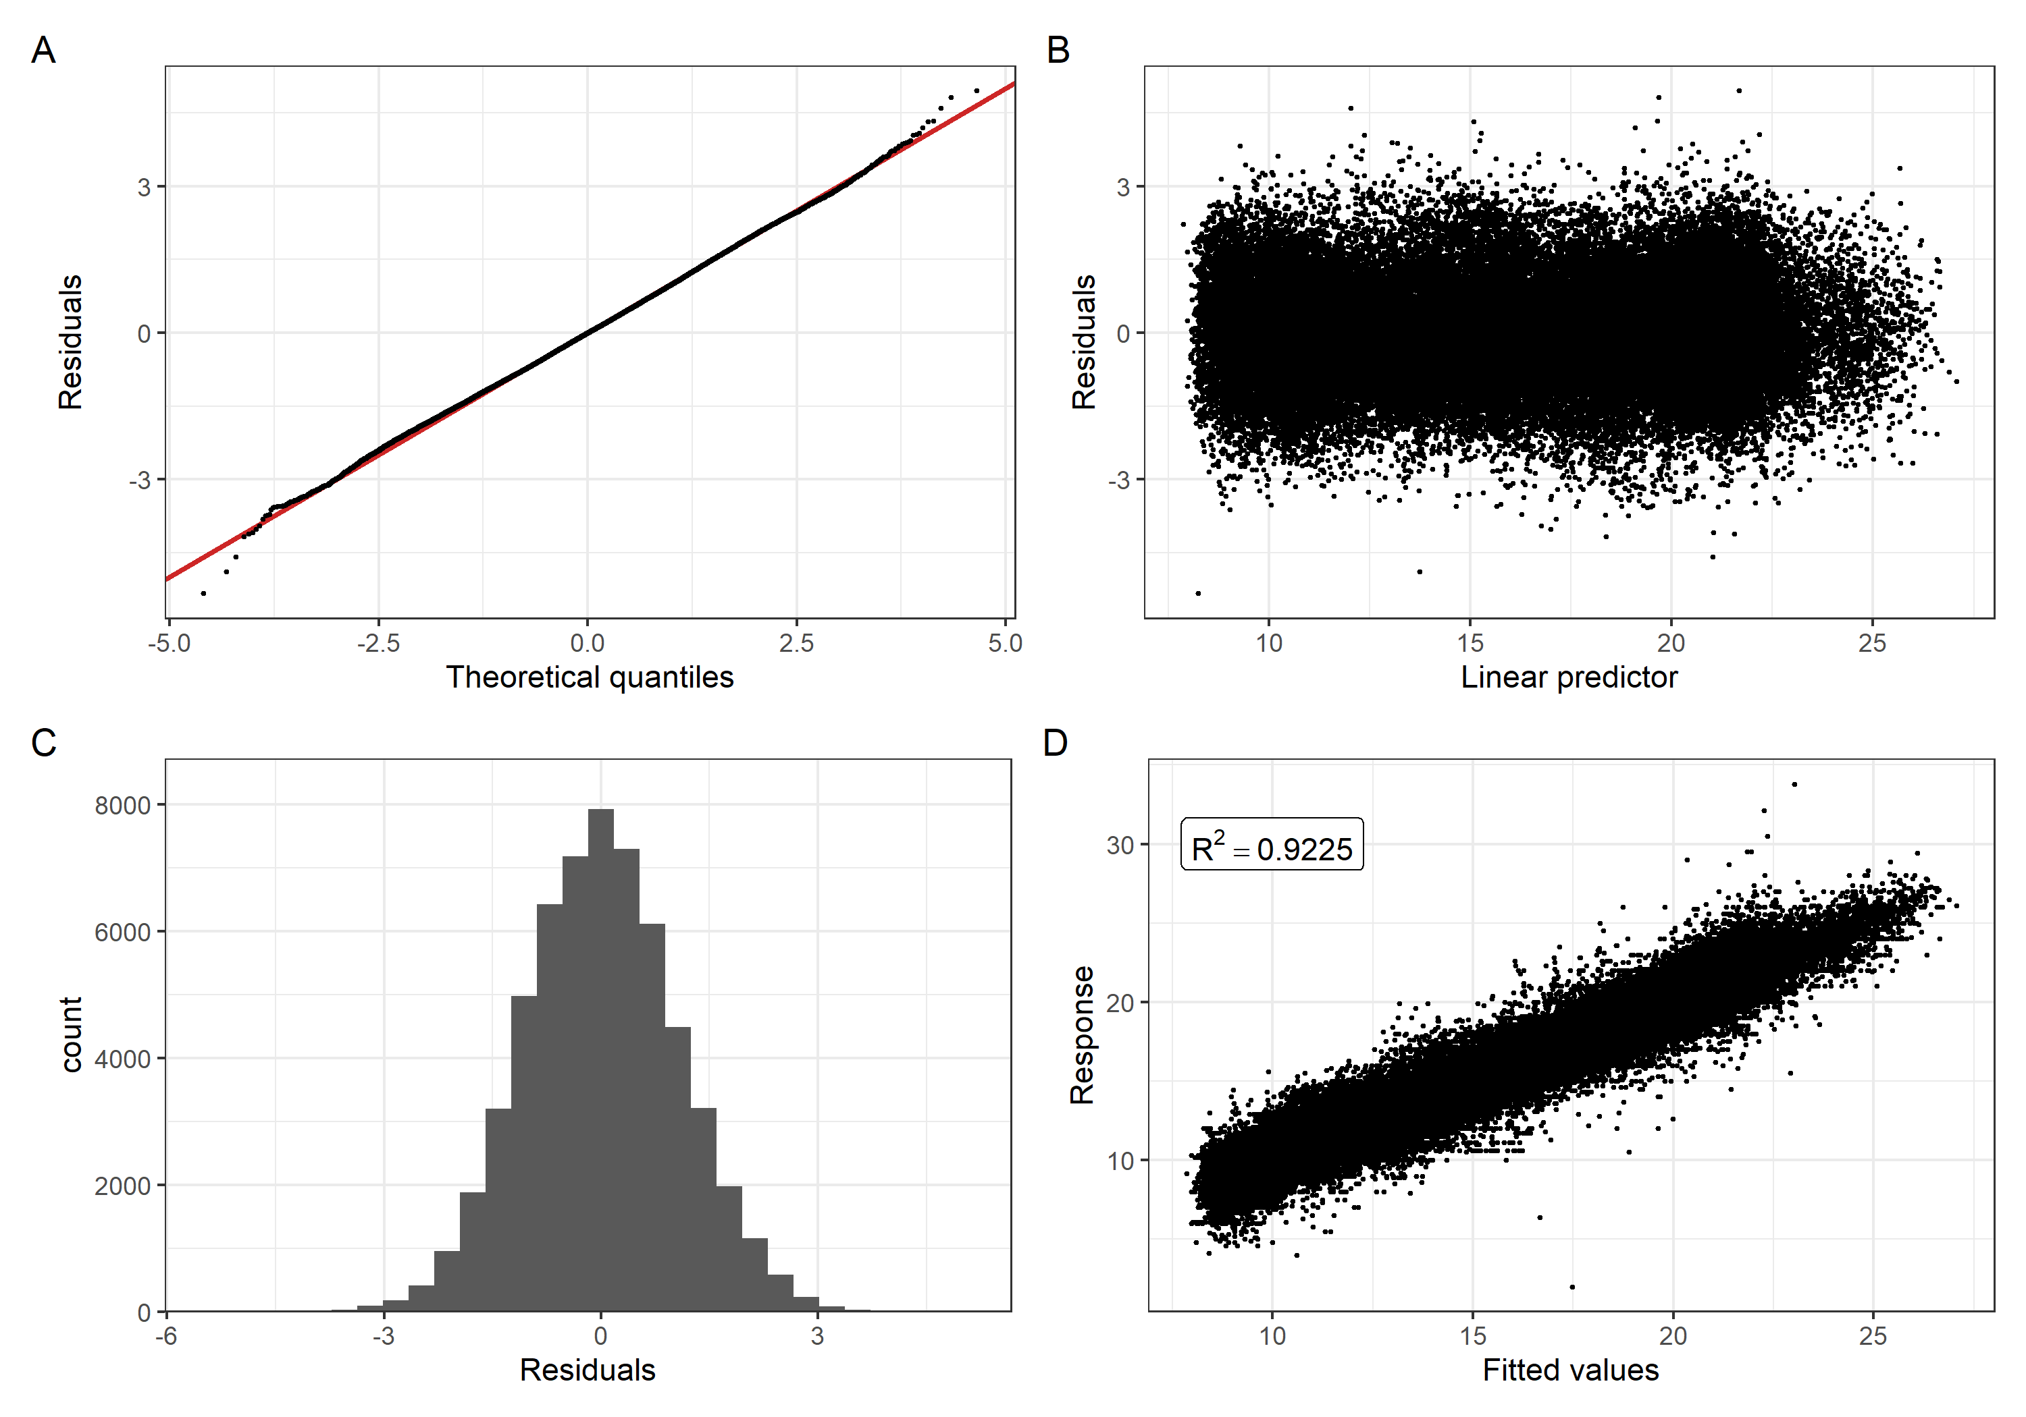
Figure 3. Model diagnostic plots from model 1. A) Q-Q plot of the theoretical quantiles and residuals. The red line represents the expected 1:1 relationship. B) Linear predictor vs. residuals. C) Histogram of residuals. D) Fitted values vs. response with adjusted R² in the inset. Plots for models 2 - 5 were almost identical (Figs. S1-S4). Adjusted R² values for models 2 - 5 were 0.9226, 0.9245, 0.9232, and 0.9186 respectively.

Spatio-seasonal trends in the total inflow temperature relationship
The relationship between water temperature and total inflow (T-I relationship) had considerable geographic and seasonal variability (Fig. 4). General patterns were similar for model 1 (inflow scaled by monthly mean and standard deviation) and model 2 (inflow scaled by global mean and standard deviation) (Fig. S10), so further results are presented from model 1 to aid interpretability.
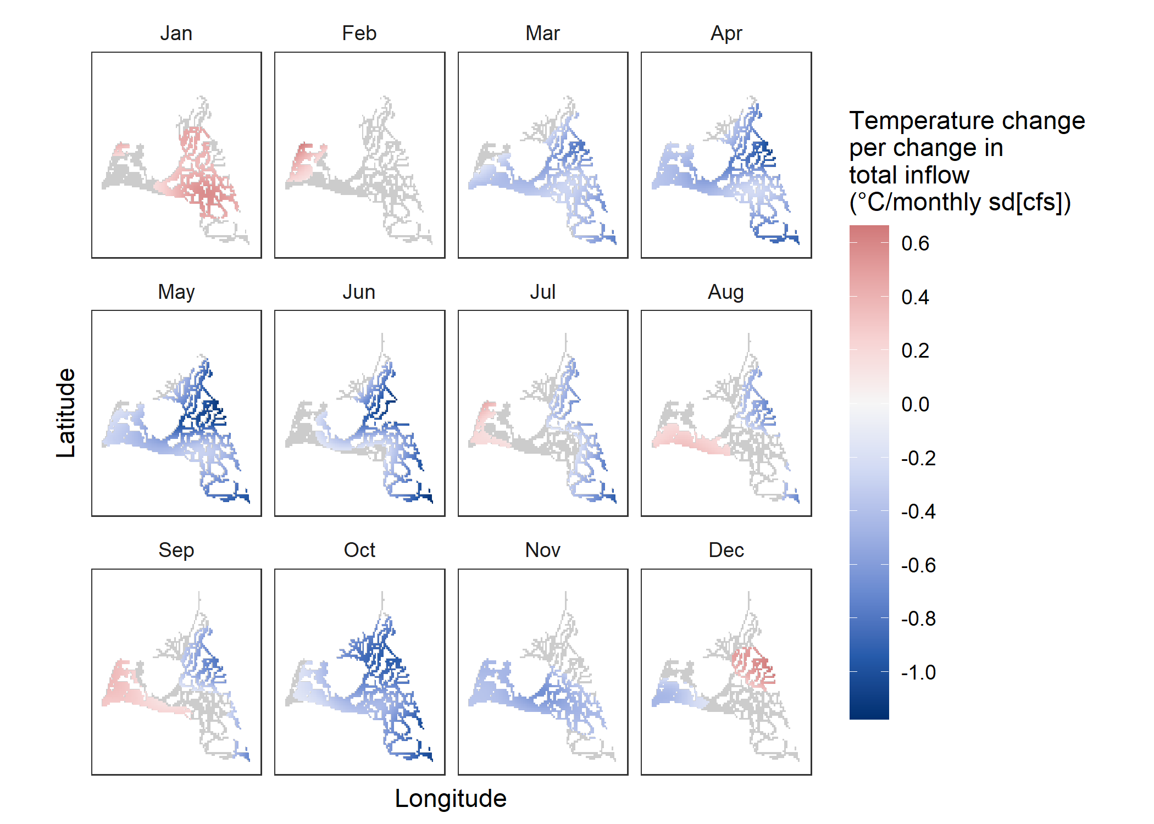
Figure 4. Relationship between monthly-standardized Delta inflow and surface water temperature (T-I relationship) from model 1. Inflow was represented as the 30-day mean inflow for each temperature observation, which was then centered and standardized by the monthly mean and standard deviation, respectively. Thus, the numbers represent the water temperature change (°C) for each one standard deviation change in inflow (cubic feet per second: cfs). The inflow standard deviation magnitude varies monthly (Table 2, Fig. S11). Red areas represent a positive correlation and blue a negative correlation. Only areas with significant (p < 0.001) T-I relationships are plotted, with gray areas representing no significant T-I relationship.
The majority of significant T-I relationships (p < 0.001) were negative, wherein increased inflow was associated with reduced water temperatures. These negative T-I relationships were strongest (highest magnitude) in the East, particularly in the months of March - June and October - November. However, we also detected significant positive T-I relationships, wherein increased inflow was associated with increased water temperatures. These positive T-I relationships were strongest and most widespread in January in the central-eastern regions, and they were also apparent in western regions in February, July, August, and September, and in the East in December. The summer months (July - September) were characterized by an east-west divide in the direction of the T-I relationship, with a negative T-I relationship in the west, and positive in the east, while December had the reverse pattern (Fig. 4, S12).
Negative T-I relationships reached higher magnitudes than the positive T-I relationships on the monthly standardized scale (Fig. 4). For example, T-I relationships reached slightly more than -1 °C / sd inflow in May, which corresponded to a 1 °C drop in water temperature for each 31,207 cubic foot per second (cfs) of increased 30-day mean inflow, and a difference of 2 °C between generally dry (-1 sd) and wet (1 sd) conditions (Table 2, Fig. 4). In January, the T-I relationship reached + 0.6°C / sd inflow, which corresponded to a 0.6 °C increase in water temperature for each 46,404 cfs of increased 30-day mean inflow, and a difference of 1.2 °C between dry and wet conditions (Table 2, Fig. 4). Furthermore, inflow values reached greater high than low extremes in most months such that ranges of two or more standard deviations above the mean were common for most months, while the lows only reached one standard deviation below the mean in most months (Fig. S11).
Model 3, in which the long-term water temperature trend was added to the model, produced almost identical results to model 1 (Figs. 3, S13). The only discernable difference was a larger region with a positive T-I relationship in December (Fig. S13).

Salinity-seasonal trends in the temperature total inflow relationship
Results from model 4, in which salinity was included as a proxy for location, generally conformed to those from model 1, although there were key differences (Fig. 5). As in model 1, negative T-I relationships were observed in March (salinity < 1.5 or > 3 PPT), April - May (all salinities), June (salinity < 1.5) and October - November (all salinities). In May, June, and to some extent in October, the same gradient of an increasingly positive T-I relationship from low to high salinity (east to west) was observed, but this gradient was not as apparent in the other months. At the lower end of the salinity range, the April T-I relationship also became increasingly positive with increasing salinity, but at salinities > 3 the pattern shifted and T-I relationships became increasingly negative with increasing salinity. This shift at a salinity of 3 was also apparent in February, March, and to a lesser extent in June and July. Positive T-I relationships similar to model 1 were found in January (salinity < 9), February (salinity < 3), and July – September (salinity < 6) (Fig. 5).
The biggest differences between models 2 and 4 were detected in in March, August, and December. In March, model 4 detected a positive T-I relationship in salinities from 1.5 - 3, while in model 1 all detected T-I relationships were negative for this month. However, salinities from 1.5 - 3 would include Suisun Marsh (Figs. 2, 6), where T-I relationships from model 1 were weak in March and the confidence intervals spanned positive values (Fig. S12). In August, model 4 detected positive T-I relationships at the lowest salinities, while model 1 detected negative T-I relationships in the east where salinities are lowest. However, model 1 did detect positive T-I relationships in some low-salinity areas east of the confluence and both models detected negative T-I relationships at the highest salinities (westernmost areas), although those T-I relationships were not significant in model 4. In December, model 4 detected negative T-I relationships at low salinities (east) and positive T-I relationships at high salinities (west), while in model 1 the reverse trend was observed. However, in the very lowest salinities corresponding to the regions in which positive T-I relationships were detected in model 1, the T-I relationship was very close to 0 in model 4.
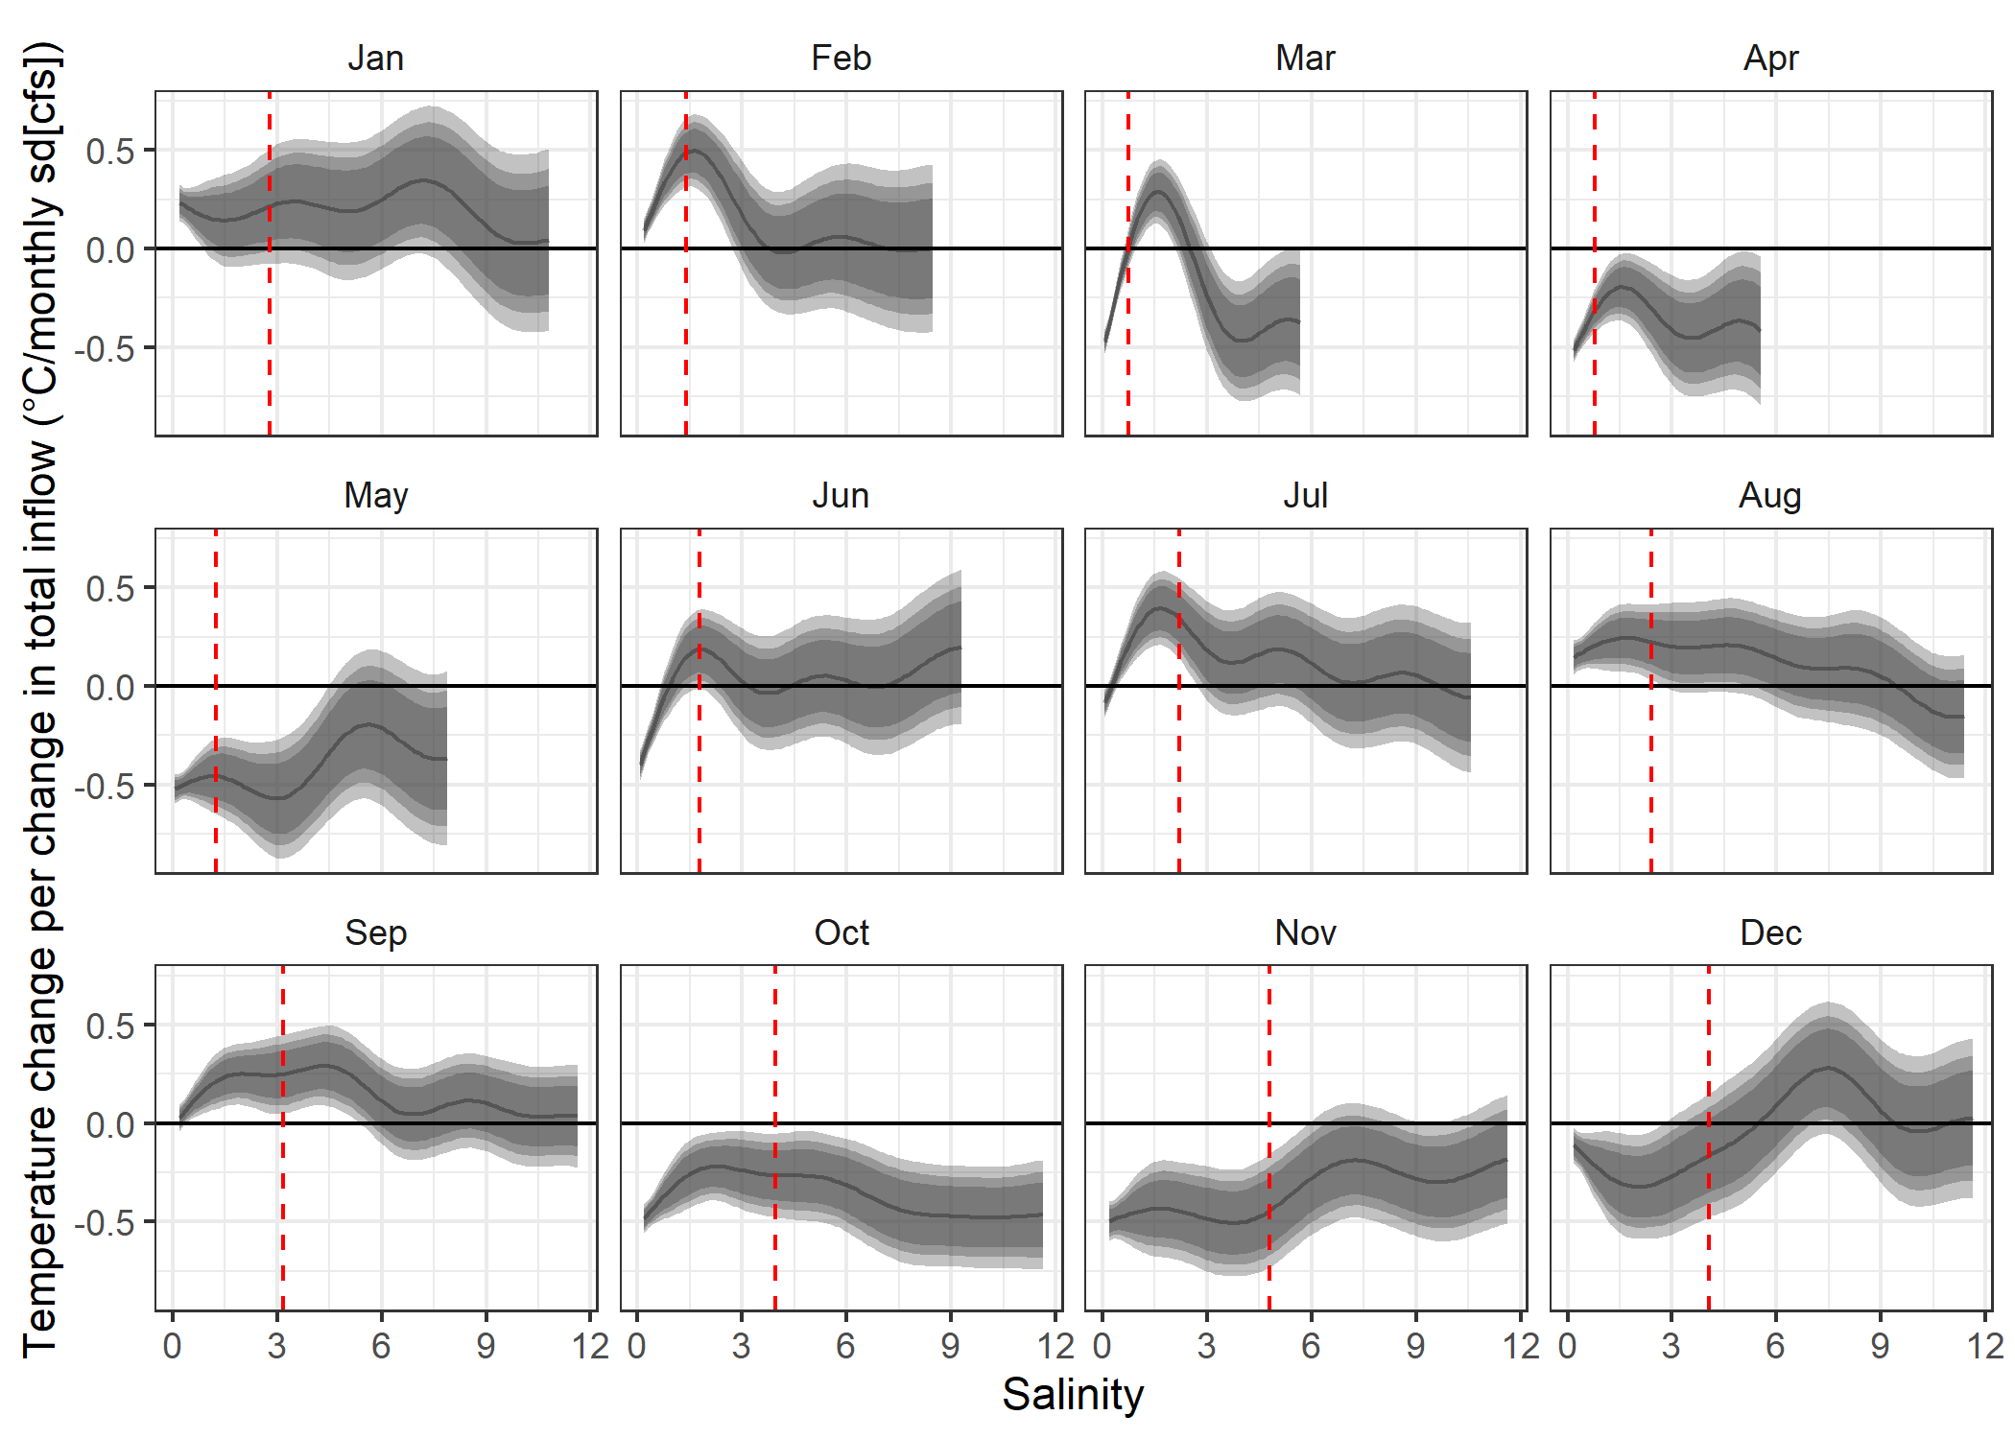
Figure 5. Relationship between monthly-standardized Delta inflow and surface water temperature (T-I relationship) along the salinity axis from model 4. The smooth line represents the mean T-I relationship, while shaded regions represent the 95%, 99%, and 99.9% confidence intervals. Salinities are truncated to values within the 5th and 95th percentiles of observed values for each month. The horizontal line represents no relationship between inflow and surface water temperature while the vertical red line indicates the monthly average salinity of the Confluence region (Fig. 6). The geographical and seasonal distribution of the salinity field can be seen in Fig. 6. Salinities are given in parts per thousand (PPT).
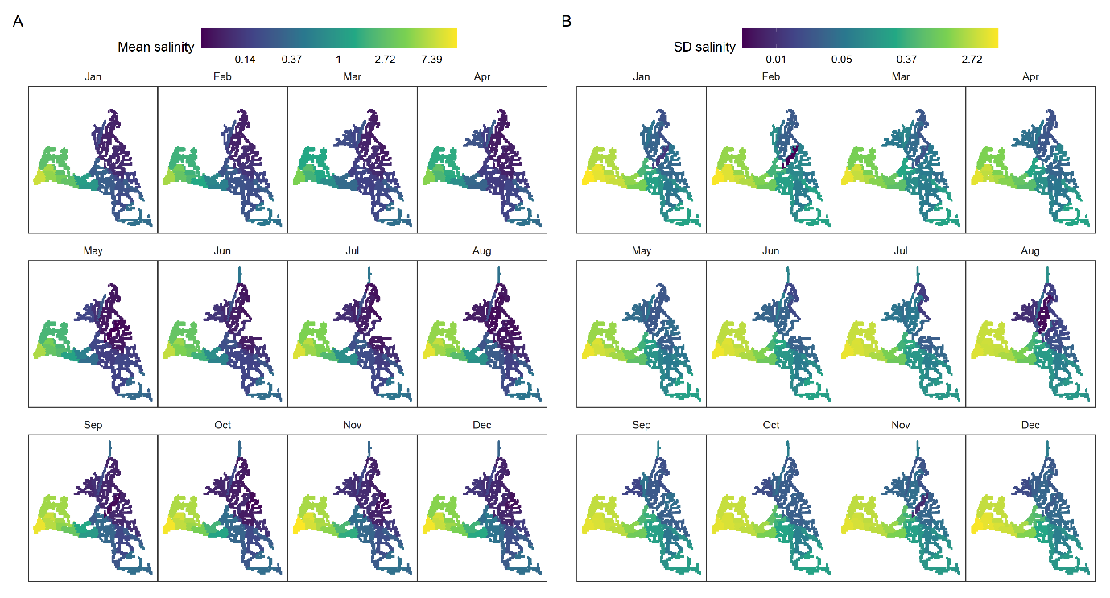
Figure 6. A) Mean and B) standard deviation (SD) of salinity over the study region, plotted on the log scale. Salinity data were summarized within each region shown in Fig. 2, so abrupt changes reflect regional boundaries. Salinities are given in parts per thousand (PPT).
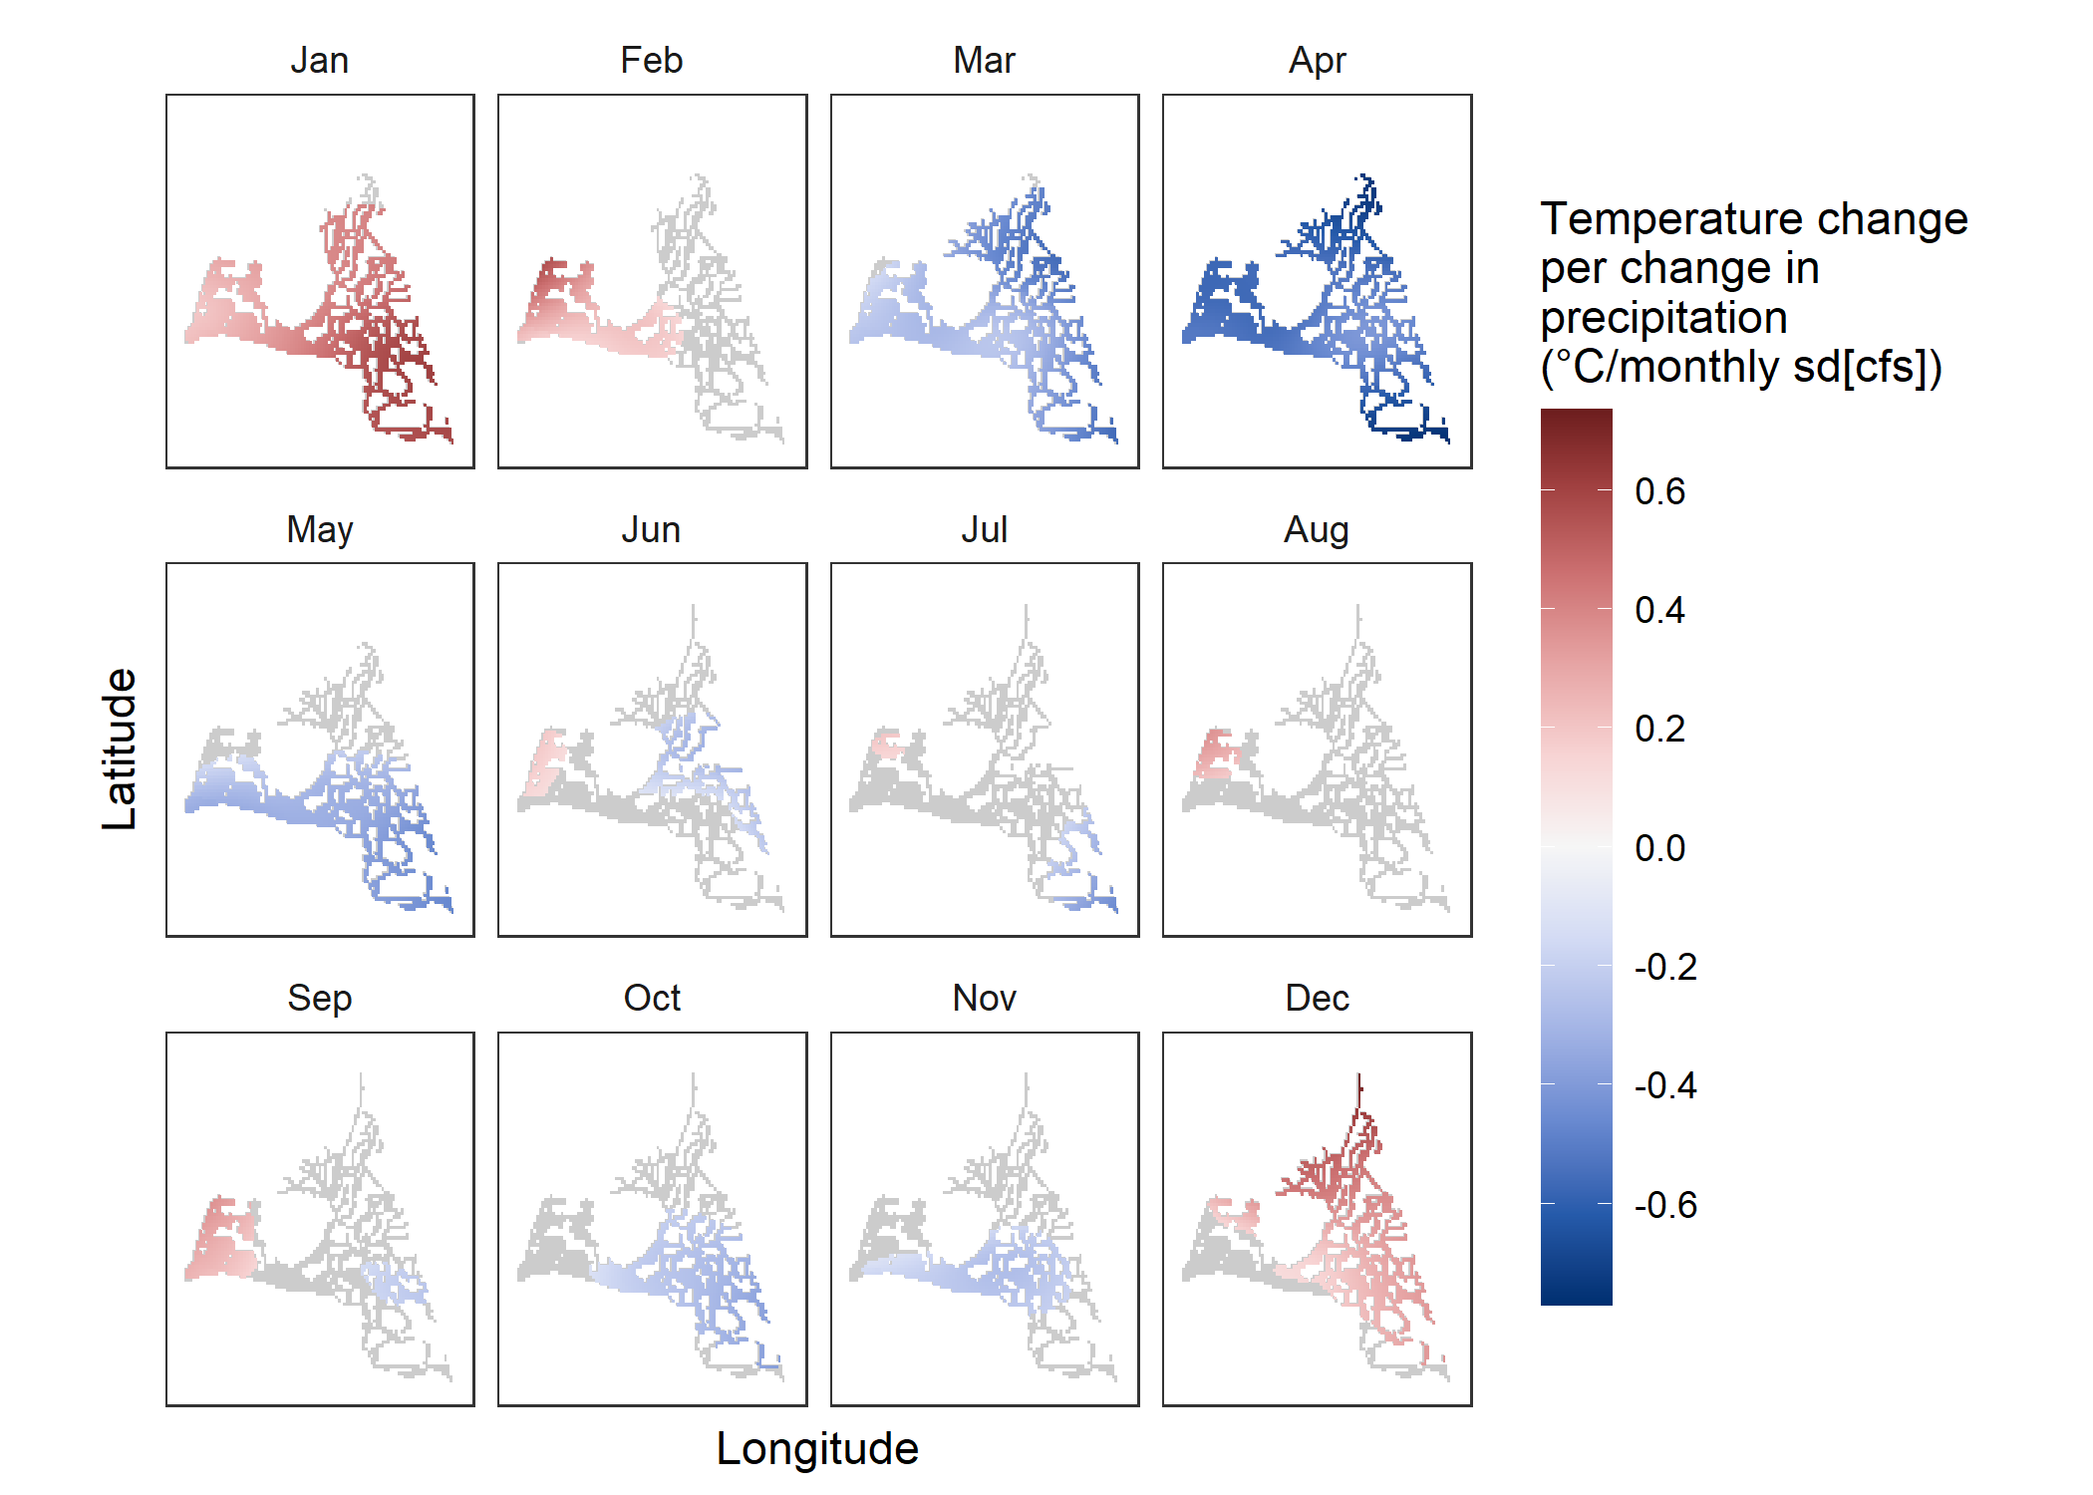
Figure 7. Relationship between monthly-standardized in-Delta precipitation and surface water temperature (T-P relationship) from model 5. Only areas with significant (p < 0.001) T-P relationships are plotted, with gray areas representing no significant trend. Note that precipitation is largely absent during the dry summers (Table 2) and precipitation values are calculated based on one station near Stockton (Fig. 2).

Spatio-seasonal trends in the temperature precipitation relationship
The temperature precipitation relationship (T-P relationship) was generally similar to the T-I relationship, with the same seasonal pattern in the direction of the relationship (Figs. 3, 5). However, the T-P relationship was greatly weakened in the summer months when precipitation is very low (Table 2), revealing the impact of inflow from out of the system driving the observed summer T-I relationship. Furthermore, the T-P relationship was stronger and more widespread in December and January when strong winter storms can change air temperature regimes as well as releasing copious rainfall (Fig. 7).

Discussion
Ecological demand for cold freshwater is likely to grow as global air and water temperatures increase. Coldwater habitat requirements for endangered fishes have led to adjustments in the timing and volume of reservoir releases in the upper extent of California's Sacramento River (Brown and Bauer 2010). Hundreds of river kilometers downstream in the upper SFE, water releases are expected to have less effect on water temperature, so there is no active temperature management (although some smaller watersheds are closer to the upper SFE). However, there is uncertainty in the extent and magnitude of the correlation between inflow and water temperature in the upper SFE given the various drivers of inflow that can indirectly affect water temperature (Fig. 1) (Kimmerer 2004; Jeffries et al. 2016; Sommer 2020). The goal of this study is not to recommend the use of freshwater flow to manage water temperature, but rather to better understand the temperature changes we would expect based on the amount of freshwater flow that enters the system, and in effect how we can expect water temperatures to change across dry vs. wet years.
We found persistent correlations between inflow and water temperature, but the strength and direction of these correlations exhibited considerable seasonal and spatial variability. Negative T-I (temperature-total inflow) relationships in which higher total inflow was associated with lower water temperatures were observed most commonly, but positive relationships were observed in the winter months, and in the western regions during the mid-late summer (Jul-Sep). The T-I relationship was probably most driven by upstream factors (e.g., snowmelt, dam releases, or inflowing river temperature) during the summer months when in-Delta precipitation had a negligible relationship with water temperature (T-P relationship). In contrast, in-Delta precipitation and the related weather conditions may drive much of the pattern in the winter months when the T-P relationship was stronger.
We found similar results from a range of model structures, providing evidence for the robustness of our approach. With model 2, we validated that our method of standardizing inflow for each month did not influence the broad patterns in T-I relationships by comparing the results with our main model (model 1, Figs 4, S10). In model 3, we estimated the long-term water temperature trend on top of the T-I relationship to confirm that the T-I relationship was not confounded by co-occurring long-term trends in water temperature and inflow (Figs. 4, S13). In addition, the long-term water temperature trend estimated in model 3 (Fig. S14) was almost identical to that estimated in a prior study using a similar model structure (without the inflow component) and the same dataset (Bashevkin et al. 2021). In model 4, we assessed the T-I relationship along the salinity continuum instead of over space. Model 4 generally produced similar results as model 1, although there were some differences (Figs. 4-5). Many of the areas of contrast between models 2 and 4 corresponded to a significant effect from one model and no significant effect of the other model, rather than conflicting directions of effects. This is likely because model 4 could transcend geographic bounds to infer patterns for select positions on the salinity continuum while model 1 was firmly rooted in geography. Lastly, our modelling approach was validated with simulated data in a prior study on the same dataset (Bashevkin et al. 2021).

Comparison to prior studies
In the upper SFE, inflowing river temperature can play a role in dictating water temperatures near the points of river input (Vroom et al. 2017). The magnitude of inflow would thus be expected to have an influence as well by controlling how far the river temperature effect penetrates the estuary. Yet few studies have looked at T-I or T-P relationships in the upper SFE, particularly at the level of spatio-seasonal resolution we include in our analysis. Some of these studies have suggested that reservoir-released inflow (an effect that we were unable to isolate in this study) has little influence on water temperatures (Sommer 2020). Similarly, Daniels and Danner (2020) found that the influence of dam discharges and discharge temperatures are greatly reduced (but not eliminated) towards the lower reaches of the Sacramento River, such that air temperature is the primary correlate of Sacramento River temperatures > 50 km upstream of our study region. However, several other studies found a general pattern of negative T-I relationships that corresponds to our findings. For example, Kimmerer (2004) compared air to water temperature correlations for low and high flow events and found negative T-I relationships at two sites along the Sacramento River and near the Confluence. Jeffries et al. (2016) compared water temperatures from the 2012-2015 extreme drought to the prior 17 years and found significantly warmer temperatures during the drought period for April – July. Lastly, Munsch et al. (2019) found nonsignificant negative correlations between winter precipitation and April water temperatures.
T-I relationships have been investigated before in estuaries and streams at more coarse resolutions. A study of the Mississippi River Estuary found that large discharges of cooler freshwater could have a cooling effect on the whole estuary (Lane et al. 2007). Similarly, in the Yaquina Estuary (Oregon, USA) a 20% reduction in river discharge during the dry season was projected to result in water temperature increases up to 1.4 °C. The impact was highest upstream and became negligible farther downstream (Brown et al. 2016a). Many studies on streams and rivers also found negative T-I relationships, likely due to the greater water mass at higher flows increasing the thermal inertia and thus dampening the impact of local air temperatures while increasing the impact of upstream water temperatures (Smith and Lavis 1975; Gu 1998; Gu et al. 1998; Webb et al. 2003; Chang and Lawler 2011; Vliet et al. 2011). In contrast, a study of a cool river in Japan found that water temperatures initially increased during high discharges from rainstorms (positive T-I relationship), but as the peak flows receded the stream temperatures decreased to values even lower than they were initially. The authors concluded that the initial increase was due to the warmer temperature of the rainfall than the stream, while the later reduction in temperature was due to the influx of cooler subsurface water (Kobayashi et al. 1999). Together, these studies suggest that the T-I relationship can modify the relative contributions of local and upstream conditions on water temperatures and that the T-I relationship is dependent on the relative temperatures of the water body of interest, rainfall, and inflowing waters (whether from upstream or groundwater).

Geographical divides in the temperature-inflow relationship
Our results show upstream-downstream gradients in the size and direction of the T-I relationship corresponding to increasingly negative relationships near the river inputs in the east and increasingly positive relationships near the connection to San Francisco Bay in the west. These gradients are especially apparent from April through October (Fig. 4), corresponding to most of the “dry season” when inflow would be driven mostly by reservoir releases with some contribution of snowmelt early in the season. April is on the boundary of the wet and dry season (Table 2) and the gradient is least discernable for that month. In July - September and December these gradients were strong enough to produce divergences in the direction of the T-I relationship (Fig 4). During the summer (July – September), we found a positive T-I relationship in the west and a negative relationship in the east, while the pattern was reversed in December. This may reflect the conflicting influences of the more seasonally stable (western) San Francisco Bay water temperatures and the seasonally variable (eastern) Delta water temperatures. In the summer, Suisun Bay waters are often cooler than the Delta, while in December that balance is reversed. Thus, inflowing waters of an intermediate temperature between these two water bodies may be able to simultaneously cool the Delta and warm Suisun Bay in the summer, with the reverse pattern in the winter, resulting in the observed pattern. It is worth noting that stratification is more common downstream (west) of the Confluence where the water becomes more saline (Fig. 6). Upstream (eastern) freshwater forms the surface layer of the water column and more saline downstream (western) water pushed upstream by the tides forms the bottom layer. Because our analysis was focused on surface water temperatures, results downstream of the confluence may not be reflective of temperature throughout the water column under stratified conditions.

Temperature-inflow relationships in the dry season
For most of the dry season (April – November), the T-P relationship is reduced or nonexistent relative to the wet-season months, although a major exception is the boundary month April in which the T-P relationship is most strongly negative (Fig. 7). The greater magnitude of the T-I relationship than the T-P relationship implies a greater importance of external influences like river temperature or flow (Figs. 1, 4, 7). This is bolstered by the stronger magnitude of the T-I relationship near the river inputs to the north, south, and east (Fig. 4). Interestingly, in most of these months, the strong T-I relationship persists farther into the Delta along the Sacramento corridor (from the North) than along the San Joaquin River corridor (from the South). This would further suggest a link to river inflow since the Sacramento River inputs 85% of all inflow into the Delta, while the San Joaquin River contributes just 11% on average (Kimmerer 2002b). Riverine input would be expected to show this pattern of reduced water temperatures correlated with higher flows when river temperatures are cooler than the ambient water in the upper SFE. This is generally the case for the Sacramento River for all months except December and January in most years (Bashevkin, unpublished data). Sacramento river temperatures > 50 km upstream of our study region are primarily controlled by atmospheric influences, although dam discharge volume can play a role in the spring (Daniels and Danner 2020).
Higher flows could reduce residence time and increase overall water volume, thereby decreasing the influence of local air temperatures and reducing water temperatures as was seen in prior studies (Smith and Lavis 1975; Gu 1998; Gu et al. 1998; Webb et al. 2003; Chang and Lawler 2011). In the upper SFE, air temperatures often exceed 30 °C in the summer and adjacent months during the daytime. But on most nights, marine air intrusions drop the temperature an extra 6 °C cooler than it would be under other wind conditions (Zaremba and Carroll 1999). Increased thermal inertia from higher flow volumes could help dampen the impact of the daytime temperature spikes and keep water temperatures lower than they would be under lower flows. Water volume and thermal inertia effects would be expected to have the greatest impact near the river inputs, where we did detect some of the highest magnitude T-I relationships (Fig. 4).

Temperature-inflow relationships in the wet season
In the wet season (December – March), we found consistent T-I and T-P relationships, implying a potential role of local precipitation or its correlates in driving the T-I relationship in this season. In the winter months (December – February), we found strongly positive T-I and especially T-P relationships (Figs. 4, 7). High flows during these months are often associated with atmospheric river events, which are accompanied by warmer air temperatures (Dettinger et al. 2011). The strongly positive T-P relationships particularly point toward these storms and their associated weather conditions (e.g., air temperature, relative humidity) as drivers of the winter T-I pattern we observed (Vroom et al. 2017), Fig. 1). However, it is interesting that the positive T-I relationship did not persist throughout the full wet season, which extends into March (Table 2). The T-I and T-P relationships are both negative in March (a pattern that continues into April), which may suggest that the influence of March storms may be different from that of December - February storms. One explanation for this directional switch in March could be an increased influence of cloud cover in March compared to the deeper winter due to the increased solar radiation from longer daytimes. Cloud cover reduces water temperatures (Vroom et al. 2017) so cloudiness from storms could have a strong cooling effect in March and other sunnier months, while its influence could be superseded by air temperature and humidity in the deeper winter when daytime is shorter. Another potential explanation could be the influence of cool snowmelt starting in March. Earlier in the wet season, much of the precipitation is stored as snow in higher elevations which typically begins to melt between March and April. Cool snowmelt runoff may explain some of the observed negative T-I relationships we observed starting in March. While mainstem Sacramento River temperatures may be unlikely to influence local water temperatures in the upper SFE due to the long distance from the upper reservoirs (Daniels and Danner 2020), several other rivers have a much shorter journey from the mountains to the upper SFE (e.g., the American and Feather Rivers to the North, and the San Joaquin River to the South). The San Joaquin River may have a particularly strong influence in the southern portion of the Delta since it is primarily snowmelt-driven, but it only contributes about 11% of annual total inflow (Kimmerer 2002b). However, except for the Cosumnes River, all river inputs to the upper SFE are controlled by reservoir releases, so snowmelt would only have an influence if directly released from reservoirs, which can occur frequently in wet years for flood control purposes.
It is worth noting that the Yolo Bypass floodplain may play a role in the T-I relationship during wet seasons. The Yolo Bypass only floods during the winter and spring of wet years between October and June with inundation peaking from January – March (Sommer et al. 2001). During very wet years, it can divert a large proportion of the Sacramento River water, accounting for roughly a third of the total inflow (Kimmerer 2004). The flooding of Yolo Bypass considerably increases the amount of shallow water area, potentially allowing water temperature to equilibrate more quickly with air temperature while increasing water residence time.

Implications
Both water temperature and freshwater flow are expected to change due to climate warming, adding further pressure to species of concern and negatively impacting important ecosystem services such as water supply (Knowles et al. 2018). While the exact drivers of the T-I relationships we observed are not identified in this study, all are linked in some way to precipitation (Fig 1). Precipitation in California is extremely variable year-to-year, more so than any other region of the United States (Dettinger et al. 2016). The T-I relationships detected in this study persisted despite increasing water temperatures (Bashevkin et al. 2021), changing precipitation regimes (Swain et al. 2018), and adjustments to water operations due to environmental regulations. Under climate change, precipitation variability is expected to increase, resulting in both increasingly intense droughts and wet periods, as well as increasingly strong swings between the two extremes (Swain et al. 2018). Our results suggest that water temperatures may be impacted along with the expected effects on Delta inflow. In the winter months (December – February), increasingly extreme wet years with high inflow may result in warmer water temperatures during these years (Figs. 4, 7). In the rest of the year, higher inflow during these extreme wet years may result in cooler water temperatures, especially in the eastern portion of the upper SFE and areas closer to river inputs (Figs. 4, 7). Meanwhile, increasingly strong droughts may result in cooler water temperatures in the winter and warmer water temperatures in other months. Furthermore, these patterns may interact with water supply management which can strongly influence inflow especially during the spring, summer, and fall months (Kimmerer 2002b).
The upper SFE serves as key habitat for a variety of aquatic species of concern. Multiple flow-abundance relationships for some of these species have been well documented and studied, though some remain contentious due to either weak correlation or a lack of mechanistic understanding (Kimmerer 2002b; Kimmerer et al. 2009, 2013; Tamburello et al. 2019). Our results indicate that flow-related changes in water temperature may be a contributing mechanism that underlies a number of these flow-abundance relationships. For example, Longfin Smelt (Spirinchus thaleichthys), a fish species listed under the California Endangered Species Act, exhibit a strong positive relationship with flow (Nobriga and Rosenfield 2016; Mahardja et al. 2021), but the mechanism behind this relationship is not entirely clear (but see Grimaldo et al. 2020). Larval and juvenile Longfin Smelt demonstrate sensitivity to high temperatures; thus warmer springtime water temperatures may partially explain their decline during droughts (Jeffries et al. 2016; Mahardja et al. 2017; Peterson and Barajas 2018).
While a number of fish species are close to their thermal limits where temperature can directly influence survival, non-lethal temperature changes can also significantly alter key life history processes (Brown et al. 2016b; Jeffries et al. 2016; Zillig et al. 2021). While some life history processes are dependent on absolute temperatures, we do not make absolute temperature predictions in this paper. However, the direction and magnitude of temperature changes can also be informative for understanding impacts on fishes. The United States Endangered Species Act-listed Delta Smelt (Hypomesus transpacificus), along with other native species, spawn in the spring during specific temperature regimes that are cooler than those required by nonnative fishes (Meng and Matern 2001; Bennett 2005). Elevated water temperatures of the magnitude we related to inflow changes can reduce Delta Smelt reproductive success by shortening the duration of their spawning window (Brown et al. 2016b). For Chinook Salmon (Oncorhynchus tshawytscha), a species of high cultural and economic importance, the upper SFE habitat serves as rearing grounds during the wintertime. California is the warmest extent of the Chinook Salmon natural range (Hecht et al. 2015), placing them close to the maximum temperatures the species can tolerate. Cooler winter temperatures enable juvenile salmon to spend more time feeding and growing in the estuarine habitat, which increases their survival in the next oceanic stage of their life (Munsch et al. 2019). Temperature increases of as little as 1 °C in winter could reduce the juvenile salmon rearing time by several days, decrease their maximum sizes by a few millimeters, and reduce their survival.

Next steps
Given the uncertainty of the mechanisms underlying the patterns we found in this study, further studies are needed to delineate the specific drivers of water temperature and inflow dynamics prior to implementing any flow-related temperature management actions in the upper SFE. In this first-pass high-level analysis of T-I relationships in the upper SFE, we did not directly assess causal relationships. We did not assess the influence of air temperatures due to the lack of data with the same spatiotemporal scope as our water temperature dataset. However, as shown in our conceptual model (Fig. 1) air temperature is directly linked to water temperatures. Various processes that determine air temperatures but are indirectly linked to inflow patterns could be driving the observed water temperature trends. For example, if dry years are hotter on average than wet years (Diffenbaugh et al. 2015), due to the same underlying climate patterns driving inflow variability, this could partially explain our observed negative T-I relationships in some months. If our observed T-I relationships are indeed driven by air temperature trends, then flow management would not be able to affect water temperatures in the upper SFE. Future targeted studies on the relationship between air temperature and flow are needed to disentangle these causal links. However, it is unlikely that just one factor is driving our observed T-I relationships (Fig. 1). Multi-variable investigations such as mechanistic, physics-based modeling could be used to disentangle the numerous interacting drivers.

Conclusion
Here we illustrate seasonal variation in the relationships between water temperature, precipitation, and total inflow in the largest estuary on the west coast of the United States, which plays a central role in statewide water supply and fisheries. Temperature and inflow are key variables in estuarine management and are both expected to be strongly impacted by climate change. Our results demonstrate that flow-related water temperature changes up 2 °C can occur depending on inflow conditions, and that the magnitude and direction of this flow-temperature relationship changes spatially and seasonally. Water management in the southwestern United States is a difficult balancing act between species persistence, ecosystem health and services, and water supply. To make well-informed decisions, it is crucial to understand the multifaceted impacts of floods and droughts, and the potential temperature shifts associated with them. Our modeling framework can be leveraged on other systems with sufficient monitoring data to quantify similar relationships between crucial variables like inflow and water temperature.

References
Bashevkin, S. M. 2021. Six decades (1959-2020) of water quality in the upper San Francisco Estuary: an integrated database of 11 discrete monitoring surveys in the Sacramento San Joaquin Delta, Suisun Bay, and Suisun Marsh. Environmental Data Initiative. doi:10.6073/PASTA/1694EA7F9EF9CC8619B01C3588029683
Bashevkin, S. M., B. Mahardja, and L. R. Brown. 2021. Warming in the upper San Francisco Estuary: Patterns of water temperature change from 5 decades of data. EcoEvoRxiv. doi:10.32942/osf.io/6u47y
Bennett, W. A. 2005. Critical Assessment of the Delta Smelt Population in the San Francisco Estuary, California. San Francisco Estuary and Watershed Science 3. doi:10.15447/sfews.2005v3iss2art1
Brown, C. A., D. Sharp, and T. C. Mochon Collura. 2016a. Effect of climate change on water temperature and attainment of water temperature criteria in the Yaquina Estuary, Oregon (USA). Estuarine, Coastal and Shelf Science 169: 136–146. doi:10.1016/j.ecss.2015.11.006
Brown, L. R., and M. L. Bauer. 2010. Effects of hydrologic infrastructure on flow regimes of California’s Central Valley rivers: Implications for fish populations. River Research and Applications 26: 751–765. doi:https://doi.org/10.1002/rra.1293
Brown, L. R., L. M. Komoroske, R. W. Wagner, T. Morgan-King, J. T. May, R. E. Connon, and N. A. Fangue. 2016b. Coupled Downscaled Climate Models and Ecophysiological Metrics Forecast Habitat Compression for an Endangered Estuarine Fish. PLOS ONE 11: e0146724. doi:10.1371/journal.pone.0146724
Chang, H., and K. Lawler. 2011. Impacts of climate variability and change on water temperature in an urbanizing Oregon basin, USA. IAHS-AISH Publication 348: 123–128.
Cloern, J. E., N. Knowles, L. R. Brown, and others. 2011. Projected Evolution of California’s San Francisco Bay-Delta-River System in a Century of Climate Change. PLOS ONE 6: e24465. doi:10.1371/journal.pone.0024465
Costanza, R., R. d’Arge, R. de Groot, and others. 1997. The value of the world’s ecosystem services and natural capital. Nature 387: 253–260. doi:10.1038/387253a0
Daniels, M. E., and E. M. Danner. 2020. The Drivers of River Temperatures Below a Large Dam. Water Resources Research 56: e2019WR026751. doi:https://doi.org/10.1029/2019WR026751
Del Rio, A. M., B. E. Davis, N. A. Fangue, and A. E. Todgham. 2019. Combined effects of warming and hypoxia on early life stage Chinook salmon physiology and development. Conservation Physiology 7. doi:10.1093/conphys/coy078
Dettinger, M., J. Anderson, M. Anderson, L. R. Brown, D. Cayan, and E. Maurer. 2016. Climate Change and the Delta. San Francisco Estuary and Watershed Science 14. doi:https://doi.org/10.15447/sfews.2016v14iss3art5
Dettinger, M., and D. R. Cayan. 2014. Drought and the California Delta—A Matter of Extremes. San Francisco Estuary and Watershed Science 12. doi:10.15447/sfews.2014v12iss2art4
Dettinger, M. D., F. M. Ralph, T. Das, P. J. Neiman, and D. R. Cayan. 2011. Atmospheric Rivers, Floods and the Water Resources of California. Water 3: 445–478. doi:10.3390/w3020445
Diffenbaugh, N. S., D. L. Swain, and D. Touma. 2015. Anthropogenic warming has increased drought risk in California. PNAS 112: 3931–3936.
Edgar, G. J., N. S. Barrett, D. J. Graddon, and P. R. Last. 2000. The conservation significance of estuaries: a classification of Tasmanian estuaries using ecological, physical and demographic attributes as a case study. Biological Conservation 92: 383–397. doi:10.1016/S0006-3207(99)00111-1
Feyrer, F., J. E. Cloern, L. R. Brown, M. A. Fish, K. A. Hieb, and R. D. Baxter. 2015. Estuarine fish communities respond to climate variability over both river and ocean basins. Global Change Biology 21: 3608–3619. doi:10.1111/gcb.12969
Goertler, P., B. Mahardja, and T. Sommer. 2021. Striped bass ( Morone saxatilis ) migration timing driven by estuary outflow and sea surface temperature in the San Francisco Bay-Delta, California. Scientific Reports 11: 1510. doi:10.1038/s41598-020-80517-5
Grimaldo, L., J. Burns, R. E. Miller, A. Kalmbach, A. Smith, J. Hassrick, and C. Brennan. 2020. Forage Fish Larvae Distribution and Habitat Use During Contrasting Years of Low and High Freshwater Flow in the San Francisco Estuary. San Francisco Estuary and Watershed Science 18. doi:https://doi.org/10.15447/sfews.2020v18iss3art5
Gu, R. 1998. A simplified river temperature model and its application to streamflow management. Journal of Hydrology (New Zealand) 37: 35–54.
Gu, R., S. Montgomery, and T. A. Austin. 1998. Quantifying the effects of stream discharge on summer river temperature. Hydrological Sciences Journal 43: 885–904. doi:10.1080/02626669809492185
Hecht, B. C., A. P. Matala, J. E. Hess, and S. R. Narum. 2015. Environmental adaptation in Chinook salmon (Oncorhynchus tshawytscha) throughout their North American range. Molecular Ecology 24: 5573–5595. doi:https://doi.org/10.1111/mec.13409
Jager, H. I., W. V. Winkle, and B. D. Holcomb. 1999. Would Hydrologic Climate Changes in Sierra Nevada Streams Influence Trout Persistence? Transactions of the American Fisheries Society 128: 222–240. doi:10.1577/1548-8659(1999)128<0222:WHCCIS>2.0.CO;2
Jeffries, K. M., R. E. Connon, B. E. Davis, L. M. Komoroske, M. T. Britton, T. Sommer, A. E. Todgham, and N. A. Fangue. 2016. Effects of high temperatures on threatened estuarine fishes during periods of extreme drought. Journal of Experimental Biology 219: 1705–1716. doi:10.1242/jeb.134528
Kimmerer, W. 2004. Open Water Processes of the San Francisco Estuary: From Physical Forcing to Biological Responses. San Francisco Estuary and Watershed Science 2. doi:10.15447/sfews.2004v2iss1art1
Kimmerer, W. J. 2002a. Effects of freshwater flow on abundance of estuarine organisms: physical effects or trophic linkages? Marine Ecology Progress Series 243: 39–55. doi:10.3354/meps243039
Kimmerer, W. J. 2002b. Physical, biological, and management responses to variable freshwater flow into the San Francisco Estuary. Estuaries 25: 1275–1290. doi:10.1007/BF02692224
Kimmerer, W. J., E. S. Gross, and M. L. MacWilliams. 2009. Is the response of estuarine nekton to freshwater flow in the San Francisco Estuary explained by variation in habitat volume? Estuaries and Coasts 32: 375.
Kimmerer, W. J., M. L. MacWilliams, and E. S. Gross. 2013. Variation of Fish Habitat and Extent of the Low-Salinity Zone with Freshwater Flow in the San Francisco Estuary. San Francisco Estuary and Watershed Science 11. doi:10.15447/sfews.2013v11iss4art1
Knowles, N., C. Cronkite‐Ratcliff, D. W. Pierce, and D. R. Cayan. 2018. Responses of Unimpaired Flows, Storage, and Managed Flows to Scenarios of Climate Change in the San Francisco Bay-Delta Watershed. Water Resources Research 54: 7631–7650. doi:10.1029/2018WR022852
Kobayashi, D., Y. Ishii, and Y. Kodama. 1999. Stream temperature, specific conductance and runoff process in mountain watersheds. Hydrological Processes 13: 865–876. doi:https://doi.org/10.1002/(SICI)1099-1085(19990430)13:6<865::AID-HYP761>3.0.CO;2-O
Lane, R. R., J. W. Day, B. D. Marx, E. Reyes, E. Hyfield, and J. N. Day. 2007. The effects of riverine discharge on temperature, salinity, suspended sediment and chlorophyll a in a Mississippi delta estuary measured using a flow-through system. Estuarine, Coastal and Shelf Science 74: 145–154. doi:10.1016/j.ecss.2007.04.008
Lytle, D. A., and N. L. Poff. 2004. Adaptation to natural flow regimes. Trends in Ecology & Evolution 19: 94–100. doi:10.1016/j.tree.2003.10.002
Mahardja, B., V. Tobias, S. Khanna, and others. 2021. Resistance and resilience of pelagic and littoral fishes to drought in the San Francisco Estuary. Ecological Applications 31: e02243. doi:https://doi.org/10.1002/eap.2243
Mahardja, B., M. J. Young, B. Schreier, and T. Sommer. 2017. Understanding imperfect detection in a San Francisco Estuary long-term larval and juvenile fish monitoring programme. Fisheries Management and Ecology 24: 488–503. doi:https://doi.org/10.1111/fme.12257
Marchetti, M. P., and P. B. Moyle. 2001. Effects of Flow Regime on Fish Assemblages in a Regulated California Stream. Ecological Applications 11: 530–539. doi:https://doi.org/10.1890/1051-0761(2001)011[0530:EOFROF]2.0.CO;2
Meng, L., and S. A. Matern. 2001. Native and Introduced Larval Fishes of Suisun Marsh, California: The Effects of Freshwater Flow. Transactions of the American Fisheries Society 130: 750–765. doi:10.1577/1548-8659(2001)130<0750:NAILFO>2.0.CO;2
Moyle, P. B., J. A. Hobbs, and J. R. Durand. 2018. Delta Smelt and Water Politics in California. Fisheries 43: 42–50. doi:https://doi.org/10.1002/fsh.10014
Munsch, S. H., C. M. Greene, R. C. Johnson, W. H. Satterthwaite, H. Imaki, and P. L. Brandes. 2019. Warm, dry winters truncate timing and size distribution of seaward-migrating salmon across a large, regulated watershed. Ecological Applications 29: e01880. doi:https://doi.org/10.1002/eap.1880
Nobriga, M. L., and J. A. Rosenfield. 2016. Population Dynamics of an Estuarine Forage Fish: Disaggregating Forces Driving Long-Term Decline of Longfin Smelt in California’s San Francisco Estuary. Transactions of the American Fisheries Society 145: 44–58. doi:10.1080/00028487.2015.1100136
Pebesma, E., and G. Heuvelink. 2016. Spatio-temporal interpolation using gstat. RFID Journal 8: 204–218.
Pebesma, E. J. 2004. Multivariable geostatistics in S: the gstat package. Computers & Geosciences 30: 683–691. doi:10.1016/j.cageo.2004.03.012
Persad, G. G., D. L. Swain, C. Kouba, and J. P. Ortiz-Partida. 2020. Inter-model agreement on projected shifts in California hydroclimate characteristics critical to water management. Climatic Change. doi:10.1007/s10584-020-02882-4
Peterson, J. T., and M. F. Barajas. 2018. An Evaluation of Three Fish Surveys in the San Francisco Estuary, 1995–2015. San Francisco Estuary and Watershed Science 16.
Poff, N. L., J. D. Allan, M. A. Palmer, and others. 2003. River flows and water wars: emerging science for environmental decision making. Frontiers in Ecology and the Environment 1: 298–306. doi:https://doi.org/10.1890/1540-9295(2003)001[0298:RFAWWE]2.0.CO;2
Postel, S. L. 2000. Entering an Era of Water Scarcity: The Challenges Ahead. Ecological Applications 10: 941–948. doi:https://doi.org/10.1890/1051-0761(2000)010[0941:EAEOWS]2.0.CO;2
R Core Team. 2020. R: A Language and Environment for Statistical Computing, R Foundation for Statistical Computing.
Schreier, A. D., B. Mahardja, and B. May. 2013. Patterns of Population Structure Vary Across the Range of the White Sturgeon. Transactions of the American Fisheries Society 142: 1273–1286. doi:10.1080/00028487.2013.788554
Service, R. F. 2007. Delta Blues, California Style. Science 317: 442–445. doi:10.1126/science.317.5837.442
Smith, K., and M. E. Lavis. 1975. Environmental Influences on the Temperature of a Small Upland Stream. Oikos 26: 228–236. doi:10.2307/3543713
Sommer, T. 2020. How to Respond? An Introduction to Current Bay-Delta Natural Resources Management Options. San Francisco Estuary and Watershed Science 18. doi:https://doi.org/10.15447//sfews.2020v18iss3art1
Sommer, T., B. Harrell, M. Nobriga, R. Brown, P. Moyle, W. Kimmerer, and L. Schemel. 2001. California’s Yolo Bypass: Evidence that flood control Can Be compatible with fisheries, wetlands, wildlife, and agriculture. Fisheries 26: 6–16. doi:https://doi.org/10.1577/1548-8446(2001)026<0006:CYB>2.0.CO;2
Sommer, T., and F. Mejia. 2013. A Place to Call Home: A Synthesis of Delta Smelt Habitat in the Upper San Francisco Estuary. San Francisco Estuary and Watershed Science 11. doi:10.15447/sfews.2013v11iss2art4
Sommer, T., F. H. Mejia, M. L. Nobriga, F. Feyrer, and L. Grimaldo. 2011. The Spawning Migration of Delta Smelt in the Upper San Francisco Estuary. San Francisco Estuary and Watershed Science 9. doi:10.15447/sfews.2014v9iss2art2
Swain, D. L., B. Langenbrunner, J. D. Neelin, and A. Hall. 2018. Increasing precipitation volatility in twenty-first-century California. Nature Climate Change 8: 427–433. doi:10.1038/s41558-018-0140-y
Tamburello, N., B. M. Connors, D. Fullerton, and C. C. Phillis. 2019. Durability of environment–recruitment relationships in aquatic ecosystems: insights from long-term monitoring in a highly modified estuary and implications for management. Limnology and Oceanography 64: S223–S239. doi:10.1002/lno.11037
Vliet, M. T. H. van, F. Ludwig, J. J. G. Zwolsman, G. P. Weedon, and P. Kabat. 2011. Global river temperatures and sensitivity to atmospheric warming and changes in river flow. Water Resources Research 47. doi:https://doi.org/10.1029/2010WR009198
Vroom, J., M. van der Wegen, R. C. Martyr‐Koller, and L. V. Lucas. 2017. What Determines Water Temperature Dynamics in the San Francisco Bay-Delta System? Water Resources Research 53: 9901–9921. doi:10.1002/2016WR020062
Wagner, R. W., M. Stacey, L. R. Brown, and M. Dettinger. 2011. Statistical Models of Temperature in the Sacramento–San Joaquin Delta Under Climate-Change Scenarios and Ecological Implications. Estuaries and Coasts 34: 544–556. doi:10.1007/s12237-010-9369-z
Webb, B. W., P. D. Clack, and D. E. Walling. 2003. Water–air temperature relationships in a Devon river system and the role of flow. Hydrological Processes 17: 3069–3084. doi:https://doi.org/10.1002/hyp.1280
Webb, B. W., and F. Nobilis. 1997. Long-Term Perspective on the Nature of the Air–Water Temperature Relationship: A Case Study. Hydrological Processes 11: 137–147. doi:https://doi.org/10.1002/(SICI)1099-1085(199702)11:2<137::AID-HYP405>3.0.CO;2-2
Winder, M., and D. E. Schindler. 2004. Climatic effects on the phenology of lake processes. Global Change Biology 10: 1844–1856. doi:https://doi.org/10.1111/j.1365-2486.2004.00849.x
Wood, S. N. 2011. Fast stable restricted maximum likelihood and marginal likelihood estimation of semiparametric generalized linear models. Journal of the Royal Statistical Society: Series B (Statistical Methodology) 73: 3–36. doi:https://doi.org/10.1111/j.1467-9868.2010.00749.x
Wood, S. N., N. Pya, and B. Säfken. 2016. Smoothing Parameter and Model Selection for General Smooth Models. Journal of the American Statistical Association 111: 1548–1563. doi:10.1080/01621459.2016.1180986
Yarnell, S. M., J. H. Viers, and J. F. Mount. 2010. Ecology and Management of the Spring Snowmelt Recession. BioScience 60: 114–127. doi:10.1525/bio.2010.60.2.6
Zaremba, L. L., and J. J. Carroll. 1999. Summer Wind Flow Regimes over the Sacramento Valley. Journal of Applied Meteorology and Climatology 38: 1463–1473. doi:10.1175/1520-0450(1999)038<1463:SWFROT>2.0.CO;2
Zillig, K. W., R. A. Lusardi, P. B. Moyle, and N. A. Fangue. 2021. One size does not fit all: variation in thermal eco-physiology among Pacific salmonids. Rev Fish Biol Fisheries 31: 95–114. doi:10.1007/s11160-020-09632-w

Acknowledgements
Special thanks to Larry Brown for invaluable input on the study planning and the contextualization and interpretation of the early results. Thanks to J. Louise Conrad, Rosemary Hartman, Laurel Larsen, Geoffrey Steinhart, Joshua Israel, Paul Stumpner, Bruce Herbold, and Lauren Damon for comments and suggestions on this manuscript. We thank the monitoring staff from the California Department of Fish and Wildlife, California Department of Water Resources, United States Fish and Wildlife Service, United States Geological Survey, and the University of California, Davis for producing the data used in these analyses. The findings and conclusions of this study are those of the authors and do not necessarily represent the views of the Delta Stewardship Council or U.S. Bureau of Reclamation.

