Invasive goby larvae: First evidence as stowaways in small watercraft motors.

Running title: Invasive gobies as stowaways in boat motors

Abstract
Aquatic invasive species (AIS) are a major threat to freshwater and marine ecosystems worldwide. Despite management efforts, human assisted dispersal continues to distribute AIS within and across waterbodies. An understudied translocation vector for AIS, especially for invasive fish, are the cooling systems of small watercraft motors. Here, we investigate the contents of boat motor cooling systems for the presence of invasive goby larvae in a collaboration with local boat owners. Because of the exclusively nocturnal drift activity of goby larvae, we drove boats in the first hours after sunset. For an estimate of the translocation potential, we quantified drift density of goby larvae as well as boat traffic after sunset. We found a goby larva in a boat motor once in 30 drives of 1-2 hours duration each. Peak drift densities of goby larvae were 2.5 per 100 m³, which is comparable to previously reported data. Recreational boats were active after sunset throughout the reproductive season of invasive gobies and are therefore a realistic translocation vector for goby larvae. Additionally, evidence of fish and other animals inside boat motor cooling systems, gathered from online boating forums, speaks for the potential of AIS transport in small watercraft. Translocation inside motors is especially likely for in-water transport of boats, which should be a management focus in interconnected aquatic systems.

Keywords:
anthropogenic transport, biosecurity, invasive fish, Neogobius melanostomus, non-indigenous species, translocation, vector

Introduction
The role of recreational boats in secondary translocation of aquatic invasive species (AIS) has been well established for plants, invertebrates or microbes (Ashton et al. 2014; Murray et al. 2011). Most studies focus on biofouling organisms as potential hitchhikers on the outside of recreational boats (Rothlisberger et al. 2010; Ulman et al. 2019). Residual waters on recreational boats are of concern as well, because of their vector potential for mobile species – for example, Campbell et al. (2016) and Darbyson et al. (2009) confirmed the presence of AIS in bilge waters. However, to fully estimate and manage the risk of translocation by small watercraft, investigating motor cooling water systems in addition to bilge water or other standing water compartments is important. Bilge water originates from passive processes (water swashing on the deck and drain into the bilge), while cooling water is actively sucked into the motor from the water column. The potential for uptake and survival of propagules should therefore differ between the two types of residual waters. Problematically, the insides of boat motors are often hardly accessible and therefore poorly characterized. While some studies indeed investigated the residual cooling water contents (Johnson et al. 2001, Minchin et al. 2006, Montz and Hirsch 2016), all of them took their samples when the boats were out of the water and a lot of the residual water had already drained. This sampling strategy might be realistic if one only focuses on overland-transport, but it neglects potential translocation within a connected system of waterbodies, or in a marine system.

Transport of small watercraft within systems of interconnected waterbodies is an important secondary transport mechanism, as it can help AIS to overcome migration barriers like dams or waterfalls via locks or boat lifts (Rahel 2007). Organisms inside of dead volumes of boat motors might have increased chances of survival than those in standing waters, because e.g. aeration and temperature could be more favourable in cooling systems while the motor is still submerged, than they are in small volumes of residual waters during overland transport (Havel and Stelzleni-Schwent 2000; Johnson et al. 2001).

Sampling cooling systems while the boat is inside of the water can be challenging, because most openings for draining water are below the water surface or require tools to reach. For example, Kelly et al. (2012) investigated AIS presence in standing waters of boats that were still in the water, but did or could not access cooling systems. In a transdisciplinary project about effective boat cleaning practices with local environmental authorities and boat mechanics, we discovered numerous living organisms inside detached lower units of boat motors, which did not drain with the residual water (AUE 2019). Furthermore, boat mechanics reported that they have encountered fish inside boat motors on occasion. The reports of fish in residual water in boats are relevant, because they indicate that the water-intake of near-surface vessels might suffice for pick-up, transport and viable release of propagules within connected water systems – as it has been shown for ballast water of transoceanic ships (Wonham et al. 2000). For this sequence of events to occur there must be a spatial and temporal overlap with vector activity and propagule.

One of the most prominent aquatic invasive fish in Europe and North America, the round goby Neogobius melanostomus (Pallas, 1814), keeps spreading outside of navigable waters (Bronnenhuber et al. 2011). Active migration within connected water systems is increasingly possible for fish due to efforts to make hydroelectric dams passable (Silva et al. 2018) – however, for bottom-dwelling fish like the round goby, the high flow rates within fish stairs might still hinder or slow down upstream migration (Wiegleb et al. 2020). Secondary transport mechanisms are therefore likely to promote their dispersal (Bronnenhuber et al. 2011). Round gobies have pelagic larval and juvenile stages (diel vertical migration or larval drift), which are present in the water column throughout the reproductive season of the gobies from dusk until dawn (Borcherding et al. 2016; Ramler et al. 2016). The drifting life stages are considered propagules for translocation via ballast water of commercial ships (Hensler and Jude 2007). The typical time of larval drift is between April and August and overlaps with the peak boating season in Europe (Hirsch et al. 2016). The possibility of goby larvae transport in residual waters of recreational boats, however, is so far unexplored, and it is unclear how much recreational boat traffic happens during the high-risk hours after sunset.

Here, we investigate the role of motor cooling water of recreational boats in assisted dispersal of invasive ponto-caspian gobies. We examine boat motor contents after drives after sunset in the river Rhine. Additionally, we determine drift densities of goby larvae at the water surface to estimate the chances for an uptake into boat cooling systems. Importantly, we sampled boat motors in close collaboration with local boat owners, resulting in a mutually informative exchange of knowledge and experiences about invasive species translocation that furthered our understanding of boater behaviour.

Methods

Study location
Our study took place at four locations along the High Rhine between Ryburg-Moehlin (km 144) and Basel (km 170, Figure 1). Round goby populations are established at all locations investigated, bighead gobies Ponticola kessleri (Günther, 1861) are only documented in Basel.

Contact to boat owners
We sent an inquiry for collaboration to 33 contacts from a stakeholder network that our working group has established in the context of the ponto-caspian goby invasion in the High Rhine area since 2012. The network is based on outreach and collaborative projects, and includes boat owners, fishermen, government employees, and other people professionally or privately connected to the Rhine across Switzerland, Germany and France. The inquiry contained the question if they a) had a suitable boat available, and b) would be willing to either lend us the boat, or drive with us (complete inquiry presented in Document S1). We defined a suitable boat as a boat with either an outboard or an inboard motor/stern drive with a minimum power of 50-75 HP, as those motors have large enough water inlets to take up particles in the size range of drifting goby larvae (6 – 10 mm, Borcherding et al. 2016; Ramler et al. 2016), as well as sizeable lower unit volumes.

After evaluating all replies to our inquiry, we ended up collaborating with five boat owners at four locations who offered to drive with us, or lend us a boat (specifications in Table S1). We conducted 14 drives in Basel, five drives in Kaiseraugst, three in Möhlin, and eight in Rheinfelden (Figure 1, Table S1).

Sampling of boat motor cooling systems and control sampling
In total, we conducted 30 drives after sunset over the reproductive season of round gobies (June-August 2020), adding up to 43 hours with running engine and covered a total distance of 202 km (Table S1). After clearing the initial contents of the boat motor residual waters or raw water strainers, we drove the boat for 1-2 h on the river with speeds < 10 km/h above water, so that we drove half the way each up- and downstream, while keeping the boat close (< 10 m) to shore. According to the collaborating boat owners, this drive profile is realistic for boaters enjoying sunset-drives, or anglers on nocturnal fishing-trips.

After each drive, we emptied the cooling water system of the motor again and preserved the contents in 100% ethanol. For outboard motors, the boat owners lifted the motor slowly, while we caught the contents exiting the water inlets using a landing net (mesh size 500 µm, Figure 2 B). For boats with a sterndrive or an inboard motor and a raw water strainer, we opened the strainer before the drive and collected the content (Figure 2 C). We installed a second layer of filter by wrapping a stocking around the raw water strainer (mesh size 75 µm, Figure 2 D), as smaller goby larvae might be flushed though the raw water strainer (mesh size 1 mm). The typical size of a round goby larva during their drifting stages is 6 – 10 mm (Borcherding et al. 2016; Ramler et al. 2016), the gape width in that size range is 0.5 – 1 mm (Olson and Janssen 2017). After each drive, we collected the contents of the raw water strainer, and then removed the stocking and emptied it in a sampling vial filled with 100 % ethanol.

Additionally, we quantified the drift density of goby larva and native fish larvae in the upper water layers during the boat drives, assuming that the likelihood of a boat motor to take up goby larva is dependent on their occurrence per volume of water. To catch goby larvae drifting in the upper water layers, we used a plankton net (manta trawl, HYDRO-BIOS Apparate Bau GmbH, Altenholz, Germany), which was towed along the water surface 15 m behind the boat (Figure S1 A, B). The manta trawl consisted of a metal frame with a mouth opening of 30 x 15 cm, two lifting bodies attached on both sides of the frame to keep the trawl at the surface, a net length of 2 m, a mesh size of 300 µm, and a removable soft net bucket to empty the contents (Figure S1 A, B). A flow meter was attached on the inside of the metal frame to collect data on the amount of water filtered during each drive. After each drive, we removed the net bucket at the lower end of the plankton net and preserved the contents in sample containers (100 ml), filled 100% ethanol.

Furthermore, we wanted to find out if goby larvae are also present in the shallow waters right next to shore (< 5 m). This information is important, because the shoreline is often the part of the river in which boats stay for longer times to load/unload the boat, or warm up the engine. We sampled shallow waters using a so-called “fishing-noose”, a traditional local fishing device equipped with a fishing net, which is lowered into the water parallel to the riverbed (Figure S1 C, D). We installed a plankton net with a mesh size of 650 µm and dimensions of 3.5 x 3.5 m on the noose. We lowered the net into the water at sunset until it just touched the river bottom (depth 0.5 – 1.5 m) and pulled it to the shore after half an hour to search for fish and fish larvae. We euthanized all larvae and stored them in 100% ethanol. We repeated this procedure four times every night starting at sunset with an interval of 30 minutes each. In total, we used the fishing noose on 19 nights across the sampling season. Because the noose was located in Basel, we used the noose primarily during the same nights in which boat drives in Basel took place. This ensured that we had trawl net and motor content data of the same location on the same dates to compare the results of the noose fishing to.

Quantification of boat traffic after sunset
To evaluate whether the uptake of goby larvae into boat motors after sunset was a realistic option, we collected data on boat traffic at the same time as when our sampling took place. Starting on June 24th, we recorded the presence of other boats active on the sampled stretch of the Rhine during the time of sampling whenever possible. On some dates, we were not able to count boats because of rainy weather conditions and therefore poor visibility.

Analysis of samples
In the lab, we searched all collected samples for fish larvae. We looked at every fish larva under a dissecting microscope, separated goby larvae and larvae of native fish, and counted them. Gobies were identified by the presence of a fused ventral fin, a trait that no native species exhibits.

We calculated the drift density per 100 m³ of goby larvae and native fish caught in the manta trawl using the formula DD = n*100/ r*0.3*A, where DD = drift density, n = number of larvae caught, r = number of revolutions of the flowmeter, A = area of net opening (constant: 0.3 * 0.1 = 0.03).
We counted all goby larvae caught close to shore with the fishing noose and compared the numbers to the DD measured on the same dates with the manta trawl. We used the DD to calculate the expected number of gobies in the volume of water sampled by the fishing noose in one pull (ca. 9 m³) and compared it to the actually caught number of goby larvae in the noose averaged per pull.

Collection of anecdotal evidence for organisms in cooling systems
To further support our finding of fish in boat motor cooling systems and to increase the geographical scope with potentially available anecdotal evidence from international boat owners, we conducted an online search using the search engine Google. On 29. January 2021, we entered the keywords “raw water strainer” OR “outboard motor lower unit” AND “fish” OR “animal” OR “critter” OR “crab” OR “shrimp”. Within the results, we focused on boating forums or grey literature in the area of aquatic invasive species, and compiled reports, pictures and anecdotes of live and dead animals in water circuits in a supplementary document (Document S2).

Results

Goby larvae in boat motor cooling systems
We detected one goby larva in the raw water strainer of a sterndrive once, after a drive on August 19th in Basel. The goby larva caught measured 7 mm total length (Figure 3). It was located in the fine-meshed filter, indicating that it moved through the raw water strainer.

Quantification of propagule density and vector activity
The plankton net, which was towed behind the boat, filtered a total of 6050 m³ of water and caught 50 larvae of native fish and 23 larvae of invasive gobies in total. Native fish larvae in the surface waters were present predominantly in June and were not present in the plankton net after mid-July, while goby larvae occurred from early June until late August (Figure 3 A). However, also for gobies the number of larvae caught was higher in June than in July or August.

We only caught goby larvae with the fishing noose between mid-June and mid-July (Figure 3 B), refelcting the peak of larval drift. The number of larvae caught with the fishing noose did not match the expected goby larvae occurrence as determined by the calculated drift densities, if we assume an equal distribution of larvae density across the whole stream. Either we did not catch any goby larvae with the fishing noose, or we caught more than expected (Figure 3 B).

During all but two drives on which we quantified boat traffic, there were other boats present and active after sunset (Figure 3 C). Identifiable categories of boat rides were pleasure rides (people eating/drinking), water sports (swimming, water ski, wakeboarding), or angling trips (fishing rods visible).

Collection of anecdotal evidence for organisms in cooling systems
We found eleven websites with documented evidence of fish and other creatures inside of boat cooling systems and other boat compartments. Especially in boat forums there were often several reports by different users reporting findings, so that the total number of reports exceeds that of the number of websites found: There were three reports of live fish, five reports of dead fish, and eight reports of fish for which it was unclear whether they were alive or dead. Additionally, we found reports of live and dead other animals inside of cooling systems, among those were crabs, shrimp, jellyfish and even a snake. The complete results of the online search are presented in Document S1.

Discussion
The presence of a goby larva in the cooling system of a boat motor is an important proof of principle for the hypothesis that invasive fish in general and specifically invasive gobies can be translocated by small watercraft. This mode of translocation has long been assumed but is still lacking empirical evidence (Ahnelt et al. 1998; Moskal'kova 1996, but see Bussmann and Burkhardt-Holm 2020). Moreover, the only mode considered for goby translocation via recreational boats so far is transport of their eggs on boat hulls (Adrian-Kalchhauser et al. 2017). Goby larvae as propagules transported by recreational boats have, to the best of our knowledge, never been considered in the scientific literature.

The density of round goby larvae in the uppermost layers of water in the sampled area of the river Rhine during the reproductive season 2020 was never higher than 2.5 individuals per 100 m³, which is in a similar range as found in some other drift-net studies (Hensler and Jude 2007; O'Brien et al. 2019). However, the long duration of round goby reproductive season makes the pick-up and viable transport and release of larvae within recreational boat engines possible at any point of time during the European summer months. Additionally, the density of round goby larvae can be much higher and vary between locations and years (Borcherding et al. 2016; Hayden and Miner 2009). Data collected with the fishing noose shows that goby larvae are present in shallow waters along the shore of rivers, sometimes even in higher numbers than expected considering the drift density data. This has ramifications for assessing the probability of larvae uptake by boats: boats often remain running for a long time to warm up the engine or load/unload the boat close to the shoreline, which might increase uptake probability.

The observed numbers of recreational boats active after sunset confirm that the intake of goby larvae is not just a hypothetical risk. Especially angling is a popular night-time activity for boat owners in the area (personal communication of various boat club members and anglers). This connection highlights how important it is to gain insight into the behavioural patterns of stakeholders, who might unintentionally translocate invasive species. For example, fishing trips can be used to infer invasion risk of round goby released as baitfish (Drake and Mandrak 2014). Our study demonstrates how invasive species could be translocated not only as baitfish but also within motor engines of fishing boats. This information can inform and improve risk models evaluating translocation probabilities (Acosta and Forrest 2009; Parretti et al. 2020), which might so far drastically underestimate the vector potential of boat cooling systems.

The lack of scientific studies reporting macrofauna in general, and especially fish, in cooling water systems of small watercraft might reflect missing awareness of the potential of those systems holding larger organisms, and/or unsuitable methodologies to sample them. We think that part of the explanation for the low number of studies looking at cooling water content of recreational boats and the lack of macrofauna reported therein are difficulties in sampling, as there are:

- The locations of water circuits and their contents are less accessible than the boat hull and bilge. For many drive types it is impossible to fully sample the cooling water systems without taking the motor apart or at least actively opening a latch/hood/valve.
- Sampling of boats often takes place on land, when large parts of the cooling water residuals have already drained from the motor – however, sediments and organisms might still be inside (Johnson et al. 2001; Montz and Hirsch 2016).
- Boat owners spontaneously asked for samples of organisms on or in their boats might agree to a check from the outside, but hesitate to give access to the inside of the boat, or lack knowledge of all the spaces where residual waters are.
- Sampling typically takes place during the day, while many organisms show diel vertical migration with high abundances at the water surface only during the night (Ringelberg 2009). For a complete estimate of potentially translocated organisms in cooling water systems, sampling would need to take place at times before as well as after sunset.

Limitations
We cannot be certain that the goby larva that we found in the raw water strainer was still alive in the motor, because we only found it during analysis in the laboratory. To prove the actual translocation potential of boat motors, the documentation of a live fish larva would be necessary. We have ample reason to believe that survival in motor cooling systems is possible: The goby larva we found looked externally unharmed upon examination of the sample. Fletcher et al. (2017) documented the successful transport of a living juvenile fish through an impeller bilge pump, which is a similar pumping system as used in boat motors. Furthermore, some of the collected anecdotal evidence (see Document S1) speaks for the possible survival of organisms in cooling water circuits and raw water strainers. Additionally, we found numerous other live organisms in the boat motor cooling systems and strainers over the course of this project, as well as during former projects looking at motor interiors (Amt für Umwelt und Energie Kanton Basel Stadt 2019).

Minimizing translocation risk of cooling systems
The risk of taking up a round goby larvae at surface drift densities as determined in our study might seem low, as we only found a single goby larvae in one out of 30 drives. However, the uptake risk of an individual boat is determined by multiple factors. For example, cooling water throughput of a motor is dependent on engine power, as well as speed. Larger engines with more power therefore have a higher probability of taking up fish larvae, as well as boats that are driving faster. Larger motors also generally have larger water inlets and larger volumes in the lower unit. Furthermore, the motor type in combination with the cooling system type differs largely in the amount of standing water inside the water circuits. An outboard motor for example has a short water circuit compared to an inboard motor, which sits amidships. Knowledge of the motor type configuration and how to properly empty and flush it should ideally be part of every boater`s education, e.g. as part of boating license training. After all, motor maintenance also increases the service life of boat engines, which would be in the interest of all boat owners. Finally, the cumulative risk of translocation in cooling systems depends on the number of boats active after sunset, and the number of those boats moving to uninvaded areas afterwards. This cumulative risk remains to be assessed, taking regional and ecosystem-dependent circumstances into account.

Further potential measures against the translocation of invasive species in the inside of boat motors and residual waters could include: motor flushing devices (“muffs”) as mandatory boat equipment, check-points with information and instructions for boats at harbours or locks, or (mobile) boat cleaning stations (Horvath 2008). We forwarded the outcomes of this study to relevant authorities in Switzerland, resulting e.g. in adjustments in a newly launched information campaign about translocation risks of recreational boats and measures for prevention to specifically include the insides of boat motors (AWEL Zuerich 2020).

Conclusions
The finding of an invasive goby larvae inside the cooling water system of a recreational boat motor is important to develop effective measures against translocation of AIS, especially during in-water transport of boats. For organisms exhibiting diel vertical migration, nocturnal boat use increases the chances for uptake into residual waters. Anecdotal evidence confirms the repeated occurrence and, in parts, the viability of organisms inside the cooling systems. The hard-to-access insides of boat motors are often neglected in studies, and underrepresented in management recommendations for boat cleaning. However, there are simple methods to avoid unintentional translocation of AIS in cooling systems: tilting the motor to remove most residual water whenever stationary, flushing the motor with hot water, and educating boat owners about the hidden organisms inside the motors and effective measures for the different types of motors could help preventing the further spread of AIS, especially across biogeographical barriers.

References
Acosta H, Forrest BM (2009) The spread of marine non-indigenous species via recreational boating: A conceptual model for risk assessment based on fault tree analysis. Ecological Modelling 220: 1586-1598. https://doi.org/10.1016/j.ecolmodel.2009.03.026
Adrian-Kalchhauser I, N’Guyen A, Hirsch P, Burkhardt-Holm P (2017) The invasive round goby may attach its eggs to ships or boats – but there is no evidence. Aquatic Invasions 12: 263-267. https://doi.org/10.3391/ai.2017.12.2.13
Ahnelt H, Banarescu P, Spolwind R, Harka A, Waidbacher H (1998) Occurrence and distribution of three gobiid species (Pisces, Gobiidae) in the middle and upper Danube region - examples of different dispersal patterns? Biologia 53: 665-678
AUE (2019) Pilotprojekt Bootsreinigung: Massnahme gegen die Verschleppung invasiver Neozoen aus dem Rhein in andere Gewässer. Amt für Umwelt und Energie, Kanton Basel-Stadt, Abteilung Gewässerschutz, Basel, Switzerland.
Ashton G, Davidson I, Ruiz G (2014) Transient small boats as a long-distance coastal vector for dispersal of biofouling organisms. Estuaries and Coasts 37: 1572-1581. https://doi.org/10.1007/s12237-014-9782-9
AWEL Zuerich (2020) Amt für Abfall, Wasser, Energie und Luft (AWEL), Kanton Zuerich, Switzerland. https://www.zh.ch/de/umwelt-tiere/umweltschutz/gebietsfremde-arten/gebietsfremde-arten-private/aquatische-neobiota-als-unbemerkte-fracht.html (Accessed 15.04.2021)
Borcherding J, Arndt H, Breiden S, Brenner K, Heermann L, Hoefer S, Leistenschneider C, Lindner J, Staas S, Gertzen S (2016) Drift of fish larvae and juveniles in the Lower Rhine before and after the goby invasion. Limnologica 59: 53-62. https://doi.org/10.1016/j.limno.2016.05.001
Bronnenhuber JE, Dufour BA, Higgs DM, Heath DD (2011) Dispersal strategies, secondary range expansion and invasion genetics of the nonindigenous round goby, Neogobius melanostomus, in Great Lakes tributaries. Molecular Ecology 20: 1845-1859. https://doi.org/10.1111/j.1365-294X.2011.05030.x
Bussmann K, Burkhardt-Holm P (2020) Round gobies in the third dimension-use of vertical walls as habitat enables vector contact in a bottom-dwelling invasive fish. Aquatic Invasions 15: 683-699. https://doi.org/10.3391/ai.2020.15.4.09
Campbell T, Verboomen T, Montz G, Seilheimer T (2016) Volume and contents of residual water in recreational watercraft ballast systems. Management of Biological Invasions 7: 281-286. https://doi.org/10.3391/mbi.2016.7.3.07
Clarke Murray C, Pakhomov EA, Therriault TW (2011) Recreational boating: a large unregulated vector transporting marine invasive species. Diversity and Distributions 17: 1161-1172. https://doi.org/10.1111/j.1472-4642.2011.00798.x
Darbyson E, Locke A, Hanson JM, Willison JM (2009) Marine boating habits and the potential for spread of invasive species in the Gulf of St. Lawrence. Aquatic Invasions 4: 87-94. https://doi.org/10.3391/ai. 2009.4.1.9
Drake DAR, Mandrak NE (2014) Bycatch, bait, anglers, and roads: quantifying vector activity and propagule introduction risk across lake ecosystems. Ecological Applications 24: 877-894. https://doi.org/https://doi.org/10.1890/13-0541.1
Fletcher LM, Zaiko A, Atalah J, Richter I, Dufour CM, Pochon X, Wood SA, Hopkins GA (2017) Bilge water as a vector for the spread of marine pests: a morphological, metabarcoding and experimental assessment. Biological Invasions 19: 2851-2867. https://doi.org/10.1007/s10530-017-1489-y
Havel JE, Stelzleni-Schwent J (2000) Zooplankton community structure: the role of dispersal. Internationale Vereinigung für theoretische und angewandte Limnologie: Verhandlungen 27: 3264-3268
Hayden TA, Miner JG (2009) Rapid dispersal and establishment of a benthic Ponto-Caspian goby in Lake Erie: diel vertical migration of early juvenile round goby. Biological Invasions 11: 1767-1776. https://doi.org/10.1007/s10530-008-9356-5
Hensler SR, Jude DJ (2007) Diel Vertical Migration of Round Goby Larvae in the Great Lakes. Journal of Great Lakes Research 33: 295-302. https://doi.org/10.3394/0380-1330(2007)33[295:Dvmorg]2.0.Co;2
Hirsch PE, Adrian-Kalchhauser I, Flamig S, N'Guyen A, Defila R, Di Giulio A, Burkhardt-Holm P (2016) A tough egg to crack: recreational boats as vectors for invasive goby eggs and transdisciplinary management approaches. Ecology and Evolution 6: 707-715. https://doi.org/10.1002/ece3.1892
Horvath T (2008) Economically viable strategy for prevention of invasive species introduction: Case study of Otsego Lake, New York. Aquatic Invasions 3. https://doi.org/10.3391/ai.2008.3.1.2
Johnson LE, Ricciardi A, Carlton JT (2001) Overland dispersal of aquatic invasive species: A risk assessment of transient recreational boating. Ecological Applications 11: 1789-1799. https://doi.org/10.1890/1051-0761(2001)011[1789:ODOAIS]2.0.CO;2
Kelly NE, Wantola K, Weisz E, Yan ND (2012) Recreational boats as a vector of secondary spread for aquatic invasive species and native crustacean zooplankton. Biological Invasions 15: 509-519. https://doi.org/10.1007/s10530-012-0303-0
Minchin D, Floerl O, Savini D, Occhipinti-Ambrogi A (2006) Small craft and the spread of exotic species. In: Davenport J, Davenport JL (eds) The Ecology of Transportation: Managing Mobility for the Environment. Springer Netherlands, Dordrecht, 99-118. https://doi:10.1007/1-4020-4504-2_6
Montz G, Hirsch J (2016) Veliger presence in residual water–assessing this pathway risk for Minnesota watercraft. Management of Biological Invasions 7: 235-240. https://doi.org/10.3391/mbi.2016.7.3.03
Moskal'kova KI (1996) Ecological and morphophysiological prerequisites to range extension in the round goby Neogobius melanostomus under conditions of anthropogenic pollution. Journal of Ichthyology/Voprosy Ikhtiologii 36: 584-590
O'Brien TP, Ireland S, Roseman EF, Briggs AS, Taylor WW (2019) Phenology and species diversity in a Lake Huron ichthyoplankton community: Ecological implications of invasive species dominance. Journal of Great Lakes Research 45: 176-186. https://doi.org/10.1016/j.jglr.2018.11.002
Olson DS, Janssen J (2017) Early feeding of round goby ( Neogobius melanostomus ) fry. Journal of Great Lakes Research 43: 728-736. https://doi.org/10.1016/j.jglr.2017.04.006
Parretti P, Canning-Clode J, Ferrario J, Marchini A, Botelho AZ, Ramalhosa P, Costa AC (2020) Free rides to diving sites: the risk of marine non-indigenous species dispersal. Ocean & Coastal Management 190: 105158. https://doi.org/https://doi.org/10.1016/j.ocecoaman.2020.105158
Rahel FJ (2007) Biogeographic barriers, connectivity and homogenization of freshwater faunas: it's a small world after all. Freshwater Biology 52: 696-710. https://doi.org/10.1111/j.1365-2427.2006.01708.x
Ramler D, Ahnelt H, Nemeschkal HL, Keckeis H (2016) The drift of early life stages of Percidae and Gobiidae (Pisces: Teleostei) in a free-flowing section of the Austrian Danube. Hydrobiologia 781: 199-216. https://doi.org/10.1007/s10750-016-2845-0
Ringelberg J (2009) Diel vertical migration of zooplankton in lakes and oceans: causal explanations and adaptive significances. Springer Science & Business Media, Dordrecht, Netherlands, https://doi.org/10.1007/978-90-481-3093-1
Rothlisberger JD, Chadderton WL, McNulty J, Lodge DM (2010) Aquatic invasive species transport via trailered boats: What is being moved, who is moving it, and what can be done. Fisheries 35: 121-132. https://doi.org/10.1577/1548-8446-35.3.121
Silva AT, Lucas MC, Castro-Santos T, Katopodis C, Baumgartner LJ, Thiem JD, Aarestrup K, Pompeu PS, O'Brien GC, Braun DC, Burnett NJ, Zhu DZ, Fjeldstad H-P, Forseth T, Rajaratnam N, Williams JG, Cooke SJ (2018) The future of fish passage science, engineering, and practice. Fish and Fisheries 19: 340-362. https://doi.org/10.1111/faf.12258
Ulman A, Ferrario J, Forcada A, Arvanitidis C, Occhipinti-Ambrogi A, Marchini A (2019) A Hitchhiker's guide to Mediterranean marina travel for alien species. Journal of Environmental Management 241: 328-339. https://doi.org/10.1016/j.jenvman.2019.04.011
Wiegleb J, Hirsch PE, Egger B, Seidel F, Burkhardt-Holm P (2020) Flow field-induced drag forces and swimming behavior of three benthic fish species. Limnologica 84: 125812. https://doi.org/10.1016/j.limno.2020.125812
Wonham MJ, Carlton JT, Ruiz GM, Smith LD (2000) Fish and ships: Relating dispersal frequency to success in biological invasions. Marine Biology 136: 1111-1121. https://doi.org/10.1007/s002270000303

Figures

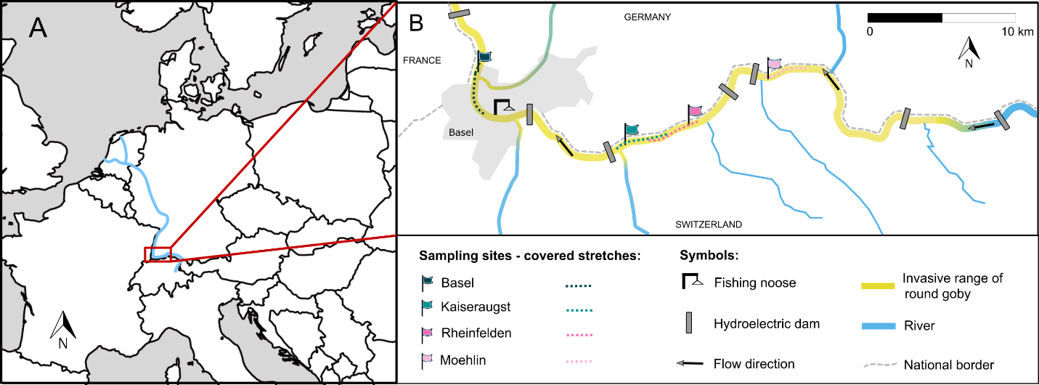
Figure 1. Map of the study locations. A Political map of Europe showing the river Rhine (blue) and the location of the studied area (red box). B Map of the river Rhine and its tributaries in the studied area. Regular night drives took place at the sampling sites on the covered stretches between June and August 2020. Control fishing for drifting larvae took place with the fishing noose. Commercial shipping including ballast water exchange stops at Rheinfelden. Hydroelectric dams act as dispersal barriers for invasive goby species, slowing down their natural spread.

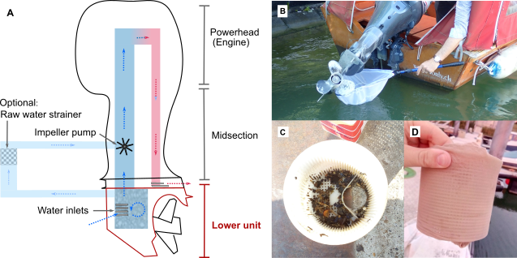
Figure 2. Boat motor water circuits and sampling. A. Simplified schematic drawing of an outboard boat motor and the water flow through the cooling system. Arrows represent flow direction. In the cavity of the lower unit (shaded), sediment and organisms accumulate if left under water. For inboard motors/stern drives (optional circuit, light blue), the engine is located inside the boat and the water circuits are therefore longer and hold more water. Additionally, they optionally include a raw water strainer to filter larger solids from the cooling water before they reach the impeller pump and the engine. B Sampling of an outboard motor in the water using a landing net. C Raw water strainer with contents (mesh size 1 mm). D Additional fine-meshed filter material wrapped around the strainer for boat drives in this study.
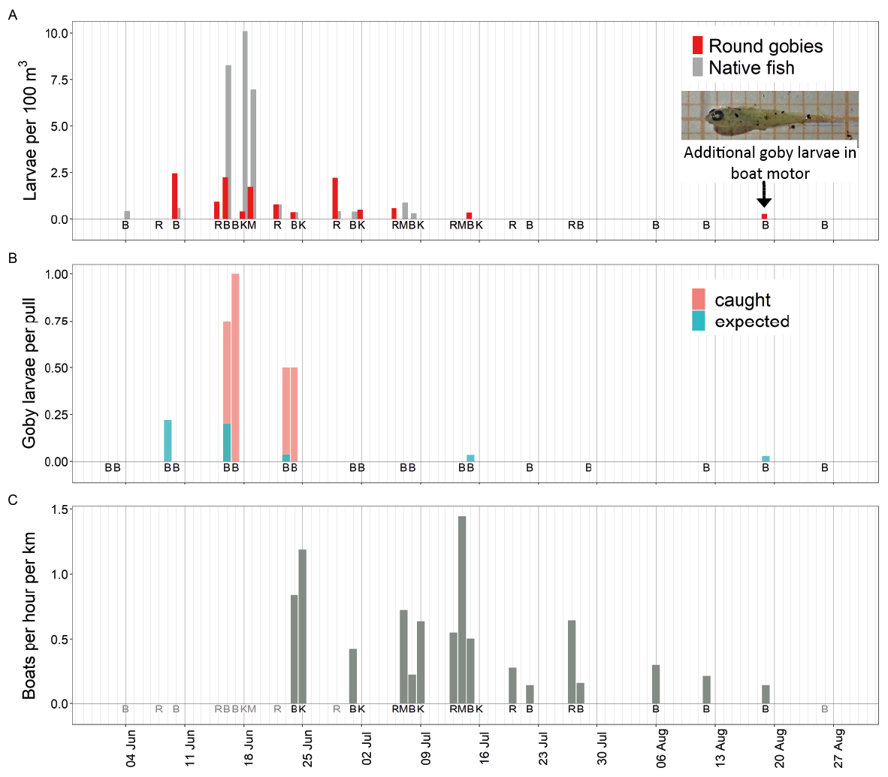
Figure 3. Results of invasive goby larvae sampling and boating activity after sunset. A Drift density of fish larvae caught in the plankton net towed behind recreational boats after sunset at different locations along the river Rhine (B = Basel, R = Rheinfelden, K = Kaiseraugst, M = Moehlin). Boat drives only took place on dates that are indicated with a study location. Round goby larvae are presented in red, native fish larvae (species not identified) are presented in grey. On 19th August, an additional goby larva was caught in a boat motor. B Expected and actual catch numbers of goby larvae per pull with the fishing noose. The location of the noose was in Basel (B). C Number of recreational boats active during the 1-2 h after sunset per kilometre at different locations along the river Rhine. Quantification of boats only took place on dates with letters printed in black, not on those printed in grey. Vertical grid lines represent days. A value of zero on a date at which a sampling took place means that no fish larvae were caught on that date, respectively no boats were seen.

Supplementary information

Document S1: Inquiry sent to boat owners to ask for collaboration on the project.

Document S2: Anecdotal evidence for organisms in boat motors from online boat forums.

Figure S1: Figure showing control sampling methods.

Table S1: Data on sampling locations, sampling dates, and boat types used for sampling.

