Systematic Review

Existing indicators do not adequately monitor progress towards meeting invasive alien species targets
Joana R. Vicente¹, A. Sofia Vaz¹, Mariona Roige², Marten Winter³, David A. Clarke⁴, Bernd Lenzner5, Melodie A. McGeoch⁶

¹Research Centre in Biodiversity and Genetic Resources (CIBIO) / InBIO Research Network in Biodiversity and Evolutionary Biology, Campus Agrário de Vairão, Rua Padre Armando Quintas nº 7, 4485-641, Vairão, Vila do Conde, Portugal
²AgResearch, Lincoln Research Centre, 1365 Springs Road, Lincoln 7674, New Zealand
³German Centre for Integrative Biodiversity Research (iDiv) Halle-Jena-Leipzig, Deutscher Platz 5e, 04103 Leipzig, Germany
⁴School of Biological Sciences, Monash University, Clayton 3800, VIC, Australia
⁵Bioinvasions, Global Change, Macroecology Group, Department of Botany and Biodiversity Research, University of Vienna, 1030 Vienna, Austria
⁶Department of Ecology, Environment and Evolution, La Trobe University, Melbourne 3086, VIC, Australia

ABSTRACT

Monitoring the progress parties have made toward meeting global biodiversity targets requires appropriate indicators. The recognition of Invasive alien species (IAS) as a biodiversity threat has led to the development of specific targets aiming at reducing their prevalence and impact. However, indicators for adequately monitoring and reporting on the status of biological invasions have been slow to emerge, with those that exist being arguably insufficient. We performed a systematic review of the peer-reviewed literature to assess the adequacy of existing IAS indicators against a range of policy-relevant and scientifically valid properties. We found that very few indicators have most of the desirable properties, and that existing indicators are unevenly spread across the components of the Driver-Pressure-State-Response and Theory of Change frameworks. We provide three possible reasons for this: i) inadequate attention paid to the requirements of an effective IAS indicator, (ii) insufficient data required to populate and inform policy-relevant, scientifically robust indicators, or (iii) deficient investment in the development and maintenance of IAS indicators. This review includes a gap analysis of where current inadequacies in IAS indicators exist, and provides a roadmap for the future development of indicators capable of measuring progress made toward mitigating and halting biological invasions.

KEYWORDS
Biological invasions; biodiversity; environmental policy; essential biodiversity variables; global environmental change

1. INTRODUCTION

Current declines in biodiversity are primarily the result of a small number of large-scale key drivers of environmental change, one of which is the impact of invasive alien species (IPBES 2019; Stoett et al. 2019). With a changing climate and an increasingly connected world, the number of introduced (and therefore also potential invasive) species, already in the tens of thousands, is predicted to grow (Seebens et al. 2017). The recognition of the impacts and costs derived from invasive species has placed biological invasions on the agenda of major global political initiatives: from the 1992 CBD - Convention on Biological Diversity (Article 8h) to the 2030 Agenda for Sustainable Development of the United Nations (Target 15.8). Specific to invasions, the Aichi Target 9 from the CBD’s Strategic Plan for Biodiversity 2011-2020, stipulated that ‘by 2020, invasive alien species and pathways are identified and prioritised, priority species are controlled or eradicated, and measures are in place to manage pathways to prevent their introduction and establishment’. However, as with many other biodiversity targets (Tittensor et al. 2014), these invasion policy targets were largely unmet (Secretariat of the Convention on Biological Diversity & CBD 2020).

Two important reasons for slow progress are the inadequate implementation of interventions necessary to slow the spread, reduce the negative impacts and measure the success of invasive alien species management (IAS; Pyšek et al. 2020b; (IPBES 2016). However, also under question is the adequacy of both available information and the indicators used to assess and monitor progress toward the CBD agenda (McGeoch & Jetz 2019). Much has been said about the desirable properties of biodiversity policy indicators and underlying variables (e.g. Mace & Baillie 2007; Collen & Nicholson 2014; Jetz et al. 2019; McQuatters-Gollop et al. 2019). In essence, such indicators of conservation targets (Noss 1990), must have two basic dimensions: (1) political relevance, i.e. clearly address a relevant policy goal and enable reporting against a policy target, including reporting in all contexts, and at all levels and scales at which the policy applies; (2) scientific validity, i.e. accurately represent (taxonomically, spatially and temporally) the status and trend in the environmental property or process of interest in an integrated and harmonized way. This includes being easy to interpret and understand (not prone to being misunderstood or misinterpreted), which requires that they are reproducible and convey information on the uncertainty and limits of the measured status or trend.

Multiple indicators for monitoring biological invasions have been developed and implemented at various spatial scales, including global, continental and national (Genovesi et al. 2013). Compared with indicators for monitoring other aspects of biodiversity policy (such as social-ecological resilience, environmental degradation, climate change mitigation, and the contribution of biodiversity to carbon stocks), Mcowen et al. (2016) concluded that invasion targets (specifically Aichi Target 9) were one of the few to have adequate associated indicators for monitoring progress. This finding, however, contradicts the view that available evidence is insufficient for quantifying progress against invasion targets (McGeoch & Jetz 2019) at a global scale. This difference can potentially be explained by the fact that Mcowen et al. (2016) assessed indicators primarily for policy relevance, including indicators with very limited scientific scope (i.e. limited temporal relevance and spatial coverage).

Despite the ongoing and increasing threat of biological invasions (Seebens et al. 2017) and the need for monitoring their status, the extent to which existing indicators have been applied to assess, report, and monitor progress toward meeting invasion targets, and a detailed analysis of invasion indicators, including their strengths, weaknesses and shortfalls, is completely missing. Insights obtained from such a review would strategically pave the way for further indicator development and application. There is a pressing need for such information, given the approaching COP-15 where the details of the post-2020 global biodiversity framework are to be agreed on (CBD 2020a), and the development of the IPBES Assessment on IAS and their Control. For example, the outcome of the IPBES IAS Assessment aims to influence invasion policies and management strategies in more than 130 countries, for whom information on effectiveness and adequacy of current invasion indicators will help inform future action (Stoett et al. 2019).

In this study we evaluated the extent to which existing indicators are adequate for the monitoring and reporting on progress towards meeting those targets established to reduce the prevalence and impact of biological invasions. We performed a systematic literature review to identify the range of indicators. We then assessed their ability to assess and report on progress against reaching IAS policy targets. Finally, we provide guidance on the type and properties of indicators that are still needed to inform global environmental policies on IAS, particularly the post-2020 global biodiversity framework.

2. METHODS

2.1. Approach and data collection
To evaluate the extent to which existing indicators are suitable for monitoring progress towards meeting invasion goals and targets, we took a three-step approach (Fig. 1). First, we conducted a systematic literature search to identify published indicators in the peer-reviewed invasion science literature (section 2.2). We followed standard protocols and guidelines for systematic literature reviews (O’Dea et al. 2021) to search for peer-reviewed indicators in the invasion literature. The Population-Intervention-Comparison-Outcome (PICO) framework was adopted to guide the selection of search keywords from well-established literature on invasion science, environmental indicators, and biodiversity monitoring. To minimize linguistic uncertainty, a common feature in invasion science (McGeoch et al. 2012), we included multiple synonyms for alien species and related terms (see Table S1 for details). As a result, our search string included a broad set of keywords for each PICO component combined with relevant boolean operators and characters. The literature search was conducted in June 2020 using ISI Web of Science (ISI WoS; http://webofknowledge.com/), Scopus (https://www.scopus.com/) and Google Scholar (http://scholar.google.com) search engines. Records retrieved from these databases were combined, resulting in a total of 501 unduplicated records.

Next, each record was subjected to an inclusion/exclusion procedure to remove unsuitable records (e.g., records on topics such as aliens/invaders from outer space; see supporting information S1 for details). Only papers that demonstrated the indicators mentioned, using data (empirical or simulated) were included, i.e., publications that simply suggested or listed desirable indicators were excluded. The final set included 27 suitable peer reviewed journal publications that contained one or more invasion related indicators. We reviewed each indicator identified in the search and classified them according to their policy relevance and scientific validity using a set of criteria (section 2.2.2). Finally, we grouped and ranked the performance of indicators, against this set of desirable properties, to assess and measure progress towards the policy targets on IAS, particularly those of the Convention on Biological Diversity and Sustainable Development Goals (section 2.3).

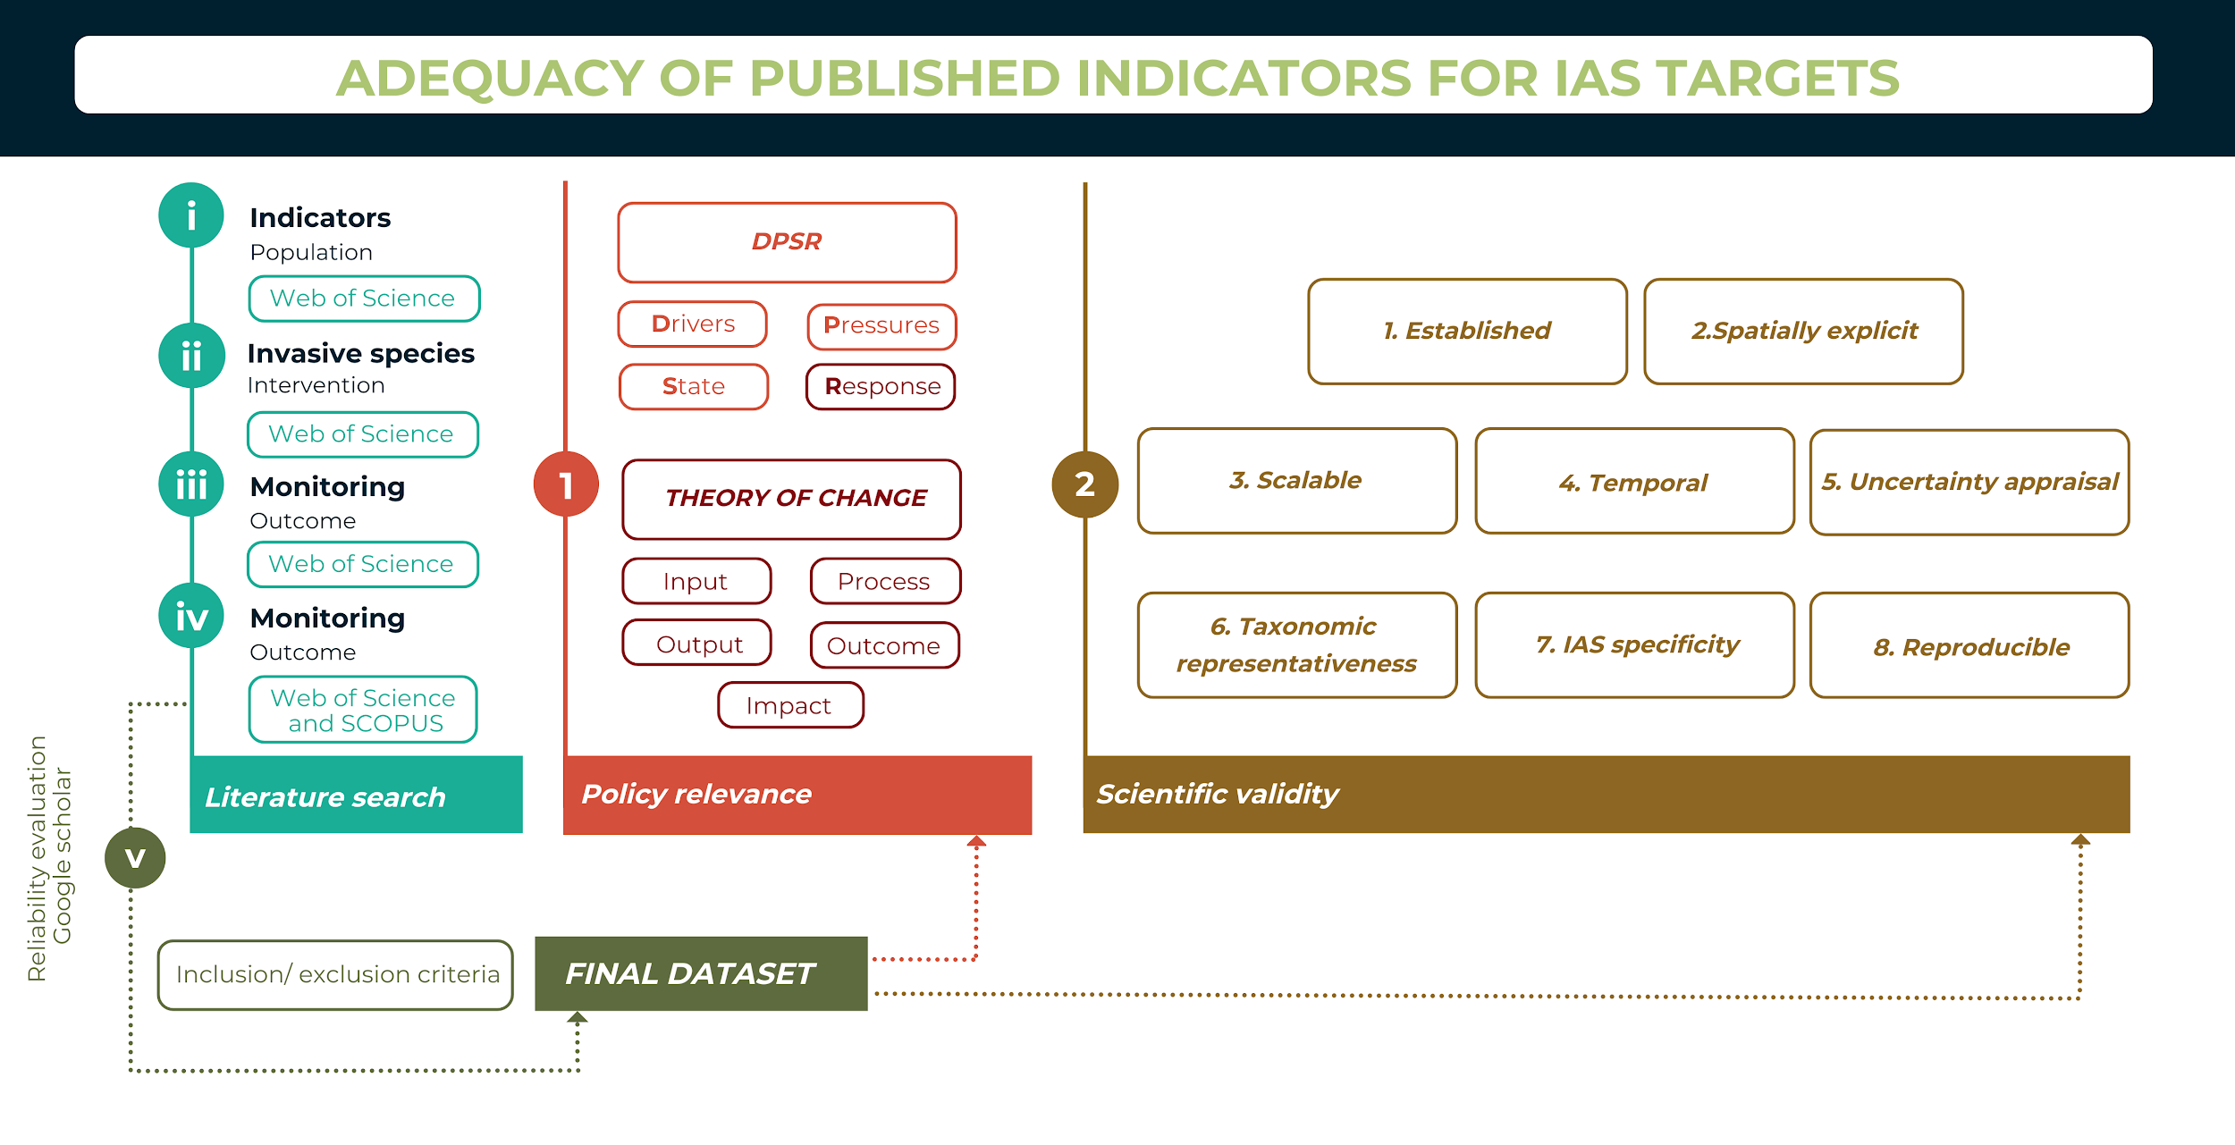
Figure 1. Approach to evaluating the adequacy of published indicators for reporting on invasive alien species (IAS) targets. The approach started (left of figure) with a literature search of published IAS indicators. These indicators were reviewed (1) to determine their policy-relevance classified according to their ability to inform on each dimension of the DPSR model (Driver-Pressure-State-Response) and the Theory of Change framework (as Input, Process, Output, Outcome, or Impact indicators). (2) The properties of each indicator were then assessed against eight criteria determining their scientific validity.

2.2. Review categories
2.2.1. Policy relevance: Invasion goals, targets and indicators in multinational agreements
In its 2011-2020 biodiversity framework, the CBD described seven “Generic Indicators” for monitoring progress towards meeting Aichi Target 9. In short, these indicators provide information on the identification, number, distribution and impact of IAS, as well as the implementation of policy responses ((CBD 2016); also (McGeoch & Jetz 2019)). The post-2020 biodiversity framework proposes the use of the Driver-Pressure-State-Response (DPSR) and Theory of Change (ToC) frameworks in the design of informative indicators (OECD 2019). Following McGeoch et al. (2010, 2015), the DPSR framework in the context of IAS distinguishes invasion indicators based on the underlying pathways for IAS (Drivers; e.g. trade or transport), indicators of IAS change (Pressure; e.g. number or abundance of IAS), biophysical conditions or state as a consequence of IAS impacts (State; e.g. number of impacted native species) and societal responses to IAS (Response; e.g. actions to control IAS). Response indicators can be further compartmentalised, according to the Theory of Change (ToC) framework, into indicators of inputs (i.e. resources needed for a response, e.g. budget or staff), processes (i.e. progress of the response that uses inputs; e.g. committees or actions), outputs (i.e. measure of the amount and quality of the response results; e.g. research, reports or policy instruments), outcomes (i.e. IAS changes resulting from the response action; e.g. number or abundance of IAS taxa), and impacts (i.e. measures of the improved condition of the invaded site). While the particular wording and scope of invasion-related goals, targets and indicators in multinational agreements change across reporting cycles, the DPSR and ToC frameworks provide stable, sustainable frameworks for formulating and assessing the indicators needed to monitor and bring about change (see McGeoch & Jetz 2019) and were therefore used here for assessing the policy relevance of existing IAS indicators.

2.2.2. Indicator properties to inform and monitor ecological change
Fundamental properties for the design of environmental indicators, including those focused on biological invasions should include their scientific validity and the extent to which they can be efficiently communicated (e.g., not prone to misinterpretation and with clear quantification and communication of uncertainty (Jetz et al. 2019; OECD 2019)). Grounded on these premises, we used eight properties (Table 1) to assess and represent the degree to which an indicator is scientifically valid and communicable (Balmford et al. 2005; Collen & Nicholson 2014; Jetz et al. 2019).

Table 1. Eight properties used to assess and classify the policy relevance and scientific validity of each indicator monitoring the status of IAS. Asterisks (*) denote those properties that are most desirable of an adequate IAS indicator.
Rational | Review categories
1. Established
Information derived from an indicator which has already been tested and applied in a range of situations and contexts will be in principle more reliable than that from an indicator which has been proposed but not yet validated | *Established - the indicator has been proposed, tested, and applied to inform on range of situations
 | Not established - the indicator is being proposed and defined for the first time, and had not been yet tested or applied to any situation
2. Spatially explicit
Spatially-explicit information enables an increasingly space-conscious capture of IAS trends and provides critical spatial sensitivity and flexibility for monitoring of IAS numbers, distributions and impacts | *Spatially explicit - the indicator provides information that can be linked to a specific spatial location (e.g., a site, region, country) so that its features can be associated with that location.
 | Not spatially explicit - the indicator does not provide information that can be linked to a spatial location
3. Scalable
Scalability enables the application of the indicator at the relevant spatial extent, a robust indicator should hence be reproducible at multiple, distinct spatial scales | *Scalable – the indicator is calculated through a hierarchy of nested spatial grains, i.e., scalable up or down.
 | Not scalable - the indicator is not calculated over different spatial grains, and does not provide clear indication on how to calculate it beyond the scale for which it was created
4. Temporal
The availability of temporal information that is timed and of a duration relevant to informing on the status and trends of IAS. The indicator should be designed so that it can be recalculated over time to support the monitoring of IAS-relevant change | *Temporal - the indicator includes a temporal dimension (is expressed as a trend), being calculated for a particular time, and is periodically updated
 | Somewhat temporal - the indicator is not specifically designed to have a temporal dimension (be expressed as a trend), but it provides clear indication that it can be repeated in future if data is collected for this purpose
 | Not temporal - the indicator is not designed to be recalculated in future nor does it provide clear indication that would allow calculation of a trend
5. Uncertainty appraisal
The presentation of measurements of uncertainty for informing on IAS trends and status represents a key aspect of any evaluation approach, with implications for implementation and reproducibility | *Quantitative uncertainty - the indicator reports a quantitative measure of uncertainty
 | Qualitative uncertainty - the indicator reports a qualitative measure of uncertainty
 | No uncertainty - no uncertainty measure is reported with the indicator
6. Taxonomic representativeness
To address a range of policy or decision-support requirements, the information provided by an indicator should be applicable to a range of IAS taxonomic groups | *Representative - the indicator is presented as a general indicator that can be, by design, applied to any taxa
 | Somewhat representative - the indicator is designed or applied to a particular species or taxon but provides clear indication that it can be transferred to other taxa
 | Not representative - the indicator is specifically designed for a particular species or taxon and it does not clearly indicate whether it can be transferred to other taxa
7. Invasive alien species (IAS) specificity
Sound measurement of progress toward preventing and controlling IAS requires indicators that use (IAS) species data (Note: this property is not applicable to some indicator types) | *IAS specific - the indicator has been calculated using IAS specific data, and not proxy data that can be used to infer on IAS. This property is particularly relevant for Pressure indicators
 | Not specific - the indicator is proposed and calculated using proxy data on IAS
8. Reproducible
Reproducibility is essential for any communication, scientific and political goal, as it allows availability, repeatability, standardization and archiving in support of information harmonization, integration and use | *Reproducible - the data necessary to populate the indicator is accessible and available for public use and indications on how to calculate the indicator are provided
 | Somewhat reproducible - data necessary to populate the indicator is not explicitly indicated as accessible, yet indications on how to calculate the indicator and get the necessary data are provided
 | Not reproducible - the data is not available for public use nor it contains explicit instructions to calculate it

2.3. Indicator classification and ranking
Each indicator identified in the systematic review was subjected to three types of information extraction and subsequent classification. First, extracted information on: (a) the spatial extent and region of focus (e.g., particular country, continent, region or global), (b) the temporal range of the assessment (e.g., at a particular point in time, or through a temporal range), (c) the main type of ecosystem under analysis (i.e., terrestrial, marine or freshwater); and (d) the targeted IAS taxa (e.g., plants, mammals and birds). Second, we categorized each indicator according to which of the DPSR and Theory of Change components was most relevant (section 2.2.1). Third, we recorded how well each indicator aligned with the eight properties in Table 1 (section 2.2.2).

We are convinced that an informative indicator of IAS should hold the full suite of desirable properties described in Table 1. As such, we ranked each indicator, using equally weighted scoring, in which a value of one was attributed whenever the indicator met the desirable property. An indicator that summed to eight was considered a more scientifically valid indicator, compared to indicators with less desirable properties (Table 1).

3. RESULTS

3.1. General characterization of IAS indicators
The 27 identified publications encompassed a total of 61 indicators (Tables S2 and S3), being published from 2005 to 2019. Most indicators were expressed at a national (~31%) or continental (~31%) level. Indicators expressed at a sub-national region (e.g., protected area or natural region) or at the global scale each contributed ~18% of the dataset. For the remaining ~20%, such information was not applicable. Most of the reviewed IAS indicators have been either tested in or applied to European countries (~28%) or South Africa (~23%), with 20% with a global scope (Fig. 2). Other regions with IAS indicator development were Antarctica (~11%) and North America (i.e., USA and Canada; ~8%), with remaining small proportions in Australia, Asia (i.e., China and India; ~3%), South America (i.e. Brazil) and the Mediterranean Sea (~2%; Fig. 2). The largest number of indicators applied to multiple (n=24), or only terrestrial (n=26) environments, with fewer for marine (n=5) and freshwater environments (n=5). Most indicators covered multiple IAS taxa (n=26) or were plant (n=17) or animal (n=8) focused. For the latter and when specified, indicators focused on birds (n=3), fishes (n=2) or mammals (n=2).

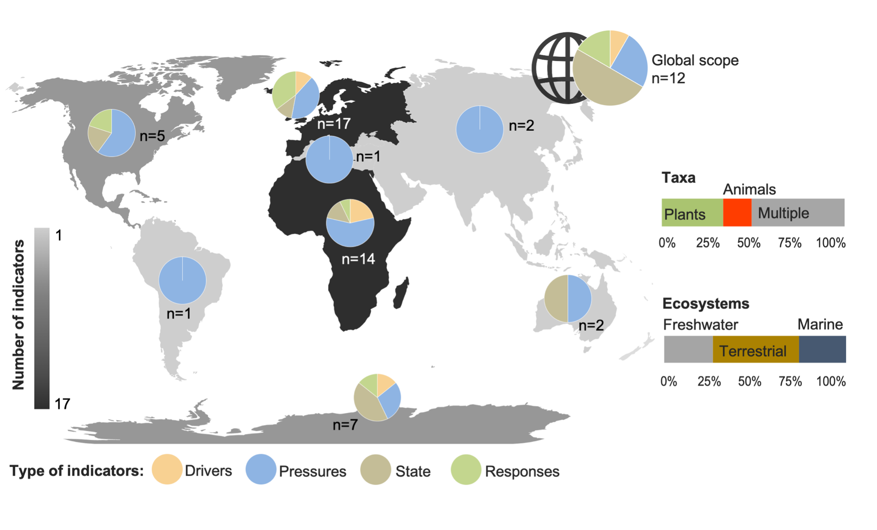
Figure 2. Number of indicators found per continent and their classification into each DPSR category: Drivers, Pressures, State and Responses (left). The figure also shows the number of indicators (n) with a global scope (n=12), and the proportion of indicators applied to particular environments (i.e., terrestrial, marine and freshwater) and taxa (plants, animals, or multiple taxa) (right).

3.2. Representation of DPSR and Theory-of-Change across indicators
In general, Pressure indicators were most numerous, accounting for ~46% of the indicators identified, followed by Response (~25%), State (~18%) and Driver (~12%) categories (Figs. 2, 3). IAS change measurements (i.e., Pressures) included the number, frequency, abundance, density, cover or area of introduced, established or invasive species. Indicators on IAS pathways (i.e., Drivers) were quantified as the number of species vectors (e.g., vessels), activities associated with invasion risk (e.g., tourism), or socio-economic indices (e.g. Gross Domestic Product, GDP; Human Development Index, HDI). IAS impacts (i.e., State) were expressed by changes in the Red List Index, ecosystem services, or relative proportion of alien to native taxa.

Response indicators primarily expressed the Output (n=8) of societal responses to IAS, evaluated as the number of relevant policies, agreements, or management plans for IAS (Fig. 3). Response indicators on Inputs (n=3) mostly captured the expenditures and costs of management actions, whereas indicators of Outcomes (n=3) measured changes in the number or abundance of IAS taxa in response to management actions. Only one Response indicator focused on Impacts, measured as improved condition in a freshwater system (a blue-green algal index) after removal of invasive carp (indicator R1 in Table S3). No Process oriented Response indicators were identified.

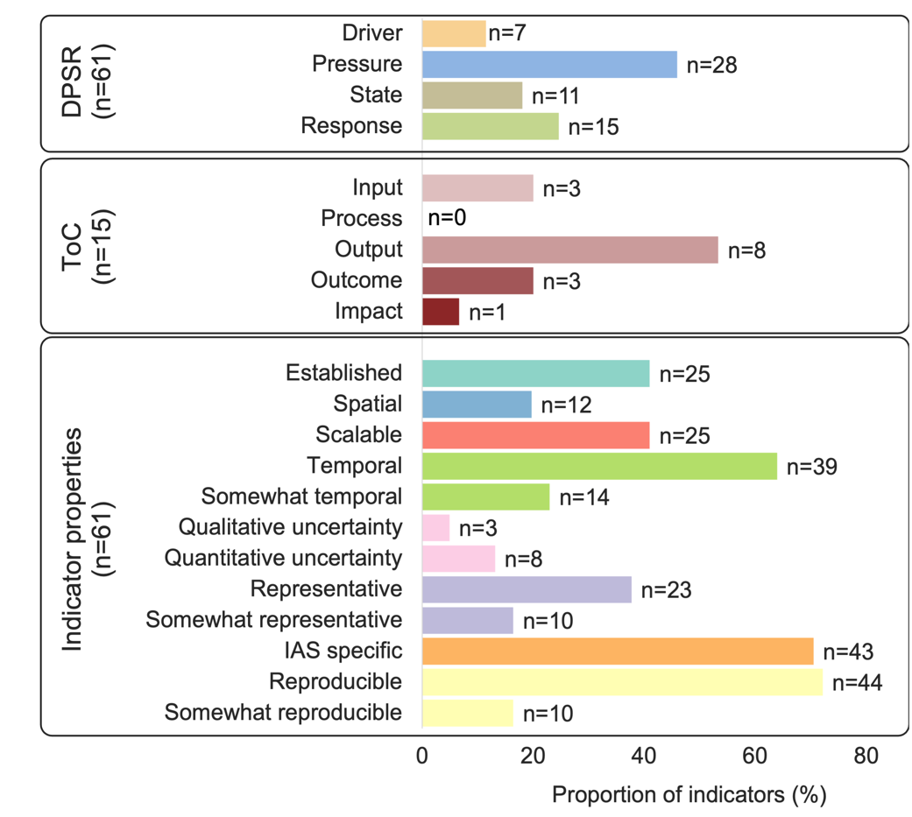
Figure 3. The policy relevance (DPSR and Theory of Change: ToC) and scientific validity (indicator properties; see Table 1) of the 61 indicators reviewed (number of indicators (n) are also shown).

3.3. Properties of IAS indicators
Overall, ~41% of all indicators were classified as established, i.e., had already been tested and applied for the purpose of management or policy reporting (Fig. 3). Only 20% of indicators were spatially explicit. Most indicators were not scalable (~59%), i.e., they could be generalised upwards or downwards through a hierarchy of spatial grains. In ~64% of cases, the indicator was specifically designed to have a temporal dimension, or at least be repeatedly calculated in the future (~23%). Most indicators (~75%) had no associated measure of uncertainty, while only ~13% and ~5% of indicators were associated with a quantitative or qualitative measure of uncertainty, respectively. Most indicators (~37%) could potentially be applied to multiple IAS taxonomic groups (~16%), and the majority (~70%) of indicators were developed using IAS-specific (rather than proxy) information. Finally, ~72% of the indicators were considered reproducible, in the sense that the data necessary to populate the indicator were accessible and available, and clear instructions on how to calculate the indicator were provided. For ~16% of indicators, clear instructions were provided on how to obtain the data or compute the indicator, however, the data were not clearly indicated as accessible (Fig. 3).

3.4. Individual indicator performance
Assessed against the desirable properties of an ideal indicator, the most complete indicators of IAS Drivers included five of the eight desirable properties (D1, D4, D6; Fig. 4). Two of these indicators focused on the pathways of introduction and spread of alien or invasive species at the continental (D1) or national scale (D6), being considered established, replicable, reproducible, IAS species and temporal. The remaining Driver indicator focused on reporting on socio-economic drivers of invasions (e.g., GDP, HDI) at the global scope, being considered replicable, reproducible, IAS specific and temporal, and providing a quantification of uncertainty (Table 2).

Pressure indicators only included one that fulfilled eight desirable properties (P5) and two missed only one desirable property: spatial explicitness (P3) and uncertainty reported (P23). These indicators measured the number or richness of alien or invasive alien taxa, applied to marine (P3), freshwater (P5) and terrestrial systems (P23), in the Mediterranean Sea, the USA and South Africa, respectively. State indicators achieved a maximum of five desirable properties. All these applied to Europe, were replicable, reproducible, scalable, and temporal. Only one of these indicators was established, but not IAS specific (S1). The remaining two, although not established, were IAS-specific (S2, S3). This set of indicators reported on the number of outbreaks or diseases associated with IAS (S3), the number of ecosystem services affected by IAS (S2) and included the Red List Index of IAS (S1; Fig. 4). The most complete indicator in the Response component reported on the number of IAS eradications in Antarctica (in the Outcome category), and included seven desirable properties, failing to report uncertainty in the assessment (R6; Fig. 4).

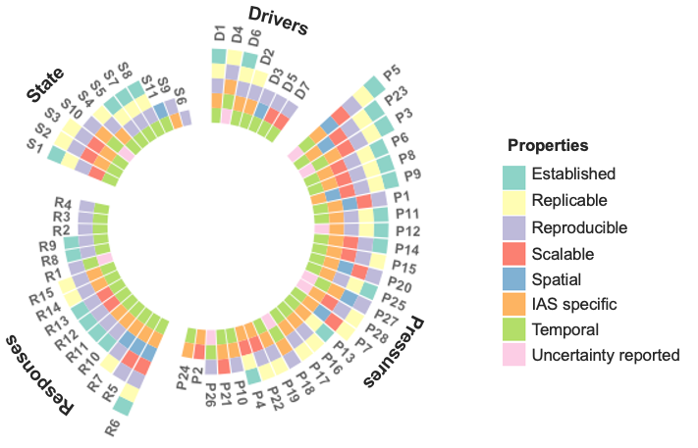
Figure 4. Indicators ranked based on their desirable properties for reporting on IAS goals and targets. The taller the bar, the more desired properties the indicator has (Indicator numbers (D1, S1, etc.) and details are provided in Table S3 and Fig. S1). The eight desired indicator properties are outlined in Table 1 (note that IAS-specific is particularly desirable for Pressure indicators). The indicators are ranked from less complete indicators (inner positions) towards more complete indicators (outer positions).

Table 2. Invasive alien species (IAS) indicators that performed comparatively well when assessed against the seven or eight desired properties for indicators. Those listed are in some cases a collation of similar indicators across publications per indicator category, encompassing the indicators that had most properties in each of the Driver, Pressure, State, Response indicator categories. Publication references are indicated with superscript numbers whereas indicator reference codes are provided in brackets (see table S2 and S3).

Indicators per DPSR component | Properties missing | Comment on indicators
DRIVER
- Pathways of invasions (D1)¹  - Socio-economic drivers of invasion (D4)²  - Number of taxa introduced via different pathways (D6)³ | Spatial (D1, D4, D6)  Scalable (D1, D4, D6)  Uncertainty reported (D1, D6)  Established (D4) | Indicators applied at the global (D4), continental (D1) or national (D6) scope. D1 is only somewhat replicable and D6 only somewhat reproducible.
PRESSURE
- Numbers of alien species in the Mediterrean by taxonomic group (P3)⁴  - Aquatic invasive species richness (P5)⁵  - Invasive plant species richness (P23)³ | Spatial (P3)  Uncertainty reported (P23) | Indicators applied at the regional scope in the Mediterranean (P3) and the USA (P5), and at the national scope (P23). P5 and P23 are only somewhat timely, and P23 is somewhat replicable.
STATE
- The Red List Index of Invasive Alien Species (S1)¹  - An indicator of IAS impacts on ecosystem services (S2) ¹  - Trends in incidence of livestock diseases (S3) ¹ | Established (S2, S3)  Spatial (S1, S2, S3)  Uncertainty reported (S1, S2, S3)  IAS specific (S1) | Indicators applied at the continental scope in Europe (S1, S2, S3).
RESPONSE
- Trends in invasive species eradications (R6)⁶ | Uncertainty reported (R6) | Indicator applied at the continental scope, in Antarctica (R6)
¹Rabitsch et al. 2016, ²Sharma et al. 2010, ³Wilson et al. 2018, ⁴Zenetos et al. 2017, ⁵Shaker et al. 2017, ⁶McGeoch et al. 2015.

4. Discussion

Most existing, peer-reviewed invasion indicators were found not adequate for measuring and/or reporting on progress toward reaching global biodiversity targets that are aimed at reducing the effects of IAS. Existing indicators do align well with policy relevant dimensions (see also Mcowen et al. 2016)), and the Driver, Pressure and State indicator categories are represented by multiple indicators. However, the Theory of Change (ToC) categories of Response indicators are sparsely represented by existing indicators, and the process, outcomes and impacts of actions to prevent and control IAS are particularly poorly covered by existing indicators. Most existing indicators fall short on multiple desirable properties of a scientifically robust indicator, with a very few exceptions (see below). For example, regularly missing properties of existing indicators were measures of uncertainty and spatially explicit information.

Policy relevance
While the wording of invasion-relevant goals and targets tends to vary to a greater or lesser extent across different multinational agreements, and under the same agreement across reporting cycles and as strategies evolve, the essential variables required to monitor progress remain the same (Latombe et al. 2017; McGeoch & Jetz 2019). For CBD and SDG goals and targets, including the current draft Post-2020 Global Biodiversity Framework (CBD 2020b) these have, since 2006, variously included pathway identification and prioritisation (Drivers); the identification, prioritisation and trends in IAS and their impacts (Pressure); the mechanisms and severity of IAS impacts to threatened species and priority sites and ecosystems (State); and a range of responses from managing pathways and priority species, allocation of resources, legislation and the adoption of relevant policies, preventing introduction and spread, and controlling and eradicating species (Response; McGeoch et al. 2010; Essl et al. 2020). The DPSR model and its ToC expansion, remain relevant for framing invasion indicators for the foreseeable future, both in terms of policy relevance and in terms of existing investment in indicator research. Sustained investment in invasion indicators for national and global reporting within the DPSR and ToC frameworks would therefore maintain their policy alignment, and further development within these would strengthen their policy relevance.

Driver indicators
Identification of invasion pathways was the most common Driver indicator, although few had many of the desirable properties. Wilson et al. (2018) proposed four pathway metrics, including information on pathway size, introduction rates, within country prominence and within country dispersal rate. However, the information to populate this indicator for all countries and at a global scale is unlikely to exist across taxa. Rabitsch et al. (2016) focused on the cumulative numbers of alien arthropods introduced by each pathway category (Horticulture/Ornamentals, Stored product pests, Biological control, Forestry, Unknown), which is less comprehensive. However, spatial information at the necessary grain would need to be collated and made available to calculate a spatially explicit pathway indicator of this type. Recent progress collating data on a standard suite of invasion pathways used across invasive alien taxa is a step towards future development and adoption of an invasion pathways indicator (McGrannachan et al. 2021).

Pressure indicators
Indicators for reporting on ‘Trends in the distributions and populations of IAS’, were more frequent than other framework components, with many deemed largely adequate (Sharma et al. 2010; Zenetos et al. 2017; Wilson et al. 2018). However, although meeting at most five of the seven desirable features, most were neither spatially explicit, nor were designed to provide trend (temporal) information. Likewise, for indicators to report on the spread and population expansion of invasive alien species, long-term data on species distributions across taxa needs to be collected, curated, easily accessible, and gathered from dedicated long-term monitoring. A ‘whole of knowledge-system’ approach, supported by Essential Biodiversity Variables (EBV) for species populations (Jetz et al. 2019) and approaches to develop and support country-level data generation (Latombe et al. 2017), has been proposed for the sustainable delivery of invasive alien species information for policy and management (McGeoch & Jetz 2019). This approach includes the pipeline from raw data from multiple sources to the production of indicators based on modelled species distribution and abundance data. Modelling solutions are needed to overcome data biases and produce robust metrics that can be used to infer establishment events over time. For example, the Global Register of Introduced and Invasive Species - GRIIS (Pagad et al. 2018) that provides species checklists is available as a baseline and mechanism for tracking species numbers at a country scale and global scope (Pagad et al. 2018). Countries participating in GRIIS have committed to regularly update their IAS data in this database. Additionally, recently developed supportive tools (e.g. Seebens et al. 2020; Arlé et al. 2021), could help to improve data integration and minimize uncertainties in data underlying IAS indicators.

State indicators
Indicators for monitoring the consequences of IAS encompass impacts on native species, communities, habitats and ecosystems. The IUCN Red List Index for species impacted by IAS is most well-developed and regularly used (Butchart 2008). Some of the indicators in the State category could be interpreted as either State or Pressure indicators, depending on study objective and whether the indicator is interpreted from the perspective of the recipient community or in terms of the invasion load, for example “Percentage of non-native plant species as an indicator of floristic quality” (Bowers & Boutin 2008) or “Trends in the incidence of livestock disease” (Rabitsch et al. 2016). The small number of IAS impact indicators focused on communities or ecosystems that do exist are not well-established and are lacking most desirable properties, suggesting that there are opportunities for further indicator development. This is a particularly pressing research endeavour given that the “Rate of invasive alien species impacts” has been proposed as a Headline Indicator for Target 5 of the draft Post-2020 Biodiversity Framework. One reason for the lack of adequate impact indicators is the complexity, inherent context dependence and often idiosyncratic nature of environmental impacts (Pyšek et al. 2020a), thus rendering generalisations to other geographic areas and spatial scales problematic. The IUCN has adopted the Environmental Impact Classification for Alien Taxa (EICAT) for quantifying the impacts of particular IAS (Hawkins et al. 2015), however, to date no indicators have yet been developed using this as an information source. More assessments that capture the taxonomic and geographic variability of environmental impacts are required for a suitable impact indicator to be populated.

Response indicators
The most significant recent advance on policy-relevant indicators has been to recognise the importance of elaborating Response indicators to capture the various types of intervention essential to bringing about progress, using ToC to identify five essential response categories (OECD 2019). While this a significant step towards improving implementation of policy for IAS and bringing about the transformative change needed, ToC indicators for IAS are particularly under-developed relative to the other DPSR categories. No indicators exist for tracking progress of the processes involved in IAS prevention and control (Process Response indicators), such as mechanisms of implementation via working groups or committees responsible for overseeing the implementation of collaborative management programmes. There were few Outcome- and Impact Response indicators for measuring the success of policy and management actions, and those found were local to regional in scale and mostly focussed on individual species. A decline in pressure from IAS measured using Pressure indicators, could be considered an option for tracking changes in IAS as a cumulative outcome of other responses to deal with IAS. In the same way, improvements in the conservation status of species threatened by IAS, tracked using the existing IUCN Red List Index for IAS (Butchart 2008), could be considered an indicator for the Response Impacts ToC category. There were also few indicators for tracking change in levels of investment in IAS management and research (Input-Response), one in Africa and two in Europe. The recent publication of a global dataset on the costs of invasive species (Diagne et al. 2020), could potentially be used as a basis for an Input-Response indicator that meets more of the desirable properties for such an indicator.

The most prominent and established IAS Response indicator was ‘Trends in the adoption of relevant policy’. Monitoring the adoption of both national and intergovernmental policies aimed at preventing and/or controlling IAS has been proposed at a range of administrative levels. However, the collation and provision of data on the implementation and success of management responses to IAS, at any administrative level, is drastically lacking (Leadley et al. 2014). Few countries appear to have accessible data of this nature, although on-ground policy implementation via such management provides a more powerful indicator of likely progress than the intention to act implied by a country committing to a relevant policy instrument.

Prospects for IAS indicator development
Relative to many other topics in invasion biology, there are a modest number of publications that develop, demonstrate, test or report on the results of IAS indicators. In addition, the number of publications and indicators are thinly spread across the multiple indicator category needs, i.e., across the DPSR and ToC framework categories. This is despite invasive species placed among the top five threats to biodiversity and ecosystems (Díaz et al. 2019), and the clear policy requirements for such indicators identified by the goals and targets of the CBD’s strategic plans and those of the Sustainable Development Goals. While it is not necessary and may even be undesirable to have many competing or non-comparable indicators of the same biodiversity change phenomenon, it is necessary to have robust and dynamic indicators, applicable across scales, environments, and taxa.

Progress with policy-relevant data collation has been significant over the last decade and useful information sources continue to become available (e.g. Dyer et al. 2017; Pagad et al. 2018; Kleunen et al. 2019). However, to ensure that the applied benefits of these data collation efforts are realised, policy relevant invasion indicators that use these data and that meet multiple criteria need to be developed, adopted, and supported. The Essential Biodiversity Variable approach provides a methodological avenue for achieving this (McGeoch & Jetz 2019). Here, by identifying and describing the key gaps, we provide the basis for a strategic way forward. In parallel, it is essential that the research community continue to increase and improve the quantity and quality of the data needed to populate these indicators. The outcomes and directions provided by this review will, we hope, assist governments as they work to implement IAS policy and report on progress to reducing the impact and limiting the spread of alien species harmful to biodiversity and ecosystems.

Acknowledgements
This is a joint effort of the sTWIST (Theory and Workflows for Invasive Species Tracking) synthesis group supported by sDiv, the synthesis centre of iDiv, the German Centre for Integrative Biodiversity Research (DFG FZT 118; 202548816). This work is a contribution to the Species Populations Working Group of the Group on Earth Observations Biodiversity Observation Network (GEO BON; https://geobon.org/ebvs/workinggroups/ species-populations). M.M. acknowledges Australian Research Council DP 200101680. J.R.V. was supported by a research contract DL57/2016/ ICETA/EEC2018/13. A.S.V. acknowledges support from Ministerio de Ciencia, Innovación y Universidades through the 2018 Juan de la Cierva-Formación program (reference: FJC2018-038131-I), and from FCT - Portuguese Foundation for Science and Technology through the program Stimulus for Scientific Employment - Individual Support (reference 2020.01175.CEECIND). B.L. acknowledges funding by the Austrian Science Foundation FWF (grant I2086-B16).

References
Balmford, A., Crane, P., Dobson, A., Green, R.E. & Mace, G.M. (2005). The 2010 challenge: data availability, information needs and extraterrestrial insights. Phil. Trans. R. Soc. B, 360, 221–228.
Bowers, K. & Boutin, C. (2008). Evaluating the relationship between floristic quality and measures of plant biodiversity along stream bank habitats. Ecological Indicators, 8, 466–475.
Butchart, S.H.M. (2008). Red List Indices to measure the sustainability of species use and impacts of invasive alien species. Bird Conservation International, 18, S245–S262.
CBD, C. on B.D. (2016). Decision adopted by the conference of the parties to the convention on biological diversity ( No. CBD/COP/DEC/XIII/28, 12 December 2016). Cancun, Mexico.
CBD, C. on B.D. (2020a). Report of the open-ended working group on the post-2020 global biodiversity framework on its second meeting ( No. CBD/WG2020/2/4). Second meeting Rome, 24-29 February 2020.
CBD, C. on B.D. (2020b). Update of the zero draft of the post-2020 global biodiversity framework. Preparations for the post-2020 biodiversity framework ( No. CBD/POST2020/PREP/2/1 17 August 2020).
Collen, B. & Nicholson, E. (2014). Taking the measure of change. Science, 346, 166–167.
Diagne, C., Leroy, B., Gozlan, R.E., Vaissière, A.-C., Assailly, C., Nuninger, L., Roiz, D., Jourdain, F., Jarić, I. & Courchamp, F. (2020). InvaCost, a public database of the economic costs of biological invasions worldwide. Sci Data, 7, 277.
Díaz, S., Settele, J., Brondízio, E.S., Ngo, H.T., Agard, J., Arneth, A., Balvanera, P., Brauman, K.A., Butchart, S.H.M., Chan, K.M.A., Garibaldi, L.A., Ichii, K., Liu, J., Subramanian, S.M., Midgley, G.F., Miloslavich, P., Molnár, Z., Obura, D., Pfaff, A., Polasky, S., Purvis, A., Razzaque, J., Reyers, B., Chowdhury, R.R., Shin, Y.-J., Visseren-Hamakers, I., Willis, K.J. & Zayas, C.N. (2019). Pervasive human-driven decline of life on Earth points to the need for transformative change. Science, 366, eaax3100.
Esler, K.J., Prozesky, H., Sharma, G.P. & McGeoch, M. (2010). How wide is the “knowing-doing” gap in invasion biology? Biol Invasions, 12, 4065–4075.
Essl, F., Latombe, G., Lenzner, B., Pagad, S., Seebens, H., Smith, K., Wilson, J.R.U. & Genovesi, P. (2020). The Convention on Biological Diversity (CBD)’s Post-2020 target on invasive alien species – what should it include and how should it be monitored? NB, 62, 99–121.
Genovesi, P., Butchart, S.H.M., McGeoch, M.A. & Roy, D.B. (2013). Monitoring Trends in Biological Invasion, its Impact and Policy Responses. In: Biodiversity Monitoring and Conservation (eds. Collen, B., Pettorelli, N., Baillie, J.E.M. & Durant, S.M.). Wiley-Blackwell, Oxford, UK, pp. 138–158.
Hawkins, C.L., Bacher, S., Essl, F., Hulme, P.E., Jeschke, J.M., Kühn, I., Kumschick, S., Nentwig, W., Pergl, J., Pyšek, P., Rabitsch, W., Richardson, D.M., Vilà, M., Wilson, J.R.U., Genovesi, P. & Blackburn, T.M. (2015). Framework and guidelines for implementing the proposed IUCN Environmental Impact Classification for Alien Taxa (EICAT). Diversity Distrib., 21, 1360–1363.
Higgins, J.P., Thomas, J., Chandler, J., Cumpston, M., Li, T., Page, M.J. & Welch, V.A. (2019). Cochrane handbook for systematic reviews of interventions. John Wiley & Sons.
IPBES. (2019). Summary for policymakers of the global assessment report on biodiversity and ecosystem services of the Intergovernmental Science-Policy Platform on Biodiversity and Ecosystem Services. Intergovernmental Science-Policy Platform on Biodiversity and Ecosystem Services secretariat, Bonn, Germany.
Jetz, W., McGeoch, M.A., Guralnick, R., Ferrier, S., Beck, J., Costello, M.J., Fernandez, M., Geller, G.N., Keil, P., Merow, C., Meyer, C., Muller-Karger, F.E., Pereira, H.M., Regan, E.C., Schmeller, D.S. & Turak, E. (2019). Essential biodiversity variables for mapping and monitoring species populations. Nat Ecol Evol, 3, 539–551.
Latombe, G., Pyšek, P., Jeschke, J.M., Blackburn, T.M., Bacher, S., Capinha, C., Costello, M.J., Fernández, M., Gregory, R.D., Hobern, D., Hui, C., Jetz, W., Kumschick, S., McGrannachan, C., Pergl, J., Roy, H.E., Scalera, R., Squires, Z.E., Wilson, J.R.U., Winter, M., Genovesi, P. & McGeoch, M.A. (2017). A vision for global monitoring of biological invasions. Biological Conservation, 213, 295–308.
Leadley, P.W., Krug, C.B., Alkemade, R., Pereira, H.M., Sumaila, U.R., Walpole, M., Marques, A., Newbold, T., Teh, L.S.L., van Kolck, J., Bellard, C., Januchowski-Hartley, S.R. & Mumby, P.J. (2014). Progress towards the Aichi Biodiversity Targets: An Assessment of Biodiversity Trends, Policy Scenarios and Key Actions ( No. Technical Series 78). Secretariat of the Convention on Biological Diversity, Montreal, Canada.
Mace, G.M. & Baillie, J.E.M. (2007). The 2010 Biodiversity Indicators: Challenges for Science and Policy: The 2010 Biodiversity Indicators. Conservation Biology, 21, 1406–1413.
McGeoch, M. & Jetz, W. (2019). Measure and Reduce the Harm Caused by Biological Invasions. One Earth, 1, 171–174.
McGeoch, M.A., Butchart, S.H.M., Spear, D., Marais, E., Kleynhans, E.J., Symes, A., Chanson, J. & Hoffmann, M. (2010). Global indicators of biological invasion: species numbers, biodiversity impact and policy responses: Invasive alien species indicator: 2010 Biodiversity Target. Diversity and Distributions, 16, 95–108.
McGeoch, M.A., Shaw, J.D., Terauds, A., Lee, J.E. & Chown, S.L. (2015). Monitoring biological invasion across the broader Antarctic: A baseline and indicator framework. Global Environmental Change, 32, 108–125.
McGeoch, M.A., Spear, D., Kleynhans, E.J. & Marais, E. (2012). Uncertainty in invasive alien species listing. Ecological Applications, 22, 959–971.
McGrannachan, C.M., Pagad, S. & McGeoch, M.A. (2021). A multiregional assessment of transnational pathways of introduction. NB, 64, 43–67.
Mcowen, C.J., Ivory, S., Dixon, M.J.R., Regan, E.C., Obrecht, A., Tittensor, D.P., Teller, A. & Chenery, A.M. (2016). Sufficiency and Suitability of Global Biodiversity Indicators for Monitoring Progress to 2020 Targets: Sufficiency and suitability of biodiversity indicators. CONSERVATION LETTERS, 9, 489–494.
McQuatters-Gollop, A., Mitchell, I., Vina-Herbon, C., Bedford, J., Addison, P.F.E., Lynam, C.P., Geetha, P.N., Vermeulan, E.A., Smit, K., Bayley, D.T.I., Morris-Webb, E., Niner, H.J. & Otto, S.A. (2019). From Science to Evidence – How Biodiversity Indicators Can Be Used for Effective Marine Conservation Policy and Management. Front. Mar. Sci., 6, 109.
Noss, R.F. (1990). Indicators for Monitoring Biodiversity: A Hierarchical Approach. Conservation Biology, 4, 355–364.
O’Dea, R.E., Lagisz, M., Jennions, M.D., Koricheva, J., Noble, D.W.A., Parker, T.H., Gurevitch, J., Page, M.J., Stewart, G., Moher, D. & Nakagawa, S. (2021). Preferred reporting items for systematic reviews and meta‐analyses in ecology and evolutionary biology: a PRISMA extension. Biol Rev, brv.12721.
OECD, O. for E.C. and D. (2019). The Post-2020 Biodiversity Framework: Targets, indicators and measurability implications at global and national level (Interim report).
Pagad, S., Genovesi, P., Carnevali, L., Schigel, D. & McGeoch, M.A. (2018). Introducing the Global Register of Introduced and Invasive Species. Sci Data, 5, 170202.
Pyšek, P., Bacher, S., Kühn, I., Novoa, A., Catford, J.A., Hulme, P.E., Pergl, J., Richardson, D.M., Wilson, J.R.U. & Blackburn, T.M. (2020a). MAcroecological Framework for Invasive Aliens (MAFIA): disentangling large-scale context dependence in biological invasions. NB, 62, 407–461.
Pyšek, P., Hulme, P.E., Simberloff, D., Bacher, S., Blackburn, T.M., Carlton, J.T., Dawson, W., Essl, F., Foxcroft, L.C., Genovesi, P., Jeschke, J.M., Kühn, I., Liebhold, A.M., Mandrak, N.E., Meyerson, L.A., Pauchard, A., Pergl, J., Roy, H.E., Seebens, H., Kleunen, M., Vilà, M., Wingfield, M.J. & Richardson, D.M. (2020b). Scientists’ warning on invasive alien species. Biol Rev, 95, 1511–1534.
Pyšek, P. & Richardson, D.M. (2010). Invasive Species, Environmental Change and Management, and Health. Annu. Rev. Environ. Resour., 35, 25–55.
Rabitsch, W., Genovesi, P., Scalera, R., Biała, K., Josefsson, M. & Essl, F. (2016). Developing and testing alien species indicators for Europe. Journal for Nature Conservation, 29, 89–96.
Seebens, H., Blackburn, T.M., Dyer, E.E., Genovesi, P., Hulme, P.E., Jeschke, J.M., Pagad, S., Pyšek, P., Winter, M., Arianoutsou, M., Bacher, S., Blasius, B., Brundu, G., Capinha, C., Celesti-Grapow, L., Dawson, W., Dullinger, S., Fuentes, N., Jäger, H., Kartesz, J., Kenis, M., Kreft, H., Kühn, I., Lenzner, B., Liebhold, A., Mosena, A., Moser, D., Nishino, M., Pearman, D., Pergl, J., Rabitsch, W., Rojas-Sandoval, J., Roques, A., Rorke, S., Rossinelli, S., Roy, H.E., Scalera, R., Schindler, S., Štajerová, K., Tokarska-Guzik, B., van Kleunen, M., Walker, K., Weigelt, P., Yamanaka, T. & Essl, F. (2017). No saturation in the accumulation of alien species worldwide. Nat Commun, 8, 14435.
Sharma, G.P., Esler, K.J. & Blignaut, J.N. (2010). Determining the relationship between invasive alien species density and a country’s socio-economic status. South African Journal of Science, 106, 1–6.
Stoett, P., Roy, H.E. & Pauchard, A. (2019). Invasive alien species and planetary and global health policy. The Lancet Planetary Health, 3, e400–e401.
Tittensor, D.P., Walpole, M., Hill, S.L.L., Boyce, D.G., Britten, G.L., Burgess, N.D., Butchart, S.H.M., Leadley, P.W., Regan, E.C., Alkemade, R., Baumung, R., Bellard, C., Bouwman, L., Bowles-Newark, N.J., Chenery, A.M., Cheung, W.W.L., Christensen, V., Cooper, H.D., Crowther, A.R., Dixon, M.J.R., Galli, A., Gaveau, V., Gregory, R.D., Gutierrez, N.L., Hirsch, T.L., Hoft, R., Januchowski-Hartley, S.R., Karmann, M., Krug, C.B., Leverington, F.J., Loh, J., Lojenga, R.K., Malsch, K., Marques, A., Morgan, D.H.W., Mumby, P.J., Newbold, T., Noonan-Mooney, K., Pagad, S.N., Parks, B.C., Pereira, H.M., Robertson, T., Rondinini, C., Santini, L., Scharlemann, J.P.W., Schindler, S., Sumaila, U.R., Teh, L.S.L., van Kolck, J., Visconti, P. & Ye, Y. (2014). A mid-term analysis of progress toward international biodiversity targets. Science, 346, 241–244.
Wilson, J.R.U., Faulkner, K.T., Rahlao, S.J., Richardson, D.M., Zengeya, T.A. & Wilgen, B.W. (2018). Indicators for monitoring biological invasions at a national level. J Appl Ecol, 55, 2612–2620.
Zenetos, A., Çinar, M.E., Crocetta, F., Golani, D., Rosso, A., Servello, G., Shenkar, N., Turon, X. & Verlaque, M. (2017). Uncertainties and validation of alien species catalogues: The Mediterranean as an example. Estuarine, Coastal and Shelf Science, 191, 171–187.

