Examining the Associations Between Neighborhood Socioeconomic Status and the Potential Distribution of Four Urban Ecosystem Services in Rochester, NY

Joshua Greene^{1*}, Karl Korfmacher¹, Kaitlin Stack Whitney^{1,2}

¹Thomas H. Gosnell School of Life Sciences, College of Science, Rochester Institute of Technology, Rochester, NY, 14623
²Science, Technology & Society Department, College of Liberal Arts, Rochester Institute of Technology, Rochester, NY, 14623

*Corresponding author = Greenej662@gmail.com

Keywords: Urban Ecosystem Services; Urban green spaces; Environmental Justice; Socioeconomic Status; Urban Planning
Abstract

As populations and the total area of impervious surfaces continue to grow in developed areas, planners and policy makers must consider how local ecological resources can be utilized to meet the needs and develop climate resilient and sustainable cities. Urban green spaces (UGS) have been identified as critical resources in improving the climate resiliency of cities and the quality of life for residents through the urban ecosystem services (UES) that they provide. However, certain communities within cities do not have uniform access to these UGS, and this may be due to historical legacies (i.e. redlining) and/or contemporary practices (i.e. urban planning). Therefore, we sought to determine if the supply of UES throughout the city of Rochester, NY is inequitably distributed. We assessed UES using geospatial analysis and literature-based coefficients to measure ecosystem services. We also assessed the distribution of socioeconomic status (SES), including contemporary demographic information (population density, household median income, homeownership percentages, race percentages, and median property value) and historic neighborhood assessment grades assigned by the HomeOwners Loan Corporation (HOLC), throughout the city. By looking at these two sets of data together, we considered the social-ecological conditions and spatial patterns throughout the city to determine if the supply of UES is correlated with SES distribution. We found that there are statistically significant positive correlations between the production of UES in block groups and the SES indicator homeownership percentages, and negative correlations with the percentage of the population that is Black and lower HOLC grades. Furthermore, clusters of block groups with significantly high levels of social need for urban greening projects and a low production of UES were found primarily in the city’s downtown area and the neighborhoods directly surrounding it. This information provides a useful framework for city planners and policy makers to identify where UGS development needs to be prioritized as well how the supply of UES in the city is inequitably distributed.

- Introduction

Urbanization is increasing globally. As of 2018, 55.3% of the world’s population lives in cities, and that percentage is expected to increase to over 68% by the year 2050 (United Nations, 2019). To support the growing urban population and to mitigate the effects of our amassing built-environment, city planners have begun implementing the development of urban green spaces (UGS) to improve the sustainability of cities and the quality of life for residents through ecosystem services (Gómez-Baggethun and Barton, 2013; McPhearson et al., 2015; Jennings et al., 2016).
Ecosystem services are categorized as the monetary and health benefits that humans freely gain from the environment; some examples include climate and water regulation, air pollution reduction, habitat provision, and cultural services (Elmqvist et al., 2015). In cities, urban ecosystem services (UES) are primarily provided by UGS such as street trees, urban forests, and parks. Given the increase in global urbanization and the anticipated impact of climate change on socioeconomically vulnerable populations (IPCC, 2014; Lynn et al., 2011), an important link for increasing urban sustainability and climate change resiliency is the social-ecological relationship between humans and the UES provided by the urban ecosystems that the majority of people now live in (Folke, 2006; Pickett and Grove, 2009).
When analyzing the social-ecological relationship, a useful way to do so is through the ecosystem services approach. The ecosystem services approach provides a useful framework for assessing current provisions, identifying shortfalls, and setting goals (Daily et al., 2009). Furthermore, integrating services into plans and policies will facilitate long-term management of the UGS that provide these services and assist in the prioritization of UGS developments that will enhance ecological functions for all urban communities (Daily et al., 2009; Haase et al., 2014). In particular, spatial analysis tools have been used to quantify and map how UES supply can vary across fragmented environments such as cities (Haas and Ban, 2018). Previous studies have demonstrated that there is an inequitable distribution of UGS in cities based on various socioeconomic status (SES) indicators (Lockwood and Berland, 2019; Pham et al, 2012; Rigolon et al., 2018). However, there has been little research that has similarly examined if the same inequities are true for UES distribution. Investigating the associations between neighborhood SES and the distribution of UES supply provides a useful framework to identify areas with the greatest need for UGS development and to prioritize types of UGS, based on an area’s lack of a given UES.

  - The Urban Social-Ecological Environment
Urbanization has been rapidly spreading throughout the US and the world, which has caused humans to change how they interact with the environment. However, how urbanization has affected people and their access to the environment can vary greatly. To elaborate, ecosystems historically considered to be the primary producers of ecosystem services, such as forests and rural agricultural land, have drastically decreased in size and their provision of services. It is projected that between 1950 and 2000, agricultural land in the United States decreased by 11%, while between 1973 and 2000 forest cover in the United States decrease by 4.2% (Brown et al., 2005; Sleeter et al., 2013). Conversely, developed land throughout the United States increased by 33% between 1973-2000 and is expected to increase by over 70% in every region by 2025 (Alig et al., 2004; Sleeter et al., 2013). These shifting trends have led to the increased examination of cities, suburbs, and exurbs as contributors to ecosystem service provision and global sustainability (Gaston et al., 2013; Haase et al., 2014). However, urban areas have extremely heterogenous ecosystems that are fragmented by physical, biological, and social barriers (Cadenasso et al., 2007; Pickett et al., 2017). While studies have been able to demonstrate the ability to quantify the supply of UES within these heterogenous ecosystems (Derkzen et al., 2015; Haas and Ban, 2017; Kremer et al., 2016; McPhearson et al., 2013), few have examined how this heterogeneity affects certain communities’ ability to access the UES provided by urban ecosystems.
One way to examine how social heterogeneity affects access to UES by certain communities is by mapping the supply of UES along with the distribution of SES. In a study by McPhearson et al. (2013), researchers acknowledged the need to spatially analyze social-ecological interactions to better understand UES distribution. They mapped the supply of UES from vacant lots within New York City and the SES of neighborhoods directly surrounding them. This valuation method provided the opportunity to compare the UES value of vacant lots across the city’s five boroughs and to identify which lots should be prioritized for UGS development based on their ecological value and the surrounding neighborhoods’ social need. However, vacant lots are some of the most undervalued and underused areas in cities (Anderson and Minor, 2017); therefore, any UES that they do supply is only an additional benefit for the city and its residents. Conversely, UGS owned and operated by municipalities should be expected to supply some predetermined value of UES equitably to all city residents. This is because of social equity, a crucial pillar of public administration, which mandates the fair and just management and distribution of all institutions that directly serve the public (Svara and Brunet, 2005).

    - Urban Ecosystem Services
UES are generated by a diverse set of habitats within highly fragmented ecosystems that humans normally interact with. This includes green spaces such as parks, urban forests, gardens, cemeteries, and vacant lots, and blue spaces such as rivers, lakes, wetlands, and reservoirs (Elmqvist et al., 2015). Furthermore, analysis of UES typically involves examining how human beings use, benefit from, and value them through biophysical, monetary, and health metrics (De Groot et al., 2010; Elmqvist et al., 2015). Therefore, addressing UES fundamentally requires a social-ecological perspective (Folke, 2006). In 2005, the United Nations released the Millennium Ecosystem Assessment, which presented their findings on the consequences of ecosystem change for human well-being and established a scientific basis for actions needed to produce more sustainable ecosystems (MA, 2005). Since then, policy makers and city planners have attempted to utilize this information to improve the sustainability of cities and increase the utility of UES for human well-being (TEEB, 2010). However, there is no homogeneous framework for UES production in cities. Given the variety of the ecological, economic, political, and social characteristics of a given city, UES research needs to be carefully contextualized in relation to the characteristics and needs of that urban area (Luederitz et al., 2015). For instance, green spaces supportive of local climate regulation may be critical in highly impervious cities that experience intense heat waves (i.e. Los Angeles, CA), while green spaces supportive of recreational activities may be more critical in highly impervious cities that utilize city parks as a key attraction for tourists and a support system for residents’ cultural service needs (i.e. New York, NY).
Complicating the push for more green spaces, urban ecosystems may also produce disservices. Ecosystem disservices are “functions, processes and attributes that result in perceived or actual negative impacts on human wellbeing” (Shackleton et al., 2016). To elaborate, urban trees are perceived as one of the primary providers of UES as they provide services such as carbon storage, air pollution removal, temperature regulation, stormwater management, habitat provision, and noise pollution reduction (Roy et al., 2012). However, despite the many documented benefits of urban trees, they have also been documented to produce several disservices as well. These include damages to a city’s built-in infrastructure, decreases in air quality through the release of allergenic pollen and biogenic volatile organic compounds (BVOC) emissions, negative aesthetic impacts from fruit and leaf litter, and requiring management costs from local municipalities (Roman et al., 2020). Altogether, the use of UES has become more prevalent in city planning and governance; however, so must the contextualization of UES by city characteristics and the understanding of disservices so that cities can effectively meet the needs of residents while also maximizing the sustainability benefits.
For this study, we examined four UES: carbon storage and sequestration (total carbon removal), air pollution removal, local climate regulation, and recreation potential. The UES carbon storage and sequestration are especially important services in urban areas with high carbon emission rates. Carbon storage refers to the amount of carbon that is bound up by woody material in trees or by the soil in the ground, whereas carbon sequestration refers to the removal of carbon from the atmosphere through processes such as photosynthesis. The services of carbon storage and sequestration are provided commonly by urban trees and is largely dependent on the tree’s biomass volume (Chaparro and Terradas, 2009). In a review of 28 U.S. cities, the average carbon storage value per square meter of tree cover was estimated to be 7.69 kgC m⁻², and the net carbon sequestration rate averaged 0.205 kgC m⁻² year⁻¹ (Nowak et al., 2013). Urban trees in the US are estimated to store up to 643 million tons of carbon and can sequester 25.6 million tons per year, which equates to an economic value of over $52 billion (Nowak et al., 2013). However, it is also important to note that highly maintained trees, such as those found in parks and planted on sidewalks, sequester significantly less carbon than their more natural counterparts (Hostetler and Escobedo, 2010). Thus, indicating the importance of naturally vegetated habitats near developed areas to support carbon storage and sequestration. Aside from urban trees, other components of UGS can assist in carbon storage and sequestration as well. For instance, in an analysis across six U.S. cities, the average soil organic carbon (SOC) density for urban soils at 1m depth was 6.3 kgC m⁻² (Pouyat et al., 2006). Furthermore, although urban grasses and herbaceous plants are not seen as major contributors to carbon removal for cities, they can store up to 0.18 kgC m⁻², according to a Chicago-based study that examined carbon uptake by green spaces between two city blocks (Jo and McPherson, 1995).
Another important UES for cities is air pollution removal. Waste treatment facilities, factories, public and private transportation, and residential heating installations all produce significant quantities of air pollution in cities, and these pollutants can become increasingly detrimental for human health in the form of cardiovascular and respiratory disease as pollutants are produced in large and concentrated quantities within cities (Manisalidis et al., 2020). However, UGS can greatly improve urban air quality by filtering out atmospheric particulates that are commonly produced in cities, such as nitrogen dioxide (NO₂), particulate matter (PM), carbon oxide (CO), ozone (O₃), and sulfur dioxide (SO₂). In a study on modeled air pollution removal rates by trees in 55 U.S. cities, researchers found the average removal value per unit of canopy cover was 10.8 g m⁻² a⁻¹, which equates to 711,000 metric tons of air pollutant removal across the whole country and is valued at $3.8 billion (Nowak et al., 2006). Furthermore, urban vegetation has shown to take up more pollutants when pollution concentrations are highest (Tallis et al., 2011). Therefore, this suggests that UGS with vegetation that is pollutant tolerant and can target specific compounds should be placed strategically close to the emission sources to maximize their pollutant uptake.
The prevalence of the urban heat island (UHI) effect in cities across the world continues grow, despite their drastically different climates. This is due in part to climate change (IPCC, 2012) and the increase of impervious surfaces within cities (Nowak and Greenfield, 2020). One study that measured the UHI effect across the 38 most populated cities in the U.S. found the average difference in land surface temperature between the innermost and outermost contour of the cities to be 3℃ (Imhoff et al., 2010). UGS can provide cooling effects that help to moderate the UHI effect, this in turn can improve resident comfort and reduce building energy demands (Armson et al. 2012). One study showed that through the shading and evapotranspiration abilities of UGS, they can help reduce local urban temperatures on average by 1.0℃ with each 5% increase in mature tree plantings (Skelhorn et al., 2014).
Recreational opportunities are perceived by city residents as one of the most common and beneficial UES that UGS provide (Andersson et al., 2015). In cities, recreational activities primarily occur in parks; in addition, parks have been shown to offer a plethora of other cultural UES including opportunities for physical exercise (West et al., 2012), improvements to mental health (Cohen-Cline et al., 2015), increased feelings of safety and social cohesion (Bogar and Beyer, 2016; Peters et al., 2010), and increased academic performance (Wu et al., 2014). Furthermore, studies have also shown that parks may help in reducing stress (Ulrich, 1981), enhancing one’s contemplativeness and feelings of peacefulness (Kaplan, 1983), and significantly increasing an individual’s perceptions of their own health (Godbey et al., 1992). While there is no biophysical unit of measurement for recreation, one common method used for measuring the recreational potential of a park is using the park’s total acreage and the walking accessibility of the park for urban residents (Rigolon et al., 2016). By utilizing these two units of measurements, it can be determined which residents can easily access the park as well as how much land they will have for recreational activities. Studying the distribution of these four UES requires the lens of environmental justice, which is the concept of ensuring the environmental equality for all citizens, regardless of race, color, national origin, or income.

    - A Brief Overview of Environmental Justice
The social movement and field of research known as environmental justice (EJ) was developed in the United States by activists and scholars during the 1980s as a response to the growing realization that poor and nonwhite populations were disproportionately exposed to environmental hazards (Boone and Fragkias, 2012). Early EJ studies demonstrated that ethnic minorities, people of color, and lower-income communities faced higher burdens of polluted air, water, and soil from industrialized facilities and other anthropogenic sources (United Church of Christ, 1987; Bullard, 1990; Colten and Skinner, 1996). As the field of EJ grew, researchers and institutions started to collaborate to develop their findings. One such event was the Conference on Race and the Incidence of Environmental Hazards at the University of Michigan, organized by sociologists Bryant and Mohai (Mohai et al. 2009). The proceedings of the conference were sent to the United States Environmental Protection Agency (US EPA), which persuaded the agency to start their own investigation into the matter (Mohai et al. 2009). The EPA eventually published their findings in 1992 entitled Environmental Equity: Reducing Risks for all Communities, which offered their own recommendations as to how to alleviate these environmental injustices (Bryant, 1995). Furthermore, an executive order was mandated in 1994 by then-President Bill Clinton requiring all federal agencies to consider EJ in their day-to-day operations (Executive Order No. 12898, 1994). These actions demonstrate how a previously fringe environmental movement made its way into the national focus and has become a formal part of local, state, and federal policy decision-making.
In the decades since its conception, the EJ framework for activism, research, and policymaking concerning relationships between environmental and social issues has extended far beyond its U.S. origins and into a more global context. Especially as EJ issues have transcended national borders through transfers of anthropogenic waste and climate change (Walker, 2009). As the field has grown, studies have begun to cast attention towards how the SES of communities influences the distribution of not just environmental disamenities, but environmental amenities as well, such as UGS.

    - Socioeconomic Status and Environmental Inequality
Despite the extensive research that has demonstrated the benefits that humans and cities derive from environmental amenities such as UGS and the UES they produce (Gomez-Baggethun and Barton, 2013; Jennings et al., 2016), not everyone in cities have equal access to UGS. This pattern of inequitable access to UGS is reminiscent yet the inverse of the unequal exposure to environmental disamenities by lower income and minority communities seen in classic environmental justice research. Research into the inequitable distribution of UGS has repeatedly found SES indicators such as income, ethnicity and race, housing characteristics, and population density to significantly influence UGS distribution (As synthesized by Wolch et al., 2014). Since these SES values have been shown to be correlated with UGS distribution, it is critical to examine how they relate to UES distribution.
As residents exit their homes, street trees are typically the first type of UGS they see and interact with. This makes them one of the most important types of UGS found in cities as they offer the most direct interaction that residents have with UES. However, studies show that there is an inequitable access to street trees. In a multivariate analysis that measured urban tree canopy cover (UTC) across seven cities in the U.S., Schwartz er al. (2015) identified a strong positive correlation between UTC cover and the median household income across all the cities examined. Furthermore, in a single city study out of Indianapolis, IN, researchers found a substantial increase in the total number of street trees planted throughout the city during a 15-year period. However, the locations of the street tree plantings were significantly correlated with neighborhood SES indicators such as education levels, population density, owner occupancy rates, and the percentage of the neighborhood that identified as Black (Lockwood and Berland, 2019). Despite street trees being one of the most direct forms of UGS urban resident interact with, research still shows that they are inequitably distributed by several SES indicators. Therefore, the study of the distribution of street trees and their UES provision is of major concern for equitable city planning for city officials and planners.
Another important UGS whose distribution is often examined in relation to SES indicators are urban forests. Urban forests are characterized as “land in and around urban areas of intensive human influence... which is occupied by trees and associated natural resources” (Strom, 2007). Due to the high density of trees in urban forests, they are considered significant contributors of UES (Jim and Chen, 2009). Single city studies have found conflicting results showing positive, negative, and/or no relationships between different minority populations and urban forest cover (Danford et al. 2014; Flocks et al. 2011). However, recent meta-analyses that examined urban forest cover have found significant inequities for urban forest cover on public land for both different racial and economic groups (Gerrish and Watkins, 2018; Watkins and Gerrish, 2018). Unlike street trees, urban forests are not found to be as widely distributed throughout cities; however, due to the high density of trees in urban forests, they do contribute significant UES. Therefore, the scrutiny of the area of distribution for urban forests should be of the utmost consideration when city officials and planners are assessing the development of new urban forests.
Parks are one of the most recognized of all UGS that provide UES by urban residents (Buchel and Frantzeskaki, 2015). However, despite the importance and popularity of parks, they also fall victim to inequitable distributions of quality and quantity. Rigolon et al. (2018) found the quality and access of city park systems in 99 of the largest cities in the U.S. were greatest in cities that had a higher median income value and were whiter. This assessment was determined by examining factors such as park acreage, walking accessibility, the state of park facilities, and the amount of money spent on maintenance by municipalities (Rigolon et al., 2018). As parks are common areas for urban residents to relax, escape the city, and enjoy nature (Chiesura, 2004), ensuring that all public parks are of the same quality and accessibility is a fundamental way to ensure that all residents are benefiting equally from them.
Aside from inequitable access to UGS by SES indicators, studies have also shown that SES indicators are associated with disparities in human health as well. It is critical to analyze SES indicators in this context as access to UGS has been shown to help improve human health. Concerning physical health issues, research has shown that compared to affluent White children, poor Hispanic, White, and Black children are 2.7, 1.9, and 3.2 times more likely to be obese, respectively (Singh et al. 2008). As for cardiovascular diseases, a leading cause of death in the United States (30.4%), premature cardiovascular deaths are higher among Black populations than White (65.2% v. 43.2%) (CDC, 2013). Consequently, studies examining cardiovascular disease and green space have found that increased accessibility to larger green space is inversely related to cardiovascular mortality (Coutts et al. 2010). This relationship is believed to occur as increased park density has shown strong positive correlations with increased levels of physical activity (West et al. 2012). Similarly, correlations have also been observed between SES and psychological health disparities. CDC data shows that suicide was the 10th highest cause of death in the United States in 2009, totaling $41.2 billion in productivity and medical costs (CDC, 2013). However, this major concern is not equally experienced among US populations. Of the 36,909 suicide deaths recorded in 2009, the highest rates of suicide among adolescents and young adults were observed among American Indian/Alaskan Native and Black populations (CDC, 2013). Importantly, a study examining green space and mental health in residents of Miami-Dade County, FL found that increased acreage of green space was significantly correlated with fewer symptoms of depression (Miles, 2012). Furthermore, research examining the relationship between UGS and health suggests that living near green spaces can encourage residents to be more physically active, socialize more with neighbors, and have higher community satisfaction, all of which help to support stronger mental health amongst individuals (as reviewed by Lachowycz and Jones, 2013).

1.1.4 The Impact of Historical and Modern Planning Decisions on Environmental Inequality
Inequitable UGS distribution by SES in cities stems from both historical planning legacies and modern-day decisions in urban planning. Historically, racially motivated segregation, de facto and de jure, encouraged disinvestment by government and private entities in minority and less affluent communities. These disinvestments have contributed to the imprints of environmental injustice we still see today. In cities across the U.S. during the 1930s, the Federal HomeOwners Loan Corporation (HOLC) was charged by the federal government to assign urban neighborhoods security risk grades for investment (Mitchell and Franco, 2018). This assessment assigned grades to neighborhoods based on criteria such as housing characteristics, transportation access, closeness to amenities such as parks and disamenities such as polluting industries, the economic class and employment status of current residents, and their ethnic and racial composition (Mitchell and Franco, 2018). The “Best” neighborhoods were color coded as green and given a letter grade of an “A” while “Hazardous” neighborhoods were color coded as red and given a letter grade of a “D” (Mitchell and Franco, 2018). The HOLC would consistently mark Black neighborhoods red, indicating a high risk for investment which was commonly known as “redlining”.
Today, the same neighborhoods that were redlined nearly a century ago still feel the impacts of those decisions. In Baltimore, MD, neighborhoods that were redlined nearly 100 years ago have significantly lower percentages of tree canopy cover compared to any other neighborhoods in the city (Grove et al. 2018). In a study by Namin et al. (2020), they also examined the impact of HOLC grades on urban tree canopies, by measuring differences in cities throughout the entire United States. Their findings showed that 85.21% of “A” graded HOLC areas in cities had the highest percentages of tree canopy cover, while 72.17% of “D” graded HOLC areas in cities throughout the U.S. had the lowest percentages of tree canopy cover. These differences in neighborhood tree cover distributions can have broader impacts that even further increase environmental disparities between communities. For instance, in Hoffman et al. (2020), they found that of the 108 cities examined, 94% of the cities had elevated land surface temperatures in formally redlined neighborhoods compared to non-redlined neighborhoods by an average of 2.6°C. Nearly 100 years later, these racist decisions in neighborhood value assessments still have in impact on the quality of those neighborhoods today.
Research examining modern urban planning decisions has also shown how UGS development is favored in wealthier and whiter areas. In a study that examined out-migration of Anglo, Black, and Hispanic populations in U.S. cities, Anglos had a higher likelihood of moving out of the neighborhood if their neighbors were of minority populations (Pais, et al. 2008). This phenomenon is known as “White flight”, which is where White families leave the densely populated parts of cities to settle into newly developed and spacious suburbs or city peripheries (Pais et al., 2008). As a result, lower income families of color move into the old and denser core of cites and inherit their older and smaller parks, while White and wealthier families relocate to the newly developed suburbs and peripheries of cities which has ample green space available for development (Boone et al. 2009).
Conversely, examining attempts to redevelop UGS in inner parts of the cities, research has shown how these projects may lead to “environmental gentrification”. Environmental gentrification is the process of environmental amenity provision (i.e. new park space or pollution clean-up) which in turn increases an area’s given property value, thus attracting wealthier residents and displacing lower-income residents (Checker ,2011). For instance, in a study examining the development of Atlanta’s Beltline sustainable urban redevelopment project (A 22-mile loop of trails, parks, and a streetcar connecting 45 neighborhoods), housing values within one-half mile of the development increased by 17.9- 26.6% over a 4-year period (Immergluck and Balan, 2018). Likewise, in another study that examined the development of NYC’s Highline project (an abandoned railway turned into an elevated walkway and green space), housing values along the project increased by as much as 35.5% (Black and Richards, 2020). In turn, these drastic upswings in housing costs may decrease the opportunity for lower-income and minority populations to experience the environmental amenities produced by the project, as they would not be able to afford to live in the area (Immergluck and Balan, 2018; Black and Richards, 2020). With greater financial means (i.e. property taxes) and green space availability, city planners tend to invest more greatly in the development of UGS in city peripheries; while UGS development within city centers are often only accessible to those that can afford to live there.

1.1.5 Reasons for Studying the Urban Social-Ecological Environment in Rochester, NY
Rochester (Fig. 1) is the fourth largest city in New York State. With a population of 207,000 people (1.08 million in the metropolitan area) and covering an area of 96 km², it has an estimated density of 2,220 people per km² (World Population Review, 2020). Today, the city is an international hub for technological and medical developments as well as hosting a number of higher education institutions (DataUSA, 2020). However, the city also has an employment rate of just 55% and a median household income of $34,000 (US Census Bureau, 2018). Rochester is also one of the most diverse cities in New York State, with the city’s population identifying as 47% White, 40% Black, 3% Asian, 1% Native American, and 3% other (World Population Review, 2020_{a}). Due to the diversity of modern-day SES, Rochester makes for an ideal location to study urban SES distribution.
Aside from the diversity of modern-day SES in the city, Rochester makes for an ideal location to analyze the distribution of SES due to its historical legacies of segregation and inequitable city planning. To elaborate, throughout much of the 19th and 20th century racial covenants were created by neighborhood associations, financial institutions, and real-estate developers which prevented property owners from allowing non-White residents to buy, live in, or use property in certain neighborhoods and housing developments (City Roots Community Land Trust and Yale Environmental Protection Clinic, 2020). Another example is educational segregation. Even though the city of Rochester ended de jure segregation of schools in 1857, over 100 years later student populations within the city’s schools were still heavily segregated through de facto measures (Grier and Grier, 1958; Murphy, 2018). Lastly, in 1939, along with other cities throughout the U.S., the HOLC assessed the value of neighborhoods in Rochester. Neighborhoods historically known for their minority populations such as Corn Hill and Markview Heights were assessed as “Hazardous” neighborhoods, while more affluent and White neighborhoods such as Charlotte and Highland Park were assessed as being more desirable to live in (Nelson, et al. 2019). Due to the history of segregation and inequitable city planning, Rochester makes for a suitable location to examine how these actions may affect the distribution of SES today.
Historically, the city of Rochester has gone by many different nicknames. These names include “America’s Boom Town”, “Flour City”, and “Flower City” (McKelvey, 1962). The name Flower City comes from Rochester’s history as being one of the premier nursery centers in America at the time and being home to one of just a handful of park systems designed by Fredrick Law Olmsted (McKelvey, 1962; Wickes and O’Connell, 1988). Today, the city can maintain the distinction as the Flower City thanks to its 97 parks, playgrounds, and recreation centers covering the city in 13 Km² of green spaces, and the 82,000+ trees owned and maintained by the city (Monroe County GIS Department, 2020). The city’s history with green spaces and plethora of current green spaces makes Rochester the ideal location to examine the distributive supply of UES.

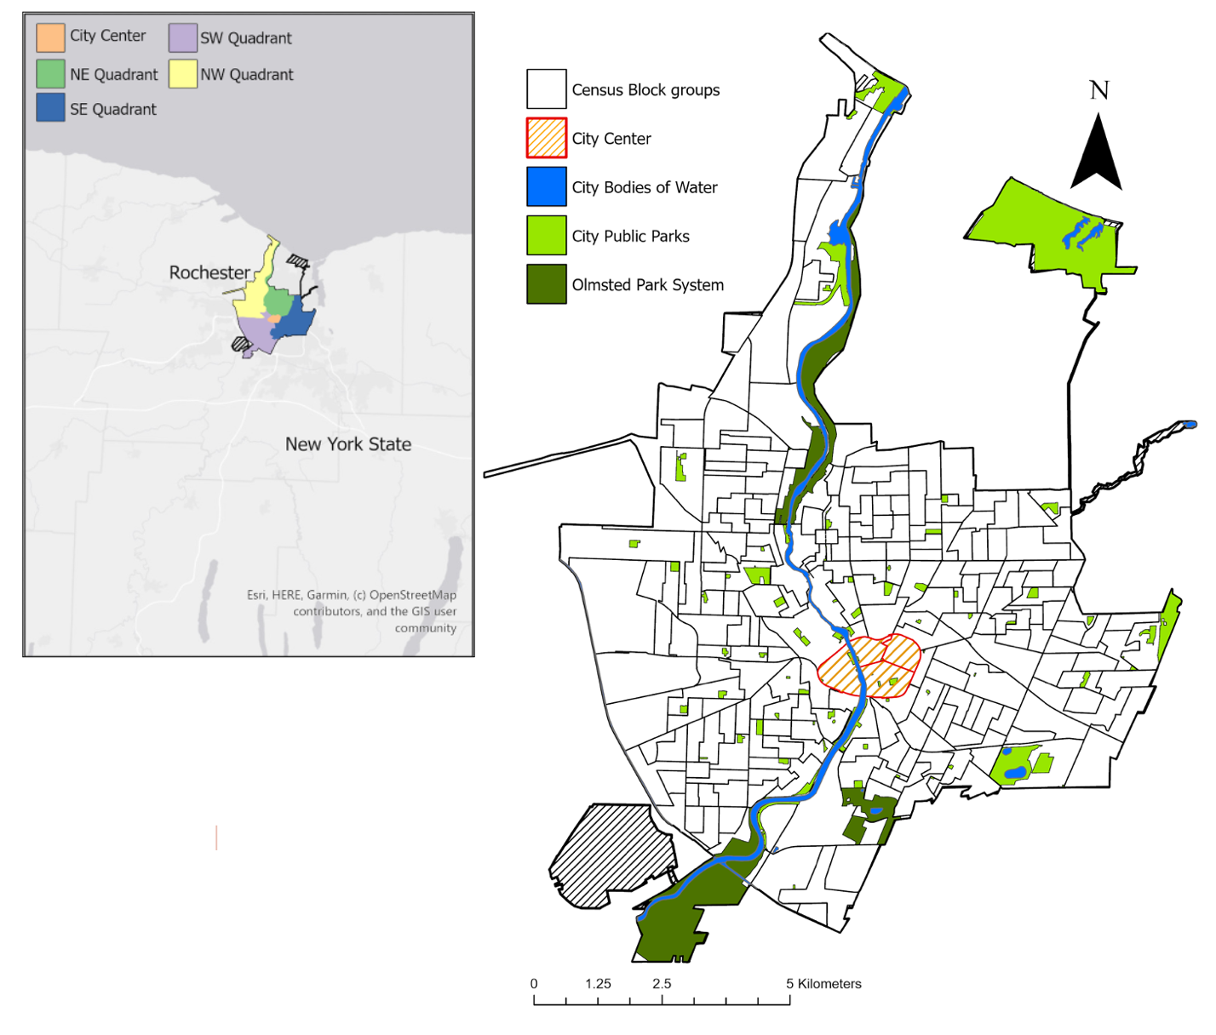

Fig. 1. A map of Rochester, NY highlighting key characteristics of the city, including block groups, parks, and the Genesee River. The city is commonly divided into four different geographic quadrants and the city center. Looking at the distribution of public parks in the city, the largest parks (Olmsted Parks System) surround the city periphery, while smaller parks are scattered throughout the center parts of the city.

1.1.6 Examples of Environmental Inequality in Rochester
Aside from the economic and racial diversity and plethora of green spaces in Rochester, another reason why Rochester makes for an ideal location to study the associations between UES supply and SES is its history of environmental inequality. These issues of environmental inequality are largely due to the city’s historically industrial-centered economy and the car-centric urbanization that has taken place over the last several decades. The American Rust Belt is the former heartland of the U.S.’s manufacturing industry and includes the many cities that were established along the Great Lakes (Pottie-Sherman, 2019). However, due to regional economic transformations, White-middle class suburbanization, and urban core disinvestment (Coppola, 2019; Hackworth, 2018), cities in the Rust Belt are largely defined today as areas of industrial, population, and status loss (Pottie-Sherman, 2019). Rochester is one of the many cities in the Rust Belt region that thrived during America’s industrial era. The city was home to many different industries throughout its history, including the Eastman Kodak Company, Bausch and Lomb, Gleason Works, and AC Delco (McKelvey, 1962). While these companies have all at one time or another brought economic success to the city, they are also all partially responsible for the alarming levels of toxic concentrations of air and water pollution found disproportionally throughout communities in the city today.
One of the most well-known companies to come out from the city of Rochester is the Eastman Kodak Company. Throughout the twentieth century as the film and movie industry skyrocketed throughout the country, Kodak was one of the country’s main producers of film and employed over 60,000 Rochestarians at its height in the 1960’s (Dickinson, 2017). However, as Kodak produced film for the whole country and was the primary employer and economic juggernaut of the city, it was simultaneously dumping millions of pounds of toxic chemicals into the city’s air and the Genesee River (Dutzik et al., 2003; Kerth and Vinyard, 2012). This in turn earned the company the distinction as one of the country’s top emitters of carcinogenic chemicals by the United States Public Interest Research Group between 1987-2000 (Dutzik et al., 2003). Kodak has invested tens of millions of dollars to clean up their environmental impacts and reduce their output of toxic chemicals (USEPA, 2014). However, the effects of pollution caused by Kodak and other companies during Rochester’s industrial era are still present today. In one study that compared the level of racial environmental inequality for toxic air pollutant exposure amongst 61 metropolitan areas in the U.S., Downey (2007) found Rochester to have the third largest levels of toxic concentrations of all cities examined. Furthermore, the study also found that Black and Hispanic populations in the city experienced toxic concentration levels nearly 2.5 times greater than those found in White populations (Downey, 2007). While the emission of air and water pollution in Rochester has significantly decreased since 2003 (USEPA, 2021), nonwhite residents living in neighborhoods near industrial facilities historically known high levels of pollution emissions, such as Eastman Kodak, may still be suffering inequitable exposure to legacy pollutants in the surrounding environment today.
Decisions made by public institutions have also contributed to the environmental justice issues in the city. Through the HOLC’s process of discriminatorily devaluing neighborhoods of lower income and minority renting populations (redlining), federal and local governments had justification for the lack of public improvement projects in these areas (Zuk et al., 2018). Furthermore, largely due to the Federal Aid Highway Act of 1944, cities were incentivized to build roadway projects that would add to the country’s interstate highway system throughout much of the second half of the 20th century (Dimento, 2009). Due to the large amounts of devalued land and a lack of homeownership, redlined neighborhoods were ideal and easily obtainable locations for the development of major roads and freeways, and other large developments such as factories and industrial plants (Dimento, 2009; Zuk et al., 2018). Consequently, these roadway developments made it easier for commuters from the suburbs to enter and leave the city for work, but in return poor and minority populations were severed and isolated from the rest of the city.
Rochester’s development of the Inner Loop in the early 1950s provides a clear example of these divides. Commonly known as the “Inner Noose”, the Inner Loop encircles the city’s downtown area in a sunken expressway, effectively separating it and the neighborhoods that surround the northern part of downtown from the rest of the city (Petti, 2017; Templeton, 2019). This area of the city is also commonly known as the “Crescent of Poverty”, as neighborhoods here form an aggregate of census tracts with some of the highest concentrations of poverty throughout the whole city (Petti, 2017). Furthermore, the development of roadway projects such as the Inner Loop has led to the amplification of numerous negative environmental impacts to land cover change and land use in these communities; these impacts include increased land surface temperatures, intensified exposure to air pollutants from vehicles, and decreases to accessible UGS (Nebal and Brom, 2018; Patton et al., 2014). Efforts have been made by the city of Rochester to lessen the adverse effects of the Inner Loop by filling parts of it in and constructing housing and commercial units where it once stood (Petti, 2017; Templeton, 2019). However, the impacts of the city’s car-centric urbanization and disinvestment in redlined neighborhoods still exist today.

  - Objectives and Hypotheses
To understand the inequality of UES supply in the city of Rochester, we examined whether the distribution of UES supply is associated with contemporary socioeconomic characteristics in city neighborhoods and historic redlining decisions. We predicted that we would find a strong correlation between a block group’s UES supply and their current SES. We anticipated this relationship to occur as previous studies have found relationships between SES and UGS distribution (Lockwood and Berland, 2019; Rigolon, 2018; Watkins and Gerrish, 2018). Therefore, since UGS are inequitably distributed in cities, so would the UES that they produce. Secondly, we anticipated that there would also be a correlation between the HOLC grade previously assigned to a neighborhood and its current supply of UES. We expected that higher HOLC graded neighborhoods would have greater overall UES supply as previous research has shown how HOLC grades have influenced the distribution of urban tree cover in cities (Namin et al., 2020), and subsequently a lack of UES such as local climate regulation (Hoffman et al., 2020). By examining how UES varies by modern and historic SES conditions, these results would inform interested parties on the environmental inequality within the city. Through providing a framework for identifying environmental inequality, interested parties will be able to help improve the environmental equality within the city through UGS development.

- Materials & Methods

For this study we had three primary objectives: (1) quantify the potential distribution of UGS and UES throughout the city of Rochester, (2) determine the distribution of modern-day SES and historic SES (HOLC grade) throughout city at the census block group level and determine if they correlate to UES distribution, (3) and identify neighborhood UES needs and opportunities for improvement using a social-ecological matrix and hot spot analysis.

2.1 LULC Classification
To quantify the estimated value of the four UES indicators in this study, we created a LULC classification for the entire extent of the city. Using an object-based image analysis (OBIA) method, we made an eight-class LULC classification of Rochester that included UGS features such as coarse vegetation (trees), fine vegetation (herbaceous plants), bare soil, and water. We generated this classification schema through five primary steps: image preprocessing, segmentation, image classification, accuracy assessment, and classification refinement (Haas and Ban, 2017).
Prior to performing the LULC classification we pre-processed the imagery. Using ArcGIS Pro 2.5 (ESRI, 2020) and 2015 orthoimagery obtained from the NYS GIS Clearinghouse, we clipped together high-resolution scenes of the city of Rochester and then mosaiced them together using the city boundary as the extent. Afterwards, we turned on the DRA function and switched the band combination of the orthoimagery to a false color composite (R=4, G=3, B=2) to highlight contrasts between vegetation and impervious surfaces.
Using the segmentation tool in ArcGIS, we created an object-based segmentation of the city which was then used for identifying features as training samples for the eight LULC classes. In recent years and with the increase in spatial resolution of imagery, OBIA classification methods have increased in popularity and are commonly considered advantageous to pixel-based classifications (Blaschke, 2010). Despite OBIA analyses being considered complex and challenging compared to pixel-based approaches, OBIA methods have far greater classification abilities, especially in respect to urban feature discrimination (De Pinho et al., 2012).
Prior to classification, we selected a sufficient number of spectrally representative training samples for each LULC class from the segmented image of Rochester. In total, we selected training samples that would represent the eight LULC classes: coarse vegetation (trees), fine vegetation (herbaceous plants), bare soil, water, buildings, roads & parking lots, other paved surfaces, and shadows. These are commonly selected LULC classes for urban LULC classification (Haas and Ban, 2017; MacFaden et al., 2012). However, we did not select training samples specifically for the eight primary LULC classes. Instead, we selected training samples for 16 subclasses that were generated for the eight primary LULC classes, to select even greater spectrally distinguishable features. For instance, the buildings class was divided into four subclasses of grey roof, white roof, yellow roof, and purple roof. Each of these classes had their own training samples selected and were classified separately before being aggregated together into the buildings class (Haas and Ban, 2017; MacFaden et al., 2012). After the training samples selection, we ran three different supervised classification methods: support vector machine (SVM), maximum likelihood, and random trees. Following our analysis of each of these classifications, we selected the SVM classification as the most visually accurate representation of the land cover in the city by comparing it to the orthoimagery used.
Upon the completion of the LULC classification, we computed an accuracy assessment in order to determine the reliability of the classification map. Using the create random points tool in ArcGIS, 2,000 random points were placed throughout the classification map proportionally to the total amount of surface area covered by each class. Then, using the 2015 orthoimagery as the reference dataset, we manually visited each point and denoted the landcover classification and ground truth class for the land directly underneath the point. Using a confusion matrix, we were able to calculate the producer’s and user’s accuracy for each class as well as the overall accuracy (OA) and kappa coefficient. We ran two confusion matrices for the SVM classification as the first one failed to produce an OA of over 80%. For the second confusion matrix, we reduced the number of LULC classifications to six by aggregating the buildings, roads & parking lot, and other paved surfaces classes into one impervious surface class. Accuracy assessments are a crucial step in the LULC classification process as it establishes the reliability of the generated data to the user (Rwanga and Ndambuki, 2017). For this classification an OA within the range of 80-90% was the intended goal as this is the median range of overall accuracies for accuracy assessments of object-based images analyses (as reviewed by Ye et al., 2018). Following the accuracy assessment, we refined the classification map by manually reclassifying any egregious errors in the LULC classes with the reclassifier tool in ArcGIS, as well as un-merging the three impervious surface classes. Upon completing these five steps, we now had a LULC classification map of Rochester that would be used to quantify the value of the UES indicators examined in this study.

2.2 Urban Ecosystem Service Modeling
We assessed the potential distribution of urban ecosystem services (UES) throughout the city of Rochester by constructing models for four UES indicators. These indicators were total carbon removal (carbon storage and sequestration), air pollution removal, climate regulation, and recreation potential. We selected these four indicators based on literature reviews that examined the benefit of UES to human health and well-being (Elmqvist et al., 2015; Gómez-Baggethun and Barton, 2013, Haase et al., 2014). We quantified the value for each UES for all census block groups within the city, using the LULC classification map, additional datasets and shapefiles, and literature-based coefficients. We selected place specific literature and data to the maximum extent throughout the modelling process to generate the most realistic models possible. For instance, Rochester and western NY-based data were preferred over data from New York City or other US cities. US-based data were selected preferentially over international urban data.

2.2.1 Total Carbon Removal
We estimated the value of carbon storage potential for each block group using data for coarse vegetation, fine vegetation, and bare soil; as for carbon sequestration, we only used coarse vegetation data. To calculate the estimated value of carbon storage and sequestration, we multiplied the area of each UGS type by the literature-based coefficient per square meter (Derkzen et al., 2015, Table 1). The value for carbon storage and sequestration were evaluated for coarse vegetation based on literature-based coefficients available from the nearest city, Syracuse, NY (Nowak et al., 2013). The estimated values of above ground biomass carbon storage and sequestration for Syracuse were 8.59 kg C/m² and 0.202 Kg C/m²/yr, respectively (Nowak et al., 2013). We were unable to find literature-based coefficients that estimated the value of carbon storage for herbaceous vegetation in any New York cities. Therefore, the value from a Chicago-based study that estimated the carbon storage value of herbaceous plants within a two-city block area to be 0.18 kg C/m² was used (Jo and McPherson, 1995). Lastly, the ability of the city’s urban soil to store carbon was assessed based on a six-city study done by Pouyat, et al. (2006). This study found the estimated value soil organic carbon density for urban soils at 1m depth from the nearest city, Syracuse, NY to be 7.1 kgC m⁻³. To calculate the total urban soil area, we summed the total area of fine vegetation and bare soil for each census block group. Coarse vegetation area was not included in this calculation as it could not be determined whether the LULC class below the canopy cover was an impervious or pervious surface.

2.2.2 Air Pollution Removal
Air pollution removal rates for coarse vegetation were estimated using coefficients from Buffalo, NY, the closest city in a 55-city urban tree pollution removal study (Nowak et al., 2006, Table 1). From this study, the coefficients of pollutant removal by trees for SO₂, NO₂, PM₁₀, O₃, and CO were used to calculate the total quantity of pollutants removed by coarse vegetation through the multiplication of the area of coarse vegetation by the literature-based coefficient per square meter (Derkzen et al., 2015, Table 1). To measure the rate of pollutant removal by fine vegetation, we used coefficients from a one-year study examining pollution removal rates of herbaceous plants on green roofs in Chicago, IL for SO₂, NO₂, and PM₁₀ (Yang et al., 2008). Just as for the coarse vegetation, to calculate the total removal of pollutants by fine vegetation, we multiplied the area of fine vegetation by the literature-based coefficients per square meter (Table 1).

Table 1. An overview of the urban ecosystem service (UES) indicators, supply rates, calculations, and sources used. The information outlined in this table was used to calculate the supply of carbon storage and sequestration, total air pollution removal, local climate regulation, and recreation potential throughout the city of Rochester.
Ecosystem Service | Coefficient | Indicator Calculation | Data | Literature Sources
Regulating Services
Carbon Storage | 8.59 kgC/m², 7.1 kgC/m⁻³, 0.18 kgC/m² | Coarse & fine veg.: UGS area x avg. storage rate (kgC/m²)  Bare soil: (Bare soil area + fine veg. area) x carbon density/m² | LULC data | Nowak et al., 2013; Jo and McPherson, 1995; Pouyat et al., 2006
Carbon Sequestration | 0.202 kgC/m²/year | Coarse veg. area x avg. sequestration rate | LULC Data | Nowak et al., 2013
Air Pollution Removal | (Coarse veg. & fine veg.) |  | LULC Data | Nowak et al., 2006; Yang et al., 2008
NO₂ | 1.0 g/m²/yr & 2.33 g/m²/yr | (Coarse veg. area x avg. storage rate) + (Fine veg. area x avg storage rate)
PM | 2.1 g/m²/yr & 1.12 g/m²/yr | (Coarse veg. area x avg. storage rate) + (Fine veg. area x avg storage rate)
SO₂ | 1.6 g/m²/yr & 0.65 g/m²/yr | (Coarse veg. area x avg. storage rate) + (Fine veg. area x avg storage rate)
CO | 0.2 g/m²/yr | (Coarse veg. area x avg. storage rate)
O₃ | 3.7 g/m²/yr | (Coarse veg. area x avg. storage rate)
Climate Regulation |  | Mean LST for the block group (℃) | Landsat 8 Imagery | Avdan and Jovanovska, 2016
Cultural Services
Recreation Potential |  | ∑ acreage from parks accessible to the block group within 0.5 miles (acres) | Monroe County GIS Department Data

2.2.3 Local Climate Regulation
We determined the cooling effects of UGS within the city by calculating the mean land surface temperature (LST) of each block group for one day using a literature-based algorithm (Avdan and Jovanovska, 2016) and Landsat 8 imagery courtesy of the U.S. Geological Survey. For the Landsat imagery that we used to calculate the mean LST, we set parameters of less than 10% cloud cover in the scene and that the imagery had to be located in the northern hemisphere during the summertime (June-August). These parameters were set to reduce any gaps in landcover data created by cloud cover and to accurately represent the consequences of the UHI effect on cities (Hoffman et al. 2020). The imagery used for this analysis was taken on June 23rd, 2019 and had a 1.2% cloud cover over the scene. Using ArcGIS, we transformed the band 10 information from the imagery into top of atmospheric spectral radiance and then converted the radiance values into at-sensor temperature. Next, using the band 4 and band 5 information, we calculated the NDVI and proportion of vegetation present for each pixel, which we then used to calculate the land surface emissivity. Calculating the NDVI was essential as vegetation plays a key role in the reduction of the UHI effects through their shading and evapotranspiration abilities (Skelhorn et al., 2014; Xie et al., 2013), as well providing information on the general health of the vegetation in the area. Then, by combining the at-sensor temperature and land surface emissivity together, we calculated the LST for each pixel. Finally, using the zonal statistics tool in ArcGIS, we calculated the mean LST for each block group in degrees Celsius for that day.

2.2.4 Recreation Potential
We calculated the UES value indicator for recreation potential using a dataset of the city’s park locations courtesy of the Monroe County GIS Department (2020) and the service area analysis tool in ArcGIS. This dataset provided by the Monroe County GIS Department included locations of all the publicly owned parks, playgrounds, and recreation centers in the city. For each park in the city, we created an 800m service area walking analysis from each of its entryways. We selected this buffer size to match the 0.5-mile distance found to be the average distance U.S. urban residents are willing to walk for recreational destinations (Yang and Roux, 2012). We considered each block group that these buffers touched able to access the entirety of the park (Wolch et al., 2005). Therefore, the indicator value for each block group was calculated through the summation of the total area of park acreage that they could access. Park acreage was chosen as the indicator coefficient as it is a common and effective indicator for potential park use (reviewed by Rigolon, 2016).

2.2.5 Normalizing Data for Model Visualization
After determining the value for each UES indicator within each block group, we then normalized these values using (eq. 1) to derive relative values of the same unit on a scale of 0-100 for each indicator.
$I_{norm}=\frac{(i-i_{min})}{(i_{max})-(i_{min})} x 100$ (eq.1) (Kremer et al., 2016)
In the given equation, I_{norm} is the normalized value of the UES indicator at any given block group (i), while i_{min} and i_{max} relate to the minimum and maximum values of a given UES indicator. Furthermore, to portray the census block groups with the lowest LST values as recipients of the highest local climate regulation values, we subtracted 100 from the normalized value.
2.3 Assessment of SES Indicators
We compiled SES data for each census block group through a dataset courtesy of the city of Rochester’s Neighborhood Data Inventory (City of Rochester, 2014). This dataset contained data from the 2010 Decennial Census and the 2013 American Community Survey. Any missing data from this dataset we filled in from supplemental sources (City-Data, 2017). We chose five SES indicators from this dataset for each block group within the city to compare to the UES indicator distributions: median household income, race percentages (Black and White), percent of home ownership occupancy, median property value, and population density. We selected median household income, race percentages, home ownership occupancy rates, and the median property values as indicators as they are commonly used in studies that have examined correlations between SES and access to UGS (Lockwood and Berland, 2019; Rigolon et al, 2018; Schwartz et al., 2015). We also included population density as a measure of the quantity of the population that potentially benefits from the UES produced by the green spaces (Pham et al., 2012). Using the normalization equation from Kremer et al. (2016), we calculated the normalized value for each SES indicator.
Along with the five modern day SES indicators, we used one historical socioeconomic indicator to assess the social need in the city today, HOLC Grades. Since HOLC grades were given to neighborhoods of extents different than census block groups, we assigned the HOLC grade for each block group depending on the grade given to the neighborhood that the block group resides in. This was done using the grades assigned by the HomeOwners Loan Corporation (HOLC) to Rochester neighborhoods in 1939, as accessed through the University of Richmond’s Digital Scholarship Lab’s “Mapping Inequality” database (Nelson, 2017). If a block group resided in two neighborhoods that were given different HOLC grades, we gave the block group the lowest of the available grades.

2.4 Social-Ecological Matrix
To compare the normalized social need and UES value for each census block group, we constructed a social-ecological matrix using the method from McPhearson et al. (2013). When calculating for the overall UES value, each UES indicator group was weighted as one. However, if more than one indicator was used to evaluate a given UES, the weight was distributed equally among the indicators (Table 2). For example, the UES indicator total carbon removal was calculated by equally weighting the value of carbon storage and sequestration each as 0.5. Defining weights for each indicator is important for creating an integrated assessment mechanism for UES; and while there is still much debate on what methods and tools to use for determining weights, there is an understanding within the field of study for their importance (Felix et al., 2011). Some common weighting methods used in previous studies include surveying local stakeholder and community priorities (Meerow and Newell, 2017) or using spatial multi criteria evaluations to evaluate different green infrastructure planning priorities (Kremer et al., 2016). However, for simplicity and the purpose of demonstrating a social-ecological matrix, all indicators (UES and SES) were weighted equally.
When calculating the overall social need value for each block group, we considered low values for median household income, median property value, and percent ownership to correspond to high social need. Therefore, 100 was subtracted from each of the normalized values for those three indicators to assign the lowest values the assertion of highest social need. Furthermore, the percentage of the population that is Black and White was not included in the overall social need model as neither a high nor low value in either should be indicative of an area's level of social need. After we calculated the final weighted and summed values for social need and the UES value for each block group, we designated the block group as having either a high or low value, based on whether it was above or below the city’s median indicator group values. The social need for UES and the UES production values were classified into four category groups: High-Low, High-High, Low-Low, and Low-High thus creating the four-level social-ecological matrix (Table 3).
Lastly, to examine patterns in the matrix at a neighborhood-wide scale, we calculated spatial hotspots of block groups that share a proximity to each other and possess statistically similar social-ecological values. Examining block group class designation hotspot’s is beneficial for examining who UGS development will affect at broader scales. Using the Getis-Ord Gi* Hotspot analysis tool in ArcGIS, we identified areas with statistically significant high and low normalized and summed values of social need and UES supply (H-L & L-H). We then combined the most significant block groups (p < 0.05) to find clustering of block groups that are in both the H-L and L-H classes.

Table 2. An explanation of the weighting method used for the social-ecological matrix. All four UES were equally weighted as one. if more than one indicator was used to evaluate a given UES I equally distributed the weight among the indicators.
UES Indicator | Weighting Coefficient
Carbon Storage | 0.5
Carbon Sequestration | 0.5
Coarse vegetation Air Pollution Removal | 0.5
Fine Vegetation Air Pollution Removal | 0.5
Local Climate Regulation | 1.0
Recreation Potential | 1.0

Table 3. An explanation of the four categories used to create the social-ecological matrix. I designated the block group as having either a high or low value for social need and UES supply based on whether it was above or below the city’s median indicator group values.
Social-Ecological Matrix Categories | Category Definitions
High-Low (H-L) | High social need for urban greening projects and a Low production of UES
High-High (H-H) | High social need for urban greening projects and a High production of UES
Low-Low (L-L) | Low social need for urban greening projects and a Low production of UES
Low-High (L-H) | Low social need for urban greening projects and a High production of UES

2.5 Statistical Analyses
To examine the association of a neighborhoods’ past and present SES and distribution of UES, we used linear regression models using R 3.6.3 and RStudio 1.3.1093 (R Core Team, 2021; RStudio, 2020). To compare the supply of the four UES by block group HOLC grades, we used a one-way ANOVA analysis using the aov function from the ‘rstatix’ package (Kassambara, 2021). We log-transformed the UES indicators using the log function to normalize their data if they were skewed. We then ran a post-hoc ANOVA multiple comparisons test known as a Tukey’s Honest Significant Difference (HSD) Test using the TukeyHSD function from the ‘rstatix’ package (Kassambara, 2021). Given the unequal samples size among the four HOLC grades, the TukeyHSD function accounted for this using the Tukey-Kramer methods.
To examine the associations of current SES status and HOLC grades with UES indicators, we used linear regression models and a two-way ANOVA analysis. The dependent variables for this analysis were the UES indicators. Just as the response variables in the one-way ANOVA, UES indicator values were log-transformed to normalize their distribution. All UES indicators except for local climate regulation were log transformed, this was because the LST values for the local climate regulation indicator were already normally distributed. The independent variables included were four of the five SES indicators (percent of the population that is Black, percent homeownership, median property values, and median household income) and the HOLC grades.
Prior to analysis, we standardized the SES values using the scale function using the R ‘base’ package (R Core team, 2021). Furthermore, before performing the linear regression models, we used the Spearman’s rank-order correlation test with the cor.test function in the ‘rstatix’ package, to screen for multicollinearity among the potential independent variables (Kassambara, 2021). Using a cut off correlation coefficient greater than 0.7 or less than -0.7 and/or a p-value less than or equal to 0.05, we removed two SES indicators from the analysis: population density and the percentage of the population that is White. We then created the linear regression models for each UES indicator using the lm function in the base R ‘stats’ package (R Core team, 2021). Using the linear regression models for the two-way ANOVA analysis, we then calculated model correlation coefficients and p-values for each fixed effect, to examine associations between individual SES and UES values and whether they are significant, and the pseudo-R-squared values for the model to examine overall model fit.
After the two-way ANOVA, we used post-hoc testing to compare group means via a Tukey’s HSD test using the TukeyHSD function from the ‘rstatix’ package (Kassambara, 2021), to compare the supply of each UES indicator between the HOLC grades. This was done to show how historic SES indicators impact UES supply today even after accounting for the modern-day SES indicators. Lastly, several residual diagnostics were run using the plot function in the R ‘base” package to check for any violations of standard regression assumptions (R Core Team, 2021). These residual diagnostics included a residuals vs fitted plot, normal QQ plot, scale-location plot, and a residuals vs leverage plot.

3.0 Results & Discussion

3.1 City Landcover Typology and Accuracy Assessment
The dominant landcover type across all city quadrants, aside from the southeast quadrant, was impervious surfaces (Table 4., Appendix Fig. 1). In the southeast quadrant, the dominant landcover type was coarse vegetation (8.17 km²). Coarse vegetation was the most dominant UGS class across all of the city’s quadrants. Even though the northwest quadrant of the city had the greatest total area of impervious surfaces (14.63 km²), it still had a 3:4 ratio of area covered in UGS features compared to impervious surfaces. Whereas the city center, the quadrant encompassing Rochester’s downtown area (Fig. 1), had the greatest disparity with a less than 1:10 ratio for area covered in UGS features compared to impervious surfaces.
The final accuracy assessment of the classification map indicated an overall accuracy (OA) of 83.2% and a kappa coefficient of 0.75 (Appendix Table 2). As the median range for LULC classification OA is 80%-90% (reviewed by Ye et al. 2018), this LULC classification met the desired OA for its data to be reliably used to calculate the UES indicators present across the city. The primary focus of this classification map was to determine the distribution of UGS features that contribute to the UES indicators measured: coarse vegetation, fine vegetation, and bare soil. The accuracy assessment’s confusion matrix showed user’s or producer’s accuracies for both the coarse and fine vegetation classes exceeding the classifications overall accuracy (Appendix Table 2). This suggests a high degree of similarity between the classification map and the actual landcover distribution for these classes. As for confusion, both the coarse vegetation and fine vegetation classes were most confused with each other and the impervious surfaces class. Confusion between coarse vegetation and the impervious surface class may have been a result of residential street tree canopy cover often obstructing the aerial view of the streets below (Appendix Fig. 2). This high degree of spatial mixture between these two classes created a salt-and-pepper effect along residential streets. The bare soil class showed the lowest accuracies across all the classes measured. This may have been due to the overall miniscule total area of the landcover class across the city, as well as its spectral similarity to brightly paved surfaces.

Table 4. The total area of four LULC classes for each quadrant of Rochester, NY. The total for each landcover is given in the units of km². UGS landcovers include coarse vegetation, fine vegetation, and bare soil. Impervious surfaces landcover includes all paved surfaces and buildings. The distribution of each city quadrant and the block groups within them are displayed in Fig.1. The impervious surface class was the dominant class across four of the five quadrants. Coarse vegetation was the dominant UGS class across all quadrants.
City Quadrant | Number of Block Groups | Total Area of Coarse Vegetation (km²) | Total Area of Fine Vegetation (km²) | Total Area of Bare Soil (km²) | Total Area of Impervious Surfaces (km²)
City Center | 4 | 0.07 | 0.047 | 0.022 | 1.42
Northeast | 53 | 4.43 | 2.18 | 2.93 | 7.50
Northwest | 55 | 6.34 | 3.90 | 1.05 | 14.63
Southwest | 51 | 5.72 | 3.23 | 5.53 | 11.18
Southeast | 66 | 8.17 | 3.10 | 2.45 | 7.72

3.2 Urban Ecosystem Service Supply
Based on the literature-based coefficients used and methods outlined in Table 1, we estimated the total rate of carbon and air pollution removal for the entire city as well as at the census block group level. We also estimated the average land surface temperature and total amount of park acreage available for each block group.
Across the city’s 228 block groups, we found the value of carbon storage ranged from 151 to 14,800 metric tons, while the rate of carbon sequestration ranged from 2.41 to 187 metric tons/yr. Looking at the city-wide scale, these values summed up to 318,458 metric tons of carbon storage and 4,995 metric tons of carbon sequestration per year. For air pollution removal, we found that the total removal rates of all pollutants examined in this study (SO₂, NO₂, PM₁₀, O₃, and CO) at the block group level ranged from 0.122 to 11.4 metric tons/yr. These rates summed to a city-wide scale, produced a removal of 261 metric tons of air pollutants per year. As for local climate regulation, we found that across the city’s block groups, the average LST value on June 23, 2019, was 30℃. Lastly, of the 13 km² (3212 acres) of total parkland within the city, census block groups had access to a median value of 24 acres and a mean value of 121 acres of parkland.
By mapping the normalized values for each of the UES indicators, we were able to spatially compare and identify areas throughout Rochester that produce the highest and lowest supplies of UES. The spatial distribution of these UES indicators which includes total carbon removal, air pollution removal, local climate regulation, and recreation potential are shown in Fig. 2. Results on these maps are shown on a normalized scale of 0 to 100. Overall, these four indicators reveal the trend that the block groups around the periphery of the city are the largest producers of UES. Total carbon removal and air pollution removal have near identical model distributions (Fig. 2A & B); however, this is due to these two services having the same indicator equation (Table 1). Examining local climate regulation, the average value of LST within the block groups ranged from 24.0-33.6℃. Looking at Fig. 2C, the highest LST values are in the city center and block groups directly eastward, whereas the coolest block groups are around the city’s boarder, especially to the north and the south. Lastly, the most disparate supply in UES can be seen in the UES indicator recreation potential (Fig. 2D). Block groups had access to anywhere from 0 to 945 acres of parkland. Block groups with access to the greatest amount of parkland were located around the Olmsted Park System: Genesee Valley Park, Highland Park, and Seneca Park.

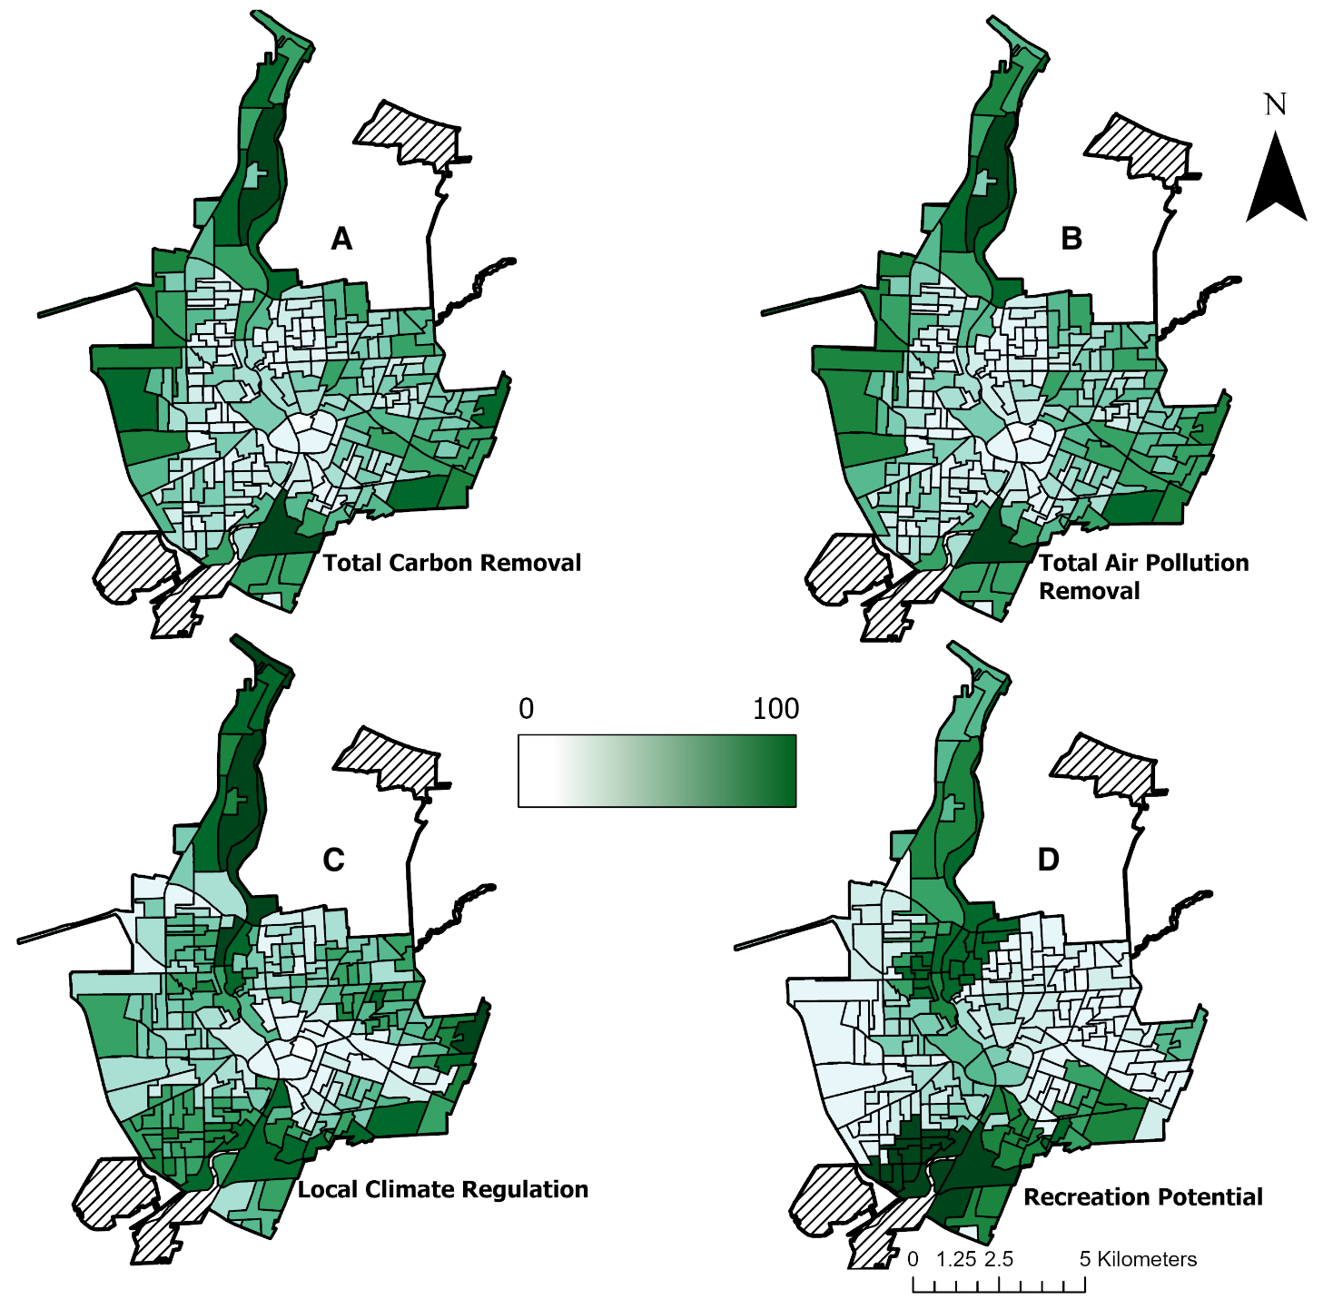
Fig. 2. Spatially explicit models showing the normalized distribution of rates of supply (0-100) of four UES in Rochester at the block group level. The greener that a given block group is, the greater the supply of UES that is produced there. (A) – total carbon removal (carbon storage and sequestration), (B) – total air pollution removal, (C) – local climate regulation, (D)- recreation potential. For all four models, the greatest supplies of UES are seen around the periphery of the city, while the lowest values are seen closer to the city center. Areas in the maps marked with hash marks were not included in the analysis as they are not census block groups with a population.

The trends observed in the models within Fig. 2 show that the highest production of UES supply in the city primarily occurs in block groups around the periphery, and this may be attributed to the synergies and trade-offs that occur between the various UES. Synergies occur when the provisioning of two services increase or decrease in unison, while trade-offs occur when the provisioning of one service increases as the service of another decreases (Rodriguez et al., 2006). Derkzen et al. (2015) was able to observe these synergies by bundling the production of six UES at the neighborhood level in Rotterdam, Netherlands. Results from this study showed synergies similar to our results between the production of local climate regulation, carbon storage, and air purification as they are supplied by the same types of UGS (Derkzen et al., 2015). Furthermore, this study also found synergies between recreation potential and run-off retention in neighborhoods closest to the city’s bodies of water (Derkzen et al., 2015). Conversely, trade-offs were observed in a study that quantified the production of various UES while modeling potential developments for an urban floodplain in Vienna, Austria (Sanon et al., 2012). This study found that trade-offs occurred largely due to differences in stakeholder development preferences; the largest trade-off occurred between scenarios where the floodplain would be developed as a fishery as opposed to a source of drinking water for the city (Sanon et al., 2012). As seen with the results from the studies by Derkzen et al. (2015) and Sanon et al. (2012), there are different forms of drivers that can influence the synergies and trade-offs between UES. In a literature review of drivers that cause ecosystem service synergies and trade-offs, Dade et al. (2018) found that some of the primary drivers include land use and land cover changes, biological and physical characteristics, policy instruments, climate change, and SES indicators. By increasing our understanding of the synergies and trade-offs between UES and the drivers that cause them, we can help to improve policy decisions and the management of UGS (Dade et al., 2018). These improved policy decisions and management practices can help improve the supply of multiple UES in areas of Rochester where they are deficient and identify which type of UGS are most needed there to synergistically improve their supply.
Compared to other cities, there is an overall high value of UES supply in Rochester. In Syracuse, NY, a central New York city with a population of more than 140,000 and just 28 Km² smaller than Rochester (World Population Review, 2020; World Population Review, 2021_{a}), urban trees can store 148,300 metric tons of carbon and sequester 4,700 metric tons per year (Nowak et al., 2002). While our calculations determined that UGS in Rochester can store nearly double the amount of carbon than Syracuse, our analysis also took into consideration the storage abilities of fine vegetation and urban bare soil. Whereas in the study by Nowak et al. (2002), they only calculated the carbon storage abilities of urban trees. Similarly, Rochester also had a higher value of air pollution removal compared to other New York cities. In Buffalo, NY, a western New York city with a population of 254,000 and an area 12 Km² larger than Rochester (World Population Review, 2020; World Population Review, 2021_{b}), urban trees are estimated to remove 165 metric tons of pollutants per year (Nowak et al., 2006). However, the calculations from that study only considered the storage abilities of Buffalo’s urban trees, while our study analyzed the air pollution removal abilities of the coarse and fine vegetation. Urban soils and fine vegetation can both be significant contributors of carbon and air pollution removal in cities. Urban soils are estimated to store 1.9 billion metric tons of carbon in the United States (Pouyat et al., 2006), that is three times the storage abilities of U.S. urban trees (Nowak et al., 2013). However, studies that have estimated the carbon and air pollution removal of urban soils and fine vegetation both note that more natural areas such as parks remove much greater amounts of pollutants compared to more managed areas like residential lawns (Jo and McPhearson, 1995; Pouyat et al., 2006).
Comparing the values from the local climate regulation analysis to another study, these values fell within the range of average LST for urban areas that have 25% or more impervious surface area (ISA) and have a temperate broadleaf and mixed forest biomes (Imhoff et al., 2010). The block groups which had the highest LST (Fig. 2C) also have the highest proportions of impervious surfaces compared to anywhere else in the city (Table 4). These results are supported by the fact that the warmest areas of cities are found in the inner-most contour and that ISA controls for 70% of the variance that is observed in urban LST (Imhoff et al., 2010). For the recreation potential indicator, residents in Rochester had better access to parks than residents in New York City. In New York City, census tract groups (a demographic subdivision one level above block groups) were within a 0.25 mi walk from a median value of 5.2 and a mean of 60 acres of parkland (Weiss et al., 2011). Rochester residents had access to a mean value of parkland double that of New York City residents (121 acres).
Through the two-way ANOVA, we found that the distribution of three of the four UES indicators are significantly correlated with at least one modern-day SES indicator (Table 5). For both total carbon removal and air pollution removal, there is a significantly negative correlation with the percentage of a block group’s population that identifies as Black (Correlation coefficient: -0.14, p-value: 0.009; Correlation coefficient: -0.11, p-value: 0.02) (Table 5). These two services are also positively correlated with the percentage of a block group’s home ownership percentages (Correlation coefficient: 0.32, p-value < 0.00000027; Correlation coefficient: 0.31, p-value: 0.000000093) (Table 5). These correlations denote that there is a decrease in the rate of total carbon and air pollution removal as the percentage of a given block group's Black population increases. Conversely, the value of these UES indicators increase as the number of homes in a block group are owned by their tenants. As for local climate regulation, the two-way ANOVA also found that the LST of block groups is correlated with the percentage of the homes in the block group that are owned by their tenants. Block groups with higher percentages of the homeownership have significantly lower average LST (Correlation coefficient -0.5, p-value: 0.00017) (Table 5).
Despite accounting for the four modern-day SES indicators (percent black population, percent homeownership, median property value, and median household income), the HOLC grades of the block groups are still significantly correlated with the supply of each of the four UES indicators. For total carbon removal, “A” graded block groups have a significantly higher supply than “B” and “C” graded block groups (Correlation coefficient: 0.915, p-value: 0.058; Correlation coefficient: 0.888, p-value: 0.0604) (Table 6). For total air pollution removal, “A” graded block groups also have a significantly higher supply than “B” and “C” graded block groups (Correlation coefficient: 0.924, p-value: 0.045; Correlation coefficient: 0.880, p-value: 0.05) (Table 6). Looking at local climate regulation, “B” graded block groups have significantly lower LST compared to “C” and “D” graded block groups (Correlation coefficient: -0.821, p-value: 0.00895; Correlation coefficient: -1.02, p-value: 0.00323) (Table 6). Lastly, as for recreation potential, “B” graded block groups have significantly more available parkland compared to “C” and “D” graded block groups (Correlation coefficient: 1.42, p-value: 0.0000136; Correlation coefficient: 1.36, p-value: 0.000319) (Table 6).

Table 5. Statistical correlations between UES indicators and SES indicators through a linear regression model and two-way ANOVA analysis. Results show that as the percentage of a block groups population that identifies as Black increases, the supply of total carbon removal (carbon storage and sequestration) and total air pollution removal decrease. Conversely, as the percentage of homeownership in a block group increases, the supply of total carbon removal, total air pollution removal, and local climate regulation all increase. Low adjusted R-squared values for all four models indicates that other factors account for a significant role in the distribution and production of UES in Rochester.
 | Total Carbon Removal | Total Air Pollution Removal | Local Climate Regulation | Recreation Potential
 | Correlation coefficient^{p-value} (standard error)
Percent Black Pop. | -0.14** (0.05) | -0.11* (0.05) | -0.06 (0.11) | -0.14 (0.13)
Percent Home Ownership | 0.32****(0.06) | 0.31**** (0.06) | -0.5**** (0.13) | -0.06 (0.15)
Median Property Value | 0.04 (0.06) | 0.03 (0.05) | 0.04 (0.11) | 0.04 (0.13)
Household Median Income | -0.05 (0.06) | -0.02 (0.06) | 0.08 (0.13) | -0.21 (0.15)
A  B  C  HOLC Grade | 0.84* (0.38) | 0.83* (0.37) | -1.04 (0.83) | 1.43 (0.94)
A  B  C  HOLC Grade | -0.12 (0.15) | -0.13 (0.15) | -1.32*** (0.33) | 1.73**** (0.38)
A  B  C  HOLC Grade | -0.09 (0.11) | -0.08 (0.10) | -0.34 (0.23) | 0.09 (0.27)
Adjusted R-Squared | 0.27 | 0.29 | 0.20 | 0.11
P-value signif. codes: 0.0001 ‘****’, 0.001 ‘***’, 0.01 ‘**’, 0.05 ‘*’, 0.1 ‘●’
The HOLC grade correlation coefficient values are those compared to “D” graded HOLC values

Table 6. Statistical correlations for UES indicator values between each of the four HOLC grades (A-D) from the two-way ANOVA analysis. Results from this analysis show the correlation in the production of each UES supply between values for each of the four HOLC grades. For total carbon removal (carbon storage and sequestration) and air pollution removal, there is a significant increase in the supply between block groups with a HOLC grade of “A” compared to “B” and “C”. For local climate regulation, block groups with a HOLC grade of “B” have significantly lower LST compared to “C” and “D” graded block groups. Lastly, for recreation potential, there is significantly more accessible parkland for residents that live in “B” graded block groups compared to “C” and “D” graded block groups.
 | Total Carbon Removal | Total Air Pollution Removal | Local Climate Regulation | Recreation Potential
 | Correlation coeffcient^{p-value}
HOLC Grade A-B | 0.915● | 0.924* | 0.428 | -0.491
HOLC Grade A-C | 0.888● | 0.880* | -0.392 | 0.930
HOLC Grade A-D | 0.803 | 0.803 | -0.587 | 0.868
HOLC Grade B-C | -0.0267 | -0.0442 | -0.821** | 1.42****
HOLC Grade B-D | -0.112 | -0.121 | -1.02** | 1.36***
HOLC Grade C-D | -0.0853 | -0.0767 | -0.195 | -0.0619
P-value signif. codes: 0.0001 ‘****’, 0.001 ‘***’, 0.01 ‘**’, 0.05 ‘*’, 0.1 ‘●’

Our findings are similar to those in other studies. In a study that measured the equity of urban forest UES production in the Bronx, NY, researchers also found that several SES indicators are significantly correlated with distribution of UES supply (Nyelele et al., 2020). In their study, Nyelele et al. (2020) found that carbon removal services, air pollution removal, and local climate regulation were all significantly correlated with at least one of six SES indicators examined. Similar to our study, Nyelele et al. (2020) also calculated that the percentage of nonwhite residents in a block group is negatively correlated with the supply of carbon and air pollution removal. However, despite the statistically significant correlations, further statistical analyses in our study and the one by Nyelele et al. (2020), show that these SES indicators only account for some of the variation seen in the distribution of UES supply. In our study, the adjusted R-squared values state that at most, only 29% of the variation seen in the measured UES supply is due to the SES indicators analyzed (Table 5). Therefore, this indicates that there are other factors that were not accounted for but play a significant role in the distribution and production of UES in Rochester.

3.3 Socioeconomic Status Analysis
Using census data retrieved from the city of Rochester, we mapped the distribution of several SES indicators at the census block group level across the city (Fig. 3). Each of these indicators displayed trends that are effective in understanding the demographic distribution of the city. For the SES indicator population density, the mean value amongst the city’s 228 block groups was 3,433 people/Km². Looking at the map of population density, it displays that the most densely populated block groups are those that surround the downtown area (Fig. 3A). Conversely, the block groups that make up the periphery of the city appear to be less densely populated (Fig. 3A). Household median income among the city’s block groups ranged from $4,316 to $84,077, with an average value of $32,661. Block groups along the periphery of the city contain households who have on average the highest rates of income, particularly the block groups to the east of city (Fig. 3B). As for homeownership percentages, the mean percentage of homes that are owned by their tenants across all block groups is 46%; however, some block groups had ownership rates as low as 0% or as high as 90%. Similar to median household income, block groups along the periphery of the city had the highest values, especially in block groups to the east and north of downtown (Fig. 3C). Racially, the SES analysis show that there is a clear divide in where White and Black people live within the city. For both race identities, block groups had as low as 0% or as high as 99% of their given population identify as either White or Black. Looking at the spatial distribution of race in the city, residents that identify as White reside mainly in block groups to the east, southeast, and north of the city (Fig. 3D), whereas residents who identify as Black primarily reside in block groups to the southwest and northeast of the city (Fig. 3E). Lastly, examining the distribution of median property values within the city, the average median property value per block group is $71,783. Some block groups have median values as low as $18,000 while other block groups have median values over $500,000. Spatially, the highest median property values are in the city center and in block groups to the east and southeast of the city (Fig. 3F).

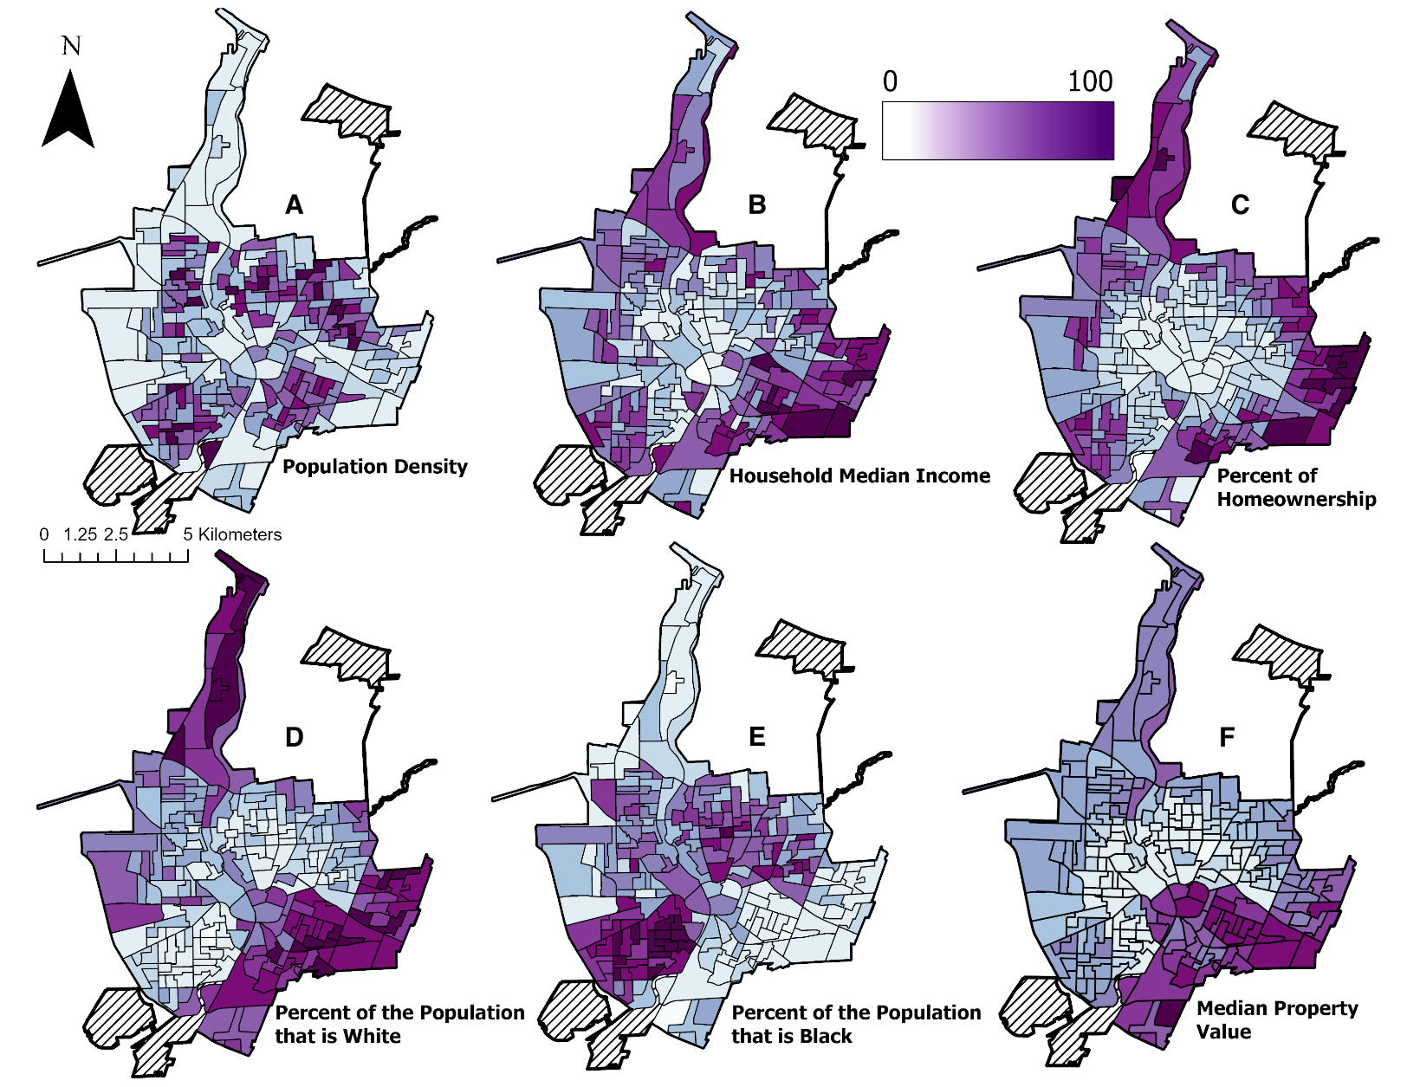
Fig. 3. Spatially explicit models showing the normalized distribution (0-100) of five SES indicators in Rochester, NY at the census block group level. The more purple that a given block group is, the higher the SES indicator value they have. The maps within this figure show the distribution of the following SES indicators: (A) population density, (B) household median income, (C) percent homeownership, (D) percent of population that is White, (E) percent of population that is Black, (F) median property value. These maps show that the wealthiest block groups are around the periphery of the city, namely to the north and east. Furthermore, map D and E show that there is a clear divide in where White and Black populations reside in the city.

As illustrated by the maps in Fig. 3, our findings indicate that the city is both economically and racially divided. The trend of the wealthiest (highest income & property values) block groups (Fig. 3B & F), Whitest block groups (Fig. 3D), and block groups with the greatest supply of recreation potential (Fig. 2D) primarily being located in the far east of the city is similar to the trends observed in environmental gentrification. With some of the city’s largest parks like Genesee Valley Park, Highland Park, and Cobb’s Hill being located here, these parks may be contributing to the high levels of property value observed in these block groups. In turn, these parts of the city and UES from the parks are inaccessible to lower income and nonwhite populations (Immergluck and Balan, 2018; Black and Richards, 2020)
Racially, the city is also distinctly separated (Fig. 3D & E) despite the near equal percentages of the city’s population that identifies as Black and White, 40% and 47%, respectively (World Population Review, 2020_{a}). This trend of the wealthiest and Whitest block groups surrounding the periphery of the city show similar trends to that of White flight (Pais et al., 2008). As the population of Black residents in the city rapidly grew from 5,000 to 32,000 between 1945 and 1964 (Southwest Tribune, 2019), White residents likely moved from the center part of the city and into the peripheries and surrounding suburbs. Thus, having left housing in the center parts of the city to be occupied by the new Black residents. It is important to understand the economic and racial distributions within cities as studies have shown that these indicators are correlated with UES and UGS distribution.
In two studies that examined the equitable distribution of UES produced by urban trees, researchers found that median income was positively correlated with ecosystem service production, while high percentages of renters and percent poverty were negatively correlated (Nyelele et al., 2020; Riley and Gardiner, 2020). Racially, studies have shown that higher quality and greater amounts UGS such as street trees and parks are found in areas with higher percentages of White populations and lower in areas with larger Black populations (Rigolon, 2016; Schwartz, 2015). Understanding the SES distribution of a city is an important part in improving the environmental and overall equity, especially in a highly economically and racially divided city such as Rochester.
Aside from the contemporary SES indicators analyzed using census data, we investigated one set of historical SES data too, HOLC grades. Mapping these values show a stark contrast in the value assessment of neighborhoods in Rochester during the 1930’s (Fig. 4). Specifically, block groups with the lowest HOLC grade of “D” are only found in the city center and neighborhoods directly surrounding it. Whereas higher HOLC grades, “A” and “B’, are exclusively found near the periphery of the city, specifically to the north and south.

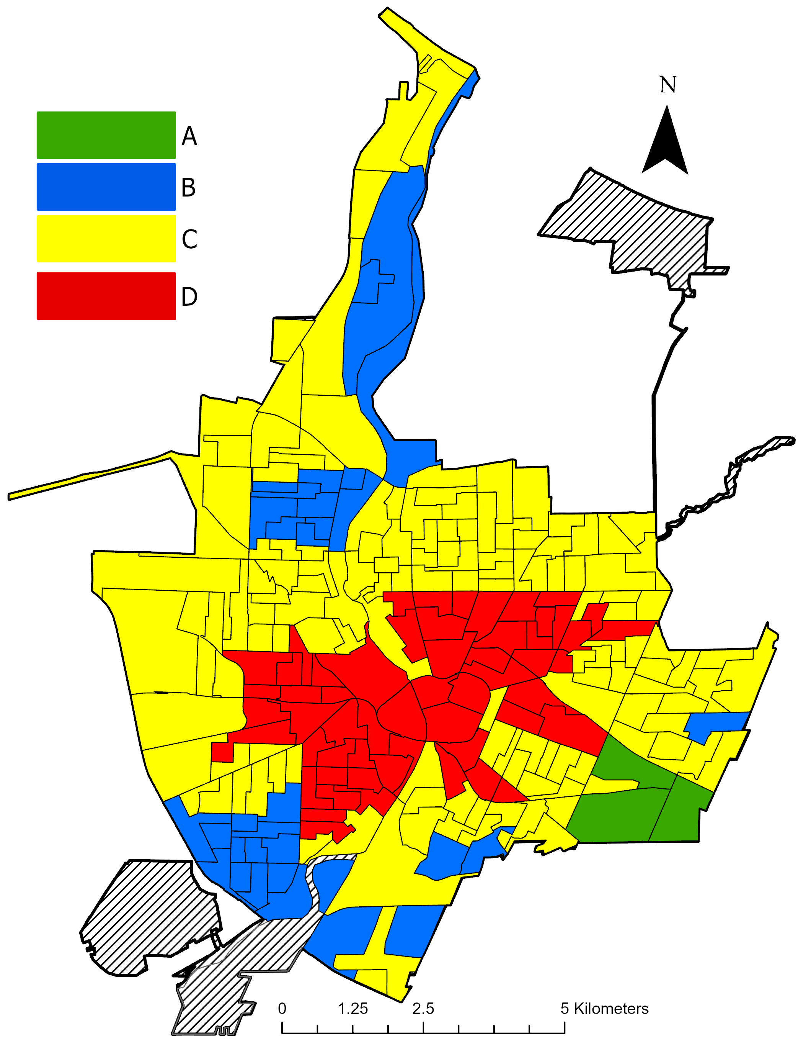
Fig. 4. A 1939 map of the HomeOwners Loan Corporation grading scheme at the census block group level in Rochester, NY. “A” indicates the most desirable neighborhoods, “B” indicates neighborhoods that are still desirable, “C” indicates neighborhoods that are declining, and “D” indicates neighborhoods that are hazardous. Overall, the lowest graded neighborhoods are in the center of the city while the highest graded neighborhoods are towards the peripheries. Since HOLC grades were only assigned to neighborhoods, we made this map by assigning grades to the census block group level.

Through the one-way ANOVA, we found significantly different mean UES indicator values for all four UES among HOLC grades (Fig. 5). For the UES indicators total carbon removal and air pollution removal, block groups given a HOLC grade of “A” experience significantly higher rates of carbon and air pollution removal compared to all other HOLC graded block groups (Fig. 5A & B). Furthermore, there was a significant difference between “C” and “D” HOLC graded block groups for both indicators, as well as significant differences between “B” and “D” for air pollution removal. The greatest mean difference for both indicators was observed between block groups with an “A” and “D” HOLC grade, both indicators had at least a mean log transformed carbon and air pollution removal difference of 1.66 with a p-value of 0.0002. For the UES indicator local climate regulation, this was the only of the four UES indicators that were not scaled and log transformed, this is because these values were already normally distributed. Significant differences in mean LST were observed between “B”, “C”, and “D” HOLC graded block groups (Fig. 5C). The mean LST temperature of block groups with a HOLC grade of “B” were 1.92℃ cooler than the mean LST for block groups with a HOLC grade of “D”, with a p-value < 0. Furthermore, “B” graded block groups were 1.17℃ cooler than “C” graded block groups, with a p-value < 0.00009. Lastly, for the UES indicator recreation potential, significant differences in the mean log transformed value of accessible park acreage were observed in block groups with a HOLC grade of “B” and “C” and “D” graded block groups (Fig. 5D). “B” graded block groups had a greater mean acreage difference of 1.5 with p-value of 0.000005 and 0.0000037 when compared to “C” and “D” graded block groups. Overall, this statistical analysis reveals the trend that higher graded block groups within the city have significantly higher UES indicator values than the lower graded block groups.

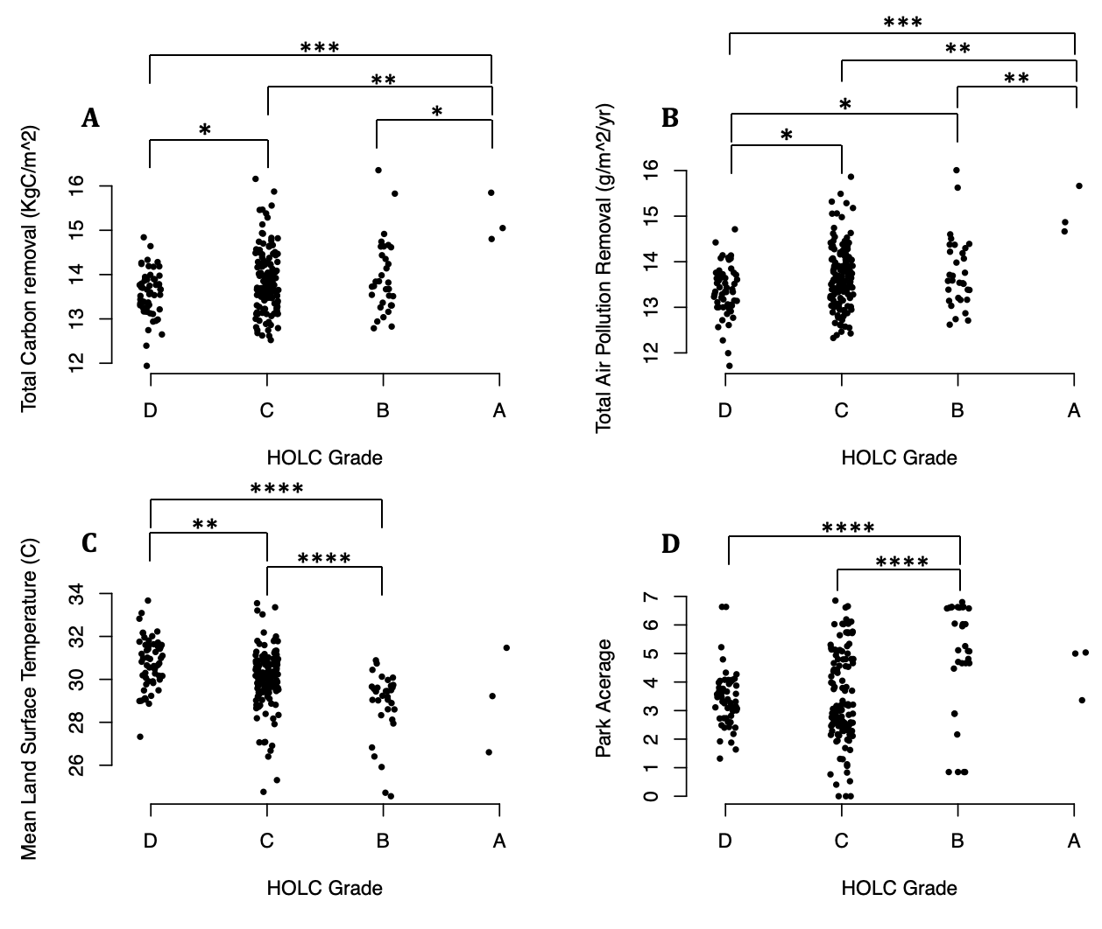
Fig. 5. Statistical comparisons between UES indicator values for each of the four HOLC grades (A-D) from a one-way ANOVA analysis. These graphs show the log transformed values for the supply of each UES indicator and the significant differences in the mean UES supply by HOLC grades as follows: (A) total carbon removal, (B) total air pollution removal, (C) mean land surface temperature, (D) available park acreage. These graphs show that the higher graded a block group is, the higher the supply of UES that block groups has. All the UES values, expect for Mean Land Surface Temperature, were log-transformed. P-values are shown using significance codes: 0.0001 ‘****’, 0.001 ‘***’, 0.01 ‘**’, 0.05 ‘*’, 0.1 ‘●’.

Taking a closer examination at the distribution of LST, our findings are like those found in other studies. In the study by Hoffman et al. (2020), where they examined the impact of HOLC grades on LST across 108 cities, researchers found that redlined neighborhoods were on average 2.6℃ warmer than non-redlined neighborhoods. In their study, one of the cities they examined was Rochester. Their analysis found that “B” graded neighborhoods in Rochester are 2.41℃ cooler than “D” graded neighborhoods, which is 0.49℃ cooler than the difference that we found between “B” and “D” graded block groups in the city. Furthermore, this study also found that the difference in Rochester between the highest graded HOLC neighborhoods (A) and the lowest graded (D) have an average temperature difference of 4.90°C, which was the third highest among the measured cities in the northeast region (Hoffman et al. 2020). However, it should be noted that in the study by Hoffman et al. (2020), they measured LST only within the HOLC boundaries assigned in the 1930s. In our study, we extended the HOLC boundaries to the census block group level. This in turn included more per pixel LST data then there was used by Hoffman et al. (2020).
The UHI effect, which is where urban temperatures are significantly higher than rural temperatures, poses as a major sustainability issue for cities. Studies show that as the rate of impervious surfaces in cities increase, so does daytime and nighttime air temperatures of the city (Armson et al., 2012; Ziter et al., 2019). The consequences of the UHI effect can lead to increased energy usage for cooling buildings, increased thermal stress on residents, increased risk of heatstroke mortality, and the degradation of the living environment (Mohajerani et al., 2017). However, the shading and evapotranspiration abilities of UGS can significantly cool the air temperature of a given area within cities (Armson et al., 2012; Skelhorn et al., 2014). Further investigation into the proportion of the land surface that is impervious within “C” and “D” graded block groups will help to better understand the disparity in LST within Rochester. By targeting impervious surfaces such as abandoned industrial facilities, parking lots, and vacant lots for UGS development in lower HOLC graded neighborhoods, the city can help to alleviate the heat-induced disservices that residents within these neighborhoods experience.

3.4 Social-Ecological Matrix Analysis
For the social-ecological matrix, each block group was placed into one of four classes ﻿by separating the aggregated SES and UES indicator values into high and low classes that indicate the level of social need in conjunction with a combined estimated measure of UES production. Nearly all the H-L (High social need – Low UES value) block groups are in the city center and the neighborhoods directly bordering it (Fig. 6). On the other side of the matrix, all block groups with the L-H (Low social need – High UES value) class were found located around the periphery of the city, with none being found in the downtown area (Fig. 6). Compared to the SES models (Fig. 3), you can see areas designated as L-H are also areas most associated with high values of median income, homeownership percentages, and percentages of White populations.
Examining the results of the hot spot analysis, this model identified block groups within the city that have significantly high and low values of the normalized and summed values of UES supply and social need, and that are spatially close to each other (Fig. 7A & B). I found that clustering of H-L block groups occurred in neighborhoods directly to the north and northwest of downtown Rochester, while L-H block group clusters were only found in the far north of the city (Fig. 7C). By overlaying the results of the hotspot analysis (Fig. 7C) with the HOLC map (Fig. 4), it revealed that 65% of the block groups in the H-L cluster are in “D” graded neighborhoods, and 35% are in “C” graded neighborhoods. Conversely, 80% of block groups found in the L-H clusters are in “B” graded neighborhoods. These findings reiterate the results from the UES and SES indicator models, that the block groups with the lowest HOLC grades also produce the lowest amounts of UES (Fig. 5) and align with areas that have the greatest social need (Fig. 3). Ultimately, these hotspot results highlight block group clusters most in need for UGS development.
Our findings in Fig. 7C indicate that the H-L cluster (High social need – Low UES values) resides in nearly the exact same location as the “Crescent of Poverty”. The base of both the identified H-L cluster and “Crescent of Poverty” straddle the city’s sunken expressway, the Inner Loop, which for decades has separated these neighborhoods from downtown. Recently, other parts of the Inner Loop on the east side have been filled in and local developers have bought this land to construct residential, retail, and office space, which has reconnected neighborhoods on the east side to Rochester’s city center (Schneider, 2016). If H-L clustered blocks were prioritized for UGS development in the city, this would mean targeting the Inner Loop North area. Due to the compactness of the H-L cluster, one way to address the social-ecological issues among these block groups would be to develop multi-block group wide UGS developments, such as street-tree plantings, multi-block parks, and community gardens. Such developments would help to improve the block group’s current low ecological quality while also meeting some of the community’s high levels of social need through improvements to their physical, mental, and social health (Jennings and Gaither, 2015). Lastly, despite the perceived lack of needed investment in L-H block groups (Fig. 6 & 7C), it is still important for them to be considered when identifying areas for UGS development. This is to ensure connectivity for those living in H-L block groups to green spaces located in L-H block groups, as well ensuring access to new UGS developments in H-L block groups for those that don’t live there.

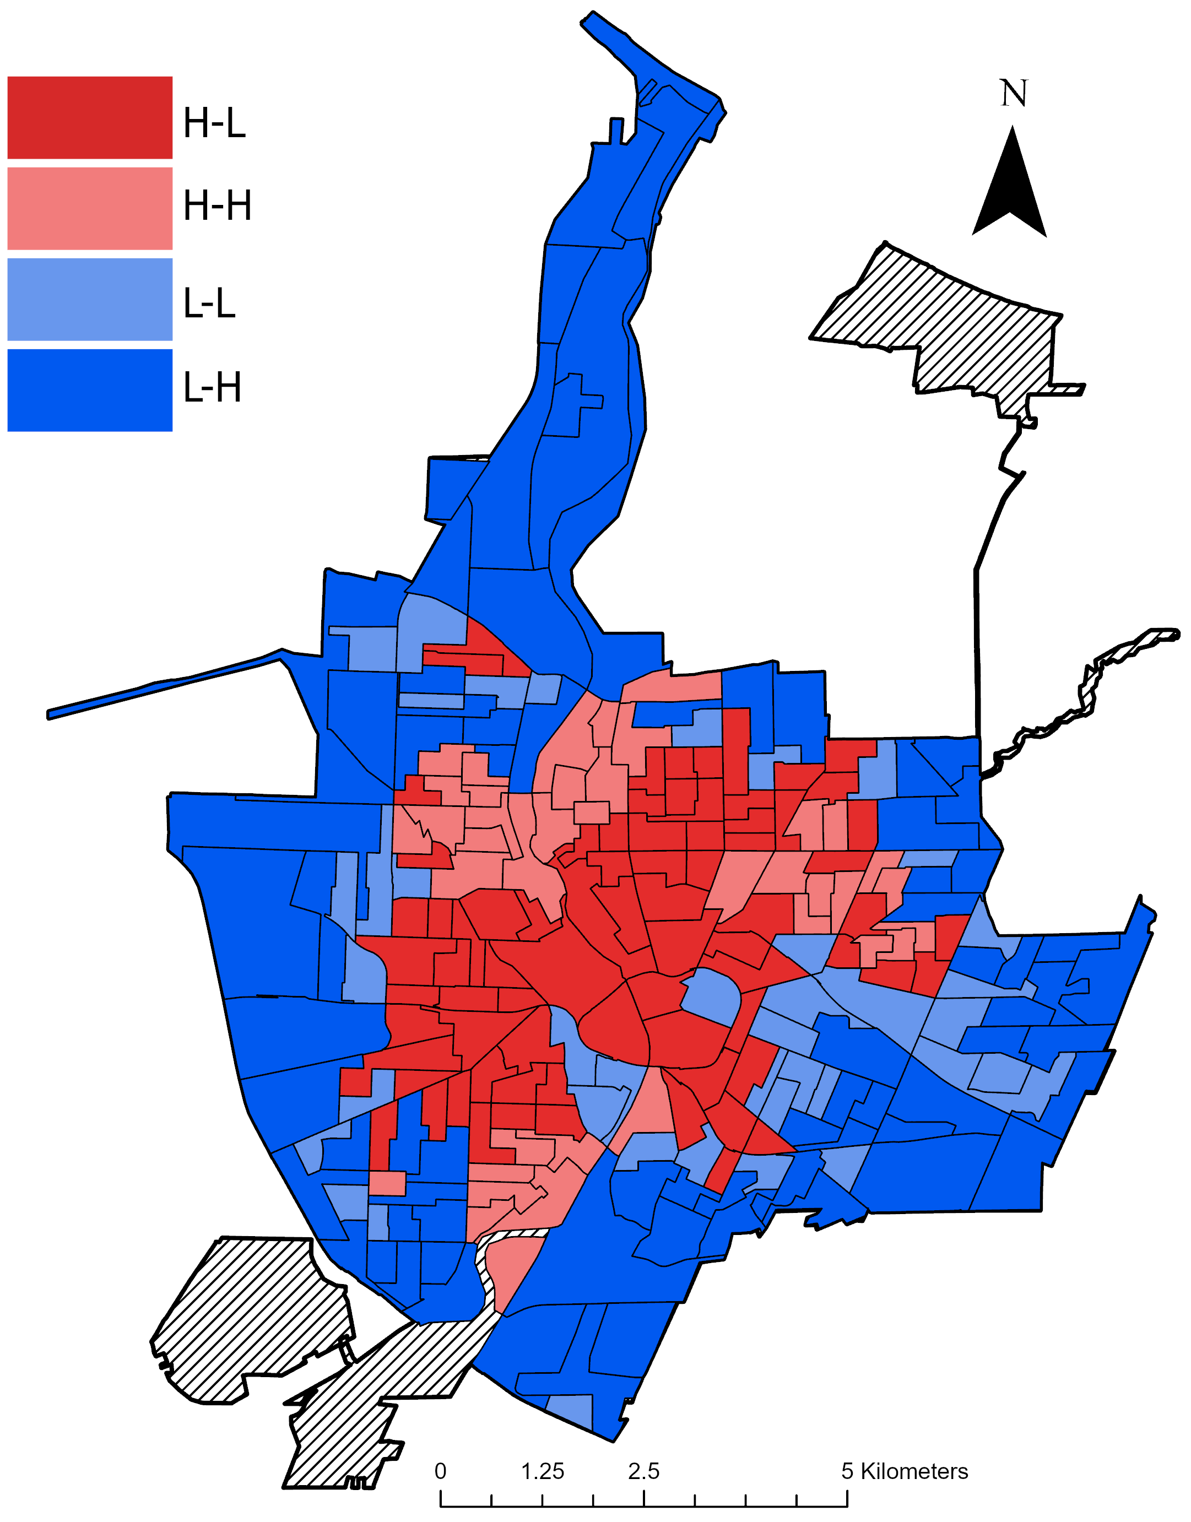

Fig. 6 A social-ecological matrix combining the normalized and summed social need and UES value for each census block group in the city of Rochester, NY: (level of social need - UES supply value). Block group class designations are defined in Table 3. Block groups were assigned to one of the four classes based on whether their normalized and summed SES and UES values were above or below the city’s median values. Overall, Block groups with the highest social need and lowest UES supply (H-L) were located primarily in the center of the city. Conversely, Block grouped with the lowest social need and highest UES supply (L-H) were located only around the periphery of the city.

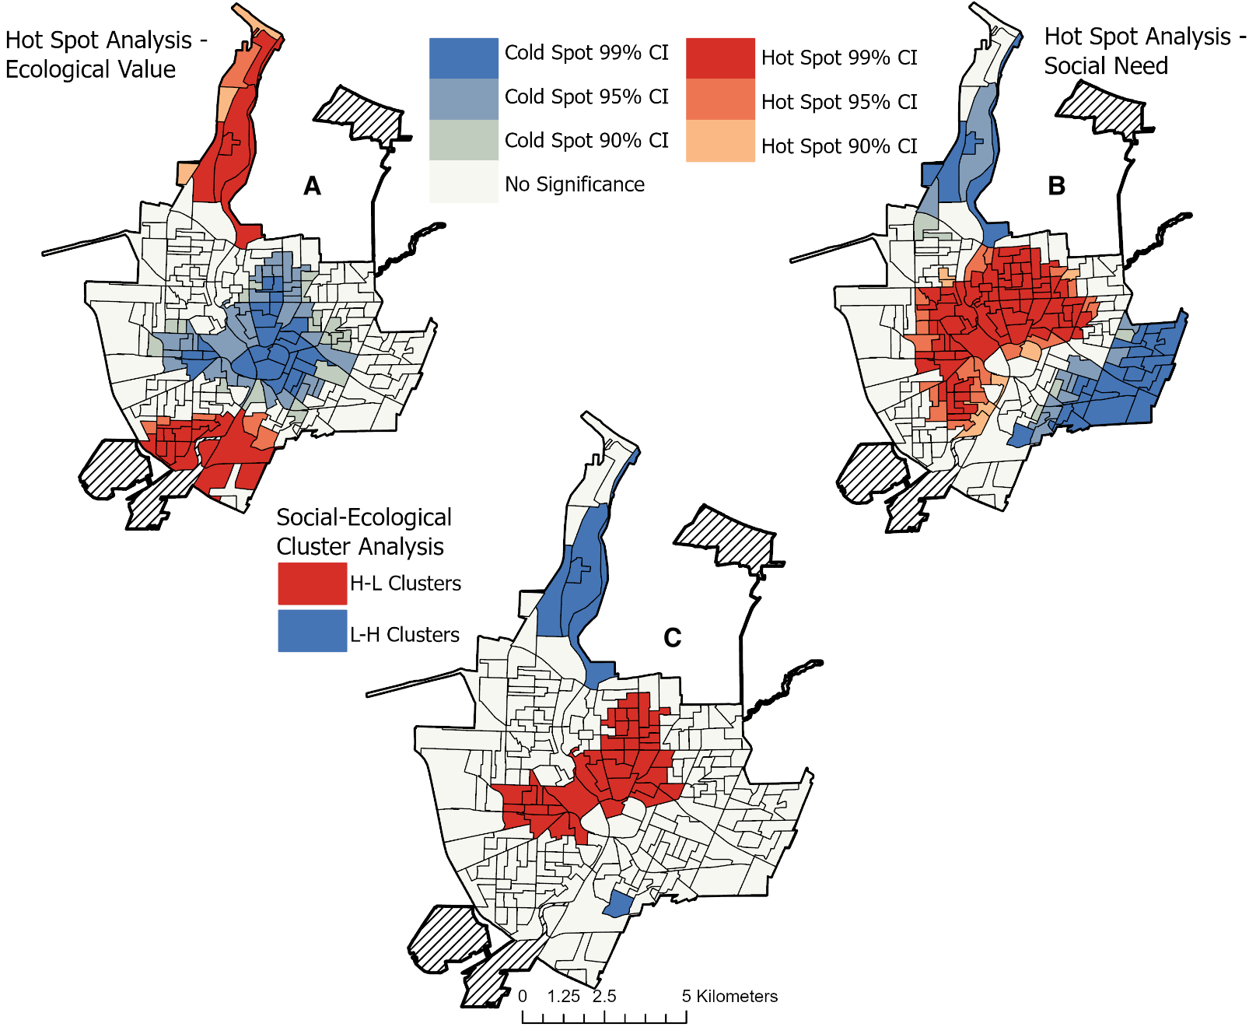
Fig. 7. Hot spot analyses identifying clusters of high (Hot) and low (Cold) values of social need and ecological value. Panel A shows hot and cold spots for the normalized and summed supply of the four UES indicators. Panel B shows hot and cold spots for the normalized and summed SES value. Combined, panel C shows spatially significant clusters of H-L and L-H block groups: (social need-ecological value). Panel A shows that the lowest values of UES are in the city center, and the highest are to the far north and south of the city. Panel B shows the highest values of social need are in the city center while the lowest value is around the northern and eastern peripheries of the city. Panel C shows that a spatially significant cluster of H-L block groups are located directly above the city center.

3.5 Research Limitations
While we did identify correlations between the potential supply of UES and the distribution of SES in Rochester, there were several limitations when obtaining these results. These limitations include a lack of data availability and stakeholder input. To elaborate, the accuracy of the supply of UES is only as good as the accuracy of the landcover data and the UES coefficients used. For the landcover map that we generated to measure the supply of carbon and air pollution removal, we used orthoimagery that was taken by the NYS Digital Ortho-imagery Program in April of 2015. Since this imagery was taken during the early Spring, much of the vegetation within the image was not at peak photosynthetic activity, which meant trees were often leafless and lacked their distinguishable green coloration. This in turn caused confusion to occur between vegetative and impervious surface classes (Appendix Table 2). In one study that compared seasonal variation in landcover mapping, researchers found that classification errors were highest in May, compared to classifications done in June and August (Karila et al., 2019). Due to the lack of green vegetation during the springtime, researchers found the greatest confusion in classifications between trees and buildings; furthermore, they concluded that the optimal time to obtain imagery for landcover classifications is in June (Karila et al., 2019). Additionally, in this study, we did not classify individual trees; areas of land within the city were only classified generally as coarse vegetation. Doing so may have incorrectly estimated the total landcover within the city that is covered by trees. In a study by MacFaden et al. (2012), they devised a method that allowed them to classify individual trees in New York City. Through this method a more accurate determination of a city’s tree inventory and distribution is obtained. By developing a landcover classification map that utilizes imagery taken during peak summertime (June) and can classify individual trees, we would be able calculate a more accurate supply of carbon and air pollution removal performed by vegetation in Rochester.
Another limitation that occurred when calculating the supply of UES in the city was the lack of Rochester-based coefficients. When calculating the rate of carbon and air pollution removal by UGS features such as trees, fine vegetation, and urban soils, we used coefficients from studies that calculated these removal rates from cities like Buffalo and Syracuse, NY, and Chicago, IL. While Buffalo and Syracuse are both New York cities that are close in proximity and size to Rochester, that does not guarantee that they will have similar UGS features and per vegetation UES supply coefficients. Utilizing coefficients that measured the rate of carbon and air pollution by UGS features in Rochester would provide more accurate results on the distribution and supply of UES in the city.
Another limitation related to a lack of data availability concerns the UES supply model for recreation potential. This model shows the greatest disparity in UES supply for all four indicators, as block groups surrounding the Olmsted Park System to the north and south of the city have the greatest recreation potential (Fig. 2D). Conversely, block groups to the east and west, where only smaller parks are located (Fig. 1), have little to no value of recreation potential, despite having high values for the other three UES indicators (Fig. 2A-C). One reason for this may be because of the tightened scope of where we determined residents can experience recreation. When calculating the access residents have to recreational opportunities, we limited it to areas such as parks, playgrounds, and recreation centers, which was based on the available data from the Monroe County GIS Department (2020). However, studies have shown that city residents can also experience recreation and other cultural services in natural vegetated areas such as urban forests and smaller neighborhood scale green spaces such as community gardens (Rall et al., 2018; Calvet-Mir et al., 2012). Failing to account for these areas does not demonstrate the full scope of areas that residents of Rochester have access to for recreational opportunities and other cultural services.
The other limitation for the recreation potential model was that even though some block groups have access to up to 945 acres of parkland, there was no way to determine if those residents actually use all of that parkland. To elaborate, the types of facilities and the quality of the parks that residents have access to may not be suited to the types of recreation or other cultural services that they desire. In a study by Rigolon et al. (2018), researchers assessed the inequity of parks in U.S. cities by using the Trust for Public Land ParkScore, which accounts for park walkability access and park acreage, which were also measured in our study. The ParkScore system also measures the state of facilities in parks (basketball courts, playground equipment, and dog parks) and the amount of money spent on park maintenance. Using this scoring system gave a more comprehensive result of how parks in U.S. cities are inequitable. Therefore, another way to improve the recreation potential model would be to utilize a system like The Trust for Public Land ParkScore while also surveying resident preferences on parks in their neighborhood. By doing so, a model will be able to more holistically capture the inequity and actual use of the parks that residents in Rochester have access to.
Aside from a lack of data availability, the other limitation in this study was the lack of consideration of stakeholder input during the construction the social-ecological matrix. When creating the social-ecological matrix, we weighted each of the UES and SES indicators equally with a value of one (Table 2). This was done for the sake of simplicity and to equally weight all four UES critical to sustainability and human well-being. However, in doing so it didn’t incorporate another equitable ecosystem services provision, stakeholder perspectives.
Environmental justice requires both the equitable distribution of environmental amenities for all residents as well as the equitable involvement of residents (stakeholders) in the decision-making process. Even in the EPA’s definition, they state that environmental justice is “the fair treatment and meaningful involvement of all people regardless of race, color, national origin, or income…” (EPA, 1998). In Jennings et al. (2012), they stated that even though promoting the practice of participatory UGS development can be a difficult and long-term process, it also a key element in promoting environmental justice. This is because active resident involvement will ensure that green spaces that are desired by the community will be the ones that are developed. In one study from Detroit, MI, researchers found through interviews how even though residents were in favor of UGS development in their neighborhood, nearly half of the residents declined offers of new tree plantings by the nonprofit The Greening of Detroit (Carmichael and McDonough, 2019). Responses for why they declined new tree plantings included experiences of past governmental mismanagement of UGS developments and the lack of shared decision-making power in the location and type of trees planted (Carmichael and McDonough, 2019). One way to address stakeholder opinions and improve participation when modeling UES supply is through a weighting mechanism that highlights stakeholder prioritization. Merrow et al. (2017) did this by mapping the supply of six UES in the city of Detroit while also interviewing resident stakeholders. By doing so, researchers were able to weigh the six UES and identify which neighborhoods in the city should be prioritized for UGS development based on stakeholder opinions on the importance of each UES (Meerow et al., 2017). By including stakeholders in the process of identifying areas for UGS development, not only will the location of areas that are most needed be identified, but residents will then be more likely to use them and be more accepting of their development.

4.0 Conclusion

Through our analysis of mapping and modeling the distribution of SES and the supply of UES, we found that the supply of UES in Rochester is correlated with the city’s SES distribution. This study gives insights into the relationships between socioeconomic status and urban ecosystem services, as well as how these relationships relate to the concepts of social equity and environmental justice in urban areas. Our results reveal that the supply of several UES in Rochester are significantly positively correlated with the percentage of homeownership and negatively correlated with the percentage of the population that identifies as Black, at the census block group level. Therefore, this supports our hypotheses that UES in the city are inequitably distributed. Not only did our analyses show that the distribution of UES supply is significantly correlated with modern-day SES indicators, but it also showed that HOLC neighborhood assessments from nearly 100 years ago are also correlated with the supply of UES today. In addition, through the social-ecological matrix, we were able to identify block groups in the city that are in the most need for UGS development. A significant cluster of blocks that were identified as being in the most need for UGS development was located just north of the city center (Fig. 7C), these block groups overlapped with an area of the city commonly known as the “Crescent of Poverty”. The development of UGS has continued to rise as a popular method amongst city planners and officials in the U.S. to address sustainability and human-well-being issues. Studies such as mine illuminate how environmental justice issues can be encountered in the distribution of UGS development and how our results can provide a framework for city planners and nonprofits so that they can reduce the inequities in the distribution of UES supply.

Acknowledgments

JG was funded in part by the RIT’s College of Science and the Steven M. Wear Endowed Graduate Fellowship. Thanks to the city government of Rochester and the Monroe County GIS department for data used in this study. Additional thanks to Dr. Richard Newman for insights and feedback on previous drafts.

References

- Alig, R., Kline, J., Lichtenstein, M. (2004). Urbanization on the US landscape: looking ahead in the 21st century. Landscape and Urban Planning. 69(2-3), 219-234. https://doi.org/10.1016/j.landurbplan.2003.07.004
- Anderson, E., Minor, E. (2017). Vacant lots: an unexplored resource for ecological and social benefits in cities. Urban Forestry and Urban Greening. 21, 146-152. https://doi.org/10.1016/j.ufug.2016.11.015
- Andersson, E., Tengo, M., McPhearson, T., Kremer, P. (2015). Cultural ecosystem services as a gateway for improving urban sustainability. Ecosystem Services. 12, 165-168. https://doi.org/10.1016/j.ecoser.2014.08.002
- Armson, D., Stringer, P., Ennos, A. (2012). The effect of tree shade and grass surface on surface and global temperatures in an urban area. Urban Forestry and Urban Greening. 11(3), 245-255. https://doi.org/10.1016/j.ufug.2012.05.002
- Avdan, U., Jovanovska, G. (2016). Algorithm for automated mapping of land surface temperature using Landsat 8 satellite data. Journal of Sensors. 1-8. https://doi.org/10.1155/2016/1480307
- Black, K., Richards, M. (2020). Eco-gentrification and who benefits from urban green amenities: NYC’s high line. Landscape and Urban Planning. 204. https://doi.org/10.1016/j.landurbplan.2020.103900
- Blaschke, T. (2010). Object based image analysis for remote sensing. ISPRS Journal of Photogrammetry and Remote Sensing. 65(1), 2-16. https://doi.org/10.1016/j.isprsjprs.2009.06.004
- Bogar, S., Beyer, K. (2016). Green space, violence, and crime: a systematic review. Journal of Trauma, Violence, and Abuse. 17(2), 160-171. DOI: 10.1177/1524838015576412
- Boone, C., Buckley, G., Grove, J., & Sister, C. (2009). Parks and people: An environmental justice inquiry in Baltimore, Maryland. Annals of the Association of American Geographers, 99(4), 767–787. https://doi.org/10.1080/00045600903102949
- Boone, C., Fragkias, M. (2012). Connecting environmental justice, sustainability, and vulnerability. Urbanization and Sustainability. In: Boone C., Fragkias M. (eds) Urbanization and Sustainability. Human-Environment Interactions, vol 3. Springer, Dordrecht. https://doi.org/10.1007/978-94-007-5666-3_4
- Brown, D., Johnson, K., Loveland, T., Theobald, D. (2005). Rural land-use trends in the in the conterminous United States, 1950-2000. Ecological Applications, 15(6), 1851-1863. Retrieved from: https://esajournals.onlinelibrary.wiley.com/doi/pdf/10.1890/03-5220
- Bryant, B. (1995). Environmental Justice: Issues, Policies, and Solutions. Washington DC: Island. https://doi.org/10.2458/v3i1.21814
- Buchel, S., Frantzeskaki, N. (2015). Citizens' voice: A case study about perceived ecosystem services by urban park users in Rotterdam, Netherlands. Ecosystem Services, 12, 169-177. https://doi.org/10.1016/j.ecoser.2014.11.014.
- Bullard, R. (1990). Dumping in Dixie: Races, class, and environmental quality. Boulder, CO: Westview. Retrieved from: https://www.jstor.org/stable/24113114?seq=7#metadata_info_tab_contents
- Cadenasso, M., Pickett, S., Schwarz, K. (2007). Spatial heterogeneity in urban ecosystems: reconceptualizing land cover and a framework for classification. Frontiers in Ecology and the Environment. 5(2), 80-88. https://doi.org/10.1890/1540-9295(2007)5[80:SHIUER]2.0.CO;2
- Calvet-Mir, L., Gomez-Baggethun, E., Reyes-Garcia, V. (2012). Beyond food production; ecosystem services provided by home gardens. A case study in Vall Fosca, Catalan Pyrenees, northeastern Spain. Ecological Economics. 74, 153-160. https://doi.org/10.1016/j.ecolecon.2011.12.011
- Carmichael, C., McDonough, M. (2019). Community stories: explaining resistance to street tree-planting programs in Detroit, Michigan. Society and Natural Resources. 32(5), 588-605. ﻿https://doi.org/10.1080/08941920.2018.1550229
- Center for Disease Control and Prevention. (2013). CDC health disparities and inequalities report - United States, 2013. Morbidity and Mortality Weekly Report. 62(3), 1-184. Retrieved from: https://www.cdc.gov/mmwr/pdf/other/su6203.pdf
- Chaparro, L., Terradas, J. (2009). Ecological services of urban forests in Barcelona. Institut Municipal de Parcs i Jardins Ajuntament de Barcelona, Àrea de Medi Ambient. Retrieved from: http://citeseerx.ist.psu.edu/viewdoc/download?doi=10.1.1.364.9799&rep=rep1&type=pdf
- Checker, M. (2011). Wiped out by the "greenwave": Environmental gentrification and the paradoxical politics of urban sustainability. City & Society, 23(2), 210-229. https://doi.org/10.1111/j.1548-744X.2011.01063.x.
- Chiesura, A. (2004). The role of urban parks for the sustainable city. Landscape and Urban Planning. 68(1), 129-138. https://doi.org/10.1016/j.landurbplan.2003.08.003
- City-Data. (2017). Rochester, New York. Retrieved from: http://www.city-data.com/city/Rochester-New-York.html
- City of Rochester. (2014). Neighborhood Data Map. Retrieved from: https://www.cityofrochester.gov/neighborhooddatamap/
- City Roots Community Land Trust., Yale Environmental Protection Clinic. (2020). Confronting racial covenants: how they segregated Monroe County and what to do about them. Retrieved from: https://law.yale.edu/sites/default/files/area/clinic/document/2020.7.31_-_confronting_racial_covenants_-_yale.city_roots_guide.pdf
- Cohen-Cline, H., Turkheimer, E., Duncan, G. (2015). Access to greenspace, physical activity, and mental health: a twin study. Journal of Epidemiology and Community Health. 69(6), 523-529. https://dx.doi.org/10.1136%2Fjech-2014-204667
- Colten, C., Skinner, P. (1996). The road to love canal: Managing industrial waste before the EPA. Austin: The University of Texas Press.
- Coppola, A. (2019). Projects of becoming in a right-sized shrinking city. Urban Geography. 40(2), 237-256. https://doi.org/10.1080/02723638.2017.1421391
- Coutts, C., Horner, M., Chapin, T. (2010). Using GIS to model the effects of green space availability on mortality in Florida. Florida State University Libraries. Retrieved from: https://fsu.digital.flvc.org/islandora/object/fsu%3A207213/datastream/PDF/view
- Dade, M., Mitchell, M., McAlpine, C., Rhodes, J. (2018). Assessing ecosystem service trade-offs and synergies: the need for a more mechanistic approach. Ambio. 48, 1116-1128. https://doi.org/10.1007/s13280-018-1127-7
- Daily, G., Polasky, S., Goldstein, J., Karevia, P., Mooney, H., Pejchar, L., Ricketts, T., Salzman, J., Shallenberger, R. (2009). Ecosystem services in decision making: time to deliver. Frontier in Ecology and the Environment. 7(1), 21-28. https://doi.org/10.1890/080025
- Danford, R., Cheng, C., Strohbach, M., Ryan, R., Nicolson, C., Warren, P. (2014). What does it take to achieve equitable urban canopy distribution? A Boston case study. Cities and the Environment (CATE). 7(1), 1-20. Retrieved from: http://digitalcommons.lmu.edu/cate/vol7/iss1/2.
- DataUSA. (2020). Rochester, NY. Retrieved from: https://datausa.io/profile/geo/rochester-ny/#economy
- De Groot, R., Fisher, B., Christie, M., Aronson, J., Braat L., Gowdy, J., Haines-Young, R., Maltby, E., Neuville, A., Polasky, S., Portela, R., Ring, I. (2010). Integrating the ecological and economic dimensions in biodiversity and ecosystem service valuation.
P. Kumar (Ed.), The Economics of Ecosystems and Biodiversity: Ecological and Economic Foundations, Earthscan, London. Retrieved from: http://www.teebweb.org/wp-content/uploads/2013/04/D0-Chapter-1-Integrating-the-ecological-and-economic-dimensions-in-biodiversity-and-ecosystem-service-valuation.pdf
- Derkzen, M. L., van Teeffelen, A., Verburg, P. (2015). Review: Quantifying urban ecosystem services based on high-resolution data of urban green space: an assessment for Rotterdam, the Netherlands. Journal of Applied Ecology. 52(4), 1020–1032. https://doi.org/10.1111/1365-2664.12469
- De Pinho, C., Fonseca, L., Korting, T., Almeida, C., Kux, H. (2012). Land-cover classification of an intra-urban environment using high resolution images and object-based image analysis. International Journal of Remote Sensing. 33(19), 5973-5995. https://doi.org/10.1080/01431161.2012.675451
- Dickinson, M. (2017). Kodak’s decades of decline. Rochester Business Journal. Retrieved from: https://rbj.net/2017/09/13/kodaks-decades-of-decline/
- DiMento, J. (2009). ﻿Stent (or Dagger?) in the Heart of Town: Urban Freeways in Syracuse, 1944–1967. Journal of Planning History. 8(2), 133-161. ﻿doi: 10.1177/1538513208330768
- Downey, L. (2007). US metropolitan-area variation in environmental inequality outcomes. Urban Studies. 44(5-6), 953-977. https://dx.doi.org/10.1080%2F00420980701256013
- Dutzik, T., Baumann, J., Purvis, M. (2003). Toxic releases and health: a review of pollution data and current knowledge on the health effects of toxic chemicals. United States Public Interest Research Group. Retrieved from: https://www.policyarchive.org/handle/10207/5189
- Elmqvist, T., Setala, H., Handel, SN., van der Ploeg, S., Aronson J., Blignaut, J., Gomez-Baggethun, E., Nowak D., Kronenburg, J., de Groot, R. (2015). Benefits of restoring ecosystem services in urban areas. Current Opinion in Environmental Sustainability. 14, 101-108. https://doi.org/10.1016/j.cosust.2015.05.001
- ESRI. (2020). ArcGIS Pro 2.5. Environmental Systems Research Institute, Redlands, CA, USA.
- Exec. Order No. 12898, 59 Fed. Reg. (February 1994). Retrieved from: https://www.epa.gov/laws-regulations/summary-executive-order-12898-federal-actions-address-environmental-justice
- Felix, M., Louise, W., Rudolf, D. (2011). Ecosystem services at the landscape scale: the need for integrative approaches. Landscape Online. 23, 1-11. https://doi.org/10.3097/LO.201023
- Flocks, J., Escobedo, F., Wade, J., Varela, S., Wald, C. (2011). Environmental Justice Implications of Urban Tree Cover in Miami-Dade County, Florida. Journal of Environmental Justice, 4(2), 125-134. DOI: 10.1089/env.2010.0018.
- Folke, C. (2006). Resilience: the emergence of a perspective for social-ecological systems analysis. Global Environmental Change. 16(3), 253-267. https://doi.org/10.1016/j.gloenvcha.2006.04.002
- Gaston, K., Avila-Jimenez, M., Edmondson, J. (2013). Managing urban ecosystems for goods and services. Journal of Applied Ecology. 50(4), 830-840. http://dx.doi.org/10.1111/1365-2664.12087
- Gerrish, E., Watkins, S. (2018). The relationship between urban forests and income: A meta-analysis. Landscape and Urban Planning, 170, 293-308. https://doi.org/10.1016/j.landurbplan.2017.09.005.
- Godbey, G., Grafe, A., James, W. (1992). The benefits of local recreation and park services. A nationwide study of the of the perceptions of the American public. College of Health and Human development. Pennsylvania State University, Pennsylvania.
- Gómez-Baggethun, E., Barton, D. (2013). Classifying and valuing ecosystem service in urban planning. Ecological Economics. 86, 235-245. https://doi.org/10.1016/j.ecolecon.2012.08.019
- Grier, E., Grier, S. (1958). Negros in five New York cities: a study of problems, achievements, and trends. Retrieved from: https://archive.org/details/negroesinfivenew00newy/page/n3/mode/2up
- Grove, M., Ogden, L., Pickett, S., Boone, C., Buckely, G., Locke, D., Lord, C., Hall, B.
(2018). The Legacy Effect: Understanding How Segregation and Environmental Injustice Unfold over Time in Baltimore. Annals of the American Association of American Geographers. 108(2), 524-537. Retrieved from: https://par.nsf.gov/servlets/purl/10054884
- Haas, J., Ban, Y. (2017). Mapping and monitoring urban ecosystem services using multitemporal high-resolution satellite data. IEEE Journal of Selected Topics in Applied Observations and Remote Sensing. 10(2), 669-680. https://doi.org/10.1109/JSTARS.2016.2586582
- Haase, D., Larondelle, N., Anderson, E., Artmann, M., Borgstrom, S., Breuste, J., Gomez-Baggethun, E., Gren, A., Hamstead, Z., Hansen, R., Kabisch, N., Kremer, P., Langemeyer, J., Rall, E., McPhearson, T., Pauleit, S., Qureshi, S., Schwarz, N., Voigt, A., Wurster, D., Elmqvist, T. (2014). A quantitative review of urban ecosystem service assessments: concepts, models, and implementation. Ambio. 43(4), 413-433. https://doi.org/10.1007/s13280-014-0504-0
- Hackworth, J. (2018). Race and the production of extreme land abandonment in the American Rust Belt. International Journal of Urban and Regional Research. 42(1), 51-73. https://doi.org/10.1111/1468-2427.12588
- Hoffman, J., Shandas, V., Pendleton, N. (2020). The Effects of Historical Housing Policies on Resident Exposure to Intra-Urban Heat: A Study of 108 US Urban Areas. Climate. 8(12), 1-15. http://dx.doi.org/10.3390/cli8010012
- Hostetler, M., Escobedo, F. (2010). What types of urban greenspace are better for carbon dioxide sequestration? University of Florida IFAS Extension. Retrieved from: http://www.fonvca.org/agendas/jul2011/news-clips/UW32400.pdf
- Immergluck, D., Balan, T. (2018). Sustainable for whom? Green urban development, environmental gentrification, and the Atlanta Beltline. Urban Studies Institute. Retrieved from: https://scholarworks.gsu.edu/urban_studies_institute/14.
- Imhoff, M., Zhang, P., Wolfe, R., Bounoua, L. (2010). Remote sensing of urban heat island effect across biomes in the continental USA. Remote Sensing of Environment. 114(3), 504-513, https://doi.org/10.1016/j.rse.2009.10.008.
- IPCC. (2014): Climate Change 2014: Impacts, Adaptation, and Vulnerability. Part A: Global and Sectoral Aspects. Contribution of Working Group II to the Fifth Assessment Report of the Intergovernmental Panel on Climate Change [Field, C.B., V.R. Barros, D.J. Dokken, K.J. Mach, M.D. Mastrandrea, T.E. Bilir,
M. Chatterjee, K.L. Ebi, Y.O. Estrada, R.C. Genova, B. Girma, E.S. Kissel, A.N. Levy, S. MacCracken, P.R. Mastrandrea, and L.L. White (eds.)]. Cambridge University Press, Cambridge, United Kingdom and New York, NY, USA, 1132 pp. Retrieved from: https://www.ipcc.ch/report/ar5/wg2/
- Jennings, V., Gaither, C., Gragg, R. (2012). Promoting environmental justice through urban green space access: a synopsis. Environmental Justice. 5(1), 1-7. DOI: 10.1089/env.2011.0007
- Jennings, V., Gaither, C. (2015). Approaching environmental heal disparities and green spaces: an ecosystem services perspective. International Journal of Environmental Research and Public Health. 12(2), 1952-1968. ﻿doi:10.3390/ijerph120201952
- Jennings, V., Larson, L., Yun, J. (2016). Advancing Sustainability through Urban Green Space: Cultural Ecosystem Services, Equity, and Social Determinants of Health. International Journal of Environmental Research and Public Health, 13(2), 1-15. DOI:10.3390/ijerph13020196
- Jim, C., Chen, W. (2009). Ecosystem services and valuation of urban forests in China. Cities, 26(4), 187-194, https://doi-org.ezproxy.rit.edu/10.1016/j.cities.2009.03.003.
- Jo, H., McPherson, G. (1995). Carbon storage and flux in urban residential greenspace. Journal of Environmental Management, 45, 109-133. Retrieved from: http://citeseerx.ist.psu.edu/viewdoc/download?doi=10.1.1.473.3979&rep=rep1&type=pdf
- Kaplan, R. (1983). The analysis of perception via preference: a strategy for studying how the environment is experienced. Landscape Planning. 12, 161-176. Retrieved from: https://citeseerx.ist.psu.edu/viewdoc/download?doi=10.1.1.977.4859&rep=rep1&type=pdf
- Karila, K., Matikainen, L., Litkey, P., Hyyppa, J., Puttonen, E. (2019). The effect of seasonal variation on automated land cover mapping from multispectral airborne laser scanning data. International Journal of Remote Sensing. 40(9), 3289-3307. https://doi.org/10.1080/01431161.2018.1528023
- Kassambara, A. (2021). Package ‘rstatix’. Retrieved from: https://cran.r-project.org/web/packages/rstatix/rstatix.pdf
- Kerth, R., Vinyard, S. (2012). Wasting our waterways 2012: toxic industrial pollution and the unfulfilled promise from the clean water act. Retrieved from Environment America Research and Policy Center: https://environmentamerica.org/sites/environment/files/reports/Wasting%20Our%20Waterways%20vUS.pdf
- Kremer, P., Hamstead, Z., McPhearson, T. (2016). The value of urban ecosystem services in New York City: A spatially explicit multicriteria analysis of landscape scale valuation scenarios. Environmental Science and Policy. 62, 57–68. https://doi.org/10.1016/j.envsci.2016.04.012
- Lachowycz, K., Jones, A. (2013). Towards a better understanding of the relationship between greenspace and health: Development of a theoretical framework. Landscape and Urban Planning, 118, 62-69. https://doi.org/10.1016/j.landurbplan.2012.10.012.
- Lockwood, B., Berland, A. (2019). Socioeconomic factors associated with increasing street tree density and diversity in central Indianapolis. Cities and the Environment (CATE), 12(1), 1-19. Available at: https://digitalcommons.lmu.edu/cate/vol12/iss1/6
- Luederitz, C., Brink E., Gralla, F., Hermelingmeier, V., Meyer, M., Niven, L., Panzer, L. Partelow, S., Rau, A., Sasaki, R., Abson, D., Lang, D., Wamsler, C., von Wehdren, H. (2015). A review of urban ecosystem services: six key challenges for future research. Ecosystem Services. 14, 98-112. https://doi.org/10.1016/j.ecoser.2015.05.001
- Lynn, K., MacKendrick, K., Donoghue, E. (2011). Social vulnerability and climate change: synthesis of literature (Report No. PNW-GTR-838). Retrieved from the US Department of Agriculture: https://www.fs.fed.us/pnw/pubs/pnw_gtr838.pdf
- MacFaden, S., O'Neil-Dunne, J., Royar, A., Lu, J., Rundle, A. (2012). High-resolution tree canopy mapping of New York City using LIDAR and object-based image analysis. Journal of Applied Remote Sensing. 6(1). http://dx.doi.org/10.1117/1.JRS.6.063567.
- Manisalidis, I., Stavropoulou, E., Stavropoulos, A., Bezirtoglou, E. (2020). Environmental and health impacts of air pollution: a review. Frontiers in Public Health. 8(14). https://doi.org/10.3389/fpubh.2020.00014
- McKelvey, B. (1962). A sesquicentennial review of Rochester’s History. Rochester History. 24(3). Retrieved from: https://www.hillside.com/wp-content/uploads/2015/01/Rochester-History-Vol24.pdf
- McPhearson, T., Kremer, P., Hamstead, Z. (2013). Mapping ecosystem services in New York City: Applying a social-ecological approach in urban vacant land. Ecosystem Services. 5, 11–26. https://doi.org/10.1016/j.ecoser.2013.06.005
- McPhearson, T., Anderson, E., Emlqivst, T., Frantzeskaki. (2015). Resilience of and through urban ecosystem services. Ecosystem Services, 12, 152-156. https://doi.org/10.1016/j.ecoser.2014.07.012
- Meerow, S., Newell, J. ﻿(2017). Spatial planning for multifunctional green infrastructure: Growing resilience in Detroit. Landscape and Urban Planning. 159, 62-75. https://doi.org/10.1016/j.landurbplan.2016.10.005
- Miles, R., Coutts, C., Mohamadi, A. (2012). Neighborhood urban form, social environment, and depression. Journal of Urban Health. 89, 1-18. https://doi.org/10.1007/s11524-011-9621-2
- Millennium Ecosystem Assessment (MA). (2005). Ecosystem and human well-being: health synthesis. Washington D.C.: Island Press. Retrieved from: https://www.millenniumassessment.org/documents/document.357.aspx.pdf
- Miller, S., Montalto, F. (2019). Stakeholder perceptions of ecosystem services provided by green infrastructure in New York City. Ecosystem Services. 37. https://doi.org/10.1016/j.ecoser.2019.100928
- Mitchell, B., Franco, R. (2018). HOLC “redlining” maps: the persistent structure of segregation and economic inequality. Retrieved from: https://ncrc.org/wp-content/uploads/dlm_uploads/2018/02/NCRC-Research-HOLC-10.pdf
- Mohai, P., Pellow, D., Timmons, J. (2009). Environmental Justice. The Annual Review of Environment and Resources, 34, 405-430. https://doi.org/10.1146/annurev-environ-082508-094348
- Mohajerani, A., Bakaric, J., Jeffrey-Bailey, T. (2017). The urban heat island effect, it’s causes, and mitigation, with reference to the thermal properties of asphalt concrete. Journal of Environmental Management. 197, 522-538. https://doi.org/10.1016/j.jenvman.2017.03.095
- Monroe GIS Department. (2020). Parks within the city of Rochester. Retrieved from: https://www.monroecounty.gov/gis
- Murphy, J. (2018). Decade of legal segregation shape Rochester’s city schools today. Democrat & Chronicle. Retrieved from: https://www.democratandchronicle.com/story/local/communities/time-to-educate/stories/2018/06/06/rochester-ny-rcsd-city-schools-history-racial-segregation/642138002/
- Namin, S., Xu, W., Zhou, Y., Beyer, K. (2020). The legacy of the HomeOwners’ Loan Corporation and the political ecology of urban trees and air pollution in the United States. Social Science & Medicine. 246. https://doi.org/10.1016/j.socscimed.2019.112758
- Nebal, V., Brom, J. (2018). Impact of highway construction on land surface energy balance and local climate derived from LANDSAT satellite data. Science of the Tool Environment. 633, 658-667. https://doi.org/10.1016/j.scitotenv.2018.03.220
- Nelson, R., Winling, L., Marciano, R., Connolly, N. (2019). “Mapping Inequality,” American Panorama, ed. Robert K. Nelson and Edward L. Ayers, accessed December 10, 2019. https://dsl.richmond.edu/panorama/redlining/#loc=12/43.189/-77.614&city=rochester-ny.
- Nowak, D., Crane, D. (2002). Carbon storage and sequestration by urban trees in the USA. Environmental Pollution. 116(3), 381-389. https://doi.org/10.1016/S0269-7491(01)00214-7
- Nowak, D., Crane, D., Stevens, J. (2006). Air pollution removal by urban trees and shrubs in the United States. Urban Forestry and Urban Greening. 4(3-4), 115-123. https://doi.org/10.1016/j.ufug.2006.01.007.
- Nowak, D., Greenfield E., Hoehn, R., Lapoint, E. (2013). Carbon storage and sequestration by trees in urban community areas of the United States. Journal of Environmental Pollution. 178, 229-236. https://doi.org/10.1016/j.envpol.2013.03.019
- Nyelele, C., Kroll, C. (2020). The equity of urban forest ecosystem services and benefits in the Bronx, NY. Urban Forestry & Urban Greening. 53. https://doi.org/10.1016/j.ufug.2020.126723
- Pais, J., South, S., Crowder, K. (2008). White flight revisited: a multiethnic perspective on neighborhood out-migration. Population Research and Policy Review. 28, 321-346. https://doi.org/10.1007/s11113-008-9101-x
- Patton, A., Perkins, J., Zamore, W., Levy, J., Brugge, D., Durant, J. (2014). Spatial and temporal differences in traffic-related air pollution in three urban neighborhoods near an interstate highway. Atmospheric Environment. 99, 309-321. https://doi.org/10.1016/j.atmosenv.2014.09.072
- Peters, K., Elands, B., Buijs, A. (2010). Social interactions in urban parks: stimulating social cohesion. Urban Forestry and Urban Greening. 9(2), 93-100. https://doi.org/10.1016/j.ufug.2009.11.003
- Petti, J. (2017). A geospatial analysis of physical and economic consequences of Rochester’s inner loop. Cornell Policy Review. Retrieved from: http://www.cornellpolicyreview.com/a-geospatial-analysis-of-the-physical-and-economic-consequences-of-rochesters-inner-loop/
- Pham, T., Apparicio, P., Seguin, A., Landry S., Gagnon, M. (2012). Spatial distribution of vegetation in Montreal: an uneven distribution of environmental inequity? Landscape and Urban Planning. 107(3), 214-224. https://doi.org/10.1016/j.landurbplan.2012.06.002
- Pickett, S., Grove, J. (2009). Urban ecosystems: what would Tansley do? Urban Ecosystems. 12, 1-8. https://doi.org/10.1007/s11252-008-0079-2
- Pickett, S., Cadenasso, M., Rosi-Marshall, E., Belt, K., Groffman, P., Grove, J., Irwin, E., Kaushal, S., LaDeau, S., Nilon, C., Swan, C., Warren, P. (2017). Dynamic heterogeneity: a framework to promote ecological integration and hypothesis generation in urban systems. Urban Ecosystems. 20(1), 1-14. https://doi.org/10.1007/s11252-016-0574-9
- Pottie-Sherman, Y. (2019). Rust and reinvention: im/migration and urban change in the American Rust Belt. Geography Compass. 14, 1-13. https://doi.org/10.1111/gec3.12482
- Pouyat, R., Yesilonis, I., Nowak, D. (2006). Carbon storage by urban soils in the United States. Journal of Environmental Quality. 35, 1566-1575. doi:10.2134/jeq2005.0215
- Rall, E., Bieling, C., Zytynska, S., Haase, D. (2017). Exploring city-wide patterns of cultural ecosystem service perceptions and use. Ecological Indicators. 77, 80-95. https://doi.org/10.1016/j.ecolind.2017.02.001
- Rigolon, A. (2016). A complex landscape of inequity in access to urban parks: A literature review. Landscape and Urban Planning. 153, 160-169. ﻿http://dx.doi.org/10.1016/j. landurbplan.2016.05.017.
- Rigolon, A., Browning, M., Jennings V. (2018). Inequalities in the quality of urban park systems: an environmental justice investigation of cities in the United States. Landscape and Urban Planning. 178, 156-169. https://doi.org/10.1016/j.landurbplan.2018.05.026
- Riley, C., Gardiner, M. (2020). Examining the distributional equity of urban tree canopy cover and ecosystem services across United States cities. PLoS One. 15(3). https://doi.org/10.1371/journal.pone.0230398
- Rodriguez, J., Beard Jr., T., Bennett, E., Cumming, G., Cork, S., Agard, J., Dobson, A., Peterson, G. (2006). Trade-offs across space, time, and ecosystem services. Ecology and Society. 11(1). Retrieved from: http://www.ecologyandsociety.org/vol11/iss1/art28/
- Roman, L., Conway, T., Eisenman, T., Koeser, A., Barona C., Locke, D., Jenerette, D., Ostberg, J., Vogt, J. (2020). Beyond “trees are good”: disservices, management costs, and tradeoffs in urban forestry. Ambio. 50, 615-630. https://doi.org/10.1007/s13280-020-01396-8
- Rosenburg-Naparsteck, R. (1988). Frankfort: birthplace of Rochester’s industry. Rochester History. 50(3), 1-23. Retrieved from: https://www.libraryweb.org/~rochhist/v50_1988/v50i3.pdf
- Roy, S., Byrne, J., Pickering, C. (2012). A systematic quantitative review of urban tree benefits, costs, and assessment methods across cities in different climatic zones. Urban Forestry and Urban Greening. 11(4), 351-363. https://doi.org/10.1016/j.ufug.2012.06.006
- R Core Team. (2021). R: a language and environmental for statistical computing. R Foundation for Statistical Computing, Vienna, Austria. Retrieved from: https://www.r-project.org
- RStudio Team. (2020). RStudio: integrated development of R. RStudio, PBC, Boston, MA. Retrieved from: http://www.rstudio.com/
- Rwanga, S., Ndambuki, J. (2017). Accuracy assessment of land use/land cover classification using remote sensing and GIS. International Journal of Geoscience. 8, 611-622. https://doi.org/10.4236/ijg.2017.84033
- Sanon, S., Hein, T., Douven, W., Winkler, P. (2012). Quantifying ecosystem service trade-offs: the case for an urban floodplain in Vienna, Austria. Journal of Environmental Management. 111, 159-172. https://doi.org/10.1016/j.jenvman.2012.06.008
- Schnieder, K. (2016). Taking out a highway that hemmed Rochester in. The New York Times. Retrieved from: https://www.nytimes.com/2016/11/02/business/old-highway-paves-road-for-recovery-in-rochester.html?_r=1
- Schwartz, K., Fragias, M., Boone, C., Zhou, W., McHale, M., Grove, J., O'Neil-Dunne, J, McFadden, J., Buckley, G., Childers, D., Ogden, L., Pincetl, S., Pataki, D., Whitmer, A., Cadenasso, M. (2015). Trees grow on money: Urban tree canopy cover and environmental justice. PLoS One. 10(4), 1-17. https://doi.org/10.1371/journal.pone.0122051.
- Shackleton, C., Ruwanza, S., Sinasson Sanni, G., Bennett, S., Lacy, P., Modipa, R., Mtati, N., Sachikonye, M., Thondhlana, G. (2016). Unpacking pandora’s box: understanding and categorizing ecosystem disservices for environmental management and human wellbeing. Ecosystems. 19(4), 587-600. DOI:10.1007/s10021-015-9952-z
- Singh, G., Kogan, M., Van Dyck, P., Siahpush, M. (2008). Racial/Ethnic, Socioeconomic, and Behavioral Determinants of Childhood and Adolescent Obesity in the United States: Analyzing Independent and Joint Associations. Annals of Epidemiology. 18(9), 682-695. https://doi.org/10.1016/j.annepidem.2008.05.001
- Skelhorn, C., Lindley, S., Levermore, G. (2014). ﻿The impact of vegetation types on air and surface temperatures in a temperate city: a fine scale assessment in Manchester, UK. Landscape and Urban Planning. 121, 129–140. https://doi.org/10.1016/j.landurbplan.2013.09.012
- Sleeter, B., Sohl, T., Loveland, T., Auch, R., Acevedo, W., Drummond, M., Sayler, K., Stehman, S. (2013). Land-cover change in the conterminous United States from 1973-2000. Global Environmental Change. 23(4), 733-748. https://doi.org/10.1016/j.gloenvcha.2013.03.006
- Southwest Tribune. (2019). The first black settlers who shaped Rochester’s minority neighborhoods. Retrieved from: https://southwesttribune.com/news/first-black-settlers-shaped-rochesters-minority-neighborhoods/
- Strom, S. (2007). Urban and community forestry: Planning and design. In J. Kuser (Eds.) Urban and community Forestry in the Northeast, 2nd ed. (pp. 99-118). Retrieved from: https://link.springer.com/content/pdf/10.1007/978-1-4020-4289-8_6.pdf
- Svara, J., Brunet, J. (2005). Social equity is a pillar of public administration. Journal of Public Affairs Education. 11(3), 253-258. https://doi.org/10.1080/15236803.2005.12001398
- Tallis, M., Taylor, G., Sinnett, D., Freer-Smith, P. (2011). Estimating the removal of atmospheric particulate pollution by the urban tree canopy of London, under current and future environments. Landscape and Urban Planning. 103(2), 129-138. https://doi.org/10.1016/j.landurbplan.2011.07.003
- The economics of ecosystems and Biodiversity (TEEB). (2010). TEEB manual for cities: ecosystem services in urban management. Geneva. Retrieved from: http://www.teebweb.org/wp-content/uploads/Study%20and%20Reports/Additional%20Reports/Manual%20for%20Cities/TEEB%20Manual%20for%20Cities_English.pdf
- Templeton, D. (2019). ﻿Re-imagining downtown Rochester creation of an equitable urban master plan (Master’s Thesis). Retrieved from: https://search.proquest.com/docview/2236102301?pq-origsite=gscholar&fromopenview=true
- Ulrich, R. (1981). Natural versus urban scenes: some psychophysiological effects. Environment and Behavior. 13(5), 523-556. https://doi.org/10.1177%2F0013916581135001
- United Church of Christ Commission for Racial Justice. (1987). Toxic waste and race in the United States: A national report on the racial and socio-economic characteristics of communities with hazardous waste sites. Public Data Access. New York: United Church of Christ Commission for Racial Justice. Retrieved from: https://www.nrc.gov/docs/ML1310/ML13109A339.pdf
- US Census Bureau. (2018). 2013-2017 American Community Survey 5-Year Estimates. Retrieved from: https://factfinder.census.gov/faces/tableservices/jsf/pages/productview.xhtml?src=bkmk
- United Nations, Department of Economic and Social Affairs, Population Division (2019). World Urbanization Prospects: The 2018 Revision (ST/ESA/SER.A/420). New York: United Nations.
- United States Environmental Protection Agency. (1998). ﻿Final guidance for incorporating environmental justice concerns in EPA’s NEPA compliance analyses. Retrieved from: https://www.epa.gov/sites/production/files/2015-02/documents/ej_guidance_nepa_epa0498.pdf
- United States Environmental Protection Agency. (2014). Case summary: bankruptcy settlements reached with the Eastman Kodak Company worth $49 million. Retrieved from: https://www.epa.gov/enforcement/case-summary-bankruptcy-settlements-reached-eastman-kodak-company-worth-49-million
- United States Environmental Protection Agency. (2021). 2019 TRI Factsheet: City – Rochester, NY. Retrieved from: https://enviro.epa.gov/triexplorer/tri_factsheet.factsheet?pzip=&pstate=NY&pcity=ROCHESTER&pcounty=&pyear=2019&pParent=TRI&pDataSet=TRIQ1
- Walker, G. (2009). Globalizing environmental justice: The geography and politics of frame contextualization and evolution. Journal of Global Social Policy, 9(3), 335-382. DOI:10.1177/1468018109343640
- Watkins, S., Gerrish, E. (2018). The relationship between urban forests and race: A meta-analysis. Journal of Environmental Management, 209(1), 152-168. https://doi.org/10.1016/j.jenvman.2017.12.021.
- Weiss, C., Purciel, M., Bader, M., Quinn, J., Lovasi, G., Neckerman, K., Rundle, A. (2011). Reconsidering access: park facilities and neighborhood disamenities in New York City. ﻿Journal of Urban Health: Bulletin of the New York Academy of Medicine. 8(2), 297-310. ﻿doi:10.1007/s11524-011-9551-z
- West, S., Shores, K., Mudd, L. (2012). Association of available parkland, physical activity, and overweight in America’s largest cities. Journal of Public Health Management and Practice. 18(5), 423-430. doi: 10.1097/PHH.0b013e318238ea27
- Wolch, J., Byrne, J., Newell, J. (2014). Urban green space, public health, and environmental justice: the challenge of making cities “just green enough”. Landscape and Urban Planning. 125, 234-244. https://doi.org/10.1016/j.landurbplan.2014.01.017
- Wolch, J., Wilson, J., Fehrenbach, J. (2005). Parks and park funding in Los Angeles: An equity mapping analysis. Journal of Urban Geography. 26(1), 4-35. This report is available at: http://www.usc.edu/dept/geography/ESPE
- World Population Review. (2020). Rochester, New York Population 2020. Retrieved from: https://worldpopulationreview.com/us-cities/rochester-population/
- World Population Review. (2021_{a}). Syracuse, New York Population 2021. Retrieved from: https://worldpopulationreview.com/us-cities/syracuse-ny-population
- World Population Review (2021_{b}). Buffalo, New York Population 2021. Retrieved from: https://worldpopulationreview.com/us-cities/buffalo-ny-population
- Wu, C., McNeeley, E., Cedeno-Laurent, J., Pan, W., Adamkiewicz, G., Dominici, F., Lung, S., Su, H., Spengler, J. (2014). Linking student performance in Massachusetts elementary schools with the “greenness” of school surroundings using remote sensing. Plos One. 9(10), 1-9. https://doi.org/10.1371/journal.pone.0108548
- Xie, M., Wang, Y., Chang, Q., Fu, M., Ye, M. (2013). Assessment of landscape patterns affecting land surface temperature in different biophysical gradients in Shenzhen, China. Journal of Urban Ecosystems. 16(4), 871-886, https://doi.org/10.1007/s11252-013-0325-0.
- Yang, Y., Diez-Roux, A. (2012). Walking distance by trip purpose and population subgroups. American Journal of Preventative Medicine. 43(1), 11-19. doi: 10.1016/j.amepre.2012.03.015
- Yang, J., Yu, Q., Gong, P. (2008). Quantifying air pollution removal by green roofs in Chicago. Atmospheric Environment. 42(31), 7266-7273, https://doi.org/10.1016/j.atmosenv.2008.07.003.
- Ye, S., Pontius, R. (2018). A review of accuracy assessment for object-based image analysis: From per-pixel to per-polygon approaches. ISPRS Journal of Photogrammetry and Remote Sensing. 141, 137-147. https://doi.org/10.1016/j.isprsjprs.2018.04.002
- Ziter, C., Pederson, E., Kucharik, C., Turner, M. (2019). Scale-dependent interactions between tree canopy cover and impervious surfaces reduce daytime urban heat during summer. PNAS. 116(15), 7575-7580. Retrieved from: https://www.pnas.org/content/pnas/116/15/7575.full.pdf
- Zuk, M., Bierbaum, A., Chapple, K., Gorska, K., Loukaitou-Sideris, A. (2018). Gentrification, displacement, and the role of public investment. Journal of Planning Literature. 33(1). ﻿doi: 10.1177/0885412217716439

Appendices
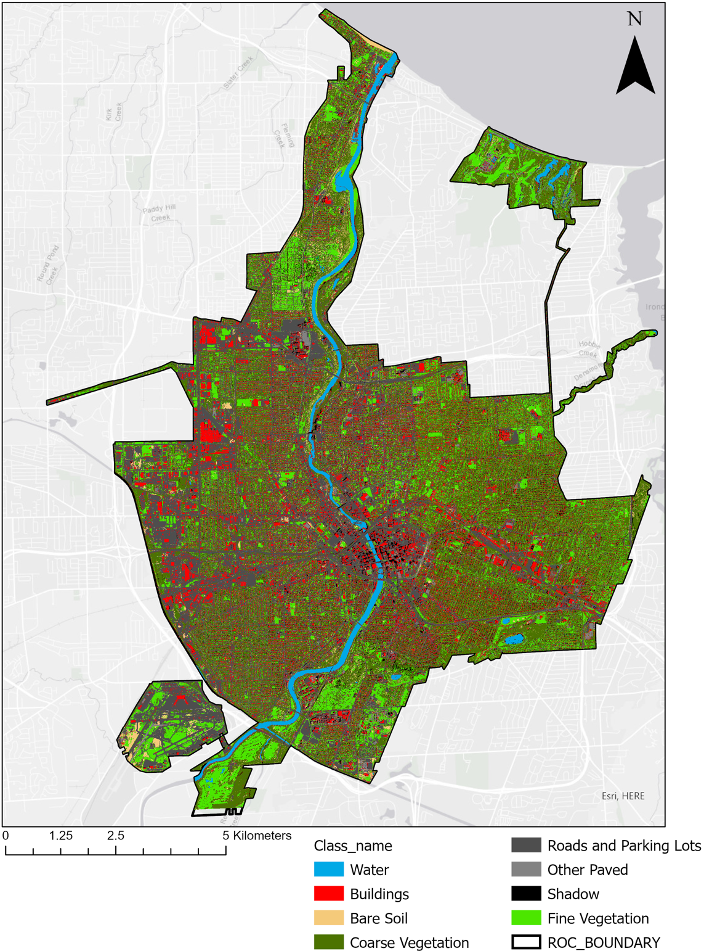
Appendix Figure 1: An LULC map of the entire city of Rochester, NY. This map classifies the surfaces within the city into eight different classes. Most of the surfaces within the center part of the city are impervious while the outer contour of the city has higher percentages of vegetative surfaces.

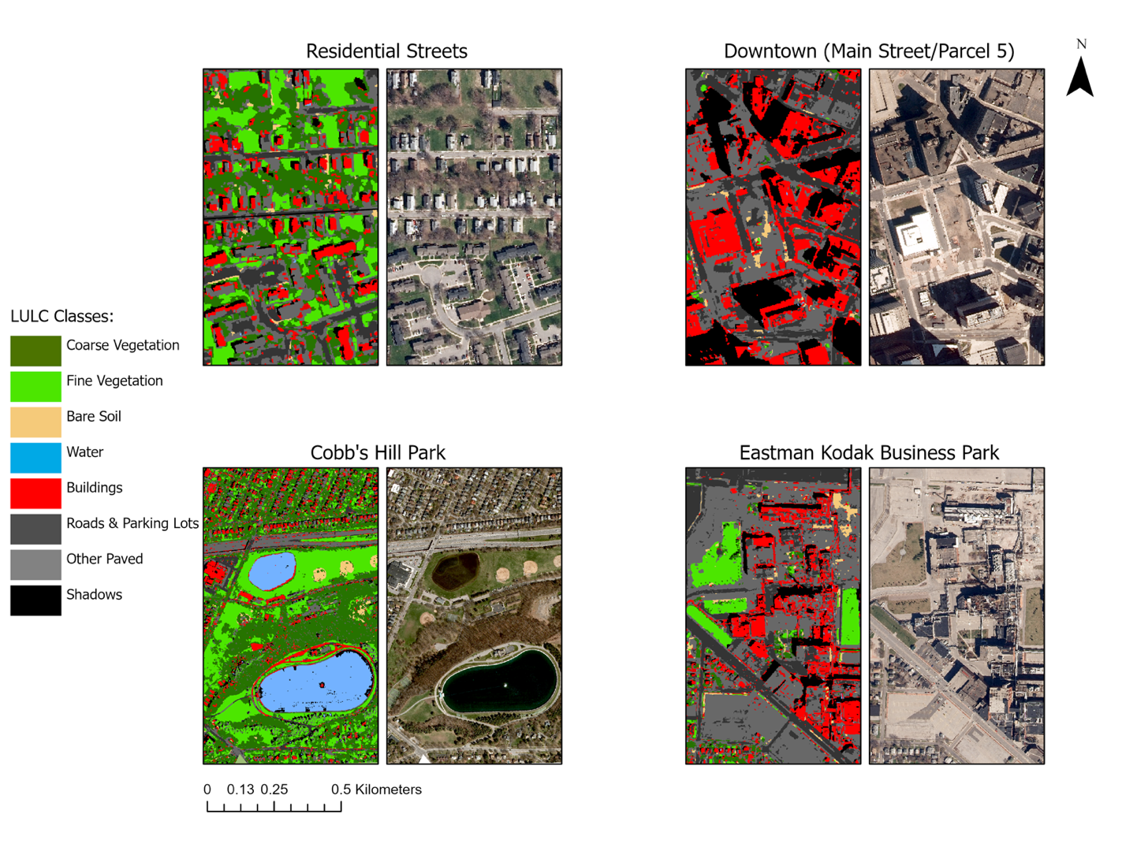
Appendix Figure 2: Comparisons between the LULC map and 2015 orthoimagery for areas of interest within the city. This figure shows the variation of landcover between various areas within the city. Areas such as residential streets and parks have high amounts of vegetative surfaces. While areas such as downtown and industrial parks within the city have greater amounts of impervious surfaces.

Appendix Table 1: Confusion matrix accuracy assessment for the six class LULC map of Rochester, NY. The user’s accuracy demonstrates how often the class on the map will actually be present on the ground, while producer’s accuracy demonstrates how often a real feature on the ground is correctly classified as such. The overall accuracy (OA) states what percentage of the entire map that is correct, while the kappa value states how accurate the classification is compared to a randomly generated one.
 | Water | Bare Soil | Coarse Veg. | Fine Veg. | Impervious Surfaces | Shadow | User’s Accuracy
Water | 45 | 0 | 0 | 0 | 4 | 0 | 92%
Bare Soil | 0 | 20 | 13 | 9 | 13 | 0 | 36%
Coarse Veg. | 0 | 0 | 430 | 47 | 87 | 0 | 77%
Fine Veg. | 0 | 1 | 26 | 268 | 4 | 0 | 90%
Impervious Surfaces | 6 | 10 | 49 | 49 | 838 |  | 88%
Shadow | 4 | 0 | 3 | 0 | 9 | 69 | 81%
Producer’s Accuracy | 82% | 65% | 83% | 72% | 88% | 100% | OA: 83.2%  Kappa: 0.75

