Running head: Quantifying STM to guide restoration

What state of the world are we in? Targeted monitoring to detect transitions in vegetation restoration projects.
Jones, C.S. ^{1,2*}, Thomas, F.M. ^{1,4}, Michael, D.R. ^{5,6}, Fraser, H. ¹, Gould, E. ¹, Wilson, J. ⁷, Vesk, P.A. ^{1,3}, Rumpff, L.^{1, 3*},
¹ School of BioSciences, University of Melbourne
² Arthur Rylah Institute for Environmental Research, Department of Environment, Land, Water and Planning
³ NESP Threatened Species Hub, University of Melbourne
⁴ Centre for Urban Research, RMIT University
⁵ANU Fenner School of Environment & Society, Australian National University
⁶ Institute for Land, Water and Society, Charles Sturt University
⁷ Goulburn Broken Catchment Management Authority
*corresponding author

Abstract
Monitoring vegetation restoration is challenging because ‘best practice’ monitoring is costly, requires long-term funding, and involves monitoring multiple vegetation variables which are often not linked back to learning about progress toward objectives. There is a clear need for the development of targeted monitoring programs that focus on a reduced set of variables that are tied to specific restoration objectives. In this paper, we present a method to progress the development of a targeted monitoring program, using a pre-existing state-and-transition model. We i) use field data to validate an expert-derived classification of woodland condition states; ii) use this data to identify which variable(s) help differentiate woodland condition states; and iii) identify the target threshold (for the variable) that signifies the desired transition has been achieved. The measured vegetation variables from each site in this study were good predictors of the different states of vegetation condition. We show that by measuring only a few of these variables, it is possible to assign the vegetation condition state for a collection of sites, and monitor if and when a transition to another state has occurred. Out of nine vegetation variables considered, the density of immature trees and percentage of exotic understorey vegetation cover were the variables most frequently specified as effective to define a threshold or transition. We synthesise findings by presenting a decision tree that provides practical guidance for the development of targeted monitoring strategies for woodland vegetation.
Key words: state-and-transition model, woodlands, monitoring, restoration, thresholds.

Introduction
The protection and restoration of native vegetation is a key focus of biodiversity management programs, to protect native flora in its own right, and as a source of food and shelter for fauna. Managers have expectations about how the site or landscape will respond over time when they are enacting management. These hypotheses about cause and effect form the basis of a process (or system) model. Whether this process model is explicitly defined or not, it represents a justification for the choice of management applied (Rumpff et al., 2011). In adaptive management, different management strategies are systematically implemented, with a goal to monitor the results and use these to improve knowledge of what, when and where management interventions work best (Nichols and Williams, 2006).
A common problem associated with monitoring the results of vegetation restoration management is that fundamental objectives (if specified) are often difficult to measure (Nichols and Williams, 2006; Parkes et al., 2003; Yoccoz et al., 2001). Defining biologically relevant performance measures that can reliably inform a manager about whether efforts are resulting in the desired outcomes is not an easy task (Di Stefano, 2003; Legg and Nagy, 2006). By definition, vegetation condition is a value judgement defined by a combination of variables, which differentially respond to environmental perturbations and management interventions (McCarthy et al., 2004). As an added complication, ‘vegetation condition’ can reasonably be defined in many ways depending on the biodiversity, production, aesthetic or social values underpinning management (Backstrom et al., 2018; Keith and Gorrod, 2006; Seastedt et al., 2008).
A significant management challenge exists in making generalisations across broad suites of species whilst maintaining an appropriate level of ecological precision and realism (Driscoll and Lindenmayer, 2009; Jeltsch et al., 2008; Whelan et al., 2001). In vegetation management, there are different approaches to measuring and monitoring ‘condition’. One is to monitor multiple variables, and combine these variables into a univariate measure (Parkes et al., 2003), in a particular but potentially arbitrary way. ‘Condition’ then represents a grouping of variables that the manager feels is relevant, but it can result in difficulties in understanding what the measure actually represents, and an unnecessary loss of clarity (McCarthy et al., 2004). It can then be difficult to examine whether investment in management actions has actually resulted in change (McCarthy et al., 2004). Alternatively, one could monitor and report on individual variables because there is recognition that each of these vegetation variables are desirable for different reasons. However, understanding how ‘condition’ responds to management can be overwhelming in this context, particularly if variables are responding differently. The third option is to use individual variables and create a process (or system) model which captures assumptions and can be empirically validated or updated with data (Rumpff et al., 2011).
Models are useful because they can lead to (qualitative or quantitative) predictions, guiding management decisions that go beyond educated guesses (Keddy, 1992; Rumpff et al., 2011). For example, state-and-transition models (STMs) are a relatively common form of process model utilised in vegetation management (Bestelmeyer et al., 2017; Stringham et al., 2007; Westoby et al., 1989). These models provide an explicit platform to formalise and communicate knowledge and beliefs about multiple, distinct states of vegetation in a landscape, with various pathways of change (Bestelmeyer et al., 2017; Westoby et al., 2007). States are defined according to single or multiple vegetation variables. It is easy to understand the broad appeal of STMs as support tools for decision-making. Development of these models in a participatory setting can promote a shared understanding and justification of the decision context, vegetation dynamics, and choice of management interventions (Bestelmeyer et al., 2010). For instance, an explicit model can be used to discuss and define management objectives (e.g., which state are you aiming for?), the management interventions and funds that are required to achieve the specified objective (Bestelmeyer et al. 2017), and to identify where uncertainty exists in the system (Rumpff et al., 2011).
When there is a desire to improve vegetation condition and monitor progress toward objectives, monitoring multiple variables that cannot identify a response to management can lead to an inefficient use of resources (McDonald-Madden et al., 2010; Nichols and Williams, 2006). With STMs, a manager can develop a more targeted monitoring strategy. For instance, they may have defined the starting state and identified a desired state. Managers may then target particular variables of vegetation condition (e.g. weeds) that, without intervention, are impeding a transition to the desired state. Presumably, if a manager has identified the threshold for that vegetation variable that defines the two states, one could monitor progress toward that threshold to know whether the desired change had been achieved at a site. Monitoring data would then simultaneously validate the model and evaluate the effect of the management intervention. Yet choosing what to monitor may not be that simple. There may be some uncertainty around system dynamics, such that the combination of environmental conditions and intervention may result in some unexpected or even perverse transition to a different state. The question then remains, what would one monitor to determine baseline condition and change, given there may be multiple pathways of change?
Given monitoring is expensive, time consuming, and often not linked back to learning about progress toward objectives (Addison et al., 2016; Field et al., 2007; Thomas et al., 2018; Wintle et al., 2010), there is potentially great value in using STMs to model vegetation condition and generating a reduced set of variables to underpin a targeted monitoring strategy. In this paper, we present a method to progress the development of a targeted monitoring program, using STMs. Using a pre-existing state-and-transition model, we i) use field data to validate an expert-derived classification of woodland condition states; ii) use this data to identify which variable(s) help differentiate woodland condition states; and iii) identify the target threshold (for the variable) that signifies that focal transitions have occurred. We discuss the limitations of the approach and provide a guide to the necessary steps for developing a targeted monitoring strategy. The development of state and transition models provides practical approach to explicitly structuring hypotheses about system dynamics that underpin management decisions. We extend this thinking to provide an intuitive and accessible way to work toward a targeted monitoring program.

Methods

The state-and-transition model: Defining the states
This method relies upon the having a pre-defined STM for vegetation condition for the system at hand, and here we build upon an existing model described in Rumpff et al. (2011). The development of STMs to guide management is covered in more detail elsewhere (e.g. see Bestelmeyer et al. 2010; Bestelmeyer et al. 2017), but here we briefly summarise the model used in this study.
The states and transitions that describe the grassy woodland communities of central Victoria were defined by a group of experts, with expertise in woodland ecology and natural resource management. The states included: Reference, Simplified, Oldfield, Thicket, Native Pasture, Exotic Pasture and Derived (Rumpff et al. 2011, see Appendix S1). Experts initially described states qualitatively in terms of their structure and composition, using vegetation variables that are commonly used in condition assessments (Noss 1990; Parkes et al., 2003; Gibbons and Freudenberger 2006; Rumpff et al. 2011). Experts then quantitatively described each state according to the expected range for each vegetation ‘state’ variable (e.g. % weed cover, see Rumpff et al. 2011).

Validating the states: Site identification and assignment of state
We presented the conceptual model and the qualitative and quantitative descriptions (see Appendix S1) of the woodland states from Rumpff et al. (2011) to five land managers in our study area, the Goulburn and Broken River catchments in Victoria, Australia. We asked land managers to identify multiple examples of sites for each state in their landscape. We aimed to have equivalent numbers of sites per vegetation state, even though they were not equally represented within the landscape. In the case of the Reference state, we sought further input from three additional land managers as there are few examples of intact high-quality woodland in this landscape. A total of 85 sites was identified (Appendix S2).
A small team of researchers visited each of the 85 identified sites and each researcher qualitatively assigned the site to a state using state descriptions and photos accompanying the conceptual model. In addition to the assessment from land managers, at least two researchers assessed each site in order to provide a coarse understanding of whether perceptions of vegetation condition states varied between individuals. There was high agreement between the assignment of state to site by the researchers, with 91% of sites classified identically. The greatest uncertainty was in the differentiation of Simplified from Oldfield states (accounting for 50% of ‘uncertain’ site classifications).
We also used data from vegetation condition assessments of 40 sites from the same study area, collected by researchers from the Australian National University (ANU). The ANU sites were assigned states by two individuals involved in the collecting the data, without collaboration. The field researchers were given the same general criteria for differentiating each state as the Victorian managers. The two researchers were in perfect agreement for the 40 ANU sites. This brought the total number of sites to 125, with a minimum of seven sites in the Reference state and maximum of 32 sites in the Simplified state (Appendix S2).

Validating the states: Field collection
Field data were collected for all 125 sites by the two separate groups of researchers between October 2011 and February 2013. Sites spanned a range of states for each group and were surveyed using equivalent survey approaches outlined in Appendix S1. Data were collected for each of the state indicator vegetation variables described in Rumpff et al. (2011) at all sites. Samples were collected in quadrat areas and along line transects in both survey approaches. Given the equivalent ecosystems and data collection methods, we combined the two datasets for analysis. Stem density and species richness data were calibrated so that all relevant variables from both groups had an equivalent spatial scale (Appendix S3).
Transitions between states
Each state was considered by the group of experts to be likely to transition to one or more alternative states, as described in the STM conceptual model (Appendix S1). This was not an exhaustive list of the possible transitions, but rather a list of the transitions commonly observed in the landscape. While all possible transitions could be evaluated, there was little value in investigating very unlikely transitions. The list of transitions and their primary drivers are listed in Table 1.

Table 1. The most likely transitions between states from the conceptual model (from Rumpff et al. 2011), to be tested in this paper.
Initial state | Transition state | Suggested drivers of change (Rumpff et al 2011)
Reference | Exotic Pasture | Major clearing (overstorey and midstorey), fertilization, sowing
 | Native Pasture | Major clearing (overstorey and midstorey)
 | Simplified | Clearing of midstorey or overstorey, grazing by domestic stock
Simplified | Native Pasture | Clearing of midstorey and overstorey, grazing by domestic stock
 | Reference | Active rehabilitation (planting or direct seeding), weed control, native and pest herbivore control, destocking and time.
Oldfield | Native Pasture | Destocking
 | Simplified | Active rehabilitation (planting), time
Native Pasture | Exotic Pasture | Fertilization, sowing
Native Pasture | Thicket | Destocking and ‘good’ rainfall year
Native Pasture | Oldfield | Removal of grazing and fencing
Native Pasture | Derived | Destocking, soil preparation, weed control, active rehabilitation (planting or direct seeding)
Exotic Pasture | Native Pasture | Cease fertilization, time
Exotic Pasture | Thicket | Destocking and ‘good’ rainfall year, or mass direct seeding of eucalyptus species with soil disturbance and a ‘good’ rainfall year.
Thicket | Oldfield | Natural or manual thinning, poor native seedbank
 | Simplified | Manual thinning where native soil seedbank present, and/or active rehabilitation (planting or direct seeding)
Derived | Simplified | Weed control, Active rehabilitation (planting or direct seeding), time.

Data analysis
Data analyses were conducted to directly address three questions relating to the STM: 1) how valid are the expert-derived woodland condition states when tested with field data 2) what are the variables that differentiate states? and 3) what variable(s) and value threshold(s) define a transition from one state to another? The first two questions were addressed using decision tree models, while the third was achieved through logistic regression. All analyses were performed using the statistical software package R version 3.6.0 (R Development Core Team, 2019).
Evaluating the visual classification of states using classification trees
We used classification trees to conduct categorical assignment of sites to individual classes (De’Ath and Fabricius, 2000). These methods are effective for this type of analysis as they make no assumptions about the distribution of variables and are not overly compromised by nonlinear relationships (De’Ath and Fabricius, 2000). We developed an all-site classification tree with the entire dataset of sites and vegetation variables for illustrative purposes only, to see whether the expert-derived STM states are consistent when quantitatively validated with field data in this successive data partitioning process. This model shows the measured vegetation variables that successively partition the entire set of sites into a specified number of groups (states) (Appendix S4). A classification tree model using all sites involves successive partitions that only use a subset of the total sites i.e. does not use all the data relating to each state transition. While there may be benefits to this all-state synthesis, the successive nature of the model with imperfect partitioning means that this approach does not fully discriminate any two particular states. An alternative approach that maximises the use of all data within each state for determining a set of specific monitoring variables is to make separate models for each pair of states that are targeted for monitoring transitions. For this reason, our set of classification trees used subsets of the data to look at each target pair of states that correspond to likely thresholds that discriminate states (Table 2).
In constructing the classification trees, we specified the ‘formula’ as a linear model where the response variable was the assigned state. The predictor variables were the various vegetation state variables measured at each site that reflect the state definitions, their transitions and drivers (Figure 1, Table 1). A stepwise approach termed recursive partitioning was used to sequentially divide splits (branches) until some point of resolution of a group, using the ‘rpart’ statistical package (Therneau and Atkinson, 2019) within R. Within the rpart function, the ‘method’ argument in all cases was set as ‘class’, while the ‘control’ argument was used to specify the number of splits within the tree to reflect the number of possible states in the set. The most useful variables for differentiating between two states can then be identified and ranked using the paired classification trees (De’Ath and Fabricius, 2000). Additionally, this process also indicates how effectively this top ranked variable split the sites (e.g. 10 out of 12 sites were split based on this single variable). This can be used to assess how well the classes mapped on to the pre-defined assignment of state (i.e. the model is not predetermined to split into the different states). However, this only speaks to the top ranked variable and would only be useful if only a single variable was going to be used to monitor state transitions.

Logistic regression: Evaluating thresholds and uncertainty for monitoring
While classification trees can provide a quantitative estimate of the threshold value of a variable that splits two groups, explicitly examining the uncertainty around this threshold was more easily achieved through logistic regression. Logistic regression also does not allow sites to switch states based on the data (as occurs within the classification trees). Exploring uncertainty will inform our confidence that a transition has occurred, because values near the threshold are weak indications of a transition. While all thresholds will be uncertain, some will be more uncertain than others and these will be less reliable indicators of transition. However, it is difficult to determine an ideal or unacceptable level of uncertainty since it depends on the relative suitability of alternative variables and the risk attitude of the manager. For each pair of states (i.e. possible initial to transition states; Table 1) we produced logistic regression models for the three best-performing variables from the classification tree (paired) models and calculated and examined the uncertainty around the threshold.
Logistic regression models were fitted with the ‘glm’ function in R (R Core Team, 2020), with the binomial ‘family’ and logit ‘link’. Models were fitted on transformed data to improve normality; square-root transformations were used for all percentages and a subset of the count data (densities and richness). In general, count data with relatively clear thresholds (little data overlap between states) produced better fitting models with log transformations, while square-root transformations performed better for uncertain thresholds. Once fitted, the ‘predict’ function was used to estimate the value (with 95% confidence interval) of the vegetation variable when the state was exactly 0.5, i.e. halfway between the two state binary values. Predictions with log transformation were made on the link scale to identify the 0.5 threshold and then back-transformed for plotting. This provides a threshold value that discriminates between the two states.

Results
The seven different states identified in the STM varied considerably in measured vegetation variables (Figure 1). Native understorey cover, shrub richness and understorey richness varied substantially within states, but less so between states. Other variables, like stem density, midstorey (shrub) cover and recruitment had greater between-state variation, predominantly due to high values in one of the states (Figure 1). The raw data demonstrates that some states have clearly distinguishing variables (e.g. Thickets are characterised by high stem density, and Derived states by high levels of shrub cover and richness).
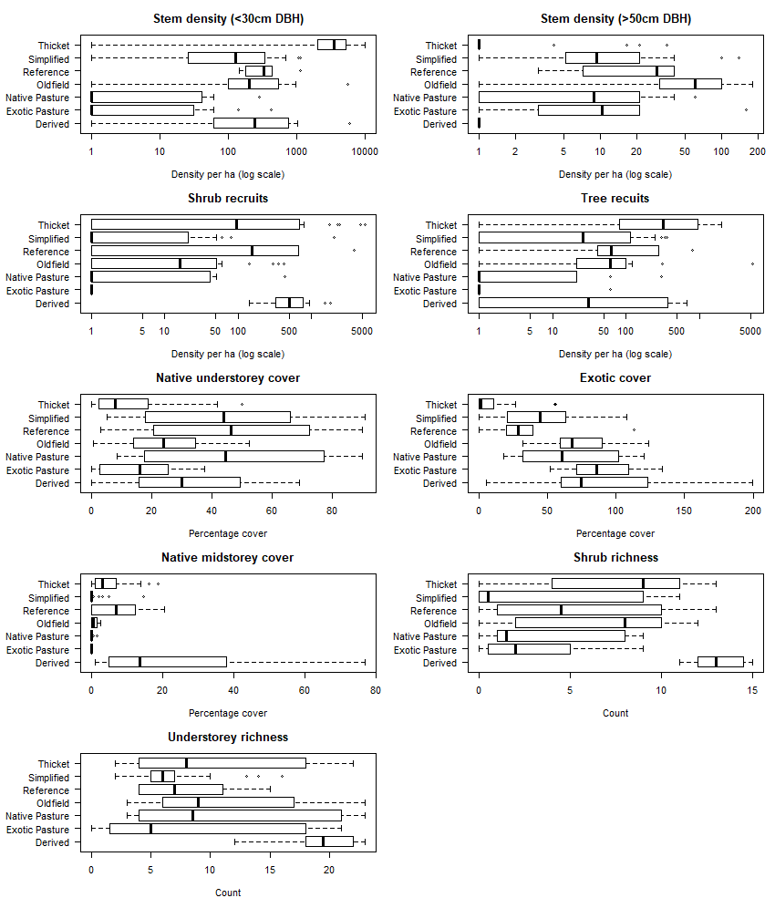

Figure 1. Boxplots representing raw data across both the ANU and UM datasets across each of the vegetation states. Tree and shrub densities are plotted on the log scale to aid visual comparisons, so a constant (1) was added to all values for plotting. Centre lines indicate median values, boxes indicate the interquartile range and whiskers extend to no more than 1.5 times the interquartile range from the box.

Classification trees
The paired classification models were run for all pairs of states with corresponding probable transitions specified in the original STM conceptual model (Appendix S1). These trees display the top ranked variable used to split between two groups, a threshold value indicating the value of the variable that best splits two states as well as an indication of effectiveness of correctly differentiating between states, as exemplified in Figure 2. The ‘Native pasture’ and ‘Exotic pasture’ states have similar stem densities, woody recruits and midstorey cover (Figure 1), but the cover of native understorey vegetation appears to be the most important differentiating variable at a 34% threshold (Figure 2). If native understorey cover alone were to be used to differentiate between these states it would correctly identify 10 out of 14 sites (71% correct) and 6 out of 7 native pasture sites (81% correct). The ‘Oldfield’ and ‘Simplified’ states differ most in their density of mature trees in the paired models with a threshold of 18 stems per hectare. If this variable alone was used to differentiate these two states, then Oldfield sites would be correctly identified 72% of the time and Simplified states 92% of the time (Figure 2).

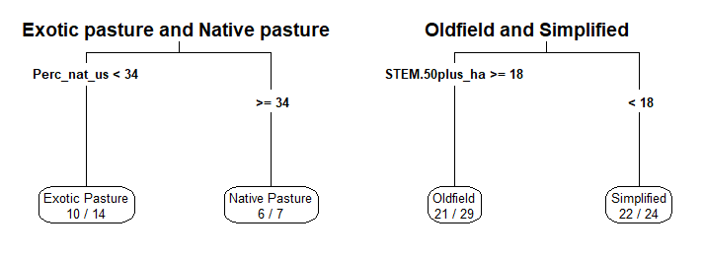 Figure 2. A graphical representation of a classification tree for two states: exotic pasture and native pasture. The tree was generated by hierarchical partitioning of 21 sites using vegetation variables. The percentage cover of native understorey was the best variable to distinguish between the two states, at a threshold of 34% cover. Values within each group refer to the number of sites reflecting the label and the total number of sites in that group.
The three most highly ranked vegetation variables defining the difference between each state-pair is recorded in Table 2. The threshold value for each variable is included in Appendix S5. Of the most highly ranked variables across all state-pairs, the density of immature trees (Stem.to30) was most frequently reported (in 9 out of 13 unique transitions). The percentage cover of exotic understorey was the second most frequently listed (in 7 out of 13 unique transitions) followed by density of tree recruits and native shrub cover (both 5 of 13). Native understorey richness, density of mature trees, density of shrub recruits and the richness of native shrubs generally indicated uncertain transitions and occurred in 3 out of 13 unique transitions. Native understorey cover was the least frequently listed (in 1 out of 13 unique transitions).

Table 2: The top three variables across the full set of classification trees for all unique combinations presented in the expert-derived conceptual model (STM). Transitions are two-way, i.e., Reference to Simplified is equivalent to Simplified to Reference, so duplications are not repeated in the table.
 |  | Model rank of variables for each state pair
From | To | 1 | 2 | 3
Reference | Exotic Pasture | Density of immature trees (Stem.to30) | Exotic understorey cover (Perc_ex_us) | Density tree recruits (REGEN_T_ha)
Reference | Native Pasture | Density of immature trees (Stem.to30) | Density tree recruits (REGEN_T_ha) | Native shrub cover (Perc_nat_shrub)
Reference | Simplified | Native shrub cover (Perc_nat_shrub) | Density shrub recruits (REGEN_SH_ha) | Density of immature trees (Stem.to30)
Simplified | Native Pasture | Density of immature trees (Stem.to30) | Native understorey richness (RICH_natund) | Density tree recruits (REGEN_T_ha)
Simplified | Reference | As in Reference to Simplified
Oldfield | Native Pasture | Density of immature trees (Stem.to30) | Density tree recruits (REGEN_T_ha) | Density of mature trees (STEM.50plus_ha)
Oldfield | Simplified | Density of mature trees (STEM.50plus_ha) | Exotic understorey cover (Perc_ex_us) | Native shrub richness (RICH_natmid)
Native Pasture | Exotic Pasture | Native understorey cover (Perc_nat_us) | Exotic understorey cover (Perc_ex_us) | Native understorey cover (RICH_natund)
Native Pasture | Thicket | Density of immature trees (Stem.to30) | Density tree recruits (REGEN_T_ha) | Exotic understorey cover (Perc_ex_us)
Native Pasture | Derived | Native shrub richness (RICH_natmid) | Native shrub cover (Perc_nat_shrub) | Density shrub recruits (REGEN_SH_ha)
Native Pasture | Oldfield | As in Oldfield to Native Pasture
Exotic Pasture | Native Pasture | As in Native Pasture to Exotic Pasture
Exotic Pasture | Thicket | Exotic understorey cover (Perc_ex_us) | Density of immature trees (Stem.to30) | Native shrub cover (Perc_nat_shrub)
Thicket | Oldfield | Exotic understorey cover (Perc_ex_us) | Density of immature trees (Stem.to30) | Density of mature trees (STEM.50plus_ha)
Thicket | Simplified | Density of immature trees (Stem.to30) | Native shrub cover (Perc_nat_shrub) | Exotic understorey cover (Perc_ex_us)
Derived | Simplified | Density shrub recruits (REGEN_SH_ha) | Native shrub richness (RICH_natmid) | Native understorey richness (RICH_natund)

Logistic regression
The top three ranked variables determined by the classification trees for each pair of states were modelled using logistic regression via a generalised linear model with a binary variable for states to calculate a threshold value, and the uncertainty (95% CI intervals) around the threshold. Three common vegetation states and their likely transitions are shown in Figure 3. These transitions represent moving in a perceived negative direction (due to a decline in condition) from a ‘Reference’ state to a ‘Simplified’ state (Cunningham et al., 2008), a positive direction moving from a ‘Derived’ state to a ‘Simplified’ state and a potentially problematic transition from ‘Native Pasture’ to ‘Thicket’ (Jones et al., 2015). The Reference to Simplified transition is uncertain and relatively inaccurate, due to the small and inconsistent differences between vegetation variables within these states. Detecting this transition is therefore likely to be difficult and require accurate data from multiple variables. In contrast, the Derived and Simplified states have clearly different data distributions of multiple vegetation variables, and therefore precise and more certain thresholds. This would be a much simpler and more reliable transition to detect. The Native Pasture and Thicket states have moderate transitions with high uncertainty at low tree densities but high certainty at high densities. Once states are clearly defined with specific ranges of vegetation variables, a manager could use these results to monitor specific site changes and get an early indication of likely or problematic transitions. The full results for each pair of states is presented in Appendix S5.
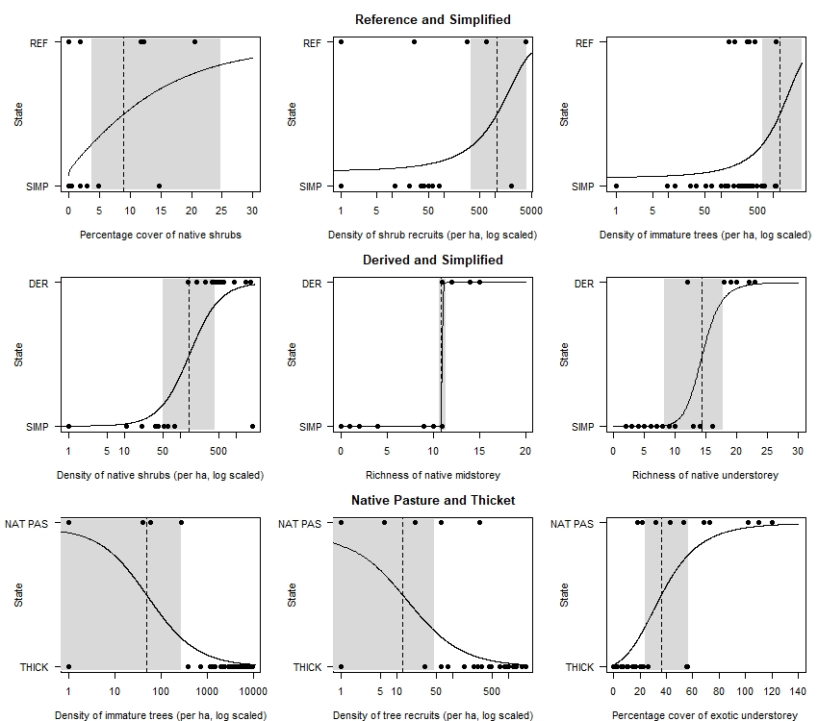

Figure 3. An example of three transitions that occur in our study region. Each transition shows the top 3 ranked vegetation variables (identified by the classification tree analysis) that would be most useful for monitoring these transitions. Solid black lines are the likelihood of a site being in one of two states given the value of a vegetation variable. Black circles indicate measured values at a site (one circle per site). The dashed black line occurs at the 0.5 probability and shaded areas represent 95% CI or uncertainty around threshold values. Densities of trees and shrubs have been log scaled for clarity, so a constant (1) was added to all values for plotting.

Examples of thresholds with low and high uncertainty are shown in Figure 4. The width of the confidence interval and the percentage deviance explained of the logistic regression (Appendix S5) are effective indicators of uncertainty around a threshold. For example, for a transition between ‘Thicket’ and ‘Oldfield’ states, the variable exotic understorey cover may be a useful monitoring variable on its own (Figure 4), as the width of the confidence interval around the threshold (37.8% cover) is narrow relative to the range of values and overlapping data distributions (26.9% – 47.7%, 79% Dev. Exp., p = 0.0024). In comparison, for a transition between ‘Reference’ and ‘Simplified’ states the percentage cover of native shrubs is unlikely to be a useful monitoring variable on its own as the width of the confidence interval around the threshold (9%) is wide (3.6% – 24.7%, 23% Dev. Exp., p = 0.012) (Figure 4).
It is more likely a change in state will be detected when monitoring variables with more certain thresholds, while monitoring very large changes may still be insufficient to conclude a state change when the thresholds are uncertain. For example, monitoring a change in exotic understorey cover of 30% at a hypothetical site is enough to be confident of a transition between Oldfield and Thicket (Figure 4). In contrast, when monitoring the cover of native shrubs at a Simplified state, one is unlikely to be confident in detecting a transition to a Reference site even if the magnitude of the change is 13% (over 10 times the initial estimate; Figure 4).
In only one case there was no overlap between the values of a variable between two different states, i.e. the data could be split perfectly into two separate groups (Appendix S5). In two other cases, the data did not overlap apart from one equal value. These include transitions between: ‘Native Pasture’ and ‘Derived’ (with native shrub richness), ‘Exotic Pasture’ to ‘Thicket’ (with % cover native shrubs) and ‘Derived’ to ‘Simplified’ (with native shrub richness, Figure 3) respectively. These represent the best-case scenario for the use of a variable to define a transition.
Despite being listed as the most frequently important indicator of a transition, immature stem densities typically had uncertain threshold values and would therefore not always be the most practical indicators on their own. Densities of larger trees and the percentage of exotic understorey cover typically had more certain thresholds, which is reflective of the greater variation in values for these variables across the sites in each state measured (Appendix S5).
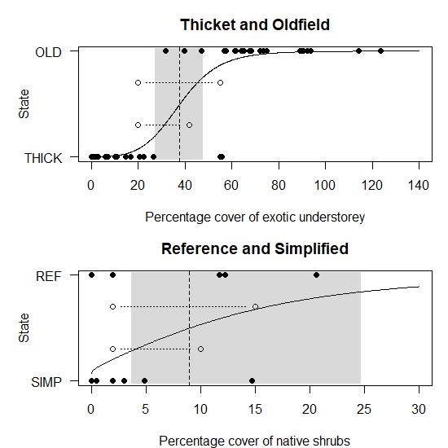
Figure 4. A linear model prediction (solid black line) of the likelihood of a site being in one of two states given the value of a vegetation variable. Black circles indicate measured values at a site (one circle per site). The dashed black line occurs at the 0.5 probability, i.e. the threshold of likelihood between states, with the grey area showing the 95% confidence interval of this prediction. The open circles and dotted lines indicate changes in value at a hypothetical site, representing examples of clear (Thicket and Oldfield) and less certain (Reference and Simplified) transitions based on these vegetation variables and different levels of certainty of threshold values.

Discussion
This study provides good justification for, and demonstrates the development of, targeted monitoring strategies for woodland vegetation. Landscape scale decision making is a focus in some ecosystems (Bestelmeyer et al., 2011; Steele et al., 2012) and STMs are useful in capturing complex ecological dynamics (Rumpff et al. 2011). However, having measurable targets and monitoring to detect a specific directional change at the site-level is often a requirement of useful monitoring programs (Nichols and Williams, 2006). The measured vegetation variables from each woodland site in this study were good predictors of the different states of vegetation condition as previously defined by experts (Rumpff et al. 2011). We demonstrate an effective approach to quantifying transition thresholds and their uncertainty. Importantly, we have shown that by measuring only a few of these variables, it is possible to assign a collection of sites into a state of vegetation condition, and to monitor if and when a transition to another state has occurred.
Of the nine vegetation variables measured across all sites, the density of immature trees and percentage of exotic understorey vegetation cover were the most reliable variables to define a threshold or transition between two woodland states. Although the percentage cover of native vegetation is a frequently monitored vegetation variable in Australia (Parkes et al. 2003), it was the least commonly listed as an important variable to define transitions in these woodlands. Likewise, species richness is a commonly recorded variable but was a relatively uncertain indicator of transition in this ecosystem, given the objective of differentiating between vegetation states. However, these variables may be important conservation attributes for other management objectives.
The paired classification approach displays the highest ranked variable for differentiating between sites as well as other useful variables. For any monitoring strategy we would advocate for monitoring at least two of the ranked variables, and this is for several reasons. First, in few cases could a single variable distinguish between states perfectly, nor would we expect this to be the case given the complex nature of ecological systems. Secondly, the vegetation variables can be measured in different ways that might be more or less prone to measurement error. For example, a threshold for native shrub cover may have narrow confidence intervals (e.g. 2% CI width in Thicket to Simplified) but if visual assessment of cover is being used to monitor this variable, measurement error may be larger than this (McCarthy et al., 2004). A narrow confidence interval around the richness of native shrub species (e.g. a one species difference in Derived to Simplified) may be less prone to measurement error, depending on detectability (Kéry and Schmidt, 2008). Third, attention needs to be given to the timeframe over which change is monitored. Reporting achievement of a transition may be best demonstrated with a more dynamic variable (i.e. percent exotic understorey cover compared to development of mature trees), but this depends on the timeframe of the monitoring given the objectives of the monitoring program. Last, this analysis has only been carried out using two data sets, and whilst those involved in this study could visually assign states to vegetation relatively reliably, the modest set of validation data may lead to potential misclassification errors. In all cases, erring on the side of caution with the choice of variable(s) is wise. A practical next step would be to test how applicable the identified vegetation variables are in signifying transitions across a range of similar vegetation types in Australia.
How to identify targeted monitoring variables, using the state-and-transition model approach?
The decision tree in Box 1 is intended to aid in developing a targeted monitoring strategy at a site level, using the process outlined in this paper. We assume the process of developing the state-and-transition model, data collection and analysis (as per this paper) is complete (for guidance see Bestelmeyer et al. 2017; Rumpff et al. 2011). The first stage in developing a monitoring strategy based on the state-and-transition model is to determine the objectives for management (Field et al., 2007). This may relate to the landscape level, and/or at the level of a site. At a landscape level, managers first need to identify the objectives for the landscape (i.e. how much of landscape should be in state X vs Y, by time Z?). This decision depends on the area and distribution of states in the landscape, and what resources are available. Then, at a site level, the objective relates to what state is desired, over what time frame.
In the decision tree (Box 1) the diamond shapes indicate questions that should be asked at each site, whilst the rectangular shapes indicate the subsequent processes required to develop the monitoring strategy. Important decision triggers include whether you have, or can identify, the starting state at a site. We recommend that more than one person assesses the starting state, as uncertainty and variation between observers can have implications for which monitoring variables are used to assess condition and change over time.
The next important decision trigger is determining how much uncertainty is tolerable in the selection of monitoring variables. This requires you to examine the uncertainty around the threshold for each monitoring variable. We have demonstrated a threshold point at which the model is most uncertain about state (i.e. a 50/50 chance of being in either state) but this threshold definition might not always be the most appropriate decision threshold. Instead, the user may wish to specify a different tolerance to uncertainty (Box 1). We recognise this is an important consideration (Rumpff et al., 2012), but is out of scope for this paper.
Even if the bounds of uncertainty are adequate, it may be prudent to monitor more than one variable to be more certain of a transition (if it occurs), or if you want to include a short-term monitoring variable (e.g. recruitment) in addition to a longer -term variable (e.g. tree density) in your strategy. Alternatively, if you are monitoring a variable and find the site in the bounds of uncertainty (i.e. the 95% CI), you might want to consider monitoring another variable if you need greater certainty about the assignment of state (Appendix S5). Of course, other variables may be collected for other purposes at the same time, but here we are focusing on the minimum number of variables to measure to reliably detect state transitions.
The next decision point requires you to reconsider how confident you want to be that a transition has occurred, or is occurring. That will influence the sampling design as greater confidence requires greater sample size, or reduced variability, or both. Typically, sample size is what one manipulates, as natural variability is less controllable, except by sampling methods of greater or lesser precision. This depends on your sampling budget and how it needs to be allocated over space and time. Last, when the desired state is reached (or maintained), a manager has to decide whether to set a new objective, and how much monitoring is required to detect whether the desired state is maintained. We use a feedback loop to indicate when a decision needs to be made, rather than to imply a site is monitored in perpetuity.
Box 1. How to identify targeted monitoring variables?
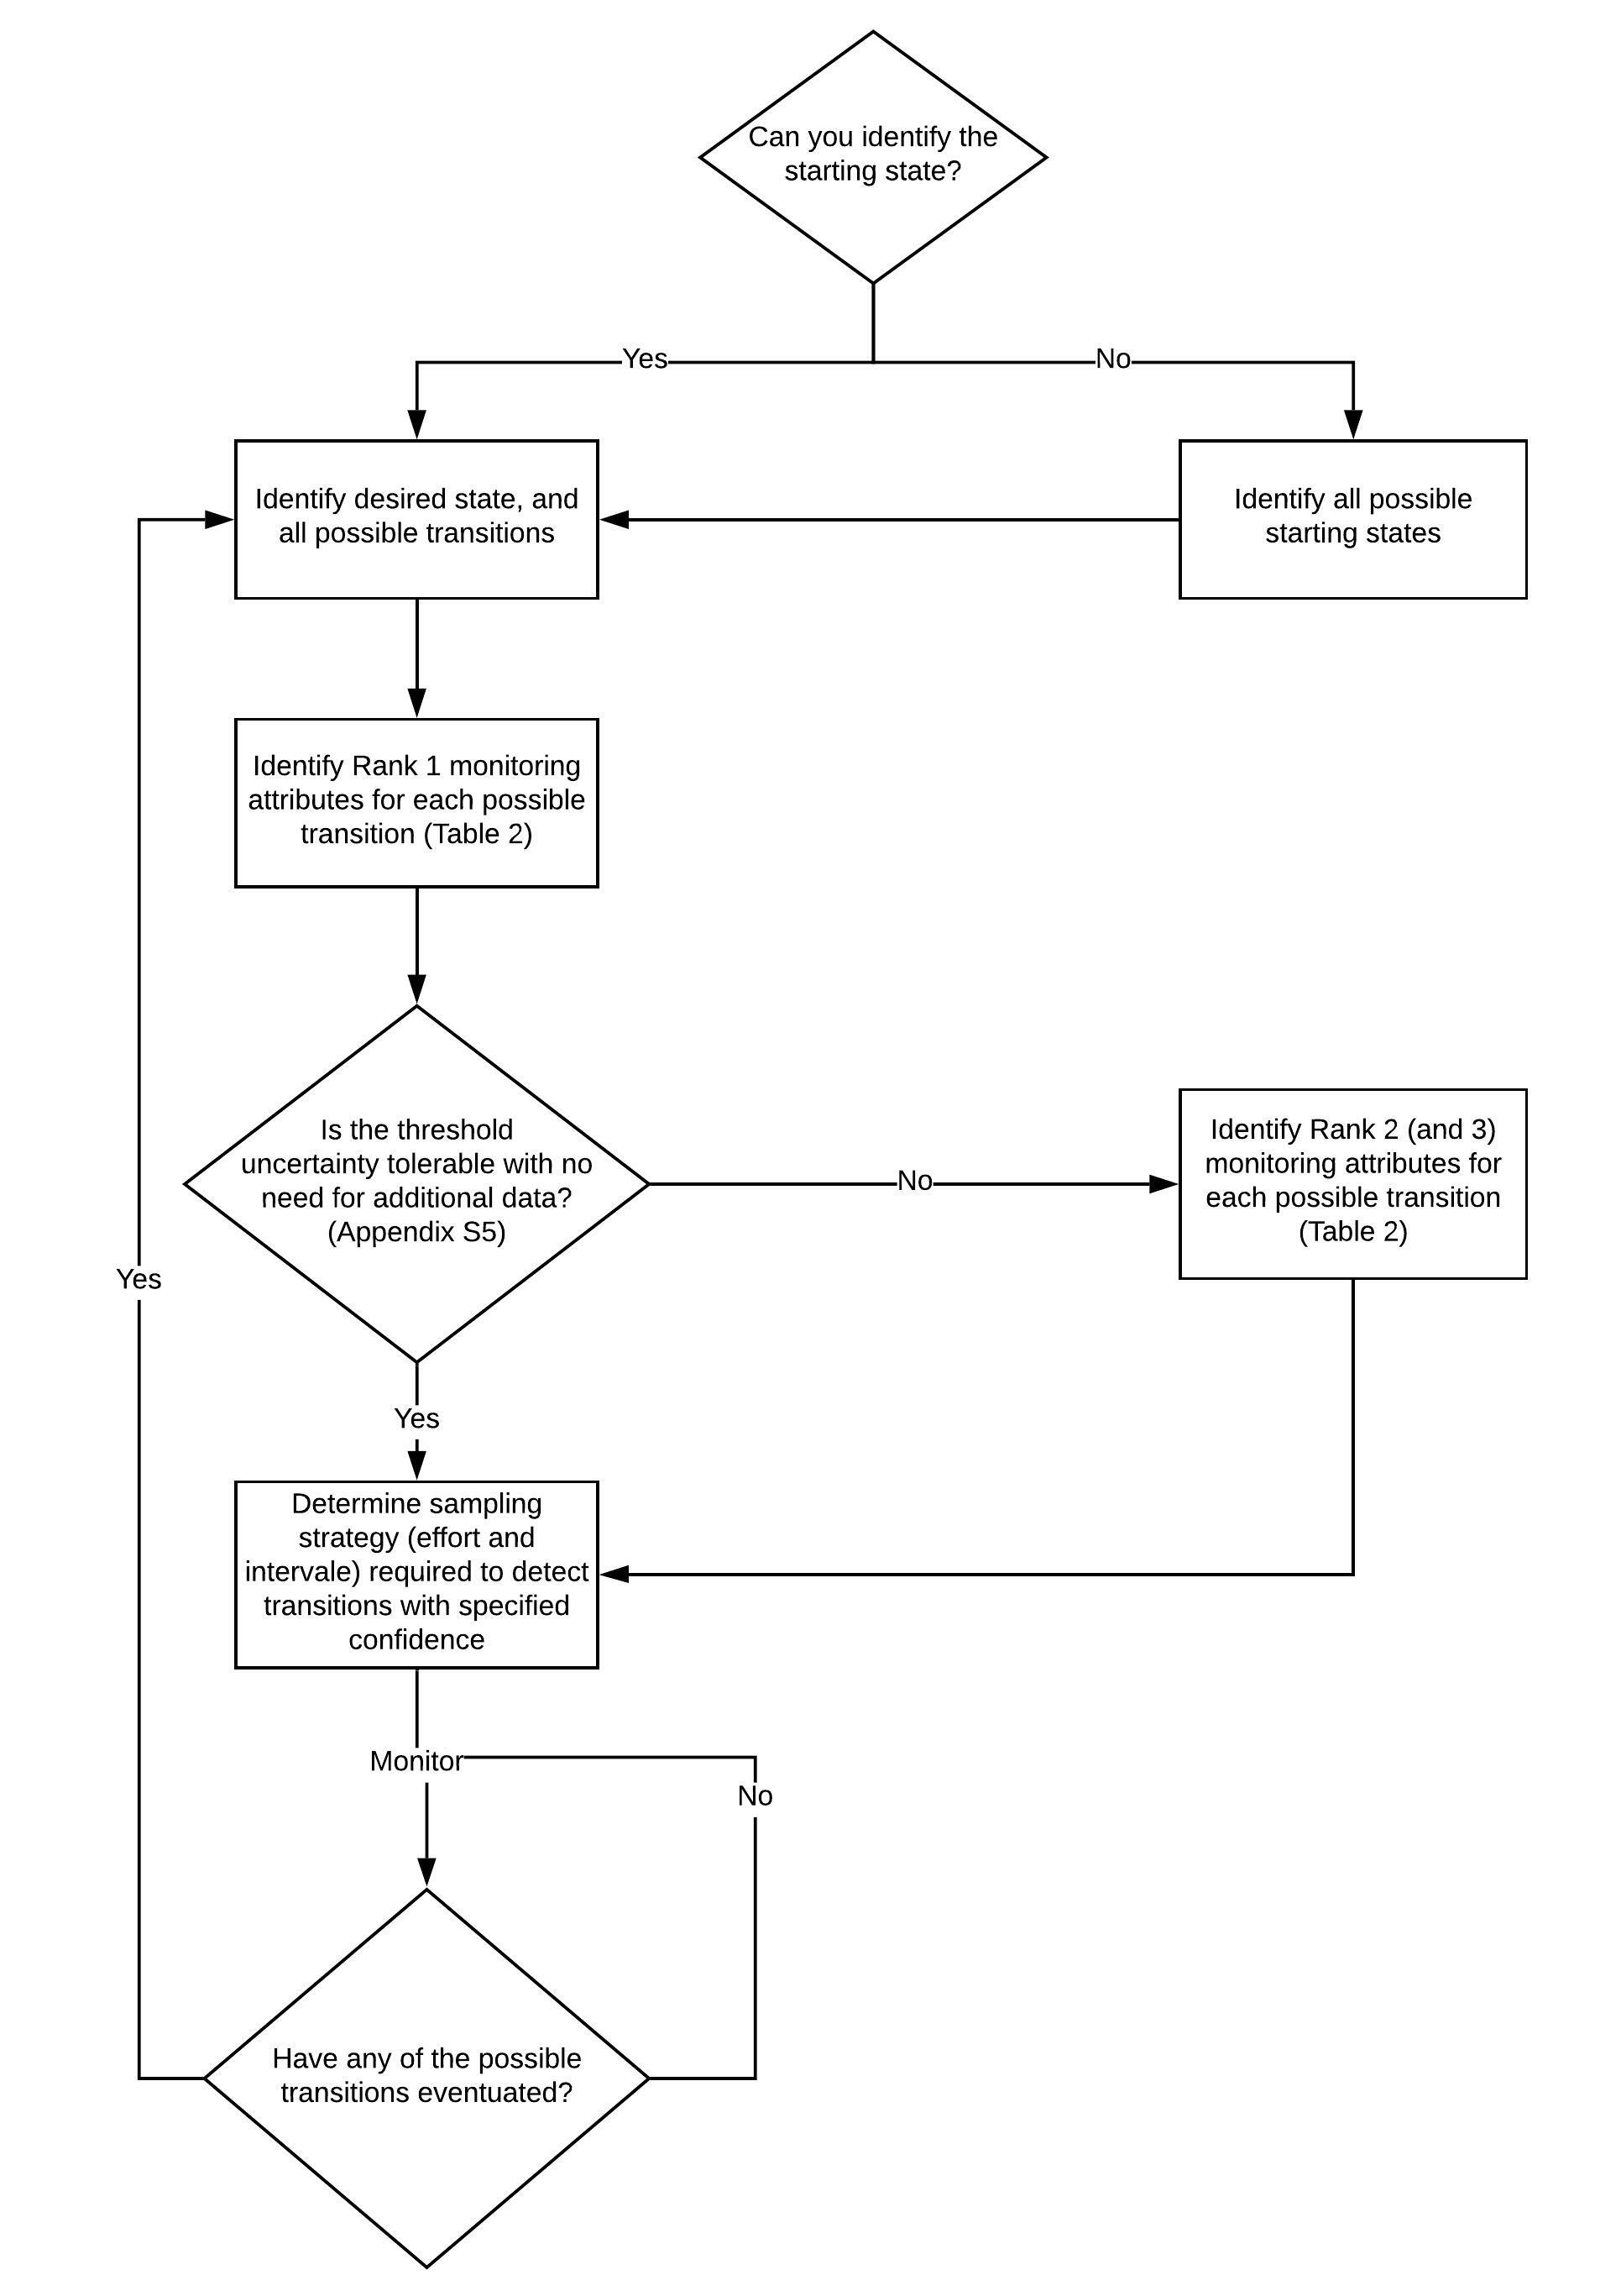

Summary
In contrast to surveillance monitoring which can be useful for discovering ‘unknown unknowns’ (Winter et al. 2010), managers and decision makers require targeted monitoring programs that focus on a reduced set of variables that are tied to specific restoration objectives. In this paper, we provide an example of testing whether a targeted monitoring program can be developed for woodland vegetation in south-east Australia. We use state-and-transition models as the framework for specifying site objectives, identifying a reduced set of monitoring variables to help distinguish between states, and identifying thresholds (with uncertainty) that provide monitoring targets that are linked to objectives. Our findings indicate that measured vegetation variables from each site in this study were good predictors of the different states of vegetation condition, and there are a few variables that can be commonly used as monitoring variables distinguishing among multiple states. This approach, whilst developed for one ecosystem only, is a promising step toward developing more targeted and efficient monitoring protocols that can support learning about change over time for vegetation restoration projects when specific objectives have been identified.

Acknowledgements
The authors would like to acknowledge Jim Begley, Dave Smith, Helen Repacholi, Susan Sleigh, Doug Robinson, Cathy Olive for help with site selection and identification of states. This project was supported by ARC LP110100321. LR and PV are currently supported by the NESP Threatened Species Hub. We would like to acknowledge reviewers from the Arthur Rylah Institute for review and feedback on the draft manuscript.

References
Addison, P.F.E., Cook, C.N., de Bie, K., 2016. Conservation practitioners’ perspectives on decision triggers for evidence-based management. J. Appl. Ecol. https://doi.org/10.1111/1365-2664.12734
Backstrom, A.C., Garrard, G.E., Hobbs, R.J., Bekessy, S.A., 2018. Grappling with the social dimensions of novel ecosystems. Front. Ecol. Environ. https://doi.org/10.1002/fee.1769
Bestelmeyer, B.T., Ash, A., Brown, J.R., Densambuu, B., Fernández-Giménez, M., Johanson, J., Levi, M., Lopez, D., Peinetti, R., Rumpff, L., Shaver, P., 2017. State and Transition Models: Theory, Applications, and Challenges. https://doi.org/10.1007/978-3-319-46709-2_9
Bestelmeyer, B.T., Goolsby, D.P., Archer, S.R., 2011. Spatial perspectives in state-and-transition models: A missing link to land management? J. Appl. Ecol. https://doi.org/10.1111/j.1365-2664.2011.01982.x
Bestelmeyer, B.T., Moseley, K., Shaver, P.L., Sanchez, H., Briske, D.D., Fernandez-Gimenez, M.E., 2010. Practical guidance for developing state-and-transition models. Rangelands. https://doi.org/10.2111/RANGELANDS-D-10-00077.1
Cunningham, R.B., Lindenmayer, D.B., Crane, M., Michael, D., MacGregor, C., Montague-Drake, R., Fischer, J., 2008. The combined effects of remnant vegetation and tree planting on farmland birds. Conserv. Biol. https://doi.org/10.1111/j.1523-1739.2008.00924.x
De’Ath, G., Fabricius, K.E., 2000. Classification and regression trees: A powerful yet simple technique for ecological data analysis. Ecology. https://doi.org/10.1890/0012-9658(2000)081[3178:CARTAP]2.0.CO;2
Di Stefano, J., 2003. How much power is enough? Against the development of an arbitrary convention for statistical power calculations. Funct. Ecol. https://doi.org/10.1046/j.1365-2435.2003.00782.x
Driscoll, D.A., Lindenmayer, D.B., 2009. Empirical tests of metacommunity theory using an isolation gradient. Ecol. Monogr. 79, 485–501. https://doi.org/10.1890/08-1114.1
Field, S.A., O’Connor, P.J., Tyre, A.J., Possingham, H.P., 2007. Making monitoring meaningful. Austral Ecol. https://doi.org/10.1111/j.1442-9993.2007.01715.x
Jeltsch, F., Moloney, K.A., Schurr, F.M., Köchy, M., Schwager, M., 2008. The state of plant population modelling in light of environmental change. Perspect. Plant Ecol. Evol. Syst. https://doi.org/10.1016/j.ppees.2007.11.004
Jones, C.S., Duncan, D.H., Rumpff, L., Thomas, F.M., Morris, W.K., Vesk, P.A., 2015. Empirically validating a dense woody regrowth “problem” and thinning “solution” for understory vegetation. For. Ecol. Manage. https://doi.org/10.1016/j.foreco.2014.12.006
Keddy, P.A., 1992. Assembly and response rules: two goals for predictive community ecology. J. Veg. Sci. https://doi.org/10.2307/3235676
Keith, D., Gorrod, E., 2006. The meanings of vegetation condition, in: Ecological Management and Restoration. https://doi.org/10.1111/j.1442-8903.2006.00285.x
Kéry, M., Schmidt, B.R., 2008. Imperfect detection and its consequences for monitoring for conservation. Community Ecol. https://doi.org/10.1556/ComEc.9.2008.2.10
Legg, C.J., Nagy, L., 2006. Why most conservation monitoring is, but need not be, a waste of time. J. Environ. Manage. https://doi.org/10.1016/j.jenvman.2005.04.016
McCarthy, M.A., Parris, K.M., Van Der Ree, R., McDonnell, M.J., Burgman, M.A., Williams, N.S.G., McLean, N., Harper, M.J., Meyer, R., Hahs, A., Coates, T., 2004. The habitat hectares approach to vegetation assessment: An evaluation and suggestions for improvement. Ecol. Manag. Restor. https://doi.org/10.1111/j.1442-8903.2004.00173.x
McDonald-Madden, E., Baxter, P.W.J., Fuller, R.A., Martin, T.G., Game, E.T., Montambault, J., Possingham, H.P., 2010. Monitoring does not always count. Trends Ecol. Evol. https://doi.org/10.1016/j.tree.2010.07.002
Nichols, J.D., Williams, B.K., 2006. Monitoring for conservation. Trends Ecol. Evol. https://doi.org/10.1016/j.tree.2006.08.007
Parkes, D., Newell, G., Cheal, D., 2003. Assessing the quality of native vegetation: The “habitat hectares” approach. Ecol. Manag. Restor. https://doi.org/10.1046/j.1442-8903.4.s.4.x
R Development Core Team, 2019. R: A language and environment for statistical computing. R Foundation for Statistical Computing, Vienna, Austria. URL http://www.R-project.org/. R Found. Stat. Comput. Vienna, Austria. https://doi.org/10.1007/978-3-540-74686-7
Rumpff, L., Duncan, D.H., Vesk, P.A., Keith, D.A., Wintle, B.A., 2011. State-and-transition modelling for Adaptive Management of native woodlands. Biol. Conserv. https://doi.org/10.1016/j.biocon.2010.10.026
Rumpff, L., Duncan, D.H., Vesk, P.A., Wintle, B.A., 2012. Development of a state-and transition model to guide investment in woodland vegetation condition, in: Landscape Logic: Pattern, People and Process in Landscape Management. CSIRO Publishing, Melbourne, Australia, pp. 157–172.
Seastedt, T.R., Hobbs, R.J., Suding, K.N., 2008. Management of novel ecosystems: Are novel approaches required? Front. Ecol. Environ. https://doi.org/10.1890/070046
Steele, C.M., Bestelmeyer, B.T., Burkett, L.M., Smith, P.L., Yanoff, S., 2012. Spatially explicit representation of state-and-transition models. Rangel. Ecol. Manag. https://doi.org/10.2111/REM-D-11-00047.1
Stringham, T.K., Krueger, W.C., Shaver, P.L., 2007. State and Transition Modeling: An Ecological Process Approach. J. Range Manag. https://doi.org/10.2307/4003893
Therneau, T., Atkinson, B., 2019. rpart: Recursive Partitioning and Regression Trees. R Packag. version 4.1-15.
Thomas, F.M., Vesk, P.A., Hauser, C.E., 2018. A field ecologist’s adventures in the virtual world: using simulations to design data collection for complex models. Ecol. Appl. https://doi.org/10.1002/eap.1801
Westoby, M., Walker, B., Noy-Meir, I., 2007. Opportunistic Management for Rangelands Not at Equilibrium. J. Range Manag. https://doi.org/10.2307/3899492
Westoby, M., Walker, B., Noy-Meir, I., 1989. Opportunistic management for rangelands not at equilibrium. J. Range Manag. https://doi.org/10.2307/3899492
Whelan, R.J., Rodgerson, L., Dickman, C.R., Sutherland, E.F., 2001. Critical life processes of plants and animals: developing a process-based understanding of population changes in fire-prone landscapes. Flammable Aust. fire regimes Biodivers. a Cont. https://doi.org/10.1046/j.1442-9993.2003.01317.x
Wintle, B.A., Runge, M.C., Bekessy, S.A., 2010. Allocating monitoring effort in the face of unknown unknowns. Ecol. Lett. https://doi.org/10.1111/j.1461-0248.2010.01514.x
Yoccoz, N.G., Nichols, J.D., Boulinier, T., 2001. Monitoring of biological diversity in space and time. Trends Ecol. Evol. https://doi.org/10.1016/S0169-5347(01)02205-4

Appendix S1. State and Transition model for non-riparian woodlands, modified from Rumpff et al 2012. A brief description of the woodland states shown to experts, modified from Rumpff et al 2011.

Appendix S2. Differences in sampling design from the two different survey methods (ANU and The University of Melbourne).
States (number of sites) | University of Melbourne | ANU
Derived (12) | 12 | 0
Exotic Pasture (12) | 8 | 4
Native Pasture (10) | 8 | 2
Oldfield (23) | 21 | 2
Reference (7) | 3 | 4
Simplified (32) | 9 | 23
Thicket (29) | 24 | 5
TOTAL (125) | 85 | 40
State variables
Native understorey  Native midstorey  & Exotic cover  (Perc_nat_us)  (Perc_nat_shrub)  (Perc_ex_us) | Percentage cover calculated from 200 point quadrats along a 200 m transect. | Average percentage cover calculated from 100 point quadrats from two 50 m transects
Immature tree density  (Stem.to30) | Stem count for native woody individuals over 2 m height, and under 30 cm DBH. Average density calculated from four 25 x 5m plots | Stem count for woody individuals under 30 cm DBH. Average density calculated from three 20 x 20 m plots.
Large tree density  (STEM.50plus_ha) | Stem count for native woody individuals over 50 cm DBH. Sampled from one 200 x 5m plot. | Stem count for woody individuals equal to or over 50 cm DBH. Average density calculated from three 20 x 20 m plots.
Shrub recruitment  (REGEN_SH_ha) | Stem count for ‘tall’ native woody non-eucalypt individuals under 1 m height. Calculated from sampling four 25 x 5 m plots. | Stem count for ‘tall’ woody non-eucalypt individuals under 1 cm basal diameter. Sampled from a 50 x 20 m plot.
Tree recruitment  (REGEN_T_ha) | Stem count for eucalypt individuals under 2 m height and for Acacia individuals under 1 m height. Calculated from sampling four 25 x 5 m plots. | Stem count for eucalypt individuals under 5 cm basal diameter. Sampled from a 50 x 20 m plot.
Native midstorey species richness  (RICH_natmid) | Accumulated native shrub and immature tree species richness within four 25 x 5m plots. Excludes shrub species with prostrate form. | Accumulated native shrub and immature tree species richness within a 20 x 20 m plot. Includes all native shrub and tree species below the overstorey canopy.
Native understorey species richness  (RICH_natund) | Accumulated native species richness within four 25x5m plots. Includes all monocots, herbs, climbers, prostrate shrubs. Excludes moss and lichen cover, and tree/tall shrub recruits. | Accumulated native species richness within a 20 x 20 m plot. Includes all monocots, herbs, climbers, shrubs (<1m tall). Excludes moss and lichen cover, and tree/tall shrub recruits.

Appendix S3. Merging the data from two different survey groups
# Understorey vegetation cover
For the understorey data, we used point intercept data along line transects to generate percentage cover for the UM sites "POINT.csv". For ANU sites we took the average of two cover estimates per site from the BIOMETRIC data "ANU veg variables.xls".
# Recruitment counts
For tree and shrub recruits we used:
The number of Eucalypt stems <2m tall and Acacias <1m tall for UM data "STEMS.csv", these values are for 100m x 5m = 500m² = 0.05ha.
For ANU data we used the sum of two counts of recruits per site: Trees <5cm basal diameter and shrubs <1cm basal diameter "ANU veg variables.xls", which were each 20m x 50m = 1000m², so 2000m² total, multiplied by five for a hectare.
# Stem counts
The ANU stem densities were given in four categories: <15cm (DBH), 15-30cm (DBH), 30+cm (DBH) (each the average of three 20m x 20m plots) and an extra category for 50+cm (DBH/ha) "ANU veg variables.xls". The smaller 3 categories were multiplied by 25 to give densities per hectare. Juvenile stems were then calculated as the sum of the two smaller categories.
The UM densities were sums within the two matching size classes: juvenile = <30cm (DBH) and large = >50cm (DBH). These were 100m x 5m = 500m² = 0.05ha.
# Richness
UM data included richness estimates surveys over a 100m x 5m = 500m² area and counted species in two separate categories: shrubs (including juvenile trees) and other.
For ANU surveys we included counts of species surveyed in the 20m x 20m = 400m² area. Midstorey and ground-storey shrubs were combined for the 'native midstorey' value, native grasses and other were combined for 'native understorey' value, and exotics as is.

Appendix S4. A graphical representation of a classification tree for all states. The tree was generated by hierarchical partitioning of 121 sites using vegetation variables. The variable that best defines a partition is labelled at each branch, with the threshold value indicated. Values within each group refer to the number of sites reflecting the label and the total number of sites in that group (i.e. 2 sites out of 12 do not reflect the Derived label). The Reference state is not represented in the model as it was classified with other states due to low sample size.
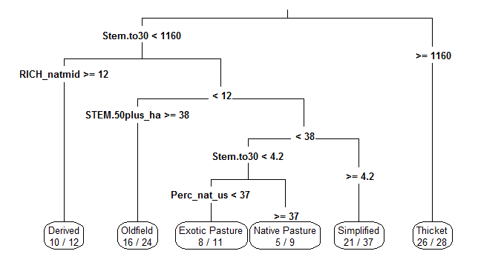

Appendix S5. The full set of transitions evaluated in the study, including the threshold value for each of the three top ranked variables for each pair of states, as well as the logistic regression model output.
From | To | Variable | Threshold (CART) | Threshold (GLM)
 |  |  |  | Mean | Lower 95CI | Upper 95CI | Slope (mag.) | % Dev. Expl. | Probability
Reference | Exotic Pasture | Stem.to30 | 140.8 | 179.2 | 68.3 | 357.7 | -0.28 | 53.0 | 0.034
 |  | Perc_ex_us | 45.5 | 49.9 | 26.5 | 71.6 | 0.87 | 43.8 | 0.039
 |  | REGEN_T_ha | 20 | 40.3 | 8.6 | 133.4 | -0.33 | 37.7 | 0.048
 | Native Pasture | Stem.to30 | 100.8 | 150.6 | 62.1 | 274.2 | -0.38 | 64.7 | 0.047
 |  | REGEN_T_ha | 30 | 92.3 | 6.5 | 478.9 | -0.15 | 18.8 | 0.10
 |  | Perc_nat_shrub | 1.0 | 1.3 | 0.1 | 6.6 | -1.41 | 35.6 | 0.090
 | Simplified | Perc_nat_shrub | 8.3 | 9 | 3.6 | 24.7 | -0.85 | 23.0 | 0.012
 |  | REGEN_SH_ha | 180 | 1077.7 | 316.1 | 4134.4 | -0.066 | 14.9 | 0.056
 |  | Stem.to30 | 137.5 | 1331.1 | 586.3 | 4299.5 | -0.078 | 8.1 | 0.12
Simplified | Native Pasture | Stem.to30 | 4.2 | 0.7 | 0 | 8.3 | -0.50 | 22.4 | 0.0049
 |  | RICH_natund | 10.5 | 16.2 | 10 | 37.1 | 0.87 | 9.0 | 0.053
 |  | REGEN_T_ha | 7.5 | 0 | 0 | 2.4 | -0.34 | 8.2 | 0.071
 | Reference | Perc_nat_shrub | 8.3 | 9 | 3.6 | 24.7 | 0.85 | 23.0 | 0.012
 |  | REGEN_SH_ha | 180 | 1077.7 | 316.1 | 4134.4 | 0.066 | 14.9 | 0.056
 |  | Stem.to30 | 137.5 | 1331.1 | 586.3 | 4299.5 | 0.078 | 8.1 | 0.12
Oldfield | Native Pasture | Stem.to30 | 50 | 24.1 | 0 | 79.4 | -0.24 | 39.3 | 0.0052
 |  | REGEN_T_ha | 12.5 | 2.2 | 0 | 13.7 | -0.58 | 20.9 | 0.0093
 |  | STEM.50plus_ha | 16.2 | 10.9 | 0.2 | 27.4 | -0.44 | 30.9 | 0.0050
 | Simplified | STEM.50plus_ha | 17.8 | 26.2 | 12.3 | 58.5 | -1.08 | 27.9 | 0.00045
 |  | Perc_ex_us | 55.6 | 63.7 | 46.4 | 88.2 | -0.56 | 17.3 | 0.0035
 |  | RICH_natmid | 1.5 | 4.1 | 1.7 | 9.8 | -1.14 | 19.7 | 0.00073
Native Pasture | Exotic Pasture | Perc_nat_us | 34.3 | 25.7 | 10 | 50.9 | -0.60 | 28.4 | 0.028
 |  | Perc_ex_us | 69.1 | 71 | 31 | 117.7 | 0.49 | 14.3 | 0.072
 |  | RICH_natund | 3.5 | 10.5 | 0 | 188.9 | -0.25 | 2.3 | 0.42
 | Thicket | Stem.to30 | 333.3 | 49 | 0.6 | 275.5 | 0.81 | 65.4 | 0.0012
 |  | REGEN_T_ha | 25 | 12.5 | 0.2 | 46.2 | 0.88 | 49.8 | 0.00095
 |  | Perc_ex_us | 17.4 | 36.3 | 23.3 | 57 | -0.84 | 56.1 | 0.0027
 | Oldfield | Stem.to30 | 50 | 24.1 | 0 | 79.4 | 0.24 | 39.3 | 0.0052
 |  | REGEN_T_ha | 12.5 | 2.2 | 0 | 13.7 | 0.58 | 20.9 | 0.0093
 |  | STEM.50plus_ha | 16.2 | 10.9 | 0.2 | 27.4 | 0.44 | 30.9 | 0.0050
 | Derived | RICH_natmid | 10 | 9.9 | 9.4 | 10.5 | 133.0 | 100.0 | 0.99
 |  | Perc_nat_shrub | 2.9 | 1.3 | 0.5 | 2.7 | 4.42 | 85.7 | 0.13
 |  | REGEN_SH_ha | 95 | 153.5 | 58.2 | 286.3 | 0.31 | 66.6 | 0.012
Exotic Pasture | Native Pasture | Perc_nat_us | 34.3 | 25.7 | 10 | 50.9 | 0.60 | 28.4 | 0.028
 |  | Perc_ex_us | 69.1 | 71 | 31 | 117.7 | -0.49 | 14.3 | 0.072
 |  | RICH_natund | 3.5 | 10.5 | 0 | 188.9 | 0.25 | 2.3 | 0.42
 | Thicket | Perc_ex_us | 59.9 | 55.9 | 46.7 | 64.5 | -3.41 | 88.2 | 0.21
 |  | Stem.to30 | 568.3 | 56 | 0.8 | 304.7 | 0.78 | 63.7 | 0.00097
 |  | Perc_nat_shrub | 0.2 | 0 | 0 | 0.1 | 28.09 | 69.1 | 0.99
Thicket | Oldfield | Perc_ex_us | 29.2 | 37.8 | 26.9 | 47.7 | 1.48 | 78.8 | 0.0024
 |  | Stem.to30 | 1080 | 712.7 | 273.4 | 1443.1 | -1.07 | 35.5 | 0.00027
 |  | STEM.50plus_ha | 17.8 | 9.5 | 3.4 | 22.6 | 1.33 | 60.2 | 0.000015
 | Simplified | Stem.to30 | 1160 | 684.4 | 316.1 | 1302.5 | -1.27 | 49.0 | 0.000086
 |  | Perc_nat_shrub | 0.2 | 1 | 0.2 | 2.6 | -1.25 | 27.5 | 0.00024
 |  | Perc_ex_us | 11.4 | 16.3 | 8.7 | 26.3 | 0.67 | 41.3 | 0.000032
Derived | Simplified | REGEN_SH_ha | 110 | 148.5 | 47.6 | 429 | -1.62 | 68.7 | 0.0043
 |  | RICH_natmid | 10.5 | 10.9 | 10.5 | 11.4 | -141.9 | 94.5 | 0.99
 |  | RICH_natund | 17 | 14.4 | 8.1 | 17.8 | -10.25 | 80.9 | 0.021

