Metapopulation-level associations in mutualistic stream fishes

Seoghyun Kim^{1*}, Christine L. Dolph², and Akira Terui¹

¹Department of Biology, University of North Carolina at Greensboro, Greensboro, NC 27412, USA

²Department of Ecology, Evolution and Behavior, University of Minnesota, St. Paul, MN 55108, USA

* Corresponding author email: seoghyunkim@gmail.com

Abstract

Positive biotic interactions are recognized as important factors determining species distributions. Although effects of positive interactions have often been observed at local scales, much less is known about consequences at larger spatial scales such as metapopulation dynamics. Here, we study nest associations of stream fishes - widespread reproductive mutualism between host (nest-builder) and beneficiary (nest associate) species in North America - as a model system to examine the role of positive interactions in determining the metapopulation-level association between host and beneficiary species. Using regional data of fish distribution in the Midwestern US, we found that watershed-level occupancy of host species (i.e., metapopulation occupancy) remarkably increased that of nest associates. Importantly, our results illustrated that the effects of positive biotic interactions at the metapopulation level were comparable or even stronger than environmental drivers, i.e., factors that have been studied most extensively in metapopulation studies. This study provides insightful evidence that positive biotic interactions have large-scale consequences for distributions of organisms than previously thought. Successful biodiversity conservation may need a broader framework that appreciates the role of positive biotic interactions at larger spatial scales.

Key words: mutualism, reproduction, interspecific interactions, stream ecosystem, species distribution, watershed, Leuciscinae
Introduction

Understanding factors affecting species distribution is a key topic in ecology due to its direct implications for biodiversity conservation. While there is a long history of relating species distributions to abiotic factors, a growing body of evidence suggests that biotic interactions can play comparable roles in driving species distribution patterns (Wisz et al. 2013, Taylor, et al. 2020). For example, negative species interactions including competition and predation are well known to influence spatial distributions of the interacting species (Chesson and Kuang 2008, Ettinger and HilleRisLambers 2013). Additionally, ecologists have begun to recognize the importance of positive interspecific interactions (e.g., mutualism) in species distributions (Bronstein 1994, Holt et al. 2002, Bruno et al. 2003, Afkhami et al. 2014, Silknetter et al. 2020, Albertson et al. 2021). These studies have advanced the field of spatial ecology by pointing to the critical yet overlooked role of positive biotic interactions in predicting species distribution patterns.
Positive interactions, such as mutualism and facilitation, have been observed in a wide array of organisms, including plants (Holland and DeAngelis 2001), birds (Wisz et al. 2013), mammals (Bronstein 1994), and fishes (Johnston 1994). These interactions mostly occur in a certain life-history stage, such as reproduction (Bronstein 1994, Johnston 1994) and dispersal (Horn et al. 2011, Correa et al. 2015). Due to the nature of mutualistic/facilitative species interactions, species involved in positive interactions often exhibit strong distributional adherence at micro to local habitat scales. For instance, some plant species create micro refugia that ameliorate abiotic environmental stress and show distributional associations with beneficiary species (Wang et al. 2011). Similar patterns have been observed among animals. Reproductive mutualism and feeding association facilitate co-occurrence between hosts and associates in stream fishes (Pendleton et al. 2012, Peoples and Frimpong 2016b, Arnhold et al. 2019). Such findings have led to a recognition that the effects of positive biotic interactions on local species co-occurrence can be comparable to abiotic controls, such as physical habitat variables (Afkhami et al. 2014, Peoples et al. 2015, Arnhold et al. 2019). Incorporating abiotic factors and biotic interactions is therefore important for a better prediction of species distributions.
Less appreciated, but perhaps more important is the metapopulation-level association of positively interacting species. In theory, equilibrium metapopulation occupancy (the proportion of habitat patches occupied within a metapopulation) is ultimately determined by the balance between colonization and extinction of local populations (Hanski and Gilpin 1991, Moilanen and Hanski 1998, Holt et al. 2002); therefore, previous empirical studies have made efforts to approximate these critical parameters using key abiotic variables, including habitat size (Franken and Hik 2004), habitat quality (Moilanen and Hanski 1998), and spatial connectivity (Hanski 1999). However, mutualistic and facilitative species should also play a crucial role in mediating the metapopulation-level occupancy of beneficiary species because positive species interactions may influence local colonization and extinction dynamics through improved fitness of beneficiary species (Holt et al. 2002, Afkhami et al. 2014, Albertson et al. 2021). Nevertheless, little is known about how positive species interactions influence the metapopulation occupancy of beneficiary species. This knowledge gap represents a major challenge for conservation and ecosystem management because long-term species persistence is maintained through metapopulation processes.
Nest association is a typical reproductive mutualism among freshwater fishes and ubiquitous throughout North America (Johnston 1994, Shao 1997, Peoples et al. 2015, Silknetter et al. 2020). Among cyprinids, nest-building species (hosts) engage over 35 nest associates (beneficiary species) in associative reproduction by constructing clean gravel pits or dome-shaped pebble nests (Miller 1962, Vives 1990, Johnston 1994). Nests constructed by host species are suitable spawning habitats for nest associates, and host males also provide parental care by adding pebbles onto nests and protecting eggs from predators (Wallin 1992, Peoples and Frimpong 2016a). As such, the presence of host species determines the successful reproduction of nest associates, especially when spawning sites are scarce or heavily embedded by siltation (Vives 1990, Peoples et al. 2015). Hence, nest association serves as an excellent model system to examine how positive interactions mediate the metapopulation occupancy of beneficiary species.
Here, we studied three nest-builders and two nest associates of stream fishes (Leuciscinae) in the midwestern USA (Fig.1) to examine the following hypotheses. First, we hypothesized that the metapopulation occupancy of nest-building species may play a primary role in determining the metapopulation occupancy of nest associates because their successful reproduction relies heavily on spawning activity of host species - a critical process for local colonization and extinction dynamics (Holt et al. 2002, Pendleton et al. 2012, Afkhami et al. 2014, Peoples and Frimpong 2016b). Additionally, nest associates show differential levels of reliance on host species; thus, we predicted greater correlations for pairs of species with strong reproductive interactions. Second, the effects of abiotic factors on the metapopulation occupancy may be variable among nest associates as they differ in habitat preference. More specifically, we examined the effects of watershed area and land use variables because these variables are related to the amount of immigrant sources (Terui and Nishijima 2019) and local habitat conditions (Moilanen and Hanski 1998), respectively. The present study provides significant insights into how positive biotic interactions regulate biodiversity patterns of metapopulation at larger spatial scales.

Methods

Study system
Our study region is the midwestern USA (580,000 km2: Fig. 1). Specifically, we focused on the Upper Mississippi River basin, Hydrologic Unit Code (HUC) 2 region 07, and the western part of Great Lakes (HUC 2 region 04) defined by the U. S. Geological Survey and U.S. Department of Agriculture Natural Resources Conservation Service (2013). This region harbors several nest associates and nest-builders of stream fishes and exhibits considerable spatial variation in land use (Fig. 1c). Therefore, the study region is ideal for comparing potential effects of abiotic and biotic controls on metapopulation occupancy of stream fishes.
Three nest-building species, such as hornyhead chub (Nocomis biguttatus), creek chub (Semotilus atromaculatus), and central stoneroller (Campostoma anomalum), are distributed at small to intermediate-sized streams in the Midwest region (Lachner 1952, Becker 1983, Cross and Collins 1995). Hornyhead chub typically prefer runs and riffles covered by gravel and pebble due to their specialized habitat requirement for spawning (Vives 1990, Wisenden et al. 2009). Creek chub and central stoneroller are habitat-tolerant species. Creek chub are distributed throughout small headwater streams and they are associated with various types of habitats, including small rocky streams, ponds, and agricultural ditches (Moshenko and Gee 1973, Magnan and FitzGerald 1984). Central stoneroller are found in intermediate-size streams and are resistant to habitat-degradation such as siltation and channelization (Miller 1962, Cross and Collins 1995, Burger et al. 2005).
Reproduction of two nest associates depends on these nest builders: common shiner (Luxilus cornutus) and southern redbelly dace (Chrosomus erythrogaster) (Becker 1983, Cross and Collins 1995). Both species are lithophilic spawners so they excavate spawning pits at runs and riffles covered by gravel substrate; however, they mostly use nests constructed by hosts. Specifically, common shiner use nests constructed by hornyhead chub (N. biguttatus) and creek chub (Semotilus atromaculatus) (Becker 1983, Vives 1990). Southern redbelly dace broadly utilize the three host species’ nests (Hemphill 1957, Settles and Hoyt 1978). However, both nest associates differ in their habitat use. Common shiner inhabit small to intermediate-sized streams covered by pebble and gravel substrate, although they are found occasionally in ponds and small lakes (Becker 1983). Southern redbelly dace have a strong habitat preference for small-sized streams covered by vegetation and woody debris (Cross and Collins 1995, Slack et al. 1997). Five other nest associates are distributed in the study region, including carmine shiner (Notropis percobromus), ozark minnow (N. nubilus), redside dace (Clinostomus elongatus), rosyface shiner (N. rubellus), and striped shiner (L. chrysocephalus) (Becker 1983, Cross and Collins 1995, Pflieger 1997). However, we did not consider these species for our analysis due to their narrow range of distribution.

Fish data and metapopulation
We compiled a dataset of regional species occurrence for 5,203 sites in the midwestern region (Fig. 1a), which were surveyed during a period of 1994 to 2015. The dataset was obtained from five state agencies, including the Iowa Department of Natural Resources, Illinois Environmental Protection Agency and Illinois Department of Natural Resources, Minnesota Pollution Control Agency, and Wisconsin Department of Natural Resources. Fish sampling was conducted between summer and fall seasons using electrofishing equipment (i.e., backpack, barge-type, or boat-mounted). We selected the latest observation at each sampling site to minimize variation in sampling efforts among sites.
Since the five focal fishes are distributed in small to intermediate-sized streams, we considered that watersheds are separated from one another if they flow into a large river (> 1,000 km² in catchment area) or lentic habitats (e.g., lake: > 1 km²) that may represent unsuitable habitats for the study species. We assigned each sampling site to one of watersheds in the region, which are assumed to represent independent metapopulations (Fig. 1b). We used the proportion of occupied sites in each watershed as a proxy for metapopulation occupancy. We used the hydrologically adjusted elevation (90-meter resolution) of MERIT Hydro (Yamazaki et al. 2019) to delineate stream networks (polylines defined as > 1 km²) and watershed polygons. Lentic habitats were extracted from Global 1-second water body map version 1.0 (Yamazaki et al. 2015). We chose watersheds with ≥ 10 sampling sites to be analyzed because a small number of sampling sites inflates statistical uncertainties in estimating metapopulation occupancy in each watershed. The final dataset included a total of 110 watersheds with 1,866 sampling sites (Fig. 1b).

Biotic and environmental variables
To examine factors affecting the metapopulation occupancy of nest associates, we calculated watershed-scale abiotic and biotic variables. We calculated the metapopulation occupancy of host species at each watershed as biotic variables. For the abiotic variables, we calculated the catchment area (km²) representing the size of ecosystems in which metapopulations are embedded. We extracted a mean elevation using the hydrologically adjusted elevation (Yamazaki et al. 2019). Elevation enabled us to assess whether the focal species are distributed at upstream habitats. Mean annual air temperature was calculated as a climate factor obtained from the climate projections at high resolution for the earth land surface areas (1km-resolution) version 1.2 (Karger et al. 2017). We calculated the percentage of land cover such as agriculture, forest, and wetland using the National Land Cover Database in 2016 from U.S. Geological Survey (30-m resolution) (Dewitz 2019: Fig. 1c). We considered agricultural land cover as a proxy of habitat degradations, such as sedimentation and hydraulic alteration (Walser and Bart 1999, Allan 2004, King et al. 2005), while forest and wetland are deemed as natural areas. All GIS processes were conducted using ArcGIS version 10.7.1 (ESRI 2019) for watershed delineation and QGIS version 3.14 (QGIS Development Team 2020) for variable calculation.

Statistical analyses
Since watersheds were distributed throughout the study region (Fig. 1b), we detected significant spatial autocorrelations based on binomial generalized linear models without predictors (null model) (common shiner model: Moran’s index = 0.08, P-value < 0.001; southern redbelly dace model: Moran’s index = 0.21, P-value < 0.001). To account for the spatial autocorrelation, we fit the binomial generalized linear mixed-effect model (GLMM) with a spatially explicit exponential correlation structure using the fitme function in the R package spaMM version 3.7.2 (Rousset and Ferdy 2014) in R version 4.0.1 (R Development Core Team 2020). This model allows us to examine the effects of abiotic and biotic variables in influencing metapopulation occupancy of the two nest associates (common shiner and southern redbelly dace) by accounting for spatial autocorrelation. We modeled the metapopulation occupancy by expressing the number of sites occupied in watershed i, $y_{i}$, as random draws from a binomial distribution. :
y_{i} ~ Binomial(N_{i}, p_{i})
where $N_{i}$is the number of sites surveyed and $p_{i}$ is the expected proportion of sites occupied or ‘metapopulation occupancy’. The expected metapopulation occupancy p_{i} was related to linear predictors as follows:
logit(p_{i})= X_{i}β + b_{i}
The parameter β is a vector of intercept and regression coefficients and X_{i} is a matrix of constant and predictor variables, including abiotic and biotic variables. The b_{i} is a component of random effects based on a spatial position of watershed i (mean latitude and longitude coordinates), and we used the Matérn correlation function to account for spatial autocorrelation (Rousset and Ferdy 2014).
The GLMM was applied for each nest associate independently. We included all 110 watersheds for the common shiner model because common shiner were distributed throughout the study region (Appendix S1). The distribution of southern redbelly dace was spatially limited, thus we used HUC4 to remove watersheds that were not located at the distributional range of southern redbelly dace (Appendix S1). The HUC4 is the subunit of HUC2 that enabled us to account for hydrological connectivity and distance among watersheds (Peoples et al. 2018). Specifically, if southern redbelly dace occurred in at least one watershed in a given HUC4, we retained all watersheds located within the HUC4. The dataset of southern redbelly dace included 71 out of 110 watersheds.
We included different host species in each model because nest associates use different hosts’ nests for reproduction. The metapopulation occupancy of hornyhead chub and creek chub was included in the common shiner model. However, we excluded central stoneroller because former studies do not observe reproductive interactions between two species (Becker 1983, Vives 1990). All three host species were included in the southern redbelly dace model because they broadly use nests constructed by most hosts. For the abiotic variables, we included the catchment area (km²), mean elevation (m), and percentage of agricultural land cover (%). However, the percentages of forest and wetland were excluded from the models because both variables showed negative correlations with agricultural land cover (Appendix S2); thus, we focused on agriculture due to its potential effects on successful reproduction in lithophilic spawners. We further excluded a mean annual air temperature (°C) from the analysis due to the strong correlation with elevation (Appendix S2). Prior to the analysis, we scaled all variables to mean = 0 and SD = 1. For the model validation, we compared the predicted and observed values using a Pearson correlation test to assess whether the model results better fit to the original data. The statistical significance of predictors was declared if 95% confidence interval (CI) did not overlap zero.

Results

Our data included 110 watersheds, which encompassed on average 17 sampling sites (range = 10 – 40). Catchment area ranged 93 – 1000 km² with a mean of 607 km² (Table 1). The range of annual temperature was 4.5 – 14.6 °C (mean = 7.7), and positively correlated with elevation (mean = 325 m, range = 126 – 516: Table 1) (Spearman ρ = -0.74, P-value < 0.001: Appendix S2). Primary land use was agriculture (mean = 60 %, range = 1 – 93: Table 1 and Fig. 1c), followed by forest (mean = 17 %, range = 4 – 64) and wetland (mean = 8 %, range = 0 – 44).
The two nest associates showed contrasting distribution patterns. The widespread beneficiary species, common shiner, were distributed throughout the study region and occurred at 92 out of 110 watersheds (Table 2). Meanwhile, southern redbelly dace showed a spatially clumped distribution at the middle of the study region, occurring at 36 out of 71 watersheds (Table 2 and Appendix S1). Based on watersheds where nest associates occurred, a mean metapopulation occupancy of common shiner and southern redbelly dace was 0.55 (range = 0.03 – 1.00) and 0.35 (range = 0.04 – 0.94), respectively (Table 2). For the host species, creek chub was most widely distributed and occurred at 109 watersheds (mean metapopulation occupancy = 0.74, range = 0.13 – 1.00: Table 2). Horneyhead chub and central stoneroller were distributed throughout the study region and occurred at 81 and 75 watersheds, respectively. However, their mean metapopulation occupancy was much less than creek chub (mean occupancy: hornyhead chub = 0.42; central stoneroller = 0.50: Table 2).
The GLMMs with spatial autocorrelation revealed a strong association between host and nest-associate species at the metapopulation level with excellent model fits (Pearson correlation test: common shiner model, r = 0.99, P-value < 0.001; southern redbelly dace model, r = 0.98 P-value < 0.001: Appendix S3). As the metapopulation occupancy of host species increases so does the metapopulation occupancy of nest associates, while the effects of hosts vary by species. Specifically, the occupancy of common shiner was positively associated with hornyhead chub (coefficient = 1.02, SE = 0.15, 95% CI = 0.73 – 1.31) and creek chub (coefficient = 0.62, SE = 0.15, 95% CI = 0.32 – 0.92: Table 3 and Fig. 2a). Meanwhile, central stoneroller played a bigger role in the metapopulation occupancy of southern redbelly dace (coefficient = 0.78, SE = 0.37, 95% CI = 0.05 – 1.50: Table 3 and Fig. 2b). By contrast to common shiner, southern redbelly dace was not associated with hornyhead chub (coefficient = 0.36, SE = 0.20, 95% CI = -0.03 – 0.75) or creek chub (coefficient = 0.39, SE = 0.28, 95% CI = -0.15 – 0.93: Fig. 2b) For the environmental variables, common shiner were likely distributed at upstream habitats (elevation: coefficient = 0.50, SE = 0.25, 95% CI = 0.02 – 0.99: Table 3 and Fig. 3a). Watersheds covered by agriculture increased the occupancy of southern redbelly dace (coefficient = 1.15, SE = 0.49, 95% CI = 0.18 – 2.13: Table 3 and Fig. 3b).

Discussion

Positive biotic interactions are now recognized as important drivers of species distributions (Holt et al. 2002, Afkhami et al. 2014, Albertson et al. 2021). However, much less is known about the role of positive interactions in driving large-scale distribution patterns (e.g., metapopulation) because emerging patterns and consequences of positive interactions have been studied at local scales (Peoples and Frimpong 2016b, Arnhold et al. 2019, Albertson et al. 2021). Here, using a regional fish dataset in the Midwestern US, we unveiled the critical roles of positive interactions in determining the metapopulation-level association between hosts and beneficiary stream fishes. Our findings highlighted that watershed-level distributions of host species remarkably increased the metapopulation occupancy of nest associates across watersheds, although the effect size was dependent on host species. The effect size of positive biotic interactions was comparable or even stronger than environmental variables, which have been most extensively studied in the metapopulation literature. These findings contribute to a growing number of studies emphasizing the importance of positive biotic interactions in large-scale species distributions in stream ecosystems (Albertson et al. 2021).
Metapopulation occupancy emerges as a consequence of local population dynamics. Although ample evidence suggests that local population persistence is primarily driven by habitat size and spatial connectivity (Moilanen and Hanski 1998, Franken and Hik 2004), positive interactions can also regulate local population persistence of beneficiary species when these interactions play an important role at a certain life stage (Holt et al. 2002, Afkhami et al. 2014, Silknetter et al. 2020). In particular, enhanced reproduction in local populations through positive species interactions may lead to reduced extinction and/or increased colonization probabilities, which are key parameters in metapopulation models (Hanski and Gilpin 1991). Nest association is a typical reproductive mutualism in freshwater fishes that is tightly linked to the successful reproduction of beneficiary species (Wallin 1992, Johnston 1994, Shao 1997, Peoples and Frimpong 2016a). The observed patterns may be an emergent property of enhanced local processes, in which the presence of host species led to improved local reproduction and consequently increased the metapopulation occupancy of nest associates.
Our findings are noteworthy because our study species are opportunistic mutualists. Most nest associates are opportunistic, and their local occurrence is less affected by host’s distributions when compared with obligate nest associates (Pendleton et al. 2012, Yamane et al. 2013, Peoples and Frimpong 2016b). However, our results discovered strong metapopulation-level associations of opportunistic mutualists. This pattern is understandable given the fact that nest association is more beneficial in marginal or unsuitable habitats (Vives 1990, Peoples et al. 2015). In such habitats, opportunistic nest associates must use the host's nests for successful reproduction because suitable nesting sites are scarce. Further, utilizing host’s nests for spawning would be a better reproductive strategy to mitigate excessive energetic costs for nest construction and defense (Johnston 1994, Shao 1997). Therefore, despite the marginal benefits of opportunistic mutualism at local scales, such positive interactions may extend the realized niche of beneficiary species and can increase inhabitable areas in a landscape.
We also found that the importance of host species varied by nest associate. This result is reasonable when considering the nature of nest associations. Unlike other host species, male creek chub often display aggressive behaviors toward certain nest associates while they defend nests (Ross 1977). Nest associates like common shiner can use nests defended by male creek chub because they are of comparable body size (creek chub = 120 – 300 mm, common shiner = 100 – 200 mm: Becker 1983). However, southern redbelly dace are not likely to successfully access creek chub’s nests because they (50 – 100 mm) are much smaller than creek chub (Ross 1977, Settles and Hoyt 1978). This may explain why creek chub could not serve as an effective host for southern redbelly dace, although they are widespread throughout the study region.
In addition, differences in habitat preference between nest associates and hosts may provide additional explanations for varied influences of host species. For example, hornyhead chub and southern redbelly dace prefer different types of local habitats, likely leading to the weak metapopulation-level association between the two species. Hornyhead chub may not occur in streams covered heavily by vegetation and woody debris which southern redbelly dace strongly prefer (Hemphill 1957, Slack et al. 1997, Wisenden et al. 2009). Thus, although reproductive association between the two species has been observed in our study region (Becker 1983), it is possible that different habitat preferences could limit the influence of these interactions at the watershed scale. By contrast, central stoneroller occur in various habitats, including suitable habitats for southern redbelly dace (Miller 1962, Settles and Hoyt 1978); thus, they would be critical for the expansion of distribution southern redbelly dace by providing nests when suitable nesting sites are scarce. Such differences in nesting behaviors and habitat requirements may have caused the variation in the importance of host species.
Environmental variables played a secondary role in predicting the metapopulation occupancy of nest associates. The positive effect of elevation on common shiner is consistent with previous observations that this species prefers small-sized streams as primary habitats (Jacobus and W. Webb 2005). Increased metapopulation occupancy of southern redbelly dace at agricultural watersheds is somewhat counterintuitive because agricultural land use often causes degradation of spawning grounds for lithophilic spawners with excessive sediment inputs (Walser and Bart 1999, Allan 2004, Piggott et al. 2012, Peoples et al. 2015). However, nutrient enrichment due to agricultural land use could lead to well-developed riparian and/or in-stream vegetation structure with increased food availability (Knysh et al. 2016, Terui et al. 2018).
It should be borne in mind that negative interactions can also influence species distributions (Chesson and Kuang 2008, Wisz et al. 2013, Hickerson et al. 2019, Taylor, et al. 2020). However, the effects of negative interactions are often masked by other environmental drivers at larger spatial scales (Ettinger and HilleRisLambers 2013) or can exert complex patterns due to non-linear effects of predator-prey interactions (Kadoya et al. 2018). In contrast, consequences of positive interactions are well defined and should therefore be tightly linked to the metapopulation occupancy as reported in this study. Although we could not quantitatively estimate the potential effects of negative species interactions in this study, we expect that the metapopulation-level impact of positive interactions through nest association is clearer and more predictable.
Our study has important implications for biodiversity conservation and effective ecosystem management. While it is well known that local loss of mutualistic partners will likely cause secondary extirpations of beneficiary species (Bronstein 1994, Bruno et al. 2003, Pendleton et al. 2012, Afkhami et al. 2014), questions still remain about the effects of positive biotic interactions on metapopulation-level association. Our findings suggest that the loss of mutualistic partners may have comparable or even greater impacts at the metapopulation level. Therefore, any potential factors that negatively affect mutualistic species such as habitat loss and fragmentation (Moilanen and Hanski 1998, Hanski 1999) are likely to exert domino effects at the metapopulation level, ultimately leading to regional extinction of beneficiary species. Although metapopulation concepts are now widely used in many conservation schemes (Hanski 1999, Holt et al. 2002), it is rare to consider potential cascading effects of positive species interactions at this level of biological organization (Albertson et al. 2021). Successful biodiversity conservation may need a broader framework that appreciates the role of positive species interactions at large spatial scales.

Acknowledgments

This research was supported financially by National Science Foundation through a Water Sustainability and Climate Program (WSC) Observatory grant (EAR‐1209402): REACH (Resilience under Accelerated Change), Environmental Protection Agency through a Water Quality Benefits grant (EPA224G2015-STAR-A1), and the University of North Carolina at Greensboro through a start-up fund. We thank Illinois Environmental Protection Agency, Minnesota Pollution Control Agency, Iowa Department of Natural Resources, and Wisconsin Department of Natural Resources for providing the fish dataset. We thank numerous people who have been involved in the collection of the fish dataset.

Author Contributions

SK and AT conceived the study. SK, AT, and CLD managed the fish dataset. SK performed statistical analyses with inputs from AT. SK and AT wrote the first draft with the significant inputs from CLD. All authors read and approved the final manuscript.

Data Availability Statement

The fish dataset provided by third parties are not available due to licensing issues. Codes for statistical analysis are available at https://github.com/seoghyunkim/public-proj_positive_interaction_metapopulation.

References

Afkhami, M. E. et al. 2014. Mutualist-mediated effects on species’ range limits across large geographic scales. - Ecol. Lett. 17: 1265–1273.
Albertson, L. K. et al. 2021. Uncovering patterns of freshwater positive interactions using meta‐analysis: Identifying the roles of common participants, invasive species and environmental context. - Ecol. Lett. 24: 594–607.
Allan, J. D. 2004. Landscapes and riverscapes: the influence of land use on stream ecosystems. - Annu. Rev. Ecol. Evol. Syst. 35: 257–284.
Arnhold, T. R. et al. 2019. Positive co‐occurrence between feeding‐associative savannah fishes depends on species and habitat. - Freshw. Biol. 64: 1029–1039.
Becker, G. C. 1983. Fishes of Wisconsin. - University of Wisconsin Press.
Bronstein, J. L. 1994. Our current understanding of mutualism. - Q. Rev. Biol. 69: 31–51.
Bruno, J. F. et al. 2003. Inclusion of facilitation into ecological theory. - Trends Ecol. Evol. 18: 119–125.
Burger, J. et al. 2005. Use of central stonerollers (Cyprinidae: Campostoma anomalum) from Tennessee as a bioindicator of metal contamination. - Environ. Monit. Assess. 110: 171–184.
Chesson, P. and Kuang, J. J. 2008. The interaction between predation and competition. - Nature 456: 235–238.
Correa, S. B. et al. 2015. Overfishing disrupts an ancient mutualism between frugivorous fishes and plants in Neotropical wetlands. - Biol. Conserv. 191: 159–167.
Cross, F. B. and Collins, J. T. 1995. Fishes in Kansas. - University of Kansas Natural History Museum Public Education Series.
Dewitz, J. 2019. National Land Cover Database (NLCD) 2016 Products (version 2.0): U.S. Geological Survey data release.
ESRI 2019. ArcGIS Desktop. - Environmental Systems Research Institute.
Ettinger, A. K. and HilleRisLambers, J. 2013. Climate isn’t everything: Competitive interactions and variation by life stage will also affect range shifts in a warming world. - Am. J. Bot. 100: 1344–1355.
Franken, R. J. and Hik, D. S. 2004. Influence of habitat quality, patch size and connectivity on colonization and extinction dynamics of collared pikas Ochotona collaris. - J. Anim. Ecol. 73: 889–896.
Hanski, I. 1999. Habitat connectivity, habitat continuity, and metapopulations in dynamic landscapes. - Oikos 87: 209–219.
Hanski, I. and Gilpin, M. 1991. Metapopulation dynamics: Brief history and conceptual domain. - Biol. J. Linn. Soc. 42: 3–16.
Hemphill, A. F. 1957. The southern redbelly dace, Chrosomus erythrogaster erythrogaster, from the lower Mississippi River drainage. - Copeia 1957: 53.
Hickerson, B. T. et al. 2019. Effects of multiple nonnative fish on an imperiled cyprinid, hornyhead chub. - Trans. Am. Fish. Soc. 148: 1132–1145.
Holland, J. N. and DeAngelis, D. L. 2001. Population dynamics and the ecological stability of obligate pollination mutualisms. - Oecologia 126: 575–586.
Holt, A. R. et al. 2002. The importance of biotic interactions in abundance-occupancy relationships. - J. Anim. Ecol. 71: 846–854.
Horn, M. H. et al. 2011. Seed dispersal by fishes in tropical and temperate fresh waters: The growing evidence. - Acta Oecol. 37: 561–577.
Jacobus, J. and W. Webb, P. 2005. Using fish distributions and behavior in patchy habitats to evaluate potential effects of fragmentation on small marsh fishes: a case study. - J. Gt. Lakes Res. 31: 197–211.
Johnston, C. E. 1994. Nest association in fishes: evidence for mutualism. - Behav. Ecol. Sociobiol. 35: 379–383.
Kadoya, T. et al. 2018. Potential oscillators and keystone modules in food webs. - Ecol. Lett. 21: 1330–1340.
Karger, D. N. et al. 2017. Climatologies at high resolution for the earth’s land surface areas. - Sci. Data 4: 170122.
King, R. S. et al. 2005. Spatial considerations for linking watershed land cover to ecological indicators in streams. - Ecol. Appl. 15: 137–153.
Knysh, K. M. et al. 2016. The influence of agricultural land-use on plant and macroinvertebrate communities in springs: Impacts of agriculture on limnocrene springs. - Limnol. Oceanogr. 61: 518–530.
Lachner, E. A. 1952. Studies of the biology of the cyprinid fishes of the chub genus Nocomis of northeastern United States. - Am. Midl. Nat. 48: 433.
Magnan, P. and FitzGerald, G. J. 1984. Ontogenetic changes in diel activity, food habits and spatial distribution of juvenile and adult creek chub, Semotilus atromaculatus. - Environ. Biol. Fish. 11: 301–307.
Miller, R. J. 1962. Reproductive behavior of the stoneroller minnow, Campostoma anomalum pullum. - Copeia 1962: 407–417.
Moilanen, A. and Hanski, I. 1998. Metapopulation dynamics: Effects of habitat quality and landscape structure. - Ecology 79: 2503–2515.
Moshenko, R. W. and Gee, J. H. 1973. Diet, time and place of spawning, and environments occupied by creek chub (Semotilus atromaculatus) in the Mink River, Manitoba. - J. Fish. Res. Bd. Can. 30: 357–362.
Pendleton, R. M. et al. 2012. The strength of Nocomis nest association contributes to patterns of rarity and commonness among New River, Virginia cyprinids. - Am. Midl. Nat. 168: 202–217.
Peoples, B. K. and Frimpong, E. A. 2016a. Context‐dependent outcomes in a reproductive mutualism between two freshwater fish species. - Ecol. Evol. 6: 1214–1223.
Peoples, B. K. and Frimpong, E. A. 2016b. Biotic interactions and habitat drive positive co‐occurrence between facilitating and beneficiary stream fishes. - J. Biogeogr. 43: 923–931.
Peoples, B. K. et al. 2015. Lotic cyprinid communities can be structured as nest webs and predicted by the stress-gradient hypothesis (F van Veen, Ed.). - J. Anim. Ecol. 84: 1666–1677.
Peoples, B. K. et al. 2018. Catchment‐scale determinants of nonindigenous minnow richness in the eastern United States. - Ecol. Freshw. Fish 27: 138–145.
Pflieger, W. L. 1997. The fishes of Missouri. - Missouri Department of Conservation.
Piggott, J. J. et al. 2012. Multiple Stressors in Agricultural Streams: A Mesocosm Study of Interactions among Raised Water Temperature, Sediment Addition and Nutrient Enrichment. - PLoS ONE 7: e49873.
QGIS Development Team 2020. QGIS: Open source geospatial foundation project.
R Development Core Team 2020. R: A language and environment for statistical computing. - R Foundation for Statistical Computing.
Ross, M. R. 1977. Aggression as a social mechanism in the creek chub (Semotilus atromaculatus). - Copeia 1977: 393–397.
Rousset, F. and Ferdy, J.-B. 2014. Testing environmental and genetic effects in the presence of spatial autocorrelation. - Ecography 37: 781–790.
Settles, W. H. and Hoyt, R. D. 1978. The Reproductive biology of the southern redbelly dace, Chrosomus erythrogaster Rafinesque, in a Spring-Fed Stream in Kentucky. - Am. Midl. Nat. 99: 290–298.
Shao, B. 1997. Effects of golden shiner (Notemigonus crysoleucas) nest association on host pumpkinseeds (Lepomis gibbosus): evidence for a non-parasitic relationship. - Behav. Ecol. Sociobiol. 41: 399–406.
Silknetter, S. et al. 2020. Positive biotic interactions in freshwaters: A review and research directive. - Freshw. Biol. 65: 811–832.
Slack, W. T. et al. 1997. Ichthyofaunal and habitat associations of disjunct populations of southern redbelly dace Phoxinus erythrogaster (Teleostei: Cyprinidae) in Mississippi. - Am. Midl. Nat. 137: 251–265.
Taylor, S. S. et al. 2020. The relative importance of biotic and abiotic determinants of temporal occupancy for avian species in North America. - Global. Ecol. Biogeogr. 29: 736–747.
Terui, A. and Nishijima, S. 2019. Spatial disturbance synchrony alters the association of food chain length and ecosystem size. - Ecol. Res. 34: 864–871.
Terui, A. et al. 2018. Stream Resource Gradients Drive Consumption Rates of Supplemental Prey in the Adjacent Riparian Zone. - Ecosystems 21: 772–781.
U. S. Geological Survey and U.S. Department of Agriculture Natural Resources Conservation Service 2013. Federal standards and procedures for the national watershed boundary dataset: Techniques and methods 11-A3.
Vives, S. P. 1990. Nesting ecology and behavior of hornyhead chub Nocomis biguttatus, a keystone species in Allequash Creek, Wisconsin. - Am. Midl. Nat. 124: 46–56.
Wallin, J. E. 1992. The symbiotic nest association of yellowfin shiners, Notropis lutipinnis, and bluehead chubs, Nocomis leptocephalus. - Environ. Biol. Fish.: 287–292.
Walser, C. A. and Bart, H. L. 1999. Influence of agriculture on in-stream habitat and fish community structure in Piedmont watersheds of the Chattahoochee River System. - Ecol. Freshw. Fish 8: 237–246.
Wang, Z. et al. 2011. Facilitation of plant species richness and endangered species by a tussock grass in a moist tall grassland revealed using hierarchical Bayesian analysis. - Ecol. Res. 26: 1103–1111.
Wisenden, B. D. et al. 2009. Functional constraints on nest characteristics of pebble mounds of breeding male hornyhead chub Nocomis biguttatus. - J. Fish Biol. 75: 1577–1585.
Wisz, M. S. et al. 2013. The role of biotic interactions in shaping distributions and realised assemblages of species: Implications for species distribution modelling. - Biol. Rev. 88: 15–30.
Yamane, H. et al. 2013. Diversity in interspecific interactions between a nest-associating species, Pungtungia herzi, and multiple host species. - Environ. Biol. Fish. 96: 573–584.
Yamazaki, D. et al. 2015. Development of a global ~90m water body map using multi-temporal Landsat images. - Remote Sens. Environ. 171: 337–351.
Yamazaki, D. et al. 2019. MERIT Hydro: A high‐resolution global hydrography map based on latest topography dataset. - Water Resour. Res. 55: 5053–5073.

Tables

Table 1. Summary of watershed-level environmental variables.
Variable | Mean (range)
Catchment area (km²) | 607 (93 – 1000)
Mean elevation (m) | 325 (128 – 516)
Mean annual temperature (°C) | 7.7 (4.6 – 14.6)
Agriculture (%) | 27 (1 – 93)
Forest (%) | 17 (4 – 64)
Wetland (%) | 11 (0 – 44)

Table 2. Summary of the number of sites occurred and metapopulation occupancy of five focal species.
Category | Species | Number of sites occurred | Number of watersheds occupied | Mean metapopulation occupancy (range)
Nest associate | Common shiner | 890 | 92 | 0.55 (0.03 – 1.00)
Nest associate | Southern redbelly dace | 254 | 36 | 0.35 (0.04 – 0.94)
Host | Hornyhead chub | 559 | 81 | 0.42 (0.04 – 1.00)
Host | Creek chub | 1409 | 109 | 0.74 (0.13 – 1.00)
Host | Central stoneroller | 691 | 75 | 0.50 (0.06 – 1.00)

Table 3. Summary of fixed effects on the metapopulation occupancy of common shiner and southern redbelly dace estimated by a generalized linear mixed model with a spatially explicit exponential correlation structure. Significant variables are shown in bold.
Species | Explanatory variable | Estimate | Cond. SE | 95% CI
 |  |  |  | Lower | Upper
Common shiner | Intercept | -0.95 | 0.79 | -2.51 |  | 0.60
Common shiner | Hornyhead chub | 1.02 | 0.15 | 0.73 |  | 1.31
Common shiner | Creek chub | 0.62 | 0.15 | 0.32 |  | 0.92
Common shiner | Catchment area | -0.07 | 0.12 | -0.33 |  | 0.18
Common shiner | Agriculture | 0.07 | 0.24 | -0.40 |  | 0.54
Common shiner | Elevation | 0.50 | 0.25 | 0.02 |  | 0.99
Southern redbelly dace | Intercept | -4.10 | 0.79 | -5.65 |  | -2.55
Southern redbelly dace | Hornyhead chub | 0.36 | 0.20 | -0.03 |  | 0.75
Southern redbelly dace | Creek chub | 0.39 | 0.28 | -0.15 |  | 0.93
Southern redbelly dace | Central stoneroller | 0.78 | 0.37 | 0.05 |  | 1.50
Southern redbelly dace | Catchment area | 0.32 | 0.19 | -0.05 |  | 0.69
Southern redbelly dace | Agriculture | 1.15 | 0.49 | 0.18 |  | 2.13
Southern redbelly dace | Elevation | 0.48 | 0.44 | -0.38 |  | 1.35

Figures
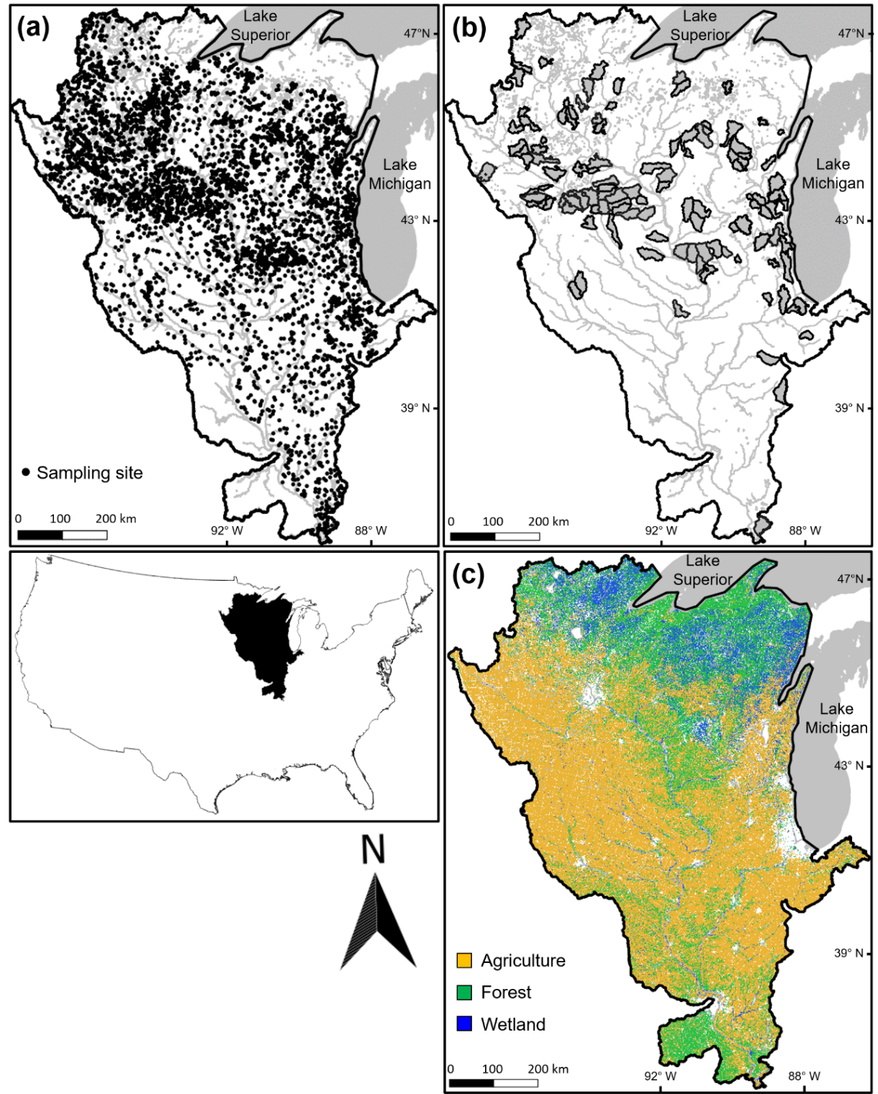
Fig .1. The study region in the midwestern United States. The black dots indicate 5,203 sampling sites across the study region on the top right panel (a). The dark gray polygons indicate 110 delineated watersheds on the top right panel (b). Land cover is shown by different colors on the bottom right panel (c).
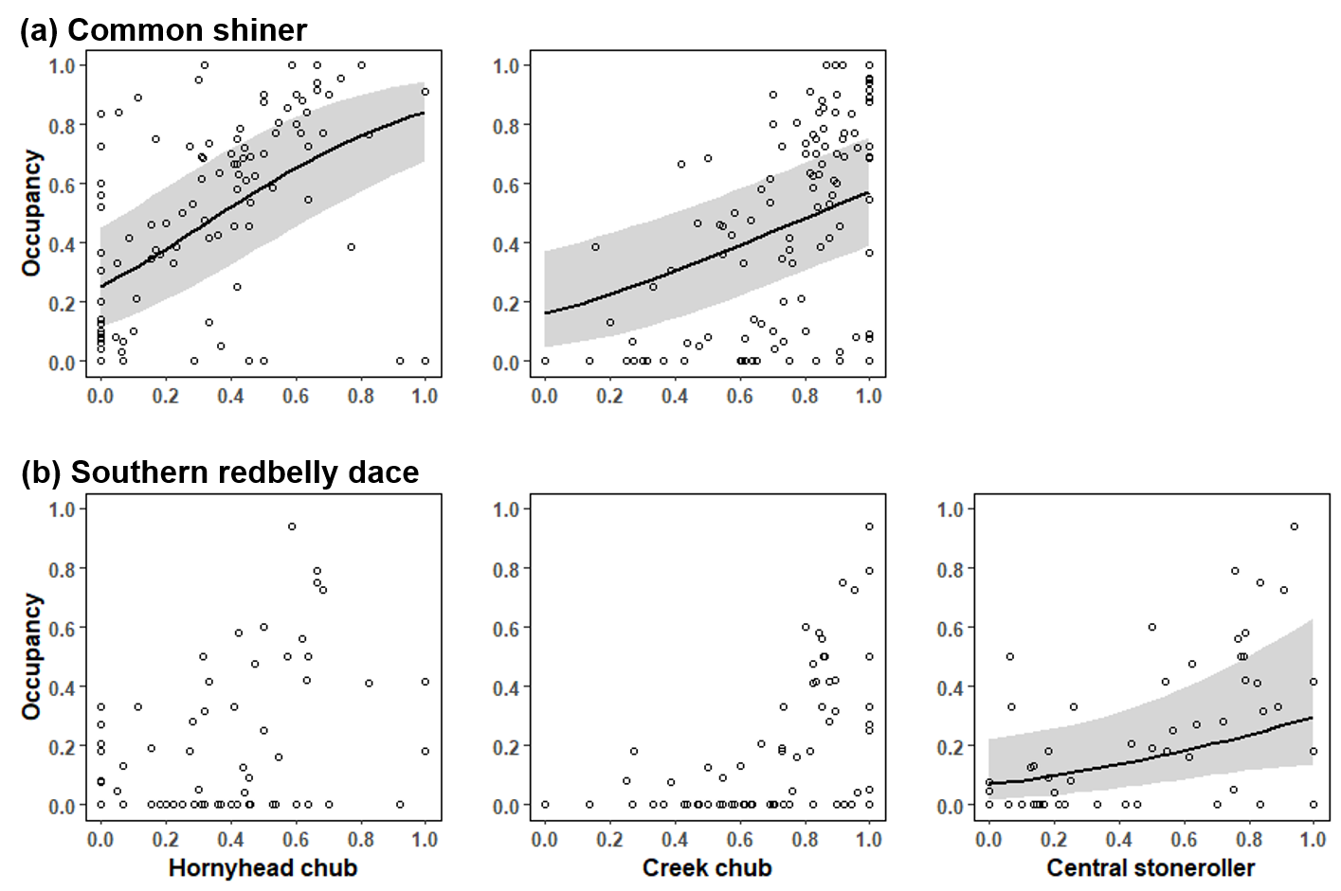
Fig. 2. Effects of biotic variables (occupancy of host species) on the metapopulation occupancy of common shiner (a) and southern redbelly dace (b). The mean effect is shown by black line and gray shading represents 95% confidence intervals.

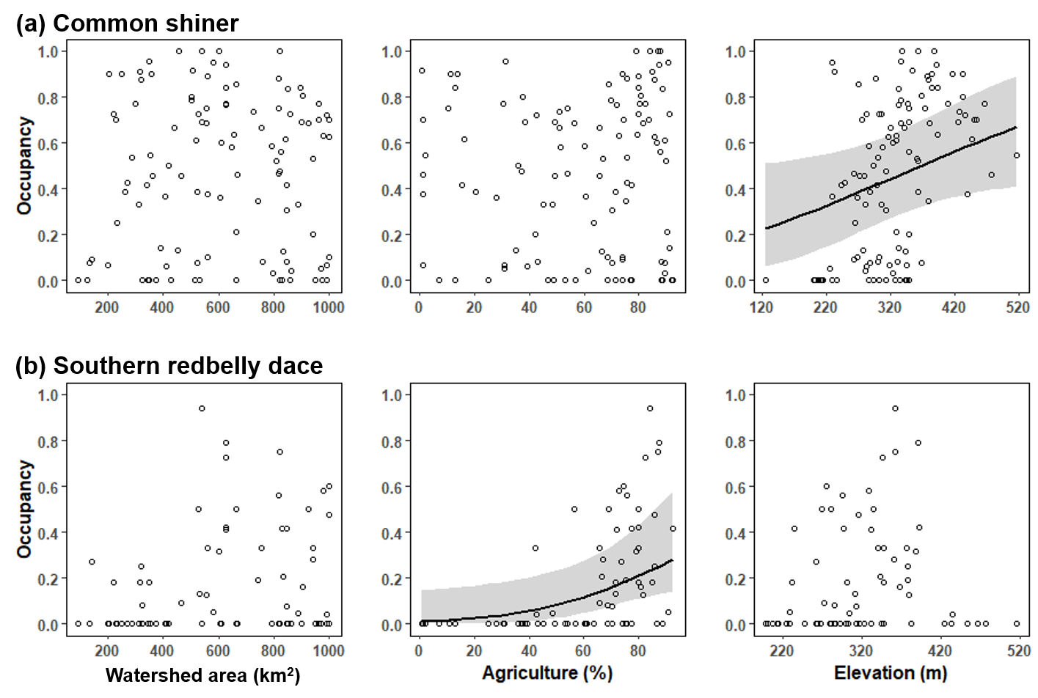
Fig. 3. Effects of abiotic variables on the metapopulation occupancy of common shiner (a) and southern redbelly dace (b). The mean effect is shown by black line and gray shading represents 95% confidence intervals.

Supplementary Materials

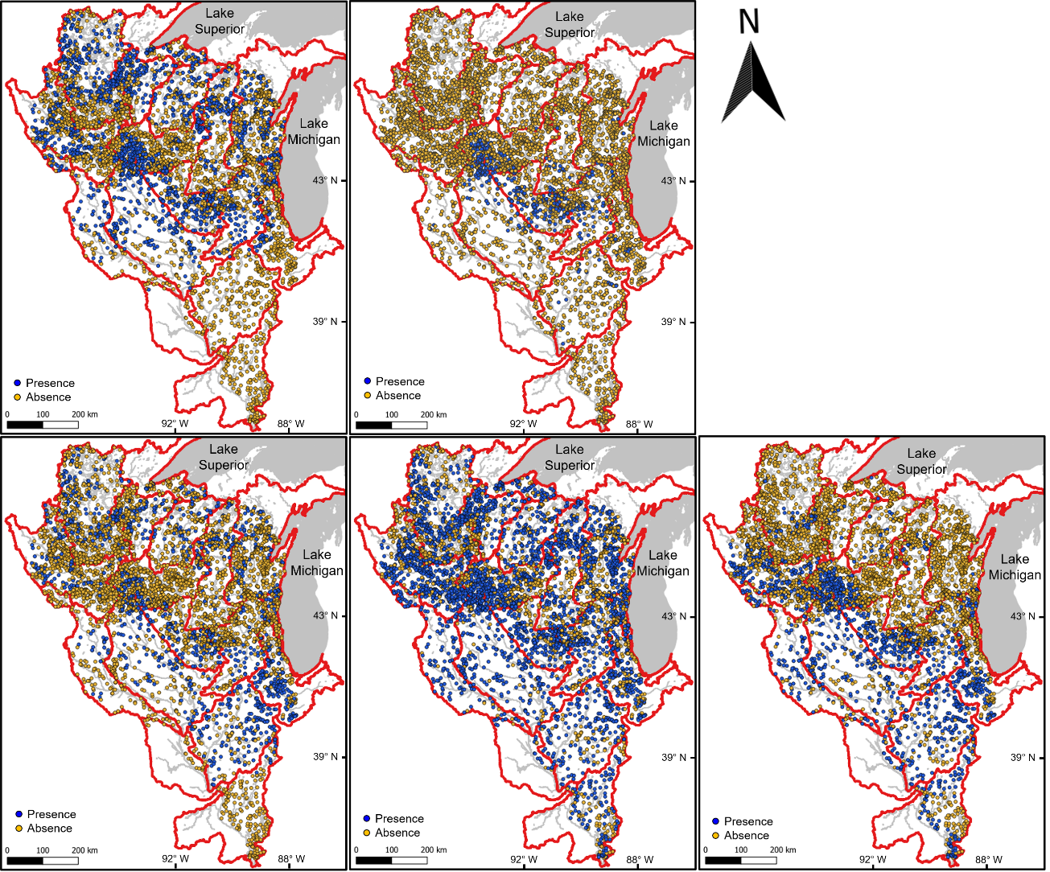
Appendix S1. Distributional patterns of five focal species in the study region based on the regional fish dataset. Circles indicate sampling sites (n= 5,203) with the presence/absence of each species, and red solid polygons indicate the Hydrologic Unit Code 4 (HUC4).

Appendix S2. Spearman’s rank correlation tests based on the metapopulation occupancy of five focal species and six environmental variables.
Variable |  | CMS | SRD | HHC | CRC | CSR | Watershed area | % Agriculture | % Forest | % Wetland | Elevation
CMS
SRD |  | 0.32***
HHC |  | 0.62*** | 0.29**
CRC |  | 0.57*** | 0.24* | 0.28**
CSR |  | 0.33*** | 0.52*** | 0.3** | 0.40***
Watershed area |  | 0.01 | 0.21* | -0.06 | 0.10 | 0.19*
% Agriculture |  | 0.07 | 0.32*** | -0.03 | 0.24* | 0.57*** | 0.06
% Forest |  | 0.11 | -0.03 | 0.08 | -0.11 | -0.45*** | 0.04 | -0.81***
% Wetland |  | -0.03 | -0.47*** | -0.02 | -0.12 | -0.61*** | -0.14 | -0.79*** | 0.55***
Elevation |  | 0.51*** | 0.06 | 0.21 | 0.39*** | -0.03 | 0.09 | -0.02 | 0.17 | 0.05
Temperature |  | -0.33*** | -0.34*** | -0.12 | -0.19* | 0.37*** | 0.16 | 0.30** | -0.28** | -0.42*** | -0.74***
CMS: common shiner; SRD: southern redbelly dace; HHC: hornyhead chub; CRC: creek chub; CSR: central stoneroller.
*: P < 0.05; **: P < 0.01; ***: P < 0.00

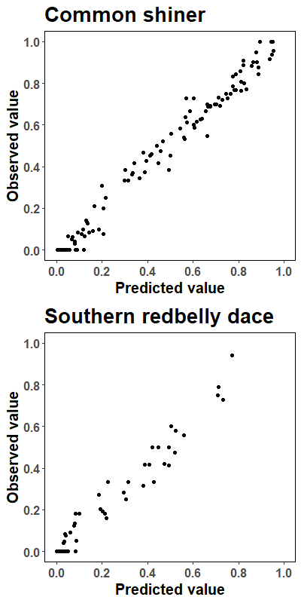
Appendix S3. A comparison between predictive and observed values from the results of generalized linear mixed models with a spatially explicit exponential correlation structure.

