Matrix quality determines the strength of habitat loss filtering on bird communities at the landscape scale

Authors: Melina de Souza Leite^{1*}, Andrea Larissa Boesing^{1,2}, Jean Paul Metzger¹ & Paulo Inácio Prado¹
1. Department of Ecology, University of São Paulo, Rua do Matão 321, T14, São Paulo, SP, 05508-090, Brazil
2. Senckenberg Biodiversity and Climate Research Institute (SBiK-F), Georg-Voigt-Straße 14, 60325 Frankfurt am Main, Hessen, Germany
* Corresponding author: melina.leite@ib.usp.br
Keywords: environmental filter, ecological drift, dispersal, functional traits, trait-environment relationship, community ecology, landscape structure.
Abstract: Habitat loss and fragmentation represent a major threat to biodiversity, however, the modulation of its effects by the non-habitat matrix surrounding habitat patches is still undervalued. The landscape matrix might change community assembly in different ways. For example, low-quality matrices can accentuate environmental filtering by reducing resource availability and/or deteriorating abiotic conditions but they may also over limit dispersal of organisms and make communities more prone to ecological drift. To understand how matrix quality modulates the effects of habitat loss, we quantified the relative importance of environmental filter and ecological drift in bird occurrences across both local and landscape gradients of habitat loss embedded in low- and high-quality matrices. We used a trait-based approach to understand habitat loss filtering effects on birds. We found that low-quality matrices, composed mainly of low-productive pasturelands, increased the severity of habitat loss filtering effects for forest specialist birds, but only at the landscape scale. Bird occurrence was in general higher in high-quality matrices, i.e., more heterogeneous and with low-contrasting edges, indicating the role of the matrix quality on attenuating species extinction risks at the landscape scale probably due to mass effect. Moreover, forest specialists presented a strong negative response to habitat loss filtering across different functional traits, while generalists presented a high variability in traits response to habitat loss. We raised evidence in supporting that landscape habitat loss filtering may be relaxed or reinforced depending on the quality of the matrix, evidencing that matrix quality has a strong impact in modulating community assembly processes in fragmented landscapes. In practical terms, it means that improving matrix quality may help in maintaining the high diversity of birds even without any increase in native forest cover.

Introduction
Anthropogenic habitat change is one of the most important drivers of biodiversity loss (Díaz et al. 2019). The division of habitats into smaller and more isolated fragments, separated by a non-habitat matrix of human-transformed land cover, alters not only the quantity but also the quality of the habitats in the landscape (Fischer & Lindenmayer 2007; Haddad et al. 2015). Much has been studied on how habitat loss and fragmentation impact biodiversity in terms of the community and species deterministic responses (environmental filtering) and random demographic events leading to stochastic changes in community composition (ecological drift) (Baselga et al. 2015; Pardini et al. 2017; Henckel et al. 2019). Nevertheless, the role of the landscape matrix in altering these deterministic and random assembly processes and thus the outcome of habitat loss on community composition is still unclear (Kupfer et al. 2006; Pardini et al. 2017).
The outcome of habitat loss and fragmentation on biodiversity may depend on how the matrix changes the relative importance of the assembly processes in the remaining habitat patches and the landscape (metacommunities sensu Leibold et al. (2004)). This knowledge is critical for mitigating the negative effects of global environmental change (Tscharntke et al. 2012; Kohli et al. 2018), especially given the vast diversity of ways humans modify landscapes and create different matrix contexts. However, it faces two main challenges: how to disentangle community assembly processes at different spatial scales, and how to characterize the matrix context in landscapes. First, community assembly processes in acting differently at local and landscape scales may result in different metacommunity arrangements (Leibold et al. 2004), which evidence the foreseen patterns of multidimensionality and scale-dependency of species richness (Chase et al. 2019) and biodiversity changes (Chase et al. 2018). One approach to disentangle community assembly processes is the use of species traits to elucidate mechanisms by which communities respond to environmental gradients (McGill et al. 2006; Cadotte et al. 2015). Such trait-environment associations proved to be critical in understanding how ecological processes affect biodiversity across scales (Newbold et al. 2013, 2014; Gilroy et al. 2015; Suárez-Castro et al. 2018). Therefore, trait-focused approaches may show how local environments and landscapes constrain diversity (Tscharntke et al. 2012), for example when the matrix influences trait diversity in habitat patches (Boesing et al. 2018a).
Second, a prolific way to characterize matrix context is by its quality for a target group of organisms. Matrix quality is context-dependent, since each species may perceive the matrix differently, but in general, it may be assumed as the structural similarity of the matrix with the native habitat (Prevedello & Vieira 2010). For instance, landscapes with high-quality matrices can maintain greater amounts and diversity of resources (Dunning et al. 1992; Pardini et al. 2009) which can be used occasionally by species living in patches (spillover; Blitzer et al. 2012). High-quality matrices can also facilitate species movement across the landscape leading to higher landscape connectivity (Antongiovanni & Metzger 2005; Fahrig 2007). Consequently, landscapes with high-quality matrices may support more species than the ones with matrices of lower quality (Carrara et al. 2015; Reider et al. 2018; Stjernman et al. 2019). Even though there is evidence that landscapes with matrices of better quality (e.g., more heterogeneous, less contrasting) permit higher species and trait diversity (Boesing et al. 2018a), the specific mechanisms are still unclear.
The matrix may change how habitat loss and fragmentation modulate community assembly processes through its effects on (1) organismal movements (Fahrig 2007; Watling et al. 2011; Biz et al. 2017), (2) the availability of supplementary or complementary resources in the landscape (Dunning et al. 1992; Boesing et al. 2021), and (3) abiotic edge conditions of habitat patches (edge effects, Saunders et al. 1991, Pardini et al. 2009, Pfeifer et al. 2017). When movements of organisms among habitat patches are heavily limited by the matrix, dispersal (sensu Vellend 2010) may be limited and, together with habitat loss, will lead to small and functionally isolated communities, which are more prone to ecological drift (Horváth et al. 2019; Siqueira et al. 2020). When matrix decreases resource availability in the landscape and/or accentuate unfavorable abiotic condition inside habitat patches (edge effects), habitat loss may be an even more severe environmental filter, selecting only those species able to persist under these harsher conditions (Chase 2007). By modulating these 3 mechanisms, matrix quality changes how habitat loss and fragmentation alter the relative importance of the assembly processes of dispersal (potentially leading to ecological drift) and environmental filtering. Moreover, given the scale-dependent nature of ecological communities (Chase et al. 2018), only a multiscale combined with a trait-based approach (Suárez-Castro et al. 2018) may help to identify the relative strength of such processes across both local and landscape scales.
In this study, we investigated whether and how matrix quality modulates the relative importance of assembly processes in bird communities across gradients of habitat loss. First, we hypothesize that the relative contribution of the assembly processes of habitat loss filtering and ecological drift will depend on (1) how dispersal is limited and (2) the harshness of the environmental filtering by matrices of different qualities. If bird dispersal is heavily limited by low-quality matrices, habitat loss will create small and isolated communities more prone to drift, which in turn will relatively decrease the importance of habitat loss filtering compared to landscapes with high-quality matrices. However, if the main effects of a low-quality matrix are in decreasing resource availability and/or deteriorating abiotic conditions in habitat patches, habitat loss will be an even more severe filter, increasing the relative importance of habitat loss filtering compared to high-quality matrix landscapes. Second, given that matrix quality is an element of the landscape, we expect that the effects of habitat loss filtering on species traits will be stronger at the landscape scale than at the local scale (hypothesis of landscape moderation of trait selection; Tscharntke et al. 2012). We compared results between forest specialist and forest generalist birds. Since specialists are considered more sensitive to habitat loss (Pardini et al. 2009; Carrara et al. 2015), habitat loss filtering should be stronger and negative for them. As forest generalists are commonly less affected by habitat loss or can even increase in abundance (Devictor et al. 2008; Nordberg & Schwarzkopf 2018), we predict a positive or null relationship of their traits to habitat loss.
To test our hypotheses and predictions, we modeled the occurrence of bird species in landscapes with different matrix quality using hierarchical models that are commonly used to analyze trait-environment associations (Pollock et al. 2012; Jamil et al. 2013; ter Braak 2019) and for disentangling scale-dependent community assembly processes (Ovaskainen et al. 2017; Poggiato et al. 2021). We used variance partitioning of the models (Nakagawa & Schielzeth 2013) to compare the relative importance of processes across assemblages. Habitat loss effects across scales were investigated by both habitat loss overall effect in birds’ occurrences and trait filtering effects. We also evaluated how much of the species response to habitat loss is explained by their traits, to understand how species traits are filtered in landscapes under different matrix contexts.

Methods

Study areas
The study was carried out in the Atlantic Forest of southeastern Brazil (Figure 1). Currently, the entire region detains less than 30% of the original forest cover (Rezende et al. 2018), and most of the forest is confined in small patches (< 50 ha) in different stages of regeneration (Ribeiro et al. 2009). Our study landscapes were constrained across two regions (far apart 90 km) detaining similar biophysical characteristics and bird species pool, but with different agricultural matrix compositions (details in Boesing et al. 2018). The northwest region (henceforth ‘high-quality matrix’) is mainly composed of a mosaic of sun-coffee, sugar cane plantations, and pastures, resulting in a more heterogeneous matrix. Coffee plantations cover around 46% of the matrix and it is usually located adjacent to forest edges, creating low-contrasting edges at the patch-scale (Figure 1A). The southeast region (henceforth ‘low-quality matrix’) is largely dominated by low-productive pastures and low diversity of other land use types, and so it is composed by a more homogeneous matrix. Additionally, the huge structural difference between pastures and forests creates high-contrasting edges at the patch scale (Figure 1B).
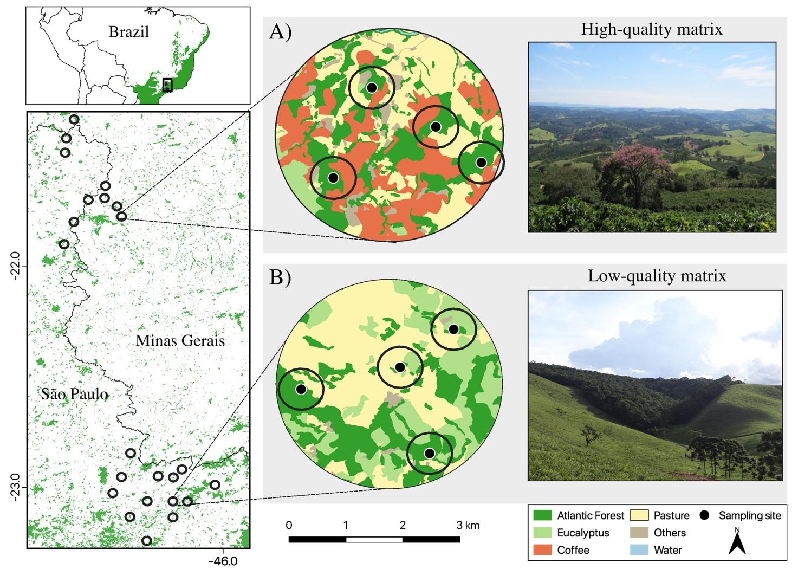
Figure 1: Location of the study area (left upper panel) within the Brazilian Atlantic Forest biome (in green) with 23 studied landscapes in southeastern Brazil (left lower panel). We show in (A) a landscape with 27% of native forest cover and high-quality matrix, which is more heterogeneous and have a high proportion of sun coffee plantations; and in (B) a landscape with the same forest cover but low-quality matrix mostly composed by low-productive pastures. Buffers of 400 m radios around sampling sites (black dots) composed the local scale, while the focal 2 km landscape with 4 sampling points composed the landscape scale.
We selected landscapes that span a gradient of landscape-level forest cover (2 km radius, 1256 ha each), while controlling for potentially confounding factors, following Pasher et al. (2013). We selected 10 and 13 focal landscapes in the high-quality (ranging from 7-46% of forest cover) and low-quality matrix (12-55% of forest cover) regions, respectively. In each landscape, we placed 4 sampling sites (total 96 sites) in forest patches in a way to cover different ranges of local forest cover inside the same landscape. See Appendix 1 and Boesing et al. (2018a) for more details about the area selection procedure.

Bird sampling and traits selection
In each sampling site, we performed a 50 m fixed radius point count (Bibby et al. 2000) and recorded all bird species detected visually or aurally during a 15 min sampling period. Each point count was visited four times, between January–April and August–November of 2014 (N=368). Both regions were sampled simultaneously. See Appendix 1 for more descriptions about the bird sampling and community.
Bird traits selection was similar to the framework proposed by Luck et al. (2012). First, we listed the potential traits based on current knowledge on bird traits related to extinction-proneness due to habitat loss, land use, or environmental change (references in Appendix 2). Then, we selected the traits based on the (1) data availability (considering mainly Wilman et al. 2014, Boesing et al. 2018, Rodrigues et al. 2019); (2) experts’ knowledge (ALB); and (3) the empirical relationship among traits (correlations). Finally, we selected four groups of response traits (sensu Violle et al. 2007) that are known to affect individual fitness by influencing growth, reproduction, or survival of the species on human-modified landscapes: body size, nest type, diet, and foraging stratum. These traits were represented by seven operational variables described in detail in Appendix 2.
The classification of the species concerning their habitat specialization (forest specialists and forest generalists, henceforth just specialists and generalists) could be also considered a life history trait (e.g., Newbold et al. 2013). However, because habitat specialization is very important for understanding the effects of habitat loss and fragmentation (Owens & Bennett 2000; Pandit et al. 2009; Kupsch et al. 2019), we kept separate analyses for specialists and generalists. Moreover, as both groups of species presented the same range of trait values on our data (Appendix 2), we also investigated if the same trait differs in response to habitat loss depending on species habitat specialization.

Modeling
To test our hypotheses and predictions, we modeled bird occurrences with hierarchical linear models commonly used to analyze trait-environment associations and disentangle scale dependency in community assembly processes (Pollock et al. 2012; Jamil et al. 2013; ter Braak 2019; Poggiato et al. 2021). We used a binomial generalized linear mixed model (logit link function) with the number of detections of each of n species (four visits) in each of m sites as response variable (Miller et al. 2018). In each species-site combination ($Y_{i}$, where i goes from 1 to n x m observations), we assigned predictors of the n species-level trait and the m site- and landscape-level forest cover (Miller et al. 2018). Following the convention of mixed models (Gelman et al. 2007; Miller et al. 2018), our model is described by:
$$Y_{i}∼Binomial\left(4,p\right)$$
$$logit\left(p\right)=\left(α+a_{spp\left[i\right]}+b_{site\left[i\right]}+c_{landscape\left[i\right]}\right)+\left(β_{1}+d_{spp\left[i\right]}\right){{forest}_{cover}}_{site\left[i\right]}+$$
${\left(β_{2}+e_{site\left[i\right]}+f_{landscape\left[i\right]}\right){trait}_{spp\left[i\right]}+β}_{12}{trait}_{spp\left[i\right]}×{{forest}_{cover}}_{site\left[i\right]}$ + (1)
$$g_{site\left[i\right]×spp\left[i\right]}+h_{landscape\left[i\right]∗spp\left[i\right]}$$
where $Y_{i}$ is the observed occurrence for each of the $i$ species-site combination (species n in site m). Fixed effects are represented in Greek and random effects in Latin letters. All random effect terms are represented by a normal distribution with mean zero and their respective estimated variances ($σ_{a}^{2}$, $σ_{b}^{2},σ_{c}^{2}$, $σ_{d}^{2}$, $σ_{e}^{2}$, $σ_{f}^{2}$,$σ_{g}^{2}$,$σ_{h}^{2}$). Terms with random intercept and slope have additional parameters denoting the correlation between them ($ρ_{ad},ρ_{be},ρ_{cf}$). The model’s formula syntax the lme4 R package (Bates et al. 2015) is:
Y ~ trait*forest_cover + (forest_cover|species) + (trait|site) + (trait|landscape) + (1|landscape:species) + (1|landscape:site)
The fixed effects in the logit link function are the main effects of habitat loss (represented by forest cover) and trait ($α,β_{1},β_{2}$ and habitat loss filtering effects through traits (interaction term $β_{12}$). We used the percentage of forest cover at both local and landscape scales as response variables to denote habitat loss and we found no collinearity between these variables (Appendix 2). We are particularly interested in: (1) the main effects of habitat loss, i.e., how steep is the decrease in occurrence probability of all birds when habitat is lost, and (2) the interaction effect of habitat loss with traits, i.e., how species with different traits will respond to habitat loss. However, these effects are not statistically easily separable from the effects of trait values in terms of variance explained (R², Johnson 2014). As we show below, we kept the whole structure of fixed effects in interpreting marginal R² as a general interpretation of habitat loss effects. Nevertheless, we also compared the estimates of habitat loss main effects among assemblages and across scales and calculated the importance of the traits in explaining habitat loss filtering (equation 2, below) to interpreting habitat loss filtering effects through traits.
Species random effects are the variation among species in their overall abundances (random intercept, $a_{spp\left[i\right]}$) and response to habitat loss (random slope${,d}_{spp\left[i\right]}$;) regardless of its trait values. They mean the idiosyncratic response of each species to habitat loss and their differences in overall abundances. Trait-site and trait-landscape random interactions (random intercepts: $b_{site\left[i\right]}$, $c_{landscape\left[i\right]}$, and slopes: $e_{site\left[i\right]}$, $f_{landscape\left[i\right]}$) deal with the trait-mediated response to non-measured environmental gradients at local and landscape scales, respectively. This is a solution to "account for any interaction that the observed trait has with any unobserved environmental gradient" (ter Braak 2019).
We included two additional random effects of site-species ($g_{site\left[i\right]×spp\left[i\right]}$), and landscape-species interactions ($h_{landscape\left[i\right]×spp\left[i\right]}$ to express that occurrence probability of the same species may vary among sites and landscapes, regardless of the species identity, its traits, and the environment (habitat loss gradients), i.e. random variation in species occurrences probabilities across sites and landscapes. In our model, the site-species interaction term is the so-called Observation Level Random Effect (OLRE), which allows for extra variance among observations. OLRE is generally used to deal with overdispersion in data modeling with the exponential family distributions (Harrison 2014, 2015). For species occurrences, overdispersion is frequently associated with individuals’ aggregations in space (Elston et al. 2001; Ozgul et al. 2009). In this sense, at the community level, we can assume that the spatial aggregation expressed by these terms is a result of differential dispersal, which may be limitation or excess of dispersal. For instance, dispersal limitation of individuals among patches and landscapes leads to ecological drift (sensu Vellend 2010). We cannot ensure that all the variances apportioned in these terms are exactly differential dispersal. However, because we have carefully handled many possible niche processes (or selection sensu Vellend 2010) in the model, probably, these terms do not include other processes than random variation in species occurrence probabilities. At least, if differential dispersal among patches and landscapes is an important process, it will be expressed in these two random effects and not in the other terms.
To express the importance of traits in explaining habitat loss filtering we calculated the proportional decrease in the variance of the species random slope of forest cover ($d_{spp\left[i\right]}$) when we include the trait-forest cover interaction term ($β_{12}$) in the model (Jamil et al. 2013):
$C_{β}=1−\frac{d_{spp\left[i\right]}\left(res\right)}{d_{spp\left[i\right]}\left(total\right)}$ (2)
$d_{spp\left[i\right]}\left(res\right)$ is the variance of the random species slope from the model with forest cover and trait main effects ($β_{2}$) and the trait-environment interaction ($β_{12}$); $d_{spp\left[i\right]}\left(total\right)$ is the same variance term for the model without trait-environment interaction but with the main effects. This proportion explains how much of the effect of habitat loss on each species can be explained by their trait values.
We computed overall R² for the models by the additive variance partitioning method (Nakagawa & Schielzeth 2013; Johnson 2014; Nakagawa et al. 2017), which is appropriate for comparing models fit to different data sets because it does not depend on sample size (Ives 2019). We also apportioned the total variance among the model terms (marginal R² sensu Ives 2019) to compare the relative importance of processes across assemblages. We calculated the overall and marginal R² on the scale of the link function (logit) since it can decouple variance and mean so that the linked scale R² can be calculated independent of the population mean (Nakagawa & Schielzeth 2010).
Table 1: Definitions and ecological interpretations of the statistical terms of the hierarchical linear model (equation 1).
Model terms  (equation 1) | Code* | Description
$$α;β_{1};β_{2};β_{12}$$ | trait*for_cov | Fixed effects: main effects of habitat loss and traits, and habitat loss filtering effects through traits (interaction terms) at both local and landscape scale.
$a_{spp\left[i\right]}$; $d_{spp\left[i\right]}$ | (for_cov|sp) | Random effects: variation among species in their overall occurrences (intercept) and response to habitat loss (slope) regardless of its traits. It is the idiosyncratic response of each species to habitat loss and their differences in overall abundances.
$b_{site\{i\}}$; $e_{site}$  $c_{landscape\left[i\right]}$; $f_{landscape\left[i\right]}$ | (trait|site)  (trait|lands) | Random effects: interaction (random intercept and slope) between trait values and sites/landscapes. It is the possible relationship of the measured trait with any unmeasured environmental variable at the site/landscape level. Trait-mediated response to other environmental gradients at local/landscape scale.
$g_{spp\left[i\right]×landscape\left[i\right]}$ | (lands:sp) | Random effects: overdispersion term indicating random variation in species occurrences across landscapes, regardless of its traits and environmental conditions.
$h_{spp\left[i\right]×site\left[i\right]}$ | (site:sp) | Random effects: overdispersion term indicating random variation in species occurrences across sites, regardless of its traits and environmental conditions.
* R syntax code following lme4 package (Bates et al. 2015).

Data analysis
We ran the model described above for each low and high-quality matrix landscapes and for forest specialists and generalists separately (hereafter assemblages) to better interpret and compare overall and marginal R²s among assemblages. We analyzed the data in two steps. First, given that ecological responses can be affected by processes acting at different spatial scales (Jackson & Fahrig 2015), we selected the best scale for the effect of local forest cover (details in Appendix 2). We chose the percentage of local forest cover measured at 400 m buffer radius around each site (Figure 1). Second, we ran separate models for each species trait (equation 1) including local and landscape forest cover (2 km radius around the centroid of the landscapes) as predictors of habitat loss. We finally combined 4 traits with the highest explanatory power for all datasets (main diet, proportion of lower strata use, body mass, and nest type) in one model to predict the trait's response to habitat loss and to compare the marginal R² of each model term. The combined traits models did not show collinearity and the traits were not correlated among species (Appendix 3).
All data analysis was performed using R (R Core Team 2019) with lme4 package (Bates et al. 2015) for modeling, and DHARMa (Hartig 2018) for quantile residuals diagnostic. See Appendix 3 for models’ implementation and diagnostic.

Results
In our modeling approach, the R² of the fixed effects – trait, habitat loss, and filtering effects at both local and landscape scales – was the variance component that had the most marked differences between specialist assemblages (Figure 2). It was 2.2 times higher for the specialists in the low-quality than in the high-quality matrix landscapes (22 and 10%, respectively), and it was up to 3 times higher for specialists than for both generalist assemblages (7-8%). It means that habitat loss effects alone and habitat loss filtering effects were much stronger for the specialist birds in low-quality matrix landscapes. Moreover, overall R² for specialists in low-quality matrix landscapes captured most of the variability in bird’s occurrence (72%), followed by specialists in high-quality matrices (58%) (Figure 2). Overall R² for generalists was smaller and similar across landscapes regardless of matrix quality (46-47%).
The R² for the terms that account for random variation in species occurrences across sites (site:sp), were very low (1%) for all assemblages. However, the R² for random variation in species occurrences at the landscape scale (lands:sp) was almost 2 times larger for the specialists in high-quality matrices than for the specialists in low-quality matrices, and it was much larger for specialists (4-7%) than generalists (1-2%). Therefore, specialists in high-quality matrices have higher random variation in species occurrences among landscapes than in low-quality matrices.
The terms that express the variation among species in their overall abundances and responses to habitat loss regardless of their traits (random intercept and slope: env|sp) presented the highest marginal R² for all assemblages, ranging from 32 to 40%, and being about 1.3 higher for the specialists than for the generalists. Similarly, marginal R² of the terms that express the effects of species traits associated with unmeasured environmental variables (trait|site and trait|land) were very low, and together they varied between 3 to 5% in all assemblages.

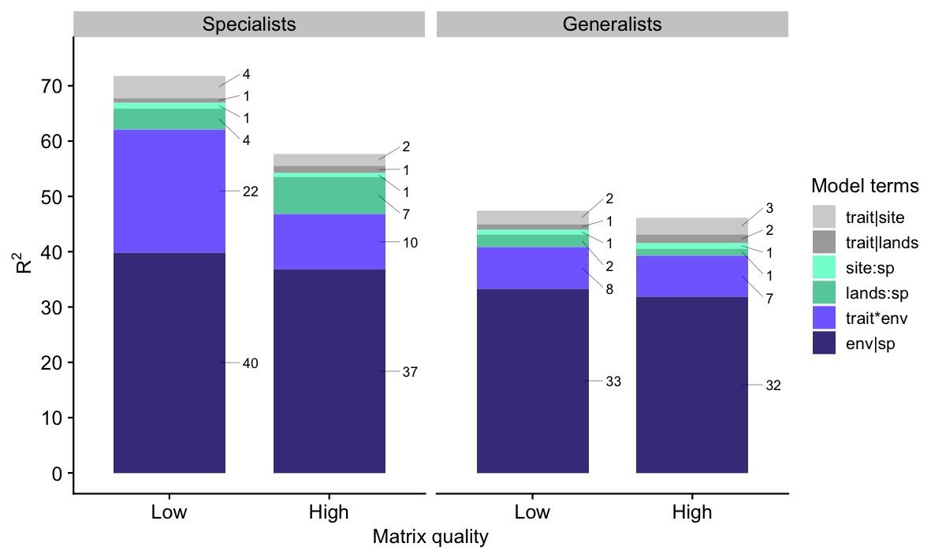
Figure 2: Overall and marginal R²s for the models with combined traits (body mass, type of nest, main diet, percentage of lower strata use) for forest generalist and forest specialists in high and low-quality matrix landscapes. The number on the right side of each bar indicates the percentages for each term. See Table 1 for model terms definitions.
In comparing habitat loss effects across scales, we found that the effects of both local and landscape habitat loss in bird occurrence were stronger for the specialists in low-quality matrix landscapes (Figure 3). While local forest cover presented similar and positive effects on bird occurrences for specialists in both high- and low-quality matrix landscapes, landscape forest cover presented a strong effect only for specialists in low-quality matrix landscapes, where this effect was larger than for local forest cover. As expected, the effects of habitat loss for generalists were generally weaker and irrelevant at any scale.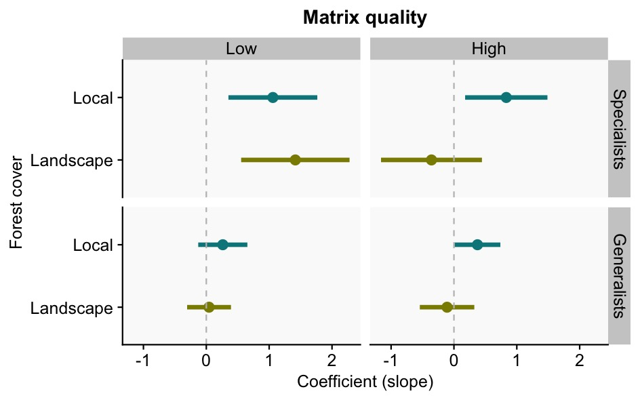

Figure 3: Slope coefficients (and 95% confidence intervals) of local and landscape forest cover for specialist and generalist birds in different matrix quality landscapes. These are results for the combined model (equation 1) with the traits: main diet, nest type, body mass and proportion of lower strata use. See Appendix 3 for a table of all coefficients estimated for each assemblage.
The importance of species traits explaining habitat loss filtering was higher for the assemblages in low-quality matrices (Figure 4, combined traits model). Trait importance for the generalists in low-quality matrix landscapes explained 26% of the variability in species response to habitat loss. For the specialists, trait importance varied between 17 and 22%, and for the generalist in high-quality landscapes, it was only 14%. In general, nest type and main diet presented the highest values of trait importance for the assemblages (Figure 4).
Bird occurrence probabilities were in general higher for the assemblage in high-quality compared to low-quality matrix landscapes (Figure 5). For specialists, all the traits were associated with a decrease in occurrence probabilities with habitat loss. For generalists, trait-habitat loss relationships changed according to the trait. For example, generalists of closed nests responded positively to habitat loss, while those that nest in cavities responded negatively and generalists of open nests almost did not change with habitat loss (Figure 5). Nevertheless, occurrence probabilities of frugivores, species that build nests in cavities, and large birds decreased with habitat loss regardless of the matrix type and habitat specificity (Figure 5).
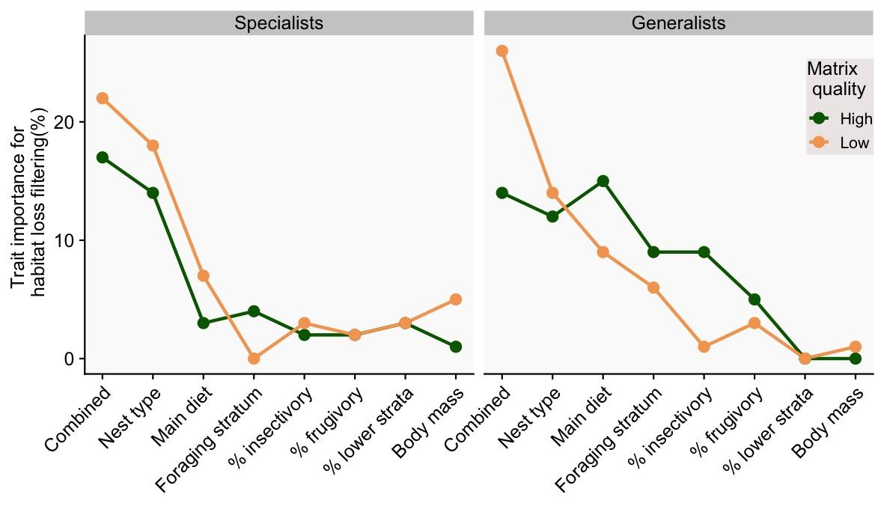
Figure 4: Importance of species traits in explaining habitat loss filtering (equation 2) for forest-specialists and forest-generalists according to matrix quality. Trait importance was calculated for each trait in separate models and for the combined model, which includes, nest type, main diet, body mass, and percentage of lower strata use. 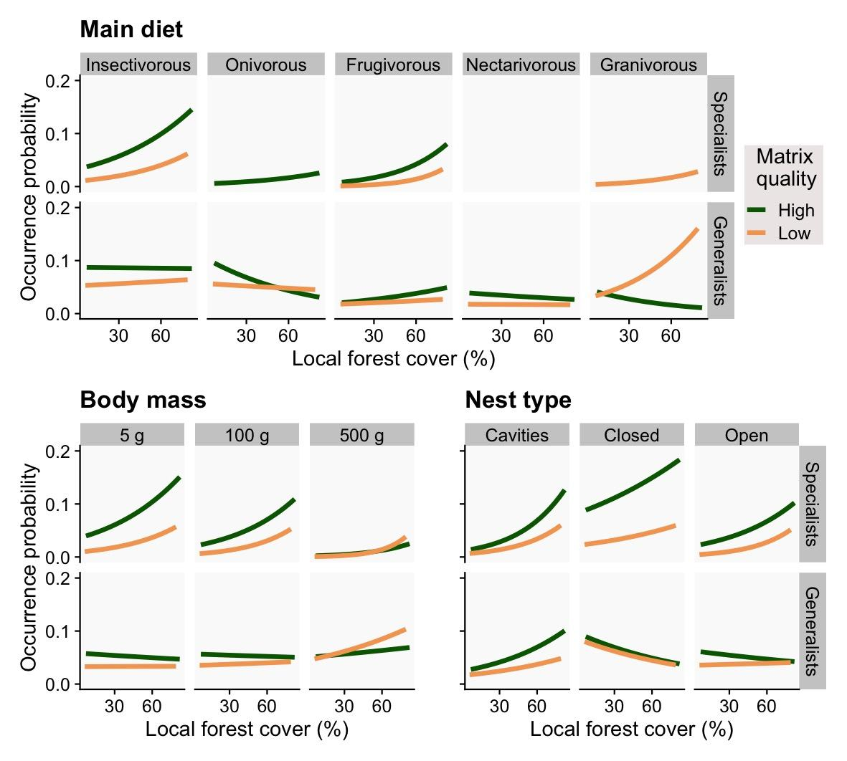Figure 5: Probabilities of occurrence of species with local forest cover (400 m buffer; %) according to main diet, body mass, and nest type for forest specialists and generalists in both high (green lines) and low-quality matrices (yellow lines). For the predictions, landscape forest cover was fixed at 30%.

Discussion
Here, we aimed to understand how the quality of the matrix surrounding habitat patches modulates the relative importance of assembly processes in bird communities across local and landscape gradients of habitat loss. We found that landscapes with low-quality matrices, composed mainly of low-productive pasturelands, increased the severity of habitat loss filtering effects for forest specialist birds (Figure 2), with habitat loss effects at the landscape scale (Figure 3) and habitat loss filtering effects through species traits (Figure 4) being much stronger in those landscapes. In high quality-matrix landscapes (more heterogeneous and with low-contrasting edges), birds’ occurrences were in general larger with more random variation among landscapes (evidence for larger differential dispersal). Both results indicate the role of matrix quality in attenuating extinction risks in the landscape, allowing species that would have been extinct due to habitat loss. As expected, forest specialists presented a stronger response to habitat loss filtering, displaying a consistent negative relationship of all traits (diet, nest type, foraging stratum, and body size) with local habitat loss, while generalists presented a high variability in traits response to habitat loss (Figure 5).

Matrix quality modulating the relative importance of habitat loss across scales
We found that matrix quality modulates habitat loss effects only for specialist birds at the landscape scale. Local habitat amount effects on birds were not dependent on the quality of the matrix. At the landscape scale, filtering processes are usually related to the selection of species according to landscape composition and configuration (Duflot et al. 2014; Suárez-Castro et al. 2018). Landscapes composed of low-quality matrices may decrease the availability of supplementary and complementary resources in the matrix (Dunning et al. 1992; Boesing et al. 2021) and/or deteriorate abiotic conditions in habitat edges (Saunders et al. 1991; Pardini et al. 2009; Pfeifer et al. 2017). These two mechanisms together with habitat loss may create an even more severe environmental filter for the communities, selecting only those species able to persist under new harsh conditions (Chase 2007). Our results for the specialist birds support this hypothesis of lower-quality matrices increasing severity of habitat loss filtering by showing: (1) a 2-times larger relative importance of habitat loss, traits, and filtering effects, with consequently (2) a stronger habitat loss effect, and (3) higher importance of traits in habitat loss filtering. In addition, there is evidence in our study system that the high-quality matrices, especially sun-coffee plantations, are serving as a source of complementary resources for biodiversity due to the movement of organisms from forest patches to the matrix for foraging (cross-habitat spillover, Boesing et al. 2018b, 2021).
Additionally, landscapes composed of low-quality matrices may hinder dispersal among patches or decrease the survival rate of dispersing individuals (Fahrig 2007; Watling et al. 2011; Biz et al. 2017). By that, dispersal limitation would create functionally isolated communities more prone to ecological drift (e.g., Baselga et al. 2015, Siqueira et al. 2020), which, in turn, would decrease species filtering effects by habitat loss. However, our results pointed to another direction, as we found that habitat loss filtering through traits was stronger in low-quality matrix landscapes. We believe that in our study system, dispersal limitation is not an issue for the forest birds in both matrix landscapes, as the marginal R²s for the differential dispersal (Figure 2, lands:sp term) were relatively low. However, the differential dispersal term was 2 times higher in relative importance (R²) for the specialists in the high-quality matrix, indicating that there may be not a limitation but an excess of dispersal in high-quality matrices – possibly resulting in source-sink dynamics (Mouquet & Loreau 2003). High-quality matrix landscapes with higher dispersal rates, more resource availability, and milder edge effects may be preventing extinctions of isolated populations by migration of individuals from other patches (mass effect in metapopulation theory, Leibold et al. 2004). This mechanism would weaken the deleterious effects of habitat loss, allowing the survival of species that are not optimally suited for the new environmental conditions (Leibold & Loeuille 2015).

Habitat loss filtering depends on the quality of the matrix
The importance of species traits in explaining habitat loss filtering effects was higher for the assemblages in low-quality matrices for both generalists and specialists (Fig. 4), evidencing stronger filtering effects in low-quality matrix landscapes as discussed above. We found that specialist birds with certain traits, e.g., small-sized, insectivorous, or birds with closed nests, were more prone to extinction due to habitat loss in landscapes embedded in low-quality matrices than species with the same traits in high-quality matrices (Fig. 5). This indicates further that habitat loss has different filtering effects (stronger or weaker) over species traits depending on the quality of the matrix. Such changes might be related to further effects of the matrix changing specific niches required by different species in-patches, mostly via edge-effects on both biotic and abiotic patterns (Murcia 1995). For instance, species that make nests in cavities or build closed nests are safer against parasitism and predation (Sibly et al. 2012), which are among the most impacting drivers of bird populations’ decline in fragmented landscapes (Cavitt & Martin 2002). As nest predation/parasitism often increases with edge effects (Murcia 1995), it may be stronger in landscapes with highly contrasting matrices, i.e., lower quality. However, this difference among matrices of different quality vanishes in low forest cover (less than 30%) for species that nest in cavities, even though they have higher occurrence probabilities for larger forest cover (~60%) in high-quality matrix landscapes. It may be the case that the lack of suitable nesting cavities under low forest cover amounts have a similarly strong effect on the reproduction of these species in both landscape types, especially for Picidae and Psittacidae families, which require old or dead trees to build their nests (Sick 1997).
Because we were able to compare the same set of traits for forest generalist and specialist species, we can understand better why habitat loss and fragmentation not necessarily leads to loss of functional diversity (Boesing et al. 2018a), change in functional traits (de Coster et al. 2015), or even functional homogenization (Devictor et al. 2008; Clavel et al. 2011; Nordberg & Schwarzkopf 2018). If specialists are replaced by generalists with similar trait values, functional differences cannot be easily observed, and thus no apparent functional differences are seen, as often reported (de Coster et al. 2015; Boesing et al. 2018a). However, we also found that species with some specific traits (such as nest type and body size) were always negatively impacted by habitat loss. This finding raises the point that not all forest generalist species succeed in fragmented landscapes, and that some key functions and/or species may be indeed lost with no substitution of traits when specialists are replaced by generalists. Overall, our results reinforce the evidence that habitat loss and matrix harshness promote abiotic environmental changes inside habitat patches which make species with specific traits to be more prone to extinction than others under different matrix conditions in the landscapes.

Theoretical and practical implications
Despite a long-standing global research effort into understanding how habitat loss and fragmentation influence species loss, and at which spatial scale species loss is observed (Horváth et al. 2019), there is still a considerable debate on which mechanisms are more important (Fahrig 2013, 2017; Haddad et al. 2015; Hanski 2015; Fletcher et al. 2018). Our findings raised evidence supporting that habitat loss is a strong filtering process that often leads more vulnerable species to extinction (Gilbert et al. 2006; Banks-Leite et al. 2012; Püttker et al. 2015; Pardini et al. 2017), but with a considerable influence of the matrix in modulating filtering processes. We have evidenced the importance of the matrix quality in modulating habitat loss effects at the landscape scale, weakening or strengthening its severity on species filtering (Chase 2007). Matrices of low quality accentuate habitat loss filtering in fragmented landscapes through its relatively larger effects in altering resource availability and edge effects, more than movement limitation. Consequently, the larger severity of habitat loss filtering in low-quality matrix landscapes decreases the relative importance of ecological drift on those assemblages.
Statistical quantification of the effects of dispersal and ecological drift is still an unresolved methodological problem with many caveats (Vellend et al. 2014). In our framework, we chose to handle possible effects of differential dispersal through terms that would take the extra variability of the data (overdispersion) produced by differences in species occurrences across sites and landscapes. This way, we saw that dispersal limitation in low-quality matrices leading to drift is not the only possible outcome after habitat loss and fragmentation. High rates of dispersal in high-quality matrix landscapes can even override environmental filtering by allowing species to occupy habitat patches where their intrinsic growth rate would be otherwise negative (Chase et al. 2020). To our knowledge, this is the first empirical evidence that a not limited dispersal in high-quality matrices may result in mass effects in metacommunities in fragmented landscapes, although its effects are relatively small in comparison with environmental filtering.
In practical terms, improving matrix quality in fragmented landscapes is a key action aiming to restore and achieve more sustainable landscapes (Leite et al. 2013; Arroyo-Rodríguez et al. 2020), especially in places where conservation practices and restoration are constrained by economic and political conflicts, are costly-demanding and requires strategic planning (Metzger et al. 2021). In this sense, converting low-productive pastures into more heterogeneous environments via tree enrichment (Prevedello et al. 2018), or converting such pastures (even if partially) in less contrasting land uses (such as diversified crops, perennial crops, or even tree plantations) can increase matrix quality, minimizing the severity of habitat loss and fragmentation for forest birds (Ruffell et al. 2017). In our study areas, the conversion of abandoned and unproductive pasturelands into silviculture in the last decades was responsible for the increase in second-growth native forests (Calaboni et al. 2018). Restoration and economic practices improving matrix quality may help in maintaining the high diversity of birds in the Atlantic Forest even without any increase in native forest cover.

Supporting information
APPENDIX 1: Extended methods, bird assemblages, and species trait selection
APPENDIX 2: Forest cover at local and landscape scales
APPENDIX 3: Additional models results and diagnostic
Data archiving: All data and code used in the analysis are available in Zenodo (http://doi.org/10.5281/zenodo.5516704) with the published version of the GitHub repository. The original data is also available in the Dryad Digital Repository: http://dx.doi.org/10.5061/dryad.37s4h (Boesing et al. 2017).
Conflicts of interest: We declare no conflict of interest.
Ethics and permits: Permission for the data collection was obtained from the Brazilian Institute of Environment and Renewable Natural Resources (IBAMA) under SISBIO number 46697-1.
Funding: The data from this study comes from the Interface project supported by the São Paulo Research Foundation (FAPESP, 2013/23457-6) with additional support from The Rufford Foundation (grant number 14223-1).
Acknowledgements: We thank Alexandre Adalardo de Oliveira and Tadeu Siqueira for important suggestions and discussions during the project development. We also thank all the researchers involved in the Interface project form the Laboratory of Landscape Ecology and Conservation (University of São Paulo). Júlia Barreto, Sara Mortara, Danilo Muniz, Diogo Borges Provete, and Pedro Peres-Neto for the early review of the manuscript.
Author Contributions: M.S.L., A.L.B. and P.I.P. conceived the project. A.L.B. and J.P.M delineated the sampling design. A.L.B. collected the data. M.S.L. and P.I.P. analyzed the data and wrote the manuscript. All authors provided substantial revisions and comments of the manuscript.

References
Antongiovanni, M. & Metzger, J.P. (2005). Influence of matrix habitats on the occurrence of insectivorous bird species in Amazonian forest fragments. Biological Conservation, 122, 441–451.
Arroyo-Rodríguez, V., Fahrig, L., Tabarelli, M., Watling, J.I., Tischendorf, L., Benchimol, M., et al. (2020). Designing optimal human-modified landscapes for forest biodiversity conservation. Ecology Letters, 23, 1404–1420.
Banks-Leite, C., Ewers, R.M. & Metzger, J.P. (2012). Unraveling the drivers of community dissimilarity and species extinction in fragmented landscapes. Ecology, 93, 2560–2569.
Baselga, A., Bonthoux, S. & Balent, G. (2015). Temporal beta diversity of bird assemblages in agricultural landscapes: land cover change vs. stochastic processes. PLOS ONE, 10, e0127913.
Bates, D., Mächler, M., Bolker, B. & Walker, S. (2015). Fitting linear mixed-effects models using lme4. Journal of Statistical Software, 67, 1–48.
Biz, M., Cornelius, C. & Metzger, J.P.W. (2017). Matrix type affects movement behavior of a Neotropical understory forest bird. Perspectives in Ecology and Conservation, 15, 10–17.
Blitzer, E.J., Dormann, C.F., Holzschuh, A., Klein, A.-M., Rand, T.A. & Tscharntke, T. (2012). Spillover of functionally important organisms between managed and natural habitats. Agriculture, Ecosystems & Environment, 146, 34–43.
Boesing, A.L., Marques, T.S., Martinelli, L.A., Nichols, E., Siqueira, P.R., Beier, C., et al. (2021). Conservation implications of a limited avian cross-habitat spillover in pasture lands. Biological Conservation, 253, 108898.
Boesing, A.L., Nichols, E. & Metzger, J.P. (2017). Data from: Biodiversity extinction thresholds are modulated by matrix type. Dryad, Dataset, https://doi.org/10.5061/dryad.37s4h.
Boesing, A.L., Nichols, E. & Metzger, J.P. (2018a). Biodiversity extinction thresholds are modulated by matrix type. Ecography, 41, 1520–1533.
Boesing, A.L., Nichols, E. & Metzger, J.P. (2018b). Land use type, forest cover and forest edges modulate avian cross-habitat spillover. Journal of Applied Ecology, 55, 1252–1264.
ter Braak, C.J.F. (2019). New robust weighted averaging- and model-based methods for assessing trait–environment relationships. Methods in Ecology and Evolution, 10, 1962–1971.
Cadotte, M.W., Arnillas, C.A., Livingstone, S.W. & Yasui, S.-L.E. (2015). Predicting communities from functional traits. Trends in Ecology & Evolution, 30, 510–511.
Calaboni, A., Tambosi, L.R., Igari, A.T., Farinaci, J.S., Metzger, J.P. & Uriarte, M. (2018). The forest transition in São Paulo, Brazil: historical patterns and potential drivers. Ecology and Society, 23, 7.
Carrara, E., Arroyo-Rodríguez, V., Vega-Rivera, J.H., Schondube, J.E., de Freitas, S.M. & Fahrig, L. (2015). Impact of landscape composition and configuration on forest specialist and generalist bird species in the fragmented Lacandona rainforest, Mexico. Biological Conservation, 184, 117–126.
Cavitt, J.E. & Martin, T.E. (2002). Effects of forest fragmentation on brood parasitism and nest predationin eastern and western landscapes. Studies in Avian Biology, 73–80.
Chase, J.M. (2007). Drought mediates the importance of stochastic community assembly. PNAS, 104, 17430–17434.
Chase, J.M., Jeliazkov, A., Ladouceur, E. & Viana, D.S. (2020). Biodiversity conservation through the lens of metacommunity ecology. Ann. N.Y. Acad. Sci., 1469, 86–104.
Chase, J.M., McGill, B.J., McGlinn, D.J., May, F., Blowes, S.A., Xiao, X., et al. (2018). Embracing scale-dependence to achieve a deeper understanding of biodiversity and its change across communities. Ecology Letters, 21, 1737–1751.
Chase, J.M., McGill, B.J., Thompson, P.L., Antão, L.H., Bates, A.E., Blowes, S.A., et al. (2019). Species richness change across spatial scales. Oikos, oik.05968.
Clavel, J., Julliard, R. & Devictor, V. (2011). Worldwide decline of specialist species: toward a global functional homogenization? Frontiers in Ecology and the Environment, 9, 222–228.
de Coster, G., Banks-Leite, C. & Metzger, J.P. (2015). Atlantic forest bird communities provide different but not fewer functions after habitat loss. Proceedings of the Royal Society B: Biological Sciences, 282, 20142844.
Devictor, V., Julliard, R., Clavel, J., Jiguet, F., Lee, A. & Couvet, D. (2008). Functional biotic homogenization of bird communities in disturbed landscapes. Global Ecology and Biogeography, 17, 252–261.
Díaz, S., Settele, J., Brondízio, E.S., Ngo, H.T., Agard, J., Arneth, A., et al. (2019). Pervasive human-driven decline of life on Earth points to the need for transformative change. Science, 366, eaax3100.
Duflot, R., Georges, R., Ernoult, A., Aviron, S. & Burel, F. (2014). Landscape heterogeneity as an ecological filter of species traits. Acta Oecologica, 56, 19–26.
Dunning, J.B., Danielson, B.J. & Pulliam, H.R. (1992). Ecological processes that affect populations in complex landscapes. Oikos, 65, 169.
Elston, D.A., Moss, R., Boulinier, T., Arrowsmith, C. & Lambin, X. (2001). Analysis of aggregation, a worked example: numbers of ticks on red grouse chicks. Parasitology, 122, 563–569.
Fahrig, L. (2007). Non-optimal animal movement in human-altered landscapes. Functional Ecology, 21, 1003–1015.
Fahrig, L. (2013). Rethinking patch size and isolation effects: the habitat amount hypothesis. Journal of Biogeography, 40, 1649–1663.
Fahrig, L. (2017). Ecological Responses to Habitat Fragmentation per se. Annual Reviews of Ecology, Evolution and Systematics, 48.
Fischer, J. & Lindenmayer, D.B. (2007). Landscape modification and habitat fragmentation: a synthesis. Global Ecol Biogeography, 16, 265–280.
Fletcher, R.J., Didham, R.K., Banks-Leite, C., Barlow, J., Ewers, R.M., Rosindell, J., et al. (2018). Is habitat fragmentation good for biodiversity? Biological Conservation, 226, 9–15.
Gelman, A., Gelman, P. in the D. of S.A. & Hill, J. (2007). Data Analysis Using Regression and Multilevel/Hierarchical Models. Cambridge University Press.
Gilbert, B., Laurance, W.F., Leigh Jr., E.G. & Nascimento, H.E.M. (2006). Can neutral theory predict the responses of amazonian tree communities to forest fragmentation? The American Naturalist, 168, 304–317.
Gilroy, J.J., Uribe, C.A.M., Haugaasen, T. & Edwards, D.P. (2015). Effect of scale on trait predictors of species responses to agriculture. Conservation Biology, 29, 463–472.
Haddad, N.M., Brudvig, L.A., Clobert, J., Davies, K.F., Gonzalez, A., Holt, R.D., et al. (2015). Habitat fragmentation and its lasting impact on Earth’s ecosystems. Sci. Adv., 1, e1500052.
Hanski, I. (2015). Habitat fragmentation and species richness. Journal of Biogeography, 42, 989–993.
Harrison, X.A. (2014). Using observation-level random effects to model overdispersion in count data in ecology and evolution. PeerJ, 2, e616.
Harrison, X.A. (2015). A comparison of observation-level random effect and Beta-Binomial models for modelling overdispersion in Binomial data in ecology & evolution. PeerJ, 3, e1114.
Hartig, F. (2018). DHARMa: Residual Diagnostics for Hierarchical (Multi-Level / Mixed) Regression Models. R package version 0.2.0.
Henckel, L., Meynard, C.N., Devictor, V., Mouquet, N. & Bretagnolle, V. (2019). On the relative importance of space and environment in farmland bird community assembly. PLOS ONE, 14, e0213360.
Horváth, Z., Ptacnik, R., Vad, C.F. & Chase, J.M. (2019). Habitat loss over six decades accelerates regional and local biodiversity loss via changing landscape connectance. Ecology Letters, 22, 1019–1027.
Ives, A.R. (2019). R2s for Correlated Data: Phylogenetic Models, LMMs, and GLMMs. Syst Biol, 68, 234–251.
Jackson, H.B. & Fahrig, L. (2015). Are ecologists conducting research at the optimal scale? Global Ecology and Biogeography, 24, 52–63.
Jamil, T., Ozinga, W.A., Kleyer, M. & ter Braak, C.J.F. (2013). Selecting traits that explain species–environment relationships: a generalized linear mixed model approach. Journal of Vegetation Science, 24, 988–1000.
Johnson, P.C.D. (2014). Extension of Nakagawa & Schielzeth’s R2GLMM to random slopes models. Methods in Ecology and Evolution, 5, 944–946.
Kohli, B.A., Terry, R.C. & Rowe, R.J. (2018). A trait-based framework for discerning drivers of species co-occurrence across heterogeneous landscapes. Ecography, 41, 1921–1933.
Kupfer, J.A., Malanson, G.P. & Franklin, S.B. (2006). Not seeing the ocean for the islands: the mediating influence of matrix-based processes on forest fragmentation effects. Global Ecology and Biogeography, 15, 8–20.
Kupsch, D., Vendras, E., Ocampo-Ariza, C., Batáry, P., Motombi, F.N., Bobo, K.S., et al. (2019). High critical forest habitat thresholds of native bird communities in Afrotropical agroforestry landscapes. Biological Conservation, 230, 20–28.
Leibold, M.A., Holyoak, M., Mouquet, N., Amarasekare, P., Chase, J.M., Hoopes, M.F., et al. (2004). The metacommunity concept: a framework for multi-scale community ecology. Ecology Letters, 7, 601–613.
Leibold, M.A. & Loeuille, N. (2015). Species sorting and patch dynamics in harlequin metacommunities affect the relative importance of environment and space. Ecology, 96, 3227–3233.
Leite, M.D.S., Tambosi, L.R., Romitelli, I. & Metzger, J.P. (2013). Landscape Ecology Perspective in Restoration Projects for Biodiversity Conservation: a Review. Natureza & Conservação, 11, 108–118.
Luck, G.W., Lavorel, S., McIntyre, S. & Lumb, K. (2012). Improving the application of vertebrate trait-based frameworks to the study of ecosystem services. Journal of Animal Ecology, 81, 1065–1076.
McGill, B., Enquist, B., Weiher, E. & Westoby, M. (2006). Rebuilding community ecology from functional traits. Trends in Ecology & Evolution, 21, 178–185.
Metzger, J.P., Villarreal-Rosas, J., Suárez-Castro, A.F., López-Cubillos, S., González-Chaves, A., Runting, R.K., et al. (2021). Considering landscape-level processes in ecosystem service assessments. Science of The Total Environment, 796, 149028.
Miller, J.E.D., Damschen, E.I. & Ives, A.R. (2018). Functional traits and community composition: A comparison among community-weighted means, weighted correlations, and multilevel models. Methods in Ecology and Evolution, 10, 415–425.
Mouquet, N. & Loreau, M. (2003). Community Patterns in Source‐Sink Metacommunities. The American Naturalist, 162, 544–557.
Murcia, C. (1995). Edge effects in fragmented forests: implications for conservation. Trends in Ecology & Evolution, 10, 58–62.
Nakagawa, S., Johnson, P.C.D. & Schielzeth, H. (2017). The coefficient of determination R2 and intra-class correlation coefficient from generalized linear mixed-effects models revisited and expanded. Journal of The Royal Society Interface, 14, 20170213.
Nakagawa, S. & Schielzeth, H. (2010). Repeatability for Gaussian and non-Gaussian data: a practical guide for biologists. Biological Reviews, 85, 935–956.
Nakagawa, S. & Schielzeth, H. (2013). A general and simple method for obtaining R2 from generalized linear mixed-effects models. Methods in Ecology and Evolution, 4, 133–142.
Newbold, T., Scharlemann, J.P.W., Butchart, S.H.M., Şekercioğlu, Ç.H., Alkemade, R., Booth, H., et al. (2013). Ecological traits affect the response of tropical forest bird species to land-use intensity. Proceedings of the Royal Society B: Biological Sciences, 280, 20122131.
Newbold, T., Scharlemann, J.P.W., Butchart, S.H.M., Şekercioğlu, Ç.H., Joppa, L., Alkemade, R., et al. (2014). Functional traits, land-use change and the structure of present and future bird communities in tropical forests. Global Ecology and Biogeography, 23, 1073–1084.
Nordberg, E.J. & Schwarzkopf, L. (2018). Reduced competition may allow generalist species to benefit from habitat homogenization. Journal of Applied Ecology, 280, 20122131.
Ovaskainen, O., Tikhonov, G., Norberg, A., Guillaume Blanchet, F., Duan, L., Dunson, D., et al. (2017). How to make more out of community data? A conceptual framework and its implementation as models and software. Ecology Letters, 20, 561–576.
Owens, I.P.F. & Bennett, P.M. (2000). Ecological basis of extinction risk in birds: Habitat loss versus human persecution and introduced predators. PNAS, 97, 12144–12148.
Ozgul, A., Oli, M.K., Bolker, B.M. & Perez-Heydrich, C. (2009). Upper respiratory tract disease, force of infection, and effects on survival of gopher tortoises. Ecological Applications, 19, 786–798.
Pandit, S.N., Kolasa, J. & Cottenie, K. (2009). Contrasts between habitat generalists and specialists: an empirical extension to the basic metacommunity framework. Ecology, 90, 2253–2262.
Pardini, R., Faria, D., Accacio, G.M., Laps, R.R., Mariano-Neto, E., Paciencia, M.L.B., et al. (2009). The challenge of maintaining Atlantic forest biodiversity: A multi-taxa conservation assessment of specialist and generalist species in an agro-forestry mosaic in southern Bahia. Biological Conservation, Conservation Issues in the Brazilian Atlantic Forest, 142, 1178–1190.
Pardini, R., Nichols, E. & Püttker, T. (2017). Biodiversity Response to Habitat Loss and Fragmentation. In: Reference Module in Earth Systems and Environmental Sciences. Elsevier.
Pasher, J., Mitchell, S.W., King, D.J., Fahrig, L., Smith, A.C. & Lindsay, K.E. (2013). Optimizing landscape selection for estimating relative effects of landscape variables on ecological responses. Landscape Ecol, 28, 371–383.
Pfeifer, M., Lefebvre, V., Peres, C., Banks-Leite, C., Wearn, O., Marsh, C., et al. (2017). Creation of forest edges has a global impact on forest vertebrates. Nature, 551, 187–191.
Poggiato, G., Münkemüller, T., Bystrova, D., Arbel, J., Clark, J.S. & Thuiller, W. (2021). On the Interpretations of Joint Modeling in Community Ecology. Trends in Ecology & Evolution, 36, 391–401.
Pollock, L.J., Morris, W.K. & Vesk, P.A. (2012). The role of functional traits in species distributions revealed through a hierarchical model. Ecography, 35, 716–725.
Prevedello, J.A., Almeida-Gomes, M. & Lindenmayer, D.B. (2018). The importance of scattered trees for biodiversity conservation: A global meta-analysis. Journal of Applied Ecology, 55, 205–214.
Prevedello, J.A. & Vieira, M.V. (2010). Does the type of matrix matter? A quantitative review of the evidence. Biodivers Conserv, 19, 1205–1223.
Püttker, T., de Arruda Bueno, A., Prado, P.I. & Pardini, R. (2015). Ecological filtering or random extinction? Beta-diversity patterns and the importance of niche-based and neutral processes following habitat loss. Oikos, 124, 206–215.
Reider, I.J., Donnelly, M.A. & Watling, J.I. (2018). The influence of matrix quality on species richness in remnant forest. Landscape Ecol, 33, 1147–1157.
Rezende, C.L., Scarano, F.R., Assad, E.D., Joly, C.A., Metzger, J.P., Strassburg, B.B.N., et al. (2018). From hotspot to hopespot: An opportunity for the Brazilian Atlantic Forest. Perspectives in Ecology and Conservation, 16, 208–214.
Ribeiro, M.C., Metzger, J.P., Martensen, A.C., Ponzoni, F.J. & Hirota, M.M. (2009). The Brazilian Atlantic Forest: How much is left, and how is the remaining forest distributed? Implications for conservation. Biological Conservation, 142, 1141–1153.
Rodrigues, R.C., Hasui, É., Assis, J.C., Pena, J.C.C., Muylaert, R.L., Tonetti, V.R., et al. (2019). ATLANTIC BIRD TRAITS: a dataset of bird morphological traits from the Atlantic forests of South America. Ecology, 0, e02647.
Ruffell, J., Clout, M.N. & Didham, R.K. (2017). The matrix matters, but how should we manage it? Estimating the amount of high-quality matrix required to maintain biodiversity in fragmented landscapes. Ecography, 40, 171–178.
Saunders, D.A., Hobbs, R.J. & Margules, C.R. (1991). Biological Consequences of Ecosystem Fragmentation: A Review. Conservation Biology, 5, 18–32.
Sibly, R.M., Witt, C.C., Wright, N.A., Venditti, C., Jetz, W. & Brown, J.H. (2012). Energetics, lifestyle, and reproduction in birds. Proceedings of the National Academy of Sciences, 109, 10937–10941.
Sick, H. (1997). Ornitologia brasileira. Editora Nova Fronteira.
Siqueira, T., Saito, V.S., Bini, L.M., Melo, A.S., Petsch, D.K., Landeiro, V.L., et al. (2020). Community size can affect the signals of ecological drift and niche selection on biodiversity. Ecology, 101, e03014.
Stjernman, M., Sahlin, U., Olsson, O. & Smith, H.G. (2019). Estimating effects of arable land-use intensity on farmland birds using joint species modeling. Ecological Applications, 29, e01875.
Suárez-Castro, A.F., Simmonds, J.S., Mitchell, M.G.E., Maron, M. & Rhodes, J.R. (2018). The Scale-Dependent Role of Biological Traits in Landscape Ecology: A Review. Curr Landscape Ecol Rep, 3, 12–22.
Tscharntke, T., Tylianakis, J.M., Rand, T.A., Didham, R.K., Fahrig, L., Batáry, P., et al. (2012). Landscape moderation of biodiversity patterns and processes - eight hypotheses. Biological Reviews, 87, 661–685.
Vellend, M. (2010). Conceptual synthesis in community ecology. The Quarterly review of biology, 85, 183–206.
Vellend, M., Srivastava, D.S., Anderson, K.M., Brown, C.D., Jankowski, J.E., Kleynhans, E.J., et al. (2014). Assessing the relative importance of neutral stochasticity in ecological communities. Oikos, 123, 1420–1430.
Violle, C., Navas, M.-L., Vile, D., Kazakou, E., Fortunel, C., Hummel, I., et al. (2007). Let the concept of trait be functional! Oikos, 116, 882–892.
Watling, J.I., Nowakowski, A.J., Donnelly, M.A. & Orrock, J.L. (2011). Meta-analysis reveals the importance of matrix composition for animals in fragmented habitat: Connectivity meta-analysis. Global Ecology and Biogeography, 20, 209–217.
Wilman, H., Belmaker, J., Simpson, J., Rosa, C. de la, Rivadeneira, M.M. & Jetz, W. (2014). EltonTraits 1.0: Species-level foraging attributes of the world’s birds and mammals. Ecology, 95, 2027–2027.

