Matrix quality determines the strength of habitat loss filtering on bird communities at the landscape scale

Authors: Melina de Souza Leite^{1*}, Andrea Larissa Boesing^{1,2}, Jean Paul Metzger¹ & Paulo Inácio Prado¹
1. Department of Ecology, University of São Paulo, Rua do Matão 321, T14, São Paulo, SP, 05508-090, Brazil
2. Senckenberg Biodiversity and Climate Research Institute (SBiK-F), Georg-Voigt-Straße 14, 60325 Frankfurt am Main, Hessen, Germany
* Corresponding author: melina.leite@ib.usp.br
Abstract
- Habitat loss represent a major threat to biodiversity, however, the modulation of their effects by the non-habitat matrix surrounding habitat patches is still undervalued. The landscape matrix might change community assembly in different ways. For example, low-quality matrices can accentuate environmental filtering by reducing resource availability and/or deteriorating abiotic conditions but they may also over limit dispersal of organisms and make communities more prone to ecological drift.
- To understand how matrix quality modulates the effects of habitat loss, we quantified the relative importance of environmental filter and ecological drift in bird communities across more local (400 m buffer around sampling sites) and broader (2 km focal landscapes) gradients of habitat loss embedded in low- and high-quality matrices. We used a trait-based approach to understand habitat loss filtering effects on forest specialist and habitat generalist bird occurrences.
- We found that low-quality matrices, composed mainly of low-productive pasturelands, increased the severity of habitat loss filtering effects for forest specialist birds, but only at the landscape scale. Bird occurrences were in general higher in high-quality matrices, i.e., more heterogeneous and with low-contrasting edges, indicating the role of the matrix quality on attenuating species extinction risks at the landscape scale, probably due to mass effect. Moreover, forest specialists presented a strong negative response to habitat loss filtering across different functional traits, while generalists presented a high variability in traits response to habitat loss.
- Synthesis and applications: We raised evidence in supporting that landscape habitat loss filtering may be relaxed or reinforced depending on the quality of the matrix, evidencing that matrix quality has a strong impact in modulating community assembly processes in fragmented landscapes. In practical terms, it means that improving matrix quality may help in maintaining the high diversity of birds even without any increase in native forest cover.
Keywords: community ecology, dispersal, ecological drift, environmental filter, functional traits, landscape structure, trait-environment relationship.

Introduction
Anthropogenic habitat change is one of the most important drivers of biodiversity loss(Díaz et al. 2019). The division of habitats into smaller and more isolated fragments, separated by a non-habitat matrix of human-transformed land cover, alters not only the quantity but also the quality of the habitats in the landscape (Fischer & Lindenmayer, 2007; Haddad et al., 2015)(Fischer & Lindenmayer 2007; Haddad et al. 2015). Much has been studied on how habitat loss and fragmentation impact biodiversity in terms of the community and species deterministic responses (environmental filtering) and random demographic events leading to stochastic changes in community composition (ecological drift) (Baselga et al., 2015; Henckel et al., 2019)(Baselga et al. 2015; Pardini et al. 2017; Henckel et al. 2019). Nevertheless, the role of the landscape matrix in altering these deterministic and random assembly processes and thus the outcome of habitat loss on community composition is still unclear (Kupfer et al., 2006; Pardini et al., 2017)(Kupfer et al. 2006; Pardini et al. 2017).
. Determining the matrix effects on community assembly processes in human-dominated landscapes faces two main challenges: how to disentangle community assembly processes at different spatial scales, and how to characterize the matrix context in landscapes. First, community assembly processes in acting differently at local and landscape scales may result in different metacommunity arrangements (Leibold et al., 2004)(Leibold et al. 2004), which evidence the foreseen patterns of multidimensionality and scale-dependency of species richness and biodiversity changes (Chase et al., 2018)(Chase et al. 2018). One approach to disentangle community assembly processes is the use of species traits to elucidate mechanisms by which communities respond to environmental gradients (McGill et al., 2006)(McGill et al. 2006; Cadotte et al. 2015). Such trait-environment associations proved to be critical in understanding how ecological processes affect biodiversity across scales (Newbold et al., 2013, 2014; Suárez-Castro et al., 2018)(Newbold et al. 2013, 2014; Gilroy et al. 2015; Suárez-Castro et al. 2018). Therefore, trait-focused approaches may show how local environments and landscapes constrain diversity (Tscharntke et al., 2012)(Tscharntke et al. 2012), for example when the matrix influences trait diversity in habitat patches (Boesing et al., 2018a; Häkkilä et al., 2017)(Boesing et al. 2018a).
Second, a prolific way to characterize matrix context is by its quality for a target group of organisms. Matrix quality is taxon and context-dependent, but in general, it may be assumed as the structural similarity of the matrix with the native habitat (Prevedello & Vieira, 2010)(Prevedello & Vieira 2010). For instance, landscapes with high-quality matrices can maintain greater amounts and diversity of resources (Dunning et al., 1992; Pardini et al., 2009)(Dunning et al. 1992; Pardini et al. 2009) which can be used occasionally by species living in habitat patches (spillover; Blitzer et al. 2012)Blitzer et al. 2012). High-quality matrices can also facilitate species movement across the landscape leading to higher landscape connectivity (Antongiovanni & Metzger, 2005; Fahrig, 2007)(Antongiovanni & Metzger 2005; Fahrig 2007). Consequently, landscapes with high-quality matrices may support more species than the ones with matrices of lower quality (Carrara et al., 2015; Reider et al., 2018)(Carrara et al. 2015; Reider et al. 2018; Stjernman et al. 2019).
The matrix may change how habitat loss and fragmentation modulate community assembly processes through its effects on (1) organismal movements (Biz et al., 2017; Fahrig, 2007; Watling et al., 2011)(Fahrig 2007; Watling et al. 2011; Biz et al. 2017), (2) the availability of supplementary or complementary resources in the landscape (Boesing et al., 2021; Dunning et al., 1992)(Dunning et al. 1992; Boesing et al. 2021), and (3) abiotic edge conditions of habitat patches (Saunders et al. 1991, Pardini et al. 2009, Pfeifer et al. 2017)Saunders et al. 1991, Pardini et al. 2009, Pfeifer et al. 2017). When movements of organisms among habitat patches are heavily limited by the matrix, dispersalVellend 2010) may be limited and, together with habitat loss, will lead to small and functionally isolated communities, which are more prone to ecological drift (Horváth et al., 2019; Siqueira et al., 2020), i.e., random fluctuations of species abundances in the community leading or not to random local extinctions (Vellend et al. 2010)(Horváth et al. 2019; Siqueira et al. 2020). When matrix decreases resource availability in the landscape and/or accentuate unfavorable abiotic condition inside habitat patches (edge effects), habitat loss may be an even more severe environmental filter, selecting only those species able to persist under these harsher conditions (Chase, 2007)(Chase 2007). By modulating these three mechanisms, matrix quality changes how habitat loss and fragmentation alter the relative importance of the assembly processes of dispersal (potentially leading to ecological drift) and environmental filtering. Moreover, given the scale-dependent nature of ecological communities (Chase et al., 2018)(Chase et al. 2018), only a multiscale combined with a trait-based approach (Suárez-Castro et al., 2018)(Suárez-Castro et al. 2018) may help to identify the relative strength of such processes across both local and landscape scales.
Bird communities are an excellent model system to investigate the effects of matrix quality on community assembly after habitat loss because it is a key factor determining birds’ movements and resource use in anthropogenic landscapes (Barros et al., 2019; Boesing et al., 2018a; Deikumah et al., 2013; Kennedy et al., 2010). Birds are especially mobile organisms, which allows them to actively search and respond to pulses of resources in ways not generally possible for other vertebrates, allowing them to leave areas in which resources are no longer sufficient and relocate to more productive locations (Whelan et al., 2008). In addition, birds have large variety of responses to landscape modification: while in general habitat-specialist species are highly intolerant to human-modified environments, habitat generalists are less restrictive and more resilient to use different kinds of environments (Boesing et al., 2021; Morante-Filho et al., 2016).
In this study, we investigated whether and how matrix quality modulates the relative importance of assembly processes in bird communities across gradients of habitat loss. First, we hypothesize that the relative contribution of the assembly processes of habitat loss filtering and ecological drift will depend on (1) how dispersal is limited and (2) the harshness of the environmental filtering by matrices of different qualities. If bird dispersal is heavily limited by low-quality matrices, habitat loss will create small and isolated communities more prone to drift, which in turn will relatively decrease the importance of habitat loss filtering compared to landscapes with high-quality matrices. However, if the main effects of a low-quality matrix are in decreasing resource availability and/or deteriorating abiotic conditions in habitat patches, habitat loss will be an even more severe filter, increasing the relative importance of habitat loss filtering compared to high-quality matrix landscapes. Second, given that matrix quality is an element of the landscape, we expect that the effects of habitat loss filtering on species traits will be stronger at the focal landscape scale than at the local scale – i.e. the amount of forest nearby the sampling point (hypothesis of landscape moderation of trait selection; Tscharntke et al. 2012)Tscharntke et al. 2012). We compared results between forest specialist and habitat generalist birds. Since specialists are considered more sensitive to habitat loss (Carrara et al., 2015; Pardini et al., 2009)(Pardini et al. 2009; Carrara et al. 2015), habitat loss filtering should be stronger and negative for them. As habitat generalists are commonly less affected by habitat loss or can even increase in abundance (Nordberg & Schwarzkopf, 2018)(Devictor et al. 2008; Nordberg & Schwarzkopf 2018), we predict a positive or null relationship of their traits to habitat loss.
To test our hypotheses and predictions, we modeled the occurrence of bird species in sets of landscapes from two regions with contrasting matrix qualities using hierarchical models that are commonly used to analyze trait-environment associations (Jamil et al., 2013; ter Braak, 2019)(Pollock et al. 2012; Jamil et al. 2013; ter Braak 2019), for disentangling scale-dependent community assembly processes (Ovaskainen et al., 2017)(Ovaskainen et al. 2017; Poggiato et al. 2021), and to sort out niche and drift effects on species abundances (Mortara, 2016). We used variance partitioning of the models (Nakagawa & Schielzeth, 2013)(Nakagawa & Schielzeth 2013) to compare the relative importance of processes across assemblages. Habitat loss effects across scales were investigated by both habitat loss overall effect in birds’ occurrences and trait filtering effects as the variation of the effects of forest cover on species with different traits (interaction terms). We also evaluated how much (in percentage) of the species response to habitat loss is explained by their traits to understand how species traits are filtered in landscapes under different matrix contexts.

Methods

Study areas
The study was carried out in the Atlantic Forest of southeastern Brazil (Fig. 1). The entire region detains less than 30% of the original forest cover, and most of the forest is confined in small patches (< 50 ha) in different stages of regeneration (Rezende et al., 2018). Our study landscapes were constrained across two regions (far apart 90 km) detaining similar biophysical characteristics and bird species pool, but with different agricultural matrix compositions. These matrices were denominated as high and low quality considering the perspectives or requirements of forest dependent bird species. Higher quality is associated with a more heterogeneous landscape and low-contrasting edges that provide more resources and facilitate the movement of forest species across the landscape. The northwest region (henceforth ‘high-quality matrix’) is mainly composed of a mosaic of sun-coffee, sugar cane plantations, and pastures, resulting in a more heterogeneous matrix. Coffee plantations cover around 46% of the matrix and it is usually located adjacent to forest edges, creating low-contrasting edges at the patch scale (Fig. 1A). The southeast region (henceforth ‘low-quality matrix’) is largely dominated by low-productive pastures and low diversity of other land use types, and so it is composed of a more homogeneous matrix. Additionally, the huge structural difference between pastures and forests creates high-contrasting edges at the patch scale (Fig. 1B). See Appendix 2 for comparisons of land use composition of landscapes at both regions.
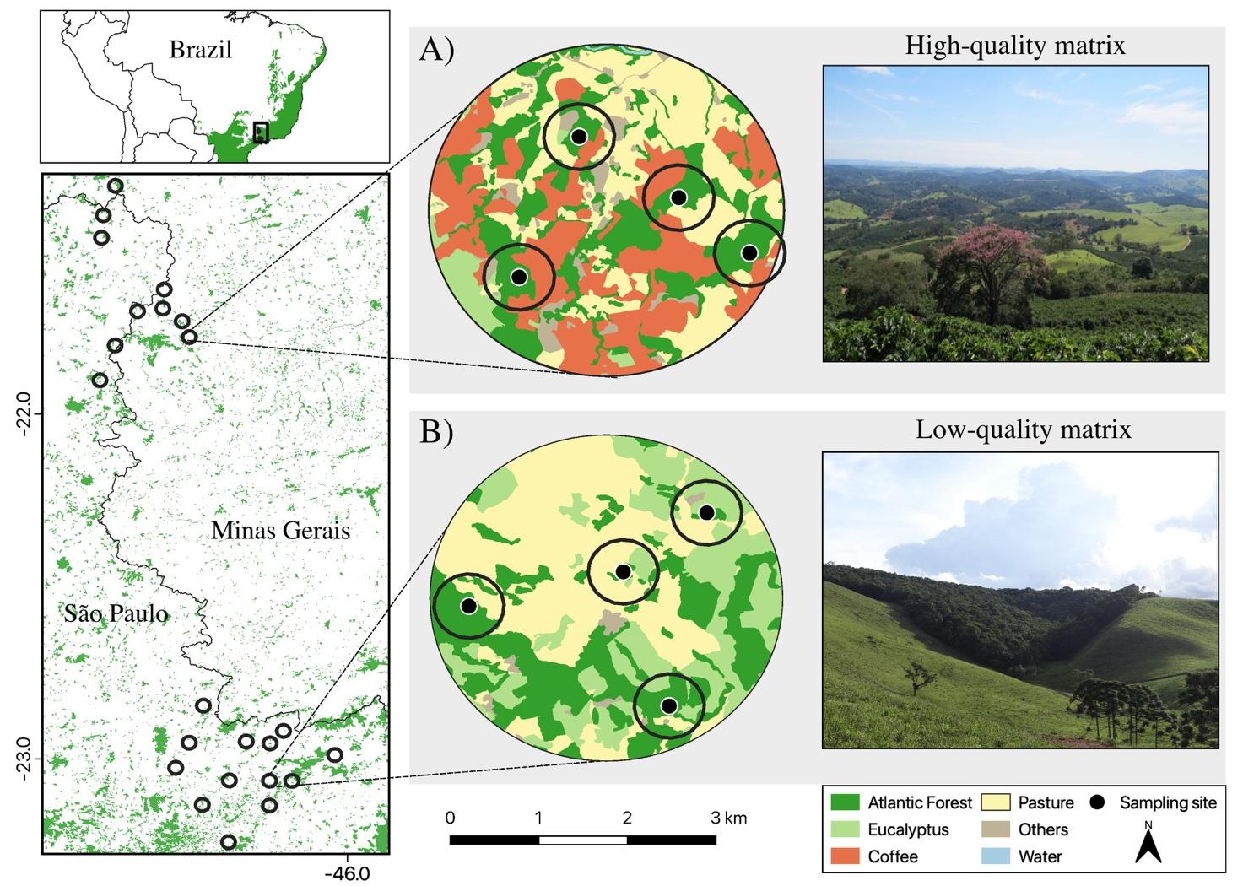
Figure 1: Location of the study area (left upper panel) within the Atlantic Forest biome (in green) with 23 studied landscapes in southeastern Brazil (left lower panel). We show two 2 km radius landscapes with 27% of native forest cover, but in (A) with a high-quality matrix – more heterogeneous with a high proportion of sun coffee plantations; and in (B) with a low-quality matrix mostly composed of low-productive pastures. In each landscape 4 local-scale sampling points of 400 m radius buffer (black dots).
We used the landscape selection approach of Pasher et al. (2013) to select independent focal landscapes that span a gradient of landscape-level forest cover, while controlling for potentially confounding factors, as altitude (ranging from 800-1300 m.a.s.l), soil type (ferric red latosol or argisol soil), presence of large highways and water reservoirs. We selected 10 and 13 focal landscapes (2 km radius, 1256 ha each) in the high-quality (ranging from 7-46% of forest cover) and low-quality matrix (12-55% of forest cover) regions, respectively. In each landscape, we placed 4 sampling sites (total 96 sites) in forest patches spaced a minimum of 800m apart (1591 ± 621 m) in a way to cover different ranges of local forest cover inside the same focal landscape. For each selected forest patch, we randomly selected a point along the forest-matrix interface and placed a sampling site within the forest patch at the end of a 100 m transect always oriented to the center of the forest patch. The matrix type of the closest edge was always a coffee plantation in high-quality landscapes and pasture in low-quality landscapes. All selected forest patches at both regions were similar in structure and composed of intermediate to advanced second-growth forest with a well-established canopy, free from cattle disturbance in the understory and, located within private properties. See Appendix 1 and Boesing et al. (2018a) for more details about the area selection procedure.

Bird sampling and traits selection
In each sampling site, we performed a 50 m fixed radius point count and recorded all bird species detected visually or aurally during a 15 min sampling period. Studies in tropical regions indicate that 10 min point counts are sufficient to record 90% of tropical bird species (Esquivel et al., 2008). Each site was visited four times, between January–April and August–November of 2014 (N=368), by the same experienced ornithologist (ALB) and both regions were sampled simultaneously (more details in Appendix 1).
To be recorded, bird individuals needed to be perched or singing inside the radius of detection: species flying above the canopy or flying through the sample area were not recorded (Bibby et al., 2000). All point counts were performed in the four hours after sunrise and in the last hour before sunset. Each point count was sampled in different times during the morning and evening periods in order to give the same chance of detection for all species (Esquivel et al., 2008). To increase the detectability of more cryptic and rare species, each point count was replicated four times, between January–April and August–November of 2014 (23 landscapes, 92 sampling sites, n = 368 point counts) and both regions were sampled simultaneously. Some of the records are deposited at: https://xeno-canto.org/contributor/ETMICIBVME.
Bird traits selection followed the framework proposed by Luck et al. (2012). First, we listed the potential traits based on current knowledge on bird traits related to extinction-proneness due to habitat loss, land use, or environmental change (references in Appendix 2). Then, we selected traits based on the (1) data availability; (2) experts’ knowledge (ALB); and (3) the empirical relationship among traits (correlations). Finally, we selected five groups of response traits that are known to affect individual fitness by influencing growth, reproduction, or survival of the species on human-modified landscapes: hand-wing index (HWI), body size, nest type, diet, and foraging stratum. These traits were represented by eight operational variables described in detail in Appendix 2.
We kept separate analyses for forest specialist and habitat generalist birds (henceforth just specialists and generalists) given that habitat specialization is very important for understanding the effects of habitat loss and fragmentation (Kupsch et al., 2019; Pandit et al., 2009). Moreover, as both groups of species presented similar ranges of trait values on our data (Appendix 2), we also investigated if the same trait differs in response to habitat loss depending on species habitat specialization. We considered forest specialists those species that depend on forest environments for breeding and survival, and habitat generalists those that rely on different habitat types, including forests, to survive (Del Hoyo, 2014). We appealed afterwards for a bird expert revision (Scott Robinson, Univ. of Florida) to guarantee the quality of our classification. We also excluded predators to conform our assemblages to the definition of a horizontal community without trophic interactions (sensu Loreau, 2010) and due to the biased method of point counts for detection of such species.

Modeling
We modeled bird occurrences with hierarchical linear models commonly used to analyze trait-environment associations and disentangle scale dependency in community assembly processes (Jamil et al., 2013; ter Braak, 2019). We used a binomial generalized linear mixed model (logit link function) with the number of detections of each of n species (four visits) in each of m sites as response variable (Miller et al., 2018). In each species-site combination ($Y_{i}$, where i goes from 1 to n x m observations), we assigned predictors of the n species-level trait and the m site- and landscape-level forest cover (Miller et al., 2018). Our model is described by:
$$Y_{i}∼Binomial\left(4,p\right)$$
$$logit\left(p\right)=\left(α+a_{spp\left[i\right]}+b_{site\left[i\right]}+c_{landscape\left[i\right]}\right)+\left(β_{1}+d_{spp\left[i\right]}\right){{forest}_{cover}}_{site\left[i\right]}+$$
${\left(β_{2}+e_{site\left[i\right]}+f_{landscape\left[i\right]}\right){trait}_{spp\left[i\right]}+β}_{12}{trait}_{spp\left[i\right]}×{{forest}_{cover}}_{site\left[i\right]}$ + (1)
$$g_{site\left[i\right]×spp\left[i\right]}+h_{landscape\left[i\right]∗spp\left[i\right]}$$
where $Y_{i}$ is the observed number of recorded occurrences for each of the $i$ species-site combination (species n in site m). Fixed effects are represented in Greek and random effects in Latin letters. All random effect terms are represented by a normal distribution with mean zero and their respective estimated variances ($σ_{a}^{2}$, $σ_{b}^{2},σ_{c}^{2}$, $σ_{d}^{2}$, $σ_{e}^{2}$, $σ_{f}^{2}$,$σ_{g}^{2}$,$σ_{h}^{2}$). Terms with random intercept and slope have additional parameters denoting the correlation between them ($ρ_{ad},ρ_{be},ρ_{cf}$). The model’s formula syntax in the lme4 R package (Bates et al., 2015) is:
Y ~ trait*forest_cover + (forest_cover|species) + (trait|site) + (trait|landscape) + (1|landscape:species) + (1|landscape:site)
The fixed effects in the logit link function are the main effects of habitat loss and trait ($α,β_{1},β_{2}$) and habitat loss filtering effects through traits (interaction term $β_{12}$). We used the percentage of forest cover at both local and landscape scales as response variables to denote habitat loss and we found no collinearity between these variables (Appendix 2). We are particularly interested in: (1) the main effects of habitat loss, i.e., how steep is the decrease in occurrence probability of all birds when habitat is lost, and (2) the interaction effect of habitat loss with traits, i.e., how species with different traits respond to habitat loss. However, these effects are not statistically easily separable from the main effects of trait in terms of variance explained (R², Johnson 2014). As we show below, we kept the whole structure of fixed effects in interpreting marginal R² as a general interpretation of habitat loss effects. Nevertheless, we also compared the estimates of habitat loss main effects among assemblages and across scales and calculated the importance of the traits in explaining habitat loss filtering (equation 2, below) to interpreting habitat loss filtering effects through traits.
Species random effects are the variation among species in their overall abundances (random intercept, $a_{spp\left[i\right]}$) and response to habitat loss (random slope${,d}_{spp\left[i\right]}$) regardless of its trait values. They express the idiosyncratic response of each species to habitat loss and their differences in overall abundances. Trait-site and trait-landscape random interactions (random intercepts: $b_{site\left[i\right]}$, $c_{landscape\left[i\right]}$, and slopes: $e_{site\left[i\right]}$, $f_{landscape\left[i\right]}$) deal with the trait-mediated response to non-measured environmental gradients at local and landscape scales, respectively. This is a solution to "account for any interaction that the observed trait has with any unobserved environmental gradient" (ter Braak, 2019).
We included two additional random effects of site-species ($g_{site\left[i\right]×spp\left[i\right]}$), and landscape-species interactions ($h_{landscape\left[i\right]×spp\left[i\right]}$ to express that the occurrence probability of the same species may vary among sites and landscapes, regardless of the species identity, its traits, and the habitat loss gradients. This term expresses a random variation in species occurrences probabilities across sites and landscapes. The site-species interaction term is the so-called Observation Level Random Effect (OLRE), which allows for extra variance among observations. OLRE is generally used to deal with overdispersion in data modeling with the exponential family distributions (Harrison, 2015). For species occurrences, overdispersion is frequently associated with individuals’ aggregations in space (e.g. Ozgul et al., 2009). In this sense, at the community level, we can assume that the spatial aggregation expressed by these terms is a result of differential dispersal, which may be a limitation or excess of dispersal. Dispersal limitation of individuals among patches and landscapes may lead to ecological drift (sensu Vellend 2010). Although it is expected that these terms express ecological drift (Mortara, 2016), we cannot ensure that all the variances apportioned in these terms are exactly differential dispersal. However, because we have carefully handled many possible niche processes (or selection sensu Vellend 2010) in the model, probably, these terms do not include other processes than random variation in species occurrence probabilities. At least, if differential dispersal among patches and landscapes is an important process, it will be expressed in these two random effects and not in the other terms.
To express the importance of traits in explaining habitat loss filtering we calculated the proportional decrease in the variance of the species random slope for forest cover ($d_{spp\left[i\right]}$) when we include the trait-forest cover interaction term ($β_{12}$) in the model (Jamil et al., 2013):
$C_{β}=1−\frac{d_{spp\left[i\right]}\left(res\right)}{d_{spp\left[i\right]}\left(total\right)}$ (2)
$d_{spp\left[i\right]}\left(res\right)$ is the variance of the random species slope from the model with forest cover and trait main effects ($β_{2}$) and the trait-environment interaction ($β_{12}$); $d_{spp\left[i\right]}\left(total\right)$ is the same variance term for the model without trait-environment interaction but with the main effects. This proportion explains how much of the effect of habitat loss on each species can be explained by their trait values.
We computed overall R² for the models by the additive variance partitioning method (Johnson, 2014; Nakagawa & Schielzeth, 2013), which is appropriate for comparing models fit to different data sets because it does not depend on sample size (Ives, 2019). We also apportioned the total variance among the model terms (marginal R² sensu Ives 2019) to compare the relative importance of processes across assemblages. We calculated the overall and marginal R² on the scale of the link function (logit) since it can decouple variance and mean so that the linked scale R² can be calculated independent of the population mean (Nakagawa & Schielzeth, 2010).

Table 1: Definitions and ecological interpretations of the statistical terms of the hierarchical linear model (equation 1). Code syntax follows lme4 R package.
Model terms | Code | Description
$$α;β_{1};β_{2};β_{12}$$ | trait*env | Fixed effects: main effects of habitat loss and traits, and habitat loss filtering effects through traits (interaction terms) at both local and landscape scale.
$a_{spp\left[i\right]}$; $d_{spp\left[i\right]}$ | (env|sp) | Random effects: variation among species in their overall occurrences (intercept) and response to habitat loss (slope) regardless of its traits. It is the idiosyncratic response of each species to habitat loss and their differences in overall abundances.
$b_{site\{i\}}$; $e_{site}$  $c_{landscape\left[i\right]}$; $f_{landscape\left[i\right]}$ | (trait|site)  (trait|lands) | Random effects: interaction (random intercept and slope) between trait values and sites/landscapes. It is the possible relationship of the measured trait with any unmeasured environmental variable at the site/landscape level. Trait-mediated response to other environmental gradients at local/landscape scale.
$g_{spp\left[i\right]×landscape\left[i\right]}$ | (lands:sp) | Random effects: overdispersion term indicating random variation in species occurrences across landscapes, regardless of its traits and habitat loss conditions.
$h_{spp\left[i\right]×site\left[i\right]}$ | (site:sp) | Random effects: overdispersion term indicating random variation in species occurrences across sites, regardless of its traits and habitat loss conditions.

Data analysis
We ran the model described above for each low and high-quality matrix landscapes and for forest specialists and habitat generalists separately (hereafter assemblages) to better interpret and compare overall and marginal R²s among assemblages. We analyzed the data in two steps. First, given that ecological responses can be affected by processes acting at different spatial scales, we selected the best scale for the effect of local forest cover (Appendix 2), which was the percentage of local forest cover measured at 400 m buffer radius around each site (Fig. 1). Second, we ran separate models for each species trait (equation 1) including local and landscape forest cover (2 km radius around the centroid of the landscapes) as predictors of habitat loss. We finally combined 4 traits with the highest explanatory power for all datasets (main diet, proportion of lower strata use, body mass, and nest type) in one model to predict the trait's response to habitat loss and to compare the marginal R² of each model term. The combined traits models did not show collinearity and the traits were not correlated among species (Appendix 3).
Considering that the two regions with high- and low-quality matrix landscapes may present different pools of species, we performed a robustness analysis with only the species that occurred at both regions with high- and low-quality landscapes. The results from the combined models with only the subset of species were very similar to the models with all species in each assemblage (Appendix 4), discarding any potential effect of biogeography or other sources of variation in species composition in our results. All data analysis was performed using R (version 4.0, R Core Team 2019) with lme4 package (Bates et al., 2015) for modeling, and DHARMa (Hartig, 2018) for quantile residuals diagnostic (Appendix 3).

Results
In our modeling approach, the R²s of the fixed effects – trait, habitat loss, and filtering effects at both local and landscape scales – were the variance component that presented the most marked differences between assemblages (Fig. 2). It was 2.2 times higher for the specialists in the low-quality than in the high-quality matrix landscapes (22 and 10%, respectively), and it was up to 3 times higher for specialists than for both generalist assemblages (7-8%). It means that habitat loss effects alone and habitat loss filtering effects were much stronger for the specialist birds in low-quality matrix landscapes. Moreover, overall R² for specialists in low-quality matrix landscapes captured most of the variability in bird’s occurrence (72%), followed by specialists in high-quality matrices (58%) (Fig. 2). Overall R² for generalists was smaller and similar across landscapes regardless of matrix quality (46-47%).
The R² for the terms that account for random variation in species occurrences across sites (site:sp), were very low (1%) for all assemblages. However, the R² for random variation in species occurrences at the landscape scale (lands:sp) was larger for the specialists in high-quality matrices than for the specialists in low-quality matrices. This term was also larger for specialists (4-7%) than generalists (1-2%).
The terms that express the variation among species in their overall abundances and responses to habitat loss regardless of their traits (random intercept and slope: env|sp) presented the highest marginal R² for all assemblages, ranging from 32 to 40%, and being about 1.3 higher for the specialists than for the generalists. Similarly, marginal R² of the terms that express the effects of species traits associated with unmeasured environmental variables (trait|site and trait|land) were very low, and together they varied between 3 to 5% in all assemblages.
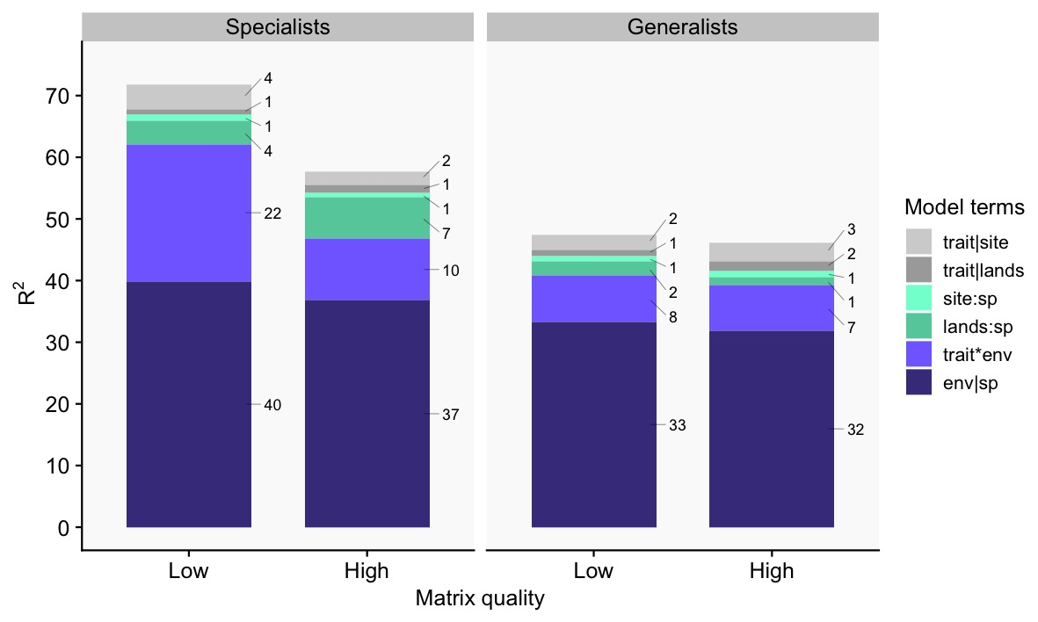
Figure 2: Overall and marginal R²s for the models with combined traits (body mass, type of nest, main diet, percentage of lower strata use) for habitat generalist and forest specialist birds in high and low-quality matrix landscapes. The number on the right side of each bar indicates the percentages for each term. See Table 1 for model terms definitions.
In comparing habitat loss effects across scales, we found that the effects of both local and landscape habitat loss in bird occurrence were stronger for the specialists in low-quality matrix landscapes (Fig. 3). While local forest cover presented similar and positive effects on bird occurrences for specialists in both high- and low-quality matrix landscapes, landscape forest cover presented a strong effect only for specialists in low-quality matrix landscapes, where this effect was larger than for local forest cover. As expected, the effects of habitat loss for generalists were generally weaker and irrelevant at any scale.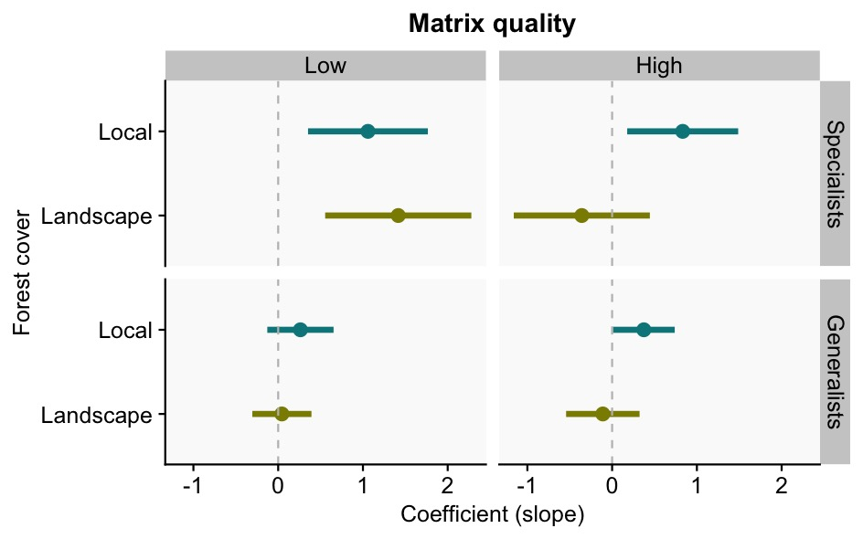
Figure 3: Slope coefficients (and 95% confidence intervals) of local and landscape forest cover for forest specialist and habitat generalist birds in different matrix quality landscapes. These are results for the combined traits model. See Appendix 3 for a table of all coefficients estimated for each assemblage.
The importance of species traits explaining habitat loss filtering was higher for the assemblages in low-quality matrices (Fig. 4, combined traits model). Trait importance for the generalists in low-quality matrix landscapes explained 26% of the variability in species response to habitat loss. For the specialists, trait importance varied between 17 and 22%, and for the generalist in high-quality landscapes, it was only 14%. In general, nest type and main diet presented the highest values of trait importance for the assemblages (Fig. 4).
Bird occurrence probabilities were in general higher for the assemblage in high-quality compared to low-quality matrix landscapes (Fig. 5). For specialists, all the traits were associated with a decrease in occurrence probabilities with habitat loss. For generalists, trait-habitat loss relationships changed according to the trait. For example, generalists of closed nests responded positively to habitat loss, while those that nest in cavities responded negatively and generalists of open nests almost did not change with habitat loss (Fig. 5). Nevertheless, occurrence probabilities of frugivores, species that build nests in cavities, and large birds decreased with habitat loss regardless of the matrix type and habitat specificity (Fig. 5).

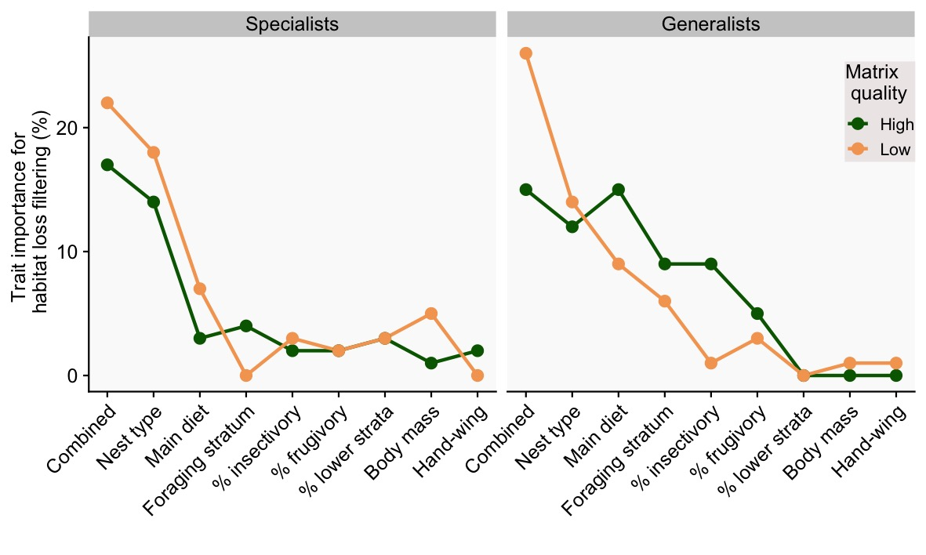
Figure 4: Importance of species traits in explaining habitat loss filtering (equation 2) for forest specialists and habitat generalist birds according to matrix quality. Trait importance was calculated for each trait in separate models and for the combined model, which includes, nest type, main diet, body mass, percentage of lower strata use, and hand-wing index. 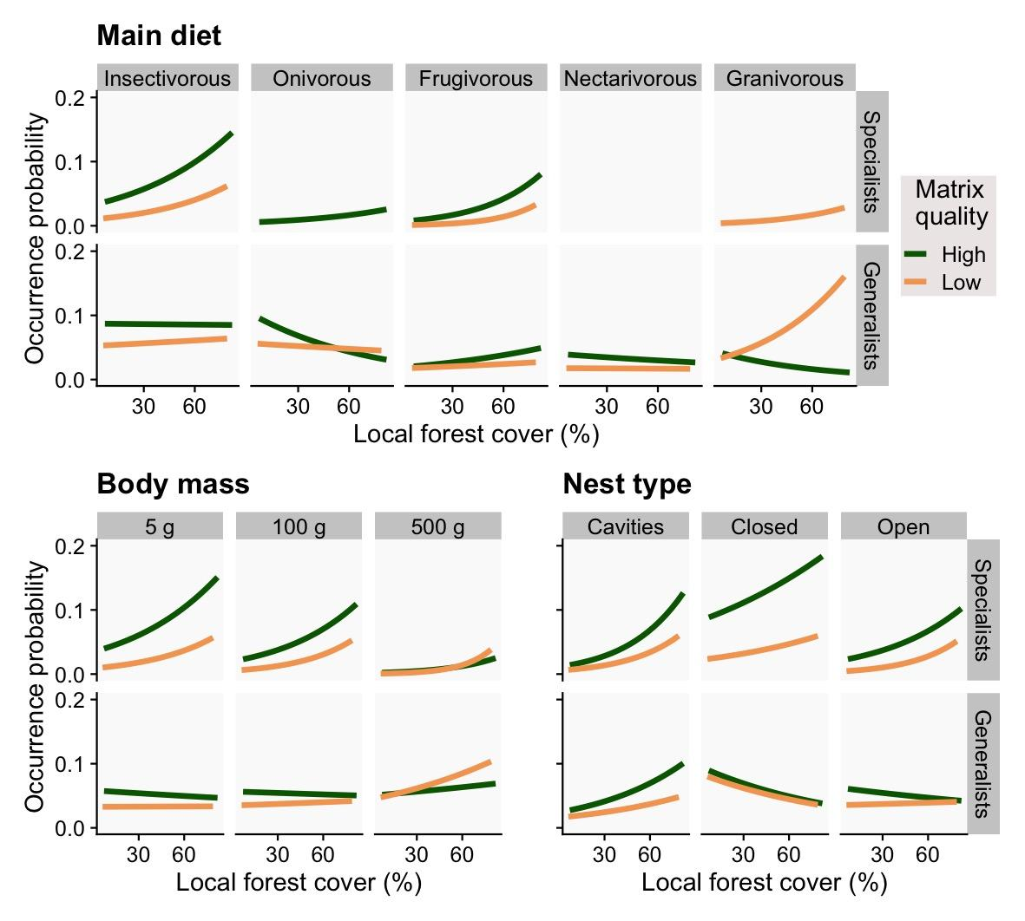Figure 5: Predicted occurrence probability of species with local forest cover (400 m buffer; %) according to main diet, body mass, and nest type for forest specialists and habitat generalists in both high (green lines) and low-quality matrices (yellow lines). For the predictions, landscape forest cover was fixed at 30%.

Discussion
Here, we aimed to understand how the quality of the matrix surrounding habitat patches modulates the relative importance of assembly processes in bird communities across local and landscape gradients of habitat loss. We found that landscapes with low-quality matrices, composed mainly of low-productive pasturelands, increased the severity of habitat loss filtering effects for forest specialist birds (Fig. 2), with habitat loss effects at the landscape scale (Fig. 3) and habitat loss filtering effects through species traits (Fig. 4) being much stronger in those landscapes. In high quality-matrix landscapes (more heterogeneous and with low-contrasting edges), birds’ occurrences were in general larger with more random variation among landscapes. Both results indicate the role of matrix quality in attenuating extinction risks in the landscape, allowing species that would have been extinct due to habitat loss in high-quality matrices. Moreover, forest specialists presented a stronger response to habitat loss filtering, displaying a consistent negative relationship of all traits (diet, nest type, foraging stratum, and body size) with local habitat loss, while generalists presented a high variability in traits response to habitat loss (Fig. 5).

Matrix quality modulating the relative importance of habitat loss across scales
We found that matrix quality modulates habitat loss effects only for specialist birds at the landscape scale. Local habitat amount effects on birds were not dependent on the quality of the matrix. At the landscape scale, filtering processes are usually related to the selection of species according to landscape composition and configuration (Duflot et al., 2014; Suárez-Castro et al., 2018). Landscapes composed of low-quality matrices decrease the availability of supplementary and complementary resources in the matrix (Boesing et al., 2021; Dunning et al., 1992) and/or deteriorate abiotic conditions in habitat edges (Pardini et al., 2009; Pfeifer et al., 2017; Saunders et al., 1991). These two mechanisms together with habitat loss create an even more severe environmental filter for the communities, selecting only those species able to persist under new harsh conditions (Chase, 2007). Our results for the specialists support this hypothesis of lower-quality matrices increasing severity of habitat loss filtering by showing: (1) a 2-times larger relative importance of habitat loss, traits, and filtering effects, with consequently (2) a stronger habitat loss effect, and (3) higher importance of traits in habitat loss filtering. In addition, there is evidence in our study system that the high-quality matrices, especially sun-coffee plantation matrices, are serving as a source of complementary resources for biodiversity due to the movement of organisms from forest patches to the matrix for foraging (cross-habitat spillover, Boesing et al. 2018b, 2021).
Additionally, landscapes composed of low-quality matrices would hinder dispersal among patches or decrease the survival rate of dispersing individuals (Biz et al., 2017; Fahrig, 2007; Watling et al., 2011). By that, dispersal limitation would create functionally isolated communities more prone to ecological drift (e.g., Baselga et al. 2015, Siqueira et al. 2020), which, in turn, would decrease the relative importance of species and trait filtering effects by habitat loss. However, our results pointed to the other direction, as we found that habitat loss filtering through traits was stronger in low-quality matrix landscapes. We believe that in our study system, dispersal limitation is not an issue for the forest birds in both matrix landscapes, as the marginal R²s for the differential dispersal (Fig. 2, lands:sp term) were relatively low. However, the differential dispersal term was higher in relative importance (R²) for the specialists in the high-quality matrix, indicating that there may be not a limitation but possibly an excess of dispersal in high-quality matrices, which corroborates earlier findings (Boesing et al., 2018b, 2021). High-quality matrix landscapes with higher dispersal rates, more resource availability, and milder edge effects may be preventing extinctions of isolated populations by migration of individuals from other patches (mass effect in metapopulation theory, Leibold et al. 2004). This mechanism would weaken the deleterious effects of habitat loss, allowing the survival of species that are not optimally suited for the new environmental conditions (Chisholm et al., 2011; Leibold & Loeuille, 2015).

Habitat loss filtering depends on the quality of the matrix
The importance of species traits in explaining habitat loss filtering effects was higher for the assemblages in low-quality matrices for both generalists and specialists (Fig. 4), evidencing stronger filtering effects in low-quality matrix landscapes as discussed above. We found that specialist birds with certain traits, e.g., small-sized, insectivorous, or birds with closed nests, were more prone to extinction due to habitat loss in landscapes embedded in low-quality matrices than species with the same traits in high-quality matrices (Fig. 5). This indicates further that habitat loss has different filtering effects (stronger or weaker) over species traits depending on the quality of the matrix. Such changes might be related to effects of the matrix changing specific niches required by different species in-patches, mostly via edge-effects on both biotic and abiotic patterns (Murcia, 1995). For instance, species that make nests in cavities or build closed nests are safer against parasitism and predation (Sibly et al., 2012), which are among the most impacting drivers of bird populations’ decline in fragmented landscapes (Cavitt & Martin, 2002). As nest predation/parasitism often increases with edge effects (Murcia, 1995), it is stronger in landscapes with highly contrasting matrices, i.e., lower quality.
Because we were able to compare the same set of traits for habitat generalist and specialist species, we can understand better why habitat loss and fragmentation do not necessarily lead to loss of functional diversity (Boesing et al., 2018a), change in functional traits (de Coster et al., 2015), or even functional homogenization (Nordberg & Schwarzkopf, 2018). If specialists are replaced by generalists with similar trait values, functional differences cannot be easily observed, and thus no apparent functional differences are seen, as often reported (Boesing et al., 2018a; de Coster et al., 2015). However, we also found that species with some specific traits (such as nest type and body size) were always negatively impacted by habitat loss. This finding raises the point that not all habitat generalist species succeed in fragmented landscapes, and that some key functions and/or species may be indeed lost with no substitution of traits when specialists are replaced by generalists. Overall, our results reinforce the evidence that habitat loss and matrix harshness promote abiotic environmental changes inside habitat patches which make species with specific traits to be more prone to extinction than others under different matrix conditions in the landscapes.

Theoretical and practical implications
Despite a long-standing global research effort into understanding how habitat loss and fragmentation influence species loss, and at which spatial scale species loss is observed (Horváth et al., 2019), there is still a considerable debate on which mechanisms are more important (Fahrig, 2017; Fletcher et al., 2018). Our findings raised evidence supporting that habitat loss is a strong filtering process that often leads more vulnerable species to extinction (Pardini et al., 2017), but with a considerable influence of the matrix in modulating filtering processes. We have evidenced the importance of the matrix quality in modulating habitat loss effects at the landscape scale, weakening or strengthening its severity on species filtering (Chase, 2007). Matrices of low quality accentuate habitat loss filtering in fragmented landscapes through its relatively larger effects in altering resource availability and edge effects, more than movement limitation. Consequently, the larger severity of habitat loss filtering in low-quality matrix landscapes decreases the relative importance of ecological drift on those assemblages.
Statistical quantification of the effects of dispersal and ecological drift is still an unresolved methodological problem with many caveats (Vellend et al., 2014). Our framework builds on the idea of handling possible effects of differential dispersal through terms that would take the extra variability of the data (overdispersion) produced by differences in species occurrences across sites and landscapes (Mortara, 2016). This way, we saw that dispersal limitation in low-quality matrices leading to ecological drift is not the only possible outcome after habitat loss and fragmentation. High rates of dispersal in high-quality matrix landscapes can even override environmental filtering by allowing species to occupy habitat patches where their intrinsic growth rate would be otherwise negative (Chase et al., 2020). To our knowledge, this is the first empirical evidence that a not limited dispersal in high-quality matrices may result in mass effects in bird metacommunities in fragmented landscapes, although its effects are relatively small in comparison with environmental filtering.
In practical terms, improving matrix quality in fragmented landscapes is a key action aiming to restore and achieve more sustainable landscapes (Arroyo-Rodríguez et al., 2020; Leite et al., 2013), especially in places where conservation practices and restoration are constrained by economic and political conflicts, are costly-demanding, and requires strategic planning (Metzger et al., 2021). In this sense, converting low-productive pastures into more heterogeneous environments through tree enrichment and creation of stepping-stones (Prevedello et al., 2018; Silva et al., 2020), or converting such pastures (even if partially) into less contrasting land uses (such as diversified crops, perennial crops and tree plantations) can increase matrix quality, minimizing the severity of habitat loss and fragmentation for forest birds (Ruffell et al., 2017). In our study areas, the conversion of abandoned and unproductive pasturelands into silviculture in the last decades was responsible for the increase in second-growth native forests (Calaboni et al., 2018). We conclude that restoration and economic practices improving matrix quality may help in maintaining the high diversity of birds in the Atlantic Forest even without any increase in native forest cover.

Supporting information
APPENDIX 1: Extended methods, bird assemblages, and species trait selection
APPENDIX 2: Forest cover at local and landscape scales
APPENDIX 3: Additional models results and diagnostic
APPENDIX 4: Additional models results for species that occur at both high and low-quality matrix landscapes
Authors’ contributions: M.S.L., A.L.B., and P.I.P. conceived the project. A.L.B. and J.P.M delineated the sampling design. A.L.B. collected the data. M.S.L. and P.I.P. analyzed the data and wrote the manuscript. All authors provided substantial revisions and comments on the manuscript.
Acknowledgments: We thank Alexandre Adalardo de Oliveira and Tadeu Siqueira for important suggestions and discussions during the project development. We also thank all the researchers involved in the Interface project from the Laboratory of Landscape Ecology and Conservation, University of São Paulo. Júlia Barreto, Sara Mortara, Danilo Muniz, Diogo Borges Provete, and Pedro Peres-Neto for the early review of the manuscript. The dataset from this study comes from the Interface project supported by the São Paulo Research Foundation (FAPESP, 2013/23457-6) with additional support from The Rufford Foundation (grant number 14223-1). Permission for the data collection was obtained from the Brazilian Institute of Environment and Renewable Natural Resources (IBAMA) under SISBIO number 46697-1.
Conflicts of interest: We declare no conflict of interest.
Data archiving: All data and code used in the analysis are available in Zenodo Repository http://doi.org/10.5281/zenodo.5516704 (Leite, 2021) with the published version of the GitHub repository. The original data is also available from the Dryad Digital Repository http://dx.doi.org/10.5061/dryad.37s4h (Boesing et al., 2017).

References
Antongiovanni, M., & Metzger, J. P. (2005). Influence of matrix habitats on the occurrence of insectivorous bird species in Amazonian forest fragments. Biological Conservation, 122(3), 441–451. https://doi.org/10.1016/j.biocon.2004.09.005
Arroyo-Rodríguez, V., Fahrig, L., Tabarelli, M., Watling, J. I., Tischendorf, L., Benchimol, M., Cazetta, E., Faria, D., Leal, I. R., Melo, F. P. L., Morante-Filho, J. C., Santos, B. A., Arasa-Gisbert, R., Arce-Peña, N., Cervantes-López, M. J., Cudney-Valenzuela, S., Galán-Acedo, C., San-José, M., Vieira, I. C. G., … Tscharntke, T. (2020). Designing optimal human-modified landscapes for forest biodiversity conservation. Ecology Letters, 23(9), 1404–1420. https://doi.org/10.1111/ele.13535
Barros, F. M., Peres, C. A., Pizo, M. A., & Ribeiro, M. C. (2019). Divergent flows of avian-mediated ecosystem services across forest-matrix interfaces in human-modified landscapes. Landscape Ecology. https://doi.org/10.1007/s10980-019-00812-z
Baselga, A., Bonthoux, S., & Balent, G. (2015). Temporal beta diversity of bird assemblages in agricultural landscapes: Land cover change vs. stochastic processes. PLOS ONE, 10(5), e0127913. https://doi.org/10.1371/journal.pone.0127913
Bates, D., Mächler, M., Bolker, B., & Walker, S. (2015). Fitting linear mixed-effects models using lme4. Journal of Statistical Software, 67(1), 1–48. https://doi.org/10.18637/jss.v067.i01
Bibby, C. J., Burgess, N. D., Hill, D. A., & Mustoe, S. (2000). Bird Census Techniques. Elsevier Science. https://books.google.com.br/books?id=Ld5wkzPp49cC
Biz, M., Cornelius, C., & Metzger, J. P. W. (2017). Matrix type affects movement behavior of a Neotropical understory forest bird. Perspectives in Ecology and Conservation, 15(1), 10–17. https://doi.org/10.1016/j.pecon.2017.03.001
Blitzer, E. J., Dormann, C. F., Holzschuh, A., Klein, A.-M., Rand, T. A., & Tscharntke, T. (2012). Spillover of functionally important organisms between managed and natural habitats. Agriculture, Ecosystems & Environment, 146(1), 34–43. https://doi.org/10.1016/j.agee.2011.09.005
Boesing, A. L., Marques, T. S., Martinelli, L. A., Nichols, E., Siqueira, P. R., Beier, C., de Camargo, P. B., & Metzger, J. P. (2021). Conservation implications of a limited avian cross-habitat spillover in pasture lands. Biological Conservation, 253, 108898. https://doi.org/10.1016/j.biocon.2020.108898
Boesing, A. L., Nichols, E., & Metzger, J. P. (2017). Data from: Biodiversity extinction thresholds are modulated by matrix type. Dryad, Dataset, Https://Doi.Org/10.5061/Dryad.37s4h. https://doi.org/DOI: 10.5061/DRYAD.37S4H
Boesing, A. L., Nichols, E., & Metzger, J. P. (2018a). Biodiversity extinction thresholds are modulated by matrix type. Ecography, 41(9), 1520–1533. https://doi.org/10.1111/ecog.03365
Boesing, A. L., Nichols, E., & Metzger, J. P. (2018b). Land use type, forest cover and forest edges modulate avian cross-habitat spillover. Journal of Applied Ecology, 55(3), 1252–1264. https://doi.org/10.1111/1365-2664.13032
Calaboni, A., Tambosi, L. R., Igari, A. T., Farinaci, J. S., Metzger, J. P., & Uriarte, M. (2018). The forest transition in São Paulo, Brazil: Historical patterns and potential drivers. Ecology and Society, 23(4), 7. https://doi.org/10.5751/ES-10270-230407
Carrara, E., Arroyo-Rodríguez, V., Vega-Rivera, J. H., Schondube, J. E., de Freitas, S. M., & Fahrig, L. (2015). Impact of landscape composition and configuration on forest specialist and generalist bird species in the fragmented Lacandona rainforest, Mexico. Biological Conservation, 184, 117–126. https://doi.org/10.1016/j.biocon.2015.01.014
Cavitt, J. E., & Martin, T. E. (2002). Effects of forest fragmentation on brood parasitism and nest predationin eastern and western landscapes. Studies in Avian Biology, 25, 73–80.
Chase, J. M. (2007). Drought mediates the importance of stochastic community assembly. Proceedings of the National Academy of Sciences, 104(44), 17430–17434. https://doi.org/10.1073/pnas.0704350104
Chase, J. M., Jeliazkov, A., Ladouceur, E., & Viana, D. S. (2020). Biodiversity conservation through the lens of metacommunity ecology. Annals of the New York Academy of Sciences, 1469(1), 86–104. https://doi.org/10.1111/nyas.14378
Chase, J. M., McGill, B. J., McGlinn, D. J., May, F., Blowes, S. A., Xiao, X., Knight, T. M., Purschke, O., & Gotelli, N. J. (2018). Embracing scale-dependence to achieve a deeper understanding of biodiversity and its change across communities. Ecology Letters, 21(11), 1737–1751. https://doi.org/10.1111/ele.13151
Chisholm, C., Lindo, Z., & Gonzalez, A. (2011). Metacommunity diversity depends on connectivity and patch arrangement in heterogeneous habitat networks. Ecography, 34(3), 415–424. https://doi.org/10.1111/j.1600-0587.2010.06588.x
de Coster, G., Banks-Leite, C., & Metzger, J. P. (2015). Atlantic forest bird communities provide different but not fewer functions after habitat loss. Proceedings of the Royal Society B: Biological Sciences, 282(1811), 20142844. https://doi.org/10.1098/rspb.2014.2844
Deikumah, J. P., McAlpine, C. A., & Maron, M. (2013). Matrix Intensification Alters Avian Functional Group Composition in Adjacent Rainforest Fragments. PLOS ONE, 8(9), e74852. https://doi.org/10.1371/journal.pone.0074852
Del Hoyo, J. (2014). Handbook of the birds of the World alive. Lynx Editions.
Duflot, R., Georges, R., Ernoult, A., Aviron, S., & Burel, F. (2014). Landscape heterogeneity as an ecological filter of species traits. Acta Oecologica, 56, 19–26. https://doi.org/10.1016/j.actao.2014.01.004
Dunning, J. B., Danielson, B. J., & Pulliam, H. R. (1992). Ecological processes that affect populations in complex landscapes. Oikos, 65(1), 169. https://doi.org/10.2307/3544901
Esquivel, M. A., Peris, S. J., & Hohenau, C. P. (2008). Influence of time of day, duration and number of counts in point count sampling of birds in an Atlantic forest of Paraguay. Ornitologia Neotropical, 19, 229–242.
Fahrig, L. (2007). Non-optimal animal movement in human-altered landscapes. Functional Ecology, 21(6), 1003–1015. https://doi.org/10.1111/j.1365-2435.2007.01326.x
Fahrig, L. (2017). Ecological Responses to Habitat Fragmentation per se. Annual Reviews of Ecology, Evolution and Systematics, 48. https://carleton.ca/fahriglab/wp-content/uploads/Fahrig-in-press-AREES-2017.pdf
Fischer, J., & Lindenmayer, D. B. (2007). Landscape modification and habitat fragmentation: A synthesis. Global Ecology and Biogeography, 16(3), 265–280. https://doi.org/10.1111/j.1466-8238.2007.00287.x
Fletcher, R. J., Didham, R. K., Banks-Leite, C., Barlow, J., Ewers, R. M., Rosindell, J., Holt, R. D., Gonzalez, A., Pardini, R., Damschen, E. I., Melo, F. P. L., Ries, L., Prevedello, J. A., Tscharntke, T., Laurance, W. F., Lovejoy, T., & Haddad, N. M. (2018). Is habitat fragmentation good for biodiversity? Biological Conservation, 226, 9–15. https://doi.org/10.1016/j.biocon.2018.07.022
Haddad, N. M., Brudvig, L. A., Clobert, J., Davies, K. F., Gonzalez, A., Holt, R. D., Lovejoy, T. E., Sexton, J. O., Austin, M. P., Collins, C. D., Cook, W. M., Damschen, E. I., Ewers, R. M., Foster, B. L., Jenkins, C. N., King, A. J., Laurance, W. F., Levey, D. J., Margules, C. R., … Townshend, J. R. (2015). Habitat fragmentation and its lasting impact on Earth’s ecosystems. Science Advances, 1(2), e1500052. https://doi.org/10.1126/sciadv.1500052
Häkkilä, M., Tortorec, E. L., Brotons, L., Rajasärkkä, A., Tornberg, R., & Mönkkönen, M. (2017). Degradation in landscape matrix has diverse impacts on diversity in protected areas. PLOS ONE, 12(9), e0184792. https://doi.org/10.1371/journal.pone.0184792
Harrison, X. A. (2015). A comparison of observation-level random effect and Beta-Binomial models for modelling overdispersion in Binomial data in ecology & evolution. PeerJ, 3, e1114. https://doi.org/10.7717/peerj.1114
Hartig, F. (2018). DHARMa: Residual Diagnostics for Hierarchical (Multi-Level / Mixed) Regression Models.
Henckel, L., Meynard, C. N., Devictor, V., Mouquet, N., & Bretagnolle, V. (2019). On the relative importance of space and environment in farmland bird community assembly. PLOS ONE, 14(3), e0213360. https://doi.org/10.1371/journal.pone.0213360
Horváth, Z., Ptacnik, R., Vad, C. F., & Chase, J. M. (2019). Habitat loss over six decades accelerates regional and local biodiversity loss via changing landscape connectance. Ecology Letters, 22(6), 1019–1027. https://doi.org/10.1111/ele.13260
Ives, A. R. (2019). R2s for Correlated Data: Phylogenetic Models, LMMs, and GLMMs. Systematic Biology, 68(2), 234–251. https://doi.org/10.1093/sysbio/syy060
Jamil, T., Ozinga, W. A., Kleyer, M., & ter Braak, C. J. F. (2013). Selecting traits that explain species–environment relationships: A generalized linear mixed model approach. Journal of Vegetation Science, 24(6), 988–1000. https://doi.org/10.1111/j.1654-1103.2012.12036.x
Johnson, P. C. D. (2014). Extension of Nakagawa & Schielzeth’s R2GLMM to random slopes models. Methods in Ecology and Evolution, 5(9), 944–946. https://doi.org/10.1111/2041-210X.12225
Kennedy, C. M., Marra, P. P., Fagan, W. F., & Neel, M. C. (2010). Landscape matrix and species traits mediate responses of Neotropical resident birds to forest fragmentation in Jamaica. Ecological Monographs, 80(4), 651–669.
Kupfer, J. A., Malanson, G. P., & Franklin, S. B. (2006). Not seeing the ocean for the islands: The mediating influence of matrix-based processes on forest fragmentation effects. Global Ecology and Biogeography, 15(1), 8–20. https://doi.org/10.1111/j.1466-822X.2006.00204.x
Kupsch, D., Vendras, E., Ocampo-Ariza, C., Batáry, P., Motombi, F. N., Bobo, K. S., & Waltert, M. (2019). High critical forest habitat thresholds of native bird communities in Afrotropical agroforestry landscapes. Biological Conservation, 230, 20–28. https://doi.org/10.1016/j.biocon.2018.12.001
Leibold, M. A., Holyoak, M., Mouquet, N., Amarasekare, P., Chase, J. M., Hoopes, M. F., Holt, R. D., Shurin, J. B., Law, R., Tilman, D., Loreau, M., & Gonzalez, A. (2004). The metacommunity concept: A framework for multi-scale community ecology. Ecology Letters, 7(7), 601–613. https://doi.org/10.1111/j.1461-0248.2004.00608.x
Leibold, M. A., & Loeuille, N. (2015). Species sorting and patch dynamics in harlequin metacommunities affect the relative importance of environment and space. Ecology, 96(12), 3227–3233. https://doi.org/10.1890/14-2354.1
Leite, M. de S. (2021). Data and code from: Matrix quality determines the strength of habitat loss filtering on bird communities at the landscape scale (v1.1). Zenodo. https://doi.org/10.5281/zenodo.5516704
Leite, M. de S., Tambosi, L. R., Romitelli, I., & Metzger, J. P. (2013). Landscape Ecology Perspective in Restoration Projects for Biodiversity Conservation: A Review. Natureza & Conservação, 11(2), 108–118.
Loreau, M. (2010). From populations to ecosystems: Theoretical foundations for a new ecological synthesis. Princeton University Press.
Luck, G. W., Lavorel, S., McIntyre, S., & Lumb, K. (2012). Improving the application of vertebrate trait-based frameworks to the study of ecosystem services. Journal of Animal Ecology, 81(5), 1065–1076. https://doi.org/10.1111/j.1365-2656.2012.01974.x
McGill, B., Enquist, B., Weiher, E., & Westoby, M. (2006). Rebuilding community ecology from functional traits. Trends in Ecology & Evolution, 21(4), 178–185. https://doi.org/10.1016/j.tree.2006.02.002
Metzger, J. P., Villarreal-Rosas, J., Suárez-Castro, A. F., López-Cubillos, S., González-Chaves, A., Runting, R. K., Hohlenwerger, C., & Rhodes, J. R. (2021). Considering landscape-level processes in ecosystem service assessments. Science of The Total Environment, 796, 149028. https://doi.org/10.1016/j.scitotenv.2021.149028
Miller, J. E. D., Damschen, E. I., & Ives, A. R. (2018). Functional traits and community composition: A comparison among community-weighted means, weighted correlations, and multilevel models. Methods in Ecology and Evolution, 10(3), 415–425. https://doi.org/10.1111/2041-210X.13119
Morante-Filho, J. C., Arroyo-Rodríguez, V., & Faria, D. (2016). Patterns and predictors of β-diversity in the fragmented Brazilian Atlantic forest: A multiscale analysis of forest specialist and generalist birds. Journal of Animal Ecology, 85(1), 240–250. https://doi.org/10.1111/1365-2656.12448
Mortara, S. R. (2016). Fern abundance in metacommunities: Linking patterns and processes with statistical models [PhD Thesis]. University of São Paulo.
Murcia, C. (1995). Edge effects in fragmented forests: Implications for conservation. Trends in Ecology & Evolution, 10(2), 58–62. https://doi.org/10.1016/S0169-5347(00)88977-6
Nakagawa, S., & Schielzeth, H. (2010). Repeatability for Gaussian and non-Gaussian data: A practical guide for biologists. Biological Reviews, 85, 935–956. https://doi.org/10.1111/j.1469-185X.2010.00141.x
Nakagawa, S., & Schielzeth, H. (2013). A general and simple method for obtaining R2 from generalized linear mixed-effects models. Methods in Ecology and Evolution, 4(2), 133–142. https://doi.org/10.1111/j.2041-210x.2012.00261.x
Newbold, T., Scharlemann, J. P. W., Butchart, S. H. M., Şekercioğlu, Ç. H., Alkemade, R., Booth, H., & Purves, D. W. (2013). Ecological traits affect the response of tropical forest bird species to land-use intensity. Proceedings of the Royal Society B: Biological Sciences, 280(1750), 20122131. https://doi.org/10.1098/rspb.2012.2131
Newbold, T., Scharlemann, J. P. W., Butchart, S. H. M., Şekercioğlu, Ç. H., Joppa, L., Alkemade, R., & Purves, D. W. (2014). Functional traits, land-use change and the structure of present and future bird communities in tropical forests. Global Ecology and Biogeography, 23(10), 1073–1084. https://doi.org/10.1111/geb.12186
Nordberg, E. J., & Schwarzkopf, L. (2018). Reduced competition may allow generalist species to benefit from habitat homogenization. Journal of Applied Ecology, 280, 20122131. https://doi.org/10.1111/1365-2664.13299
Ovaskainen, O., Tikhonov, G., Norberg, A., Guillaume Blanchet, F., Duan, L., Dunson, D., Roslin, T., & Abrego, N. (2017). How to make more out of community data? A conceptual framework and its implementation as models and software. Ecology Letters, 20(5), 561–576. https://doi.org/10.1111/ele.12757
Ozgul, A., Oli, M. K., Bolker, B. M., & Perez-Heydrich, C. (2009). Upper respiratory tract disease, force of infection, and effects on survival of gopher tortoises. Ecological Applications, 19(3), 786–798.
Pandit, S. N., Kolasa, J., & Cottenie, K. (2009). Contrasts between habitat generalists and specialists: An empirical extension to the basic metacommunity framework. Ecology, 90(8), 2253–2262. https://doi.org/10.1890/08-0851.1
Pardini, R., Faria, D., Accacio, G. M., Laps, R. R., Mariano-Neto, E., Paciencia, M. L. B., Dixo, M., & Baumgarten, J. (2009). The challenge of maintaining Atlantic Forest biodiversity: A multi-taxa conservation assessment of specialist and generalist species in an agro-forestry mosaic in southern Bahia. Biological Conservation, 142(6), 1178–1190. https://doi.org/10.1016/j.biocon.2009.02.010
Pardini, R., Nichols, E., & Püttker, T. (2017). Biodiversity Response to Habitat Loss and Fragmentation. In Reference Module in Earth Systems and Environmental Sciences. Elsevier. https://doi.org/10.1016/B978-0-12-409548-9.09824-9
Pasher, J., Mitchell, S. W., King, D. J., Fahrig, L., Smith, A. C., & Lindsay, K. E. (2013). Optimizing landscape selection for estimating relative effects of landscape variables on ecological responses. Landscape Ecology, 28(3), 371–383. https://doi.org/10.1007/s10980-013-9852-6
Pfeifer, M., Lefebvre, V., Peres, C., Banks-Leite, C., Wearn, O., Marsh, C., Butchart, S., Arroyo-Rodríguez, V., Barlow, J., Cerezo, A., Cisneros, L., D’Cruze, N., Faria, D., Hadley, A., Harris, S., Klingbeil, B., Kormann, U., Lens, L., Medina-Rangel, G., … Ewers, R. (2017). Creation of forest edges has a global impact on forest vertebrates. Nature, 551(7679), 187–191. https://doi.org/10.1038/nature24457
Prevedello, J. A., Almeida-Gomes, M., & Lindenmayer, D. B. (2018). The importance of scattered trees for biodiversity conservation: A global meta-analysis. Journal of Applied Ecology, 55(1), 205–214. https://doi.org/10.1111/1365-2664.12943
Prevedello, J. A., & Vieira, M. V. (2010). Does the type of matrix matter? A quantitative review of the evidence. Biodiversity and Conservation, 19(5), 1205–1223. https://doi.org/10.1007/s10531-009-9750-z
Reider, I. J., Donnelly, M. A., & Watling, J. I. (2018). The influence of matrix quality on species richness in remnant forest. Landscape Ecology, 33(7), 1147–1157. https://doi.org/10.1007/s10980-018-0664-6
Rezende, C. L., Scarano, F. R., Assad, E. D., Joly, C. A., Metzger, J. P., Strassburg, B. B. N., Tabarelli, M., Fonseca, G. A., & Mittermeier, R. A. (2018). From hotspot to hopespot: An opportunity for the Brazilian Atlantic Forest. Perspectives in Ecology and Conservation, 16(4), 208–214. https://doi.org/10.1016/j.pecon.2018.10.002
Ruffell, J., Clout, M. N., & Didham, R. K. (2017). The matrix matters, but how should we manage it? Estimating the amount of high-quality matrix required to maintain biodiversity in fragmented landscapes. Ecography, 40(1), 171–178. https://doi.org/10.1111/ecog.02097
Saunders, D. A., Hobbs, R. J., & Margules, C. R. (1991). Biological Consequences of Ecosystem Fragmentation: A Review. Conservation Biology, 5(1), 18–32.
Sibly, R. M., Witt, C. C., Wright, N. A., Venditti, C., Jetz, W., & Brown, J. H. (2012). Energetics, lifestyle, and reproduction in birds. Proceedings of the National Academy of Sciences, 109(27), 10937–10941. https://doi.org/10.1073/pnas.1206512109
Silva, C. M., Pereira, J. A. C., Gusmões, J. D. S. P., Mendes, B. E. P., Valente, H., Morgan, A. P., Goulart, D., & Hasui, É. (2020). Birds’ gap-crossing in open matrices depends on landscape structure, tree size, and predation risk. Perspectives in Ecology and Conservation, 18(2), 73–82. https://doi.org/10.1016/j.pecon.2020.02.001
Siqueira, T., Saito, V. S., Bini, L. M., Melo, A. S., Petsch, D. K., Landeiro, V. L., Tolonen, K. T., Jyrkänkallio‐Mikkola, J., Soininen, J., & Heino, J. (2020). Community size can affect the signals of ecological drift and niche selection on biodiversity. Ecology, 101(6), e03014. https://doi.org/10.1002/ecy.3014
Suárez-Castro, A. F., Simmonds, J. S., Mitchell, M. G. E., Maron, M., & Rhodes, J. R. (2018). The Scale-Dependent Role of Biological Traits in Landscape Ecology: A Review. Current Landscape Ecology Reports, 3(1), 12–22. https://doi.org/10.1007/s40823-018-0031-y
ter Braak, C. J. F. (2019). New robust weighted averaging- and model-based methods for assessing trait–environment relationships. Methods in Ecology and Evolution, 10(11), 1962–1971. https://doi.org/10.1111/2041-210X.13278
Tscharntke, T., Tylianakis, J. M., Rand, T. A., Didham, R. K., Fahrig, L., Batáry, P., Bengtsson, J., Clough, Y., Crist, T. O., Dormann, C. F., Ewers, R. M., Fründ, J., Holt, R. D., Holzschuh, A., Klein, A. M., Kleijn, D., Kremen, C., Landis, D. A., Laurance, W., … Westphal, C. (2012). Landscape moderation of biodiversity patterns and processes—Eight hypotheses. Biological Reviews, 87(3), 661–685. https://doi.org/10.1111/j.1469-185X.2011.00216.x
Vellend, M. (2010). Conceptual synthesis in community ecology. The Quarterly Review of Biology, 85(2), 183–206.
Vellend, M., Srivastava, D. S., Anderson, K. M., Brown, C. D., Jankowski, J. E., Kleynhans, E. J., Kraft, N. J. B., Letaw, A. D., Macdonald, A. A. M., Maclean, J. E., Myers-Smith, I. H., Norris, A. R., & Xue, X. (2014). Assessing the relative importance of neutral stochasticity in ecological communities. Oikos, 123(12), 1420–1430. https://doi.org/10.1111/oik.01493
Watling, J. I., Nowakowski, A. J., Donnelly, M. A., & Orrock, J. L. (2011). Meta-analysis reveals the importance of matrix composition for animals in fragmented habitat: Connectivity meta-analysis. Global Ecology and Biogeography, 20(2), 209–217. https://doi.org/10.1111/j.1466-8238.2010.00586.x
Whelan, C. J., Wenny, D. G., & Marquis, R. J. (2008). Ecosystem Services Provided by Birds. Annals of the New York Academy of Sciences, 1134(1), 25–60. https://doi.org/10.1196/annals.1439.003

