RESEARCH ARTICLE



Cite as: Bass E, Kessler A (2022) Comment on “Information arms race explains plant-herbivore chemical communication in ecological communities.” EcoEvoRxiv, ver. 6 peer-reviewed and recommended by Peer Community in Ecology.
https://doi.org/10.32942/osf.io/xsbtm

Posted: 09 March 2022

Recommender: Rodrigo Medel

Reviewers: Claudio Ramirez and two anonymous reviewers

Correspondence: eb565@cornell.edu

Comment on “Information arms race explains plant-herbivore chemical communication in ecological communities”

Ethan Bass¹*, André Kessler¹

¹ Department of Ecology and Evolutionary Biology, Cornell University, Ithaca, NY 14850, USA.
*Corresponding author

This article has been peer-reviewed and recommended by
Peer Community in Ecology
https://doi.org/10.24072/pci.ecology.100094

Abstract
Zu et al (Science, 19 Jun 2020, p. 1377) propose that an ‘information arms-race’ between plants and herbivores explains plant-herbivore communication at the community level. However, the analysis presented here shows that key assumptions of the proposed model either a) conflict with standard evolutionary theory or b) with our current understanding of plant-insect interactions and phytochemical evolution. We investigate whether specific conditional information might be more suitable as a fitness proxy than the community averages proposed by Zu et al. Finally, we show that the presented statistical patterns can be explained more parsimoniously (e.g. through a null model) without invoking an unlikely process of community selection.
Keywords: chemical information, chemical language, secondary metabolism, volatile organic compounds, plant-herbivore coevolution, coevolutionary arms-race

Zu et al (1) propose that a (dis)information arms race between plants and herbivores structures chemical information transfer in ecological communities and that this process explains the evolution of plant volatile organic compound (VOC) redundancy and insect dietary specialization. In support of this hypothesis, the authors present a mathematical model of plant-herbivore coevolution, where communities of plants and herbivores evolve to optimize fitness indices, which are a function of conditional entropies derived from information theory. Conditional entropies measure the uncertainty associated with a random variable (e.g. herbivore identity), given knowledge of a second random variable (e.g. VOC composition). Thus, the authors propose that plant fitness can be related to H(A|V) – the average conditional entropy of herbivores with respect to the VOC profiles of their host plants. They reason that this metric should be related to overall plant “fitness” insofar as it reflects the average difficulty of host-finding by herbivores. Herbivore “fitness” meanwhile is equated with 1 - H(V|A), which is meant to reflect the average decoding efficiency of herbivores. However, this formulation of fitness as a function of average conditional entropies implies that plant volatile emissions and herbivore host range are shaped primarily by selection at the community level, contradicting the fundamental evolutionary principle that Darwinian individuals (or replicators) must have differential fitness (2). Below, we discuss several key assumptions of the proposed model, arguing that they are either inconsistent with our present understanding of plant-insect coevolution or incompatible with standard evolutionary theory.
Misleading usage of evolutionary nomenclature
While the information arms race hypothesis proposed by Zu et al makes heavy usage of evolutionary nomenclature (e.g. “fitness”, “mutation”, “selection” and “arms race”), the model’s core assumption that plants and herbivores evolve to maximize community benefits is inconsistent with the most basic principles of Darwinian evolution. Under the proposed model, plants evolve cooperatively to maximize herbivore confusion, as reflected by H(A|V), while herbivores evolve to maximize their collective host-finding ability. Since these metrics are community-level averages, calculated by averaging across the rows or columns of the AV matrix, plant and herbivore species all have the identical fitness under this model. Thus, these assumptions clearly exclude the possibility of differential success (or fitness) between lineages, one of the most basic features of evolution by natural selection (2).
The authors examine several different “optimization processes”, reflecting different hypotheses about the relationship between community conditional entropies and fitness, however all tested hypotheses assume that selection acts primarily at the community level. The implicit assumption that plants share a collective interest in herbivore confusion, irrespective of their host range, is also in tension with basic ecological theory, since it apparently ignores the important role of competition in the assembly of ecological communities. While it’s plausible that plants may sometimes share a common interest in confusing shared herbivores, the implication that information transmission can never benefit plants seems highly dubious. To pick an obvious counterexample, by confusing host-finding in non-adapted herbivores, a plant can only be expected to benefit its competitors.
Alternative functions of chemical information
Similarly, while it may seem intuitively obvious that the interests of plants and herbivores should be diametrically opposed as assumed under the information arms race hypothesis, the reality is likely to be more complicated. On closer examination, this belief can be justified only under the untenable assumption that toxicity plays no role in plant-herbivore interactions, leaving chemical crypsis or camouflage as the only possible strategies through which plants can avoid being preyed upon. In fact, communication can mutually benefit both predators and prey when toxicity is considered, as shown by the existence of aposematism (3). By neglecting to consider toxicity, the proposed model establishes chemical camouflage as the only plausible function of chemical information, automatically excluding the leading alternative to the information arms race hypothesis.
While it’s plausible that chemical crypsis or camouflage could play a role in the evolution of VOC redundancy (4), there is still no strong evidence that this is a major function of chemical information transfer, much less the only function. On the other hand, we know that plant chemical defenses are a major determinant of herbivore host-range and fitness (5, 6). Thus, it appears exceedingly unlikely that the evolution of plant VOCs can be understood apart from their role in the transmission of information about the underlying metabolites which render plants palatable or toxic to their consumers.
The decision to disregard toxicity leads naturally to the homogenization of plant chemistry in the resulting model, since plants can increase herbivore confusion (and thus their own fitness) primarily by increasing VOC redundancy. However, the model still fails to explain why plants should produce VOCs at all, since they could presumably induce the same confusion (at less metabolic cost) by abstaining from VOC production altogether. The model’s prediction that chemical similarity is associated with reduced herbivory is also contradicted by considerable empirical evidence. For example, a number of studies have shown that chemical similarity is associated with increased herbivory at the community level (7–10). These observations suggest that herbivores commonly drive chemical diversification (11) rather than contributing to chemical homogenization as predicted by the information arms race hypothesis.
Importantly, Zu et al do not present any direct evidence that plant resistance or fitness are related to community chemical similarity, H(P|V), or to the collective confusion of herbivores, H(A|V). Instead, their argument relies wholly on the alignment of the conditional entropies generated from their model with the equivalent empirical values estimated from their field data. However, the biological relevance of the chosen statistical indices is questionable (as shown above) and little theoretical justification is given for their suitability as metrics of fitness.
Are conditional entropies related to fitness?
The assumption that conditional entropies are suitable as fitness proxies cannot be tested at the community level, since it is unclear how “community fitness” can be measured. If, however, VOC redundancy benefits plants by reducing their apparency (12), as assumed under the information arms race model, it follows that plants with more distinctive VOC profiles should be exposed to greater damage from herbivores. In order to test this hypothesis, one must first derive species- or individual-level indices of volatile information. Accordingly, the mutual information can be decomposed into:
- $$\begin{aligned}I\left(O;S\right)=\sum_{o}{p}\left(o\right)I\left(O=o;S\right) \\ \\ \end{aligned}$$
where the specific information, $I\left(O=o;S\right)$ is a measure of the information associated with a particular outcome o of O (13, 14).
- $$\begin{aligned}I\left(O=o;S\right)=\sum_{s}{p}\left(s | o\right)\left[\text{log}\frac{p\left(o | s\right)}{p\left(o\right)}\right] \\ \\ \end{aligned}$$
According to Bayes Theorem, the specific information can then be rewritten as:
- $$\begin{aligned}I\left(O=o;S\right)=\sum_{s}{p}\left(s | o\right)\left[\text{log}\frac{p\left(s | o\right)}{p\left(s\right)}\right] \\ \\ \end{aligned}$$
We used this specific information to test whether the specific information associated with a plant’s VOC profile, $I\left(P_{i},V\right),$could be used to predict the number of associated herbivore species. We found no relationship between $I\left(P_{i},V\right)$ and the number of herbivores associated with a particular plant species (F(1,18)= 0.162, p = 0.69, $R^{2}=.009$), suggesting that the volatile specific information may not be a major determinant of herbivore preference (Fig. 1A). Thus, we find no support for the assumption that specific conditional entropies are related to plant fitness. While it would be preferable to measure herbivore damage directly, we used the number of herbivores associated with a given plant as a loose proxy for herbivore resistance (and ultimately fitness), since direct data on herbivore damage was not available. Further work could be done to test whether specific information is predictive of herbivore damage in the field.
The specific conditional information (Equation 3) can also be used to assess whether the community fitness concept proposed by Zu et al can be reconciled with the equivalent species-level fitness metric. To this end, we investigated to what extent the specific conditional information (Equation 3) aligns with the average conditional information proposed by Zu et al (1) as a proxy for fitness. Specifically, we defined individual plant fitness as $1−I\left(A_{p},V\right)$, and herbivore fitness as $I\left(V,A_{j}\right)$. We define $I\left(A_{p},V\right)$ as the weighted average of $I\left(A=a,V\right)$ taken over the set of herbivores associated with a particular plant, p, such that
- $$I\left(A_{p},V\right)=\sum_{i}^{A_{p}}{p}\left(a_{i}\right)I\left(A=a_{i};V\right)$$
where $A_{p}$ is defined as the set of herbivores associated with plant p.
We found that the community conditional entropies calculated by Zu et al often fail to align with the equivalent species-level indices, especially for plants, leading to nonsensical results, such as the fixation of mutations that increase the fitness of the community at the expense of the affected species (Figs. 1B & C). These results show that the concept of community fitness defined by Zu et al is incongruous with the equivalent species-level indices. Thus, even when the community conditional entropies are correlated with the equivalent species-level indices, the information arms race model cannot be reconciled with standard evolutionary theory, since it assumes that evolution is driven toward the optimization of “community fitnesses” instead of maximizing the fitness of the affected species.
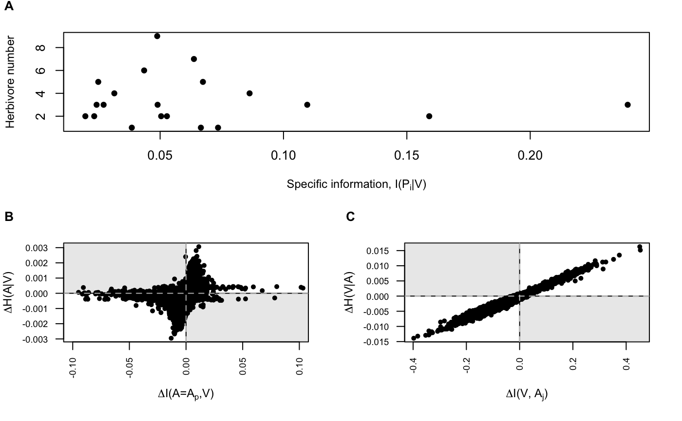
Fig. 1 (A) Relationship between the specific information $I\left(P_{i}∨V\right)$ and the number of herbivores associated with each plant species $\left(F\left(1,18\right)=0.162,p=0.69,R^{2}=0.009\right)$. (B) Relationship between the fitness of the mutated plant species, calculated as $1−I\left(A_{p},V\right)$ and the community conditional entropy H(A|V), where $I\left(A_{p},V\right)$ is calculated as the weighted average of the specific information, $I\left(A=a,V\right)$ (Equation 3), for the set of herbivores that interact with plant p ($p=0.001,R^{2}=0.27$. (C) Relationship between the fitness of the mutated herbivore species, calculated as $I\left(A_{j},V\right)$, and the community conditional entropy H(V|A), where $I\left(A=a_{j},V\right)$ is the specific information of the mutated herbivore species with respect to VOCs ($p<0.001,R^{2}=0.96$. (The shaded quadrants in B and C indicate areas where the “community fitness” and the species-level fitness are of opposite sign, indicating that a mutation would be fixed in one model and eliminated in the other).
Alternative explanations of VOC redundancy and herbivore specialization
Below, we show that a null model parameterized by the observed frequency of links in the plant-herbivore and plant-volatile networks reproduces the “information structure” deduced from the field data equally as well as the proposed model while relying on fewer problematic assumptions (Fig. 2). The null model demonstrates that the proposed information theoretical indices can be explained solely on the basis of network connectedness, such that any model generating the observed connectedness values will produce similar entropies as outputs. In other words, any mechanism producing moderate VOC redundancy along with moderate insect dietary specialization would be sufficient to reproduce the observed patterns. Since an information arms race is not a unique explanation for the observed pattern, we must instead assess the hypothesis on the validity of its core assumptions or the accuracy of its other predictions.
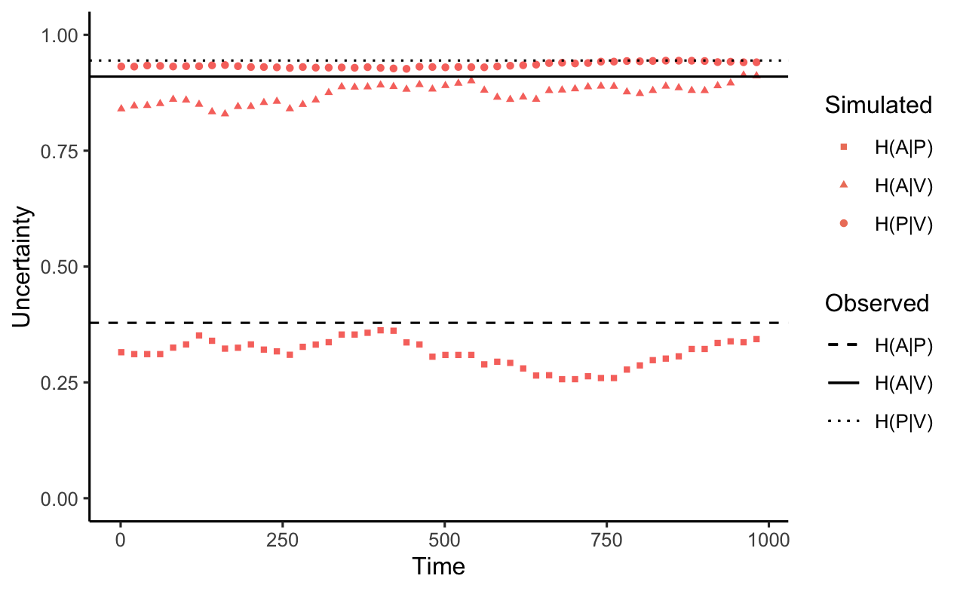
Fig. 2 Simulation of neutrally evolving plant-herbivore community, where the connectedness of the PV and AP matrices is parameterized using frequencies estimated from the field data. We estimate that plant-volatile links occur with a probability of 0.8 and plant-herbivore links occur with a probability of 0.1. Observed entropies plotted as horizontal lines are mean values from three years of data reported by Zu et al. (Compare with Figure 3A in Zu et al 2020 (1)).
VOC redundancy and herbivore specialization can both be explained more parsimoniously without invoking an implausible process of community selection. VOC redundancy, for example, can be explained as an outcome of the shared evolutionary history between plant species, combined with stabilizing selection for beneficial VOCs. Alternatively, distantly related species can evolve the same VOCs through convergent evolution if they experience similar selective pressures (15). Importantly, this convergence does not necessarily imply that chemical similarity is itself adaptive, as suggested by the information arms race hypothesis. Meanwhile, the “information processing hypothesis” – that herbivore specialization can arise from selection on insects to maximize host-finding efficiency (or minimize confusion) – while plausible, is not original to the present work, being one of several widely discussed explanations of herbivore specialization (16–18). While the general approach of integrating information theory with ecological and evolutionary theory is exciting, we wish to emphasize that attempts to integrate information theoretic indices with evolutionary theory must be rigorously tested to ensure that the field can move forward on firm empirical footing.
Data, script and code availability:

All data is included in (1) and associated supplements. Code to reproduce these analyses in R is available on Zenodo (https://doi.org/10.5281/zenodo.6081815).
Acknowledgments:

We thank the authors of Zu et al. (1), Paul Glaum, Stephen P. Ellner, and the Kessler Lab group for helpful discussion and feedback on the manuscript. We also thank Rodrigo Medel, Claudio Ramirez and two anonymous reviewers for feedback on an earlier version of this manuscript. Version 6 of this preprint has been peer-reviewed and recommended by Peer Community In Ecology (https://doi.org/10.24072/pci.ecology.100094).
Funding:
No funding was used to carry out this work.
Author contributions:
E.B. carried out the reported analyses and wrote the manuscript with input from A.K.
Conflict of interest disclosure:
The authors of this article declare that they have no financial conflict of interest with the content of this article.
References and Notes:
(1) Zu, P.; Boege, K.; del-Val, E.; Schuman, M. C.; Stevenson, P. C.; Zaldivar-Riverón, A.; Saavedra, S. Information Arms Race Explains Plant-Herbivore Chemical Communication in Ecological Communities. Science 2020, 368 (6497), 1377–1381. https://doi.org/10.1126/science.aba2965.
(2) Lewontin, R. C. The Units of Selection. Annual Review of Ecology and Systematics 1970, 1, 1–18.
(3) Eisner, T.; Grant, R. P. Toxicity, Odor Aversion, and “Olfactory Aposematism.” Science 1981, 213 (4506), 476–476. https://doi.org/10.1126/science.7244647.
(4) Endler, J. A. An Overview of the Relationships between Mimicry and Crypsis. Biol J Linn Soc 1981, 16 (1), 25–31. https://doi.org/10.1111/j.1095-8312.1981.tb01840.x.
(5) Bruce, T.; Pickett, J. Perception of Plant Volatile Blends by Herbivorous Insects – Finding the Right Mix. Phytochemistry 2011, 72 (13), 1605–1611. https://doi.org/10.1016/j.phytochem.2011.04.011.
(6) Kessler, A.; Baldwin, I. T. Defensive Function of Herbivore-Induced Plant Volatile Emissions in Nature. Science 2001, 291 (5511), 2141–2144. https://doi.org/10.1126/science.291.5511.2141.
(7) Massad, T. J.; Moraes, M. M. de; Philbin, C.; Oliveira, C.; Torrejon, G. C.; Yamaguchi, L. F.; Jeffrey, C. S.; Dyer, L. A.; Richards, L. A.; Kato, M. J. Similarity in Volatile Communities Leads to Increased Herbivory and Greater Tropical Forest Diversity. Ecology 2017, 98 (7), 1750–1756. https://doi.org/10.1002/ecy.1875.
(8) Zhang, Q.-H.; Schlyter, F. Olfactory Recognition and Behavioural Avoidance of Angiosperm Nonhost Volatiles by Conifer-Inhabiting Bark Beetles. Agricultural and Forest Entomology 2004, 6 (1), 1–20. https://doi.org/10.1111/j.1461-9555.2004.00202.x.
(9) Salazar, D.; Jaramillo, A.; Marquis, R. J. The Impact of Plant Chemical Diversity on Plant–Herbivore Interactions at the Community Level. Oecologia 2016, 181 (4), 1199–1208. https://doi.org/10.1007/s00442-016-3629-y.
(10) Grof-Tisza, P.; Karban, R.; Rasheed, M. U.; Saunier, A.; Blande, J. D. Risk of Herbivory Negatively Correlates with the Diversity of Volatile Emissions Involved in Plant Communication. Proceedings of the Royal Society B: Biological Sciences 2021, 288 (1961), 20211790. https://doi.org/10.1098/rspb.2021.1790.
(11) Ehrlich, P. R.; Raven, P. H. Butterflies and Plants: A Study in Coevolution. Evolution 1964, 18 (4), 586–608. https://doi.org/10.1111/j.1558-5646.1964.tb01674.x.
(12) Feeny, P. Plant Apparency and Chemical Defense. In Biochemical Interaction Between Plants and Insects; Recent Advances in Phytochemistry; Springer, Boston, MA, 1976; pp 1–40. https://doi.org/10.1007/978-1-4684-2646-5_1.
(13) Williams, P. L.; Beer, R. D. Nonnegative Decomposition of Multivariate Information. arXiv:1004.2515 2010.
(14) Deweese, M. R.; Meister, M. How to Measure the Information Gained from One Symbol. Network: Computation in Neural Systems 1999, 10 (4), 325–340. https://doi.org/10.1088/0954-898X_10_4_303.
(15) Pichersky, E.; Lewinsohn, E. Convergent Evolution in Plant Specialized Metabolism. Annual Review of Plant Biology 2011, 62 (1), 549–566. https://doi.org/10.1146/annurev-arplant-042110-103814.
(16) Levins, R.; MacArthur, R. An Hypothesis to Explain the Incidence of Monophagy. Ecology 1969, 50 (5), 910–911. https://doi.org/10.2307/1933709.
(17) Bernays, E. A.; Wcislo, W. T. Sensory Capabilities, Information Processing, and Resource Specialization. The Quarterly Review of Biology 1994, 69 (2), 187–204. https://doi.org/10.1086/418539.
(18) Bernays, E. A. Neural Limitations in Phytophagous Insects: Implications for Diet Breadth and Evolution of Host Affiliation. Annual Review of Entomology 2001, 46 (1), 703–727. https://doi.org/10.1146/annurev.ento.46.1.703.

