Mexican agricultural frontier communities differ in forest dynamics with consequences for conservation and restoration

Madelon Lohbeck ^{1,2}, Ben DeVries ³, Frans Bongers ¹, Miguel Martinez-Ramos ⁴, Armando Navarrete-Segueda ⁴, Sergio Nicasio-Arzeta ⁴, Christina Siebe ⁵, Aline Pingarroni ⁴, Germán Wies ⁴, Mathieu Decuyper ^{1,2}

1. Wageningen University and Research, Wageningen, the Netherlands
2. World Agroforestry, Nairobi, Kenya
3. Department of Geography, Environment and Geomatics, University of Guelph, Canada
4. Instituto de Investigaciones en Ecosistemas y Sustentabilidad, Morelia, Universidad Nacional Autónoma de Mexico, Mexico
5. Instituto de Geología, Universidad Nacional Autónoma de Mexico, Mexico City, Mexico

Running head:
Drivers of forest dynamics in Mexico

Abstract
Forest regrowth is key to achieve restoration commitments, but a general lack of understanding when it occurs and how long secondary forests persist, hampers effective upscaling. We quantified spatiotemporal forest dynamics in a recently colonized agricultural frontier in southern Mexico, and tested how temporal variation in climate, and cross-community variation in land ownership, land quality and accessibility affect forest disturbance, regrowth and secondary forest persistence.
We consistently found more forest loss than regrowth, resulting in a net decrease of 45% forest cover (1991-2016) in the study region. Secondary forest cover remained relatively constant while secondary forest persistence increased, suggesting that farmers are moving away from shifting cultivation. Temporal variation in disturbance was explained by annual variation in climatic variables and key policy and market interventions.
We found large differences in forest characteristics across communities, and these were explained by differences in land ownership and soil quality. Forests were better conserved on communal land, while secondary forest was more persistent when farms were larger and soil quality is better. At the pixel-level both old forest and secondary forests were better represented on low-quality lands indicating agricultural concentration on productive land. Both old forest and secondary forest were less common close to the main road, where secondary forests were also less persistent.
We demonstrate the suitability of timeseries analyses to quantify forest disturbance and regrowth and we analyse drivers across time and space. Communities differ in forest dynamics, indicating different possibilities, needs and interests. We warrant that stimulating private land ownership may cause remaining forest patches to be lost and that conservation initiatives should benefit the whole community. Forest regrowth competes with agricultural production and ensuring farmers have access to restoration benefits is key to restoration success.

keywords
secondary succession, Landsat, Marqués de Comillas, Mexico, Chiapas, natural regeneration, soil quality

Introduction
Increasing forest cover is central to achieving restoration commitments during the 2021-2030 decade of ecosystem restoration. The extent to which forest gains contribute to restoration depend on the characteristics of these new forests. Forests are often replaced by monoculture plantations (Rudel et al. 2016, Sloan et al. 2019) with limited restoration benefits, while secondary forest could make substantial contributions (Chazdon and Guariguata 2016). Secondary forests, or natural regeneration, is less costly and more effective than tree planting (Chazdon and Uriarte 2016, Crouzeilles et al. 2017). Secondary forests are resilient, capture large amounts of carbon (Chazdon et al. 2016, Poorter et al. 2016, Schwartz et al. 2017), host many species (Dent and Wright 2009, Rozendaal et al. 2019) and provide multiple ecosystem services (Zeng et al. 2019). However, the extent to which secondary forests provide ecological and societal benefits depend on their persistence. Secondary forests are commonly ephemeral (van Breugel et al. 2013) like in the Brazilian Amazon where median persistence is about 5 years (Jakovac et al. 2017). Instead in Costa Rica median persistence was 20 years (Reid et al. 2018), allowing substantial benefits for restoration and conservation. To make use of natural regeneration for restoration we need to understand under what conditions regrowth occurs and how long secondary forests persist. Recent developments in remote sensing allow us to track continuous disturbance-regrowth dynamics using satellite image timeseries (Verbesselt et al. 2010, DeVries et al. 2015a) which enables to quantify the spatiotemporal forest dynamics and identify forest ages (George‐Chacón et al. 2021).

In addition, little is known about the drivers of forest dynamics (but see Carreiras et al. 2014, Schwartz et al. 2017). In this study we propose that forest conservation, forest regrowth and secondary forest persistence across communities are influenced by variation in three key variables: land ownership (average farm size and the proportion of communally owned land), land quality (quality of the soil and hydrological properties) and accessibility (access to infrastructure and markets) that were shown to have a close connection to colonisation frontier development and forest transition theory (Richards 1996, Mather and Needle 1998). The early pioneer stage is characterized by rapid forest clearance for subsistence agriculture and where forest regrowth takes place as fallows in shifting cultivation systems. In the second stage agricultural concentration on high-quality land may give rise to forest regrowth on marginal lands, allowing for more persistent secondary forests (Mather and Needle 1998, Smith et al. 2001). During the third stage the market develops which increases accessibility, and may further enforce agricultural concentration on high quality lands (Mather and Needle 1998) or decouple productivity from land quality because farmers get access to external inputs. During the fourth closing frontier stage no land is left to colonise and is characterized by urbanisation, land concentration and social differentiation (Richards 1996).

We assess how societal and biophysical characteristics have shaped forest dynamics in agricultural frontier communities. We studied Marqués de Comillas region (MdC), a dynamic agricultural frontier located in the Mesoamerican biodiversity hotspot in the humid tropics of Mexico. MdC provides a suitable natural experiment of landscape change in a colonization context because colonization was recent (1970's-1980's), rapid, had big consequences for forest cover, and the region is representative of many such frontier areas in the tropics (Lepers et al. 2005).
Specifically, we ask 1) how land ownership, land quality, and accessibility affect the extent of conserved forest, the extent and persistence of secondary forest across communities, and 2) how annual changes in climate have shaped forest dynamics.
We hypothesized that: Land ownership, and specifically farm size, positively influences forest conservation and regrowth because land is only spared when basic food production needs are met. Land quality positively influences forest conservation because higher quality lands have a large productive potential which allows to produce more efficiently. Regrowth extent and persistence may be either decreased with land quality because of shorter fallow cycles, or it may be increased because agricultural concentration leads to land abandonment on marginal lands. Accessibility decreases forest cover as the pressure on land increases with market access. In addition, we expected a negative interaction between land quality and farm size because when land quality is high, less land is needed to meet livelihood needs. Finally, we expected that with accessibility, farmers may get access to off-farm income and external inputs, decreasing effects of farm size and land quality. We further expect that climatic variation may alter the developments predicted by colonisation theory. The results are discussed in the light of key policy interventions which may accelerate or slow down these transitions.

Methods
Study region
The study took place in the Marqués de Comillas region (about 2000 km²) in Chiapas, Mexico (Fig. 1). It consists of two municipalities: Marqués de Comillas and Benemérito de las Américas and one community from the municipality of Ocosingo, and is enclosed by Guatemala and the Montes Azules Biosphere Reserve on the north-western side. The original vegetation is tropical rainforest. Close to 40 settler communities colonized the region from 1972 to 1986 rapidly converting forest into agricultural landscapes (de Vos 2003). Deforestation was significantly increased by settlement of Central American refugees in the 1980s (de Jong et al. 2000). Communities were organized in ejidos, which is a term for the agrarian collective use of the land. Farmers vary from subsistence smallholders to those that depend partly on markets (Montes de Oca et al. 2015) and poverty levels are high (CONEVAL 2015). The region is characterized by complex human-modified landscapes consisting of crop fields (mainly maize, beans), cattle ranches, forests and plantations (Martínez-Ramos et al. 2016).

For the spatial analysis the community is the unit of replication (n = 41), which is justified by the relatively unified colonisation history in which initial settlers usually arrived together and from the same region of origin (de Vos 2003). Most communities (n = 37) are indeed formally recognized as ejidos, four units are not (see Fig. 1).

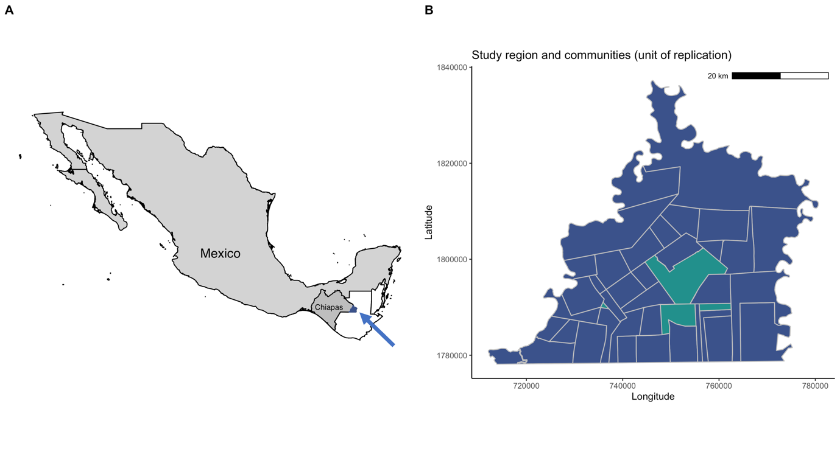

Figure 1. The 41 communities considered in this study. The dark blue units are formally recognized as ejidos, the green units are not. For the spatial analyses across communities only the dark blue communities (ejidos) were used.

Forest dynamics trajectories
To quantify forest landscape characteristics per community, we first characterized pixel-level forest dynamics trajectories using Landsat time series (1984-2016). An NDMI (Normalized Difference Moisture Index) raster stack was constructed and forest dynamics trajectories were created using on a mix of methods (detailed methods presented in Supplementary materials). A baseline was set in 1991, for which we produced a forest non-forest map using a maximum likelihood classifier applied in ArcGIS (ESRI 2012), which ensured sufficient data (1984-1991) as a historical reference. For pixels that were not forested in the baseline we instead used a spatial reference (DeVries et al. 2015a). To characterize disturbance-regrowth trajectories, we applied three sets of disturbance and regrowth algorithms to the monitoring period (1991-2017). To start, a harmonic seasonal model was fitted to the reference pixels (historical or spatial) which served as a reference (Verbesselt et al. 2012). Forest disturbance (forest to non-forest) was detected when first, a pixel deviated significantly from the reference model (cf. Verbesselt et al. 2012) and second, the median residual within the one year following, is less than -0.02, with the residual being the difference between the observed NDMI value and the reference model (Verbesselt et al. 2012, DeVries et al. 2015b). A magnitude threshold of -0.02 was taken from a similar study in Southern Peru (DeVries et al. 2015b) and was considered appropriate for this study region based on qualitative and quantitative accuracy assessments. Regrowth (non-forest to forest) was detected using the rgrowth R package (DeVries 2015) and records the date at which a pixel with a previous disturbance becomes statistically comparable in temporal structure to the historical reference, for at least one year, and is based on a time series test (DeVries et al 2015a). Each method records the date at which a pixel undergoes the event, and this iterative process results in six rasters representing the dates of first, second and third disturbance and regrowth dates for each pixel. The date of regrowth represents the year in which the timeseries reaches values comparable in magnitude and seasonality to the reference, and occurs several years after the start of regrowth. Overall accuracies were 0.77 for disturbance (0.04 standard error) and 0.72 for regrowth (0.07 standard error).

Based on the baseline forest map (1991) and the pixel-level forest dynamics trajectories, we identified the state of each pixel. Old forest was forest in the baseline and no disturbance was identified during the monitoring period. This implies that old forest has been undisturbed for at least 26 years, and is not the same as old-growth forest. Secondary forest was not forested at some point in time, after which regrowth was detected and persisted until the year of interest. For pixels identified as regrowth we calculated the age (year of interest - year of regrowth detection), as the year of regrowth detection occurs some years after the start of regrowth, presents an underestimation of the actual age. Since our monitoring period starts in 1991, the oldest secondary forest that could be identified was 26 years (1991-2017). Secondary forest in this region rarely reach 26 years (van Breugel et al. 2006) so for our study this method is appropriate. Our method was not designed to distinguish regrowth by secondary forest from plantations. Recent maps of oil palm were developed using Sentinel-2 imagery and an object-based image segmentation (SAGA-GIS) classification method (Fig. S2, and detailed methods in Supplementary Materials) and masked from the secondary forest and old forest maps.

Forest landscape characteristics
From the current (2017) state of each pixel, we calculated the four forest landscape characteristics at the level of the community. 1) Forest cover is the proportion of the land covered with forest. 2) Old forest cover is the proportion of the land covered with old forest. 3) Secondary forest is the proportion of the land covered with secondary forest. 4) Secondary forest age, estimated as the time (years) at which half of the forests survived (median survival) was calculated based on Kaplan-Meier survival analyses using the R-package survival (Therneau 2015). As one pixel may exhibit a maximum of three cycles of disturbance and regrowth, we only included the first cycle for any single pixel. Survival analyses were carried out for each community, and for the entire region. For five out of the 41 communities this value could not be estimated because the probability of survival remained higher than 0.5, we then used 25 years as the median survival. We also split the dataset into two equal 10-year time periods (1994-2003 and 2004-2013) to evaluate shifts in median survival over time (cf. Jakovac et al. 2017).

Community-level spatial drivers of forest landscape characteristics
We used six community-level indicators to quantify the drivers land ownership, land quality and accessibility. Land ownership reflects the land available for each farmer to produce food and the land that is communally owned. For this we assessed the proportion of privately owned and communally owned land at the ejido-level (Registro Agrario Nacional 2020). Average farm size (ha/ farmer) was quantified by dividing privately owned land by the number of landowners in the village (RAN; datos.gob.mx). Communally owned land is the proportion of ejido land that is communally owned.
Land quality is the quality of the land and soil and determines the land’s agricultural potential. For land quality we used two indicators, one based on soil quality (see detailed methods in Supplementary materials), important for crop production, and one based on hydrological properties, important for cattle ranching. We calculated the mean topsoil carbon based on the soil organic carbon contents (%) across each community and the proportion of the land covered with high productive soils (Fluvial terrace, Alluvial plain and the Karst Range of Limestone-Claystone; see Fig. S3). Hydrological properties were indicated by calculating the internal river length density (km of river length / km² of land area) for each community (INEGI 2010b) (see Fig. S4). Accessibility is whether communities have access to infrastructure. With the opening of the road in 1994, the region was connected with nearby cities and markets, but left some communities better connected than others. Accessibility of each ejido was included as the proportion of the land that falls within 1 km from the main road (see Fig. S5).

Temporal drivers of forest dynamics
We tested whether climatic variables explained annual variation in forest disturbance across the region. We did not test the annual variation in forest regrowth because, rather than reflecting the start of regrowth, regrowth dates reflect when regrowing forests become comparable to the reference, making a test for climatic drivers less meaningful. The Oceanic Niño Index (ONI) reflects the El Niño-Southern Oscillation (ENSO). ENSO is a recurring climate pattern involving changes in the temperature of the central and eastern tropical Pacific Ocean where El Niño is a warming of the ocean surface and La Niña is a cooling of the ocean surface (NOAA 2020). This oscillation affects rainfall on land where Mexico receives less rain during El Niño events and more during La Niña events. As indicators of rainfall we used the total annual rainfall and the total rainfall in the dry season (February to April), as derived from the nearby Lacantún meteorological station (conagua.gob.mx).

Statistical analyses
For the spatial analyses we tested whether community-level forest landscape characteristics could be explained by drivers. Only communities formally recognized as 'ejidos' could be included, for one ejido land ownership could not be estimated because it had no privately owned land, so this analysis relied on 36 communities. To test the most important drivers we used generalised linear models (glm) following a three-step approach. First, we tested a simple model without interactions, including all six community-level drivers. Second, we tested a model including all drivers and a two-way interaction between land ownership and land quality. Third, we tested a model including all drivers and a three-way interaction between land ownership, land quality and accessibility. The best model for each of the forest landscape characteristics was selected based on model significance. When multiple models were significant the model with the lowest Aikaike Information Criterion (Burnham and Anderson 2002) was selected, choosing the simplest model when ﻿ΔAICc < 2. We also calculated pixel-level odd-ratios to evaluate the probabilities of different forest types to occur on land characterized by the drivers.
For the temporal analyses we used the year as the unit of replication (n= 26). We tested whether the ONI index, the annual rainfall and the rainfall in the dry season (February to April) explained the disturbances in the same year. The best model was selected based on the criteria outlined above. Correlations between predictors are presented in Table S4. Graphics were made in the ggplot2 package (Wickham 2016), to estimate marginal effects we used the ggeffects package (Lüdecke 2018). All statistical analyses were carried out using R version 3.5.3 (R Development Core Team 2011).

Results
Forest landscape characteristics
The proportion of forest in 2017 in MdC was 0.48, of which 0.37 is old forest, 0.11 is secondary forest. Forest characteristics differ widely across communities (Figs 2, 3a)

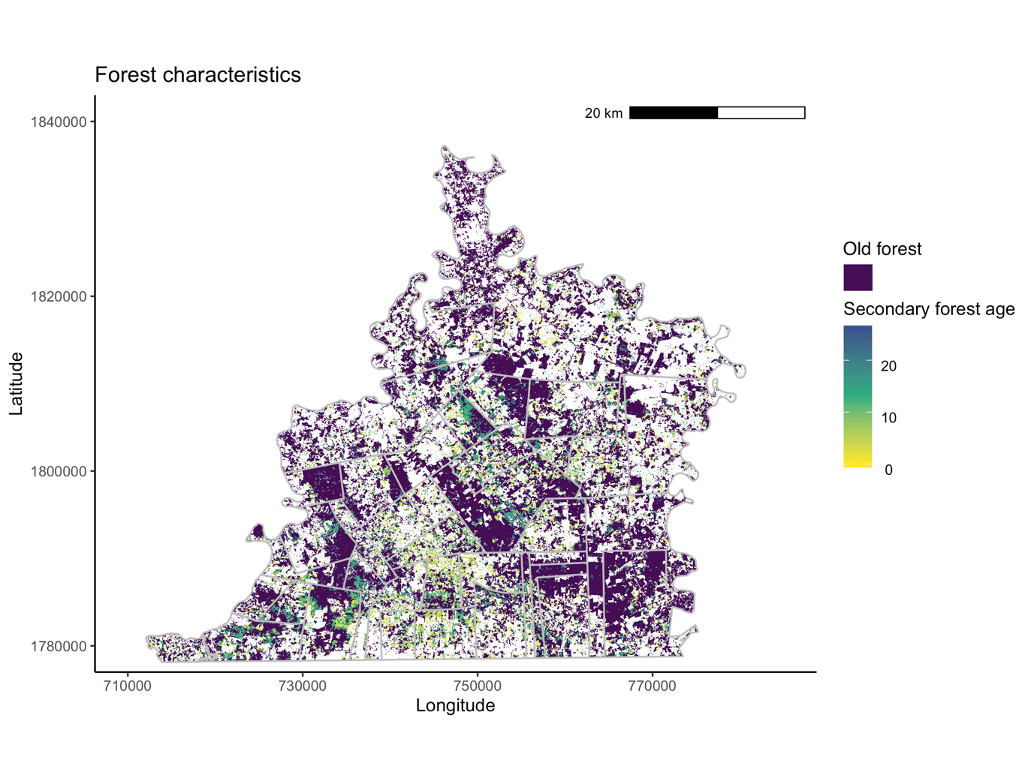
Figure 2. Map of the current (2017) forest landscape characteristics in Marqués de Comillas region, Mexico. Old forest is forest conserved for at least 26 years, blues, greens and yellows are secondary forests specified by their ages, no colour indicates no forest and can be pasture, maize field, oil palm or other land uses.

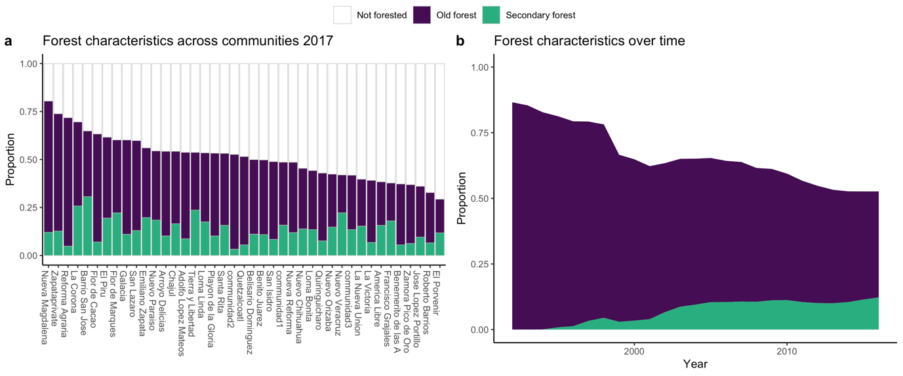
Figure 3. a) Current (2017) forest characteristics across Marqués de Comillas communities (see also Fig. 2). b) Trend in forest characteristics over time, for the entire study region. Colours indicate the proportion of old forest, secondary forest and not forested.

Marqués de Comillas consistently shows more forest loss than regrowth (Fig. 4), resulting in a net decrease of 45% in forest cover in the period 1991-2016 (Fig. 3b). A remarkable peak in forest disturbance was found in the year 1998 (Fig. 4) for which we assess its variation across communities (Fig. S6). Secondary forest cover has remained relatively constant since 2004 (10-11% of land area; Fig. 3b), while secondary forest persistence has increased (Fig. 5b).

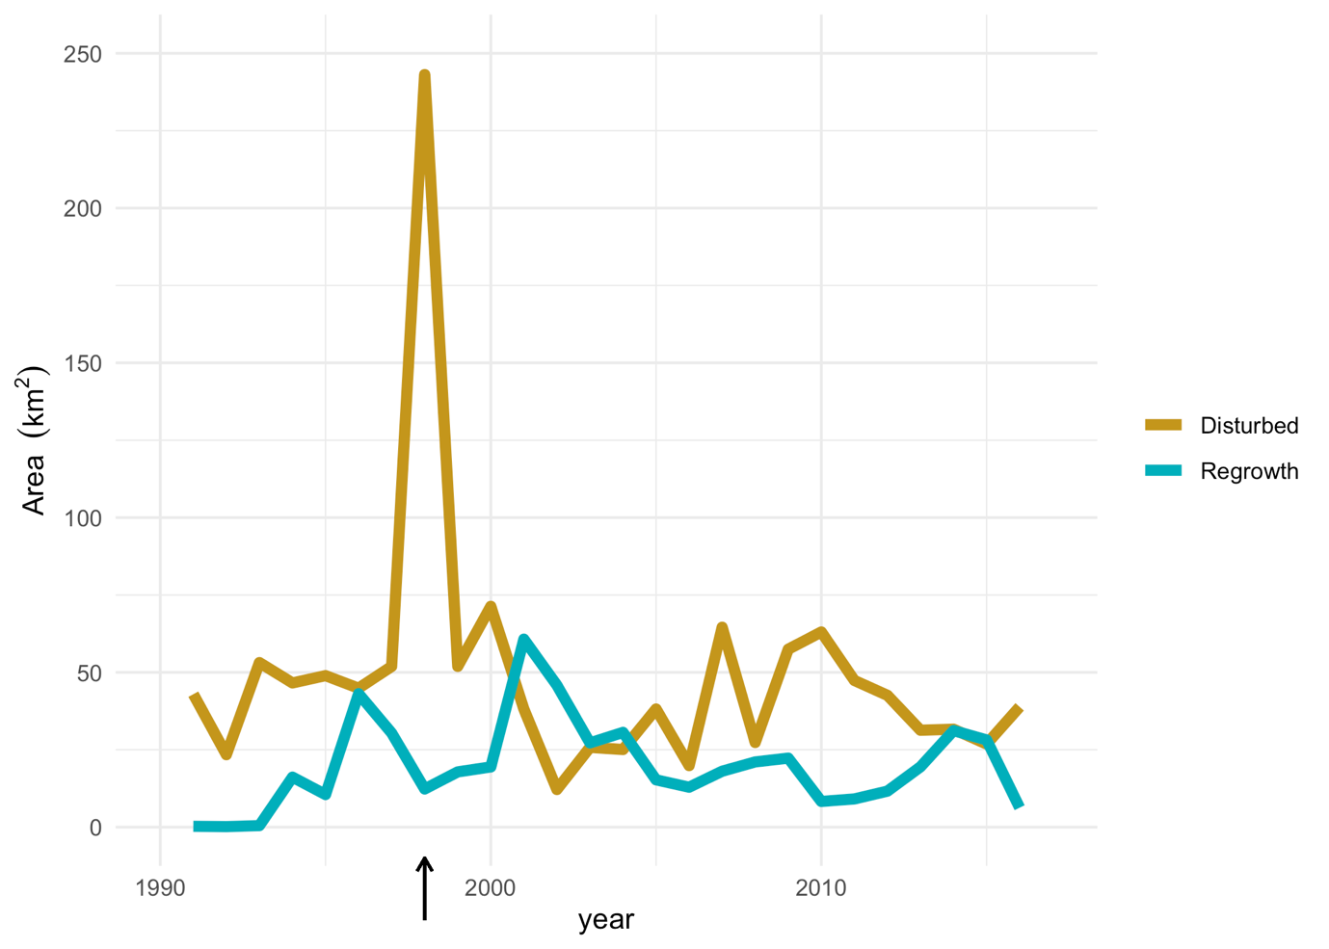
Figure 4. Total area of forest disturbed (pixels that changed from forest to non-forest) and of forest regrowth (pixels that changed from non-forest to forest) between 1991 and 2017. The year 1998 shows a remarkable peak in forest disturbance, which is also analysed for its spatial variation across communities (see Figs S6, 6).

Secondary forest in MdC reached a median age of 7.7 years (Fig. 5a), but values differ widely among communities (range: 2.7 - 25 years, mean: 9.7). Analysing the probability of surviving for two decades separately we found that there has been an increase in median secondary forest survival from 5.1 years in 1994-2003 to 7.9 years in 2004-2013 (Fig. 5b).

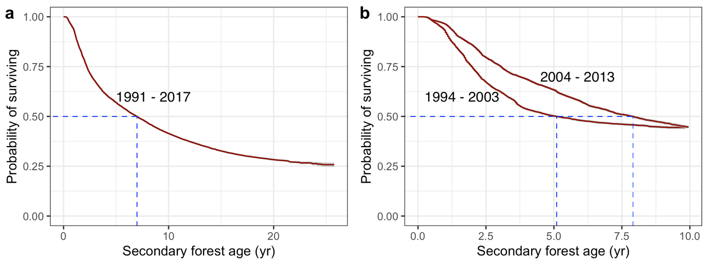
Figure 5. Persistence of secondary forests in MdC based on survival analyses. Dashed lines indicate the median age (0.5 probability of surviving) of secondary forests. a) Including all years of study period 1991-2016, b) Separating data in two decades to evaluate changes in survival over time.

Spatial drivers of forest landscape characteristics
From the four forest landscape characteristics plus the variation in area disturbed in 1998, the simple model (without interactions) best explained the data in all cases, only for proportion of secondary forest no model fitted the criteria (Table S2). Communities that had more land that is communally owned tended to have more forest and more old forest (Fig. 6a, b), and secondary forest persisted longer (Fig. 6d). Secondary forest also persisted longer when farms are larger (Fig 6c) and topsoil organic carbon was higher (Fig 6e). The peak in disturbances in the year 1998 was particularly pronounced in communities that had less land with high productive potential (Fig. 6f) and had higher soil organic carbon (Fig 6g).

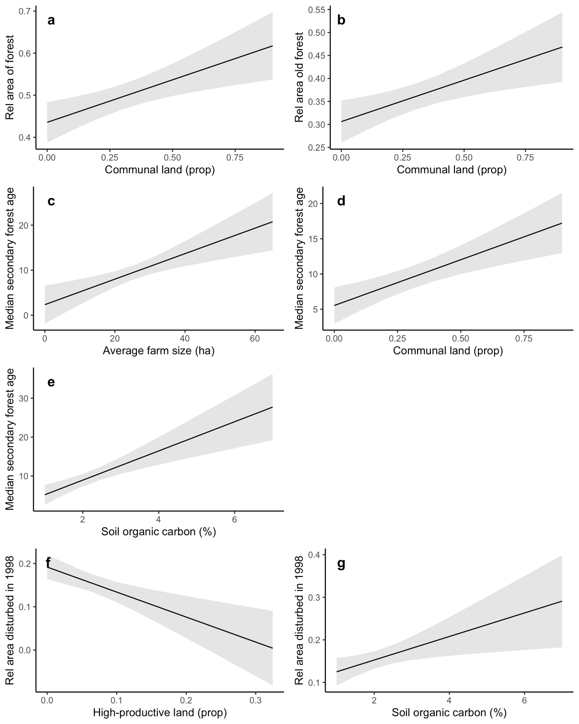
Figure 6. Marginal effects of the significant explanatory variables from the best fitted generalised linear models explaining forest landscape characteristics across communities. The area covered by forest (a) and old forest (b) are explained by the proportion of communal land in the community. Median secondary forest ages are explained by the farm size (c), the proportion of communal land (d) and the mean topsoil organic carbon (e). The relative area disturbed in 1998 is explained by the proportion of high-productive land (f) and by topsoil organic carbon (g) (see Table S2 for test results).

At the pixel-level all drivers contributed to explaining the probability of being covered with forest, old forest or secondary forest as well as the secondary forest ages. In terms of land ownership, it is more likely to find forest and old forest on communal land compared to private land and secondary forests tend to be older. In terms of land quality we found more forest and more secondary forest on low quality land, while no differences were found for old forest occurrence or for secondary forest ages. We found that all forest types were less common inside the 1km buffer from the main road, and secondary forests tended to be younger (see Table 1).

Table 1. Odds ratios to evaluate the effect of land ownership, land quality and accessibility on forest characteristics at the pixel-level. Given are the number of pixels covered with forest, old forest and secondary forest in given categories of land ownership (on private or communal land), land quality (on high or low quality soil) and accessibility (within or outside the 1km-buffer of the road), the proportion of the forest type within each of the categories, and the odds ratio which indicates the ratio of the proportions of the forest type in the two categories. Odds ratios around 1 indicate the forest type is as likely to occur across the categories. Odds that differ from 1 indicate that the probability of that forest type to occur is different for the two categories, presented in bold. The last row gives the median forest secondary forest age in each category, noteworthy differences presented in bold.
 |  | Land ownership |  |  | Land quality |  |  | Accessibility
# pixels | total | private land | communal land | odds ratio | high quality soil | low quality soil | odds ratio | within 1 km buffer of road | outside buffer of road | odds ratio
total | 2215790 | 1348171 | 677927 |  | 384495 | 1831295 |  | 381720 | 1834070
forest | 1065633 | 544851 | 406491 |  | 165526 | 900107 |  | 141325 | 924308
proportion | 0.481 | 0.404 | 0.600 | 0.674 | 0.431 | 0.492 | 0.876 | 0.370 | 0.504 | 0.735
old forest | 828305 | 433854 | 345182 |  | 139477 | 688828 |  | 110377 | 717928
proportion | 0.374 | 0.322 | 0.509 | 0.632 | 0.363 | 0.376 | 0.964 | 0.289 | 0.391 | 0.739
secondary forest | 237328 | 144192 | 71624 |  | 26049 | 211279 |  | 30948 | 206380
proportion | 0.107 | 0.107 | 0.106 | 1.012 | 0.068 | 0.115 | 0.587 | 0.081 | 0.113 | 0.721
median secondary forest age | 10.67 | 9.01 | 12.95 |  | 10.59 | 10.67 |  | 9.84 | 10.81

Temporal drivers of forest dynamics
Forest disturbance was best explained by an interaction between the rainfall in the dry season and the Oceanic Niño Index; El Niño years combined with lowered rainfall in the dry season led to peaks in forest clearance (Fig. 7).

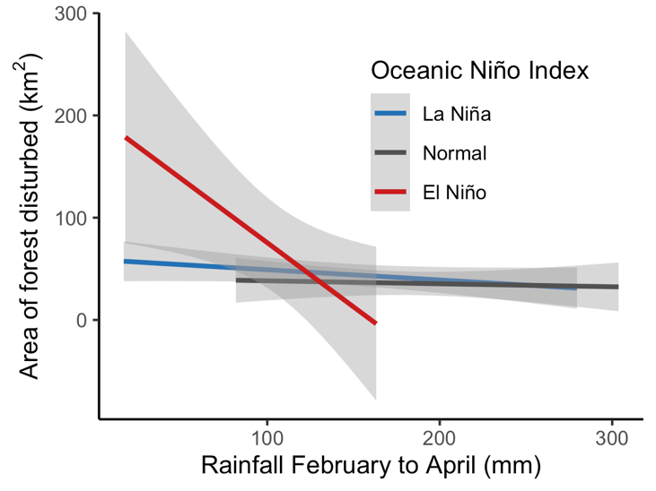
Figure 7. Forest disturbance explained by the interactive effects of Oceanic Niño Index (La Niña, El Niño and normal years) and the rainfall in the dry season between February and April (see Table S3 for test results).

Discussion
We quantified almost three decades of forest dynamics across a recently colonized agricultural frontier in Mexico. Results show consistently more disturbance than regrowth; forest cover has continued to decline despite efforts to revert this. Secondary forest area has remained constant over the last decade though secondary forest persistence is increasing. We found large differences in forest characteristics among communities, and these were explained by differences in land ownership and soil quality. When assessing impacts at the pixel-level, also accessibility contributed to explaining forest characteristics. Forest dynamics was further associated to annual variation in climate. Our results show that forest dynamics can be explained by a complex interplay of drivers across time, space and scale (cf. Berget et al. 2021). Results give insights into agricultural frontier development and have consequences for conservation and restoration.

Continuous decline in forest cover
We found that forest disturbance consistently exceeds forest regrowth, resulting in a 45% decline in forest cover during our monitoring period (1991-2016)(Figs 3b, 4). This confirms Fernández-Montes de Oca et al. (2015) demonstrating that deforestation in the region was continuously high from 2000 to 2012, and Vaca et al (2012) who showed forest cover to decline from 1990-2006. An older study covering 1970-1990’s already reported this decline and attributed it to policy support for agricultural expansion (de Jong et al. 2000). Although policy support for agriculture continues up to today, there seems to have been a shift from support for agricultural expansion (PROCAMPO since 1993, payments for arable fields on area basis) towards agricultural intensification (support for oil palm since 2007 and PROGAN support for cattle ranching on per-capita basis since 2008). The latter programmes, combined with those that aim to protect remaining forests, such as the payments for ecosystem services programme (Costedoat et al. 2015), highlight efforts to intensify agricultural production and halt deforestation. This shift came into effect after international pressure, notably during the UN Summit of 1992, and coincided with signing the North Atlantic Free Trade Agreement (Tello et al. 2020). However, at least for MdC, these efforts have not halted or reverted deforestation.

Forest conservation
We found more forest and more old forest in communities that had more communally owned land (Fig. 6a, b), and this was confirmed by the odds ratio analyses where old forest is 1.5 times more likely to be present on communal land than it is on private land (Table 1). This goes against the conception that resources managed under the commons will eventually be overexploited, known as the tragedy of the commons (Hardin 1968). However this theory has been disputed by many studies (e.g. Feeny et al. 1990), also in Mexico where communally owned coniferous forest had lower deforestation rates (Barsimantov and Kendall 2012). Other studies instead found no difference between communally and privately owned lands in Mexico, which was attributed to differences in community organisation and marginalisation (Bunge-Vivier and Martínez-Ballesté 2017, Ellis et al. 2017). These results warrant that the Neoliberal discourse stimulating private ownership may accelerate forest loss in this region, as recently demonstrated for Mexico (Lazos-Chavero et al. 2021), as well as globally (Davis et al. 2020). Results suggests that conservation programmes should ensure benefits for the community and not only target individuals. Although accessibility of communities did not explain forest cover, at the pixel-level we found that 35% more old forest occurs outside the buffer of the main road. This confirms that infrastructure determines the extent and ease in which farmers access markets, which increases land value and adversely affects forest cover (Putz and Romero 2014, Alamgir et al. 2017, Vaca et al. 2019).

Restoration: Forest regrowth and secondary forest persistence
Secondary forest covered 11% of the land (Fig. 1), its cover remained relatively constant while median secondary forest ages increased over time (Figs 3b, 5b). This suggest a change from shifting cultivation to permanent cultivation, in line with forest transition theory and colonisation frontier development (Richards 1996, Mather and Needle 1998). Shifting cultivation was the main livelihood practice in the early pioneer stage (de Vos 2003), where secondary forests occur as part of fallows. De Jong et al (2000) estimated that secondary forests covered 17% in 1996. As agricultural frontiers increase access to markets, during the second and third stages of colonization development (Richards 1996), communities move towards more intensive land uses with cattle production and cash crops (van Vliet et al. 2012). Often this is characterized by agricultural concentration on high-quality lands allowing secondary forests to persist on marginal land (Richards 1996, Mather and Needle 1998, Smith et al. 2001). We found that secondary forests were more persistent in communities with larger farms, more communal land and higher soil organic carbon (Fig. 6c, d, e), suggesting that farm size and soil quality impose important conditions for agricultural concentration to take place. Indeed secondary forests are 70% more frequent on poor soils, though, surprisingly, soil did not explain differences in secondary forest ages (Table 1). Forest regrowth was also associated with poor soils in Costa Rica (Arroyo-Mora et al. 2005), though other studies found no link with soil quality (Sloan et al. 2016). Van Vliet et al (2012) report market development, population growth, policies and economic structures, increased land tenure security, government support for cash crops and/or cattle as drivers of the transition from shifting cultivation to permanent agriculture. In MdC similar developments have occurred: land could be owned individually since 1992 (Assies and Duhau 2009), government support shifted focus from agricultural expansion to agricultural intensification (Tello et al. 2020), and NAFTA marked the start of a neoliberal discourse (Klepeis and Vance 2003) which caused farmers to change from crops (often in shifting cultivation) to (more permanent) cattle production (Speelman et al. 2014). The proportion of communally owned land increasing secondary forest ages across communities, as well as secondary forests being more persistent on communal land, seems to be a result of the better protection of forest on communal land, as discussed previously, rather than a result of agricultural intensification. Secondary forest was 30% less likely to be present within 1 km of the road where it was also less persistent, similar to findings from Peru (Schwartz et al. 2017).
Results show that restoration through forest regrowth is limited in communities with smaller farms and with relatively infertile lands. This suggests that incentives may be needed to compensate farmers for losses in agricultural production to further increase the restoration potential of secondary forests (Rudel et al. 2016, Chazdon et al. 2020). Payments for Ecosystem Services does not currently fulfill this role because the programme’s minimal area requirements exclude most secondary forests. Alleviating the minimum area requirement can be an important step forward.

Temporal drivers of forest dynamics
Our method allows a unique and detailed historical trajectory of forest disturbance and regrowth, which is valuable to analyse drivers in space and time. We found that annual variation in climate explained the variation in disturbance over time. More forest is disturbed in El Niño years (Fig. 7), which is driven particularly by the year 1998 that showed a four-fold increase in disturbance (Fig. 4). The extreme drought in 1998 enabled the rapid (unintentional) spread of intentional fires. Additionally, fire burned forest, which had higher flammability than in normal years (Román-Cuesta et al. 2003, 2004). As the disturbance-peak in 1998 was not followed by a regrowth peak, we expect that farmers replaced much of the burned forest by agriculture. The price-changes resulting from NAFTA (Speelman et al. 2014), which increased the popularity of extensive cattle ranching, may have paved the way for this expansion. Indeed more forest was disturbed in communities that had less land suitable for permanent cultivation (Fig. 6f), and that had more relatively fertile lands, as indicated by a higher soil organic carbon (Fig 6g). This suggest that farmers took advantage of the drought to expand extensive cattle ranching, which is suitable on the relatively fertile lands that cannot support permanent crop cultivation. Land use is the result of a complex interplay of drivers across scales (cf. Sendzimir et al. 2011), as illustrated by the 1998 disturbance peak which coincided with an El Niño event and followed changes in tenure security, government support programmes, and changing commodity prices.

Limitations of this study
Our method on pixel-level forest dynamics yielded good overall accuracies but probably overestimated the current amount of old forest and underestimated the area not forested and under secondary forest. While we found 37% old forest and 11% secondary forest, INEGI 2011 estimated 42% of forest cover, including both old growth and secondary forest (INEGI 2010a). Estimates based on plot-data in the southwestern part of the region estimated 33% old-growth forest and 17% secondary forest (Zermeño-Hernández et al. 2016). Although definitions of old forest and of secondary forest may partially underlie this (in our case old is older than 26 years), we expect that model assumptions also played a role. Our method took a conservative approach to detecting disturbance or regrowth with thresholds that reduce commission errors but may increase omission errors. As a consequence some disturbances will go undetected (increasing old forest cover), and that some regrowth will go undetected (decreasing secondary forest cover). This may apply particularly to regrowth which remains hard to identify due to its gradual nature (DeVries et al. 2015a). In addition, forest regrowth was detected when NDMI values are similar in magnitude and seasonality to the reference, and occurs several years after the start of regrowth. This has the consequence that very young secondary forests may go undetected thus underestimating area under secondary forest. Although we recognize this bias, such errors will apply homogenously to the whole region, and thus not affect our results in terms of the drivers across time and space.

Recommendations and conclusions
We demonstrate the suitability of timeseries analyses to quantify forest disturbance and regrowth and we analyse drivers across time and space. This is urgently needed to design better policies to stimulate forest conservation and restoration. Communities differ in forest dynamics, indicating different possibilities, needs and interests. Policies that acknowledge this diversity and allow for bottom-up initiatives are more likely to be effective (cf. Pingarroni et al. 2022). We warrant that further stimulating private land ownership will lead remaining forest patches on communal land to be lost and that initiatives geared towards enhancing forest conservation should benefit the community. To ensure that secondary forests contribute to restoration targets, forest regrowth and secondary forest persistence should be stimulated which requires incentivising farmers to set aside land for restoration (cf. Chazdon et al. 2020).

Acknowledgements
We thank Carolina Berget, Oscar Barrera, Rocio Aguilar, Patricia Balvanera and Lucas de Carvalho-Gomez for constructive discussions that helped to improve this manuscript, and Julia Hacklander for accuracy assessment. This research was supported by the Interdisciplinary Research and Education Fund of Wageningen University (INREF) as part of the FOREFRONT programme. ML was supported by research programme ALW-VENI (863.15.017), financed by the Netherlands Organisation for Scientific Research (NWO). MMR was supported by CONACYT to BIOPAS project (Grant number CB-2016-285940). MD and ML acknowledge financial support by the CGIAR Programme on Forests, Trees and Agroforestry (FTA).

Authors’ Contribution Statement
ML conceived the idea, carried out the statistical analyses and led the writing. MD and BdV performed the remote sensing analyses. ANS and CS have collected data for the soil properties and created the map on geomorphical units, SN and GW have created the oil palm map. All authors contributed to the writing and have approved the final version of this work.
The authors declare no conflict of interest

Please refer to the supplementary materials for:
Detailed methods on forest disturbance and regrowth identification
Detailed methods on oil palm classification
Detailed methods on soil properties across the geomorphic units
Figure S1. Illustrating the forest dynamics trajectory method and validation
Figure S2. Map of oil palm plantations in Marqués de Comillas, Mexico
Figure S3. Geomorphic land units across Marqués de Comillas and their values for high-productive potential and soil organic carbon
Figure S4. Internal rivers in Marqués de Comillas region
Figure S5. The main road (built in 1994) that connects communities in Marqués de Comillas region
Figure S6. Forest disturbance in year 1998 in Marqués de Comillas region
Figure S7. Map with formally registered lands under private and communal ownership across Marqués de Comillas region
Figure S8. The main rivers that border Marqués de Comillas region
Table S1. Soil sampling across the six main geomorphic units and across land uses
Table S2. Test statistics for the drivers of forest landscape characteristics across communities
Table S3. Test statistics for the drivers of dynamics over time
Table S4. Correlations between predictor variables

Bibliography
Alamgir, M., M. J. Campbell, S. Sloan, M. Goosem, G. R. Clements, M. I. Mahmoud, and W. F. Laurance. 2017. Economic, Socio-Political and Environmental Risks of Road Development in the Tropics. Curr Biol 27:R1130-R1140.
Arroyo-Mora, J. P., G. A. Sánchez-Azofeifa, B. Rivard, J. C. Calvo, and D. H. Janzen. 2005. Dynamics in landscape structure and composition for the Chorotega region, Costa Rica from 1960 to 2000. Agriculture, Ecosystems & Environment 106:27-39.
Assies, W., and E. Duhau. 2009. Land tenure and tenure regimes in Mexico: An overview.in J. M. Ubink, A. J. Hoekema, and W. J. Assies, editors. Legalising land rights, Local Practices, State Responses and Tenure Security in Africa, Asia and Latin America Leiden University Press, Leiden.
Barsimantov, J., and J. Kendall. 2012. Community Forestry, Common Property, and Deforestation in Eight Mexican States. The Journal of Environment & Development 21:414-437.
Berget, C., G. Verschoor, E. García-Frapolli, E. Mondragón-Vázquez, and F. Bongers. 2021. Landscapes on the Move: Land-Use Change History in a Mexican Agroforest Frontier. Land 10.
Bunge-Vivier, V., and A. Martínez-Ballesté. 2017. Factors that influence the success of conservation programs in communal property areas in Mexico. International Journal of the Commons 11.
Burnham, K. P., and D. R. Anderson. 2002. Model selection and multimodel inference: a practical information-theoretic approach. Springer, New York.
Carreiras, J. M., J. Jones, R. M. Lucas, and C. Gabriel. 2014. Land use and land cover change dynamics across the Brazilian Amazon: insights from extensive time-series analysis of remote sensing data. PLoS ONE 9:e104144.
Chazdon, R. L., E. N. Broadbent, D. M. A. Rozendaal, F. Bongers, A. M. Almeyda Zambrano, T. M. Aide, P. Balvanera, J. M. Becknell, V. Boukili, P. H. S. Brancalion, D. Craven, J. S. Almeida-Cortez, G. A. L. Cabral, B. d. Jong, J. S. Denslow, D. H. Dent, S. J. DeWalt, J. M. Dupuy, S. M. Durán, M. M. Espírito-Santo, M. C. Fandino, R. G. César, J. S. Hall, J. L. Hernández-Stefanoni, C. C. Jakovac, A. B. Junqueira, D. Kennard, S. G. Letcher, M. Lohbeck, M. Martínez-Ramos, P. Massoca, J. A. Meave, R. Mesquita, F. Mora, R. Muñoz, R. Muscarella, Y. R. F. Nunes, S. Ochoa-Gaona, E. Orihuela-Belmonte, M. Peña-Claros, E. A. Pérez-García, D. Piotto, J. S. Powers, J. Rodríguez-Velazquez, I. E. Romero-Pérez, J. Ruíz, J. G. Saldarriaga, A. Sanchez-Azofeifa, N. B. Schwartz, M. K. Steininger, N. G. Swenson, M. Uriarte, M. v. Breugel, H. v. d. Wal, M. D. M. Veloso, H. Vester, I. C. G. Vieira, T. V. Bentos, G. B. Williamson, and L. Poorter. 2016. Carbon sequestration potential of second-growth forest regeneration in the Latin American tropics. Science Advances 2:e1501639.
Chazdon, R. L., and M. R. Guariguata. 2016. Natural regeneration as a tool for large-scale forest restoration in the tropics: prospects and challenges. Biotropica 48:716-730.
Chazdon, R. L., D. Lindenmayer, M. R. Guariguata, R. Crouzeilles, J. M. Rey Benayas, and E. Lazos Chavero. 2020. Fostering natural forest regeneration on former agricultural land through economic and policy interventions. Environmental Research Letters 15.
Chazdon, R. L., and M. Uriarte. 2016. Natural regeneration in the context of large-scale forest and landscape restoration in the tropics. Biotropica 48:709-715.
CONEVAL. 2015. Informe Anual Sobre La Situación de Pobreza y Rezago Social. Inf. Anu. Sobre La Situación Pobr. Y Rezago Soc. 2, Online: http://www.dof.gob.mx/SEDESOL/Chiapas_108.pdf.
Costedoat, S., E. Corbera, D. Ezzine-de-Blas, J. Honey-Roses, K. Baylis, and M. A. Castillo-Santiago. 2015. How effective are biodiversity conservation payments in Mexico? PLoS ONE 10:e0119881.
Crouzeilles, R., M. S. Ferreira, R. L. Chazdon, D. B. Lindenmayer, J. B. B. Sansevero, L. Monteiro, A. Iribarrem, A. E. Latawiec, and B. B. Strassburg. 2017. Ecological restoration success is higher for natural regeneration than for active restoration in tropical forests. Science Advances 3.
Davis, K. F., H. I. Koo, J. Dell’Angelo, P. D’Odorico, L. Estes, L. J. Kehoe, M. Kharratzadeh, T. Kuemmerle, D. Machava, A. d. J. R. Pais, N. Ribeiro, M. C. Rulli, and M. Tatlhego. 2020. Tropical forest loss enhanced by large-scale land acquisitions. Nature Geoscience 13:482-488.
de Jong, B. H. J., S. Ochoa-Gaona, M. A. Castillo-Santiago, N. Ramírez-Marcial, and M. A. Cairns. 2000. Carbon flux and patterns of land-use/land-cover change in the Selva Lacandona, Mexico. Ambio 29:504-511.
de Vos, J. 2003. Una Tierra Para Sembrar Sueños: Historia Reciente de la Selva Lacandona, 1950-2000 Fondo de Cultura Económica, Mexico.
Dent, D. H., and S. J. Wright. 2009. The future of tropical species in secondary forests: A quantitative review. Biological Conservation 142:2833-2843.
DeVries, B. 2015. rgrowth: Post-disturbance regrowth monitoring with dense LTS. R package version 1.0. https://github.com/bendv/rgrowth.
DeVries, B., M. Decuyper, J. Verbesselt, A. Zeileis, M. Herold, and S. Joseph. 2015a. Tracking disturbance-regrowth dynamics in tropical forests using structural change detection and Landsat time series. Remote Sensing of Environment 169:320-334.
DeVries, B., J. Verbesselt, L. Kooistra, and M. Herold. 2015b. Robust monitoring of small-scale forest disturbances in a tropical montane forest using Landsat time series. Remote Sensing of Environment 161:107-121.
Ellis, E. A., J. A. Romero Montero, and I. U. Hernández Gómez. 2017. Deforestation Processes in the State of Quintana Roo, Mexico. Tropical Conservation Science 10.
ESRI. 2012. ArcGIS Desktop 10. Redlands, CA: Environmental Systems Research Institute.
Feeny, D., F. Berkes, B. J. McCay, and J. M. Acheson. 1990. The tragedy of the commons 22 years later. Human Ecology 18:1-19.
Fernández-Montes de Oca, A., A. Gallardo Cruz, and M. Martínez. 2015. Deforestación en la region Selva Lacandona.in J. Carabias, J. De la Maza, and R. Cadena, editors. Conservación y desarollo sustentable en la Selva Lacandona, 25 años de actividades y experiencias. Natura y Ecosistemas Mexicanos.
George‐Chacón, S. P., J. F. Mas, J. M. Dupuy, M. A. Castillo‐Santiago, and J. L. Hernández‐Stefanoni. 2021. Mapping the spatial distribution of stand age and aboveground biomass from Landsat time series analyses of forest cover loss in tropical dry forests. Remote Sensing in Ecology and Conservation.
Hardin, G. 1968. The tragedy of the commons Science 80:1243-1248.
INEGI. 2010a. Instituto Nacional de Estadística y Geografía: Censo de Población y Vivienda. http://www.inegi.org.mx/est/contenidos/Proyectos/ccpv/.
INEGI. 2010b. RED HIDROGRÁFICA ESCALA 1:50 000 Edición: 2.0, SUBCUENCA HIDROGRÁFICA RH30Ba R. CHIXOY /CUENCA R. CHIXOY /R.H. GRIJALVA - USUMACINTA. Edition 2.0.in I. N. d. E. y. G.-. INEGI, editor., Aguascalientes, Ags., México.
Jakovac, C. C., L. P. Dutrieux, L. Siti, M. Peña-Claros, and F. Bongers. 2017. Spatial and temporal dynamics of shifting cultivation in the middle-Amazonas river: expansion and intensification. PLoS ONE 12 e0181092.
Klepeis, P., and C. Vance. 2003. Neoliberal policy and deforestation in southeastern Mexico: An assessment of the PROCAMPO program. Economic Geography 79:221-240.
Lazos-Chavero, E., P. Meli, and C. Bonfil. 2021. Vulnerabilities and Threats to Natural Forest Regrowth: Land Tenure Reform, Land Markets, Pasturelands, Plantations, and Urbanization in Indigenous Communities in Mexico. Land 10.
Lepers, E., E. F. Lambin, A. C. Janetos, R. DeFries, F. Achard, N. Ramankutty, and R. J. Scholes. 2005. A Synthesis of Information on Rapid Land-cover Change for the Period 1981–2000. BioScience 55:243-254.
Lüdecke, D. 2018. ggeffects: Tidy Data Frames of Marginal Effects from Regression Models. Journal of Open Source Software 3.
Martínez-Ramos, M., I. A. Ortiz-Rodríguez, D. Piñero, R. Dirzo, and J. Sarukhán. 2016. Anthropogenic disturbances jeopardize biodiversity conservation within tropical rainforest reserves. Proceedings of the National Academy of Sciences:201602893.
Mather, A. S., and C. L. Needle. 1998. The forest transition: a theoretical basis. Area 30:117-124.
Montes de Oca, R. E., E. Castro, C. Ramirez-Martinez, J. Naime, and J. Carabias. 2015. Características socioeconómicas del municipio de Marqués de Comillas.in J. Carabias, J. De la Maza, and R. Cadena, editors. Conservación y desarrollo sustentable en la Selva Lacandona: 25 años de actividades y experiencia. Natura y Ecosistemas Mexicanos.
NOAA. 2020. Historical El Nino / La Nina episodes (1950-present).in N. W. S. National Oceanic and Atmospheric Administration (NOAA), United States Department of Commerce, editor.
Pingarroni, A., A. J. Castro, M. Dela-Gambi, F. Bongers, M. Kolb, E. García-Frapolli, and P. Balvanera. 2022. Uncovering spatial patterns of ecosystem services and biodiversity in a tropical agricultural frontier through socio-cultural perceptions, preferences and human motivations. Ecosystem Services under revision.
Poorter, L., F. Bongers, T. M. Aide, A. M. Almeyda Zambrano, P. Balvanera, J. M. Becknell, V. Boukili, P. H. S. Brancalion, E. N. Broadbent, R. L. Chazdon, D. Craven, J. S. de Almeida-Cortez, G. A. L. Cabral, B. H. J. de Jong, J. S. Denslow, D. H. Dent, S. J. DeWalt, J. M. Dupuy, S. M. Durán, M. M. Espírito-Santo, M. C. Fandino, R. G. César, J. S. Hall, J. L. Hernandez-Stefanoni, C. C. Jakovac, A. B. Junqueira, D. Kennard, S. G. Letcher, J.-C. Licona, M. Lohbeck, E. Marín-Spiotta, M. Martínez-Ramos, P. Massoca, J. A. Meave, R. Mesquita, F. Mora, R. Muñoz, R. Muscarella, Y. R. F. Nunes, S. Ochoa-Gaona, A. A. de Oliveira, E. Orihuela-Belmonte, M. Peña-Claros, E. A. Pérez-García, D. Piotto, J. S. Powers, J. Rodríguez-Velázquez, I. E. Romero-Pérez, J. Ruíz, J. G. Saldarriaga, A. Sanchez-Azofeifa, N. B. Schwartz, M. K. Steininger, N. G. Swenson, M. Toledo, M. Uriarte, M. van Breugel, H. van der Wal, M. D. M. Veloso, H. F. M. Vester, A. Vicentini, I. C. G. Vieira, T. V. Bentos, G. B. Williamson, and D. M. A. Rozendaal. 2016. Biomass resilience of Neotropical secondary forests. Nature 530:211-214.
Putz, F. E., and C. Romero. 2014. Futures of tropical forests (sensu lato). Biotropica 46:495-505.
Registro Agrario Nacional. 2020. RAN datos.gob.mx.
Reid, J. L., M. E. Fagan, J. Lucas, J. Slaughter, and R. A. Zahawi. 2018. The ephemerality of secondary forests in southern Costa Rica. Conservation Letters 12.
Richards, M. 1996. A review of the options for colonist technology development on the Amazon frontier. ODA Rural Development Poverty Research Programme, ODI, London.
Román-Cuesta, R. M., M. Gracia, and J. Retana. 2003. Environmental and human factors influencing fire trends in ENSO and non-ENSO years in tropical Mexico. Ecol Appl 13:1177-1192.
Román-Cuesta, R. M., J. Retana, and M. Gracia. 2004. Fire Trends in Tropical Mexico: A Case Study of Chiapas. Journal of Forestry 102:26-32.
Rozendaal, D. M. A., F. Bongers, T. M. Aide, E. Alvarez-Dávila, N. Ascarrunz, P. Balvanera, J. M. Becknell, T. V. Bentos, P. H. S. Brancalion, G. A. L. Cabral, S. Calvo-Rodriguez, J. Chave, R. G. César, R. L. Chazdon, R. Condit, J. S. Dallinga, J. S. de Almeida-Cortez, B. de Jong, A. de Oliveira, J. S. Denslow, D. H. Dent, S. J. DeWalt, J. M. Dupuy, S. M. Durán, L. P. Dutrieux, M. M. Espírito-Santo, M. C. Fandino, G. W. Fernandes, B. Finegan, H. García, N. Gonzalez, V. G. Moser, J. S. Hall, J. L. Hernández-Stefanoni, S. Hubbell, C. C. Jakovac, A. J. Hernández, A. B. Junqueira, D. Kennard, D. Larpin, S. G. Letcher, J.-C. Licona, E. Lebrija-Trejos, E. Marín-Spiotta, M. Martínez-Ramos, P. E. S. Massoca, J. A. Meave, R. C. G. Mesquita, F. Mora, S. C. Müller, R. Muñoz, S. N. de Oliveira Neto, N. Norden, Y. R. F. Nunes, S. Ochoa-Gaona, E. Ortiz-Malavassi, R. Ostertag, M. Peña-Claros, E. A. Pérez-García, D. Piotto, J. S. Powers, J. Aguilar-Cano, S. Rodriguez-Buritica, J. Rodríguez-Velázquez, M. A. Romero-Romero, J. Ruíz, A. Sanchez-Azofeifa, A. S. de Almeida, W. L. Silver, N. B. Schwartz, W. W. Thomas, M. Toledo, M. Uriarte, E. V. de Sá Sampaio, M. van Breugel, H. van der Wal, S. V. Martins, M. D. M. Veloso, H. F. M. Vester, A. Vicentini, I. C. G. Vieira, P. Villa, G. B. Williamson, K. J. Zanini, J. Zimmerman, and L. Poorter. 2019. Biodiversity recovery of Neotropical secondary forests. Science Advances 5:eaau3114.
Rudel, T. K., S. Sloan, R. Chazdon, and R. Grau. 2016. The drivers of tree cover expansion: Global, temperate, and tropical zone analyses. Land Use Policy 58:502-513.
Schwartz, N. B., M. Uriarte, R. DeFries, V. H. Gutierrez-Velez, and M. A. Pinedo-Vasquez. 2017. Land-use dynamics influence estimates of carbon sequestration potential in tropical second-growth forest. Environmental Research Letters 12:074023.
Sendzimir, J., C. P. Reij, and P. Magnuszewski. 2011. Rebuilding Resilience in the Sahel: Regreening in the Maradi and Zinder Regions of Niger. Ecology and Society 16.
Sloan, S., M. Goosem, and S. G. Laurance. 2016. Tropical forest regeneration following land abandonment is driven by primary rainforest distribution in an old pastoral region. Landscape Ecology 31:601-618.
Sloan, S., P. Meyfroidt, T. K. Rudel, F. Bongers, and R. Chazdon. 2019. The forest transformation: Planted tree cover and regional dynamics of tree gains and losses. Global Environmental Change 59.
Smith, J., B. Finegan, C. Sabogal, d. S. G. Ferreira, P. Van de Kop, and A. Diaz Barba. 2001. Management of secondary forests in colonist swidden agriculture in Peru, Brazil and Nicaragua. Pages 263-278 in M. Palo, J. Uusivuori, and G. Mery, editors. World Forests Book Series: world forests, markets and policies. Kluwer Academic Publishers, Dordrecht, the Netherlands.
Speelman, E. N., J. C. J. Groot, L. E. García-Barrios, K. Kok, H. van Keulen, and P. Tittonell. 2014. From coping to adaptation to economic and institutional change – Trajectories of change in land-use management and social organization in a Biosphere Reserve community, Mexico. Land Use Policy 41:31-44.
Tello, J., P. P. Garcillan, and E. Ezcurra. 2020. How dietary transition changed land use in Mexico. Ambio 49:1676-1684.
Therneau, T. 2015. A Package for Survival Analysis in R. version 2.38, <URL: Https://CRAN.R-project.org/package=survival>.
Vaca, R. A., D. J. Golicher, L. Cayuela, J. Hewson, and M. Steininger. 2012. Evidence of incipient forest transition in Southern Mexico. PLoS ONE 7:e42309.
Vaca, R. A., D. J. Golicher, R. Rodiles-Hernandez, M. A. Castillo-Santiago, M. Bejarano, and D. A. Navarrete-Gutierrez. 2019. Drivers of deforestation in the basin of the Usumacinta River: Inference on process from pattern analysis using generalised additive models. PLoS ONE 14:e0222908.
van Breugel, M., J. S. Hall, D. Craven, M. Bailon, A. Hernandez, M. Abbene, and P. van Breugel. 2013. Succession of ephemeral secondary forests and their limited role for the conservation of floristic diversity in a human-modified tropical landscape. PLoS ONE 8:e82433.
van Breugel, M., M. Martínez-Ramos, and F. Bongers. 2006. Community dynamics during early secondary succession in Mexican tropical rain forests. Journal of Tropical Ecology 22:663-674.
van Vliet, N., O. Mertz, A. Heinimann, T. Langanke, U. Pascual, B. Schmook, C. Adams, D. Schmidt-Vogt, P. Messerli, S. Leisz, J.-C. Castella, L. Jørgensen, T. Birch-Thomsen, C. Hett, T. Bech-Bruun, A. Ickowitz, K. C. Vu, K. Yasuyuki, J. Fox, C. Padoch, W. Dressler, and A. D. Ziegler. 2012. Trends, drivers and impacts of changes in swidden cultivation in tropical forest-agriculture frontiers: A global assessment. Global Environmental Change 22:418-429.
Verbesselt, J., R. Hyndman, G. Newnham, and D. Culvenor. 2010. Detecting trend and seasonal changes in satellite image time series. Remote Sensing of Environment 114:106-115.
Verbesselt, J., A. Zeileis, and M. Herold. 2012. Near real-time disturbance detection using satellite image time series. Remote Sensing of Environment 123:98-108.
Wickham, H. 2016. ggplot2: Elegant Graphics for Data Analysis Springer-Verlag New York.
Zeng, Y., M. Gou, S. Ouyang, L. Chen, X. Fang, L. Zhao, J. Li, C. Peng, and W. Xiang. 2019. The impact of secondary forest restoration on multiple ecosystem services and their trade-offs. Ecological Indicators 104:248-258.
Zermeño-Hernández, I., A. Pingarroni, and M. Martínez-Ramos. 2016. Agricultural land-use diversity and forest regeneration potential in human- modified tropical landscapes. Agriculture, Ecosystems & Environment 230:210-220.

