Title: Impacts of the COVID-19 pandemic on protected area management and conservation outcomes in Mexico

Authors: Kathryn A. Powlen^{a1}, Kelly W. Jonesª, Elva Ivonne Bustamante Moreno^{b}, Maira Abigail Ortíz Cordero^{b,c}, Jennifer N. Solomonª, Michael C. Gavinª

ª Human Dimensions of Natural Resources, Colorado State University, Fort Collins, CO, USA
^{b} Dirección de Evaluación y Seguimiento, Comisión Nacional de Áreas Naturales Protegidas, México City, MX
^{c} Instituto de Biología, Universidad Nacional Autónoma de México, México City, MX

¹Corresponding author (contact information: kapowlen@colostate.edu)

Abstract
Protected areas (PAs) are under immense pressure to safeguard much of the world’s remaining biodiversity and can be strained by unpredicted events such as the COVID-19 pandemic. Understanding the extent of the pandemic on PA inputs, mechanisms, and conservation outcomes is critical for recovery and future planning to buffer against these types of events. We use survey and focus group data to quantify the impact of the pandemic on Mexico’s PA network and outline the pathways that led to conservation outcomes. On average, across 62 PAs, we find substantial changes in management capacity, monitoring, and tourism, and a slight increase in non-compliant activities. Our findings highlight the need to increase short-term relief efforts and long-term livelihood diversification initiatives for communities dependent on tourism, who were most vulnerable during the pandemic. Increased management support, including technical capacity and financial resources, could also better sustain management activities in future shocks.

- Introduction
The COVID-19 pandemic has had substantial impacts on conservation outcomes. Early evidence suggested that global restrictions on human mobility led to positive impacts on the environment in the early months of the pandemic, including clearer skies, cleaner waterways, reduced ecosystem stress, and increased frequency of sensitive species sightings in human-dominated landscapes (e.g., Bates, Primack, Moraga, & Duarte, 2020; Cheval et al., 2020; Corlett et al., 2020; Manenti et al., 2020; Rupani et al., 2020). However, as the pandemic and the associated restrictions continued, the narrative around environmental impacts grew increasingly negative, pointing to increases in illegal activities such as wildlife trafficking and illegal logging (e.g., Cumming et al., 2021; Hockings et al., 2020), and increasing pressure within many protected areas (PAs).
Research examining the impact of the pandemic in PAs has found an increase in biodiversity threats, as well as negative outcomes on management capacity and tourism benefits, with the impact often varying regionally (Buckley, 2020; Hockings et al., 2020; Jacobs et al., 2020; Lindsey et al., 2020; McCleery, Fletcher Jr., Kruger, Govender, & Ferreira, 2020; Singh et al., 2021; Spenceley et al., 2021). Continued research is needed to fully understand the impacts of the pandemic on PAs and examine how they vary geographically. In this paper we add to the growing empirical evidence by exploring the diverse impacts of the COVID-19 pandemic on conservation outcomes in PAs across Mexico.
In addition to understanding the pandemic’s impact on PA outcomes, it is critical to understand how and why these impacts occurred. However, clear models identifying specific impact pathways, as well as PA characteristics that may influence the level of impact, remain limited, with only a few studies presenting evidence of these links in South Africa (Smith et al., 2021) and for marine PAs globally (Phua et al., 2021). We add to the nascent knowledge base on COVID-19 impacts on PA networks by summarizing the perceived impacts of the pandemic across 62 PAs in Mexico. Specifically, we use data from a survey of PA directors to identify areas of change, and draw on qualitative data to link those changes to perceived changes in biodiversity threats. Understanding the pathways through which unexpected events such as the COVID-19 pandemic impact PA performance can help PA directors and conservation practitioners not only with the design of post-pandemic relief efforts, but also in planning for future crises, such as conflict, political instability, economic shocks, and the climate crisis.

- Theory of Change: COVID-19 Impact on PAs in Mexico

We developed a theory of change (TOC) to outline potential impacts of the pandemic on Mexico’s PA network with the help of the Comisión Nacional de Áreas Naturales Protegidas (CONANP; National Commission for Natural PAs) prior to data collection (see Figure 1). The TOC outlines how PA inputs link to conservation outcomes through various mechanisms and moderators. A mechanism is the process through which the inputs lead to positive or negative outcomes, which can be enhanced or obstructed by moderators, or external factors (not affected by inputs), which can ultimately affect the ability to achieve a specific goal (Ferraro & Hanauer, 2015). We then sought to understand how the COVID-19 pandemic influenced the pathways identified in the TOC.
  - Inputs: Human & Financial Capacity
Higher management capacity has been found to have a positive relationship with conservation outcomes in PAs in Mexico (Powlen, Gavin, & Jones, 2021) and on a global scale (Geldmann et al., 2018). Management capacity can include human capacity, financial capacity, the ability to carry out management activities such as monitoring and maintenance, and effective and collaborative decision-making abilities. Recent evaluations have noted several different negative impacts that the pandemic has had on human capacity, including anxiety, fatigue, and stress, communication challenges, as well as reduced financial capacity and increased financial uncertainty (Smith et al., 2021; Waithaka et al., 2021).
In addition, by March 2021, at least 24 countries had proposed budget cuts to PA management agency budgets or environmental regulation rollbacks, including Mexico (see Cumming et al., 2021; Kroner et al., 2021), and researchers have predicted a reduction in philanthropic and international aid benefiting PAs caused by the pandemic (e.g., Lindsey et al., 2020). Based on these findings, we chose to examine both human capacity and financial capacity as the primary management inputs for our TOC.
We hypothesized that the pandemic would lead to a reduction in human capacity in Mexico due to restrictions on mobility, illness, and a reduction in staff availability due to new tasks (e.g., increased cleaning, introduction of virtual technology) or familial reasons (e.g., lack of childcare, ill family members) (Jacobs et al., 2020). Additionally, we predicted a shift in government spending priorities, reducing the overall financial capacity of PAs in 2020.
  - Outcomes: Biodiversity threats
Previous research has found biodiversity threats to have increased during the pandemic in PAs across the globe, with some regional variation (Hockings et al., 2020; Singh et al., 2021; Waithaka et al., 2021). For example, Singh et al. (2021) found South America and Africa were experiencing the greatest increases in illegal logging, encroachment, and subsistence hunting, while gathering of non-timber forest products and grazing was found to be the primary threat to biodiversity in most other regions.

We identified a list of non-compliant activities that pose a threat to Mexico’s PA network using responses from the Management Effectiveness Tracking Tool (see Stolton & Dudley, 2016), existing literature, and the authors’ prior knowledge in order to measure changes in biodiversity threats. Selected activities included human-caused fires, land clearing for agriculture, hunting, fishing, logging, mining, unapproved settlements, and unapproved camping or use of trails.
  - Mechanisms: Tourism & Monitoring
Previous pandemic-related research has identified impacts on two key PA mechanisms that can shape PA performance – the ability to conduct monitoring activities and tourism (e.g., Bates et al., 2020; Hockings et al., 2020; McCleery et al., 2020; Mcginlay et al., 2020; Mitchell & Phillips, 2021; Spenceley et al., 2021). Monitoring is a critical mechanism for reducing non-compliant activities in PAs. Tourism provides financial support to PAs and livelihood opportunities to neighboring communities, in addition to increasing the overall human presence in PAs, ultimately decreasing the likelihood of non-compliant activities. While we recognize that many other mechanisms can influence PA performance, we focus on these two mechanisms and seek to understand how changes in each can lead to changes in the non-compliant activities previously identified (Figure 1).
PA monitoring can vary in terms of total area monitored, number of trips, number of personnel responsible for monitoring, and support from community monitoring groups. The reduction in staff availability, financial capacity, and mobility restrictions were expected to reduce the capacity for monitoring across all four dimensions. We also expected that the Procuraduría Federal de Protección al Ambiente (PROFEPA; Federal Attorney for Environmental Protection), the agency responsible for enforcement of PA regulations, would experience similar reductions in staff availability and mobility, also reducing their capacity for enforcement. We expected that a reduction in monitoring and enforcement capacity by PA staff and PROFEPA would lead to an increase in non-compliance and threats to biodiversity.

As part of Mexico’s response to the pandemic, PAs were closed to the public between March and June 2020, with a slow reopening thereafter starting at 20% visitor capacity (CONANP, 2020). We therefore predicted a decrease in the total number of visitors to PAs in 2020. Based on early studies (e.g., Manenti et al., 2020), we expected this to lead to an improvement in ecosystem health due to reduced visitor-caused damage, as well as an increase in PA staff’s ability to complete other tasks. However, we also expected reduced visitation to decrease PA financial capacity and income opportunities for local communities, potentially increasing the risk of non-compliant activities.

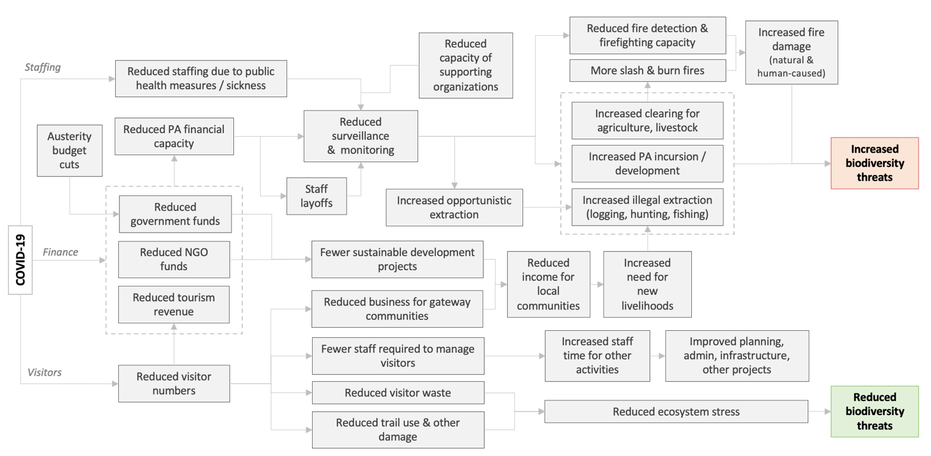
Figure 1: TOC outlining hypothesized changes caused by the COVID-19 pandemic in PAs in Mexico.

  - Moderators

We expected that non-compliant activities would be moderated by additional income gained through government subsidies and sustainable development programs such as the Programa de Conservación para el Desarrollo Sostenible (Conservation for Sustainable Development Program; PROCODES), as well as support from non-governmental organizations. We predicted that reductions in government spending and human capacity would reduce the ability to carry out these programs. Fewer government support programs, in combination with less tourism-related business, was expected to decrease income for local communities. We expected the decrease in income for local communities to create a need for new livelihood activities, potentially increasing non-compliance and threatening biodiversity.

- Methods
We used data from focus groups and an online survey with 62 PA directors to test the pathways hypothesized in our TOC and to gain a holistic understanding of the impact of the COVID-19 pandemic on PAs across Mexico. Appropriate IRB approval was gained prior to data collection (ID: 19-8870H).

  - Focus groups
We conducted two focus groups in February 2021 with 10 directors from different marine and terrestrial PAs. Focus group participants were selected with the help of CONANP to represent a range of ecoregions and PA types (e.g., National Park, Biosphere Reserve). We gathered a range of information about the experiences of each director in their respective PAs. Each focus group began by asking what changes to PA management and activities were experienced due to the pandemic. We then used guiding questions to gather more information on the reported changes (Yin, 2015).
After receiving verbal permission from all participants, focus groups were recorded, transcribed, and translated from Spanish to English. Transcriptions were coded using a multi-level coding scheme, grouping key themes into broader categories of PA inputs, mechanisms, moderators, and outcomes (Yin, 2015).
  - Survey
We used Kobo Toolkit (Harvard Humanitarian Initiative, 2021) to create an electronic, Spanish-language survey to quantitatively measure changes in PAs on a national scale. The design of the survey was guided by the TOC, focus groups, and CONANP’s i-efectividad evaluation, a standardized survey used to monitor management effectiveness in PAs nationally (Comisión Nacional de Áreas Naturales Protegidas, 2019). We distributed the survey via email to directors of all PAs in Mexico that had a management plan, annual operating program, and budget (132 PAs). The survey took 25 minutes to complete, on average. If the director was not able to take the survey, we invited other management staff with knowledge of management decisions and operations to participate.
The survey covered management inputs, mechanisms, moderators, and outputs (Table 1). Question types included binary and multiple-choice questions to measure changes in inputs, mechanisms, moderators, and outcomes, and seven-point scale bars to measure the degree to which perceived changes were considered attributable to the pandemic. Additionally, multiple optional open-ended questions allowed respondents to expand on their responses or share additional thoughts (see supplementary information for additional details).
Table 1. Main components of the survey conducted in this study.
Category | Themes of Questions
Inputs | Management inputs (human capacity, financial capacity)
Mechanisms | Monitoring activities, visitation
Moderators | Governmental & non-governmental organization programs, emergency funds or in-person support, advisory council
Outcomes | Non-compliance, ecological restoration
The survey was piloted with five PA directors and minor adjustments were made before sending the survey to all PAs in March 2021. Limited adjustments were made after piloting the survey, specifically increasing the number of optional open-ended responses. Therefore, piloted responses were included in the final sample. The survey stayed open for six weeks and seven reminders were sent via email.
One survey response from each PA was used in the final analysis. If more than one response was received for a single PA, we used the responses from the director of the PA. If the director did not respond, we then used responses from the individual who had worked for the PA the longest.
We used descriptive statistics to identify the degree of change in various PA dimensions using structured questions. We translated and coded all open-ended questions using a multi-level thematic coding approach (Yin, 2015). Major patterns in the data were coded using open codes and then organized into broader themes. We used the codes to verify links in the TOC and to identify changes not previously included.

- Results
We received responses from 62 PAs, representing almost half of the PAs with a management plan and annual operative budget in Mexico (47%) (Figure 2). The PAs in our sample were primarily Flora and Fauna PA (FFPA; 37%), Biosphere Reserves (BR; 31%) and National Parks (NP; 29%). One Natural Resource PA (NRPA) and one Sanctuary (S) also participated. Our sample was primarily terrestrial PAs (77%), with only 8% marine and 13% mixed terrestrial and marine. The ages of the PAs in our sample ranged from four to 84 years (median=29). Prior to 2020, respondents had worked at their respective PAs between 1 and 34 years (median=8).
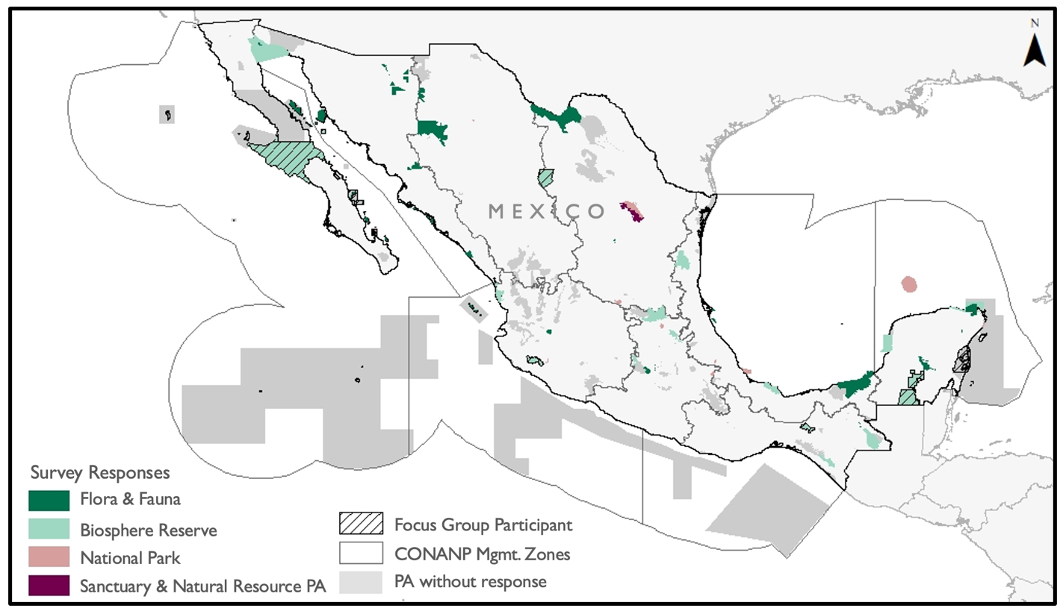
Figure 2: Map of PAs that participated in focus groups and responded to the survey. Survey sample includes FFPA (n=23), BR (n=19), NP (n=18), S (n=1) and NRPA (n=1).
On average, our results found that PA directors perceived negative impacts on PA management capacity, tourism, and support for local communities from the pandemic (Figure 3). Additionally, we found a perceived increase in non-compliance in 2020 compared to 2019, on average, across Mexico. However, as detailed below, we also note that impacts varied widely across different PAs. Using our survey responses to identify substantial areas of change and qualitative data to link these changes to reported conservation outcomes, we highlight the potential pathways through which the COVID-19 pandemic has impacted PAs.
  - Inputs
Respondents reported that the most prevalent impacts of the pandemic on human capacity were illness (63%) and reduced time availability (52%) (Figure 3). Of the 39 PAs with staff becoming sick with the virus, 47% had less than 20% of staff become ill and 33% reported between 20-40% of staff became ill. At one PA, 60-80% of staff contracted the virus.
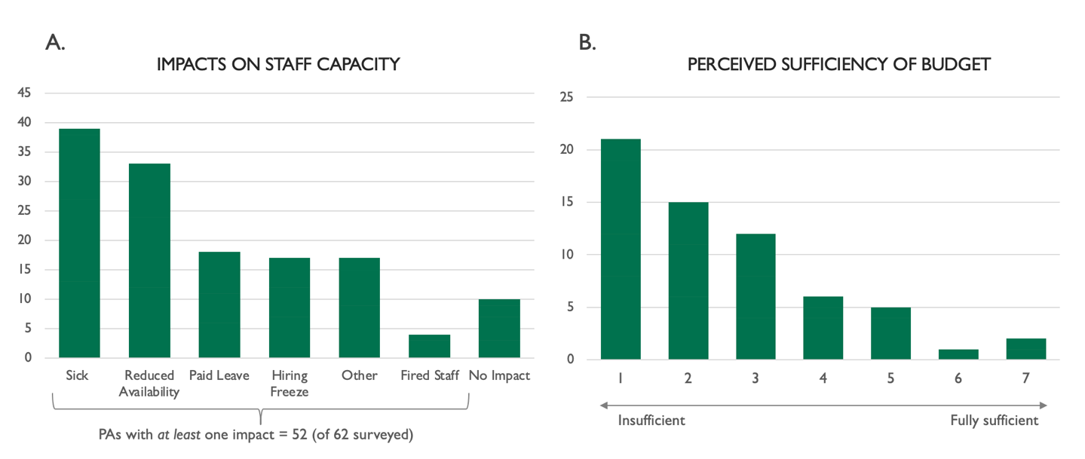
Figure 3: Count of protected areas who reported A) perceived impacts on human capacity and B) level of sufficiency of budget for basic needs in 2020 compared to 2019.
Less than a third of PAs in our sample offered paid leave to staff members (31%) and experienced hiring freezes on new positions (27%). Only three PAs were forced to fire staff and no PAs had staff on unpaid leave. Additional impacts reported by directors included salary reduction, voluntary leave/resigning, and various emotional impacts such as stress, depression, and anxiety caused by the uncertainty of the pandemic. Ten PAs reported no impacts on their staff.
Seventy-seven percent of respondents reported a budget reduction in 2020 compared to 2019, with 42% reporting a significant reduction. Nineteen percent of respondents reported no change, and one PA reported an increase. The average estimated budget reduction from 2019 to 2020 among all respondents was 39%. When rating the sufficiency of budgets, 77% of respondents rated the budget at a 3 out of 7 or lower, with an average rating of 2.5 (Figure 4). While many directors reported a decrease in financial capacity in 2020, few perceived the pandemic as the primary driver, with a median attribution of 2.5 out of 7 (Figure 4). As one survey respondent stated, “The COVID-19 pandemic aggravated and complicated our activities even more. They were already reduced due to lack of money and now also uncertain due to the pandemic.”
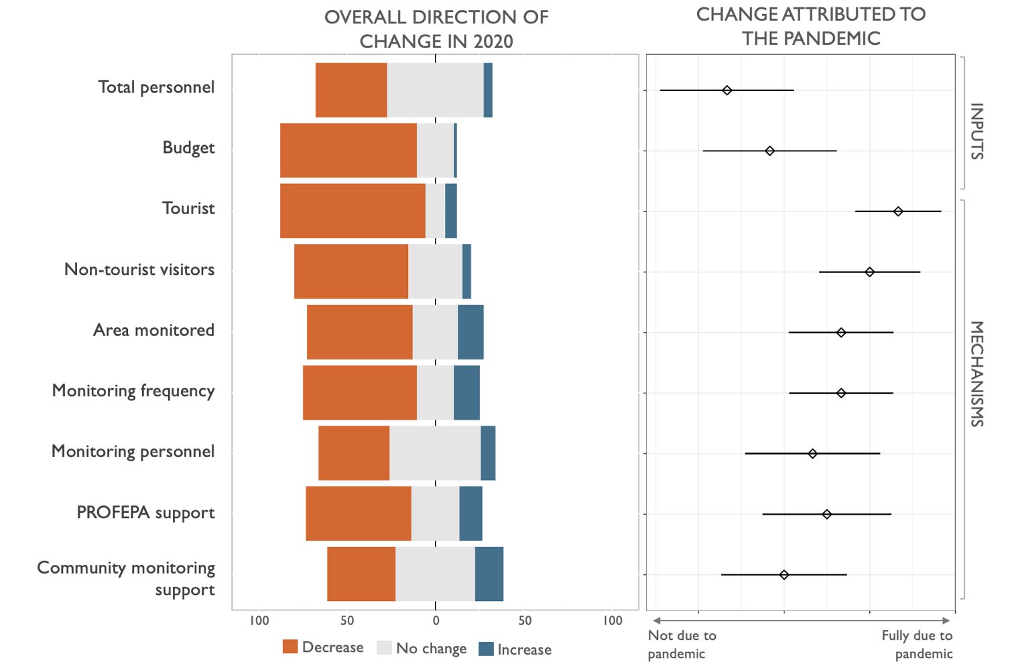
Figure 4: Portion of the participating PAs that experienced changes to PA inputs and mechanisms and the degree to which they were attributed to the pandemic (median shown).
  - Mechanisms
PAs reported dramatic declines in the number of tourist and non-tourist visitors (e.g., researchers, maintenance, etc.) in 2020. Almost 91% of PAs reported a reduction in tourism of 25% or greater, with little difference across PA type. Thirty-six percent of PAs reported a reduction of 75% or greater. Similarly, 76% of PAs reported a reduction in non-tourist visitors, with about 19% reporting a reduction of 75% or greater. About 7% and 6% saw an increase in tourist and non-tourist visitors, respectively.
Directors most closely linked the change in tourist (median attribution of 7 out of 7) and non-tourist visitors (6 out of 7) to the pandemic. In addition to COVID-19 closures and other health and safety procedures, respondents in our sample identified reduced household spending on recreational activities (n=5), reduced budgets for research and project development (n=5), and a perceived increase in crime in and around PAs (n=3) as the main reasons for these changes in an open-ended question.
PA directors perceived the reduction in tourism to have significant impacts on local community livelihoods, including tourism-related occupations and supporting industries. As one focus group participant explained, “The pandemic did not directly impact the management of the PA, but rather the economy of the inhabitants. Since there is no tourism … their income fell to zero.”
As a second participant explained, the impacts went beyond just those directly engaged in tourism activities: “Fisheries, like tourism service providers, were directly influenced by [changes in] tourism… There is a direct link between tourists and fishing. As there are no tourists,… there is no market where fishermen can sell their product.”
Monitoring capacity of PAs decreased in 2020 compared to 2019, on average (Figure 4). Approximately 60% of respondents reported a decrease in the frequency of monitoring, 53% reported a decrease in the total area monitored and 39% reported a decrease in the total number of staff responsible for monitoring. In contrast, 16% of respondents reported an increase in both the frequency and area monitored, and 11% reported an increase in the total number of staff.
On average, respondents estimated that the frequency of monitoring decreased, with a 23% reduction in the number of monitoring trips (median= -25%). The total area being monitored also decreased by almost 18%, and the number of staff responsible for monitoring fell by about 12% on average (area median= -25%; personnel median = 0%). Respondents estimated that the pandemic had the largest influence on the change in total area being monitored and the frequency of monitoring trips, with the median pandemic attribution rate of the change in both equal to 5 out of 7. Change in personnel due to the COVID-19 pandemic was estimated at 4 out of 7.
The respondents perceived the reduction in monitoring capacity to be due to reduced human and financial capacity, reduced access to appropriate equipment, and the restricted ability to collaborate with groups that support these activities. As one respondent explained, “Changes in the individuals responsible for inspection and surveillance and budget adjustments, coupled with problems generated by the COVID-19 pandemic, have hampered inspection and surveillance activities in the PA.” A second respondent stated, “Monitoring requires collaboration with local actors and suppliers, and this collaboration was reduced by the COVID pandemic.”
Over half of the PAs in our study (57%) reported a decrease in the level of support provided by PROFEPA in 2020 compared to 2019. This reduction was partially attributed to the pandemic - specifically to the mobility restrictions, inability to be in the office, and reduced staff availability. However, respondents also reported a multi-year trend of decreasing PROFEPA capacity due to budget cuts which have left the organization under-resourced.
While community monitoring groups were present in almost all participating PAs (89%), changes in the level of support provided by community groups varied across PAs. Forty percent of respondents reported no change in the level of community monitoring support, 40% reported a decrease, and 20% reported an increase.
  - Moderators
Over half of the PAs reported impacts to subsidy programs implemented by the PA for local communities (57%), as well as impacts to other government programs (36%) and non-governmental programs (31%). About 25 of the 35 PAs reporting changes to subsidy programs experienced an overall reduction in the value of subsidies provided. Six PAs reported delays in subsidy delivery and four reported other impacts, such as reduced participation and freezes on new project enrollment.
Approximately 60% of PAs perceived a reduction in other government programs, 23% reported a pause and 14% reported a delay. For non-governmental programs, more directors reported a pause in implementation (42%), with 32% perceiving a reduction and 11% a delay. There was a high level of uncertainty in the impacts on non-subsidy government programs and non-governmental programs, with 27% and 31% reporting unknown impacts respectively.
Almost half (48%) of participating PAs reported access to emergency funds which helped to compensate for the limited financial capacity in 2020. Fund-providing organizations included national and international conservation funds (e.g., Mexico’s National Fund for the Conservation of Nature [FMCN] and the Global Environmental Facility [GEF]). Many PAs also reported additional support to manage non-compliance, most commonly provided by the National Guard.
Additionally, access to technology (e.g., internet, computers, WhatsApp) emerged as an important moderator from our focus group and survey data. For those with access, technology allowed for the continuation of regular management activities, monitoring of subsidy programs, communicating health and safety guidelines to community members, and supporting and facilitating the collaborative decision-making processes of the advisory council. For example, when talking about the advisory council, one respondent reported, “Only one meeting could be held over the year and it was held virtually. Many of the counselors, who are from the local communities, found it difficult to attend because they did not have internet and computers.”
  - Outcomes
Although responses varied, on average respondents reported that non-compliance increased across Mexico’s PA network in 2020 (Figure 5). The largest increase perceived by directors was in fishing, followed by hunting, the establishment of new settlements, logging, land clearance for agriculture, and mining. Directors perceived a slight decrease in the number of human-caused fires and unpermitted camping and trail use. The specific patterns of perceived changes in non-compliant activities did not appear to vary across different PA types.
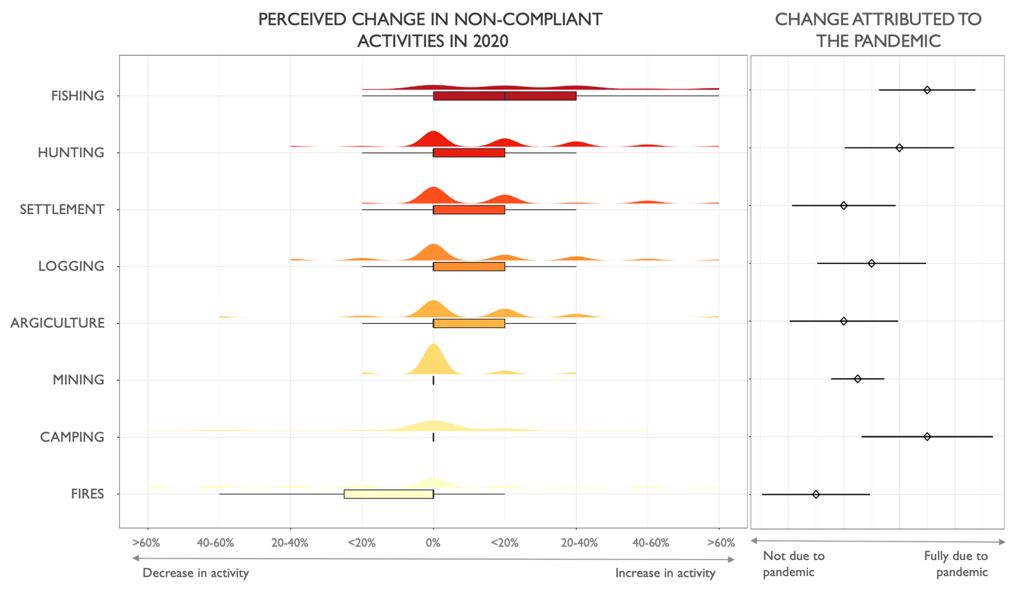
Figure 5. Raincloud plot showing perceived changes in non-compliance experienced in 2020 compared to 2019 and the degree to which they were attributed to the pandemic. (Q₁ and Q₃ of mining and camping are equal to 0, resulting in no boxplot).
Although respondents reported increases across most non-compliant activities, the perceived degree of attribution to the pandemic varied. Change in activities perceived to be most attributable to the pandemic include fishing (median=5 out of 7), camping and trail use (median=5), hunting (median=4) and logging (median=3). In an optional open-ended question, an increase in unpermitted water extraction and stone extraction were each reported by one respondent.
Many PA directors perceived the lack of a presence of authority and decreases in livelihood opportunities as the main reasons for the perceived increases in non-compliant activities. One focus group participant stated, “In March, April, and May, CONANP personnel were confined. However, essential activities continued, such as fishing. It was said to be taking place in the PA, and that fishing activities, especially irregular activities, began to increase. We received many calls from other fishermen who were noticing”.
Other respondents noted:
“In the absence of… authorities such as PROFEPA, the National Guard, and the police who monitor the roads, we have detected an increase in illegal activities around the PA, such as clearings, illegal construction, and trespassing.”; and
“The impact of COVID on the economy increases demand for natural resources that are used and traded illegally.”
- Discussion
We found that the COVID-19 pandemic had substantial impacts on many of the factors considered in our TOC. Specifically, we found considerable impacts on human capacity and well-being, such as staff illness, increased stress and anxiety, and an overall reduction in staff availability, similar to Smith et al. (2021) and Waithika et al. (2021) (Figure 2). Respondents also reported a decrease in financial capacity, with many respondents perceiving their annual budget to be insufficient for management needs (Figure 2). However, respondents did not perceive changes in financial capacity to be solely attributed to the pandemic. Rather, respondents felt the financial limitations resulting from the COVID-19 pandemic further compounded a more significant general trend in reduced capacity for PAs.
These findings are in line with existing evidence on PA capacity limitations found in Mexico and globally (Coad et al., 2019; Singh et al., 2020; Watson, Dudley, Segan, & Hockings, 2014). A recent evaluation found that 50% of PAs in Mexico currently experience partially effective or ineffective management prior to the pandemic (CONANP, CONABIO, & SRE, 2020) and Coad et al. (2019) found over 75% of the PAs in their global analysis did not have adequate staff and financial resources. While CONANP has recently made significant progress in strengthening management effectiveness (Powlen et al., 2021), the agency has experienced multiple budget cuts over the past five years. Thus, as Cumming et al. (2021) argues, the current global crisis serves to “magnify, intensify, and exacerbate existing structural and systemic financial constraints and weaknesses”, rather than introducing novel threats to PAs (Cumming et al., 2021, p149).
Tourism, a key mechanism in our TOC, was significantly reduced in most PAs across Mexico, similar to other regions of the world (e.g., Spenceley et al., 2021). These decreases were largely attributed to the pandemic, due to closures and capacity restrictions. Survey respondents and focus group participants perceived the reduction in tourism to have significant implications for local community livelihoods, reducing opportunities for tourism service providers, as well as linked industries, such as fishing. Additionally, survey respondents reported negative impacts on community programs, such as subsidies, further exacerbating the negative impacts on local communities. Previous research has also found local populations living in and around PAs, especially those in remote areas, have been the most affected in terms of employment and income, and health (Mitchell & Phillips, 2021). Future research is needed to document community perspectives to fully understand the extent of this impact.
Survey respondents also reported substantial changes in monitoring, the second key mechanism. The reduction in monitoring, in addition to reduced tourism-related livelihoods, were perceived to be the main drivers of the increase in non-compliance, similar to the predictions in previous research (e.g., Buckley, 2020; Hockings et al., 2020; McCleery et al., 2020; Mitchell & Phillips, 2021). The perceived increase in subsistence and economic-driven activities, such as fishing, hunting, and logging, support these assumptions, and decrease in unpermitted camping and trail use, support this assumption. In a global overview of the pandemic impacts in PAs, Waithaka et al. (2021) also found an overall perceived increase in logging, poaching, settlements and fires.
Survey respondents perceived a link between the negative impacts to both monitoring and tourism and the increase in non-compliance in 2020. Additionally, we found evidence of various moderators influencing the degree of impact, highlighting the complexity of interacting factors outlined in our TOC. Using our results, we updated our TOC (SI 3) and identified two potential avenues to reducing the impact of future global crises on PAs, similar to those identified by Cumming et al. (2021) and Waithaka et al. (2021).
First, increased overall resourcing of PA management, including financial support, appropriate equipment, and capacity building, could help to reduce the impact of shocks on management by enabling better planning, enhancing capacity to maintain management activities with reduced support from external organizations, and reducing financial stress. Given the negative trends in institutional support from governments, it will be important that PAs are supported by diverse funding mechanisms going forwards (e.g., Kroner et al., 2021; Waithaka et al., 2021).
Second, the promotion of more diverse and sustainable livelihood options in communities in and around PAs should help to reduce the reliance on PA-related tourism income, which left many communities vulnerable during the pandemic (e.g., Spenceley et al., 2021). Greater attention should be paid to supporting these areas, both through short-term relief efforts during crises, as well as longer-term building of community resilience to future shocks, which may in turn help to safeguard biodiversity in these areas (Cumming et al., 2021).
  - Limitations
The challenges in monitoring and measuring illicit behavior or non-compliance are well documented (e.g., Gavin, Solomon, & Blank, 2010; Solomon, Gavin, & Gore, 2015). Given the sensitivity of the topic and challenges of detecting certain activities, it is often best to triangulate evidence using diverse data sources. For example, while a fire occurrence may be easily spotted by smoke or a burn scar after an event, illegal hunting can be harder to detect. Given the recency of changes in our outcomes of interest, and the ongoing practical limitations to field research during the pandemic, data sources on biodiversity impacts of the pandemic remain limited. Therefore, perceived impacts reported by PA managers and directors are the most accessible data source, and commonly used in existing literature (e.g., Singh et al., 2021; Smith et al., 2021; Waithaka et al., 2021).
We also recognize the potential biases introduced when using the perceptions of PA managers to measure management conditions and perceived changes in management or outcomes. For example, PA staff may be incentivized to exaggerate positive performance measures while providing more conservative answers for other indicators. Additionally, while PA directors have access to the information gathered in this study, there is no guarantee that they referred to existing documents while responding to the survey questions. While we recognize these limitations, local perceptions have been identified as an “indispensable form of evidence” to understand social impacts and ecological outcomes in conservation research (Bennett, 2016), and can provide valuable insight in understanding immediate impacts of significant events, such as the pandemic, especially when limited alternative forms of data are available.
  - Future Research & Conclusion
Given the challenges of measuring biodiversity threats, future research should attempt to triangulate these findings with additional perspectives and data sources, such as those from community members, tourism service providers, and satellite imagery. Additionally, given the potential time lag for changes to materialize, future research should continue to monitor changes in conservation outcomes and management trends in order to improve our understanding of COVID-19 impacts, the response of PAs to shocks, and the length of recovery period required.
The COVID-19 pandemic has highlighted the importance of preparedness for shocks and stressors on PAs. We now have an opportunity to critically examine how this has affected conservation efforts in order to better prepare in the future. Our research has identified potential pathways of impact on conservation outcomes perceived by PA directors across Mexico’s PAs. Specifically, we found that the pandemic reduced human capacity and tourism, ultimately reducing monitoring capacity and financial benefits for communities in and around PAs across Mexico. Additionally, we found an increase in subsistence and market-driven non-compliant activities in 2020, on average.
Moving forward, it will be critical to provide support for directors to efficiently and effectively plan, design, and implement management activities, as well as to engage and collaborate with stakeholders to improve adaptive capacity in PAs globally. PA planning should also begin to integrate relief plans in anticipation of future shocks and crises. In order to be effective, these plans will need to pay particular attention to impacts on local communities.

Acknowledgements
This research was supported in part by the Society of Woman Geographers Evelyn L. Pruitt National Dissertation Fellowship. Additionally, the authors are grateful to the protected area directors who contributed their time and perspectives for this research.
Author Contributions
Conceptualization: KAP, MCG, KWJ; Project administration: KAP, EIBM, MAOC; Formal analysis and investigation: KAP; Writing - original draft preparation: KAP; Writing - review and editing: All authors.

References
Bates, A. E., Primack, R. B., Moraga, P., & Duarte, C. M. (2020). COVID-19 pandemic and associated lockdown as a “Global Human Confinement Experiment” to investigate biodiversity conservation. Biological Conservation, 248(108665). https://doi.org/10.1016/j.biocon.2020.108665
Bennett, N. J. (2016). Using perceptions as evidence to improve conservation and environmental management. Conservation Biology, 30(3), 582–592. https://doi.org/10.1111/cobi.12681
Buckley, R. (2020). Conservation implications of COVID19: Effects via tourism and extractive industries. Biological Conservation, 247(108640).
Cheval, S., Adamescu, C. M., Georgiadis, T., Herrnegger, M., Piticar, A., & Legates, D. R. (2020). Observed and Potential Impacts of the COVID-19 Pandemic on the Environment. International Journal of Environmental Research and Public Health, 17(11).
Coad, L., Watson, J. E. M., Geldmann, J., Burgess, N. D., Leverington, F., Hockings, M., … Marco, M. Di. (2019). Widespread shortfalls in protected area resourcing undermine efforts to conserve biodiversity. Frontiers in Ecology and the Environment, 259, 259–264. https://doi.org/10.1002/fee.2042
Comisión Nacional de Áreas Naturales Protegidas. (2019). Documento técnico base del Sistema Permanente de Evaluación e la Efectividad del Manejo de las Áreas Naturales Protegidas Federales. México.
CONANP. (2020). Compilación de medidas tomadas en la Comisión Nacional de Áreas Naturales Protegidas ante la pandemia del SARS-CoV-2 (COVID-19). Mexico City, MX. Retrieved from https://www.gob.mx/conanp información relativa al COVID-19,
CONANP, CONABIO, & SRE. (2020). Progress towards achieving Achi Target 11 in Mexico. Mexico City, MX.
Corlett, R. T., Primack, R. B., Devictor, V., Maas, B., Goswami, V. R., Bates, A. E., … Roth, R. (2020). Impacts of the coronavirus pandemic on biodiversity conservation. Biological Conservation, 246(108571).
Cumming, T., Seidl, A., Emerton, L., Spenceley, A., Kroner, R. G., Uwineza, Y., & Zyl, H. Van. (2021). Building Sustainable Finance for Resilient Protected and Conserved Areas: Lessons from COVID-19. Parks, 27, 149–160.
Ferraro, P. J., & Hanauer, M. M. (2015). Through what mechanisms do protected areas affect environmental and social outcomes? Philosophical Transactions of the Royal Society B: Biological Sciences, 370(1681). https://doi.org/10.1098/rstb.2014.0267
Gavin, M. C., Solomon, J. N., & Blank, S. G. (2010). Measuring and Monitoring Illegal Use of Natural Resources. Conservation Biology, 24(1), 89–100.
Geldmann, J., Coad, L., Barnes, M. D., Craigie, I. D., Woodley, S., Balmford, A., … Burgess, N. D. (2018). A global analysis of management capacity and ecological outcomes in terrestrial protected areas. Conservation Letters, 11(3), 1–10. https://doi.org/10.1111/conl.12434
Hockings, M., Dudley, N., Elliott, W., Napolitano Ferreira, M., Mackinnon, K., Pasha, M. K. S., … Yang, A. (2020). Editorial Essay: COVID-19 and Protected and Conserved Areas. Parks, 26(1), 7–24.
Jacobs, L., Blacketer, M. P., Peterson, B. A., Levithan, E., Russel, Z. A., & Brunson, M. (2020). Responding to COVID-19 and future times of uncertainty: Challenges and opportunities associated with visitor use , management, and research in parks and protected areas. The Interdisciplinary Journal of Place-Based Conservation, 36(3). https://doi.org/10.5070/P536349860
Kroner, R. G., Barbier, E. B., Chassot, O., Jr, L. C., Cruz-trinidad, A., Howard, J., … Rica, C. (2021). COVID-Era Policies and Economic Recovery Plans: Are governments building back better for protected and conserved areas? Parks, 27, 135–148.
Lindsey, P., Allan, J., Brehony, P., Dickman, A., Robson, A., Begg, C., … Fitzgerald, K. (2020). Conserving Africa’s wildlife and wildlands through the COVID-19 crisis and beyond. Nature Ecology & Evolution, 4, 1300–1310. https://doi.org/10.1038/s41559-020-1275-6
Manenti, R., Mori, E., Canio, V. Di, Mercurio, S., Picone, M., Caffi, M., … Rubolini, D. (2020). The good, the bad and the ugly of COVID-19 lockdown effects on wildlife conservation: Insights from the first European locked down country. Biological Conservation, 249(108728). https://doi.org/10.1016/j.biocon.2020.108728
McCleery, R. A., Fletcher Jr., R. J., Kruger, L. M., Govender, D., & Ferreira, S. M. (2020). Conservation needs a COVID-19 bailout. Science, 369(6503), 515–517.
Mcginlay, J., Gkoumas, V., Holtvoeth, J., Fuertes, R. F. A., Bazhenova, E., Benzoni, A., … Jones, N. (2020). The Impact of COVID-19 on the Management of European Protected Areas and Policy Implications. Forest, 11(1214), 1–15.
Mitchell, B. A., & Phillips, A. (2021). A global tragedy in search of answers: Editor’s introduction. Parks, 27, 7–12.
Phua, C., Andradi-brown, D. A., Mangubhai, S., Ahmadia, Gabby, N., Mahajan, S. L., Larsen, K., … Wells, S. (2021). Marine Protected and Conserved Areas in the Time of COVID. Parks, 27, 85–102.
Powlen, K. A., Gavin, M. C., & Jones, K. W. (2021). Management effectiveness positively influences forest conservation outcomes in protected areas. Biological Conservation, 260, 109192. https://doi.org/10.1016/j.biocon.2021.109192
Rupani, P. F., Nilashi, M., Abumalloh, R. A., Asadi, S., Samad, S., & Wang, S. (2020). Coronavirus pandemic (COVID - 19) and its natural environmental impacts. International Journal of Environmental Science and Technology, 17, 4655–4666. https://doi.org/10.1007/s13762-020-02910-x
Singh, R., Galliers, C., Moreto, W., Slade, J., Long, B., Aisha, H., … Ghosh, S. (2021). Impact of the COVID-19 Pandemic on Rangers and the Role of Rangers as a Planetary Health Service. Parks, 27(Special Issue), 119–134. https://doi.org/10.2305/IUCN.CH.2021.PARKS-27-SIRS.en
Singh, R., Gan, M., Barlow, C., Long, B., Mcvey, D., De Kock, R., … Belecky, M. (2020). What do rangers feel? Perceptions from Asia, Africa and Latin America. Parks, 26.1. https://doi.org/10.2305/IUCN.CH.2020.PARKS-26-1RS.en
Smith, M. K. S., Smit, I. P. J., Swemmer, L. K., Mokhatla, M. M., Freitag, S., Roux, D. J., & Dziba, L. (2021). Sustainability of protected areas: Vulnerabilities and opportunities as revealed by COVID-19 in a national park management agency. Biological Conservation, 255(108985). https://doi.org/10.1016/j.biocon.2021.108985
Solomon, J. N., Gavin, M. C., & Gore, M. L. (2015). Detecting and understanding non-compliance with conservation rules. Biological Conservation, 189. https://doi.org/10.1016/j.biocon.2015.04.028
Spenceley, A., Mccool, S., Newsome, D., Báez, A., Barborak, J. R., Blye, C.-J., … Zschiegner, A.-K. (2021). Tourism in Protected and Conserved Areas Amid the COVID-19 Pandemic. Parks, 27(Special Issue), 103–118.
Stolton, S., & Dudley, N. (2016). METT Handbook: A guide to using the Management Effectiveness Tracking Tool (METT). WWF-UK.
Waithaka, J., Dudley, N., Álvarez, M., Mora, S. A., Chapman, S., Figgis, P., … Wong, M. (2021). Impacts of COVID-19 on Protected and Conserved Areas: A Global Overview and Regional Perspectives. Parks, 27(Special Issue), 41–56.
Watson, J. E. M., Dudley, N., Segan, D. B., & Hockings, M. (2014). The performance and potential of protected areas. Nature, 515, 67–73. https://doi.org/10.1038/nature13947
Yin, R. K. (2015). Qualitative research from start to finish. Guilford Publications.

