The better, the choosier: a meta-analysis on inter-individual variation of male mate choice
Pietro Pollo*, Shinichi Nakagawa & Michael M. Kasumovic
Evolution & Ecology Research Centre, School of Biological, Earth & Environmental Sciences, University of New South Wales, Kensington, Sydney 2052 NSW, Australia
* Corresponding author: pietro_pollo@hotmail.com

Keywords: differential resource allocation, interindividual variation, mate availability, male mate choice, male mate preferences, prudent choice.

Abstract
Male mate choice occurs in several animal species, but we know little about the factors that influence the expression of this behaviour. Males vary in their capacity to acquire mates (i.e. male quality), which could be crucial to male mate choice expression but it is often overlooked. Using a meta-analytical approach, we explore inter-individual variation in the expression of male mate choice by comparing the mating investment of males of different qualities and phenotypes to high- and low-quality females. We used two datasets that together contained information from 60 empirical studies, comprising 52 species. We found that males of all qualities and phenotypes prefer high-quality females, but differ in the strength of such preference. High- and medium-quality males are choosier than low-quality males. Similarly, males that are larger or in greater body condition are choosier than their counterparts. In contrast, male body mass and age are not associated with changes in male mate choice. We also show that experimental design may influence our understanding of male mating investment patterns, which may limit the generalization of our findings. Nonetheless, we argue that male quality may be an important feature in the expression of male mate choice.

Introduction
There is little doubt that mate choice has shaped the evolution of many species (Rosenthal 2017), but identifying when and which individuals should be choosy can still pose a challenge. Mate choice involves not only binary decisions, such as to accept or to reject a mate, but also the amount of resources to invest in each mate before, during, and after copula (Bonduriansky 2001; Edward 2015; cf. Halliday 1983). It is the relationship between the capacity to (reproductively) invest in prospective mates and mate availability that should predict the expression of mate choice (Edward & Chapman 2011). When there are more prospective mates than an individual can invest optimally in, that individual must make reproductive decisions that lead to mate choice. Using this rationale, it is intuitive to understand why the traditional theory of sexual selection posits that females should be selective regarding their mates: they have a limited amount of reproductive resources (eggs) and often many males willing to mate with them (Bateman 1948; Trivers 1972). On the other hand, male mate choice should be restricted to situations in which males have less reproductive resources (e.g. limited sperm production) or fewer mating opportunities (e.g. synchronized female maturation). Yet, it is unlikely that such specific situations explain all occurrences of male mate choice given that this behaviour is widespread in the animal kingdom (Bonduriansky 2001; Edward & Chapman 2011). It is thus imperative to explore how various factors can affect the expression of male mate choice.
Several factors beyond breeding resources are vital in explaining mate choice evolution. For instance, greater mate quality variation should increase the benefits of mate choice while greater mate encounter rate should decrease its costs (Kokko & Monaghan 2001). However, even under optimal conditions for male mate choice evolution, male mate choice may not be viable if all males prefer the same females (the ones that provide males the most benefits, i.e. high-quality females). This is because the net benefit of being choosy decreases as competition for a subset of females increases (Servedio & Lande 2006). However, this rationale does not account for variation in male capacity to acquire mates, such as their individual attractiveness or fighting ability. We hereby refer to this individual male capacity to acquire mates as male quality, but we note that our use of this term is not necessarily connected to individual fitness (Wilson & Nussey 2010) or overall condition (Rowe & Houle 1996). Several theoretical models indicate that males may express mate choice differently according to their quality (Fawcett & Johnstone 2003; Härdling & Kokko 2005; Härdling et al. 2008; Venner et al. 2010; Puurtinen & Fromhage 2017; Chevalier et al. 2020). However, these studies vary in their predictions depending on which and how they model the factors that are crucial to male mate choice expression (e.g. quality variation in Fawcett & Johnstone 2003; mating costs in Puurtinen & Fromhage 2017).
In certain scenarios, males are predicted to express assortative mate preferences: while high-quality males are often predicted to prefer high-quality females, low-quality males are predicted to prefer low-quality females. Although this process may lead to assortative mating, such outcome is not certain given that its occurrence also depends on other mechanisms (e.g. female choice, male competition; Jiang et al. 2013). We argue that males should possess different preferences without any prior external feedback to avoid wasting resources in courting and mating with females they have low chances of securing. In other words, because the net benefit of male mate choice is male quality dependent, so should be its expression. This means that males can assess their own quality innately and act accordingly (which the above models assume), meaning that such male mate choice dependency on male quality should occur even when males are inexperienced and in the absence of competitors.
To be able to test whether male mate choice depends on male quality, one needs to know which male traits predict male mate acquisition capacity (i.e. we need to define male quality beforehand). Yet, researchers commonly assume male quality based solely on the expression of a given male trait. For instance, under a traditional perspective of sexual selection, males that are larger, heavier, older, and have greater body condition are thought to be more attractive or better fighters in many species (Andersson 1994) and are then assumed to be of better quality. Even if such patterns are generally valid, assuming such phenotypic patterns without prior testing could hinder broad theoretical conclusions on male mate choice patterns. For example, greater size may be detrimental to male mate acquisition instead of beneficial (e.g. Székely et al. 2004; Gress et al. 2013), and the same can be said about male age (e.g. Wilder & Rypstra 2007). Therefore, caution is required to understand patterns of male mate choice in nature, making it important to understand the relative importance various traits have on both mate choice and how we assess male quality.
Drawing broad conclusions about mate choice can be further challenging because empirical studies are extremely diverse regarding their experimental design (reviewed in Dougherty 2020). For example, when testing for male mate choice, researchers can allow males to interact with females in trials or control for female mating decisions using physical barriers or indirect cues (Dougherty 2020). Moreover, researchers may also provide a single female or multiple females to males to assess male mate choice (i.e. no- vs multiple-choice tests; Dougherty & Shuker 2015; Dougherty 2020). These factors potentially influence mate choice outcomes (Dougherty & Shuker 2015; Dougherty 2020) and thus have to be taken into consideration when examining mate choice patterns. Moreover, the female traits used to elicit male mate choice often vary from study to study, and sometimes are assumed to reflect female quality without species-specific evidence. For instance, males are often predicted to prefer larger females as they should be more fecund (Bonduriansky 2001), but fecundity is not always predicted by female size (e.g. Schneider & Elgar 2002). This means that different female traits, and whether they truly represent female quality, possibly affects male mate choice patterns as well.
Here we conduct a meta-analysis to explore inter-individual variation in male mate choice and the role that phenotypic assumptions and experimental design have on our understanding of the expression of male mate choice. To do so, we used experimental studies in which males of different phenotypes could invest resources in females of different qualities before, during, or after mating with them. Following theoretical studies (e.g. Fawcett & Johnstone 2003; Härdling & Kokko 2005; Härdling et al. 2008; Venner et al. 2010; Puurtinen & Fromhage 2017; Chevalier et al. 2020), we hypothesize that male quality influences male mate choice expression. We predict that male mate preferences vary with male quality, so that high-quality males prefer high-quality females, while low-quality males prefer low-quality females so they do not waste resources being outcompeted by other males. Our second hypothesis is that certain male phenotypes, without necessarily verifying that they truly represent male quality, can generate the same pattern of male mate choice that male quality does. We thus predict that males that are large, heavy, old, and in good body condition prefer high-quality females, while males that are small, light, young, and in low body condition prefer low-quality females. We also explored and verified several aspects related to experimental design and female traits used in male mate choice tests to ensure that our analyses are robust and can be generalized.

Material and methods
We followed PRISMA-EcoEvo reporting guidelines (O’Dea et al. 2021) as much as possible to conduct our meta-analysis (Figure 1, Supporting information SI1). All stages of the methods (i.e. identification, screening, and extraction) were conducted by P.P., which were partially checked by S.N. and M.K..

(1) Search protocol
As a first step in our systematic literature search, we conducted keyword searches in ISI Web of Science and Scopus databases on July 2nd, 2019. The sets of keywords we used were associated with male or mutual mate choice or preference, but they differed slightly between these databases due to the distinct Boolean characters available in each database (see Supporting information SI2). Additionally, still on July 2nd, 2019, we searched backward and forward citations of three highly relevant studies to our meta-analysis using ISI Web of Science: two reviews of male mate choice (Bonduriansky 2001; Edward & Chapman 2011) and a meta-analysis on cryptic male mate choice (Kelly & Jennions 2011). Altogether, after removing duplicated references, we obtained 3130 studies (Figure 1).
We inspected titles and abstracts of all papers retrieved in our searches, applying our inclusion criteria (see below). We identified 95 studies as relevant to our meta-analysis after this initial screening. We then searched backward and forward citations of these selected papers on March 5th, 2021, using the application citationchaser (Haddaway et al. 2021), which uses the Lens database. Because we conducted this additional search to gather recently published studies, we only considered citations from 2018, providing 430 other published studies to screen (not counting duplicates). From these, we judged 14 other studies as relevant. We then inspected all the studies that we deemed relevant (109) in detail and checked whether they still met our inclusion criteria. Our combined dataset for our meta-analysis was based on 60 papers, as some of them did not meet our criteria or simply did not show sufficient data to calculate our effect sizes (see Supporting information SI3).

(2) Inclusion criteria
To be included in our study, the paper had to contain information (explicitly stated in the abstract) regarding the influence of at least one male trait and one female trait on male mating decisions. We considered all male mating decisions as valid: preference proxies and male mating investment from before (e.g. latency to mate, courtship intensity), during (e.g. sperm transferred, copula duration) or after (e.g. guarding duration) copulation. We focused on investigations that used female and male traits that could potentially be connected to our definition of female quality (i.e. related to female benefits to males) and male quality (i.e. related to male-male competition or female mate choice), respectively.
At first, we considered all female traits as valid for inclusion in our meta-analysis, having no filter a priori. However, we later decided to exclude from our meta-analysis selected papers that explored only male mate choice for female receptivity (e.g. arbitrary female behaviours; Bakker & Rowland 1995; Fernandez et al. 2008) or female social context (Gasparini et al. 2013) because of their unclear connection to our definition of female quality.
Apart from social rank, we only considered intrinsic male characteristics as valid male traits to be included in our meta-analysis (i.e. age, personality, body or body part related traits—linear measurements, area, mass, body condition, colour, morph). Consequently, we did not consider studies that only tested the influence of different environmental conditions (e.g. diet, population density) or male social experiences (e.g. reproductive status) on male mate choice without explicit data on the male traits stated above. We later had to exclude some studies due to our male quality inference methodology (see Data collection and classification section).
We only considered studies that relied on lab or field experiments, as mating patterns from uncontrolled field observations may reflect several mechanisms other than male mate choice (e.g. male-male competition; see Jiang et al. 2013; Moura et al. 2021). Moreover, we only considered studies that used only one male in each trial, otherwise male mating decisions can be influenced by other males (even in female-biased sex ratios; Dougherty 2020). We made one exception to this rule for Magallón-Gayón et al. (2011), in which a female was given a choice between two males that were tethered and isolated from one another. In that case, once a female chose a male, the couple’s interaction could be classified as a no-choice mate choice test from the male perspective. At last, we only considered studies that tested male mate choice for females of the same species, as mate recognition and mate choice can be distinct processes (Rosenthal 2017).

(3) Data collection and classification
We first classified individuals used in experiments according to their phenotypes. Phenotypes could not be included in meta-regressions as continuous variables even when they were available as such because each individual would require its own effect size. Thus, when data related to individual traits were available as continuous variables (from scatter plots, detailed tables, or raw data), we did the following classification that differed between males and females. We classified males in three categories (high, medium, and low trait value; e.g. large, medium-sized, small; old, medium-aged, young; etc) by dividing the range of that male trait in three equal parts. We note that this classification sometimes resulted in low sample size for certain male categories depending on the distribution of sampled individuals, sometimes making it impossible to extract an effect size from a given male category. However, the advantage of using three male categories instead of two is that it better reflects traits that are continuous and allow us to explore whether male mate choice varies gradually or abruptly depending on such traits. We used the original paper’s classification when data related to individual traits was not available as continuous data (i.e. categorical data; e.g. dominant and subordinate). We were unable to classify females in three categories because effect size calculation depended on only two means of male mate investment (see Effect size calculation). Thus, we separated females into two categories (high and low trait value; e.g. large and small; old and young; etc) simply by dividing the female trait range (greatest value and lowest value sampled) in two halves.
We inferred individual quality using the individual trait value classification described above coupled with information from the papers we extracted data from (i.e. papers that met our inclusion criteria). Such information could be shown by authors through original experiments or by citing species-specific evidence. For example, Hoefler (2007) tested male mate choice with males of different sizes and showed that greater male size in the jumping spider Phiddipus clarus is associated with greater success in male-male contests. Thus, for that study, we had greater certainty in classifying large males as high-quality, medium-sized males as medium-quality, and small males as low-quality. In other words, we were able to verify the link between the male trait reported in the study and male quality. If male categories were binary (e.g. dominant and subordinate), we classified them as high and low quality (medium quality inexistent).
Several studies did not provide specific evidence to infer individual quality for the species used in their experiments. When information about female quality was vaguely presented or absent in papers, we inferred female quality based on a general pattern or arbitrarily (see Supporting information S3). In contrast, we did not make any assumptions when the same issue occurred for males. Effect sizes in which male quality could not be verified by the use of phenotypic traits were not used to explore the relationship between the expression of male mate choice and male quality (Table 1). However, if these effect sizes were related to male phenotypes regarding age, body condition, or body size (linear measurements or mass), we still used them to understand whether certain phenotypes are associated with different patterns of male mate choice expression (Table 1, see also Meta-analysis and meta-regressions section). We chose these specific traits because they apply to all species and because they were more often reported in studies than other traits. We thus opted for excluding other male traits of which related quality information was absent (Table 1).

(4) Effect size calculation
We used standardized mean differences (SMDs) to compare male mating investment between high- and low-quality females. Positive SMDs represent greater male investment to high-quality females than to low-quality females, whereas negative SMDs represent greater male investment to low-quality females than to high-quality females. We note that we also used male mate preference indices as a form of male mating investment. The SMDs we used were analogous to the slope of a preference function, which reflects the strength of mate preference (Edward 2015). We calculated SMDs for each male quality category, allowing us to test our hypothesis that male mate choice is quality dependent.
We calculated SMDs with distinct approaches depending on the nature of the data extracted. First, we used the standard equation for SMD (Cohen 1988; Borenstein et al. 2021) when male mating investment was given as an absolute measurement for each female (e.g. sperm number):
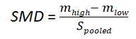(eq. 1)
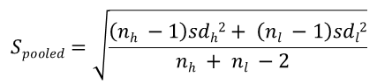(eq. 2)
where m_{h} and m_{l} are the means of male mating investment received by high- and low-quality females, respectively, and S_{pooled} is the pooled standard deviation. n_{h} and n_{l} are sample sizes of high- and low-quality females, respectively, while sd_{h} and sd_{l} are standard deviations for male mating investment received by high- and low-quality females, respectively. We also applied equation 1 for relative measurements of male mating investment that did not sum one (e.g. figures in Baxter et al. 2015).
Second, when data were already given as a grouped mean difference, we used a slight variation of equation 1:
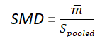(eq. 3)
where m̄ is the mean difference in mating investment that high- and low-quality females received from males. In such cases, the standard deviation given was divided by two and used to calculate S_{pool} as in equation 2, with sd_{h} = sd_{l}.
Third, when mate choice was shown as binary data (e.g. which female was preferred) or proportions that summed one (e.g. proportion of time spent with each female), we used two other equations to calculate SMDs:
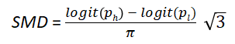(eq. 4)
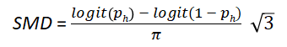(eq. 5)
where p_{h} and p_{l} are the mean proportions associated with preference for high- and low-quality females, respectively. We used equation 4 for no-choice tests, in which a relative measurement of male investment is given for each female (e.g. proportion of trials in which copula occurred for each female type). Equation 5 was used for multiple-choice tests, for which only a single proportion is given (e.g. proportion of trials in which the high-quality female was preferred; mean proportion of association time with the high-quality female). We note that we assumed the data follows a logistic distribution and thus we used its standard deviation ($\frac{π}{\sqrt{3}}$) in place of S_{pooled}. When proportions given in studies were extreme (such as when all or none of the males tested preferred large females over small females), we corrected them to a maximum of 0.95 or to a minimum of 0.05 to avoid unrealistic effect sizes.
We calculated the sampling variance for each SMD using the following equations:
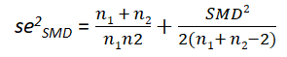(eq. 6)
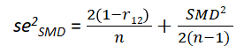(eq. 7)
where r₁₂ is the correlation coefficient between two groups (set as 0.5 in all cases; see Noble et al. 2017) and n is the trial sample size. We used equation 6 for effect sizes in which male mating investment given to high-quality females was independent of the male mating investment given to low-quality females. This mainly occurred in studies that used a no-choice design in which males were used a single time. In such cases, we excluded effect sizes whose sum of sample sizes of high- and low-quality females (n_{h} + n_{l}) was lower than six. In contrast, we used equation 7 for effect sizes in which male mating investment given to females of different qualities was not independent. This occurred when studies used a multiple-choice design or repeated focal males in no-choice tests. For these cases, we excluded effect sizes whose trial sample size (n) was lower than three.
When we calculated SMDs referent to male investment as latency to mate or to court, we inverted the rationale of the equations used: instead of subtracting the investment given to low quality females from the investment given to high quality females, we subtracted the investment given to high quality females from the investment given to low quality females. This is because a preference for high-quality females would generate lower latency (greater responsiveness) with these females than with low-quality females.
We only used descriptive statistics (means and standard deviations) to calculate SMDs. We contacted authors when such information was ambiguous or missing. Within the software R 4.0.3 (R Core Team 2021), we used the package metaDigitise (Pick et al. 2018) to extract data from figures.

(5) Meta-analysis and meta-regressions
We used multilevel meta-analytical models because our effect sizes were not independent of one another. Different effect sizes could share the same study ID, experiment ID (within each study), investment measurement ID (within each study), and species ID. Thus, in addition to effect size ID, we used these variables as random factors in our models to control for non-independence. We also included a correlation matrix related to phylogenetic relatedness for the species in our model as a random factor (Nakagawa & Santos 2012). From meta-analytical models with all these random factors, we quantified total I² (a measure of heterogeneity not attributed to sampling error; Higgins et al. 2003) and how much of it each random factor explained (partial I²). Based on this, we removed phylogenetic relatedness from our meta-regressions as this random factor did not explain much of the heterogeneity between effect sizes (partial I² < 0.001%) for both of our analyses (see below). In our study, the output from a meta-analytical model with random factors but without any moderators (explanatory variables) represents the average general male mate choice (i.e. regardless of male trait values or quality).
We conducted several meta-regressions to test our hypotheses. Using the subset of our data in which male quality was verified (Table 1), we set male quality category (high quality [HQ], medium quality [MQ], or low quality [LQ]) as a moderator to explore whether male mate choice is associated with male quality. To verify whether differences in experimental design and female traits used in empirical studies impact male mate choice expression and the role of male quality in it, we added other moderators as follows. First, we verified the role of female physical contact with males in male mate choice tests (contact allowed vs. contact precluded). Second, we compared the provision of multiple females with a single female to males in male mate choice tests (multiple-choice tests vs. no-choice tests). Third, we evaluated the influence of our method of female quality inference (verified vs. assumed). In addition to conducting meta-regressions with each of these three variables as moderators, we also conducted meta-regressions with these variables in interactions with male quality.
To understand whether male mate choice is dependent on specific male phenotypes, we did an additional meta-regression model including only effect sizes related to certain male traits: age, body condition, and body size (separated in linear measures and mass). In this second model, the moderator was an interaction between these male traits and their values (high trait value, medium trait value, low trait value). We note that we used some of the effect sizes from our first analysis (male quality) in the second one (male phenotypes; Table 1). We note that the results using only the data points for which we had no information on male quality (i.e. exclusive of the second analysis) were very similar to our results with male quality information. However, differences between male quality categories disappeared for linear measures of male size, likely because of lower sample sizes (Supporting information SI5).
All statistical analyses were conducted in the software R 4.0.3 (R Core Team 2021). We fitted meta-analytical models using the rma.mv function from the package metafor (Viechtbauer 2010). We calculated marginal R² (Nakagawa & Schielzeth 2013), and total and partial I² using, respectively, r2_ml and i2_ml functions from the package orchaRd (Nakagawa et al. 2021b). Phylogenetic trees were built using the packages ape (Paradis & Schliep 2019) and rotl (Michonneau et al. 2016), which uses data from OpenTreeOfLife et al. (2019). Pairwise comparisons were done using the function glht from the package multcomp (Hothorn et al. 2008).

(6) Publication bias
We searched for signs of publication bias in our study using multiple approaches using our full dataset (joined data used for both of our analyses). First, we visually evaluated funnel asymmetry using a funnel plot, which shows the residuals of a meta-analytical model containing all moderators used in our study against effect sizes’ precision (i.e. inverse of standard error). Second, we further assessed funnel asymmetry with an alternative approach to Egger’s regression: using the inverse of the effective sample size as a moderator in a multilevel meta-analytical model (see Nakagawa et al. 2021a). Third, we verified time-lag bias using publication year as a moderator in a multilevel meta-analytical model.

Results

(1) Does male mate choice depend on male quality?
We obtained a total of 336 effect sizes from 38 studies and 32 species for this first analysis (Figure 2A), in which male quality could be verified. On average, males invested moderately more in high-quality females than in low-quality females (SMD = 0.659, 95% confidence interval, hereafter, CI = 0.422 to 0.896; Figure 3). However, the difference in male mating investment between females of distinct qualities was greater in high- and medium-quality males than in low-quality males (SMD_{HQ} = 0.732, CI_{HQ} = 0.48 to 0.985; SMD_{MQ} = 0.759, CI_{MQ} = 0.491 to 1.027; SMD_{LQ} = 0.55, CI_{LQ} = 0.3 to 0.801; Figure 3). Despite these differences, male quality as a moderator explained little of the variance in the data (R² = 0.015). Heterogeneity across effect sizes was high (I² = 85%), with study ID accounting for 3.9% of the heterogeneity, experiment ID accounting for 11.1% of the heterogeneity, measurement ID accounting for 8.8% of the heterogeneity, species ID accounting for 37.1% of the heterogeneity, while the remaining 24.1% of the heterogeneity was attributed to effect size ID (i.e. residual variance).

(2) Does experimental design influence male mate choice patterns related to male quality?
Some aspects from the experimental design of empirical studies we used to extract our effect sizes influenced patterns of inter-individual variation in male mate choice. For instance, mean effect sizes differed depending on male quality when males could physically interact with females during experiments (SMD_{HQ} = 0.869, CI_{HQ} = 0.574 to 1.164; SMD_{MQ} = 0.86, CI_{MQ} = 0.535 to 1.185; SMD_{LQ} = 0.672, CI_{LQ} = 0.376 to 0.967; Figure 4), but not when males were precluded from interacting with females (SMD_{HQ} = 0.482, CI_{HQ} = 0.098 to 0.868; SMD_{MQ} = 0.567, CI_{MQ} = 0.179 to 0.955; SMD_{LQ} = 0.337, CI_{LQ} = -0.042 to 0.716; Figure 4). Similarly, mean effect sizes differed depending on male quality when males were presented with more than one female in experiments (SMD_{HQ} = 0.827, CI_{HQ} = 0.522 to 1.131; SMD_{MQ} = 0.913, CI_{MQ} = 0.591 to 1.234; SMD_{LQ} = 0.52, CI_{LQ} = 0.22 to 0.82; Figure 4), but not when males were presented with a single female (SMD_{HQ} = 0.574, CI_{HQ} = 0.172 to 0.976; SMD_{MQ} = 0.494, CI_{MQ} = 0.061 to 0.927; SMD_{LQ} = 0.557, CI_{LQ} = 0.153 to 0.96; Figure 4). In contrast, mean effect sizes differed depending on male quality regardless of whether female quality was verified (SMD_{HQ} = 0.808, CI_{HQ} = 0.531 to 1.085; SMD_{MQ} = 0.72, CI_{MQ} = 0.432 to 1.007; SMD_{LQ} = 0.556, CI_{LQ} = 0.279 to 0.833; unverified female quality: SMD_{HQ} = 0.647, CI_{HQ} = 0.362 to 0.932; SMD_{MQ} = 0.815, CI_{MQ} = 0.505 to 1.125; SMD_{LQ} = 0.533, CI_{LQ} = 0.236 to 0.83; Figure 4). A meta-analytical model with these three aspects as moderators interacting with male quality increased some of the variance explained (R² = 0.073).

(3) Does male mate choice depend on male phenotype?
We obtained a total of 674 effect sizes from 53 studies and 46 species for our analysis related to male mate choice expression for certain male phenotypes (specifically regarding male age, body condition, body size; Figure 2B). Similar to our results regarding male quality, on average, males of all phenotypes invested moderately more in high-quality females than in low-quality females (SMD = 0.524, CI = 0.351 to 0.696). Heterogeneity across effect sizes was high (I² = 78.5%), with study ID accounting for 33.9% of the heterogeneity, experiment ID accounting for 13.9% of the heterogeneity, measurement ID accounting for 1.3% of the heterogeneity, species ID accounting for 9.5% of the heterogeneity, while the remaining 19.9% of the heterogeneity was attributed to effect size ID (i.e. residual variance).
The difference in male mating investment between females of distinct qualities was greater in males with great body condition than in males with low body condition (SMD_{great} = 0.865, CI_{great} = 0.489 to 1.241; SMD_{low} = 0.31, CI_{low} = 0.016 to 0.603, Figure 5). In comparison, males with medium body condition showed an intermediate mean effect size value, which was not statistically different from males in great or low body condition (SMD_{medium} = 0.574, CI_{medium} = 0.309 to 0.84; Figure 5). The relationship between the strength of male mate preference and male size depended on how it was measured. Considering only linear measures of body size (e.g. length, width), the difference in male mating investment between females of distinct qualities was greater in large and medium-sized males than in small males (SMD_{large} = 0.628, CI_{large} = 0.422 to 0.833; SMD_{medium} = 0.556, CI_{medium} = 0.356 to 0.756; SMD_{small} = 0.357, CI_{small} = 0.16 to 0.555, Figure 5). In contrast, there was no difference of mean effect sizes between males of different body mass (SMD_{heavy} = 0.468, CI_{heavy} = 0.22 to 0.715; SMD_{medium} = 0.607, CI_{medium} = 0.391 to 0.822; SMD_{light} = 0.443, CI_{light} = 0.22 to 0.666, Figure 5). Similarly, there was no difference of mean effect sizes between males of different age (SMD_{old} = 0.646, CI_{old} = 0.382 to 0.91; SMD_{medium} = 0.555, CI_{medium} = 0.302 to 0.808; SMD_{young} = 0.606, CI_{young} = 0.36 to 0.852, Figure 5). Using male trait, male trait value, and their interaction as moderators explained little of the variance in the data (R² = 0.029).

(4) Was publication bias detected?
Our funnel plot suggests funnel asymmetry as there are more extreme positive residuals than negative ones (Figure 6). However, a meta-analytical regression using the square-root of the inverse of the effective sample size as a moderator shows that effect size values are not predicted by effective sample size (coefficient estimate = -0.05; CI = -0.11 to 0.01; Figure 7A). In contrast, more recent publications contained lower effect size values, indicating time-lag publication bias (coefficient estimate = -0.25; CI = -0.38 to -0.13; Figure 7B).

Discussion
In this study, we carried out the first synthesis and meta-analytical exploration regarding inter-individual variation of male mate choice. We did not find support for our prediction that male mate choice is assortative regarding male quality, as males of all quality categories prefer high-quality females (varying from moderate to high magnitude, Cohen 1988). However, we found that high- and medium-quality males are, on average, choosier than low-quality males, meaning that male quality is associated with different strengths of mate preference. We also did not find support for our prediction that males with different size, body mass, age, and body condition had different mate preferences. Nonetheless, we found that the strength of male mate preference varies with male body size and body condition (but not with male body mass and age). This means that assuming male quality solely on male phenotype may lead to different patterns of male mate choice expression. We also found that certain methodological aspects from empirical studies can have an impact on our general findings, i.e. differences in experimental design can have a strong effect on our understanding of male mate choice. As such, readers should also take our results with an understanding of the limitations of the data provided.

(1) Does male mate choice depend on male quality?
Theoretical studies indicate that males may express mate choice differently according to their quality (Fawcett & Johnstone 2003; Härdling & Kokko 2005; Härdling et al. 2008; Venner et al. 2010; Puurtinen & Fromhage 2017; Chevalier et al. 2020). Yet, there is not a consensus among these studies on the exact pattern that should arise for male mate choice expression related to male quality. This is because theoretical studies model a plethora of ecological variables that can modulate how male quality influences fitness outputs from male decisions, including male mate choice. Although often restricted to certain scenarios, a pattern that arises in all the theoretical studies cited above is that male mate choice expression can be assortative in respect to quality. We used this pattern to predict our results, but we did not find support for it: all males, on average, prefer high- over low-quality females (i.e. they invest more resources in the former than in the latter). However, on average, high and medium-quality males show greater strength of mate preference than low-quality males. Our findings may suggest that the net benefit for males of being choosy depends only weakly on male quality or, alternatively, that such dependence varies across species (resulting in lower average differences). We note that our study aimed to examine average differences between males of distinct qualities in male mate choice expression, but that patterns of male mate choice expression in nature vary and that such variation is predicted by theoretical studies. While male quality indeed affects male mate choice only in strength in some species (e.g. Sato et al. 2006; Sato & Goshima 2007b; Ng & Williams 2014), it can influence the direction of male mate preference in others (e.g. Baldauf et al. 2013; Pollo et al. 2019). Thus, our results showing that male quality plays a role in male mate choice expression in a nuanced pattern should not be interpreted as a norm for all animals, but rather highlight the importance of considering male quality in male mate choice assays.
In our meta-analysis, we only included empiric studies in which males were in a non-competitive scenario. Thus, one assumption of our study is that males are able to assess their own quality and then express mate choice that is optimal based on their assessment. It is possible that, at least in some species, males of different qualities primarily prefer high-quality females, but become unselective after being rejected or losing contests. This would be a carry-over effect similar to the “loser effect”, in which males decrease their fighting ability after losing a previous contest (e.g. Kasumovic et al. 2010). In other words, experience may modulate future male mate preference. Alternatively, male quality may only influence male mate choice expression in certain contexts, such as when competition intensity is high (e.g. Bel-Venner et al. 2008) or when males are in the presence of competitors (e.g. Jordan et al. 2014). Although a recent meta-analysis explored whether mate choice depends on context (Dougherty 2021), it did not explore contexts related to competition. Thus, synthesising how experience and competition-related contexts influence mate choice should be a fruitful next step.

(2) Does experimental design influence male mate choice patterns related to male quality?
The experimental design of the studies we extracted our effect sizes from influenced patterns of male mate choice expression. The difference in male investment between high- and low-quality females was, on average, greater for high-quality males than for low-quality males only when males were allowed to physically interact with females and when multiple females were presented to males in experiments. It is possible that females influenced the amount of resources they received from males when individuals could physically interact in experiments, which suggests that interpreting our effect sizes exclusively as male mate choice may be erroneous to some degree. Alternatively, the differences we found related to physical contact may have occurred because there were fewer studies in which males were precluded from physically interacting with females, generating wider confidence intervals and consequently decreasing the chance that small differences across male quality categories could be detected.
We also found that patterns of male mate choice expression vary with the number of females presented to males in experiments. Dougherty & Shuker (2015) found (also using a meta-analytical approach) that individuals tend to be choosier when multiple prospective mates are available, given that in such scenarios being choosy should be less costly. Our results support this as we found that, across effect sizes, the strength of male mate preference is lower in no-choice than multiple-choice experiments. Moreover, we found that this decrease occurred more strongly in high- and medium-quality males than in low-quality males, so that male mate choice expression in no-choice experiments does not vary across male quality categories. The differences we found in male mate choice expression due to distinct experimental design may be an indicator that the role of male quality on male mate choice is context-specific. In contrast, our method of female quality inference did not seem to extensively impact the pattern we observed when all data was clumped together. For example, the only difference we saw was that the strength of male mate choice from high-quality males was lower when female quality was assumed compared with when it was verified. This means that assumptions on female quality may not be extremely problematic for male mate choice studies, although it should not be advisable.

(3) Does male mate choice depend on male phenotype?
Our study also explored whether assuming male quality from generalizations based on certain male traits influences male mate choice expression. More specifically, we verified whether male mate choice varies with male age, body size, and body condition, without necessarily knowing whether or how such traits affect male quality in a given species. We found that males that are large and in great body condition are choosier than males that are small and in low body condition, but that old and heavy males express similar preference strength to young and light males. These results are likely a product of differences regarding the relationship between these male traits and male quality, i.e. whether male age, body size, and body condition really predict male quality consistently in several species. Here, we briefly speculate about this relationship, but we emphasize that this matter deserves its own investigation.
The relationship between male age and male quality appears to be conflicting. Older males should be more attractive if greater age reflects good genes (Kokko 1998). On the other hand, females may avoid older males if they reduce female fitness (e.g. Bista & Omkar 2015), given that they often produce ejaculates of lower quality (e.g. Johnson et al. 2018; Vega-Trejo et al. 2019). Thus, it is likely that the relationship between male age and quality is inconsistent enough so that no clear pattern between male age and male mate choice expression arises. In addition, mate choice should be more costly for older males because they are more likely to die. As a consequence, older males should be less choosy as any mating opportunity could be their last. Regardless of the reason, our results suggest that male age does not consistently influence male mate choice expression as other male traits, such body size and body condition, do.
The influence of male body size and male body condition on male quality has been well documented (Andersson 1994). Even when these traits are not directly sexually selected, they may predict male quality due to their relationship to the expression of male weapons and ornaments (Andersson 1994; Johnstone 1995; Emlen 2008; e.g. Contreras-Garduño et al. 2008). Thus, it is expected that the effect of these traits on male mate choice expression would be similar to the effect of verified male quality. Yet, it is difficult to understand why male linear measures of size influence male mate choice, but male body mass does not. It could be that body mass is not as consistently related to male quality because it is more labile than structural body size, as the latter is constant once individuals reach maturity in several taxa. If body mass tends to change quickly, there would be weaker selection for males to use their body mass as a behavioural compass. However, this rationale would also affect body condition, which is usually calculated by taking the residuals of a linear regression of body mass on a linear measure of body size (Jakob et al. 1996). This questions why we see the pattern we do in body condition, but not body mass. It is possible that our results for body condition are misrepresented, as our data for this trait (with the exception of one study) was a subset of the studies that also report body mass. This would be plausible if researchers tend to report body condition indices only when body mass influences male mate choice expression.

(4) Implications
Evolutionary biologists often argue in favour of the sex-stereotypification of behavioural expression, often summoned in the motto “males fight, females choose” (criticized by Tang-Martinez 2016; Pollo & Kasumovic 2021). Our study counters this rationale with evidence that males of all qualities, on average, prefer high-quality females over low-quality females. This, however, may be contested because our methodology was not intended to synthesize the mate preference strength for all males, as we only used studies that explored inter-individual variation in male mate choice. Still, we highlight that the strength of male mate preference increases with male quality and that it could be a crucial factor when assessing mate choice. By treating all males homogeneously, one can easily overview the existence of male mate choice. In addition, such inter-individual variation in mate choice can also be seen in females (Jennions & Petrie 1997; Cotton et al. 2006), suggesting that males and females may be more similar regarding mate choice expression than suggested by the traditional theory of sexual selection. Thus, we recommend that researchers consider that individuals of both sexes can express mate choice (see also Ahnesjö et al. 2020), and that such expression may be inconspicuous given its inter-individual variation.
Male mate choice is often considered as one of the possible processes responsible for assortative mating (Jiang et al. 2013; Moura et al. 2021). This is evident in cases in which assortative male mate choice is detected (e.g. Pollo et al. 2019). However, our results suggest that male mate choice alone should not affect assortative mating in most species as we found that, on average, all males prefer high-quality females, albeit with different strengths according to male quality. Yet, if females are also choosy, then the process of mutual mate choice can lead to assortative mating (e.g. Baldauf et al. 2009). In addition, in a scenario where all males prefer high-quality females, assortative mating may arise if low-quality males are precluded from pairing with preferred females due to intrasexual competition (e.g. Hoefler 2007). This means that, although other evolutionary processes need to be in play, male mate choice may play a crucial role to generate assortative mating, making it imperative that researchers do not neglect it.

(5) Caveats and recommendations
Our results depend on the assumption that our datasets are unbiased and representative samples of the role of male quality and male phenotype on male mate choice in nature. We did not find strong evidence of publication bias as effect sizes with smaller precision do not have greater values. Yet, as in many meta-analyses, older studies tended to report greater effect sizes than more recent ones. This may have happened because journals were less prone to accept small effect sizes or “non-significant” results in the past (Koricheva et al. 2013). We also note that our datasets showed high heterogeneity (although most of it was controlled in our multilevel models) and that our moderators did not explain much of the variance in the data, suggesting that there may be other factors relevant to the expression of male mate choice than the ones explored in our study.
Two factors in our study can decrease the generality of our results. First, as previously mentioned, our results were sensitive to the experimental design used in empirical papers. We thus advise empiricists to employ multiple settings in their experiments (see Dougherty 2020) to understand how experiment design mediates the expression of male mate choice with more precision. If not possible, empiricists should prioritize methods in which males cannot physically interact with females to ensure that any male decisions are free of female influence. Second, most of our data comes from two taxonomic groups: fish and insects. To ameliorate such taxonomic bias, we recommend that empiricists evaluate mate choice in mammals, birds, reptiles, amphibians, and non-arthropod invertebrates, even when there is no apparent reason to believe that males are choosy.

(6) Conclusion
In this study, we show that male quality plays a role in male mate choice expression: greater male quality increases choosiness. Furthermore, we show that body size and body condition are key male traits given they are connected to differences in male mate choice expression while other traits are not. We also emphasize that male mate choice is a complex behavioural process that can be influenced by several other factors (as seen by high heterogeneity and differences across distinct experimental designs), and that these factors can also modulate the dependency of male mate choice on male quality. Thus, we strongly recommend more research on male mate choice expression to uncover its complexity, as our knowledge about it is minimal, especially when compared with female mate choice.

Acknowledgements
We thank Theo Bakker, Sebastian A. Baldauf, Susan M. Bertram, Charlie K. Cornwallis, Aron K. Costello-Harris, Rebecca Fox, Francisco García-González, Therésa M. Jones, Clelia Gasparini, Mariella E. Herberstein, Sarah Kraak, Matthew S. Lattanzio, Brian S. Mautz, Paola A. Olivero, Luis M. Pardo, Andrew Piatkowski, Mary Reid, Richard Shine, Jutta M. Schneider, Timo Thünken, Mary S. Tudor, Daniel A. Warner, and Shawn Wilder for sending data. We also thank Russell Bonduriansky for comments on the manuscript. The authors declare no conflict of interest.

Authorship
Pietro Pollo: Conceptualization, Methodology, Formal Analysis, Investigation, Data Curation, Writing – Original draft, Writing – Review & Editing, Visualization, Project administration. Shinichi Nakagawa: Methodology, Writing – Review & Editing, Supervision, Project Administration. Michael Kasumovic: Conceptualization, Writing – Review & Editing, Supervision, Project Administration.

References
References with asterisks were used to calculate effect-sizes in the meta-analysis.
Ahnesjö, I., Brealey, J.C., Günter, K.P., Martinossi-Allibert, I., Morinay, J., Siljestam, M., et al. (2020). Considering gender-biased assumptions in evolutionary biology. Evol. Biol., 47, 1–5.
*Amundsen, T. & Forsgren, E. (2003). Male preference for colourful females affected by male size in a marine fish. Behav. Ecol. Sociobiol., 54, 55–64.
Andersson, M. (1994). Sexual selection. Princeton University Press, Princeton, New Jersey.
Bakker, T.C.M. & Rowland, W.J. (1995). Male mating preference in sticklebacks: effects of repeated testing and own attractiveness. Behaviour, 132, 935–949.
*Baldauf, S.A., Engqvist, L., Ottenheym, T., Bakker, T.C.M. & Thünken, T. (2013). Sex-specific conditional mating preferences in a cichlid fish: implications for sexual conflict. Behav. Ecol. Sociobiol., 67, 1179–1186.
*Baldauf, S.A., Kullmann, H., Schroth, S.H., Thünken, T. & Bakker, T.C. (2009). You can’t always get what you want: size assortative mating by mutual mate choice as a resolution of sexual conflict. BMC Evol. Biol., 9, 1–9.
*Basolo, A.L. (2004). Variation between and within the sexes in body size preferences. Anim. Behav., 68, 75–82.
Bateman, A.J. (1948). Intra-sexual selection in Drosophila. Heredity, 2, 349–368.
*Baxter, C.M., Barnett, R. & Dukas, R. (2015). Effects of age and experience on male mate choosiness. Ethology, 121, 353–363.
*Beeching, S. & Hopp, A.B. (1999). Male mate preference and size-assortative pairing in the convict cichlid. J. Fish Biol., 55, 1001–1008.
Bel-Venner, M.C., Dray, S., Allainé, D., Menu, F. & Venner, S. (2008). Unexpected male choosiness for mates in a spider. Proc. R. Soc. B Biol. Sci., 275, 77–82.
*Bertram, S.M., Loranger, M.J., Thomson, I.R., Harrison, S.J., Ferguson, G.L., Reifer, M.L., et al. (2017). Choosy males in Jamaican field crickets. Anim. Behav., 133, 101–108.
*Bisazza, A. (1997). Sexual selection constrained by internal fertilization in the livebearing fish Xenotoca eiseni. Anim. Behav., 54, 1347–1355.
*Bisazza, A., Manfredi, S. & Pilastro, A. (2000). Sexual competition, coercive mating and mate assessment in the one-sided livebearer, Jenynsia multidentata: are they predictive of sexual dimorphism? Ethology, 106, 961–978.
*Bista, M. & Omkar. (2015). Age dependent mate choice influences reproductive and progeny attributes in aphidophagous ladybird beetles (Coleoptera: Coccinellidae). Eur. J. Entomol., 112, 648–657.
Bonduriansky, R. (2001). The evolution of male mate choice in insects: a synthesis of ideas and evidence. Biol. Rev., 76, 305–339.
Borenstein, M., Hedges, L. V., Higgins, J.P.T. & Rothstein, H.R. (2021). Introduction to meta-analysis. John Wiley & Sons, Hoboken, NJ.
*Borghezan, E. de A., Pinto, K. da S., Zuanon, J. & Pires, T.H. da S. (2019). Someone like me: size-assortative pairing and mating in an Amazonian fish, sailfin tetra Crenuchus spilurus. PLoS One, 14, e0222880.
*Bowcock, H., Brown, G.P. & Shine, R. (2013). Sexual selection in cane toads Rhinella marina: a male’s body size affects his success and his tactics. Curr. Zool., 59, 747–753.
*Burley, N. (1977). Parental investment, mate choice, and mate quality. Proc. Natl. Acad. Sci. U. S. A., 74, 3476–3479.
*Callander, S., Backwell, P.R.Y. & Jennions, M.D. (2012). Context-dependent male mate choice: the effects of competitor presence and competitor size. Behav. Ecol., 23, 355–360.
*Candolin, U. & Salesto, T. (2009). Does competition allow male mate choosiness in threespine sticklebacks? Am. Nat., 173, 273–7.
*Chen, B. jian, Liu, K., Zhou, L. jun, Gomes-Silva, G., Sommer-Trembo, C. & Plath, M. (2018). Personality differentially affects individual mate choice decisions in female and male Western mosquitofish (Gambusia affinis). PLoS One, 13, 1–23.
Chevalier, L., Labonne, J., Galipaud, M. & Dechaume-Moncharmont, F.X. (2020). Fluctuating dynamics of mate availability promote the evolution of flexible choosiness in both sexes. Am. Nat., 196, 730–742.
Cohen, J. (1988). Statistical power analysis for the behavioral sciences. Lawrence Erlbaum Associates, Hillsdale, NJ.
Contreras-Garduño, J., Buzatto, B.A., Serrano-Meneses, M.A., Nájera-Cordero, K. & Córdoba-Aguilar, A. (2008). The size of the red wing spot of the American rubyspot as a heightened condition-dependent ornament. Behav. Ecol., 19, 724–732.
*Cornwallis, C.K. & Birkhead, T.R. (2007). Changes in sperm quality and numbers in response to experimental manipulation of male social status and female attractiveness. Am. Nat., 170, 758–770.
*Costello, A.K., Greiner, E.A. & Meikle, D.B. (2015). Investigation of female house mice (Mus musculus domesticus) by males in relation to the presence and absence of anogenital odors from dominant or subordinate males. Ethol. Ecol. Evol., 27, 345–356.
Cotton, S., Small, J. & Pomiankowski, A. (2006). Sexual selection and condition-dependent mate preferences. Curr. Biol., 16, R755–R765.
*Dhole, S. & Pfennig, K.S. (2014). Age-dependent male mating investment in Drosophila pseudoobscura. PLoS One, 9.
Dougherty, L.R. (2020). Designing mate choice experiments. Biol. Rev., 12.
Dougherty, L.R. (2021). Meta‐analysis shows the evidence for context‐dependent mating behaviour is inconsistent or weak across animals. Ecol. Lett., ele.13679.
Dougherty, L.R. & Shuker, D.M. (2015). The effect of experimental design on the measurement of mate choice: a meta-analysis. Behav. Ecol., 26, 311–319.
Edward, D.A. (2015). The description of mate choice. Behav. Ecol., 26, 301–310.
Edward, D.A. & Chapman, T. (2011). The evolution and significance of male mate choice. Trends Ecol. Evol., 26, 647–654.
*Elgar, M.A., Bruce, M.J., Crespigny, F.E.C. de, Cutler, A.R., Cutler, C.L., Gaskett, A.C., et al. (2003). Male mate choice and patterns of paternity in the polyandrous, sexually cannibalistic orb-web spider, Nephila plumipes. Aust. J. Zool., 51, 357–365.
Emlen, D.J. (2008). The evolution of animal weapons. Annu. Rev. Ecol. Evol. Syst., 39, 387–413.
Fawcett, T.W. & Johnstone, R.A. (2003). Mate choice in the face of costly competition. Behav. Ecol., 14, 771–779.
Fernandez, A.A., Fernandez, L.R. & Toth, L. (2008). Head over heels: an examination of a possible mating signal in female swordtails, Xiphophorus cortezi. Anim. Behav., 76, 1073–1081.
*Foote, C.J. (1988). Male mate choice dependent on male size in salmon. Behaviour, 106, 63–80.
*Fox, R.J., Gearing, E.E., Jennions, M.D. & Head, M.L. (2019). Variation in the condition-dependence of individual sexual traits in male eastern mosquitofish, Gambusia holbrooki. Behav. Ecol., 30, 666–674.
*Freeman, A.R., Sheehan, M.J. & Ophir, A.G. (2019). Anogenital distance predicts sexual odour preference in African giant pouched rats. Anim. Behav., 148, 123–132.
*García-González, F. & Gomendio, M. (2004). Adjustment of copula duration and ejaculate size according to the risk of sperm competition in the golden egg bug (Phyllomorpha laciniata). Behav. Ecol., 15, 23–30.
Gasparini, C., Serena, G. & Pilastro, A. (2013). Do unattractive friends make you look better? Context-dependent male mating preferences in the guppy. Proc. R. Soc. B Biol. Sci., 280, 20123072.
*Gress, B.E., Waltzer, R.J., Lüpold, S., Droge-Young, E.M., Manier, M.K. & Pitnick, S. (2013). Alternative mating tactics in the yellow dung fly: resolving mechanisms of small-male advantage off pasture. Proc. R. Soc. B Biol. Sci., 281.
Haddaway, N.R., Grainger, M.J. & Gray, C.T. (2021). citationchaser: an R package and Shiny app for forward and backward citations chasing in academic searching. Available at https://github.com/nealhaddaway/citationchaser. Last accessed at 17th November 2021.
Halliday, T. (1983). The study of mate choice. In: Mate choice (ed. Bateson, P.). Cambridge University Press, Cambridge, pp. 3–32.
Härdling, R., Gosden, T. & Aguilée, R. (2008). Male mating constraints affect mutual mate choice: prudent male courting and sperm‐limited females. Am. Nat., 172, 259–271.
Härdling, R. & Kokko, H. (2005). The evolution of prudent choice. Evol. Ecol. Res., 7, 697–715.
*Harley, E., Birge, L.M., Small, J., Tazzyman, S.J., Pomiankowski, A. & Fowler, K. (2013). Ejaculate investment and attractiveness in the stalk-eyed fly, Diasemopsis meigenii. Ecol. Evol., 3, 1529–1538.
Higgins, J.P.T., Thompson, S.G., Deeks, J.J. & Altman, D.G. (2003). Measuring inconsistency in meta-analyses. Br. Med. J., 327, 557–560.
*Hoefler, C.D. (2007). Male mate choice and size-assortative pairing in a jumping spider, Phidippus clarus. Anim. Behav., 73, 943–954.
Hothorn, T., Bretz, F. & Westfall, P. (2008). Simultaneous inference in general parametric models. Biometrical J., 50, 346–363.
Jakob, E.M., Marshall, S.D. & Uetz, G.W. (1996). Estimating fitness: a comparison of body condition indices. Oikos, 77, 61–67.
Jennions, M.D. & Petrie, M. (1997). Variation in mate choice and mating preferences: a review of causes and consequences. Biol. Rev., 72, 283–327.
Jiang, Y., Bolnick, D.I. & Kirkpatrick, M. (2013). Assortative mating in animals. Am. Nat., 181, 125–138.
Johnson, S.L., Zellhuber-Mcmillan, S., Gillum, J., Dunleavy, J., Evans, J.P., Nakagawa, S., et al. (2018). Evidence that fertility trades off with early offspring fitness as males age. Proc. R. Soc. B Biol. Sci., 285.
Johnstone, R.A. (1995). Sexual selection, honest advertisement and the handicap principle: reviewing the evidence. Biol. Rev., 70, 1–65.
*Jones, T.M., Featherston, R., Paris, D.B.B.P. & Elgar, M.A. (2007). Age-related sperm transfer and sperm competitive ability in the male hide beetle. Behav. Ecol., 18, 251–258.
Jordan, L.A., Kokko, H. & Kasumovic, M. (2014). Reproductive foragers: male spiders choose mates by selecting among competitive environments. Am. Nat., 183, 638–649.
Kasumovic, M.M., Elias, D.O., Sivalinghem, S., Mason, A.C. & Andrade, M.C.B. (2010). Examination of prior contest experience and the retention of winner and loser effects. Behav. Ecol., 21, 404–409.
Kelly, C.D. & Jennions, M.D. (2011). Sexual selection and sperm quantity: meta-analyses of strategic ejaculation. Biol. Rev., 86, 863–884.
Kokko, H. (1998). Good genes, old age and life-history trade-offs. Evol. Ecol., 12, 739–750.
Kokko, H. & Monaghan, P. (2001). Predicting the direction of sexual selection. Ecol. Lett., 4, 159–165.
Koricheva, J., Gurevitch, J. & Mengersen, K. (2013). Handbook of meta-analysis in ecology and evolution. Princeton University Press, Princeton, NJ.
*Kraak, S.B.M. & Bakker, T.C.M. (1998). Mutual mate choice in sticklebacks: attractive males choose big females, which lay big eggs. Anim. Behav., 56, 859–866.
*Krohmaly, K.I., Martin, Z.W. & Lattanzio, M.S. (2018). Male mate choice and the potential for complex mating dynamics in the tree lizard (Urosaurus ornatus). Ethology, 124, 236–244.
*Lemaître, J.F., Ramm, S.A., Hurst, J.L. & Stockley, P. (2012). Inbreeding avoidance behaviour of male bank voles in relation to social status. Anim. Behav., 83, 453–457.
*Magallón-Gayón, E., Briones-Fourzán, P. & Lozano-Álvarez, E. (2011). Does size always matter? Mate choice and sperm allocation in Panulirus guttatus, a highly sedentary, habitat-specialist spiny lobster. Behaviour, 148, 1333–1358.
*Martel, V., Damiens, D. & Boivin, G. (2008). Male mate choice in Trichogramma turkestanica. J. Insect Behav., 21, 63–71.
*Mautz, B.S. & Jennions, M.D. (2011). The effect of competitor presence and relative competitive ability on male mate choice. Behav. Ecol., 22, 769–775.
*McLain, D.K. & Boromisa, R.D. (1987). Male choice, fighting ability, assortative mating and the intensity of sexual selection in the milkweed longhorn beetle, Tetraopes tetraophthalmus (Coleoptera, Cerambycidae). Behav. Ecol. Sociobiol., 20, 239–246.
Michonneau, F., Brown, J.W. & Winter, D.J. (2016). rotl: an R package to interact with the Open Tree of Life data. Methods Ecol. Evol., 7, 1476–1481.
*Mishra, G. & Omkar. (2014). Phenotype-dependent mate choice in Propylea dissecta and its fitness consequences. J. Ethol., 32, 165–172.
Moura, R.R., Oliveira Gonzaga, M., Silva Pinto, N., Vasconcellos-Neto, J. & Requena, G.S. (2021). Assortative mating in space and time: patterns and biases. Ecol. Lett., 24, 1089–1102.
Nakagawa, S., Lagisz, M., Jennions, M.D., Koricheva, J., Noble, D.W.A., Parker, T.H., et al. (2021a). Methods for testing publication bias in ecological and evolutionary meta‐analyses. Methods Ecol. Evol., 2021, 0, 1–18.
Nakagawa, S., Lagisz, M., O’Dea, R.E., Rutkowska, J., Yang, Y., Noble, D.W.A., et al. (2021b). The orchard plot: cultivating a forest plot for use in ecology, evolution, and beyond. Res. Synth. Methods, 12, 4–12.
Nakagawa, S. & Santos, E.S.A. (2012). Methodological issues and advances in biological meta-analysis. Evol. Ecol., 26, 1253–1274.
Nakagawa, S. & Schielzeth, H. (2013). A general and simple method for obtaining R² from generalized linear mixed-effects models. Methods Ecol. Evol., 4, 133–142.
*Ng, T.P.T. & Williams, G.A. (2014). Size-dependent male mate preference and its association with size-assortative mating in a mangrove snail, Littoraria ardouiniana. Ethology, 120, 995–1002.
Noble, D.W.A., Lagisz, M., O’dea, R.E. & Nakagawa, S. (2017). Nonindependence and sensitivity analyses in ecological and evolutionary meta-analyses. Mol. Ecol., 26, 2410–2425.
O’Dea, R.E., Lagisz, M., Jennions, M.D., Koricheva, J., Noble, D.W.A., Parker, T.H., et al. (2021). Preferred reporting items for systematic reviews and meta‐analyses in ecology and evolutionary biology: a PRISMA extension. Biol. Rev., 96, 1695–1722.
*Olivero, P.A., Vrech, D.E., Oviedo-Diego, M.A., Mattoni, C.I. & Peretti, A. V. (2019). Courtship performance as function of body condition in an “ancient” form of sperm transfer. Anim. Biol., 69, 33–46.
OpenTreeOfLife, McTavish, B.R., Reyes, L.L.S., Cranston, K.A., Allman, J., Holder, M.T., et al. (2019). Open Tree of Life Synthetic Tree.
*Pandey, P. & Omkar. (2013). Age-based mate choice improves reproductive performance and offspring attributes in parthenium beetle, Zygogramma bicolorata (Coleoptera: Chrysomelidae). Can. Entomol., 145, 292–301.
Paradis, E. & Schliep, K. (2019). ape 5.0: an environment for modern phylogenetics and evolutionary analyses in R. Bioinformatics, 35, 526–528.
*Pardo, L.M., Riveros, M.P., Chaparro, O.R. & Pretterebner, K. (2018). Ejaculate allocation in Brachyura: What do males of Metacarcinus edwardsii respond to? Aquat. Biol., 27, 25–33.
Pick, J.L., Nakagawa, S. & Noble, D.W.A. (2019). Reproducible, flexible and high-throughput data extraction from primary literature: the metaDigitise R package. Methods Ecol. Evol., 10, 426–431.
*Pollo, P., Muniz, D.G. & Santos, E.S.A. (2019). Be prudent if it fits you well: male mate choice depends on male size in a golden orb-weaver spider. Anim. Behav., 156, 11–20.
*Ptacek, M.B. & Travis, J. (1997). Mate choice in the sailfin molly, Poecilia latipinna. Evolution, 51, 1217–1231.
Puurtinen, M. & Fromhage, L. (2017). Evolution of male and female choice in polyandrous systems. Proc. R. Soc. B Biol. Sci., 284, 20162174.
R Core Team (2021). R: A language and environment for statistical computing. R Foundation for Statistical Computing, Vienna.
*Reid, M.L. & Baruch, O. (2010). Mutual mate choice by mountain pine beetles: size-dependence but not size-assortative mating. Ecol. Entomol., 35, 69–76.
Rosenthal, G.G. (2017). Mate choice: the evolution of sexual decision making from microbes to humans. Princeton University Press, Princeton, NJ.
Rowe L, Houle D. 1996. The lek paradox and the capture of genetic variance by condition dependent traits. Philos Trans R Soc B Biol Sci. 263:1415–1421.
*Rundus, A.S., Biemuller, R., DeLong, K., Fitzgerald, T. & Nyandwi, S. (2015). Age-related plasticity in male mate choice decisions by Schizocosa retrorsa wolf spiders. Anim. Behav., 107, 233–238.
*Sato, T., Ashidate, M., Jinbo, T. & Goshima, S. (2006). Variation of sperm allocation with male size and recovery rate of sperm numbers in spiny king crab Paralithodes brevipes. Mar. Ecol. Prog. Ser., 312, 189–199.
*Sato, T. & Goshima, S. (2007a). Effects of risk of sperm competition, female size, and male size on number of ejaculated sperm in the stone crab Hapalogaster dentata. J. Crustac. Biol., 27, 570–575.
*Sato, T. & Goshima, S. (2007b). Sperm allocation in response to a temporal gradient in female reproductive quality in the stone crab, Hapalogaster dentata. Anim. Behav., 74, 903–910.
Schneider, J.M. & Elgar, M.A. (2002). Sexual cannibalism in Nephila plumipes as a consequence of female life history strategies. J. Evol. Biol., 15, 84–91.
*Schneider, J.M., Zimmer, S.M., Gatz, A.L. & Sauerland, K. (2016). Context- and state-dependent male mate choice in a sexually cannibalistic spider. Ethology, 122, 257–266.
Servedio, M.R. & Lande, R. (2006). Population genetic models of male and mutual mate choice. Evolution, 60, 674.
*Shine, R., Phillips, B., Waye, H., LeMaster, M. & Mason, R.T. (2003). The lexicon of love: what cues cause size-assortative courtship by male garter snakes? Behav. Ecol. Sociobiol., 53, 234–237.
*Sisodia, S. & Singh, B.N. (2004). Size dependent sexual selection in Drosophila ananassae. Genetica, 121, 207–217.
*Srivastava, S. & Omkar. (2005). Mate choice and reproductive success of two morphs of the seven spotted ladybird, Coccinella septempunctata (Coleoptera: Coccinellidae). Eur. J. Entomol., 102, 189–194.
*Su, W., Michaud, J.P., Xiaoling, T., Murray, L. & Fan, Z. (2013). Melanism in a chinese population of Harmonia axyridis (Coleoptera: coccinellidae): a criterion for male investment with pleiotropic effects on behavior and fertility. J. Insect Behav., 26, 679–689.
Székely, T., Freckleton, R.P. & Reynolds, J.D. (2004). Sexual selection explains Rensch’s rule of size dimorphism in shorebirds. Proc. Natl. Acad. Sci. U. S. A., 101, 12224–12227.
Tang-Martinez, Z. (2016). Rethinking Bateman’s principles: challenging persistent myths of sexually reluctant females and promiscuous males. J. Sex Res., 53, 532–559.
*Thünken, T., Bakker, T.C.M. & Baldauf, S.A. (2014). “Armpit effect” in an African cichlid fish: self-referent kin recognition in mating decisions of male Pelvicachromis taeniatus. Behav. Ecol. Sociobiol., 68, 99–104.
*Thünken, T., Baldauf, S.A., Kullmann, H., Schuld, J., Hesse, S. & Bakker, T.C.M. (2011). Size-related inbreeding preference and competitiveness in male Pelvicachromis taeniatus (Cichlidae). Behav. Ecol., 22, 358–362.
Trivers, R.L. (1972). Parental investment and sexual selection. In: Sexual selection and the descent of man: 1871-1971 (ed. Campbell, B.). Aldine Publishing Company, Chicago, IL, pp. 136–179.
*Tudor, S. & Morris, M. (2009). Variation in male mate preference for female size in the swordtail Xiphophorus malinche. Behaviour, 146, 727–740.
Vega-Trejo, R., Fox, R.J., Iglesias-Carrasco, M., Head, M.L. & Jennions, M.D. (2019). The effects of male age, sperm age and mating history on ejaculate senescence. Funct. Ecol., 33, 1267–1279.
Venner, S., Bernstein, C., Dray, S. & Bel-Venner, M.-C. (2010). Make love not war: when should less competitive males choose low-quality but defendable females? Am. Nat., 175, 650–661.
Viechtbauer, W. (2010). Conducting meta-analyses in R with the metafor. J. Stat. Softw., 36, 1–48.
*Villarreal, A.E., Godin, J.G.J. & Bertram, S.M. (2018). Influence of the operational sex ratio on mutual mate choice in the Jamaican field cricket (Gryllus assimilis): Testing the predictions of the switch point theorem. Ethology, 124, 816–828.
*Wada, S., Arashiro, Y., Takeshita, F. & Shibata, Y. (2011). Male mate choice in hermit crabs: prudence by inferior males and simple preference by superior males. Behav. Ecol., 22, 114–119.
*Warner, D.A., Kelly, C.D. & Lovern, M.B. (2013). Experience affects mating behavior, but does not impact parental reproductive allocation in a lizard. Behav. Ecol. Sociobiol., 67, 973–983.
*Wilder, S.M. & Rypstra, A.L. (2007). Male control of copulation duration in a wolf spider (Araneae, Lycosidae). Behaviour, 144, 471–484.
Wilson, A.J. & Nussey, D.H. (2010). What is individual quality? An evolutionary perspective. Trends Ecol. Evol., 25, 207–214.
*Yip, E.C., Berner-Aharon, N., Smith, D.R. & Lubin, Y. (2016). Coy males and seductive females in the sexually cannibalistic colonial spider, Cyrtophora citricola. PLoS One, 11, e0155433.

Tables
Table 1. The hypotheses that we were able to test depending on the male traits examined and whether male quality was verifiable. Hypothesis 1: male mate choice expression depends on male quality. Hypothesis 2: male mate choice expression depends on male phenotype. The ‘None’ category means that neither hypothesis could be tested. Data in parentheses are the number of papers used to explore the hypothesis.
 | Male traits
 | Age, body size,  body condition | Morph, ornament,  personality, social rank
Verifiable  male quality | Hypothesis 1 &  Hypothesis 2 (N = 29) | Hypothesis 1 (N = 9)
Unverifiable  male quality | Hypothesis 2 (N = 29) | None (N = 2)

Figures
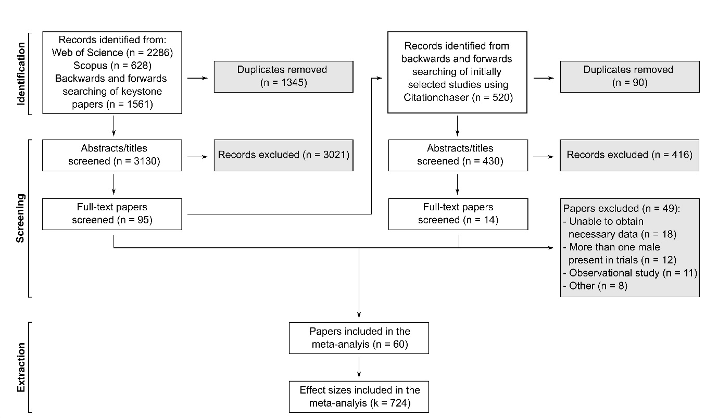
Figure 1. PRISMA flow diagram of the data collection process.

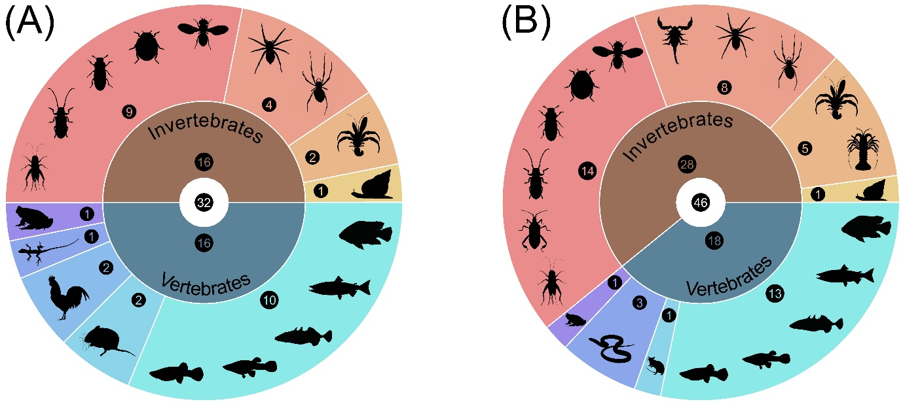
Figure 2. Number of species of each animal taxa in our datasets regarding the role of male quality (A) and male phenotype (B) on male mate choice expression. Silhouettes illustrate certain species used from each group. From the yellow section, in anti-clockwise order: molluscs, crustaceans, arachnids, insects, amphibians, non-avian reptiles, birds (only in the first dataset), mammals, and fish.

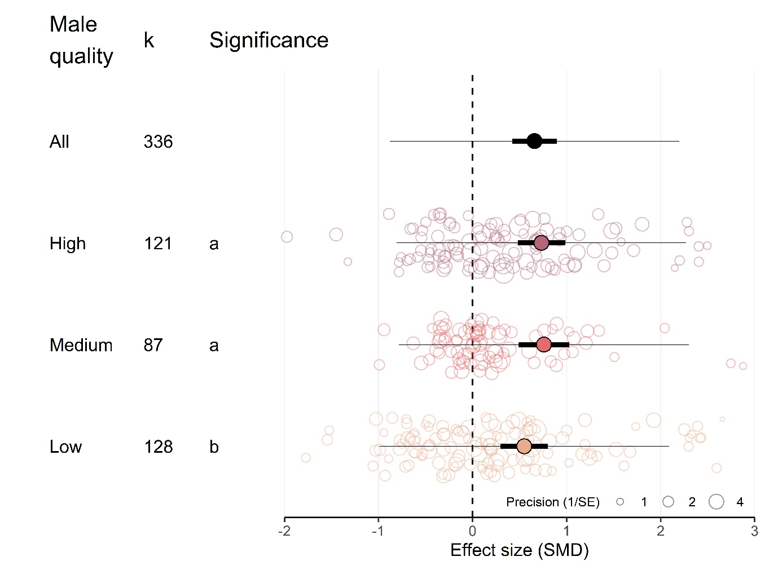
Figure 3. Mean effect sizes for male mate choice according to each male quality category. Positive values represent that males invest more in high-quality females than in low-quality females. Thick horizontal lines represent 95% confidence interval and thin horizontal lines represent prediction interval. k is the number of effect sizes in each category. Different letters represent statistically significant differences between groups (α < 0.05).

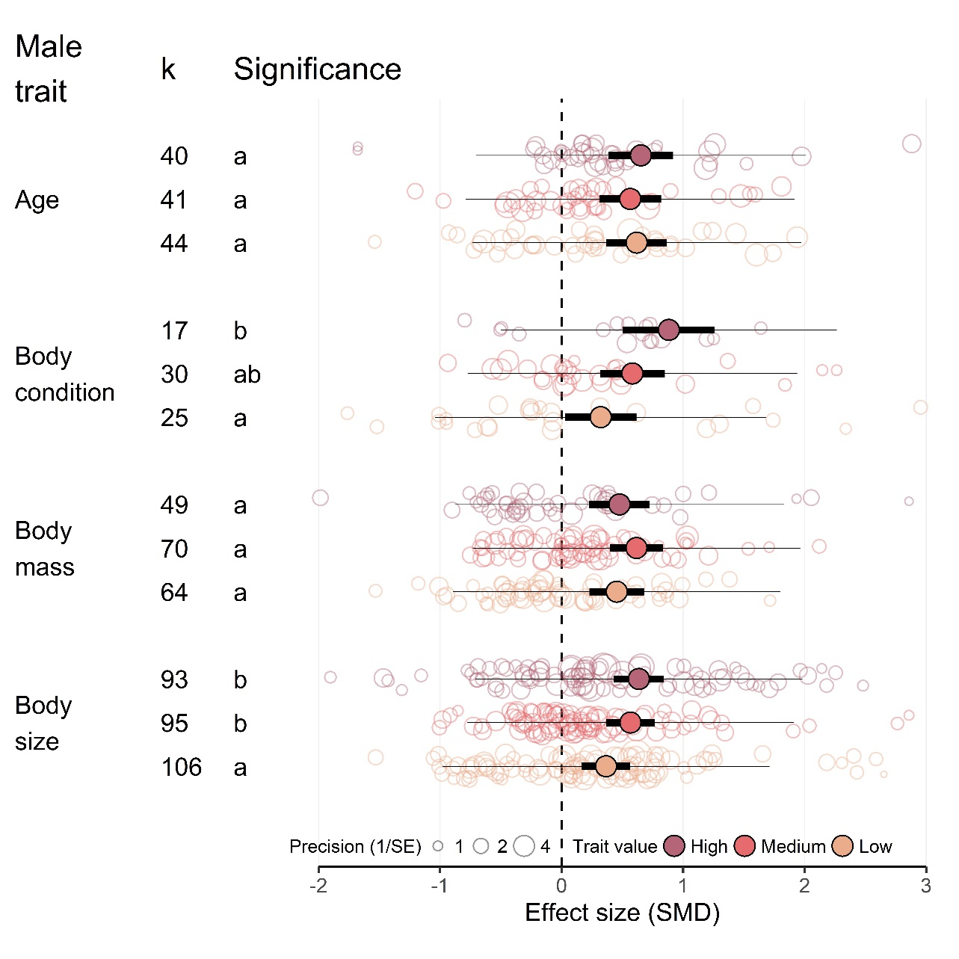
Figure 4. Mean effect sizes for male mate choice according to male quality under different experimental designs. Positive values represent that males invest more in high-quality females than in low-quality females. Thick horizontal lines represent 95% confidence interval and thin horizontal lines represent prediction interval. k is the number of effect sizes in each category. Pairwise comparisons were conducted within each experimental design; different letters represent statistically significant differences between groups (α < 0.05).

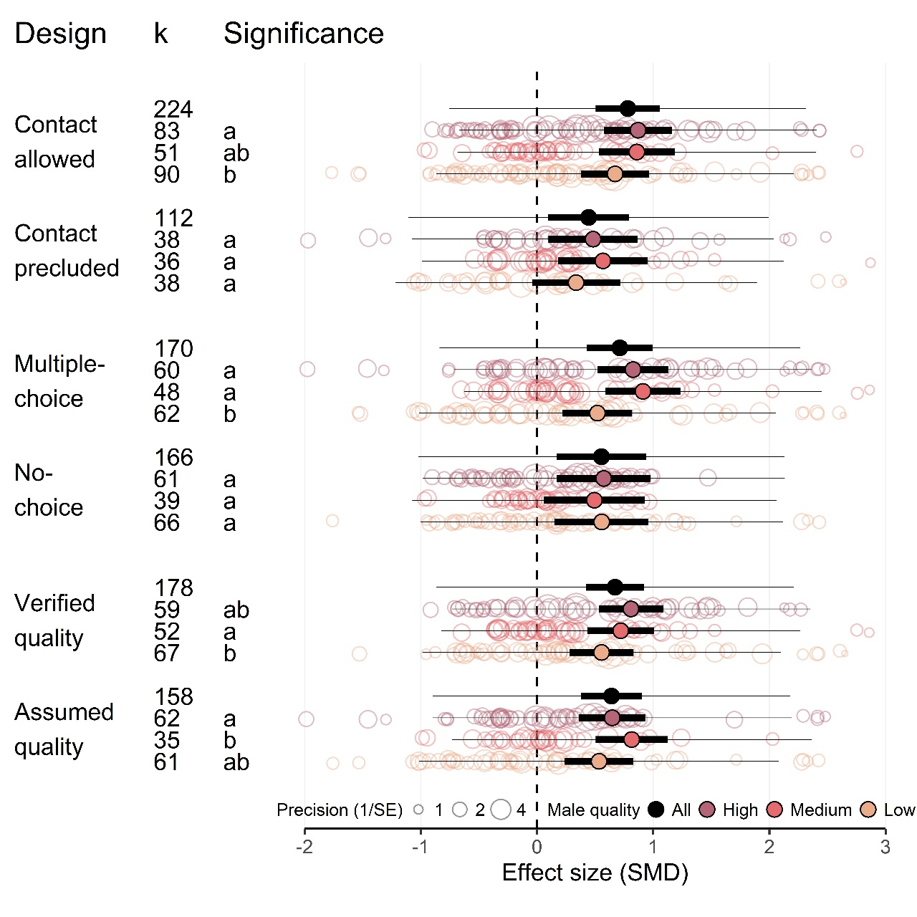
Figure 5. Mean effect sizes for male mate choice according to male phenotypes, for different male traits. Positive values represent that males invest more in high-quality females than in low-quality females. Thick horizontal lines represent 95% confidence interval and thin horizontal lines represent prediction interval. k is the number of effect sizes in each category. Pairwise comparisons were conducted within each male trait; different letters represent statistically significant differences between groups (α < 0.05).

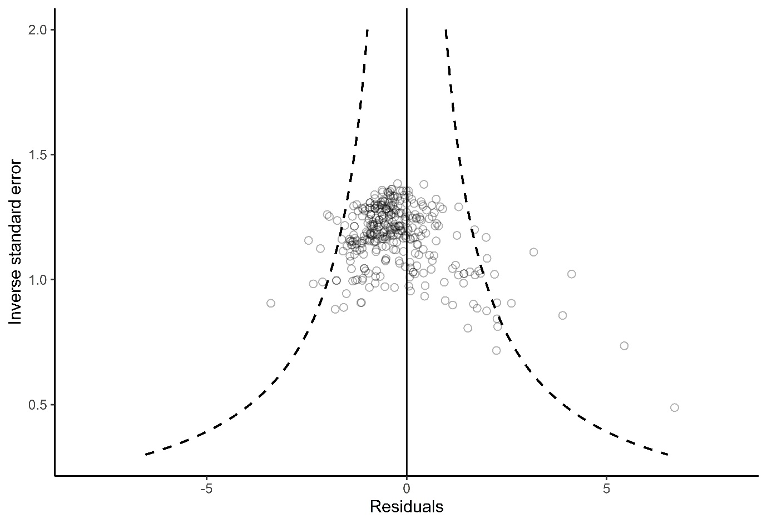
Figure 6. Funnel plot of the residuals of a meta-analytical model using data on male mate choice expression with several moderators (see Material and methods).

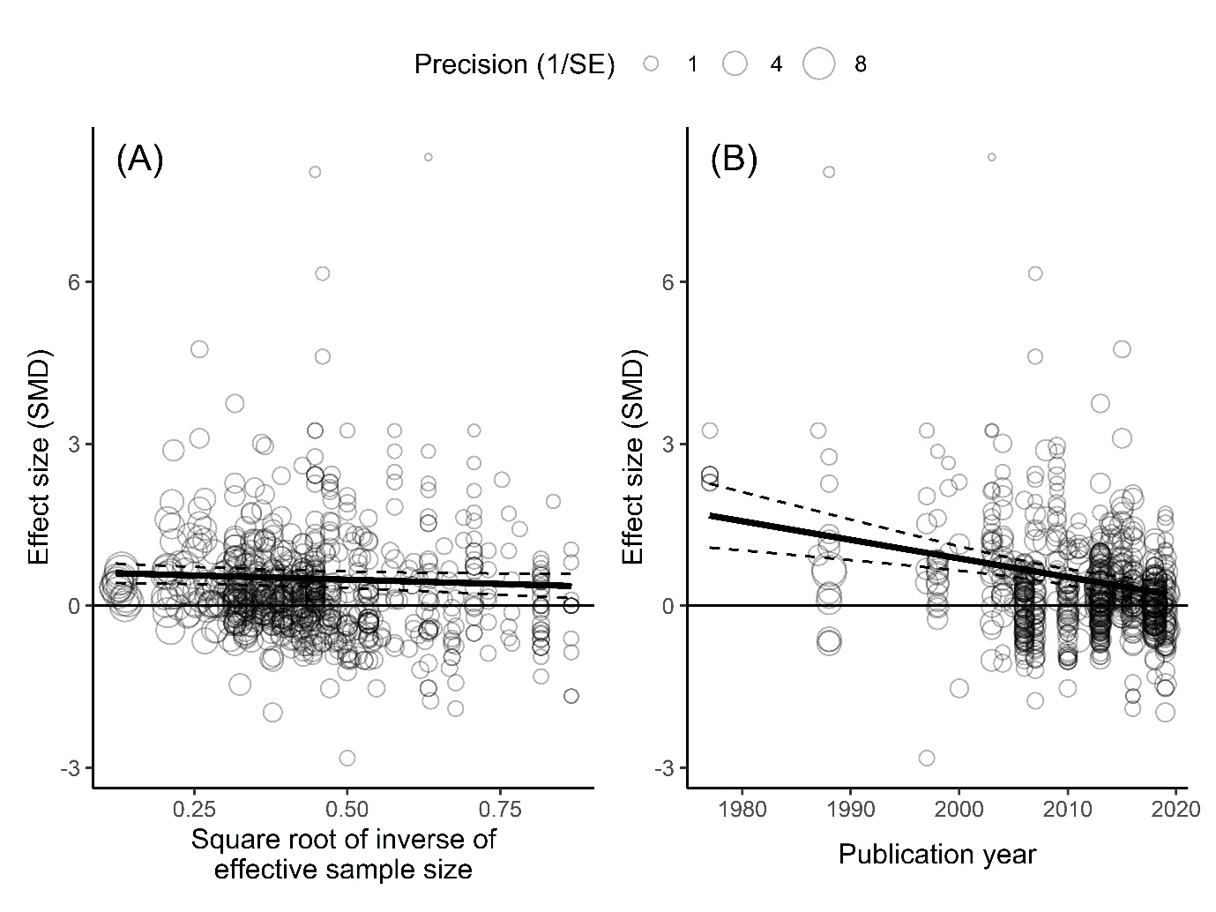
Figure 7. Assessments of publication bias. (A) Relationship between effect size (SMD) and square root of inverse of effective sample size. (B) Relationship between effect size (SMD) and publication year. Broken lines represent 95% confidence intervals for regression estimates.

