Identify, quantify, act: tackling the unused potential of ecological research

^{1,2}Marija Purgar (orcid: 0000-0002-7192-1486), ¹Tin Klanjscek (orcid: 0000-0002-9341-344X), ^{1,3}Antica Culina (orcid: 0000-0003-2910-8085)

¹ Rudjer Boskovic Institute, Zagreb, Croatia
² Department of Biology, University of Osijek, Osijek, Croatia
³ Netherlands Institute of Ecology, NIOO-KNAW, Wageningen, The Netherlands

Preface
‘Ignorance is expensive’¹. The statement also applies to ignorance of research inefficiencies that can generate huge waste: 85% of health research, amounting to $170 billion annually, is avoidably wasted². This alarming finding elicited a number of responses that have since reduced the waste in health research³. Commonality of research and dissemination practices implies that other scientific fields could also benefit from identifying and quantifying waste and acting to reduce it. Yet, no estimate of research waste is available for other fields. Given that ecological issues interweave most of the UN sustainable development goals⁴, we argue tackling research waste in ecology should be prioritized.
Our study leads the way. We estimate components of waste in ecological research, based on a systematic review and a meta-analysis. Shockingly, our results suggest only 11%-18% of conducted ecological research reaches its full informative value. Our duty towards science, environment, organisms we study, and the public dictates that we should urgently act and reduce this considerable yet preventable loss, and harness the full potential of ecological research. We propose to achieve this through actions from researchers, funders, journals, and academic institutions. Finally, we call for other research fields to adopt our framework and derive comparable estimates across scientific disciplines.
Main
Research generates a wealth of output: datasets, workflows, analytical codes, and - ultimately - derived results^{5,6}. Only a small and likely biased subset of the output is published^{7,8}, and is thus available as information often used within evidence synthesis^{9,10}. Hence, much of potential knowledge remains hidden. More worryingly, when the ‘publish or perish’ research culture¹¹ couples with human cognitive biases¹² and the lack of training¹³, even data collection and analysis can be sub-optimal and biased. These issues are becoming hard to ignore. Emerging evidence indicates that the problem could be relatively large across sciences¹⁴⁻¹⁶ including ecology¹⁷⁻²³, and is exacerbated by the failure to replicate results of previous studies across disciplines¹⁴⁻¹⁶. Some think we are facing a crisis²⁴. Yet, to understand how much information we lose in the current research and publishing system, and how to best act to rectify the problem, we need quantitative estimate of information loss (i.e. research waste) over the research life-cycle. Yet, research waste has been quantified only in medicine^{2,}.
A highly influential seminal editorial by Altman in 1994²⁵, and a follow-up work on research waste in medicine² triggered a series of seminars, meetings, and introduction of new policies that target reduction of the waste in medicine^{3,26}, thereby increasing the value of medicinal research. We want to start a comparable, global and focused movement in ecology, but also across the sciences, to quantify the problem of research waste and facilitate a more serious and coordinated move towards changing standards for research and publishing. Identifying research waste is clearly the first step.
To facilitate discussion, we introduce a new term - unused potential of research, which is likely much larger than the waste but at the same time impossible to calculate (at present). For example, we cannot foresee what impact particular research would have had if its design had been better, or its results well rather than partially reported. Further, we believe that focusing on unused potential instead of waste better facilitates actionable recommendations for improvement.
The health of our environment, and thus of humans, and our ability to solve global challenges depends on robust and well-informed ecological research. As ecologists, as well as those that fund ecological research, we must aim to reduce the waste produced in our work. But how large is this waste, and how big of a problem is it?

Components of research waste
Research waste accumulates over the classical research life-cycle (Fig 1). The main stages of the research cycle for which we estimate the research waste are: study planning (includes core study design, data collection, and data analysis), results reporting, and publication. For our classification of waste components, we consider that research waste generated during data collection and data analysis is a problem of study planning. Well-planned studies should foresee, before data collection and analysis: the core study design (e.g. experimental treatment allocation for the data collection set-up), exact data-collection procedures (e.g. blinding while collecting data), and statistical approaches that are appropriate given the core study design and the type of data collected (e.g. controlling for covariates).
We distinguish two types of waste: core waste and exploitative waste. The core waste is all of the conducted (and funded) work that never gets published. The causes of the core waste are dual: low-quality studies, and publication bias. Low-quality studies remain unpublished because they are poorly planned or poorly conducted. Their publication would actually be detrimental. Publication bias, on the other hand, prevents publication of the research of adequate conceptual and methodological quality. This research remains unpublished only because results are not considered to be ‘interesting’ (e.g. null results). Exploitative waste represents a reduced potential of published work to inform the users. Exploitative waste is generated by all published studies with issues at study planning stage²⁷, or result reporting stage²¹. Core waste and exploitative waste combine and lead to the overall waste that accumulates over research life-cycle. This overall waste is one of the components of the unused potential of ecological research.
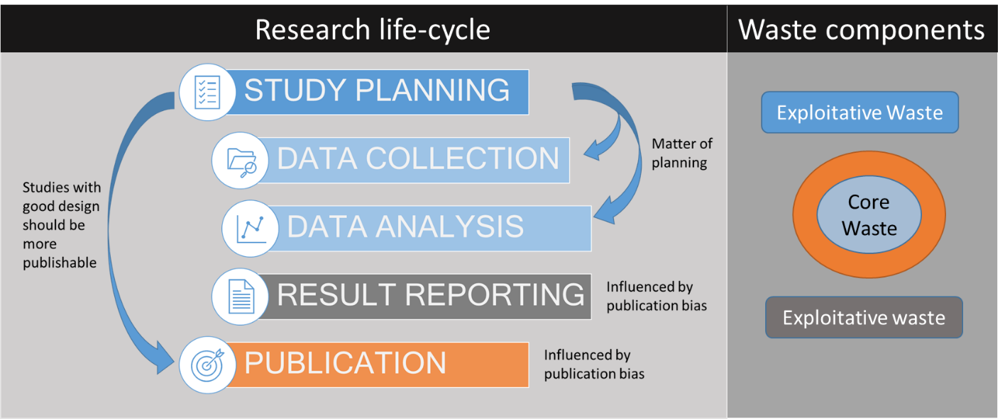
Fig 1. Stages of the classical research life-cycle (left panel). We consider that any suboptimal study planning leads to waste in data collection and data analysis. This is because data collection and analysis should conceptually happen at the study planning stage even though physically conducted later. Further, the study planning stage influences the publication stage because badly planned studies are less likely to be published. The components of the research life-cycle translate into components of research waste (right panel) where Core waste represents all of the unpublished work (due to either low-quality study planning, or publication bias) and the Exploitative waste represents all the published work with a reduced use-value due to either bad planning or poor results reporting.

How much research in ecology is avoidably wasted?
Here we provide a breakdown of the components of the research waste based on a review of published literature (see Box 1 for an overview, and Supplementary Methods for detailed methodology). We identified 34 meta-studies that estimated components of research waste in ecology. We define a meta-study as a study that used published (and less often unpublished) studies to estimate different components of waste in ecology (at the study planning, at result reporting, and at publication stage). Only one meta-study used an indirect estimation method (see below and Supplementary Methods) and was thus excluded from the meta-analysis. Thus, our overall sample size was 33 meta-studies that, based on 10464 studies, provided 43 estimates of research waste components. We summarised estimates of research waste that belong to the same waste component using a meta-analytical model (see the Supplementary Methods). Here, we weighted each effect size by the sample size of a meta-study. When combined, these meta-analytic estimates of the components of research waste led to the first estimate of the overall research waste in ecology.
We investigated two scenarios; both give worryingly high estimates of the overall research waste (Fig 2). The best-case scenario assumes waste components overlap, i.e. that all under-reporting appears in poorly planned studies, reducing the waste to 82%. In the worst-case scenario, poor planning and under-reporting do not happen in the same studies, increasing the waste to 89%. Hence, between 82% and 89% of research appears to be avoidably wasted, or, in other words, unused. Interestingly, these numbers are very close to the only other existing estimate of 85% waste for medicine². We provide the break-down of the waste components bellow.
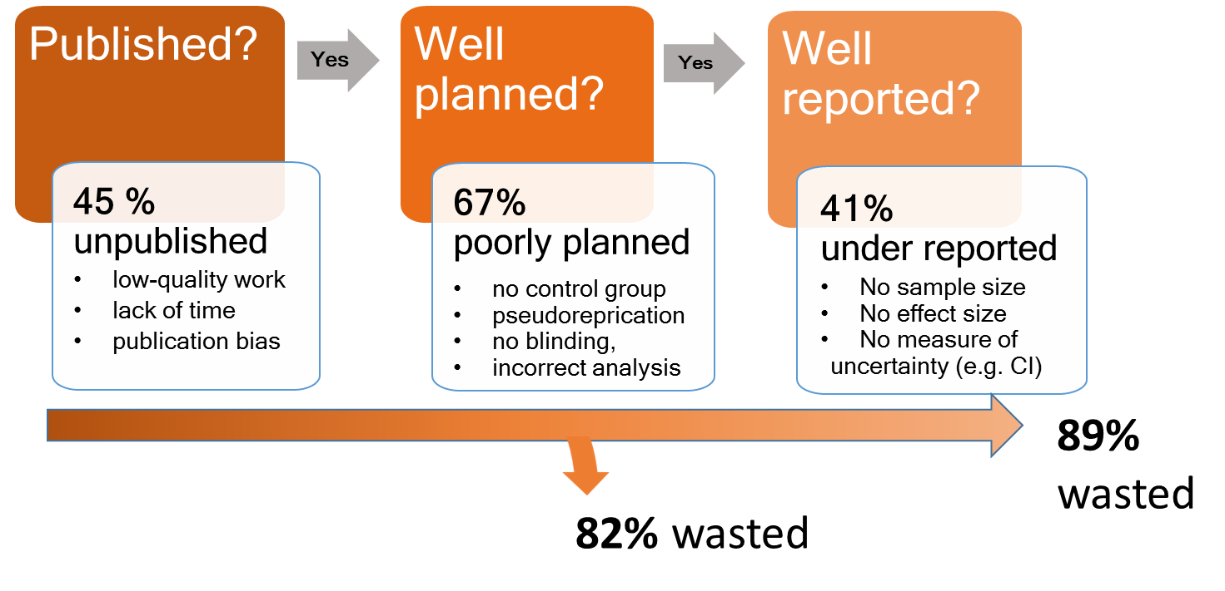
Fig 2 Overall estimate of the unused potential of ecological research based on a meta-analysis of waste at each stage (with examples of causes). In the best-case scenario, 82% of the research is wasted and thus remains unused because all under-reporting is assumed to happen in poorly planned studies. In the worst-case scenario, 89% of the research remains unused because all of the under-reporting is assumed to happen in the otherwise well-planned research. Consequently, only 11%-18% of conducted ecological research can inform users (other researchers, public, policymakers).

The core waste
The core waste is all the work that remains unpublished due to either its low quality, or publication bias. Meta-analysis of ten direct estimates from nine meta-studies (based on an overall sample size of 2252 studies) estimated that the core waste equals to 44.7% (95%CI 44,2%-46,7%, Fig 3A) of research. The estimates from meta-studies included percentage of unpublished projects (e.g. projects collecting telemetry data that never published a single result²⁸), unpublished theses chapters (e.g.²⁹), or unpublished literature (e.g.³⁰). Only one of the meta-studies¹⁹ provided an indirect estimate of unpublished research, which was derived using the trim-and-fill method³¹. We excluded this indirectly estimated value from the main meta-analysis (please see Supplementary Methods for reasons), but we show the recalculated meta-analytical mean with this indirect estimate included (Supplementary Results, Fig S4). The meta-analytic estimate of the core waste was similar when the studies were broken down into those concerning broader areas of ecology (e.g. ecology, conservation ecology), and those with a more narrow topic coverage (e.g. facultative sex-ratio adjustment in birds), as shown in Fig 3A.
We lacked data to calculate the proportion of core waste caused by publication bias versus caused by studies that remain unpublished because of their low quality. Only one meta-study compared quality of study design between published and unpublished studies³², finding that 13% of unpublished studies, and 25% of published studies lacked a control group. Further, the study of Koricheva²⁹ broke down the reasons for why some of the 187 doctoral thesis chapters were never published. She found that 10.1% of these were never submitted for publication, largely due to a lack of time (68%). Of 156 submitted chapters, 16.7% got rejected. Of these, 42.5% were rejected because of the issues at the study planning stage (study design issues, data analysis issues, poor theoretical background), while around 14% were rejected as of the lack of novelty in the findings.

Exploitative waste
Exploitative waste represents the component of published research with a limited ability to inform future work either because the study conducted (and later published) was of low quality (e.g. issues with study design), or because results of the study were reported in a way that prevents their use (for example, effect size or sample size not reported). A shockingly high percentage of published research has issues at the level of study planning: meta-analytic mean of 22 estimates from 21 meta-study with an overall sample size of 7505 studies, showed that 67.4% (95%CI 66.3%-68.4%) of published studies in ecology have issues in the planning stage (Fig 3A).
Conceptually, the core study design (e.g. randomization of treatment units), data collection protocol (e.g. blinded data collection), and analysis plan should be created at the study planning stage. Yet, time-wise these happen sequentially and refer to different time-steps of the classical research life-cycle (Fig 1). Thus, we broke down the Study planning stage into estimates that correspond to these three different time-steps of the research life-cycle. Meta-analytic mean of 16 estimates from 15 meta-studies with an overall sample size of 6606 studies, showed that 65.2% of studies (95% CI 64.0-66.4%) have core design issues (Fig 3B). A majority of core design issues are a consequence of pseudo-replication (e.g.³³). At the data collection stage, the only available estimates were those for blinded vs non blinded data collection: based on five estimates with a sample size of 981 it appears that most of the studies in ecology do not blind the observer to the data (81.5%, 95% CI 79.0%-83.9%, Fig 3B). Finally, at the statistical analysis stage, four estimates with a sample size of 288 showed that overall 47.1% (95% CI, 41.3%-52.8%) of analytical choices are sub-optimal or incorrect. The severity of the problem seems to be slightly worse when considering only the estimates from the meta-studies that capture more general filed of ecology (Fig 3B).
Results of research will be used by different users (other researchers, policymakers, industry etc), commonly in the form of evidence synthesis^{9,10}. The results can be well reported, reported incorrectly (misreported), or under-reported. Under-reporting seems to be common, with 40.7% (95%CI 38.7%-42.8%, Fig 3A) of results being under-reported (based on 9 estimates with a sample size of 2246). For example, a large proportion of results were reported without effect size, sample size, or measure of uncertainty around the estimate. Our review did not identify any estimate of misreported results in ecology.
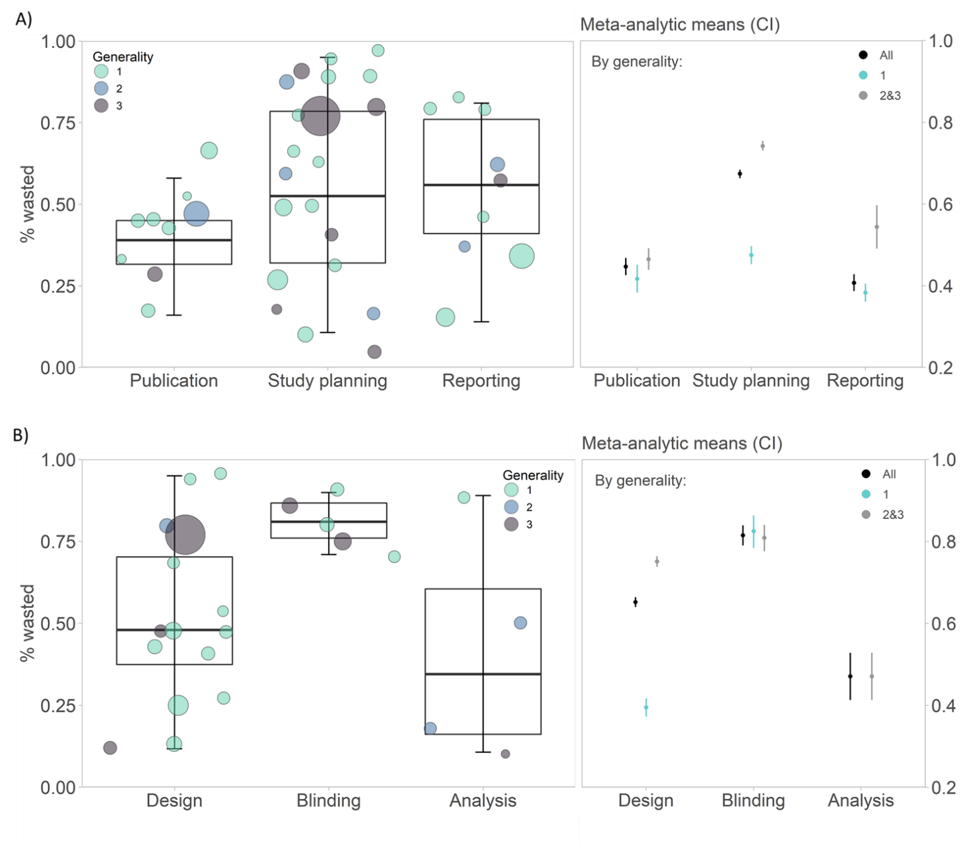Figure 3 Estimates of the main components of research waste (A), and breakdown of research waste generated during the study planning stage, partitioned between different temporal stages of research life-cycle (B). The left-hand panels provide the estimates of research waste (circles) as reported by each meta-study (whisker plot denotes their distribution). The circle size is proportional to the sample size used in a meta-study. Circles are coloured by the Degree of generality, with 1 representing meta-studies covering narrow ecological subfield and 3 representing meta-studies that are not limited to a certain ecological subfield (i.e. are broad). The right-hand side panels show the meta-analytic mean of all effect sizes (black circles), effect sizes coming from meta-studies with narrow scope (Generality 1, blue circles), and broad scope (Generality of 2&3, grey circles), with 95% CI.
Core waste undoubtedly constitutes loss of knowledge. However, to determine how much exploitative waste contributes to information loss is difficult. Even non-rigorously conducted and under-reported research can still have an informative value, albeit reduced compared to rigorous or well-reported research. For example, a study reporting only a direction of an effect, without an effect size, will have a higher informative value than if the result was not reported at all. For a similar reason we have opted to exclude estimates of underpowered studies from our calculations of waste. Underpowered research can still lead to valid conclusions and can contribute to the overall evidence for a certain effect. Power is not only a statistical issue, but is limited by finances, time available, and sometimes by the study system or organism (e.g. rare species). It would be unfair to claim that a study unable to reach the desired sample size is wasted. However, we do call for more consideration of sample size calculation in ecology, as our data suggest that almost all of the studies in ecology are underpowered (e.g.³⁴, also see Dataset_starting data for extracted estimates of underpowered research in Ecology).

Other factors that contribute to the unused potential of ecological research
We estimate that a shockingly high proportion of ecological research (82%-89%) has limited information value because of the research waste accumulating over the research life-cycle. Yet, other factors also contribute to the potential of research to inform future research, policy, or interventions. These factors include access options (whether research has been published open access or with a paywall), and the transparency and openness of the underlying research process.
Not all results are accessible to everyone
Published results are unfortunately not equally available to everyone. We estimated, based on the literature listed at the EuropePMC³⁵ (see Supplementary Methods for details) that 57.7 % of 19 165 articles published in 94 ecological journals between 1957 and 2021 are Open Access. The situation changed for the better: amongst articles published after 2014 (11 980 articles), 73.0% are Open Access. This likely reflects overall trends in mandates by research funders to make funded research open access (e.g. see ROARMAP³⁶). Open access does not only enable equality in access to information, but it also exposes information to a higher number of users and thus has a higher potential to lead to discoveries, to generate novel ideas, or to spot errors.
Unpublished data, methods, and codes
Published results are only the tip of the iceberg, whose body is composed of datasets, methods, and data processing codes and pipelines. These can be often more informative than the published results themselves, especially if the results are, as we have demonstrated in this work, under-reported. Additionally, having access to all research components helps the intended audience understand how published results were derived^{37,38}. More importantly, re-use of data, methods, and code can further accelerate scientific discovery and progress^{18,39,40}. While it seems that the amount of open data is increasing in ecology⁴⁰, we lack a large-scale estimate of its quality, and thus usability (e.g. as done on a smaller sample by Roche et al.⁴¹). Regarding the code availability, a recent study¹⁸ estimated that even amongst journals with a code policy, only around 27% of papers published also submitted their analytical codes. This situation is far from satisfactory and it increases the unused potential of ecological research.
Reference to previous studies
Research waste is reduced when any new research is informed by past research^{26,42} by, for example, conducting a systematic review of existing literature prior to starting new research. Such a practice is being adopted in medicine, especially since the 2014 Lancet Series on ‘Research: Increasing Value, Reducing Waste’. Ecology is lagging despite recent call for systematic review as a first stage of research cycle⁴² - probably because a lack of estimates (and therefore awareness) of the extent of the problem.

Limitations of our approach
Our approach to calculating research waste components has few limitations. First, like most literature reviews it remains restricted to the literature published in English^{26,43}. Thus, strictly speaking, we have estimated the research waste of research published in the English language. The evidence on whether research waste components differ between languages is limited and is non-conclusive in medical research^{44,45}. Only one meta-study within our sample addressed the difference between English and non-English language literature: Kozlov & Vorobeichik⁴⁶ found that studies published in English tend to have a better quality of result reporting compared to studies published in Russian (68% vs 28% of results are well reported, respectively).
Second, we were not able to look into the trends as most of the meta-studies considered extended periods (e.g. all the work published before a certain year). Based on several studies that did report separate values for different periods, it appears that there was no major shift in reducing waste components over time (see Dataset_MA_final data).
Finally, our literature review did not retrieve any estimates of the prevalence of some of the questionable research practices¹⁷. Examples of these practices include optional stopping in data collection until a ‘wanted’ result is obtained^{17,47}, or taking advantage of the flexibility in the choice of analytical procedures (called researchers degrees of freedom⁴⁷) to obtain the desired result such as by including and excluding variables. One meta-study did estimate the prevalence of questionable research practices in ecology, but only based on surveys of researchers¹⁷. This study has, for example, detected that among 807 ecologists and evolutionary biologists 42% had collected more data after inspecting whether results were statistically significant, and 4.5% fabricated their data.
For the above reasons, we want to call for a community-wide discussion on the implications of different components of the research waste for knowledge generation and knowledge loss, as well as to continue working on estimating the waste components on a larger set of ecological literature, including time-trends.

Priority actions
Our results are plain – we have a huge knowledge loss from the onset of studies to the publication of results. In the 21st century and in line with meeting sustainable development goals⁴ our priorities should be clear: reduce the research waste and increase the knowledge gain from the rich ongoing ecological (and other) research. Responsibility to do this lies with researchers, research institutions, publishers, and funders. The aim of our study was not to dissect all the possible ways for reducing research waste, but start and facilitate a serious discussion and concrete actions on changing this alarming situation (as happened in medicine). Thus, we provide only a brief outline of some potential solutions. These include changes in incentives and mandates, promotion of rigorous research practices and transparent research, and better training of and support for scientists to conduct this type of research.
Some of the components of research waste, as detected by our study, should be easy to correct. For example blinding leads to more robust results compared to unblinded research²², and should not incur any additional study costs. Therefore, researchers should blind themselves to data collection or, if this is not possible, to the data during analysis. Similar, quality of reporting can be rapidly increased as high-quality result reporting should not be time-consuming or costly, and many guidelines on the result (and method) reporting are available^{48,49}. Some changes, however, might require more effort and time. For example, pre-registration of studies is still not widely adopted in ecology, but it has been shown to reduce bias in research (in medicine⁵⁰). Pre-registration also enables detection of errors in study design before the study is conducted, thus reducing (or preventing) the main component of waste as detected in our study (Study planning stage).
Scientific incentives are a significant driver of behaviour and therefore research practices. A long-set focus on journal publication, especially in high-impact factor journals, and an interconnected focus on securing funding was set up to select the best science and best scientists. However, it appears that this system is also good at selecting for questionable research practices and non-rigorous science and scientists, including low diversity of those selected⁵¹. For example, a recent large-scale study of Dutch scientists has shown that over 50% of scientists engage in questionable research paractices⁵².
Funders and academic institutions have a primary responsibility for the reduction of waste. They shape the behaviour of researchers by deciding what research to fund, and by setting the reward, promotion, and mandate systems in science and academia. For example, European Commission has achieved a high level of open access publications (83%) under Horizon 2020 programme⁵³. Publishers can then build on the system by further regulating type of research that gets published, and can set additional requirements. For example, an increase in the quantity of open data has been reported after many journals adopted open data policies⁵⁴. Similar, it has been recently shown that introduction of Natures reproducibly checklist has improved reporting standards of papers published with the Nature Publishing Group⁵⁵.
The good news is that funders and institutions are becoming aware that something has to change, and their power to drive the change. For example, the University of California leveraged its size and purchasing power to force open access concessions from Elsevier⁵⁶. The bad news is that the incentives are shifting very slowly, and in a non-synchronized way between countries and disciplines. Science is a global, cross-disciplinary endeavour. Thus, it is imperative to establish a global set of new incentives and rules. Further, new incentives should promote robust research even though such research takes longer, and might also be more likely to produce less ‘exciting’ but more robust findings. Consequences of notable international efforts to change evaluation of researchers should be examined and, if successful, widely adopted (e.g. the San Francisco Declaration on Research Assessment – DORA). Finally, funders need to become more transparent in their funding decisions, and mindful that the funded research is not only of high priority, but also of high methodological quality^{26, 50}.
Related to the above, funders and academic institutions should provide an adequate system to support scientists in conducting better science. This support should include both training of researchers, and support in a form of additional skilled personnel and infrastructures. Thus we call for: (1) more courses on methodologically robust and transparent scientific research in student curricula, and training of established researchers^{13,26}; (2) increase in involvement of experienced methodologists, statisticians, and data stewards on projects²⁶ by for example securing funding for such personnel, or establishing advisory bodies that would provide advice and guidance for funded projects; (3) better technical/infrastructural support⁵⁷ for enabling open science practices, rigorous reporting, archival of all elements of research, and creating linkages among them. We especially call for support for pre-registration of studies as much of the issues with study design and later appearing QRPs can be avoided this way.

The outlook
Apart from the immediate actions listed in the previous section, we also call for coordinated meta-scientific research and more funding for meta-science in ecology (as already done seven years ago in medicine²⁶). Open science^{6,58} and meta-science^{5,59}, two movements that span scientific disciplines, have emerged largely because of the need to address and reduce the impact of research biases on scientific knowledge. Open science aims to make all the components of the research cycle available to everyone. This generates higher knowledge gains based on the conducted research and increases trust in science⁶⁰. Further, open science calls for changes in scientific incentives, as these are likely at the root of research biases.
Meta-science goes in hand with open science as it investigates efficiency, quality, and bias in the scientific ecosystem, and offers solutions to the challenges this system is facing^{5,59}. Meta-science emerged as a discipline very recently, following a failure of several large-scale replication projects to replicate results of the previous studies¹⁴⁻¹⁶. However, meta-science remains poorly integrated into most disciplines. In ecology, meta-science has not even emerged as a strong research line⁶¹, thought the number of meta-studies has been increasing (including this one).
Our framework can (and – we argue – should) be used to identify waste components and calculate the waste-driven unused potential of any research field. Further, we should develop and apply methods to investigate additional unused potential that transcends pure waste. Given commonalities across research disciplines, we should then be able to arrive at a common set of policies that would utilize unused research potential in science.

Conclusions
In this study we derived to a shockingly high estimate of the research waste in ecological research. Thus, a large part of ecological research remains unused. However, the overall unused potential of any research is impossible to calculate. This is because we cannot foresee the potential impact of any single result, data-set, or method on knowledge development or applied solutions, especially as these are sometimes visible only in the far future. This is exactly why we need to urgently reduce the waste that accumulates over the research life-cycle and open up all of the components of research. Only in this way we can enable the highest knowledge gain from past and ongoing research.
We hope our call will awaken researchers, research institutions, publishers, and funders to the tremendous cost of ignoring unused potential in ecological research, and research in general. ‘Ignorance is expensive’¹, and we cannot allow this loss of knowledge to streamline and continue. Thus, in our conclusions we will just repeat the plain finding – we lose 82%-89% of research due to suboptimal practices.

Box 1: Literature review and meta-analyses
In May 2021, we used WoS to conduct a literature review to locate studies that have estimated one of the research waste components for ecological literature. We term these meta-studies. In this way, we obtained 474 studies that were screened independently by three reviews for eligibility. All the meta-studies deemed relevant after the full screening procedure (12 studies) were subjected to a backward and forward reference check to locate any additional relevant meta-studies. We repeated this until no new relevant meta-study was added to our list (four iterations). In this way, we obtained additional 23 studies. Five meta-studies were included from other sources, based on the prior familiarity with the published literature. We excluded six meta-studies that only provided estimates of under-powered research (reasons for this decision can be found in the Supplementary Methods). Further, we excluded one meta-study that provided an indirect estimate of the publication bias. More details can be found in the Supplement. In this way, we have obtained 33 meta-studies with 43 estimates of research waste components, and with an overall sample size of 10464. To each meta-study, we assigned a degree of generality from 1 to 3, depending on its literature coverage. The degree of generality describes whether a meta-study is concerned with a narrow research field within ecology (e.g. facultative sex-ratio adjustment in birds²¹, coded with 1) or a broad area of ecological research (e.g. literature from nine prominent ecological journals²², coded with 3). The final scores were derived based on scores given by all three reviewers (MP, TK, AC).

Nine studies estimated percentage of unpublished literature (either as unpublished project, thesis chapters, or percentage of grey literature), based on an overall sample size of 2252. There were 22 estimates on the Study planning stage of research, and 9 estimates of Result reporting, based on an overall sample size of 7505, and 2246 respectively. To obtain the mean estimate of each waste component, we ran a weighted meta-analysis on the published estimates of the corresponding components (publication, study planning, result reporting). We also preformed meta-regressions to obtain mean estimates from the meta-studies (a) with a narrow coverage (degree of generality 1), and those with more general coverage (2 and 3 combined); (b) for different subcomponents of study planning stage (i.e. core study design, data collection, data analysis). We performed the analysis in RStudio Integrated Development Environment, Version 1.4.1106⁶² using package Matafor, Version 2.4-0⁶³. Please see details in the Supplementary Methods.

Data availability

The data used in this article will be deposited at Zenodo once the article is accepted. These include the original effect sizes as extracted from studies and the final set of the effect sizes used in the meta-analysis. Data can currently be found at https://osf.io/ft8nb/

Code availability

The code used to perform meta-analysis and to create plots (in the main article and the supplementary files) will be deposited at Zenodo. The code is currently available at https://osf.io/ft8nb/

Funding

MP and TK were funded by the Croatian science foundation (HRZZ) project AqADAPT (no. IP‐2018‐01‐3150). AC was supported by the NWO VENI personal grant (grant number 016.Veni.181.054).
References
Note: references used in the meta-analysis are marked with *
1. Kunin, W. E. Robust evidence of declines in insect abundance and biodiversity. Nature 574, 641–642 (2019).
2. Chalmers, I. & Glasziou, P. Avoidable waste in the production and reporting of research evidence. Lancet 374, 86–89 (2009).
3. Chalmers, I. & Glasziou, P. Research waste is still a scandal. BMJ 2018;363:k4645 (2018)
4. United Nations. Transforming our world: the 2030 Agenda for Sustainable Development. (2015)
5. Ioannidis, J. P. A., Fanelli, D., Dunne, D. D. & Goodman, S. N. Meta-research: Evaluation and Improvement of Research Methods and Practices. PLOS Biology 13, e1002264 (2015).
6. Hampton, S. E. et al. The Tao of open science for ecology. Ecosphere 6, art120 (2015).
7. Rothstein, H. R., Sutton, A. J. & Borenstein, M. Publication Bias in Meta-Analysis: Prevention, Assessment and Adjustments. (Wiley, 2005).
8. Sutton, A. J. Publication bias. in The handbook of research synthesis and meta-analysis (eds. Cooper, H., Hedges, L. V. & Valentine, J. C.) 435–452 (Russell Sage Foundation, 2009).
9. Nakagawa, S., Koricheva, J., Macleod, M. & Viechtbauer, W. Introducing our series: research synthesis and meta-research in biology. BMC Biology 18, 20 (2020).
10. Nakagawa, S. et al. A new ecosystem for evidence synthesis. Nat Ecol Evol 4, 498–501 (2020).
11. Coolidge, H. J. & Lord, R. H. Archibald Cary Coolidge: Life and Letters. in Archibald Cary Coolidge: Life and Letters 308 (Houghton Mifflin Harcourt, 1932).
12 Nickerson, R. S. Confirmation Bias: A Ubiquitous Phenomenon in Many Guises. Review of General Psychology 2, 175–220 (1998).
13 Touchon, J. C. & McCoy, M. W. The mismatch between current statistical practice and doctoral training in ecology. Ecosphere 7, e01394 (2016).
14. Begley, C. G. & Ellis, L. M. Raise standards for preclinical cancer research. Nature 483, 531–533 (2012).
15. Open Science Collaboration. Estimating the reproducibility of psychological science. Science 349, aac4716 (2015).
16. Camerer, C. F. et al. Evaluating the replicability of social science experiments in Nature and Science between 2010 and 2015. Nat Hum Behav 2, 637–644 (2018).
17. Fraser, H., Parker, T., Nakagawa, S., Barnett, A. & Fidler, F. Questionable research practices in ecology and evolution. PLoS One 13, e0200303 (2018).
18. Culina, A., van den Berg, I., Evans, S. & Sánchez-Tójar, A. Low availability of code in ecology: A call for urgent action. PLOS Biology 18, e3000763 (2020).
19. Jennions, M. D. & Møller, A. P. Publication bias in ecology and evolution: an empirical assessment using the ‘trim and fill’ method. Biol Rev Camb Philos Soc 77, 211–222 (2002). *
20. Jennions, M. D. & Møller, A. P. A survey of the statistical power of research in behavioral ecology and animal behavior. Behavioral Ecology 14, 438–445 (2003).
21. Cassey, P., Ewen, J. G., Blackburn, T. M. & Møller, A. P. A survey of publication bias within evolutionary ecology. Proc Biol Sci 271 Suppl 6, S451-454 (2004). *
22. Kardish, M. R. et al. Blind trust in unblinded observation in Ecology, Evolution, and Behavior. Frontiers in Ecology and Evolution 3, 51 (2015). *
23. Jennions, M. D. & Møller, A. P. Relationships fade with time: a meta-analysis of temporal trends in publication in ecology and evolution. Proc Biol Sci 269, 43–48 (2002).
24. Baker, M. 1,500 scientists lift the lid on reproducibility. Nature 533, 452–454 (2016).
25. Altman, D. G. The scandal of poor medical research. BMJ 308, 283–284 (1994).
26. Chalmers, I. et al. How to increase value and reduce waste when research priorities are set. Lancet 383, 156–165 (2014).
27. Christie, A. P. et al. Quantifying and addressing the prevalence and bias of study designs in the environmental and social sciences. Nat Commun 11, 6377 (2020). *
28. Campbell, H. A. et al. Finding our way: On the sharing and reuse of animal telemetry data in Australasia. Sci Total Environ 534, 79–84 (2015). *
29. Koricheva, J. Non-significant results in ecology: a burden or a blessing in disguise? Oikos 102, 397–401 (2003). *
30. Bennett, L. T. & Adams, M. A. Assessment of ecological effects due to forest harvesting: approaches and statistical issues. Journal of Applied Ecology 41, 585–598 (2004). *
31. Duval, S. & Tweedie, R. A nonparametric ‘trim and fill’ method of accounting for publication bias in meta-analysis. Journal of the American Statistical Association 95, 89–98 (2000).
32. Brlík, V. et al. Weak effects of geolocators on small birds: A meta-analysis controlled for phylogeny and publication bias. Journal of Animal Ecology 89, 207–220 (2020). *
33. Hurlbert, S. H. Pseudoreplication and the Design of Ecological Field Experiments. Ecological Monographs 54, 187–211 (1984). *
34. Jennions, M.D. & Møller, A.P. A survey of the statistical power of research in behavioral ecology and animal behaviour. Behavioral Ecology 14, Pages 438–445 (2003).
35. Ferguson, C, Araújo, D., Faulk, L, Gou, Y, Hamelers, A. Huang, Z et al. Europe PMC in 2020, Nucleic Acids Research, Volume 49, Issue D1, 8 (2021) Pages D1507–D1514, https://doi.org/10.1093/nar/gkaa994
36. Registry of Open Access Repository Mandates and Policies http://roarmap.eprints.org/ (2021).
37. Munafò, M. R. et al. A manifesto for reproducible science. Nat Hum Behav 1, 1–9 (2017).
38. O’Dea, R. E. et al. Towards open, reliable, and transparent ecology and evolutionary biology. BMC Biology 19, 68 (2021).
39. Culina, A. et al. Navigating the unfolding open data landscape in ecology and evolution. Nat Ecol Evol 2, 420–426 (2018).
40. Culina, A., Crowther, T. W., Ramakers, J. J. C., Gienapp, P. & Visser, M. E. How to do meta-analysis of open datasets. Nat Ecol Evol 2, 1053–1056 (2018).
41. Roche, D. G., Kruuk, L. E. B., Lanfear, R. & Binning, S. A. Public Data Archiving in Ecology and Evolution: How Well Are We Doing? PLOS Biology 13, e1002295 (2015).
42. Grainger, M. J., Bolam, F. C., Stewart, G. B. & Nilsen, E. B. Evidence synthesis for tackling research waste. Nat Ecol Evol 4, 495–497 (2020).
43. Nuñez, M. A. & Amano, T. Monolingual searches can limit and bias results in global literature reviews. Nat Ecol Evol 5, 264–264 (2021).
44. Morrison, A. et al. The effect of English-language restriction on systematic review-based meta-analyses: a systematic review of empirical studies. Int J Technol Assess Health Care 28, 138–144 (2012).
45. Wu, T., Li, Y., Bian, Z., Liu, G. & Moher, D. Randomized trials published in some Chinese journals: how many are randomized? Trials 10, 46 (2009).
46. Vorobeichik, E. L. & Kozlov, M. V. Impact of point polluters on terrestrial ecosystems: Methodology of research, experimental design, and typical errors. Russ J Ecol 43, 89–96 (2012). *
47. Simmons, J. P., Nelson, L. D. & Simonsohn, U. False-Positive Psychology: Undisclosed Flexibility in Data Collection and Analysis Allows Presenting Anything as Significant. Psychol Sci 22, 1359–1366 (2011).
48. Parker, T. H. et al. Transparency in Ecology and Evolution: Real Problems, Real Solutions. Trends Ecol Evol 31, 711–719 (2016).
49. Announcement: Reducing our irreproducibility. Nature 496, 398–398 (2013).
50. Moher, D. et al. Increasing value and reducing waste in biomedical research: who’s listening? Lancet 387, 1573–1586 (2016).
51. Smaldino, P. E. & McElreath, R. The natural selection of bad science. Royal Society Open Science 3, 160384.
52. Vrieze, J. Landmark research integrity survey finds questionable practices are surprisingly common. Science https://www.sciencemag.org/news/2021/07/landmark-research-integrity-survey-finds-questionable-practices-are-surprisingly-common (2021).
53. Athena Research & Innovation Center, Directorate-General for Research and Innovation (EC), PPMI, UNU-MERIT. Monitoring the open access policy of Horizon 2020 (2021). European Comission
54. Vines, T. H. et al. Mandated data archiving greatly improves access to research data. The FASEB Journal 27, 1304–1308 (2013).
55. The NPQIP Collaborative Group. Did a change in Nature journals’ editorial policy for life sciences research improve reporting? BMJ Open Science 3, e000035 (2019).
56. Kwon D.: University of California and Elsevier Forge Open-Access Deal. TheScientit (2021). Accessed 20.09. 2021 https://www.the-scientist.com/news-opinion/university-of-california-and-elsevier-forge-open-access-deal--68557
57. Glasziou, P. et al. Reducing waste from incomplete or unusable reports of biomedical research. Lancet 383, 267–276 (2014).
58. Fecher, B. & Friesike, S. Open Science: One Term, Five Schools of Thought. in Opening Science: The Evolving Guide on How the Internet is Changing Research, Collaboration and Scholarly Publishing (eds. Bartling, S. & Friesike, S.) 17–47 (Springer International Publishing, 2014).
59. Hardwicke, T. E. et al. Calibrating the Scientific Ecosystem Through Meta-Research. Annual Review of Statistics and Its Application 7, 11–37 (2020).
60. McKiernan, E. C. et al. How open science helps researchers succeed. eLife 5, e16800 (2016).
61. Fidler, F. et al. Metaresearch for Evaluating Reproducibility in Ecology and Evolution. Bioscience 67, 282–289 (2017).
62. RStudio Team. RStudio: Integrated Development for R. RStudio, PBC, Boston, MA (2020) URL: http://www.rstudio.com/.
63. Viechtbauer, W. Conducting meta-analyses in R with the metafor package. Journal of Statistical Software, 36(3), 1-48. (2010). URL: https://www.jstatsoft.org/v36/i03/
Additional references for studies used in meta-analysis and not mentioned in the main reference list
Cleasby, I. R. et al. What is our power to detect device effects in animal tracking studies? Methods in Ecology and Evolution 12, 1174–1185 (2021).
Cornwall, C. E. & Hurd, C. L. Experimental design in ocean acidification research: problems and solutions. ICES Journal of Marine Science 73, 572–581 (2016).
Davidson, A. D. & Hewitt, C. L. How often are invasion-induced ecological impacts missed? Biol Invasions 16, 1165–1173 (2014).
Fidler, F., Burgman, M. A., Cumming, G., Buttrose, R. & Thomason, N. Impact of criticism of null-hypothesis significance testing on statistical reporting practices in conservation biology. Conserv Biol 20, 1539–1544 (2006).
Forstmeier, W. & Schielzeth, H. Cryptic multiple hypotheses testing in linear models: overestimated effect sizes and the winner’s curse. Behav Ecol Sociobiol 65, 47–55 (2011).
Garamszegi, L. Z., Markó, G. & Herczeg, G. A meta-analysis of correlated behaviours with implications for behavioural syndromes: mean effect size, publication bias, phylogenetic effects and the role of mediator variables. Evol Ecol 26, 1213–1235 (2012).
Gillespie, B. R., Desmet, S., Kay, P., Tillotson, M. R. & Brown, L. E. A critical analysis of regulated river ecosystem responses to managed environmental flows from reservoirs. Freshwater Biology 60, 410–425 (2015).
Haddaway, N. R., Styles, D. & Pullin, A. S. Evidence on the environmental impacts of farm land abandonment in high altitude/mountain regions: a systematic map. Environmental Evidence 3, 17 (2014).
Heffner, R. A., Butler, M. J. & Reilly, C. K. Pseudoreplication Revisited. Ecology 77, 2558–2562 (1996).
Holman, L., Head, M. L., Lanfear, R. & Jennions, M. D. Evidence of Experimental Bias in the Life Sciences: Why We Need Blind Data Recording. PLOS Biology 13, e1002190 (2015).
Hurlbert, S. H. & White, M. D. Experiments with Freshwater Invertebrate Zooplanktivores: Quality of Statistical Analyses. Bulletin of Marine Science 53, 128–153 (1993).
Johnson III, W. T. & Freeberg, T. M. Pseudoreplication in use of predator stimuli in experiments on antipredator responses. Animal Behaviour 119, 161–164 (2016).
Kozlov, M. V. Pseudoreplication in ecological research: the problem overlooked by Russian scientists. Zh Obshch Biol 64, 292–307 (2003).
Kozlov, M. V. Plant studies on fluctuating asymmetry in Russia: Mythology and methodology. Russian Journal of Ecology 48, 1–9 (2017).
Lemoine, N. P. et al. Underappreciated problems of low replication in ecological field studies. Ecology 97, 2554–2561 (2016).
McDonald, S., Cresswell, T., Hassell, K. & Keough, M. Experimental design and statistical analysis in aquatic live animal radiotracing studies: A systematic review. Critical Reviews in Environmental Science and Technology, 1–30 (2021).
Møller, A. P., Thornhill, R. & Gangestad, S. W. Direct and indirect tests for publication bias: asymmetry and sexual selection. Animal Behaviour 70, 497–506 (2005).
Mrosovsky, N. & Godfrey, M. The path from grey literature to Red Lists. Endangered Species Research 6, 185–191 (2008).
O’Brien, C., van Riper, C. & Myers, D. E. Making reliable decisions in the study of wildlife diseases: using hypothesis tests, statistical power, and observed effects. J Wildl Dis 45, 700–712 (2009).
Parker, T. H. What do we really know about the signalling role of plumage colour in blue tits? A case study of impediments to progress in evolutionary biology. Biol Rev Camb Philos Soc 88, 511–536 (2013).
Ramage, B. S. et al. Pseudoreplication in tropical forests and the resulting effects on biodiversity conservation. Conserv Biol 27, 364–372 (2013).
Sallabanks, R., Arnett, E. B. & Marzluff, J. M. An Evaluation of Research on the Effects of Timber Harvest on Bird Populations. Wildlife Society Bulletin (1973-2006) 28, 1144–1155 (2000).
Sánchez-Tójar, A. et al. Meta-analysis challenges a textbook example of status signalling and demonstrates publication bias. eLife 7, e37385 (2018).
Smith, D. R., Hardy, I. & Gammell, M. Power rangers: no improvement in the statistical power of analyses published in Animal Behaviour. Animal Behaviour 81, 347–352 (2011).
Waller, B., Warmelink, L., Liebal, K., Micheletta, J. & Slocombe, K. Pseudoreplication: A widespread problem in primate communication research. Animal Behaviour 86, 483–488 (2013).
van Wilgenburg, E. & Elgar, M. A. Confirmation Bias in Studies of Nestmate Recognition: A Cautionary Note for Research into the Behaviour of Animals. PLOS ONE 8, e53548 (2013).
Yoccoz, N. G. Use, Overuse, and Misuse of Significance Tests in Evolutionary Biology and Ecology. Bulletin of the Ecological Society of America 72, 106–111 (1991).
Zaitsev, A. S., Gongalsky, K. B., Malmström, A., Persson, T. & Bengtsson, J. Why are forest fires generally neglected in soil fauna research? A mini-review. Applied Soil Ecology 98, 261–271 (2016).
Zvereva, E. L. & Kozlov, M. V. Biases in studies of spatial patterns in insect herbivory. Ecological Monographs 89, e01361 (2019).

