Plant community data from a statewide survey of paired serpentine and non-serpentine soils in California, USA

Jesse E. D. Miller^{1,2,*}, Stella Copeland³, Kendi Davies⁴, Brian Anacker⁵, Hugh Safford^{1,6}, & Susan Harrison¹
¹Department of Environmental Science and Policy, University of California, Davis, Davis, CA, USA, 95616
²Current address: Department of Biology, Stanford University, Stanford, CA, USA, 94305
³ US Department of Agriculture−Agricultural Research Service, Eastern Oregon Agricultural Research Center, 67826-A Hwy 205, Burns, OR 97720, USA
⁴Department of Ecology and Evolutionary Biology, University of Colorado, Boulder, CO, USA, 80309
⁵City of Boulder, Open Space and Mountain Parks, Boulder, CO 80301
⁶USDA Forest Service Region 5, 1323 Club Drive, Vallejo, CA 94592
*Corresponding author: jedmiller@ucdavis.edu

Metadata

Class I. Data set descriptors
- Data set identity: Plant community data from a statewide survey of paired serpentine and non-serpentine soils in California, USA
- Data set identification code: DataS1.zip
- Data set description
  - Originator(s): Susan Harrison and Hugh Safford (see affiliations in author list)
  - Abstract:
Soils derived from ultramafic parent materials (hereafter serpentine) provide habitat for unique plant communities containing species with adaptations to the low nutrient levels, high magnesium: calcium ratios, and high metal content (Ni, Zn) that characterize serpentine. Plants on serpentine have long been studied in evolution and ecology, and plants adapted to serpentine contribute disproportionately to plant diversity in many parts of the world.
In 2000-2003, serpentine plant communities were sampled at 107 locations representing the full range of occurrence of serpentine in California, USA, spanning large gradients in climate. In 2009-2010, plant communities were similarly sampled at 97 locations on nonserpentine soil, near to and paired with 97 of the serpentine sampling locations. (Some serpentine locations were revisited in 2009-2010 to assess the degree of change since 2000-2003, which was minimal.) At each serpentine or nonserpentine location, a north- and a south-facing 50 m x10 m plot were sampled. This design produced 97 “sites” each consisting of four “plots” (north-south exposure, serpentine-nonserpentine soil). All plots were initially visited >3 times over 2 years to record plant diversity and cover, and a subset were revisited in 2014 to examine community change after a drought.
The original question guiding the study was how plant diversity is shaped by the spatially patchy nature of the serpentine habitat. Subsequently, we investigated how climate drives plant diversity at multiple scales (within locations, between locations on the same and different soil types, and across entire regions) and at different levels of organization (taxonomic, functional, and phylogenetic).
- Keywords: California, edaphic endemics, Mediterranean climate, modified Whittaker plots, ophiolite, peridotite, plant communities, plant diversity, serpentinite, ultramafic

Class II. Research origin descriptors
- Overall project description:
  - Identity: Plant community data from a statewide survey of paired serpentine and non-serpentine soils in California, USA
  - Originator(s): Susan Harrison and Hugh Safford
  - Period of study: 2000-2014
  - Objectives: Study drivers of plant community diversity and composition across major climate and soil gradients in California
  - Abstract: Plant community diversity is shaped by the interacting forces of environmental variation (climate, soils, disturbances), species interactions, and historical processes that may lead to dispersal limitation. The relative influences of these forces might be expected to vary over spatial scales, between more- and less-connected habitats, and among different forms of diversity (taxonomic, functional, phylogenetic). This project began as an effort to isolate the role of dispersal limitation by testing whether collections of small and isolated patches of serpentine soils might support lower taxonomic diversity at local scales, but higher diversity at regional scales. Among many other covariates that were measured in this phase of the study, large-scale climate (a tenfold precipitation gradient across California) had by far the greatest influence on plant diversity at all organizational levels. To better understand the role of climate, the study grew to incorporate paired nonserpentine plant communities, field-measured plant functional traits, and phylogenetic information. These elements made it possible to study more scales of diversity (i.e., beta diversity among slopes and soils and across spatial distance gradients), and more forms of diversity (functional and phylogenetic). Ultimately, the synthesized results provided support for the tolerance hypothesis for climatic diversity gradients, under which diversity is highest in benign environments that permit the persistence of ancient lineages and the coexistence of variable functional strategies.
  - Source(s) of funding: National Science Foundation, Division of Environmental Biology, grant numbers DEB-0075369, DEB-0947368, DEB-1439246, and DEB-1748610.

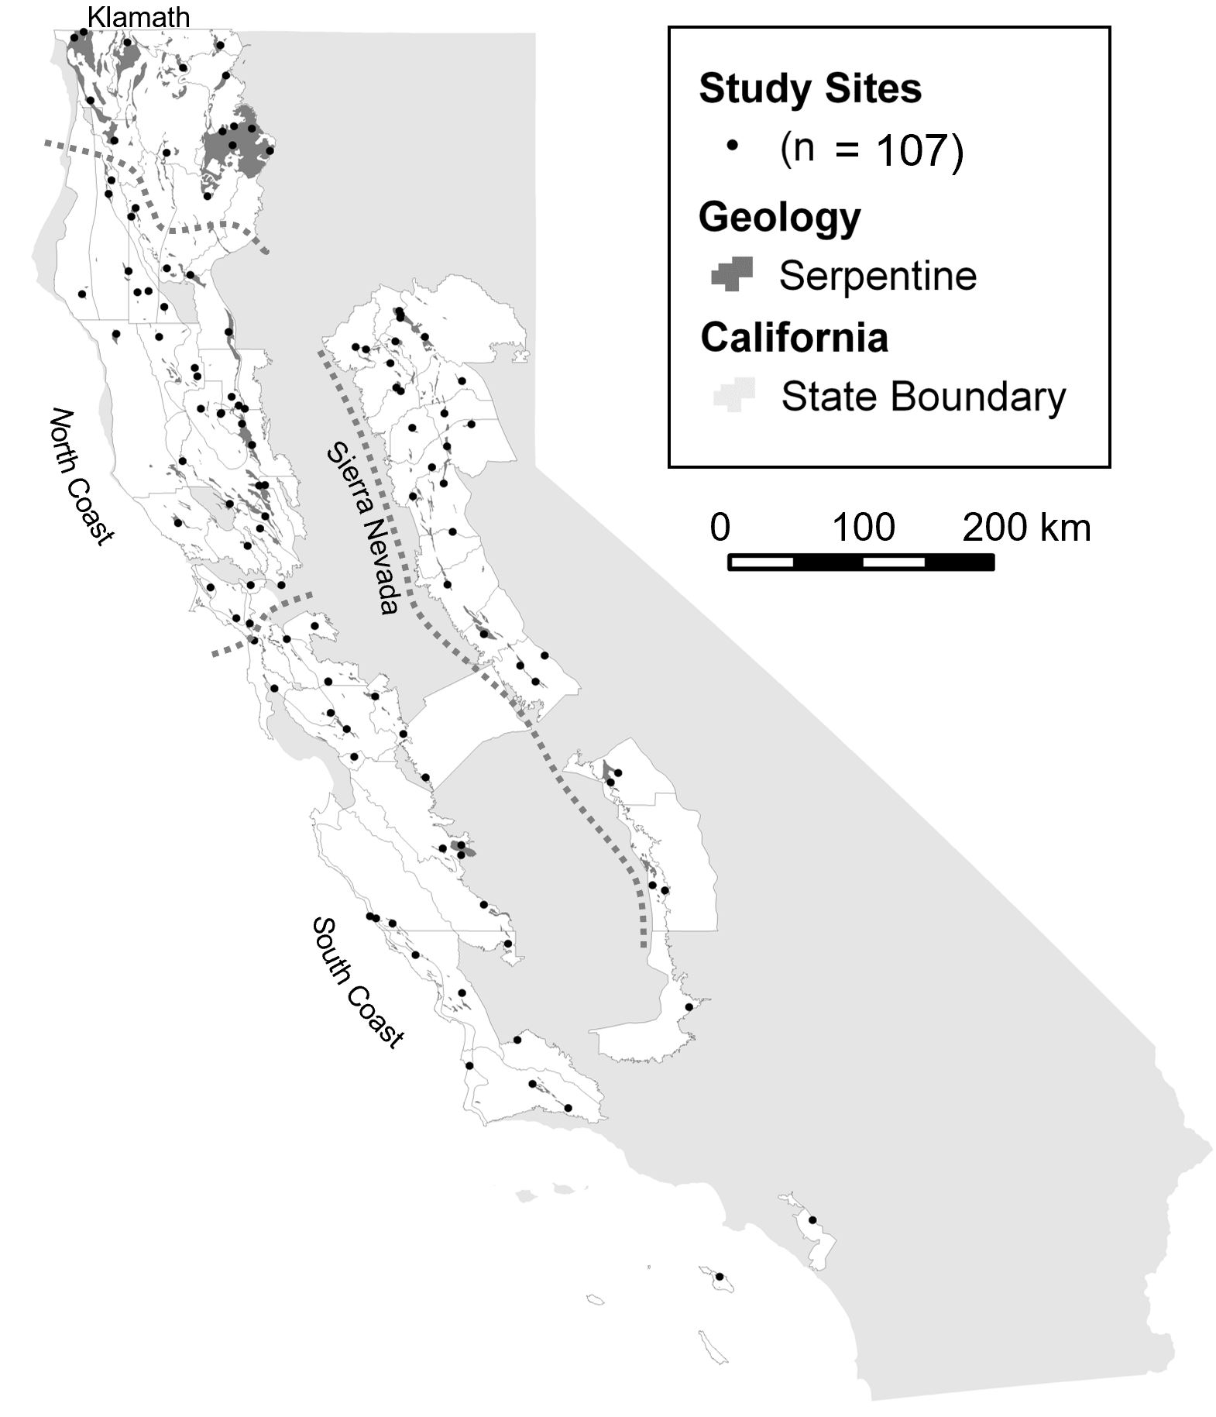

Figure 1. Map of locations of study sites in California, USA.

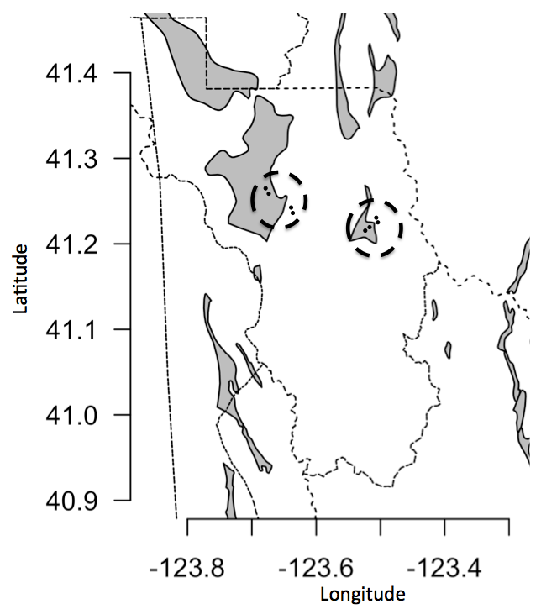

Figure 2. Illustration of sample design. Grey shapes are serpentine outcrops. Thick dashed lines represent study sites; black dots represent individual study plots

- Specific subproject description
  - Site description
    - Site type: Upland terrestrial ecosystems
    - Geography: California: Klamath Mountains, North and South Coast Ranges, and Sierra Nevada foothills
    - Habitat: Varied upland habitats including rocky barrens, grasslands, shrublands, savannas, woodlands, and forests.
    - Geology, landform: Serpentine soils, derived from various types of ultramafic parent rock with variable degrees of weathering; nonserpentine soils, derived from various igneous and sedimentary parent rocks, with relatively balanced chemistry supporting vegetation typical for the region; upland habitats often with significantly differing vegetation on cool (N-NE) and warm (S-SE) slopes
    - Watersheds, hydrology: Upland areas of many watersheds throughout California
    - Site history: Some sites were grazed by livestock; most had not burned in the historic record, and none had burned recently.
    - Climate: Mediterranean climate
  - Experimental or sampling design
    - Design characteristics: Each site consisted of 4 plots, 2 on serpentine soil and 2 on an adjacent nonserpentine soil; within each soil, 1 plot on a N to NE-facing slope and 1 on a S to SW-facing slope. Distance among study plots within a soil was typically 50-100 m; distance among plots across soil types ranged from 100 m – 5 km.
    - Permanent plots: The 10 x 50 m modified Whittaker plots were marked using metal pin flags, and GPS coordinates and directions were recorded. During the 2014 revisits, if we could not locate the pin flag we approximated the location using GPS and written location information, and did not use sites where we lacked confidence in our approximate relocation ability.
    - Data collection period, frequency, etc.: Plots were initially visited >3 times within two consecutive years between 2000-2003 for serpentine plots and 2009-2010 for nonserpentine plots. In the 2014 revisits, plots were visited either once for perennial-dominated sites, or twice if annual plants were a significant component of the flora.

  - Research methods
    - Field/laboratory: Serpentine sampling locations were selected by using a spatial floristic database to subdivide California into small regions (Figure 1), and then visiting each region that contained serpentine soil to find at least one undisturbed and accessible sampling location on serpentine soil where a N to NE slope occurred near a S to SW slope. Nonserpentine locations were selected by searching within 5 km of each serpentine location for an undisturbed and accessible location on nonserpentine soil, supporting typical vegetation for the region, with similar criteria of low disturbance and contrasting N-NE and S-SE slopes. Each pair of serpentine and nonserpentine locations was henceforth called a site (Figure 2). Each site consisted of 4, 10x50 m modified-Whittaker plots (Figure 3), on the factorial combination of 2 soils x 2 slopes. Plots were oriented so the 50-m axis paralleled the slope.
On each visit we visually recorded presence or absence of all species in the plot; visual cover estimates of herbaceous species and environmental variables (bare soil, litter cover, etc.) in 7 nested 1 x 1m quadrats; and woody cover by species along a 50m transect in the center of each plot.
Soils were analyzed for texture and nutrients by A&L Western Laboratories, Inc. (al-labs-west.com; S1B soil analysis package; see Harrison et al. 2006 for full description of the analytic protocols).
    - Data collection period, frequency, etc.: Plots were initially visited >3 times within two consecutive years to ensure that annual plants were found. In the 2014 resampling, plots were visited once for perennial-dominated sites, or twice where annual plants were a significant part of the flora.
    - Instrumentation: Compass, 50 measuring tape, 1 m PVC measuring stick, plant presses, trowel for soil samples, GPS unit
    - Taxonomy and systematics: Taxonomy follows The Jepson Manual (Hickman et al. 1993).
    - Permit history: Permits were obtained where required
    - Legal/organizational requirements: N/A
- Project personnel: Susan Harrison, Hugh Safford, Kendi Davies, Brian Anacker, Barbara Fernandez, Stella Copeland, Jesse E. D. Miller, Florence Caplow, Patricia Maloney, Jane van Susteren, Susan Fawcett, Roger Stephens, Stefan Grozev, Rosie Murphy-Deak, Mack Neal Byers

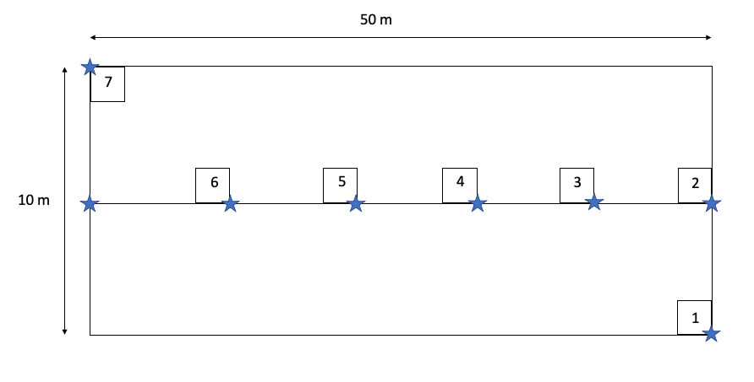
Figure 3. Schematic of study plot layout (not to scale). Small boxes represent 1 x 1 m qudarats. Quadrat seven was located in the far upper left corner of the plot for the surveys as shown in surveys on nonserpentine soil and all 2014 plot revisits, but was located 10m farther to the right (directly above subplot six in the diagram) for the original 2000-2003 surveys on serpentine soil. Blue stars represent the locations where pin flags were placed. The line running down the center of the plot represents the transect along which woody plant cover was measured. Plots are generally oriented with the central transect running uphill, with subplots 1 and 2 at the bottom of the plot, and subplot 7 at the top.

Class III. Data set status and accessibility
- Status
  - Latest update: September 2021
  - Latest archive date: September 2021
  - Metadata status: updated in September 2021
  - Data verification: Checked for completeness in August 2021
- Accessibility
  - Storage location and medium: Data are available on Figshare:
doi:10.6084/m9.figshare.17009027

  - Contact person(s): Jesse E. D. Miller, Department of Biology, Stanford University, jedmiller@ucdavis.edu
  - Copyright restrictions: None
  - Proprietary restrictions: We request that users of these data cite this data paper in any publications that result from its use. The authors are available for consultations about and collaborations involving the data.
- Costs: Costs associated with acquiring data (may vary by size of data request, desired medium, etc.): None

Class IV. Data structural descriptors
- Data set file
  - Identity: DataS1.zip
  - Size: 349 kb when zipped, 2.5 Mb when unzipped
  - Format and storage mode: Comma-separated values (.csv)
  - Header information: See variable descriptions in section B below
  - Alphanumeric attributes: mixed
  - Special characters/fields: NA indicates missing data
  - Authentication procedures: N/A

- Variable information
1_Location_topography.csv: This file contains data on the location and topography of study plots. Locations are included for both original surveys and the 2014 site revisits, since we were not always able to find the original plot markers for the 2014 revisits.
Field | Description | Unit | Variable Type
PlotKey | Name of site; beginning with N for Nonserpentine or S for serpentine. The second and third letters represent the region. Regions are South Coast (SC), Sierra Nevada (SN), North Coast (NC), and Klamath (KL). The fourth and fifth letters represent the name of the site. The sixth letter is either N or S for north or south-facing aspect. |  | text string
Latitude | Latitude of plot location | decimal degrees | numeric
Longitude | Longitude of plot location | decimal degrees | numeric
Aspect | Aspect of plot | degrees | numeric
Slope | Average topographic slope of plot | degrees | numeric
Visit | Sampling period; Initial 2-3 visits or revisit in 2014 |  | text string

2_Species_occurrence.csv: This file lists all plant species (herbs and woody plants) that occur within each study plot.
Field | Description | Unit | Variable Type
PlotKey | Name of site; beginning with N for Nonserpentine or S for serpentine. The second and third letters represent the region. Regions are South Coast (SC), Sierra Nevada (SN), North Coast (NC), and Klamath (KL). The fourth and fifth letters represent the name of the site. The sixth letter is either N or S for north or south-facing aspect. |  | text string
Species | Species name; corresponds to the Jepson Manual (Hickman et al. 1993) |  | text string
Visit | Sampling period; Initial 2-3 visits or revisit in 2014 |  | text string

3_Subplot plant cover.csv: This file contains the cover of all herb species that were recorded in each of the seven quadrats in each study plot. 25 plots did not have any herb cover in the quadrats and are not listed here.
Field | Description | Unit | Variable Type
PlotKey | Name of site; beginning with N for Nonserpentine or S for serpentine. The second and third letters represent the region. Regions are South Coast (SC), Sierra Nevada (SN), North Coast (NC), and Klamath (KL). The fourth and fifth letters represent the name of the site. The sixth letter is either N or S for north or south-facing aspect. |  | text string
Date | Year or date species was recorded | date or year | numeric or date
Species code | Species name; corresponds to the Jepson Manual (Hickman et al. 1993) |  | text sring
q1 | Cover in 1 x 1 quad #1 | % | numeric
q2 | Cover in 1 x 1 quad #2 | % | numeric
q3 | Cover in 1 x 1 quad #3 | % | numeric
q4 | Cover in 1 x 1 quad #4 | % | numeric
q5 | Cover in 1 x 1 quad #5 | % | numeric
q6 | Cover in 1 x 1 quad #6 | % | numeric
q7 | Cover in 1 x 1 quad #7 | % | numeric
Visit | Sampling period; Initial 2-3 visits or revisit in 2014 |  | text string

4_Subplot envir: This file contains environmental variables that were measured at the scale of the quadrats nested within each study plot. Environmental variables were measured for only five of the seven quadrats at some plots. Data for one plot (N-NCHHN) are missing. The 2014 revisits only included measurements for moss, rock, bare soil, litter depth, herb cover, and shrub cover.
Field | Description | Unit | Variable Type
PlotKey | Name of site; beginning with N for Nonserpentine or S for serpentine. The second and third letters represent the region: South Coast (SC), Sierra Nevada (SN), North Coast (NC), and Klamath (KL). The fourth and fifth letters are the name of the site. The sixth letter is either N or S for north or south-facing aspect. |  | text string
Subplot.Number | Identity of subplot (1-7) |  | integer
Aspect | Aspect of subplot | degrees | numeric
Slope | Topographic slope of subplot | degrees | numeric
Card | Aspect of subplot converted to cardinal direction | cardinal direction | text string
Moss | Moss cover in subplot | % | numeric
Rocks | Rock cover in subplot | % | numeric
Bare.Soil | Bare soil in subplot | % | numeric
Burrow | Animal burrow cover in subplot | % | numeric
Litter.Depth | Average litter depth in subplot | % | numeric
Scat | Animal scat cover in subplot | % | numeric
Ovst.Cov | Overstory cover in subplot | % | numeric
Herb.Cover | Herb cover in subplot | % | numeric
Mean.shrub.ht | Mean shrub height in subplot | % | numeric
Max.shrub.ht | Maximum shrub height in subplot | % | numeric
Visit | Sampling period; Initial 2-3 visits or revisit in 2014 |  | text string
Shrub.Cover | Shrub cover in subplot | % | numeric

5_Soil.csv: This file contains the results of soil analysis at the plot scale. Some variables are missing for some plots.
Field | Description | Unit | Variable Type
PlotKey | Name of site; beginning with N for Nonserpentine or S for serpentine. The second and third letters represent the region. Regions are South Coast (SC), Sierra Nevada (SN), North Coast (NC), and Klamath (KL). The fourth and fifth letters represent the name of the site. The sixth letter is either N or S for north or south-facing aspect. |  | text string
Date | Year collected; 2001 - 2003, 2009 and 2014 | year | numeric
OM | Organic matter | % | numeric
ENR | Estimated Nitrogen Release | lbs/acre | numeric
P_BRAY | Bray method P | ppm | numeric
P_OLSEN | Olsen method P | ppm | numeric
PH | Soil pH |  | numeric
K | Potassium | ppm | numeric
CA_MGRatio | Calcium to magnesium ratio; a key indicator of serpentine characteristics | ratio | numeric
MG | Magnesium | ppm | numeric
CA | Calcium | ppm | numeric
NA. | Sodium | ppm | numeric
H | Hydrogen | meq/100g | numeric
CEC | Cation exchange capacity | meq/100g | numeric
K_PCT | Percent K cation saturation (computed) | % | numeric
MG_PCT | Percent K cation saturation (computed) | % | numeric
CA_PCT | Percent K cation saturation (computed) | % | numeric
H_PCT | Percent H cation saturation (computed) | % | numeric
NA_PCT | Percent Na cation saturation (computed) | % | numeric
NO3_N | Nitrate | ppm | numeric
S | Sulfur | ppm | numeric
SAND | Sand | % | numeric
SILT | Silt | % | numeric
CLAY | Clay | % | numeric
TEXTURE | Soil texture categories: Sandy Loam; Loam; Loamy Sand; Sandy Clay Loam; Clay loam; Sand; Silt Loam | seven values | text string
CR | Chromium | ppm | numeric
MO | Molybdenum | ppm | numeric
N | Possibly NH4; Ammonium; See A & L Western Labs methods | ppm | numeric
ZN | Zinc | ppm | numeric
MN | Manganese | ppm | numeric
FE | Iron | ppm | numeric
CU | Copper | ppm | numeric
B | Boron | ppm | numeric
CO | Cobalt | ppm | numeric
NI | Nickel | ppm | numeric
S_Salts | Soluble salts | mmhos/cm | numeric

6_Woody_plant_cover.csv: This file contains the percent cover of each woody species that was encountered in each plot, as measured along a 50 m transect running down the center of the plot. Original measurements were made for each 1 m segment.
PlotKey | Name of site; beginning with N for Nonserpentine or S for serpentine. The second and third letters represent the region. Regions are South Coast (SC), Sierra Nevada (SN), North Coast (NC), and Klamath (KL). The fourth and fifth letters represent the name of the site. The sixth letter is either N or S for north or south-facing aspect. |  | text string
Species | Species of woody plant observed |  | text string
Cover | Percent cover (intercept) along 50 m transect | % | numeric
Visit | Sampling period; Initial 2-3 visits or revisit in 2014 |  | text string

7_Visit dates.csv: This file contains an incomplete list of the dates on which study plots were visited.

Field | Description | Unit | Variable Type
PlotKey | Name of site; beginning with N for Nonserpentine or S for serpentine. The second and third letters represent the region. Regions are South Coast (SC), Sierra Nevada (SN), North Coast (NC), and Klamath (KL). The fourth and fifth letters represent the name of the site. The sixth letter is either N or S for north or south-facing aspect. |  | text string
Date | Date of a visit to the plot |  | date

Class V. Supplemental descriptors
- Data acquisition
  - Data forms or acquisition methods: Paper data forms
  - Location of completed data forms: Susan Harrison’s laboratory, UC Davis
  - Data entry verification procedures: Data were reviewed by lab personnel after data entry
- Quality assurance/quality control procedures: Graphical analysis and examination of data ranges
- Related materials: See Figures 1 & 2
- Computer programs and data-processing algorithms: N/A
- Archiving
  - Archival procedures: Online
  - Redundant archival sites: N/A
- Publications and results: Several studies have used these data: Harrison et al. 2006a, 2006b, Grace et al. 2007, Davies et al. 2007, Anacker and Harrison 2012, Fernandez-Going et al. 2013, Copeland et al. 2016

Acknowledgements
Land managers, landowners, local botanists, and other community members across California helped facilitate access to study sites, provided lodging, and assisted with plant identification. Although they are too numerous to list individually, we are very grateful to all. We also thank the numerous field technicians and students who assisted with fieldwork. The EOARC is jointly funded by the USDA-ARS and Oregon State Agricultural Experiment Station. USDA-ARS and Oregon State University are equal opportunity providers and employers. Mention of a proprietary product does not constitute a guarantee or warranty of the product by USDA-ARS, Oregon State University, or the authors and does not imply approval to the exclusion of other products.

Literature cited
Anacker, B. L., and S. P. Harrison. 2012. Historical and ecological controls on phylogenetic diversity in Californian plant communities. The American Naturalist 180:257-269.
Copeland, S. M., S. P. Harrison, A. M. Latimer, E. I. Damschen, A. M. Eskelinen, B. Fernandez-Going, M. J. Spasojevic, B. L. Anacker, and J. H. Thorne. 2016. Ecological effects of extreme drought on Californian herbaceous plant communities. Ecological Monographs 86:295-311.
Davies, K. F., S. Harrison, H. D. Safford, and J. H. Viers. 2007. Productivity alters the scale dependence of the diversity–invasibility relationship. Ecology 88:1940-1947.
Fernandez-Going, B. M., S. P. Harrison, B. L. Anacker, and H. D. Safford. 2013. Climate interacts with soil to produce beta diversity in Californian plant communities. Ecology 94:2007-2018.
Grace, J. B., H. D. Safford, and S. Harrison. 2007. Large-scale causes of variation in the serpentine vegetation of California. Plant and Soil 293:121-132.
Harrison, S., K. F. Davies, H. D. Safford, and J. H. Viers. 2006. Beta diversity and the scale-dependence of the productivity-diversity relationship: a test in the Californian serpentine flora. Journal of Ecology 94:110-117.
Harrison, S., J. B. Grace, K. F. Davies, H. D. Safford, and J. H. Viers. 2006. Invasion in a diversity hotspot: Exotic cover and native richness in the Californian serpentine flora. Ecology 87:695-703.
Harrison, S., H. D. Safford, J. B. Grace, J. H. Viers, and K. F. Davies. 2006. Regional and local species richness in an insular environment: Serpentine plants in California. Ecological Monographs 76:41-56.
Harrison, S., M. J. Spasojevic, and D. Li. 2020. Climate and plant community diversity in space and time. Proceedings of the National Academy of Sciences 117:4464-4470.
Hickman, J. C., and W. L. Jepson. 1993. The Jepson manual : higher plants of California. University of California Press, Berkeley.

