Genomic evidence of a functional RH2 opsin in New Zealand parrots and implications for pest control
Stefanie Grosserª, Ludovic Dutoitª, Yasmin Fosterª, Fiona Robertsonª, Andrew E. Fidler^{b}, Denise Martini^{c}, Michael Knapp^{c,d} and Bruce C. Robertsonª
ªDepartment of Zoology, University of Otago, Dunedin, New Zealand; ^{b}Kea Conservation Trust, Queenstown, New Zealand; ^{c}Department of Anatomy, University of Otago, Dunedin, New Zealand; ^{d} Coastal People, Southern Skies Centre of Research Excellence, Department of Anatomy, University of Otago, Dunedin, New Zealand
Correspondence:
Stefanie Grosser, Email: stefanie.grosser[at]otago.ac.nz, Department of Zoology, University of Otago, Dunedin, New Zealand
Bruce Robertson, Email: bruce.robertson[at]otago.ac.nz, Department of Zoology, University of Otago, Dunedin, New Zealand

Keywords: bird vision, kea, New Zealand parrots, opsins, pest control, RH2
Running title: Kea RH2 opsin
ORCID IDs:
Stefanie Grosser: https://orcid.org/0000-0002-1524-7255
Ludovic Dutoit: https://orcid.org/0000-0002-0164-9878
Yasmin Foster: https://orcid.org/0000-0002-0377-1244
Andrew Fidler: https://orcid.org/0000-0003-2992-658X
Michael Knapp: https://orcid.org/0000-0002-0937-5664
Denise Martini:https://orcid.org/0000-0001-8676-9328
Bruce Robertson: https://orcid.org/0000-0002-5348-2731
Abstract
Recent genomic evidence suggest that kea (Nestor notabilis) have a non-functional RH2 opsin gene potentially leading to impaired vision in the green region of the electromagnetic spectrum. In New Zealand, it is standard procedure to add green dye to aerial poison baits used in mammalian predator control operations to deter native birds from eating toxic bait. A visual deficiency could impact how kea perceive and interact with green-dyed baits and thus have unforeseen consequences for kea conservation. Here, we sequenced the partial RH2 gene of seven wild kea and re-analysed the kea genome raw sequencing data of the RH2 locus. We demonstrate that the reported premature stop codon is most likely an assembly artefact. An extended analysis of the published genomes of all three extant New Zealand parrots (Superfamily: Strigopoidea) confirms that the RH2 gene is functional in this entire group.

Introduction
Birds are living in a visual world (Walls 1943). Birds rely heavily on their sense of vision for a variety of activities, including foraging (Viitala et al. 1995; Tedore and Nilsson 2019), reproduction (Bennett et al. 1996) and movement (Wagner and Sauer 2010; Muheim 2011). The bird's retina, like that of other vertebrates, consists of two types of photoreceptors, rod and cone cells, which express different types of photopigments or opsins. Rod cells contain rhodopsin (RH1), responsible for low-light vision. Cone cells express cone opsins, which underlie colour vision. In birds cone opsins can be divided into four subgroups corresponding to their light absorption spectra: a medium-wavelength sensitive opsin (RH2), an opsin sensitive to long wavelengths (LWS), and two types of short-wavelength sensitive opsins (SWS1, SWS2). Thus most birds possess a tetrachromatic visual system (reviewed in Hart 2001 and Hart and Hunt 2007).
Recently, the Bird 10K (B10K) consortium investigated avian opsin genes in 363 species across the bird phylogeny as part of a large comparative genomics project (Feng et al. 2020). The consortium found that RH1 and RH2 were present in all birds but were incomplete or pseudogenised in a small number of species (5 and 11 respectively). The remaining three genes showed varied patterns of presence and absence (Feng et al. 2020). An earlier comparative genomics study of avian opsins had revealed a pseudogenised RH2 gene in the barn owl (Tyto alba) and a segmental deletion within RH2 in penguins, consistent with adaptation to a nocturnal and an aquatic lifestyle in the owl and in penguins, respectively (Borges et al. 2015).
The kea (Nestor notabilis), a large and endangered parrot endemic to the South Island of New Zealand (Higgins 1999) was one of the species reported in Feng et al. (2020) to have a premature stop codon in RH2, potentially leading to impaired vision in the green region of the electromagnetic spectrum (λmax = 499–506 nm; Hart and Hunt 2007). A deficiency in green colour vision could have unforeseen consequences for kea conservation in New Zealand. Introduced mammalian predators such as stoats, rats, and possums have been devastating New Zealand’s native biodiversity and one of the most effective eradication tools to protect the unique flora and fauna are large scale aerial drops of sodium fluoroacetate, 1080 poison baits (Towns et al. 2013; Russell and Broome 2016). As standard practice, green dye has been added to aerial poison baits to deter native birds from eating toxic bait pellets (Caithness and Williams 1971), based on studies that have shown avoidance of green food items by several avian species (Cowan and Crowell 2017). Aerial poison drops using green toxic bait are frequently preceded by drops of undyed or green-dyed non-toxic pre-feed bait to increase subsequent consumption of toxic baits by neophobic predators. The effects of using either undyed or green pre-feed bait on non-target avian species remains unknown (Cowan and Crowell 2017; Brunton-Martin et al. 2021).
Kea may be of particular by-kill risk from aerial drops as they are omnivorous ground-feeders, intelligent and inquisitive birds (Diamond and Bond 1999), and readily explore novel food objects (Kemp et al. 2019). They may directly feed on poison bait, especially if they have learnt that non-toxic pre-feed bait is an acceptable food source (Orr-Walker and Roberts 2009). Brunton-Martin et al. (2021) modelled the appearance of different predator control baits based on “average parrot vision”, to gauge the ability of kea to discern bait from different backgrounds and between dyed and undyed bait. The study’s findings suggest that kea are likely able to distinguish between green-dyed and undyed baits in well-lit environments and that green-dying baits likely had a camouflage effect (Brunton-Martin et al. 2021). The authors highlighted the need to review the current practice of using undyed pre-feed and green toxic baits in the light of their findings but they also acknowledged that their model based on average parrot vision might not reflect the true visual capabilities of kea. In this context, it is essential to further investigate the claim of a non-functional RH2 gene, and its potential implications for green vision impairment in kea.
In this study, we sequenced the partial RH2 gene of seven wild kea and re-analysed the B10K kea genome raw sequencing data of the RH2 locus. We demonstrate that the reported premature stop codon is most likely an assembly artefact in the reference genome. Further, we extended our analyses to the published genomes of all three extant New Zealand parrots, kea, kākā (Nestor meridionalis), and kākāpō (Strigops habroptilus), (superfamily: Strigopoidea) and confirm that the RH2 gene is functional in this entire group.

Material and Methods

Kea, kākā, and kākāpō reference assemblies
No information has been published on the location of the premature stop codon within the coding sequence (CDS) of the RH2 locus in kea (Feng et al. 2020). For further examination, we identified and retrieved the RH2 gene region from the kea reference genome assembly ASM69687v1 (GenBank accession: GCA_000696875.1) by running an NCBI blastn search with the zebra finch (Taeniopygia guttata) RH2 mRNA as query (accession: NM_001076696.1). We also retrieved the RH2 sequence of the two other New Zealand parrot species, the kākāpō (accession: GCF_004027225.2; Dussex et al. 2021) and the kākā (Martini et al. 2021) for comparison. A multiple sequence alignment of the RH2 CDS for kea, kākā, kākāpō, and zebra finch was generated using the web application of MAFFT v. 7 (Katoh et al. 2019) with default parameters.

Reassembly of the RH2 locus
The RH2 genes in the kea and kākā reference assemblies contained some unresolved sequence (N-stretches), therefore we performed a reassembly of the RH2 gene region for both species. Specifically, we mapped the kea raw sequencing reads (SRR959225 - 27) against the scaffold of the reference genome containing the RH2 gene (NW_009924444.1; 24,924 bp) using the bwa mem algorithm from BWA v. 0.7 (Li 2013). Similarly, the kākā raw reads (Martini et al. 2021) were mapped to scaffold ps_chr26 (4.90 Mbp) of the kākā reference assembly. Using Samtools view v1.13 (Li et al. 2009), we extracted all mapped reads (-F 4) from a 10 kb and a 100 kb region surrounding the RH2 locus on the kea and kākā scaffolds, respectively. We converted the mapped reads from bam to fastq format with BamUtil’s bam2FastQ v. 1.0.14 (Jun et al. 2015). Adapters and low quality bases (q < 10) were trimmed with TrimGalore v. 0.6.4 (Krueger et al. 2021). Reads shorter than 40 bp after trimming were discarded. Trimmed reads were then assembled into scaffolds with ABySS v. 2.0.2 (Jackman et al. 2017) with k-mer size set to 64. We used Geneious Prime v. 2020.2.2 (Biomatters Ltd.) to visualise and manually curate the resulting sequences. Scripts used for the reassembly are available on Github (https://github.com/StefanieGrosser/Kea_RH2opsin).

Primer design
We used the Primer3Plus web application (Untergasser et al. 2007) to design PCR primers targeting the region containing the presumed premature stop codon. We designed the primers in sequence regions conserved between the three New Zealand parrot species to allow cross-amplification: the forward primer in exon 3 (Kea_RH2_Exon3_578CDS_F: 5’-CCCACAACCCTGACTATCACA-3’) and reverse primer in exon 4 (Kea_RH2_Exon4_840CDS_R: 5’-TCCCTTGTTGGTGAAGATCC-3’).

Kea DNA extraction, PCR, and Sanger sequencing
DNA was extracted from seven kea blood samples held at the Department of Zoology, University of Otago for conservation related studies (Wildlife Act permit nr. 78375-DOA) using a standard phenol-chloroform extraction protocol (Sambrook and Russell 2001). PCR reactions were set up in 25 µl volumes containing 1× PCR buffer, 1.5mM MgCl₂, 200 μM of each dNTP, 0.5 U of Taq DNA polymerase (BioTaq, Bioline USA Inc.), and 0.5 µM of each primer. The thermocycling conditions were an initial denaturation of 2 min at 94°C, followed by 35 cycles of 94°C for 30 sec, 50°C for 40 sec and 72°C for 1 min; followed by a final extension of 10 min at 72°C. PCR products were purified using Acroprep 96 filter plates (Pall Corporation) following the manufacturer's protocol. Sanger sequencing of PCR products in both directions was performed on an ABI3730xl at the Genetic Analysis Services, Otago University, Dunedin New Zealand.

Sanger sequence analysis
Sanger sequences were edited in Geneious Prime. Primer sequences and low quality 5’-ends were manually trimmed from the sequences. Forward and reverse sequences were aligned using the pairwise Geneious Alignment option with default parameters and a consensus sequence was generated (no mismatches between forward and reverse sequences allowed). A multiple alignment including the full CDS of RH2 extracted from the kea reference genome and the partial CDSs extracted for the seven representative kea samples was generated using the web application of MAFFT v. 7 with default parameters.

Results
We extracted and aligned the full CDS of the RH2 opsin gene from the zebra finch, kea, kākā, and kākāpō reference genomes (1,068 bp in length, 356 amino acid residues). We identified the premature stop codon previously reported for kea at the beginning of exon 4 at residue 239 (a glutamic acid in all other sequences) caused by a single G⇒T nucleotide substitution at the first codon position (Figure 1A &1B). Additionally, we observed an amino acid change from alanine to glutamine (residue 233) caused by two nucleotide substitutions at the first and second codon position. Moreover, the full gene sequence revealed that intron 3 of the kea RH2 gene contained a stretch of unknown sequence (Ns) close to the start of exon 4. Because of the close proximity of the 2 non-synonymous substitutions in exon 4 (causing a loss of function of the gene), the N-stretch in intron 3, as well as the gene’s position at the scaffold edge, we suspected that the kea reference assembly might be of low quality in this region of the genome and the premature stop might represent an assembly artefact rather than a true loss of function mutation.
We attempted to verify this hypothesis in two ways. We Sanger sequenced this particular gene region in seven individual wild kea. We found that none of these samples had a premature stop codon at residue 239, and instead all sequences contained a glutamic acid at this position (Figure 1C). Similarly, at residue 233 none of the samples had the two nucleotide substitutions causing the alanine to glutamine change in the reference assembly. Finally, Sanger sequencing resolved the 31 bp N stretch at the 3’-end of intron 3 as two missing base pairs—an A and a C —in the reference assembly. We also identified four polymorphic sites within the alignment of the 7 wild kea (Supplementary Figure S1); three sites in exon 3 and one site in exon 4. Interestingly, the polymorphism identified at position 674 of the CDS nucleotide alignment, a G⇒A transition at the 2nd codon position of residue 225, results in a non-conservative amino acid replacement (arginine to histidine). This polymorphism was found in only one individual wild kea, which was heterozygous at this site (the polymorphism was confirmed from the forward and the reverse sequencing read).
To further assess the possibility of an assembly artifact in the kea reference genome at the RH2 locus, we reassembled this genomic region from the raw reads. We extracted and reassembled 8,025 reads that mapped to scaffold NW_009924444.1 (corresponding to a mean scaffold coverage of approx. 32X). This resulted in a new assembly of 37 scaffolds with an N50 of 3,046 bp (range: 72 - 5651 bp). We identified scaffolds containing the RH2 gene by using NCBI blastn against the nr/nt database and a subsequent manual alignment of positive hits against the kea RH2 gene in Geneious Prime. Only seven scaffolds (range: 145 - 545 bp) aligned to the RH2 gene (covering ~68% of the gene). The shortest scaffold of 145 bp aligned within exon 4 and contained a glutamic acid at residue 239 (premature stop codon in the reference). Residue 233 was not contained within this short scaffold (or any of the other scaffolds). Additionally, we examined the bam file (NW_009924444.1 with mapped raw reads) using IGV v. 2.8.2 (Robinson et al. 2011). Residue 239 was covered by 11 reads of which nine supported a G instead of a T.
Similar to the kea, we reassembled the RH2 locus for kākā by mapping raw reads against a 100kb scaffold region of the reference assembly. We assembled a 15,493 bp scaffold containing the RH2 locus. While this scaffold also contained several N stretches within intronic regions, we could successfully resolve the first 29 bp of the missing nucleotide sequence in exon 2 (which is identical to the kea, Supplementary Figure S2). Overall, we observed 14 conservative and 2 non-conservative amino acid substitutions between the zebra finch and the New Zealand parrots, and four conservative amino acid replacements between kākāpō and the two Nestor species (for three of these changes kea and kākā showed the same amino acid identity as the zebra finch).

Discussion
In this study we examined if the kea RH2 opsin gene contains a premature stop codon as previously reported by Feng et al. (2020), which would be indicative of a non-functional green opsin gene. We Sanger sequenced several wild kea individuals at the RH2 gene region containing the presumed stop codon and reassembled the genomic region from raw sequencing data of the kea genome assembly. We show that kea have an intact RH2 gene and suggest that the published kea genome (GCA_000696875.1) is likely misassembled at this locus.
The kea genome assembly was generated as part of a comparative avian genomics study which included the first 48 available bird genomes (Zhang et al. 2014). The genome is assembled from low coverage (32X) Illumina short-read data with two insert-size libraries and is highly fragmented. Missing, truncated, or incorrectly assembled genes are common in such short-read assemblies (Yin et al. 2019; Rhie et al. 2021). While the loss or pseudogenisation of RH2 has been established in several avian (Borges et al. 2015; Le Duc et al. 2015; Wu et al. 2016) and other vertebrate lineages (Bowmaker 2008), our results show that the loss of function previously reported for kea RH2 (Feng et al. 2020) is an artifact caused by low genome assembly quality. Our reassembly of the RH2 locus from raw sequencing data resulted in many short contigs and did not allow for the reconstruction of the entire gene, however, a short fragment matching parts of exon 4 showed the expected glutamic acid at position 239 where the kea reference assembly contains the premature stop codon. Our results may suggest that functional loss of the RH2 (and other opsin) genes in other avian species reported in Feng et al. (2020) could equally originate from assembly artefacts. More generally, evolutionary inference based on comparative genomics studies that rely on highly fragmented or low-quality genome assemblies warrants careful assessment.
Despite providing evidence for a functional RH2 gene, our analyses alone cannot determine the true visual capabilities of kea and the other two New Zealand parrots. The models employed by Brunton-Martin et al. 2021 based on “average parrot vision” seem to remain a reasonable proxy for kea vision. We concur with (Brunton-Martin et al. 2021) that more research is required to determine keas’ behaviour towards green-dyed and undyed types of baits used in aerial predator control operations.

Acknowledgements
We thank Kerry Weston, Bruce McKinlay, and Jo Monks from the New Zealand Department of Conservation (DOC), and Te Rūnanga o Ngāi Tahu for their support with the kea work. We are also grateful to the iwi and hapū that are kaitiaki for kākā, Te Hau Kainga o Pureora and Te Rūnanga o Ngāi Tahu. Kea blood samples were collected by DOC and the Kea Conservation Trust with the required approvals, and held under Wildlife Act permission (Permit number: 78375-DOA). The authors wish to acknowledge the use of New Zealand eScience Infrastructure (NeSI) high performance computing facilities, consulting support and/or training services as part of this research. New Zealand's national facilities are provided by NeSI and funded jointly by NeSI's collaborator institutions and through the Ministry of Business, Innovation & Employment's Research Infrastructure programme.

Data availability statement
RH2 opsin sequences for wild kea have been deposited in NCBI GenBank under accessions XXXXX (for individuals sharing identical sequences only one representative sequence has been deposited). Access to kākā genome data is subject to iwi consultation. For details please see Martini et al. 2021.

Disclosure statement
The authors have no conflicts of interest to declare.

Authors contributions
BCR, AF, SG, YF, LD conceived the study. BCR provided samples, FR performed lab work. SG and LD performed sequence analysis. MK and DM provided sequence data for kaka. SG, with the help of LD, YF, and BCR wrote the manuscript. All authors contributed to the final version of the manuscript.

References
Bennett ATD, Cuthill IC, Partridge JC, Maier EJ (1996). Ultraviolet vision and mate choice in zebra finches. Nature 380, 433–435. doi:10.1038/380433a0
Borges R, Khan I, Johnson WE, Gilbert MTP, Zhang G, Jarvis ED, O’Brien SJ, Antunes A (2015). Gene loss, adaptive evolution and the co-evolution of plumage coloration genes with opsins in birds. BMC Genomics 16, 751. doi:10.1186/s12864-015-1924-3
Bowmaker JK (2008). Evolution of vertebrate visual pigments. Vision Research 48, 2022–2041. doi:10.1016/j.visres.2008.03.025
Brunton-Martin A, Nichols M, Gaskett A (2021). Assessing kea perception of cereal baits using modelling of spectral reflectance. New Zealand Journal of Ecology. doi:10.20417/nzjecol.45.3
Caithness TA, Williams GR (1971). Protecting birds from poison baits. New Zealand Journal of Agricultural Research 122, 38–43.
Cowan P, Crowell M (2017). Visual and taste cues for minimising native bird interactions with toxic 1080 baits – a review of current practices. New Zealand Journal of Ecology 41. doi:10.20417/nzjecol.41.19
Diamond J, Bond AB (1999). ‘Kea, bird of paradox: the evolution and behavior of a New Zealand parrot’. (University of California Press: Berkeley)
Dussex N, van der Valk T, Morales HE, Wheat CW, Díez-del-Molino D, von Seth J, Foster Y, Kutschera VE, Guschanski K, Rhie A, Phillippy AM, Korlach J, Howe K, Chow W, Pelan S, Mendes Damas JD, Lewin HA, Hastie AR, Formenti G, Fedrigo O, Guhlin J, Harrop TWR, Le Lec MF, Dearden PK, Haggerty L, Martin FJ, Kodali V, Thibaud-Nissen F, Iorns D, Knapp M, Gemmell NJ, Robertson F, Moorhouse R, Digby A, Eason D, Vercoe D, Howard J, Jarvis ED, Robertson BC, Dalén L (2021). Population genomics of the critically endangered kākāpō. Cell Genomics 1, 100002. doi:10.1016/j.xgen.2021.100002
Feng S, Stiller J, Deng Y, Armstrong J, Fang Q, Reeve AH, Xie D, Chen G, Guo C, Faircloth BC, Petersen B, Wang Z, Zhou Q, Diekhans M, Chen W, Andreu-Sánchez S, Margaryan A, Howard JT, Parent C, Pacheco G, Sinding M-HS, Puetz L, Cavill E, Ribeiro ÂM, Eckhart L, Fjeldså J, Hosner PA, Brumfield RT, Christidis L, Bertelsen MF, Sicheritz-Ponten T, Tietze DT, Robertson BC, Song G, Borgia G, Claramunt S, Lovette IJ, Cowen SJ, Njoroge P, Dumbacher JP, Ryder OA, Fuchs J, Bunce M, Burt DW, Cracraft J, Meng G, Hackett SJ, Ryan PG, Jønsson KA, Jamieson IG, da Fonseca RR, Braun EL, Houde P, Mirarab S, Suh A, Hansson B, Ponnikas S, Sigeman H, Stervander M, Frandsen PB, van der Zwan H, van der Sluis R, Visser C, Balakrishnan CN, Clark AG, Fitzpatrick JW, Bowman R, Chen N, Cloutier A, Sackton TB, Edwards SV, Foote DJ, Shakya SB, Sheldon FH, Vignal A, Soares AER, Shapiro B, González-Solís J, Ferrer-Obiol J, Rozas J, Riutort M, Tigano A, Friesen V, Dalén L, Urrutia AO, Székely T, Liu Y, Campana MG, Corvelo A, Fleischer RC, Rutherford KM, Gemmell NJ, Dussex N, Mouritsen H, Thiele N, Delmore K, Liedvogel M, Franke A, Hoeppner MP, Krone O, Fudickar AM, Milá B, Ketterson ED, Fidler AE, Friis G, Parody-Merino ÁM, Battley PF, Cox MP, Lima NCB, Prosdocimi F, Parchman TL, Schlinger BA, Loiselle BA, Blake JG, Lim HC, Day LB, Fuxjager MJ, Baldwin MW, Braun MJ, Wirthlin M, Dikow RB, Ryder TB, Camenisch G, Keller LF, DaCosta JM, Hauber ME, Louder MIM, Witt CC, McGuire JA, Mudge J, Megna LC, Carling MD, Wang B, Taylor SA, Del-Rio G, Aleixo A, Vasconcelos ATR, Mello CV, Weir JT, Haussler D, Li Q, Yang H, Wang J, Lei F, Rahbek C, Gilbert MTP, Graves GR, Jarvis ED, Paten B, Zhang G (2020). Dense sampling of bird diversity increases power of comparative genomics. Nature 587, 252–257. doi:10.1038/s41586-020-2873-9
Hart NS (2001). The visual ecology of avian photoreceptors. Progress in Retinal and Eye Research 20, 675–703. doi:10.1016/S1350-9462(01)00009-X
Hart NS, Hunt DM (2007). Avian visual pigments: Characteristics, spectral tuning, and evolution. The American Naturalist 169, S7–S26. doi:10.1086/510141
Higgins PJ (Ed.) (1999). ‘Handbook of Australian, New Zealand & Antarctic birds’. (Oxford University Press: Melbourne)
Jackman SD, Vandervalk BP, Mohamadi H, Chu J, Yeo S, Hammond SA, Jahesh G, Khan H, Coombe L, Warren RL, Birol I (2017). ABySS 2.0: resource-efficient assembly of large genomes using a Bloom filter. Genome Research 27, 768–777. doi:10.1101/gr.214346.116
Jun G, Wing MK, Abecasis GR, Kang HM (2015). An efficient and scalable analysis framework for variant extraction and refinement from population-scale DNA sequence data. Genome Research 25, 918–925. doi:10.1101/gr.176552.114
Katoh K, Rozewicki J, Yamada KD (2019). MAFFT online service: multiple sequence alignment, interactive sequence choice and visualization. Briefings in Bioinformatics 20, 1160–1166. doi:10.1093/bib/bbx108
Kemp J, Mosen C, Elliott G, Hunter C, van Klink P (2019). Kea survival during aerial poisoning for rat and possum control. New Zealand Journal of Ecology 43. doi:10.20417/nzjecol.43.2
Krueger F, James F, Ewels P, Afyounian E, Schuster-Boeckler B (2021). ‘TrimGalore: v0.6.7’. (Zenodo) doi:10.5281/ZENODO.5127899
Le Duc D, Renaud G, Krishnan A, Almén MS, Huynen L, Prohaska SJ, Ongyerth M, Bitarello BD, Schiöth HB, Hofreiter M, Stadler PF, Prüfer K, Lambert D, Kelso J, Schöneberg T (2015). Kiwi genome provides insights into evolution of a nocturnal lifestyle. Genome Biology 16, 147. doi:10.1186/s13059-015-0711-4
Li H (2013). Aligning sequence reads, clone sequences and assembly contigs with BWA-MEM. arXiv, arXiv:1303.3997v2.
Li H, Handsaker B, Wysoker A, Fennell T, Ruan J, Homer N, Marth G, Abecasis G, Durbin R, 1000 Genome Project Data Processing Subgroup (2009). The Sequence Alignment/Map format and SAMtools. Bioinformatics 25, 2078–2079. doi:10.1093/bioinformatics/btp352
Martini D, Dussex N, Robertson BC, Gemmell NJ, Knapp M (2021). Evolution of the “world’s only alpine parrot”: Genomic adaptation or phenotypic plasticity, behaviour and ecology? Molecular Ecology, mec.15978. doi:10.1111/mec.15978
Muheim R (2011). Behavioural and physiological mechanisms of polarized light sensitivity in birds. Philosophical Transactions of the Royal Society B: Biological Sciences 366, 763–771. doi:10.1098/rstb.2010.0196
Orr-Walker T, Roberts L (2009). Population estimations of wold Kea (Nestor notabilis). Kea Conservation Trust.
Rhie A, McCarthy SA, Fedrigo O, Damas J, Formenti G, Koren S, Uliano-Silva M, Chow W, Fungtammasan A, Kim J, Lee C, Ko BJ, Chaisson M, Gedman GL, Cantin LJ, Thibaud-Nissen F, Haggerty L, Bista I, Smith M, Haase B, Mountcastle J, Winkler S, Paez S, Howard J, Vernes SC, Lama TM, Grutzner F, Warren WC, Balakrishnan CN, Burt D, George JM, Biegler MT, Iorns D, Digby A, Eason D, Robertson B, Edwards T, Wilkinson M, Turner G, Meyer A, Kautt AF, Franchini P, Detrich HW, Svardal H, Wagner M, Naylor GJP, Pippel M, Malinsky M, Mooney M, Simbirsky M, Hannigan BT, Pesout T, Houck M, Misuraca A, Kingan SB, Hall R, Kronenberg Z, Sović I, Dunn C, Ning Z, Hastie A, Lee J, Selvaraj S, Green RE, Putnam NH, Gut I, Ghurye J, Garrison E, Sims Y, Collins J, Pelan S, Torrance J, Tracey A, Wood J, Dagnew RE, Guan D, London SE, Clayton DF, Mello CV, Friedrich SR, Lovell PV, Osipova E, Al-Ajli FO, Secomandi S, Kim H, Theofanopoulou C, Hiller M, Zhou Y, Harris RS, Makova KD, Medvedev P, Hoffman J, Masterson P, Clark K, Martin F, Howe K, Flicek P, Walenz BP, Kwak W, Clawson H, Diekhans M, Nassar L, Paten B, Kraus RHS, Crawford AJ, Gilbert MTP, Zhang G, Venkatesh B, Murphy RW, Koepfli K-P, Shapiro B, Johnson WE, Di Palma F, Marques-Bonet T, Teeling EC, Warnow T, Graves JM, Ryder OA, Haussler D, O’Brien SJ, Korlach J, Lewin HA, Howe K, Myers EW, Durbin R, Phillippy AM, Jarvis ED (2021). Towards complete and error-free genome assemblies of all vertebrate species. Nature 592, 737–746. doi:10.1038/s41586-021-03451-0
Robinson JT, Thorvaldsdóttir H, Winckler W, Guttman M, Lander ES, Getz G, Mesirov JP (2011). Integrative genomics viewer. Nature Biotechnology 29, 24–26. doi:10.1038/nbt.1754
Russell J, Broome K (2016). Fifty years of rodent eradications in New Zealand: another decade of advances. New Zealand Journal of Ecology 40, 197–204. doi:10.20417/nzjecol.40.22
Sambrook J, Russell DW (2001). ‘Molecular cloning: a laboratory manual’ 3rd ed. (Cold Spring Harbor Laboratory Press: Cold Spring Harbor, N.Y)
Tedore C, Nilsson D-E (2019). Avian UV vision enhances leaf surface contrasts in forest environments. Nature Communications 10, 238. doi:10.1038/s41467-018-08142-5
Towns DR, West CJ, Broome KG (2013). Purposes, outcomes and challenges of eradicating invasive mammals from New Zealand islands: an historical perspective. Wildlife Research 40, 94. doi:10.1071/WR12064
Untergasser A, Nijveen H, Rao X, Bisseling T, Geurts R, Leunissen JAM (2007). Primer3Plus, an enhanced web interface to Primer3. Nucleic Acids Research 35, W71–W74. doi:10.1093/nar/gkm306
Viitala J, Korplmäki E, Palokangas P, Koivula M (1995). Attraction of kestrels to vole scent marks visible in ultraviolet light. Nature 373, 425–427. doi:10.1038/373425a0
Wagner HO, Sauer F (2010). Die Sternenorientierung nächtlich ziehender Grasmücken (Sylvia atricapilla, borin und curruca). Zeitschrift für Tierpsychologie 14, 29–70. doi:10.1111/j.1439-0310.1957.tb00525.x
Walls GL (1943). ‘The vertebrate eye and its adaptive radiation’. (The Cranbrook Press: Bloomfield Hills, Michigan, USA)
Wu Y, Hadly EA, Teng W, Hao Y, Liang W, Liu Y, Wang H (2016). Retinal transcriptome sequencing sheds light on the adaptation to nocturnal and diurnal lifestyles in raptors. Scientific Reports 6, 33578. doi:10.1038/srep33578
Yin Z-T, Zhu F, Lin F-B, Jia T, Wang Z, Sun D-T, Li G-S, Zhang C-L, Smith J, Yang N, Hou Z-C (2019). Revisiting avian ‘missing’ genes from de novo assembled transcripts. BMC Genomics 20, 4. doi:10.1186/s12864-018-5407-1
Zhang G, Li C, Li Q, Li B, Larkin DM, Lee C, Storz JF, Antunes A, Greenwold MJ, Meredith RW, Ödeen A, Cui J, Zhou Q, Xu L, Pan H, Wang Z, Jin L, Zhang P, Hu H, Yang W, Hu J, Xiao J, Yang Z, Liu Y, Xie Q, Yu H, Lian J, Wen P, Zhang F, Li H, Zeng Y, Xiong Z, Liu S, Zhou L, Huang Z, An N, Wang J, Zheng Q, Xiong Y, Wang G, Wang B, Wang J, Fan Y, da Fonseca RR, Alfaro-Núñez A, Schubert M, Orlando L, Mourier T, Howard JT, Ganapathy G, Pfenning A, Whitney O, Rivas MV, Hara E, Smith J, Farré M, Narayan J, Slavov G, Romanov MN, Borges R, Machado JP, Khan I, Springer MS, Gatesy J, Hoffmann FG, Opazo JC, Håstad O, Sawyer RH, Kim H, Kim K-W, Kim HJ, Cho S, Li N, Huang Y, Bruford MW, Zhan X, Dixon A, Bertelsen MF, Derryberry E, Warren W, Wilson RK, Li S, Ray DA, Green RE, O’Brien SJ, Griffin D, Johnson WE, Haussler D, Ryder OA, Willerslev E, Graves GR, Alström P, Fjeldså J, Mindell DP, Edwards SV, Braun EL, Rahbek C, Burt DW, Houde P, Zhang Y, Yang H, Wang J, Avian Genome Consortium, Jarvis ED, Gilbert MTP, Wang J, Ye C, Liang S, Yan Z, Zepeda ML, Campos PF, Velazquez AMV, Samaniego JA, Avila-Arcos M, Martin MD, Barnett R, Ribeiro AM, Mello CV, Lovell PV, Almeida D, Maldonado E, Pereira J, Sunagar K, Philip S, Dominguez-Bello MG, Bunce M, Lambert D, Brumfield RT, Sheldon FH, Holmes EC, Gardner PP, Steeves TE, Stadler PF, Burge SW, Lyons E, Smith J, McCarthy F, Pitel F, Rhoads D, Froman DP (2014). Comparative genomics reveals insights into avian genome evolution and adaptation. Science 346, 1311–1320. doi:10.1126/science.1251385

Figures
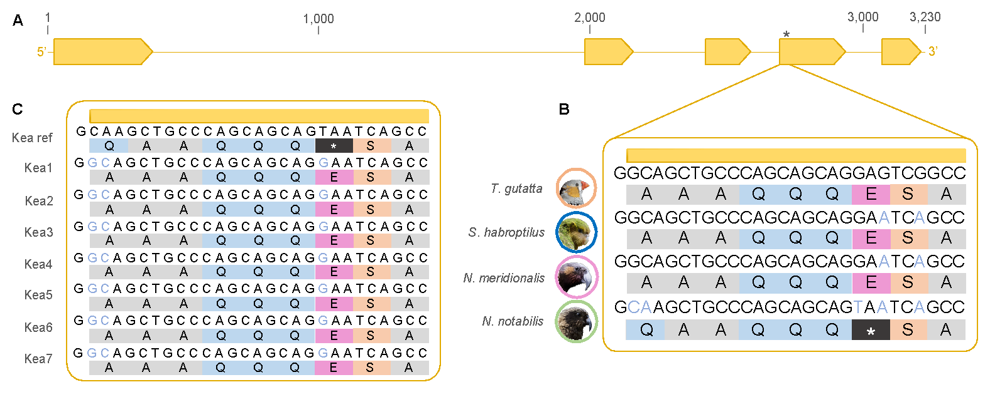
Figure 1. Avian RH2 opsin gene. A Schematic of the zebra finch RH2 gene (GenBank accession NC_045024: LOC751972) with exons depicted as arrows. The asterisk indicates the position of the premature stop codon in the kea reference assembly. B Nucleotide sequences and corresponding amino acid translations for the zebra finch, kākāpō, kākā, and kea shown for the 5’-end of exon 4. Nucleotide substitutions in the New Zealand parrots compared to the zebra finch are shown in light blue. C Nucleotide sequences and corresponding amino acid translations for the kea reference assembly and seven kea samples ascertained with Sanger sequencing for the 5’-end of exon 4. Nucleotide substitutions in the kea samples compared to the reference assembly are shown in light blue.

Supplementary Figures
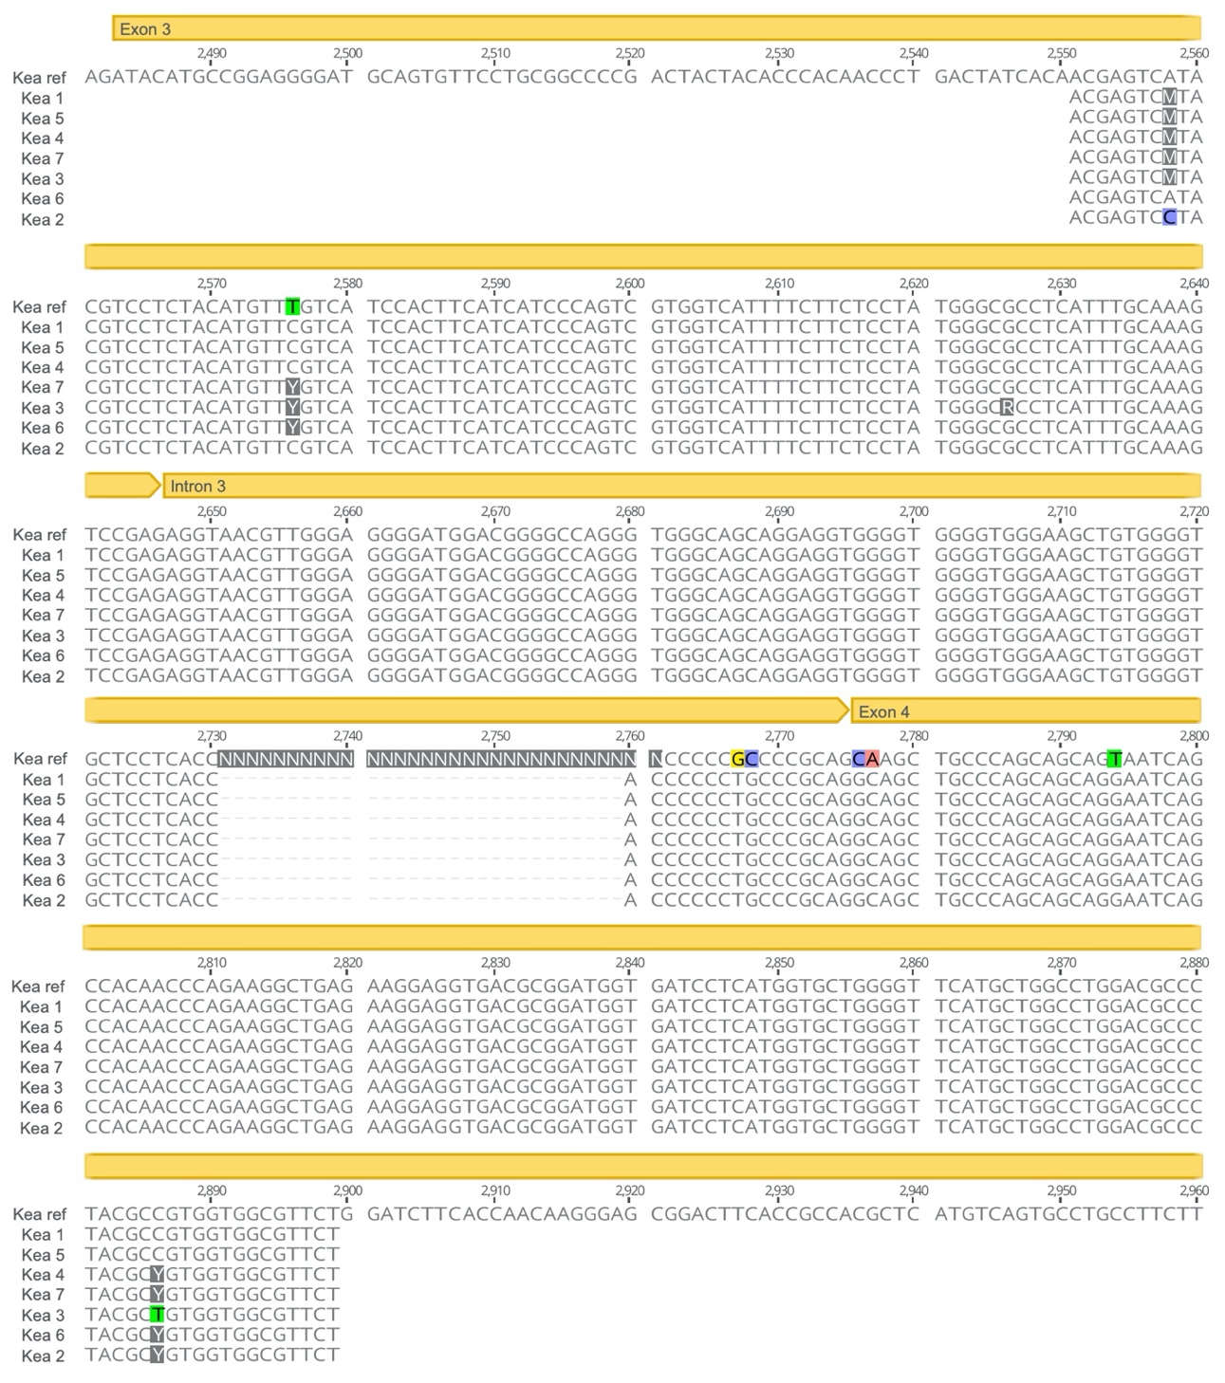
Figure S1. Partial nucleotide sequences alignment of the RH2 gene for the kea reference assembly and seven kea samples ascertained with Sanger sequencing (exon 3, intron 3 and partial exon 4). The yellow bar above the sequence indicates the start and stop position of the exons and intron. Coloured nucleotides and amino acids highlight polymorphisms between the different samples.
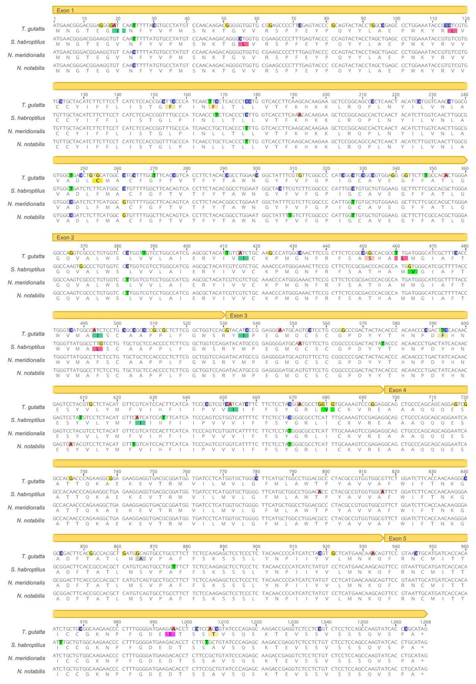
Figure S2. RH2 gene CDS nucleotide alignment (and amino acid translation) for zebra finch, kākāpō, kākā, and kea (the later sequences have been corrected based on the results of this study). The yellow bar above the sequence indicates the start and stop position of the exons. Coloured nucleotides and amino acids highlight polymorphisms between the different species.

