[Research Paper]
Intergenerational effects of overfeeding on aversive learning in zebrafish (Danio rerio)
Hamza Anwer^{1,2,} Dominic Mason^{1,2}, Susanne Zajitschek^{1, 2, 3}, Daniel Hesselson^{2,4}, Daniel W.A. Noble⁵, Margaret J. Morris⁶, Malgorzata Lagisz^{1, 2}, Shinichi Nakagawa^{1, 2}
¹ Evolution & Ecology Research Centre and School of Biological, Earth and Environmental Sciences, University of New South Wales, Sydney, NSW, Australia
² Diabetes and Metabolism Division, Garvan Institute of Medical Research, Darlinghurst, Sydney, NSW, Australia
³ Liverpool John Moores University, School of Biological and Environmental Sciences, Liverpool L3 3 AF, United Kingdom
⁴ Centenary Institute and Faculty of Medicine and Health, University of Sydney, Sydney, Australia
⁵ Division of Ecology and Evolution, Research School of Biology, The Australian National University, Canberra, Australia
⁶ Department of Pharmacology, School of Medical Sciences, University of New South Wales, Sydney, NSW, Australia

Corresponding Author:
Hamza Anwer¹
Email address: hamza.anwer@student.unsw.edu.au
Present address: Evolution & Ecology Research Centre and School of Biological, Earth and Environmental Sciences, University of New South Wales, Sydney, NSW, Australia

Funding
This research was funded through an Australian Research Council Discovery grant (DP180100818) awarded to S. Nakagawa
Autour Contributions
Hamza Anwer: conceptualization, methodology, data curation, formal analysis, investigation, writing – original draft preparation, writing – review and editing, visualization, Dominic Mason: investigation, writing – review and editing. Susanne Zajitschek: writing – review and editing, supervision. Daniel Hesselson: resources, writing – review and editing. Daniel Noble: conceptualization, methodology, writing – review and editing. Margaret Morris: writing – review and editing, supervision. Malgorzata Lagisz: data curation, writing – review and editing, supervision, Shinichi Nakagawa: conceptualization, methodology, software, resources, writing – review and editing, supervision, funding acquisition
Data accessibility. All data and code can be accessed at the GitHub link: https://github.com/Apex619/Zebrafish_intergenerational_learning_obesity
Highlights

- Offspring from both parents that were fed an obesogenic diet showed the weakest learning responses
- Offspring with one parent exposed displayed the strongest learning responses although the responses were not repeatable
- All offspring displayed similar responses in an anxiety tank test
- We found no statistically different sex effect on learning and anxiety responses

Abstract

The obesity epidemic is among the most serious and rapidly growing public health challenges of the 21st century. This rapid increase is concerning as obesity appears to negatively impact cognition and behaviour. Furthermore, some studies suggest that this negative effect could be carried across generations from both mothers and fathers although evidence is not consistent. Here, we attempt to address how obesogenic diets in the parental generation (F0) can impact offspring’s cognition and anxiety intergenerationally (F1) in a zebrafish model. We compare both mean trait values and their variances. Using a multifactorial design, we created a total of four groups: F1T (treatment mothers x treatment fathers); F1M (treatment mothers x control fathers); F1P (treatment fathers x control mothers); and F1C (control mothers x control fathers, F1C); and subjected them to anxiety tank tests and aversive learning assays. When both parents were exposed, offspring (F1T) displayed the poorest aversive learning, while offspring that only had one parent exposed (F1P and F1M) learnt the aversive learning task the best. Zebrafish in all groups displayed no statistically significant differences in anxiety-associated behaviours. Males and females also performed similarly in both anxiety and aversive learning assays. While all F1 groups had similar levels of fasting blood glucose, variance in glucose levels were reduced in F1P and F1T indicating the importance of investigating heteroskedasticity between groups. Furthermore, anxiety behaviours of these two groups appeared to be less repeatable. To our knowledge, this is the first study to test the intergenerational effects of an obesogenic diet on zebrafish cognition. Our multifactorial design as well as repeated tests also allowed us to disentangle maternal and paternal effects (as well as combined effects) and accurately detect subtle information such as between-individual variation. However, our work is restricted to aversive learning. It would be interesting to see whether appetitive and other types of learning produce similar results in zebrafish offspring.
Keywords: Diet, Zebrafish, Intergenerational, Behaviour, Cognition, Repeatability

Introduction
The obesity epidemic is among the most serious and rapidly growing public health challenges of the 21st century [1]. According to WHO, worldwide obesity has nearly tripled in the last 40-50 years [2]. This rapid increase is concerning because obesity is associated with a cluster of risk factors for cardiovascular disease and diabetes (i.e., insulin resistance, hyperglycemia and hypertension; known as the ‘Metabolic Syndrome’) [3]. This complex association of risk factors has been known for decades. However, recent research has highlighted a specific link between obesity and cognitive function [4]. There is strong evidence for cognitive impairment in individuals with obesity [4]–[6]. It is also known that increased body mass index (BMI) and greater intake of unhealthy foods, high in fat, is associated with deficits in learning, memory and executive functioning [7]–[9].

Animal models are often used in experiments using obesogenic diets to investigate the underpinnings of detrimental effects on animal cognition [10], [11]. One form of typical learning paradigms in animal studies is classical conditioning [12]. Classical conditioning using an aversive stimuli, or hereafter, aversive conditioning, can be used to investigate the neural processes and psychophysiological mechanisms that underlie learning about danger cues [13]. It is essential for survival that animals learn the relationship between aversive events and the environmental factors that predict them [14]. Aversive conditioning has been used in several diet-induced obesity studies in rodents to explore impacts on cognitive abilities [15], [16]. More recently, however, zebrafish have emerged as a valuable alternative in such studies [17], [18], although no studies have explicitly tested the intergenerational effects of obesogenic diets on cognition in zebrafish.

The zebrafish (Danio rerio) is a promising animal model in both obesogenic diet studies [19] and behavioural neuroscience [20]. Not only do they possess similar pathophysiological pathways with mammals [21], but they are cheap, reproduce in large numbers in short intervals, are easy to experimentally manipulate and possess a rich behavioural repertoire [22], [23]. Furthermore, they have sophisticated sensory and motor systems making them highly desirable due to their ability to learn in a variety of learning paradigms [24]–[27]. Of relevance to this study, zebrafish are an external fertilising species, which allows a more straightforward decoupling of maternal and paternal effects because the role of maternal responses in mediating effects is limited [28].

The maternal and paternal effects of diet-induced obesity on offspring cognition have been investigated before in animal models [29], [30]. For instance, it has been shown that high-fat diet (HFD) consumption in mothers and fathers impairs learning and memory in both rat and mice offspring [31]–[33]. It is important to note that maternal and paternal effects are viewed as key elements in generating phenotypic variation in offspring [34]–[37]. Therefore, nutritional stress in the parental generation could generate phenotypic variation in the offspring generation [38]. In our modern obesogenic environment, high-caloric foods are in abundance and readily available in comparison to the past [39], [40]. Indeed, we can see such abundant availability of food as “an evolutionarily novel stressor”, requiring organisms to develop an adaptive response to the obesogenic environment [41]. Yet, it still remains largely unresolved whether intergenerational transmission (i.e., parental effects) allows for adaptive evolution in the face of novel environmental stress (i.e., an obesogenic diet) [42], [43].

Here, we attempt to address the question of how obesogenic diets in the parental generation (F0) can impact offspring’s cognition intergenerationally (F1) in zebrafish. We conduct a multifactorial experiment by breeding four F1 groups from F0 fish with and without exposure to an obesogenic diet (i.e., treatment mothers x treatment fathers, or F1T; treatment mothers x control fathers, or F1M; treatment fathers x control mothers, or F1P; control mothers x control fathers, F1C). All F1 groups were then subjected to aversive learning assays to answer our main question – “What is the effect of an obesogenic parental diet on offspring cognition in terms of its magnitudes and variability?” (i.e., changes in means and variances between groups). Notably, our multifactorial design allows us to investigate treatment effects, as well as discern maternal and paternal influences. We predict that both maternal and paternal exposures to an obesogenic diet will negatively impact offspring cognition and may generate more variation, which would be greater in offspring where both parents were exposed. Also, we conduct novel tank tests for anxiety, an emotional state that has been shown to be closely associated with cognitive ability [44]. We also examine sex differences, as they are ubiquitous. There have been repeated calls for inclusion of sex as an important biological variable in experiments [45], although we do not have a priori predictions on the direction of these differences. Finally, we explore the effects of parental diet on offspring body weight and fasting blood glucose, which we expect to be adversely affected, as shown in earlier work [46], [47].

Materials and Methods

2.1 Experimental subjects and design

Zebrafish Husbandry
We raised and maintained Mixed Wildtype (WT) zebrafish stock in a Tecniplast Zebtec System at 28°C under a 12-h light:12-h dark cycle at the Garvan Institute of Medical Research, Sydney, Australia. The wild-type stock was derived from of a mixture of Tübingen long fin, AB and other unidentified strains (which had been interbred for 8–10 generations to increase genetic diversity). Adult zebrafish were housed in 3.5L tanks (max 24 fish per 3.5-litre tank), and larval zebrafish until 1 month of age in 1.1L tanks (max 50 larval zebrafish per 1.1L tank). All tanks received recirculating water (pH 7-8, conductivity 500-2500 μs). We fed zebrafish larvae a standard facility diet of Paramecium twice daily up until 10-12 dpf, at which point they were weaned onto live Artemia (twice a day) and dried fish food (once a day). The Garvan Animal Ethics Committee approved all animal experimental procedures described here (approval: ARA 18_18), with handling and maintenance following established protocols.

Parental diets
At 16 weeks post-fertilization (wpf), parental zebrafish (F0) were assigned to obesogenic (experimental) and control diets. Diets were adapted from Oka et al. [21] and consisted of freshly hatched Artemia, dried decapsulated Artemia (INVE Artemia Shell Free: An Artemia Nauplii Alternative) and commercially available fish food (O.range GROW-L). We fed both groups Artemia (freshly hatched and dried) twice daily: zebrafish in the obesogenic group received 60 mg/fish/day (i.e., 1440 mg/tank), while zebrafish in the control group received 5 mg/fish/day (i.e., 120 mg/tank). We provided all obesogenic and control tanks with 200 mg of fish food once in the morning.

Experimental overview
We produced the F1 generation by breeding parental zebrafish after 18 weeks of dietary manipulation. We bred within control and treatment groups (that is, males and females were selected from the same group and not interbred between groups) and created sex-specific crosses between parental control and treatment groups. This design allowed us to investigate treatment effects, as well as discern maternal and paternal influences. We created a total of four groups: F1T (treatment mothers x treatment fathers); F1M (treatment mothers x control fathers); F1P (treatment fathers x control mothers); and F1C (control mothers x control fathers, F1C). We balanced sex ratio and family representation within each group for statistical independence. F1 fish were void of any diet manipulation and fed a standard facility diet. From 21 wpf, we subjected F1 zebrafish to aversive learning and anxiety tests (Figure 1). Due to competitive hierarchies in relation to food access among zebrafish in tanks [48], we used 20 fish from each tank per group (n = 40 F1T, n = 40 F1M; n = 40 F1P; n = 40 F1C; total 160; (Figure 1) excluding 2 of the heaviest males and 2 of the heaviest females from F1C (likely 4 most dominant individuals), and 2 of the lightest males and 2 of the lightest females from F1T, F1P and F1M (likely 4 most subordinate individuals). Zebrafish that died during the experiment were replaced with a counterpart from a spare tank (each group had an allocated spare tank). We weighed zebrafish a total of 3 times (at 20 wpf, 23 wpf and 30 wpf) before culling them for fasting blood glucose measurements (Figure 1).
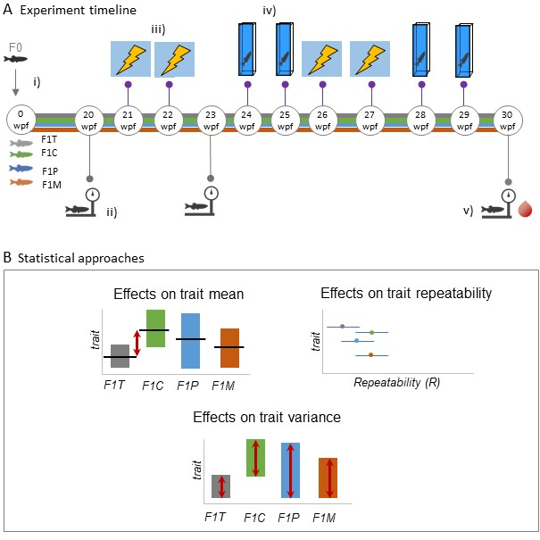
Figure 1) Experimental overview and statistical approaches
A: Experimental overview and timeline: i) F0 control and treatment groups bred to produce 4 groups of F1 generation fish: F1T (treatment mothers x treatment fathers); F1C (control mothers x control fathers, F1C; F1P (treatment fathers x control mothers); F1M (treatment mothers x control fathers); ii) Weighing zebrafish begins at 20 wpf (first of 3 measurements); iii) F1 zebrafish subjected to aversive learning experiments at 21 wpf and 22 wpf (first 2 of 4 trials) iv) F1 zebrafish first subjected to anxiety tank tests at 24 wpf and 25 wpf (first 2 of 4 trials); v) final body weight measurements and all fish are sacrificed for fasting blood glucose measurements; B: Statistical approaches used to analyse data: mean and variance differences calculated between groups through the use of mixed models and; repeatability of behaviour estimates calculated as the proportion of between-group (between-individual) variance out of total variance.

Behavioural assays and other measurements

3.1 Aversive learning assay
We used an aversive conditioning assay to investigate learning ability in offspring of zebrafish fed obese and control diets. Behavioural tests were performed using the Zantiks [AD] fully automated behavioural testing boxes (Zantiks Ltd., Cambridge, UK) following the protocol described by Mason et al. [49]. We quantified learning as the difference in time spent in the CS+ before and after the aversive experience (difference = time spent in the CS+ during baseline - time spent in the CS+ during probe). A higher difference indicates less time spent in the CS+ following the aversive experience. Differences are expressed as seconds per minute. Each fish experienced the aversive learning assay a total of 4 times (sessions were separated by approximately 1 – 3 weeks; see Figure 1).

3.2 Anxiety assay
We followed the procedure as described in Anwer et al. [50], which uses a taller tank than traditional apparatus. Our work has shown that this type of tank generates more between-individual differences and is suited for detecting subtle differences in behaviour. As described in our earlier work, we can measure several anxiety-associated behaviours. However, since many of these behaviours are correlated, we focussed our analysis on two highly repeatable, less correlated behaviours: 1) time spent in the low zone (seconds) and, 2) total distance travelled (cm). We subjected zebrafish to the anxiety assay a total of 4 times (the sessions were separated by approximately 1-3 weeks, see Figure 1). For each of the four assay sessions, we tested all fish in a single day. We pseudorandomized the order of fish being tested to account for the day of experiments, as well as the time of day. Trials began at 10 am and ended at 4 pm. We changed the water every hour to minimize drops in temperature (water was maintained at ~28°C) and the effects of stress hormones from fish already trialled [51], [52].

3.3 Body weight and fasting blood glucose
Body weight (g) measurements for F1 were taken at 20, 23 and 30 wpf using an AND EJ-123 scale. At the end of the study, fasting blood glucose levels (mmol/L) were analysed using glucose meters (Freestyle Freedom Lite). Our methodology involved dipping test strips into cardiac blood directly after decapitation, following methods of other studies [53], [54]. Fish were fasted for 24 hours prior to blood glucose testing and anaesthetised before the procedure, following ethical guidelines. Anaesthetizing solution consisted of 4.2ml of 0.4% tricaine mixed with 100mL of circulated system water. We used three Freestyle Freedom Lite glucose meters to obtain 3 readings from each fish which were used to calculate the intra-class correlation coefficient (ICC). The ICC refers to correlations within a class (cluster) of data (in our case, repeated measurements of glucose readings) and is a well-known statistical tool for measuring the reliability of an experimental method [55], [56].

Statistical analysis
All statistical analyses were conducted in the R environment (Version 3.4.3) [57] with R Studio (Version 1.1.453) [58]. We conducted two types of analyses: 1) mean and variance analyses and 2) repeatability analyses; the former involved all the traits introduced above (aversive learning, anxiety measurements, fish mass and blood glucose levels), while the latter did not include fish mass data due to expected growth changes. Both types of analyses involved using a mixed effects model framework with sex and treatment groups (4 different groups) used as fixed effects and fish ID as a random (clustering) factor in all analyses. Mixed models with the two anxiety traits required an additional scaled fixed effect (water condition, a temporal factor to control for fish being trialled in water that had not yet been changed and therefore exposed to stress hormones from other fish); as did body weight (week of measurement) following Anwer et al. [50].

4.1 Mean and variance differences
To calculate mean and variance differences in the aforementioned traits, we used linear mixed models implemented in the function lme in the nlme package (version 3.1-148) [59]. To model different residual variance between the four groups (i.e., heteroskedasticity), we specified the ‘weight’ argument in the lme function to do so, but also, we ran the same models assuming a constant variance between groups. These two models were compared by likelihood ratio tests using the anova function from the R ‘stats’ package (Version 3.6.2) [57] to examine statistical significance for modelling different variances.

4.2 Repeatability
We estimated repeatability estimates of anxiety behaviours and aversive learning responses and reliability for glucose measurements, using rptR (Version 0.9.21), which quantified intra-class correlations, ICC [60]; this package is based on a mixed-effects model framework using the R package lme4 (version 20) [61]. All estimates were ‘adjusted’ repeatabilities which included sex as a fixed effect [56] and were done separately for each different treatment group. For ICC of glucose readings, we included group, sex and glucose meter as fixed effects as data was not subsetted. All models incorporated fish IDs as a random effect. We obtained standard error and 95% confidence intervals (CIs) using rptr, which employs parametric bootstrapping [62] with our models set to have 10,000 bootstrap samples. Repeatability estimates with confidence intervals not overlapping 0 were considered statistically significant.

Results

5.1 Aversive learning assay
Overall, the F1M offspring group displayed the highest difference between the baseline and probe period (i.e., spent less time in the conditioned stimulus) (LMM F1M Intercept, est = 9.57, df = 473, t = 8.08, p < 0.0001; see Figure 2). There were no statistically significant differences between the F1M Group and the F1P group. However, both the F1M group and F1P group had statistically higher differences than the F1T group (LMM F1M – F1T, est = 4.50, df = 155, t = 3.01, p = 0.02; LMM F1P – F1T, est = 4.26, df = 155, t = 2.83, p = 0.03). Subsequent contrast analysis also revealed no significant differences between F1M and F1C (control group) as well as between F1P and F1C. All groups had similar variance (Figure 2) and zebrafish learning was not significantly impacted by sex. Zebrafish learning was significantly (moderately) repeatable for F1 control and treatment groups (F1C: R = 0.33, 95% CI [0.16, 0.49]; F1T: R = 0.19, 95% CI [0.04, 0.36]; Figure 3) but not significantly repeatable for F1 maternal and F1 paternal groups (F1M: R = 0.10, 95% CI [0, 0.25]; F1P: R = 0.06, 95% CI [0, 0.20]; Figure 3). Furthermore, differences in repeatability estimates were statistically significant between F1C and F1P (95 % CI [0.04 – 0.46]; Figure 3).
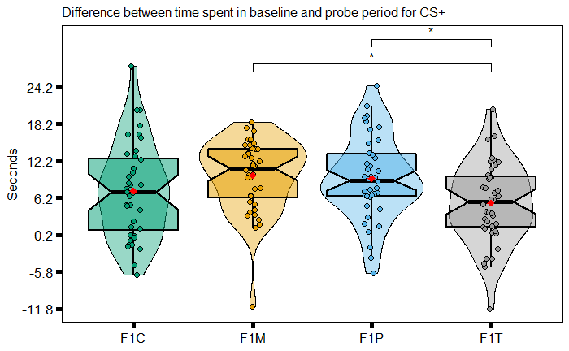
Figure 2) Distributions of baseline-probe differences for each F1 zebrafish group
Each plot displays mean individual data points for males (n = 20 F1C, F1T, F1M; n= 19 F1P) and females (n = 20 F1C, F1T, F1M; n = 21 F1P) from four observations. Box plots show the median, 95% confidence interval of the median, quantiles, and outliers. Violin plots display the distribution density. Average of mean values are denoted with a red diamond. Groups without pairwise comparisons are not significantly different to one another. Note: *p < 0.05.
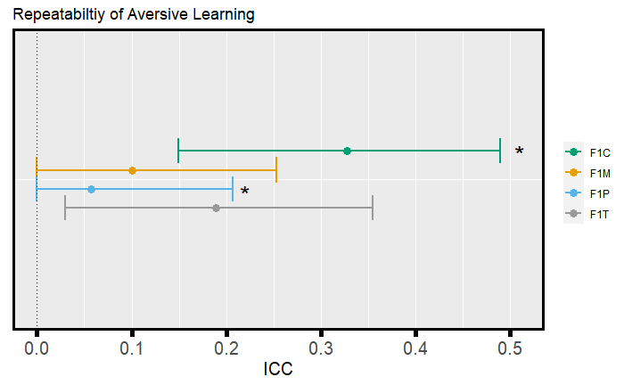
Figure 3) Forest plot of baseline-probe difference repeatability estimates for each F1 group Repeatability estimates are deemed significant if the associated 95 % confidence interval does not cross 0. Estimates with an asterisk are deemed as being statistically significantly different from one another.

5.2 Anxiety assay
Overall, we found no statistically significant differences between F1 groups for the anxiety-associated behaviours total distance travelled and time spent in the low zone (Figure 4, Table S1). In addition, we did not find statistically significant differences between males and females in this assay (Figure 4). As expected, as time passed after a water change, zebrafish travelled significantly less (LMM, est = -43.92, df = 476, t = -2.97, p = 0.003) and spent significantly more time in the low zone (LMM, est = 7.02, df = 476, t = 3.53, p < 0.001). Differences in variance were statistically insignificant between the four groups (Figure 4). However, the total distance travelled was significantly repeatable in all four groups (F1C: R = 0.58, 95% CI [0.41, 0.71]; F1T: R = 0.37, 95% CI [0.19, 0.53]; F1M: R = 0.55, 95% CI [0.38, 0.68]; F1P: R = 0.32, 95% CI [0.14, 0.48]; see Figure 5), as was time spent in the low zone (F1C: R = 0.49, 95% CI [0.31, 0.64]; F1T: R = 0.40, 95% CI [0.22, 0.55]; F1M: R = 0.54, 95% CI [0.37, 0.68]; F1P: R = 0.30, 95% CI [0.12, 0.46]; see Figure 5). Furthermore, differences in repeatability estimates were statistically significant between F1P and F1C (95 % CI [0.02 – 0.48]) for the total distance travelled, and between F1M and F1P (95 % CI [0.01 – 0.46]) for the time spent in the low zone (Figure 5).
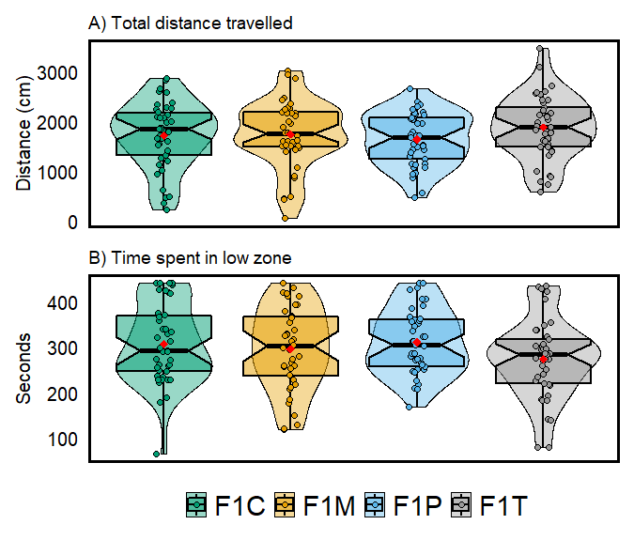
Figure 4) Distribution of anxiety-associated parameters
A) total distance travelled (cm) and B) time spent in the low zone (seconds) for four F1 zebrafish group. Each plot displays mean individual data points for males (n = 21 F1C; n = 20 F1T, F1M; n = 19 F1P) and females (n = 21 F1C, F1T; n =20 F1M; n = 22 F1P) from four observations. Box plots show the median, 95% confidence interval of the median, quantiles, and outliers. Violin plots display distribution density. Average of mean values are denoted with red diamonds.
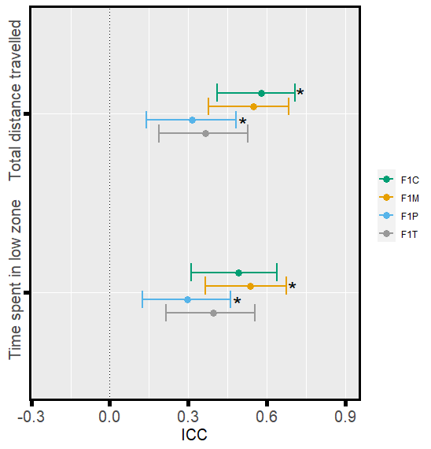
Figure 5) Forest plots of repeatability estimates for anxiety-associated parameters
The plot shows: total distance travelled, and time spent in the low zone, for four F1 groups. Repeatability estimates are deemed significant if the associated 95 % confidence interval does not cross 0. Estimates with an asterisk are deemed as being significantly different from one another.

5.3 Body weight and fasting blood glucose
There were no statistically significant differences between groups in body weight (g) (Figure 6, Table S2). As expected, males were significantly lighter than females across all groups (LMM, est = -0.16, df = 313, t = -15.1, p < 0.001). All groups showed a slight yet significant increase in weight over weeks (LMM, est = 0.002, df = 313, t = 5.74, p < 0.001). There was no statistically significant difference in variances between the four groups.

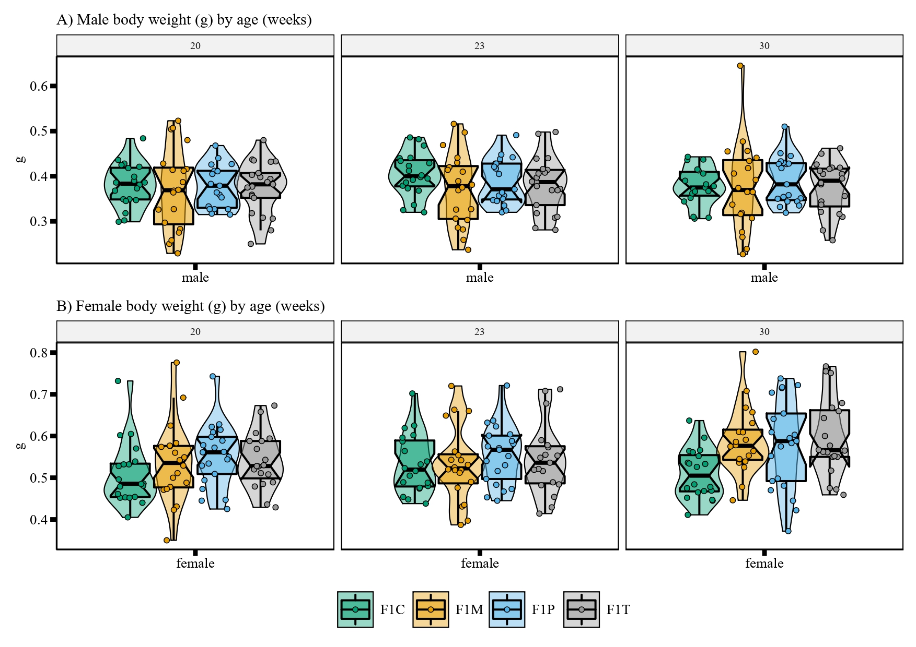
Figure 6) Distribution of body weight for each F1 zebrafish group
The plot shows body weights at 20-, 23- and 30-weeks post-fertilization subsetted by males (n = 20 F1C, F1M, F1P; n = 21 F1T) and females (n = 20 F1M, F1T; n = 21 F1c; n = 22 F1P). Box plots show the median, 95% confidence interval of the median, quantiles, and outliers. Violin plots display the distribution density.

Similarly, there were no statistically significant differences between groups in fasting glucose levels (mmol/L) (Table S3) and males had lower levels of glucose in comparison to females (LMM, est = -0.53, df = 173, t = -3.83, p = 0.001; Figure 7). However, variance levels were statistically different in each group (p <0.001). The F1T, F1P and F1M group had reduced variability in relation to the F1C group (by 65%, 40% and 0.02% respectively). Glucose measurements (obtained 3 times using separate glucose meters) were highly reliable (ICC = 0.91, 95% CI [0.89, 0.93]).
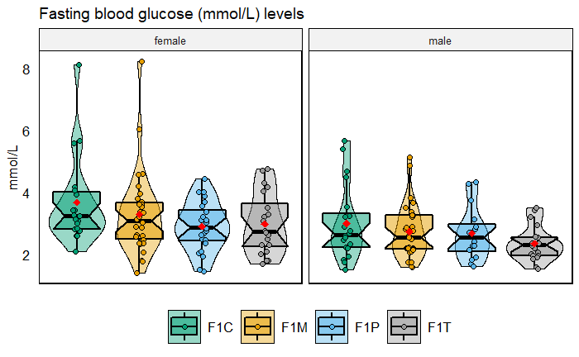
Figure 7) Distributions of fasting blood glucose (mmol/L) for the four F1 zebrafish groups
Plots are subsetted by sex. Each plot displays mean individual data points for males (n = 20 F1C, F1T; n = 29 F1M; n = 16 F1P) and females (n = 19 F1C; n =20 F1T; n = 31 F1M; n = 24 F1P) from three observations. Box plots show the median, 95% confidence interval of the median, quantiles, and outliers. Violin plots display the distribution density. Average of mean values are denoted with red diamonds.

Discussion

Our study aimed to address how obesogenic diets in F0 generation zebrafish could influence zebrafish cognition at F1 (intergenerational effects) in terms of both its magnitude and variability. When both parents were exposed, offspring (F1T) displayed the weakest aversive learning responses (i.e., they were deemed the least capable of learning; Figure 2). Contrary to our predictions, we found that offspring that only had one parent exposed to an obesogenic diet (F1P and F1M) displayed the strongest aversive learning responses (i.e., they were deemed the most capable of learning); and there were no significant differences in variability among the four groups (Figure 2). Zebrafish displayed no statistically significant differences in anxiety-associated behaviours (Figure 4). Also, both males and females performed similarly in both aversive learning and anxiety assays. Further, all F1 groups had similar body weights (within sex; Figure 6) and fasting blood glucose levels (Figure 7). Yet, we detected reduced variability in the glucose levels in F1 fish from the F1P and F1T groups compared to the F1C and F1M groups (Figure 6). Notably, these two groups (F1P and F1T) also showed lower repeatability in anxiety-associated behaviours, compared to the F1C and F1M (Figure 5).

6.1 Intergenerational effects on aversive learning

In line with our prediction, the F1T fish displayed the weakest aversive learning responses. This is consistent with a previous study in humans, whereby if both parents were obese, their children had more difficulty with problem solving, compared to when neither parent was obese or only one parent was obese [30]. Also, the F1C group displayed a response not significantly different from that of the F1T fish, but F1C group’s response was consistent with our earlier study (that is, zebrafish in our previous study spent a similar amount of time in the CS+ during the probe period) [49]. Our study in the F0 parental generation revealed that zebrafish on an obesogenic diet displayed tendencies consistent with poor cognition. That is, some individuals in the obesogenic diet group performed consistently worse in aversive learning tests than control fish, which seemed to have led to higher repeatability estimates [63]. Recently, two other studies examined cognitive function in zebrafish following a HFD treatment [18], [64]. Both studies employed aversive learning assays and discovered significant impairments in memory acquisition and avoidance of aversive stimuli in obese zebrafish. While these results are important in supporting the immediate effects of HFD’s on zebrafish cognition, these zebrafish studies did not extend to the F1 generation.

We found unexpected results across F1 groups, with some evidence potentially indicating adaptive parental effects that aid offspring survival [65]. Those F1 zebrafish that only had one parent exposed to an obesogenic diet displayed the strongest aversive learning responses, although repeatability was non-significant, suggesting most individuals did not perform consistently better or worse in aversive learning responses over the 4 trials. Our results are intriguing because others have reported that both maternal and paternal obesity could result in impaired cognitive function in offspring in rodents [32], [66]. Despite accumulating evidence for adverse parental effects in rodent studies, not all studies concur. In a recent mouse study, male offspring born to HFD fed dams displayed no significant impairments in cognition [67]. Whereas, Bilbo & Tsang [68] reported offspring (F1) of parents fed a HFD performed better than their control counterparts in the Morris water maze task in rats. Similarly, in a study by Johnson et al. [69], male offspring of females exposed to a high fat diet showed improved abilities in spatial learning and memory when compared with control male offspring. Further, a meta-analysis by Menting et al. [70] showed rodent offspring of obese mothers displayed similar abilities in memory tasks to control offspring. Taken together, when only one parent is exposed, there may be a mitigation effect occurring, whereby an obesogenic diet exerts a protective effect on aspects of offspring brain development [71]. For instance, studies by Huang et al. [72] and Rincel et al. [73] noted offspring of prenatally stressed rats fed a HFD throughout pregnancy and lactation had improved brain development. Further studies are needed to understand the mechanisms behind such results.

6.2 No intergenerational effects on anxiety responses
Emotional states (i.e., mood) influence information processing and affect responses to stimuli [74]. As anxiety has been shown to be closely associated with cognitive processes [44], we also subjected F1 zebrafish to anxiety tank tests. Behavioural measurements analysed for anxiety were significantly repeatable and displayed similar trends. The groups F1C and F1M were overall more repeatable than the groups F1P and F1T, suggesting individuals were more predictable in their behavioural profiles. While we found no evidence distinguishing anxious states between the F1 groups, several mice studies have showcased interrelations between a perturbed emotional state and impaired cognitive performance [75], [76]. Also, in humans, heightened anxiety can elicit impaired cognitive functioning in aspects such as perception, attention and learning [77]; and spatial and verbal working memory [78], [79].

6.3 No sex effect on aversive learning and anxiety responses
While our study found no sex differences in both anxiety and aversive learning, sex remains an important biological variable. Its inclusion in experiments has been repeatedly called for to improve the value of research, particularly in the fields of neuroscience and (bio)-medicine [45], [80], [81]. Sex-specific effects are important when attempting to understand the magnitude and mechanisms of intergenerational as well as transgenerational parental effects on offspring [82], [83]. Ignoring sex effects by pooling males and females together will result in not only underestimated effects, but the inability to question issues associated with the interrelations between intergenerational plasticity and sex-specific selective pressures [82]. Here we demonstrated that, in zebrafish, intergenerational effects of F0 diets affect males and females in a similar manner.

6.4 Negligible effects on weight but variable effects on glucose in F1
All F1 zebrafish offspring displayed similar body weights, regardless of parental diet. This seems to contradict the findings that rodent studies often show offspring of mothers and fathers fed HFD’s display increased weight gain as well as body fat percentage [84]–[88]. A zebrafish study observed offspring of parents fed a high-fat diet gained less weight when compared to offspring of parents fed a high-carbohydrate diet [46]. Therefore, results may vary across animal models and may also depend on the type of obesogenic diet.

Similarly, all F1 zebrafish also presented with similar fasting blood glucose levels (regardless of parental diet). Although, the control group (F1C) had highly variable levels and the F1M group had a similar level. In contrast, the treatment group (F1T) had the least amount of variation, followed by the F1P group, suggesting a canalization effect [89]. A recent meta-analysis of rodent studies discussed a similar pattern, suggesting a ceiling effect, whereby levels are at their physiological capacity, effectively reducing the amount of variation [90]. Intriguingly, these two groups F1T and F1P were less repeatable in the anxiety assay, indicating some relationship between glucose levels and anxiety-related behaviour. Nevertheless, our results are still unexpected, as there is much evidence from rodents and zebrafish indicating impaired glucose metabolism in offspring following parental obesity [47], [91]–[95]. A few rodent studies have also shown it is not uncommon for parental HFD’s to have no effect on offspring metabolic parameters [96]–[98]. This suggests that many more factors need to be considered to determine whether offspring will experience physiological disturbances from parental HFD’s.

6.5 Conclusion and future perspectives
In conclusion, our study is the first to test the intergenerational effects of an obesogenic diet on zebrafish cognition. When both parents were exposed, offspring (F1T) performed worse in aversive learning assays. However, this effect was seemingly mitigated when only one parent was exposed, resulting in stronger learning responses in the F1M and F1P groups. Repeatability estimates were also affected, with F1T offspring displaying consistently poor learning responses. While anxiety-associated behaviours as well as fasting blood glucose were unaffected, F1P and F1T offspring had poorer repeatability for anxiety-associated behaviours as well as less variability in glucose levels. We also found no significant influences of offspring sex. Our study examined the effects on aversive learning, but not appetitive learning. Therefore, it would be interesting to see whether appetitive learning produces similar results in zebrafish offspring. Most notably, our study’s multifactorial design allowed us to disentangle maternal and paternal effects as well as combined effects. More future studies should employ similar multifactorial experimental designs to investigate intergenerational effects on a wide range of traits not only in zebrafish, but also in other animal models.

Acknowledgements
We are grateful for the staff at the Biological Testing Facility, Garvan Institute of Medical Research (in particular, to Miki Jahn) for their support and husbandry of zebrafish.

References

[1] J. C. Seidell and J. Halberstadt, “The global burden of obesity and the challenges of prevention,” Annals of Nutrition and Metabolism, vol. 66, no. 2, pp. 7–12, Jun. 2015, doi: 10.1159/000375143.
[2] World Health Organization, “Obesity and overweight,” www.who.int, 2017. http://www.who.int/en/news-room/fact-sheets/detail/obesity-and-overweight
[3] K. Alberti et al., “Harmonizing the metabolic syndrome: a joint interim statement of the international diabetes federation task force on epidemiology and prevention; national heart, lung, and blood institute; American heart association; world heart federation; international ,” Circulation, vol. 120, no. 16, pp. 1640–1645, 2009.
[4] E. Smith, P. Hay, L. Campbell, and J. N. Trollor, “A review of the association between obesity and cognitive function across the lifespan: implications for novel approaches to prevention and treatment,” Obesity reviews, vol. 12, no. 9, pp. 740–755, 2011.
[5] C. Prickett, L. Brennan, and R. Stolwyk, “Examining the relationship between obesity and cognitive function: A systematic literature review,” Obesity Research and Clinical Practice, vol. 9, no. 2. Elsevier Ltd, pp. 93–113, Mar. 01, 2015. doi: 10.1016/j.orcp.2014.05.001.
[6] M. F. Elias, P. K. Elias, L. M. Sullivan, P. A. Wolf, and R. B. D’Agostino, “Lower cognitive function in the presence of obesity and hypertension: The Framingham heart study,” International Journal of Obesity, vol. 27, no. 2, pp. 260–268, Feb. 2003, doi: 10.1038/sj.ijo.802225.
[7] M. Cournot et al., “Relation between body mass index and cognitive function in healthy middle-aged men and women,” Neurology, vol. 67, no. 7, pp. 1208–1214, 2006.
[8] Z. A. Cordner and K. L. K. Tamashiro, “Effects of high-fat diet exposure on learning & memory,” Physiology & Behavior, vol. 152, pp. 363–371, 2015, doi: https://doi.org/10.1016/j.physbeh.2015.06.008.
[9] J. J. Buie, L. S. Watson, C. J. Smith, and C. Sims-Robinson, “Obesity-related cognitive impairment: The role of endothelial dysfunction,” Neurobiology of Disease, vol. 132, p. 104580, 2019, doi: https://doi.org/10.1016/j.nbd.2019.104580.
[10] A. Dickinson, “Associative learning and animal cognition,” Philosophical Transactions of the Royal Society B: Biological Sciences, vol. 367, no. 1603, pp. 2733–2742, 2012.
[11] N. Castanon, G. Luheshi, and S. Layé, “Role of neuroinflammation in the emotional and cognitive alterations displayed by animal models of obesity,” Frontiers in Neuroscience, vol. 9, no. JUL. Frontiers Research Foundation, p. 229, Jul. 03, 2015. doi: 10.3389/fnins.2015.00229.
[12] P. I. Pavlov, “Conditioned reflexes: an investigation of the physiological activity of the cerebral cortex,” Annals of neurosciences, vol. 17, no. 3, p. 136, 2010.
[13] T. Shechner, M. Hong, J. C. Britton, D. S. Pine, and N. A. Fox, “Fear conditioning and extinction across development: Evidence from human studies and animal models,” Biological Psychology, vol. 100, no. 1. Elsevier, pp. 1–12, 2014. doi: 10.1016/j.biopsycho.2014.04.001.
[14] S. Maren, “Neurobiology of Pavlovian fear conditioning,” Annual review of neuroscience, vol. 24, no. 1, pp. 897–931, 2001.
[15] N. Yamada‐Goto et al., “Impairment of fear‐conditioning responses and changes of brain neurotrophic factors in diet‐induced obese mice,” Journal of neuroendocrinology, vol. 24, no. 8, pp. 1120–1125, 2012.
[16] A. C. Reichelt, J. Maniam, R. F. Westbrook, and M. J. Morris, “Dietary-induced obesity disrupts trace fear conditioning and decreases hippocampal reelin expression,” Brain, Behavior, and Immunity, vol. 43, pp. 68–75, Jan. 2015, doi: 10.1016/J.BBI.2014.07.005.
[17] S. Macrì, M. Karakaya, C. Spinello, and M. Porfiri, “Zebrafish exhibit associative learning for an aversive robotic stimulus,” Lab Animal, vol. 49, no. 9, pp. 259–264, Sep. 2020, doi: 10.1038/s41684-020-0599-9.
[18] S. Meguro, S. Hosoi, and T. Hasumura, “High-fat diet impairs cognitive function of zebrafish,” Scientific Reports, vol. 9, no. 1, 2019, doi: 10.1038/s41598-019-53634-z.
[19] L. Zang, L. A. Maddison, and W. Chen, “Zebrafish as a model for obesity and diabetes,” Frontiers in Cell and Developmental Biology, vol. 6, no. AUG. Frontiers Media S.A., p. 91, Aug. 20, 2018. doi: 10.3389/fcell.2018.00091.
[20] R. Aoki, T. Tsuboi, and H. Okamoto, “Y-maze avoidance: An automated and rapid associative learning paradigm in zebrafish,” Neuroscience Research, vol. 91, pp. 69–72, Feb. 2015, doi: 10.1016/j.neures.2014.10.012.
[21] T. Oka et al., “Diet-induced obesity in zebrafish shares common pathophysiological pathways with mammalian obesity,” BMC Physiology, vol. 10, no. 1, p. 21, 2010, doi: 10.1186/1472-6793-10-21.
[22] M. Nguyen et al., “Developing ‘integrative’ zebrafish models of behavioral and metabolic disorders,” Behavioural Brain Research, vol. 256, pp. 172–187, 2013, doi: https://doi.org/10.1016/j.bbr.2013.08.012.
[23] A. V Kalueff et al., “Towards a comprehensive catalog of zebrafish behavior 1.0 and beyond,” Zebrafish, vol. 10, no. 1, pp. 70–86, Mar. 2013, doi: 10.1089/zeb.2012.0861.
[24] M. Sison and R. Gerlai, “Associative learning in zebrafish (Danio rerio) in the plus maze,” Behavioural Brain Research, vol. 207, no. 1, pp. 99–104, 2010, doi: https://doi.org/10.1016/j.bbr.2009.09.043.
[25] R. Spence, G. Gerlach, C. Lawrence, and C. Smith, “The behaviour and ecology of the zebrafish, Danio rerio,” Biological Reviews, vol. 83, no. 1. John Wiley & Sons, Ltd, pp. 13–34, Feb. 01, 2008. doi: 10.1111/j.1469-185X.2007.00030.x.
[26] S. Pather and R. Gerlai, “Shuttle box learning in zebrafish (Danio rerio),” Behavioural brain research, vol. 196, no. 2, pp. 323–327, Jan. 2009, doi: 10.1016/j.bbr.2008.09.013.
[27] R. E. Blaser and D. G. Vira, “Experiments on learning in zebrafish (Danio rerio): A promising model of neurocognitive function,” Neuroscience & Biobehavioral Reviews, vol. 42, pp. 224–231, 2014, doi: https://doi.org/10.1016/j.neubiorev.2014.03.003.
[28] A. J. Crean and R. Bonduriansky, “What is a paternal effect?,” Trends in Ecology & Evolution, vol. 29, no. 10, pp. 554–559, 2014, doi: https://doi.org/10.1016/j.tree.2014.07.009.
[29] E. Basatemur, J. Gardiner, C. Williams, E. Melhuish, J. Barnes, and A. Sutcliffe, “Maternal prepregnancy BMI and child cognition: a longitudinal cohort study,” Pediatrics, vol. 131, no. 1, pp. 56–63, 2013.
[30] E. H. Yeung, R. Sundaram, A. Ghassabian, Y. Xie, and G. B. Louis, “Parental obesity and early childhood development,” Pediatrics, vol. 139, no. 2, Feb. 2017, doi: 10.1542/peds.2016-1459.
[31] C. Lin et al., “Maternal High-Fat Diet Multigenerationally Impairs Hippocampal Synaptic Plasticity and Memory in Male Rat Offspring,” Endocrinology, vol. 162, no. 1, pp. 1–18, Jan. 2021, doi: 10.1210/endocr/bqaa214.
[32] Y. Zhou et al., “Diet-Induced Paternal Obesity Impairs Cognitive Function in Offspring by Mediating Epigenetic Modifications in Spermatozoa,” OBESITY, vol. 26, no. 11, pp. 1749–1757, Nov. 2018, doi: 10.1002/oby.22322.
[33] K. Hasebe, M. D. Kendig, and M. J. Morris, “Mechanisms Underlying the Cognitive and Behavioural Effects of Maternal Obesity,” Nutrients, vol. 13, no. 1, p. 240, 2021.
[34] D. Nettle and M. Bateson, “Adaptive developmental plasticity: What is it, how can we recognize it and when can it evolve?,” Proceedings of the Royal Society B: Biological Sciences, vol. 282, no. 1812. Royal Society of London, 2015. doi: 10.1098/rspb.2015.1005.
[35] R. Bonduriansky and M. Head, “Maternal and paternal condition effects on offspring phenotype in Telostylinus angusticollis (Diptera: Neriidae),” Journal of Evolutionary Biology, vol. 20, no. 6, pp. 2379–2388, Nov. 2007, doi: 10.1111/j.1420-9101.2007.01419.x.
[36] J. Puy, C. P. Carmona, H. Dvořáková, V. Latzel, and F. de Bello, “Diversity of parental environments increases phenotypic variation in Arabidopsis populations more than genetic diversity but similarly affects productivity,” Annals of botany, vol. 127, no. 4, pp. 425–436, Mar. 2021, doi: 10.1093/aob/mcaa100.
[37] R. Bonduriansky and T. Day, “Nongenetic inheritance and its evolutionary implications,” Annual Review of Ecology, Evolution, and Systematics, vol. 40, pp. 103–125, 2009.
[38] F. Luca, G. H. Perry, and A. Di Rienzo, “Evolutionary adaptations to dietary changes,” Annual review of nutrition, vol. 30, pp. 291–314, Aug. 2010, doi: 10.1146/annurev-nutr-080508-141048.
[39] S. Vandevijvere, C. C. Chow, K. D. Hall, and B. A. Swinburn, “Increased food energy supply as a major driver of the obesity epidemic: a global analysis,” Bulletin World Health Organisation, vol. 93, no. 7, pp. 446–456, 2015, doi: http://dx.doi.org/10.2471/BLT.14.150565.
[40] A. Lev‐Ran, “Human obesity: an evolutionary approach to understanding our bulging waistline,” Diabetes/metabolism research and reviews, vol. 17, no. 5, pp. 347–362, 2001.
[41] A. Tsatsoulis, M. D. Mantzaris, S. Bellou, and M. Andrikoula, “Insulin resistance: An adaptive mechanism becomes maladaptive in the current environment — An evolutionary perspective,” Metabolism, vol. 62, no. 5, pp. 622–633, May 2013, doi: 10.1016/J.METABOL.2012.11.004.
[42] T. Uller, “Developmental plasticity and the evolution of parental effects,” Trends in Ecology & Evolution, vol. 23, no. 8, pp. 432–438, 2008, doi: https://doi.org/10.1016/j.tree.2008.04.005.
[43] R. E. O’Dea, D. W. A. Noble, S. L. Johnson, D. Hesselson, and S. Nakagawa, “The role of non-genetic inheritance in evolutionary rescue: epigenetic buffering, heritable bet hedging and epigenetic traps,” Environmental epigenetics, vol. 2, no. 1, 2016.
[44] F. Darcet, I. Mendez-David, L. Tritschler, A. M. Gardier, J.-P. Guilloux, and D. J. David, “Learning and memory impairments in a neuroendocrine mouse model of anxiety/depression,” Frontiers in Behavioral Neuroscience, vol. 8, no. MAY, p. 136, May 2014, doi: 10.3389/fnbeh.2014.00136.
[45] S. R. K. Zajitschek et al., “Sexual dimorphism in trait variability and its eco-evolutionary and statistical implications,” eLife, vol. 9, pp. 1–17, Oct. 2020, doi: 10.7554/eLife.63170.
[46] M. Türkoğlu et al., “The potential effect mechanism of high-fat and high-carbohydrate diet-induced obesity on anxiety and offspring of zebrafish,” Eating and Weight Disorders, vol. 1, p. 3, Mar. 2021, doi: 10.1007/s40519-021-01140-5.
[47] B. do Carmo Rodrigues Virote et al., “Obesity induction in adult zebrafish leads to negative reproduction and offspring effects,” Reproduction, vol. 160, no. 6, pp. 833–842, Dec. 2020, doi: 10.1530/REP-20-0119.
[48] G. C. Paull, A. L. Filby, H. G. Giddins, T. S. Coe, P. B. Hamilton, and C. R. Tyler, “Dominance hierarchies in zebrafish (Danio rerio) and their relationship with reproductive success,” Zebrafish, vol. 7, no. 1, pp. 109–117, 2010.
[49] D. Mason, S. Zajitschek, H. Anwer, R. E. O’Dea, D. Hesselson, and S. Nakagawa, “ Low repeatability of aversive learning in zebrafish ( Danio rerio ) ,” Journal of Experimental Biology, vol. 224, no. 11, Jun. 2021, doi: 10.1242/jeb.240846.
[50] H. Anwer et al., “An efficient new assay for measuring zebrafish anxiety: Tall tanks that better characterize between-individual differences,” Journal of Neuroscience Methods, vol. 356, p. 109138, May 2021, doi: 10.1016/j.jneumeth.2021.109138.
[51] M. Pavlidis et al., “Husbandry of zebrafish, danio rerio, and the cortisol stress response,” Zebrafish, vol. 10, no. 4, pp. 524–531, Dec. 2013, doi: 10.1089/zeb.2012.0819.
[52] B. D. Fontana, N. Alnassar, and M. O. Parker, “The impact of water changes on stress and subject variation in a zebrafish (Danio rerio) anxiety-related task,” Journal of Neuroscience Methods, vol. 363, p. 109347, Nov. 2021, doi: 10.1016/J.JNEUMETH.2021.109347.
[53] M. Gleeson, V. Connaughton, and L. S. Arneson, “Induction of hyperglycaemia in zebrafish (Danio rerio) leads to morphological changes in the retina,” Acta Diabetologica, vol. 44, no. 3, pp. 157–163, 2007, doi: 10.1007/s00592-007-0257-3.
[54] S. C. Eames, L. H. Philipson, V. E. Prince, and M. D. Kinkel, “Blood Sugar Measurement in Zebrafish Reveals Dynamics of Glucose Homeostasis,” Zebrafish, vol. 7, no. 2, pp. 205–213, Jun. 2010, doi: 10.1089/zeb.2009.0640.
[55] D. Liljequist, B. Elfving, and K. Skavberg Roaldsen, “Intraclass correlation – A discussion and demonstration of basic features,” PLOS ONE, vol. 14, no. 7, p. e0219854, Jul. 2019.
[56] S. Nakagawa and H. Schielzeth, “Repeatability for Gaussian and non-Gaussian data: a practical guide for biologists,” Biological Reviews, vol. 85, no. 4, p. no-no, Jun. 2010, doi: 10.1111/j.1469-185X.2010.00141.x.
[57] R. C. Team, “R: A language and environment for statistical computing.” Vienna, Austria, 2021.
[58] Rs. Team, “RStudio: integrated development for R,” RStudio, Inc., Boston, MA URL http://www. rstudio. com. 2021.
[59] J. Pinheiro, D. Bates, S. DebRoy, D. Sarkar, and R Core Team, “nlme: Linear and Nonlinear Mixed Effects Models.” 2020.
[60] M. A. Stoffel, S. Nakagawa, and H. Schielzeth, “rptR: Repeatability estimation and variance decomposition by generalized linear mixed‐effects models,” Methods in Ecology and Evolution, vol. 8, no. 11, pp. 1639–1644, 2017.
[61] D. Bates, M. Maechler, B. Bolker, and S. Walker, “lme4: Linear mixed-effects models using Eigen and S4,” R package version, vol. 1, no. 7, pp. 1–23, 2014.
[62] J. J. Faraway, Extending the linear model with R: generalized linear, mixed effects and nonparametric regression models. CRC press, 2016.
[63] H. Anwer et al., “The effects of an obesogenic diet on behaviour and cognition in zebrafish (Danio rerio): traits average, variability, repeatability, and behavioural syndromes,” 2022, Accessed: Feb. 07, 2022. [Online]. Available: https://ecoevorxiv.org/ewq64/
[64] V. L. Picolo et al., “Short-term high-fat diet induces cognitive decline, aggression, and anxiety-like behavior in adult zebrafish,” Progress in Neuro-Psychopharmacology and Biological Psychiatry, vol. 110, p. 110288, Aug. 2021, doi: 10.1016/j.pnpbp.2021.110288.
[65] D. J. Marshall and T. Uller, “When is a maternal effect adaptive?,” Oikos, vol. 116, no. 12, pp. 1957–1963, 2007.
[66] E. L. Sullivan, E. K. Nousen, and K. A. Chamlou, “Maternal high fat diet consumption during the perinatal period programs offspring behavior,” Physiology & Behavior, vol. 123, pp. 236–242, Jan. 2014, doi: https://doi.org/10.1016/j.physbeh.2012.07.014.
[67] J. Zieba, G. M. Uddin, N. A. Youngson, T. Karl, and M. J. Morris, “Long-term behavioural effects of maternal obesity in C57BL/6J mice,” Physiology & Behavior, vol. 199, pp. 306–313, 2019, doi: https://doi.org/10.1016/j.physbeh.2018.11.004.
[68] S. D. Bilbo and V. Tsang, “Enduring consequences of maternal obesity for brain inflammation and behavior of offspring,” The FASEB Journal, vol. 24, no. 6, pp. 2104–2115, 2010.
[69] S. A. Johnson et al., “Effects of a maternal high-fat diet on offspring behavioral and metabolic parameters in a rodent model,” Journal of developmental origins of health and disease, vol. 8, no. 1, pp. 75–88, 2017.
[70] M. D. Menting et al., “The link between maternal obesity and offspring neurobehavior: A systematic review of animal experiments,” Neuroscience & Biobehavioral Reviews, vol. 98, pp. 107–121, 2019.
[71] K. L. Lindsay, C. Buss, P. D. Wadhwa, and S. Entringer, “The Interplay Between Nutrition and Stress in Pregnancy: Implications for Fetal Programming of Brain Development,” Biological Psychiatry, vol. 85, no. 2, pp. 135–149, Jan. 2019, doi: 10.1016/J.BIOPSYCH.2018.06.021.
[72] C.-F. Huang et al., “Effect of prenatal exposure to LPS combined with pre- and post-natal high-fat diet on hippocampus in rat offspring,” Neuroscience, vol. 286, pp. 364–370, 2015, doi: https://doi.org/10.1016/j.neuroscience.2014.12.002.
[73] M. Rincel et al., “Maternal high-fat diet prevents developmental programming by early-life stress,” Translational Psychiatry, vol. 6, no. 11, pp. e966–e966, 2016, doi: 10.1038/tp.2016.235.
[74] D. Nettle and M. Bateson, “The evolutionary origins of mood and its disorders,” Current Biology, vol. 22, no. 17. Cell Press, pp. R712–R721, Sep. 11, 2012. doi: 10.1016/j.cub.2012.06.020.
[75] A. R. Salomons, S. S. Arndt, and F. Ohl, “Impact of anxiety profiles on cognitive performance in BALB/c and 129P2 mice,” Cognitive, Affective and Behavioral Neuroscience, vol. 12, no. 4, pp. 794–803, Dec. 2012, doi: 10.3758/s13415-012-0109-7.
[76] F. Ohl, A. Roedel, E. Binder, and F. Holsboer, “Impact of high and low anxiety on cognitive performance in a modified hole board test in C57BL/6 and DBA/2 mice,” European Journal of Neuroscience, vol. 17, no. 1, pp. 128–136, 2003.
[77] O. J. Robinson, K. Vytal, B. R. Cornwell, and C. Grillon, “The impact of anxiety upon cognition: perspectives from human threat of shock studies,” Frontiers in Human Neuroscience, vol. 7, p. 203, May 2013, doi: 10.3389/fnhum.2013.00203.
[78] K. E. Vytal, B. R. Cornwell, A. M. Letkiewicz, N. E. Arkin, and C. Grillon, “The complex interaction between anxiety and cognition: insight from spatial and verbal working memory,” Frontiers in Human Neuroscience, vol. 7, no. MAR, p. 93, Mar. 2013, doi: 10.3389/fnhum.2013.00093.
[79] K. Vytal, B. Cornwell, N. Arkin, and C. Grillon, “Describing the interplay between anxiety and cognition: from impaired performance under low cognitive load to reduced anxiety under high load,” Psychophysiology, vol. 49, no. 6, pp. 842–852, 2012.
[80] M. M. McCarthy, C. S. Woolley, and A. P. Arnold, “Incorporating sex as a biological variable in neuroscience: What do we gain?,” Nature Reviews Neuroscience, vol. 18, no. 12. Nature Publishing Group, pp. 707–708, Dec. 01, 2017. doi: 10.1038/nrn.2017.137.
[81] A. K. Beery and I. Zucker, “Sex bias in neuroscience and biomedical research,” Neuroscience and Biobehavioral Reviews, vol. 35, no. 3. Pergamon, pp. 565–572, Jan. 01, 2011. doi: 10.1016/j.neubiorev.2010.07.002.
[82] J. K. Hellmann et al., “Sex-specific plasticity across generations I: Maternal and paternal effects on sons and daughters,” J Anim Ecol, vol. 89, no. 12, pp. 2788–2799, Dec. 2020, doi: 10.1111/1365-2656.13364.
[83] J. K. Hellmann, E. R. Carlson, and A. M. Bell, “Sex-specific plasticity across generations II: Grandpaternal effects are lineage specific and sex specific,” Journal of Animal Ecology, vol. 89, no. 12, pp. 2800–2812, Dec. 2020, doi: 10.1111/1365-2656.13365.
[84] T. J. G. Chambers, M. D. Morgan, A. H. Heger, R. M. Sharpe, and A. J. Drake, “High-fat diet disrupts metabolism in two generations of rats in a parent-of-origin specific manner,” Scientific Reports, vol. 6, 2016, doi: 10.1038/srep31857.
[85] L. A. Consitt et al., “Paternal high‐fat diet enhances offspring whole‐body insulin sensitivity and skeletal muscle insulin signaling early in life,” Physiological Reports, vol. 6, no. 5, p. e13583, Mar. 2018, doi: 10.14814/phy2.13583.
[86] Q. Wu and M. Suzuki, “Parental obesity and overweight affect the body‐fat accumulation in the offspring: the possible effect of a high‐fat diet through epigenetic inheritance,” Obesity reviews, vol. 7, no. 2, pp. 201–208, 2006.
[87] Q. Wu, Y. Mizushima, M. Komiya, T. Matsuo, and M. Suzuki, “Body fat accumulation in the male offspring of rats fed high-fat diet,” Journal of clinical biochemistry and nutrition, vol. 25, no. 2, pp. 71–79, 1998.
[88] M. Lagisz, H. Blair, P. Kenyon, T. Uller, D. Raubenheimer, and S. Nakagawa, “Little appetite for obesity: meta-analysis of the effects of maternal obesogenic diets on offspring food intake and body mass in rodents,” International Journal Of Obesity, vol. 39, p. 1669, Aug. 2015.
[89] J. C. K. Wells, “Adaptive variability in the duration of critical windows of plasticityImplications for the programming of obesity,” Evolution, Medicine, and Public Health, vol. 2014, no. 1, pp. 109–121, Jan. 2014, doi: 10.1093/EMPH/EOU019.
[90] H. Anwer, M. J. Morris, D. W. A. Noble, S. Nakagawa, and M. Lagisz, “Transgenerational effects of obesogenic diets in rodents: A meta-analysis,” Obesity Reviews, vol. 23, no. 1, p. e13342, Jan. 2022, doi: https://doi.org/10.1111/obr.13342.
[91] S. F. Ng, R. C. Y. Lin, D. R. Laybutt, R. Barres, J. A. Owens, and M. J. Morris, “Chronic high-fat diet in fathers programs β 2-cell dysfunction in female rat offspring,” Nature, vol. 467, no. 7318, pp. 963–966, Oct. 2010, doi: 10.1038/nature09491.
[92] L. Dearden and N. Balthasar, “Sexual Dimorphism in Offspring Glucose-Sensitive Hypothalamic Gene Expression and Physiological Responses to Maternal High-Fat Diet Feeding,” Endocrinology, vol. 155, no. 6, pp. 2144–2154, Jun. 2014, doi: 10.1210/en.2014-1131.
[93] G. A. Ribaroff, E. Wastnedge, A. J. Drake, R. M. Sharpe, and T. J. G. Chambers, “Animal models of maternal high fat diet exposure and effects on metabolism in offspring: a meta-regression analysis,” Obesity Reviews, vol. 18, no. 6, pp. 673–686, Jun. 2017, doi: 10.1111/obr.12524.
[94] N. M. Long et al., “Maternal obesity and increased nutrient intake before and during gestation in the ewe results in altered growth, adiposity, and glucose tolerance in adult offspring,” Journal of Animal Science, vol. 88, no. 11, pp. 3546–3553, Nov. 2010, doi: 10.2527/jas.2010-3083.
[95] M. D. Menting et al., “Maternal obesity in pregnancy impacts offspring cardiometabolic health: Systematic review and meta‐analysis of animal studies,” Obesity Reviews, vol. 20, no. 5, pp. 675–685, 2019.
[96] K. M. Platt, R. J. Charnigo, and K. J. Pearson, “Adult offspring of high-fat diet-fed dams can have normal glucose tolerance and body composition,” Journal of Developmental Origins of Health and Disease, vol. 5, no. 3, pp. 229–239, 2014, doi: 10.1017/S2040174414000154.
[97] E. H. Chin et al., “A maternal high-fat, high-sucrose diet has sex-specific effects on fetal glucocorticoids with little consequence for offspring metabolism and voluntary locomotor activity in mice,” PLOS ONE, vol. 12, no. 3, p. e0174030, Mar. 2017, doi: 10.1371/journal.pone.0174030.
[98] V. King et al., “Maternal obesity has little effect on the immediate offspring but impacts on the next generation,” Endocrinology, vol. 154, no. 7, pp. 2514–2524, 2013, doi: 10.1210/en.2013-1013.

