Only rare, acute blood parasite infections induce physiological costs in juvenile hosts
Abstract
Parasites trigger reactions in their hosts, leading to suppressive resistance and/or tolerance, limiting costs caused by parasites. Both colonization by parasites and defense activation can induce varying amount of costs for the host. An emergent task of eco-immunology is to identify how and when during infections defense syndromes are activated, thereby constraining symptoms and fitness effects. To evaluate potential effects of blood parasite infection, we compared physiological traits of Common Buzzard nestlings Buteo buteo i) at different stages of infection and ii) with increasing levels of parasitemia (frequency of infected host cells) with Leucocytozoon, an agent of malaria-like conditions. We expected costs of infection to appear from the onset and during peak parasitemia in nestlings, rather than in chicks with decreasing parasitemia and uninfected hosts. We found no difference in physiological traits among infection stages, indicating low immediate parasitic costs and pointing to infection tolerance. Surprisingly, parasitemia led to a host health decrease only during some transient stages of infection. Thus, rather than mounting costly innate immune defenses, raptor chicks may mostly tolerate moderate parasitemia of their main blood parasites until their acquired immunity activates effectively. Juveniles, as a relatively parasite-tolerant life-history stage, can therefore enable parasite transmission in the population whithout experiencing host morbidity and mortality during this critical period.
Keywords: Avian malaria, bird of prey, disease tolerance, host-parasite interactions, immune system, infection burden, physiology, nestlings

Introduction
Parasites commonly have negative fitness consequences for their hosts and therefore play an important role for their short- and long-term fitness (Stockdale et al. 2015; Bermejo et al. 2006; Simonsen and Viboud 2021; Foley et al. 2011). Parasite infections can affect directly host survival and reproduction through diverse non-lethal but costly effects on host physiology, behavior and ecology (Knowles et al., 2010; Poulin, 1998; Dunn et al., 2013; Townsend et al., 2018). They may also exacerbate indirect effects of intra- or interspecific interactions (Hatcher, Dick, and Dunn 2006), co-infections (Ramsay and Rohr 2021), and the abiotic environment (Brown and Pascoe 1989; Martinez and Merino 2011). Hosts can develop two main defense syndromes to cope with infections. 1) resistance, i.e. the actions of the host immune system to reduce or clear pathogens and 2) tolerance, i.e. the combination of mechanisms lowering parasite-induced costs (Little et al. 2010; Medzhitov, Schneider, and Soares 2012; Råberg, Sim, and Read 2007). In contrast to the assumptions of many early studies, activity of immune components is not constant but rather dynamic and dependent on the developmental stage and condition of individuals (Simon, Hollander, and McMichael 2015; Ashby and Bruns 2018). Additionally, during the course of infections, response components are activated which can mediate and trade-off both resistance and tolerance (Best, White, and Boots 2008; Lars Råberg 2014). When fighting a parasite becomes too costly, tolerance may be physiologically cheaper and preferable over resistance.
In many taxa, infection with parasites can occur already in early life (Ashby and Bruns 2018; Cowman et al. 2015; Kubi et al. 2006; Panter and Jones 2002) and young hosts can be particularly prone to intense parasite infections (Townsend et al., 2018; World Health Organization, 2016; Herman et al., 1975). During the early stages of development, the adaptive immunity is not fully developed, which can reduce the risk of pervasive autoimmunity. At the same time, this may render infants more susceptible and slower at clearing parasites compared with adults, thus some childhood infections can be life-threatening (Ashby and Bruns 2018; Simon, Hollander, and McMichael 2015). However, organisms typically experience certain infections before immune maturity and effective suppressive resistance are achieved. Such young hosts, which are both accessible and susceptible, may face strong selection for tolerance and robustness to compensate for lower capacity of resistance to a pathogen. Early life host-parasite interactions can therefore have important consequences for host survival and parasite transmission but still are insufficiently understood.
Here, we investigated effects of infection in wild raptor nestlings using four physiological parameters as informative proxies of potential infection-related costs. We measured and also experimentally manipulated blood parasite infection intensity to evaluate whether nestlings would bear higher costs from infections during increasing and peak parasitemia compared with nestlings with decreasing parasitemia and uninfected ones.
Vertebrate blood parasites of the genera Plasmodium, Haemoproteus and Leucocytozoon, (order Haemosporida, Eukaryota, Protista) are known to be significant disease and mortality agents in humans and suggested to systematically play similar roles in wildlife (Puente et al. 2010; Martinez and Merino 2011). In the host, Leucocytozoon parasitemia (i.e. infection intensity, frequency of infected host cells) usually first increases and then decreases rapidly (Fig. 1a, Valkiūnas, 2005). During the pre-patent phase, parasites only start developing in internal organs like liver and spleen, but are absent in the blood. Stages released into the blood invade blood cells and blood parasitemia increases until reaching peak infection, which might last up to several days. When the humoral immunity succeeds to mount a specific response, parasitemia falls and stabilizes at low chronic levels, usually followed by relapses or effective clearance (Fig. 1 a & b, Snounou et al., 1989; Valkiūnas, 2005). Overall, effects of blood parasite infection can be expected to occur during the pre-patent and acute stages of infection (e.g. before and during peak parasitemia) when tissue damage and inflammation are highest, rather than during chronic and low parasitemia when recovery ensues (Williams 2005).
In this study, we performed an experiment to examine the effects of blood parasite infection on physiological traits in nestlings of wild common buzzards, Buteo buteo. In the study population, the prevalence of Leucocytozoon can surpass 50% before fledging of nestlings (Chakarov, Pauli, and Krüger 2017; Wiegmann et al. 2021). We recorded and manipulated the levels of parasitemia in order to evaluate how they affect physiological traits and show potential infection- and immunity-related costs to hosts. We predicted that
- Under a scenario of dominating resistance, nestlings with increasing or peak parasitemia would invest in a suppressive response, firstly through mobilization of costly innate immune components. In this case, nestlings would have deteriorating body condition, lower growth rate, worse thermoregulation and higher breathing rate compared with uninfected nestlings or ones with decreasing infection intensity. We also expected that the magnitude of change of these condition proxies would be correlated with infection intensity. In this scenario, tolerance is a constitutive but mostly subdominant component of coping with the parasites during the course of infection and over individual age (Fig. 1b).
- Under a scenario where tolerance dominates the response, it would start at a high point due to high tissue growth and renewal and possibly gradually decrease with age. At the same time, innate immunity costs would be expected to remain lower (Fig. 1b). Under this scenario, we expected physiological parameters indicative of resistance (i.e. body temperature) to not change between infection stages or correlate with infection intensity. Similarly, as tolerance should not directly depend on infection intensity, parameters indicative of parasitic damage (e.g. changes in body condition, breathing and growth rates) would not be expected to correlate with infection intensity. Hence, we predicted that under this scenario body temperature, change in body condition, breathing and growth rates would be similar in all test groups.
In both scenarios, the natural decrease of parasitemia is expected to start with the onset of the effective adaptive immune response (Fig. 1b).
Methods
Host-parasite system
Common buzzards (Buteo buteo) are accipitriform birds of prey that breed in temperate Eurasian forests, in solitary tree nests at heights between 10 to 30 m. Common buzzards are the most common accipitriform in Germany, are long-lived birds (up to thirty years old) and have the highest prevalence of blood parasites of the genus Leucocytozoon among sympatric raptor species (Wiegmann et al. 2021). Leucocytozoon toddi (Eukaryota, Protista, Haemosporidiae, lineages MILANS04 and MILVUS01) is by far the most common blood parasite in our study population of common buzzard. The vector-borne transmission of Leucocytozoon (Chakarov et al. 2020) has been suggested to mostly occur in a quasi-vertical direction. Black fly vectors (Simuliidae) may first suck blood from infected parents at the nest site and predominantly transmit the same genetic pool of parasites to their offspring (Chakarov et al. 2015).
Data collection
The study was performed in a 300-km² study area in North Rhine-Westphalia, Germany (8°25’ E and 52°06’ N). From 2016 to 2020, 276 common buzzard nestlings (n = 32, 65, 71, 108 in 2016, 2018, 2019, 2020 respectively) were sampled. All individuals were resampled on average eight days after first sampling (mean ± s.d. = 8.36 ± 4.21 days). Nestling age was estimated using a sex-specific polynomial regression between age and wing length, based on growth data for buzzards of known age (Bijlsma 1998). The average estimated age of nestlings at second sampling was 27.84 days (± s.d. 5.36), an age where nestling infection status is usually already fixed and microscopically visible (Chakarov et al. 2015). Blood smears were screened by microscopy for Leucocytozoon infection at first and second sampling. The intensity of infection was scored on a scale from zero (no infection), one, two, three and four (high parasitemia). Among the sampled nestlings, 66% (N=183) were infected during at least one of the two time points, whereas 34% (N=93) were not infected at both time points; only few nestlings naturally displayed decreasing parasitemia between both samplings. Decreasing parasitemia was experimentally achieved by giving 7mg of an antimalarial medicine (MalaroneTM; Atovaquone and Proguanil Hydrochloride, GlaxoSmithKline, UK) solved in water to a random subset of sampled nestlings in 2018, 2019 and 2020. Control nestlings did not receive antimalarial medicine. Similar treatments have been previously shown to significantly reduce the prevalence of Plasmodium in bird populations (Knowles, Palinauskas, and Sheldon 2010; Palinauskas et al. 2009; Schoenle et al. 2017). According to the change in infection intensity between both samplings, the 276 nestlings were separated into four groups: (i) uninfected nestlings (no apparent infection at both samplings, n = 93), (ii) increasing infection (n = 92), (iii) peak infection (i.e., high stable infection intensity, n = 24) and (iv) decreasing infection (n = 67). These groups were considered to reflect the infection stage along the expected course (Fig. 1a).
Cost-indicative physiological parameters
At first and second sampling, we measured the body weight (to the nearest 5 g) with a spring scale and the respiratory rate (duration of 30 breathings in seconds) of each nestling. The cloacal temperature (henceforth body temperature, measured with an electronic thermometer) was recorded in 2019 and 2020. The repeatability of the temperature measures was R²= 0.91 (CI = 0.81 – 0.96, P < 0.001), calculated from 27 paired measures taken on both adults and nestling common buzzards (mean: 40.35°C, s.d. ± 0.39°C). To control for an ambient temperature effect, the average daily temperatures of the sampling days were obtained from the NASA POWER Project (Sparks 2022). Growth rate was calculated as the weight change between first and second sampling divided by the difference in days separating the two measurements. The body condition index of a nestling was estimated for each sampling event as the residual variance of the sex-specific linear regression between weight and wing length (log-transformed) based on standard growth data of common buzzard nestlings (Bijlsma 1998). To account for state-dependent development of individual body condition, we used the change in body condition (Δ body condition) between the second and first sampling as a proxy in our models.
Statistical analyses
We fitted a linear mixed model to estimate the effect of antimalarial treatment on the infection intensity change of the nestlings between first and second sampling, adding year and interval between samplings as covariates and nest ID as random factor. As suggested by Råberg et al. (2007), we used regressions explaining a potential fitness-informative trait and infection intensity to interpret their slope as a proxy of tolerance. Slopes were compared among infection stages and to zero using the emmeans (Lenth 2022) package in R 4.0.2 (R Core Team 2020). To examine the relationship between (i) host infection stages and (ii) infection intensity with different cost-related physiological parameters, we used linear mixed models fitted by REML as implemented in lme4 (Bates et al. 2014). We fitted one model with breathing rate, body temperature, change in body condition and growth rate as the response variable, respectively. As fixed factors, we specified either (i) the infection stage or (ii) the infection intensity, sampling interval (in days), year of sampling, sex and age. To account for potential effect of the anti-malarial treatment on the response variables, we included the interaction between the infection stage (or infection intensity) and the treatment (antimalarial treatment versus control) as fixed factor in all models. Numerical explanatory variables were standardized using a z-transformation (Schielzeth 2010). Nest ID was fitted as a random factor in all models to consider nestling relatedness. All models are described in detail in Table S1.
Results
Efficiency of the antimalarial treatment
The number of infected nestlings remained stable in the treated group while it increased in control nestlings between pre- and post-treatment samplings (Fig. 2a). The antimalarial treatment significantly reduced the infection intensity of the treated nestlings (Treatment [Malarone]: est. = -1.77, s.d. = 0.28, df = 177, t = -6.45, P = 1.03e-9, Fig. 2b). However, initial infection intensity was higher in treated than in control nestlings (permutation two sample t-test, mean ± s.d.: Control = 0.86 ± 1.34, Malarone = 1.58 ± 1.57, perm.: 999, t = -3.97, P = 0.002, Fig. 2b).
Reaction norms of host health to infection intensity
Overall, body condition decreased with increasing infection intensity (est. = -7.02, s.d. = 3.16, df = 274, t = -2.22, P = 0.027). Body condition decreased with parasitemia particularly in nestlings with increasing (est. = -24.08, s.d. = 5.99, df = 177, t = -4.02, P < 0.001) and peak infections (est. = -41.80, s.d. = 23.47, df = 177, t = -1.78, P = 0.054). In contrast, in nestlings with decreasing parasitemia condition did not decrease with infection intensity (Fig. 3, Table S2). Moreover, slopes of body condition against increasing and decreasing parasitemia tended to be different (Table S2).
Body condition change among infection stages and intensities
The change in body condition did not differ among infection stages (Table 1b), but nestlings with acute infections (level 4) tended to have a lower body condition change compared with uninfected nestlings (est. = -33.90, CI = -71.88 – 4.09, df = 247, t = -1.76, P = 0.080, Table 2b). There was a significantly higher body condition in 2020 compared to 2016. No effects on body condition were found for age and the interaction between infection stages and treatment.
Breathing rate according to infection stages
We found no difference in breathing rate attributable to infection stage or infection intensity (Table 1a & 2a respectively). Heavier nestlings were breathing more slowly, regardless of their infection status and age (est. = -2.62, CI = -4.20 – -1.04, df = 249, t = -3.26, P = 0.001). The breathing rate of nestlings correlated negatively with ambient temperature (est. = -3.01, CI = -4.19 – -1.83, df = 125, t = -5.06, P < 0.001, Table S3a). Breathing rates in 2018 and 2020 were significantly lower than in 2016 (Table S3a). There was no significant effect of the interaction between antimalarial treatment and infection status on the breathing rate (Table S3a).
Body temperature among infection stages and intensities
We found no difference in body temperature among infection stages (Table 1a). However, body temperature decreased as infection intensity increased, leading to significantly lower body temperature of nestlings with acute parasitemia (level 4) compared with uninfected nestlings (est. = -0.81, CI = -1.38 – -0.24, df = 140, t = -2.80, P = 0.006, Table 2a, Fig. 4b). Body temperature of nestlings was positively explained by ambient temperature and was negatively related to the time interval between both samplings. After accounting for ambient temperature, nestlings of 2019 still had a lower temperature than in 2020 (Table S3a). There was no effect of the interaction between antimalarial treatment and infection status on the body temperature.
Growth rate among infection stages and intensities
We found that growth rate of nestlings did not differ between different infection trajectories after accounting for potential confounding factors, despite non-significant impressions that decreasing growth coincide with later infection stages (Table 1b, Fig. S1d). There was weak evidence that nestlings with medium and highest infection intensity (level 2 and 4) had a lower growth rate than uninfected nestlings (Table 2b, Fig. 4d). Females had higher growth rates than males. Growth rate decreased with age of the nestlings, as they were approaching adult size. Growth rate also tended to be higher during the last year of the study and when the time interval between both samplings was longer. Finally, there was weak evidence for control nestlings with low parasitemia (level 1) to have lower growth rate than Malarone-treated nestlings of the same infection intensity (est. = -5.32, CI = -11.36 – 0.72, df = 242, t = -1.73, P =0.084).
Discussion
Host responses to parasite infections receive great interest because of the potentially important consequences for host fitness (Dadam et al. 2019). Avian blood parasites are often considered pathogenic even though the generality of evidence has mostly remained controversial (Granthon and Williams, 2017; Hahn et al., 2018). Thus, better understanding is needed for non-model host-parasite systems (but see Townsend et al. 2018; Herman, Barrow, and Tarshis 1975; Asghar et al. 2015). Here, we recorded and experimentally manipulated infections of the main blood parasite in young, slowly developing hosts to assess infection-related changes in physiology and growth. Parasitic effects are known to often impair host body condition and growth rate, most likely through costs of defense deployment (Blanco et al. 2001; Møller et al. 1998; Ramsay and Rohr 2021). In turn, these changes may lead to higher predation probabilities for infected hosts or generally to lose more frequently in intra-/inter-specific interactions (Hatcher, Dick, and Dunn 2006). Altogether, consequences of parasite infections, if demonstrated, might likely impair survival rates of infected hosts (Puente et al. 2010; Pigeault et al. 2018).
Our results suggest that young common buzzards do not display strong signs of parasitic burden during the course of infection. Only in rare cases of acute infection, nestlings appeared unable to completely maintain thermoregulation, body condition and growth rate; which are probable but rarely occurring costs of parasite exploitation and immune activation. Importantly, many parasites of the genus Leucocytozoon typically do not form megaloschizonts, 200µm cells correlated with infection severity, unlike members of the sister genera Plasmodium and Haemoproteus (Atkinson, T., C. and Van Riper III, C. 1991). Nevertheless; cases have been reported with substantial damage and population-wide mortality due to exceptionally high Leucocytozoon parasitemia (Herman, Barrow, and Tarshis 1975; Valkiūnas 2005).
In our study, no difference in breathing rate was apparent among nestlings in different stages of infection and uninfected nestlings. These results do not suggest that Leucocytozoon cause anemia in nestlings, reducing the physiological oxygen availability, thereby leading to respiratory complications (Wale et al. 2019, Hayworth, van Riper, and Weathers 1987). Plasmodium and Leucocytozoon species differ in their life cycle as Plasmodium schizogony occurs within red blood cells causing them to burst whereas Leucocytozoon makes erythrocytes only weaker and/or more susceptible to the immune defenses (Atkinson and Van Riper III, 1991). Here, we confirm that Leucocytozoon infections do not cause alteration of breathing rate in young raptor hosts.
Thermoregulation failure as a typical inflammatory response is common in hosts infected by blood parasites (Hayworth, van Riper, and Weathers 1987; Williams 2005). However, such responses were found only in bird-Plasmodium systems where fever and hypothermia appeared after parasite inoculation in captive birds (Williams 2005; Hayworth, van Riper, and Weathers 1987). In our case of wild raptor nestlings, no difference in body temperature was found among infection stages, even at decreasing parasitemia, the stage most likely to show thermoregulatory response to parasites. This result contradicts both our resistance scenario and previous references, and may suggest that raptor nestlings rarely produce a costly thermoregulatory immune reaction over the course of infection. However, chicks with acute infections did display lower body temperatures, potentially reflecting hypothermia. Altogether, nestlings showed no apparent signs of inflammatory response over the course of infection unless they were challenged with maximum infection intensity.
As several different organs and tissue types may be targeted during blood parasite infections, host body condition is expected to deteriorate while parasites increasingly invade host cells (Williams 2005; Commichau and Jonas 1977). Body condition change tended to be lower in nestlings suffering from acute infections, while this was not reflected by comparing parasitemia stages. Therefore, parasitic costs might be paid immediately and are only noticeably high when infection is at its highest. Acute infection may lead to a decrease in juvenile survival if they are not able to compensate for condition loss before independence, as nestling body condition can determine juvenile survival in large bird species (Townsend et al. 2018, Ottensmann et al. in prep).
We have shown that the year of sampling explains variation in all four physiological parameters. Body condition change as well as growth rate might be tightly linked to annual fluctuations in vole abundance that are known to have strong effects on raptor ecology as their main source of energy (Sundev, Yosef, and Birazana 2009). Moreover, fluctuations in vole abundance have been shown to explain variation in the breeding success of common buzzard in different parts of the breeding range (Chakarov and Krüger 2010; Panek 2021). The proportion of voles among different prey deposits in our surveyed corresponded to differences in body condition and growth rate of nestlings during the same year. Future research should address specifically predator-parasite relationships in the light of the highly dynamic fluctuation of prey populations.
Growth rate appeared to decrease as nestlings went through the parasite infection, despite differences to uninfected nestlings remaining not significant. Nestlings bearing medium (level 2) and high infection intensities tended to display lower growth rates. Such contrasts with uninfected nestlings might have long-term fitness consequences, especially in a ranked brooding system.
We predicted that under a scenario of dominating resistance, especially nestlings with increasing and peak infection would bear immediate costs of infection and the response to it. On the contrary, our results suggest that parasitic costs are not apparent at any stage of infection but only at the highest level of parasitemia. Tolerance might be a dominating component during low to medium parasitic pressure, when innate immunity is too costly to scale up (e.g. metabolic costs, immunopathology, Bonneaud et al. 2003; Graham, Allen, and Read 2005). The absence of apparent costs to the hosts during the first stages of infection – when the parasites are rapidly multiplying – might also indicate tolerant hosts that cope with parasitic damages along with initiating the suppression of the infection through the adaptive immune response. Nestlings in increasing and decreasing parasitemia appeared to differ in tolerance (slopes of reaction norms) suggesting a regaining of condition by the onset of adaptive immunity and therefore a mild pathogenicity of Leucocytozoon parasites, at least in the long-term. Regardless of the infection trend, body condition change, our best proxy for fitness-relevant host health, decreased with increasing parasite load, which indicates current costs for hosts bearing increasingly intense Leucocytozoon infections. Thus, it has been suggested that timing of infection in raptors and similar big birds may be adaptive as parental care provides buffering against the short cost-intense period of peak infection (Valkiūnas 2005; Shutler, Ankney, and Mullie 1999).
The moderate effects of Leucocytozoon on raptor nestlings are supported by studies showing that these parasites appear to not drastically change the blood chemistry of hosts which would be indicative of substantial tissue damages (Wiegmann et al. 2021). Pathogenic effects may occur when haemosporidian megaloschizonts develop in organs such as liver, spleen and brain (Murphy and Weaver 2016). However, these parasitic stages are not obligatory for haemosporidian development, do not appear in all Leucocytozoon lineages and a dependence of their occurrence on host characteristics still remains to be explored (Valkiūnas 2005). The apparent low parasite virulence together with the absent-unless-extreme physiological, infection-related responses suggest that host and parasite might have defused their arms-race by allowing wide transmission in this immunologically naïve but susceptible nestling stage. Unlike generalist parasites, the evolution of Leucocytozoon might be especially shaped by such relaxed pressure, allowing it to spread widely within the population and their few alternative host species (Wiegmann et al. 2021).
Furthermore, individual survival within the same buzzard population was not explained by Leucocytozoon infection status but is explained by body condition during nestling phase (Ottensmann et al., in prep). However, acute parasitic infection reducing body condition of their hosts might interact with other factors affecting the host fitness, such as co-infections (Pigeault et al. 2018), prey availability or weather conditions (Sundev, Yosef, and Birazana 2009; Kostrzewa and Kostrzewa 2008), reducing the long-term survival prospects of some individuals.
Overall, we found few and weak signs of infection costs on nestling physiology during the different stages of malarial infection, suggesting a low pathogenicity of Leucocytozoon parasites. Infrequent acute infections co-occurred with lower body temperatures and negative trends for body condition and growth rate. These effects of infection indicate reaction to pathogen infection and potential costs of immune system activation, appearing only during high and relatively uncontrolled parasite infections. While being overall rare occurences, such infection may reduce the middle- to long-term fitness of the corresponding hosts. During the majority of less intense parasite infections however, juveniles might be overall tolerant hosts that enable parasite transmission without paying substantial fitness costs and thereby limiting direct or indirect parasite-induced host mortality.
Literature cited
Asghar, M., D. Hasselquist, B. Hansson, P. Zehtindjiev, H. Westerdahl, and S. Bensch. 2015. “Hidden Costs of Infection: Chronic Malaria Accelerates Telomere Degradation and Senescence in Wild Birds.” Science 347 (6220): 436–38. https://doi.org/10.1126/science.1261121.
Ashby, Ben, and Emily Bruns. 2018. “The Evolution of Juvenile Susceptibility to Infectious Disease.” Proceedings of the Royal Society B: Biological Sciences 285 (1881): 20180844. https://doi.org/10.1098/rspb.2018.0844.
Atkinson, T., C. and Van Riper III, C. 1991. Bird-Parasite Interactions. J.E Loye&M. Zuk. Vol. Pathology and epizootiology of haematozoa. Oxford Ornitohlogy Series.
Bates, Douglas, Martin Mächler, Ben Bolker, and Steve Walker. 2014. “Fitting Linear Mixed-Effects Models Using Lme4.” ArXiv:1406.5823 [Stat], June. http://arxiv.org/abs/1406.5823.
Bermejo, M., J. D. Rodriguez-Teijeiro, G. Illera, A. Barroso, C. Vila, and P. D. Walsh. 2006. “Ebola Outbreak Killed 5000 Gorillas.” Science 314 (5805): 1564–1564. https://doi.org/10.1126/science.1133105.
Best, A., A. White, and M. Boots. 2008. “Maintenance of Host Variation in Tolerance to Pathogens and Parasites.” Proceedings of the National Academy of Sciences 105 (52): 20786–91. https://doi.org/10.1073/pnas.0809558105.
Bijlsma, Rob G. 1998. Roofvogels: handleiding veldonderzoek.
Blanco, Guillermo, Javier De La Puente, Mercedes Corroto, Arturo Baz, and Jordi Colás. 2001. “Condition-Dependent Immune Defence in the Magpie: How Important Is Ectoparasitism?” Biological Journal of the Linnean Society 72 (2): 279–86. https://doi.org/10.1111/j.1095-8312.2001.tb01317.x.
Bonneaud, Camille, Jérémy Mazuc, Guillermo Gonzalez, Claudy Haussy, Olivier Chastel, Bruno Faivre, and Gabriele Sorci. 2003. “Assessing the Cost of Mounting an Immune Response.” The American Naturalist 161 (3): 367–79. https://doi.org/10.1086/346134.
Brown, Andrew F, and David Pascoe. 1989. “Parasitism and Host Sensitivity to Cadmium: An Acanthocephalan Infection of the Freshwater Amphipod Gammarus Pulex.” Journal of Applied Ecology 26 (2): 473–87.
Chakarov, Nayden, Helge Kampen, Anja Wiegmann, Doreen Werner, and Staffan Bensch. 2020. “Blood Parasites in Vectors Reveal a United Blackfly Community in the Upper Canopy.” Parasites & Vectors 13 (1): 309. https://doi.org/10.1186/s13071-020-04177-0.
Chakarov, Nayden, and Oliver Krüger. 2010. “Mesopredator Release by an Emergent Superpredator: A Natural Experiment of Predation in a Three Level Guild.” Edited by Hans-Ulrich Peter. PLoS ONE 5 (12): e15229. https://doi.org/10.1371/journal.pone.0015229.
Chakarov, Nayden, Burkhard Linke, Martina Boerner, Alexander Goesmann, Oliver Krüger, and Joseph I. Hoffman. 2015. “Apparent Vector-Mediated Parent-to-Offspring Transmission in an Avian Malaria-like Parasite.” Molecular Ecology 24 (6): 1355–63. https://doi.org/10.1111/mec.13115.
Chakarov, Nayden, Martina Pauli, and Oliver Krüger. 2017. “Immune Responses Link Parasite Genetic Diversity, Prevalence and Plumage Morphs in Common Buzzards.” Evolutionary Ecology 31 (1): 51–62. https://doi.org/10.1007/s10682-016-9871-2.
Commichau, C, and D Jonas. 1977. “A Disease of Ducklings Caused by Leucocytozoon Simondi with Special Reference to Histopathological Diagnosis.” Zentralblatt Für Veterinärmedizin Reihe B 24 (8): 662–67.
Cowman, Alan F, Healer, Julie, Marapana, Danushka, and Marsh, Kevin. 2015. “Malaria: Biology and Disease.” Cell, 15. http://dx.doi.org/10.1016/j.cell.2016.07.055.
Dadam, Daria, Robert A. Robinson, Anabel Clements, Will J. Peach, Malcolm Bennett, J. Marcus Rowcliffe, and Andrew A. Cunningham. 2019. “Avian Malaria-Mediated Population Decline of a Widespread Iconic Bird Species.” Royal Society Open Science 6 (7): 182197. https://doi.org/10.1098/rsos.182197.
Dunn, Jenny C, Simon J Goodman, Tim G Benton, and Keith C Hamer. 2013. “Avian Blood Parasite Infection during the Non-Breeding Season: An Overlooked Issue in Declining Populations?” BMC Ecology 13 (1): 30. https://doi.org/10.1186/1472-6785-13-30.
Foley, Janet, Deana Clifford, Kevin Castle, Paul Cryan, and Richard S. Ostfeld. 2011. “Investigating and Managing the Rapid Emergence of White-Nose Syndrome, a Novel, Fatal, Infectious Disease of Hibernating Bats: White-Nose Syndrome in Bats.” Conservation Biology, January, no-no. https://doi.org/10.1111/j.1523-1739.2010.01638.x.
Graham, Andrea L., Judith E. Allen, and Andrew F. Read. 2005. “Evolutionary Causes and Consequences of Immunopathology.” Annual Review of Ecology, Evolution, and Systematics 36 (1): 373–97. https://doi.org/10.1146/annurev.ecolsys.36.102003.152622.
Granthon, Carolina, and Dean A. Williams. 2017. “Avian Malaria, Body Condition, and Blood Parameters In Four Species of Songbirds.” The Wilson Journal of Ornithology 129 (3): 492–508. https://doi.org/10.1676/16-060.1.
Hahn, Steffen, Silke Bauer, Dimitar Dimitrov, Tamara Emmenegger, Karina Ivanova, Pavel Zehtindjiev, and William A. Buttemer. 2018. “Low Intensity Blood Parasite Infections Do Not Reduce the Aerobic Performance of Migratory Birds.” Proceedings of the Royal Society B: Biological Sciences 285 (1871): 20172307. https://doi.org/10.1098/rspb.2017.2307.
Hatcher, Melanie J., Jaimie T. A. Dick, and Alison M. Dunn. 2006. “How Parasites Affect Interactions between Competitors and Predators.” Ecology Letters 9 (11): 1253–71. https://doi.org/10.1111/j.1461-0248.2006.00964.x.
Hayworth, Anita M., Charles van Riper, and Wesley W. Weathers. 1987. “Effects of Plasmodium Relictum on the Metabolic Rate and Body Temperature in Canaries (Serinus Canarius).” The Journal of Parasitology 73 (4): 850. https://doi.org/10.2307/3282431.
Herman, Carlton M., James H. Barrow, and I. Barry Tarshis. 1975. “LEUCOCYTOZOONOSIS IN CANADA GEESE AT THE SENEY NATIONAL WILDLIFE REFUGE.” Journal of Wildlife Diseases 11 (3): 404–11. https://doi.org/10.7589/0090-3558-11.3.404.
Knowles, S. C. L., V. Palinauskas, and B. C. Sheldon. 2010. “Chronic Malaria Infections Increase Family Inequalities and Reduce Parental Fitness: Experimental Evidence from a Wild Bird Population.” Journal of Evolutionary Biology 23 (3): 557–69. https://doi.org/10.1111/j.1420-9101.2009.01920.x.
Kostrzewa, A., and R. Kostrzewa. 2008. “The Relationship of Spring and Summer Weather with Density and Breeding Performance of the Buzzard Buteo Buteo, Goshawk Accipiter Gentilis and Kestrel Falco Tinnunculus.” Ibis 132 (4): 550–59. https://doi.org/10.1111/j.1474-919X.1990.tb00278.x.
Kubi, C., J. Van Den Abbeele, R. De Deken, T. Marcotty, P. Dorny, and P. Van Den Bossche. 2006. “The Effect of Starvation on the Susceptibility of Teneral and Non-Teneral Tsetse Flies to Trypanosome Infection.” Medical and Veterinary Entomology 20 (4): 388–92. https://doi.org/10.1111/j.1365-2915.2006.00644.x.
Lenth, Russell V. 2022. Emmeans: Estimated Marginal Means, Aka Least-Squares Means. https://CRAN.R-project.org/package=emmeans.
Little, Tom J., David M. Shuker, Nick Colegrave, Troy Day, and Andrea L. Graham. 2010. “The Coevolution of Virulence: Tolerance in Perspective.” Edited by Marianne Manchester. PLoS Pathogens 6 (9): e1001006. https://doi.org/10.1371/journal.ppat.1001006.
Martinez, J., and S. Merino. 2011. “Host-Parasite Interactions under Extreme Climatic Conditions.” Current Zoology 57 (3): 390–405. https://doi.org/10.1093/czoolo/57.3.390.
Medzhitov, Ruslan, David S. Schneider, and Miguel P. Soares. 2012. “Disease Tolerance as a Defense Strategy.” Science 335 (6071): 936–41. https://doi.org/10.1126/science.1214935.
Møller, A. P., Ph. Christe, J. Erritzøe, J. Mavarez, A. P. Moller, and J. Erritzoe. 1998. “Condition, Disease and Immune Defence.” Oikos 83 (2): 301. https://doi.org/10.2307/3546841.
Murphy, Kenneth, and Casey Weaver. 2016. Janeway’s Immunology. 9th edition. New York London: GS Garland Science, Taylor & Francis Group.
Palinauskas, Vaidas, Gediminas Valkiūnas, Asta Križanauskienė, Staffan Bensch, and Casimir V. Bolshakov. 2009. “Plasmodium Relictum (Lineage P-SGS1): Further Observation of Effects on Experimentally Infected Passeriform Birds, with Remarks on Treatment with MalaroneTM.” Experimental Parasitology 123 (2): 134–39. https://doi.org/10.1016/j.exppara.2009.06.012.
Panek, Marek. 2021. “Does Habitat Diversity Modify the Dietary and Reproductive Response to Prey Fluctuations in a Generalist Raptor Predator, the Eurasian Buzzard Buteo Buteo?” Birds 2 (1): 114–26. https://doi.org/10.3390/birds2010008.
Panter, S.N, and D.A Jones. 2002. “Age-Related Resistance to Plant Pathogens.” In Advances in Botanical Research, 38:251–80. Elsevier. https://doi.org/10.1016/S0065-2296(02)38032-7.
Pigeault, R., C.-S. Cozzarolo, R. Choquet, M. Strehler, T. Jenkins, J. Delhaye, L. Bovet, J. Wassef, O. Glaizot, and P. Christe. 2018. “Haemosporidian Infection and Co-Infection Affect Host Survival and Reproduction in Wild Populations of Great Tits.” International Journal for Parasitology 48 (14): 1079–87. https://doi.org/10.1016/j.ijpara.2018.06.007.
Poulin, Robert. 1998. “Evolution and Phylogeny of Behaviour Manipulation of Insect Hosts by Parasites.” In Parasitology. Vol. 116. https://books.google.de/books?id=4EDSLrvER_gC&lpg=SL19-PA3&ots=CfFKfZoQrw&dq=behaviour%20change%20parasite&lr&hl=fr&pg=SL19-PA3#v=onepage&q&f=false.
Puente, Josué Martínez-de la, Santiago Merino, Gustavo Tomás, Juan Moreno, Judith Morales, Elisa Lobato, Sonia García-Fraile, and Eduardo Jorge Belda. 2010. “The Blood Parasite Haemoproteus Reduces Survival in a Wild Bird: A Medication Experiment.” Biology Letters 6 (5): 663–65. https://doi.org/10.1098/rsbl.2010.0046.
R Core Team. 2020. R: A Language and Environment for Statistical Computing. Vienna, Austria: R Foundation for Statistical Computing. https://www.R-project.org.
Råberg, L., D. Sim, and A. F. Read. 2007. “Disentangling Genetic Variation for Resistance and Tolerance to Infectious Diseases in Animals.” Science 318 (5851): 812–14. https://doi.org/10.1126/science.1148526.
Råberg, Lars. 2014. “How to Live with the Enemy: Understanding Tolerance to Parasites.” PLoS Biology 12 (11): e1001989. https://doi.org/10.1371/journal.pbio.1001989.
Ramsay, Chloe, and Jason R. Rohr. 2021. “The Application of Community Ecology Theory to Co‐infections in Wildlife Hosts.” Ecology 102 (3). https://doi.org/10.1002/ecy.3253.
Schielzeth, Holger. 2010. “Simple Means to Improve the Interpretability of Regression Coefficients: Interpretation of Regression Coefficients.” Methods in Ecology and Evolution 1 (2): 103–13. https://doi.org/10.1111/j.2041-210X.2010.00012.x.
Schoenle, Laura A., Meredith Kernbach, Mark F. Haussmann, Frances Bonier, and Ignacio T. Moore. 2017. “An Experimental Test of the Physiological Consequences of Avian Malaria Infection.” Edited by Daniel Ardia. Journal of Animal Ecology 86 (6): 1483–96. https://doi.org/10.1111/1365-2656.12753.
Shutler, Dave, C Davison Ankney, and Adele Mullie. 1999. “Effects of the Blood Parasite Leucocytozoon Simondi on Growth Rates of Anatid Ducklings” 77: 6.
Simon, A. Katharina, Georg A. Hollander, and Andrew McMichael. 2015. “Evolution of the Immune System in Humans from Infancy to Old Age.” Proceedings of the Royal Society B: Biological Sciences 282 (1821): 20143085. https://doi.org/10.1098/rspb.2014.3085.
Simonsen, Lone, and Cecile Viboud. 2021. “A Comprehensive Look at the COVID-19 Pandemic Death Toll,” 3.
Snounou, G, W Jarra, S Viriyakosol, J Wood, and K Brown. 1989. “Use of a DNA Probe to Analyse the Dynamics of Infection with Rodent Malaria Parasites Confirms That Parasite Clearance during Crisis Is Predominantly Strain- and Species-Specific.” Molecular and Biochemical Parasitology 37 (1): 37–46. https://doi.org/10.1016/0166-6851(89)90100-X.
Sparks, Adam. 2022. Nasapower: NASA-POWER Data from R. https://doi.org/10.5281/zenodo.1040727.
Stockdale, Jennifer E, Jenny C Dunn, Simon J Goodman, Danaë K Sheehan, Philip V Grice, and Keith C Hamer. 2015. “The Protozoan Parasite Trichomonas Gallinae Causes Adult and Nestling Mortality in a Declining Population of European Turtle Doves, Streptopelia Turtur,” 9.
Sundev, Gombobaatar, Reuven Yosef, and Odkhuu Birazana. 2009. “Brandt’s Vole Density Affects Nutritional Condition of Upland Buzzard Buteo Hemilasius on the Mongolian Grassland Steppe” 86: 9.
Townsend, Andrea K., Sarah S. Wheeler, David Freund, Ravinder N. M. Sehgal, and Walter M. Boyce. 2018. “Links between Blood Parasites, Blood Chemistry, and the Survival of Nestling American Crows.” Ecology and Evolution 8 (17): 8779–90. https://doi.org/10.1002/ece3.4287.
Valkiūnas, G. 2005. Avian Malaria Parasites and Other Haemosporidia. Boca Raton: CRC Press.
Wale, Nina, Matthew J. Jones, Derek G. Sim, Andrew F. Read, and Aaron A. King. 2019. “The Contribution of Host Cell-Directed vs. Parasite-Directed Immunity to the Disease and Dynamics of Malaria Infections.” Proceedings of the National Academy of Sciences 116 (44): 22386–92. https://doi.org/10.1073/pnas.1908147116.
Wiegmann, Anja, Andrea Springer, Tony Rinaud, Meinolf Ottensmann, Marko Legler, Oliver Krüger, Michael Fehr, Nayden Chakarov, and Christina Strube. 2021. “The Prevalence of Leucocytozoon Spp. in Nestlings of Three Wild Raptor Species Including Implications on Haematological and Blood Chemistry Values.” International Journal for Parasitology: Parasites and Wildlife 16 (December): 236–43. https://doi.org/10.1016/j.ijppaw.2021.10.009.
Williams, R. B. 2005. “Avian Malaria: Clinical and Chemical Pathology of Plasmodium Gallinaceum in the Domesticated Fowl Gallus Gallus.” Avian Pathology 34 (1): 29–47. https://doi.org/10.1080/03079450400025430.
World Health Organization. 2016. World Malaria Report 2015. World Health Organization.

Table 1: Results of four linear mixed models described in Table S1, testing the effect of infection stages on the cost-related physiological parameters of Common Buzzard nestlings. a) Breathing rate and body temperature as response variables, b) Body condition change (Δ body condition) and growth rate as response variables. Full model results are presented in Table S3.
a. Predictors | Breathing rate |  |  |  |  | Body temperature
 | Estimates | CI | df | t | p | Estimates | CI | df | t |  | p
Intercept | 36.90 | 31.65 – 42.14 | 180 | 13.88 | <0.001 | 39.88 | 39.42 – 40.35 | 147 | 169.62 |  | <0.001
Increasing parasitemia | -1.46 | -4.26 – 1.35 | 253 | -1.02 | 0.307 | -0.20 | -0.59 – 0.19 | 130 | -1.00 |  | 0.317
Peak parasitemia | -1.61 | -5.70 – 2.47 | 244 | -0.78 | 0.438 | -0.33 | -0.83 – 0.17 | 130 | -1.31 |  | 0.191
Decreasing parasitemia | -1.58 | -5.55 – 2.39 | 251 | -0.78 | 0.434 | -0.11 | -0.62 – 0.40 | 140 | -0.42 |  | 0.674
… | … | … |  | … | … | … | … |  | … |  | …
Random Effects | 135 Nests |  |  |  |  | 77 Nests
Observations | 269 |  |  |  |  | 178
Marginal / Conditional R² | 0.185 / 0.391 |  |  |  |  | 0.308 / 0.712
b. Predictors | Δ Body condition |  |  |  |  | Growth rate
 | Estimates | CI | df | t | P | Estimates | CI | df | t | P
Intercept | -17.15 | -64.28 – 29.99 | 189 | -0.72 | 0.474 | 19.49 | 12.43 – 26.55 | 197 | 5.45 | <0.001
Increasing parasitemia | -3.46 | -27.75 – 20.83 | 250 | -0.28 | 0.779 | -1.57 | -5.47 – 2.32 | 261 | -0.80 | 0.427
Peak parasitemia | -18.04 | -53.11 – 17.03 | 235 | -1.01 | 0.312 | -3.91 | -9.61 – 1.79 | 253 | -1.35 | 0.178
Decreasing parasitemia | -14.04 | -48.32 – 20.25 | 243 | -0.81 | 0.421 | -3.85 | -9.39 – 1.69 | 258 | -1.37 | 0.172
… | … | … |  | … | … | … | … |  | … | …
Random Effects | 139 Nests |  |  |  |  | 139 Nests
Observations | 276 |  |  |  |  | 276
Marginal / Conditional R² | 0.049 / 0.477 |  |  |  |  | 0.238 / 0.452

a. Predictors | Breathing rate |  |  |  |  | Body temperature
 | Estimates | CI | df | t | P | Estimates | CI | df | t | P
Intercept | 36.31 | 31.13 – 41.48 | 168 | 13.85 | <0.001 | 39.94 | 39.48 – 40.39 | 142 | 173.68 | <0.001
Infection intensity 1 | 0.47 | -2.96 – 3.90 | 249 | 0.27 | 0.786 | 0.08 | -0.40 – 0.55 | 132 | 0.32 | 0.753
Infection intensity 2 | -2.37 | -6.49 – 1.75 | 244 | -1.13 | 0.259 | -0.12 | -0.60 – 0.36 | 135 | -0.49 | 0.626
Infection intensity 3 | -1.61 | -4.67 – 1.46 | 252 | -1.03 | 0.303 | -0.23 | -0.65 – 0.19 | 136 | -1.08 | 0.281
Infection intensity 4 | -0.09 | -4.63 – 4.45 | 249 | -0.04 | 0.969 | -0.81 | -1.38 – -0.24 | 140 | -2.80 | 0.006
… | … | … |  | … | … | … | … |  | … | …
Random Effects | 135 Nests |  |  |  |  | 77 Nests
Observations | 269 |  |  |  |  | 178
Marginal / Conditional R² | 0.186 / 0.402 |  |  |  |  | 0.322 / 0.722
b. Predictors | Δ Body condition |  |  |  |  | Growth rate
 | Estimates | CI | df | t | P | Estimates | CI | df | t | P
Intercept | -20.39 | -66.36 – 25.58 | 178 | -0.88 | 0.383 | 18.29 | 11.42 – 25.17 | 184 | 5.25 | <0.001
Infection intensity 1 | 22.98 | -5.71 – 51.67 | 242 | 1.58 | 0.116 | 2.43 | -2.22 – 7.08 | 257 | 1.03 | 0.304
Infection intensity 2 | -18.42 | -53.27 – 16.43 | 229 | -1.04 | 0.299 | -4.77 | -10.47 – 0.92 | 250 | -1.65 | 0.100
Infection intensity 3 | -10.44 | -37.05 – 16.17 | 256 | -0.77 | 0.440 | -2.35 | -6.60 – 1.91 | 261 | -1.09 | 0.279
Infection intensity 4 | -33.90 | -71.88 – 4.09 | 247 | -1.76 | 0.080 | -5.25 | -11.39 – 0.89 | 258 | -1.68 | 0.094
… | … | … |  | … | … | … | … |  | … | …
Random Effects | 139 Nests |  |  |  |  | 139 Nests
Observations | 276 |  |  |  |  | 276
Marginal / Conditional R² | 0.072 / 0.501 |  |  |  |  | 0.252 / 0.476
Table 2: Results of four linear mixed models described in Table S1, testing the effect of infection intensity on cost related physiological parameters in Common Buzzard nestlings. a) Breathing rate and body temperature as response variables, b) Body condition change (Δ body condition) and growth rate. Full model results are presented in Table S4.

Figure 1: a) Theoretical dynamics of parasitemia in a host. The y-axis is parasitemia, i.e., score of infection intensity. The x-axis represents time with the different phases of parasitemia. The corresponding infection stages at resampling (1 = uninfected, 2 = increasing, 3 = peak and 4 = decreasing) are shown as vertical color bands. The top right diagram shows the average interval between first (t0) and second (t1) sampling. b) Two contrasting scenarios for the development of potential host responses to infection at the corresponding parasitemia stage. The y-axis corresponds to coping effectiveness, where each response component (tolerance, innate and adaptive response) is expected to show a characteristic magnitude of relative costs.
Figure 2: a) First-to-second sampling count of uninfected and infected nestlings between treatments (control versus antimalarial treatments). b) First-to-second sampling mean infection intensity between control and Malarone-treated nestlings. Error bars represent standard errors.
Figure 3: Relationship between body condition change (proxy of host health) and parasitemia at second sampling (parasitic load as a score from 1 to 4). Reaction norms are displayed for each of the infection stages (blue: increasing, yellow: peak and red: decreasing parasitemia). Comparisons of reaction norms among infection stages and in comparison to a null slope are presented in Table S2.
Figure 4: Comparison of predicted resistance-related physiological parameters among infection intensities (ranging from 0, uninfected, to 4, highest parasitemia). Points are predicted means, colored boxes the standard errors and 95% CI as the error bars. The black dashed lines represent the predicted mean value across groups of a given parameter. a) comparison of breathing rate, b) comparison of body temperature, c) comparison of body condition change and d) comparison of growth rate among infection stage groups.
Figure 1
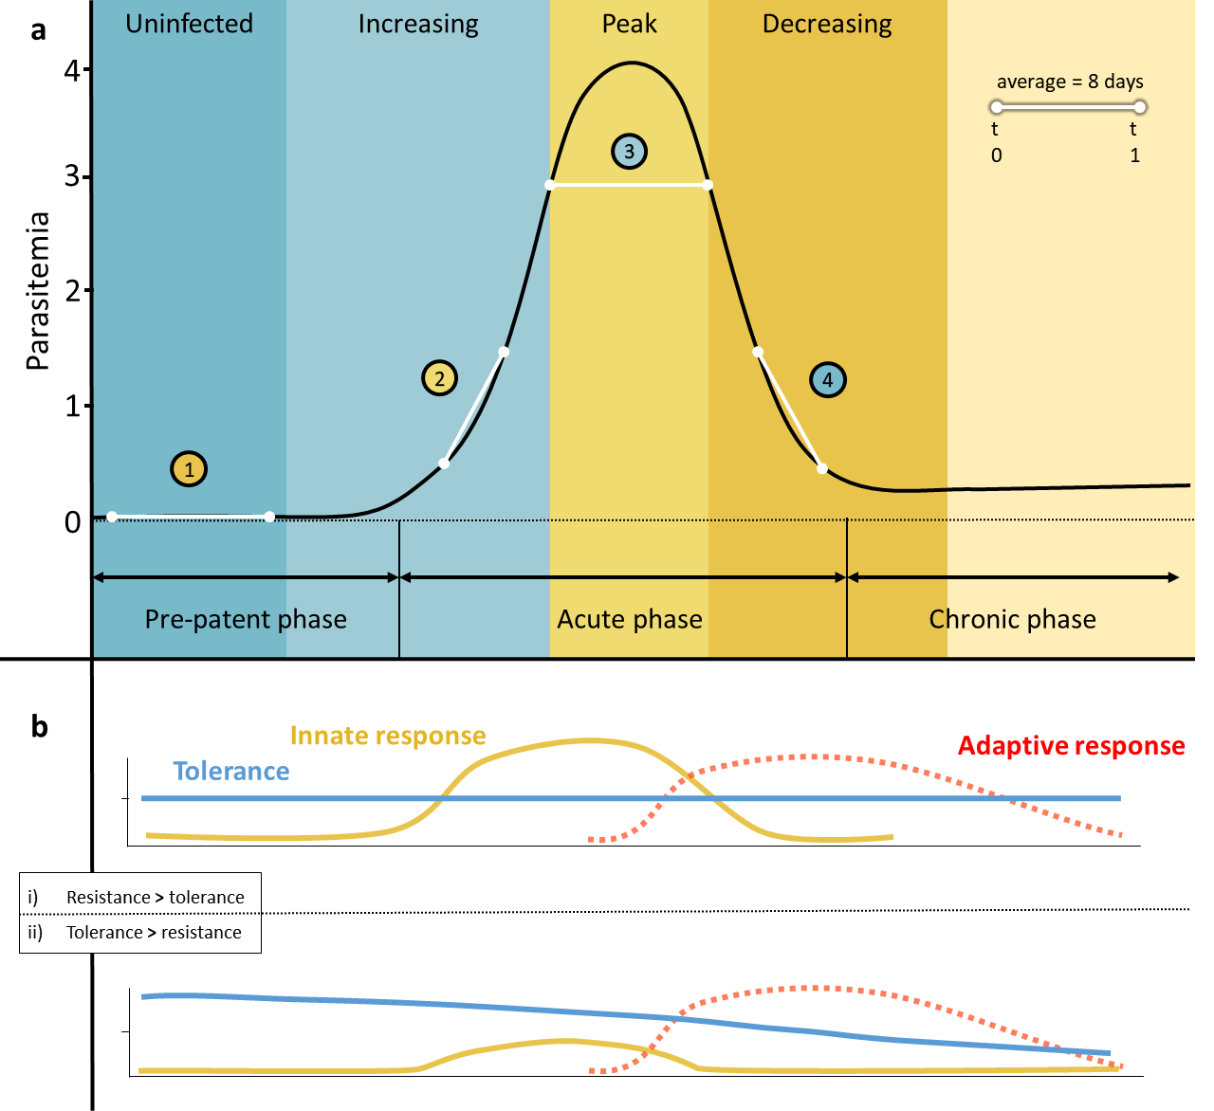

Figure 2
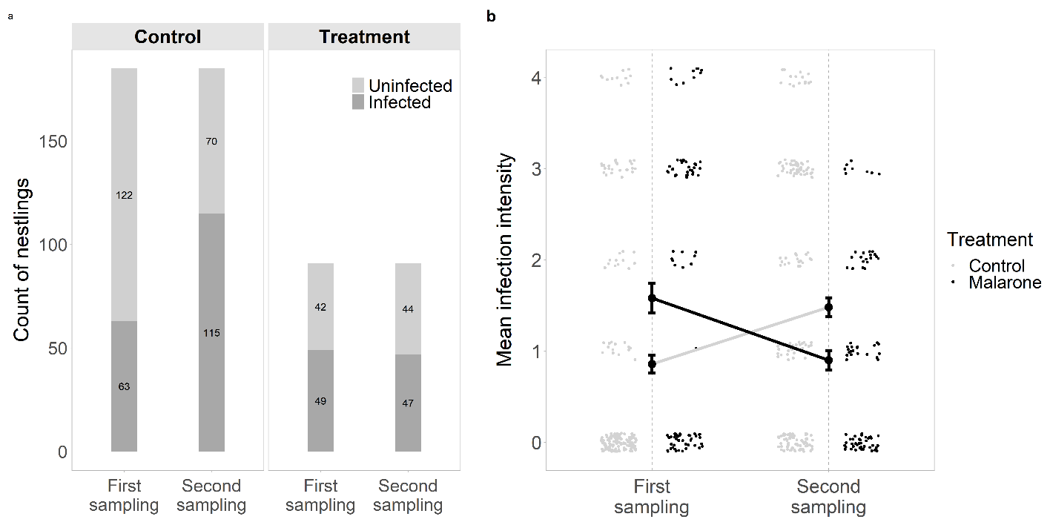

Figure 3
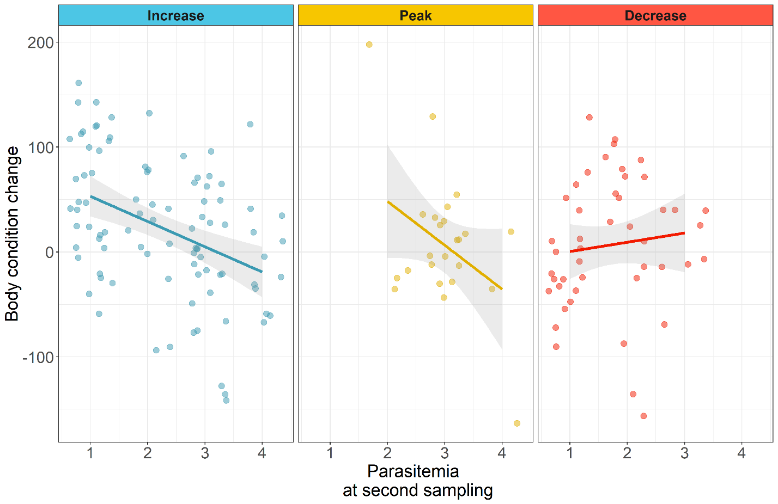

Figure 4