Acute blood parasite infections induce moderate physiological costs in juvenile raptor hosts
Tony Rinaud*¹, Meinolf Ottensmann¹, Oliver Krüger¹, Nayden Chakarov¹
¹ Department of Animal Behaviour, Bielefeld University, Bielefeld, Germany

Correspondence:
Tony Rinaud
Department of Animal Behaviour
Bielefeld University
Morgenbreede 45
33615 Bielefeld
E-mail: tony.rinaud@uni-bielefeld.de
Orcid ID: https://orcid.org/0000-0003-3811-2270

Abstract
Parasites trigger reactions in hosts, leading to suppressive resistance and/or tolerance, aiming to limit the parasitic costs. Both colonization by parasites and defense activation can induce varying amount of costs for the host. Understanding parasite-induced effects on host fitness crucially depends on assessing parasitic costs in specific wild host-parasite systems. To evaluate potential effects of blood parasite infection, we compared physiological traits of Common Buzzard nestlings Buteo buteo i) at different stages of infection and ii) with increasing levels of parasitemia (frequency of infected host cells) with Leucocytozoon toddi, a pathogen causing malaria-like conditions. We expected infection costs to appear from the onset of infection and during peak parasitemia, rather than when parasitemia was decreasing or in uninfected hosts. We found no difference in physiological traits among infection stages, indicating low immediate parasitic costs and pointing to infection tolerance in this ontogenic stage. Surprisingly, infection only led to decrease of host health during rare and particularly acute expressions of infection. Thus, Leucocytozoon toddi appears to typically display low virulence towards their hosts, during all stages of infection. Juveniles, as a relatively parasite-tolerant life-history stage, may enable parasite transmission in the population while avoiding infection-driven host mortality during this critical period.
Keywords: Avian malaria, bird of prey, disease tolerance, host-parasite interactions, immune system, infection burden, physiology, nestlings

Introduction
Parasites have negative fitness consequences for their hosts and therefore play an important role for their short- and long-term fitness [1–4]. Parasite infections can affect directly host survival and reproduction through diverse non-lethal but costly effects on host physiology, behavior and ecology [5–7]. They can also exacerbate indirect effects of the abiotic environment [8, 9], intra- or interspecific interactions [10], and other symbionts [11] .
In most organisms, infection with parasites can occur already in early life [12–15] with young hosts being particularly prone to intense infections [16–18]. During the early stages of host development, the adaptive immunity is not fully developed, which can reduce the risk of pervasive autoimmunity. At the same time, this may render infants more susceptible and slower at suppressing parasites compared with adults. Thus, some infections are life-threatening during childhood [12, 19]. However, organisms typically experience certain infections before immune maturity and effective suppressive resistance are achieved. Such young hosts, which are both accessible and susceptible, may face strong selection to limit parasitic damages and thus develop mechanisms for tolerance and robustness in order to compensate for lower resistance to a pathogen [20–22]. Early life host-parasite interactions can therefore have important consequences for host survival and parasite transmission but are still insufficiently understood.
Vertebrate blood parasites of the genera Plasmodium, Haemoproteus and Leucocytozoon, (order Haemosporida, Eukaryota, Protista) are known as significant disease and mortality agents in humans and have been suggested to systematically play similar roles in wildlife [9, 23]. In the host, Leucocytozoon parasitemia (i.e. frequency of infected host cells) usually first increases, reaches a plateau/peak and then decreases rapidly (Fig. 1) [24]. During the pre-patent phase, parasites only start developing in internal organs, like liver and spleen, but are absent in the blood. Stages released into the blood invade blood cells and blood parasitemia increases until reaching peak infection, which might last up to several days. When the humoral immunity succeeds to mount a specific response, parasitemia falls and stabilizes at low chronic levels, usually followed by relapses or effective clearance (Fig 1) [24, 25]. Overall, costs of blood parasite infection can be expected to occur during the pre-patent and acute stages of infection (e.g. before and during peak parasitemia) when resource depletion, tissue damage and inflammation are highest, rather than during chronic and low parasitemia when gradual recovery ensues [26].
In this study, we used physiological traits as informative proxies of infection-related costs in nestlings of wild common buzzards, Buteo buteo and performed an experiment to examine the effects of blood parasite infection. In the study population, the prevalence of Leucocytozoon toddi before fledging of nestlings can surpass 50% [27, 28]. We recorded and manipulated the levels of parasitemia in order to evaluate how they affect physiological states and show potential infection- and immunity-related costs to hosts. We predicted that nestlings would bear higher costs from infections during increasing and peak parasitemia compared with nestlings with decreasing parasitemia and uninfected ones. Additionally, the severity of costs was expected to correlate positively with host parasitemia.
Results
Efficiency of the antimalarial treatment
The number of infected nestlings remained stable in the antimalarial treatment group, while in control nestlings it increased between pre- and post-treatment samplings (Fig. 2a). The antimalarial treatment significantly reduced the parasitemia of the nestlings (Treatment [Malarone]: est. = -1.77, s.d. = 0.28, df = 177, t = -6.45, P = 1.03e-9, Fig. 2b). However, initial parasitemia was higher in treated than in control nestlings (permutation two sample t-test, mean ± s.d.: Control = 0.86 ± 1.34, Malarone = 1.58 ± 1.57, perm.: 999, t = -3.97, P = 0.002, Fig. 2b).
Host health to parasitemia
Overall, body condition decreased with increasing parasitemia (est. = -7.02, s.d. = 3.16, df = 274, t = -2.22, P = 0.027). Body condition decreased with parasitemia particularly in nestlings with increasing (est. = -24.08, s.d. = 5.99, df = 177, t = -4.02, P < 0.001) and peak infections (est. = -41.80, s.d. = 23.47, df = 177, t = -1.78, P = 0.054). In contrast, in nestlings with decreasing parasitemia condition did not decrease with parasitemia (Fig. 3, Supplementary Table S2). Moreover, slopes of body condition against increasing and decreasing parasitemia tended to be different (Supplementary Table S2).
Breathing rate and infection stage
We found no difference in breathing rate attributable to infection stage or parasitemia (Table 1a & 2a respectively, fig. Sfig. 4a). Heavier nestlings were breathing more slowly, regardless of their infection status and age (est. = -2.62, CI = -4.20 – -1.04, df = 249, t = -3.26, P = 0.001). The breathing rate of nestlings correlated negatively with ambient temperature (est. = -3.01, CI = -4.19 – -1.83, df = 125, t = -5.06, P < 0.001, Supplementary Table S3a). Breathing rates in 2018 and 2020 were significantly lower than in 2016 (Supplementary Table S3a). There was no significant effect of the interaction between antimalarial treatment and infection status on the breathing rate (Supplementary Table S3a).
Body temperature among infection stages and intensities
We found no difference in body temperature among infection stages (Table 1a). However, body temperature decreased as parasitemia increased, revealing a significantly lower body temperature of nestlings with acute parasitemia (level 4) compared to uninfected nestlings (est. = -0.81, CI = -1.38 – -0.24, df = 140, t = -2.80, P = 0.006, Table 2a, Fig. 4b). Body temperature of nestlings increased with ambient temperature and decreased with time between both samplings. There was no effect of the interaction between antimalarial treatment and infection status on the body temperature.
Body condition and infection
The change in body condition did not differ among infection stages (Table 1b), but nestlings with acute peak infections (level 4) tended to have a higher decrease in body condition compared with uninfected nestlings (Fig. 4c, est. = -33.90, CI = -71.88 – 4.09, df = 247, t = -1.76, P = 0.080, Table 2b). Nestlings had a significantly higher body condition in 2020 compared to 2016 (est. = 60.84, CI = 10.23 – 111.44, df = 275, t = 2.37, P = 0.019). Age and the interaction between infection stages and treatment showed no effects on body condition.
Growth rate among infection stages and intensities
We found that growth rate of nestlings did not differ between different infection stages after accounting for potential confounding factors, despite a non-significant reduction of growth in later infection stages (Table 1b, Supplementary Fig. S1d). There was weak evidence that nestlings with medium and highest parasitemia (level 2 and 4) had a lower growth rate than uninfected nestlings (Table 2b, Fig. 4d). Females had higher growth rates than males. Growth rate decreased with age of the nestlings, as they were approaching adult size. Growth rate tentatively appeared higher during the last year of the study and when the time interval between both samplings was longer. Finally, there was weak evidence for control nestlings with low parasitemia (level 1) to grow slower compared to Malarone-treated nestlings with similar levels of parasitemia (est. = -5.32, CI = -11.36 – 0.72, df = 242, t = -1.73, P =0.084).
Discussion
Host responses to parasite infections receive great interest because of their crucial consequences for host fitness [39]. However, to understand which responses are effective and adequate specific measurements are needed for classic but also for non-model host-parasite systems (but see [16, 18, 40]). Haemosporidian blood parasites are often considered pathogenic even though the generality of evidence among hosts groups remains equivocal [41, 42]. Here, we recorded and experimentally manipulated infections of the main blood parasite in young, slowly developing hosts to assess infection-related changes in several physiological and developmental traits. Multiple samplings of the same individual allow us to estimate the stage along the course of infection for each individual in this study. Parasites are known to impair host body condition and growth rate, often through costs of defense deployment [11, 43, 44]. In turn, these effects may lead to higher predation, starvation and inferiority in intra-/inter-specific interactions of infected hosts [10]. Altogether, consequences of parasite infections can impair the survival probability of infected hosts but before labeling a parasite as such costs have to be demonstrable [23, 45].
Our results suggest that young common buzzards do not display strong signs of parasite-induced costs during the course of infection. Only in cases of acute infection (extraordinarily high levels of peak infection), nestlings appeared unable to completely maintain thermoregulation, body condition and growth rate. These appear to be possible but rarely occurring costs of parasite exploitation and immune activation. Importantly, many parasites of the genus Leucocytozoon typically do not form large tissue stages (megaloschizonts) correlated with infection severity, unlike members of other blood parasite taxa like Plasmodium and Haemoproteus [46]. Nevertheless cases have been reported with substantial damage and population-wide mortality due to exceptionally high Leucocytozoon parasitemia [18, 24].
We found no difference in breathing rate among nestlings in different stages of infection and uninfected nestlings. This result suggests that Leucocytozoon do not cause substantial anemia in nestlings, which could reduce the physiological oxygen availability and lead to respiratory complications [47, 48]. Blood parasites differ in their life cycle with potential relevance in this aspect - Plasmodium multiply within red blood cells causing them to burst (schizogony) whereas Leucocytozoon only makes erythrocytes weaker and/or more susceptible to the immune defenses [46]. While we find no changes in breathing rate, this finding may be specific to young raptor hosts.
Thermoregulation failure as a typical inflammatory response is common in hosts infected by blood parasites [26, 48]. However, such responses have been found only in bird-Plasmodium systems where fever and hypothermia appeared after parasite inoculation in captive birds [26, 48]. In our case of wild raptor nestlings, no difference in body temperature was found among infection stages. This result suggests that raptor nestlings rarely produce a costly thermoregulatory reaction over the course of infection. However, chicks with acute infections displayed lower body temperatures on average by 0.8°C, potentially reflecting hypothermia. Altogether, nestlings showed no apparent signs of inflammatory response over the course of infection, unless they were challenged with extraordinarily high parasitemia during the peak infection stage.
As several different organs and tissue types may be targeted during infections with blood parasites, host body condition can be expected to deteriorate while parasites increasingly invade host cells [26, 49]. Body condition tended to be lower in nestlings experiencing acute infections, while there was no difference between infection stages. Therefore, symptomatic costs of infection appear to be paid immediately and are only noticeably high when infection is extraordinarily intense. Nestling body condition predicts juvenile survival in large bird species [16]. Therefore, acute infection may contribute to delayed increase of juvenile mortality, if chicks are not able to compensate for condition loss before independence.
We show that year of sampling explains variation in all four physiological parameters. Body condition and growth rate are tightly linked to food availability while annual fluctuations in vole abundance as the main source of energy for common buzzards are known to have strong effects on their demography [50].Fluctuations in vole abundance also explain variation in the breeding success in different parts of the breeding range [51, 52]. The proportion of voles among prey items in our study area corresponded to differences in body condition and growth rate of nestlings during the same year (unpublished data). Future research should address specifically predator-parasite relationships in the light of the highly dynamic prey populations.
Growth of nestlings appeared to slow down in consecutive stages of parasitic infection, although differences to uninfected nestlings remained not significant. Nestlings bearing medium (level 2) and high parasitemia tended to display lower growth rates than other groups. Such contrast with uninfected nestlings might lead to long-term fitness consequences, especially in a ranked brooding system.
Our results suggest that parasitic costs are not apparent at every stage of infection but only at the highest levels of parasitemia, which occur in only few sampled individuals. Symptoms of infection are only displayed during uncontrolled parasitemia and might translate in long-term and interacting consequences for fitness of these hosts. Nestlings with increasing and decreasing parasitemia appeared to differ in tolerance (slopes of host health parameters to parasitemia) suggesting a regaining of condition by the onset of adaptive immunity and therefore a mild pathogenicity of Leucocytozoon parasites, at least in the long-term. Regardless of the infection trend, body condition, our best proxy for fitness-relevant host health, decreased with parasite load. This indicates immediate costs for hosts bearing intense infections. Thus, the timing of infection in raptors and similar big birds appears to be adaptive, as parental care provides a buffer against the short cost-intense period of peak infection [24, 53].
The moderate effects of Leucocytozoon on raptor nestlings are supported by recent studies showing that these parasites do not drastically change the blood chemistry of hosts which would be indicative of substantial tissue damage [28]. Pathogenic effects may occur when large tissue stages (haemosporidian megaloschizonts) develop in organs such as liver, spleen and brain [54]. However, these parasitic stages are not obligatory for haemosporidian development and host characteristics which predispose their appearance remain to be found [24]. The apparent low virulence together with the mostly absent physiological responses to infection suggest that host and parasite may have defused the co-evolutionary arms-race by reaching widespread transmission in this immunologically naïve and susceptible but tolerant nestling stage. Unlike generalist parasites, the evolution of Leucocytozoon might be especially shaped by such relaxed selection pressure, allowing these parasites to spread widely in the population of the their main and few alternative host species [28].
Furthermore, individual survival within the same buzzard population is not explained by Leucocytozoon infection status but is explained by body condition during nestling phase (Ottensmann et al., in prep). However, through this effect acute parasitic infection reducing body condition of chicks can decrease the long-term survival prospects of some individuals [45] along with established factor such as prey availability or weather conditions [50, 55].
Overall, we found few and weak signs of infection costs on nestling physiology during different stages of infection, suggesting on average low pathogenicity in this stage of host development. During most non-extreme infections, juveniles appear to be overall tolerant hosts that enable parasite transmission without paying substantial fitness costs and thereby curb direct or indirect parasite-induced host mortality. Our study demonstrates the necessity to understand in greater detail “childhood diseases” in the wild. We promote exploration without prejudice of symbiotic and parabiotic relationships between microorganisms and the most probable host developmental stages at time of first contact, which could be most relevant for the long-term co-evolutionary dynamics.

Methods
Host-parasite system
Common buzzards (Buteo buteo) are accipitriform birds of prey that breed in temperate Eurasian forests, in tree nests at heights between 10 to 30 m. Common buzzards are long-lived birds (up to thirty years old) and the most common accipitriform in Germany. They have the highest prevalence of blood parasites of the genus Leucocytozoon among sympatric raptor species [28]. Leucocytozoon toddi (Eukaryota, Protista, Haemosporidiae, lineages MILANS04, MILVUS01, BUTBUT01) is by far the most common blood parasite in our study population of common buzzard. The vector-borne transmission of Leucocytozoon has been suggested to mostly occur in a quasi-vertical direction [29]. Black fly vectors (Simuliidae) may first suck blood from infected parents at the nest site and predominantly transmit the same genetic pool of parasites to their offspring [30]. Prevalence of infection varied across years: 37.5% in 2016, 18.5% in 2018, 49.3% in 2019 and 49.1% in 2020 in our dataset.
Data collection
The study was performed in a 300-km² study area in North Rhine-Westphalia, Germany (8°25’ E and 52°06’ N). From 2016 to 2020, 276 common buzzard nestlings (n = 32, 65, 71, 108 in 2016, 2018, 2019, 2020 respectively) were sampled. Sampling and drug application of common buzzards followed the ARRIVE guidelines and were approved by the Animal Ethics Committee at Bielefeld University and permitted by the local authority Kreis Gütersloh, permit number: 4.5.2-723-Bussard and by the ethics committee of the Animal Care and Use Committee of the German North Rhine-Westphalia State Office for Nature, Environment and Consumer Protection (Landesamt für Nature, Umwelt und Verbraucherschutz Nordrhein-Westfalen) under permit numbers: 84-02.04.2014.A091, 84-02-04.2017.A147. All individuals were resampled on average eight days after first sampling (mean ± s.d. = 8.36 ± 4.21 days). Nestling age was estimated using a sex-specific polynomial regression between age and wing length, based on growth data for buzzards of known age [31]. The average estimated age of nestlings at second sampling was 27.84 days (± s.d. 5.36), an age where most nestlings have already long encountered Leucocytozoon and hence infections are microscopically visible [30]. Blood smears were screened by microscopy for Leucocytozoon toddi infection at first and second sampling. Approximately 10.000 erythrocytes were scanned in thin blood smears and parasitemia was categorized as follows: not infected (no detectable parasites), parasitemia 1 (1–10 parasites per 10.000 erythrocytes), parasitemia 2 (>10–100 parasites per 10.000 erythrocytes); parasitemia 3 (>100–1000 parasites per 10.000 erythrocytes) and parasitemia 4 (>1000 parasites per 10.000 erythrocytes). Among the sampled nestlings, 66% (N=183) were infected during at least one of the two time points, whereas 34% (N=93) were not infected at both time points; only few nestlings naturally displayed decreasing parasitemia between both samplings. Decreasing parasitemia was experimentally achieved by giving orally 0.5mL distilled water with 11mg of antimalarial medicine (MalaroneTM; Atovaquone and Proguanil Hydrochloride, GlaxoSmithKline, UK, range: 7-21 mg/kg) to a random subset of sampled nestlings in 2018, 2019 and 2020. Control nestlings did not receive antimalarial medicine. Similar treatments have been previously shown to substantially reduce the prevalence of Plasmodium in bird populations [5, 32, 33]. According to the change in parasitemia between both samplings, the 276 nestlings were separated into four groups (Fig. 1): (i) uninfected nestlings (no apparent infection at both samplings, n = 93), (ii) increasing infection (n = 92), (iii) peak infection (i.e., constant parasitemia and >10 parasites per 10.000 erythrocytes at both samplings), n = 24) and (iv) decreasing infection (n = 67).
Cost-indicative physiological parameters
At first and second sampling, we measured the body weight (to the nearest 5 g) with a spring scale and the respiratory rate (duration of 30 breathings in seconds) of each nestling. The cloacal temperature (henceforth body temperature, measured with an electronic thermometer) was recorded in 2019 and 2020. The repeatability of the temperature measures was R²= 0.91 (CI = 0.81 – 0.96, P < 0.001), calculated from 27 paired measures taken on both adults and nestling common buzzards (mean: 40.35°C, s.d. ± 0.39°C). To control for an ambient temperature effect, the average daily temperatures of the sampling days were obtained from the NASA POWER Project [34]. Growth rate was calculated as the weight change between first and second sampling divided by the difference in days separating the two measurements. The body condition index of a nestling was estimated for each sampling event as the residual variance of the sex-specific linear regression between weight and wing length (log-transformed) based on standard growth data of common buzzard nestlings [31]. To account for state-dependent development of individual body condition, we used the change in body condition (Δ body condition) between the second and first sampling as a proxy of investment and costs in our models.
Statistical analyses
We fitted a linear mixed model to estimate the effect of antimalarial treatment on the parasitemia of nestlings, adding year and interval between samplings as covariates and nest ID as random factor. As suggested by Råberg et al. (2007), we used regressions explaining a potential fitness-informative trait and parasitemia and interpreted the slope as a proxy of tolerance. Slopes were compared among infection stages and to zero using the emmeans [35] package in R 4.0.2 [36]. To examine the relationship between (i) host infection stages and (ii) parasitemia with different cost-related physiological parameters, we used linear mixed models fitted by REML as implemented in lme4 [37]. We fitted four models with breathing rate, body temperature, change in body condition and growth rate as the response variables, respectively. As fixed factors, we specified either (i) the infection stage or (ii) the parasitemia, sampling interval (in days), year of sampling, sex and age. To account for a potential effect of the anti-malarial treatment on the response variables, we included the interaction between the infection stage (or parasitemia) and the treatment (antimalarial treatment versus control) as fixed factor in all models. Numerical explanatory variables were standardized using a z-transformation [38]. Nest ID was fitted as a random factor in all models to consider nestling relatedness. All models are described in detail in Supplementary Table S1.

Data availability statement:
The manuscript is available as a preprint on EcoevoRxiv under the licence CC-By Attribution-ShareAlike 4.0 International (doi: 10.32942/osf.io/4tcqu).
Raw data and associated code for analyses are available on this repository (https://github.com/TonyRinaud/MS_physiology_infection).
References
1. J. E. Stockdale, J. C. Dunn, S. J. Goodman, D. K. Sheehan, P. V. Grice, K. C. Hamer, The protozoan parasite Trichomonas gallinae causes adult and nestling mortality in a declining population of European Turtle Doves, Streptopelia turtur, 9 (2015).
2. M. Bermejo, J. D. Rodriguez-Teijeiro, G. Illera, A. Barroso, C. Vila, P. D. Walsh, Ebola Outbreak Killed 5000 Gorillas. Science. 314, 1564–1564 (2006).
3. L. Simonsen, C. Viboud, A comprehensive look at the COVID-19 pandemic death toll, 3 (2021).
4. J. Foley, D. Clifford, K. Castle, P. Cryan, R. S. Ostfeld, Conserv. Biol., in press, doi:10.1111/j.1523-1739.2010.01638.x.
5. S. C. L. Knowles, V. Palinauskas, B. C. Sheldon, Chronic malaria infections increase family inequalities and reduce parental fitness: experimental evidence from a wild bird population. J. Evol. Biol. 23, 557–569 (2010).
6. R. Poulin, "Evolution and phylogeny of behaviour manipulation of insect hosts by parasites" in Parasitology (1998; https://books.google.de/books?id=4EDSLrvER_gC&lpg=SL19-PA3&ots=CfFKfZoQrw&dq=behaviour%20change%20parasite&lr&hl=fr&pg=SL19-PA3#v=onepage&q&f=false), vol. 116.
7. J. C. Dunn, S. J. Goodman, T. G. Benton, K. C. Hamer, Avian blood parasite infection during the non-breeding season: an overlooked issue in declining populations? BMC Ecol. 13, 30 (2013).
8. A. F. Brown, D. Pascoe, Parasitism and Host Sensitivity to Cadmium: An Acanthocephalan Infection of the Freshwater Amphipod Gammarus pulex. J. Appl. Ecol. 26, 473–487 (1989).
9. J. Martinez, S. Merino, Host-parasite interactions under extreme climatic conditions. Curr. Zool. 57, 390–405 (2011).
10. M. J. Hatcher, J. T. A. Dick, A. M. Dunn, How parasites affect interactions between competitors and predators. Ecol. Lett. 9, 1253–1271 (2006).
11. C. Ramsay, J. R. Rohr, The application of community ecology theory to co‐infections in wildlife hosts. Ecology. 102 (2021), doi:10.1002/ecy.3253.
12. B. Ashby, E. Bruns, The evolution of juvenile susceptibility to infectious disease. Proc. R. Soc. B Biol. Sci. 285, 20180844 (2018).
13. A. F. Cowman, Healer, Julie, Marapana, Danushka, Marsh, Kevin, Malaria: Biology and Disease. Cell, 15 (2015).
14. C. Kubi, J. Van Den Abbeele, R. De Deken, T. Marcotty, P. Dorny, P. Van Den Bossche, The effect of starvation on the susceptibility of teneral and non-teneral tsetse flies to trypanosome infection. Med. Vet. Entomol. 20, 388–392 (2006).
15. S. N. Panter, D. A. Jones, "Age-related resistance to plant pathogens" in Advances in Botanical Research (Elsevier, 2002; https://linkinghub.elsevier.com/retrieve/pii/S0065229602380327), vol. 38, pp. 251–280.
16. A. K. Townsend, S. S. Wheeler, D. Freund, R. N. M. Sehgal, W. M. Boyce, Links between blood parasites, blood chemistry, and the survival of nestling American crows. Ecol. Evol. 8, 8779–8790 (2018).
17. World Health Organization, World malaria report 2015 (World Health Organization., 2016).
18. C. M. Herman, J. H. Barrow, I. B. Tarshis, Leucocytozoonosis in Canada geese at the Seney national wildlife refuge. J. Wildl. Dis. 11, 404–411 (1975).
19. A. K. Simon, G. A. Hollander, A. McMichael, Evolution of the immune system in humans from infancy to old age. Proc. R. Soc. B Biol. Sci. 282, 20143085 (2015).
20. T. J. Little, D. M. Shuker, N. Colegrave, T. Day, A. L. Graham, The Coevolution of Virulence: Tolerance in Perspective. PLoS Pathog. 6, e1001006 (2010).
21. R. Medzhitov, D. S. Schneider, M. P. Soares, Disease Tolerance as a Defense Strategy. Science. 335, 936–941 (2012).
22. L. Råberg, D. Sim, A. F. Read, Disentangling Genetic Variation for Resistance and Tolerance to Infectious Diseases in Animals. Science. 318, 812–814 (2007).
23. J. M. la Puente, S. Merino, G. Tomás, J. Moreno, J. Morales, E. Lobato, S. García-Fraile, E. J. Belda, The blood parasite Haemoproteus reduces survival in a wild bird: a medication experiment. Biol. Lett. 6, 663–665 (2010).
24. G. Valkiūnas, Avian malaria parasites and other haemosporidia (CRC Press, Boca Raton, 2005).
25. G. Snounou, W. Jarra, S. Viriyakosol, J. Wood, K. Brown, Use of a DNA probe to analyse the dynamics of infection with rodent malaria parasites confirms that parasite clearance during crisis is predominantly strain- and species-specific. Mol. Biochem. Parasitol. 37, 37–46 (1989).
26. R. B. Williams, Avian malaria: clinical and chemical pathology of Plasmodium gallinaceum in the domesticated fowl Gallus gallus. Avian Pathol. 34, 29–47 (2005).
27. N. Chakarov, M. Pauli, O. Krüger, Immune responses link parasite genetic diversity, prevalence and plumage morphs in common buzzards. Evol. Ecol. 31, 51–62 (2017).
28. A. Wiegmann, A. Springer, T. Rinaud, M. Ottensmann, M. Legler, O. Krüger, M. Fehr, N. Chakarov, C. Strube, The prevalence of Leucocytozoon spp. in nestlings of three wild raptor species including implications on haematological and blood chemistry values. Int. J. Parasitol. Parasites Wildl. 16, 236–243 (2021).
29. N. Chakarov, H. Kampen, A. Wiegmann, D. Werner, S. Bensch, Blood parasites in vectors reveal a united blackfly community in the upper canopy. Parasit. Vectors. 13, 309 (2020).
30. N. Chakarov, B. Linke, M. Boerner, A. Goesmann, O. Krüger, J. I. Hoffman, Apparent vector-mediated parent-to-offspring transmission in an avian malaria-like parasite. Mol. Ecol. 24, 1355–1363 (2015).
31. R. G. Bijlsma, Roofvogels: handleiding veldonderzoek (1998).
32. V. Palinauskas, G. Valkiūnas, A. Križanauskienė, S. Bensch, C. V. Bolshakov, Plasmodium relictum (lineage P-SGS1): Further observation of effects on experimentally infected passeriform birds, with remarks on treatment with MalaroneTM. Exp. Parasitol. 123, 134–139 (2009).
33. L. A. Schoenle, M. Kernbach, M. F. Haussmann, F. Bonier, I. T. Moore, An experimental test of the physiological consequences of avian malaria infection. J. Anim. Ecol. 86, 1483–1496 (2017).
34. A. Sparks, nasapower: NASA-POWER Data from R (2022; https://CRAN.R-project.org/package=nasapower).
35. R. V. Lenth, emmeans: Estimated Marginal Means, aka Least-Squares Means (2022; https://CRAN.R-project.org/package=emmeans).
36. R Core Team, R: A Language and Environment for Statistical Computing (R Foundation for Statistical Computing, Vienna, Austria, 2020; https://www.R-project.org).
37. D. Bates, M. Mächler, B. Bolker, S. Walker, Fitting Linear Mixed-Effects Models using lme4. ArXiv14065823 Stat (2014) (available at http://arxiv.org/abs/1406.5823).
38. H. Schielzeth, Simple means to improve the interpretability of regression coefficients: Interpretation of regression coefficients. Methods Ecol. Evol. 1, 103–113 (2010).
39. D. Dadam, R. A. Robinson, A. Clements, W. J. Peach, M. Bennett, J. M. Rowcliffe, A. A. Cunningham, Avian malaria-mediated population decline of a widespread iconic bird species. R. Soc. Open Sci. 6, 182197 (2019).
40. M. Asghar, D. Hasselquist, B. Hansson, P. Zehtindjiev, H. Westerdahl, S. Bensch, Hidden costs of infection: Chronic malaria accelerates telomere degradation and senescence in wild birds. Science. 347, 436–438 (2015).
41. C. Granthon, D. A. Williams, Avian Malaria, Body Condition, and Blood Parameters In Four Species of Songbirds. Wilson J. Ornithol. 129, 492–508 (2017).
42. S. Hahn, S. Bauer, D. Dimitrov, T. Emmenegger, K. Ivanova, P. Zehtindjiev, W. A. Buttemer, Low intensity blood parasite infections do not reduce the aerobic performance of migratory birds. Proc. R. Soc. B Biol. Sci. 285, 20172307 (2018).
43. G. Blanco, J. D. L. Puente, M. Corroto, A. Baz, J. Colás, Condition-dependent immune defence in the Magpie: how important is ectoparasitism? Biol. J. Linn. Soc. 72, 279–286 (2001).
44. A. P. Møller, Ph. Christe, J. Erritzøe, J. Mavarez, A. P. Moller, J. Erritzoe, Condition, Disease and Immune Defence. Oikos. 83, 301 (1998).
45. R. Pigeault, C.-S. Cozzarolo, R. Choquet, M. Strehler, T. Jenkins, J. Delhaye, L. Bovet, J. Wassef, O. Glaizot, P. Christe, Haemosporidian infection and co-infection affect host survival and reproduction in wild populations of great tits. Int. J. Parasitol. 48, 1079–1087 (2018).
46. Atkinson, T., C., Van Riper III, C., Bird-Parasite Interactions (Oxford Ornitohlogy Series, J.E Loye&M. Zuk., 1991), vol. Pathology and epizootiology of haematozoa.
47. N. Wale, M. J. Jones, D. G. Sim, A. F. Read, A. A. King, The contribution of host cell-directed vs. parasite-directed immunity to the disease and dynamics of malaria infections. Proc. Natl. Acad. Sci. 116, 22386–22392 (2019).
48. A. M. Hayworth, C. van Riper, W. W. Weathers, Effects of Plasmodium relictum on the Metabolic Rate and Body Temperature in Canaries (Serinus canarius). J. Parasitol. 73, 850 (1987).
49. C. Commichau, D. Jonas, A disease of ducklings caused by Leucocytozoon simondi with special reference to histopathological diagnosis. Zentralblatt Für Veterinärmedizin Reihe B. 24, 662–667 (1977).
50. G. Sundev, R. Yosef, O. Birazana, Brandt’s Vole density affects nutritional condition of Upland Buzzard Buteo hemilasius on the Mongolian Grassland Steppe. 86, 9 (2009).
51. N. Chakarov, O. Krüger, Mesopredator Release by an Emergent Superpredator: A Natural Experiment of Predation in a Three Level Guild. PLoS ONE. 5, e15229 (2010).
52. M. Panek, Does Habitat Diversity Modify the Dietary and Reproductive Response to Prey Fluctuations in a Generalist Raptor Predator, the Eurasian Buzzard Buteo buteo? Birds. 2, 114–126 (2021).
53. D. Shutler, C. D. Ankney, A. Mullie, Effects of the blood parasite Leucocytozoon simondi on growth rates of anatid ducklings. 77, 6 (1999).
54. K. Murphy, C. Weaver, Janeway’s Immunology (GS Garland Science, Taylor & Francis Group, New York London, 9th edition., 2016).
55. A. Kostrzewa, R. Kostrzewa, The relationship of spring and summer weather with density and breeding performance of the Buzzard Buteo buteo, Goshawk Accipiter gentilis and Kestrel Falco tinnunculus. Ibis. 132, 550–559 (2008).
Acknowledgments
We would like to thank Thomas Grünkorn who climbed trees to deliver us precious samples for this study. We are also grateful for all the field assistants that helped during fieldwork of 2016, 2018, 2019 and 2020. This study was supported by the German Science Foundation (DFG) as part of the SFB TRR 212 “A Novel Synthesis of Individualisation across Behaviour, Ecology and Evolution: Niche Choice, Niche Conformance, Niche Construction (NC3)” (project number 396780709) and a research grant for the project “Short- and long-term consequences of malaria-like infections in birds” (project number 398434413).
Author contributions
TR, MO, OK and NC collected the data; TR, NC and MO conceived the ideas and designed methodology. TR and NC led the writing of the manuscript. All authors contributed critically to the drafts and gave final approval for publication.
Competing interests
The authors declare that they have no conflict of interest.

Table 1: Results of four linear mixed models described in Supplementary Table S1, testing the effect of infection stages on the cost-related physiological parameters of Common Buzzard nestlings. a) Breathing rate and body temperature as response variables, b) Body condition change (Δ body condition) and growth rate as response variables. Full model results are presented in Supplementary Table S3.
a. Predictors | Breathing rate |  |  |  |  | Body temperature
a. Predictors | Estimates | CI | df | t | p | Estimates | CI | df | t |  | p
Intercept | 36.90 | 31.65 – 42.14 | 180 | 13.88 | <0.001 | 39.88 | 39.42 – 40.35 | 147 | 169.62 |  | <0.001
Increasing parasitemia | -1.46 | -4.26 – 1.35 | 253 | -1.02 | 0.307 | -0.20 | -0.59 – 0.19 | 130 | -1.00 |  | 0.317
Peak parasitemia | -1.61 | -5.70 – 2.47 | 244 | -0.78 | 0.438 | -0.33 | -0.83 – 0.17 | 130 | -1.31 |  | 0.191
Decreasing parasitemia | -1.58 | -5.55 – 2.39 | 251 | -0.78 | 0.434 | -0.11 | -0.62 – 0.40 | 140 | -0.42 |  | 0.674
… | … | … |  | … | … | … | … |  | … |  | …
Random Effects | 135 Nests |  |  |  |  | 77 Nests
Observations | 269 |  |  |  |  | 178
Marginal / Conditional R² | 0.185 / 0.391 |  |  |  |  | 0.308 / 0.712
b. Predictors | Δ Body condition |  |  |  |  | Growth rate
b. Predictors | Estimates | CI | df | t | P | Estimates | CI | df | t | P
Intercept | -17.15 | -64.28 – 29.99 | 189 | -0.72 | 0.474 | 19.49 | 12.43 – 26.55 | 197 | 5.45 | <0.001
Increasing parasitemia | -3.46 | -27.75 – 20.83 | 250 | -0.28 | 0.779 | -1.57 | -5.47 – 2.32 | 261 | -0.80 | 0.427
Peak parasitemia | -18.04 | -53.11 – 17.03 | 235 | -1.01 | 0.312 | -3.91 | -9.61 – 1.79 | 253 | -1.35 | 0.178
Decreasing parasitemia | -14.04 | -48.32 – 20.25 | 243 | -0.81 | 0.421 | -3.85 | -9.39 – 1.69 | 258 | -1.37 | 0.172
… | … | … |  | … | … | … | … |  | … | …
Random Effects | 139 Nests |  |  |  |  | 139 Nests
Observations | 276 |  |  |  |  | 276
Marginal / Conditional R² | 0.049 / 0.477 |  |  |  |  | 0.238 / 0.452

a. Predictors | Breathing rate |  |  |  |  | Body temperature
a. Predictors | Estimates | CI | df | t | P | Estimates | CI | df | t | P
Intercept | 36.31 | 31.13 – 41.48 | 168 | 13.85 | <0.001 | 39.94 | 39.48 – 40.39 | 142 | 173.68 | <0.001
Parasitemia 1 | 0.47 | -2.96 – 3.90 | 249 | 0.27 | 0.786 | 0.08 | -0.40 – 0.55 | 132 | 0.32 | 0.753
Parasitemia 2 | -2.37 | -6.49 – 1.75 | 244 | -1.13 | 0.259 | -0.12 | -0.60 – 0.36 | 135 | -0.49 | 0.626
Parasitemia 3 | -1.61 | -4.67 – 1.46 | 252 | -1.03 | 0.303 | -0.23 | -0.65 – 0.19 | 136 | -1.08 | 0.281
Parasitemia 4 | -0.09 | -4.63 – 4.45 | 249 | -0.04 | 0.969 | -0.81 | -1.38 – -0.24 | 140 | -2.80 | 0.006
… | … | … |  | … | … | … | … |  | … | …
Random Effects | 135 Nests |  |  |  |  | 77 Nests
Observations | 269 |  |  |  |  | 178
Marginal / Conditional R² | 0.186 / 0.402 |  |  |  |  | 0.322 / 0.722
b. Predictors | Δ Body condition |  |  |  |  | Growth rate
b. Predictors | Estimates | CI | df | t | P | Estimates | CI | df | t | P
Intercept | -20.39 | -66.36 – 25.58 | 178 | -0.88 | 0.383 | 18.29 | 11.42 – 25.17 | 184 | 5.25 | <0.001
Parasitemia 1 | 22.98 | -5.71 – 51.67 | 242 | 1.58 | 0.116 | 2.43 | -2.22 – 7.08 | 257 | 1.03 | 0.304
Parasitemia 2 | -18.42 | -53.27 – 16.43 | 229 | -1.04 | 0.299 | -4.77 | -10.47 – 0.92 | 250 | -1.65 | 0.100
Parasitemia 3 | -10.44 | -37.05 – 16.17 | 256 | -0.77 | 0.440 | -2.35 | -6.60 – 1.91 | 261 | -1.09 | 0.279
Parasitemia 4 | -33.90 | -71.88 – 4.09 | 247 | -1.76 | 0.080 | -5.25 | -11.39 – 0.89 | 258 | -1.68 | 0.094
… | … | … |  | … | … | … | … |  | … | …
Random Effects | 139 Nests |  |  |  |  | 139 Nests
Observations | 276 |  |  |  |  | 276
Marginal / Conditional R² | 0.072 / 0.501 |  |  |  |  | 0.252 / 0.476
Table 2: Results of four linear mixed models described in Supplementary Table S1, testing the effect of parasitemia on cost related physiological parameters in Common Buzzard nestlings. a) Breathing rate and body temperature as response variables, b) Body condition change (Δ body condition) and growth rate. Full model results are presented in Supplementary Table S4.

Figure 1: Theoretical dynamics of parasitemia in a host. The y-axis is parasitemia score. The x-axis represents time with the different phases of parasitemia. The corresponding infection stages at resampling (1 = uninfected, 2 = increasing, 3 = peak and 4 = decreasing) are shown as vertical color bands. The top right diagram shows the average interval between first (t0) and second (t1) sampling.
Figure 2: a) First-to-second sampling count of uninfected and infected nestlings between treatments (control versus antimalarial treatments). b) First-to-second sampling mean parasitemia between control and Malarone-treated nestlings. Error bars represent standard errors.
Figure 3: Relationship between body condition change (proxy of host health) and parasitemia at second sampling (parasitic load as a score from 1 to 4). Reaction norms are displayed for each of the infection stages (blue: increasing, yellow: peak and red: decreasing parasitemia). Comparisons of reaction norms among infection stages and in comparison to a null slope are presented in Supplementary Table S2.
Figure 4: Comparison of predicted resistance-related physiological parameters among parasitemia (ranging from 0, uninfected, to 4, highest parasitemia). Points are predicted means, colored boxes the standard errors and 95% CI as the error bars. The black dashed lines represent the predicted mean value across groups of a given parameter. a) comparison of breathing rate, b) comparison of body temperature, c) comparison of body condition change and d) comparison of growth rate among infection stage groups.

Figure 1
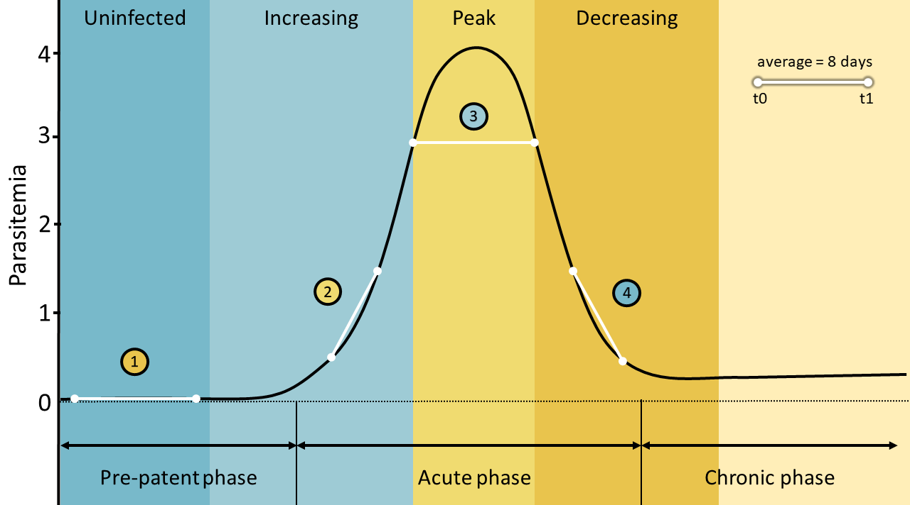

Figure 2
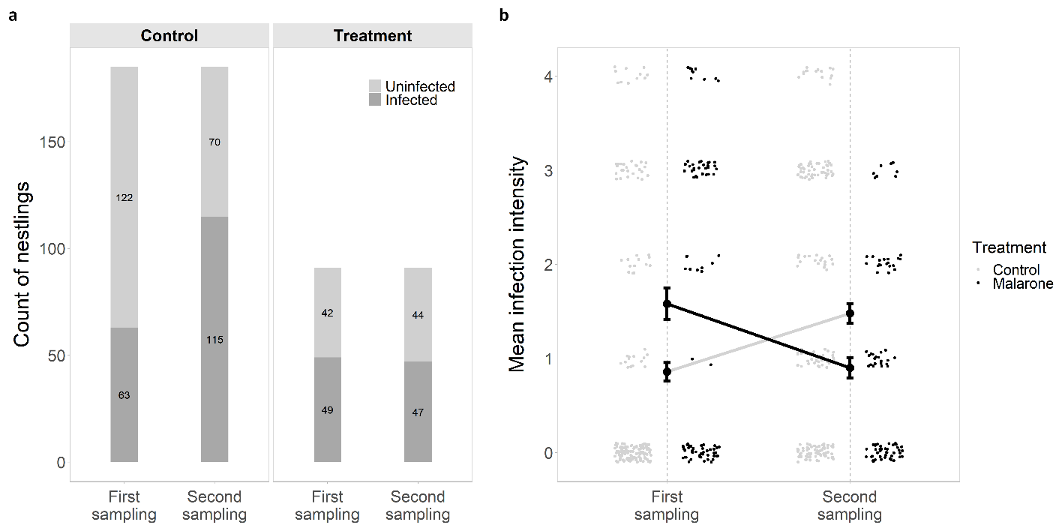

Figure 3
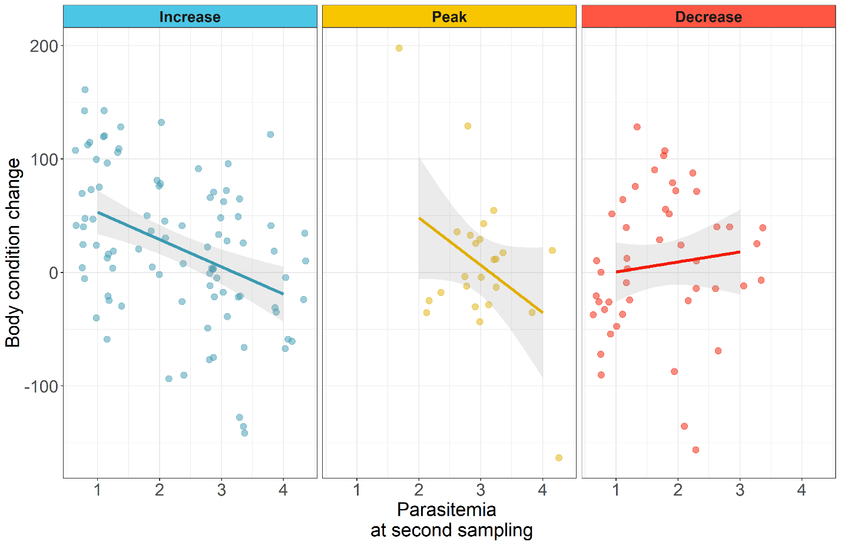

Figure 4