Mountain Gorillas benefit from social distancing too: Close proximity to tourists disturbs gorillas' sociality.

Raquel Costa^{1,2*}, Valéria Romano^{3⸙}, André S. Pereira^{4,5⸙}, Jordan D. A. Hart⁴, Andrew J. J. MacIntosh¹, and Misato Hayashi^{1,6,7}

¹ Primate Research Institute, Kyoto University, Inuyama 484-8506, Aichi, Japan
² Primate Cognition Research Group, Centre for Philosophy of Science of the University of Lisbon, Lisbon 1749-016, Portugal
³ Centre National de la Recherche Scientifique (CNRS), Institut Pluridisciplinaire Hubert Curien (IPHC) UMR 7178, Strasbourg, France
⁴ Centre for Research in Animal Behaviour, University of Exeter, Exeter, EX4 4QG, United Kingdom
⁵ Research Centre for Anthropology and Health, Department of Life Sciences, University of Coimbra, 3000-456 Coimbra, Portugal
⁶Chubu Gakuin University, Kakamigahara 504-0837, Gifu, Japan
⁷Japan Monkey Center, Inuyama 484-0081, Aichi, Japan

* Presently at ²Primate Cognition Research Group, University of Lisbon, Portugal
⸙ These authors contributed equally. The order of these authors was decided by the number of World Cups finals reached by the author’s home countries in professional female football.

* Corresponding author contact information:
E-mail: raquelberingei@gmail.com
Phone: +81 (0) 7007040072092
Postal address: 444-1336 Aichi ken, Takahama shi, Kuretake cho 1-1-14, Japan
ORCID: 0000-0003-2631-4027

Abstract
Gorilla tourism supports the protection of the gorilla ecosystem, benefiting humans and wildlife populations living therein. Assessing to what degree the presence and proximity of tourists affect wildlife aids long-term benefits. Because wild animals might see human activities as stressors, we hypothesised that the increased presence and proximity of tourists leads to an immediate increase in gorilla social cohesion. We constructed social networks from association rates before, during and after tourist visits, and when tourists were very close (≤ 3m) or close (> 3m). Our analysis focused on this small distance threshold (≤ 3m and > 3m) because the 7m rule enforced by the national park was violated 84% of the time. Our analysis showed that gorillas spent more time in closer association after tourists arrived and when they were in very close (< 3m away). Immediate changes were detected in the number of individuals close to each other, the time they spent together and the distance of an individual to all other individuals indicate that gorillas might increase social cohesion because they perceive tourists as a risk. These results highlight the need to enforce the tourism guidelines (maximum of 8 people per group, including park staff, and a minimum distance of 7m).

- Introduction
Gorilla tourism have not only promoted the recovery of the endangered mountain gorillas (Gorilla beringei beringei) but also benefited other coexisting species (Granjon et al., 2020; Tumusiime and Vedeld, 2012). Yet, direct human-gorilla interactions may increase the risk of pathogen transmission (Gilardi et al., 2015), which can lead to fatal episodes among gorillas (Mazet et al., 2021) as well as behavioural and social changes (Mabano, 2014). Great ape tourism guidelines advise that tourist group sizes should not exceed 8 people (including tourists and park staff), at least a 7 m distance from the animals (Macfie and Williamson, 2010) but tourists often keep shorter distances (Webber, Kalema-Zikusoka and Stevens, 2020).
In many species, human-driven effects on the structure of animal social networks (i.e., the patterns and distributions of social interactions among individuals) have been linked to individual fitness, such as changes in reproductive patterns, communication, foraging efficiency, antipredator behavior and disease outbreaks (Banks, Piggott, Stow and Taylor, 2007; Bond, König, Lee, Ozgul and Farine, 2020; Maldonado-Chaparro, Alarcón-Nieto, Klarevas-Irby and Farine, 2018; Shannon et al., 2013; Whittier et al., 2021). Understanding to what extent the presence and proximity of tourists influences the social structure (i.e., social networks) of wild animals creates the roots for developing and enforcing protocols aiming to preserve natural social and demographic processes (Bond et al., 2020).
Primates and cetaceans tend to increase inter-individual proximity in response to human activities (e.g., tourism, fishing, sonar exposure, local population shared landscapes) and when directly encountering humans (Guan , Huang, Ning, Ni and Jiang, 2012; Marechal, MacLarnon, Majolo and Semple, 2016; Marty et al., 2019; Visser et al., 2016; but see Bateman and Fleming, 2017 for a review). At the ultimate level, an increase in social cohesion (i.e., inter-individual proximity) might constitute an adaptive response to perceived risk (Samuni, Mielke, Preis, Crockford and Wittig, 2020) and at the proximate level it might provide a coping mechanism to relieve the stress associated with the presence of tourists (Marechal et al., 2016; Marty et al., 2019). Yet, we still need to understand the triggers of immediate behavioral changes.
In this study, we investigate to what extent humans’ presence and proximity drive immediate changes in gorilla social networks. We hypothesize that gorillas increase their social cohesion during tourist visits and in conditions where tourists are in extreme proximity to the gorillas, approaching them at less than half of the allowed minimum distance. We predict that: 1) gorillas increase their number of close associates, 2) the amount of time they spend in close association with others, and 3) their overall connectedness within the group’s social network. Given the dyadic and global nature of our hypotheses, we use well-established social network analysis, which are particularly useful for answering questions related to social structure at the global and dyadic level (Krause, James, Franks and Croft, 2015).

- Methodology

  - Ethics
Permission to conduct the study was approved by the Uganda Wildlife Authority (#UWA/COD/96/05) and by the Uganda National Council for Science and Technology (#NS29ES).

  - Study site and subjects
We focused on a group of mountain gorillas (Gorilla beringei beringei) in the Bwindi Impenetrable National Park, Uganda. R.C. collected data 5-6 days per week for a period of 9 months (3 x 3-month field seasons) between December 2017 and February 2019, following a 2-month pilot study. According to the rules of the National Park, the habituated gorillas could be followed for 4 uninterrupted hours each day, which included 1h of tourist visit. Following the age/sex classification system for mountain gorillas (Williamson and Geral-Steklis 2002), the group (N=15) included 4 adult males (silverback: 12+ years old, blackback: 8–12 years old), 7 adult females (8+ years old), and 4 infants (0–3.5 years old).

  - Data collection
Observations took place between 7:20 and 16:30, were divided into 3 conditions: i) before, ii) during and iii) after a tourist visit. The before condition ceased as soon as tourists arrived in the vicinity of the gorillas, while the after condition started when tourists were no longer seen or heard by the observer. R.C. conducted 10-minute focal follows, continuously recording the number of gorillas within arm’s reach (approximately 1 m) of the focal individual. Close inter-individual proximity is often used as an index of cohesiveness in mountain gorillas (e.g., Stoinski, Hoff and Maple, 2003). All subjects were followed a similar number and amount of time (see Supporting Information Table S1). When a focal individual was not visible for more than 20% of the observation session, the session was discarded.
In the during condition, we also continuously recorded the distance between the focal gorilla and the closest person within the tourist group, as well as the number of tourists in each visit. Tourist group sizes included the park staff that was escorting tourists (porters, guides, trackers) to reflect the recommendation of 6 tourists and 2 park staff per group. Initially, we defined the distance condition (< 3m, 3-7m, > 7m) and tourist group size (small: ≤ 8 individuals; large: ≥ 9 individuals). Distance conditions were based on the current 7m rule (Homsy, 1999; Macfie and Williamson, 2010) and the average of the real distance tourists maintain from gorillas in Bwindi (Sandbrook and Semple, 2006). However, a preliminary analysis of our data showed that tourists spent 59% of the time within 3 m of the animals (Costa, 2020). This meant that the distance condition data were strongly unbalanced between the pre-defined distance conditions, so instead we compared the distance conditions of ≤ 3m and > 3m. This comparison does not imply in the alleviation of the 7m rule – as it is also important for avoiding the increased risk of pathogen transmission. Instead, it only confirms the tourism pressure on gorillas, and allows us to test the effect of the real tourists-gorilla proximity (i.e., exercised by tourists) on gorilla’s behaviour. Finally, a preliminary analysis showed that only 4% of tourist visits complied with the 8-individual maximum rule (Costa, 2020). Consequently, we only analysed data from large tourist groups.
  - Data Analysis
We used social network analysis to estimate associations among gorillas. Social networks are representations of social systems that describe individuals as “nodes” connected to other individuals by “edges”. Edges encode the strength of social bonds between individuals and the pattern of social connections among individuals can be estimated by network metrics. We chose the metrics that best allowed us to test our predictions, namely node degree, node strength, and node closeness (degree, strength and closeness, hereafter).
Degree is equal to the number of connections an individual has, describing how many social partners they have, and strength is an extension of degree that weights each connection (Sosa, Sueur and Puga-Gonzalez, 2020). Because these metrics measure the number of partners and the strength of association of an individual, they were used to test our first two predictions: that gorillas will increase a) their number of close associates and b) the amount of time they spend in close association with others during tourist visits and during close proximity to tourists. Closeness is defined as the mean length of the shortest paths an individual has to all other individuals in the network (Kasper and Voelk, 2009). Closeness is often used to describe how well an individual is embedded into their social system and is thus appropriate to test our last prediction: that the overall connectedness within the gorilla network is higher during tourist visits and during close proximity to tourists. We created undirected weighted networks based on association rates among individuals. For each condition, we calculated each dyad’s association rate as the number of seconds spent within arm’s reach divided by the sum of the total hours of observation of each dyad member.
We used the package “brms” (Bürkner 2017; Bürkner 2018) to build two regression models for each network metric. We used a Gaussian family distribution for all regression models. In all cases, network metrics were included as the dependent variable and individual ID as a random effect. For each metric we ran two models. In one model we included period [conditions i) before, ii) during and iii) after] as a fixed effect and in the other, we included distance [conditions of ≤ 3m and > 3m] as the population-level effect. For all models, we used weakly informative priors (Supplementary File “Code”). For all models, we used the function hypothesis() to set two-sided hypothesis between all levels of the population-level effect and compute its respective BF01, BF10 and HDI. We confirmed if the models converged and if the chains mixed visually and by checking the Gelman-Rubin R-hat statistic (Gelman and Rubin 1992). We also used the function “pp_check” from “brms” to run posterior predictive checks by generating data under the fitted model and then comparing these to the observed data (Gelman and Hill 2007). We report the 95% credible interval (CI) and BF to assess the relationship between the dependent variable and the predictor. We calculated the credible interval via the Highest Density Interval method, which provides a clear interpretation of the CI given that all values inside the CI calculated with this method have higher probability density than any value outside the CI, and therefore, the CI includes the most credible values. We considered that there was a relationship between the dependent variable and the predictor when the CI of the posterior distribution of the predictor did not span 0, indicating that the estimated effect of the predictor is systematically different from 0. The BF was computed via the Savage-Dickey density ratio method (Morey et al. 2016). When the null hypothesis was more likely than the alternative hypothesis, we reported the BF01, which showed how much more likely the null hypothesis was than the alternative hypothesis. When the alternative hypothesis was more likely than the null hypothesis, we reported the BF10, which was calculated as$\frac{1}{BF01}$ and showed how much more likely the alternative hypothesis was than the null hypothesis. When there is extremely strong evidence for one hypothesis over another, the BF cannot be computed precisely using numerical methods. For this reason, we reported values of BF above 10¹⁰ as BF > 10¹⁰.

- Results
In total, 577 observation hours were collected (189 total observation days, mean ± SD = 18.33 ± 4.36 focal sessions per day) (see Supporting Information Table S1 for individual distribution of sessions). The human-gorilla distance varied within focal sessions, but overall, the distance between the closest tourist and the focal gorilla was ≤ 3 m 59% of the time, 3-7 m 26% of the time, and > 7 m 15% of the time.
Compared to before tourists arrived, we found that tourist presence was associated with an increase in degree (estimate= -1.00; 95% CI= [-1.64, -3.97*10⁻¹]; BF10= 3.86; mean degree ± standard deviation for before= 11.8 ± 2.23; mean degree ± standard deviation for during= 12.8 ± 1.47), strength (estimate= -3.77*10⁻¹; 95% CI= [-4.72*10⁻¹, -2.80*10⁻¹]; BF10> 10¹⁰; mean strength ± standard deviation for before= 5.47*10⁻¹ ± 2.78*10⁻¹ ; mean strength ± standard deviation for during= 9.24*10⁻¹ ± 4.14*10⁻¹), and closeness centrality (estimate= -6.13*10⁻³; 95% CI= [-8.21*10⁻³, -4.09*10⁻³]; BF10> 10¹⁰; mean closeness ± standard deviation for before= 6.57*10⁻² ± 7.48*10⁻³; mean closeness ± standard deviation for during= 7.18*10⁻² ± 6.79*10⁻³) (Figure 1). This behavioral response persisted after tourist left, with no significant difference between the during and after visit conditions in degree (estimate= 1.37*10⁻¹; 95% CI= [-4.48*10⁻¹, 7.72*10⁻¹]; BF01= 2.59*10¹; mean degree ± standard deviation for after= 12.7 ± 1.92), strength (estimate= 2.61*10⁻²; 95% CI= [-6.95*10⁻¹, 1.16*10⁻¹]; BF01= 1.49*10²; mean strength ± standard deviation for after= 8.98*10⁻¹ ± 4.33*10⁻¹), and closeness centrality (estimate= 8.06*10⁻⁴; 95% CI= [-1.39*10⁻³, 2.85*10⁻³]; BF01= 5.57*10¹; mean closeness ± standard deviation for after= 7.10*10⁻² ± 7.54*10⁻³). When comparing the before and after visit conditions, results show a higher inter-individual proximity in the latter: degree (estimate= -8.67*10⁻¹; 95% CI= [-1.47, -2.18*10⁻¹]; BF10= 1.43), strength (estimate= -3.51*10⁻¹; 95% CI= [-4.45*10⁻¹, -2.54*10⁻¹]; BF10> 10¹⁰), and closeness centrality (estimate= -5.32*10⁻³; 95% CI= [-7.39*10⁻³, -3.27*10⁻³]; BF10= 3.75*10¹).
During tourist visits, increased tourist proximity (≤ 3 m) was correlated with increased strength (estimate= 3.29*10⁻¹; 95% CI= [2.16*10⁻¹, 4.49*10⁻¹]; BF10= 1.59*10⁷; mean strength ± standard deviation for ≤3m= 1.07 ± 4.57*10⁻¹; mean strength ± standard deviation for >3m= 7.43*10⁻¹ ± 3.79*10⁻¹) and node closeness (estimate= 4.69*10⁻³; 95% CI= [2.11*10⁻³, 7.29*10⁻³]; BF10= 4.81; mean closeness ± standard deviation for ≤3m= 7.19*10⁻² ± 7.86*10⁻³; mean closeness ± standard deviation for >3m= 6.72*10⁻² ± 8.09*10⁻³) (Figure 2). Contrary to our prediction, we found no evidence for an effect of tourist proximity on degree (estimate= 6.69*10⁻¹; 95% CI= [-9.20*10⁻³, 1.31]; BF01= 3.08; mean degree ± standard deviation for ≤3m= 12.5 ± 1.75; mean degree ± standard deviation for >3m= 11.9 ± 2.31), suggesting that gorillas did not increase their number of social partners when tourists were closer than ≤ 3 m compared to > 3 m. The visual representation of the social networks across the different conditions can be found in Figure 3.
****INSERT FIG. 1, 2 AND 3 HERE****

- Discussion
Proximity between individuals may depend upon perceived levels of risk in the environment (LaBarge, Allan, Berman, Margulis and Hill, 2020). From this perspective, the response of mountain gorillas to the presence and immediate proximity of tourists suggests that gorillas might perceive tourists as a risk as animals might increase inter-group proximity in the presence of tourists to optimize their vigilance (Bateman and Fleming, 2017). Gorillas maintained those increased proximity levels even after the departure of tourists. Maintaining increased levels of proximity might increase the likelihood of receiving social support or protection should the risk return (Mirville et al., 2020), or of receiving social information that predicts or mitigates the return of such risk (Evans and Morand-Ferron, 2019). This mechanism has already been suggested for Barbary macaques (Marechal et al., 2016) and long-tailed macaques (Marty et al., 2019) at popular tourist sites. A previous study on mountain gorillas suggested that increased inter-individual proximity and affiliation after intergroup encounters might reflect a strategy for reducing post-conflict tension (Mirville et al., 2020). It is possible that, at a proximate level, increased proximity between group members is driven by a stress reduction mechanism. Indeed, studies show that close inter-individual proximity may have a calming effect because affiliative interactions activate hormones, such as oxytocin and vasopressin (Platt, Seyfarth and Cheney, 2016; Wu, 2021).
Considering that tourists spend most of their time in close proximity to gorillas, there is the increased risk of zoonotic disease transmission (Whittier et al., 2021). Tourists visiting wild mountain gorillas do not always recognize or admit their symptoms (Hanes, Kalema-Zikusoka, Svensson and Hill, 2018). They may also be asymptomatic, and thus unaware of the risk they pose to the vulnerable wild gorillas. In large groups of tourists, above 8 people per group, tourists clump together to observe gorillas, at increasingly shorter distances to gorillas (Costa, 2020). In response, gorillas form more cohesive and connected aggregations - as indicated by the observed changes in node strength. Elsewhere, transmission of respiratory infections within gorilla groups was shown to be rapid, possibly because of the strong connections between individuals (Morrison, Mushimiyimana, Stoinski and Eckardt, 2022) the compounding effects of shorter distances between potentially infectious humans and more cohesive gorillas aggregations may impose greater risks of cross-species pathogen transmission (Whittier et al., 2021). Although speculative, our findings also hint at the possible role that individuals might have in disease transmission. It is possible that, if group members that are usually peripheral (i.e., blackbacks) are integrated into more spatially central positions (see Supporting Information Table S1), they could transmit parasites and diseases to the core group or be infected with parasites and diseases affecting the core group in the presence of tourists, increasing disease spread. Ultimately, more data is needed to properly assess this possibility.
We are aware this study has limitations that ought to be addressed in forthcoming research. First, because of limitations of field work, we sampled a single gorilla group. Future studies could increase sample size with groups at different levels of habituation to visitors (fully habituated vs under the habituation process). Second, we were unable to test the effect of the violation of the 7m distance rule and the 8 people maximum rule on gorillas’ behaviour. Our current results must not be interpreted as a suggestion that the 7m rule can be reduced to a minimum distance of 3m. Rather, it should be interpreted as evidencing that gorilla behaviour is indeed influenced by the excessive proximity of tourists, supporting a stronger enforcement of the 7m rule, which is also in place to reduce the risk of disease spread. Likewise, we were unable to test the effect of tourist group size because only 4% of visits complied with the rule (8 people or fewer). Finally, it is possible that trends observed are, in part, due to the fact that we were limited to collect data on the following order of events: before, during and after tourist visits. Such patterns might be reflected in natural within-day variation in the cohesion of the gorillas that we could not control for. However, our response variables are derivative network measures, so controlling for observation time in different periods of the day in the model is non-trivial.

  - Implications for conservation
Gorilla tourism provides benefits to other parks and communities across the country that would otherwise not have tourism (Tumusiime and Vedeld, 2012). To ensure the sustainable success of gorilla tourism, we recommend revisiting the original rules of Homsy [1999] and Macfie and Williamson [2010] to enforce the maximum number of people per tourist group (6 tourists and 2 guiding park staff). We were not able to test the different social responses to tourists at < 7 and > 7m, because the 7m rule was seldom enforced. We again repeat that it is critical that our result is not interpreted as a suggestion that the 7m rule can be reduced to a minimum distance of 3m. our result only evidence that gorillas are affected by the proximity of tourists and must be taken as critical evidence to ensure a stronger enforcement of the 7m rule, which is also in place to reduce the risk of disease spread. The current global pandemic has brought to the public`s attention the risk for new zoonosis, setting a good context to facilitate the spread of such messages, following the recent popularization of potential transmission of SARS-Cov-2 to captive and wild mountain gorillas (Mazet et al., 2020; van Hamme, Svensson, Morcatty, Nekaris and Nijman, 2021). In addition to the immediate threat to the animals, repeated infections facilitated by continuous contact with humans due to tourism (Mazet et al., 2020, Whittier et al., 2021) may lead to the emergence of new variants of this or other viruses or new enzootic reservoirs (Fishhoff, Castellanos, Rodrigues, Varsani and Han, 2021). Although recent models suggest that inter-group disease transmission is unlikely (Morrison et al., 2021; Whittier et al., 2021), we should reconsider the habituation of more groups of wild mountain gorillas to ensure the wild populations are free of pathogens and parasites of human origin (Hansen, Kalan, Riley and Waters, 2022). Following the loosening of COVID-19 travel restrictions, people maintain a strong desire to engage in nature-based tourism (Usui, Sheeran, Asbury and Blackson, 2021). To ensure that the rules are respected when tourists return, park staff could deliver more effective messages on the reason underpinning the established rules (Gessa and Rothman, 2021). Furthermore, tourists are willing to increase their donations to aid wildlife conservation (Murphy, Campbell and Drew, 2018) so it is possible to plan an increase in the permit prices. By maintaining the number of tourists complacent with the 8 person per group policy, without losing the necessary economic gains that help protect the species, we should be able to avoid habituating further gorilla groups for tourism, ensuring that part of the population of mountain gorillas remains free of tourism interference and potential zoonotic disease risk.

DATA AVAILABILITY
The data sets analyzed in the current study are available from the corresponding author on reasonable request.

LITERATURE CITED
Bateman, P. W., & Fleming, P. A. (2017). Are negative effects of tourist activities on wildlife over-reported? A review of assessment methods and empirical results. Biology Conservation, 211, 10-19.
Banks, S. C., Piggott, M. P., Stow, A. J., & Taylor, A. C. (2007). Sex and sociality in a disconnected world: a review of the impacts of habitat fragmentation on animal social interactions. Canadian Journal of Zoology, 85(10), 1065-1079.
Bond, M. L., König, B., Lee, D. E., Ozgul, A., & Farine, D. R. (2020). Proximity to humans affects local social structure in a giraffe metapopulation. Journal of Animal Ecology, 90(1), 212-221.
Bürkner, P.C. (2017). brms: An R package for Bayesian multilevel models using Stan. Journal Statistical Software. 80(1).
Bürkner, P.C. (2018). Advanced Bayesian multilevel modeling with the R package brms. The R Journal. 10:395–411.
Butts, C. T. (2008). Social network analysis: A methodological introduction. Asian Journal of Social Psychology, 11(1), 13–41.
Costa, R. (2020). Behavioural flexibility in wild mountain gorillas and implications for its conservation: Anthropogenic impacts on species-specific behaviours. Kyoto University (unpublished doctoral dissertation).
Evans, J. C., & Morand-Ferron, J. (2019). The importance of preferential associations and group cohesion: constraint or optimality. Behavioral Ecology and Sociobiology, 73(8), 109.
Fischhoff, I. R., Castellanos, A. A., Rodrigues, J. P., Varsani, A., & Han, B. A. (2021). Predicting the zoonotic capacity of mammals to transmit SARS-CoV-2. Proceedings of the Royal Society B, 288(1963), 20211651.
Gelman, A. & Hill, J. (2007). Data analysis using regression and multilevel/hierarchical models. New York: Cambridge University Press.
Gelman, A., & Rubin, D. B. (1992). Inference from iterative simulation using multiple sequences. Statistical science, 457-472.
Gessa, S. J., & Rothman, J. M. (2021). The importance of message framing in rule compliance by visitors during wildlife tourism. Conservation Science and Practice, 3(10), e515.
Gilardi, K. V., Gillespie, T. R., Leendertz, F. H., Macfie, E. J., Travis, D. A., Whittier, C. A., & Williamson, E. A. (2015). Best practice guidelines for health monitoring and disease control in great ape populations. Gland: IUCN/SSC Primate Specialist Group.
Granjon, A. C., Robbins, M. M., Arinaitwe, J., Cranfield, M. R., Eckardt, W., Mburanumwe, I., ... & Hickey, J. R. (2020). Estimating abundance and growth rates in a wild mountain gorilla population. Animal Conservation, 23(4), 455-465.
Guan, Z. H., Huang, B., Ning, W. H., Ni, Q. Y., & Jiang, X. L. (2012). Proximity association in polygynous western black crested gibbons (Nomascus concolor jingdongensis): network structure and seasonality. Zoological Research, 34(E1), E1-E8.
Hanes, A. C., Kalema-Zikusoka, G., Svensson, M. S., & Hill, C. M. (2018). Assessment of Health Risks Posed by Tourists Visiting Mountain Gorillas in Bwindi Impenetrable National Park, Uganda. Primate Conservation, 32, 123-132.
Hansen, M. F., Kalan, A. K., Riley, E. P., & Waters, S. (2022). Evaluating the need to habituate: Modern approaches to field primatology during the COVID-19 pandemic and beyond. Primate Conservation, 36, 1-13.
Hobson, E. A., Avery, M. L., & Wright, T. F. (2013). An analytical framework for quantifying and testing patterns of temporal dynamics in social networks. Animal Behaviour, 85(1), 83–96.
Homsy, J. (1999). Ape tourism and human diseases: how close should we get. A Critical Review of Rules and Regulations Governing Park Management and Tourism for the Wild Mountain Gorilla, Gorilla gorilla beringei. Report to the International Gorilla Conservation Programme
Kasper, C., & Voelkl, B. (2009). A social network analysis of primate groups. Primates, 50(4), 343-356.
Krause, J., James, R., Franks, D. W., & Croft, D. P. (Eds.). (2015). Animal social networks. Oxford University Press, USA.
LaBarge, L. R., Allan, A. T., Berman, C. M., Margulis, S. W., & Hill, R. A. (2020). Reactive and pre-emptive spatial cohesion in a social primate. Animal Behaviour, 163, 115-126. doi.org/10.1016/j.anbehav.2020.03.005.
Mabano, A. (2014). Impact of tourists on mountain gorilla behavior. National University of Rwanda, Rwanda (unpublished bachelor dissertation).
McElreath R. 2016. Statistical Rethinking: A Bayesian Course With Examples in R and Stan. 1st ed. Boca Raton: Chapman and Hall/CRC.
Macfie, E. J. and Williamson, E. A. 2010. Best Practice Guidelines for Great Ape Tourism. Gland, Switzerland, IUCN/SSC Primate Specialist Group.
Maldonado-Chaparro, A. A., Alarcón-Nieto, G., Klarevas-Irby, J. A., & Farine, D. R. (2018). Experimental disturbances reveal group-level costs of social instability. Proceedings of the Royal Society B, 285(1891), 20181577.
Maréchal, L., MacLarnon, A., Majolo, B., & Semple, S. (2016). Primates’ behavioral responses to tourists: evidence for a trade-off between potential risks and benefits. Scientific Reports, 6, 32465.
Marty, P. R., Beisner, B., Kaburu, S. S., Balasubramaniam, K., Bliss-Moreau, E., Ruppert, N., … & McCowan, B. (2019). Time constraints imposed by anthropogenic environments alter social behavior in long-tailed macaques. Animal Behavior, 150, 157-165.
Mazet, J. A., Genovese, B. N., Harris, L. A., Cranfield, M., Noheri, J. B., Kinani, J. F., ... & Gilardi, K. V. (2020). Human Respiratory Syncytial Virus Detected in Mountain Gorilla Respiratory Outbreaks. EcoHealth, 1-12.
Mirville, M. O., Ridley, A. R., Samedi, J. P. M., Vecellio, V., Ndagijimana, F., Stoinski, T. S., & Grueter, C. C. (2020). Intragroup behavioral changes following intergroup conflict in mountain gorillas (Gorilla beringei beringei). International Journal of Primatology, 1-19.
Morey R.D., Romeijn J., & Rouder J.N. (2016). The philosophy of Bayes factors and the quantification of statistical evidence. Journal Matemathical Psychology. 72:6–18.
Morrison, R. E., Mushimiyimana, Y., Stoinski, T. S., and Eckardt, W. (2021). Rapid transmission of respiratory infections within but not between mountain gorilla groups. Scientific reports, 11(1), 1-12.
Murphy, S. E., Campbell, I., & Drew, J. A. (2018). Examination of tourists’ willingness to pay under different conservation scenarios; Evidence from reef manta ray snorkeling in Fiji. PloS one, 13(8), e0198279.
Platt, M. L., Seyfarth, R. M., & Cheney, D. L. (2016). Adaptations for social cognition in the primate brain. Philosophical Transactions of the Royal Society B: Biological Sciences, 371(1687), 20150096.
R Core Team (2019). R: A language and environment for statistical computing. R Foundation for Statistical Computing, Vienna, Austria. URL https://www.R-project.org/.
Samuni, L., Mielke, A., Preis, A., Crockford, C., & Wittig, R. M. (2019). Intergroup competition enhances chimpanzee (Pan troglodytes verus) in-group cohesion. International Journal of Primatology, 41(2), 342-362.
Sandbrook, C., Semple, S., 2006. The rules and the reality of mountain gorilla (Gorilla beringei beringei) tracking: how close do tourists get? Oryx, 40(4), 428-433.
Schad, D. J., Vasishth, S., Hohenstein, S., & Kliegl, R. (2020). How to capitalize on a priori contrasts in linear (mixed) models: A tutorial. Journal of Memory and Language, 110, 104038.
Shannon, G., Slotow, R., Durant, S. M., Sayialel, K. N., Poole, J., Moss, C., & McComb, K. (2013). Effects of social disruption in elephants persist decades after culling. Frontiers in zoology, 10(1), 1-11.
Sosa, S., Sueur, C., & Puga-Gonzalez, I. (2020). Network measures in animal social network analysis: Their strengths, limits, interpretations and uses. Methods in Ecology and Evolution. 12(1), 10-21.
Stoinski, T. S., Hoff, M. P., & Maple, T. L. (2003). Proximity patterns of female western lowland gorillas (Gorilla gorilla gorilla) during the six months after parturition. American Journal of Primatology, 61(2), 61-72.
Tumusiime, D. M., & Vedeld, P. (2012). False promise or false premise? Using tourism revenue sharing to promote conservation and poverty reduction in Uganda. Conservation and Society, 10(1), 15-28.
Usui, R., Sheeran, L. K., Asbury, A. M., & Blackson, M. (2021). Impacts of the COVID‐19 pandemic on mammals at tourism destinations: a systematic review. Mammal review, 51(4), 492-507.
Van Hamme, G., Svensson, M. S., Morcatty, T. Q., Nekaris, K. A. I., and Nijman, V. (2021). Keep your distance: Using Instagram posts to evaluate the risk of anthroponotic disease transmission in gorilla ecotourism. People and Nature, 3(2), 325-334.
Visser, F., Curé, C., Kvadsheim, P. H., Lam, F. P. A., Tyack, P. L., & Miller, P. J. (2016). Disturbance-specific social responses in long-finned pilot whales, Globicephala melas. Scientific reports, 6(1), 1-11.
Weber, A., Kalema-Zikusoka, G., & Stevens, N. J. (2020). Lack of Rule-Adherence During Mountain Gorilla Tourism Encounters in Bwindi Impenetrable National Park, Uganda, Places Gorillas at Risk From Human Disease. Public Health Frontiers, 8(1).
Whittier, C. A., Nutter, F. B., Johnson, P. L., Cross, P., Lloyd‐Smith, J. O., Slenning, B. D., & Stoskopf, M. K. (2021). Population structure, intergroup interaction, and human contact govern infectious disease impacts in mountain gorilla populations. American Journal of Primatology, e23350.
Wu, A. (2021). Social buffering of stress–physiological and ethological perspectives. Applied Animal Behaviour Science, 239, 105325.

FIGURES
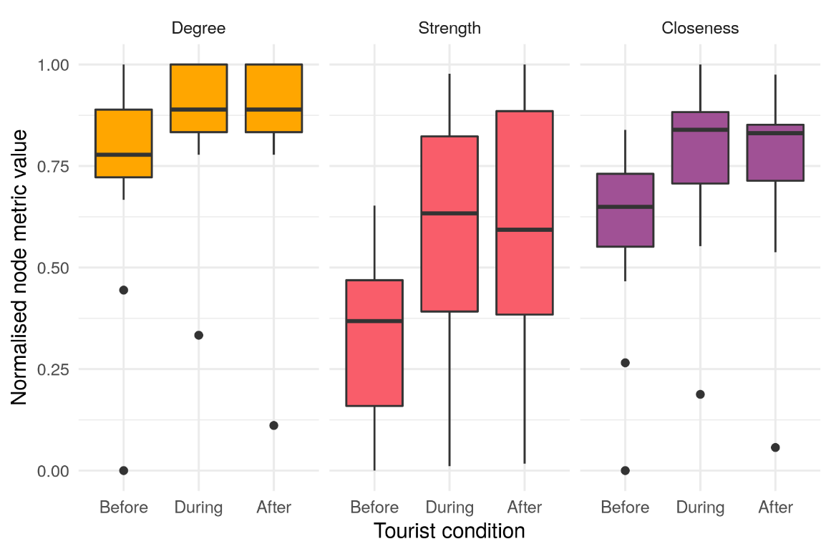
Figure 1. Group`s average node degree, strength and closeness observed before, during and after tourist visits.

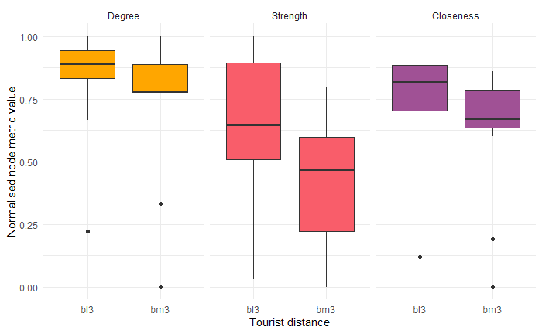
Figure 2. Changes in the group`s average node degree, strength and closeness observed in function of distance between focal gorilla and tourists (≤3 m or >3 m).
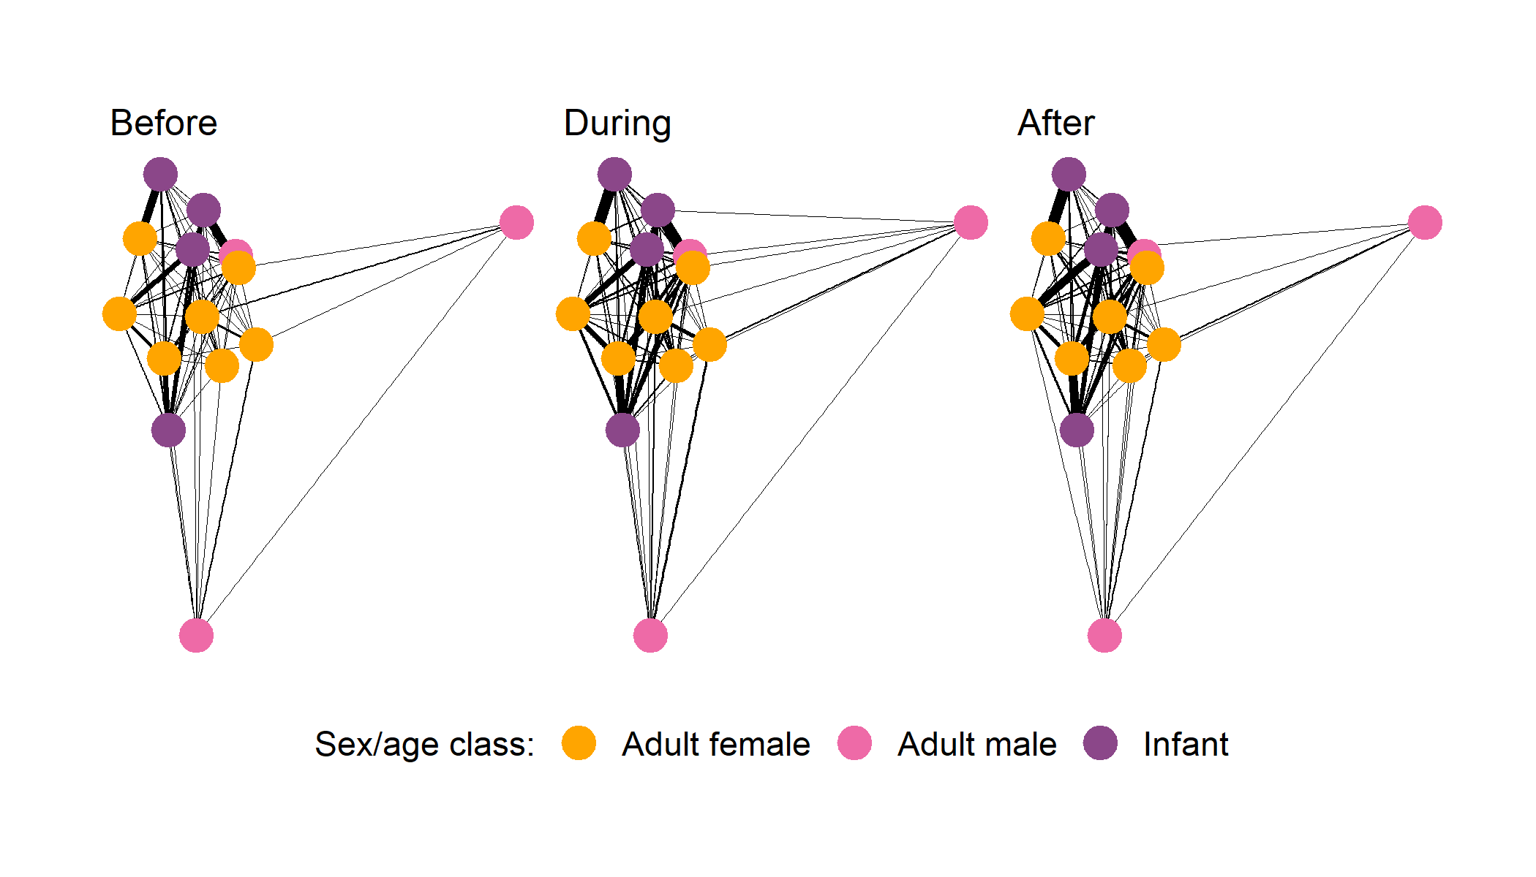
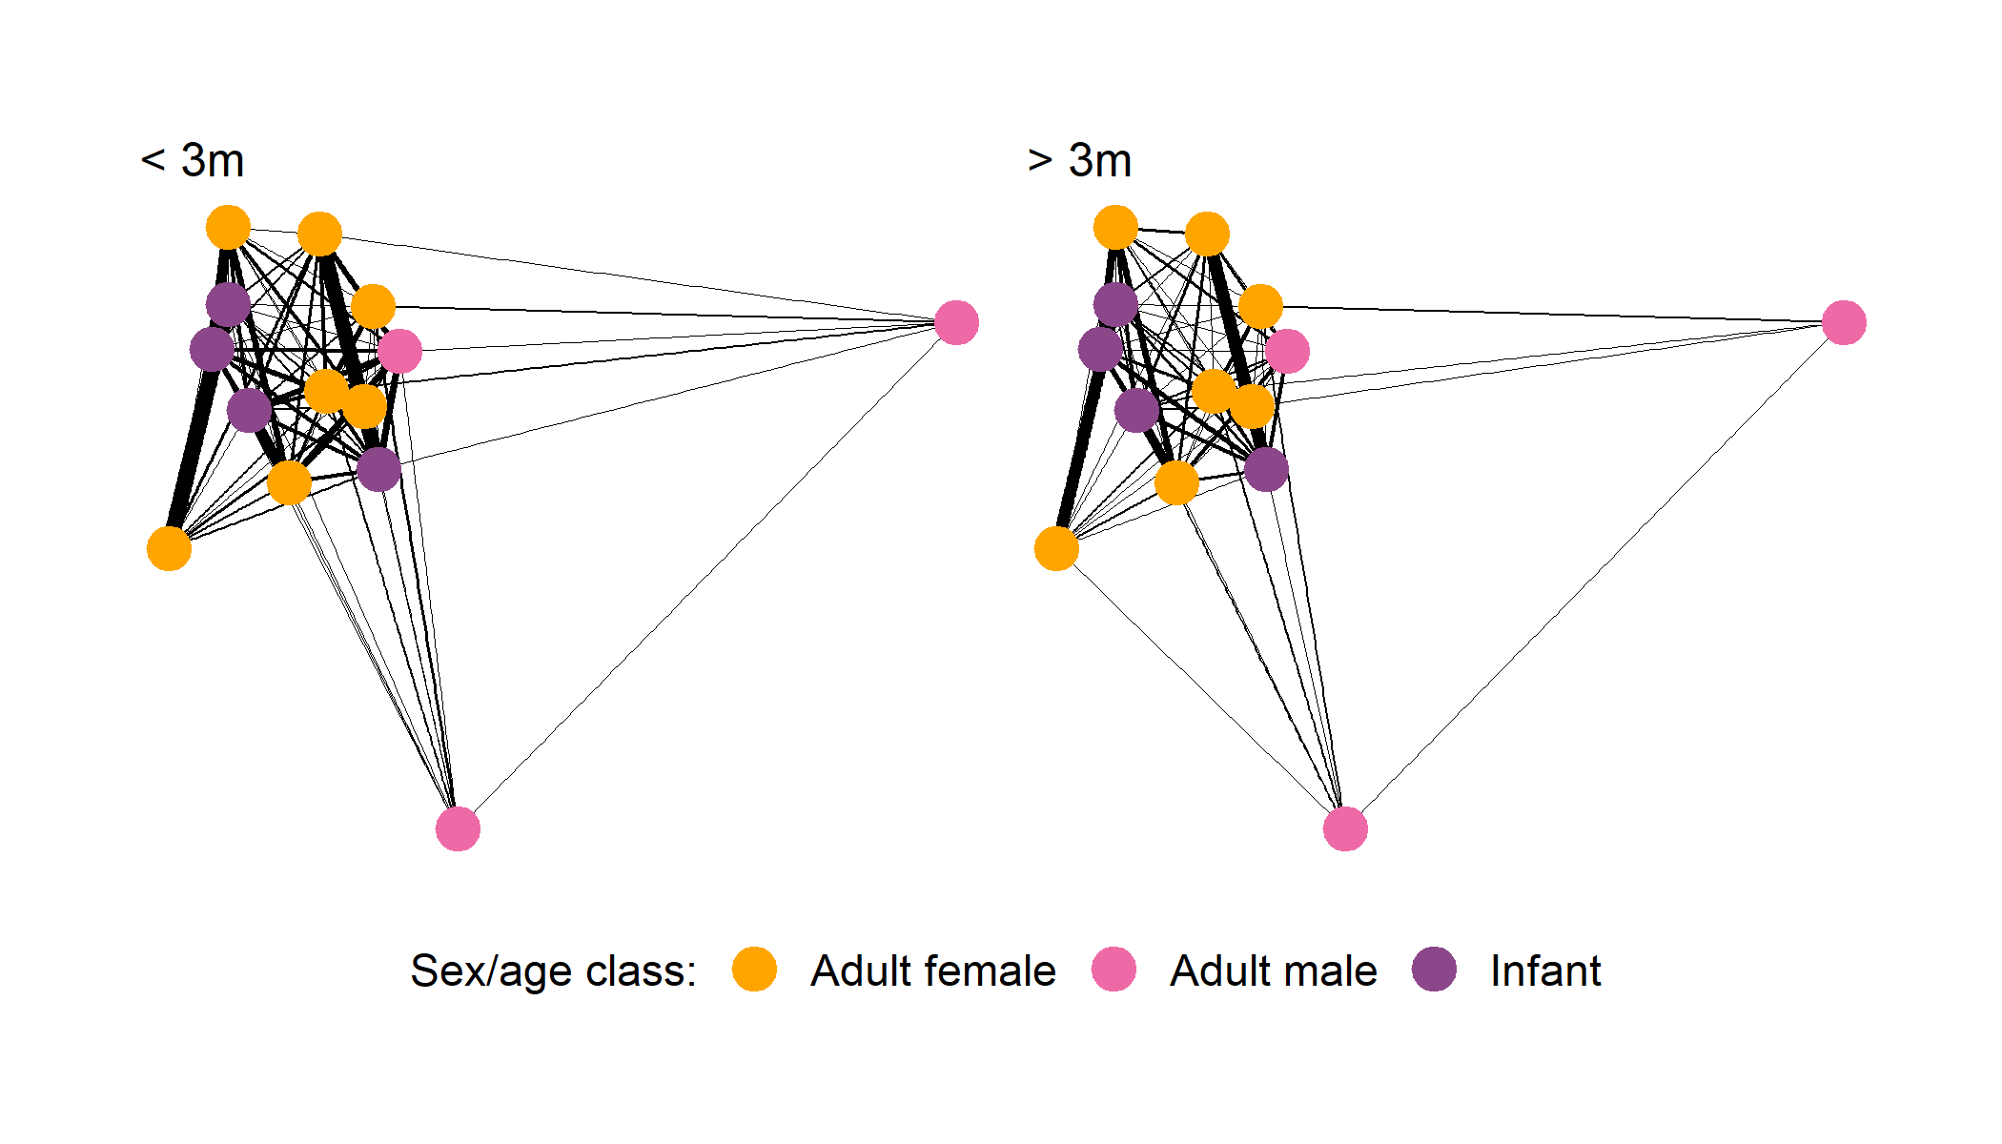
Figure 3. Social networks of wild mountain gorillas (a) before, (b) during and (c) after tourist visits, as well as (d) within 3m and (e) beyond 3m from the tourists during visits by age-class. Networks were constructed using R package “ggraph”. Yellow nodes represent adult females, pink nodes represent adult males and purple nodes represent infants (unknown sex). The lines represent the connections between individuals and its thickness is related to the individual strength.

