Multi-level instrumentation of bivouac thermoregulation:
Current methods and future directions

Kaitlin M. Baudier¹, Theodore P. Pavlic²

¹ School of Biological, Environmental & Earth Sciences, The University of Southern Mississippi (corresponding author)
² School of Computing and Augmented Intelligence; School of Sustainability; School of Complex Adaptive Systems, Arizona State University

Abstract: Army ants are frequently used as charismatic organismal representatives of collective behavior in nature, providing templates for modern engineered systems as well as continuing to drive aspirational goals for the engineered systems of the future. Most attention on army ants has been focused on the ability of groups of ants to self-assemble into adaptive structures such as bridges or even whole-colony bivouacs (living nests) that provide shelter and protection. Less attention has been paid to the demonstrated abilities of these large-scale army-ant structures to thermoregulate, which is a particularly notable adaptation given that each individual ant has limited ability to regulate her own body temperature. Understanding the emergence of group-level thermoregulation from inexpensive components provides significant opportunities for engineered systems but also requires surmounting significant instrumentation challenges. Here, we review what is known about army-ant thermoregulation, what is currently possible in terms of multi-scale instrumentation, and what important gaps need to be filled to advance the field further.

Keywords: Collective behavior, Dorylinae, Homeostasis, Methodology, Thermal performance, Thermal regulation

1 INTRODUCTION
Social insects form a variety of striking and adaptive self-assemblages [3]. Army ants perform a particularly wide array of well-studied collective behaviors which include different forms of self-assembly [4-8]. This group of ants are group-foraging, nomadic predators [9, 10]. Due to their nomadism, army-ant colonies are constantly tackling the challenge of living in unfamiliar and changing environments, making them interesting biological models for studying robust mechanisms that preserve colony homeostasis across significant environmental variation. Bioinspired designs have arisen from investigations elucidating both the adaptive function of army-ant assemblages as well as the mechanistic rules for how they perform [11]. Here, we explore a case in which the entire colony is the self-assemblage: army-ant “bivouacs.”
Army ants are any species of ant that possess three qualifying characteristics: 1) group hunting (raiding), 2) the founding of new colonies by splitting the worker force among typically flightless queens, and 3) colony nomadism (frequent nest relocation) [12]. Army-ant syndrome has convergently evolved in several lineages of carnivorous ants, the largest of which are in the mostly pantropical subfamily Dorylinae [13]. Because all army ants are nomadic, all have mobile nests termed “bivouacs”. However, most army ants have subterranean bivouacs that are less well described in terms of homeostasis or even form, with some exceptions [14-16]. The aboveground bivouacs of army ants in genus Eciton are far better described and will be the focus of this review. However, the potential for comparative studies of bivouac form and function is great, especially given evolutionary convergence on bivouacking across distant ant subfamilies.
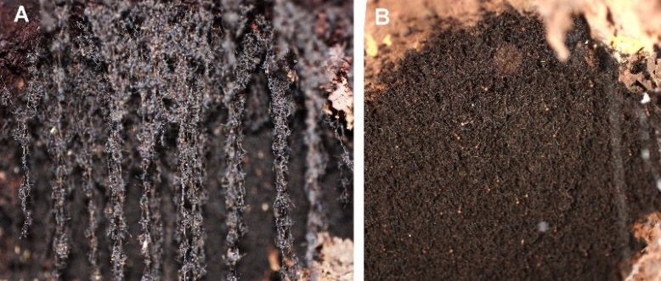

Figure 1. (A) Strands of ants visible in a newly forming bivouac of E. burchellii parvispinum. (B) The same bivouac several hours later. (Photos: Kaitlin Baudier)

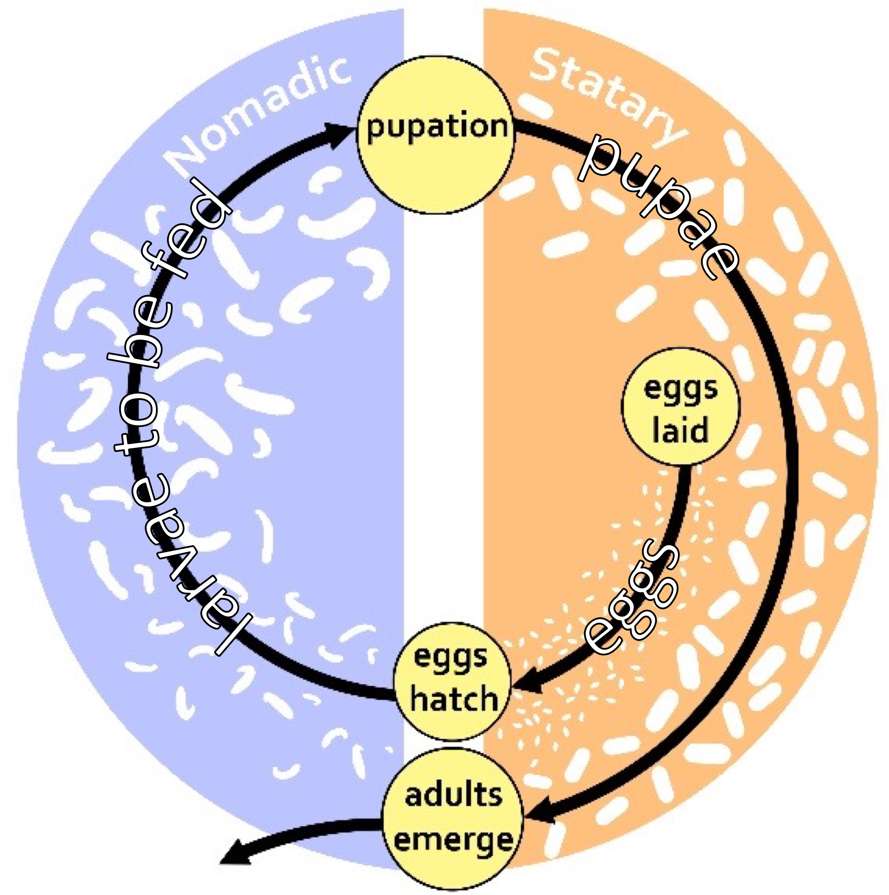
The aboveground bivouacs of Eciton burchellii and Eciton hamatum are among the largest self-assembled social-insect structures and assume the role that non-living nest materials play for other ants (and other social-insect taxa, such as honeybees). When not raiding, the entire army-ant colony is part of the bivouac – a large, three-dimensional structure built entirely of linked bodies of ants that functions to provide shelter to those ants (Fig. 1). In E. burchellii, as many as 500,000 adults and 30,000 juveniles coordinately join together to form a bivouac [9, 10]. Bivouacs disassemble fully during emigrations (i.e., nomadic colony relocations) and partially during raids. The supporting scaffolds of these bivouacs are vertical “strands” of ants that link together by grasping tarsal claws (Fig. 1A) [7].
Figure 2. Diagram showing the bi-phasic cycle of army-ant colony movements and their association with brood development. Illustration adapted from Baudier [17].
According to brood-stimulation theory, the timing of bivouac assembly, disassembly, and reassembly follows the shadow of the timing of brood-stage development in the colony [17]. In particular, for species that lay synchronous broods (such as those in genus Eciton), each cohort progresses together through three discrete stages of development – when nearly all brood in the cohort are eggs, when nearly all are larvae, and when nearly all are pupae. The eggs of the next cohort are laid part-way through the pupal stage of the previous cohort. This means that at any one instant, a bivouac houses only larvae, only pupae, or a mix of pupae and eggs (Fig. 2). Only larvae need to be fed, which provides the main cyclic forcing function leading to bivouac mobility in search of food to supply the larval demand [17]. More raiding and emigrating take place when the bivouac houses hungry larvae (the mobile, nomadic phase) than when the bivouac houses non-feeding pupae and eggs (the immobile, statary phase) [18].
Army ants within these enormous, complex, and mobile structures coordinate much like cells in a body to allow the bivouacs to achieve adaptive functions beyond the ability of the individual. Not only do these ants coordinate the collective motion of the bivouac during the nomadic phase, but they also regulate internal characteristics important to bivouac function within both the statary and nomadic phases. Although collective motion and collective assembly have received the most attention from nature-inspired engineers [11], there is much potential to learn from the decentralized mechanisms that achieve homeostasis within the assembled bivouacs – regulating variables important to colony function against the background context of uncertain and dynamic environmental disturbances. In this paper, we focus on the self-organized regulation of bivouac temperature and the practical challenges to instrumenting it for detailed study.

2 BIVOUAC THERMOREGULATION
Army-ant colonies contend with highly variable climates as they emigrate across wide expanses, but they also face within-site diel and seasonal fluctuations. Ambient air temperature measured at a statary bivouac of E. burchellii dropped from 49.6˚C to 25.1˚C as the rainy season began in Guanacaste, CR (unpublished data). Nightfall also routinely exposes tropical montane and temperate bivouacs of Labidus praedator to temperatures as low as 14˚C and 9˚C respectively [14,15]. As such, a major function of army-ant bivouacs is the construction and maintenance of an internal microclimate conducive to brood development [1, 19, 20].
Endothermy resulting in thermal homeostasis is an emergent property of army-ant bivouacs. The physiology of individual ants (particularly their small size) requires them to thermally conform to environmental temperatures when operating alone. Thus, individual ants, which have an extremely variable body temperature, act in concert so that the bivouac built from thousands of their linked bodies approximates a large, endothermic superorganism. Together, army ants use a suite of strategies to optimize brood development by keeping bivouacs generally warmer, higher humidity, and less variable than the external environment [19, 20]. This is achieved via passive and active means [21].
Site selection is an important passive mechanism of bivouac thermoregulation (Fig. 3A). That is, in the hierarchy of thermal regulation, effective decentralized agreement on a bivouac site reduces the lower-level challenges of regulating temperature once assembled on that site. A new bivouac site is chosen collectively by workers during the previous day’s raid [7, 22]. Site choice varies across elevations and appears to be especially important for cooling in hot climates [2, 23]. Eciton burchellii in the humid sites where they predominantly occur are more likely to bivouac in trees at low elevations to enhance convective cooling [23]. However, E. burchellii parvispinum found in especially arid low-elevation regions are more likely to choose subterranean bivouacking sites in burrows to avoid severe, midday dry heat spikes aboveground [2]. When designing artificial collectives that adaptively thermoregulate, a lesson from army ants is that one collective problem to solve is how to search and come to consensus on a site that avoids introducing extreme challenges to maintaining homeostasis. Studying army-ant site selection in more detail can provide insights into search heuristics and selection consensus mechanisms that help to ensure convergence on a site with relatively few thermal challenges.
Once situated, bivouacs can also actively regulate internal temperature by modifying the amount that the bivouac metabolically warms by more than a factor of 10, responsive to local ambient temperatures [2] (Fig. 3B). Although the amount of metabolic heat produced by a single ant is insufficient to raise its body temperature above that of ambient, collective metabolic heat when ants are in a bivouac is sufficient to warm brood in a manner similar to how cells function within a large-bodied endotherm. Modification of metabolic warming at the group level has been highly studied in winged social insects (e.g., honeybees) that can twitch flight muscles to increase warming or fan wings to relieve overheating [21, 24, 25], but precisely how this is accomplished by a group of wingless army ants remains an open question. Thus, in the design of artificial collectives that thermoregulate, army ants may provide novel strategies for collective temperature regulation that do not require specialized fanning/warming hardware. Furthermore, when compared to cavity-nesting Apis mellifera honeybees (for which relatively more is known about collective thermoregulation), open-nesting army ants are potentially a better macroscopic, observable model for the kind of thermoregulatory processes that take place in large multicellular organisms (e.g., the human body). Whereas A. mellifera individuals lack significant morphological diversity and build semi-permanent nests that incorporate non-living wax combs that are embedded within discovered cavities, army ants (like multicellular organisms) are heterogeneous aggregations of many different types of living units within a body whose external surface is exposed to challenges from the outside environment. When considering large, complex artificial aggregates (e.g., flexible manufacturing systems or autonomously constructed and maintained multi-robot assemblages in space-exploration applications), army-ant tactics for harvesting or evacuating heat may be more instructive than the examples from winged insects that heat or cool through activation of flight muscle.
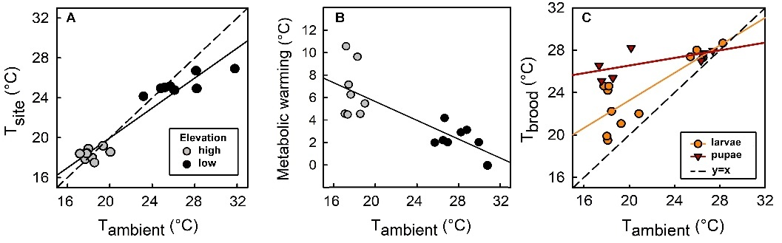

Figure 3. Modified from Baudier et al. [2]. (A) Selected sites are significantly cooler than ambient (Slope significantly < 1; α = 0.05). (B) Estimated additional active bivouac warming from individuals after subtracting site effects. (C) Total thermoregulation according to brood type. Pupal slope not significantly different from 0. Larval slope > 0 and < 1 (α = 0.05).
The thermoregulatory abilities of army ants are modulated by a high level of diversity amongst colony members. Army-ant colonies are a heterogeneous team of individuals, showing remarkable morphological differentiation between sexes, queens versus workers, and even among worker sub-castes [9, 26, 27]. Within each morphotype, individuals also range in age from eggs to senescing adults. There is evidence that both of these factors are associated with differences in thermal tolerance limits among army ant workers [14, 28]. The weak-link hypothesis predicts that the most thermally vulnerable (weakest link) group members are the most limiting to cooperative function, and so when social insects evolve to occupy more thermally variable environments, this should coincide with adaptations that reduce costs incurred by the most thermally vulnerable individuals [29]. Consistent with the weak-link hypothesis, particularly thermally vulnerable callow workers (very young adults) of the army ant Labidus praedator appear to be housed in more thermoregulated portions of bivouacs [14], and army-ant species adapted to more thermally variable microhabitats have especially heat- and cold-tolerant small workers [28, 30]. However, the most thermally vulnerable individuals within an army-ant colony are likely the brood. In other juvenile hymenopterans, small deviations in pupal rearing temperature can impact adult neural function [31-33]. Consistent with this, statary bivouacs that house pupae tend to be more tightly thermoregulated than larval (nomadic) bivouacs [2] (Fig. 3C). This is consistent with temporal heterothermy, the energy-saving strategy of switching between tightly self-regulating internal temperatures in one period of life and allowing more external forcing in another period, which is used by mammals that experience torpor during overwintering [34, 35]. Thus, army ants provide a novel model for understanding the challenges and opportunities related to operating cohesive heterogeneous collectives. Variability across components in a collective at any given time means individuals that adjust their behaviors to regulate conditions for maximal performance of other individuals may do so at a performance cost to themselves. Variability over time means that tight regulation may sometimes be able to be relaxed to save energy or meet the needs of another. Overall, variability may be a resource that can be capitalized on – with some individuals that may be less thermally tolerant but better suited for certain colony tasks able to benefit from the increased thermal tolerance of others that are not as well suited for those same colony tasks. A better understanding of how army-ant colonies make use of and respond to variability across individuals can provide novel ideas for how to use (or cope with) heterogeneity in long-run operations of autonomous collectives.

3 INSTRUMENTING BIVOUAC THERMOREGULATION
As described in Section 2, the phenomenon of thermoregulation in army-ant colonies has much potential to be a model for understanding robust homeostatic processes in collectives in general (both natural and artificial). Although army-ant bivouacs (particularly those of E. buchellii) are large and conspicuous, there are still significant challenges to instrumenting them so as to better understand their mechanisms and functional principles. In this section, we describe what has been done and where there is room for improvement. Just as engineers may be able to benefit from lessons learned from army ants, army-ant researchers may be able to benefit from novel technologies that can mitigate the present challenges to bivouac instrumentation.
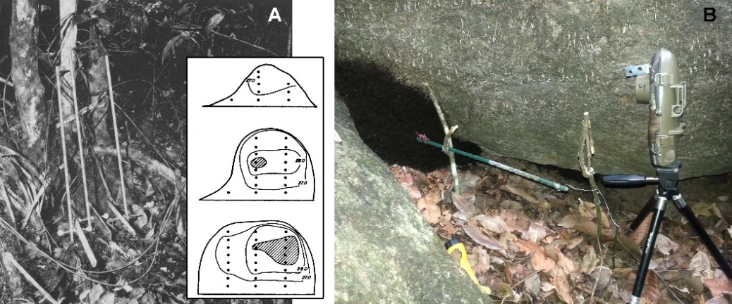
Figure 4. (A) Modified from Jackson [1], an array of thermal probes used to characterize internal bivouac isoclines. (B) Similar use of a transect of temperature and humidity loggers inserted into a bivouac through the middle of the brood core [2].

3.1 Tracking Army-Ant Colonies
Tracking army-ant colony position (and thus bivouac position) is important for understanding the dynamics of bivouac site selection as well as the typical thermal challenges emerging from the selected sites. For larger animals that are solitary or live in smaller societies (e.g., vertebrates that periodically relocate), radio- or GPS-based trackers might be used to assist in locating and/or logging movements in the field. However, army-ant colonies consist of large numbers of ants that are individually too small to be tagged with powered beacons or data loggers. Moreover, bivouacs can travel too far for lightweight, remotely powered beacons (e.g., RFID’s) to be in detection range even if it is hypothetically possible to attach those beacons to enough individuals to ensure that losing an individual (or beacon) would not cause the whole colony to be lost. Consequently, field-based tracking of bivouac movement currently requires significant direct human involvement. Because army-ant raid fronts are typically connected continuously via a column of trailing workers to the bivouac, trail walking can be used to locate bivouacs of aboveground species [36]. This can even be performed systematically to estimate relative aboveground army-ant density across sites [37]. When a raid column is encountered, following the column in the direction of carried food leads to the bivouac [36]. Once at the bivouac, the next task is to assess how long the colony will remain in that location. Emigration columns typically have much higher, unidirectional traffic flow than raid columns and contain large quantities of brood. If a colony is not currently emigrating, the brood age can be checked directly by the high-disturbance method of cutting into the bivouac with a machete [36]. Alternatively, either a negligible mound of waste or a midden pile covered in thousands of discarded pupal cases indicate that the phase is nomadic and that emigration will likely occur within 24 hours. A substantial midden pile without discarded pupal cases indicates that the colony is in the statary phase and will not emigrate soon. Checking on nomadic colonies in the afternoon to evening and following emigrations to new bivouac locations ensures that subject colonies can be found the next day.
Table 1. Summary of E. burchellii parvispinum bivouac size data (n = 34 bivouacs) [2]

Dimension | Mean ± SD | Min | Max
height (cm)  width (cm)  depth (cm)  volume (cm³)  brood depth (cm) | 23.69 ± 8.21  25.46 ± 11.21  34.47 ±14.67  12227 ± 10693  15.98 ± 7.95 | 8  3  8  268  0.15 | 45  48  75  43312  31

Researchers first used string tied to stakes or simply counted steps to estimate emigration and raid paths and lengths [7, 20, 36]. The string method had been used to prevent the researchers themselves from getting lost while tracking ants through thick tropical forest [29]. Subsequent studies marked the forest out into a grid of hectare squares, tracking colony activity among them [18, 38]. More recently, hand-held GPS units have become the default tool for these tasks [2]. However, on-foot daily bivouac checking remains labor intensive, and the development of tools that allow individual colonies to be tracked remotely remains appealing. Studies of army-ant population genetics have more recently addressed questions of how army-ant colonies disperse across landscapes (e.g., across large waterways [39] and through mountaintop forests [40, 41]). Modern genomics approaches have been used to reveal traces of army-ant movement patterns during closing of the isthmus of Panama several million years ago [42].

3.2 Quantifying Internal Bivouac Microclimates
Early studies of bivouac microclimates used Bristol drum-type continuous recording hygrothermographs [20] or Wessor TH 65 thermocouple difference thermometers [19] to measure temperature and relative humidity inside and outside of bivouacs. However, exact probe placement within bivouacs can be complicated by tremendous variation in bivouac size, shape, attached substrates, and brood depth (Tab. 1) [2, 19, 20]. Internal thermal isoclines also vary widely across bivouacs, as first revealed by Jackson [1], who inserted mercury-in-glass thermometer arrays into planar sections of E. hamatum bivouacs (Fig. 4A). More recent studies have used I-button® temperature and humidity loggers fastened onto a thin dowel inserted into bivouacs to characterize the gradient between the warmest and most thermally stable internal portions of the bivouac as well as the relatively more variable outer layers of bivouac [2, 14]. Digital loggers allow for monitoring both relative humidity and temperature at multiple bivouacs simultaneously and produce downloadable digital outputs. However, all these methods share the same problem. Namely, if the function of the bivouac is primarily to thermoregulate the brood, then it is essential to know the temperatures within the bivouac that the brood are experiencing specifically. Baudier et al. [2] dealt with this issue by periodically checking by hand the position of brood relative to the probe transect and using small time-lapse game cameras to continuously monitor shifts in bivouac shape and position from the outside over time (Fig. 4B).
Key also to quantifying bivouac thermoregulation is having a comparable set of ambient measurements. For aboveground army-ant species, ambient temperature and humidity probes have been placed immediately external to the bivouac surface (which is less than ideal because it is often subject to warming from the nearby bivouac), on the forest floor some meters away or at a similar height above ground as the probes inserted into the bivouac itself [1, 2, 20]. Similarly, probes placed at the same depths below ground as subterranean bivouacs can provide useful simultaneous comparisons [14]. Apparatuses put in place to monitor internal bivouac conditions can also easily be left in place following colony emigration to characterize the effect of nest-site selection on overall bivouac thermoregulation [1, 2].
One limitation of current bivouac thermal instrumentation is the difficulty of measuring individual behaviors that construct this collective thermoregulatory assembly. Because of how densely packed ants are within bivouacs and the tendency of workers to cling to any introduced surfaces, it is difficult to continuously monitor the internal movement of individuals even when using endoscopic cameras (pers. obs.). Continuously slicing into a bivouac may also disrupt the processes one might hope to observe. Developing less invasive methods for tracking individuals three dimensionally within bivouacs would allow for tests of hypotheses related to how individual decisions construct bivouac homeostasis. In some cases, these measurements could be coarser grained than at the level of every individual. For instance, a relatively large amount of ant movement between the hot bivouac center and areas near the cooler surface of the bivouac could help shed heat, equilibrating across bivouac depths in hot environments where bivouac site temperature is already near to optimal brood temperature. Less of such cross-depth movement could have an insulating effect in cooler temperature environments, aiding colonies in boosting central bivouac temperature. At finer scales, developing low-impact ways to count ants within a bivouac or methods to finely approximate bivouac density (ants per volume) would provide opportunities to further explore bivouac density and colony size as factors in thermoregulation. Recently developed portable computed tomography units may begin to provide this capability [43, 44].
Ultimately, being able to directly manipulate the microclimate of army-ant bivouacs would help to provide compelling evidence for or against different thermoregulation hypotheses. In principle, this could be done by heating or cooling whole bivouacs or even introducing devices into the middle of bivouacs to alter the temperature of finer-scale regions or setup temperature gradients across the colony. At this time, we know of no existing published research that has pursued these approaches (which would be associated with significant technical challenges). Thus, an important future research direction is to develop tools and techniques that allow for direct manipulation of temperatures around and within bivouacs.

3.3 Accounting for Diverse Thermal Needs Across Colony Members
Another challenge to understanding what problems bivouac thermoregulation solve is a lack of information regarding heterogeneous thermal needs of colony members, especially those of brood. Critical thermal maxima and minima (so-called CT_{max} and CT_{min}, respectively) are widely used to assess the bounds of functional operative temperatures in adult animals, but these are typically determined via visual changes to motor function (e.g., loss of mobility or onset of spasms as the individual is subjected to a wide range of different temperatures) [45, 46]. These approaches are not useful to estimate critical limits of small and essentially immobile ant brood. Assessment of long-term army-ant brood survival at different temperatures is also challenging due to high mortality when brood are separated from workers as well as the abnormal behavior of small numbers of workers when they are separated from the colony (pers. obs.). Circumventing these issues may require the use of non-movement associated indicators of the onset of thermal stress or improving colony and brood survival in a lab setting, such as temperature- (and humidity-) dependent respirometry.

4 CONCLUSIONS
In this paper, we have called for more attention to the thermoregulatory capabilities of army-ant bivouacs. Collective thermoregulation by itself may be a desirable feature in artificial collectives, such as complex robotic assemblages operating in environments where temperatures are high or simply highly variable, as in certain manufacturing systems as well as space-exploration contexts. Furthermore, collective thermoregulation serves as a model for homeostasis more generally. Long-term collective autonomy will require systems to adaptively respond to environmental fluctuations so as to maintain internal environmental conditions within operational constraints. Understanding the general homeostatic principles operating within thermoregulating army ants can help to inspire novel homeostatic approaches for future artificial collectives. Moreover, understanding the hierarchical solutions at play in an army-ant colony (e.g., passive thermoregulation by site selection before active thermoregulation through changes in internal organization) highlights other more general problems (e.g., collective search and consensus on an aggregation site).
The existence alone of thermoregulating army ants may be inspirational to engineers and computer scientists, and this paper may increase the exposure of that community to these organisms. That said, more specific lessons relating to the particular mechanisms that the army ants use to achieve collective thermoregulation (as well as the many adaptive functions related to thermoregulation itself) will require continued development of instrumentation tools that provide more detailed descriptions of their behavior and tests of hypotheses. Over time, new technologies have been developed that have aided scientists in this regard. However, more interest from engineers and computer scientists may lead to a further development of novel tools tailored for the unique problems of instrumenting and manipulating army-ant bivouacs. Thus, like poikilothermic army ants joining together to form endothermic bivouacs, the combination of scientists and engineers over the problem of army-ant thermoregulation can have synergistic benefits for all involved.

REFERENCES
1. Jackson, W.B., Microclimatic patterns in the army ant bivouac. Ecology, 1957. 38(2): p. 276-285.
2. Baudier, K.M., et al., Plastic collective endothermy in a complex animal society (army ant bivouacs: Eciton burchellii parvispinum). Ecography, 2019. 42(4): p. 730-739.
3. Anderson, C., G. Theraulaz, and J.-L. Deneubourg, Self-assemblages in insect societies. Insectes sociaux, 2002. 49(2): p. 99-110.
4. Powell, S. and N.R. Franks, How a few help all: living pothole plugs speed prey delivery in the army ant Eciton burchellii. Animal Behaviour, 2007. 73(6): p. 1067-1076.
5. Reid, C.R., et al., Army ants dynamically adjust living bridges in response to a cost–benefit trade-off. Proceedings of the National Academy of Sciences of the United States of America, 2015. 112(49): p. 15113-15118.
6. Baudier, K.M. and T.P. Pavlic, Incidental interactions among Neotropical army-ant colonies are met with self-organized walls of ants (Hymenoptera: Formicidae). Myrmecological News, 2020. 30.
7. Schneirla, T.C., Studies on Army Ant Raids in Panama. Journal of comparative psychology, 1933. 15: p. 267.
8. McCreery, H.F., et al., Hysteresis stabilizes dynamic control of self-assembled army ant constructions. Nature Communications, 2022. 13(1): p. 1-13.
9. Gotwald Jr, W.H., Army Ants: The Biology of Social Predation. 1995: Cornell University Press. 302.
10. Kronauer, D.J.C., Army Ants, in Encyclopedia of Social Insects, C.K. Starr, Editor. 2019, Springer International: Switzerland.
11. Malley, M., et al. Eciton robotica: Design and algorithms for an adaptive self-assembling soft robot collective. in 2020 IEEE International Conference on Robotics and Automation (ICRA). 2020. IEEE.
12. Kronauer, D.J., Army Ants: Nature's Ultimate Social Hunters. 2020, Cambridge, MA: Harvard University Press. 368.
13. Borowiec, M.L., Convergent evolution of the army ant syndrome and congruence in big-data phylogenetics. Systematic biology, 2019. 68(4): p. 642-656.
14. Baudier, K.M. and S. O’Donnell, Structure and thermal biology of subterranean army ant bivouacs in tropical montane forests. Insectes Sociaux, 2016. 63(3): p. 467–476.
15. Fowler, H.G., Notes on Labidus praedator (Fr. Smith) in Paraguay (Hymenoptera: Formicidae: Dorylinae: Ecitonini). Journal of Natural History, 1979. 13(1): p. 3-10.
16. Berghoff, S., et al., Nesting habits and colony composition of the hypogaeic army ant Dorylus (Dichthadia) laevigatus Fr. Smith. Insectes sociaux, 2002. 49(4): p. 380-387.
17. Baudier, K.M., Brood Stimulation Hypothesis, in Encyclopedia of Social Insects, C.K. Starr, Editor. 2019, Springer International: Switzerland.
18. Teles da Silva, M., Behaviour of the army ant Eciton burchellii Westwood (Hymenoptera: Formicidae) in the Belém region. I. Nomadic-statary cycles. Animal Behaviour, 1977. 25: p. 910-923.
19. Franks, N.R., Thermal Regulation in Army Ant Bivouacs. Physiological Entomology, 1989. 14(4): p. 397-404.
20. Schneirla, T.C., R.Z. Brown, and F.C. Brown, The Bivouac or Temporary Nest as an Adaptive Factor in Certain Terrestrial Species of Army Ants. Ecological Monographs, 1954. 24(3): p. 269-296.
21. Jones, J.C. and B.P. Oldroyd, Nest thermoregulation in social insects. Advances in Insect Physiology, 2006. 33: p. 153-191.
22. O’Donnell, S. and T.P. McGlynn, Emigrating on the fly: a novel method of army ant colony movement observed in Eciton mexicanum. Journal of Insect Behavior, 2017. 30(5): p. 471-474.
23. Soare, T.W., et al., Choice of nest site protects army ant colonies from environmental extremes in tropical montane forest. Insectes Sociaux, 2011. 58(3): p. 299-308.
24. Thapa, R. and S. Wongsiri. Distinct fanning behaviour of two dwarf honeybees Apis andreniformis (Smith) and Apis florea (Fab.). in Proceedings of Second International Conference of the Asian Apicultural Association. 1994.
25. Ono, M., et al., Unusual thermal defence by a honeybee against mass attack by hornets. Nature, 1995. 377(6547): p. 334-336.
26. Franks, N.R., Reproduction, foraging efficiency and worker polymorphism in army ants. Experimental behavioral ecology and sociobiology, ed. B. Hölldobler and M. Lindauer. 1985.
27. Powell, S. and N.R. Franks, Ecology and the evolution of worker morphological diversity: a comparative analysis with Eciton army ants. Functional Ecology, 2006. 20(6): p. 1105-1114.
28. Baudier, K.M., et al., Microhabitat and body size effects on heat tolerance: implications for responses to climate change (army ants: Formicidae, Ecitoninae). Journal of Animal Ecology, 2015. 84(5): p. 1322-30.
29. Baudier, K.M. and S. O’Donnell, Weak links: How colonies counter the social costs of individual variation in thermal physiology. Current opinion in insect science, 2017. 22: p. 85-91.
30. Baudier, K.M., et al., Extreme insolation: Climatic variation shapes the evolution of thermal tolerance at multiple scales. The American Naturalist, 2018. 192(3): p. 347-359.
31. Becher, M.A., H. Scharpenberg, and R.F.A. Moritz, Pupal developmental temperature and behavioral specialization of honeybee workers (Apis mellifera L.). Journal of Comparative Physiology A, 2009. 195(7): p. 673-679.
32. Jones, J.C., et al., The effects of rearing temperature on developmental stability and learning and memory in the honey bee, Apis mellifera. Journal of Comparative Physiology A, 2005. 191(12): p. 1121-1129.
33. Groh, C., J. Tautz, and W. Rössler, Synaptic organization in the adult honey bee brain is influenced by brood-temperature control during pupal development. Proceedings of the National Academy of Sciences, 2004. 101(12): p. 4268-4273.
34. Puchalski, W., et al., Photoperiod, temperature and melatonin effects on thermoregulatory behavior in Djungarian hamsters. Physiology & behavior, 1988. 42(2): p. 173-177.
35. Hut, R., B. Barnes, and S. Daan, Body temperature patterns before, during, and after semi-natural hibernation in the European ground squirrel. Journal of Comparative Physiology B, 2002. 172(1): p. 47-58.
36. Rettenmeyer, C.W., Behavioral Studies of Army Ants. University of Kansas Science Bulletin, 1963. 44(9): p. 281-465.
37. O’Donnell, S. and A. Kumar, Microclimatic factors associated with elevational changes in army ant density in tropical montane forest. Ecological Entomology, 2006. 31(5): p. 491-498.
38. Teles da Silva, M., Behaviour of army ants Eciton burchellii and E. hamatum (Hymenoptera, Formicidae) in the Belem region III. Raid activity. Insectes Sociaux, 1982. 29(2): p. 243-267.
39. Berghoff, S.M., et al., Dispersal and population structure of a New World predator, the army ant Eciton burchellii. Journal of Evolutionary Biology, 2008. 21(4): p. 1125-1132.
40. Soare, T.W., et al., Genetic evidence for landscape effects on dispersal in the army ant Eciton burchellii. Molecular ecology, 2014. 23(1): p. 96-109.
41. Soare, T., et al., Multi-year genetic sampling indicates maternal gene flow via colony emigrations in the army ant Eciton burchellii parvispinum. Insectes Sociaux, 2019. 67: p. 155-166.
42. Winston, M.E., D.J. Kronauer, and C.S. Moreau, Early and dynamic colonization of Central America drives speciation in Neotropical army ants. Molecular Ecology, 2017. 26: p. 859–870.
43. Schiffers, F., et al., Disassemblable Fieldwork CT Scanner Using a 3D-printed Calibration Phantom. arXiv preprint arXiv:2011.06671, 2020.
44. Bochynek, T., et al., Anatomy of a superorganism--structure and growth dynamics of army ant bivouacs. arXiv preprint arXiv:2110.09017, 2021.
45. Lutterschmidt, I. and V.H. Hutchison, The critical thermal maximum: data to support the onset of spasms as the definitive end point. Canadian Journal of Zoology, 1997. 75(10): p. 1553-1560.
46. Ribeiro, P.L., A. Camacho, and C.A. Navas, Considerations for assessing maximum critical temperatures in small ectothermic animals: insights from leaf-cutting ants. PLoS ONE, 2012. 7(2).

