Running title: Effects of an acute heatwave on barnacle beds

Extreme heatwave drives topography-dependent patterns of mortality in a bed-forming intertidal barnacle, with implications for associated community structure
Amelia V. Hesketh^{1*} and Christopher D.G. Harley^{1,2}
- Department of Zoology, University of British Columbia, 4200-6270 University Blvd., Vancouver, BC, V6T 1Z4

- Institute for the Oceans and Fisheries, University of British Columbia, 2202 Main Mall, Vancouver, BC, V6T 1Z4

* Corresponding author: avhesketh@gmail.com

Abstract
Heatwave frequency and intensity will increase as climate change progresses. Intertidal sessile invertebrates, which often form thermally benign microhabitats for associated species, are vulnerable to thermal stress because they have minimal ability to behaviourally thermoregulate. Understanding what factors influence the mortality of biogenic species and how heatwaves might impact their ability to provide habitat is critical. Here, we characterize the community associated with the thatched barnacle, Semibalanus cariosus (Pallass 1788), in British Columbia, Canada and attempt to determine what environmental factors — air temperature, time of low tide, shoreline orientation, algal cover, and the angle of solar incidence — explain variations in S. cariosus mortality induced by an unprecedented regional heatwave, the 2021 Pacific Northwest Heat Dome. Further, we used a manipulative shading experiment deployed prior to the heat dome to examine the effect of thermal stress on barnacle survival and recruitment and the barnacle-associated community. We identified 50 taxa inhabiting S. cariosus beds, with variations in species diversity and community composition between sites. Site-scale variables and algal canopy cover did not predict S. cariosus mortality, but patch-scale variation in substratum orientation did, with more direct solar irradiance corresponding with higher barnacle mortality. The shading experiment demonstrated that S. cariosus survival, barnacle recruitment, and invertebrate community diversity were higher under shades, where substratum temperatures were lower. Associated community composition also differed between shaded and non-shaded plots, suggesting S. cariosus was not able to fully buffer acute thermal stress for its associated community . While habitat provisioning by intertidal foundation species is an important source of biodiversity, these species alone may not be enough to prevent substantial community shifts following extreme heatwaves. As heatwaves become more frequent and severe, they may further reduce diversity via the loss of biogenic habitat, and spatial variation in these impacts may be substantial.

Keywords: British Columbia, facilitation, foundation species, heatwaves, intertidal zone, mortality, Semibalanus cariosus, topography

Introduction
Anthropogenic climate change is marked not only by increasing mean temperatures globally but also by longer, more frequent, and more severe heatwaves (Hoegh-Guldberg et al., 2018; Perkins-Kirkpatrick & Lewis, 2020). These shifting patterns in the thermal environment have far-reaching physiological and ecological consequences, as temperature is inextricably linked to organism performance through biochemistry and metabolism (Brown et al., 2004). This dependence is particularly important for ectotherms, which lack the physiological mechanisms to regulate their internal body temperature (Dillon et al., 2010; Riemer et al., 2018). Thermal extremes that exceed the physiological tolerance of organisms can lead to negative sublethal effects and mortality, making increases in thermal variability a potentially greater threat to organisms than increases in mean temperature (Vasseur et al., 2014).
Heatwaves occur when the 90th percentile of temperature, derived from historical baseline data, is exceeded for three or more days in the case of terrestrial heatwaves (Perkins & Alexander, 2013) or five or more days in the case of marine heatwaves (Hobday et al., 2016). Heatwaves have been implicated both directly and indirectly in the mortality of many ectotherms, among them corals (Babcock et al., 2020), fish (Genin et al., 2020), macroalgae (Román et al., 2020; Wernberg et al., 2013), mussels (Harley, 2008), oysters (Scanes et al., 2020), seagrasses (Arias-Ortiz et al., 2018), and, when concomitant with drought stress, grasses, forbs (De Boeck et al., 2018) and trees (Bussotti et al., 2021). The impacts of heatwaves on organisms can affect higher levels of biological organization by altering community structure (De Boeck et al., 2018; Pansch et al., 2018; Sorte et al., 2010) and homogeneity, as measured by beta diversity (Robinson et al., 2019), and by driving stochastic patterns in succession and community reassembly (Kreyling et al., 2011; Seifert et al., 2015). While the negative effects of heatwaves are evident, questions remain about what environmental factors and species traits shape mortality risk for populations exposed to heatwaves (Harvey et al., 2022) and how biological interactions may be affected.
The intertidal zone, at the intersection of marine and terrestrial systems, represents a thermally challenging landscape. Within the intertidal zone, where many organisms live near their thermal limits (Tomanek & Helmuth, 2002), there are often steeper thermal gradients found over metres of shore than on a broader latitudinal scale (Helmuth et al., 2006; Jurgens & Gaylord, 2018). While motile species can mitigate temperature stress by relocating to thermal refugia (e.g., Hayford et al., 2015; Reid & Harley, 2021) sessile foundation species that have no such recourse may be especially susceptible to heatwave impacts. For example, temperature can set the upper extent of distribution for certain intertidal sessile invertebrates (Harley, 2011). At a given shore level, small-scale topographic variation such as substratum orientation and angle and shading by physical features can affect solar irradiance and thus organism body temperature (Miller et al., 2009; Seabra et al., 2011), which can in turn drive patterns of organism mortality in response to thermal stress (Harley, 2008).
Many sessile invertebrate species facilitate epifaunal and infaunal communities by creating biogenic habitat (Barnes, 2000; Bracken, 2018; McAfee & Bishop, 2019; van der Ouderaa et al., 2021). In the intertidal zone, this habitat is often more thermally benign than the surrounding shore, and thus the importance of facilitation in promoting the survival of associated species may become more important as temperatures rise (Bulleri et al., 2016; Jurgens et al., 2021). For instance, the interstices created by Mytilus californianus mussel beds, which host some 300 species (Suchanek, 1992), are both cooler and more thermally stable than nearby rock clearings during summer (Jurgens & Gaylord, 2018). This dampening of thermal extremes, along with the moisture retention provided by M. californianus beds, results in greater survival of associated fauna within mussel beds compared to bare plots (Jurgens et al., 2021). Similar thermally mediated facilitations have been measured for other invertebrate foundation species including barnacles, a cosmopolitan intertidal taxon. In a subtropical high intertidal system, all limpets associating with barnacles survived a six-hour exposure to a 40 ºC simulated heatwave, while 100% mortality was observed when barnacles were absent (Cartwright & Williams, 2014). In addition to affecting temperature, heatwaves also increase desiccation stress (Straub et al., 2019), which barnacles may mitigate by retaining moisture. For example, in the desiccating environment of Argentinian Patagonia, areas with moisture-retaining barnacles host a greater abundance of pulmonate limpets than areas without barnacles (Hesketh et al., 2021). However, we do not fully know if there is an upper threshold of abiotic stress above which such positive interactions weaken or cease entirely. Thus, to understand how the function of a given foundation species will be altered by heatwaves, we must ask: can the foundation species in question able to survive heat stress, and, in places where it survives — which may depend on microclimatic conditions generated by habitat features or other foundation species in the system — can it continue to facilitate associated species under thermally challenging conditions?
The Pacific Northwest Heat Dome of 2021 (hereafter, ‘heat dome’ for brevity), which occurred in an area stretching from Oregon, USA, to northern British Columbia (BC), Canada, represented an enormous thermal challenge for both ecological and human communities throughout the region. In BC, the heat dome occurred between 25–29 June 2021 and exceeded historical mean maximum daily temperatures by over 18 ºC and 5 ºC along the inner and outer coasts, respectively (Climate Canada, 2022; see Fig. S1). These high temperatures coincided with some of the lowest mid-day tides and longest days of the year, generating lethal conditions for many sessile intertidal organisms. In this study, we seek to determine how the heat dome affected the survival of a common mid-intertidal foundation species in the northeast Pacific, the thatched barnacle Semibalanus cariosus (Pallass, 1788), and the composition of its associated community.
Semibalanus cariosus forms dense beds where it occurs in high abundance (Dayton, 1971). While not as speciose or diverse as co-occurring mussel beds, beds of S. cariosus are known to facilitate numerous species (Gosselin & Chia, 1995; Harley, unpublished data). Despite its importance as a facilitator, its ecological role remains understudied relative to other dominant spaceholders in this system. In this study, we sought to quantify the importance of S. cariosus as a facilitator across part of its distribution in coastal BC, which spans a well-characterized thermal gradient from cooler conditions on the temperate outer coast to thermally stressful conditions in the eastern portion of the Salish Sea (Harley, 2011). Further, we hoped to determine what factors, both among and within sites, might have contributed to heat dome-induced mortality patterns in this species along this gradient. We hypothesized that S. cariosus mortality would increase with several site-level factors: a) air temperature, since this would make it more likely that substratum exceeded the critical thermal maximum, b) the hour of the low tide, since tides occurring later in the afternoon would more closely overlap with maximum substratum temperatures, c) alignment of the shore relative to the solar azimuth, since shores facing towards to the solar azimuth are exposed to greater solar irradiance. At the quadrat level, we expected greater mortality with decreasing algal canopy, which mitigates thermal extremes, and at smaller angles of solar incidence — that is, on flatter shores facing towards the solar azimuth — where solar irradiance was most direct during the heat dome. We then used a factorial experiment with both a shading and barnacle removal treatment to measure how the community associated with S. cariosus, along with barnacle mortality and recruitment, varied according to differences in the prevailing environmental temperature. During our shading experiment, we expected that shades and the presence of barnacles would reduce substratum temperature, thereby increasing S. cariosus survival, barnacle recruitment, and the diversity of the associated algal and invertebrate communities. We also expected that associated fauna within S. cariosus beds would differ in composition between shaded and unshaded barnacle beds due to species-specific differences in thermal tolerance, and that communities inhabiting shaded barnacle beds would be more diverse.

Materials and Methods

Sampling locations
We performed surveys and collections of S. cariosus beds over a part of their distribution in coastal British Columbia, Canada (Fig. 1; Table S1) between 13 April 2021 and 11 September 2021. Most study sites were concentrated in the Salish Sea along the southern tip of Vancouver Island, with additional sites on BC’s central coast at Calvert Island. Shores were typically granitic bedrock aside from two sites in the Gulf Islands (TE and TK in Fig. 1), which were sandstone bedrock, two sites on Vancouver Island (BO and KE in Fig. 1) that were a mix of bedrock and pilings and bedrock and boulders, respectively, and a site near Vancouver, BC (TS in Fig. 1) that was a granitic boulder shore. Sites ranged in wave exposure, with the outer coast being more wave-exposed and waters toward the Strait of Georgia being more sheltered. Note that Indigenous place names, where known, are used throughout (Table S1).
Semibalanus cariosus is a long-lived mid-intertidal barnacle (Connell 1972) that commonly co-occurs with mussels (Mytilus spp.), smaller acorn barnacles (Balanus glandula and Chthamalus dalli), clonal anemones (Anthopleura elegantissima), and algae (mostly notably Fucus distichus, Endocladia muricata, and Mastocarpus spp.) throughout its range (Dayton 1971). Beds of S. cariosus also host a range of motile invertebrates such as limpets, littorine snails, isopods, amphipods, chitons, and polychaete and nemertean worms (Harley, unpublished data).
Figure 1. Map of sites surveyed along the coast of BC, Canada. Symbols associated with each site indicate which data were collected at that site (A = substratum angle/orientation, C = community, M = mortality), and symbol color is used to visually distinguish between sites. Note that not all data were collected at all sites. A. Inset map of sites along the Strait of Juan de Fuca. B. Inset map of sites on Calvert Island. C. Inset map of sites on the south coast of Vancouver Island and in the Strait of Georgia region; note that site SA is the location at which the shading experiment was conducted. See Table S1 for site details.

Summary of data collected
This study occurred in three parts. First, we characterized the community associated with S. cariosus barnacle beds by destructively sampling barnacle beds at nine sites and enumerating species therein (labeled C in Fig. 1) with the goal of better understanding the importance of this little-studied species as biogenic habitat. Second, we capitalized on the extreme thermal challenge presented by the heat dome to determine what environmental factors influenced the mortality of S. cariosus induced by the heat dome. We used transect-based mortality surveys to characterize across-site differences in mortality, which was performed at 13 sites (labeled M in Fig. 1), and a second set of haphazard surveys to determine how the angle of solar incidence at the quadrat level influenced mortality, which was performed at six sites (labeled A in Fig. 1). Third, we used a shading experiment deployed in advance of the heat dome to examine the effect of ambient versus artificially reduced temperatures during the heat dome on S. cariosus and its associated community for bare experimental plots and those containing intact barnacle beds.

Diversity within barnacle beds
To characterize the diversity of fauna associated with S. cariosus, we collected we collected 15$\text{×}$15 cm areas of S. cariosus beds from nine sites. Five such samples were collected at each site after the heat dome had occurred, between 5 August 2021 and 11 September 2021, while eight samples were collected at Prasiola Point (PP in Fig. 1) in April and September 2021 to have sufficient statistical power to characterize seasonal shifts in community structure. The goal of these collections was not the characterize the effect of the heat dome, and thus the lag between the heat dome and the time of sampling allowed the community to recover and reassemble following thermal stress. For sampling purposes, we chose areas of shore where live S. cariosus was the dominant spaceholder (>50% cover), and scraped these areas clean of all species using a chisel and putty knife. We preserved samples after collection in 70% ethanol at room temperature or else froze samples until processing. Associated species were enumerated under a dissecting microscope, in most cases identifying taxa down to genus or species, though polychaete worms were only identified to family, amphipods and insects to order, one unknown bivalve species to class, and platyhelminths and nematodes to phylum (see Table S2 for taxonomic details).

Mortality and substratum orientation surveys
To investigate factors underlying S. cariosus mortality following the heat dome, we performed two types of mortality surveys: transect-based mortality surveys at 13 sites to measure patterns in mortality across sites and additional surveys at six sites designed to capture the dependence of mortality on substratum angle and orientation. In the first case, we sampled mortality along 10 m horizontal transects, usually three per site, placed haphazardly on the shore within the middle of S. cariosus beds. Within each transect, we recorded the number of live and dead S. cariosus individuals and the percent cover of the algal canopy within ten 12.7$\text{×}$12.7 cm square quadrats, the position of which we determined randomly for each one-metre interval of the transect. We surveyed only two transects at ke:?ioadl (Fishboat Bay; KE in Fig. 1, Table S1) and one at ĆELḰINES (Moses Point; CE, Fig. 1, Table S1). In total, 347 quadrats were surveyed within 36 transects over 13 sites. For all sites, we calculated the mean maximum daily temperature during the heatwave period (25–29 June 2021) using data from the most proximate weather station (Climate Canada, 2022) and the mean time of the low tide from the most proximate tidal data station (Fisheries and Oceans Canada, 2022). We also noted the prevailing shore orientation in the area surveyed from satellite images, and from this computed the shore aspect in terms of degrees from the solar azimuth at the peak of the heat dome, the determination of which is described below.
During mortality surveys to account for the effect of substratum orientation and angle on mortality, we placed quadrats of the same size (12.7$\text{×}$12.7 cm) haphazardly on shore, selecting for surfaces that varied in both the compass orientation they faced and their angle relative to the horizontal. We recorded the compass direction and angle of the substratum using the Commander Compass application (version 3.10.9 for iOS) and recorded the number of live and dead S. cariosus within the quadrat as described above to determine the proportion mortality of the barnacles therein. Note that the rarity of S. cariosus at Thousand-and-one Steps (site TS in Fig. 1) meant that we recorded the mortality of single barnacles in each quadrat area, resulting in mortality being either 0 (barnacle alive) or 1 (barnacle dead). In total, we recorded mortality in 152 quadrats over six sites. In order to determine the angle of solar incidence (ASI) for each quadrat, we first determined the solar elevation and azimuth using a solar calculator (National Oceanic and Atmospheric Administration, 2022) for what we estimated to be the hottest hour on 28 June 2021, the peak of the heat dome in coastal BC (Fig. S1). Because barnacle body temperatures are much closer to substratum temperature than air temperature (LaScala-Gruenewald & Denny, 2020), we estimated the hottest hour as the time of day when substratum temperature was at its maximum. To do this, we used previously collected temperature logger data from several sites in the region surveyed to determine the relationship between the hour of maximum substratum temperature and the time of the lowest low tide, since tidal immersion has a strong bearing on substratum temperatures (Gilman et al., 2015), which may result in substantial differences between the time of maximum intertidal substratum temperature and time of maximum aerial temperature (methodological details in Supplement 1). Using the time of the low tide on 28 June 2021, we could then use our constructed regression formulae to approximate the time of maximum substratum temperature (hottest time of day), allowing us to select an appropriate solar elevation and azimuth and thereafter compute the angle of solar incidence at each quadrat (Equation S1).

Shading experiment
To determine how the community associated with S. cariosus is affected, in terms of composition and succession, by heat stress, we installed a shading experiment at Sahsima in Victoria, British Columbia, which lies in the traditional territory of the Songhees nation (latitude: 48.40578º, longitude: -123.32331º). We used a stratified random design for this experiment, factorially crossing a shading manipulation (unshaded or shaded), which acted as a passive thermal manipulation, with a barnacle removal manipulation (barnacle bed intact or removed), which allowed us to look at effects on different community successional stages, generating four treatments: UI (unshaded, barnacles intact); SI (shaded, barnacles intact); UR (unshaded, barnacles removed); SR (shaded, barnacles removed). At the time of initial deployment on 16 April 2021, we installed 12 randomized blocks of experimental treatments on gently sloping areas of southwest-facing shore where S. cariosus was dominant, a shore level of 1.22 ± 0.19 m (mean ± SE). We fabricated 25$\text{×}$25 cm area, 5 cm high shades from PVC-coated steel fencing (2.54 cm mesh size; McMaster-Carr, Elmhurst, IL, USA) covered in Vexar mesh (6.4 mm mesh size; NorPlex Inc., Auburn, WA, USA) affixed with zip-ties to limit the solar irradiance, and thus the heat, reaching the substratum (Fig. S4). We attached shades to the substratum by zip-tying the cages to eyebolts drilled into the bedrock. To ensure motile invertebrates could access experimental plots, we made shades with two open sides, and we ensured that closed sides were installed with an orientation that maximized shading of the central plot during the hottest part of the afternoon. We marked the area of unshaded plots with stainless steel lag bolts to assist in relocation. For the barnacle removal treatment, we chiselled away adult barnacles and any attached species within the central 15x15 cm area of the plot and scraped biota away with a putty knife. To measure temperature differences between treatments, we installed iButton temperature loggers (DS1921G-F5# Thermochron, Dallas Semiconductor) on the substratum surface within five randomly chosen experimental blocks. Temperature loggers, which recorded substratum temperature at hourly intervals, were wrapped in Parafilm (Bemis, Neenah, WI, USA) and embedded in a small amount of A-788 Splash Zone epoxy (Pettit Paints, NJ, USA) with fewer than 5 mm of epoxy overlying the surfaces of the logger. Some iButtons were installed at the edges of shaded plots and received full solar irradiance at some points during the heat dome; these data were removed from later analysis of temperature differences between treatments since they did not properly capture treatment effects. We performed visual surveys of experimental plots at the time of installation (for intact treatments only), early July 2021, and in late August 2021 to identify and quantify the invertebrate and algae present and document any barnacle mortality or differences in recruitment resulting from the heat dome. At the end of the experimental period, we destructively sampled and preserved remaining experimental plots containing intact barnacle beds as described previously to characterize differences in the composition and beta diversity (homogeneity) of the associated invertebrate community (including meiofauna) in response to shading treatments.

Statistical analyses
We completed all analyses within R version 4.1.2 (R Core Development Team, 2021) with a significance threshold of P = 0.05 for all statistical tests. Unless otherwise noted, we constructed all linear models as random-intercept models using the glmmTMB package (version 1.1.2.3, Brooks et al., 2017), inspected models using the DHARMa package (version 0.4.4; Hartig, 2021), and tested models with either a Type III or Type II ANOVA through the car package (version 3.0–12; Fox & Weisberg, 2019) depending on whether an interaction term was or was not hypothesized, respectively. If the hypothesized interaction term for a Type III ANOVA was not significant, the model was instead analyzed using a Type II ANOVA. We generated plots and manipulated data within the tidyverse (version 1.3.1; Wickham et al., 2019) and created maps with Stamen Map tiles using ggmap (version 3.0.0.903; Kahle & Wickham, 2019) and multi-panel figures with patchwork (version 1.1.1; Pedersen, 2020). Further statistical details including model structures, coefficients, and statistical outputs can be found in Supplement 2.
We modeled factors underlying S. cariosus mortality during the heat dome as an additive function of the quadrat-level algal cover, prevailing orientation of the substratum relative to the solar azimuth, and the mean hour of the low tide and mean maximum daily temperature during the heat dome (25-29 June 2021). A model allowing two-way interactions was attempted, but the model could not converge, likely due to low statistical power. For the additive model, we utilized a Tweedie error distribution after logistic and beta error distributions failed due to substantial zero inflation of the data, and we included a random intercept for transect nested within site. We subsequently modeled mortality within each quadrat as a function of the ASI using a weighted logistic regression, with observations weighted by the total number of barnacles in each quadrat, and we included a random-slope effect of survey site.
For the shading experiment, we modeled differences in the mean maximum daily temperature for each treatment as a multiplicative function of shading and barnacle removal treatments with a random block effect. Residuals plots demonstrated heteroskedasticity, and we added a dispersion formula with additive effects of shading and removal treatment to correct for this violation of model assumptions. We modeled differences in barnacle mortality using a weighted logistic regression with a random effect for block, with the total number of barnacles in each quadrat used to weight observations. This model violated the assumption of homogeneity of variance, but since sample sizes were similar between treatments (n=10 for shaded, n=12 for unshaded), the Type II ANOVA used should be robust to this violation. Algal cover between shaded and unshaded plots was modeled using a beta distribution after first transforming the response variable to ensure values were between zero and one (Smithson & Verkuilen 2006), also including a random block effect. For barnacle recruitment, we constructed a similar model, this time using a negative binomial error distribution with no transformation of the response variable. We modeled the interactive effect of shading and barnacle removal treatments on the species richness of the intertidal community using a Poisson distribution with log link and a random block effect. Due to zero inflation, we chose to model the effect of shading and barnacle removal on the Shannon diversity of the algal community using a Tweedie distribution but used a Gaussian error distribution for the corresponding model of invertebrate Shannon diversity. In order to determine the effect of S. cariosus mortality in destructively sampled unshaded plots on the abundance and species richness of invertebrates, including meiofauna, we ran generalized linear models with a negative binomial error distribution (through the MASS package, version 7.3–54; Venables & Ripley 2002) and Poisson error distribution, respectively, while we modeled Shannon diversity using a Gaussian error distribution and tested this model with a Type I ANOVA.
We used the vegan package (version 2.5–7; Okansen et al., 2020) for analyzing differences in invertebrate community diversity within destructively-sampled S. cariosus beds, both when comparing community composition between sites and for the shading experiment. For PERMANOVA and PERMDISP analyses, we first performed Nonmetric Multidimensional Scaling (NMDS) on community data using Bray-Curtis dissimilarity indices through the metaMDS function with 999 iterations and transformation of community data allowed. We performed a three-dimensional NMDS to scale across-site community data since the stress was relatively high for our initial two-dimensional analysis (0.2413). A two-dimensional NMDS proved sufficient for scaling community data for the shading experiment and when distinguishing a seasonal shift in the associated community at Prasiola Point (stress < 0.2). We ran PERMANOVA analyses with 999 free permutations and allowed bias adjustment for PERMDISP analyses to measure beta diversity due to the small sample sizes employed.

Results
Barnacle bed communities
We first aimed to characterize the community associated with S. cariosus and to determine to what extent the diversity of this community varied across the geographic distribution surveyed. Overall, 50 unique infaunal and epifaunal invertebrate taxa were identified. Richness was greatest at site WBS on the outer central coast of BC (Fig. 2A; 19.6 ± 1.3 identified taxa) and lowest at site PP on the west coast of Vancouver Island (Fig. 2A; 12.4 ± 1.2 taxa). Shannon diversity peaked at sites with intermediate wave exposure and was highest site SP on the southern coast of Vancouver Island (Fig. 2B; 2.198 ± 0.048) and lowest at site PP (Fig. 2B; 1.47 ± 0.13). Juvenile mussels, small clams, and isopods made up most of the organismal abundance recorded at each site, which was highest at site WBS (Fig. 2C). The composition of the community associated with S. cariosus beds differed significantly between collection sites (Fig. S2; PERMANOVA: df = 8, F_{8,47} = 6.7753, R² = 0.5816, P = 0.001), and community heterogeneity was similar among sites (PERMDISP not significant; Table S5).
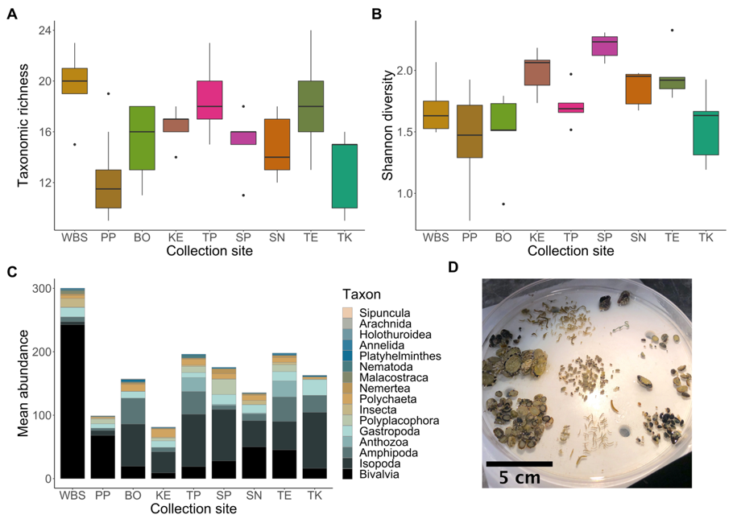
Figure 2. A. Taxonomic richness of invertebrate assemblages removed from 15$\text{×}$15 cm samples of S. cariosus beds collected at sites along the west coast of British Columbia (see Table S1 for site codes and locations; n=5 for all sites except WBS and SA, where n=8). Note that collection sites are arranged along the x-axis from the outer coast of BC (WBS; most exposed) to the Strait of Georgia (TK; least exposed) going from left to right. B. Shannon diversity of invertebrates from the same samples C. Mean abundance of invertebrates counted within the same samples, with colours corresponding to coarse taxonomic groupings. D. Visual example of community removed from one S. cariosus sample.

Barnacle mortality surveys
Following the heat dome, we sought to determine what factors, both across and within sites, affected the mortality of S. cariosus in response to extreme thermal stress. At the site scale, the mortality of S. cariosus was greater where higher maximum air temperatures were reached during the heat dome, but this trend did not have substantial statistical support (Fig. 3; Type II ANOVA: χ² = 3.1966, df = 1, P = 0.0738). While there was a slight trend whereby shores facing towards the solar azimuth had higher observed barnacle mortality than those facing away, this trend, too was marginally insignificant (χ² = 3.6115, df = 1, P = 0.0574). The effects of the time of low tide and algal cover were not significant in determining mortality (Supplement 2).
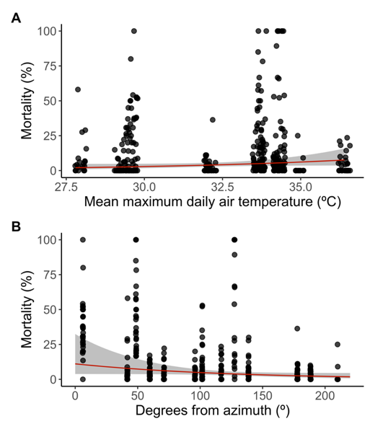
Figure 3. The relationship between the mortality of S. cariosus observed during surveys (N=347 quadrats) and A. the mean maximum daily air temperature during the heat dome period (25–29 June 2021) at the survey site and B. the prevailing aspect of the shore, in degrees from the solar azimuth (direct irradiance). The red lines represent the predicted effect of the explanatory variable conditioned on the average values of other fixed effects in the multiple regression model, and the shaded area about the line represents the confidence interval of model predictions.

Although the coarse-scale orientation of shorelines was not related to patterns of mortality, finer-scale orientation was. At the plot-scale, the angle of solar incidence (ASI) had an inverse relationship with mortality; that is, a smaller ASI (more direct sunlight) tended to correspond with higher barnacle mortality, while a larger ASI (less direct sunlight) was associated with lower mortality, following a logistic pattern (Fig. 4). This relationship was highly statistically significant (Type II ANOVA: χ² = 5.899, df = 1, P = 0.01515).
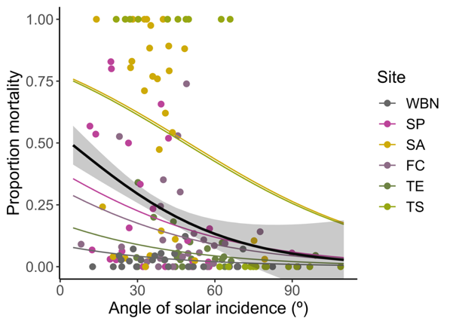
Figure 4. The effect of the ASI (direct sun = 0º) on the proportion mortality of S. cariosus within 12.7$\text{×}$12.7 cm quadrats (N =152). Thin coloured lines represent site-specific relationships, while the central black trendline represents values predicted by the generalized linear model when the site-level random effect is removed. The Shaded ribbon about the best-fit line represents standard error.

Shading experiment
Using a shading experiment, we characterized how thermal stress and community successional stage (the presence or absence of barnacle beds) affected barnacle survival and recruitment and the diversity of the community associated with S. cariosus. Temperature differences between treatments were most pronounced during fortnightly spring tides, and the heat dome coincided with some of the lowest daytime tides of the summer (Fig. 5A). During the heat dome at low tide, the mean substratum temperature in shaded plots was 6.1 ± 0.7 ºC (mean ± SE) lower than in unshaded plots. Even so, during this period, shaded plots (mean temperature = 23.3 ± 0.5 ºC) were still warmer during the heat dome than were unshaded plots during the rest of the summer (mean temperature = 19.9 ± 0.1 ºC). The mean maximum daily substratum temperature recorded during low tide over the entire experimental period was 5.0 ± 0.9 ºC lower on average in shaded versus unshaded plots, a significant difference (Fig. 5A–B, Fig. S5; Type II ANOVA: χ² = 207.4, df = 1, P < 0.001), and conditions were warmer in plots where barnacles were removed (χ² = 6.766, df = 1, P = 0.00929).
Semibalanus cariosus mortality was substantially higher in unshaded plots than shaded plots (Fig. 5C; Type II ANOVA: χ² = 65.53, df = 1, P < 0.001). Barnacle recruitment (summed across all three species present: S. cariosus; Balanus glandula; and Chthamalus dalli) was lower in unshaded plots (Fig. 5D; Type II ANOVA: χ² = 11.53, df = 1, P < 0.001). Communities in unshaded plots had lower species richness at the end of the summer than those in shaded plots when barnacles were absent, but the presence of barnacles ameliorated the effect of high temperatures (Fig. 5E; Type III ANOVA: shading $\text{× }$removal, χ² = 4.538, df = 1, P = 0.0332). A similar pattern was found when considering the Shannon diversity of invertebrate communities, which was high when barnacles, shade, or both were present, but low when both were absent (Fig. 5F; Type III ANOVA: shading $\text{×}$ removal, χ² = 12.23, df = 1, P < 0.001). The cover and Shannon diversity of the algal community were low overall, and while they tended to be slightly higher where barnacles were present at the end of the summer, no effect of shading or barnacle removal treatments on algal cover or diversity was statistically supported (Fig. S6A; Supplement 2).
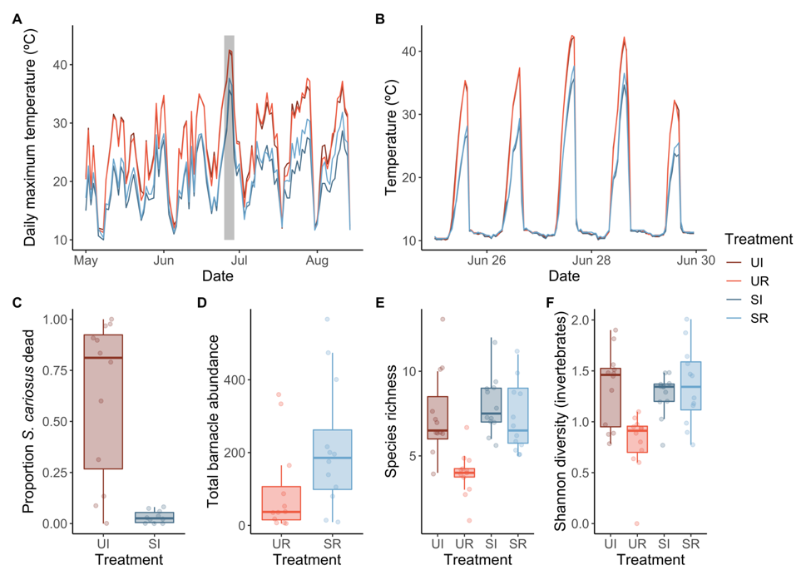
Figure 5. A. Mean daily maximum substratum temperature over time for each treatment recorded by iButton temperature loggers on shore. The grey box indicates the period of the heat dome (25–29 June 2021). B. Hourly temperature during the heat dome for each treatment. C. The effect of shading treatment on the mortality of adult S. cariosus in intact barnacle beds as recorded on 21 August 2021 (n=12 for UI, n=10 for SI). D. The effect of shading treatment on the recruitment of barnacles (S. cariosus, B. glandula, and C. dalli) to barnacle removal plots when recruits were most abundant (8 July 2021; n=12). E. Differences in the overall species richness of communities for each treatment group including both invertebrate and algal taxa at the end of the experiment (21 August 2021; n=12). F. Differences in the Shannon diversity of invertebrate taxa between treatment groups at the end of the experiment (21 August 2021; n=12). For treatment codes, U=unshaded plot, S=shaded plot, I=intact barnacle bed, R=removed barnacle bed.

Within destructively sampled barnacle bed samples at the end of the shading experiment, the composition of the associated community differed between shaded and unshaded plots (Fig. 6A; PERMANOVA: F = 5.1284, R² = 0.2427, P = 0.0469), and the communities were more heterogeneous (had higher beta diversity) in unshaded than in shaded communities (PERMDISP: F_{1,16} = 9.3662, P = 0.00747). Results were similar when we removed rare species from the analysis (see Fig. S7 for details). In unshaded plots, the abundance, richness, and diversity of taxa present within S. cariosus beds tended to be negatively related to barnacle mortality (Fig. S8), but only the relationship between invertebrate abundance and barnacle mortality was statistically significant (Type I ANOVA: residual deviance = 7.9952, df = 7, P = 0.00873; Supplement 2). Infaunal communities demonstrated seasonality; communities shifted in composition between the start and end of the summer on both the outer of Vancouver Island (Fig. S9; PERMANOVA: site × date, F_{1,28} = 4.2632, R² = 0.10631, P = 0.001).
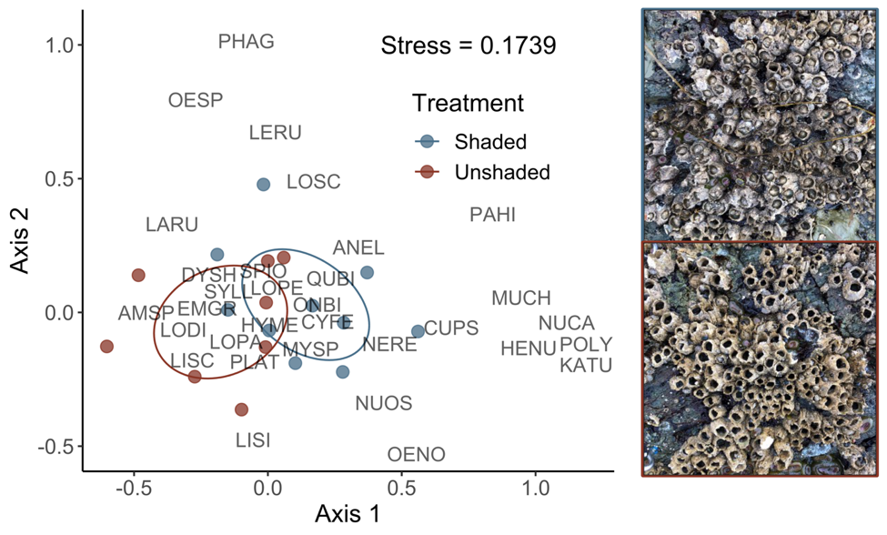
Figure 6. Two-dimensional NMDS plot showing differences in associated community composition between shaded and unshaded S. cariosus barnacle beds at Sahsima, Victoria, British Columbia at the end of summer shading experiment (n=8). See Table S2 for species code details. We collected all samples on 21 August 2021. While not strongly visually apparent, beta diversity is higher for the unshaded barnacle bed communities. Photos on the right side of the figure demonstrate stark visual differences in survival between a shaded barnacle bed (top) and unshaded barnacle bed (bottom).

Discussion
Through our study, we aimed to answer three questions: first, what diversity of species does S. cariosus facilitate; second, what determined the mortality risk of S. cariosus during the heat dome; and third, was S. cariosus still able to facilitate a diverse community of associated species after experiencing substantial thermal stress? We found that S. cariosus facilitates a speciose and diverse community throughout its range, though the exact composition of the community varies between sites. Semibalanus cariosus mortality caused by the heat dome was extremely variable, ranging from 0–100% at the quadrat level. Contrary to our expectations, we found that mortality was not explained well by any of the site-level factors considered, nor by algal canopy cover. However, the angle of solar incidence (ASI), which is greatly affected by the plot-level angle and compass orientation of the substratum, significantly affected mortality; S. cariosus beds on gently sloping substrata facing the sun during the hottest portion of the low tide had greater mortality than those on surfaces angled more obliquely to incoming solar radiation (e.g., steeply sloping and/or northeast facing surfaces). Experimental shading, which lowered the substratum temperature, was associated with higher S. cariosus survival, barnacle recruitment, and invertebrate species richness and Shannon diversity than unshaded control plots as anticipated but had no apparent effect on algal communities. Unshaded barnacle beds hosted a significantly different invertebrate assemblage at the end of the summer than did shaded plots, which we expected, though variation between species assemblages in unshaded beds (beta diversity) was greater, not less, than in shaded plots.
The diversity of species we observed within S. cariosus beds across the distribution surveyed is consistent with the limited data available about this species. Semibalanus cariosus beds in Barkley Sound, BC (location of site PP in Fig. 1) are known to facilitate clams (Lasaea rubra) and juvenile mussels (Mytilus californianus) in the same abundance as do M. californianus beds, providing prey as well as protection for juvenile Nucella ostrina whelks (Gosselin & Chia, 1995). We found these same three species within S. cariosus beds during our study, with M. californianus and L. rubra present in high abundances at West Beach (Calvert Island) and Prasiola Point (Barkley Sound), the most wave-exposed sites. Across all sites, we documented 50 unique taxa, some of which most likely included multiple species (e.g., Nereidae, Amphipoda). Semibalanus cariosus beds collected at Calvert Island in 2017 contained 52 identified species (Harley, unpublished data), comparable to our findings here. Notably, the assemblages sampled in our study differed in their diversity and composition between sites. Previous studies of mussel beds have found that meiofauna community composition varies regionally, probably driven by differences in the richness of the local species pool or in the substratum underlying the biogenic habitat (Buschbaum et al., 2009). Interestingly, peak Shannon diversity coincided with an intermediate level of wave exposure, consistent with the intermediate disturbance hypothesis (Connell, 1978). As wave stress was not formally quantified and sample sizes were small for these surveys, it is difficult to confirm that this qualitative pattern can be ascribed to wave exposure alone. In any case, certain species may have been abundant in some locations and not others depending on their species-specific tolerances to abiotic stressors, since complex environmental and ecological gradients are present over the geographic gradient sampled (Harley, 2011; Ianson et al., 2016; Widdowson, 1965).
In our multiple regression model of mortality, we considered the effects air temperature, timing of low tide, and the prevailing shore orientation as additive variables since these all affect substratum temperature, and thus the body temperature of sessile invertebrates (LaScala-Gruenewald & Denny, 2020). However, if low statistical power had not precluded its use, a multiplicative model may have been more appropriate. For example, the effect of air temperature on substratum temperature is contingent upon the timing of the low tide; even if aerial temperatures are high, low daily maximum substratum temperatures are measured when low tides occur during evening or morning, while the highest maximum substratum temperatures are observed only when low tides occur during the afternoon (Hayford et al., 2015). The timing of low tide also modifies the effect of shore orientation on substratum temperature because of diurnal changes in the angle of solar incidence on shore; during morning low tides, east-facing shores are often warmer than equatorward-facing shores, but during afternoon low tides, the reverse is true (Gilman et al., 2015). Additionally, air temperature, while we considered it in our model, is not necessarily an informative variable; while body temperature may correlate closely with air temperature for organisms having less physical contact with the substratum (e.g., algae; Román et al., 2020), this is not usually true for species like S. cariosus that are in close contact with the substratum (Helmuth, 1998; LaScala-Gruenewald & Denny, 2020).
Algal cover, which we expected to reduce mortality risk, did not have a significant effect on mortality, a finding largely inconsistent with previous studies. In another study conducted in the mid-intertidal zone in our study region, algal canopy covering whelk biomimetics decreased their temperature by 2.3 ºC on average and reduced the incidence at which lethal temperatures were recorded relative to adjacent sun-exposed areas (Gilman et al., 2015). Similarly, the survival of barnacles during a hot summer, particularly those on equatorward-facing shores (low ASI), was higher where algal canopy was present than in cleared plots (Leonard, 2000). Higher densities of intertidal algal cover are correlated with higher abundances of invertebrates (Umanzor et al., 2017), and species richness and Shannon diversity are generally higher in areas with canopy-forming algae present compared to areas where algae are removed (Lilley & Schiel, 2006). Yet, algal cover sometimes has an equivocal effect on the survival of underlying organisms (Hancock & Petraitis, 2001). Perhaps algal canopy cover was too low in our study to provide adequate thermal and desiccation protection, or perhaps what protection it did provide could not be sustained during the acute, prolonged thermal stress of the heat dome as has been found for other algal facilitations under high levels of environmental stress (Navarro-Barranco et al., 2022; Scrosati, 2017).
While across-site factors did not explain S. cariosus mortality, small-scale topographic differences did. Previous studies have found that substratum temperature, which closely tracks the body temperature of barnacles (Harley & Lopez, 2003), is highly correlated with the ASI at the substratum surface (Harley, 2008). At temperate latitudes, equatorward-facing shores experience both higher mean temperatures and more frequent extreme high temperatures than poleward-facing shores (Amstutz et al., 2021). Similarly, in the northeast Pacific, the body temperature of whelk biomimetics on sun-exposed south-facing shores were 2.8 ºC hotter than those on similarly sun-exposed east-facing shores (Gilman et al., 2015). These temperature differences may translate to patterns in organismal mortality and distribution. Smaller values of ASI have been linked to higher rates of mussel mortality and localized decreases in limpet abundance, with both trends following a roughly logistic pattern (Harley, 2008). Similarly, the upper limit of limpet distribution on shore was highest on poleward-facing shores (high ASI) and lowest on shores facing towards the solar azimuth (low ASI; Miller et al., 2009). Despite an overall significant relationship between ASI and mortality, the exact shape of this relationship differed between sites, which may be due to site-level differences in the timing of low tides during the heat dome, wave exposure, or other factors not captured by the underlying model.
In our shading experiment, which we conducted on a predominantly southwest-facing shore with a low ASI, shades reduced substratum temperature by several degrees, which generally benefited the underlying barnacle-associated community. Shading treatments, while they reduce thermal stress, cannot be disentangled from a concurrent reduction in desiccation stress and incoming light (Harley & Lopez, 2003; Morelissen & Harley, 2007), so the effects of shading cannot be wholly assigned to temperature differences for species that are strongly influenced by desiccation and light availability (e.g., seaweeds). For heterotrophs that can resist desiccation, including many shelled invertebrates such as barnacles, temperature would likely be the most important environmental difference between shaded and unshaded areas. Barnacles within shaded beds were found to have lower mortality after exposure to hot summer temperatures than those in unshaded control plots in our study, a pattern that has been documented by others (Levine et al., 1999; Wethey, 1984). This mortality difference was likely driven by differences in the level of physiological stress encountered in unshaded versus shaded plots. The upper limit of the congener Semibalanus balanoides within the intertidal zone is known to be set by intolerance of thermal and desiccation stress (Wethey, 1984). Mussels in sun-exposed areas, even though they are better acclimated to withstand thermal stress, are still more likely to experience lethal temperatures that exceed their critical upper limit of cardiac function than those in shaded areas, resulting in higher mortality in sun versus shade (Li et al., 2021). Barnacle recruitment was more successful in shaded plots, consistent with previous studies (Pardal-Souza et al., 2017).We also observed higher species richness and invertebrate Shannon diversity under shades as in other studies (Takada, 1999), with shades being particularly important for plots where barnacles had been removed. Barnacles, by providing shade (Cartwright & Williams, 2014) and increasing moisture retention (Harley & O’Riley, 2011), reduce heat and desiccation stress where present; here, we found that the presence of barnacles had a small but significant effect in reducing the maximum substratum temperature. Thus, having a shade present when barnacles were absent may have had more pronounced effect in mitigating environmental stress. We detected no effects of shading or barnacle removal on algal cover or diversity, consistent with prior observations of macroalgal cover in response to shading (Morelissen & Harley, 2007). Even if thermal stress is lower beneath shades, low light may have limited algal growth (Pardal-Souza et al., 2017), preventing the benefit of reduced temperatures from becoming apparent. High intertidal acorn barnacles tend to facilitate a greater abundance of fleshy macroalgae in the northeast Pacific (Hesketh et al., 2021), so an effect of barnacle removal may also have been observed with a longer experiment. Further, the generally low prevalence of algae in terms of both cover (0–20 % cover) and diversity (six species present) at this site may have prevented the detection of any treatment effects.
Within destructively sampled barnacle beds, shading treatments altered the invertebrate communities associated with S. cariosus, which may have been driven by differences in abiotic tolerance between taxa, changes in the microhabitats available, or both. Shifts in community composition in response to heatwaves have been documented in various system and appear to be mediated by species-specific responses to thermal stress (De Boeck et al., 2018; Pansch et al., 2018; Sorte et al., 2010; Tituskin et al., 2021). We observed that taxa dominating unshaded plots at the end of summer were typically motile, small, and/or well-calcified (e.g., littorine snails, limpets, amphipods, isopods), while taxa in shaded plots were typically less motile, larger, and/or less heavily calcified (e.g., sea cucumbers, anemones, chitons, whelks). Highly motile species, such as those dominating unshaded barnacle beds here, can more easily escape to thermal refugia during stressful periods, and thus may be expected to re-establish in perturbed systems more quickly than less motile species following a heatwave (Harvey et al., 2022). Larger organisms are less tolerant of short-term thermal stress than smaller organisms (Peralta-Maraver et al., 2021), and calcified structures such as the shells of high intertidal gastropods (e.g., family Littorinidae) confer protection against thermal and desiccation stress (Vermeij, 1978); thus, we might expect small, calcified invertebrates to be more tolerant of heatwaves, which may explain the divergence in taxonomic assemblages between shaded and unshaded barnacle beds following the heat dome. As S. cariosus mortality increased in unshaded plots, the abundance of invertebrate taxa within destructively sampled beds declined significantly; similar effects were observed on invertebrate species richness and Shannon diversity, but these lacked statistically significance, possibly due to the low sample size, and thus low power, of this experiment. Other intertidal biogenic species have been found to maintain their facilitative ability beyond the point of death, though sometimes the identity of species associated with the biogenic habitat changes (Liversage et al., 2020; McAfee & Bishop, 2019; Uyà et al., 2020). Empty barnacle tests form important microhabitats for intertidal organisms (Barnes, 2000) and may thus continue to facilitate communities of organisms adapted to empty tests after barnacle death. While unshaded S. cariosus beds had higher beta diversity than shaded beds, likely reflecting the stochastic nature of community assembly following heatwave disturbances (Kreyling et al., 2011), empty barnacle tests are ultimately an ephemeral habitat at higher risk of dislodgement than live barnacles (Reimer, 1976) and may not provide high-quality habitat in the long-term.
Overall, our results suggest that heatwave-induced mortality of foundation species may be somewhat predictable at certain scales. The patchy mortality of S. cariosus was largely explained by small-scale differences in intertidal topography; barnacle beds on substrata that are shaded or receive only oblique solar irradiance will likely be able to persist through future heatwaves and continue to facilitate a diverse community, while populations on shores where irradiance is high will be increasingly impacted, along with the species they facilitate. The ability of S. cariosus to adapt to increased thermal stress is unknown but given that aquatic invertebrates at mid-latitudes generally demonstrate acclimation capacity to warm conditions (Morley et al., 2019) and that the generation time of barnacles is relatively short, limited adaptation may be possible. Prediction remains difficult given that mortality risk from heatwaves is affected not only by the constitutive thermal tolerance of organisms, but also their degree of induced defense (e.g., through production of heat shock proteins; Denny, 2018) and the duration (Peralta-Maraver et al., 2021) and frequency (Siegle et al., 2018) of heatwaves. The Salish Sea region of BC is a known “hot spot” (Helmuth et al., 2002), and thus S. cariosus in the study region may already be close to the limits of their adaptive capacity. Further, S. cariosus, while its generation time may be short, is at high risk of predation by whelks (Nucella spp.) until the age of two (Connell, 1972), and grows slowly thereafter (Sebens & Lewis, 1985); thus, whether mature S. cariosus beds can re-establish if repeated heatwaves occur is unclear.
While habitat provision by biogenic species remains an important mechanism by which the environmental stress experienced by associated species can be mitigated (Jurgens et al., 2021; Jurgens & Gaylord, 2018), there may be an upper limit to the stress under which such facilitations can occur (Navarro-Barranco et al., 2022; Scrosati, 2017). Extreme heatwaves like the heat dome will only occur more frequently through time (Perkins-Kirkpatrick & Lewis, 2020), and events of this magnitude may prove lethal for foundation species or disrupt their ability to facilitate associated organisms. In order to assess the potential benefit that facilitative interactions will provide to ecological communities in the future, we must characterize not only the thermal tolerances of important foundation species under single and repeated heatwaves of varying magnitudes, but also measure the thresholds beyond which facilitative interactions collapse. Our results highlight the importance of consistently monitoring populations of biogenic species to capture the full effects of extreme events and suggest that incorporating variability — including short-term extremes — into studies of climate change is necessary to fully anticipate its impacts.

Acknowledgements
We thank the First Nations on whose traditional and (in most cases) unceded territories this work was conducted for their historic and current care for our lands and water, namely the Wuikiuxv, Huu-ay-aht, Pacheedaht, T’Souke, Esquimalt, Songhees, W̱SÁNEĆ, and Semiahmoo peoples. In addition, we thank J. Li, C. Burtlake, A. Garg, C. Steell, and G. Brownlee for field assistance, S. Emry and C. Konecny for support during early barnacle excursions, and L. & C. Hesketh and G. Jesse for accommodation and sustenance during field work. We thank C. Brauner, S. Dudas, and R. Germain for comments on this manuscript. We acknowledge Bamfield Marine Sciences Centre for their generous support of this work and the Hakai Institute for field support and supplying hourly air temperature data for Calvert Island. Funding was provided by a Natural Sciences and Engineering Research Council of Canada Discovery Grant to CDGH.

Literature cited

Amstutz, A., Firth, L.B., Spicer, J.I., & Hanley, M.E. (2021). Facing up to climate change: Community composition varies with aspect and surface temperature in the rocky intertidal. Marine Environmental Research, 172, 105482. doi: 10.1016/j.marenvres.2021.105482
Arias-Ortiz, A., Serrano, O., Masqué, P., Lavery, P. S., Mueller, U., Kendrick, G. A., Rozaimi, M., Esteban, A., Fourqurean, J.W., Marbà, N., Mateo, M.A., Murray, K., Rule, M.J., & Duarte, C.M. (2018). A marine heatwave drives massive losses from the world’s largest seagrass carbon stocks. Nature Climate Change, 8, 338–344. doi: 10.1038/s41558-018-0096-y
Babcock, R.C., Thomson, D.P., Haywood, M.D.E., Vanderklift, M.A., Pillans, R., Rochester, W.A., Miller, M., Speed, C.W., Shedrawi, G., Field, S., Evans, R., Stoddart, J., Hurley, T. J., Thompson, A., Gilmour, J., Depczynski, M., Babcock, R. C., Thomson, D. P., Haywood, M.D.E., … Depczynski, M. (2020). Recurrent coral bleaching in north-western Australia and associated declines in coral cover. Marine and Freshwater Research, 72, 620–632. doi: 10.1071/MF19378
Barnes, M. (2000). The use of intertidal barnacle shells. In: Oceanography and Marine Biology: An Annual Review (Vol. 38, pp. 157–187). Taylor & Francis.
Bracken, M.E.S. (2018). When one foundation species supports another: Tubeworms facilitate an extensive kelp bed in a soft-sediment habitat. Ecosphere, 9, e02429. doi: 10.1002/ecs2.2429
Brooks, M.E., Kristensen, K., van Benthem, K.J., Magnusson, A., Berg, C.W., Nielsen, A.,Skaug, H.J., Maechler, M. & Bolker, B.M. (2017). glmmTMB balances speed and flexibility among packages for zero-inflated generalized linear mixed modeling. The R Journal, 9(2), 378-400.
Brown, J.H., Gillooly, J.F., Allen, A.P., Savage, V.M., & West, G.B. (2004). Toward a Metabolic Theory of Ecology. Ecology, 85, 1771–1789. doi: 10.1890/03-9000
Bulleri, F., Bruno, J.F., Silliman, B.R., & Stachowicz, J.J. (2016). Facilitation and the niche: Implications for coexistence, range shifts and ecosystem functioning. Functional Ecology, 30, 70–78. doi: 10.1111/1365-2435.12528
Buschbaum, C., Dittmann, S., Hong, J.-S., Hwang, I.-S., Strasser, M., Thiel, M., Valdivia, N., Yoon, S.-P., & Reise, K. (2009). Mytilid mussels: Global habitat engineers in coastal sediments. Helgoland Marine Research, 63, 47–58. doi: 10.1007/s10152-008-0139-2
Bussotti, F., Papitto, G., Di Martino, D., Cocciufa, C., Cindolo, C., Cenni, E., Bettini, D., Iacopetti, G., & Pollastrini, M. (2021). Defoliation, recovery and increasing mortality in Italian forests: levels, patterns and possible consequences for forest multifunctionality. Forests, 12, 1476. doi: 10.3390/f12111476
Cartwright, S.R., & Williams, G.A. (2014). How hot for how long? The potential role of heat intensity and duration in moderating the beneficial effects of an ecosystem engineer on rocky shores. Marine Biology, 161, 2097–2105. doi: 10.1007/s00227-014-2489-4
Climate Canada. (2022, January 26). Historical Data. https://climate.weather.gc.ca/historical_data/search_historic_data_e.html.
Connell, J.H. (1972). Community interactions on marine rocky intertidal shores. Annual Review of Ecology and Systematics, 3, 169–192.
Connell, J.H. (1978). Diversity in tropical rain forests and coral reefs. Science, 199, 1302–1310.
Dayton, P.K. (1971). Competition, disturbance, and community organization: The provision and subsequent utilization of space in a rocky intertidal community. Ecological Monographs, 41, 351–389.
De Boeck, H.J., Hiltbrunner, E., Verlinden, M., Bassin, S., & Zeiter, M. (2018). Legacy effects of climate extremes in alpine grassland. Frontiers in Plant Science, 9, 1586. doi: 10.3389/fpls.2018.01586
Denny, M.W. (2018). Survival in spatially variable thermal environments: Consequences of induced thermal defense. Integrative Zoology, 13, 392–410. doi: 10.1111/1749-4877.12308
Dillon, M.E., Wang, G., & Huey, R.B. (2010). Global metabolic impacts of recent climate warming. Nature, 467, 704–706. doi: 10.1038/nature09407
Fisheries and Oceans Canada. (2022, February 9). Tides, currents, and water levels. https://tides.gc.ca/en.
Fox, J. & Weisberg, S. (2019). An {R} companion to applied regression, third edition. Thousand Oaks CA: Sage.
Genin, A., Levy, L., Sharon, G., Raitsos, D.E., & Diamant, A. (2020). Rapid onsets of warming events trigger mass mortality of coral reef fish. Proceedings of the National Academy of Sciences of the United States of America, 117, 25378–25385. doi: 10.1073/pnas.2009748117
Gilman, S., Hayford, H., Craig, C., & Carrington, E. (2015). Body temperatures of an intertidal barnacle and two whelk predators in relation to shore height, solar aspect, and microhabitat. Marine Ecology Progress Series, 536, 77–88. doi: 10.3354/meps11418
Gosselin, L., & Chia, F. (1995). Distribution and dispersal of early juvenile snails: effectiveness of intertidal microhabitats as refuges and food sources. Marine Ecology Progress Series, 128, 213–223. doi: 10.3354/meps128213
Hancock, K.M., & Petraitis, P.S. (2001). Effects of herbivorous snails and macroalgal canopy on recruitment and early survivorship of the barnacle Semibalanus balanoides (L.). Journal of Experimental Marine Biology and Ecology, 257, 205–218. doi: 10.1016/S0022-0981(00)00337-3
Harley, C.D.G. (2008). Tidal dynamics, topographic orientation, and temperature-mediated mass mortalities on rocky shores. Marine Ecology Progress Series, 371, 37–46. doi: 10.3354/meps07711
Harley, C.D.G. (2011). Climate change, keystone predation, and biodiversity loss. Science, 334, 1124–1127.
Harley, C.D.G., & Lopez, J.P. (2003). The natural history, thermal physiology, and ecological impacts of intertidal mesopredators, Oedoparena spp. (Diptera: Dryomyzidae). Invertebrate Biology, 122, 61–73. doi: 10.1111/j.1744-7410.2003.tb00073.x
Harley, C.D.G., & O’Riley, J.L. (2011). Non-linear density-dependent effects of an intertidal ecosystem engineer. Oecologia, 166, 531–541. doi: 10.1007/s00442-010-1864-1
Hartig, F. (2021). DHARMa: Residual diagnostics for hierarchical (multi-level/mixed) regression models. R package version 0.4.4.
Harvey, B.P., Marshall, K.E., Harley, C.D.G., & Russell, B.D. (2022). Predicting responses to marine heatwaves using functional traits. Trends in Ecology & Evolution, 37(1), 20–29. doi: 10.1016/j.tree.2021.09.003
Hayford, H., Gilman, S., & Carrington, E. (2015). Foraging behavior minimizes heat exposure in a complex thermal landscape. Marine Ecology Progress Series, 518, 165–175. doi: 10.3354/meps11053
Helmuth, B., Broitman, B.R., Blanchette, C. A., Gilman, S., Halpin, P., Harley, C.D.G., O’Donnell, M.J., Hofmann, G.E., Menge, B., & Strickland, D. (2006). Mosaic patterns of thermal stress in the rocky intertidal zone: implications for climate change. Ecological Monographs, 76, 461–479. doi:10.1890/0012-9615(2006)076[0461:MPOTSI]2.0.CO;2
Helmuth, B., Harley, C.D.G., Halpin, P.M., O’Donnell, M., Hofmann, G.E., & Blanchette, C.A. (2002). Climate change and latitudinal patterns of intertidal thermal stress. Science, 298,1015–1017. doi: 10.1126/science.1076814
Helmuth, B. S. T. (1998). Intertidal mussel microclimates: Predicting the body temperature of a sessile invertebrate. Ecological Monographs, 68, 51–74. doi: 10.1890/0012-9615(1998)068[0051:IMMPTB]2.0.CO;2
Hesketh, A.V., Schwindt, E., & Harley, C.D.G. (2021). Ecological and environmental context shape the differential effects of a facilitator in its native and invaded ranges. Ecology, 102, e03478. doi: 10.1002/ecy.3478
Hobday, A.J., Alexander, L.V., Perkins, S.E., Smale, D.A., Straub, S.C., Oliver, E.C.J., Benthuysen, J.A., Burrows, M.T., Donat, M.G., Feng, M., Holbrook, N.J., Moore, P.J., Scannell, H.A., Sen Gupta, A., & Wernberg, T. (2016). A hierarchical approach to defining marine heatwaves. Progress in Oceanography, 141, 227–238. doi: 10.1016/j.pocean.2015.12.014
Hoegh-Guldberg, O., Jacob, D., Taylor, M., Bindi, M., Brown, S., Camilloni, I., Diedhiou, A., Djalante, R., Ebi, K. L., Engelbrecht, F., Hijioka, Y., Mehrotra, S., Payne, A., Seneviratne, S. I., Thomas, A., Warren, R., Zhou, G., Halim, S. A., Achlatis, M., … Sherstyukov, B. (2018). Impacts of 1.5°C of Global Warming on Natural and Human Systems. In: Masson-Delmotte, V., P. Zhai, H.-O. Pörtner, D. Roberts, J. Skea, P.R. Shukla, A. Pirani, W. Moufouma-Okia, C. Péan, R. Pidcock, S. Connors, J.B.R. Matthews, Y. Chen, X. Zhou, M.I. Gomis, E. Lonnoy, T. Maycock, M. Tignor, and T. Waterfield (Eds.), Global Warming of 1.5°C. An IPCC Special Report on the impacts of global warming of 1.5°C above pre-industrial levels and related global greenhouse gas emission pathways, in the context of strengthening the global response to the threat of climate change, sustainable development, and efforts to eradicate poverty.
Ianson, D., Allen, S.E., Moore-Maley, B.L., Johannessen, S.C., & Macdonald, and Robie W. (2016). Vulnerability of a semienclosed estuarine sea to ocean acidification in contrast with hypoxia. Geophysical Research Letters, 43, 5793–5801. doi: 10.1002/2016GL068996
Jurgens, L.J., Ashlock, L.W., & Gaylord, B. (2021). Facilitation alters climate change risk on rocky shores. Ecology, e03596. doi: 10.1002/ecy.3596
Jurgens, L.J., & Gaylord, B. (2018). Physical effects of habitat-forming species override latitudinal trends in temperature. Ecology Letters, 21, 190–196. doi: 10.1111/ele.12881
Kahle, D. & Wickham, H. (2013). ggmap: Spatial Visualization with ggplot2. The R Journal, 5(1), 144-161.
Kreyling, J., Jentsch, A., & Beierkuhnlein, C. (2011). Stochastic trajectories of succession initiated by extreme climatic events. Ecology Letters, 14, 758–764. doi: 10.1111/j.1461-0248.2011.01637.x
LaScala-Gruenewald, D.E., & Denny, M.W. (2020). Long-term mechanistic hindcasts predict the structure of experimentally-warmed intertidal communities. Oikos, 129, 1645–1656. doi: 10.1111/oik.07468
Leonard, G.H. (2000). Latitudinal variation in species interactions: A test in the New England rocky intertidal zone. Ecology, 81, 1015–1030. doi: 10.2307/177175
Levine, J.M., Bruno, J.F., Leonard, G.H., & Bertness, M.D. (1999). Climate-driven interactions among rocky intertidal organisms caught between a rock and a hot place. Oecologia, 120, 446–450. doi: 10.1007/s004420050877
Li, X., Tan, Y., Sun, Y., Wang, J., & Dong, Y. (2021). Microhabitat temperature variation combines with physiological variation to enhance thermal resilience of the intertidal mussel Mytilisepta virgata. Functional Ecology, 35, 2497–2507. doi: 10.1111/1365-2435.13885
Lilley, S.A., & Schiel, D.R. (2006). Community effects following the deletion of a habitat-forming alga from rocky marine shores. Oecologia, 148, 672–681. doi: 10.1007/s00442-006-0411-6
Liversage, K., Kotta, J., Fraser, C.M.L., Figueira, W.F., & Coleman, R.A. (2020). The overlooked role of taphonomy in ecology: Post-mortem processes can outweigh recruitment effects on community functions. Oikos, 129, 420–432. doi: 10.1111/oik.06780
McAfee, D., & Bishop, M.J. (2019). The mechanisms by which oysters facilitate invertebrates vary across environmental gradients. Oecologia, 189, 1095–1106. doi: 10.1007/s00442-019-04359-3
Miller, L.P., Harley, C.D.G., & Denny, M.W. (2009). The role of temperature and desiccation stress in limiting the local-scale distribution of the owl limpet, Lottia gigantea. Functional Ecology, 23, 756–767. doi: 10.1111/j.1365-2435.2009.01567.x
Morelissen, B., & Harley, C.D.G. (2007). The effects of temperature on producers, consumers, and plant–herbivore interactions in an intertidal community. Journal of Experimental Marine Biology and Ecology, 348, 162–173. doi: 10.1016/j.jembe.2007.04.006
Morley, S.A., Peck, L.S., Sunday, J.M., Heiser, S., & Bates, A.E. (2019). Physiological acclimation and persistence of ectothermic species under extreme heat events. Global Ecology and Biogeography, 28, 1018–1037. doi: 10.1111/geb.12911
Navarro-Barranco, C., Gribben, P.E., Ledet J.J., & Poore, A.G.B. (2022). Habitat-complexity regulates the intensity of facilitation along an environmental stress gradient. Oikos, e08818. doi: 10.1111/oik.08818
National Oceanic and Atmospheric Administration. NOAA Solar Calculator. (2022, February 9). https://gml.noaa.gov/grad/solcalc/.
Oksanen, J., Blanchet, F.G., Friendly, M., Kindt, R., Legendre, P., McGlinn, D., Minchin, P.R., O'Hara, R. B., Simpson, G.L., Solymos, P., Stevens, M.H.H., Szoecs, E. & Wagner, H. (2020). vegan: Community Ecology Package. R package version 2.5-7. https://CRAN.R-project.org/package=vegan
Pansch, C., Scotti, M., Barboza, F.R., Al-Janabi, B., Brakel, J., Briski, E., Bucholz, B., Franz, M., Ito, M., Paiva, F., Saha, M., Sawall, Y., Weinberger, F., & Wahl, M. (2018). Heat waves and their significance for a temperate benthic community: A near-natural experimental approach. Global Change Biology, 24, 4357–4367. doi: 10.1111/gcb.14282
Pardal-Souza, A.L., Dias, G.M., Jenkins, S.R., Ciotti, Á. M., & Christofoletti, R.A. (2017). Shading impacts by coastal infrastructure on biological communities from subtropical rocky shores. Journal of Applied Ecology, 54, 826–835. doi: 10.1111/1365-2664.12811
Pedersen, T.L. (2020). patchwork: The Composer of Plots. R packages version 1.1.1. https://CRAN.R-project.org/package=patchwork
Peralta-Maraver, I. & Rezende, E.L. (2021). Heat tolerance in ectotherms scales predictably with body size. Nature Climate Change, 11, 58–63. doi: 10.1038/s41558-020-00938-y
Perkins, S.E., & Alexander, L.V. (2013). On the measurement of heat waves. Journal of Climate, 26, 4500–4517. doi: 10.1175/JCLI-D-12-00383.1
Perkins-Kirkpatrick, S.E., & Lewis, S.C. (2020). Increasing trends in regional heatwaves. Nature Communications, 11, 3357. doi: 10.1038/s41467-020-16970-7
Reid, H., & Harley, C. (2021). Low temperature exposure determines performance and thermal microhabitat use in an intertidal gastropod (Littorina scutulata) during the winter. Marine Ecology Progress Series, 660, 105–118. doi: 10.3354/meps13588
Reimer, A.A. (1976). Succession of invertebrates in vacant tests of Tetracfita stalactifera panamensis. Marine Biology, 13, 239-251.
Riemer, K., Anderson-Teixeira, K.J., Smith, F.A., Harris, D.J., & Ernest, S.K.M. (2018). Body size shifts influence effects of increasing temperatures on ectotherm metabolism. Global Ecology and Biogeography, 27, 958–967. doi: 10.1111/geb.12757
Robinson, J.P.W., Wilson, S.K., Jennings, S., Graham, N.A.J. (2019). Thermal stress induces persistently altered coral reef fish assemblages. Global Change Biology, 25: 2739–2750
Román, M., Román, S., Vázquez, E., Troncoso, J., & Olabarria, C. (2020). Heatwaves during low tide are critical for the physiological performance of intertidal macroalgae under global warming scenarios. Scientific Reports, 10, 21408. doi: 10.1038/s41598-020-78526-5
Scanes, E., Parker, L.M., O’Connor, W.A., Dove, M.C., & Ross, P.M. (2020). Heatwaves alter survival of the Sydney rock oyster, Saccostrea glomerata. Marine Pollution Bulletin, 158, 111389. doi: 10.1016/j.marpolbul.2020.111389
Scrosati, R.A. (2017). Community-level facilitation by macroalgal foundation species peaks at an intermediate level of environmental stress. Algae, 32, 41–46. doi: 10.4490/algae.2017.32.2.20
Seabra, R., Wethey, D.S., Santos, A.M., & Lima, F.P. (2011). Side matters: Microhabitat influence on intertidal heat stress over a large geographical scale. Journal of Experimental Marine Biology and Ecology, 400, 200–208. doi: 10.1016/j.jembe.2011.02.010
Sewbens, K.P. & Lewis, J.R. (1985). Rare events and population structure of the barnacle Semibalanus cariosus (Pallass, 1788). Journal of Experimental Marine Biology and Ecology, 87, 55–65.
Seifert, L.I., Weithoff, G., & Vos, M. (2015). Extreme heat changes post‐heat wave community reassembly. Ecology and Evolution, 5, 2140–2148. doi: 10.1002/ece3.1490
Siegle, M.R., Taylor, E.B., & O’Connor, M.I. (2018). Prior heat accumulation reduces survival during subsequent experimental heat waves. Journal of Experimental Marine Biology and Ecology, 501, 109–117. doi: 10.1016/j.jembe.2018.01.012
Sorte, C.J.B., Fuller, A., & Bracken, M.E.S. (2010). Impacts of a simulated heat wave on composition of a marine community. Oikos, 119, 1909–1918. doi: 10.1111/j.1600-0706.2010.18663.x
Straub, S.C., Wernberg, T., Thomsen, M.S., Moore, P.J., Burrows, M.T., Harvey, B.P., & Smale, D.A. (2019). Resistance, extinction, and everything in between — the diverse responses of seaweeds to marine heatwaves. Frontiers in Marine Science, 6, 763. doi: 10.3389/fmars.2019.00763
Suchanek, T. (1992). Extreme biodiversity in the marine environment: Mussel bed communities of Mytilus californianus. The Northwest Environmental Journal, 8, 150–152.
Takada, Y. (1999). Influence of shade and number of boulder layers on mobile organisms on a warm temperate boulder shore. Marine Ecology Progress Series, 189, 171–179. doi: 10.3354/meps189171
Tituskin, J.R., Waddell, S.M., & Mabry, K.E. (2021). Species-specific responses to warming alter community composition. Ecological Entomology. doi: 10.1111/een.13112
Tomanek, L., & Helmuth, B. (2002). Physiological ecology of rocky intertidal organisms: A synergy of concepts. Integrative and Comparative Biology, 42, 771–775. doi: 10.1093/icb/42.4.771
Umanzor, S., Ladah, L., Calderon-Aguilera, L., & Zertuche-González, J. (2017). Intertidal macroalgae influence macroinvertebrate distribution across stress scenarios. Marine Ecology Progress Series, 584, 67–77. doi: 10.3354/meps12355
Uyà, M., Bulleri, F., Wright, J.T., & Gribben, P.E. (2020). Facilitation of an invader by a native habitat-former increases along interacting gradients of environmental stress. Ecology, 101, e02961. doi: 10.1002/ecy.2961
van der Ouderaa, I.B.C, Claassen, J.R., van de Koppel, J., Bishop, M.J. & Eriksson, B.K. (2021). Bioengineering promotes habitat heterogeneity and biodiversity on mussel reefs. Journal of Experimental Marine Biology and Ecology, 540, 151561. doi: 10.1016/j.jembe.2021.151561
Vasseur, D.A., DeLong, J.P., Gilbert, B., Greig, H.S., Harley, C.D.G., McCann, K.S., Savage, V., Tunney, T.D., & O’Connor, M.I. (2014). Increased temperature variation poses a greater risk to species than climate warming. Proceedings of the Royal Society B: Biological Sciences, 281, 20132612. doi: 10.1098/rspb.2013.2612
Venables, W. N. & Ripley, B. D. (2002). Modern Applied Statistics with S. Fourth Edition. Springer, New York.
Vermeij, G. J. (1978). Biogeography and Adaptation: Patterns of Marine Life. Harvard University Press.
Wernberg, T., Smale, D.A., Tuya, F., Thomsen, M.S., Langlois, T.J., de Bettignies, T., Bennett, S., & Rousseaux, C.S. (2013). An extreme climatic event alters marine ecosystem structure in a global biodiversity hotspot. Nature Climate Change, 3, 78–82. doi: 10.1038/nclimate1627
Wethey, D.S. (1984). Sun and shade mediate competition in the barnacles Chthamalus and Semibalanus: A field experiment. Biological Bulletin, 167, 176–185. doi: 10.2307/1541346
Wickham, H., Averick, M., Bryan, J., Chang, W., McGowan, L.D., François, R., Grolemund, G., Hayes, A., Henry, L., Hester, J., Kuhn, M., Pedersen, T.L., Miller, E., Bache, S.M., Müller, K., Ooms, J., Robinson, D., Seidel, D.P., Spinu, V., Takhashi, K., … & Yutani, H. (2019). Welcome to the tidyverse. Journal of Open Source Software, 4, 1686, doi: 10.21105/joss.01686
Widdowson, T. B. (1965). A survey of the distribution of intertidal algae along a coast transitional in respect to salinity and tidal factors. Journal of the Fisheries Research Board of Canada, 22, 1425–1454.

