The evolution of conspicuousness in frogs: when to signal toxicity?

Sophie May Roberts¹, Devi Stuart-Fox¹ and Iliana Medina¹
¹ School of BioSciences, University of Melbourne, Parkville, VIC 3010.

Abstract
Many organisms use conspicuous color patterns to advertise their toxicity or unpalatability, a strategy known as aposematism. Despite the recognized benefits of this anti-predator tactic, not all chemically defended species exhibit warning coloration. Here, we use a comparative approach to investigate which factors predict the evolution of conspicuousness in frogs, a group in which conspicuous coloration and toxicity have evolved multiple times. We extracted color information from dorsal and ventral photos of 594 frog species for which chemical defense information was available. Our results show that chemically defended and diurnal species have higher internal chromatic contrast, both ventrally and dorsally, than chemically undefended and/or nocturnal species. Among species that are chemically defended, conspicuous coloration is more likely to occur if species are diurnal. Contrary to previous studies, our results suggest that the evolution of conspicuous color is more likely to occur in chemically defended prey with smaller body size. We discuss potential explanations for this association and suggest that prey profitability (related to body size) could be an important force driving the macroevolution of warning signals.

Introduction
Aposematism can be defined as the advertisement of toxicity or unprofitability to a potential predator, and is typically achieved through conspicuous coloration or patterning (Ruxton et al. 2004). Warning signals have been shown to facilitate predator learning and lead to dietary conservatism in predators (Leimar et al. 1986; Marples et al. 1998; Gamberale-Stille and Tullberg 1999; Lindström 1999); the distinctiveness of warning signals may improve detection by experienced predators and thus reduce recognition errors or forgetting (Guilford 1990). Recent meta-analyses have shown, across different taxa, that there is a positive relationship between overall conspicuousness and the strength of chemical defenses (i.e. level of toxicity), supporting the idea that aposematism is a quantitatively honest signal (White and Umbers 2021). Not all chemically defended organisms, however, advertise their toxicity; while the presence of conspicuous colors might be an honest signal, the absence of conspicuous colors does not indicate lack of chemical defenses. For instance, Ithomiinae butterflies are transparent despite being highly unpalatable; chemically defended shield bugs from the family Acanthosomatidae are cryptic; and pufferfish have not evolved conspicuous coloration to advertise one of the most potent toxins in nature (Wang 2011; McClure et al. 2019). Under what conditions do chemically defended prey evolve conspicuous colors? It remains unclear to what extent the presence or absence of chemical defenses can predict the evolution of conspicuous color features, and what drives the evolution of conspicuous colors in organisms that are already chemically defended.

Perhaps the most expected variable to predict the presence of conspicuous coloration in chemically defended species is diurnal activity. Diurnal species are more commonly at risk from visually hunting predators and, in active species, effective camouflage might be harder to achieve if there is day-time illumination, favoring instead the evolution of warning signals (Ruxton et al. 2004; Merilaita and Tullberg 2005). In the conspicuous clade of poison-dart frogs (Dendrobatidae) it is thought that a switch to diurnal activity facilitated the exploitation of novel dietary sources, which could have led to increased toxicity and further selection for aposematic coloration (Santos et al. 2003). In other lineages (e.g. Bufonidae) that contain aposematic species it is also thought that shifts to diurnal activity occurred early on, preceding the evolution of aposematism (Santos and Grant 2011). In species with chemical defences, color signals are expected to target visually oriented predators, although colour signals could be involved in sexual selection to some extent as well (Maan and Cummings 2008). Therefore, we would expect selection to favor the evolution of conspicuous coloration in diurnal and chemically defended species, but not in species that are nocturnal or that are not chemically defended.

Multiple experimental and comparative studies have also suggested a positive relationship between body size and conspicuous coloration. Body size may enhance an aposematic signal or, alternatively, when an animal is already aposematic there might be no selection from predators for it to remain small, leading to a higher prevalence of aposematism in larger prey (Ruxton et al. 2004; Smith et al. 2014). In insects, dendrobatid frogs and salamanders, for example, there is a positive association between body size and antipredator signaling or conspicuousness (Hagman and Forsman 2003; Winebarger et al. 2018; Loeffler-Henry et al. 2019; Medina et al. 2020). On the other hand, some studies suggest that a positive relationship between body size and conspicuousness is not favored if prey are already conspicuous due to their large size. Tseng et al. (2014), for instance, showed that body size in weevils may already be used as a warning signal in the absence of aposematic coloration. Selection for conspicuous coloration could also be influenced by prey profitability, whereby in situations where prey is highly profitable, predators are more willing to ingest toxin in exchange for the nutritional benefits (Smith et al. 2014; Skelhorn et al. 2016). Under this scenario, the benefits of advertising toxicity with conspicuous colors may be lower in larger prey. Given the variation in results across studies, and the restricted phylogenetic scope in many of these, we still lack an understanding of the link between aposematism and body size at a broad evolutionary scale.

Anurans represent an ideal clade to study the broad scale evolution of aposematic coloration. Warning signals have been extremely well studied in poison dart frogs (Dendrobatidae), but toxicity and aposematism are also common in other anuran families such as Bufonidae, Myobatrachidae and Mantellidae (Vences et al. 2003). Capitalizing on the multiple independent origins of aposematism in frogs, we use a comparative framework to study its evolution and investigate 1) to what extent different aspects of conspicuous coloration are associated with the presence of chemical defenses in frogs and 2) which species traits (body size, diurnal activity) predict conspicuousness in frogs that are chemically defended.

Methods
Photograph collection
We collected photographs of dorsal and ventral views for anuran species (dorsal: 594 spp., ventral: 445 spp.) which had previously had their chemical defense status established (Arbuckle and Speed 2015). Most photos were obtained from websites such as inaturalist.com or calphotos.com or google image search (supplementary file). To ensure that species had not been mislabeled we checked that general colors matched across the different views, and confirmed identity using AmphibiaWeb (https://amphibiaweb.org). We selected photos that were not over or under exposed and minimized variation in view (i.e. were taken as close as possible from a perpendicular view to dorsal or ventral). Although the photos are unstandardized, they provide biologically meaningful color information for broad-scale comparative analyses (Kang et al. 2017; Loeffler-Henry et al. 2019; Medina et al. 2020). Photos or drawings from field guides can represent well the colouration of a species and should offer comparable results to standardized measures when used across species (Dale et al. 2015; Medina et al. 2020). In our case, photos were the best available resource given that frog color is not retained in museum specimens and collecting standardized photos for hundreds of live frog species is not feasible. In addition to data extracted from photographs, we also use a previous classification of frog coloration into “conspicuous” and “not conspicuous” from Arbuckle and Speed (2015).

Color extraction
Images were analyzed using the software Image J (Schneider et al. 2012). From each photo, we manually extracted pixel intensity values for the red (R), green (G) and blue (B) channels for each distinct color patch (from 1 to 5 colors) on the dorsal surface of the frog (all extraction done by SR). As photos were not standardized, we did not use an automatic color extraction and analysis software; instead, we chose specific regions in the photograph to ensure that they were free of lighting artefacts (no specular highlights, not in shadow) and that clearly represented each distinct color within the frog outline. Our preliminary analyses indicated that this manual approach more reliably identified the primary color patches and their color values than an automated approach for images that varied in angle of view and illumination. Colors were classified into one of three categories according to the area they occupied within the frog’s outline: >30%, between 30% and 10%, and less than 10% of the area. We recorded which color patches were adjacent to each other and to the background (i.e., were present at the edge of the frog’s outline and thus adjacent to the background, from a dorsal view). We extracted color information for 60 backgrounds from the same photographs, containing either green (leaves, grass) or brown (trunks, ground) coloration. These values were used as samples of natural background colors, following (Medina et al. 2017), details are provided in the supplementary material.

Using RGB values from photos, we estimated internal and background contrast, which can both be important elements in a warning signal (Prudic et al. 2006; Aronsson and Gamberale-Stille 2009). Internal contrast was calculated as the contrast between the two dominant, adjacent colors within the frog’s outline, and background contrast was calculated as the contrast of the dominant color adjacent to the natural background against both average green and brown backgrounds. For each of these components (internal and background contrast) we calculated both contrast in color (chromatic contrast) and contrast in brightness (luminance contrast). Chromatic contrast was calculated as the Euclidean distance in a two dimensional color space where axes are the standardized difference between red and green ((R-G)/(R+G+B) and green and blue ((G-B)/(R+G+B) channels (Endler 1990; Grill and Rush 2000).
Chromatic contrast = $\sqrt{{\left[\left(\begin{aligned}R1−G1 \\ R1+G1+B1\end{aligned}\right)−\left(\begin{aligned}R2−G2 \\ R2+G2+B2\end{aligned}\right)\right]}^{2}+{\left[\left(\begin{aligned}G1−B1 \\ R1+g1+b1\end{aligned}\right)−\left(\begin{aligned}G2−B2 \\ R2+G2+B2\end{aligned}\right)\right]}^{2}}$
Luminance contrast was calculated as the difference between the average RGB value (luminance) of adjacent color patches.

Luminance contrast = ((R₁+G₁+B₁)/3) - ((R₂+G₂+B₂)/3)]

where subscripts denote the two color patches. Full details of contrast calculations are given in the supplementary material. These measures are independent of a viewer’s visual system, but highly correlated with perceived conspicuousness to tetrachromatic predators such as birds (Smith et al. 2016). In total, we used eight variables to describe dorsal and ventral conspicuousness: six contrast measures for dorsal coloration (internal chromatic and luminance contrast; chromatic and luminance contrast against green and brown backgrounds) and two for ventral coloration (internal chromatic and luminance contrast). These variables were used as response variables in subsequent analyses.

Additional variables: toxicity, body size and activity time
We used information on toxicity data from Arbuckle and Speed (2015). This dataset classified species into two categories (chemically defended or not) based on a range of different published sources. Data on nocturnal and diurnal activity of frog species was obtained mainly from a global database of ecological traits (Oliveira et al. 2017) in which activity during the day or night was recorded independently as “yes” or “no”. From this information we created a new variable with three levels: nocturnal, diurnal and “no data”. Species that exhibited both nocturnal and diurnal activity were scored as diurnal, since we were interested in the presence of activity during the day. As additional sources we also extracted information from Anderson and Wiens (2017) and Callaghan and Rowley (2021). For the first one, we collated information on whether a species was diurnal/nocturnal or arrhythmic, if these were ‘arrhythmic’ we re-classified them as diurnal, given they could be found also during the day. Callaghan and Rowley published information on the ‘percentage of diurnality’ of a species, based on the number of calls that were recorded during the day relative to the total number of calls recorded. We considered a species as diurnal or nocturnal if more than 90% of the time they were recorded calling during the day or night, respectively. We highlight that these classifications only reflect available evidence; for example, if a species has been recorded as nocturnal (but not diurnal) it does not mean that it is not diurnal, it means that so far there is no evidence of diurnal activity. Lastly, we also extracted information on overall species size (SVL, mm) from Womack and Bell (2020).

Statistical analyses
Association between conspicuous coloration and chemical defense
For all analyses we used the PGLS function (phylogenetic generalized least squares) in the R package CAPER 1.0.1 (Orme 2018) in R 4.0.3 (RStudio-Team 2020), and used maximum likelihood to estimate the phylogenetic signal (lambda) of each model. To test the link between chemical defense and conspicuousness, we ran models with each of the eight contrast measures as the response variable and a predictor variable with four categories (defended/diurnal, defended/nocturnal, undefended/diurnal, undefended/nocturnal). We used this approach rather than a model with two predictor variables (defense and time of activity) because there was an association between diurnal activity and toxicity, and diurnal species were more likely to be toxic. We also ran models that only included a binary variable of chemical defense (defended/undefended) because not all species had information on time of activity, so the sample size is larger (n=455 spp. vs 594 spp.).

Predictors of conspicuousness in chemically defended species
In a second set of models, we performed PGLS analyses to test which variables were the best predictors of conspicuousness in chemically defended frog species (n=370 spp). We ran models with each of the eight contrast measures as the response variable and log(body size) and time of activity (diurnal, nocturnal and ‘no information’) as predictors. Results were qualitatively identical when including or excluding species with no information, so we present analyses on the largest dataset. We included interactions between time of activity and body size, since we expected body size to be associated with conspicuousness in diurnal but not nocturnal species. Using the Arbuckle and Speed (2015) dataset, we also tested whether species classified as conspicuous vs. inconspicuous differed in body size. This color classification in independent from our colour data, so this analysis offers an additional source of evidence for the patterns presented. As conspicuousness was classified as a binary variable in this dataset, we used the R package brms (Bürkner 2017) and ran a Bernoulli linear mixed model (logit link) with conspicuousness (1/0) as response and log body size as predictor. We included a matrix with phylogenetic relationships as a random factor.

Finally, we examined whether the use of either dorsal or ventral conspicuous coloration for aposematic signaling was associated with body size. To do this, we created a new variable by calculating the difference between dorsal and ventral internal chromatic contrast (with larger values representing more contrasting dorsal coloration). We did not necessarily expect a linear relationship between body size and this new variable, because small values could be present in species that are either cryptic or contrasting on both sides. Therefore, we grouped species into four categories based on the difference between dorsal and ventral internal chromatic contrast, and overall contrast: species with higher dorsal contrast, higher ventral contrast, high contrast on both sides and low contrast on both sides. Categories were created based on the distribution of the continuous variable described before (difference between dorsal and ventral chromatic contrast), details are shown in supplementary material (Figure S1). We then used a PGLS to test whether there were differences in body size (response variable) between species that signal dorsally, ventrally or on both sides.

In all analyses, we accounted for phylogenetic relationships by using a published time calibrated consensus tree (Jetz and Pyron 2018). When significant patterns were detected, we tested the effect of phylogenetic uncertainty by repeating the analyses using 100 additional trees taken from the posterior distribution of a Bayesian phylogenetic analysis (Jetz and Pyron 2018). For all models we report estimates, t-values and p-values. We used the R packages ggplot2 (Wickham 2016) and ggtree (Yu 2020) for all figures.
Results
Association between conspicuous coloration and chemical defense
Of the 594 frog species for which we extracted RGB values, 370 were chemically defended whilst 224 lacked chemical defenses (Figure 1). Color variables extracted were correlated to some extent, but most correlations were moderate (r² < 0.30, Figure S2). Six out of eight color variables were strongly linked to the presence of chemical defenses. Across all species, those that were diurnal and chemically defended had higher internal chromatic contrast (both dorsally and ventrally; Table 1, Table S4) and higher dorsal chromatic contrast against brown backgrounds (Figure 2, Table S1 and S4). For luminance contrast, ventral internal contrast and dorsal contrast against brown and green was associated with chemical defense and diurnal activity (Table 1); whereas there was no relationship for dorsal internal luminance contrast.

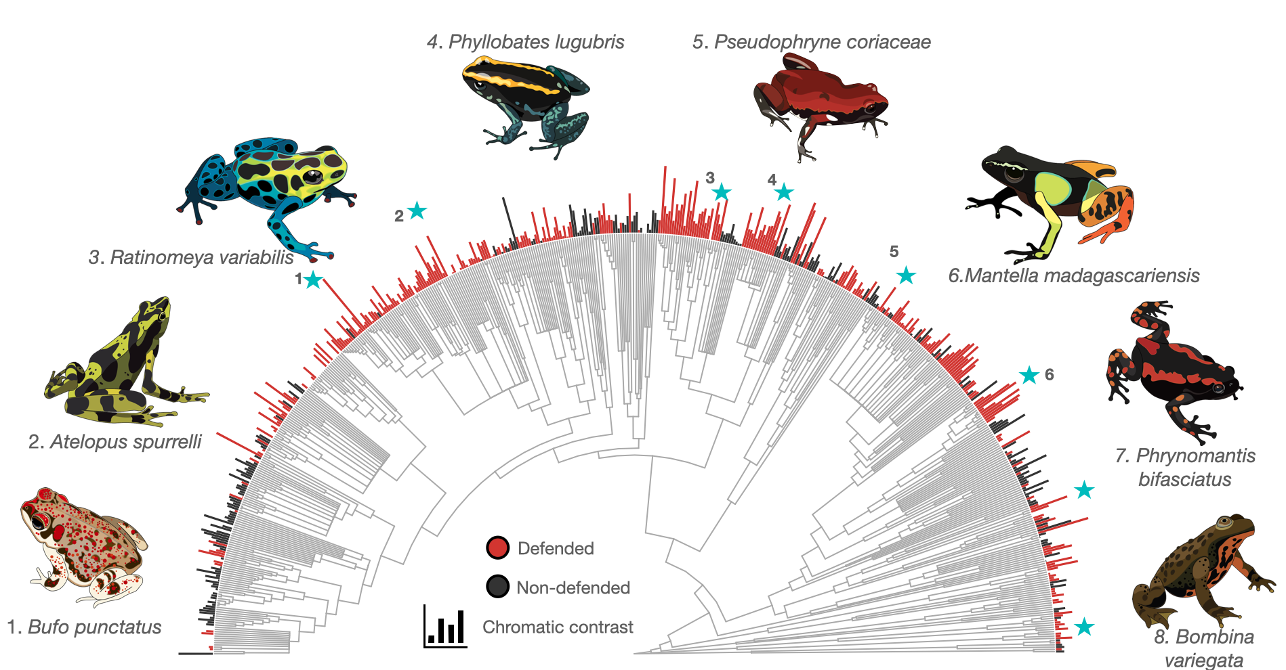
Figure 1. Phylogenetic tree showing species included in the study (594 spp.) and information on chemical defenses (red vs. grey) and internal chromatic contrast (bar length). We note that the prevalence of chemical defenses in this sample of species is high, and possibly a result of biases in searching for defenses in species that are already suspected to have those. Illustrations by Daniela Perez.

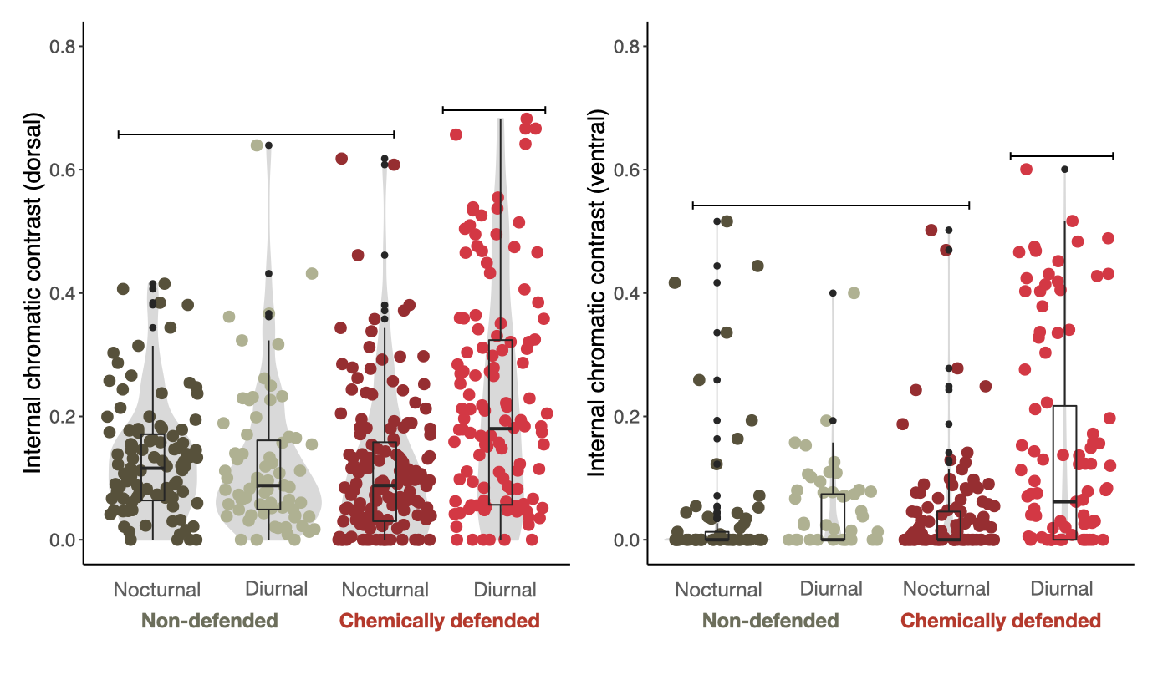
Figure 2. Differences in internal chromatic contrast according to defense status and time of activity, for dorsal (left) and ventral (right) views.

Predictors of conspicuousness in chemically defended species
For chemically defended species, both dorsal and ventral internal chromatic contrast were higher in smaller species, if these were diurnal (Figure 2, Table S2 and S5). Diurnal species were significantly smaller (F= 6.851, p-value=0.001) but this did not cause multicollineratity issues in our models, as all VIF (Variance Inflation Factors) were below 2. In any case, models including only body size as predictor showed the same association with colour (Table S3). We found strong negative associations between body size and multiple colour variables in species that are chemically defended. We did not find an association between body size and conspicuousness in species that are not chemically defended (Table S3). We also found negative associations between body size and ventral internal luminance contrast and dorsal luminance contrast against the background (Table S2 and S5). Associations between body size and conspicuousness were also evident when using Arbuckle & Speed’s (2015) binary measure of conspicuousness; however, models using phylogenetic control presented biased estimates and convergence issues, that could not be solved (Figure 3a, Estimate= -10.49; 95% HPD interval= -50.41 to 9.52). The model without phylogenetic control showed a similar pattern to our analysis, that is, a negative association between conspicuousness and body size (Estimate= -3.95; 95% HPD interval= -5.36 to -2.76).

There was no significant association between body size and categories of chemically defended species with only dorsal or ventral contrasting colouration (Figure S4, Estimate= 0.151, t-value=1.653, p-value=0.101). However, sample size was small for some categories in this analysis, due to lack of species signalling exclusively dorsally or ventrally (26 spp. with only dorsal signal and 14 spp. with only ventral signal).

For all analyses with significant patterns, these were consistent when the analyses were performed across 100 trees (supplementary material, Tables S4 and S5). A graphic summary of main results can be seen in Figure 4.

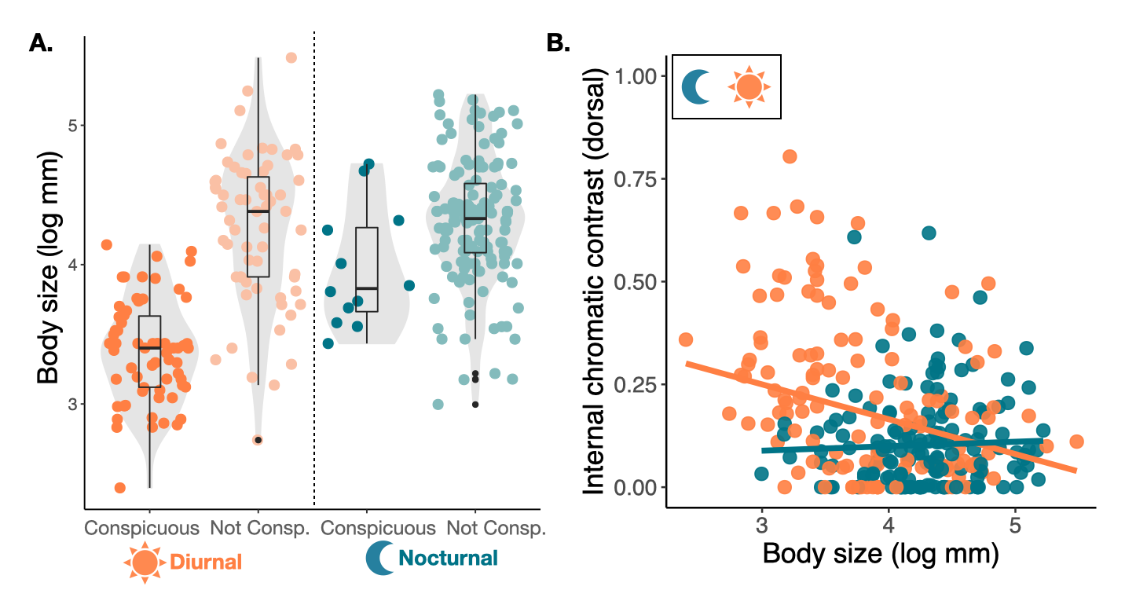
Figure 3. Association between body size and internal chromatic contrast for diurnal (orange) and nocturnal species (blue). A. When using binary color classification from Arbuckle and Speed (2015). B. When using continuous measures of conspicuousness extracted in this study. All species included in these figures are chemically defended. Slopes in B calculated from phylogenetically controlled models (Table S2).

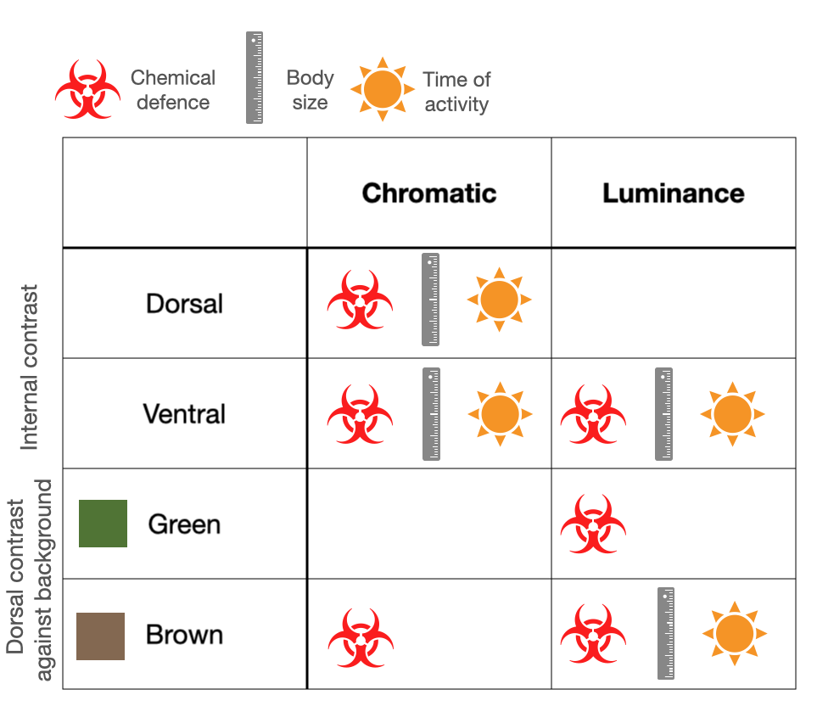
Figure 4. Graphic summary of results for different color variables extracted, and different predictors used. Models testing links with chemical defense included the complete dataset, and models testing links between body size and time of activity included only chemically defended species (since we were interested in predictors of conspicuousness in these species).

Discussion
Conspicuousness in toxic species often serves as an anti-predator warning signal, yet the global evolutionary drivers of these signals remain poorly understood (Kikuchi et al. 2021). We evaluated whether factors such as chemical defense, diurnal activity, and body size could predict conspicuous coloration in frogs. We found that chemically defended species that are diurnal have greater chromatic contrast between color pattern elements, both dorsally and ventrally, and against brown backgrounds. They also had greater luminance contrast between ventral color pattern elements. In addition, we found that toxic species are more conspicuous when they are diurnal and have a smaller body size. Together, these results support at a broader scale the role of color contrast as a warning signal in frogs and reveal that the association between body size and conspicuousness could be different from what has been previously proposed for frogs.

Our analyses suggest that the chromatic component of the internal color (i.e. hue, saturation) is a more important aspect of aposematic signaling than luminance, at least dorsally, which is consistent with broad observations in other clades (Ruxton et al. 2004). Chromatic contrast can be more important than luminance contrast for object recognition in birds, especially when targets are large (Zylinski and Osorio 2013). Chromatic signals provide robust information under variable illumination conditions, and color associations are more efficiently learned than achromatic associations, which could be key in the evolution of warning signals (Osorio et al. 1999; Stevens 2007; Kazemi et al. 2014). However, the lack of association between chemical defense and internal contrast in luminance can also be expected for other reasons, besides predator cognition. High internal luminance contrast can be found in both conspicuous and camouflaged color patters, especially in the case of disruptive coloration (Schaefer and Stobbe 2006). For instance, cryptic color patterns comprising black and light grey or brown patches will have high internal luminance contrast (Stevens and Merilaita 2009). Given the closer correspondence between conspicuousness and chromatic than luminance contrast, we would expect a stronger association between chemical defense and the former, and this expectation was corroborated by our results.

Our analyses also revealed that variation in internal contrast across species can be better explained by time of activity and body size than variation in contrast against backgrounds. Most internal contrast variables were linked to the presence of chemical defenses and, in toxic frogs, to body size and time of activity. This was not the case for contrast against green, and only partially for contrast against brown backgrounds. We acknowledge that this could be product of our approach, were using one color measure to represent green and brown natural backgrounds could limit our power to explain variation in background contrast. Nevertheless, the approach of using average brown and green backgrounds has been able to explain color evolution in other systems (Delhey et al. 2010; Delhey et al. 2013; Medina et al. 2017). It has been shown experimentally that chicks learn faster to avoid prey when it contrasts against the background, but not when there is a high internal contrast (Aronsson and Gamberale-Stille 2009). However, internal contrast is independent of variation in background coloration; thereby ensuring conspicuousness against any background. For active or mobile species that may encounter a variety of backgrounds, internal contrast may provide a more consistent and reliable signal; and indeed is a feature of most warning coloration (Stevens and Ruxton 2012; Barnett et al. 2016).

Ventral coloration is often involved in deimatic displays and could also have an important function in intraspecific communication (Maan and Cummings 2008; Umbers et al. 2017). Our results show a strong link between ventral internal luminance contrast and chemical defense. It is unclear, however, why some chemically defended species signal ventrally instead of dorsally, and this does not seem to be related to body size (although species signaling only ventrally tend to be smaller). For species with available information, we found that having only a conspicuous dorsal signal was more common that having only a ventral one. For those groups with only ventral signaling (e.g. Bombina, Melanophryniscus), camouflage may be the main defense, with warning colors as a secondary defense, once the prey is detected (Toledo et al. 2011).

For chemically defended species we found that diurnal and smaller species were more likely to evolve conspicuous coloration. Warning signals that involve color to advertise toxicity are thought to be directed towards visually oriented predators, such as birds or lizards (Ruxton et al. 2004; Ratcliffe and Nydam 2008). To our knowledge, this is the first time a link between diurnal activity and conspicuousness has been reported across frogs, but this association has been shown in other lineages. In lepidoptera, in seven phylogenetically matched pairs of clades, aposematic color evolved in the diurnal but not in the nocturnal clades (Merilaita and Tullberg 2005). It is unclear whether changes from nocturnal to diurnal behaviours preceded the evolution of toxicity and conspicuousness in frogs, but in Dendrobatidae and Bufonidae (two of the families with the highest number of aposematic species) diurnal activity is suggested to be ancestral, and to have preceded the evolution of toxicity, which was then followed by the evolution of conspicuous coloration in chemically defended species (Grant et al. 2006; Santos and Grant 2011).

Previous studies have found a positive association between conspicuousness and body size in frogs, opposite to what we found. These studies, however, included both defended and undefended species. Therefore, these studies suggest that aposematic species are larger than species that are non-toxic and cryptic, but they do not provide information on whether size can predict the evolution of conspicuousness in chemically defended frogs. In our dataset, chemically defended species tended to be larger than non-defended species, broadly supporting the idea that larger species are better defended; however, among species that are toxic, those that are large are less likely to be conspicuous (in both chromatic and luminance contrast). Our results match previous findings in nudibranchs, where larger species were more likely to be cryptic (Cheney et al. 2014). Most nudibranchs are chemically defended, which means that, similar to our results, chemically defended nudibranchs that are smaller are more likely to be conspicuous.

A negative link between body size and conspicuousness could arise because the increased profitability of toxic prey (in this case their large size) could reduce selection for conspicuous signals, and instead favor crypsis to avoid detection. It has been shown experimentally that when relative profitability is high, then crypsis is a better alternative than aposematism (Johansen et al. 2011). Intake of toxic prey increases when the nutritional content is artificially increased, suggesting that the nutritional value of prey can impact the evolution of anti-predator strategies (Halpin et al. 2013; Smith et al. 2014; Skelhorn et al. 2016). Body size may be negatively associated with conspicuous coloration in toxic frogs for other reasons too. For example, if size serves as a memorable signal in itself, as demonstrated by Tseng et al. (2014) in weevils, this may reduce the need for conspicuousness in larger species, although some studies have shown that color is a more salient feature than size (Halpin et al. 2013). In addition, larger animals generally contain more toxin and may, therefore, be less palatable and already better defended (Jeckel et al. 2019). Interestingly, it has been suggested that ingesting toxic, but profitable prey, could allow investment in detoxification processes and can favor the evolution of mechanisms to overcome toxicity in predators (Halpin et al. 2013). If this is the case, then predator-prey coevolution related to toxicity could be more common in larger defended species, where their high relative profitability increases the probability that predators ingest toxic prey. This, in turn, and relaxes selection for warning signals in larger prey because these signals are less likely to deter predators.

Our study has shown that chromatic aspects of color patterns and internal contrast are strongly related to the evolution of chemical defenses in frogs. We have also established that diurnal activity and smaller body size can predict the evolution of more conspicuous colors in chemically defended species, and these variables could help explain the prevalence of warning signals in different communities. Future studies could explore the extent to which these macroevolutionary patterns apply to other aposematic clades, marine and terrestrial, and the precise mechanisms driving the negative link between body size and conspicuousness.
Acknowledgements
We would like to thank Ben Phillips and Mark Elgar for insightful comments on earlier versions of this study. Thank you also to every member of the Stuart-Fox Lab, for the fascinating weekly zooms, laughs and input.
Funding
IM was funded by an ARC DECRA DE200100500 and DSF was funded by an ARC Future Fellowship FT180100216.

References
Anderson, S. R. and J. J. Wiens. 2017. Out of the dark: 350 million years of conservatism and evolution in diel activity patterns in vertebrates. Evolution 71:1944-1959.
Arbuckle, K. and M. P. Speed. 2015. Antipredator defenses predict diversification rates. Proceedings of the National Academy of Sciences 112:13597.
Aronsson, M. and G. Gamberale-Stille. 2009. Importance of internal pattern contrast and contrast against the background in aposematic signals. Behavioral Ecology 20:1356-1362.
Barnett, J. B., N. E. Scott-Samuel, and I. C. Cuthill. 2016. Aposematism: balancing salience and camouflage. Biology Letters 12:20160335.
Bürkner, P.-C. 2017. brms: An R package for Bayesian multilevel models using Stan. Journal of statistical software 80:1-28.
Callaghan, C. T. and J. J. Rowley. 2021. A continental assessment of diurnality in frog calling behaviour. Austral Ecology 46:65-71.
Cheney, K. L., F. Cortesi, M. J. How, N. G. Wilson, S. P. Blomberg, A. E. Winters, S. Umanzör, and N. J. Marshall. 2014. Conspicuous visual signals do not coevolve with increased body size in marine sea slugs. Journal of evolutionary biology 27:676-687.
Dale, J., C. J. Dey, K. Delhey, B. Kempenaers, and M. Valcu. 2015. The effects of life history and sexual selection on male and female plumage colouration. Nature 527:367-370.
Delhey, K., M. Hall, S. A. Kingma, and A. Peters. 2013. Increased conspicuousness can explain the match between visual sensitivities and blue plumage colours in fairy-wrens. Proceedings of the Royal Society B: Biological Sciences 280:20121771.
Delhey, K., M. Roberts, and A. Peters. 2010. The carotenoid-continuum: Carotenoid-based plumage ranges from conspicuous to cryptic and back again. BMC ecology 10:13.
Endler, J. A. 1990. On the measurement and classification of colour in studies of animal colour patterns. Biological Journal of the Linnean Society 41:315-352.
Gamberale-Stille, G. and B. Tullberg. 1999. Experienced chicks show biased avoidance of stronger signals: An experiment with natural colour variation in live aposematic prey. Evol. Ecol 13:579-589.
Grant, T., D. R. Frost, J. P. Caldwell, R. Gagliardo, C. F. Haddad, P. J. Kok, D. B. Means, B. P. Noonan, W. E. Schargel, and W. C. Wheeler. 2006. Phylogenetic systematics of dart-poison frogs and their relatives (Amphibia: Athesphatanura: Dendrobatidae). Bulletin of the American Museum of natural History 2006:1-262.
Grill, C. P. and V. N. Rush. 2000. Analysing spectral data: comparison and application of two techniques. Biological Journal of the Linnean society 69:121-138.
Guilford, T. 1990. The secrets of aposematism: unlearned responses to specific colours and patterns. Elsevier Current Trends.
Hagman, M. and A. Forsman. 2003. Correlated Evolution of Conspicuous Coloration and Body Size in Poison Frogs (Dendrobatidae). Evolution 57:2904-2910.
Halpin, C., J. Skelhorn, and C. Rowe. 2013. Predators' decisions to eat defended prey depend on the size of undefended prey. Animal behaviour 85:1315-1321.
Jeckel, A. M., S. Kocheff, R. A. Saporito, and T. Grant. 2019. Geographically separated orange and blue populations of the Amazonian poison frog Adelphobates galactonotus (Anura, Dendrobatidae) do not differ in alkaloid composition or palatability. Chemoecology 29:225-234.
Jetz, W. and R. A. Pyron. 2018. The interplay of past diversification and evolutionary isolation with present imperilment across the amphibian tree of life. Nature Ecology & Evolution 2:850-858.
Johansen, A. I., A. Exnerová, K. H. Svádová, S. Pavel, B. S. Tullberg, and G. Gamberale-Stille. 2011. Anti-Predatory defences in the shieldbug Graphosoma lineatum (Heteroptera: Pentatomidae) differ between life stages and colour forms: an experiment with hand reared great tits (Parus major) as predators.
Kang, C., R. Zahiri, and T. N. Sherratt. 2017. Body size affects the evolution of hidden colour signals in moths. Proceedings of the Royal Society B: Biological Sciences 284:20171287.
Kazemi, B., G. Gamberale-Stille, B. S. Tullberg, and O. Leimar. 2014. Stimulus salience as an explanation for imperfect mimicry. Current Biology 24:965-969.
Kikuchi, D. W., M. E. Herberstein, M. Barfield, R. D. Holt, and J. Mappes. 2021. Why aren't warning signals everywhere? On the prevalence of aposematism and mimicry in communities. Biological Reviews Early view.
Leimar, O., M. Enquist, and B. Sillen-Tullberg. 1986. Evolutionary Stability of Aposematic Coloration and Prey Unprofitability: A Theoretical Analysis. The American Naturalist 128:469-490.
Lindström, L. 1999. Experimental Approaches to Studying the Initial Evolution of Conspicuous Aposematic Signalling. Evolutionary Ecology 13:605-618.
Loeffler-Henry, K., C. Kang, and T. N. Sherratt. 2019. Consistent Associations between Body Size and Hidden Contrasting Color Signals across a Range of Insect Taxa. The American Naturalist 194:28-37.
Maan, M. E. and M. E. Cummings. 2008. Female preferences for aposematic signal components in a polymorphic poison frog. Evolution: International Journal of Organic Evolution 62:2334-2345.
Marples, N. M., T. J. Roper, and D. G. Harper. 1998. Responses of wild birds to novel prey: evidence of dietary conservatism. Oikos:161-165.
McClure, M., C. Clerc, C. Desbois, A. Meichanetzoglou, M. Cau, L. Bastin-Héline, J. Bacigalupo, C. Houssin, C. Pinna, B. Nay, V. Llaurens, S. Berthier, C. Andraud, D. Gomez, and M. Elias. 2019. Why has transparency evolved in aposematic butterflies? Insights from the largest radiation of aposematic butterflies, the Ithomiini. Proceedings of the Royal Society B: Biological Sciences 286:20182769.
Medina, I., K. Delhey, A. Peters, K. E. Cain, M. L. Hall, R. A. Mulder, and N. E. Langmore. 2017. Habitat structure is linked to the evolution of plumage colour in female, but not male, fairy-wrens. BMC Evolutionary Biology 17:35.
Medina, I., R. Vega-Trejo, T. Wallenius, M. R. E. Symonds, and D. Stuart-Fox. 2020. From cryptic to colorful: Evolutionary decoupling of larval and adult color in butterflies. Evolution Letters 4:34-43.
Merilaita, S. and B. S. Tullberg. 2005. Constrained camouflage facilitates the evolution of conspicuous warning coloration. Evolution 59:38-45.
Oliveira, B. F., V. A. São-Pedro, G. Santos-Barrera, C. Penone, and G. C. Costa. 2017. AmphiBIO, a global database for amphibian ecological traits. Scientific Data 4:170123.
Orme, F., Thomas, Petzoldt, Fritz, Isaac, Pearse. 2018. CAPER(Comparative Analyses of Phylogenetics and Evolution in R). 1.0.1.
Osorio, D., A. Miklósi, and Z. Gonda. 1999. Visual ecology and perception of coloration patterns by domestic chicks. Evolutionary Ecology 13:673-689.
Prudic, K. L., A. K. Skemp, and D. R. Papaj. 2006. Aposematic coloration, luminance contrast, and the benefits of conspicuousness. Behavioral Ecology 18:41-46.
Ratcliffe, J. M. and M. L. Nydam. 2008. Multimodal warning signals for a multiple predator world. Nature 455:96-99.
RStudio-Team. 2020. R version 4.0.3 -- "Bunny-Wunnies Freak Out".
Ruxton, G., T. Sherratt, and M. Speed. 2004. Avoiding Attack: The Evolutionary Ecology of Crypsis, Warning Signals and Mimicry.
Santos, J. C., L. A. Coloma, and D. C. Cannatella. 2003. Multiple, recurring origins of aposematism and diet specialization in poison frogs. Proceedings of the National Academy of Sciences 100:12792.
Santos, R. R. and T. Grant. 2011. Diel pattern of migration in a poisonous toad from Brazil and the evolution of chemical defenses in diurnal amphibians. Evolutionary Ecology 25:249-258.
Schaefer, H. M. and N. Stobbe. 2006. Disruptive coloration provides camouflage independent of background matching. Proceedings of the Royal Society B: Biological Sciences 273:2427-2432.
Schneider, C. A., W. S. Rasband, and K. W. Eliceiri. 2012. NIH Image to ImageJ: 25 years of image analysis. Nat Methods 9:671-675.
Skelhorn, J., C. G. Halpin, and C. Rowe. 2016. Learning about aposematic prey. Behavioral Ecology 27:955-964.
Smith, K. E., C. G. Halpin, and C. Rowe. 2014. Body size matters for aposematic prey during predator aversion learning. Behavioural Processes 109:173-179.
Smith, K. R., V. Cadena, J. A. Endler, M. R. Kearney, W. P. Porter, and D. Stuart-Fox. 2016. Color change for thermoregulation versus camouflage in free-ranging lizards. The American Naturalist 188:668-678.
Stevens, M. 2007. Predator perception and the interrelation between different forms of protective coloration. Proceedings of the Royal Society B: Biological Sciences 274:1457-1464.
Stevens, M. and S. Merilaita. 2009. Defining disruptive coloration and distinguishing its functions. Philosophical Transactions of the Royal Society B: Biological Sciences 364:481-488.
Stevens, M. and G. D. Ruxton. 2012. Linking the evolution and form of warning coloration in nature. Proceedings of the Royal Society B: Biological Sciences 279:417-426.
Toledo, L. F., I. Sazima, and C. F. Haddad. 2011. Behavioural defences of anurans: an overview. Ethology Ecology & Evolution 23:1-25.
Tseng, H.-Y., C.-P. Lin, J.-Y. Hsu, D. A. Pike, and W.-S. Huang. 2014. The Functional Significance of Aposematic Signals: Geographic Variation in the Responses of Widespread Lizard Predators to Colourful Invertebrate Prey. PLOS ONE 9:e91777.
Umbers, K. D. L., S. De Bona, T. E. White, J. Lehtonen, J. Mappes, and J. A. Endler. 2017. Deimatism: a neglected component of antipredator defence. Biology letters 13:20160936.
Vences, M., J. Kosuch, R. Boistel, C. F. B. Haddad, E. La Marca, S. Lötters, and M. Veith. 2003. Convergent evolution of aposematic coloration in Neotropical poison frogs: a molecular phylogenetic perspective. Organisms Diversity & Evolution 3:215-226.
Wang, I. J. 2011. Inversely Related Aposematic Traits: Reduced Conspicuousness Evolves With Increased Toxicity In a Polymorphic Poison-Dart Frog. Evolution 65:1637-1649.
White, T. E. and K. D. Umbers. 2021. Meta-analytic evidence for quantitative honesty in aposematic signals. Proceedings of the Royal Society B 288:20210679.
Wickham, H. 2016. ggplot2: Elegant Graphics for Data Analysis. Springer-Verlag New York.
Winebarger, M. M., M. W. Pugh, M. M. Gangloff, M. S. Osbourn, and L. Siefferman. 2018. Body Size Is Positively Correlated With Conspicuous Coloration in Ambystoma Salamanders, but Negatively Correlated With Conspicuous Coloration in Plethodon Salamanders. Frontiers in Ecology and Evolution 6.
Womack, M. C. and R. C. Bell. 2020. Two-hundred million years of anuran body-size evolution in relation to geography, ecology and life history. Journal of Evolutionary Biology 33:1417-1432.
Yu, G. 2020. Ggtree: a serialized data object for visualization of phylogenetic tree and annotation data. bioRxiv:2020.2010.2021.348169.
Zylinski, S. and D. Osorio. 2013. Visual contrast and color in rapid learning of novel patterns by chicks. Journal of Experimental Biology 216:4184-4189.

Tables

Table 1. Model results (PGLS) for association between chemical defenses, diurnal activity and internal chromatic and luminance contrast (dorsal and ventral). Estimates from analysis on MCC tree, results across 100 trees reported in supplementary material.

 | Dorsal |  |  | Ventral
Internal contrast (chromatic) | Estimate | t-value | P-value | Estimate | t-value | P-value
Defended diurnal vs. Defended nocturnal | -0.072 | -4.090 | < 0.001 | -0.055 | -3.116 | 0.002
Defended diurnal vs. Not defended diurnal | -0.084 | -4.012 | < 0.001 | -0.070 | -3.388 | 0.001
Defended diurnal vs. Not defended nocturnal | -0.065 | -3.183 | 0.002 | -0.051 | -2.428 | 0.016
Chemically defended vs. Not defended | 0.033 | 2.681 | 0.007 | 0.028 | 2.163 | 0.031
Internal contrast (luminance)
Defended diurnal vs. Defended nocturnal | -7.869 | -1.282 | 0.201 | -18.007 | -2.229 | 0.026
Defended diurnal vs. Not defended diurnal | -13.441 | -1.845 | 0.066 | -26.203 | -2.778 | 0.006
Defended diurnal vs. Not defended nocturnal | -0.867 | -0.122 | 0.903 | -32.486 | -3.389 | 0.001
Chemically defended vs. Not defended | 2.070 | 0.472 | 0.636 | 16.540 | 2.735 | 0.006

