Are we underestimating the ecological and evolutionary effects of warming? Interactions with other environmental drivers increase vulnerability to high temperatures

Elena Litchman¹, Mridul K. Thomas²

¹ Michigan State University, USA
² University of Geneva, Switzerland

corresponding author email: litchman@msu.edu

Keywords: Thermal performance curve (TPC), optimum temperature, stressor interaction, global environmental change, warming
Abstract
Warming, the most prominent aspect of global environmental change, already affects most ecosystems on Earth. In recent years, biologists have increasingly integrated the effects of warming into their models by capturing how temperature shapes their physiology, ecology, behavior, evolutionary adaptation, and probability of extirpation/extinction. The more physiologically-grounded approaches to predicting ectotherms’ responses use thermal performance curves (TPCs) obtained by measuring species performance (e.g., growth rate) under different temperatures while other factors are held constant. These other factors are usually held at benign levels to ‘isolate’ the effects of temperature. Here we highlight that this practice may paint a misleading picture because TPCs are functions of other factors, including global change stressors. We review evidence that resource limitation, pH, oxygen and CO₂ concentration, water availability, as well as parasites, all influence TPC shape and thermal traits such as optimum temperature for growth. Evidence from a wide variety of organisms – phytoplankton, protists, plants, insects, and fish – points towards such interactions increasing organisms’ susceptibility to high temperatures. Failing to account for these interactions is likely to lead to erroneous predictions of performance in nature and possibly an underestimation of the risks of warming. We discuss the general patterns and possible consequences of such interactions for ecological communities. But importantly, interactions with TPCs share common features that we can learn from. Incorporating these interactions into population and community models should lead to deeper insights and more accurate predictions of species’ performance in nature, now and in the future.

Introduction
The next 100 years are expected to see temperature increases of at least 2 to 3°C both on land and in the ocean, and the warming will continue beyond that time frame (IPCC 2021). Understanding and predicting the consequences of this change has been a major, defining goal of biological research for nearly a generation – and will continue to be, for years or decades to come. A multitude of approaches has been used to understand what this and associated environmental changes mean for organisms, communities and ecosystems: from experiments in the lab, mesocosm and field, correlative analyses on expression patterns, genes, species, communities and ecosystems, from local to global scales, theoretical models ranging from the abstract and simple, to the detailed and specific. To make this problem tractable, a substantial proportion of this work – especially the experimental and theoretical parts of it – has focused on isolating the effects of temperature change alone on populations and communities and maintaining other environmental factors at benign (high nutrient/food levels) or at ambient levels. We argue that this approach must change. By ignoring how temperature interacts with other factors to influence populations and communities, we draw conclusions and make projections that are likely to be heavily biased.
Here we briefly describe how temperature shapes the growth of ectotherms, highlight the available evidence on temperature interactions with other environmental factors in determining thermal performance curves and discuss major consequences of such interactions for predicting the effects of rising temperatures on species and communities.
Thermal performance curves (TPCs)
At a fundamental level, temperature affects organisms by changing chemical reaction rates. Accelerating reaction rates with increasing temperature from a low baseline tends to increase organismal performance and vital rates. As summarized in the Metabolic Theory of Ecology, temperature variation drives variation in rates of growth, death, movement, consumption, reproduction, mutation and more (Brown et al. 2004). This simple exponential increase with increasing temperatures drives global variation in a host of traits and life history strategies. For any particular biochemical reaction, however, the exponential increase in reaction rate with increasing temperatures does not continue indefinitely: it slows, stops, and reverses rapidly. At a high enough temperature, enzyme conformations begin to fail and they bind with unintended target molecules. In all ectotherms, from bacteria to reptiles, this manifests at the organismal and population level as performance being a left-skewed unimodal function of temperature (Fig. 1A).
This unimodal function, called the thermal performance curve (TPC) or thermal reaction norm has been at the core of attempts to mechanistically link physiology with species ranges, population dynamics and community composition. While the full TPC can be incorporated into theoretical models, the parameters describing these TPCs - especially the optimum, maximum and minimum temperatures (T_{opt}, T_{max} and T_{min}, respectively) - form convenient species traits that are often used to assess species’ vulnerability to high or low temperatures or define their thermal niches (Fig. 1A, Deutsch et al. 2008, Addo-Beddiako et al. 2000, Thomas et al. 2012, Sunday et al. 2011). TPCs and the associated traits capture important patterns in – and constraints on - growth rates and geographic ranges (Sunday et al. 2012, Payne et al. 2016). Therefore, projecting how warming will alter species performance and shift their ranges seems readily achievable. At individual locations, temperature projections through time instead of space are used to generate expectations of whether species would be able to persist and whether community composition would remain similar. There are complications that are difficult to address rigorously with this approach at present, such as evolution and biotic interactions that are subject to other species’ TPCs. We focus here on one complication that can and should be addressed.

Figure 1. How growth rate depends on temperature and nutrient concentration. Top: Growth dependence on temperature. Left: Growth dependence on nutrient concentration. C. The growth rate surface as a function of temperature and nutrients, showing how the major temperature traits, optimum temperature for growth, T_{opt}, the minimum, T_{min} and maximum temperature for growth, T_{max} all vary with nutrients.

The dependence of thermal performance curves on environmental factors
The work characterizing the dependence of growth and other eco-physiological characteristics on temperature is conceptually rigorous but suffers from a considerable weakness. Even without considering evolution and intraspecific variation, the TPC is not a stable property of species, populations or even individuals. Temperature interacts with a number of other environmental factors to determine performance; or stated differently, the TPC is itself a function of other factors. Food/nutrient availability, pH, light (for photosynthetic organisms), water availability, oxygen concentration, as well as biotic interactions such as parasitism, all can alter the shape of the TPC (Ern et al. 2016, Thomas et al. 2017, Aldea-Sánchez et al. 2021, Hector et al. 2021). While ubiquitous, these interactions of temperature with other abiotic and biotic factors have been mostly neglected when assessing how temperature affects population and community dynamics. Partly to reduce experimental complexity, it is common to ‘isolate’ the effects of temperature in experiments by setting other factors at their most benign level (e.g., optimal light, moisture or nutrient conditions for primary producers, high food supply levels for consumers). This practice is understandable - we have done the same in our own work - but comes at the obvious cost of making TPCs less representative of temperature-dependent performance in nature.
The available evidence suggests that TPC dependence on other environmental factors is widespread. The pattern that emerges across taxa and environmental factors is that thermal traits such as T_{opt} and T_{max} decline in stressful conditions such as resource limitation (Fig. 1). In other words, organisms are more sensitive to high temperatures when deprived of resources or subjected to extremes in other environmental dimensions. In phytoplankton, major oceanic primary producers, resource (nutrient) limitation has been shown to not only decrease their maximum population growth rates but also lower their T_{opt} by 3 - 15°C (Boyd 2019, Thomas et al. 2017, Bestion et al. 2018). Light limitation also decreases T_{opt} in phytoplankton by about 4°C on average (Edwards et al. 2016) and increases high temperature sensitivity in seagrasses (Kendrick et al. 2019). This food dependence is not limited to photoautotrophs. T_{opt} and T_{max} decreasing by approximately 3-7°C in the freshwater ciliate Urotricha farcta (Weisse et al. 2002) and the marine flagellate Oxyrrhis marina (Kimmance et al. 2006). This occurs in fish as well. T_{opt} for somatic growth declines by approximately 10°C in salmon (Brett 1971) and several degrees in coral reef damselfish larvae, although a narrow experimental temperature range meant that precise values could not be quantified in the latter case (McLeod et al. 2013). The salmon study also showed a decrease in the upper temperature limit, T_{max}, also of approximately 10°C. Mosquitoes also show decreases in their T_{opt} of about 6°C (though this is poorly constrained) and their T_{max} as well (Huxley et al. 2021).
Theoretical investigation of these interactions has also been limited, but at least two models that approach the question of how temperature-resource (nutrient/food) interactions influence populations, or equivalently, how resources alter TPCs (Thomas et al. 2017, Huey and Kingsolver 2019). Thomas et al. (2017) developed a simple model of temperature-resource interactions that separates the effects of the two factors on birth and death processes (loosely defined). Huey & Kingsolver (2019) formulated a bioenergetic model that focusses on the thermal sensitivities of energy gain and metabolism. Despite their structural differences, both models come to a similar conclusion: T_{opt} and T_{max} are saturating functions of resource concentration, consistent with the findings described earlier. Both models also predict that T_{min} is altered as well, with low resources reducing cold tolerance in a similar manner. Consistent with this prediction, high N availability may increase cold tolerance in plants (Taulavuori et al. 2014, Toca et al. 2017). That these patterns can be modelled in a relatively straightforward way to yield important insights about how organisms will respond to environmental change indicates that there is still low-hanging fruit to be plucked: the implications of these interactions deserve urgent theoretical attention.
Consequences of interactions of temperature with other environmental factors
Using TPCs obtained in otherwise benign conditions, with no resource limitation or other environmental stress, to predict species survival and shifts in their geographic ranges is likely to underestimate the negative effects of warming. This is because in most habitats, environmental factors are at stressful levels at least part of the time. The observed dependence of thermal traits on other environmental factors has many consequences that need to be accounted for when predicting the effects of rising temperature on organisms, populations and communities. Here we outline several such consequences that should be investigated.
- Aquatic and terrestrial ecosystems with pronounced resource limitation may be more adversely affected by warming than ecosystems that are not resource-limited. Nutrient (nitrogen, phosphorus or iron) limitation is widespread in the oceans and is predicted to become even more prevalent in the future (Sarmiento et al. 2004, Hayashida et al. 2020). On land, vast regions are also limited by P, N or co-limited by more than one nutrient (Du et al. 2020, Hou et al. 2021). Aridification of the land surface is also increasing, especially in the subtropics, thus increasing areas with water limitation (Shi et al. 2021). Because resource limitation decreases T_{opt} and T_{max} (Thomas et al. 2017, Huey and Kingsolver 2019), a simultaneous reduction in resource availability alongside increasing temperatures is likely to be substantially worse for many species than warming alone. And because regions experiencing resource limitation are widespread both on land and in the ocean, temperature-resource interactions are likely to be important in determining species growth across broad swathes of the globe. Identifying areas that are undergoing rapid warming and simultaneously experience changes in the type and degree of resource limitation (Hayashida et al. 2020) could help pinpoint communities that may be especially vulnerable to climate change. Fig. 2 shows global ocean nitrate concentration, temperature, and the regions where the lowest nitrate concentration and highest temperatures overlap. Such areas appear predominantly in the tropics, and if we take into account that tropical phytoplankton’s T_{opt} values match the current ambient temperatures (Thomas et al. 2012), the T_{opt} decline due to nutrient limitation is likely to be especially detrimental. Importantly, high levels of some resources may still result in resource limitation by other resources due to stoichiometric imbalances (Sterner and Elser 2002).

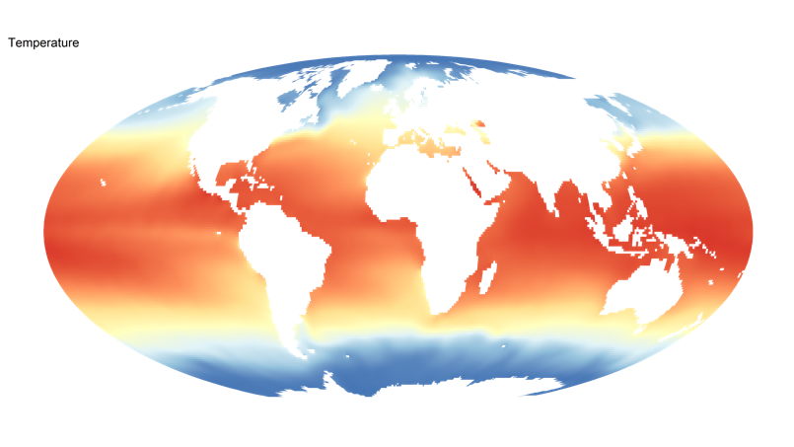
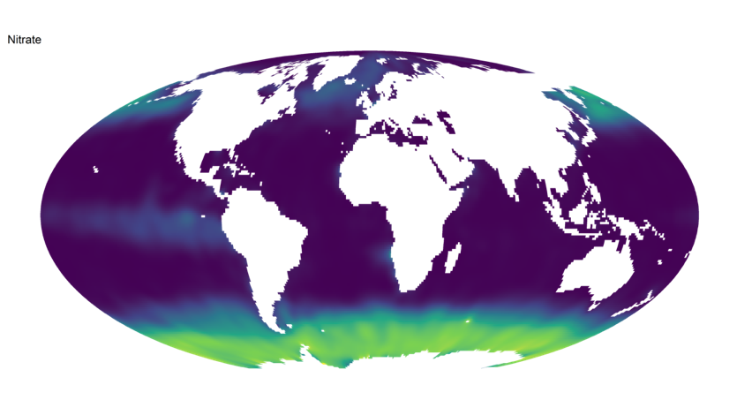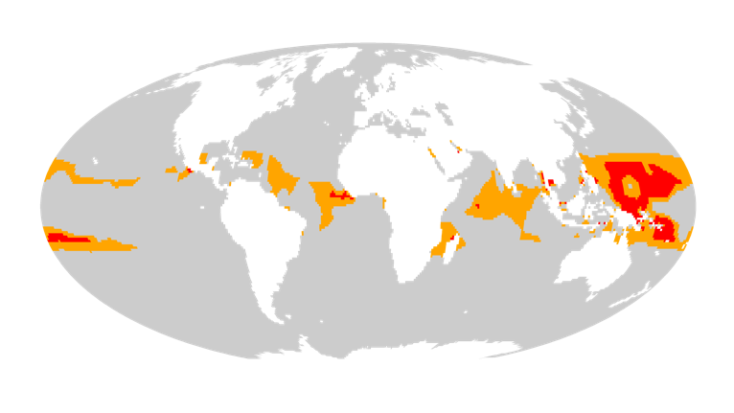
Figure 2. Oceanic regions where temperature-nutrient interactions are most likely to limit phytoplankton growth, and possibly shape ecosystem dynamics. The top and middle maps show global distributions of sea surface temperature and nitrate. The bottom map highlights locations where temperatures at near their maximum and nitrate concentrations near their minimum. Red indicates marine regions where temperature is in the top 10% and nitrate in the bottom 10%. Orange uses a 20% threshold for both instead. For both variables, we use annual mean values and ignore other factors that also shape growth. Data source: World Ocean Atlas 2018 (Garcia et al. 2018, Locarnini et al. 2019).
- Because species differ in their resource requirements, same resource levels could be limiting to some species and not to others, and these differences will affect the possible changes in thermal traits and, thus, may increase differences in thermal sensitivity. For example, good nutrient competitors may have their TPCs relatively unchanged by decreases in resources. In contrast, poor nutrient competitors may experience severe nutrient limitation and have their TPCs altered; the associated decrease in T_{opt} and T_{max} would make these poor nutrient competitors more sensitive to warming.
- Within species, populations located in low-resource regions - such as the oceanic gyres or drylands - may be a valuable source of genetic diversity. As a consequence of adaptation to resource limitation, they may be better able to tolerate high temperatures in higher resource conditions, forming a reservoir of (relative) heat tolerance. Heat waves in adjacent high-resource regions may provide opportunities for migrants from these environments by removing competitors adapted to high-resource conditions. These preadapted genotypes can either disperse into novel environments on their own or be transplanted deliberately to rescue declining populations (Bay et al. 2017).
- Just as species are expected to migrate towards cooler regions, species from hot environments that also experience other stresses at present (low resource availability or low pH, for example) may survive by migrating towards high-resource or moderate pH environments, thereby decreasing their sensitivity to warming. These may favour the survival of otherwise vulnerable taxa. This complicates predictions of extirpation and extinction based solely on thermal limits, and can lead to more complex patterns of community reorganization than presently envisioned. A species that persists by migrating towards high-resource or moderate pH environments necessarily competes with resident taxa, possibly causing extirpations. This complex outcome of environmental warming will be hard to predict or model, but properly accounting for interactions is a necessary step towards attempting this.
- The interacting effects of temperature and resources also cascade through food webs. If prey species decline due to warming, this triggers a similar temperature-food interaction problem in the predators. This may amplify the negative effects of warming.
- Phenological shifts can also change resource availability for different trophic levels. Flowering plants in peak summer may be an especially important resource for local pollinator communities and their predators. Changes in fruiting times may also have important effects on consumer species’ heat tolerances. For example, shifts in flowering time may create new periods of resource limitation for pollinators and therefore increase pollinator temperature vulnerability at critical times.
- Selection on temperature tolerance is likely much stronger in nature than anticipated from lab studies, because of the increased heat stress associated with periods of low food and other stresses.
- Evolutionary adaptation to temperature may be impaired by suboptimal levels of other environmental factors, such as nutrient or other resource limitation (Aranguren-Gassis et al. 2019).
- Fertilization practices in agriculture are likely to be especially important to consider as the climate warms. Although excess fertilization is a major environmental concern because of the consequent greenhouse gas emissions (Tian et al. 2020), reducing nutrient limitation in plants could provide some protection against heat waves.
Conclusion
Our review shows that across different organisms and ecosystems, various abiotic and biotic factors may significantly modify organismal responses to high temperature. When these environmental drivers inhibit growth, they at the same time increase the sensitivity to high temperatures. Because these effects appear so widespread, we need to explicitly consider how temperature interacts with other environmental factors, including global change stressors, to develop better predictions of how warming will affect species and communities. A focused research agenda to investigate systematically the effects of multiple interacting stressors on species’ TPCs from a wide range of habitats in oceanic, freshwater and terrestrial ecosystems would be in line with the ongoing efforts to implement the multistressor framework in global change research (Boyd et al. 2019, Wake 2019). Among the key questions to address are how universal the negative effects of other stressors on the high temperature tolerances are, the magnitudes and the mechanisms of the effects and whether adding more than one or two stressors would exacerbate thermal sensitivity even further. The new research would help to better assess the effects of global warming on species growth, future geographic ranges, productivity and biodiversity. Moreover, it is essential for developing predictive models for conservation, agriculture, fisheries and climate change mitigation.

References
Aldea-Sánchez, P., et al. 2021. Heat tolerance, energetics, and thermal treatments of honeybees parasitized with Varroa. - Frontiers in Ecology and Evolution 9.
Aranguren-Gassis, M., et al. 2019. Nitrogen limitation inhibits marine diatom adaptation to high temperatures. - Ecology Letters 22: 1860-1869.
Bay, R. A., et al. 2017. Genomic models predict successful coral adaptation if future ocean warming rates are reduced. - Science Advances 3: e1701413.
Bestion, E., et al. 2018. Nutrient limitation constrains thermal tolerance in freshwater phytoplankton. - Limnology and Oceanography Letters 3: 436-443.
Boyd, P. W. 2019. Physiology and iron modulate diverse responses of diatoms to a warming Southern Ocean. - Nature Climate Change 9: 148-152.
Boyd, P. W., et al. 2019. SCOR WG149 Handbook to support the SCOR Best Practice Guide for ‘Multiple Drivers’ Marine Research.
Brown, J. H., et al. 2004. Toward a metabolic theory of ecology. - Ecology 85: 1771-1789.
Du, E., et al. 2020. Global patterns of terrestrial nitrogen and phosphorus limitation. - Nature Geoscience 13: 221-226.
Edwards, K. F., et al. 2016. Phytoplankton growth and the interaction of light and temperature: A synthesis at the species and community level. - Limnology and Oceanography 61: 1232-1244.
Ern, R., et al. 2016. Oxygen dependence of upper thermal limits in fishes. - Journal of Experimental Biology 219: 3376-3383.
Garcia, H., et al. 2018. World Ocean Database 2018. Users Manual (Prerelease). NOAA Atlas NESDIS 81.
Hayashida, H., et al. 2020. Background nutrient concentration determines phytoplankton bloom response to marine heatwaves. - Global Change Biology 26: 4800-4811.
Hector, T. E., et al. 2021. Thermal limits in the face of infectious disease: How important are pathogens? - Global Change Biology 27: 4469-4480.
Hou, E., et al. 2021. Latitudinal patterns of terrestrial phosphorus limitation over the globe. - Ecology Letters 24: 1420-1431.
Huey, R. B. and Kingsolver, J. G. 2019. Climate warming, resource availability, and the metabolic meltdown of ectotherms. - American Naturalist 194: E140-E150.
Huxley, P. J., et al. 2021. The effect of resource limitation on the temperature dependence of mosquito population fitness. - Proceedings of the Royal Society B: Biological Sciences 288: 20203217.
Kendrick, G. A., et al. 2019. A systematic review of how multiple stressors from an extreme event drove ecosystem-wide loss of resilience in an iconic seagrass community. - Frontiers in Marine Science 6.
Kimmance, S., et al. 2006. Do temperature-food interactions matter? Responses of production and its components in the model heterotrophic flagellate Oxyrrhis marina. - Aquatic Microbial Ecology 42: 63-73.
Locarnini, M., et al. 2019. Temperature, World Ocean Atlas 2018. - NOAA Atlas NESDIS 81.
McLeod, I. M., et al. 2013. Climate change and the performance of larval coral reef fishes: the interaction between temperature and food availability. - Conservation Physiology 1.
Sarmiento, J. L., et al. 2004. Response of ocean ecosystems to climate warming. - Global Biogeochemical Cycles 18: GB3003, doi:3010.1029/2003GB002134.
Shi, H., et al. 2021. Terrestrial biodiversity threatened by increasing global aridity velocity under high-level warming. - Proceedings of the National Academy of Sciences 118: e2015552118.
Sterner, R. W. and Elser, J. J. 2002. Ecological stoichiometry: the biology of elements from molecules to the biosphere. - Princeton University Press.
Taulavuori, K., et al. 2014. Truths or myths, fact or fiction, setting the record straight concerning nitrogen effects on levels of frost hardiness. - Environmental and Experimental Botany 106: 132-137.
Thomas, M. K., et al. 2017. Temperature–nutrient interactions exacerbate sensitivity to warming in phytoplankton. - Global Change Biology 23: 3269-3280.
Thomas, M. K., et al. 2012. A global pattern of thermal adaptation in marine phytoplankton. - Science 338: 1085-1088.
Tian, H., et al. 2020. A comprehensive quantification of global nitrous oxide sources and sinks. - Nature 586: 248-256.
Toca, A., et al. 2017. Species ecology determines the role of nitrogen nutrition in the frost tolerance of pine seedlings. - Tree Physiology 38: 96-108.
Wake, B. 2019. Experimenting with multistressors. - Nature Climate Change 9: 357-357.
Weisse, T., et al. 2002. Interactive effect of temperature and food concentration on growth rate: A test case using the small freshwater ciliate Urotricha farcta. - Limnology and Oceanography 47: 1447-1455.

