Are we underestimating the ecological and evolutionary effects of warming? Interactions with other environmental drivers may increase species vulnerability to high temperatures

Elena Litchman^{1,2*} and Mridul K. Thomas³
¹Kellogg Biological Station, Michigan State University, Hickory Corners, MI 49060, USA
²Department of Global Ecology, Carnegie Institution for Science, Stanford, CA 94305, USA
³Department F.-A. Forel for environmental and aquatic sciences, University of Geneva, CH-1211, Switzerland
*Corresponding author: elitchman@carnegiescience.edu

Abstract

Warming, the most prominent aspect of global environmental change, already affects most ecosystems on Earth. In recent years, biologists have increasingly integrated the effects of warming into their models by capturing how temperature shapes their physiology, ecology, behavior, evolutionary adaptation, and probability of extirpation/extinction. The more physiologically-grounded approaches to predicting ectotherms’ responses use thermal performance curves (TPCs) obtained by measuring species performance (e.g. growth rate) under different temperatures. TPCs are typically measured while other factors are held constant at benign levels to ‘isolate’ the effects of temperature. Here we highlight that this practice paints a misleading picture because TPCs are functions of other factors, including global change stressors. We review evidence that resource limitation, pH, oxygen and CO₂ concentration, salinity, water availability, parasites and mutualists, all influence TPC shape and thermal traits such as optimum temperature for growth. Evidence from a wide variety of organisms – phytoplankton, protists, plants, insects, and fish – points towards such interactions increasing organisms’ susceptibility to high temperatures (reducing it in the case of mutualists). Failing to account for these interactions is likely to lead to erroneous predictions of performance in nature and an underestimation of the risks of warming. We discuss the general patterns and possible consequences of such interactions for ecological communities. But importantly, interactions with TPCs share common features that we can learn from. Incorporating these interactions into population and community models should lead to deeper insights and more accurate predictions of species’ performance in nature – as well as strategies for managing natural and agricultural ecosystems in the face of warming.
Keywords: Thermal performance curve (TPC), optimum temperature, stressor interaction, resource limitation, global environmental change, warming.
Introduction
The next 100 years are expected to see temperature increases of at least 2 to 3°C both on land and in the ocean, and the planet will likely continue to warm beyond that time frame (IPCC 2021). Understanding and predicting the consequences of this change has been a major, defining goal of biological research for nearly a generation – and will continue to be, for decades to come. A multitude of approaches has been used to understand what warming and associated environmental changes means for organisms, communities, and ecosystems: from experiments in the lab, mesocosm and field, correlative analyses on expression patterns, genes, species, communities and ecosystems, from local to global scales, theoretical models ranging from the abstract and simple to the detailed and specific. To make this problem tractable, a substantial proportion of this work – especially the experimental and theoretical parts – has focused on isolating the effects of temperature change alone on populations and communities and maintaining other environmental factors at benign (e.g., high nutrient/food levels) levels. We argue that this approach must change. By ignoring or oversimplifying how temperature interacts with other factors to influence populations and communities, we draw conclusions and make projections that are likely to be heavily biased.
Here we briefly describe how temperature shapes the growth of ectotherms, then discuss the available evidence on temperature interactions with other environmental factors, and the consequences of such interactions for predicting the effects of rising temperatures on species and communities. The strongest existing evidence is for the effects of resource limitation on the temperature response because this has received the most careful study, but we also provide examples of how other abiotic and biotic factors affect thermal performance curves.

Thermal performance curves (TPCs)
At a fundamental level, temperature affects organisms by changing chemical reaction rates. Accelerating reaction rates with increasing temperature from a low baseline tends to increase organismal performance and vital rates. As summarized in the Metabolic Theory of Ecology, increasing temperature drives exponential increases in rates of growth, death, movement, consumption, reproduction, mutation and more (Brown et al. 2004). This in turn causes global variation in a host of traits and life history strategies. For any particular biochemical reaction, however, the exponential increase in reaction rate with increasing temperature does not continue indefinitely: it slows, stops, and reverses rapidly. At a high enough temperature, enzyme conformations begin to fail and they bind with unintended target molecules. In all ectotherms, from bacteria to reptiles, this manifests at the organismal and population level as performance being a left-skewed unimodal function of temperature (Fig. 1A). There are also additional thermodynamic, metabolic and physiological processes that control thermal limits (Tomanek 2008, Ritchie 2018).
This unimodal function describing the dependence of growth or other process on temperature is called the thermal performance curve (TPC) or thermal reaction norm. It has been at the core of attempts to mechanistically link physiology with species ranges, population dynamics and community composition. While the full TPCs can be incorporated into theoretical models, they can also conveniently be summarized using a few easily-understood parameters such as the optimum, maximum and minimum temperatures (T_{opt}, T_{max} and T_{min}). These parameters can be thought of as traits, and are often used to assess species’ vulnerability to high or low temperatures and define their thermal niches (Fig. 1A, Deutsch et al. 2008, Addo-Beddiako et al. 2000, Thomas et al. 2012, Sunday et al. 2011). TPCs and these associated traits capture important patterns in – and constraints on – growth rates and geographic ranges (Sunday et al. 2012, Payne et al. 2016). Therefore, using these TPCs to project how warming will alter species performance and shift their ranges seems feasible with our present level of knowledge. At individual locations, temperature projections through time instead of space can be used to generate expectations of whether species would be able to persist (expected net population growth rate ≥ 0) and whether community composition would remain similar. There are complications that are difficult to address rigorously with this approach at present due to insufficient empirical data on TPC evolution and on how biotic interactions depend on species’ TPCs (O'Donnell et al. 2018, Tüzün and Stoks 2018). We focus here on one complication that can and should be addressed: the dependence of TPCs and temperature traits on other environmental drivers such as nutrient/food availability.
A.
B.
C.
Figure 1. The dependence of population growth rate on temperature and nutrient concentration. A. A typical thermal performance curve (TPC). B. Growth dependence on nutrient concentration. C. The growth rate surface as a function of temperature and nutrients, based on a model and data from Thomas et al. (2017). Growth rate is highest when the temperature is at T_{opt} and nutrient concentration is high. Growth rates below -0.1 are suppressed to highlight variation in positive values.

The dependence of TPCs on environmental factors
The TPC is not a stable property of species, populations or even individuals. Temperature interacts with a number of other environmental factors to determine performance; or stated differently, the TPC is itself a function of other factors. Food/nutrient availability, pH, light (for photosynthetic organisms), salinity, water availability, oxygen concentration, as well as biotic interactions such as parasitism or mutualism, all can alter the shape of the TPC (Ern et al. 2016, Thomas et al. 2017, Aldea-Sánchez et al. 2021, Hector et al. 2021).
The available evidence suggests that TPC dependence on various environmental factors is widespread. The pattern that emerges across taxa and environmental factors is that T_{opt} and T_{max} (as well as maximum growth rate) decline in stressful conditions such as resource limitation (Fig. 1C). In other words, organisms are more sensitive to high temperatures when deprived of resources or subjected to extremes in other environmental dimensions. In phytoplankton, major oceanic primary producers, nutrient limitation has been shown to not only decrease their maximum population growth rates but also lower their T_{opt} by 3 - 15°C (Boyd 2019, Thomas et al. 2017, Bestion et al. 2018). Light limitation also decreases T_{opt} in phytoplankton by about 4°C on average (Edwards et al. 2016) and as much as 18°C in well-resolved cases (Kovács et al. 2016); it also increases vulnerability to high temperature in seagrasses (Kendrick et al. 2019). In kelp, nitrogen limitation reduced high temperature tolerance (Fernández et al. 2020). In maize, one of the world’s most important crops, high temperatures reduced yield three-fold more per °C with increasing water limitation (30%, vs 10% at higher water availability) (Anderson et al. 2015). In another study, irrigated maize was not negatively affected by high temperatures (Carter et al. 2016), though this is partly due to cooling by evaporation (Siebert et al. 2017).
This resource-dependence of temperature responses is not limited to photosynthetic organisms. Food reduction decreased T_{opt} and T_{max} by approximately 3-7°C in the freshwater ciliate Urotricha farcta (Weisse et al. 2002) and the marine flagellate Oxyrrhis marina (Kimmance et al. 2006). The decline in optimum temperature occurs in fish as well: at low food availability, T_{opt} for somatic growth declines by approximately 10°C in salmon (Brett 1971) and several degrees in coral reef damselfish larvae (precise values could not be quantified) (McLeod et al. 2013). The salmon study also showed a decrease in T_{max} of approximately 10°C. Food limitation also decreased T_{opt} and T_{max} for population growth rate by about 6°C in mosquitoes (Huxley et al. 2021). In some studies, however, a zooplankter Daphnia’s survival at high temperature was higher when fed low phosphorus algae or poor food quality cyanobacteria (Starke et al. 2021, Sarrazin and Sperfeld 2022), suggesting that the effects of resource limitation may differ depending on the temporal scale of responses (Sarrazin and Sperfeld 2022).
Other environmental drivers and biotic interactions modify TPCs in a manner that is often similar to the effects of resource limitation. Salinity reduction lowered T_{opt} and T_{max} in phytoplankton from an estuary by 2 - 10°C (Bill et al. 2016). Frogs infected by chytrid pathogens had a reduced tolerance for high temperatures, experiencing spasms at temperatures ~4°C lower than uninfected frogs (Greenspan et al. 2017). Reductions in high-temperature tolerance were also found in Daphnia infected by bacterial pathogens, in both short- and long-term experiments (Vale et al. 2008, Hector et al. 2019, Laidlaw et al. 2020). We note that some of these biotic interaction experiments used short-term assays that are substantially different from those used when studying abiotic interactions, and so some caution in comparing measurements is warranted.
In contrast, mutualistic interactions increase heat tolerance in a wide range of taxa. In both wild and crop plants, fungal symbionts increase tolerance of high temperatures as well as other stresses such as drought (Redman et al. 2002, Rodriguez et al. 2008, Hubbard et al. 2014). In one extraordinary example, the host plant’s heat tolerance is dependent on both a fungal endophyte and a virus that infects the fungus (Márquez et al. 2007). The gut microbiota increased heat tolerance of fruit flies (Jaramillo and Castañeda 2021) and tadpoles (Fontaine et al. 2022), and the symbionts of corals increased the thermal tolerance of holobionts (Berkelmans and van Oppen 2006, Pelosi et al. 2021). While the mechanisms of these interactions are not well understood, they alter high-temperature tolerance in a manner consistent with resource change: deprivation reducing T_{max} in the case of parasites/pathogens (due to reallocation towards combating infection) and supply increasing T_{max} in the case of mutualists.
Theoretical investigation of interactions between temperature and other drivers has been limited, but at least two recent models have examined temperature-resource (nutrient/food) interactions influence populations, or equivalently, how resource limitation alters TPCs (Thomas et al. 2017, Huey and Kingsolver 2019). Thomas et al. (2017) developed a simple model of temperature-resource interactions that separates the effects of the two factors on birth and death processes. Huey & Kingsolver (2019) formulated a bioenergetic model that focusses on the thermal sensitivities of energy gain and metabolism. Despite their structural differences, both models come to a similar conclusion: T_{opt} and T_{max} are saturating functions of resource concentration, consistent with the empirical findings described earlier. Both models also predict that T_{min} is altered as well, with low resources reducing cold tolerance in a similar manner. Although fewer studies have examined T_{min}, high N availability appears to increase cold tolerance in plants (Taulavuori et al. 2014, Toca et al. 2017).
Consequences of interactions of temperature with other environmental factors
Using TPCs obtained in otherwise benign conditions – with no resource limitation or other environmental stress – to predict species survival and shifts in their geographic ranges is likely to underestimate the negative effects of warming. This is because in most habitats, environmental factors are at stressful levels at least part of the time. The observed dependence of thermal traits on other environmental factors has many consequences for organisms, populations and communities that need to be accounted for when predicting the effects of rising temperature and preparing for the future. Here we outline several such consequences that should be investigated.
1. Aquatic and terrestrial ecosystems with pronounced resource limitation may be more adversely affected by warming than ecosystems that are not resource-limited. Nutrient (nitrogen, phosphorus or iron) limitation is widespread in the oceans and is predicted to become even more prevalent in the future (Sarmiento et al. 2004, Hayashida et al. 2020). On land, vast regions are also limited by P, N or co-limited by more than one nutrient (Du et al. 2020, Hou et al. 2021). Aridification of the land surface is also increasing, especially in the subtropics, thus increasing areas with water limitation (Shi et al. 2021). Because resource limitation decreases T_{opt} and T_{max} (Thomas et al. 2017, Huey and Kingsolver 2019), a simultaneous reduction in resource availability alongside increasing temperatures is likely to be substantially worse than warming alone, affecting broad swathes of the globe (Busseni et al. 2020). Identifying areas that are undergoing changes in temperature as well as the type and degree of resource limitation (Hayashida et al. 2020) could help pinpoint communities that are especially vulnerable to climate change. Fig. 2 shows global ocean nitrate concentration, temperature, and the regions where the lowest nitrate concentration and highest temperatures overlap. Such areas appear predominantly in the tropics. T_{opt} values of tropical phytoplankton measured under replete nutrient conditions are very close to current ambient temperatures (Thomas et al. 2012), and so the declines of T_{opt} due to nutrient limitation are likely to be especially detrimental there, assuming temperatures rise or nutrients decline further in these regions. Tropical terrestrial organisms’ T_{opt} values are also close to ambient temperatures (Deutsch et al. 2008), raising the possibility that food declines will reduce heat tolerance on land as well. In terrestrial plants, most studies focus either on the effects of single stressors, namely temperature and water limitation, or on their interactions (Fahad et al. 2017, El Haddad et al. 2021). The next step should be investigating the effects of nutrient limitation on plant sensitivity to high temperatures, both at high and low water availability.
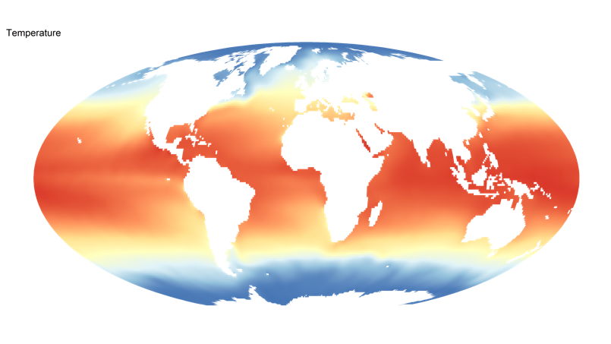
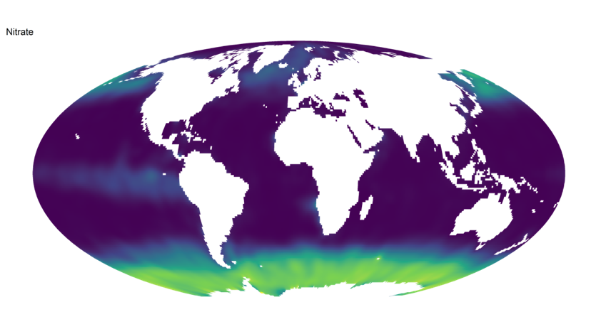
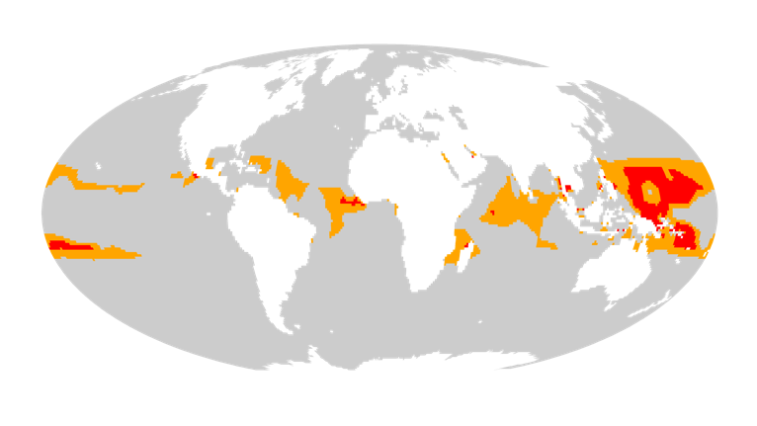
Figure 2. Oceanic regions where temperature-nutrient interactions are most likely to be limiting phytoplankton growth and possibly shaping ecosystem dynamics. The bottom map highlights oceanic locations where temperatures at near their maximum and nitrate concentrations near their minimum. Red indicates regions where temperature is in the top 10% and nitrate in the bottom 10%. Orange uses a 20% threshold for both instead. For both variables, we use annual mean values and ignore other factors that also shape growth. Data source: World Ocean Atlas 2018 (Garcia et al. 2018, Locarnini et al. 2019).

2. Heat stress may increase resource requirements while impairing the ability to acquire nutrients/food, such as by damaging nutrient transport mechanisms or reducing time available for foraging. This exacerbates both the harmful effects of resource limitation and high temperatures, causing a harmful positive feedback loop termed a ‘metabolic meltdown’ (Gerecht et al. 2018, Giri et al. 2017, Huey and Kingsolver 2019). These feedback loops are underexplored, and may already play an important role in organismal performance in the tropics and during heat waves.
3. The available evidence is consistent with a simple prediction: environmental conditions (both abiotic and biotic) that reduce growth rate also reduce T_{opt} and T_{max}, relative to benign conditions. This remains to be tested rigorously across a wide range of conditions. But if true, it would offer us a simple and powerful tool because quantifying changes in growth rate is often cheaper, faster and easier than quantifying T_{opt} and T_{max} directly. Predicting how other environmental changes will shape tolerance of high temperatures would become easier if general ecophysiological patterns such as this exist.
4. Because species differ in resource requirements, the same resource levels are limiting to some species and not others (Edwards et al. 2012, Grover 1997). These differences may increase the differences in vulnerability to high temperatures and therefore change community composition. Good nutrient competitors may have their TPCs relatively unchanged by decreases in resources while poor nutrient competitors experience decreases in T_{opt} and T_{max} that make them more sensitive to warming and reduce their relative abundance in the community. An additional source of complexity that we do not discuss here is that resource competitive abilities are also a function of temperature (Tilman et al. 1981, Lewington-Pearce et al. 2019). These feedbacks between temperature and nutrients have not yet been adequately incorporated into our predictions of the global change effects on organisms, populations and communities.
5. Within species, populations located in low-resource regions today - such as the oceanic gyres or drylands - may be a valuable source of genetic diversity. Being adapted to low resource levels, they may be better able to tolerate high temperatures under high-nutrient conditions than populations presently living in high-resource regions. They could therefore form a reservoir of (relative) heat tolerance. Heat waves in adjacent high-resource regions may provide opportunities for immigrants from low-resource environments by removing competitors adapted to high-resource conditions. These preadapted genotypes can either disperse into novel environments on their own or be transplanted deliberately to rescue declining populations (Bay et al. 2017).
6. Just as species are expected to migrate towards cooler regions, species from hot environments that also experience other stresses at present (low resource availability or low pH, for example) may survive by migrating towards high-resource or moderate pH environments. Such migrations may favour the persistence of otherwise vulnerable taxa. This complicates predictions of extirpation and extinction based solely on thermal limits. It can also lead to more complex spatial and temporal patterns of community reorganization than presently envisioned. A species that persists by migrating towards high-resource or moderate pH environments necessarily competes with resident taxa, possibly causing extirpations. This complex outcome of environmental warming will be hard to predict or model, but properly accounting for interactions is a necessary step towards achieving this.
7. The interacting effects of temperature and resources also cascade through food webs. If prey species decline due to warming, this may trigger a similar temperature-food interaction problem in their predators. They may become more sensitive to high temperatures due to resource (food) limitation, and this may amplify the negative effects of warming on consumers. While some studies are starting to address the indirect effects of temperature on food webs (Gibert 2019), we know very little about how resource limitation will shape the TPCs of different trophic levels. We need to incorporate such interactions for multiple trophic levels into food web models to realistically model multiple driver effects on food webs.
8. Phenological shifts can also change resource availability for different trophic levels (Nord and Lynch 2009, Visser and Both 2005) and may therefore increase vulnerability to high temperatures. Flowering plants in peak summer may be an especially important resource for local pollinator communities and their predators. Shifts in flowering times leading to lower resource availability for pollinators (Solga et al. 2014) may make pollinators - especially the specialists - more vulnerable to high temperatures, including heat waves. Changes in fruiting times may also have important effects on consumer species’ heat tolerances.
9. Selection on temperature tolerance is likely much stronger in nature than anticipated from lab studies, because of the increased heat stress associated with periods of low food and other stresses. Evolutionary adaptation to high temperature may itself be affected by resource availability and other environmental drivers. Under the suboptimal levels of other environmental factors, adaptation to rising temperatures may either be faster due to stronger selection or be slowed down or arrested, if there are trade-offs between temperature tolerances and resource requirements (Aranguren-Gassis et al. 2019), in addition to the simpler reason that population sizes may be reduced. Evolution experiments under different combinations of environmental drivers and temperature would help determine how driver interactions affect thermal adaptation.
10. Fertilization practices in agriculture are likely to be especially important to consider as the climate warms. Although excess fertilization is a major environmental concern because of the consequent greenhouse gas emissions (Tian et al. 2020) and aquatic eutrophication (Conley et al. 2009), preventing periods of nutrient limitation in plants could provide protection against heat waves. Nutrient supply has been proposed as a crop cultivation strategy to offset the negative effects of high temperatures (Waraich et al. 2012).
11. Because some mutualistic interactions appear to increase high-temperature tolerance (at least in plants), developing and using crop mutualists may alleviate future increases in heat stress. Mutualists from hot environments may improve high-temperature performance of existing crops, a phenomenon known as ‘habitat-adapted symbiosis’ (Rodriguez et al. 2008). Conversely, disease will likely reduce tolerance for high temperatures. Optimizing crops for future heat waves may require approaches that increase mutualist abundance and resource availability while decreasing disease prevalence. These are likely steps that would be useful even in the absence of warming, but protection from heat stress makes them even more valuable. Possible trade-offs that reduce the possibility of accomplishing these goals are worth investigating to improve crop performance, such as between receptiveness to mutualism and resistance against infection.

Conclusions
Across different organisms and ecosystems, a variety of abiotic and biotic drivers modify organisms’ ability to tolerate high temperatures. Because these effects appear so widespread, we need to explicitly consider how temperature interacts with other environmental factors, including global change stressors, to develop better predictions of how warming will affect species and communities. So far, most research on the environmental driver interactions with temperature has focused on nutrients and water availability, but the effects of many other environmental factors - especially biotic ones - on TPCs remains underexplored. A focused research agenda to investigate systematically the effects of multiple interacting stressors on species’ TPCs from a wide range of habitats in oceanic, freshwater and terrestrial ecosystems (including agricultural systems), would align well with the ongoing efforts to implement the multiple driver/multistressor framework in global change research (Boyd et al. 2019, Wake 2019). Among the key topics to address are: how universal the negative effects of other stressors on the high temperature tolerances are, the magnitudes and the mechanisms of the effects and whether adding more than one or two stressors exacerbates thermal sensitivity even further. The new research would help to better assess the effects of global warming on species growth, future geographic ranges, productivity and biodiversity. Moreover, it is essential for developing predictive models for conservation, agriculture, fisheries and climate change mitigation.

References
Aldea-Sánchez, P., et al. 2021. Heat tolerance, energetics, and thermal treatments of honeybees parasitized with Varroa. - Frontiers in Ecology and Evolution 9.
Anderson, C. J., et al. 2015. Placing bounds on extreme temperature response of maize. - Environmental Research Letters 10: 124001.
Aranguren-Gassis, M., et al. 2019. Nitrogen limitation inhibits marine diatom adaptation to high temperatures. - Ecology Letters 22: 1860-1869.
Bay, R. A., et al. 2017. Genomic models predict successful coral adaptation if future ocean warming rates are reduced. - Science Advances 3: e1701413.
Berkelmans, R. and van Oppen, M. J. 2006. The role of zooxanthellae in the thermal tolerance of corals: a 'nugget of hope' for coral reefs in an era of climate change. - Proceedings. Biological sciences 273: 2305-2312.
Bestion, E., et al. 2018. Nutrient limitation constrains thermal tolerance in freshwater phytoplankton. - Limnology and Oceanography Letters 3: 436-443.
Bill, B. D., et al. 2016. Effects of temperature and salinity on the growth of Alexandrium (Dinophyceae) isolates from the Salish Sea. - Journal of Phycology 52: 230-238.
Boyd, P. W. 2019. Physiology and iron modulate diverse responses of diatoms to a warming Southern Ocean. - Nature Climate Change 9: 148-152.
Boyd, P. W., et al. 2019. SCOR WG149 Handbook to support the SCOR Best Practice Guide for ‘Multiple Drivers’ Marine Research.
Brown, J. H., et al. 2004. Toward a metabolic theory of ecology. - Ecology 85: 1771-1789.
Busseni, G., et al. 2020. Large scale patterns of marine diatom richness: Drivers and trends in a changing ocean. - Global Ecology and Biogeography 29: 1915-1928.
Carter, E. K., et al. 2016. Separating heat stress from moisture stress: analyzing yield response to high temperature in irrigated maize. - Environmental Research Letters 11: 094012.
Conley, D. J., et al. 2009. Controlling eutrophication: nitrogen and phosphorus. - Science 323: 1014-1015.
Du, E., et al. 2020. Global patterns of terrestrial nitrogen and phosphorus limitation. - Nature Geoscience 13: 221-226.
Edwards, K. F., et al. 2012. Allometric scaling and taxonomic variation in nutrient utilization traits and growth rates of marine and freshwater phytoplankton. - Limnology and Oceanography 57: 554-566.
Edwards, K. F., et al. 2016. Phytoplankton growth and the interaction of light and temperature: A synthesis at the species and community level. - Limnology and Oceanography 61: 1232-1244.
El Haddad, N., et al. 2021. High-temperature and drought stress effects on growth, yield and nutritional quality with transpiration response to vapor pressure deficit in lentil. - Plants (Basel) 11.
Ern, R., et al. 2016. Oxygen dependence of upper thermal limits in fishes. - Journal of Experimental Biology 219: 3376-3383.
Fahad, S., et al. 2017. Crop production under drought and heat stress: plant responses and management options. - Frontiers in Plant Science 8.
Fernández, P. A., et al. 2020. Nitrogen sufficiency enhances thermal tolerance in habitat-forming kelp: implications for acclimation under thermal stress. - Scientific Reports 10: 3186.
Fontaine, S. S., et al. 2022. Experimental manipulation of microbiota reduces host thermal tolerance and fitness under heat stress in a vertebrate ectotherm. - Nature Ecology & Evolution 6: 405-417.
Garcia, H., et al. 2018. World Ocean Database 2018. Users Manual (Prerelease). NOAA Atlas NESDIS 81.
Gerecht, A. C., et al. 2018. Phosphorus limitation and heat stress decrease calcification in Emiliania huxleyi. - Biogeosciences 15: 833-845.
Gibert, J. P. 2019. Temperature directly and indirectly influences food web structure. - Scientific Reports 9: 5312.
Giri, A., et al. 2017. Heat Stress Decreases Levels of Nutrient-Uptake and -Assimilation Proteins in Tomato Roots. - Plants (Basel) 6.
Greenspan, S. E., et al. 2017. Infection increases vulnerability to climate change via effects on host thermal tolerance. - Scientific Reports 7: 9349.
Grover, J. P. 1997. Resource competition. - Chapman and Hall.
Hayashida, H., et al. 2020. Background nutrient concentration determines phytoplankton bloom response to marine heatwaves. - Global Change Biology 26: 4800-4811.
Hector, T. E., et al. 2019. Pathogen exposure disrupts an organism's ability to cope with thermal stress. - Global Change Biology.
Hector, T. E., et al. 2021. Thermal limits in the face of infectious disease: How important are pathogens? - Global Change Biology 27: 4469-4480.
Hou, E., et al. 2021. Latitudinal patterns of terrestrial phosphorus limitation over the globe. - Ecology Letters 24: 1420-1431.
Hubbard, M., et al. 2014. Fungal endophytes enhance wheat heat and drought tolerance in terms of grain yield and second-generation seed viability. - Journal of Applied Microbiology 116: 109-122.
Huey, R. B. and Kingsolver, J. G. 2019. Climate warming, resource availability, and the metabolic meltdown of ectotherms. - American Naturalist 194: E140-E150.
Huxley, P. J., et al. 2021. The effect of resource limitation on the temperature dependence of mosquito population fitness. - Proceedings of the Royal Society B: Biological Sciences 288: 20203217.
Jaramillo, A. and Castañeda, L. E. 2021. Gut microbiota of Drosophila subobscura contributes to its heat tolerance and is sensitive to transient thermal stress. - Frontiers in Microbiology 12.
Kendrick, G. A., et al. 2019. A systematic review of how multiple stressors from an extreme event drove ecosystem-wide loss of resilience in an iconic seagrass community. - Frontiers in Marine Science 6.
Kimmance, S., et al. 2006. Do temperature-food interactions matter? Responses of production and its components in the model heterotrophic flagellate Oxyrrhis marina. - Aquatic Microbial Ecology 42: 63-73.
Kovács, A. W., et al. 2016. Thermal-dependent growth characteristics for Cylindrospermopsis raciborskii (Cyanoprokaryota) at different light availabilities: methodological considerations. - Aquatic Ecology 50: 623-638.
Laidlaw, T., et al. 2020. Pathogen exposure reduces sexual dimorphism in a host’s upper thermal limits. - Ecology and Evolution 10: 12851-12859.
Lewington-Pearce, L., et al. 2019. Temperature-dependence of minimum resource requirements alters competitive hierarchies in phytoplankton. - Oikos 128: 1194-1205.
Locarnini, M., et al. 2019. Temperature, World Ocean Atlas 2018. - NOAA Atlas NESDIS 81.
Márquez, L. M., et al. 2007. A virus in a fungus in a plant: three-way symbiosis required for thermal tolerance. - Science 315: 513-515.
McLeod, I. M., et al. 2013. Climate change and the performance of larval coral reef fishes: the interaction between temperature and food availability. - Conservation Physiology 1.
Nord, E. A. and Lynch, J. P. 2009. Plant phenology: a critical controller of soil resource acquisition. - Journal of Experimental Botany 60: 1927-1937.
O'Donnell, D. R., et al. 2018. Rapid thermal adaptation in a marine diatom reveals constraints and trade-offs. - Global Change Biology 24: 4554-4565.
Pelosi, J., et al. 2021. Thermally tolerant symbionts may explain Caribbean octocoral resilience to heat stress. - Coral Reefs 40: 1113-1125.
Redman, R. S., et al. 2002. Thermotolerance generated by plant/fungal symbiosis. - Science 298: 1581.
Ritchie, M. E. 2018. Reaction and diffusion thermodynamics explain optimal temperatures of biochemical reactions. - Scientific Reports 8: 11105.
Rodriguez, R. J., et al. 2008. Stress tolerance in plants via habitat-adapted symbiosis. - The ISME Journal 2: 404-416.
Sarmiento, J. L., et al. 2004. Response of ocean ecosystems to climate warming. - Global Biogeochemical Cycles 18: GB3003, doi:3010.1029/2003GB002134.
Sarrazin, J. and Sperfeld, E. 2022. Food quality mediates responses of Daphnia magna life history traits and heat tolerance to elevated temperature. - Freshwater Biology 67: 1521-1531.
Shi, H., et al. 2021. Terrestrial biodiversity threatened by increasing global aridity velocity under high-level warming. - Proceedings of the National Academy of Sciences 118: e2015552118.
Siebert, S., et al. 2017. Heat stress is overestimated in climate impact studies for irrigated agriculture. - Environmental Research Letters 12: 054023.
Solga, M. J., et al. 2014. Timing is everything: an overview of phenological changes to plants and their pollinators. - Natural Areas Journal 34: 227-234, 228.
Starke, C. W. E., et al. 2021. Interactive effects of water temperature and stoichiometric food quality on Daphnia pulicaria. - Freshwater Biology 66: 256-265.
Taulavuori, K., et al. 2014. Truths or myths, fact or fiction, setting the record straight concerning nitrogen effects on levels of frost hardiness. - Environmental and Experimental Botany 106: 132-137.
Thomas, M. K., et al. 2017. Temperature–nutrient interactions exacerbate sensitivity to warming in phytoplankton. - Global Change Biology 23: 3269-3280.
Thomas, M. K., et al. 2012. A global pattern of thermal adaptation in marine phytoplankton. - Science 338: 1085-1088.
Tian, H., et al. 2020. A comprehensive quantification of global nitrous oxide sources and sinks. - Nature 586: 248-256.
Tilman, D., et al. 1981. Competition and nutrient kinetics along a temperature gradient--an experimental test of a mechanistic approach to niche theory. - Limnology and Oceanography 26: 1020-1033.
Toca, A., et al. 2017. Species ecology determines the role of nitrogen nutrition in the frost tolerance of pine seedlings. - Tree Physiology 38: 96-108.
Tomanek, L. 2008. The importance of physiological limits in determining biogeographical range shifts due to global climate change: the heat-shock response. - Physiol Biochem Zool 81: 709-717.
Tüzün, N. and Stoks, R. 2018. Evolution of geographic variation in thermal performance curves in the face of climate change and implications for biotic interactions. - Current Opinion in Insect Science 29: 78-84.
Vale, P. F., et al. 2008. Temperature-dependent costs of parasitism and maintenance of polymorphism under genotype-by-environment interactions. - Journal of Evolutionary Biology 21: 1418-1427.
Visser, M. E. and Both, C. 2005. Shifts in phenology due to global climate change: the need for a yardstick. - Proceedings of the Royal Society B: Biological Sciences 272: 2561-2569.
Wake, B. 2019. Experimenting with multistressors. - Nature Climate Change 9: 357-357.
Waraich, E. A., et al. 2012. Alleviation of temperature stress by nutrient management in crop plants: a review. - Journal of soil science and plant nutrition 12: 221-244.
Weisse, T., et al. 2002. Interactive effect of temperature and food concentration on growth rate: A test case using the small freshwater ciliate Urotricha farcta. - Limnology and Oceanography 47: 1447-1455.

