Playback experiments elicit temporary group repulsion, not attraction, in a globally distributed pest parrot

Running Head: Behavioral responses to playbacks by a pest parrot

Authors: Cesar O. Estien^{1,2}, Claire L. O’Connell², Xavier Francis², Grace Smith-Vidaurre^{2,3,4}, Bryan M. Kluever⁵, Elizabeth A. Hobson² and Annemarie van der Marel²

¹ Department of Environmental Science, Policy, and Management, University of California–Berkeley, Berkeley, CA 94720, USA
² Department of Biological Science, University of Cincinnati, Cincinnati, OH, 45221, USA
³ Laboratory of Neurogenetics of Language, Rockefeller University, New York, NY 10065, USA
⁴ Rockefeller University Field Research Center, Millbrook, NY, 12545, USA
⁵ U.S. Department of Agriculture, Animal and Plant Health Inspection Service, Wildlife Services, National Wildlife Research Center, Florida Field Station, 2820 East University Avenue, Gainesville, FL, 32641, USA

Orcid ID:
Estien: 0000-0001-8410-7371
O’Connell: 0000-0002-3852-3021
Francis: 0000-0001-7286-3284
Smith-Vidaurre: 0000-0002-0155-8159
Kluever: 0000-0001-8417-4339
Hobson: 0000-0003-1523-6967
van der Marel: 0000-0003-3942-8314

Correspondence: Cesar O. Estien, cesaroestien@gmail.com

Abstract
Human-wildlife interactions continue to increase due to anthropogenic disturbances, with some interactions resulting in conflict. Leveraging a taxa’s bias for a particular sensory cue is a promising management avenue for reducing the potential and realized negative consequences of human-wildlife conflict. For instance, many avian species heavily depend on acoustic communication, and acoustic cues can provide opportunities to reduce conflict with a variety of avian species. The monk parakeet (Myiopsitta monachus) is a gregarious parrot native to South America that has established populations worldwide and is considered an urban and agricultural pest in parts of its native and introduced ranges. We conducted playback experiments with a captive population of monk parakeets to evaluate auditory cues that may be useful for designing management protocols. Our experiment evaluated the efficacy of two stimuli that we expected to either repulse or attract parakeets: predator vocalizations and conspecific vocalizations, respectively. We measured two responses: (1) categorical group-level behavioral responses and (2) time to cease vigilance and return to baseline behavior. In the repulsion playbacks, monk parakeets were repelled by predator vocalizations in 80% of trials and took longer to cease vigilance and return to baseline behavior compared to attraction playbacks. In the attraction playbacks, monk parakeets exhibited vigilant behavior and weak or no attraction to the stimulus, with attraction only being observed in 10% of trials. Our results demonstrate that predator playbacks may be particularly useful for completing management objectives, such as temporary removal from a location.

Keywords
Playback experiments, human-wildlife conflict, behavior, management, avian pests, Myiopsitta monachus

Introduction
Anthropogenic disturbances and policies, including changes in human land use, continue to alter ecosystems worldwide. These disturbances are bringing humans and wildlife into more frequent and novel forms of contact, which are leading to changes in wildlife behavior (Wilson et al. 2020; Gaynor et al. 2018), increases in species mortality and habitat loss (Hill et al. 2020; Kennedy et al. 2019; Hoekstra et al. 2004), and the alteration of ecological and evolutionary processes in cities (Des Roches et al. 2021; Schell et al. 2020). These impacts on various species, and the associated human-wildlife conflict, have prompted various management strategies to reduce the negative consequences that may come from human-wildlife interactions, including indirect practices such as building fences to exclude wildlife from specific areas and direct approaches such as lethal management (Wilkinson et al. 2020; Khorozyan and Waltert 2019). The effectiveness of management strategies is crucial for adequately preventing and resolving current human-wildlife conflict consequences (Treves et al. 2006). To create effective management strategies, wildlife management should be informed by an experimental approach (Walters and Holling 1990, Enck et al. 2006; Richardson et al. 2020).
Recently, researchers have highlighted the benefits of incorporating sensory ecology into management policies. These benefits can include reducing harm to wildlife and predicting how wildlife will respond to environmental change (Elmer et al. 2021). Management strategies built around a species’ sensory ecology focus on a particularly relevant sense of the target species and can function as repulsive or attractive signals that can cause animals to avoid or gather in areas for specific management-related activities. For example, olfactory cues like wolf urine can stimulate avoidance behavior in deer (Osada, Miyazono, and Kashiwayanagi 2014; Chamaillé-Jammes et al. 2014), while visual cues, such as changes in lighting or mounted specimen that represent a high risk of predation, can cause target species to alter their foraging strategies and overall activity (ship rats (Rattus rattus) Farnworth et al. 2020; black-capped chickadees (Poecile atricapillus) Arteaga-Torres, Wijmenga, and Mathot 2020). Additionally, acoustic cues have been used to investigate species reproduction and movement (bark beetles (Coleoptera: Curculionidae) Hofstetter et al. 2014; fish (Putland and Mensinger 2019)), territoriality (Frostman and Sherman 2004; Reif et al. 2015; Heinsohn 1997), vocal discrimination (Searcy, Nowicki, and Hughes 1997; Searcy et al. 2002), and anti-predator behavior (Bshary 2001; Adams and Kitchen 2020). With many species attuned to auditory cues for decision making, auditory cues provide useful opportunities for nonlethal and widespread management strategies that may reduce human-wildlife conflict.
Natural auditory stimuli, such as vocal signals, are easy to record and then broadcast to implement population-level management strategies. These recorded stimuli can be used for two types of management goals. First, repulsive signals can deter individuals from an area where they are unwanted, such as deterring birds from buildings (Boycott et al. 2021) and reducing crop damage on agricultural lands (Mahjoub, Hinders, and Swaddle 2015; Werrell et al. 2021). Second, attraction signals can encourage individuals to move to an area where the presence of those animals is desired, including inciting individuals to visit and remain in specific habitat patches (DeJong et al. 2015; Buxton, Ward, and Sperry 2018). With these advances in implementing biologically relevant auditory cues via playback experiments, auditory cues can readily be used as a management approach, particularly when designing management strategies to control of avian pests ( Khan et al. 2011; Berge et al. 2007; Depino and Areta 2019; Budka et al. 2019).
The strong foundation of playback experiments provides a robust framework for continous assessments of how auditory stimuli may contribute to alleviating human-avian conflict, particularly in widespread species. A prime example of widespread avian species that can pose problems for human populations are parrots (Psittaciformes), a species-rich taxon with global distribution ( Davies et al. 2007; Kosman et al. 2019; Vergara-Tabares et al. 2020; Calzada Preston and Pruett-Jones 2021) that have become increasingly naturalized (e.g., novel range expansions) (Joseph, 2014). As parrot species distributions change with increasing urbanization (Liu et al. 2020; Huang et al. 2019) and movement via the pet trade (Edelaar et al. 2015; Pires 2015; Martin 2018), parrots are often coming in close contact with humans. Human-parrot conflict increases as parrots settle in or near human-modified habitats like farms or suburban/urban greenspaces (de Matos Fragata et al. 2022; Menchetti and Mori 2014), with ~44% of parrot species using croplands as habitat (Barbosa et al. 2021). These conditions make this group opportune to explore how integrating auditory stimuli can alleviate not only human-parrot conflict, but human-wildlife conflict more generally.
The monk parakeet (Myiopsitta monachus) has become one of the most widely distributed parrot species (Calzada Preston and Pruett-Jones 2021), making them a well-suited species to experimentally test approaches that may alleviate human-wildlife conflict. Monk parakeets are gregarious parrots native to South America and have been introduced in over 20 countries in North America, Europe, Africa, Asia, and at least four Caribbean islands as a byproduct of the pet trade (Burgio, Rubega, and Sustaita 2014; Hobson, Smith-Vidaurre, and Salinas-Melgoza 2017) (Avery et al. 2020, CABI 2010). Monk parakeets build communal and colonial nests that range in size, with larger multi-chambered hosting dozens of pairs (Bucher et al. 1990; Eberhard 1998; Avery et al. 2002). Conflict among humans and monk parakeets typically manifests in three ways: (1) economic and safety hazards in urban areas, (2) agricultural impacts, and (3) health concerns. Following their establishment of new populations, monk parakeets have established nests throughout the urban sprawl on artificial structures as varied as power poles, electricity substations, silos, and fire escapes (Avery and Lindsay 2016), introducing economic costs and safety concerns for humans (Avery et al. 2002; Stafford 2003). In addition to their role as an urban pest, monk parakeets’ propensity to inhabit changing landscapes and consume a wide variety of food resources (Postigo et al. 2021; Bucher and Aramburú 2014) have also led them to become agricultural pests in parts of their native and introduced ranges (Davis 1974; MacGregor-Fors et al. 2011; Mott 1973; Senar et al. 2016; Stafford 2003). For instance, damage in Barcelona ranges from 0.4% to 37% crop loss depending on the particular crop (Senar et al. 2016). Lastly, recent research indicates that monk parakeets may serve as a reservoir for zoonotic diseases in some areas (Morinha et al. 2020), introducing a concern for human health; however, this is not widely observed (Ortiz-Catedral et al. 2022). As a result of these concerns and conflicts, monk parakeets have become a management priority in many areas. Thus, ecologically informed techniques for managing these parrot populations are essential to mitigate conflict among human and monk parakeet populations.
Here, we explore group-level behavioral responses of a captive population of monk parakeets to biologically relevant auditory stimuli and discuss our findings within a wildlife management context. We used two auditory cues that we expected to serve as either repulsion or attractive stimuli: predator vocalizations and conspecific vocalizations, respectively. We hypothesized (1) that predator playbacks would result in the repulsion of the group away from the auditory source in accordance with the literature on prey responses to predator stimuli (Smith et al. 2017; Hettena, Munoz, and Blumstein 2014; Lönnstedt et al. 2012) and (2) that conspecific playbacks would result in the attraction of the group towards the auditory source, in line with previous work that used conspecific vocalizations to attract individuals of a focal species and to attract focal species to specific patches (Lewis, Williams, and Gilman 2021; Ahlering et al. 2010). We then discuss how our results could help inform different management strategies and goals for avian pest species.

Methods

Study Species and Location
We conducted this study on a captive population of monk parakeets (n = 20) in Gainesville, Florida at the USDA Wildlife Services National Wildlife Research Center Florida Field Station from April to July 2021. This population was held in a large 2,025 m² outdoor semi-natural flight pen (Figure 1). All experiments were approved by University of Cincinnati (IACUC protocol #AM02-19-11-19-01) and the National Wildlife Research Center (Quality Assurance protocol #3203).
Figure 1: Overview of the flight pen at the USDA Wildlife Services National Wildlife Research Center, Florida Field Station. Positions for speakers during playback trials are shown as outlined speakers with locations A, B, C, and D. Crosses and boxes represent perch areas throughout the flight pen, and circles represent trees.

Playback Stimuli
We used three playback stimuli to conduct our experiments: a predator call to test for repulsion, a conspecific call to test for attraction, and a control to ensure that attraction and repulsion patterns were not due to our playback setup or speaker. For our predator playback, we used vocalizations from a local predator, the red-tailed hawk (Buteo jamaicensis). For our conspecific playback, we used vocalizations from monk parakeets that were strangers to the group. For our control playback, we used vocalizations from a local bird species, the mourning dove (Zenaida macroura). We maintained a consistent volume for the playback stimuli across all trials. We created all playback tracks in Raven Lite version 2.0.1 (Bioacoustics Research Program 2014, Cornell Lab of Ornithology) and used randomization in RStudio version 4.1.0 (R Core Team 2021) to choose the variant of each playback track used in each trial.
Both red-tailed hawk and mourning dove vocalizations were selected for their biological relevance as predatory and non-predatory species, respectively, and their common occurrence in Florida. Neither of these species was abundant around the flight pen, which lessened the chance of attracting local birds when playing conspecific calls and confounding parakeets’ responses to our experimental stimuli. We downloaded screech calls of red-tailed hawks and perched songs of mourning doves from xeno-canto, a non-profit website that stores recordings of bird vocalizations uploaded by recordists worldwide (Planqué and Vellinga 2008; Vellinga and Planqué 2015). We chose recordings that did not contain any background vocalizations of conspecifics or heterospecifics. We chose three unique files per species and selected the first 30 seconds of each file to create a playback track. This method resulted in three unique tracks (exemplars) per stimuli. Predator playback tracks contained four to ten vocalizations per track, and control playback tracks contained three vocalizations per file (exemplars). In each repulsion and control trial, we randomly selected one of the three exemplars to broadcast to the captive parakeets.
For conspecific vocalizations, we randomly selected non-native (n = 3) and native (n = 3) range monk parakeet contact calls collected in previous studies (Smith-Vidaurre, Araya-Salas, and Wright 2020; Smith-Vidaurre, Perez-Marrufo, and Wright 2021). We used contact calls as our stimuli because parrots often use these vocalizations to maintain auditory contact within pairs and flocks (Bradbury and Balsby 2016). When selecting non-native range calls, we selected monk parakeet contact calls collected from outside Florida but within the United States of America to avoid possible skews in behavioral responses due to previous exposure to local calls. We created three unique playback tracks (exemplars) for each native and non-native range call. For each playback track, we randomly selected one call and repeated each call ten times, separated by three-second gaps to simulate natural calling behavior (Hobson et al. 2015). Each conspecific playback was 30 seconds long and contained ten replicates of each exemplar. In each conspecific trial, we randomly selected one of these playback tracks to broadcast to the captive parakeets.
All playback tracks contain vocalizations from unique individuals. The predator/control playback tracks are similar in duration to the conspecific playback tracks. The difference between the predator/control tracks and the conspecific tracks is that we used different vocalizations for the predator/control tracks but repeated one vocalization for the conspecific tracks.

Experiment and Setup
We conducted playback sessions between 09:00 and 18:00 using a wireless speaker (JBL Charge 4 Wireless speaker). We randomized the placement of the speaker to four locations within the flight pen (Figure 1). We also randomized the order of playback stimuli (predator, conspecific, and control) and the track used per trial to reduce the chances of habituation. Each playback trial was separated by a minimum of five hours to reduce the chance of habituation (we conducted most trials with about 48 hours between playback sessions).
Before playback sessions, observers verified that red-tail hawks and mourning doves were not present in the vicinity of the flight pen. To maximize the chances that the parakeets heard the selected playbacks, we did not begin a playback session until we observed low levels of parakeet activity in the flight pen was low (e.g., low call rates, individuals perching in trees behaving non-agonistically). When activity was low, we set up the speakers in the pre-designated, randomized location, and then gave the birds fifteen minutes to return to baseline behavior prior to starting the playback trials.

Data Collection
During each trial, two observers recorded the behavioral response of the birds, one in blind 1 and one in either blind 2A or 2B (Figure 1). We observed group-level behavior for five minutes prior to each playback session to establish baseline group-level behavior. We recorded two responses to playbacks for at least 50% of the group: (1) categorical group behavioral responses; (2) the time it took birds to cease response behavior and return to baseline behavior (latency in seconds). We then used group responses to score the overall flight responses observed.
To measure group responses, we scored group-level behaviors on a scale of 0-4: (0) no response (birds continue their activities without becoming vigilant); (1) vigilant (birds do not move, stop the behaviors they were performing, and become alert); (2) minor movement (birds become alert, and there is slight movement in trees (e.g., hopping between branches)); (3) less than 50% fly (≤ 10 birds take flight and become vigilant); (4) more than 50% birds fly (> 10 birds take flight and become vigilant). We used the animal behavior data collection app Animal Observer (version 1.0, Dian Fossey Gorilla Fund International 2012; van der Marel et al. 2021) to score responses. Observers narrated into the voice recorder function of Animal Observer to record the behavior of visible birds starting 5 min prior to the playback to establish baseline behavior and ending narration 5 min after the playback, or until birds returned to baseline behavior. Observers also narrated when the playback session began, when the playback session ended, and when the majority of the birds (>50% of the group) resumed baseline behavior after the playback ended. Upon completion of the playback session, we determined the latency of all responses as the difference between the playback end time and the time at which the majority of birds resumed baseline behavior. We averaged measurements between blind 1 and the second blind we used (either blind 2A or 2B, see Figure 1), depending on which blind was randomly selected for observation.

Data Analysis
We examined the effect of the three different playback stimuli (predator, conspecific, control) on group behavior and latency using mixed models. We included playback stimuli and trial as independent factors. We included trial (n = 5) to test for the effect of habituation on both group response and latency. We used playback track and observer as random factors in the group response model but only track as a random factor in the latency model. To begin model selection, we tested for the effect of each random factor by sequentially excluding one of the random factors. We then compared the AICc values of the different random effect models using the performance package (Lüdecke et al. 2021) and selected the model that best fit the data. We did not find a significant effect of observers on the model, indicating that this random factor would not bias our results. Therefore, we did not run a Z-test to control for observer bias and excluded observer for further analyses. We then built four models to examine which independent variables fit our data: a full model with all independent variables, two models where either playback stimuli or trial were omitted, and a null model where both independent variables were omitted. We fit these models to the data again with the performance package (Lüdecke et al. 2021) and selected the model with the lowest AICc value. After model selection for both group responses and latency models, we tested for significant differences between the best fitted and null model from the lmtest package (Zeileis and Hothorn 2002) using likelihood ratio tests (LRT). When the best-fitted model was significantly different from the null model, we performed an LRT to investigate the effect of that independent variable by comparing the best-fitted model with the independent variable of interest to a model without that independent variable. If the independent variable showed a significant effect, we assessed the statistical significance using Tukey’s Honest Significant Differences.
We first examined the effect of the playback stimuli (predator, conspecific, control) on group behavior. Group behavior followed an ordinal distribution, so we used a cumulative link mixed model (CLMM) from the ordinal package (Christen 2019). Then, since latency was a continuous variable, we used the car and MASS packages (Fox and Weisberg 2019; Venables and Ripley 2002) to examine which distribution best fit the data. We found that a normal probability distribution best fit our latency data, so we analyzed latency using linear mixed models (LMMs) in the lme4 package (Douglas et al. 2015). We checked for heteroscedasticity and overall model performance using the performance package. We reported the mean and standard deviation for latency for each playback stimuli below. Finally, we derived flight responses from group behaviors using a scale from 1 to -1, with the sign contingent on whether it was a repulsion behavior (positive) or an attraction behavior (negative). Flight responses were given a score based on these criteria: (0): no behavior, vigilant, and minor movement; (± 0.5): less than 50% of birds fly; (± 1): more than 50% of birds fly. To examine differences in flight behaviors among the playback stimuli, we analyzed the flight responses using Kruskal-Wallis’ one-way analysis of variance followed by a pairwise comparison using Wilcoxon’s rank-sum test.
We completed all analyses in RStudio v.4.1.0 (R Core Team 2021). We made all plots using the ggplot2 package (Wickham 2016) and aestheticized plots (e.g., adding species icons) in Adobe Illustrator (Adobe Illustrator, Adobe Inc.).

Results
We conducted 20 playback trials: 5 repulsion playbacks (predator calls), 10 attraction playbacks (conspecific calls: 5 non-native range and 5 native range), and 5 control playbacks (mourning dove calls). We assessed whether playback stimuli influenced group response, latency, and flight response.

How Do Monk Parakeets Behaviorally Respond to Playbacks?
We found significant differences in group response among playback stimuli (LRT: Λ = 17.70, p < 0.001; Table 2). Monk parakeets exhibited significant differences in group responses to predator playbacks compared to conspecific playbacks (Tukey’s p < 0.05) and control playbacks (Tukey’s p < 0.05; Table 2) (Figure 2A and 3). In response to predator playbacks, monk parakeets exhibited more than half-flock dispersal for 60% of trials, at least half-flock dispersal for 20% of trials, and vigilance for 20% of trials (Figure 4). We did not find significant differences in group responses to conspecific playbacks compared to control playbacks (Tukey’s p = 0.15; Table 2, Figure 2A and 3). In response to conspecific playbacks, monk parakeets exhibited half-flock dispersal in 10% of trials, with no change in behavior, minor movement, and vigilance making up 20%, 10% and 60% of trials, respectively (Figure 3). In response to control playbacks, monk parakeets exhibited vigilance for 40% of trials and no change in behavior for 60% of trials (Figure 4). We found no evidence that monk parakeets habituated regarding group response to playback stimuli as trial was not included in the model with the lowest AICc value (Table 1, Figure S1).
Table 1. AIC model selection results for our response variables: (1) group response and (2) latency. Exemplar was included as a random factor for each model. K is the number of estimated parameters for each model, LL is the log-likelihood of each model, AICc is the second-order AIC, Delta is the difference in AIC score between the best model and the model being compared, weight is the weight of evidence in favor of a given model, and R² is the proportion of variance in the dependent variable that can be explained by the selected independent variable(s).
Response Variable | Variable(s) | K | LL | AICc | Delta | Weight | R²₁
Group response | Playback Stimuli + Trial | 11 | -15.14 | 85.28 | 24.82 | < 0.001 | NA
 | Playback Stimuli | 7 | -18.56 | 51.12 | 0 | 0.99 | NA
 | Trial | 9 | -25.88 | 87.76 | 27.31 | < 0.001 | NA
 | Null | 5 | -27.41 | 69.11 | 8.65 | 0.01 | NA
Latency | Playback Stimuli + Trial | 9 | -59.16 | 154.32 | 0 | 0.995 | 0.71
 | Playback Stimuli | 5 | -75.33 | 164.95 | 10.63 | 0.005 | 0.64
 | Trial | 7 | -75.78 | 174.89 | 20.58 | < 0.001 | 0.09
 | Null | 3 | -92.02 | 191.55 | 37.23 | < 0.001 | < 0.001
NA = not available.
¹R² is not available for group response.

Table 2. 95% confidence interval for the group response and latency of monk parakeets in response to playback stimuli for the model selected. 95% confidence interval is reported as (LL, UL) such that LL = lower limit for 95% confidence interval and UL = upper limit for 95% confidence interval.
 | Group response₁ | Latency
Family | Ordinal | Gaussian
Intercept | NA | (-2.86, 26.06)
Conspecific playback | (-0.16, 6.78) | (2.48, 31.42)
Predator playback | (2.32, 16.68) | (44.29, 77.71)
NA = not available
¹Intercept is not available for group response.

Figure 2: Behavioral responses measured in response to playback stimuli. In panel A, group-level responses are on the x-axis. In panel B, the time to return to baseline behavior in seconds (latency) is on the x-axis. Repulsion (predator – red-tailed hawk, n = 5), attraction (conspecific – monk parakeet, n = 10), and control (non-predatory – mourning dove, n = 5) stimuli are on the y-axis. Measurements are shown in box plots with the median (panel A) and mean (panel B) shown as a black diamond. Error bars indicate 95% confidence intervals.
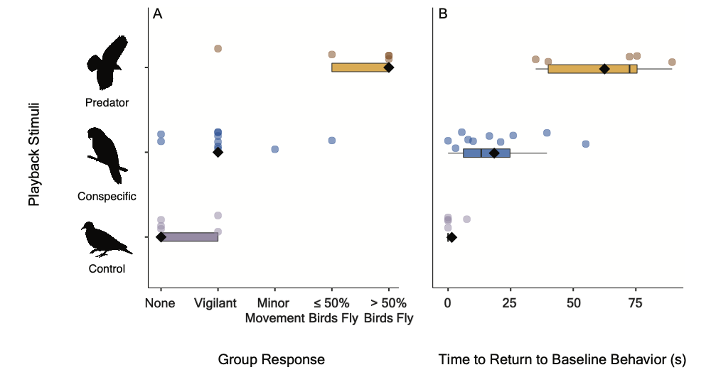

Figure 3: The percentage of group responses measured in response to each playback stimuli. Stronger group responses are shown in darker blue and weaker behavioral responses in lighter blue. 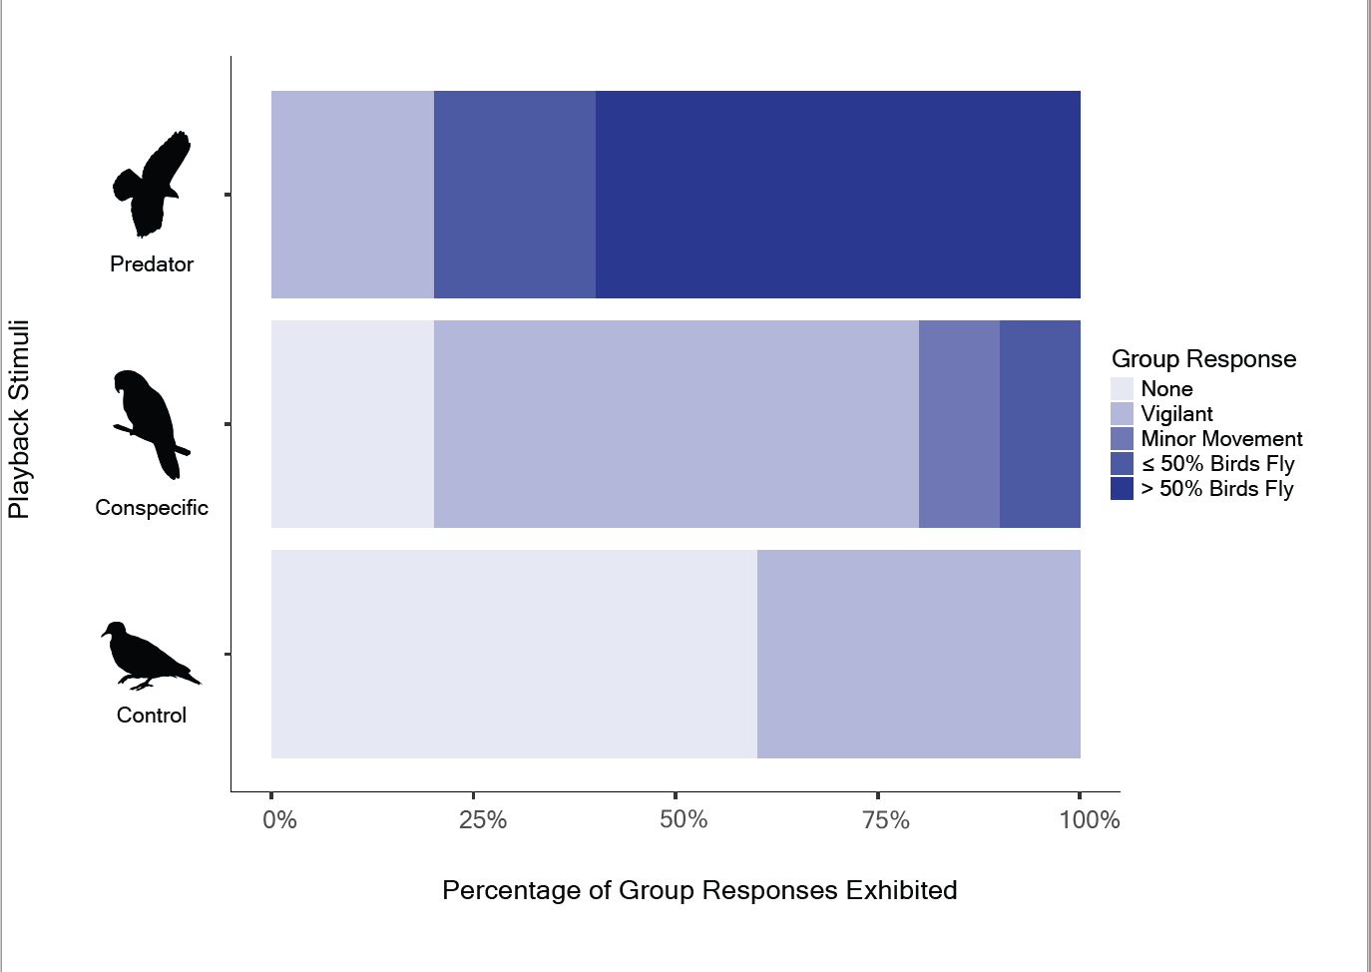

How Long do Monk Parakeets Take to Return to Baseline Behavior?
The model that best explained latency included playback stimuli and trial (LRT: Λ = 30.70, p < 0.001; Table 1). We found significant differences in latency among playback stimuli (LRT: Λ = 28.22, p < 0.001; Fig. 3B), but we did not find a significant effect of trial on latency (LRT: Λ = 8.64, p = 0.07; Figure S2). Average latency to return to baseline behavior in response to predator playbacks (62.50 ± 23.77 s) was longer and had more variation than conspecific (18.50 ± 17.56 s; Tukey’s p < 0.01) and control (1.50 ± 3.35 s; Tukey’s p < 0.001) playbacks (Table 2, Figure 2B). Unlike overall group response, the effect of conspecific playbacks on latency to return to baseline behavior was not significantly different compared to control playbacks (Tukey’s p = 0.18; Table 2, Figure 2B), although the confidence interval did not include zero (Table 2).

Which Playback Stimulus Produced a Flight Response?
We found significant differences in flight responses (Kruskal-Wallis’s p < 0.01) and that the flight response of predator playbacks was more consistent than conspecific playbacks (Figure 4). Predator playbacks elicited repulsion behavior in 80% of playback trials and showed significant differences in flight response when compared to conspecific (Wilcoxon’s p < 0.05) and control flight responses (Wilcoxon’s p = 0.01). Unlike predator playbacks, conspecific playbacks only produced the predicted behavior (attraction) in 10% of trials (Figure 3). Conspecific playbacks showed no significant difference in flight response compared to the control playbacks (Wilcoxon’s p = 0.57).
Figure 4: Repulsion and attraction behavior shown in response to predator playbacks (n = 5), conspecific playbacks (n = 10), and control playbacks (n = 5). Group responses were rescaled and categorized in the context of repulsion and attraction. Predator playbacks showed significant differences in flight response compared to both conspecific and control playbacks. Measurements are shown in box plots with the mean indicated by black diamonds. Error bars indicate 95% confidence intervals.
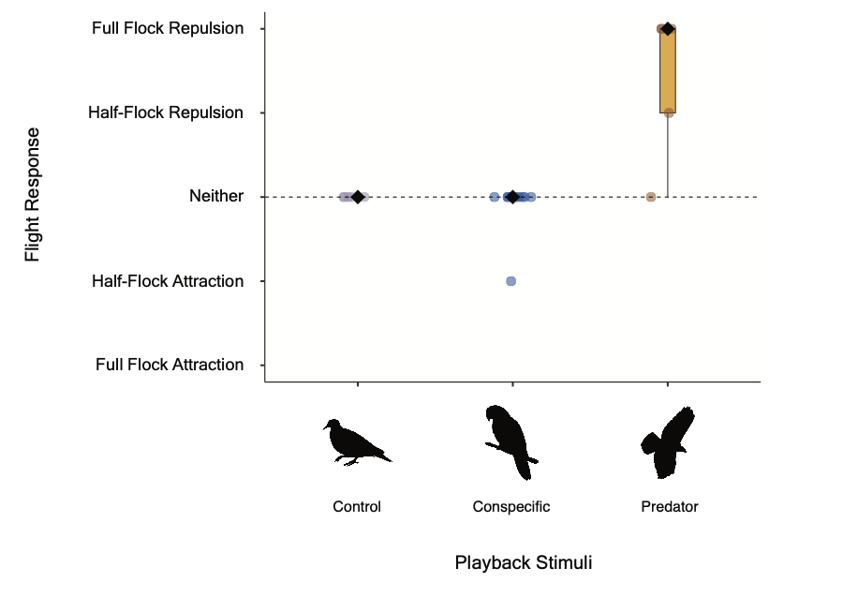

Discussion
The primary objective of this study was to test how different auditory stimuli (predator or conspecific) produced repulsion or attraction behaviors in a captive group of monk parakeets. We found differences in how strongly the parakeets responded to both types of stimuli, which could be important to consider when integrating auditory stimuli into management strategies for this species.
Our results support the hypothesis that predator vocalizations cause flock dispersal away from auditory sources (repulsion). Predator playbacks produced stronger behavioral responses in monk parakeets than conspecific and mourning dove playbacks. Predator playbacks resulted in flight 80% of the time, whereas conspecific playbacks resulted in flight 10% of the time, and mourning dove playbacks never produced flight behavior. These results align with studies that showcase strong behavioral responses to predators in the form of mobbing, movement, and/or vocalizing (Crawford et al. 2022; Dutour, Lena, and Lengagne 2017; Zuberbühler 2001; Manser, Seyfarth, and Cheney 2002). For example, predator playbacks of the sparrow hawk (Accipiter nisus) successfully repelled house sparrows (Passer domesticus), with no habituation observed after six days of exposure (Frings and Frings 1967), and playbacks of a peregrine falcon (Falco peregrinus) call was also effective at dispersing gulls from Vancouver International Airport (Gunn 1973). Because of these strong responses, managers seeking to displace monk parakeets from a specific area temporarily may have success in using predator calls.
In contrast, our results do not support the hypothesis that conspecific calls attract parakeets to the auditory source. We found that conspecific calls resulted in weak or no attraction of parakeets to the stimulus, with half-flock movement towards the auditory source observed only once across all ten trials. From a management perspective, our results indicate that conspecific calls may not be effective stimuli to attract parakeets to a specific area, for example, to facilitate trapping. However, other variables may need to be considered when selecting conspecific vocalizations for playbacks, which may affect their effectiveness for management aims. For example, Nocera et al. (2006) showed that, due to a lack of experience, natal dispersers (i.e., juveniles) might be more receptive to conspecific vocalizations. Kelly and Ward (2017) suggested that in yellow warblers (Setophaga petechia), site selection via conspecific attraction is more successful when vocalizations from paired males are used, while Connell et al. (2019) suggested that in black-tailed prairie dogs (Cynomys ludovicianus), other cues, such as the physical presence of and/or relationship to the caller, may be essential factors to consider for playbacks. Thus, an individual’s response to an auditory cue may also depend on the social information communicated through vocalizations in a particular social system.
Monk parakeets may respond to conspecific calls based on their relationship to the caller (Hobson et al. 2015), which has been seen in other birds such as acorn woodpeckers (Melanerpes formicivorus) (Pardo et al. 2018), carrion crows (Corvus corone) (Wascher et al. 2012), and ravens (Corvus corax) (Szipl et al. 2015). They may also respond based on the locality of the call, which has been observed in rufous-collared sparrows (Zonotrichia capensis) (Danner et al. 2011), yellow-naped amazons (Amazona auropalliata) (Wright and Dorin 2001), and stonechats (Saxicola torquata)(Mortega, Flinks, and Helm 2014). Moreover, monk parakeets exhibit unique vocal signatures in contact calls tied to individual identities, and these individual signatures are simpler in smaller non-native range populations, which suggests that monk parakeets use contact calls to recognize distinct individuals (Smith-Vidaurre, Perez-Marrufo, and Wright 2021; Smith-Vidaurre, Araya-Salas, and Wright 2020). Therefore, it may be useful for researchers to explore behavioral responses to familiar or unfamiliar individuals to determine which calls may be best for management purposes.
We did not examine differences in individual responses to playbacks with this study design. However, it can be important to understand how individual characteristics (e.g., sex or age) and social relationships (e.g., partnered with another individual) influence an individual’s response to stimuli, and how this may influence overall group-decision making, for a robust management approach. For example, Kerman (2018) found that male monk parakeets that are risk-aversive while foraging become bolder in the presence of conspecifics, and it has been observed that monk parakeets decrease vigilance effort as flock size increases (South and Pruett-Jones 2000). Thus, assessing how social context (e.g., flock size) may underlie behavioral responses to external stimuli could be necessary for management success. When managing group-living species such as monk parakeets (e.g., red-backed fairy-wrens (Malurus melanocephalus)), it may be important to adjust for population-level differences due to possible individual and group-dynamic behavioral variation as a result of unique ecological pressures (Maldonado-Chaparro and Chaverri 2021). Future studies should explicitly consider how individual, population, and temporal characteristics, including variation in group size and season, influence responses to sensory cues that may be useful for management.

Management Implications
Our results showcase clear behavioral outcomes based on the playback stimuli used, with no evidence of habituation, that are promising for management purposes. Auditory cues can be used at a very low cost, with little to no ecosystem disturbance, and are readily available. Furthermore, auditory cues may not come with conflicts of interest compared to other forms of management, such as culling via poisons (van Eeden et al. 2017). Our results show that in captive monk parakeets, predator playbacks produced a momentary change in behavior. Predator stimuli may be useful when management objectives require the temporary dispersal of individuals from a small area. For example, once monk parakeets are detected at a site, predator playbacks may help disperse birds and prevent site-specific nest building (Burgio, Rubega, and Sustaita 2014). When implementing predator playbacks, managers should consider the geographic location of the monk parakeet population to select the appropriate predator(s). In Florida, common avian predators include the red-tailed hawk, red-shouldered hawk (Buteo lineatus), and Cooper’s hawk (Accipiter cooperii), but in introduced locations such as the Iberian Peninsula, avian predators such as the Eurasian sparrowhawk (Accipiter nisus) and Eurasian kestrel (Falco tinnunculus) may be more appropriate choices.
When considering playbacks as part of a management plan, the timing of the intervention should also be carefully considered, as the parakeets may be more or less responsive to predator stimuli. For example, monk parakeet site fidelity increases once nests have been established (Dawson Pell et al. 2021), so management interventions could be timed to occur prior to this increased fidelity. Because of this high nest fidelity, it is unlikely that predator playbacks would cause nest and site abandonment once the parakeets have initiated nest building. Although auditory cues alone may not be enough to control a particular group or population, coupling auditory cues with additional management strategies may be powerful for desired outcomes. In this case, it may be useful to leverage an integrated approach, including other currently implemented avian management tools (e.g., frightening devices (Enos, Ward, and Hauber 2021)). For example, in areas where lethal shooting is authorized and safe to implement, using predator playbacks to prompt flocking behavior could help maximize the efficacy of culling as a management tool.

Conclusion
Our experiments show the potential for repulsion stimuli to be an effective tool for some management plans for monk parakeet populations, where the goal is to temporarily displace a group of parakeets and induce flight and vigilance behaviors. Our results re-emphasize the importance of informing management with data from experiments. These results can then be framed to recommend options managers can consider when managing monk parakeet populations and other populations that rely on ecological information in the form of auditory cues.

Acknowledgements

We acknowledge that the fieldwork for this project was conducted on the ancestral and unceded lands of the Seminole and Timucua people. We acknowledge that the majority of writing and data analysis was completed at UC Berkeley which sits on the ancestral and unceded lands of the Ohlone people. These lands of what is now considered Gainesville, Florida and Berkeley, California continue to be great importance to their respective Indigenous people, and we recognize that we benefit from the use and occupation of these lands. We would like to thank the USDA staff, especially Eric Tillman, John Humphrey, Danyelle Sherman, and Palmer Harrell, for their assistance and support. We would like to the thank the members and affiliates of the Schell Lab, especially Dr. Christine Wilkinson, Tali Caspi, Yasmine Hentati, Dr. Lauren Stanton, and Samantha Kreling, for feedback on an early version of this paper. During preparation of this work, COE was supported by University of California, Berkeley’s Chancellor Fellowship and the National Science Foundation Graduate Research Fellowship under Grant No. 2146752, GSV was supported by a NSF Postdoctoral Research Fellowship (grant number 2010982), and XF and EAH was supported by NSF IOS 2015932. The findings and conclusions in this publication have not been formally disseminated by the U.S. Department of Agriculture and should not be construed to represent any agency determination or policy. This research was supported in part by the U.S. Department of Agriculture, National Wildlife Research Center.

Supplementary Materials

Figure S1: Groups responses to playback stimuli over the test period. Group responses are colored by playback stimuli: predator playbacks (brown), conspecific playbacks (blue), and control playbacks (purple). Monk parakeets did not show habituation in their responses to playbacks over all trials.

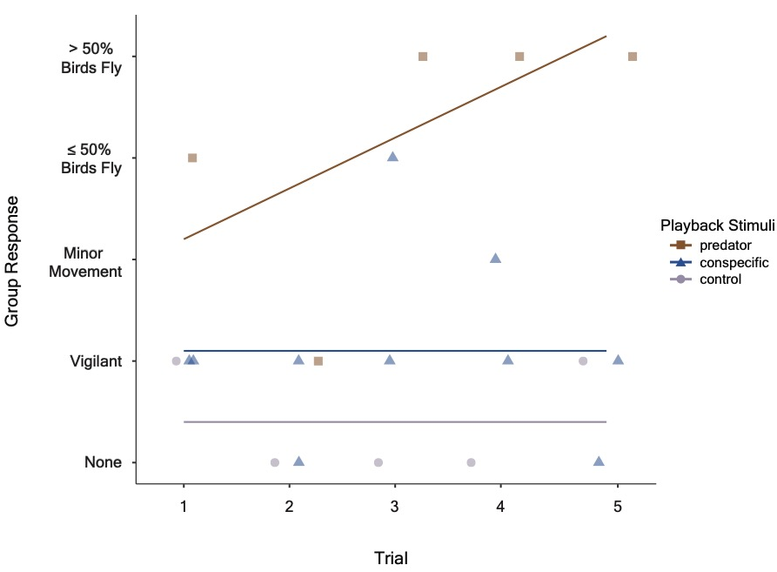

Figure S2: Latency in response to playback stimuli over the test period. Latency is colored by playback stimuli: predator playbacks (brown), conspecific playbacks (blue), and control playbacks (purple). Monk parakeets did not show habituation in their latency to playbacks over all trials.

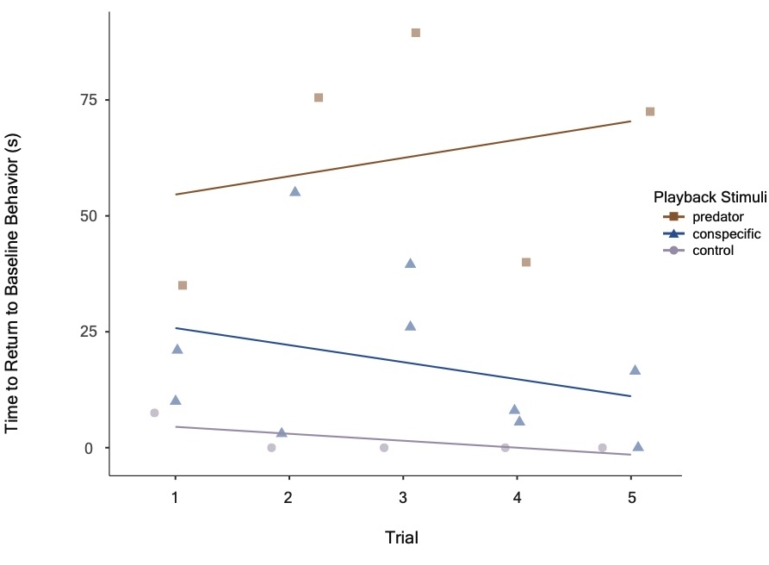

References
Achim Zeileis, Torsten Hothorn (2002). Diagnostic Checking in Regression Relationships. R News 2(3), 7-10. URL: https://CRAN.R-project.org/doc/Rnews/
Adams, Dara B., and Dawn M. Kitchen. 2020. “Model vs. Playback Experiments: The Impact of Sensory Mode on Predator‐specific Escape Responses in Saki Monkeys.” Ethology: Formerly Zeitschrift Fur Tierpsychologie 126 (5): 563–75.
Adobe Inc., 2019. Adobe Illustrator, Available at: https://adobe.com/products/illustrator.
Ahlering, Marissa A., Debora Arlt, Matthew G. Betts, Robert J. Fletcher, Joseph J. Nocera, and Michael P. Ward. 2010. “Research Needs and Recommendations for the Use of Conspecific-Attraction Methods in the Conservation of Migratory SongbirdsNecesidades de Investigatión y Recomendaciones Para El Uso de Métodos de Atracción de Individuos Coespecíficos En La Conservatión de Aves Canoras Migratorias.” The Condor 112 (2): 252–64.
Arteaga-Torres, Josue David, Jan J. Wijmenga, and Kimberley J. Mathot. 2020. “Visual Cues of Predation Risk Outweigh Acoustic Cues: A Field Experiment in Black-Capped Chickadees.” Proceedings. Biological Sciences / The Royal Society 287 (1936): 20202002.
Avery, Michael L., Ellis C. Greiner, James R. Lindsay, James R. Newman, and Stephen Pruett-Jones. 2002. “Monk Parakeet Management at Electric Utility Facilities in South Florida.” Proceedings of the Vertebrate Pest Conference 20 (20).
Avery, Michael L., and J. R. Lindsay. 2016. “Monk Parakeets. Wildlife Damage Management Technical Series.” USDA, APHIS, WS National Wildlife Research Center, Ft. Collins, Colorado., 11p.
Avery, M. L. 2020. Monk parakeet (Myiopsitta monachus) Boddaert, 1783. Pages 76–84 in Downs, C.T. and L. Hart, editors
Barbosa, Jomar M., Fernando Hiraldo, Miguel Á. Romero, and José L. Tella. 2021. “When Does Agriculture Enter into Conflict with Wildlife? A Global Assessment of Parrot–Agriculture Conflicts and Their Conservation Effects.” Diversity & Distributions 27 (1): 4–17.
Berge, Andrew, Michael Delwiche, W. Paul Gorenzel, and Terrell Salmon. 2007. “Bird Control in Vineyards Using Alarm and Distress Calls.” American Journal of Enology and Viticulture 58 (1): 135–43.
Bioacoustics Research Program. 2014. Raven Pro: interactive sound analysis software (version 1.5) [Computer software]. Ithaca (NY) :The Cornell Lab of Ornithology. Available from http://www.birds.cornell.edu/raven.
Boycott, Timothy J., Sally M. Mullis, Brandon E. Jackson, and John P. Swaddle. 2021. “Field Testing an ‘Acoustic Lighthouse’: Combined Acoustic and Visual Cues Provide a Multimodal Solution That Reduces Avian Collision Risk with Tall Human-Made Structures.” PloS One 16 (4): e0249826.
Bradbury, Jack W., and Thorsten J. S. Balsby. 2016. “The Functions of Vocal Learning in Parrots.” Behavioral Ecology and Sociobiology. Springer Verlag.
Bshary, Redouan. 2001. “Diana Monkeys, Cercopithecus Diana, Adjust Their Anti-Predator Response Behaviour to Human Hunting Strategies.” Behavioral Ecology and Sociobiology 50 (3): 251–56.
Bucher, Enrique H., and Rosana M. Aramburú. 2014. “Land-Use Changes and Monk Parakeet Expansion in the Pampas Grasslands of Argentina.” Journal of Biogeography 41 (6): 1160–70.
Bucher, Enrique H., Liliana F. Martin, Mónica B. Martella, and Joaquín L. Navarro. 1990. “Social Behaviour and Population Dynamics of the Monk Parakeet.” Acta XX Congressus Internationalis Ornithologici 2: 681–89.
Budka, Michał, Piotr Matyjasiak, Jakub Typiak, Mateusz Okołowski, and Magdalena Zagalska-Neubauer. 2019. “Experienced Males Modify Their Behaviour during Playback: The Case of the Chaffinch.” Journal of Ornithology / DO-G 160 (3): 673–84.
Burgio, Kevin R., Margaret A. Rubega, and Diego Sustaita. 2014. “Nest-Building Behavior of Monk Parakeets and Insights into Potential Mechanisms for Reducing Damage to Utility Poles.” PeerJ 2 (September): e601.
Buxton, Valerie L., Janice K. Enos, Jinelle H. Sperry, and Michael P. Ward. 2020. “A Review of Conspecific Attraction for Habitat Selection across Taxa.” Ecology and Evolution 10 (23): 12690–99.
Buxton, Valerie L., Michael P. Ward, and Jinelle H. Sperry. 2018. “Evaluation of Conspecific Attraction as a Management Tool across Several Species of Anurans.” Diversity 10 (1): 6.
CABI. 2010. Myiopsitta monachus (monk paraket). <https://www.cabi.org/isc/datasheet/74616>. Accessed 10 January 2021.
Calzada Preston, Carlos E., and Stephen Pruett-Jones. 2021. “The Number and Distribution of Introduced and Naturalized Parrots.” Diversity 13 (9): 412.
Chamaillé-Jammes, Simon, Hélène Malcuit, Soizic Le Saout, and Jean-Louis Martin. 2014. “Innate Threat-Sensitive Foraging: Black-Tailed Deer Remain More Fearful of Wolf than of the Less Dangerous Black Bear Even after 100 Years of Wolf Absence.” Oecologia 174 (4): 1151–58.
Christensen, R. H. B. (2019). ordinal - Regression Models for Ordinal Data. R package version 2019.12-10. https://CRAN.R-project.org/package=ordinal.
Connell, Lauren C., Lauren M. Porensky, Anna D. Chalfoun, and John D. Scasta. 2019. “Black-Tailed Prairie Dog, Cynomys Ludovicianus (Sciuridae), Metapopulation Response to Novel Sourced Conspecific Signals.” Animal Behaviour 150 (April): 189–99.
Crawford, Daniel A., L. Mike Conner, Michael Clinchy, Liana Y. Zanette, and Michael J. Cherry. 2022. “Prey Tells, Large Herbivores Fear the Human ‘Super Predator.’” Oecologia, January. https://doi.org/10.1007/s00442-021-05080-w.
Danner, Julie E., Raymond M. Danner, Frances Bonier, Paul R. Martin, Thomas W. Small, and Ignacio T. Moore. 2011. “Female, but Not Male, Tropical Sparrows Respond More Strongly to the Local Song Dialect: Implications for Population Divergence.” The American Naturalist 178 (1): 53–63.
Davies, Richard G., C. David L. Orme, Andrea J. Webster, Kate E. Jones, Tim M. Blackburn, and Kevin J. Gaston. 2007. “Environmental Predictors of Global Parrot (Aves: Psittaciformes) Species Richness and Phylogenetic Diversity.” Global Ecology and Biogeography: A Journal of Macroecology 16 (2): 220–33.
Davis, Lewis R. 1974. “The Monk Parakeet: A Potential Threat to Agriculture.” Proceedings of the Vertebrate Pest Conference 6 (6). https://escholarship.org/uc/item/257183xh.
Dawson Pell, Francesca S. E., Juan Carlos Senar, Daniel W. Franks, and Ben J. Hatchwell. 2021. “Fine-Scale Genetic Structure Reflects Limited and Coordinated Dispersal in the Colonial Monk Parakeet, Myiopsitta Monachus.” Molecular Ecology 30 (6): 1531–44.
DeJong, Leanna N., Samuel D. Cowell, Thuy Nhi N. Nguyen, and Darren S. Proppe. 2015. “Attracting Songbirds with Conspecific Playback: A Community Approach.” Behavioral Ecology: Official Journal of the International Society for Behavioral Ecology 26 (5): 1379–88.
Depino, Emiliano A., and Juan I. Areta. 2019. “V-Netting with Playback: An Active Cost-Effective Method for Trapping Small Rails.” Ardeola 67 (1): 101–12.
Des Roches, Simone, Kristien I. Brans, Max R. Lambert, L. Ruth Rivkin, Amy Marie Savage, Christopher J. Schell, Cristian Correa, et al. 2021. “Socio-Eco-Evolutionary Dynamics in Cities.” Evolutionary Applications 14 (1): 248–67.
Douglas Bates, Martin Maechler, Ben Bolker, Steve Walker (2015). Fitting Linear Mixed-Effects Models Using lme4. Journal of Software, 67(1), 1-48. doi:10.18637/jss.v067.i01.
Dutour, Mylene, Jean-Paul Lena, and Thierry Lengagne. 2017. “Mobbing Behaviour in a Passerine Community Increases with Prevalence in Predator Diet.” The Ibis 159 (2): 324–30.
Eberhard, Jessica R. 1998. “Breeding Biology of the Monk Parakeet.” The Wilson Bulletin 110 (4): 463–73.
Edelaar, Pim, Severine Roques, Elizabeth A. Hobson, Anders Gonçalves da Silva, Michael L. Avery, Michael A. Russello, Juan C. Senar, Timothy F. Wright, Martina Carrete, and José L. Tella. 2015. “Shared Genetic Diversity across the Global Invasive Range of the Monk Parakeet Suggests a Common Restricted Geographic Origin and the Possibility of Convergent Selection.” Molecular Ecology 24 (9): 2164–76.
Eeden, Lily M. van, Chris R. Dickman, Euan G. Ritchie, and Thomas M. Newsome. 2017. “Shifting Public Values and What They Mean for Increasing Democracy in Wildlife Management Decisions.” Biodiversity and Conservation 26 (11): 2759–63.
Elmer, Laura K., Christine L. Madliger, Daniel T. Blumstein, Chris K. Elvidge, Esteban Fernández-Juricic, Andrij Z. Horodysky, Nicholas S. Johnson, Liam P. McGuire, Ronald R. Swaisgood, and Steven J. Cooke. 2021. “Exploiting Common Senses: Sensory Ecology Meets Wildlife Conservation and Management.” Conservation Physiology 9 (1).
Enck, Jody W., Daniel J. Decker, Shawn J. Riley, John F. Organ, Len H. Carpenter, and William F. Siemer. 2006. “Integrating Ecological and Human Dimensions in Adaptive Management of Wildlife-Related Impacts.” Wildlife Society Bulletin 34 (3): 698–705.
Enos, Janice K., Michael P. Ward, and Mark E. Hauber. 2021. “A Review of the Scientific Evidence on the Impact of Biologically Salient Frightening Devices to Protect Crops from Avian Pests.” Crop Protection 148 (October): 105734.
Farnworth, Bridgette, John Innes, Michael Davy, Lauren Little, Vanessa Cave, and Joseph R. Waas. 2020. “Antipredator Responses of Ship Rats to Visual Stimuli: Combining Unimodal Predation Cues Generates Risk Avoidance.” Animal Behaviour 168 (October): 149–57.
Fox. John and Sanford Weisberg (2019). An {R} Companion to Applied Regression, Third Edition. Thousand Oaks CA: Sage. https://socialsciences.mcmaster.ca/jfox/Books/Companion
Frings, H. and M. Frings. 1967. Behavioral manipulation (visual, mechanical, and acoustical).Pages 387-454 in W.W. Kilgor and R.L. Doutt (eds), Pest Control: biological, physical and selected chemical methods. Academic Press, New York, NY.
Frostman, Polly, and Peter T. Sherman. 2004. “Behavioral Response to Familiar and Unfamiliar Neighbors in a Territorial Cichlid, Neolamprologus Pulcher.” Ichthyological Research 51 (3): 283–85.
Gaynor, Kaitlyn M., Cheryl E. Hojnowski, Neil H. Carter, and Justin S. Brashares. 2018. “The Influence of Human Disturbance on Wildlife Nocturnality.” Science 360 (6394): 1232–35.
Gunn, WW.H. 1973. Experimental research on the use of sound to disperse Dunlin sandpipers at Vancouver International Airport. Rep. from LGL Ltd., Edmonton, Alb. for Assoc. Comm. On Bird Hazards to Aircraft, Nat. Res. Council, Ottawa, Ont. 8 p.
Heinsohn, R. 1997. “Group Territoriality in Two Populations of African Lions.” Animal Behaviour 53 (6): 1143–47.
Hettena, Alexandra M., Nicole Munoz, and Daniel T. Blumstein. 2014. “Prey Responses to Predator’s Sounds: A Review and Empirical Study.” Ethology: Formerly Zeitschrift Fur Tierpsychologie 120 (5): 427–52.
Hill, Jacob E., Travis L. DeVault, Guiming Wang, and Jerrold L. Belant. 2020. “Anthropogenic Mortality in Mammals Increases with the Human Footprint.” Frontiers in Ecology and the Environment 18 (1): 13–18.
Hobson, Elizabeth A., Darlene J. John, Tiffany L. Mcintosh, Michael L. Avery, and Timothy F. Wright. 2015. “The Effect of Social Context and Social Scale on the Perception of Relationships in Monk Parakeets.” Current Zoology 61 (1): 55-69.
Hobson, Elizabeth A., Grace Smith-Vidaurre, and Alejandro Salinas-Melgoza. 2017. “History of Nonnative Monk Parakeets in Mexico.” PloS One 12 (9): e0184771.
Hoekstra, Jonathan M., Timothy M. Boucher, Taylor H. Ricketts, and Carter Roberts. 2004. “Confronting a Biome Crisis: Global Disparities of Habitat Loss and Protection.” Ecology Letters 8 (1): 23–29.
Hofstetter, Richard W., David D. Dunn, Reagan McGuire, and Kristen A. Potter. 2014. “Using Acoustic Technology to Reduce Bark Beetle Reproduction.” Pest Management Science 70 (1): 24–27.
Huang, Kangning, Xia Li, Xiaoping Liu, and Karen C. Seto. 2019. “Projecting Global Urban Land Expansion and Heat Island Intensification through 2050.” Environmental Research Letters: ERL [Web Site] 14 (11): 114037.
Joseph, L. (2014). Perspectives from parrots on biological invasions. In H. H. Prins & I. J. Gordon (Eds.), Invasion Biology and Ecological Theory: Insights from a Continent in Transformation (pp. 58–82). Cambridge: Cambridge University Press.
Kassambara Alboukadel (2021). rstatix: Pipe-Friendly Framework for Basic Statistical Tests. R package version 0.7.0. https://CRAN.R-project.org/package=rstatix
Kelly, Janice K., and Michael P. Ward. 2017. “Do Songbirds Attend to Song Categories When Selecting Breeding Habitat? A Case Study with a Wood Warbler.” Behaviour 154 (11): 1123–44.
Kennedy, Christina M., James R. Oakleaf, David M. Theobald, Sharon Baruch-Mordo, and Joseph Kiesecker. 2019. “Managing the Middle: A Shift in Conservation Priorities Based on the Global Human Modification Gradient.” Global Change Biology 25 (3): 811–26.
Kerman, Kaan, Kathryn E. Sieving, Colette St. Mary, and Michael L. Avery. 2018. “Social Conformity Affects Experimental Measurement of Boldness in Male but Not Female Monk Parakeets (Myiopsitta Monachus).” Behaviour 155 (13-15): 1025–50.
Khan, Hammad Ahmad, Shahzad Ahmad, Muhammad Javed, Khalial Ahmad, and M. Ishaque. 2011. “Comparative Effectiveness of Some Mechanical Repellents for Management of Rose Ringed Parakeet (Psittacula Krameri) in Citrus, Guava and Mango Orchards.” International Journal of Agriculture and Biology 13 (3).
Khorozyan, Igor, and Matthias Waltert. 2019. “A Framework of Most Effective Practices in Protecting Human Assets from Predators.” Human Dimensions of Wildlife 24 (4): 380–94.
Kosman, Evsey, Kevin R. Burgio, Steven J. Presley, Michael R. Willig, and Samuel M. Scheiner. 2019. “Conservation Prioritization Based on Trait‐based Metrics Illustrated with Global Parrot Distributions.” Diversity & Distributions 25 (7): 1156–65.
Lewis, Rebecca N., Leah J. Williams, and R. Tucker Gilman. 2021. “The Uses and Implications of Avian Vocalizations for Conservation Planning.” Conservation Biology: The Journal of the Society for Conservation Biology 35 (1): 50–63.
Liu, Xiaoping, Yinghuai Huang, Xiaocong Xu, Xuecao Li, Xia Li, Philippe Ciais, Peirong Lin, et al. 2020. “High-Spatiotemporal-Resolution Mapping of Global Urban Change from 1985 to 2015.” Nature Sustainability 3 (7): 564–70.
Lönnstedt, Oona M., Mark I. McCormick, Mark G. Meekan, Maud C. O. Ferrari, and Douglas P. Chivers. 2012. “Learn and Live: Predator Experience and Feeding History Determines Prey Behaviour and Survival.” Proceedings. Biological Sciences / The Royal Society 279 (1736): 2091–98.
Lüdecke et al., (2021). performance: An R Package for Assessment, Comparison and Testing of Statistical Models. Journal of Open Source Software, 6(60), 3139.
MacGregor-Fors, Ian, Rafael Calderón-Parra, Alejandro Meléndez-Herrada, Silvia López-López, and Jorge E. Schondube. 2011. “Pretty, but Dangerous! Records of Non-Native Monk Parakeets (Myiopsitta Monachus) in Mexico.” Revista Mexicana de Biodiversidad 82 (3): 1053–56.
Mahjoub, Ghazi, Mark K. Hinders, and John P. Swaddle. 2015. “Using a ‘Sonic Net’ to Deter Pest Bird Species: Excluding European Starlings from Food Sources by Disrupting Their Acoustic Communication.” Wildlife Society Bulletin 39 (2): 326–33.
Maldonado-Chaparro, Adriana A., and Gloriana Chaverri. 2021. “Why Do Animal Groups Matter for Conservation and Management?” Conservation Science and Practice 3 (12).
Manser, Marta B., Robert M. Seyfarth, and Dorothy L. Cheney. 2002. “Suricate Alarm Calls Signal Predator Class and Urgency.” Trends in Cognitive Sciences 6 (2): 55–57.
Marler, Peter R., and Hans Slabbekoorn. 2004. “Nature’s Music: The Science of Birdsong,” October.
Martin, R. O. 2018. “Grey Areas: Temporal and Geographical Dynamics of International Trade of Grey and Timneh Parrots (Psittacus Erithacus and P. Timneh) under CITES.” Emu - Austral Ornithology 118 (1): 113–25.
Matos Fragata, Marcia de, Fabricio Baccaro, André Luís Sousa Gonçalves, and Sérgio Henrique Borges. 2022. “Living in a Tropical Concrete Jungle: Diversity and Abundance Variation in a Parrot Assemblage (Aves, Psittacidae) of a Major Amazonian City.” Urban Ecosystems, January.
Menchetti, M., and E. Mori. 2014. “Worldwide Impact of Alien Parrots (Aves Psittaciformes) on Native Biodiversity and Environment: A Review.” Ethology Ecology & Evolution 26 (2–3): 172–94.
Morinha, Francisco, Martina Carrete, José L. Tella, and Guillermo Blanco. 2020. “High Prevalence of Novel Beak and Feather Disease Virus in Sympatric Invasive Parakeets Introduced to Spain From Asia and South America.” Diversity 12 (5): 192.
Mortega, Kim G., Heiner Flinks, and Barbara Helm. 2014. “Behavioural Response of a Migratory Songbird to Geographic Variation in Song and Morphology.” Frontiers in Zoology 11 (1): 85.
Mott, Donald F. 1973. “Monk Parakeet Damage to Crops in Uruguay and Its Control.” In Bird Control Seminars Proceedings, 102.
Ortiz-Catedral, Luis, Connor J. Wallace, Robert Heinsohn, Elizabeth A. Krebs, Naomi E. Langmore, Dusan Vukelic, Enrique H. Bucher, Arvind Varsani, and Juan F. Masello. 2022. “A PCR-Based Retrospective Study for Beak and Feather Disease Virus (BFDV) in Five Wild Populations of Parrots from Australia, Argentina and New Zealand.” Diversity 14 (2): 148.
Osada, Kazumi, Sadaharu Miyazono, and Makoto Kashiwayanagi. 2014. “Pyrazine Analogs Are Active Components of Wolf Urine That Induce Avoidance and Fear-Related Behaviors in Deer.” Frontiers in Behavioral Neuroscience 8 (August): 276.
Pardo, Michael A., Emilee A. Sparks, Tejal S. Kuray, Natasha D. Hagemeyer, Eric L. Walters, and Walter D. Koenig. 2018. “Wild Acorn Woodpeckers Recognize Associations between Individuals in Other Groups.” Proceedings. Biological Sciences 285 (1882): 20181017.
Pires, Stephen F. 2015. “The Heterogeneity of Illicit Parrot Markets: An Analysis of Seven Neo-Tropical Open-Air Markets.” European Journal on Criminal Policy and Research 21 (1): 151–66.
Planqué, Bob, and Willem-Pier Vellinga. 2008. “Xeno-Canto: A 21st-Century Way to Appreciate Neotropical Bird Song.” Neotrop. Birding 3: 17–23.
Postigo, J. L., J. Carrillo-Ortiz, J. Domènech, X. Tomàs, L. Arroyo, and J. C. Senar. 2021. “Dietary Plasticity in an Invasive Species and Implications for Management: The Case of the Monk Parakeet in a Mediterranean City.” Animal Biodiversity and Conservation, December, 185–94.
Putland, R. L., and A. F. Mensinger. 2019. “Acoustic Deterrents to Manage Fish Populations.” Reviews in Fish Biology and Fisheries 29 (4): 789–807.
R Core Team (2021). R: A language and environment for statistical computing. R Foundation for Statistical Computing, Vienna, Austria. URL https://www.R-project.org/.
Reif, Jiří, Martin Jiran, Radka Reifová, Jana Vokurková, Paveł T. Dolata, Adam Petrusek, and Tereza Petrusková. 2015. “Interspecific Territoriality in Two Songbird Species: Potential Role of Song Convergence in Male Aggressive Interactions.” Animal Behaviour 104 (June): 131–36.
Richardson, Suzanne, Aileen C. Mill, Darryl Davis, David Jam, and Alastair I. Ward. 2020. “A Systematic Review of Adaptive Wildlife Management for the Control of Invasive, Non‐native Mammals, and Other Human–Wildlife Conflicts.” Mammal Review 50 (2): 147–56.
Lenth, Russel V. (2021). emmeans: Estimated Marginal Means, aka Least-Squares Means. R package version 1.7.0. https://CRAN.R-project.org/package=emmeans
Schell, Christopher J., Karen Dyson, Tracy L. Fuentes, Simone Des Roches, Nyeema C. Harris, Danica Sterud Miller, Cleo A. Woelfle-Erskine, and Max R. Lambert. 2020. “The Ecological and Evolutionary Consequences of Systemic Racism in Urban Environments.” Science, August, eaay4497.
Searcy, William A., Stephen Nowicki, and Melissa Hughes. 1997. “The Response of Male and Female Song Sparrows to Geographic Variation in Song.” The Condor 99 (3): 651–57.
Searcy, William A., Stephen Nowicki, Melissa Hughes, and Susan Peters. 2002. “Geographic Song Discrimination in Relation to Dispersal Distances in Song Sparrows.” The American Naturalist 159 (3): 221–30.
Senar, J. C., J. Domènech, L. Arroyo, I. Torre, and O. Gordo. 2016. “An evaluation of monk parakeet damage to crops in the metropolitan area of Barcelona.” Animal biodiversity and conservation 39 (1): 141–45.
Smith, Justine A., Justin P. Suraci, Michael Clinchy, Ayana Crawford, Devin Roberts, Liana Y. Zanette, and Christopher C. Wilmers. 2017. “Fear of the Human ‘Super Predator’ Reduces Feeding Time in Large Carnivores.” Proceedings of the Royal Society B: Biological Sciences 284 (1857): 20170433.
Smith-Vidaurre, Grace, Marcelo Araya-Salas, and Timothy F. Wright. 2020. “Individual Signatures Outweigh Social Group Identity in Contact Calls of a Communally Nesting Parrot.” Behavioral Ecology: Official Journal of the International Society for Behavioral Ecology 31 (2): 448–58.
Smith-Vidaurre, Grace, Valeria Perez-Marrufo, and Timothy F. Wright. 2021. “Individual Vocal Signatures Show Reduced Complexity Following Invasion.” Animal Behaviour 179 (September): 15–39.
South, Jason M., and Stephen Pruett-Jones. 2000. “Patterns of Flock Size, Diet, and Vigilance of Naturalized Monk Parakeets in Hyde Park, Chicago.” The Condor 102 (4): 848–54.
Stafford, Teri. 2003. Pest Risk Assessment for the Monk Parakeet in Oregon. Oregon Department of Agriculture Salem, Oregon, USA.
Szipl, Georgine, Markus Boeckle, Claudia A. F. Wascher, Michela Spreafico, and Thomas Bugnyar. 2015. “With Whom to Dine? Ravens’ Responses to Food-Associated Calls Depend on Individual Characteristics of the Caller.” Animal Behaviour 99 (January): 33–42.
Treves, Adrian, Robert B. Wallace, Lisa Naughton-Treves, and Andrea Morales. 2006. “Co-Managing Human–Wildlife Conflicts: A Review.” Human Dimensions of Wildlife 11 (6): 383–96.
Valente, Jonathon J., Christa L. LeGrande-Rolls, James W. Rivers, Anna M. Tucker, Richard A. Fischer, and Matthew G. Betts. 2021. “Conspecific Attraction for Conservation and Management of Terrestrial Breeding Birds: Current Knowledge and Future Research Directions.” Ornithological Applications 123 (2).
Vellinga, Willem-Pier, and Robert Planqué. 2015. “The Xeno-Canto Collection and Its Relation to Sound Recognition and Classification.” In CLEF (Working Notes). academia.edu.
Venables, W. N. & Ripley, B. D. (2002) Modern Applied Statistics with S. Fourth Edition. Springer, New York. ISBN 0-387-95457-0
Vergara-Tabares, David L., Javier M. Cordier, Marcos A. Landi, George Olah, and Javier Nori. 2020. “Global Trends of Habitat Destruction and Consequences for Parrot Conservation.” Global Change Biology 26 (8): 4251–62.
Walters, Carl J., and C. S. Holling. 1990. “Large-Scale Management Experiments and Learning by Doing.” Ecology 71 (6): 2060–68.
Wascher, Claudia A. F., Georgine Szipl, Markus Boeckle, and Anna Wilkinson. 2012. “You Sound Familiar: Carrion Crows Can Differentiate between the Calls of Known and Unknown Heterospecifics.” Animal Cognition 15 (5): 1015–19.
Werrell, Amanda K., Page E. Klug, Romuald N. Lipcius, and John P. Swaddle. 2021. “A Sonic Net Reduces Damage to Sunflower by Blackbirds (Icteridae): Implications for Broad-Scale Agriculture and Crop Establishment.” Crop Protection 144 (June): 105579.
Wickham, H. ggplot2: Elegant Graphics for Data Analysis. Springer-Verlag New York, 2016.
Wilkinson, Christine E., Alex McInturff, Jennifer R. B. Miller, Veronica Yovovich, Kaitlyn M. Gaynor, Kendall Calhoun, Harshad Karandikar, et al. 2020. “An Ecological Framework for Contextualizing Carnivore-Livestock Conflict.” Conservation Biology: The Journal of the Society for Conservation Biology 34 (4): 854–67.
Wilson, Margaret W., April D. Ridlon, Kaitlyn M. Gaynor, Steven D. Gaines, Adrian C. Stier, and Benjamin S. Halpern. 2020. “Ecological Impacts of Human-Induced Animal Behaviour Change.” Ecology Letters 23 (10): 1522–36.
Wright, Timothy F., and Melinda Dorin. 2001. “Pair Duets in the Yellow-Naped Amazon (Psittaciformes: Amazona Auropalliata): Responses to Playbacks of Different Dialects.” Ethology: Formerly Zeitschrift Für Tierpsychologie 107 (2): 111–24.
Zuberbühler, Klaus. 2001. “Predator-Specific Alarm Calls in Campbell’s Monkeys, Cercopithecus Campbelli.” Behavioral Ecology and Sociobiology 50 (5): 414–22.

