COMMUNITY-SOURCED SIGHTINGS OF ATYPICAL BIRDS CAN BE USED TO UNDERSTAND THE EVOLUTION OF PLUMAGE COLOR AND PATTERN
Stepfanie M. Aguillon¹ and Allison J. Shultz²
¹ Department of Biology, Stanford University, 327 Campus Dr., Stanford, CA 94305
² Ornithology Department, Natural History Museum of Los Angeles County, 900 Exposition Blvd., Los Angeles, CA 90007
Corresponding authors: Stepfanie M. Aguillon (stepfanie.aguillon@gmail.com), Allison J. Shultz (ashultz@nhm.org)

ABSTRACT
Birds are known for their brilliant colors and extraordinary patterns. Sightings of individuals with atypical plumage often cause considerable excitement in the birding public, but the difficulty of studying these one-off sightings means they have received less attention by the scientific community. In this perspective, we argue that sightings of individuals with atypical plumage hold the potential to further our understanding of the evolution of plumage color and patterning in birds. As a demonstration, we focus on sightings of leucistic individuals—those that lack melanin across the body or in certain feather patches—and outline two case studies. First, we discuss the potential for understanding carotenoid pigmentation with these sightings. Leucism influences melanins, but not carotenoids, and so with these sightings the extent and distribution of carotenoids across the body are unmasked. In a leucistic individual, carotenoids may or may not be more extensive than what is typically visible and this could help to understand the energetic costs and constraints that are involved in obtaining, processing, and depositing carotenoids in different species. Second, we discuss how partial leucism could provide insights into plumage pattern evolution. We demonstrate that one can use the many observations present on community science platforms to identify repeated patterns in different partially leucistic individuals of the same species, and match these to patches present in related species. These patterns could be the result of shared underlying genetic variation that controls plumage patterning in birds over a variety of evolutionary distances. With these case studies we outline just a few potential lines of inquiry that are possible with sightings of these atypical individuals. We encourage researchers to take full advantage of these chance sightings when they occur and database managers to make it possible to more easily tag photos or sightings of individuals with atypical plumage.

LAY SUMMARY
- The fascination of the birding public with the brilliant colors and patterns of birds means sightings of individuals with atypical plumage receive extraordinary attention.
- We suggest these sightings should receive equal attention from the scientific community, as they could further our evolutionary understanding of bird color and patterning.
- As a demonstration, we outline two case studies using sightings of leucistic individuals—those lacking melanin in some or all of their plumage.
- We encourage researchers to take full advantage of these rare sightings and database managers to enable easy searches for sightings of atypical individuals.

The vibrant diversity of bird coloration and patterning has fascinated ornithologists and birders alike for centuries. Differences in coloration and patterning provided the foundation in ornithology for describing new bird species and their evolutionary relationships to each other. In the last century, the desire to understand the function of bird phenotypes in natural and sexual selection—from mate choice and camouflage to thermoregulation and feather structural integrity—has driven many ornithologists (Hill and McGraw 2006a, Terrill and Shultz 2021). And in more recent years, there has been a surge of interest in understanding the genetic basis of these phenotypic differences (Funk and Taylor 2019, Price-Waldman and Stoddard 2021). All of these endeavors are made possible by the great diversity of bird coloration and patterning that is produced by just a handful of processes. Melanin (blacks/browns/grays) and carotenoid (yellows/oranges/reds) pigments are predominant across birds (Hill and McGraw 2006b), but less common pigments such as psittacofulvins (parrots; Stradi et al. 2001), spheniscins (penguins; Thomas et al. 2013), and porphyrins (Bleiweiss 2015) are also present in certain species. The addition of feather structure in combination with deposited pigments further increases the phenotypic diversity in birds, allowing for both iridescence and colors (e.g., blue, super black) that cannot be produced by pigments alone (Price-Waldman and Stoddard 2021, McCoy et al. 2021).
With the exceptional interest in bird coloration and patterning, it is no surprise that sightings of birds with atypical plumage often receive a lot of attention. As it is both easy enough to identify when a bird has “abnormal” plumage and occurs frequently enough in nature, when these sightings occur they often become an attraction to be chased by the birding public (e.g., the sightings of “yellow cardinals” that occur every few years; Saha 2018). In contrast, these sightings get a much more muted interest in the scientific literature (e.g., Schreiber et al. 2006, Shawkey and Hill 2006). The rise in community-driven science has made it possible to study these sightings in large numbers (Izquierdo et al. 2018, Zbyryt et al. 2021) in a way that is nearly impossible with museum holdings or an individual’s own sightings alone. Here, we argue that viewing atypically colored birds through an evolutionary lens represents a unique opportunity to understand the evolution of plumage coloration in birds. In this perspective, we focus specifically on sightings of leucistic individuals.
Leucistic birds lack melanin pigmentation in the feathers of certain body patches (“partial” leucism) or across the entire body (“full” leucism). This lack of melanin in the feathers reveals the patterns and colors that are present underneath, allowing us to see what is not normally visible in the plumage. We believe this “unmasking” of the plumage underlying melanins could provide important insights into topics such as pigment deposition, the costs involved in depositing different pigments, and the role different pigments play in other feather functions. Additionally, the patterns present in individuals with partial leucism could advance our understanding of the genetic basis and evolution of color patterning in birds. Below, we present two case studies demonstrating the potential uses of sightings of leucistic individuals.

Case Study #1: leucism can unmask mechanisms involved in carotenoid pigmentation
Sightings of leucistic individuals are particularly useful for understanding the distribution and extent of carotenoid coloration (Figure 1). As carotenoid pigmentation is not influenced by the same biological processes that produce or deposit melanin pigmentation (Toews et al. 2017), a leucistic bird that possesses both melanin and carotenoid pigments in their feathers would have their carotenoid pigmented feathers on display. In some cases, the extent of carotenoid patches may differ in leucistic individuals from what is typically visible, as is the case in the Red-winged Blackbird (Agelaius phoeniceus; Figure 1A-B). In other cases they may be similar, as in the Yellow-rumped Warbler (Setophaga coronata coronata; Figure 1C-D). Both situations present an opportunity to understand the specificity of carotenoid pigment deposition across the body and how energetically costly it might be to produce the carotenoid patch. If the carotenoid patch is much more extensive in the leucistic individual (Figure 1A), then it may not be difficult to obtain the dietary carotenoids in nature or be energetically costly to produce the patch. As the energetic cost of carotenoid pigmentation has a long-history of study and debate (reviewed in Svensson and Wong 2011, Koch et al. 2018)—from obtaining the dietary carotenoids to biochemically processing them in the body and depositing them in the developing feathers—assessing the extent of carotenoids in leucistic individuals could provide a clue to the ease of obtaining dietary carotenoids and the costliness of producing the patch. On the other hand, if the extent of the carotenoid patch is similar in the leucistic individual as in the typical plumage (Figure 1C), then this might suggest some kind of cost or constraint does exist.
As feather patches that are pigmented with carotenoids are often the subject of sexual selection (Hill and McGraw 2006a), understanding the actual extent of the deposited carotenoids can influence our understanding of the evolution of these colors. For example, a common argument in birds is that females prefer males that are brighter in their carotenoid plumage as this represents an honest signal of the male’s quality (Svensson and Wong 2011). This assumes some cost or constraint in obtaining or producing the bright coloration resulting in only the best quality males being able to produce the brightest colors. Assessing leucistic individuals in a particular species of interest can help determine if this kind of argument might apply. It might be possible to better pinpoint the stage in the carotenoid acquisition, processing, or deposition where constraints exist: maybe it is easy to obtain carotenoids in the diet (e.g., if carotenoids are more extensive in leucistic individuals than in the typical plumage), but there is a constraint in the carotenoid deposition (e.g., if there is variation in the extent of carotenoid plumage in leucistic individuals). Leucistic individuals might reveal that the constraint is more complicated than initially thought, or that the constraint does not exist at all. Importantly, sightings of leucistic individuals make this kind of assessment straightforward without the need to assess if carotenoids are present across the different patches of the body using more exhaustive and expensive methods.

Case Study #2: partial leucism can elucidate plumage pattern evolution
Partial leucism can be produced by different mechanisms, and can produce patterns ranging from a few aberrant feathersto entire body regions. When an individual has distinct leucistic plumage regions, they may be useful for understanding the evolution of typical plumage patterns across species. There have been great advances in the genetic and developmental mechanisms underlying plumage patterns in the genomic era, but many questions remain unanswered, particularly regarding the mechanisms underlying the spatial distribution of plumage colors on an individual (Price-Waldman and Stoddard 2021). Recent genomic studies of closely related species have identified regions of the genome associated with plumage patterns that contain sets of genes that demonstrate modular evolution (e.g., genes that are shared across a radiation and seem to turn color in body patches on or off; Stryjewski and Sorenson 2017, Estalles et al. 2022). However, we know very little about how plumage patterns might evolve or persist on longer evolutionary timescales. Studying partially leucistic individuals that demonstrate particular plumage patterns may be a way to bridge some of the gaps in our understanding.
For some species, there are observations made of many leucistic individuals that occur in different parts of their range, suggesting that they occur independently of each other. By quantifying where on the body leucistic patches occur, one could identify consistent patterns that occur across multiple individuals. These patterns may be indicative of genetic variation for color patterns that exist in the genome that are not usually expressed. For example, by using observations of birds marked as “leucistic” on iNaturalist (http://www.inaturalist.org), we identified consistent patterns in the head of the Red-winged Blackbird (Figure 2A-C) and in the cheeks and crown of the House Finch (Haemorhous mexicanus) (Figure 2D-F). Photographs can be very useful for quantifying phenotypic trends, but cannot provide genotypes for the individuals in question. However, leucistic birds may persist in certain localities (e.g., the individual in Figure 2B is known as ‘baldy’ and has been observed on the same territory for several years) and as has been demonstrated with hybrids (Toews et al. 2020), a vigilant observer of community science platforms may be able to obtain DNA samples from known individuals. Once consistent patterns have been identified within a species, identifying analogous patches from typical plumage of birds related to the species with leucistic patches may provide insight into how long genetic variation might persist in the genome. In Figure 3, we provide four examples of leucistic patches that occur in typical individuals of species from the same family. With a large dataset, calculating evolutionary time between species could illuminate patterns of patch evolution across the bird phylogeny.

Concluding thoughts
In this perspective, we demonstrate how sightings of leucistic birds provide a unique opportunity to understand coloration and patterning in birds, especially when viewed through an evolutionary lens. We outline just a small subset of the potential scientific applications for sightings of birds with atypical plumage. Similar lines of inquiry can be applied to leucistic birds that possess less common pigment types, such as in the recent sighting of a leucistic King Penguin (Aptenodytes patagonicus) that produces yellow coloration with spheniscins instead of carotenoids (Zhang 2021). Moreover, sightings of individuals with different kinds of atypical plumage—such as melanism—could also provide insights into the evolution of color patterning across birds.
We suggest researchers take full advantage of sightings of atypical individuals of their particular species of interest when they occur and to mine community science databases for previous sightings. Particularly in species that are difficult to study, these fortuitous sightings could help complement or reinforce findings from current work or even provide useful starting hypotheses for future work. Additionally, we believe these sightings represent a great opportunity to engage with community scientists and the birding public, as they already express an outsize interest in atypically colored birds (e.g., various projects on iNaturalist and fervent press focused on these sightings). In fact, the British Trust for Ornithology already encourages their members to report individuals with atypical plumage sighted in British gardens (BTO 2012). Finally, we encourage those that manage databases of bird sightings to make it possible to more easily tag when a photo or sighting is from an individual with atypical plumage. Advancing research on these sightings will require accessible photos and documentation, and this will only become practical when it is easily possible to search and download sightings of atypical individuals.

ACKNOWLEDGMENTS
We thank the virtual Carotenoids in Ornithology reading group (organized by E. A. Webb) for their inspiration in writing this paper. Many thanks to the contributors to iNaturalist, Twitter, and various birding Facebook groups that post their photos of interesting, atypical bird sightings.
Funding statement: S.M.A. was supported by a Stanford Science Fellowship.
Ethics statement: The authors declare no conflicts of interest.
Author contributions: S.M.A. and A.J.S conceived the idea and wrote the paper.
Data availability: No new data were generated in this study. All photo credits are available in the figure captions.

LITERATURE CITED
Bleiweiss, R. (2015). Extrinsic versus intrinsic control of avian communication based on colorful plumage porphyrins. Evolutionary Biology 42:483–501.
BTO (2012). Abnormal Plumage Survey. British Trust for Ornithology. [Online.] Available at https://www.bto.org/our-science/projects/gbw/about/background/projects/plumage.
Estalles, C., S. P. Turbek, M. José Rodríguez-Cajarville, L. F. Silveira, K. Wakamatsu, S. Ito, I. J. Lovette, P. L. Tubaro, D. A. Lijtmaer, and L. Campagna (2022). Concerted variation in melanogenesis genes underlies emergent patterning of plumage in capuchino seedeaters. Proceedings of the Royal Society B: Biological Sciences 289:20212277.
Funk, E. R., and S. A. Taylor (2019). High-throughput sequencing is revealing genetic associations with avian plumage color. The Auk: Ornithological Advances 136:1–7.
van Grouw, H. (2021). What’s in a name? Nomenclature for colour aberrations in birds reviewed. Bulletin of the British Ornithologists’ Club 141.
Guay, P.-J., D. Potvin, and R. Robinson (2012). Aberrations in plumage coloration in birds. Australian Field Ornithology 29:23–30.
Hill, G. E., and K. J. McGraw (2006a). Bird Coloration: Function and Evolution. Harvard University Press, Cambridge, Massachusetts.
Hill, G. E., and K. J. McGraw (2006b). Bird Coloration: Mechanisms and Measurements. Harvard University Press, Cambridge, Massachusetts.
Izquierdo, L., R. L. Thomson, J. I. Aguirre, A. Díez-Fernández, B. Faivre, J. Figuerola, and J. D. Ibáñez-Álamo (2018). Factors associated with leucism in the common blackbird Turdus merula. Journal of Avian Biology 49:e01778.
Koch, R. E., G. E. Hill, and B. Sandercock (2018). Do carotenoid‐based ornaments entail resource trade‐offs? An evaluation of theory and data. Functional Ecology 32:1908–1920.
McCoy, D. E., A. J. Shultz, C. Vidoudez, E. van der Heide, J. E. Dall, S. A. Trauger, and D. Haig (2021). Microstructures amplify carotenoid plumage signals in tanagers. Scientific Reports 11:8582.
Price-Waldman, R., and M. C. Stoddard (2021). Avian coloration genetics: recent advances and emerging questions. Journal of Heredity 112:395–416.
Saha, P. (2018). Why is this northern cardinal yellow? Audubon. [Online.] Available at https://www.audubon.org/news/why-northern-cardinal-yellow.
Schreiber, R. W., E. A. Schreiber, A. M. Peele, and E. H. B. Jr (2006). Pattern of damage to albino great frigatebird flight feathers supports hypothesis of abrasion by airborne particles. The Condor 108:736–741.
Shawkey, M. D., and G. E. Hill (2006). Significance of a basal melanin layer to production of non-iridescent structural plumage color: evidence from an amelanotic Steller’s jay (Cyanocitta stelleri). Journal of Experimental Biology 209:1245–1250.
Stradi, R., E. Pini, and G. Celentano (2001). The chemical structure of the pigments in Ara macao plumage. Comparative Biochemistry and Physiology Part B: Biochemistry and Molecular Biology 130:57–63.
Stryjewski, K. F., and M. D. Sorenson (2017). Mosaic genome evolution in a recent and rapid avian radiation. Nat Ecol Evol 1:1912–1922.
Svensson and Wong (2011). Carotenoid-based signals in behavioural ecology: a review. Behaviour 148:131–189.
Terrill, R. S., and A. J. Shultz (2021). On the multifunctionality of feathers and the evolution of birds. [Online.] Available at https://ecoevorxiv.org/t7p94/.
Thomas, D. B., C. M. McGoverin, K. J. McGraw, H. F. James, and O. Madden (2013). Vibrational spectroscopic analyses of unique yellow feather pigments (spheniscins) in penguins. Journal of The Royal Society Interface 10:20121065.
Toews, D. P. L., N. R. Hofmeister, and S. A. Taylor (2017). The evolution and genetics of carotenoid processing in animals. Trends in Genetics 33:171–182.
Toews, D. P. L., G. R. Kramer, A. W. Jones, C. L. Brennan, B. E. Cloud, D. E. Andersen, I. J. Lovette, and H. Streby (2020). Genomic identification of intergeneric hybrids in New World wood-warblers (Aves: Parulidae). Biological Journal of the Linnean Society. https://doi.org/10.1093/biolinnean/blaa085/5879242
Zbyryt, A., P. Mikula, M. Ciach, F. Morelli, and P. Tryjanowski (2021). A large-scale survey of bird plumage colour aberrations reveals a collection bias in Internet-mined photographs. Ibis 163:566–578.
Zhang, M. (2021). Wildlife photographer captures “never before seen” yellow penguin. PetaPixel. [Online.] Available at https://petapixel.com/2021/02/18/wildlife-photographer-captures-never-before-seen-yellow-penguin/.

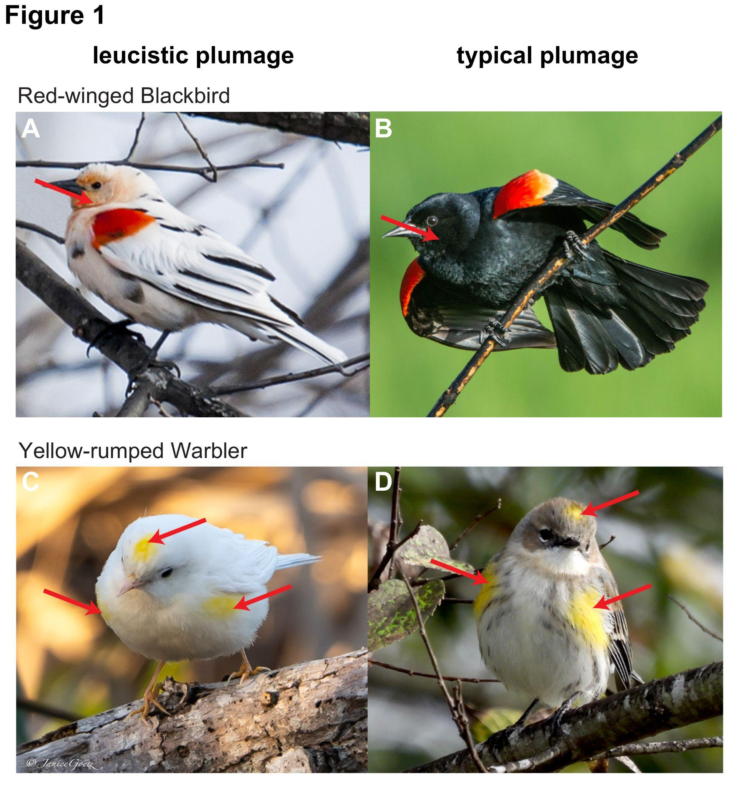
FIGURE 1. Red-winged Blackbirds (Agelaius phoeniceus) with (A) leucistic and (B) typical plumage demonstrating carotenoid coloration on the head, face, and throat that is hidden by melanin. Yellow-rumped Warblers (Setophaga coronata coronata) with (C) leucistic and (D) typical plumage demonstrating no hidden carotenoid coloration. Photo credits: (A) permission from Nancy Nabak; remaining photos obtained from iNaturalist and used under a CC-BY-NC license from (B) Jacob Collison, (C) Janice Goetz, and (D) Christa Denning.

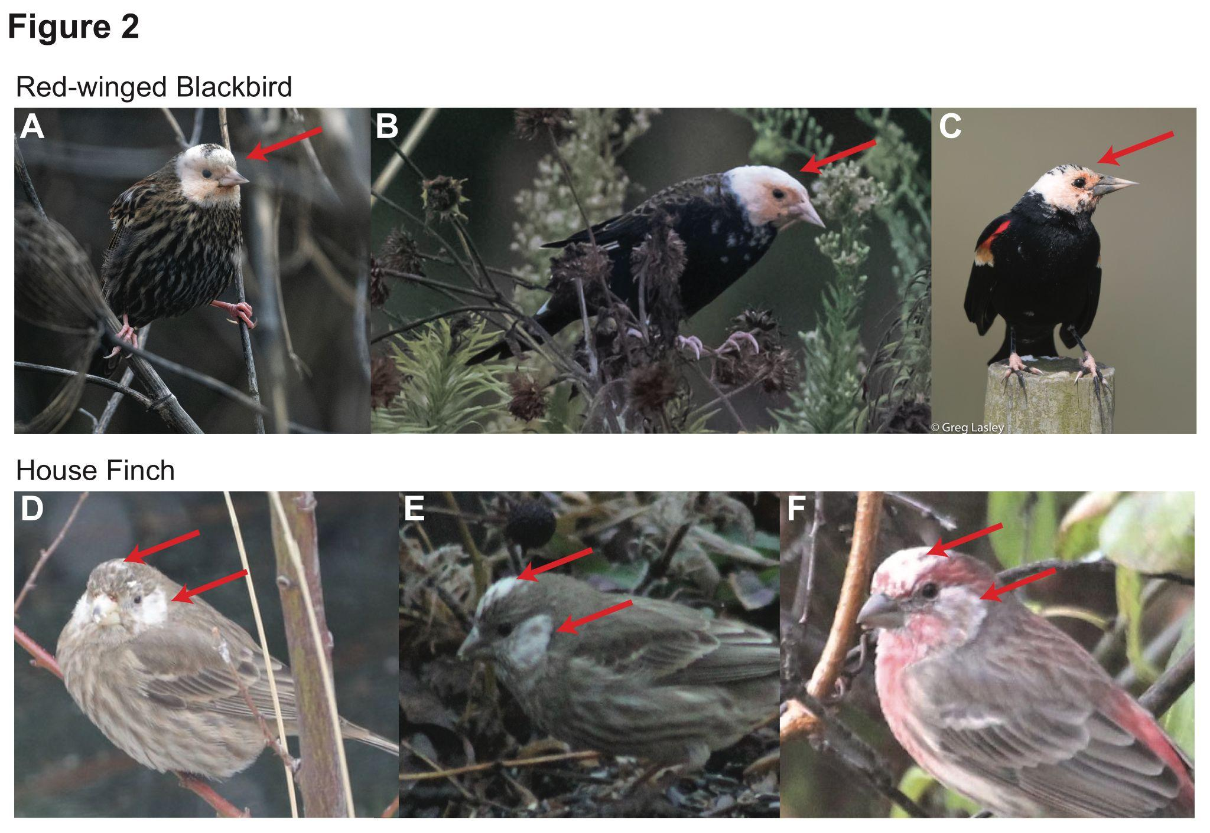
FIGURE 2. Examples of similar patterns of partial leucism present in different (A-C) Red-winged Blackbirds and (D-F) House Finches (Haemorhous mexicanus). All photos obtained from iNaturalist. Photo credits: (A) CC-BY Jonathan Eisen, (B) CC-BY-NC-ND Randy Harwood, (C) CC-BY-NC Greg Lasley, (D) CC-BY Kalvin Chan, (E) CC-BY-NC Chris Bosacki, and (F) CC-BY-NC Reina Pearson.
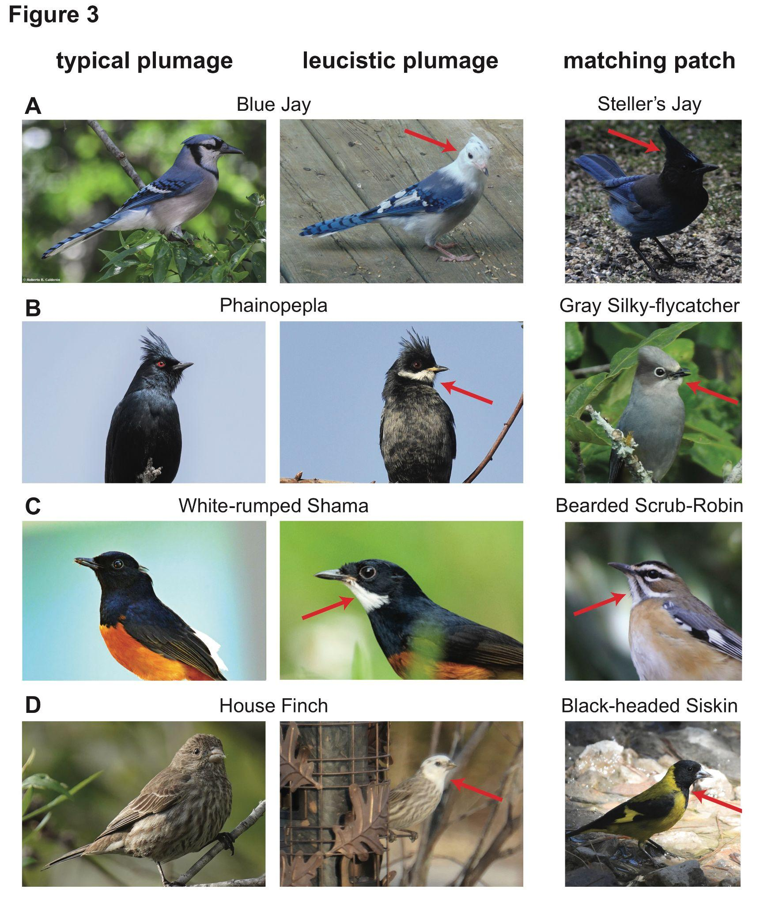
FIGURE 3. When specific regions of the plumage are leucistic, they may be similar to plumage patterns observed in other related species. These four examples each demonstrate a leucistic plumage patch that is matched by the plumage pattern of another species in the same family. (A) The leucistic head, upper back, and breast of the Blue Jay (Cyanocitta cristata) is similar to the black patch observed in the Steller’s Jay (Cyanositta stelleri). (B) The leucistic chin of the Phainopepla (Phainopepla nitens) is similar to the light-colored chin of the Gray Silky-flycatcher (Ptiliogonys cinereus). (C) The leucistic chin of the White-rumped Sharma (Copsychus malabaricus) is similar to the white chin of the Bearded Scrub-Robin (Cercotrichas quadrivirgata). (D) The leucistic head of the House Finch is similar to the black head of the Black-headed Siskin (Spinus notata). All photos obtained from iNaturalist. Photo credits (in order from left to right within panels): (A) CC-BY-NC Roberto R. Calderón, CC-BY-NC madworld1962, and CC-BY-NC macrhybopis. (B) CC-BY-NC Mark Otnes, CC-BY-NC brodiaea_max, and CC-BY Martín Márquez. (C) CC-BY-NC sunmr, CC-BY-NC Ben Tsai蔡維哲, and CC-BY-NC maritzasouthafrica. (D) CC-BY Daniel S. Katz, CC-BY-NC Susan Cahill, and CC-BY-NC Christopher Lindsey.

Note that the terminology around atypical plumage has varied greatly over time and across the different groups interested in birds (Guay et al. 2012, van Grouw 2021).

