Macroecological processes drive spiritual ecosystem services obtained from giant trees

Ryosuke Nakadai*
ORCID: 0000-0002-9512-8511

Biodiversity Division, National Institute for Environmental Studies, Onogawa 16-2, Tsukuba, Ibaraki 305-8506, Japan
* Correspondence: R. Nakadai
E-mail: r.nakadai66@gmail.com, nakadai.ryosuke@nies.go.jp
Receive date:
Accepted date:
Author contributions
R.N. conceived the study, analyzed the empirical data, and wrote the manuscript.
Acknowledgments: This study was supported by the Japan Society for the Promotion of Science and the National Institute for Environmental Studies, Japan.
Competing interests: The author declares no conflicts of interest.
Data availability: Giant tree data was downloaded from the giant trees database in Japanese (https://kyoju.biodic.go.jp/) on February 27, 2022. Climate data was downloaded from Mesh Climate Data 2010 (Japan Meteorological Agency, http://nlftp.mlit.go.jp/ksj/gml/datalist/KsjTmplt-G02.html). The complete dataset will be available in figshare after acceptance of the manuscript.

Abstract
Giant trees in Japan, that have come to have their own unique identities, are often named by local people and can inspire a sense of awe and become objects of faith. Although these giant trees provide various kinds of spiritual ecosystem services to the human society, the drivers of these services remain unclear. Using structural equation modeling, this study showed that macroecological processes, such as annual precipitation and temperature, drive spiritual ecosystem services, which are derived from giant trees.

Main
Giant trees are the largest and longest living organisms on the planet and play an important ecological role in the natural world^{1,2}. Moreover, human societies are gradually recognizing trees that will become relatively large and are studying their social and cultural significance^{3,4}. These trees have come to have their own unique names, and occasionally, they inspire a sense of awe in people, eventually becoming objects of faith (i.e., naturism)^{3,5}. In this manner, giant trees provide various kinds of cultural and spiritual ecosystem services to human society worldwide^{1,3,6}. For instance, the Celts, Druids, and many other societies in ancient Europe venerated trees, and oak (Quercus spp.) and spruce (Picea spp.) trees were of special significance in old Germanic rituals, the source of the tradition of the Christmas tree⁴. However, the natural drivers and processes that influence these ecosystem services, especially the spiritual services, have rarely been studied⁷. Therefore, the mechanisms behind giant trees and their relationship with human society remains unclear.
The size and distribution of organisms are influenced by geography and climate, and a main topic in macroecology is of describing patterns and revealing background processes⁸. In this context, giant trees are no exception, and I hypothesize that their sizes and distributions, and the resulting spiritual ecosystem services are influenced by macroecological processes (e.g., temperature and precipitation) related to the properties of each tree. Therefore, these unknown processes could be revealed from a macroecological perspective using appropriate methodology.
Here, I aimed to test whether spiritual ecosystem services provided by giant trees are driven by macroecological processes on a regional scale depending on the properties of each tree. Moreover, I considered the possibility that geographical and climatic factors directly affect spiritual ecosystem services by changing the relationship between giant trees and human society. To test the hypothesis, I compiled a comprehensive dataset of 5,353 individual giant trees with trunk circumference ≥300 cm across the Japanese archipelago. When considering variables for analysis, I focused on the probabilities of being an object of faith and receiving a unique name for spiritual ecosystem services, trunk circumference and tree age for the properties of giant trees and annual mean temperature, annual precipitation, elevation, and latitude as macroecological variables. Specific hypotheses were: 1) larger circumference and older age of a tree tend to increase the probability of it being an object of faith and receiving a unique name (i.e., properties of giant trees influence spiritual ecosystem service), 2) lower annual mean temperature and higher annual precipitation facilitate larger trunk circumferences and older tree ages (i.e., macroecological processes influence properties of giant trees), and 3) geographical (i.e., latitude and elevation) and climatic (i.e., annual mean temperature and precipitation) conditions alter the probabilities of of a tree being an object of faith and receiving a unique name (i.e., macroecological processes influence spiritual ecosystem services). The overview of the relationships and the general organization of the model is shown in Extended data Fig. 1. For testing these hypotheses, I used piecewise structural equation modeling (SEM)⁹ to analyze links among spiritual ecosystem services obtained from giant trees, individual tree properties, and macroecological processes.

The model outline and statistical analysis results are shown in Fig. 1, Table 1, respectively. The piecewise SEM analysis showed that macroecological variables directly and indirectly affected spiritual ecosystem services obtained from giant trees (Global goodness-of-fit: Fisher's C = 7.834 and P-value = 0.898, Table 1). Trunk circumference was influenced positively by tree age and annual precipitation, and negatively by annual mean temperature; however, there was no relationship between tree age and macroecological processes, and hypothesis 1 was partially supported. The probabilities of being an object of faith and receiving a unique name were both positively correlated with giant tree trunk circumference. Conversely, the probabilities of being an object of faith and getting a unique name were negatively and positively correlated with tree age, respectively. Therefore, hypothesis 2 was partly supported, except for the link between faith and tree age. Additionally, the probability of being an object of faith was positively correlated with latitude and negatively correlated with annual precipitation and elevation. Furthermore, the probability of getting a unique name was positively correlated with latitude and elevation and negatively correlated with annual precipitation, thereby supporting hypothesis 3. Trunk circumference was the strongest explaining variable for both probabilities of being an object of faith and receiving a unique name (r = 0.3224 and 0.4110, respectively). A positive correlation between both probabilities of being an object of faith and receiving a unique name was observed (r = 0.1989). Annual mean temperature was negatively influenced by both latitude and elevation, and annual precipitation was negatively influenced by latitude (Table 1).
This study clearly showed that macroecological processes (i.e., geographical and climatic factors) determined patterns of tree size, and, consequently, the occurrence probability of spiritual ecosystem services provided. However, few studies have been conducted on the driving factors of cultural ecosystem services, which include spiritual services⁷, because the processes by which nature supplies these services are unknown. Thus, giant tree size is a simple and ideal property for clarifying these mechanisms. Generally, larger giant trees have stronger relationships with human society and, thus, provide a spiritual ecosystem service. Most of the results are consistent with the hypotheses, except for paths related to tree age. The negative influence of tree age on the probablity of being an object of faith was particularly the most unexpected result. Tree age was a variable which had only four ranks based on estimated age and depending on the person reporting, the reported information was possibly different from the actual tree age.
The results showed that that climatic and geographic factors directly affected spiritual services. The most prominent relationships were that both the probabilities of being an object of faith and receiving a unique name tended to increase with lower annual precipitation (Table 1). The worship of giant trees is partly related to “pray for rain” (雨乞い; “Amagoi” in Japanese)^{8,9} and some trees even have names related to this. Considering these facts, the piecewise SEM results are strongly consistent with previous empirical findings that the probability of having a unique name or being an object of faith increases when precipitation is low^{10,11}. Originally, rice cultivation was the foundation of the traditional Japanese society, and the abundance or failure of the rice crop was a matter of the greatest concern, that was directly linked to life and death⁹. Among various climatic factors, drought was the strongest causality of a devastating decline in rice yields. Therefore, future changes in rainfall may alter the impact of spiritual services obtained from giant trees.
This study of giant trees in the Japanese archipelago is the first to clearly demonstrate the relationship between spiritual services and underlying macroecological processes, which have been difficult to evaluate quantitatively. Although comprehensively assessing spiritual and religious values across regions and countries is difficult¹², future research on the drivers of non-material ecosystem services, including spiritual services, worldwide is necessary to accumulate knowledge on their similarities and differences and to prevent loss of spiritual ecosystem services, the roles of which in human society are unclear yet in ecology.
Methods
Data Preparation
Animism was a primitive religion in ancient Japan, and sacred trees are frequently found at both shrines and temples and also remote places such as steep mountains in contemporary Japan⁵. Since the fourth National Survey of the Natural Environment in Japan (1988–1991), the Ministry of Environment conducted a survey of giant trees and forests across the Japanese archipelago, which is a long chain of continental islands located off the eastern coast of Asia and recognized as a biodiversity hotspot¹³. Therefore, the data I used for analysis was based on this survey (giant trees database, ‘巨樹・巨木林データベース’ in Japanese; https://kyoju.biodic.go.jp/). A single-trunk tree was considered giant when its trunk circumference exceeded 300 cm^{10,14}. If a tree had multiple trunks originating from the same root system, individual trunk circumferences were measured and combined, and considered giant when the total circumference exceeded 300 cm. In the original dataset, the location of each giant tree was identified by its address in Japan. Based on these addresses, I geocoded the location of each giant tree using the Google Maps Geocoding API (https://developers.google.cn/maps/documentation/geocoding). However, records with only prefectural information were excluded from the main analysis because the resolution was insufficient. Based on both latitude and longitude, the elevation of each location was determined by the Google Maps Elevation API (https://developers.google.cn/maps/documentation/elevation/overview). For the climatic variables, I used annual mean temperature and precipitation at the 1-km grid scale from Mesh Climate Data 2010 (Japan Meteorological Agency, http://nlftp.mlit.go.jp/ksj/gml/datalist/KsjTmplt-G02.html). The 1-km grids have 30-s lattitude and 45-s longitude grid cells (the Japanese Standard Third Mesh). The package ‘jpmesh’ (version 2.1.0)¹⁵ was used in R software to convert the location of each giant trees to an identity number of the Japanese Standard Third Mesh. I linked the location of each giant tree with climatic variables using the mesh identity number.
Data Filtering
Based on the information in the giant trees database, I summarized presence/absence of both faith and unique name for each tree, because the original dataset included more detailed information. The records targeting only individual giant trees were selected; thus, those targeting a row of trees or a forest area were not considered. The range of trunk circumferences was between 300–2830 cm. Tree age was approximated and categorized into four ranks, 1) ≤99 years, 2) >100 and ≤199 years, 3) >200 and ≤299 years, and 4) >300 years, as reported by the observed person of the records in the giant trees database¹⁰. The original records use the Japanese name for each tree; therefore, I converted the Japanese names to scientific names using a checklist of Japanese plant names¹⁶ and linked them with a plant family. Unmatched individuals at the species level were removed prior to statistical analysis. For individuals with overlapping data, complementary data were combined into one species, while duplicate data about presence/absence mismatches were assumed to be present, and newer data were prioritized. In addition, missing data (NA values) were deleted list-wise. Finally, the dataset, containing 5,353 complete records of individual giant trees, was compiled and used for the following statistical analysis.
Piecewise SEM Statistical Analysis
To explore direct and indirect relationships among spiritual ecosystem services obtained from giant trees and macroecological processes, I performed the analysis using the ‘piecewiseSEM’ R package⁷. The SEMs included probabilities of being an object of faith and receiving a unique name as variables related to spiritual ecosystem services, trunk circumference and tree age as variables related to properties of giant trees, and annual mean temperature, annual precipitation, elevation, and latitude as macroecological variables. First, I constructed a model that included all hypothesized paths between macroecological processes, properties of giant trees, and spiritual ecosystem services (Extended data Fig. 1), which included the plant family information of each giant tree as a random effect. The model was continuously updated by removing and adding potential paths until both of the following criteria were satisfied: 1) no significant relationship in Shipley’s test of directed separation, and 2) no non-significant paths in the model. After finishing the updates, I compared models with and without the plant family information of each giant tree as a random effect for the response variables (i.e., trunk circumference, tree age, faith, and unique name) using Akaike's Information Criterion. As a result, only paths with trunk circumference as explanatory variable were included with the plant family as a random effect. After determining the best model, I conducted a goodness-of-fit evaluation for piecewise SEM based on Fisher's C and chi-square tests (P > 0.05). The final model satisfied the criteria for adequate model fit with Fisher's C = 7.834 and P = 0.898 (Table 1).

References
1. Lindenmayer, D. B. & Laurance, W. F. The ecology, distribution, conservation and management of large old trees. Biol. Rev. Camb. Philos. Soc. 92, 1434–1458 (2017).
2. Voigt, C. C., Borissov, I. & Kelm, D. H. Bats Fertilize Roost Trees. Biotropica 47, 403–406 (2015).
3. Blicharska, M. & Mikusiński, G. Incorporating social and cultural significance of large old trees in conservation policy. Conserv. Biol. 28, 1558–1567 (2014).
4. Sponsel, L.E. Spiritual ecology: a quiet revolution. (ABC-CLIO, 2012).
5. Omura, H. Trees, Forests and Religion in Japan. Mt. Res. Dev. 24, 179-182 (2004).
6. MA, 2005. Millennium Ecosystem Assessment. Ecosystems and Human Well-Being: Synthesis (Washington, DC: Island Press, 2005)
7. Vihervaara, P., Rönkä, M. & Walls, M. Trends in ecosystem service research: early steps and current drivers. Ambio 39, 314–324 (2010).
8. Brown, J. H. Macroecology (University of Chicago Press, 1995)
9. Lefcheck, J. S. PiecewiseSEM: piecewise structural equation modelling in r for ecology, evolution, and systematics. Methods Ecol. Evol. 7, 573–579 (2016).
10. Biodiversity Center of Japan & Ministry of the Environment. Japan. Giant Trees Follow-Up Survey Report, the Sixth Census of the National Survey of the Natural Environment https://www.biodic.go.jp/reports2/6th/kyojuflup/6_kyojuflup.pdf (2001). (in Japanese)
11. Makino, K. Folkloristics of Giant Trees (Kobunsha, 1986). (in Japanese)
12. Daniel, T. C. et al. Contributions of cultural services to the ecosystem services agenda. Proc. Natl Acad. Sci. USA 109, 8812–8819 (2012).
13. Mittermeier, R. A., Turner, W. R., Larsen, F. W., Brooks, T. M. & Gascon, C. Global biodiversity conservation: the critical role of hotspots in (eds Zachos, F. E. & Habel, J. C.), Biodiversity Hotspots 3–22 (Springer, 2011)
14. Watanabe, T., Matsunaga, K., Kanazawa, Y., Suzuki, K. & Rotherham, I. D. Landforms and distribution patterns of giant Castanopsis sieboldii trees in urban areas and western suburbs of Tokyo, Japan. Urban Greening 60 (2021).
15. Uryu, S. jpmesh: Utilities for Japanese Mesh Code. R package version 2.1.0. https://CRAN.R-project.org/package=jpmesh (2022).
16. Yamanouchi, T. et al. A checklist of Japanese plant names. https://www.gbif.jp/v2/activities/wamei_checklist.html (2019).

Table 1. Global goodness-of-fit of the final model is an overview of piecewise structural equation modelling (SEM)⁷ results with Fisher's C = 7.834 and P-value = 0.898, satisfying the criteria of adequate fit. Abbreviations: LAT, latitude; ELV, elevation; AMT, annual mean temperature; AP, annual precipitation; TC, trunk circumference; AGE, tree ages; FAI, probability of being an object of faith; NAM, probability of receiving a unique name.
Response | Explanatory variable | Standardized coefficient (r) | P-value
Causal effect
AMT | LAT | –0.7625 | <0.001
AMT | ELE | –0.7266 | <0.001
AP | LAT | –0.3491 | <0.001
TC† | AMT | –0.0720 | <0.001
TC† | AP | 0.0914 | <0.001
TC† | AGE | 0.1997 | <0.001
FAI | LAT | 0.0727 | <0.001
FAI | TC | 0.3224 | <0.001
FAI | AGE | –0.1141 | <0.001
FAI | AP | –0.1370 | <0.001
FAI | ELE | –0.0867 | <0.001
NAM | LAT | 0.1126 | <0.001
NAM | TC | 0.4110 | <0.001
NAM | AGE | 0.1051 | <0.001
NAM | AP | –0.0689 | <0.001
NAM | ELE | 0.1459 | <0.001
Covariance
FAI | NAM | 0.1989 | <0.001
AMT | AP | –0.1464 | <0.001
†The trunk circumference analysis considered the plant family of each giant tree as a random effect.

Figure legend
Figure 1. Relationship diagram of piecewise structural equation modelling (SEM) explaining links among macroecological processes, giant trees, and spiritual ecosystem services. Red and blue arrows indicate significant positive and negative correlations, respectively. Path thickness indicates the strength (absolute value) of the standardized coefficients at three levels: ≤0.3, >0.3, and >0.6. Abbreviations: LAT, latitude; ELV, elevation; AMT, annual mean temperature; AP, annual precipitation; TC, trunk circumference; AGE, tree age; FAI, probability of being an object of faith; NAM, probability of receiving a unique name.

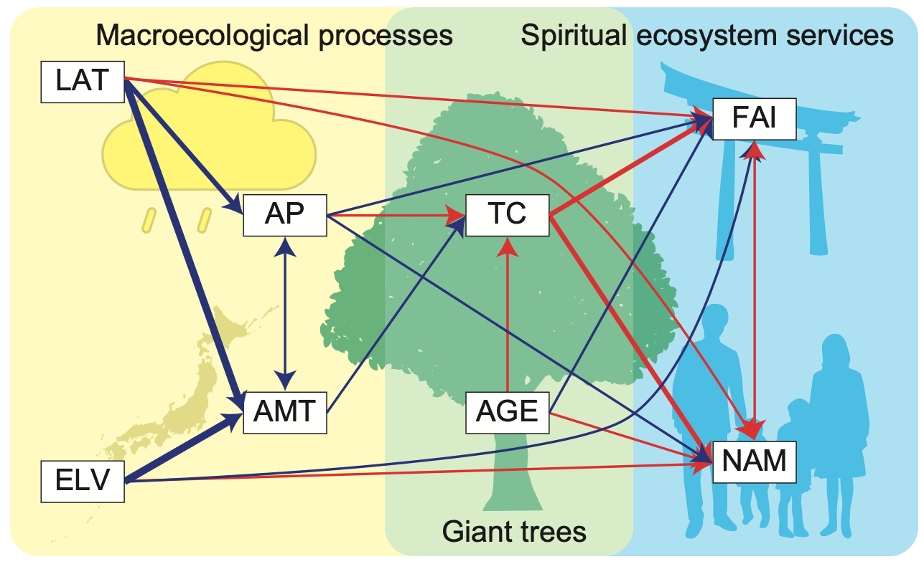
Figure 1

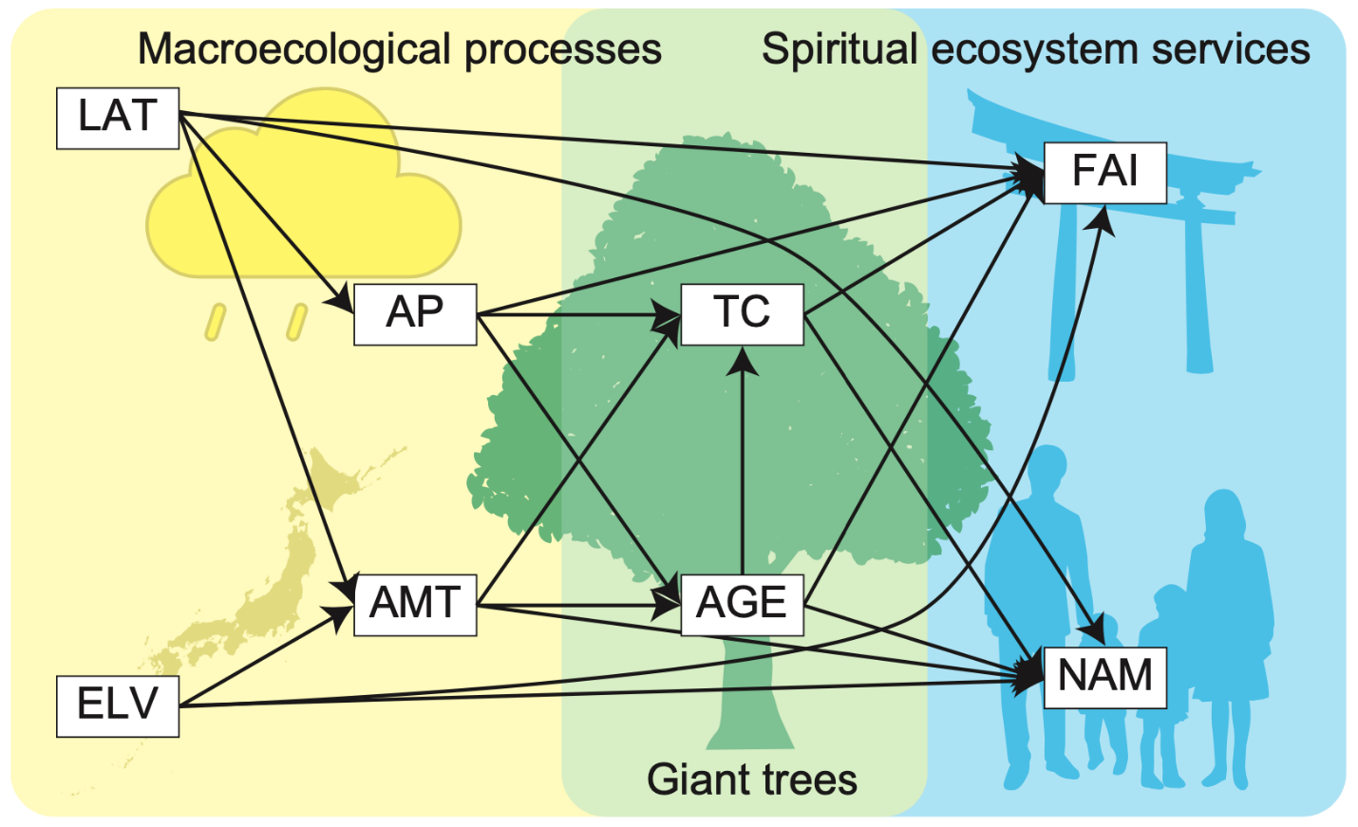
Extended data Figure S1. Initial model structure for piecewise SEM analysis.

