Social manipulations disentangle rank effects of individual characteristics and social history

Authors
Annemarie van der Marel^{1,2}, Xavier Francis¹, Claire L. O’Connell¹, Cesar O. Estien^{1,3}, Chelsea Carminito¹, Bryan M. Kluever⁴, Elizabeth A. Hobson¹

Affiliations
¹ Department of Biological Sciences, University of Cincinnati, Cincinnati, OH, 45221, USA
² Departamento de Ecología, Facultad de Ciencias Biológicas, Pontificia Universidad Católica de Chile, Santiago, Chile
³ Department of Environmental Science, Policy, and Management, University of California–Berkeley, Berkeley, CA 94720, USA
⁴ United States Department of Agriculture, Wildlife Services, National Wildlife Research Center, Florida Field Station, Gainesville, FL, 32641, USA
Corresponding author: A. van der Marel, avdmarel@outlook.com

ORCID
Annemarie van der Marel: 0000-0003-3942-8314
Xavier Francis: 0000-0001-7286-3284
Claire L. O’Connell: 0000-0002-3852-3021
Cesar O. Estien: 0000-0001-8410-7371
Chelsea Carminito: 0000-0002-0432-3865
Bryan M. Kluever: 0000-0001-8417-4339
Elizabeth A. Hobson: 0000-0003-1523-6967

Funding
During preparation of this work, EAH, CC, and XF were supported by NSF IOS 2015932, and the research was supported in part by the US Department of Agriculture, Animal and Plant Health Inspection Service, Wildlife Services, National Wildlife Research Center. COE was supported by University of California, Berkeley’s Chancellor Fellowship and the National Science Foundation Graduate Research Fellowship under Grant No. 2146752.

Acknowledgements
We thank the USDA staff at the Florida Field Station, especially Eric Tillman, John Humphrey, Danyelle Sherman, and Palmer Harrell, for their assistance and support. We acknowledge the fieldwork was conducted on the unceded lands of the Seminole and Timucua people and the analyses and writing work on the native homeland of the Indigenous Algonquian speaking tribes, including the Delaware, Miami, and Shawnee tribes.

Data availability
The data and code are available on the GitHub repository (annemarievdmarel/Monk_rank_socialVSchar; van der Marel 2022).

Lay summary
Dominance rank can influence many aspects of an individual’s biology across many species. We manipulated group membership to determine whether rank is the product of a group’s social history or bodyweight in monk parakeets. After reintroducing removed individuals, no top-ranked individuals could re-take their rank, and bodyweight was inconsistently correlated with rank across all birds. Our results show that rank is more likely an outcome of social history rather than being driven by individual characteristics.

Social manipulations disentangle rank effects of individual characteristics and social history

Abstract
Dominance hierarchies can provide many benefits to individuals depending on their ranks. Individuals can establish rank in these hierarchies from outcomes based on individual characteristics to outcomes based on social interactions and memory, and these drivers are not mutually exclusive. Generally, researchers evaluate the basis of rank by employing correlative methods between individual characteristics and rank. A lack of a correlation does not automatically indicate that social history, rather than individual characteristics, is important in rank emergence. To better disentangle social history and individual characteristics as the basis for rank, we conducted experimental social perturbations on a captive group of 20 monk parakeets (Myiopsitta monachus). We tested whether individuals could re-take their ranks in hierarchies after reintroduction following their removal period from the group. If rank is more an outcome of recent social interactions within a group, a removed individual should not be able to re-take its previous rank following reintroduction. If rank is more of an outcome of individual characteristics, these characteristics should be associated with rank and removed individuals should be able to re-take their ranks following reintroduction. We performed three perturbations that consisted of an eight-day removal and an eight-day reintroduction period of three unique top-ranked focal birds. We found that none of the focal birds could regain their previous rank following reintroduction. We also found that an individual characteristic (body mass) was largely unassociated with rank. Our repeated samples of body mass suggest that this characteristic may be responsive to rank, rather than a factor driving rank. Combined with previous results, this experiment supports that rank in monk parakeet dominance hierarchies is more likely to be an emergent outcome of past interactions, memory, and observing agonistic interactions rather than based strongly on individual characteristics.

Keywords
Animal aggression, dominance hierarchy, dominance rank, parrot, parakeet, social perturbation, sociality

Introduction
Dominance hierarchies structure aggression in many social groups across the animal kingdom (Shizuka and McDonald 2012; Holekamp and Strauss 2016; Hobson et al. 2021). The ranks that individuals hold in these hierarchies, and the aggression one receives based on rank, can affect their access to resources (Pizzari and McDonald 2019), health and stress levels (Cavigelli and Caruso 2015; Simons et al. 2022), and ability to reproduce (Hodge et al. 2008; Sukmak et al. 2014). These effects demonstrate that rank is not just a feature detectable by researchers but that rank is a phenomenon that can have significant biological effects on individuals in these groups.
Understanding how and why specific individuals achieve high rank has been an area of active research during the history of dominance hierarchy study (Strauss et al. 2022). In some species, rank is strongly correlated with the characteristics of the individuals, such as body size, weapon or ornament size, age, motivation, or maternal inheritance (Engh et al. 2000; Chase and Seitz 2011; Reddon et al. 2011; Santos et al. 2011; O’Connor et al. 2015). However, rank in other species appears to be independent on many of these characteristics (Chase et al. 2002). Rank in these cases may be a product of the history of interactions and, thus, an emergent property of group interactions (Hotta et al. 2014; Massen et al. 2014; Hobson and DeDeo 2015; Tibbetts et al. 2019). Rank can emerge solely as an outcome, or as a combination of individual characteristics or social history (reviewed in Holekamp and Strauss 2016; Hobson 2020), which would translate to rank determinants existing along a continuum that may or may not be mutually exclusive. Knowing where a group falls on this rank continuum and how individuals achieve or gain and lose rank, can provide insight into the relative importance of individual characteristics and social factors (Hobson 2020).
To determine what factors influence rank, researchers often measure individual characteristics and then correlate those measures to the rank of individuals (e.g., Ardia et al. 2010; Matthews and Wong 2015; Feng et al. 2016). A strong correlation would be interpreted as evidence that the measured characteristic could be a determining factor affecting rank. However, it is important to note that the characteristic could instead be an outcome of rank. Finding an association between individual characteristics and rank at a single time point is not immediately informative about the direction of causality and further examination of the relationship across time is necessary to be able to differentiate whether individual characteristics influence rank or rank influences characteristics. The absence of a strong association between characteristics and rank is also difficult to interpret. For example, a lack of association may occur if characteristics largely determine rank, but the salient trait was not identified, measured, and tested in the study (Chase and Seitz 2011). Alternatively, a lack of association may indicate that rank is more dependent on social factors than characteristics, or both social factors and individual characteristics that were not tested. Additional analyses are needed to reach this conclusion. For example, analyses of the amount and type of social information in a system, combined with a lack of association between characteristics and rank, can provide stronger indications that social history is important to rank (e.g., Hobson & DeDeo 2015). Experimental manipulation of social groups that exhibit dominance hierarchies could be used to better clarify the factors that determine rank.
Experimental approaches can allow researchers to thoroughly investigate several aspects about rank including: (1) the effect of an individual’s social history and environment, (2) the effect of an individual’s characteristics, and (3) the direction of causality of the relationship between rank and individual characteristics. If rank is dependent on social history, altering group composition through removing, replacing, or reintroducing individuals should change the ranks of individuals. Previous captive perturbation experiments across species have tested, for example, whether the removal of conflict managers affects group-level measures and robustness (Flack et al. 2005), what happens to the hierarchy after an alpha male leaves (Grossel et al. 2022), whether social ascent is costly in a size-based rank system (Fialkowski et al. 2021), and if behavioral patterns differ per rank position (Rueger et al. 2021), or if the dominance hierarchy structure changes (Kubitza et al. 2015). These kinds of social perturbation events can also occur naturally in wild populations through demographic (e.g., deaths, births, dispersal and immigration events, Shizuka and Johnson 2020), or stochastic environmental processes, such as hurricanes (Testard et al. 2021). However, these processes in wild populations are difficult to experimentally control as the timing of these perturbations are haphazard and, consequently, replication of these events are difficult to account for. Natural perturbation events can be simulated in more controlled captive conditions by experimentally manipulating the system by removing or (re)introducing individuals via targeted captures. If rank is dependent on characteristics, artificially modifying those characteristics should change that individual’s rank (e.g., Santos et al. 2011; Cline et al. 2016; Levin et al. 2018; Portugal et al. 2020). Alternatively, it is also possible that rank may affect individual characteristics through feedback mechanisms (Setchell and Dixson 2001). If so manipulating an individual’s characteristics can alter rank which in turn can alter individual characteristics (Dey et al. 2014).
In this study, we used social perturbations to test whether rank was more likely an outcome of social processes or individual characteristics. We tested whether top-ranked individuals could re-take their ranks following an experimental removal and reintroduction within their groups. We tested this idea in monk parakeets (Myiopsitta monachus), small neotropical, widely invasive parrots that readily form dominance hierarchies in captivity (Hobson et al. 2013; Hobson et al. 2014; Hobson et al. 2015; Hobson and DeDeo 2015). Previous work with this species has indicated that social history was likely more important in determining rank than individual characteristics, but this work used only computational approaches to detect evidence for the effect of social history on rank (Hobson and DeDeo 2015; Hobson et al. 2021). Here, we expand on this previous work by using a social perturbation experiment to disentangle the influence of social history and individual characteristics on rank emergence. In each trial, we identified the top-ranked individual, removed it from the group, and reintroduced it after an 8-day absence. We predicted that if the short-term history of social interactions was more important in achieving and maintaining rank, these formerly top-ranked individuals should not immediately re-take their previous ranks, and individual characteristics would not be associated with rank. However, if individual characteristics were more important in determining rank in this system, removed individuals should quickly re-take their previous top-ranked position and rank would be highly associated with individual characteristics. A correlation between rank and individual characteristics could either mean that the individual characteristic affects rank or that an individual characteristic is influenced by rank. Therefore, we also investigated the direction of causality for the relationship between rank and individual characteristics using repeated measures of power scores and body mass. This experimental approach allowed us to determine the foundations of rank more clearly in this monk parakeet group. A better understanding of rank determinants may provide insight into the role of cognitive processes like perception, comparison, memory, and inference, on rank acquisition.

Methods
The social experiments and observations took place at the United States Department of Agriculture National Wildlife Research Center (USDA NWRC), Florida Field Station, in Gainesville, FL, USA. We observed a captive group of 20 monk parakeets from April – July 2021 and recorded aggressive interactions among individuals. This group of 20 monk parakeets had never interacted as one social group before and was comprised of birds that were captured by the USDA NWRC from feral populations in South Florida just prior to our social experiment. All animal-related activities were approved by the University of Cincinnati (IACUC protocol #AM02-19-11-19-01) and the National Wildlife Research Center (Quality Assurance #3203).

Social interaction data collection
To facilitate individual identification, we marked each parakeet on the head, cheeks, and neck with a unique color combination using nontoxic, permanent markers (Sharpie, Inc.®) (Hobson et al. 2013). This unique color combination also represented a unique letter ID for each bird combining the three different colors chosen from blue, green, orange, and purple (Fig.1). All marks were re-applied at each capture event (see below). Once (re)marked, parakeets were released into a large 45 x 45m seminatural outdoor flight pen. We allowed the group to interact and the social structure to stabilize in the flight pen for 44 days before starting the social perturbations. Social perturbations occurred between 16 May and 5 July 2021. Each perturbation cycle lasted 16 days, including an 8-day removal and an 8-day reintroduction period (Supplemental Material (SM) 1).
Four observers monitored parakeet behaviors in the flight pen. The observers collected data on social interactions between 08:00 and 19:00 from three different blinds in the flight pen. Observers recorded dyadic interactions using all-occurrence sampling (Altmann 1974) and entered data directly into electronic format using an iPad and the Animal Observer application (Diane Fossey Gorilla Fund v1.0), which we customized to record all-occurrence observations of agonistic interactions (van der Marel et al. 2022). We recorded two types of directed agonistic interactions: crowds, where the actor approached a target, but the target moved away before the actor was within striking range, and displacements, where the actor aggressively approached another bird within striking distance and supplanted it from its location.
From these observations, we excluded any interaction where either of the two interactants was unknown (keeping only interactions where the actor and the target were positively identified). We also excluded duplicated observations, for example, if two observers recorded the same fight. To do this, we determined the maximum number of aggressive interactions (including both crowds and displacements) between each pair of individuals (dyads) recorded by an observer each minute. Combining both crowds and displacements was a more conservative method to remove duplicates as it resulted in less interactions but excluded the instances where two observers observed the same interaction but where one observer could have coded it as a crowd and the other observer as a displacement. We retained the most complete interaction record for each dyad in each minute of observation (observations from the observer that recorded the most events during that one minute; see van der Marel et al. 2020).

Quantifying rank
We used both crowd and displacement aggression as pairwise interactions to find the dominance rank of each bird. We included both crowd and displacement interactions in our calculation of rank because our analyses indicated that we could treat these two behaviors as interchangeable (see SM2, using methods in van der Marel et al. 2020). We pooled data into a series of 3-day bins (i.e., rank assessment periods, SM1) to better estimate individual ranks. Each perturbation cycle consisted of four 3-day rank assessment periods. We used power as a continuous measure of rank for each individual and calculated power using a modified version of PageRank implemented in the ‘Domstruc’ package (Hobson et al. 2021; Mønster et al. 2021). We used the continuous power measure instead of ordinal rank measures because a continuous rank measure contains more information than when scores are transformed to an ordinal ranking. In an ordinal ranking method each individual is ranked in a linear order, whereas power can also discern between cases where individuals have similar power scores. For example, individuals that have rank positions 1 and 2 could either have very similar or dissimilar power scores. For the analyses, we primarily used the continuous measure, power, but we also incorporated ordinal ranking to highlight rank positions.

Rank-based removals
We first identified which parakeet was currently the top-ranked bird in the group at each removal point using the agonistic interactions collected during the three days prior to removals (Fig. 1, rank assessment points 1, 5, and 9). On each removal day, we trapped all the parakeets in the flight pen using mist nets, removed the most dominant parakeet, and released the remaining birds back into the flight pen. We allowed the birds to recover in the afternoon after trapping, and this recovery period was not included in our analyses. The removed top-ranked bird was housed in its standard housing cage during the removal period (2 x 2 meter wire cage), which is where the parakeets normally reside when they are not in the flight pen. The removed bird was housed near other parakeets (not involved in the flight pen experiment) but away from the social group remaining in the flight pen. After eight days, we reintroduced the removed bird by releasing it back into the social group.

Individual characteristic measure
We used body mass and relative body size as our individual characteristics, however we focused our assessment of individual characteristics in the paper on body mass (for justification, see SM3). On removal days when all individuals were captured (n = 20 monk parakeets), we measured the body mass of each bird in grams using a digital scale, totaling five capture events and body mass measures. We excluded seven data points with incorrectly recorded body masses (SM3). We tested for sex differences in body mass by genetically sexing all individuals with feather samples (IQGenetics, Inc., Miami, FL, USA) because monk parakeets are sexually monomorphic. We calculated the mean of each bird’s body mass across the five capture events and used a t-test to test for a sex difference in mean body mass.

Testing whether social processes underly rank
We quantified all birds’ rank and power dynamics in the group throughout our social experiment. To test whether individuals could re-take their previous rank position in the dominance hierarchy following an absence, we quantified all parakeets’ ranks and power scores in the group prior to each removal and following each reintroduction (e.g., rank assessment points 1 and 4). We then compared the focal birds’ absolute rank and power score change to the remaining group members. The timing of our power, relative rank, and weight recovery measurements of the focal bird of trial three (rank assessment point 13) was slightly delayed by a tropical storm. Before the storm, we moved all birds to their holding cages after rank assessment period 12 and released them back into the flight pen after two days. To obtain the recovery data for the focal bird, we calculated the bird’s recovery using a two-day observation period (rank assessment point 13). We excluded rank assessment period 13 from the rest of our analyses, but we included the power assessment for this time point in Figure 1.

Testing whether individual characteristics underly rank
If individual characteristics underly rank, rank should be associated with individual characteristics. We correlated power score and bodyweight just prior to removals using Kendall’s correlation because this correlation measure is robust for small sample sizes (Bonett and Wright 2000).

Determining the direction of causality of rank and mass
If an association between rank and mass is present, causality could go in two directions: 1) body mass could predict achieved rank, or 2) rank could influence body mass. First, we tested whether initial weight or sex predicted power after the initial group formation period. We used the initial body mass prior to social experiments and the power prior to first removal (rank assessment point 1, SM1). As power scores followed a beta distribution, we used linear regression for beta distribution to test the effect of mass and sex on rank using the ‘betareg’ package (Cribari-Neto and Zeileis 2010). We used the likelihood ratio test (LRT) between the full model and a null model (excluding mass and sex) to test for significance. As we did not find differences in body masses between sexes or an effect of sex on power score (see results), we excluded sex from further analyses.
Second, we investigated whether body mass may be an outcome of rank. If changes in power score drive changes in body mass, then we should see a correlation between power change and body mass change. Additionally, focal birds that cannot re-take their top rank position should also lose weight upon reintroduction. We correlated the power score change between time points prior to removals (rank assessment points 1 and 5, 5 and 9; Fig. SM1) using Kendall’s correlation and calculated the percentage of birds that either both lost or gained weight and power. This percentage would reflect the percentage of birds that followed our prediction. We excluded the comparison of trial 3 as we did not have the power score at the end of trial 3 due to a tropical storm (see above). To investigate the relationship between changes in mass and power score of the focal birds, we measured the mass of all removed focal birds at three time points: 1) at each group capture event (on removal days), 2) just prior to reintroduction to the group, and 3) at the following group capture event (normally 8 days after reintroductions, except for trial 3, see above). This method allowed us to detect changes in mass that occurred during the removal phase, during the reintroduction phase, and across the entire 16-day trial. We did not test for the significance of mass change of the focal birds due to low statistical power. As a comparison to the weight change of the focal birds, we also quantified the percent weight change across all the birds in the group, with masses measured at each group capture event. We tested for a difference in percent weight change across trials using a linear mixed model with ID as a random factor as we had multiple weight measures per bird. We tested for significance using a likelihood ratio test and calculated the confidence intervals using the ‘emmeans’ package (Lenth 2021). We compared the focal birds’ overall body mass change for each trial (difference between weight at capture event 1 and 2, etc.) to the remaining birds in the flight pen.

Data availability
We performed all analyses in R version 4.1.2 (R Core Team 2021) and created the figures using ggplot2 (Wickham 2016). The data and code are available on the GitHub repository (link will be provided after the double-blind review process).

Results
We observed the monk parakeets for 269.9 hours and 1034.6 person hours (i.e., total hours observed for all four observers combined) across 38.5 days. Each 3-day bin used for rank assessment was based on an average of 21.3 ± 2.3 (SD) observation hours. After excluding unidentified individuals and duplicate interactions, we used 24317 agonistic interactions (rank assessment points 1 through 13; Fig. 1, SM1) to address how parakeets responded to dominance rank perturbations. We performed removal/reintroduction trials for three unique top-ranked individuals in the group. In total, 7 females and 13 males were part of the study. We measured their body weight at five different capture events. On average, body mass was 110.1 ± 6.8 g. Males (111.7 ± 6.6 g) were not significantly heavier than females (107.2 ± 6.4 g; t-test = -1.69, p = 0.11).

Do social processes underly rank?
Throughout the experiment, we observed that the group showed relatively stable power scores despite the perturbations but that individuals did undergo rank and power score changes (Fig. 1). The average of the absolute power score changes of the remaining parakeets, excluding the focal birds, between the rank assessment points just prior to removal and just after reintroduction was 0.011 ± 0.008, 0.017 ± 0.021, and 0.014 ± 0.013 (mean ± SD) for trials 1, 2, and 3, respectively (Fig. SM4.1). The focal birds dropped much more in power and showed greater absolute power score changes (trial 1: 0.159, trial 2: 0.051, and trial 3: 0.158) than the birds that remained in the flight pen for the duration of the 16-day trial (Fig. SM4.1). None of the three removed birds were able to re-take their previous rank immediately after reintroduction (Fig. 1, Table 1).
Table 1. Change in measured variables between different timepoints for each focal bird for (a) changes between removal and reintroduction (e.g., difference between rank assessment points 4 and 1, Fig. 1) and (b) changes between reintroduction and the next focal removal (e.g., difference between rank assessment points 5 and 4). Columns show changes in power, ordinal rank, and weight (negative values indicate losses, positive values indicate gains, 0 indicates no change).
¹ The recovery values were calculated using a two-day observation period (rank assessment point 13, Fig. 1) collected after the birds were placed back into their holding cages for two days due to a tropical storm.
 |  |  | (a) |  |  |  |  | (b)
Trial | Focal bird |  |  | Power | Rank | Weight |  |  | Power | Rank | Weight
1 | BBB |  |  | -0.16 | -20 | +0.40 |  |  | +0.01 | 0 | -6.60
2 | GPG |  |  | -0.05 | -16 | -2.30 |  |  | +0.03 | +7 | +0.20
3 | OPP |  |  | -0.16 | -20 | +0.57 |  |  | +0.02¹ | 0¹ | -7.37¹

Figure 1. Dominance rank changes over time. The rank assessment points include power score assessments calculated over three days of observations. Each of the three top-ranked focal birds (BBB, GPG, and OPP) are highlighted with bolder power lines. Circles show the power scores (i.e., modified PageRank score) of focal birds prior to removals; diamonds show the power scores following reintroductions; colored dashed lines show the change in rank for each focal prior to removal compared to following their reintroduction to the group; grey dashed lines show removal points; grey dotted lines show reintroduction points.
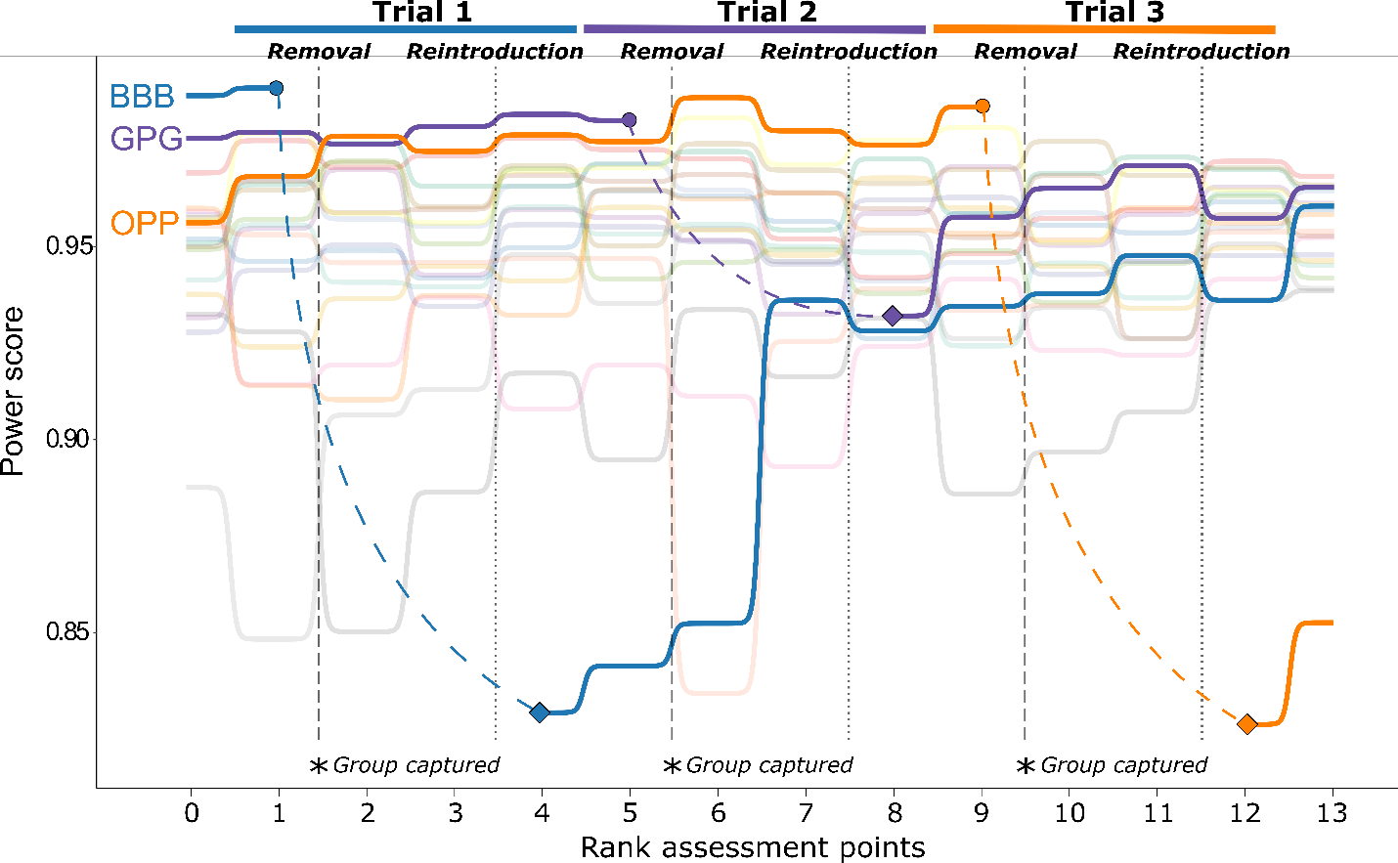

Do individual characteristics underly rank?
We found no significant association between body mass and power in 2 out of the 3 trials (trial 2: τ = 0.19, p = 0.26; and trial 3: τ = 0.08, p = 0.65, Fig. 2a). Power and body mass were positively correlated when the social structure was stable and just prior to first removal (trial 1 Kendall correlation: τ = 0.33, p = 0.04; Fig. 2). The correlation results were not uniform across trials.
Figure 2. Assessing the relationship between body mass and power score in monk parakeets. The figure shows the correlation between body mass and power score just prior to removals 1, 2, and 3, respectively. Females are denoted with green circles and males with blue triangles.
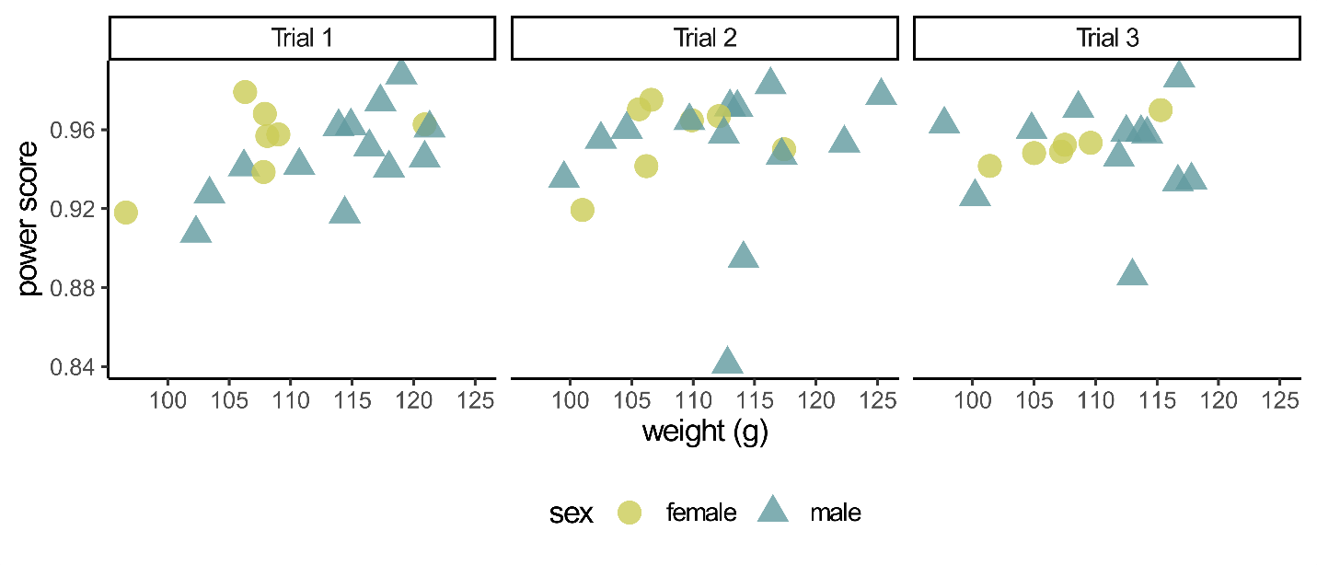

Can we determine the direction of causality of rank and mass?
We investigated the direction of causation of the association between power and body mass in two ways. First, we tested whether initial body mass or sex predicted power at the end of the initial group formation period. We found that neither initial body mass nor sex predicted power prior to first removal (LRT: λ = 3.85, p = 0.15, weight estimate ± SE = 0.01 ± 0.01, sex estimate ± SE = -0.38 ± 0.19; Fig. 3).
Figure 3. Assessing the direction of causality between rank and body mass. Beta regression of initial body mass in gram on power score calculated during the 3-days at the end of the initial group formation period just prior the first removal. Females are denoted with green circles and males with blue triangles.
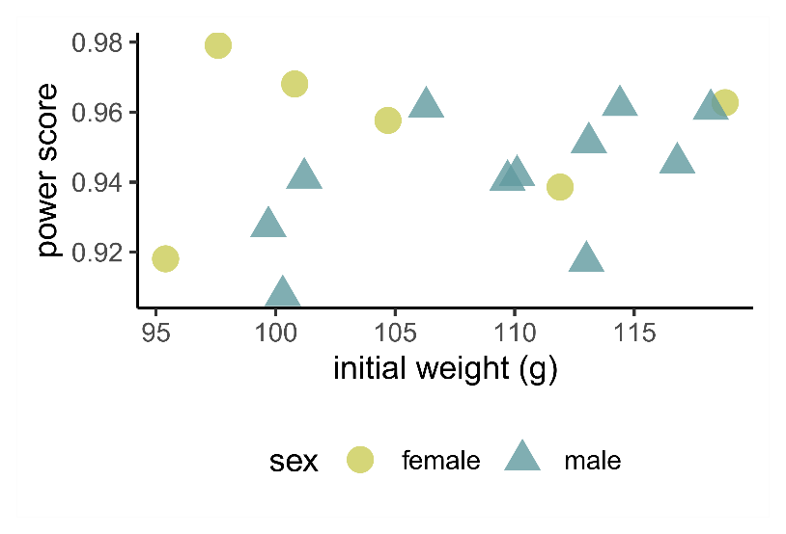
Second, we tested whether mass could be an outcome of rank position. Power and weight change were not correlated when the focal was included (trial 1: Kendall's τ = 0.16, p = 0.33; trial 2: τ = 0.13, p = 0.45; Fig. 4; Fig. SM5.1) or excluded (trial 1: τ = 0.06, p = 0.70; trial 2: τ = 0.13, p = 0.48). We found that 55 % and 50 % of birds for trial 1 and 2, respectively, followed our prediction that if individuals lose or gain power they will then lose or gain weight. We observed that the two focal birds that had an extreme loss of rank (-20 rank positions) upon reintroduction also lost weight after reintroduction (Table 1; Fig. 5b). The other focal bird (trial 2) did not lose as many rank positions (it dropped 16 places in rank) and, in contrast to the other two birds, this bird gained weight after it was reintroduced (Table 1; Fig. 5b). Body mass for all non-focal birds did not significantly change during the social experiment (LR test: λ = 5.6, p = 0.06: Fig. 5c). All the confidence intervals crossed zero, so weight change did not differ across trials (trial 1: CI [-1.58 – 0.55], trial 2: CI [-2.11 – 0.02], trial 3: CI [-0.41 – 1.87]). Compared to the mass change of the remaining birds in the flight pen across the entire perturbation trial, the focal birds of trials 1 and 3 showed weight loss but this weight loss was not unusual compared to the weight loss of the remaining group members (Fig. 5).
Figure 4. The association between power score changes and weight changes for trials 1 and 2. The colors of points represent the ordinal rank of the individuals at the start of the trial with top-ranked birds in red and bottom-ranked birds in blue. The grey rectangles represent the quadrants where we would expect the datapoints to fall in if body mass is an outcome of rank: the bottom-left quadrant represents when individuals lose rank and weight and the top-right quadrant represents when individuals gain weight and rank.
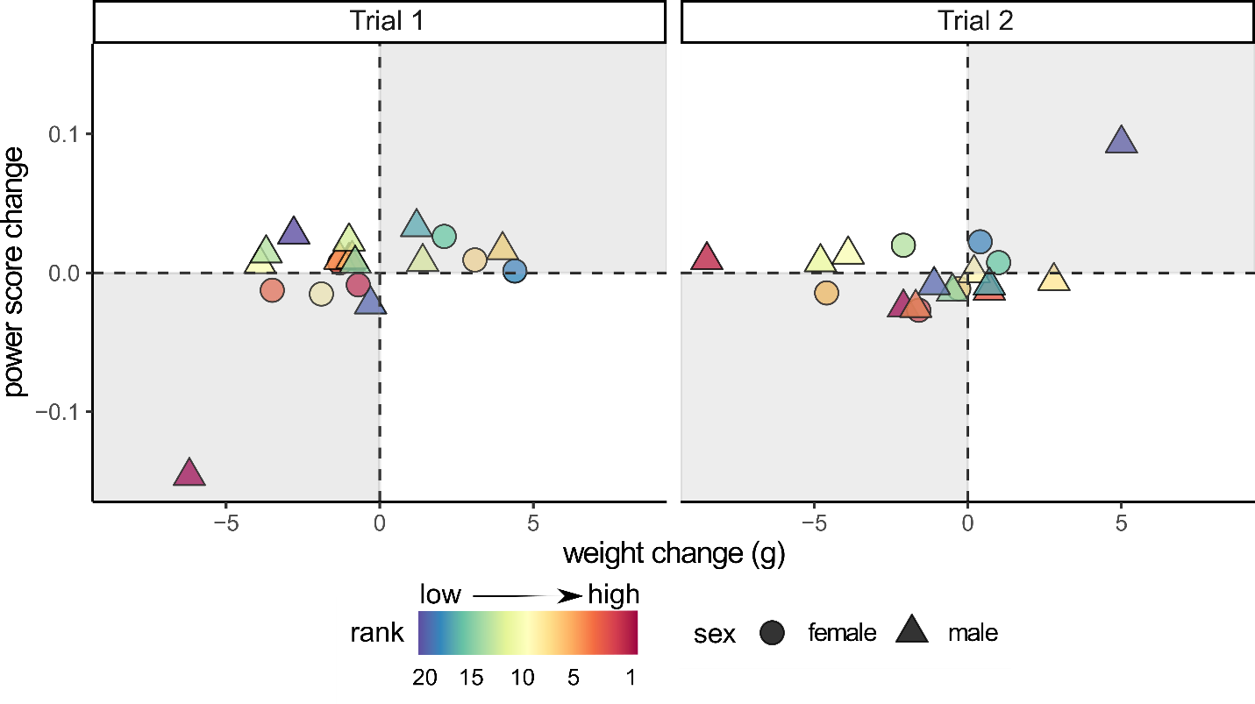

Figure 5. Weight changes across time in the focal birds and across all individuals in the group. Panel (a) shows weight change following the removal period for the three focal birds, comparing mass at reintroduction to mass on removal. Panel (b) shows weight change following the reintroduction period for each focal, comparing mass at the next capture event to mass on reintroduction. For comparison, panel (c) shows the percent weight change across capture events for all group members (excluding the focal birds). A positive weight change indicates weight gain, and a negative weight change indicates weight loss.
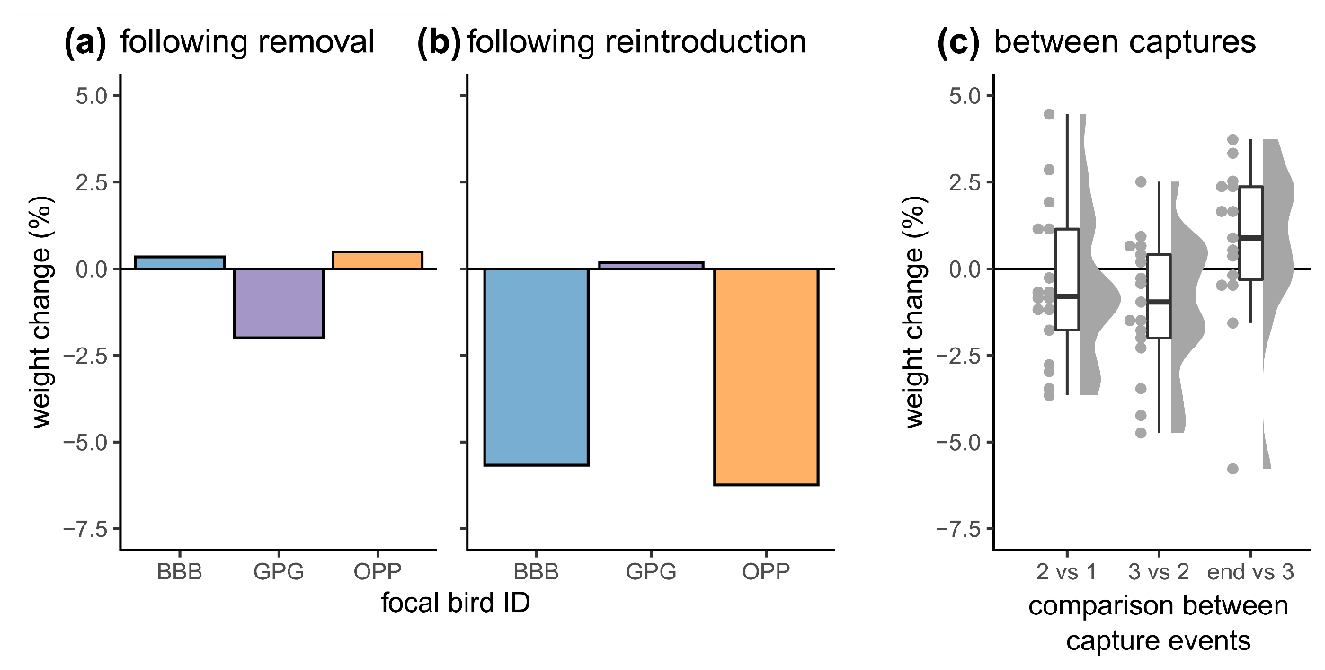

Discussion
We investigated two alternative non-mutually exclusive hypotheses to explain achieved rank in a group of monk parakeets. We tested whether rank was more an outcome of the history of past interactions or more an outcome of individual characteristics. If we observed that removed birds could not re-take their previous top-rank position, then we would see support for the social history hypothesis. Further, if we found a correlation between an individual characteristic (body mass) and rank, then we would see support for the individual characteristics hypothesis. Lastly, we determined the direction of causality of the correlation between rank and the characteristic.
Our results show strong support for the effect of social history on rank and weak to no evidence that body mass is a determinant of rank. Past interactions of monk parakeets influence rank because none of the three removed birds could re-take their previous rank upon reintroduction, similar to previous studies (Hobson and DeDeo 2015; Hobson et al. 2021). We also found that body mass was not associated with rank in most trials (2 out of 3) which is largely consistent with earlier results (Hobson and DeDeo 2015). Focal birds did regain rank over time despite not re-taking their previous rank position immediately upon reintroduction, lending support that both the short-term history of past interactions and individual characteristics may matter in rank acquisition. Recent interactions and their outcomes can affect individual characteristics and, in turn, lead to a change in rank positions, forming a feedback loop (Hobson and DeDeo 2015; Dehnen et al. 2022). The regaining of rank by focal birds could also indicate that social ascent and aggressive interactions may be costly (Fialkowski et al. 2021; Humphries et al. 2021; Milewski et al. 2022), take time to accomplish, and involve an understanding of current social dynamics and connections.
When investigating the causality of the association between mass and rank, we found no evidence that body mass predicted rank, but some evidence that body mass may be driven by rank. We found that the focal birds that suffered an extreme loss of rank upon reintroduction lost weight in the 8 days following their reintroduction, suggesting that mass may be affected by rank changes rather than being the driving factor behind rank achievement. Overall, these results highlight the complexity by which rank could be determined in species. In our study, we see that a significant correlation between an individual characteristic and rank does not immediately rule out other rank determinants or that these individual characteristics influence rank ubiquitously. Further manipulative experiments are required to assess the causality of individual characteristics on rank.
Additional factors could explain the rank dynamics we observed upon reintroduction. The first mechanism is stress. Top-ranked focal birds might not re-take their rank position immediately if the removal period was stressful. A response to a stressor (in this case, the removal from or reintroduction into the social group) could be decreased food intake or increased heat production and activity (Harris 2015). However, we found that the mass of the removed birds did not drastically decrease when we compared the focal bird’s masses on removal and at reintroduction, suggesting that the removal period was not stressful for the focal birds in terms of body mass loss. Experimental manipulation of body mass, for example, by artificial mass loading or by adding satellite tags, can affect dominance rank in some (Portugal et al. 2020) but not other species (Sergio et al. 2015). In our study, the loss in rank upon reintroduction is more likely due to the focal bird’s history with its group members than body mass alone because the birds that lost most rank positions (focal birds from trials 1 and 2) gained weight during removal and, thus, were heavier upon reintroduction. It is possible that some other unmeasured factor could have changed over the 8-day removal period. However, in combination with previous results showing that the outcomes of experienced and observed fights contained information about rank (Hobson and DeDeo 2015; Hobson et al. 2021), these results suggest that our measured individual characteristic is not the main driving factor of rank in captive monk parakeets. Second, more research is needed on the role that social support may play in the rank dynamics upon reintroduction. Having social support in the form of affiliative partnerships could buffer negative and stressful events (Cohen and Wills 1985; Seeman and Mcewen 1996), such as perturbations (Testard et al. 2021), and could improve rank and fitness (e.g., spotted hyenas, Crocuta crocuta, Strauss and Holekamp 2019). In the parakeet group, relationships between the focal and the remaining group members may have affected the removed individual’s ability to re-take rank. Individuals that had strong and stable partnerships before removal and that can re-join on reintroduction may be able to reintegrate at a similar rank position in the hierarchy when they return from an absence.
In our study, we only investigated the effects of removing the top-ranked individuals from a group. The loss or reintroduction of top-ranked individuals can affect network structure differently than the loss or introduction of a random individual (Barrett et al. 2012; Goldenberg et al. 2016; Wiśniewska et al. 2020). Additional experiments removing differently ranked individuals in multiple groups would get at the questions whether aggression is specifically aimed at the reintroduced bird or whether the group similarly treats any newcomer, whether all birds suffer rank loss on reintroduction, and how body mass changes may be mediated by rank during reintroductions. Although the study was performed on a captive population, which may influence bird behavior (i.e., results may be an artifact of captivity), dominance structure and social dominance patterns across species show no evidence that they are consistently affected by captivity (Shizuka and McDonald 2015; Hobson et al. 2021).
Using experimental social manipulations, we set out to disentangle whether the rank system of monk parakeets was more a result of an individual characteristic or an individual’s social history. We distinguished that social processes underly rank and showed that an individual characteristic might be responsive to rank rather than a factor driving rank in this group of monk parakeets. In systems where rank is more based on social interactions and memory, individuals may heavily rely on their cognitive abilities to achieve and maintain rank. Greater cognitive processing is required in these systems as decisions on whom to fight at the individual level are made using emergent rank information by observing the interactions between other individuals (Chase and Seitz 2011; Hobson and DeDeo 2015; Reichert and Quinn 2017; Hobson et al. 2021). In these systems, individuals may use perception, recognition of group members, memory of past interactions, and transitive inference to infer the rank of others. However, even in systems where rank is based on individual characteristics (e.g., cichlid fish, Astatotilapia burton), cognitive ability and performance can vary with rank position (Wallace et al. 2022), suggesting that throughout the rank continuum cognitive abilities may play an important role in rank acquisition and retention. Further experimentation with other species that vary where they fall on the rank acquisition continuum is essential to assess the cognitive processing required to achieve and maintain rank. Gaining a better understanding of how individuals achieve and maintain rank can give more insight into the role of cognition on rank acquisition as rank position can have significant biological effects on individuals in hierarchically structured groups.

References
Altmann J. 1974. Observational study of behavior: Sampling methods. Behaviour. 49:227–267.
Ardia DR, Broughton DR, Gleicher MJ. 2010. Short-term exposure to testosterone propionate leads to rapid bill color and dominance changes in zebra finches. Horm Behav. 58(3):526–532. doi:10.1016/j.yhbeh.2010.04.004. http://dx.doi.org/10.1016/j.yhbeh.2010.04.004.
Barrett L, Peter Henzi S, Lusseau D. 2012. Taking sociality seriously: The structure of multi-dimensional social networks as a source of information for individuals. Philos Trans R Soc B Biol Sci. 367(1599):2108–2118. doi:10.1098/rstb.2012.0113.
Bonett DG, Wright TA. 2000. Sample size requirements for estimating Pearson, Kendall and Spearman correlations. Psychometrika. 65(1):23–28. doi:10.52041/serj.v19i2.110.
Cavigelli SA, Caruso MJ. 2015. Sex, social status and physiological stress in primates: The importance of social and glucocorticoid dynamics. Philos Trans R Soc B Biol Sci. 370(1669). doi:10.1098/rstb.2014.0103.
Chase ID, Seitz K. 2011. Self-structuring properties of dominance hierarchies. A new perspective. 1st ed. Elsevier Inc. http://dx.doi.org/10.1016/B978-0-12-380858-5.00001-0.
Chase ID, Tovey C, Spangler-Martin D, Manfredonia M. 2002. Individual differences versus social dynamics in the formation of animal dominance hierarchies. Proc Natl Acad Sci U S A. 99(8):5744–5749. doi:10.1073/pnas.082104199.
Cline MH, Hatt JL, Conroy MJ, Cooper RJ. 2016. Experimental evidence for a phenotypic trait as an age-dependent intrasexual social signal between familiar individuals. Anim Behav. 111:319–327. doi:10.1016/j.anbehav.2015.11.004.
Cohen S, Wills TA. 1985. Stress, Social Support, and the Buffering Hypothesis. Psychol Bull. 98(2):310–357.
Dehnen T, Arbon JJ, Farine DR, Boogert NJ. 2022 Feb 12. How feedback and feed‐forward mechanisms link determinants of social dominance. Biol Rev. doi:10.1111/brv.12838.
Dey CJ, Dale J, Quinn JS. 2014. Manipulating the appearance of a badge of status causes changes in true badge expression. Proc R Soc B Biol Sci. 281(1775):20132680. doi:10.1098/rspb.2013.2680. https://royalsocietypublishing.org/doi/10.1098/rspb.2013.2680.
Engh AL, Esch K, Smale L, Holekamp KE. 2000. Mechanisms of maternal rank ‘inheritance’ in the spotted hyaena, Crocuta crocuta. Anim Behav. 60(3):323–332. doi:10.1006/anbe.2000.1502.
Feng X, Wu X, Morrill RJ, Li Zhifei, Li C, Yang S, Li Zhaoxia, Cui D, Lv L, Hu Z, et al. 2016. Social correlates of the dominance rank and long-term cortisol levels in adolescent and adult male rhesus macaques (Macaca mulatta). Sci Rep. 6(1):25431. doi:10.1038/srep25431.
Fialkowski R, Aufdemberge P, Wright V, Dijkstra P. 2021. Radical change: temporal patterns of oxidative stress during social ascent in a dominance hierarchy. Behav Ecol Sociobiol. 75(2):43. doi:10.1007/s00265-021-02981-x.
Flack JC, Krakauer DC, De Waal FBM. 2005. Robustness mechanisms in primate societies: A perturbation study. Proc R Soc B Biol Sci. 272(1568):1091–1099. doi:10.1098/rspb.2004.3019.
Goldenberg SZ, Douglas-Hamilton I, Wittemyer G. 2016. Vertical transmission of social roles drives resilience to poaching in elephant networks. Curr Biol. 26(1):75–79. doi:10.1016/j.cub.2015.11.005.
Grossel LA, Javorouski ML, Moreira N, de Araujo Monteiro-Filho EL. 2022. Dominance hierarchy and social network in a captive group of white-lipped peccary males: what happens after the alpha male leaves? Acta Ethol. 25(2):65–77. doi:10.1007/s10211-021-00386-7. https://doi.org/10.1007/s10211-021-00386-7.
Harris RBS. 2015. Chronic and acute effects of stress on energy balance: are there appropriate animal models? Am J Physiol Integr Comp Physiol. 308(4):R250–R265. doi:10.1152/ajpregu.00361.2014.
Hobson EA. 2020. Differences in social information are critical to understanding aggressive behavior in animal dominance hierarchies. Curr Opin Psychol. 33:209–215. doi:10.1016/j.copsyc.2019.09.010. https://doi.org/10.1016/j.copsyc.2019.09.010.
Hobson EA, Avery ML, Wright TF. 2013. An analytical framework for quantifying and testing patterns of temporal dynamics in social networks. Anim Behav. 85(1):83–96. doi:10.1016/j.anbehav.2012.10.010. https://linkinghub.elsevier.com/retrieve/pii/S000334721200468X.
Hobson EA, Avery ML, Wright TF. 2014. The socioecology of monk parakeets: Insights into parrot social complexity. Auk. 131(4):756–775. doi:10.1642/AUK-14-14.1. https://academic.oup.com/auk/article/131/4/756-775/5149389.
Hobson EA, DeDeo S. 2015. Social feedback and the emergence of rank in animal society. PLoS Comput Biol. 11(9):1–20. doi:10.1371/journal.pcbi.1004411.
Hobson EA, John DJ, McIntosh TL, Avery ML, Wright TF. 2015. The effect of social context and social scale on the perception of relationships in monk parakeets. Curr Zool. 61(1):55–69. doi:10.1093/czoolo/61.1.55.
Hobson EA, Mønster D, DeDeo S. 2021. Aggression heuristics underlie animal dominance hierarchies and provide evidence of group-level social information. Proc Natl Acad Sci. 118(10):e2022912118. doi:10.1073/pnas.2022912118. http://www.pnas.org/lookup/doi/10.1073/pnas.2022912118.
Hodge SJ, Manica A, Flower TP, Clutton-Brock TH. 2008. Determinants of reproductive success in dominant female meerkats. J Anim Ecol Ecol. 77(1):92–102. doi:10.1111/j.1365-2656.2007.01318.x.
Holekamp KE, Strauss ED. 2016. Aggression and dominance: an interdisciplinary overview. Curr Opin Behav Sci. 12:44–51. doi:10.1016/j.cobeha.2016.08.005. http://dx.doi.org/10.1016/j.cobeha.2016.08.005.
Hotta T, Takeyama T, Jordan LA, Kohda M. 2014. Duration of memory of dominance relationships in a group living cichlid. Naturwissenschaften. 101(9):745–751. doi:10.1007/s00114-014-1213-z. http://link.springer.com/10.1007/s00114-014-1213-z.
Humphries DJ, Nelson‐Flower MJ, Bell MB V., Finch FM, Ridley AR. 2021. Kinship, dear enemies, and costly combat: The effects of relatedness on territorial overlap and aggression in a cooperative breeder. Ecol Evol. 11(23):17031–17042. doi:10.1002/ece3.8342.
Kubitza RJ, Suhonen J, Vuorisalo T. 2015. Effects of experimental perturbation of group structure on hierarchy formation and behaviour in House Sparrows. Ornis Fenn. 92(4):157–171.
Lenth R V. 2021. emmeans: Estimated Marginal Means, aka Least-Squares Means. https://cran.r-project.org/package=emmeans.
Levin II, Fosdick BK, Tsunekage T, Aberle MA, Bergeon Burns CM, Hund AK, Safran RJ. 2018. Experimental manipulation of a signal trait reveals complex phenotype-behaviour coordination. Sci Rep. 8(1):1–7. doi:10.1038/s41598-018-33948-0. http://dx.doi.org/10.1038/s41598-018-33948-0.
van der Marel A. 2022. Monk_rank_socialVSchar: Code and date for social perturbation experiment of dominance rank in monk parakeets. Zenodo. https://doi.org/10.5281/zenodo.6418416.
van der Marel A, O’Connell CL, Prasher S, Carminito C, Francis X, Hobson EA. 2022. A comparison of low‐cost behavioral observation software applications for handheld computers and recommendations for use. Ethology. 128(3):275–284. doi:10.1111/eth.13251. https://onlinelibrary.wiley.com/doi/10.1111/eth.13251.
van der Marel A, Prasher S, Carminito C, O’Connell CL, Phillips A, Kluever BM, Hobson EA. 2021. A framework to evaluate whether to pool or separate behaviors in a multilayer network. Fisher D, editor. Curr Zool. 67(1):101–111. doi:10.1093/cz/zoaa077.
Massen JJM, Pašukonis A, Schmidt J, Bugnyar T. 2014. Ravens notice dominance reversals among conspecifics within and outside their social group. Nat Commun. 5(1):3679. doi:10.1038/ncomms4679. http://www.nature.com/articles/ncomms4679.
Matthews SA, Wong MYL. 2015. Temperature-dependent resolution of conflict over rank within a size-based dominance hierarchy. Behav Ecol. 26(3):947–958. doi:10.1093/beheco/arv042.
Milewski TM, Lee W, Champagne FA, Curley JP. 2022. Behavioural and physiological plasticity in social hierarchies. Philos Trans R Soc B Biol Sci. 377(1845). doi:10.1098/rstb.2020.0443. [accessed 2022 Jan 11]. https://royalsocietypublishing.org/doi/10.1098/rstb.2020.0443.
Mønster D, Hobson E, DeDeo S. 2021. domstruc: Compute Metrics of Dominance Hierarchies. R Packag version 010. https://github.com/danm0nster/domstruc.
O’Connor CM, Reddon AR, Ligocki IY, Hellmann JK, Garvy KA, Marsh-Rollo SE, Hamilton IM, Balshine S. 2015. Motivation but not body size influences territorial contest dynamics in a wild cichlid fish. Anim Behav. 107:19–29. doi:10.1016/j.anbehav.2015.06.001.
Pizzari T, McDonald GC. 2019. Sexual selection in socially-structured, polyandrous populations: Some insights from the fowl. Adv Study Behav. 51:77–141. doi:10.1016/bs.asb.2019.02.001.
Portugal SJ, Usherwood JR, White CR, Sankey DWE, Wilson AM. 2020. Artificial mass loading disrupts stable social order in pigeon dominance hierarchies. Biol Lett. 16(8):20200468. doi:10.1098/rsbl.2020.0468.
R Core Team. 2021. R: A language and environment for statistical computing. R Found Stat Comput. https://www.r-project.org/.
Reddon AR, Voisin MR, Menon N, Marsh-Rollo SE, Wong MYL, Balshine S. 2011. Rules of engagement for resource contests in a social fish. Anim Behav. 82(1):93–99. doi:10.1016/j.anbehav.2011.04.003. http://dx.doi.org/10.1016/j.anbehav.2011.04.003.
Reichert MS, Quinn JL. 2017. Cognition in Contests: Mechanisms, Ecology, and Evolution. Trends Ecol Evol. 32(10):773–785. doi:10.1016/j.tree.2017.07.003. [accessed 2021 Mar 8]. http://dx.doi.org/10.1016/j.tree.2017.07.003773.
Rueger T, Heatwole S, Wong M. 2021. Cooperative and aggressive behaviours vary between ranks in anemonefish social hierarchies. bioXiv.:1–32. doi:10.1101/2021.01.19.427348.
Santos ESA, Scheck D, Nakagawa S. 2011. Dominance and plumage traits: Meta-analysis and metaregression analysis. Anim Behav. 82(1):3–19. doi:10.1016/j.anbehav.2011.03.022. http://dx.doi.org/10.1016/j.anbehav.2011.03.022.
Seeman TE, Mcewen BS. 1996. Impact of social environment characteristics on neuroendocrine regulation. Psychosom Med. 58(5):459–471. doi:10.1097/00006842-199609000-00008.
Sergio F, Tavecchia G, Tanferna A, López Jiménez L, Blas J, De Stephanis R, Marchant TA, Kumar N, Hiraldo F. 2015. No effect of satellite tagging on survival, recruitment, longevity, productivity and social dominance of a raptor, and the provisioning and condition of its offspring. J Appl Ecol. 52(6):1665–1675. doi:10.1111/1365-2664.12520.
Setchell JM, Dixson AF. 2001. Changes in the secondary sexual adornments of male mandrills (Mandrillus sphinx) are associated with gain and loss of alpha status. Horm Behav. 39(3):177–184. doi:10.1006/hbeh.2000.1628.
Shizuka D, Johnson AE. 2020. How demographic processes shape animal social networks. Simmons L, editor. Behav Ecol. 31(1):1–11. doi:10.1093/beheco/arz083. https://academic.oup.com/beheco/article/31/1/1/5512707.
Shizuka D, McDonald DB. 2012. A social network perspective on measurements of dominance hierarchies. Anim Behav. 83:925–934. doi:10.1016/j.anbehav.2012.01.011. http://dx.doi.org/10.1016/j.anbehav.2012.01.011.
Shizuka D, McDonald DB. 2015. The network motif architecture of dominance hierarchies. J R Soc Interface. 12(105). doi:10.1098/rsif.2015.0080.
Simons ND, Michopoulos V, Wilson M, Barreiro LB, Tung J. 2022. Agonism and grooming behaviour explain social status effects on physiology and gene regulation in rhesus macaques. Philos Trans R Soc B Biol Sci. 377(1845). doi:10.1098/rstb.2021.0132.
Strauss ED, Curley JP, Shizuka D, Hobson EA. 2022. The centennial of the pecking order: current state and future prospects for the study of dominance hierarchies. Philos Trans R Soc B Biol Sci. 377(1845). doi:10.1098/rstb.2020.0432.
Strauss ED, Holekamp KE. 2019. Social alliances improve rank and fitness in convention-based societies. Proc Natl Acad Sci. 116(18):8919–8924. doi:10.1073/pnas.1810384116. www.pnas.org/cgi/doi/10.1073/pnas.1810384116.
Sukmak M, Wajjwalku W, Ostner J, Schülke O. 2014. Dominance rank, female reproductive synchrony, and male reproductive skew in wild Assamese macaques. Behav Ecol Sociobiol. 68(7):1097–1108. doi:10.1007/s00265-014-1721-z.
Testard C, Larson SM, Watowich MM, Kaplinsky CH, Bernau A, Faulder M, Marshall HH, Lehmann J, Ruiz-Lambides A, Higham JP, et al. 2021. Rhesus macaques build new social connections after a natural disaster. Curr Biol. 31(11):2299-2309.e7. doi:10.1016/j.cub.2021.03.029.
Tibbetts EA, Agudelo J, Pandit S, Riojas J. 2019. Transitive inference in Polistes paper wasps. Biol Lett. 15(5):20190015. doi:10.1098/rsbl.2019.0015. https://royalsocietypublishing.org/doi/10.1098/rsbl.2019.0015.
Wallace KJ, Choudhary KD, Kutty LA, Le DH, Lee MT, Wu K, Hofmann HA. 2022. Social ascent changes cognition, behaviour and physiology in a highly social cichlid fish. Philos Trans R Soc B Biol Sci. 377(1845). doi:10.1098/rstb.2020.0448.
Wickham H. 2016. ggplot2: Elegant Graphics for Data Analysis. New York: Springer-Verlag. https://ggplot2.tidyverse.org.
Wiśniewska M, Puga-Gonzalez P, Lee P, Moss CJ, Russell G, Garnier S, Sueur C. 2020. Simulated poaching affects connectedness and efficiency in social networks of African savanna elephants. bioRxiv.:1–21. doi:10.1101/2020.08.24.252536.

Supplemental Material

Social manipulations disentangle rank effects of individual characteristics and social history
Annemarie van der Marel^{1,2}, Xavier Francis¹, Claire L. O’Connell¹, Cesar O. Estien³, Chelsea Carminito¹, Bryan M. Kluever⁴, Elizabeth A. Hobson¹
¹ Department of Biological Sciences, University of Cincinnati, Cincinnati, OH, 45221, USA
² Departamento de Ecología, Facultad de Ciencias Biológicas, Pontificia Universidad Católica de Chile, Santiago, Chile
³ Department of Environmental Science, Policy, and Management, University of California–Berkeley, Berkeley, CA 94720, USA
⁴ United States Department of Agriculture, Wildlife Services, National Wildlife Research Center, Florida Field Station, Gainesville, FL, 32641, USA
Corresponding author: A. van der Marel, avdmarel@outlook.com
Supplemental Material 1. Experimental schedule
Supplemental Material 2. Results decision framework pooling agonistic interactions
Supplemental Material 3. Justification of using body mass as individual characteristic
Supplemental Material 4. Figure of absolute power change per trial
Supplemental Material 5. Accessibility figure of the correlation between power score changes and weight changes

Supplemental Material 1: Experimental schedule
Table SM1.1 The experimental setup of our social perturbation experiment in monk parakeets. Each perturbation cycle lasted 16 days with an 8-day removal and an 8-day reintroduction period. We observed in total for 6 days during the removal and 6 days during the reintroduction period. We pooled three days to assess rank rendering 12 rank assessment points that we used in our paper.
Start date | End date | Trial | Period | Days | Hours observed | Birds | Agonistic events
2021-04-05 | 2021-05-18 | na | Initial group formation + social structure stabilization | 41
2021-05-16 | 2021-05-18 | 1 | rank assessment 1 | 3 | 22.85 | 20 | 1977
2021-05-19 |  | 1 | capture 1 | 1
2021-05-20 | 2021-05-22 | 1 | rank assessment 2 | 3 | 21.82 | 19 | 2111
2021-05-23 | 2021-05-24 | 1 | days off | 2
2021-05-25 | 2021-05-27 | 1 | rank assessment 3 | 3 | 22.58 | 19 | 1738
2021-05-28 | 2021-05-30 | 1 | rank assessment 4 | 3 | 26.7 | 20 | 2928
2021-05-31 | 2021-06-01 | 1 | days off | 2
2021-06-02 | 2021-06-04 | 2 | rank assessment 5 | 3 | 21.38 | 20 | 1856
2021-06-05 |  | 2 | capture 2 | 1
2021-06-06 | 2021-06-08 | 2 | rank assessment 6 | 3 | 20.95 | 19 | 2218
2021-06-09 | 2021-06-10 | 2 | days off | 2
2021-06-11 | 2021-06-13 | 2 | rank assessment 7 | 3 | 19.68 | 19 | 1887
2021-06-14 | 2021-06-16 | 2 | rank assessment 8 | 3 | 18.37 | 20 | 1713
2021-06-17 | 2021-06-18 | 2 | days off | 2
2021-06-19 | 2021-06-22 | 3 | rank assessment 9 | 3.5 | 20.97 | 20 | 1615
2021-06-23 |  | 3 | capture 3 | 1
2021-06-24 | 2021-06-26 | 3 | rank assessment 10 | 3 | 17.82 | 19 | 897
2021-06-27 | 2021-06-28 | 3 | days off | 2
2021-06-29 | 2021-07-01 | 3 | rank assessment 11 | 3 | 21.38 | 19 | 2131
2021-07-02 | 2021-07-04 | 3 | rank assessment 12 | 3 | 20.98 | 20 | 2005
2021-07-05 | 2021-07-08 | 3 | captures 4 and 5; birds moved to holding cages due to tropical storm | 2
2021-07-09 | 2021-07-10 | 3 | Rank assessment 13 | 2 | 14.43 | 20 | 1241

Supplemental Material 2. Results decision framework pooling crowds and displacements
We used the observations of crowd and displacements for the 3-day bins during the stable phase with 20 birds (bins 1, 5, and 9) to determine whether we could pool the two behaviors into one agonistic behavioral context following the methods as described in van der Marel et al. (2020).
Step 1: Here, we determined whether basic characteristics of crowds and displacements were similar. We found that crowds were the rarer behavior type but both behaviors were highly correlated (Table. SM2.1). These results provide initial support for pooling behaviors, allowing us to move to Steps 2 and 3 of our decision framework.
Table SM2.1. Descriptive summary of crowds and displacements for the 3-day bins during the stable phase with 20 monk parakeets.
Bin | Crowds | Displacements | Total aggression | Mantel correlation
1 | 1210 | 1797 | 3007 | 0.83
5 | 819 | 1150 | 1969 | 0.74
9 | 700 | 981 | 1681 | 0.82

Steps 2 and 3: Here, we created 2 reference models. Reference model 1 allowed us to see whether the behaviors are interchangeable and reference model 2 told us whether the results of reference model 1 is due to uneven number of events for crowds and displacements.
First, we investigated whether the aggression matrices of crowds and displacements were correlated. We found that the observed value fell higher than the distribution of both reference models for all 3 bins (Fig. SM2.1). These results are another indication that the two behaviors are functionally similar.
Figure SM2.1. Mantel correlations of the aggression matrices of each run for reference model 1 (dark blue) and reference model 2 (light blue) with the observed correlation depicted with the red vertical bar. For all three bins and both reference models, the observed correlation was much higher than the randomized correlation, suggesting that we could pool the 2 behaviors.
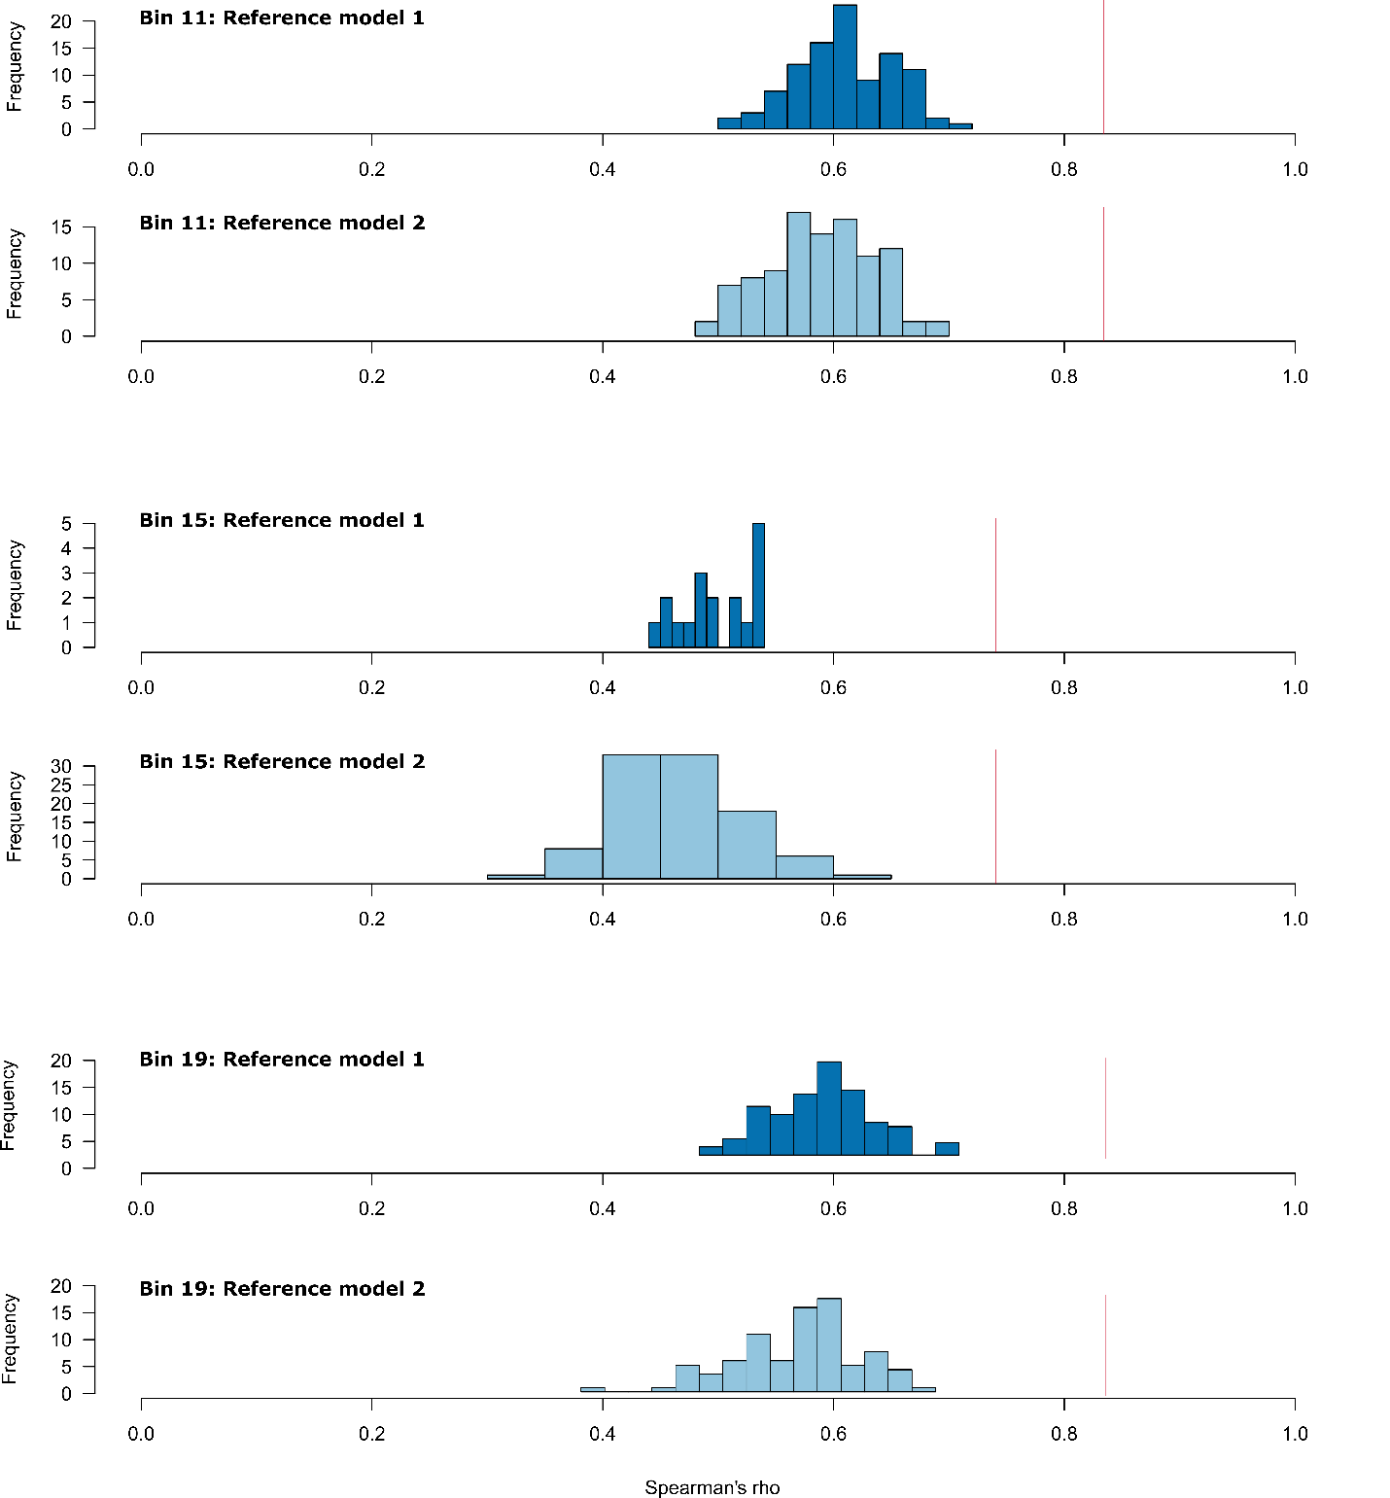

Second, we studied whether the behaviors were interchangeable using different individual-level social measures, such as modified eigenvector centrality as the measure for dominance rank, betweenness centrality, and eigenvector centrality. Here, we provide the results of bin 11. The results are similar for all 3 bins, where dominance rank and eigenvector centrality are highly correlated for both reference models and the observed values were significantly higher than the reference model distributions (Fig. SM2.2). Betweenness centrality was not correlated, and the observed value fell within the reference model distribution. These results tell us we could pool the 2 behaviors.
Figure SM2.1. This figure shows the individual social metrics, modified PageRank as dominance measure, betweenness centrality, and eigenvector centrality, from the left to right columns, respectively. The top and middle rows are scatterplots between crowds and displacement for reference model 1 (dark blue) and reference model 2 (light blue), respectively. The bottom row represents the matrix correlation strength for each reference model. Observed values are indicated in red. An asterisk shows where the observed correlation fell outside the correlation values of the reference models and NS shows that the observed value fell within the reference model distribution. 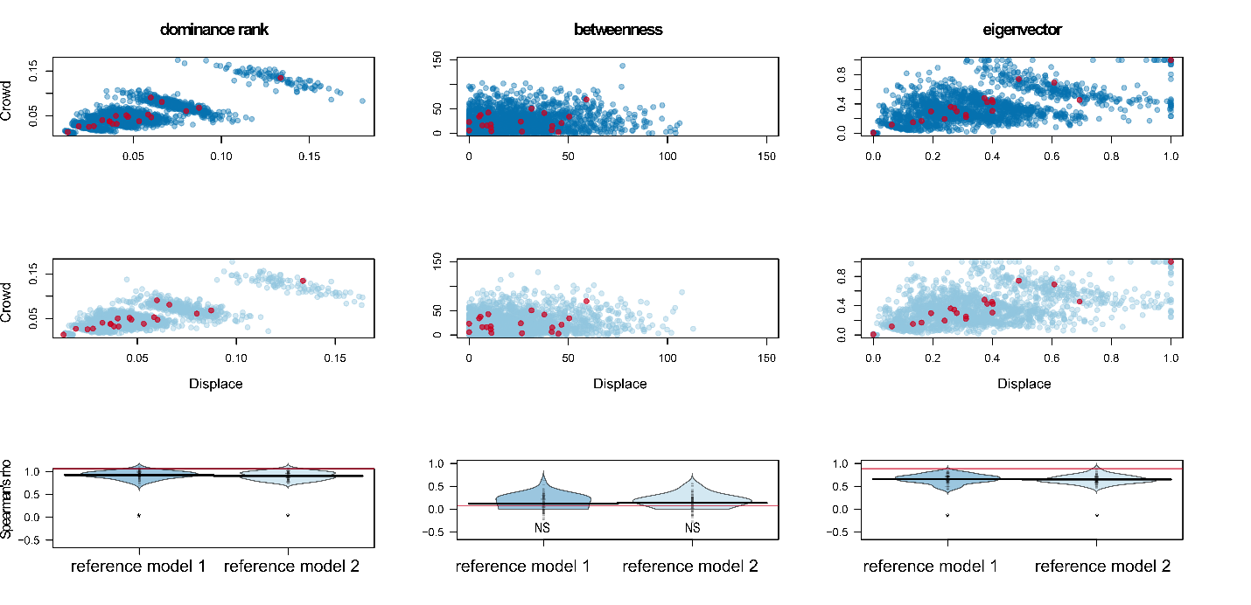
Third, we investigated whether the behaviors were interchangeable using different group-level hierarchy measures, such as linearity, steepness, and triangle transitivity. We received some contrasting results (Fig. SM2.3). The pooled values were significantly different from the behaviors separately, except for triangle transitivity. Furthermore, only displacements were the same for the observed data as the reference model distribution. This tells us that triangle transitivity is the same, but that linearity and steepness values are lower for the behaviors separately compared to when they are pooled.
Finally, we investigated the social dominance patterns for crowds, displacements, and crowds and displacements combined. Again, we ran 100 reference models and compared the observed pattern to the percentage of runs with the reference model dominance patterns. The observed patterns corresponded with the majority of reference model runs (Fig. SM2.4). Plus, for 2/3 of the trials, the dominance patterns were the same for crowds, displacements, and both behaviors pooled.
Figure SM2.2. This figure shows the group-level hierarchy metrics, linearity, steepness, and triangle transitivity from the left to right column, respectively. The top row shows the results for bin 11, the center row for bin 15, and the bottom row for bin 19. Observed values are indicated in red and the distributions show values from reference model runs. The observed value falls within the distribution of the reference model runs when P<0.05 (noted as asterisks) and falls outside the range when P>0.05 (noted as NS).
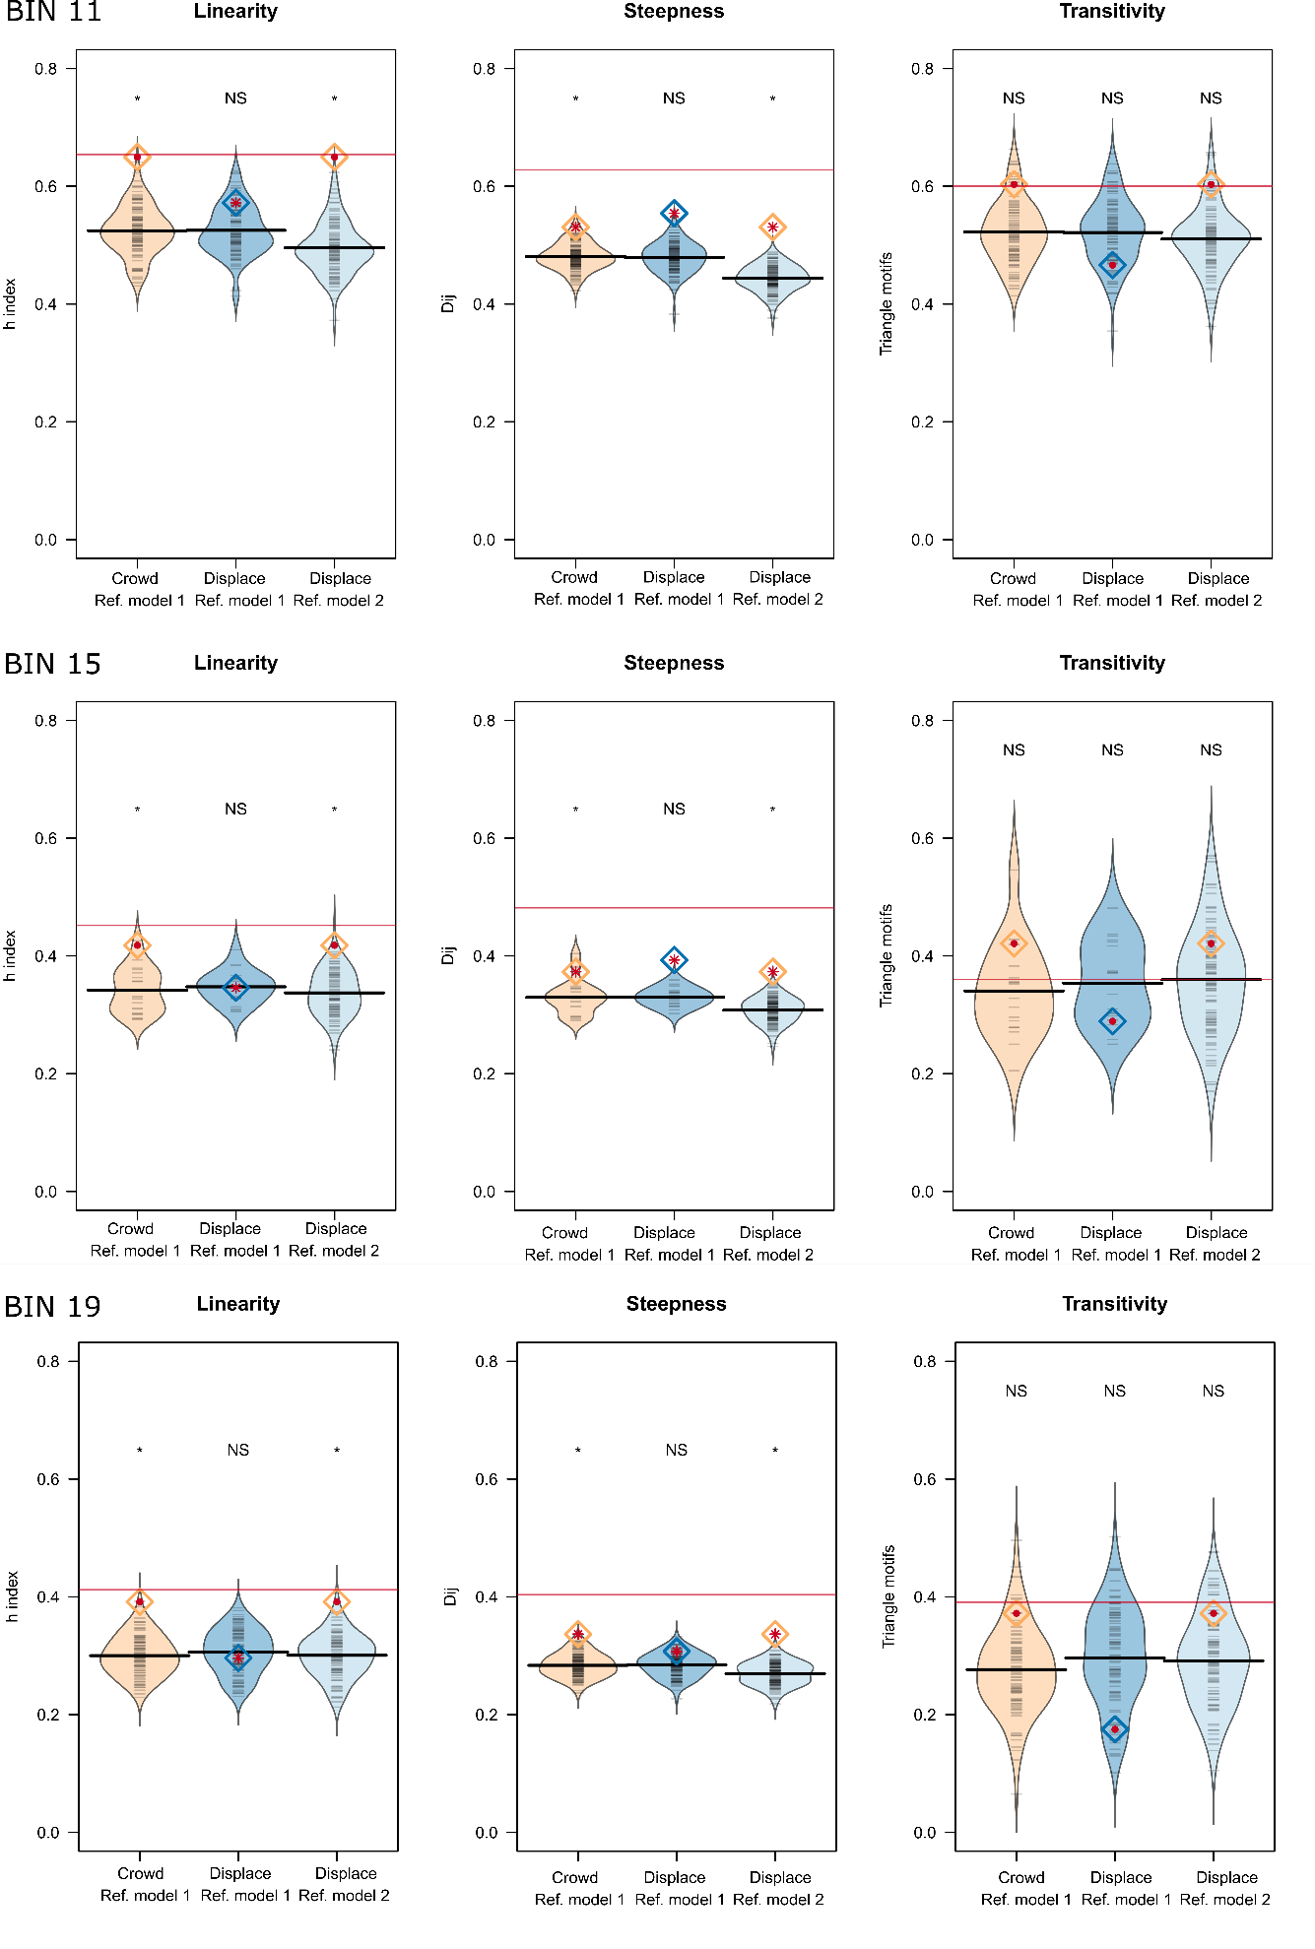
Figure SM2.3. The percent runs with dominance patterns of the reference models. The observed patterns are the same in 2 out of 3 stable periods (bin 15 and 19) for crowds and displacements separately and when pooled (indicated in red in italics). Plus, the observed patterns are the same as the majority reference runs. These results suggest we could pool the behaviors. 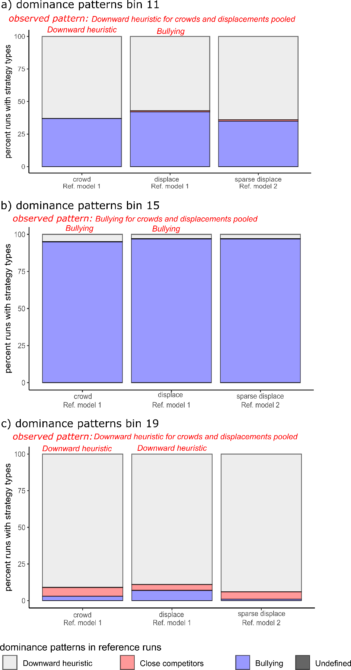

Supplemental Material 3. Justification of using body mass as individual characteristic
Justification of using body mass as individual characteristic
We decided to use body mass as an individual characteristic over other morphometric measurements for multiple reasons: 1) mass change can happen on a short timescale while morphometrics take time to change. Within the timespan of the 3 trials (48 days), body mass could have changed while we would not expect other morphometric measures (e.g., tarsus) to change; 2) other morphometric measurements were not as reliable measures in monk parakeets. For example, tarsus is not a reliable measure in parakeets (EAH, personal observation) and wing cord and tail length are variable because feathers can tear due to captivity. We took two culmen measurements that refer to the beak size (Hobson and DeDeo 2015): culmen length, which is affected by captive conditions because the animal care personnel trimmed their beaks when necessary, and culmen width, which would be a measure that we could have used besides body mass as a proxy of body size and to create a relative body size measure. Below we provided the analyses to determine whether body size or condition underly rank and the causality of the direction of this relationship.
Culmen width repeatability and relative body size assessment
We used the repeatable package to assess repeatability of culmen width. Culmen width (mean ± SD = 12.93 ± 0.61 mm, n = 4 -5 measures per ID) was significantly repeatable (R = 0.34, se = 0.12, CI = [0.092 – 0.549], p < 0.001). Body mass and culmen width were positively correlated (Pearson’s correlation: r² = 0.22, p = 0.03). As we did not expect culmen width to change throughout the duration of the social experiment, we performed a correlation between average culmen width and power at the end of the initial group formation period prior to first removal. We then got the residuals of the linear regression of body mass and culmen width as a proxy for relative body size and performed the same analyses for body mass in the manuscript using relative body size instead.
Exclusion of body mass data points
Upon checking our morphometrics data frame, we identified multiple instances, where we potentially reported a wrong body mass. These instances may have been due to incorrect reporting of the mass of the bird bags or the mass of bird bag and bird together and on some days we had strong winds which could have caused an incorrect weight. Other times, we may not have tared the scale correctly. As a precaution, we excluded the following points in our dataset:
- BBB on 2021-04-05 with a bird bag weight of 112.08 g, resulting in a bird weight of 105.8 g, and on 2021-07-05 with a bird weight of 86.8 g, which are lower compared to the bird’s other weights (always above 110g).
- POP on 2021-06-23 with a bird bag weight of 129.94 g, resulting in a bird weight of 121.4 g, which is higher compared to other weights of this bird (always below 107 g).
- BOB on 2021-07-08 with a bird bag weight of 169.77, resulting in a bird weight of 109.1 g, which is lower compared to other weights of this bird (always above 100 g).
- OOO on 2021-06-23 with a bird weight of 72.82 g, which is low compared to other weights of this bird (always above 115 g)
- PPB on 2021-04-05 with a bird weight of 86.2 g, which is low compared to other weights (always above 100g)
- GPG on 2021-04-05 with a bird weight of 89.2 g, which is low compared to other weights (always above 110g)

Does culmen width or relative body size underly rank?
We did not find a correlation between average culmen width and power at the end of the initial group formation period, when social structure was stable (Kendall's tau = -0.001, p = 0.97). Therefore, we did not include culmen width in further analyses.
We found partial support for a relationship between relative body size and power. Relative body size and power were correlated at trial 1 (Kendall's tau = 0.33, p = 0.05), but not at trial 2 (tau = 0.08, p = 0.63) or trial 3 (tau = 0.09, p = 0.65; Fig. SM3.1), which was similar to the body mass results (Fig. 2).
Figure SM3.1. Assessing the relationship between relative body size and power score in monk parakeets. The figure shows the correlation between relative body size and power score just prior to removals 1, 2, and 3, respectively. Females are denoted with pink circles and males with blue triangles.
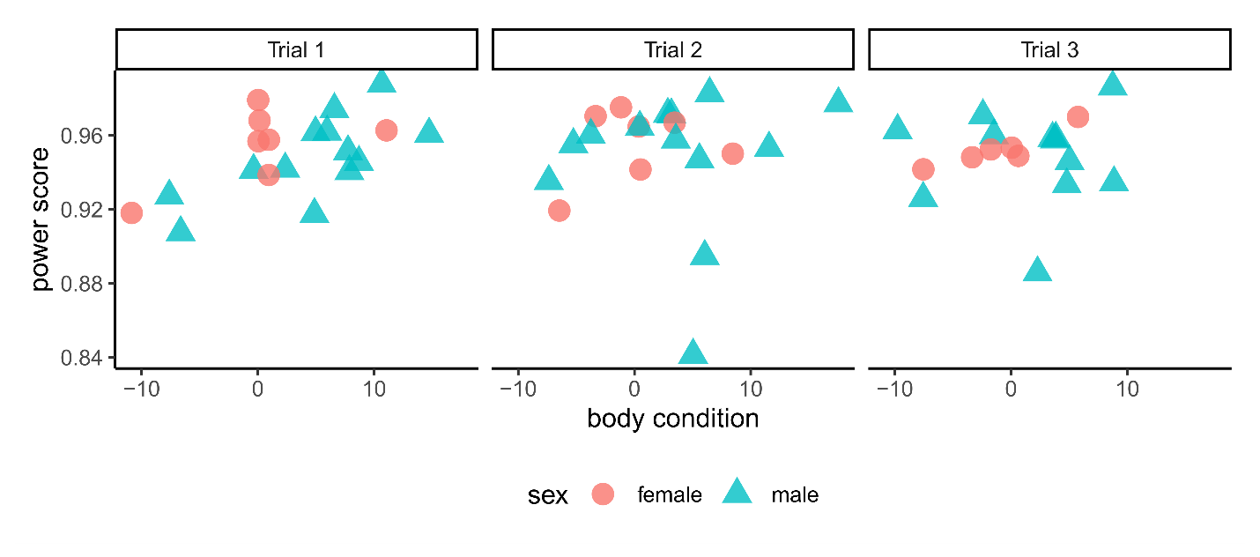
Can we determine the direction of causality?
We investigated the direction of causation of the association. First, we tested whether initial relative body size predicted power at the end of the initial group formation period. We measured their body weight and culmen width at five different capture events. Relative body size was on average 0.41 ± 6.9 g. We found that relative body size did not predict power prior to first removal (LRT: λ = 0.38, p = 0.54, estimate ± SE = 0.01 ± 0.01, Fig. SM3.2).
Figure SM3.2. Assessing the direction of causality between rank and relative body size. Beta regression of initial relative body size in gram on power score calculated during the 3-days at the end of the initial group formation period just prior the first removal. Females are denoted with pink circles and males with blue triangles.
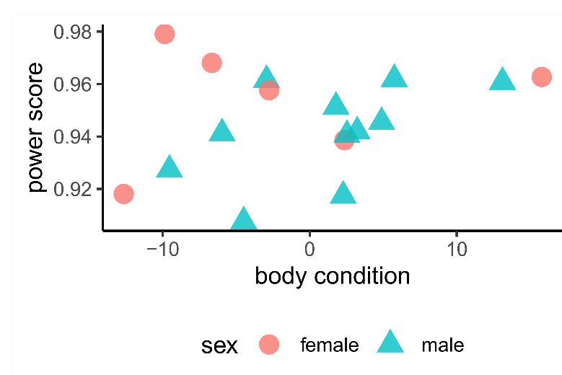
Second, we tested whether relative body size could be an outcome of rank position. Power and relative body size change were not correlated both when the focal was included (trial 1: Kendall's tau = 0.17, p = 0.32; trial 2: Kendall’s tau = -0.02, p = 0.94) and excluded (trial 1: Kendall's tau = 0.08, p = 0.68; trial 2: Kendall’s tau = -0.03, p = 0.90). We found that 40 % and 45% of the birds for trials 1 and 2, respectively, followed the prediction that if rank influences relative body size, then = birds should either show an increase in relative body size and an increase in power or alternatively, show a loss of power and a decrease in relative body size (Fig. SM3.3). Compared to the relative body size change of the remaining birds in the flight pen across the entire perturbation trial, all three focal birds showed relative body size loss (trial 1 change in relative body size = -5.61; trial 2 = -2.69; trial 3 = -5.79) but this loss was similar to the loss of some of the remaining group members (trial 1: mean ± SD = -0.67 ± 2.81 [-4.89, 4.40]; trial 2: -1.92 ± 3.31 [-8.59, 3.39]; trial 3: -5.04 ± 3.37 [-11.23, 0.49], n = 17; Fig. SM3.4).
Fig. SM3.3. The correlation between power score changes and relative body size changes for trials 1 and 2, respectively. The colored points represent the ordinal rank of the individuals at the start of the trial with top-ranked birds in red and bottom-ranked birds in blue. The grey rectangles represent the quadrants where we would expect the datapoints to fall in if relative body size is an outcome of rank. The grey rectangle in the left bottom corner represents when individuals lose rank and relative body size and the grey rectangle in the right upper corner represents when individuals gain relative body size and rank. We found that 40 % and 45 % of birds for trial 1 and 2, respectively followed our prediction that if individuals lose or gain power they will then show an decrease or increase in relative
body size.
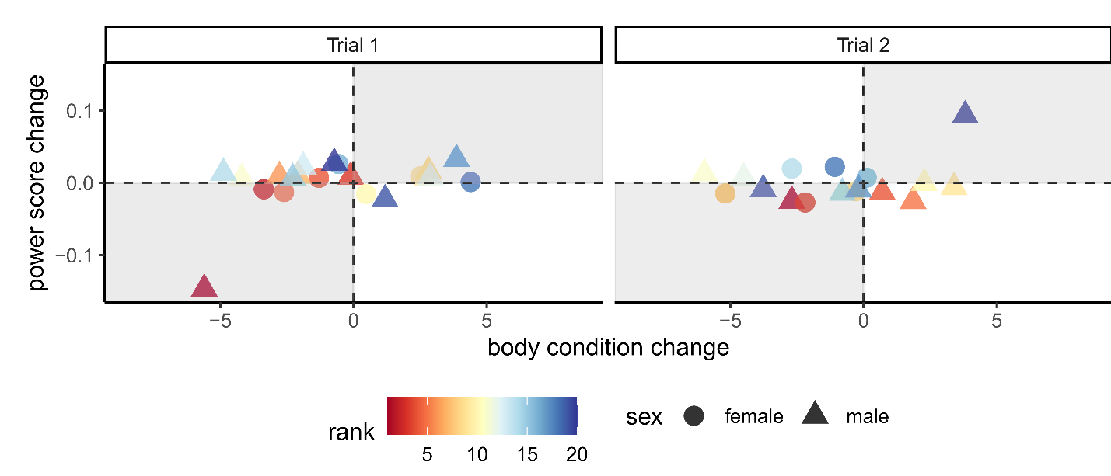

Fig. SM3.4. Relative body size changes across time in the focal birds and across all individuals in the group. The relative body size change across capture events for all group members with the focal birds highlighted in color. A positive value indicates an increase in relative body size and a negative value
indicates a decrease in relative body size.
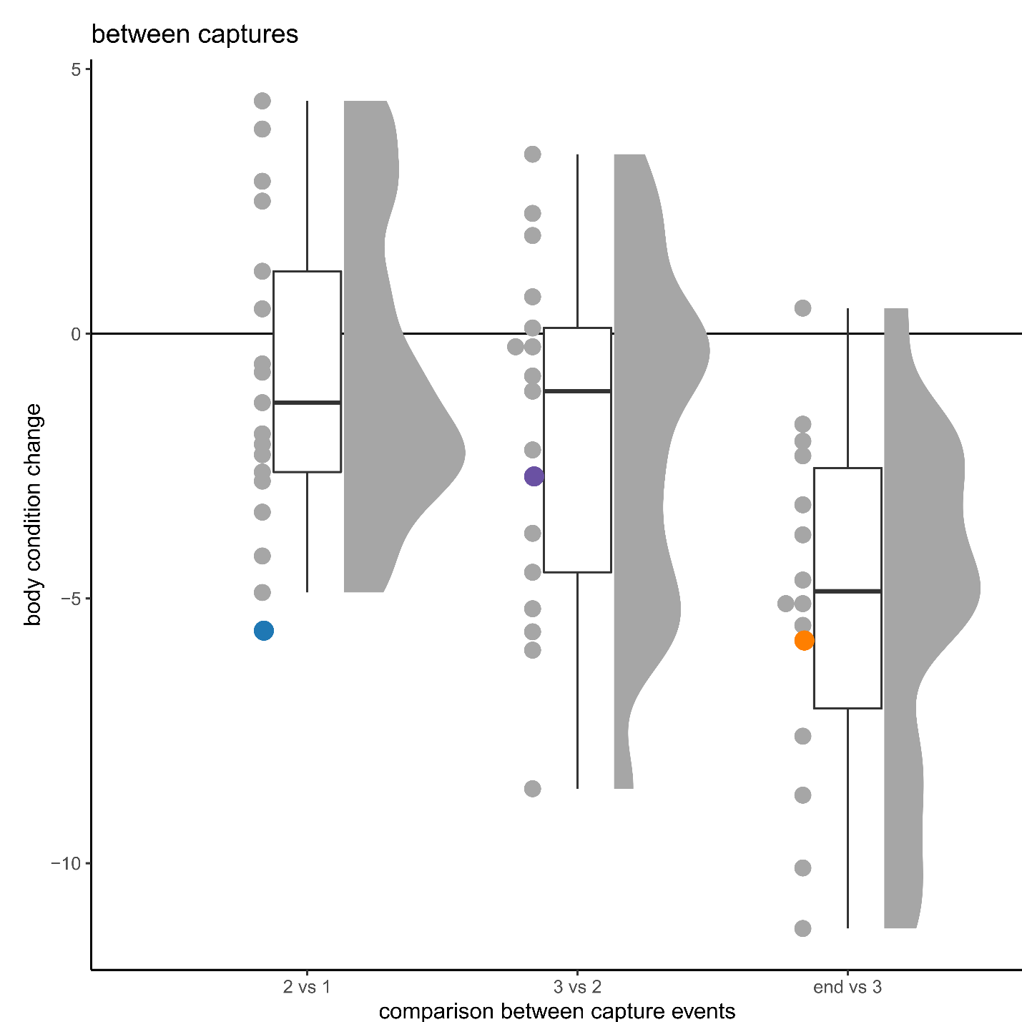

Supplemental Material 4. Figure of absolute power change per trial
Figure SM4.1. A raincloud plot of the absolute power change for each monk parakeet between the rank assessment points just prior the removal of the focal and just after the reintroduction of the focal. The focal power change is highlighted in blue for trial 1, purple for trial 2, and orange for trial 3. The focal birds had a higher absolute power change than almost all the remaining group members resulting in extreme rank loss of the focal birds (see also Figure 1).
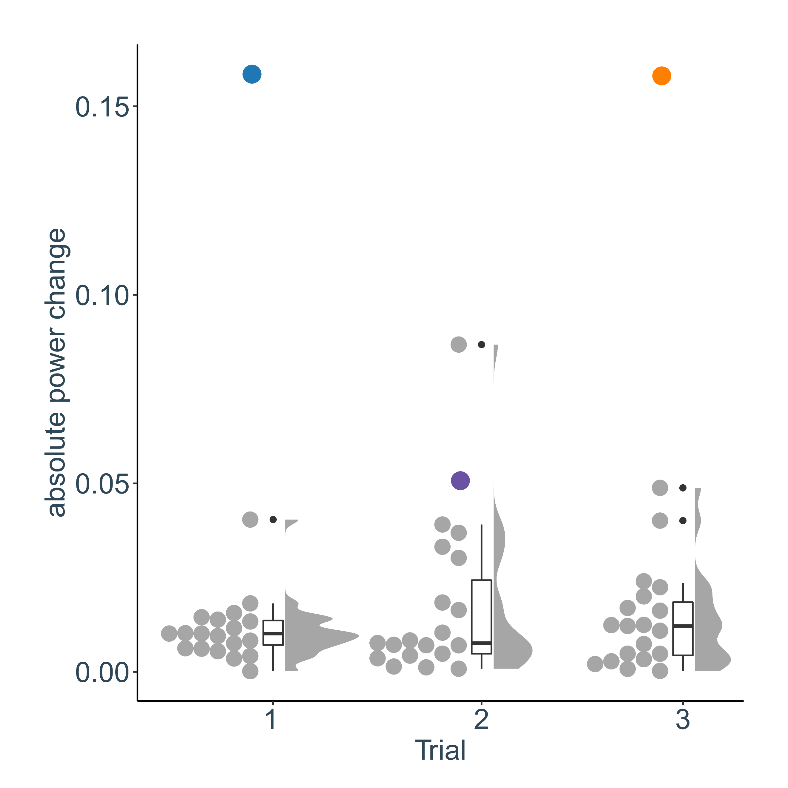

Supplemental Material 5. Accessibility figure of the correlation between power score changes and weight changes
Figure SM5.1. The correlation between power score changes and weight changes for trials 1 and 2, respectively. The colored points represent the ordinal rank of the individuals at the start of the trial with top-ranked birds in red and bottom-ranked birds in blue. The label of each datapoint corresponds to the ordinal ranking at the start of the trial. 