Title: Human disturbance decreases dominance in riparian plant communities
Filipe S. Dias*^{1,2,3}, Patrícia María Rodríguez-González^{4,5}, Henrique M. Pereira^{6,7}, Luís Borda-de-Água^{1,2,3}

Affiliations
1. CIBIO/InBio, Centro de Investigação em Biodiversidade e Recursos Genéticos, Laboratório Associado, Universidade do Porto, Campus Agrário de Vairão, 4485-661 Vairão, Portugal
2. CIBIO/InBio, Centro de Investigação em Biodiversidade e Recursos Genéticos, Laboratório Associado, Instituto Superior de Agronomia, Universidade de Lisboa, Tapada da Ajuda, 1349-017 Lisbon, Portugal
3. BIOPOLIS Program in Genomics, Biodiversity and Land Planning, CIBIO, Campus de Vairão, 4485-661 Vairão, Portugal
4. Centro de Estudos Florestais, Instituto Superior de Agronomia, Universidade de Lisboa, Tapada da Ajuda, 1349-017 Lisboa, Portugal
5. Laboratório Associado Terra, Instituto Superior de Agronomia, Universidade de Lisboa, Tapada da Ajuda, 1349-017 Lisboa, Portugal
6. German Centre for Integrative Biodiversity Research (iDiv) Halle-Jena-Leipzig, Leipzig, Germany.
7. Institute of Biology, Martin Luther University Halle-Wittenberg, Halle (Saale), Germany.

Abstract
Conservation science usually devotes little attention to common species, which are crucial in determining ecosystem structure and function. Dominant species are a particular type of common species that affect ecosystem functions proportional to their abundance or cover. In this study, we examined how human disturbance affects the cover of the dominant riparian species in 404 sites located in multiple streams across continental Portugal. Specifically, we asked if the percentage of cover of the dominant species is higher or lower in the least disturbed areas. We performed the analysis using Extreme Value Theory. We found that the percentage of cover of the dominant species was significantly higher in the least disturbed communities compared to the disturbed communities. Riparian vegetation clearing is common in more humanized and disturbed areas which may explain the reduction in the cover of the dominant species. In the least disturbed areas, vegetation clearing is less frequent, allowing more growing time and permitting the dominant species to have a higher cover percentage. Since we found significant differences in the percentages of cover, we examined the identity and ecological characteristics of the dominant species. We found that the common alder was the species that more often had the highest percentage of cover regardless of the disturbance level. However, we found substantial differences in the identity of the remaining dominant species, which we believe were linked to their ecological requirements.

Keywords: abundance distribution; commonness; community structure; dominance; extreme value theory.

1. Introduction
In ecological communities, most species are rare, and only a few are common (Hubbell, 2013; Magurran & Henderson, 2011). This pattern is so prevalent that it has been called an ecological law (McGill et al., 2007). Research usually focuses on rare species which are more likely to be endangered due to having small populations, restricted geographical ranges, and narrow ecological niches. (Rabinowitz, 1981; Gaston, 1994; Hubbell, 2013). Less attention has been devoted to common species, which play a key role in determining ecosystem structure and function (Gaston, 2011). Dominant species are a special type of common species that affect ecosystem functions proportional to their abundance or cover (Gaston, 2011; Avolio et al., 2019). In plant communities, the role of dominant species can be explained by the “mass ratio hypothesis” (Grime, 1998), which predicts that abundant and widely occurring species with high biomass should contribute proportionally to production and resource use, as well as affect energy flow, biogeochemical cycling and degradation processes (Grime, 1998; Avolio et al., 2019).

Both common and dominant species often provide most of the ecosystems' biologically generated physical structure, with the 25% most abundant species frequently contributing at least 50% of the biomass within taxonomic assemblages (Gaston, 2011). Due to their high abundance and biomass, common species are typically vital ecosystem engineers, modifying, maintaining, and creating habitats. Common species can be both autogenic engineers, changing the environment through their physical structures, and allogenic engineers, changing the environment by transforming living or nonliving materials through mechanical or chemical means (Jones et al., 1994, 199). The structural effects of common species can be observed on large scales. For instance, several studies showed that tree cover, caused mainly by a few common species, is crucial for determining regional temperature and rainfall patterns (e.g., Webb et al. 2006). In fact, some models suggest that natural forests may act as biotic pumps, transporting atmospheric water from the ocean to the interior of continental masses (Makarieva and Gorshkov, 2007). Concerning ecosystem function, common species can be responsible for most primary production and carbon storage (Smith and Knapp, 2003; Bunker et al., 2005). Common species can also have a significant influence on other ecosystem properties such as bioturbation (Solan et al., 2004), carbon flows (Taylor et al., 2006), functional stability (Polley et al., 2007), and invasion resistance (e.g., Emery and Gross 2007).

Here we are interested in the impact of human disturbance, that is, any event that kills, displaces or damages individuals (Sousa, 1984) and causes an increase or decrease in the percentage of cover of the most dominant species in the Mediterranean riparian plant communities. In the Mediterranean basin, riparian plant communities are composed of a well-developed layer of herbs and shrubs and a few dominant tree species (Stella et al., 2013). In drier areas, trees may be absent and replaced by dominant shrub species, such as willows (Salix sp) and xeric shrubs. Dominant riparian plants are important autogenic river engineers (Gurnell, 2014; Polvi and Sarneel, 2018), adding tensile strength to the bank material, increasing bank stability and reducing mechanical erosion (Abernethy and Rutherfurd, 1998; Simon and Collison, 2002). Stems and above-ground biomass also modify the flow field, increasing turbulence and decreasing flow velocity (McBride et al., 2007; Liu et al., 2019). In Mediterranean regions, riparian habitats are often disturbed by hydromorphological alteration, intensive grazing, fires, vegetation clearing for agriculture and forestry, urbanization and the introduction of invasive species, which cause changes in community composition and reductions in riparian zone extent (Aguiar and Ferreira, 2005; Aguiar et al., 2009; Stella et al., 2013; Pabst et al., 2022)). We examined how human disturbance affects the cover of the dominant riparian species in 404 sites located in multiple streams across continental Portugal. Specifically, we asked if the percentage of cover of the dominant species is higher or lower in the least disturbed areas. We used Extreme Value Theory, also known as Statistics of Extremes (Coles, 2001; Castillo et al., 2004), to perform the analysis. As we describe below, Extreme Value Theory studies the tails of distributions to describe the behaviour of the maxima or minima of samples. Here we are interested in the dominant species' cover (i.e., the maximum) in riparian habitats.

2. Methods

2.1 Study area

We run the study in mainland Portugal which is located in southwestern Europe (Fig. 1). The northern part of the country is hilly, with 95% of the area above 400 m, while the southern half is mostly flat with 62% below 200 m (Miranda et al., 2002). In the northwest, the climate is Temperate, but Mediterranean in the centre and south. The lowest mean annual temperature is seven degrees in the mountains of central Portugal, and the highest is 18 °C in the southern regions. The northwestern areas have the highest mean annual precipitation (>3000 mm/year), while the lowest values are recorded in the south (> 500 mm/year). Approximately 42% of the annual precipitation occurs during the winter (December–February), and only 6% during Summer (June–August) (Olson et al., 2001).

2.2 Data collection and processing

The riparian vegetation data were collected between 2004-2006 in 404 sites across 38 river basins in continental Portugal (Fig. 1). This work was part of the pre-assessment surveys conducted to implement the Water Framework Directive (WFD) in Portugal (CIS-WFD 2003, INAG 2008, Agência Portuguesa do Ambiente 2012). Field surveys followed the protocol defined for the WFD implementation, which consisted of evenly establishing 100 meter sampling plots along the river network (covering all river types) with a width proportional to regular floods in each site. In each plot, the identity of every species was recorded, and its relative percentage cover was visually estimated.

As a proxy for human disturbance we used the Global Human Modification of Terrestrial Systems data set (Kennedy et al., 2019, 2020). This data set was built using the human modification model (Theobald, 2013), which considers human activities' spatial extent, intensity, and co-occurrence to derive the potential impacts on terrestrial systems using a parsimonious list of stressors (Salafsky et al., 2008). The assessment was conducted using spatially explicit global data sets, and considered 13 anthropogenic stressors, including human settlements, agriculture, electrical and transportation infrastructures, mining, and energy production. The result is an empirically based, continuous 0-1 metric with 1 km² resolution that considers the proportion of a landscape modified by human activities (Gustafson and Parker, 1992). We used QGIS 3.2 (QGIS Development Team, 2021) to obtain human modification for each plot.

2.3 Data analysis

To analyse how the percentage of cover of the dominant species changes with human disturbance we used Extreme Value Theory (EVT). The purpose of EVT is to describe the values in the tails of a distribution, particularly the distribution of the maxima or minima (Coles, 2001; Castillo et al., 2004) . A significant result from EVT is that, under a linear normalization of the data, extreme values follow one of three distributions: maxima follow Fréchet, Gumbel or reverse Weibull distributions, while minima follow reverse Fréchet, reverse Gumbel or Weibull distributions. Each of these distributions is a particular case of the Generalized Extreme Distribution (GEV), which is parameterized by three parameters, the location, scale parameter and shape parameters (Coles, 2001). If the shape parameter is negative, we recover the reverse Weibull (maxima) or the Weibull distribution (minima). On the other hand, if it is positive, we recover the Fréchet (maxima) or the reverse Fréchet distribution (minima). When the shape parameter tends to zero, we obtain the Gumbel (maxima) or the reverse Gumbel distribution (minima). We identified the species with the largest percentage of cover in each riparian plant community and collected the corresponding disturbance index from the Global Human Modification of Terrestrial Systems data set. Next, we selected the 5% most disturbed communities and the 5% least disturbed communities and gathered the cover values of the dominant species in each community. Then, we fitted GEV distributions to the distribution of cover values in the disturbed sites and in the least disturbed sites. We repeated this procedure with threshold values ranging between 5% and 50% with increments of 1%.
Since we found significant differences in the percentage of cover of the dominant species in disturbed and least disturbed communities, we examined the identity and ecological characteristics of the dominant species. As before, we used a threshold based approach with values ranging between 10% and 40% with 5% increments. We created barplots that show the number of times each of the top 5 most dominant species had the highest percentage of cover in the disturbed and least disturbed communities.

3. Results

The percentage of cover of the dominant species was significantly higher in the least disturbed communities compared to the disturbed communities when threshold values ranged between 0.28 and 0.47. The location parameter of the GEV fitted to the cover values from the least disturbed communities is significantly higher than the corresponding parameter in the disturbed communities group (Fig 2B). As for the scale and shape parameters there were no significant differences for any threshold values (Fig 2 C and D).

Concerning the most abundant species, we found that the common alder (Alnus glutinosa) was the species that more often had the highest percentage of cover regardless of the selected disturbance threshold. In the least disturbed sites, the narrow-leaved ash (Fraxinus angustifolia) came in second place and the southern sage-leaved willow (Salix salviifolia) in third (Fig. 3 left). In disturbed areas, the second species that had the highest cover depended on the threshold. When thresholds were between 10 and 15%, the species that came in second place was the large grey willow (Salix atrocinerea). For 20% or higher thresholds, it was the giant reed (Arundo donax) or the narrow-leaved ash. In third place it was the same two species mentioned before, plus the elm-leaf blackberry (Rubus ulmifolius) (Fig. 3 right).

4. Discussion

Our results suggest that the percentage of cover of the dominant species in riparian environments in continental Portugal tends to be higher in the least disturbed communities than in the disturbed communities. This difference was only statistically significant when we considered thresholds between 30% and 47%. This may happen because when we choose low threshold values, we assign a small number of communities to the disturbed and least disturbed groups (Fig 2A). Therefore, the small sample size increases the uncertainty associated with the location parameter of the GEV distribution that we used to characterize the distribution of maximum percentages of cover. As a result, the associated confidence intervals are larger, making it harder to detect statistically significant differences. Thresholds above 45% probably do not create enough separation between disturbed and least disturbed communities, hence the non-significant differences.

The species composition of riparian plant communities is influenced by biogeographical and evolutionary processes, which determine which species from the regional species pool will occur in a given area. These patterns are then modified by human disturbance. (Rodríguez-González et al., 2008). Riparian vegetation clearing is common in more humanized areas, such as peri-urban areas, agricultural areas and forest production areas, which causes a reduction in the cover of the dominant species. In the least disturbed areas, vegetation clearing is less frequent, allowing for more growing time and permitting the dominant species to have a higher percentage of cover.
Alnus glutinosa was the most dominant species on least disturbed sites (Fig. 3). This species is adapted to poor soils (Claessens et al., 2010) , coarse sands and gravels and grows very fast, particularly when young (Rodríguez-González et al., 2014). It can fix nitrogen in symbiotic root nodules with the bacteria Frankia alni (Schwencke and Carú, 2001), making it a valuable pioneer species that can grow even in disturbed sites (Houston Durrant et al., 2016). At a local scale, these ecological features can probably explain why this species is dominant in so many areas, irrespective of disturbance. The second most dominant species in the least disturbed areas was Fraxinus angustifolia, a fast-growing and light-demanding species that grows well on moist soils and in temporarily flooded lowlands (Gomes Marques et al., 2018; Rodríguez-González et al., 2021). This species prefers aerated or only moderately compacted soils (Caudullo and Houston Durrant, 2016). In disturbed areas, soil compaction can be high when there is intensive livestock grazing, which may explain this result. The third most dominant species was Salix salvifolia, which grows along rivers and streams with seasonally low water levels and torrential regimes (Castroviejo, 1986; Monteiro-Henriques et al., 2014). Such conditions are common in the least disturbed streams, which typically have not been channelized or regulated.

In disturbed areas, Salix atrocinerea was the second most dominant species. Unlike Salix salvifolia, this species well adapted to lentic environments (Castroviejo, 1986; Rodríguez-González et al., 2008, 2010), which are often found in disturbed streams that have been regulated. Two other species were often dominant. Arundo donax is an exotic species that grows along lakes, streams, drains, and other wet sites. The species adapts well to riparian areas with regular flood cycles, and it is usually associated with waterways with altered hydrologic regimes (e.g., dams) and disturbed riparian vegetation (Bell 1997, Morais et al. 2016). Rubus ulmifolius is a fast-growing, deciduous shrub that prefers humid environments, clearings, and forest edges. Although its seedlings present low survival rates when there is shade and competition, their seeds can remain viable in the soil for long periods. Following a disturbance, such as vegetation clearing, this species can quickly cover riparian zones (Mazzolari et al., 2011).

Human disturbance can change the number of species and their evenness. Several studies show that evenness often responds more rapidly to human disturbance than species richness (Chapin III et al., 2000; Hillebrand et al., 2008) , which means that ecosystems can suffer significant losses long before any species have gone extinct (Hillebrand et al., 2007). One the most extreme changes in the dominance structure of a community can occur following an invasion by an exotic species (Seabloom et al., 2003; Guo et al., 2006). In our study area, we observed such situations in sites that become dominated by Arundo donax, an exotic invasive species, after the natural vegetation was cleared for agriculture. The replacement of the naturally occurring riparian vegetation by a single dominant species after a major disturbance can also involve native species. We found several sites where the riparian vegetation had been replaced by Rubus ulmifolius. Increases in the availability of nutrients caused by fertilization are associated with decreases in evenness and increased dominance in almost all ecosystems (Harpole and Tilman, 2007; Hillebrand et al., 2007). In a meta-analysis conducted across multiple ecosystems, Hillebrand et al. (2007) found that fertilization significantly decreased evenness, and herbivores increased evenness in plant and algal communities. We think the results from our study are largely in line with those of the study by Hillebrand et al. (2007). We found that the dominant species in disturbed sites had a lower percentage cover than in the least disturbed areas. We used a composite disturbance metric (i.e. an index) that does not separate between physical disturbance (e.g., vegetation clearing) and chemical disturbance (e.g., nutrient runoff). However, based on our field experience, we believe physical disturbance was the most important source of disturbance in the study areas. In Hillebrand et al. (2007), the physical removal of plant biomass through herbivory caused lower evenness. In our study, the physical removal of plant due to clearing may be responsible for lower percentages of cover of the dominant plant species.

5. Acknowledgments
FD, LBA and PMRG were financed by FEDER Funds through the Operational Competitiveness Factors Program - COMPETE and by National Funds through Fundação para a Ciência e a Tecnologia (FCT). FD through project PTDC/BIA-ECO/28729/2017 - POCI-01-0145-FEDER-028729, LBA under the Norma Transitória – L57/2016/ CP1440/CT0022, and PMRG through CEEC Individual Programme (2020.03356.CEECIND). Forest Research Centre is a research unit funded by FCT (UIDB/00239/2020).

6. References
Abernethy, B., and Rutherfurd, I. (1998). Where Aong a River’s Length Will Vegetation Most Effectively Stabilize Stream Banks? Geomorphology 23, 55–75. doi: 10.1016/S0169-555X(97)00089-5.
Aguiar, F. C., and Ferreira, M. T. (2005). Human-disturbed landscapes: effects on composition and integrity of riparian woody vegetation in the Tagus River basin, Portugal. Environ. Conserv. 32, 30–41. doi: 10.1017/S0376892905001992.
Aguiar, F. C., Ferreira, M. T., Albuquerque, A., Rodríguez-González, P., and Segurado, P. (2009). Structural and functional responses of riparian vegetation to human disturbance: performance and spatial scale-dependence. Fundam. Appl. Limnol. 175, 19. doi: <a href="http://dx.doi.org/10.1127/1863-9135/2009/0175-0249">http://dx.doi.org/10.1127/1863-9135/2009/0175-0249</a>.
Avolio, M. L., Forrestel, E. J., Chang, C. C., La Pierre, K. J., Burghardt, K. T., and Smith, M. D. (2019). Demystifying dominant species. New Phytol. 223, 1106–1126. doi: 10.1111/nph.15789.
Bunker, D. E., DeClerck, F., Bradford, J. C., Colwell, R. K., Perfecto, I., Phillips, O. L., et al. (2005). Species Loss and Aboveground Carbon Storage in a Tropical Forest. Science 310, 1029–1031. doi: 10.1126/science.1117682.
Castillo, E., Hadi, A. S., Balakrishnan, N., and Sarabia, J. M. (2004). Extreme Value and Related Models with Applications in Engineering and Science. 1st edition. Hoboken, N.J: Wiley-Interscience.
Castroviejo, S. (1986). Flora ibérica: plantas vasculares de la Península Ibérica e Islas Baleares. Madrid, Spain: Real Jardín Botánico, CSIC.
Caudullo, G., and Houston Durrant, T. H. (2016). “Fraxinus angustifolia in Europe: distribution, habitat, usage and threats,” in European Atlas of Forest Tree Species (Luxem: Publ. Off. EU,).
Chapin III, F. S., Zavaleta, E. S., Eviner, V. T., Naylor, R. L., Vitousek, P. M., Reynolds, H. L., et al. (2000). Consequences of changing biodiversity. Nature 405, 234–242. doi: 10.1038/35012241.
Claessens, H., Oosterbaan, A., Savill, P., and Rondeux, J. (2010). A review of the characteristics of black alder (Alnus glutinosa (L.) Gaertn.) and their implications for silvicultural practices. For. Int. J. For. Res. 83, 163–175. doi: 10.1093/forestry/cpp038.
Coles, S. (2001). An Introduction to Statistical Modeling of Extreme Values. 2001st edition. London ; New York: Springer.
Emery, S. M., and Gross, K. L. (2007). Dominant Species Identity, Not Community Evenness, Regulates Invasion in Experimental Grassland Plant Communities. Ecology 88, 954–964. doi: 10.1890/06-0568.
Gaston, K. J. (1994). “What is rarity?,” in Rarity, ed. K. J. Gaston (Dordrecht: Springer Netherlands), 1–21. doi: 10.1007/978-94-011-0701-3_1.
Gaston, K. J. (2011). Common Ecology. BioScience 61, 354–362. doi: 10.1525/bio.2011.61.5.4.
Gomes Marques, I., Campelo, F., Rivaes, R., Albuquerque, A., Ferreira, M. T., and Rodríguez-González, P. M. (2018). Tree rings reveal long-term changes in growth resilience in Southern European riparian forests. Dendrochronologia 52, 167–176. doi: 10.1016/j.dendro.2018.10.009.
Grime, J. P. (1998). Benefits of plant diversity to ecosystems: immediate, filter and founder effects. J. Ecol. 86, 902–910. doi: 10.1046/j.1365-2745.1998.00306.x.
Guo, Q., Shaffer, T., and Buhl, T. (2006). Community maturity, species saturation and the variant diversity- productivity relationships in grasslands. Ecol. Lett. 9, 12841292. doi: 10.1111/j.1461-0248.2006.00980.x.
Gurnell, A. (2014). Plants as river system engineers. Earth Surf. Process. Landf. 39, 4–25. doi: 10.1002/esp.3397.
Gustafson, E. J., and Parker, G. R. (1992). Relationships between landcover proportion and indices of landscape spatial pattern. Landsc. Ecol. 7, 101–110. doi: 10.1007/BF02418941.
Harpole, W. S., and Tilman, D. (2007). Grassland species loss resulting from reduced niche dimension. Nature 446, 791–793. doi: 10.1038/nature05684.
Hillebrand, H., Bennett, D. M., and Cadotte, M. W. (2008). Consequences of dominance: A review of evenness effects on local and regional ecosystem processes. Ecology 89, 1510–1520. doi: 10.1890/07-1053.1.
Hillebrand, H., Gruner, D. S., Borer, E. T., Bracken, M. E. S., Cleland, E. E., Elser, J. J., et al. (2007). Consumer versus resource control of producer diversity depends on ecosystem type and producer community structure. Proc. Natl. Acad. Sci. U. S. A. 104, 10904–10909. doi: 10.1073/pnas.0701918104.
Houston Durrant, T. H., de Rigo, D., and Caudullo, G. (2016). “Alnus glutinosa in Europe: distribution, habitat, usage and threats,” in European Atlas of Forest Tree Species (Luxem: Publ. Off. EU,).
Hubbell, S. P. (2013). Tropical rain forest conservation and the twin challenges of diversity and rarity. Ecol. Evol. 3, 3263–3274. doi: 10.1002/ece3.705.
Jones, C. G., Lawton, J. H., and Shachak, M. (1994). Organisms as Ecosystem Engineers. Oikos 69, 373–386. doi: 10.2307/3545850.
Kennedy, C. M., Oakleaf, J. R., Theobald, D. M., Baruch‐Mordo, S., and Kiesecker, J. (2019). Managing the middle: A shift in conservation priorities based on the global human modification gradient. Glob. Change Biol. 25, 811–826. doi: 10.1111/gcb.14549.
Kennedy, C. M., Oakleaf, J. R., Theobald, D. M., Baruch-Mordo, S., and Kiesecker, J. (2020). Global Human Modification of Terrestrial Systems. Available at: https://doi.org/10.7927/edbc-3z60.
Liu, H., Gale, S. W., Cheuk, M. L., and Fischer, G. A. (2019). Conservation impacts of commercial cultivation of endangered and overharvested plants. Conserv. Biol. 33, 288–299. doi: 10.1111/cobi.13216.
Makarieva, A., and Gorshkov, V. (2007). Biotic pump of atmospheric moisture as driver of the hydrological cycle on land. Hydrol. Earth Syst. Sci. 11. doi: 10.5194/hessd-3-2621-2006.
Mazzolari, A., Comparatore, V., and Bedmar, F. (2011). Control of elmleaf blackberry invasion in a natural reserve in Argentina. J. Nat. Conserv. - J NAT CONSERV 19, 185–191. doi: 10.1016/j.jnc.2010.12.002.
McBride, M., Hession, W., Rizzo, D., and Thompson, D. (2007). The Influence of Riparian Vegetation on Near-Bank Turbulence: A Flume Experiment. Earth Surf. Process. Landf. 32, 2019–2037. doi: 10.1002/esp.1513.
Monteiro-Henriques, T., Rodríguez-González, P. M., and Albuquerque, A. (2014). Memória descritiva das cartas de regiões ambientalmente homogéneas de oito espécies ribeirinhas de Portugal continental. Lisboa: ISA Press.
Pabst, R., Dias, F. S., Borda-de-Água, L., Rodríguez-González, P. M., and Capinha, C. (2022). Assessing and Predicting the Distribution of Riparian Invasive Plants in Continental Portugal. Front. Ecol. Evol. 10, 875578. doi: 10.3389/fevo.2022.875578.
Polley, H. W., Wilsey, B. J., and Derner, J. D. (2007). Dominant Species Constrain Effects of Species Diversity on Temporal Variability in Biomass Production of Tallgrass Prairie. Oikos 116, 2044–2052.
Polvi, L. E., and Sarneel, J. M. (2018). Ecosystem engineers in rivers: An introduction to how and where organisms create positive biogeomorphic feedbacks. WIREs Water 5. doi: 10.1002/wat2.1271.
QGIS Development Team (2021). QGIS Geographic Information System - Version 3.20.3. Open Source Geospatial Foundation Project. http://qgis.osgeo.org.
Rabinowitz, D. (1981). “Seven forms of rarity,” in The Biological Aspects of Rare Plant Conservation, ed.Hugh Synge (Wiley), 205–217. Available at: https://ci.nii.ac.jp/naid/10016890604/ [Accessed March 16, 2022].
Rodríguez-González, P. M., Campelo, F., Albuquerque, A., Rivaes, R., Ferreira, T., and Pereira, J. S. (2014). Sensitivity of black alder (Alnus glutinosa [L.] Gaertn.) growth to hydrological changes in wetland forests at the rear edge of the species distribution. Plant Ecol. 215, 233–245. doi: 10.1007/s11258-013-0292-9.
Rodríguez-González, P. M., Colangelo, M., Sánchez-Miranda, Á., Sánchez-Salguero, R., Campelo, F., Rita, A., et al. (2021). Climate, drought and hydrology drive narrow-leaved ash growth dynamics in southern European riparian forests. For. Ecol. Manag. 490, 119128. doi: 10.1016/j.foreco.2021.119128.
Rodríguez-González, P. M., Ferreira, M. T., Albuquerque, A., Santo, D. E., and Rego, P. R. (2008). Spatial variation of wetland woods in the latitudinal transition to arid regions: a multiscale approach. J. Biogeogr. 35, 1498–1511. doi: 10.1111/j.1365-2699.2008.01900.x.
Rodríguez-González, P. M., Stella, J. C., Campelo, F., Ferreira, M. T., and Albuquerque, A. (2010). Subsidy or stress? Tree structure and growth in wetland forests along a hydrological gradient in Southern Europe. For. Ecol. Manag. 259, 2015–2025. doi: 10.1016/j.foreco.2010.02.012.
Salafsky, N., Salzer, D., Stattersfield, A. J., Hilton-Taylor, C., Neugarten, R., Butchart, S. H. M., et al. (2008). A standard lexicon for biodiversity conservation: unified classifications of threats and actions. Conserv. Biol. J. Soc. Conserv. Biol. 22, 897–911. doi: 10.1111/j.1523-1739.2008.00937.x.
Schwencke, J., and Carú, M. (2001). Advances in Actinorhizal Symbiosis: Host Plant- Frankia Interactions, Biology, and Applications in Arid Land Reclamation. A Review. Arid Land Res. Manag. 15, 285–327. doi: 10.1080/153249801753127615.
Seabloom, E. W., Harpole, W. S., Reichman, O. J., and Tilman, D. (2003). Invasion, competitive dominance, and resource use by exotic and native California grassland species. Proc. Natl. Acad. Sci. 100, 13384–13389. doi: 10.1073/pnas.1835728100.
Simon, A., and Collison, A. J. C. (2002). Quantifying the mechanical and hydrologic effects of riparian vegetation on streambank stability. Earth Surf. Process. Landf. 27, 527–546. doi: 10.1002/esp.325.
Smith, M., and Knapp, A. (2003). Dominant species maintain ecosystem function with non-random species loss. Ecol. Lett. 6, 509–517. doi: 10.1046/j.1461-0248.2003.00454.x.
Solan, M., Cardinale, B. J., Downing, A. L., Engelhardt, K. A. M., Ruesink, J. L., and Srivastava, D. S. (2004). Extinction and Ecosystem Function in the Marine Benthos. Science 306, 1177–1180. doi: 10.1126/science.1103960.
Sousa, W. P. (1984). The Role of Disturbance in Natural Communities. Annu. Rev. Ecol. Syst. 15, 353–391.
Stella, J. C., Rodríguez-González, P. M., Dufour, S., and Bendix, J. (2013). Riparian vegetation research in Mediterranean-climate regions: common patterns, ecological processes, and considerations for management. Hydrobiologia.
Taylor, B., Flecker, A., and Hall, R. (2006). Loss of a Harvested Fish Species Disrupts Carbon Flow in a Diverse Tropical River. Science 313, 833–6. doi: 10.1126/science.1128223.
Theobald, D. M. (2013). A general model to quantify ecological integrity for landscape assessments and US application. Landsc. Ecol. 28, 1859–1874. doi: 10.1007/s10980-013-9941-6.
Webb, T. J., Gaston, K. J., Hannah, L., and Ian Woodward, F. (2006). Coincident scales of forest feedback on climate and conservation in a diversity hot spot. Proc. R. Soc. B Biol. Sci. 273, 757–765. doi: 10.1098/rspb.2005.3364.

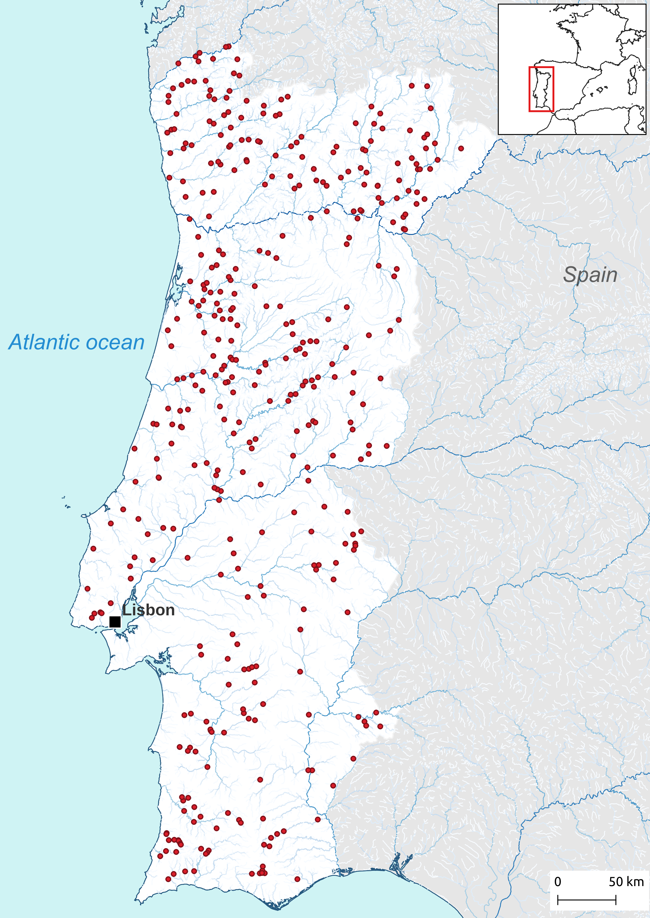

Figure 1- The red dots represent the 404 locations where riparian vegetation surveys took place.

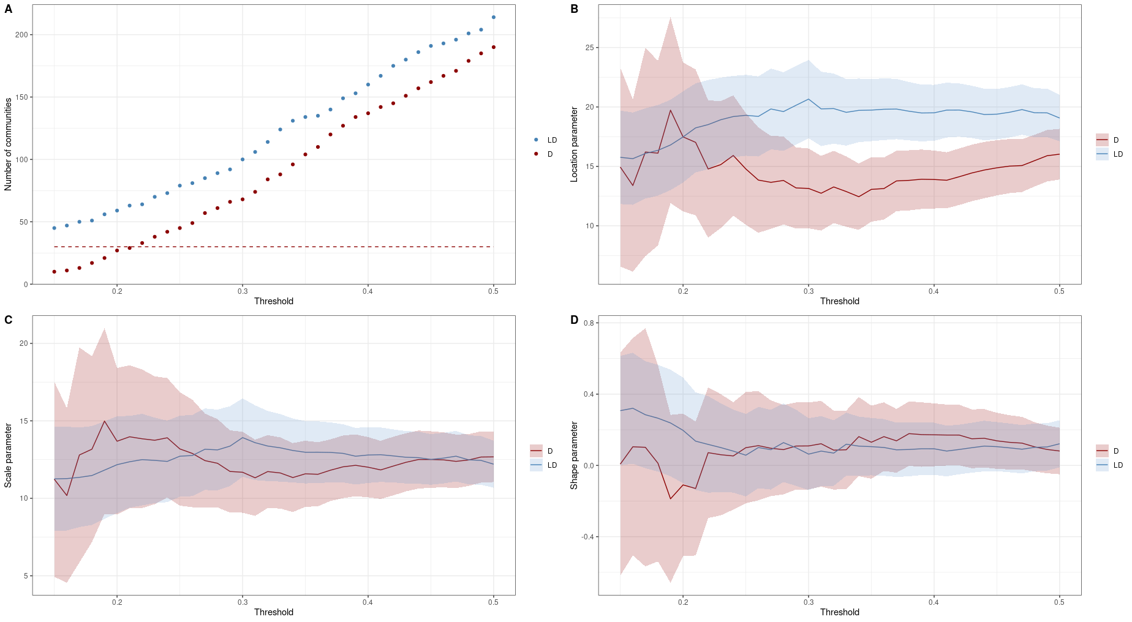
Figure 2 - A) The number of communities classified as least disturbed (LD) (blue) and more disturbed (D) (red) with increasing threshold values. Panels B), C), and D) show the location, scale, and shape parameters from the GEV distribution plotted against threshold values. The red lines and dots correspond to the ecological communities with larger human modification indices (more disturbed), while the blue ones correspond to communities is small indices (less disturbed). The shaded areas represent two standard errors. D – Disturbed, LD- Least disturbed.

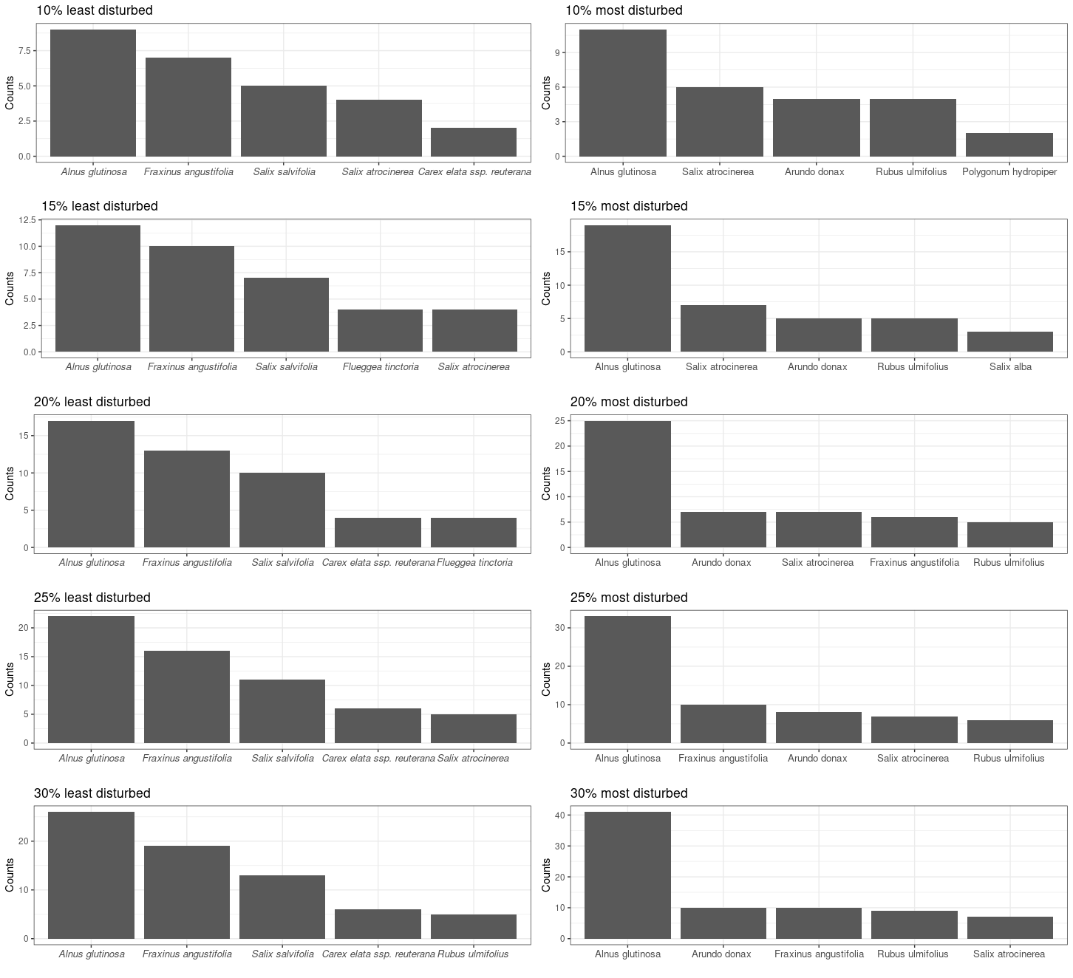

Figure 3 – This bar plot shows how the number of times each of the top 5 more dominant species had the highest percentage of cover in each of the 404 sampled communities.

