Uneven biodiversity sampling across redlined urban areas in the United States

Diego Ellis-Soto¹, Melissa Chapman², Dexter H Locke³

1 Department of Ecology and Evolutionary Biology, Yale University, New Haven, USA
2 Department of Environmental Science, Policy, and Management, University of California, Berkeley, Berkeley, CA, USA
3 USDA Forest Service, Northern Research Station, Baltimore Field Station, Suite 350, 5523 Research Park Drive, Baltimore, MD21228, USA
Corresponding author: diego.ellissoto@yale.edu

Keywords: Biodiversity, environmental justice, redlining, citizen science, urban ecology

Abstract: Citizen science data has rapidly gained influence in urban ecology and conservation planning, but with limited understanding of how such data reflects social, economic, and political conditions and legacies. Understanding patterns of sampling bias across socioeconomic gradients is critical to accurately map and understand biodiversity patterns, and to generating representative and just environmental knowledge. In this study we explore how historic racially-explicit zoning policies (redlining) relate to biodiversity data collection across and within 195 metropolitan areas in the United States covering >30 million people across 38 states. We specifically look at birds, as they are the most widely studied group of animals, and hundreds of thousands of citizen scientists collect biodiversity data each year. We consistently find uneven bird observation sampling density across redlined areas, with so-called ‘desirable’ areas (i.e. historically white areas) having more than twice the density than areas redlined as ‘hazardous’. We further estimate the degree to which historically redlined areas are surveyed sufficiently and identify regions across all metro areas in need of enhanced bird surveying. After accounting for differences in vegetation, open space, and climate, we find significantly lower sampling density and sampling completeness in these redlined neighborhoods. Our results shed light on the importance of considering socio-political conditions in the interpretation of urban biodiversity estimates. We conclude by discussing specific policy implementations– such as the Justice 40 Initiative and propose a new EPA indicator – and opportunities in collaborating with bottom-up community and social justice organizations for a more representative understanding of biodiversity in urban areas.

Significance Statement: Historic race-based zoning policies, such as redlining in the United States during the 1930s, are associated with racial inequity and adverse multigenerational socioeconomic conditions such as health, income, education, and disparate environmental conditions such as tree cover and vegetation across cities. We quantify how redlining across 195 cities in the United States is associated with bird biodiversity sampling density and completeness of sampling - two critical metrics of biodiversity knowledge. We show that historically redlined neighborhoods remain the most under-sampled urban areas for bird biodiversity, potentially impacting conservation priorities and propagating urban environmental inequities. We identify specific areas and policies that may promote more equitable sampling of biodiversity.

Introduction:

Biodiversity crisis and bias in biodiversity data collection
Biodiversity is increasingly threatened by human activities and rising temperatures which has implications for ecosystem functioning and, ultimately, human-wellbeing (1, 2). The global biodiversity crisis requires immediate action to prevent further population declines and species extinctions (1). In light of the post-2020 global biodiversity framework, an improved understanding of the availability and reliability of biodiversity data is critical to equitably and rigorously assessing progress towards global and national contributions targets (3). Identifying such knowledge gaps and guiding efforts towards more equitable sampling efforts are priorities for global biodiversity agendas, such as the Intergovernmental Science-Policy Platform on Biodiversity and Ecosystem Services (4).

To effectively address the drivers and consequences of biodiversity loss, it is essential to first gather evidence to detect changes in biodiversity over space and through time (5). The past few decades have seen a drastic growth in the amount of available biodiversity data, driven primarily by technological advances and digital collection from citizen scientists using cellphone apps, such as the eBird platform to collect bird observations (6). However, data collected by volunteers is highly spatially biased with species records’ locations (7). As a consequence, these large datasets may have gaps or redundancies that complicate subsequent analyses (8). The lack of data in certain geographic regions, strong sampling bias, and preference towards specific taxa, will limit the inferences on where and why species live within and across regions (9–11). Research on so called ‘biodiversity knowledge gaps’, therefore tends to explore coarse patterns (i.e. comparing countries) of biodiversity across the world and commonly identifies the tropics as data poor and the northern hemisphere as data rich (9, 10). Overall, there appears to be socioeconomic, linguistic, and ecological drivers for these gaps and biases in our current understanding and available information on biodiversity (10). For example, sampling bias in biological fossil records is driven by legacies of colonialism and political stability which hinders a more representative view of our past biodiversity (12).

Urban biodiversity knowledge might be particularly sensitive to the social, economic, and cultural environments of cities: most urban biodiversity data come from citizen scientists whose movements through urban landscapes are influenced, if not guided, by these factors (13). Urban environmental injustices might be worse than previously documented due to biased sampling campaigns by volunteer efforts. The problem may be particularly acute in the United States because of large socioeconomic inequality (13). Histories of and present-day socioeconomic inequalities may lead to highly disparate sampling of biodiversity records across neighborhoods. This is because environmental amenities are unevenly distributed (14). This would represent a pivotal limitation for equitable and just planning of sustainable cities as we risk underestimating urban biodiversity in under sampled regions, such as low-income neighborhoods. How can we protect what we don’t even know we have?

In the United States racial segregation is the norm, not the exception (15). One notable race-based housing policy colloquially referred to as “Redlining” in the 1930’s categorized neighborhoods by racial composition and housing stock, and then used those maps to guide mortgage loans. As part of The New Deal, the Home Owners’ Loan Corporation (HOLC) appraised neighborhoods based on their perceived safety of real estate investment using a ranking system of A (green), B, (blue), C (yellow), or D (red, hence “redlining”). A consequence of differential loan access is blocking the transfer of wealth intergenerationally. Today, across the US, lower-graded sections exhibited declines in home ownership (16) and home values, higher vacancy rates (17), higher poverty (18). Historic redlining practices have also become associated with shorter life expectancies and poorer overall health in present day (19); and lower educational achievement (20).

There are environmental correlates of redlining, too. Studies of more than 100 metropolitan regions show that areas formerly inhabited by racial minorities and immigrants have currently less vegetation (21) overall, and are hotter (22) than neighborhoods formerly consisting of US-born, white residents. A study using high-resolution, high-accuracy tree canopy maps for 37 US cities found that neighborhoods composed predominantly US-born white neighborhoods in the 1930s have on average 43% tree canopy today, whereas the areas with formerly predominantly comprised of racial and ethnic minorities have on average 23% tree canopy cover today (14). The current distribution of greenspaces, and biodiversity is influenced both by current and past land uses (23). Birds are without doubt the best sampled taxa and constitute approximately 67% of the globally available biodiversity information (based on gbif.org queried on May 1st 2021) collected in most part by hundreds of thousands of citizen scientists using the eBird citizen science platform (24).

A growing body of evidence showcasing the effect of systemic racism and socioeconomic disparities on environmental conditions across urban areas further allows making assumptions on these effects on the ecology and evolution of urban biodiversity (25, 26). Specifically, how biodiversity varies with the degree of residential segregation within and among cities appears to be a fundamental knowledge gap to our present day understanding and distribution of biodiversity (25). Investigating these hypotheses is intended to guide future environmental justice research in relation to biodiversity science. This paper explores how historic zoning policies relate to bird data collection across and within 195 cities in the United States, after controlling for, greenspace and climate (Fig. 1). Specifically, we look at the key building blocks for reliable biodiversity estimates; namely the sampling density of biodiversity records to identify potential biases and differences in data collection, and survey completeness which is a measure to indicate certainty in documenting all bird species in a region or whether more sampling is necessary to make reliable inferences. We ask (1) how does sampling effort of bird biodiversity vary with socioeconomic (historic housing segregation policies, such as HOLC-graded neighborhoods) and biophysical drivers across urban environments, and (2) whether the least sampled areas for bird biodiversity (biodiversity coldspots hereafter) are consistently located in regions that were segregated by redlining?

Results

We found significant and meaningful differences of sampling across HOLC grades. A total of 16% of HOLC A neighborhoods did not display any bird records compared to 26% for grade D polygons. Formerly A-graded areas have more than twice the sampling density (1,289 per square km) when compared to formerly D-graded areas (570 samples per square km) (Fig. 2a). Beyond sampling density, how complete our understanding of bird biodiversity is across HOLC grades was also significantly different, with redlined areas being the least complete areas of study (Fig. 2b) and having the largest number of biodiversity coldspots (Fig. 2c).

A mixed effects model showed that the adjusted odds of being sampled at all are 48% lower in D neighborhoods than in A. Another mixed effects model revealed that sampling density varied significantly across all HOLC grades, when adjusting vegetation greenness (NDVI), open space (the percentage of the polygon covered by protected open space), and population density (people per km2; Table 1). Climate did not appear to be a meaningful predictor after performing model selection (Suppl. Table 1). Although NDVI, open space, and population density were retained as significant predictors, NDVI was not significantly associated with sampling density. Sampling density was greatest in formerly A-Graded neighborhoods. Sampling density odds are 31% lower in B-graded neighborhoods OR 0.69 95% [0.58, 0.81], 59% lower in C-graded neighborhoods OR 0.41 95% [0.35, 0.48], and 69% lower in D-graded neighborhoods OR 0.31 95% [0.25, 0.37] (Fig. 3). The rank-order of the HOLC grading system matches the sampling density of volunteer bird sampling efforts. A third mixed effect model of survey completeness also showed significant variation by HOLC grades when adjusting for vegetation and open space, although not all pairs of grades were different (Table 1). Completeness was greatest in formerly A-graded (~65%) and lowest in formerly D-graded areas (~58%) at mean NDVI, percent open space, and population density values (Fig. 3). This suggests greater uncertainty for any estimates of key biodiversity metrics, such as species richness, in grade D areas.

Discussion:

Our study shows disparities in the density of bird records from the past 90 years in historically marginalized communities across 195 cities in the United States (Fig. 2). The odds of sampling in formerly D-graded areas is 69% lower, and the survey completeness is 7.51 percentage points lower (or 12% lower) than formerly A-graded neighborhoods (Table 1). Taken together, this evidence highlights how formerly redlined areas are significantly under sampled compared to non-redlined areas, and that there is overall less certainty about the number of bird species that are known to occupy these areas. These differences persisted even after accounting for differences in vegetation, open space, population density, and climate (Suppl. Table 1). These data disparities caution against comparing bird biodiversity within cities and across urban neighborhoods given sampling intensity is the first building block for biodiversity estimates. If samples are not representative, they are biased, as we see across HOLC grades. This can dramatically influence measurements of biodiversity change (27), hindering our ability to accurately map and forecast species’ distributions. Urban bird biodiversity knowledge appears biased towards areas that used to be single family detached homes occupied by US-born, white families; formerly A-graded areas. However, this does not necessarily mean that these areas have higher biodiversity.

Ecological research increasingly includes social-ecological processes, yet incorporation of environmental justice remains low (28). Environmental justice highlights the need for a just and even access and sampling of natural resources – including opportunities to sample biodiversity, as well as a fair representation in education and policy (28). Our findings highlight the need to address environmental injustice scholarship in the most widely adopted citizen science activity; bird watching. Without an even sampling of natural resources, understanding of ecosystem services will remain limited in marginalized communities, hindering environmental sustainability for the most vulnerable groups. We found that the legacy of redlining has negatively affected our understanding of current urban biodiversity, limiting our ability to accurately map bird species distributions in cities. In responding to Schell and colleagues (25) thought provoking questions, we find biodiversity sampling varies by former residential segregation - via HOLC grades.

Solution or system change to break the cycle
Demographic disparities in participation in citizen science have been documented extensively, including in bird watching (29, 30). Citizen science is often predominantly collected by adult, well-educated, white and affluent users (29, 30). Simultaneously, sites frequently sampled by citizen science efforts may be in areas of low environmental justice concern (29), which can simultaneously lead to disparate representation of sampling (such as shown in our study). Previous work has suggested that in order to reduce disparities, citizen science initiatives could ‘center in the margins’, meaning that if existing projects are accessible to the marginalized, they will be accessible to all (31). A definition of ecosystem services in landscape planning describes how nature contributes to the well-being of humans (32). Benefits of citizen science include increased environmental advocacy (31, 33), closer connection to nature, increased scientific literacy of public research participants through connection with academic institutions and communities (34), and physical activity in urban greenspaces indirectly promoting physical and mental health benefits (32). Aligning scientific research goals of improving sampling of bird biodiversity identified as coldspots in our analysis, alongside with local grassroots organizations (NGOs, neighborhood associations) involved in increasing scientific literacy (i.e. STEM high school programs using citizen science applications, black birders week, https://www.audubon.org/black-birders-week) or promoting nature walks for minority groups (such as latino outdoors https://latinooutdoors.org) could be a step towards more inclusive citizen science and serving groups historically and currently underserved.

Local communities harnessing their power in data collection may better advocate environmental protections in their own community (35). More importantly, a lack of representation and information about biodiversity may lead to uneven funding for environmental restoration and benefits to communities, thus reinforcing environmental justice disparities (36). Such a feedback loop may promote a cycle of continued disinvestment in areas of underrepresented and underserved populations and their environments. We find however, these areas are where the greatest knowledge gaps exist, and the greatest uncertainty of species’ spatial distribution and abundance remains. Ultimately, citizen science is a volunteer activity and merits the question whether participants are seeking to fill important gaps in our urban knowledge of birds, or for purely recreational purposes, or some combination of both (37). The coldspots map identifies opportunities to optimize the value of information volunteers collect for improved scientific inference while simultaneously advancing environmental justice (Suppl. Material).

Paths towards addressing sampling bias
A better understanding of urban biodiversity is both beneficial for local communities residing in their area, as well as improving accurately representative and complete understanding of biodiversity overall, especially as it relates to sustainability and climate goals. We envision that biodiversity sampling and coverage becomes included as an environmental justice index by the EPA (https://www.epa.gov/ejscreen), something that is currently lacking, particularly for key species such as birds or insect pollinators. The federal environmental justice initiative by the current Biden Administration, labeled the Justice40 Initiative, seeks to ensure that at least 40 % of federal climate and energy program funding to communities is directed to communities that are and have in the past been most affected to environmental injustice https://www.whitehouse.gov/omb/briefing-room/2021/07/20/the-path-to-achieving-justice40/. The administration aims to use environmental justice screening tools by the EPA to identify disadvantaged communities for this benefit program. This executive order also aims to track performance towards the Justice40 Initiative by assisting vulnerable communities as well as benefiting these communities with infrastructure investment.

At a global scale, the 2030 United Nations Sustainable Goal 11 aims to achieve recognition in global policy agendas for sustainable and inclusive urban growth that minimizes inequality (38). Thus, understanding the effect of socio-ecological dynamics on environmental justice is a crucial knowledge gap (39). Increasingly, people’s experience with nature will occur in cities, with potential benefits for human-health and well-being linked to biodiversity conservation (40). Centering justice in urban bird monitoring through whole community engagement and mobilization could substantially increase our understanding of biodiversity in identified coldspots (41) and provide a foundation towards a more environmentally just sampling of biodiversity across urban areas.

Materials and methods
HOLC polygons
The Home Owners Loan Corporation (HOLC) polygons were obtained for a total of 195 cities from the University of Richmond’s (42). These maps were digitized and georeferenced as part of the Mapping Inequality Project (https://dsl.richmond.edu/panorama/redlining/) and HOLC-defined neighborhoods for each city. We calculated the total geographic area of each HOLC grade for each city in km2 the sf package (43) using R v. 4.1.1 (44) and the tigris package to obtain the county level information for each city (45). Population estimates for each HOLC polygon were created via areal interpolation, whereby each neighborhood was assigned the weighted sum of the proportional overlap of each Census block group’s from the 2013-2017 American Community Survey population using spatial intersection (46).

Bird biodiversity records
We obtained a total of 10,043,533 georeferenced biodiversity records for bird species (class Aves) occurring within 9,851 HOLC-defined neighborhoods in 195 cities, from the Global Biodiversity Information Facility (https://gbif.org), which also contains records from the eBird database (47). We used the rgbif package (48) to query and download bird records that had geographic coordinates, and were collected after 1932 (as the Home Owners Loan Corporation began categorizing neighborhoods in 1933) up to February 2022. We included records defined as ‘observation’, ‘living specimen’, ‘human observation’, ‘preserved specimen’ and ‘machine observation’. We calculated the number of bird observations as well as the species richness (number of unique bird species) for each HOLC grade for each city. To calculate how the number of bird observations differed across HOLC grades, we calculated the sampling density of bird records by accounting for the area of each HOLC grade per city in km2. Because extensive work has demonstrated the importance of greenspace for bird presence in urban environments (49, 50), we modeled sampling density separately based on the area of greenspace habitats for each HOLC grade in cities by using the PAD database (described below).

Calculating bird sampling gaps and survey completeness across HOLC in cities
To investigate disparate survey efforts of bird biodiversity across HOLC grade in cities, we used the KnowBR package to calculate survey completeness of bird information in a geographic unit; individual HOLC polygons in our case (51). Specifically, survey completeness calculated by KnowBR reflects our ability to quantify the full species assemblage in a HOLC polygon defined as the percentage of observed species richness captured by expected species richness (51).

Calculating bird information cold spots
We further used KnowBR to estimate incomplete sampling of bird information-- ‘cold spots’ hereafter -- across redlined areas. Besides survey completeness, we calculated the slope of the species accumulation curves as well as the completeness percentage for each HOLC polygon. Specifically, we used the reversed rationale used in (49, 51) to remove poorly surveyed areas. Thus, we considered polygons to be incompletely sampled (bird information cold spots) using parameter recommendations from (51); the slope of the species accumulation curve is >0.3, survey completeness below 50, and the ratio between occurrence record numbers and the number of observed species as <3. This allowed us to calculate the percentage of incompletely sampled redlined polygons. These areas could be used to guide local residents, ornithologists, and citizen scientists for an overall more spatially even sampling of bird biodiversity.

Greenspace, vegetation and climate data
We used the United States Protected Area Database (PAD-US) (52) to calculate the percent area of parks within each neighborhood. Additionally, we created a composite NDVI map using Google Earth Engine using an atmospherically corrected surface reflectance from the Landsat 8 sensors. We took all images taken during a five year period (2014-2019), masked clouds, calculated mean NDVI per month using the normalized difference calculated is (NIR - red) / (NIR + red). This results in a number between 1 and -1, where pixels with high photosynthetic activity have a high NDVI. We then calculated the mean value per redlining polygon. We obtained the mean annual precipitation and mean annual temperature built on monthly averages of climate data collected from meteorological stations around the globe from 1979 to 2013 at 1km2 resolution (53) and calculated average temperature and rainfall for each city.

Statistics
Three mixed effects models were estimated. The first estimated whether or not a HOLC neighborhood was sampled at all (binary outcome) using a generalized linear mixed model, the second estimated the log of sampling density, and the third survey completeness using linear mixed models. We assessed model performance based on AIC-minimization criterion selection between simple and complex models with an increasing number of covariates (54). The simplest null model (intercept only) was fit, fixed effects for HOLC (primary variable of interest) was added. Next the following terms were added: Metropolitan statistical area (MSA) as a random intercept, HOLC grade as a random slope, and fixed effects for NDVI, percent open space, and population density random slopes within HOLC-defined city for mean temperature and precipitation (climate) interacting. Because NDVI, percent open space, and population density are measured on very different scales, they were standardized via z-scores before being used as predictors. For the binary outcome (sampled or not) and log of sampling density, random intercept and random slope model was best, and for survey completeness random intercepts.

Figures and Tables

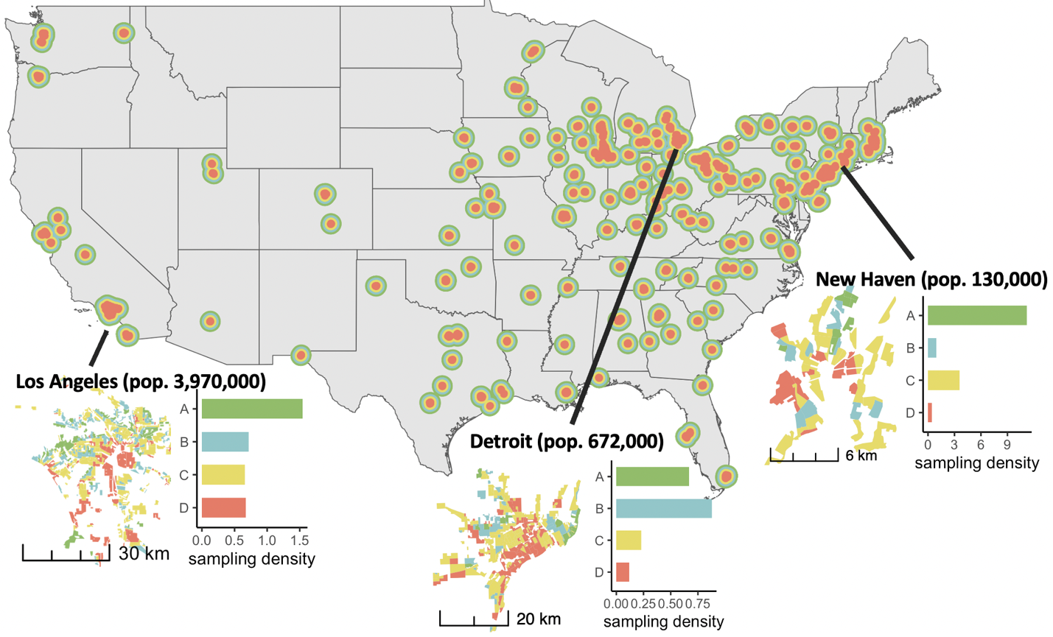
Figure 1: Map of selected 195 cities included in the analyses, span a range of social and ecological conditions. New Haven, CT, Los Angeles, CA, Detroit, MI show how areas formerly D-graded (or “Redlined”) have far lower citizen science sampling density for birds.

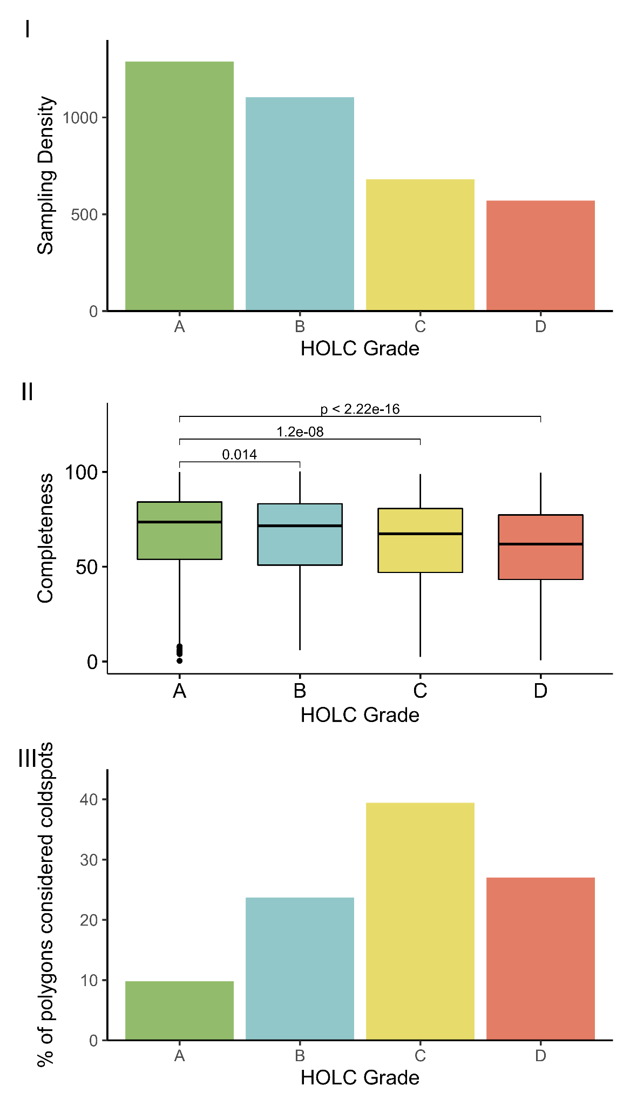
Figure 2: Patterns of biodiversity across redlined areas. Sampling density (bird records per km2) is lowest in HOLC D neighborhoods (I). The completeness of available bird biodiversity information differs significantly across HOLC grades (II), with the significantly lower completeness in redlined, D-graded areas. The largest proportion of neighborhood polygons deemed insufficiently (cold spots) sampled in terms of bird biodiversity are found in HOLC C grades, followed by D grade (III).

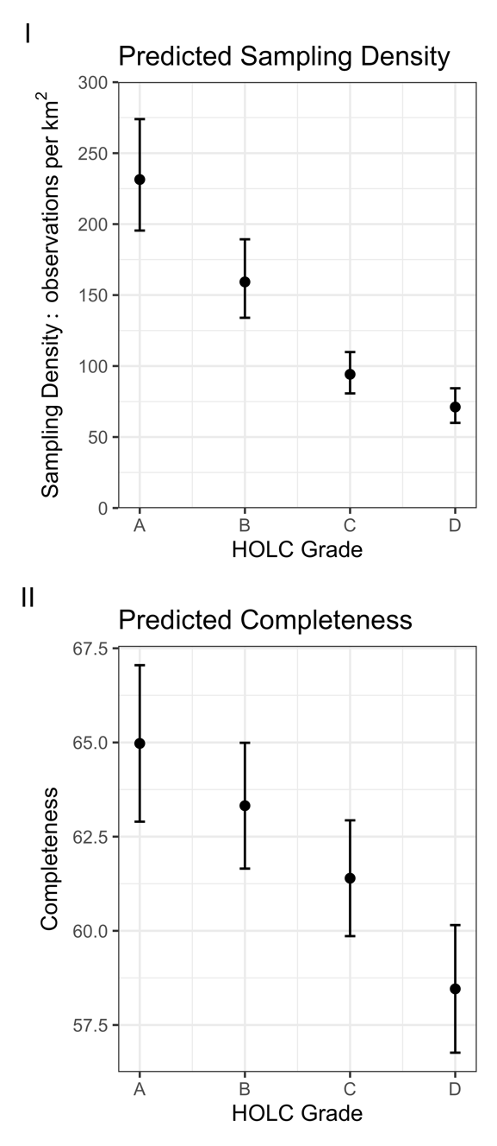
Figure 3: Predicted sampling density (I) adjusts for NDVI, Open Space (%), population density (population per km2), with random intercepts per metropolitan statistical area (MSA), and random slopes for HOLC grade in that MSA. Predicted percent completeness (II) for adjusts for NDVI, Open Space (%), population density, and random intercepts for MSA. Note that y-axis does not start at zero.

Table 1: Mixed effects models predicting whether or not a HOLC neighborhood sampled (left), sampling density (center), and sampling completeness (right)

Acknowledgements
We thank Tagan Engel, Elizabeth B. Larry, Dr. Chloe Schmidt, Dr. Scott Yanco, Dr. Ruth Oliver, and Dr. J. Morgan Grove for helpful feedback on this manuscript. D.E.S. acknowledges support from the Yale Institute for Biospheric Studies. The findings and conclusions in this paper are those of the author(s) and should not be construed to represent any official USDA or U.S. Government determination or policy.

Data sharing plans
Data used in this analysis is publicly available and code will be available on GitHub upon acceptance of this manuscript.

Author Contributions
D.E.S, M.C. and D.H.L designed the study, performed research and statistical analysis, and participated in the writing of the manuscript.

Competing Interest Statement
The authors declare no competing interests

References
1. B. J. Cardinale, et al., Biodiversity loss and its impact on humanity. Nature 486, 59 (2012).
2. G. T. Pecl, et al., Biodiversity redistribution under climate change: Impacts on ecosystems and human well-being. Science. 355, eaai9214 (2017).
3. UNEP, Update of the zero draft of the post-2020 global biodiversity framework. Proc. United Nations Environ. Program. Conf. Parties to UN Conv. Biol. Divers. (2020).
4. I. Díaz-Reviriego, E. Turnhout, S. Beck, Participation and inclusiveness in the Intergovernmental Science–Policy Platform on Biodiversity and Ecosystem Services. Nat. Sustain. 2, 457–464 (2019).
5. W. Jetz, et al., Essential biodiversity variables for mapping and monitoring species populations. Nat. Ecol. Evol. 3, 539–551 (2019).
6. T. Amano, J. D. L. Lamming, W. J. Sutherland, Spatial Gaps in Global Biodiversity Information and the Role of Citizen Science. Bioscience 66, 393–400 (2016).
7. T. J. Bird, et al., Statistical solutions for error and bias in global citizen science datasets. Biol. Conserv. 173, 144–154 (2014).
8. C. T. Callaghan, J. J. L. Rowley, W. K. Cornwell, A. G. B. Poore, R. E. Major, Improving big citizen science data: Moving beyond haphazard sampling. PLOS Biol. 17, 1–11 (2019).
9. S. Frank A. La, M. Somveille, Survey completeness of a global citizen-science database of bird occurrence. Ecography 43, 34–43 (2020).
10. C. Meyer, W. Jetz, R. P. Guralnick, S. A. Fritz, H. Kreft, Range geometry and socio-economics dominate species-level biases in occurrence information. Glob. Ecol. Biogeogr. 25, 1181–1193 (2016).
11. J. Troudet, P. Grandcolas, A. Blin, R. Vignes-Lebbe, F. Legendre, Taxonomic bias in biodiversity data and societal preferences. Sci. Rep. 7, 9132 (2017).
12. N. B. Raja, et al., Colonial history and global economics distort our understanding of deep-time biodiversity. Nat. Ecol. Evol. 6, 145–154 (2022).
13. Q. Wang, N. E. Phillips, M. L. Small, R. J. Sampson, Urban mobility and neighborhood isolation in America{\textquoteright}s 50 largest cities. Proc. Natl. Acad. Sci. 115, 7735–7740 (2018).
14. D. H. Locke, et al., Residential housing segregation and urban tree canopy in 37 US Cities. npj Urban Sustain. 1, 15 (2021).
15. S. Athey, B. Ferguson, M. Gentzkow, T. Schmidt, Estimating experienced racial segregation in US cities using large-scale GPS data. Proc. Natl. Acad. Sci. 118, e2026160118 (2021).
16. D. Aaronson, D. Hartley, B. Mazumder, The Effects of the 1930s HOLC “Redlining” Maps. Am. Econ. J. Econ. Policy 13, 355–392 (2021).
17. I. Appel, J. Nickerson, Pockets of Poverty: The Long-Term Effects of Redlining. SSRN Electron. J. (2016) https:/doi.org/10.2139/ssrn.2852856.
18. D. Q. Rutan, M. R. Glass, The Lingering Effects of Neighborhood Appraisal: Evaluating Redlining’s Legacy in Pittsburgh. Prof. Geogr. 70, 339–349 (2018).
19. G. C. Gee, A Multilevel Analysis of the Relationship Between Institutional and Individual Racial Discrimination and Health Status. Am. J. Public Health 92, 615–623 (2002).
20. D. S. Massey, American Apartheid: Segregation and the Making of the Underclass. Am. J. Sociol. 96, 329–357 (1990).
21. A. Nardone, K. E. Rudolph, R. Morello-Frosch, J. A. Casey, Redlines and Greenspace: The Relationship between Historical Redlining and 2010 Greenspace across the United States. Environ. Health Perspect. 129, 17006 (2021).
22. J. S. Hoffman, V. Shandas, N. Pendleton, The Effects of Historical Housing Policies on Resident Exposure to Intra-Urban Heat: A Study of 108 US Urban Areas. Climate 8 (2020).
23. L. A. Roman, et al., Human and biophysical legacies shape contemporary urban forests: A literature synthesis. Urban For. Urban Green. 31, 157–168 (2018).
24. R. Bonney, Expanding the Impact of Citizen Science. Bioscience 71, 448–451 (2021).
25. C. J. Schell, et al., The ecological and evolutionary consequences of systemic racism in urban environments. Science. 4497, eaay4497 (2020).
26. C. Schmidt, C. J. Garroway, Systemic racism alters wildlife genetic diversity. EcoEvoRxiv Prepr., 0–3 (2022).
27. A. C. Hughes, et al., Sampling biases shape our view of the natural world. Ecography 44, 1259–1269 (2021).
28. M. N. Miriti, G. Bowser, C. R. Cid, N. C. Harris, Overcoming Blind Spots to Promote Environmental Justice Research. Trends Ecol. Evol. 36, 269–273 (2021).
29. C. Blake, A. Rhanor, C. Pajic, The demographics of citizen science participation and its implications for data quality and environmental justice. Citiz. Sci. Theory Pract. 5, 1–10 (2020).
30. J. D. Rutter, et al., Racial, ethnic, and social patterns in the recreation specialization of birdwatchers: An analysis of United States eBird registrants. J. Outdoor Recreat. Tour. 35, 100400 (2021).
31. C. B. Cooper, et al., Inclusion in citizen science: The conundrum of rebranding. Science. 372, 1386–1388 (2021).
32. R. P. Remme, et al., An ecosystem service perspective on urban nature, physical activity, and health. Proc. Natl. Acad. Sci. 118, e2018472118 (2021).
33. R. C. Jordan, S. A. Gray, D. V Howe, W. R. Brooks, J. G. Ehrenfeld, Knowledge Gain and Behavioral Change in Citizen-Science Programs. Conserv. Biol. 25, 1148–1154 (2011).
34. C. Brewer, Outreach and Partnership Programs for Conservation Education Where Endangered Species Conservation and Research Occur. Conserv. Biol. 16, 4–6 (2002).
35. P. A. Gonzalez, et al., Community-Based Participatory Research and Policy Advocacy to Reduce Diesel Exposure in West Oakland, California. Am. J. Public Health 101, S166–S175 (2011).
36. M. A. Dernoga, S. Wilson, C. Jiang, F. Tutman, Environmental justice disparities in Maryland’s watershed restoration programs. Environ. Sci. Policy 45, 67–78 (2015).
37. P. Tiago, M. J. Gouveia, C. Capinha, M. Santos-Reis, H. M. Pereira, The influence of motivational factors on the frequency of participation in citizen science activities. Nat. Conserv. 18, 61–78 (2017).
38. United Nations, Sustainable Development Goal 11: Sustainable Cities and Communities. Sutainable Dev. Goals Overv. (2021).
39. K. A. Marshall, M. A. Gonzalez-Meler, Can ecosystem services be part of the solution to environmental justice? Ecosyst. Serv. 22, 202–203 (2016).
40. A.-C. Prévot, H. Cheval, R. Raymond, A. Cosquer, Routine experiences of nature in cities can increase personal commitment toward biodiversity conservation. Biol. Conserv. 226, 1–8 (2018).
41. N. B. Pollock, et al., Personal BioBlitz: A New Way to Encourage Biodiversity Discovery and Knowledge in K–99 Education and Outreach. Bioscience 65, 1154–1164 (2015).
42. R. K. Nelson, L. Winling, R. Marciano, N. Connolly, Mapping inequality: Redlining in new deal America. Am. Panor. (2018).
43. E. Pebesma, Simple features for R: Standardized support for spatial vector data. R J. (2018) https:/doi.org/10.32614/rj-2018-009.
44. R Core Team, R core team (2021). R A Lang. Environ. Stat. Comput. R Found. Stat. Comput. Vienna, Austria. URL http//www. R-project. org (2021).
45. K. Walker, Tigris: An r package to access and work with geographic data from the us census bureau. R J. (2016) https:/doi.org/10.32614/rj-2016-043.
46. M. F. Goodchild, L. Anselin, U. Deichmann, A Framework for the Areal Interpolation of Socioeconomic Data. Environ. Plan. A Econ. Sp. 25, 383–397 (1993).
47. B. Sullivan, et al., eBird: A citizen-based observation network in the biological sciences. Biol. Conserv. 142, 2282–2292 (2009).
48. S. Chamberlain, Package 'rgbif’ - Interface to the Global “Biodiversity” Information Facility API. CRAN Repos. (2019).
49. F. A. La Sorte, M. F. J. Aronson, C. A. Lepczyk, K. G. Horton, Area is the primary correlate of annual and seasonal patterns of avian species richness in urban green spaces. Landsc. Urban Plan. 203, 103892 (2020).
50. C. T. Callaghan, et al., Using citizen science data to define and track restoration targets in urban areas. J. Appl. Ecol. 56, 1998–2006 (2019).
51. J. M. Lobo, et al., KnowBR: An application to map the geographical variation of survey effort and identify well-surveyed areas from biodiversity databases. Ecol. Indic. 91, 241–248 (2018).
52. USGS GAP, Protected Areas Database of the United States (PAD-US) version 2.1. Geol. Surv. data release (2020).
53. D. N. Karger, et al., Climatologies at high resolution for the earth’s land surface areas. Sci. Data 4, 170122 (2017).
54. H. Aguinis, R. K. Gottfredson, H. Joo, Best-Practice Recommendations for Defining, Identifying, and Handling Outliers. Organ. Res. Methods 16, 270–301 (2013).

