Dispersal and space use of captive-reared and wild-rehabilitated Harpy Eagles released in Central American landscapes: Implications for reintroduction and reinforcement management
Adrián Naveda-Rodríguez^{1,2}, Edwin Campbell-Thompson¹, Richard T. Watson¹, Jennifer McCabe¹ and Félix Hernán Vargas¹
¹The Peregrine Fund, 5668 West Flying Hawk Lane, Boise, ID 83709, USA
²Wildlife Conservation Society, Ecuador Program, Quito, Ecuador.
Correspondence: Adrián Naveda-Rodríguez , Department of Wildlife, Fisheries and Aquaculture, Mississippi State University, MS 39762, USA. adrian.naveda@gmail.com
Short title: Movement patterns of harpy eagles
Adrián Naveda-Rodríguez: https://orcid.org/0000-0002-7557-2893
Edwin Campbell-Thompson: https://orcid.org/0000-0001-5896-6105
Félix Hernán Vargas: https://orcid.org/0000-0002-0035-7670

ABSTRACT
Understanding the spatial context of animal movements is fundamental for establishment and management of protected areas (PA). However, these data are not readily available for large raptors, particularly for tropical species. We telemetry-tracked 36 captive-reared and wild-rehabilitated Harpia harpyja and estimated dispersal and space use after release in Mesoamerica. We evaluated the effectiveness of PA in the protection of home ranges and examined how individual traits (sex/age), human intervention (captive management/release method) and landscape composition and configuration influenced dispersal and home range using mixed-effects models. Mean post-release dispersal was 29.4 km (95% CI: 22.5-38.5), annual home ranges averaged 1039.5 km² (95% CI: 627-1941). The home ranges of nine individuals were distributed across three countries. Home ranges were influenced by release method, patch richness, patch and edge density, and contagion. PA in Mesoamerica may not be effective conservation units for this species. Harpy Eagle average home range greatly exceeded the average size of 1115 terrestrial PA (52.7±6.1 km²) in Mesoamerica. Given its spatial requirements, restoration of the Harpy Eagle in Mesoamerica may provide an opportunity to inform the design and management of dynamic conservation concepts, such as biological corridors. Due to their wide use of space, including transboundary, Harpy Eagles conservation efforts may fail if they are not carefully coordinated between the countries involved. Future restoration efforts of umbrella forest-dwelling raptors should select release sites with highly aggregated and poorly interspersed forest. Release sites should have a buffer of approximately 30 km and should be located completely within PA.
KEYWORDS
animal movement, contagion, headstarting, landscape detective, landscape heterogeneity, Mesoamerican Biological Corridor, Neotropical bird of prey.

INTRODUCTION
Birds of prey have key functional roles in terrestrial ecosystems and are often used as umbrella species (species with large habitat needs whose protection could lead to the conservation of many other co-occurring species) to achieve conservation goals (Sarasola et al. 2018). Furthermore, their long-term conservation is contingent on reliable knowledge of their natural history. Understanding the ecological consequences of movement strategies such as dispersal and space use, and their drivers is fundamental in ecology, but also for choosing the scale of management that aids the creation and management of protected areas (Schwartz 1999; Allen & Singh 2016). However, these data are usually not available for large raptors, particularly tropical species.
Raptor dispersal (intentional individual displacement from population centers) and space use are key to colonize new areas and connects fragmented populations (Bildstein 2017; Serrano 2018). Dispersal and space use are related to body size, age, gender, habitat conditions, prey availability and breeding season (Newton 1979; Peery 2000; Serrano 2018). Studies on movements of large tropical raptors are often characterized by small sample sizes, limiting the ability to clearly identify ecological patterns. For example, Abaño et al. (2015) found large variability in dispersal of six Philippine Eagles (Pithecophaga jefferyi) and van Eeden et al. (2017) reported no major differences in space use between males and females of six Martial Eagles (Polemaetus bellicosus) studied in South Africa.
The Harpy Eagle (Harpia harpyja) is the largest forest-dwelling eagle found in lowland forests from south Mexico to north-east Argentina (Ferguson-Lees and Christie 2001). It is threatened by habitat loss and human persecution and thus globally classified as Near Threatened and considered endangered or locally extinct in some countries of Central America (BirdLife International 2017). This situation originated the proposal of conservation actions such as the creation and strengthening of protected areas and captive breeding programs. Between 1987 and 2006, The Peregrine Fund’s Harpy Eagle restoration program bred eagles in captivity, rehabilitated confiscated eagles, and successfully released 49 captive-born and wild-rehabilitated Harpy Eagles in Mesoamerica (Watson et al. 2016). Since forest-dependent raptors are inconspicuous and difficult to study because their natural low population density, the Harpy Eagle restoration program has facilitated the development of applied research focused on captive breeding and ecological monitoring of released individuals (Touchton et al. 2002; Campbell-Thompson et al. 2012; Miranda et al. 2018) with little attention on the spatial ecology.
The movement ecology of this species remains largely unstudied. Efforts to understand Harpy Eagle dispersal and space use were initiated in 1996 in Venezuela (Blanco 2015). However, data collected on more than 30 individuals has not been analyzed or published and the published information is based on limited studies along its geographic range (Aguiar-Silva 2016; Muñiz-Lopez et al. 2012; Rotenberg et al. 2012; Urios et al. 2017). These published results illustrate the need for a more formal and quantitatively rigorous approach to elucidate the underlying mechanisms influencing movement ecology of this major predator of neotropical forests.
We used data from 36 captive-reared and wild-rehabilitated Harpy Eagles released in Belize and Panama between 2002 and 2009 to estimate post-release dispersal and annual home range size. Further, we examined how these parameters were influenced by individual traits, landscape composition and configuration, and human intervention. We analyzed whether post-release dispersal and home range differed between sex or age as observed in other large raptors (Newton 1979; Serrano 2018). Acknowledging that human intervention (e.g. captivity and translocation) can affect behavior and personality of captive-reared and rehabilitated animals (Merrick and Koprowski 2017), we also analyzed the relationships of release methods (hard and soft-release) and age at release to movement strategies of the eagles. Moreover, we examined the effect of landscape composition and configuration on dispersal and space use, and assessed the effectiveness of natural protected areas on the conservation of this species.
Based on previous research on movements of Harpy Eagle (Aguiar-Silva 2016; Muñiz-Lopez et al. 2012; Rotenberg et al. 2012; Urios et al. 2017), we did not expect to see differences between sexes or ages. We predicted hard-released eagles (no pre-conditioning or food provisioning after release) would exhibit greater dispersal rates and home ranges than soft-released eagles (food provisioning after release). Finally, being the Harpy Eagle a forest specialist, we forecast that dispersal and space use would increase with increasing landscape heterogeneity which is assumed to be poor quality habitat for Harpy Eagles since they rely on extensive areas of pristine forests with abundant arboreal mammals (Stotz et al. 1996).
METHODS
Study area
Harpy Eagles were released in Chiquibul Forest Reserve in Belize, and Soberania National Park, La Amistad International Park and Darien National Park in Panama (Fig. 1). Campbell-Thompson et al. (2012) and Watson et al. (2016) provided detailed information of release sites. Release sites were selected considering: (i) previous occurrence of Harpy Eagles in these areas prior to extirpation, (ii) protection from human persecution, and (iii) presence of large forest tracts of suitable habitat and with suitable prey sources.
Harpy Eagle data
Harpy Eagles were bred or rehabilitated at The Peregrine Fund’s World Center of Birds of Prey in Idaho, USA and Neotropical Raptor Center located in Ciudad del Saber, Republic of Panama. Muela et al. (2003) and Watson et al. (2016) outline details on breeding facilities, rehabilitation of wild eagles and management of breeding pairs and nestlings. We analyzed data from 31 captive-bred and five wild-rehabilitated eagles (20 females and 16 males determined by the marked reversed sexual dimorphism in this species [Ferguson-Lees and Christie 2001]). Eagles were classified into four age classes at release. Class one included 10 individuals age 6-7-months, class two 11 individuals age 18-23-months, class three 10 individuals older than 30-months, and class four included five adult wild-rehabilitated eagles. Eagles older than four years were classified as adults, age of wild-rehabilitated individuals was determined based on plumage (Ferguson-Lees and Christie 2001). Thirteen eagles were released in Belize and 23 eagles were released in Panama.
Movement data
Eagles were fitted with radio telemetry (VHF Biotrack 70g, Merlin System 60g) and satellite telemetry units (Doppler PTT-100 95g, Argos/GPS LC4T PTT-100s 105g, Solar Argos/GPS PTT-100s 70g) attached in a backpack configuration. Locations were obtained from November 2002 to December 2011. Eagles with VHF transmitters were located by two observers three time per week by homing (animals are located by visual contact within a distance <100 m. and their positions are recorded with a handheld GPS). Satellite units were programmed to record data during 11 consecutive hours (1 GPS-fix per hour) every four days. Fixes recorded by each PTT were processed by the Argos System. For analysis we used positions with an estimated accuracy ≤ 500 m (Argos location classes 2 and 3).
Release methods
Harpy Eagles were released using two basic approaches. Soft-releases were conducted using the adapted hacking technique developed for this species (Campbell-Thompson et al. 2012) where 19 captive-bred eagles were placed in hacking boxes for a period of 3-6 weeks until release, and food provisioned after release until independence. See Campbell-Thompson et al. (2012) for details of release protocol.
Hard-release included 12 captive-bred and five wild-rehabilitated eagles. Hard-released eagles were transported in kennels to the release site; the cage door was open, and the eagle flushed without pre-conditioning or food provisioning after release.
Dispersal
Dispersal was considered to have occurred once eagles flew beyond the average inter-nest of neighboring pairs distance (Cadahia et al. 2008), and remained 30 continuous nights outside the radii created by the inter-nest distance. The inter-nest of neighboring pairs distance for Harpy Eagles in Central America has been estimated in 4.1 (Vargas-González and Vargas 2011). We measured post-release dispersal with net-squared displacement analysis using the amt R package (Signer et al. 2019; R Core Team 2018). Maximum distances from release point were used as a measure of maximum post-release dispersed distance.
Home range
We estimated space use following the workflow proposed by Calabrese et al. (2016), we used the autocorrelated kernel density estimation (AKDE, Fleming et al. 2015) in the ctmm R package (Fleming & Calabrese, 2019) to calculate error-informed home range sizes and to implement the small sample size bias correction proposed by Fleming and Calabrese (2017). We estimate home range for each bird in each calendar year. We applied Argos location classes to account for telemetry error. Since eagles with VHF telemetry were located by homing, we assigned these positions to Argos location class 3 (estimated error <250 m).
Because eagle relocations followed different sampling schedule, we used the optimal weighting method implemented in ctmm to account for sampling bias and to correct for irregular and missing data (Fleming et al. 2018). Eagles with at least 180 days of continuous tracking data and exhibiting home ranging behavior were selected for space use calculation. Home ranging behavior were determined by analyzing the empirical semi-variogram of each individual (Fleming et al. 2015). We calculated annual core areas and home ranges as the 50% and 95% isopleth of utilization distribution using AKDE, respectively, along with 95% confidence intervals on the areas estimated.
Landscape metrics
We used land cover information for 2003-2011 at 500 m grain size from Terra MODIS MCD12Q1 (Friedl et al. 2015) to calculate landscape composition, configuration and connectivity metrics (hereafter landscape metrics) within the annual home range of each eagle (Turner and Gardner, 2015). Composition metrics comprised patch richness and Shannon’s diversity index, configuration metrics included patch density, largest patch index, edge density, landscape shape index, and contagion index. Landscape division index was deemed a connectivity metric. Landscape metrics were calculated in Fragstat 4.2 using the 8-neigbor rule (McGarigal et al. 2012).
We set the spatial scale of our analysis to one kilometer. We clipped annual land cover raster using upper limit confidence interval of individual annual home ranges as clipping feature. The grain size of the input raster and the clipping features allowed us to have a grain and extent sizes two times smaller and >2 times larger, respectively, than the scale of analysis as recommended by O’Neill et al. (1996) to avoid sensitivity of landscape metrics to grain size and calculation scales.
Data analysis
We calculated and reported accordingly average, standard errors or 95% nonparametric bootstrap confidence intervals (95% CI) of tracking time, maximum post-release dispersed distance, annual core area, annual home range and landscape metrics. Nonparametric bootstrap confidence intervals correspond to the adjusted bootstrap percentile interval and were calculated in the boot R package (Canty and Ripley, 2019).
We performed a GAP analysis (gaps in the representation of eagle’s home ranges within protected areas, Scott et al. 1993) to assess the efficacy of protected areas in Harpy Eagles’ habitat conservation. Using ArcGIS 10.4 (ESRI 2011), we intersected the network of protected areas of Central America (IUCN-ORMACC 2016) with the annual home ranges to calculate the proportion of home ranges inside of protected areas. Since Pearce et al. (2008) proposed 40% of habitat protection for avian species with little identified suitable habitat; we assumed that protected areas are effectively protecting the Harpy Eagles in Central America if >40% of the annual home range was included within them.
Since post-release dispersal was positive correlated to annual home range (r_{s} = 0.93), a similar response is expected; therefore, we only determined the relationships of home range (response variable) to selected independent variables and their interactions. We fitted 11 linear mixed-effects models for our response variable (Table 1) using the lme4 R package (Bates et al. 2015). We acknowledge the effect of age at release and release method may not be the same after the first year. Captive-reared, wild-rehabilitated or translocated wildlife may not display long-term shifts in movement parameters after being exposed to captivity (Tolhurst et al. 2016; Whitfield et al. 2009). Thus, we are assuming that the artificial selection placed by captive-breeding and rehabilitation of Harpy Eagles in this study can impose a radically and permanent shift in temperament as suggested by McDougall et al. (2006) and Shier (2016), so we expect the effect of age at release and release method to be same in the long term.
Response variable were log-transformed and landscape metrics variables were standardized (x-μ/σ) prior to analysis. We checked for multicollinearity among these variables using the variance inflation factor (VIF) metrics and removed any variables where VIF >2 (Zuur et al. 2010); largest patch index, division, Shannon’s diversity index and landscape shape index were omitted because of collinearity. Each individual eagle was included as random effect and models were validated by checking diagnostic plots.
We used the second-order Akaike’s Information Criterion (AICc) and AICc weights to rank and select competitive models (ΔAICc <2) for inference. We evaluated goodness-of-fit of selected top-ranked model using the marginal (R²m) and conditional (R²c) coefficient of determination as suggested by Nakagawa and Schielzeth (2013).
Ethical statement
Harpy Eagles releases were approved by the Belize Forest Department’s Wildlife Conservation Division, and the National Environmental Authority of the Ministry of Environment of Panama.
RESULTS
We recorded 6873 telemetry fixes (559 VHF and 6314 Argos/GPS) from 31 captive-reared and five wild-rehabilitated Harpy Eagles released in Belize and Panama. During the course of this study we did not find any of these individual breeding. The average tracking period per individual was 670±71 days. Six out of 36 eagles did not stablished a home range and/or did not have at least 180 continuous days of tracking data, therefore were not included in the analysis of space use.
Dispersal and home ranges were highly variable among sex, age, age at release and release method (Fig. 2). In general, older eagles and hard-released individuals dispersed further, had greater core areas and home ranges. Females had larger average core areas and home ranges than males (details provided in supporting information Tables S1 and S2). Post-release dispersal averaged 29.4 km (95% CI: 22.5-38.5). All individuals performed exploratory movements going back and forth from release site (supporting information Fig. S1). Since we tracked eagles from one to four years, we estimated 55 individual eagle annual core areas and home ranges, these averaged 247.5 km² (95% CI: 144-483) and 1039.5 km² (95% CI: 627-1941), respectively. Nine individuals released in Belize dispersed to Guatemala and/or Mexico and their home ranges were distributed among the three countries. The representation of Harpy Eagles home ranges within the network of protected areas varied from zero to 100% with a mean value of 71.8% ±5. Twenty-one Harpy Eagles had >50% of their home ranges within protected areas.
In general, home ranges were characterized by having 7±1 land cover types, 0.2±0 patches/km², 392.1±37 m of edge/km² and high contagion (77%±2). The top-ranked model had good fit (R²m = 0.93 R²c = 0.95) and indicated home ranges were highly influenced by release method and landscape metrics (Table 1 and 2). Home range responded positively to patch richness (Fig. 3A) and negatively to patch density (Fig. 3B). Space use of hard and soft-released individuals decreased in landscapes with high edge density and contagion (Fig. 3C-D).
DISCUSSION
Our study represents the first report describing the spatial ecology of the Harpy Eagles with the greatest sample size to date. Differences between our estimates of dispersal and space use and those from previous research (Aguiar-Silva 2016; Muñiz-Lopez et al. 2012; Rotenberg et al. 2012; Urios et al. 2017) were to be expected because of differences in sample size and analytical approaches used. Kernel density estimators have been widely used to quantify animal space use (Worton 1989), but these do not account for autocorrelation of animal movement data and may underestimate space use which would consequently provide unreliable knowledge for management decisions (Fleming et al. 2015; Noonan et al. 2019).
Our results were nevertheless consistent with the observed variability in dispersal and space use of individual eagles reported in previous studies. Observed differences in movements by individuals of the same population may reflect individual behavioral or physiological traits (Merrick and Koprowski 2017). Abaño et al. (2015) attributed large variability in space use and dispersal distance of Philippine Eagles to randomness of dispersal directions and habitat preferences. We have no information on whether wild Harpy Eagles similarly exhibit great variability in movement strategies as did the captive-reared and wild-rehabilitated individuals in our study and in Brazil (Aguiar-Silva 2016). However, we suggest this variability in movement and space use may be a species-specific trait and not a pattern as may occur with other neotropical forest raptors (Whitacre and Jenny 2013), and not necessarily connected to habitat quality and availability since pristine habitats still existed in the release sites.
Our GAP analysis indicated protected areas in Central America may not be effective for the protection of Harpy Eagles. Although 80% of the individuals had >40% of their annual home ranges within 200 protected areas (mean±SE size = 213.7±53.7 km²), the average size of these areas did not cover >40% of the average home range size (≥415 km²). Average core areas and home ranges were considerably greater than the average size (52.7±6.1 km²) of 1115 terrestrial protected areas in Central America, where the extent of only 37 of these protected areas were ≥415 km² (IUCN-ORMACC 2016). Conversely, protected areas where we conducted the study averaged 2178.2 km², which is barely larger than mean home range. These 37 protected areas, including two where we released eagles, are largely disconnected. Thus, connectivity amongst protected areas in Central America must be prioritized. We recognize that the approach we implemented to assess the effectiveness of protected areas for the protection of Harpy Eagles may be weak since it lack information on survival, nesting success, resource selection and enforcement actions; unfortunately, such information is not readily available and we suggest future studies pursue this topic further.
Given that 69% of the eagles released in Belize dispersed and established home ranges in more than one country suggests population conservation efforts may fail if these are not rigorously articulated among the countries involved. For instance, a binational protected area will not suffice if the management plan for the same area differs between countries (e.g. La Amistad International Park), or if two protected areas with different management objectives and conservation goals share borders as is the case of Columbia River Forest Reserve and Chiquibul-Montañas Maya Biosphere Reserve.
Landscape heterogeneity affected dispersal and space use of Harpy Eagles. Space use was smaller where resources for this species (e.g. closed and continuous canopy of the same habitat) were probably more aggregated, meaning where patch richness, patch density and edge density were low, and contagion was high. High edge density may entails resistant to movements. Conversely, high edge density could be related to habitat quality, where some species may find high quality habitats. For instance, home range size and edge density are negatively correlated in Crested Serpent-Eagles (Spilornis cheela, Walther et al. 2014) and Eagle Owls (Bubo bubo, Penteriani and Delgado 2019). These studies explained that edge habitats acted as food magnets because they offered abundant resources for herbivores frequenting these areas and attract predators. Therefore, since resources are spatially concentrated, there is no need of large home ranges.
Resources spatially concentrated may explain Harpy Eagles dispersal and space use. First, some of the main prey species (sloths and monkeys) of Harpy Eagles have strong preference for intact forest characterized by tall and continuous forest canopy, namely low patch richness, patch density and edge density, and high contagion (Mittermeier and van Roosmalen, 1981; Arroyo-Rodríguez and Mandujano 2006; Aguiar-Silva et al. 2014; Mendoza et al. 2014; Santos et al. 2016), suggesting these resources are spatially concentrated. This is consistent with the observed response of soft-released eagles that were food-provisioned in specific feeding trees (resources spatially concentrated).
Habitat aggregation and interspersion have been found to shape movements strategies of birds of prey and also habitat management recommendations. For instance, Red-shouldered Hawks (Buteo lineatus) and Red-tailed Hawk (Buteo jamaicensis) selected foraging areas with more and less habitats interspersion, respectively (Bednarz and Dinsmore 1982). Management plans for Common Buzzard (Buteo buteo) and Northern Goshawk (Accipiter gentilis) recommend the establishment of interspersed vegetation matrix to favor prey species (Sergio et al. 2005; Youtz et al. 2008). Territories of forest-dwelling raptors are typically associated with large and undisturbed forest areas (Thiollay 1989; Robinson 1994). Our results on the relationship of dispersal and space use with contagion are consistent with these previous studies.
Harpy Eagles had largest home ranges when landscapes were poorly aggregated and highly interspersed. We suggest Harpy Eagles track resources and limit their movements where resources are aggregated. Luz (2005) found Harpy Eagles prefer to nest in forest with greater canopy height, which is reduced in fragmented forest (Vaughn et al. 2014; Almeida et al. 2019). Eagles explored different areas until they found suitable habitat conditions such as continuous canopy that besides offering more prey, it can also provide suitable areas for shelter.
Future Harpy Eagle restoration efforts should select release site based on landscape composition and configuration and size of protected areas and not only consider the presence of large forest tracts. Beyond large forest tracts, Harpy Eagles may respond to high contagion in the landscape. Thus, there could be areas with more than two forest types poorly aggregated and highly interspersed that should be avoided. On the other hand, since average dispersed distance was approximately 30 km, we recommend release sites include a buffer of this size at least, resulting in a polygon of 2826 km², half of the average Harpy Eagle home range size. Such polygons should be characterized by high contagion and located within one or more protected areas to increase Harpy Eagle persistence. Areas fulfilling these requirements may be scarce and probably located in remote areas where soft-releases will be difficult to conduct. Thus, we suggest using the hard-release technique for future restoration efforts. To conclude, umbrella large tropical raptors, such as the Harpy Eagle, can be considered a landscape detective species (Cullen et al. 2017), with wide ranging movements that provide information from the landscape on how to design, manage and connect dynamic conservation concepts such as protected areas networks. Further information regarding resource selection and survival are necessary to support this designation and the identification of potential release sites and suitable areas to be protected and/or connected.
ACKNOWLEDGMENT
This project was supported by more than 192 organization and individuals (see supporting information). We thank Peregrine Fund personnel Saskia Santamaria, Angel Muela, José Vargas, Nancy Clum, Marta Curti, Peter Harrity, Willard Heck, William Heinrich, Magaly Linares, Cal Sandfort, Nadia Sureda, Heather Springstead, and numerous technicians. Volunteers were essential for the lengthy release process. We are grateful to Francisco J. Vilella for his valuable comments on draft versions of this manuscript.
STATEMENTS & DECLARATIONS
Competing Interest
The authors declare that they have no conflict of interest.
Author contribution
RTW and FHV formulated the idea and raised the funds. ECT collected the data. ANR performed the statistical analysis, ANR and FHV wrote the manuscript. All co-authors reviewed the manuscript and contributed to the discussion of the results.
Data Availability
The datasets generated during and/or analyzed during the current study are available from the corresponding author on reasonable request.
REFERENCES
Abaño TRC, Tampos GG, Taraya RL, Salvador DJI, Ibañez JC (2015) Dispersal of Philippine Eagles released in the Forests of Mindanao, Philippines. J. Raptor Res. 49: 506-512.
Aguiar-Silva FH (2016) Uso e seleção de recursos por Harpia em múltiplas escalas espaciais: persistência e vulnerabilidade. PhD thesis, Instituto Nacional de Pesquisas da Amazônia.
Aguiar-Silva FH, Sanaiotti TM, Luz BB (2014) Food habits of the Harpy Eagle, a top predator from the Amazonian rainforest canopy. J. Raptor Res. 48: 24-35.
Allen AM, Singh NJ (2016) Linking movement ecology with wildlife management and conservation. Front. in Ecol. Evol. 3:155.
Almeida DRA, Stark SC, Schietti J, Camargo JLC, Amazonas NT, Gorgens EB, Rosa DM, Smith MN, Valbuena R, Saleska S, Andrade A, Mesquita R, Laurance SG, Laurance WF, Lovejoy TE, Broadbent EN, Shimabukuro YE, Parker GG, Lefsky M, Silva CA, Brancalion PHS (2019) Persistent effects of fragmentation on tropical rainforest canopy structure after 20 yr of isolation. Ecol. Appl. 29:e01952.
Alvarez-Cordero E (1996) Biology and conservation of the Harpy Eagle in Venezuela and Panama. PhD thesis, University of Florida.
Arroyo-Rodríguez V, Mandujano S (2006) Forest fragmentation modifies habitat quality for Alouatta palliata. Int. J. Primatol. 27:1079-1096.
Bates D, Mächler M, Bolker B, Walker S (2015) Fitting linear mixed-effects models using lme4. J. Stat. Soft 67: 1-48.
Bednarz JC, Dinsmore JJ (1982) Nest-sites and habitat of Red-Shouldered and Red-Tailed Hawks in Iowa. Wilson Bull. 94:31-45.
Beier P, Drennan JE (1997) Forest structure and prey abundance in foraging areas of Northern Goshawks. Ecol. Appl. 7: 564-571.
Bildstein KL (2017) Raptors: the curious nature of diurnal birds of prey. Comstock Publishing Associates, a division of Cornell University Press, Ithaca.
BirdLifeInternational (2017) Species factsheet: Harpia harpyja. Available at: http://datazone.birdlife.org/species/factsheet/harpy-eagle-harpia-harpyja. Accessed Accessed 26 November 2019.
Blanco A (2015) Programa de conservación del Aguila Harpía. Rio Verde 16:76-80.
Cadahía L, López-López P, Urios V, Negro JJ (2008) Estimating the onset of dispersal in endangered Bonelli's Eagle Hieraaetus fasciatus tracked by satellite telemetry: a comparison among methods. Ibis 150: 416-420.
Calabrese JM, Fleming CH, Gurarie E (2016) ctmm: an R package for analyzing animal relocation data as a continuous-time stochastic process. Methods Ecol. Evol. 7:1124-1132.
Campbell-Thompson E, Vargas FH, Watson RT, Muela A, Cáceres NC (2012) Effect of sex and age at release on the independence of hacked Harpy Eagles. J. Raptor Res. 46:158-167.
Canty A, Ripley B (2019) boot: bootstrap R (S-Plus) functions. R package version 1.3-23. Available at: https://cran.r-project.org/web/packages/boot/index.html. Accessed 17 Januray 2020.
Cullen L, Uezu A, Martins CS, Padua CB (2017) The use of selected species in landscape planning and restoration of the Atlantic Forest, Brazil. In: Aguirre AA, Sukumar R (eds) Tropical Conservation: Perspectives on Local and Global Priorities. Oxford University Press, New York. pp. 40-55.
ESRI (2011) ArcGIS Desktop: Release 10. Environmental Systems Research Institute, Redlands, CA.
Estrada A, Coates-Estrada R, Meritt Jr. D (1994) Non flying mammals and landscape changes in the tropical rain forest region of Los Tuxtlas, Mexico. Ecography 17:229-241.
Ferguson-Lees J, Christie DA (2001) Raptors of the World. Houghton Mifflin, New York.
Fernández M, Oria J, Sánchez R, Gonzalez LM, Margalida A (2009) Space use of adult Spanish Imperial Eagles Aquila adalberti. Acta Ornithol 44:17-26.
Fleming CH, Calabrese JM (2017) A new kernel density estimator for accurate home-range and species-range area estimation. Methods Ecol. Evol. 8:571-579.
Fleming CH, Calabrese JM (2019) ctmm: Continuous-Time Movement Modeling. R package version 0.5.6. Availabe at: https://github.com/ctmm-initiative/ctmm. Accessed 13 July 2019.
Fleming CH, Fagan WF, Mueller T, Olson KA, Leimgruber P, Calabrese JM (2015) Rigorous home range estimation with movement data: a new autocorrelated kernel density estimator. Ecology 96:1182-1188.
Fleming CH, Sheldon D, Fagan WF, Leimgruber P, Mueller T, Nandintsetseg D, Noonan MJ, Olson KA, Setyawan E, Sianipar A, Calabrese JM (2018) Correcting for missing and irregular data in home-range estimation. Ecol. Appl. 28:1003-1010.
Friedl M, Sulla-Menashe D (2015) MCD12Q1 MODIS/Terra+Aqua Land Cover Type Yearly L3 Global 500m SIN Grid V006. NASA EOSDIS Land Processes DAAC. Available at: https://doi.org/10.5067/MODIS/MCD12Q1.006. Accessed Accessed 25 January 2019.
IUCN-ORMACC (2016) Map of the Indigenous Peoples, Protected Areas and Natural Ecosystem of Central America. IUCN-ORMACC. Available at: https://iucn.cr/arcgis/home. Accessed 6 June 2019.
Kudo T, Ozaki K, Takao G, Sakai T, Yonekawa H, Ikeda K (2005) Landscape analysis of Northern Goshawk breeding home range in northern Japan. J. of Wildlife Manage. 69:1229-1239.
Luz BB (2005) Características de árvores ultilizadas por gavião-real (Harpia harpyja) para a reprodução na Amazônia brasileira. MSc thesis, Instituto Nacional de Pesquisas da Amazônia.
Martínez JE, Pagán I, Palazón JA, Calvo JF (2007) Habitat use of Booted Eagles (Hieraaetus pennatus) in a special protection area: implications for conservation. Biodivers. Conserv. 16:3481-3488.
McDougall PT, Réale D, Sol D, Reader SM (2006) Wildlife conservation and animal temperament: causes and consequences of evolutionary change for captive, reintroduced, and wild populations. Anim. Conserv. 9: 39-48.
McGarigal K, Cushman SA, Neel MC, Ene E (2012) FRAGSTATS v4: Spatial Pattern Analysis Program for Categorical and Continuous Maps. Computer software program produced by the authors at the University of Massachusetts, Amherst. Available at: http://www.umass.edu/landeco/research/fragstats/fragstats.html. Accessed 12 February 2019.
Mendoza JE, Peery MZ, Gutiérrez GA, Herrera G, Pauli JN (2014) Resource use by the two-toed sloth (Choloepus hoffmanni) and the three-toed sloth (Bradypus variegatus) differs in a shade-grown agro-ecosystem. J. Trop. Ecol. 31:49-55.
Merrick MJ, Koprowski JL (2017) Should we consider individual behavior differences in applied wildlife conservation studies? Biol. Conserv. 209:34-44.
Miller K, Chang E, Johnson N (2001) Defining common ground for the Mesoamerican Biological Corridor. p. 45. World Resources Insititue, Washington, D.C.
Miller TA, Brooks RP, Lanzone MJ, Cooper J, O'Malley K, Brandes D, Duerr A, Katzner TE (2017) Summer and winter space use and home range characteristics of Golden Eagles (Aquila chrysaetos) in eastern North America. Condor 119:697-719.
Miranda EBP, Campbell-Thompson E, Muela A, Vargas FH (2018) Sex and breeding status affect prey composition of Harpy Eagles Harpia harpyja. J. Ornithol. 159:141-150.

Mittermeier RA, van Roosmalen MGM (1981) Preliminary Observations on Habitat Utilization and Diet in Eight Surinam Monkeys. Folia Primatol. 36:1-39.
Muela A, Watson R, Mutch BD, Heinrich WR, Jenny JP, Curti M (2003) The Harpy Eagle: biology, restoration and hacking procedures. The Peregrine Fund, Panama.
Muñiz-López R (2017) Harpy Eagle (Harpia harpyja) mortality in Ecuador. Stud. Neotropical Fauna Environ. 52:81-85.
Muñiz-López R, Limiñana R, Cortés GD, Urios V (2012) Movements of Harpy Eagles Harpia harpyja during their first two years after hatching. Bird Study 59:509-514.
Nakagawa S, Schielzeth H (2013) A general and simple method for obtaining R2 from generalized linear mixed-effects models. Methods Ecol. Evol. 4:133-142.
Nandintsetseg D, Bracis C, Olson KA, Böhning-Gaese K, Calabrese JM, Chimeddorj B, Fagan WF, Fleming CH, Heiner M, Kaczensky P, Leimgruber P, Munkhnast D, Stratmann T, Mueller T (2019) Challenges in the conservation of wide-ranging nomadic species. J. Appl. Ecol. 56:1916-1926.
Newton I (1979) Population Ecology of Raptors. Buteo Books, Vermillion, South Dakota.
Niebuhr BBS, Wosniack ME, Santos MC, Raposo EP, Viswanathan GM, da Luz MGE, Pie MR (2015) Survival in patchy landscapes: the interplay between dispersal, habitat loss and fragmentation. Sci Rep 5:11898-11898.
Noonan MJ, Tucker MA, Fleming CH, Akre TS, Alberts SC, Ali AH, Altmann J, Antunes PC, Belant JL, Beyer D, Blaum N, Böhning-Gaese K, Cullen Jr. L, de Paula RC, Dekker J, Drescher-Lehman J, Farwig N, Fichtel C, Fischer C, Ford AT, Goheen JR, Janssen R, Jeltsch F, Kauffman M, Kappeler PM, Koch F, LaPoint S, Markham AC, Medici EP, Morato RG, Nathan R, Oliveira-Santos LGR, Olson KA, Patterson BD, Paviolo A, Ramalho EE, Rösner S, Schabo DG, Selva N, Sergiel A, Xavier da Silva M, Spiegel O, Thompson P, Ullmann W, Zięba F, Zwijacz-Kozica T, Fagan WF, Mueller T, Calabrese JM (2019) A comprehensive analysis of autocorrelation and bias in home range estimation. Ecol. Monogr 89: e01344.
O'Neill RV, Hunsaker CT, Timmins SP, Jackson BL, Jones KB, Riitters KH, Wickham JD (1996) Scale problems in reporting landscape pattern at the regional scale. Landscape Ecol. 11:169-180.
Pearce JL, Kirk DA, Lane CP, Mahr MH, Walmsley J, Casey D, Muir JE, Hannon S, Hansen A, Jones K (2008) Prioritizing avian conservation areas for the Yellowstone to Yukon Region of North America. Biol. Conserv. 141:908-924.
Peery MZ (2000) Factors affecting interspecies variation in home-range size of raptors. Auk 117:511-517.
Penteriani V, Delgado MM (2019) The Eagle Owl. Bloomsbury Publishing, London.
Penteriani V, Gallardo M, Roche P (2002) Landscape structure and food supply affect Eagle Owl (Bubo bubo) density and breeding performance: a case of intra-population heterogeneity. J. Zool. 257:365-372.
R Core Team (2018) R: a language and environment for statistical computing. R Foundation for Statistical Computing, Vienna, Austria.
Redford KH (1992) The Empty Forest. BioScience 42: 412-422.
Robinson SK (1994) Habitat selection and foraging ecology of raptors in Amazonian Peru. Biotropica 26: 443-458.
Rotenberg JA, Marlin JA, Pop L, Garcia W (2012) First record of a Harpy Eagle (Harpia harpyja) nest in Belize. Wilson J. Ornithol. 124: 292-297.
Santos PM, Chiarello AG, Ribeiro MC, Ribeiro JW, Paglia AP (2016) Local and landscape influences on the habitat occupancy of the endangered maned sloth Bradypus torquatus within fragmented landscapes. Mamm. Biol. 81:447-454.
Sarasola JH, Grande JM, Negro JJ (2018) Birds of Prey: biology and conservation in the XXI century. Springer International Publishing, Cham.
Scharf AK, Belant JL, Beyer DE, Wikelski M, Safi K (2018) Habitat suitability does not capture the essence of animal-defined corridors. Mov. Ecol. 6: 18.
Schwartz MW (1999) Choosing the appropriate scale of reserves for conservation. Annu. Rev. Ecol. Syst 30:83-108.
Scott JM, Davis F, Csuti B, Noss R, Butterfield B, Groves C, Anderson H, Caicco S, D'Erchia F, Edwards TC, Ulliman J, Wright RG (1993) Gap Analysis: A Geographic Approach to Protection of Biological Diversity. Wildlife Monogr. 123:3-41.
Sergio F, Scandolara C, Marchesi L, Pedrini P, Penteriani V (2005) Effect of agro-forestry and landscape changes on Common Buzzards (Buteo buteo) in the Alps: implications for conservation. Anim. Conserv. 8: 17-25.
Serrano D (2018) Dispersal in Raptors. In: Sarasola JH, Grande JM, Negro JJ (eds) Birds of Prey: Biology and conservation in the XXI century. Springer International Publishing, Cham. pp. 95-121.
Shier D (2016) Manipulating animal behavior to ensure reintroduction success. In: Saltz D, Berger-Tal O (eds) Conservation Behavior: Applying Behavioral Ecology to Wildlife Conservation and Management. Cambridge University Press, Cambridge. pp. 275-304.
Signer J, Fieberg J, Avgar T (2019) Animal movement tools (amt): R package for managing tracking data and conducting habitat selection analyses. Ecol. Evol. 9:880-890.
Stotz DF, International C, Fitzpatrick JW, Parker TA, History FMoN, Moskovits DK (1996) Neotropical Birds: ecology and conservation. University of Chicago Press, Chicago.
Tapia L, Zuberogoitia I (2018) Breeding and Nesting Biology in Raptors. In: Sarasola JH, Grande JM, Negro JJ (eds) Birds of Prey: Biology and conservation in the XXI century. Springer International Publishing, Cham. pp. 63-94.
Thiollay J-M (1989) Area requirements for the conservation of rain forest raptors and game birds in French Guiana. Conserv. Biol. 3: 128-137.
Tolhurst B, Grogan A, Hughes H, Scott D (2016) Effects of temporary captivity on ranging behaviour in urban Red Foxes (Vulpes vulpes). Appl. Anim. Behav. Science 181:182-190.
Touchton J, Hsu Y, Palleroni A (2002) Foraging ecology of reintroduced captive-bred subadult Harpy Eagles on Barro Colorado Island, Panama. Ornitol. Neotropical 13: 365-380.
Turner MG, Gardner RH (2015) Landscape Ecology in Theory and Practice: Pattern and Process. Springer, New York.
Urios V, Muñiz-López R, Vidal-Mateo J (2017) Juvenile dispersal of Harpy Eagles (Harpia harpyja) in Ecuador. J. Raptor Res. 51: 439-445.
van Eeden R, Whitfield DP, Botha A, Amar A (2017) Ranging behaviour and habitat preferences of the Martial Eagle: Implications for the conservation of a declining apex predator. PLOS ONE 12: e0173956.
Vargas-González JdJ, Vargas FH (2011) Nesting density of Harpy Eagles in Darien with population size estimates for Panama. J. Raptor Res. 45: 199-210.
Vargas-González JdJ, Whitacre D, Mosquera R, Albuquerque J, Piana RP, Thiollay JM, Márquez C, Sánchez JE, Lezama-López M, Midence S, Matola S, Aguilar S, Rettig N, Sanaiotti T (2006) Estado y distribucion del Aguila Arpia (Harpia harpyja) en Centro y Sur America. Ornitol. Neotropical 17: 39-55.
Vaughn NR, Asner GP, Giardina CP (2014) Centennial impacts of fragmentation on the canopy structure of tropical montane forest. Ecol. Appl. 24:1638-1650.
Village A (1982) The home range and density of kestrels in relation to vole abundance. J. Anim. Ecol 51:413-428.
Walther BA, Chou T-C, Lee P-F (2014) Population density, home range, and habitat use of Crested Serpent-Eagles (Spilornis cheela hoya) in Southern Taiwan: using distance-based analysis and compositional analysis at different spatial scales. J. Raptor Res. 48:195-209.
Watson RT, McClure CJW, Vargas FH, Jenny JP (2016) Trial restoration of the Harpy Eagle, a large, long-lived, tropical forest raptor, in Panama and Belize. J. Raptor Res. 50: 3-22.
Whitacre D, Jenny JP (2013) Neotropical Birds of Prey: Biology and Ecology of a Forest Raptor Community. Cornell University Press, Ithaca.
Whitfield DP, Douse A, Evans RJ, Grant J, Love J, McLeod DRA, Reid R, Wilson JD (2009) Natal and breeding dispersal in a reintroduced population of White‐tailed Eagles Haliaeetus albicilla. Bird Study 56: 177-186.
Worton BJ (1989) Kernel methods for estimating the utilization distribution in home-range studies. Ecology 70: 164-168.
Youtz JA, Graham RT, Reynolds RT, Simon J (2008) Implementing northern goshawk habitat management in southwestern forests: a template for restoring fire-adapted forest ecosystems. In: Integrated restoration of forested ecosystems to achieve multiresource benefits: Proceedings of the 2007 national silviculture workshop. Department of Agriculture, Forest Service, Pacific Northwest Research Station, Portland. pp. 173-191.
Zuur AF, Ieno EN, Elphick CS (2010) A protocol for data exploration to avoid common statistical problems. Methods Ecol. Evol. 1: 3-14.

Table 1. Models fitted to explain home range size of captive-reared and wild-rehabilitated Harpy Eagles (Harpia harpyja) released in Central American landscapes. All models contain a random effect for individual. K = number of model parameters, ΔAICc = difference between AICc values from the competitive and top model, AICc wi = model weight, ModelLik=relative likelihood of the model. PR=Patch richness, PD=Patch density, ED=Edge density, Con=Contagion.
Models | K | AICc | ΔAICc | AICc wi | ModelLik
Release Method*PR+Release Method*PD+Release Method*ED+Release Method*Con | 12 | 139.9 | 0.0 | 0.999 | 1.0000
Age*PR+Age*PD+Age*ED+Age*Con | 12 | 154.3 | 14.4 | 0.001 | 0.0008
Sex+Age+Age at Release+Release Method+PR+PD+ED+Con | 13 | 165.3 | 25.4 | 0.000 | 0.0000
PR+PD+ED+Con | 7 | 165.7 | 25.8 | 0.000 | 0.0000
Sex*PR+Sex*PD+Sex*ED+Sex*Con | 12 | 166.5 | 26.6 | 0.000 | 0.0000
Age at Release*PR+Age at Release*PD+Age at Release*ED+Age at Release*Con | 22 | 183.3 | 43.4 | 0.000 | 0.0000
Release Method | 4 | 231.1 | 91.2 | 0.000 | 0.0000
Age | 4 | 232.1 | 92.2 | 0.000 | 0.0000
Sex | 4 | 244.5 | 104.6 | 0.000 | 0.0000
Null | 3 | 245.1 | 105.2 | 0.000 | 0.0000
Age at Release | 6 | 245.3 | 105.4 | 0.000 | 0.0000

Table 2. Parameter estimates and 95% confidence intervals (CI) from the top-ranked model explaining the relationship of landscape metrics with space use of captive-reared and wild-rehabilitated Harpy Eagles (Harpia harpyja) released in Central American forest between 2002 and 2009.

Home range~Release method*Landscape metrics | Estimate | CI
Hard-released | 5.14 | 4.71, 5.57
Soft-released | -0.94 | -1.49, -0.40
Hard-released:Patch richness | 2.25 | 1.71, 2.80
Hard-released:Patch density | -0.97 | -2.78, 0.84
Hard-released:Edge density | -1.48 | -3.43, 0.47
Hard-released:Contagion | -0.21 | -2.28, 1.85
Soft-released:Patch richness | -0.3 | -0.98, 0.37
Soft-released:Patch density | 0.44 | -1.38, 2.26
Soft-released:Edge density | 0.71 | -1.36, 2.77
Soft-released:Contagion | -0.78 | -3.00, 1.44

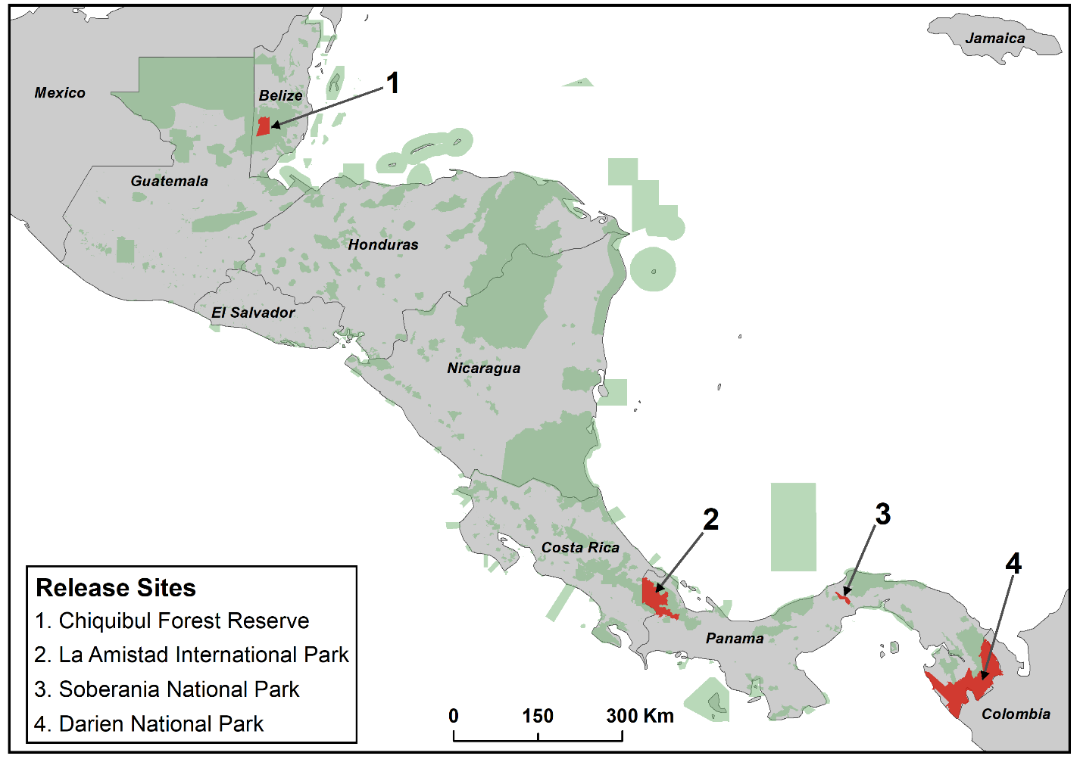
Figure 1. Location of release sites of captive-reared and wild-rehabilitated Harpy Eagles (Harpia harpyja) in Central American landscapes. Protected areas are indicated in green. Protected areas where eagles were released are highlighted in red.

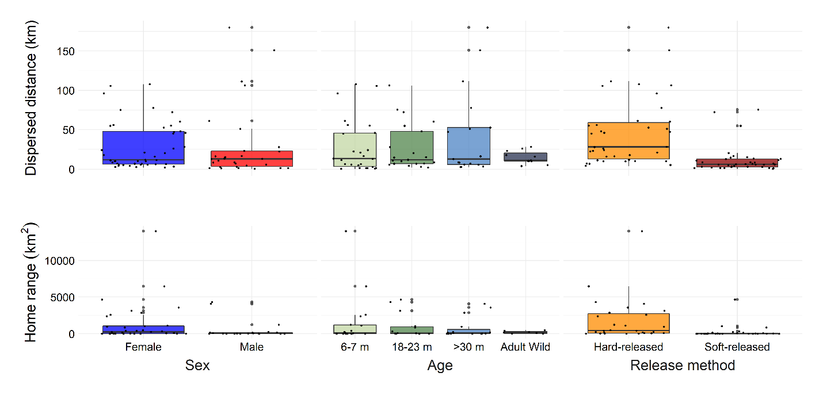
Fig 2. Dispersal and home ranges among sex, age at release and release method of captive-reared and wild-rehabilitated Harpy Eagles (Harpia harpyja) in Central American landscapes.

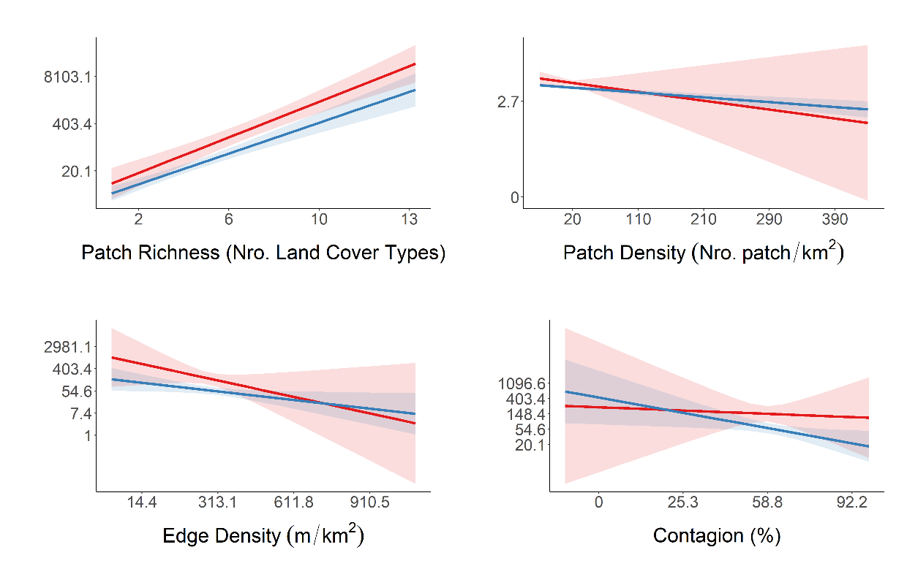
Figure 3. Marginal effects of the effects of released methods and landscape metrics on space use (home range size) of captive-reared and wild-rehabilitated Harpy Eagles (Harpia harpyja) in Central American landscapes. Red and blue lines correspond to hard- and soft-released individuals, respectively. Vertical axis is natural logarithmic scale (back-transformed to km²). Color shadows represent 95% confidence intervals.

