Record of Halmahera Walking (Hemiscyllium halmahera) Shark in South Morotai
Muhammad Ichsan¹, Harimurti Asih Bimantara², Niomi Pridina¹, Adinda Nindya Wardhanie²

¹Yayasan Impak Laut Biru Indonesia (Impact Blue Sea Foundation), Perum Pesona Khayangan Blok BS No. 18 RT/RW 01/27, Mekarjaya, Sukmajaya, Depok, Bogor, West Java. 16411
²Gorango Morotai (GOMO) Dive, Jl. Pelabuhan Ferry No.31, Juanga, Kec. Morotai Sel., Kabupaten Pulau Morotai, Maluku Utara 97771

Abstract
In 2013, Allen et. al. discovered the Halmahera walking shark (Hemiscyllium halmahera) in North Maluku, Indonesia. The current known distribution of this species is within Halmahera Island and surrounding islands, such as Ternate, Tidore, Bacan, and Morotai. This study discussed the records history of the species on Morotai Island and the risk faced by this species. Where recently, one individual of this species was recorded opportunistically during SCUBA Diving activity in April 2022 in Southern Morotai, one of Indonesia's most well-known marine tourism sites for shark diving. Understanding the species distribution, habitat, and behavior within this area is essential for improving conservation and tourism management, especially for endemic shark species with a limited habitat range.

Introduction
Halmahera walking shark (Hemiscyllium halmahera) is a species of shark that was recently found in North Maluku waters, Indonesia. [1]. The species are part of the Hemiscylliidae family, commonly known as the walking sharks, bamboo sharks, and epaulette sharks, which consisted of two genera; Chiloscyllium and Hemiscyllium (Müller & Henle - 1837 & 1838) and seven and nine species have respectively identified. This group of sharks is nocturnal and lives in a coral reef, seagrass and sandy substrate ecosystem [2]. The Total length of this species is not more than 80 cm according to Allen et. al 2013, and another study by Madduppa et. al 2013 shows the maximum TL of 74 cm and average TL of 52.3±10.2 cm for both species (N=32). The recorded depth of this species is mostly around 3-10 m [1], [3], [4] with a maximum depth recorded at 18 m in other studies [5].

Since the first discovery of this species in 2013, there are still limited studies regarding their distribution, biology, ecology, and conservation approaches. Based on the historical records of the distribution of H. Halmahera species, the current known distribution is within the northwestern Ternate Island (Ternate City); Kao Bay (North Halmahera District); Tidore, Maitara, Mare Island (Tidore Islands City); Loleo (Central Halmahera District) and Proco Island, Bacan Island, Guraici, Weda Bay and Lei-Lei (South Halmahera District) and Southern Morotai (Morotai Island District) [1], [3]–[7].

Records of this species in Morotai Island are very scarce, although we distinguished several anecdotal reports from local dive guides and fishers throughout the years. Two records in Fathiya Point, South Morotai, both seen at night dive; the first was by Ichsan et al. in 2015, and the second was from an Instagram social media post (@rumahfirman and @sharkdivingindonesia) in 2016 that located around 5 km from the new encountered of this species. Further understanding of the species distribution, habitat, and behaviour is essential for conservation, especially for endemic shark species with a limited habitat range.

Methods
Halmahera walking shark was observed in Ciko Play Ground (CPG) Dive site, Tanjung Dehegila, South Morotai, North Maluku (Figure 1 and 2). This dive site is a reef slope with a maximum depth of 30 m. One of the authors reported seeing one individual Halmahera walking shark during recreational SCUBA diving when the individual was hiding between coral reefs at approximately 7 m depth. Documentation of Halmahera walking shark was taken at 11 am on 8 of April 2022 at a depth of 7 m during the only sighting recorded with GoPro 10 Action Camera with automatic underwater setting. The temperature recorded at the sighting time was 29ºC. Photographs and video stills were taken during the encounter and were identified based on morphological features based in several scientific publications focusing on this species [1], [3], [4].
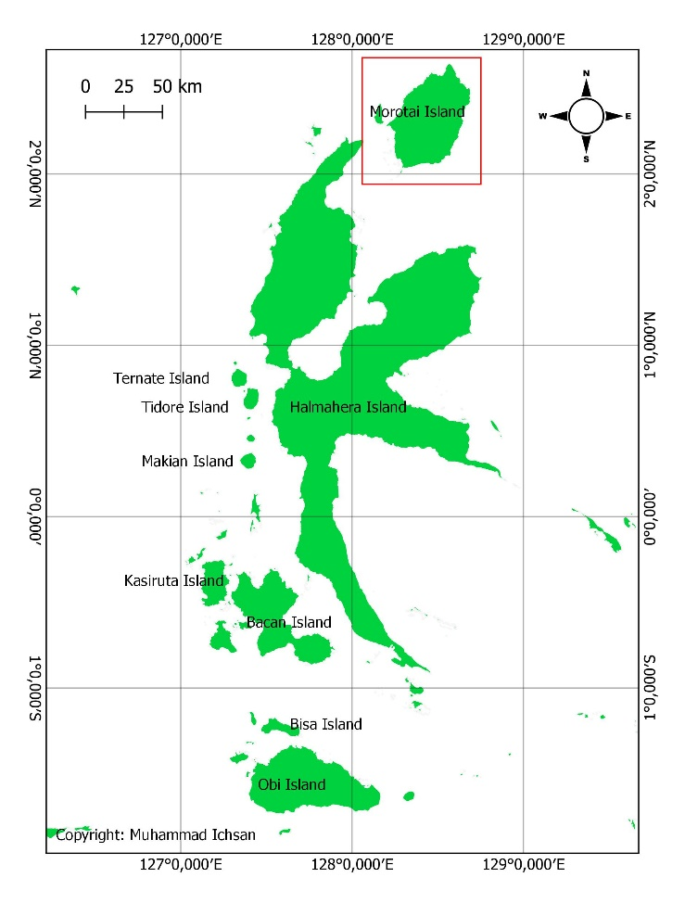
Figure 1. Morotai Island District (red box) within North Maluku Province.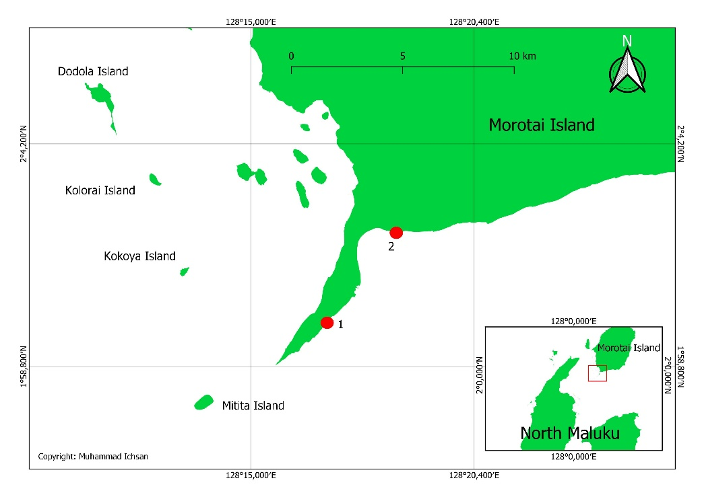
Figure 2. Location of documented H. halmahera individuals in Morotai.
Ciko Play Ground (CPG), Tanjung Dehegila (in red dot no. 1, this study) and Fathiya Point (in red dot no. 2, Ichsan et. al. 2015) both in South Morotai Sub-district (inset in red box), Morotai Island District.

Results and Discussion

Species identification
Order: Orectolobiformes
Family: Hemiscylliidae
Genus: Hemiscyllium
Species: H. halmahera (G. R. Allen, Erdmann & Dudgeon, 2013)

Based on the documentation (Figure 3 and 4), theindividual is distinguished by their shape and colour pattern [1]. The sex of the individual could not be identified due to the shark's position when encountered.
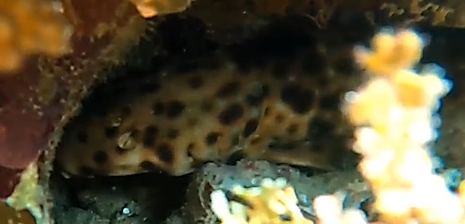
$©$Harimurti Asih Bimantara
Figure 3. The head part image of H. halmahera
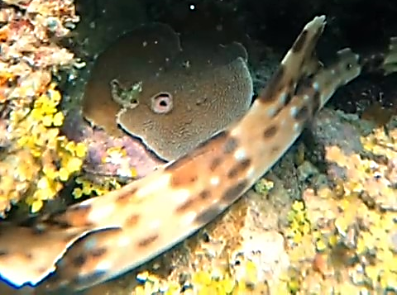
$©$Harimurti Asih Bimantara
Figure 3. the rear part image of H. halmahera

Extention risk
H.halmahera face several threats to survival, such as loss and degradation of habitat, artisanal fisheries as secondary catch, local and international trade for aquaria and climate change. Like every species in the genus of Hemiscylliidae, H. halmahera heavily relies on shallow reef habitats and has small range sizes. Any disturbance in their habitat will increasethe possibility of local extinction [8]. In North Maluku, habitat degradation of reef flats due to unsustainable fishing and mining activities in coastal zones is a concerning threat as a study shows heavy metal exposure in H. halmahera (Jutan et al., 2019). Change of habitat due to climate change can also result in rising sea surface temperature that can negatively affect species survival, especially in species that are highly reliant on specific and small habitats [8]–[11]. Moreover, H. halmahera is a bottom-dwelling species with a colorful appearance and hasbeen collected as an ornamental fish in the national and international aquarium trade, with a report of up to 60 individuals per shipment [6], [12].

Conservation
H. halmahera is listed as Near Threatened by the International Union of Conservation of Nature (IUCN), with no species-specific protection at global and national levels [12]. Marine spatial protection is essential for species that highly rely on specific habitats like H. halmahera. As per 2020, North Maluku Province have six (6) Marine Protected Areas that cover 667.683,08 Ha of their marine area (Table 1)[13].
Table 1. MPAs of North Maluku [13]
MPA | District / City | Area (Ha)
KKPD Pulau Mare | Tidore Islands City | 7.060,87
KKPD Pulau Rao-Tanjung Dehegila | Morotai Island District | 65.892,42
KKPD Kepulauan Sula | Sula Islands District | 120.723,88
KKPD Kepulauan Widi | South Halmahera District | 315.117,92
KKPD Kepulauan Guraici | South Halmahera District | 91.538,99
KKPD Pulau Makian-Moti | Ternate City | 67.349,00
Total Area |  | 667.683,08

In Morotai Island District, the MPA covers 65.892,42 Ha of marine area (Table 1), with seven subzones focusing on the protecting marine habitat, tourism and sustainable fisheries. The sites of documented H. halmahera currently are within traditional fisheries zone (CPG) and the sustainable tourism zone (Fathiya Point) [14].
Based on this species' recorded habitat location and preference, it is safe to assume that they could occupy most of the Morotai Island. However, with limited protection of these species and considering the lack of reports and many undocumented sightings, there is a need to further understand their condition through a long-term monoitoringprogram, and increasing the conservation effort within this area. Some recommendations to achieve this includes: 1) strengthening awareness for endemic and small-range species protection; 2) developing clear and specific objectives in managing this species within the MPA Management action plan ; 3) encouraging research effort, especially for citizen science, with active participation from tourism stakeholders such as dive-and snorkelling guides.

Acknowledgement
We want to thank the Gorango Morotai (GOMO) Dive crew and the Morotai Island District Government for supporting this study and the development of conservation-based shark diving tourism in the region.

Reference
[1] G. R. Allen, M. V. Erdmann, and C. L. Dudgeon, “Hemiscyllium halmahera, a new species of Bamboo Shark (Hemiscylliidae) from Indonesia,” vol. 19, no. 3, p. 14, 2013.
[2] L. J. V. Compagno, Sharks of the world, Bullhead, mackerel and carpet sharks (Heterodontiformes, Lamniformes and Orectolobiformes)., vol. 2. 2001.
[3] N. Akbar, I. Tahir, A. Baksir, R. E. Paembonan, and F. Ismail, “Morphologies description of Halmahera epaulette shark endemic species (Hemiscyllium halmahera, Allen & Erdmann, 2013) in North Maluku Sea,” J Iktiol Indones, vol. 19, no. 2, p. 297, Feb. 2020, doi: 10.32491/jii.v19i2.494.
[4] H. Madduppa et al., “Morphometric and DNA Barcoding of endemic Halmaheran walking shark (Hemiscyllium halmahera, Allen, 2013) in North Maluku, Indonesia: Morphogenetic of endemic Halmaheran walking shark,” Biodiversitas, vol. 21, no. 7, Jun. 2020, doi: 10.13057/biodiv/d210757.
[5] M. Ichsan, N. Pridina, and D. A. Mukharror, “Pariwisata Penyelaman Ikan Hiu Di Perairan Morotai, Maluku Utara, Indonesia,” p. 6, 2015.
[6] Y. Jutan, A. Retraubun, A. Khouw, V. Nikijuluw, and J. Pattikawa, “Study on the population of Halmahera walking shark (Hemiscyllium halmahera) in kao bay, north maluku, Indonesia,” International Journal of Fisheries and Aquatic Studies, vol. 6, no. 4, pp. 36–41, 2018.
[7] D. A. Mukharror, D. Susiloningtyas, and M. Ichsan, “Tonic immobility induction and duration on halmahera walking shark ( Hemischyllium halmahera ),” IOP Conf. Ser.: Earth Environ. Sci., vol. 404, p. 012080, Dec. 2019, doi: 10.1088/1755-1315/404/1/012080.
[8] W. J. VanderWright, C. L. Dudgeon, M. V. Erdmann, A. Sianipar, and N. K. Dulvy, “Extinction Risk and the Small Population Paradigm in the Micro-Endemic Radiation of Epaulette Sharks,” in Imperiled: The Encyclopedia of Conservation, Elsevier, 2022, pp. 752–762. doi: 10.1016/B978-0-12-821139-7.00130-6.
[9] D. D. U. Heinrich et al., “A product of its environment: the epaulette shark (Hemiscyllium ocellatum) exhibits physiological tolerance to elevated environmental CO2,” Conservation Physiology, vol. 2, no. 1, pp. cou047–cou047, Oct. 2014, doi: 10.1093/conphys/cou047.
[10] M. R. Heupel, J. Carlson, and C. A. Simpfendorfer, “Marine Ecology Progress Series 337:287,” Mar Ecol Prog Ser, p. 11, 2007.
[11] G. Wise, J. M. Mulvey, and G. M. C. Renshaw, “Hypoxia tolerance in the epaulette shark (Hemiscyllium ocellatum),” J. Exp. Zool., vol. 281, no. 1, pp. 1–5, May 1998, doi: 10.1002/(SICI)1097-010X(19980501)281:1<1::AID-JEZ1>3.0.CO;2-S.
[12] W. J. VanderWright, G. R. Allen, D. Derrick, C. L. Dudgeon, M. V. Erdmann, and A. Sianipar, “Hemiscyllium halmahera (amended version of 2020 assessment). The IUCN Red List of Threatened Species 2021: e.T176486052A198885632.,” The IUCN Red List of Threatened Species, 2021. https://dx.doi.org/10.2305/IUCN.UK.2021-2.RLTS.T176486052A198885632.en (accessed Jun. 27, 2022).
[13] Direktorat Jenderal Pengelolaan Ruang Laut, Kementerian Kelautan dan Perikanan, “Data Kawasan Konservasi Perairan,” Kementerian Kelautan dan Perikanan, 2022. https://kkp.go.id/djprl/kkhl/page/2023-data-kawasan-konservasi-perairan (accessed Jun. 28, 2022).
[14] Dinas Kelautan dan Perikanan Provinsi Maluku Utara, “Rencana Pengelolaan Dan Zonasi Taman Wisata Perairan (TWP) Pulau Rao-Tanjung Dehegila Provinsi Maluku Utara Tahun 2020 - 2040.” Dinas Kelautan dan Perikanan Provinsi Maluku Utara, 2019.

