The IUCN Red List is not sufficient to protect genetic diversity
Chloé Schmidt*^{1,2,3}, Sean Hoban⁴, Margaret Hunter⁵, Ivan Paz-Vinas⁶, Colin J Garroway³

Affiliations
¹ Department of Ecology and Evolutionary Biology, Yale University, New Haven, CT, USA
² Center for Biodiversity and Global Change, Yale University, New Haven, CT, USA
³ Department of Biological Sciences, University of Manitoba, Winnipeg, Manitoba, Canada
⁴ The Center for Tree Science, The Morton Arboretum, Lisle, IL, USA
⁵ U.S. Geological Survey, Wetland and Aquatic Research Center, Gainesville, Florida, USA
⁶ Laboratoire Evolution et Diversité Biologique (EDB), UMR5174, Université Toulouse 3 Paul Sabatier, CNRS, IRD, Toulouse, France

ORCIDs: CS: 0000-0003-2572-4200; MH: 0000-0002-4760-9302; IPV: 0000-0002-0043-9289; CJG: 0000-0001-8010-9388

Correspondence:
Chloé Schmidt
Department of Biological Sciences
50 Sifton Road
University of Manitoba
Winnipeg, MB R3T 2N2
email: schmid46@myumanitoba.ca

Word count: 5,504
Abstract
The International Union for Conservation of Nature (IUCN) Red List is an important and widely used conservation prioritization tool. It uses information about species range size, habitat quality and fragmentation levels, and trends in abundance to assess species extinction risk. Genetic erosion is an additional key factor determining extinction risk, but the Red List was not designed to assess genetic diversity. Declining populations experience stronger effects of genetic drift and higher rates of inbreeding, which can reduce the efficiency of selection, lead to fitness declines, and hinder species’ capacities to adapt to environmental change. Given the importance of conserving genetic diversity, several studies have attempted to find relationships between Red List status and genetic diversity. Yet, there is still no general consensus on whether genetic diversity is captured by the current Red List categories in a way that is informative for conservation, likely partly due to assessments using different molecular markers and taxa. Here, we synthesize previous work and re-analyze three datasets using different marker types (mitochondrial DNA, microsatellites, and whole genomes) to assess whether genetic diversity accurately predicts Red List threat status. Consistent with previous work we found that on average, species with higher threat status tended to have lower genetic diversity for all marker types, but the strength of these relationships varied across taxa. However, genetic diversity did not predict threat status well for any taxon or marker type. Our analyses indicate that Red List status is not a useful metric for informing species-specific decisions about the protection of genetic diversity. This is unsurprising because the Red List was not designed for conservation at the genetic level. Our findings clearly indicate a need to develop and incorporate metrics specifically developed to assess genetic diversity into our conservation policy frameworks.

Keywords: conservation policy, vertebrates, heterozygosity, genetic drift, molecular markers, data synthesis, mitochondrial DNA, nuclear DNA

Main text
Background
The International Union for Conservation of Nature (IUCN) Red List is a criterion-based evaluation of species extinction risk that is widely used to prioritize species for conservation. Specifically, the Red List evaluates demographic threats to species persistence. Species are placed into one of several categories of extinction risk based on assessments of species-wide declines in the number of adult individuals (Criterion A); small range sizes, very high levels of habitat fragmentation, or few populations (Criterion B); a declining population (Criterion C); or a very small number of individuals (Criterion D). The IUCN also classifies species abundance trends as decreasing, stable, or increasing. Genetic diversity is not directly incorporated in risk assessments; however, fragmented, small, and declining populations are susceptible to the erosion of genetic diversity due to heightened levels of genetic drift. Low genetic diversity can also lead to reduced population sizes and inbreeding, ultimately resulting in population declines via an extinction vortex. This has led to an ongoing conversation about the extent to which Red List risk statuses might also be useful for guiding the protection of genetic diversity (e.g., (Garner et al. 2020; Canteri et al. 2021; Petit-Marty et al. 2021). Resolving this question is important because genetic diversity is not well-integrated into global conservation policy (Hoban et al. 2020). If Red List status sufficiently captures processes that reduce genetic diversity via demographic changes in populations, there would be no need to add direct indicators of genetic diversity to an already complex conservation policy toolbox.
Resolving the question of whether Red List status captures genetic diversity in a way that is useful for species assessments is timely for conservation policy given recent and upcoming Convention on Biological Diversity post-2020 Global Biodiversity Framework talks (Xu et al. 2021). Several studies have addressed the question of whether the Red List is suitable for assessing extinction risk due to low genetic diversity (Nabholz et al. 2008; Rivers et al. 2014; Doyle et al. 2015; Willoughby et al. 2015; Li et al. 2016; Brüniche-Olsen et al. 2018, 2021; Garner et al. 2020; Buffalo 2021; Canteri et al. 2021; Petit-Marty et al. 2021). Relationships between Red List risk status and genetic diversity are generally–but not consistently–detectable, and it is often argued that these associations are informative for conservation and management decisions related to genetic diversity (e.g., Canteri et al. 2021; Petit-Marty et al. 2021). However, it remains unclear whether these general associative trends between species’ Red List risk status and genetic diversity are useful for identifying species exhibiting genetic erosion (Fig. 1). Models that capture general trends in data often perform poorly when the goal is prediction.
General trends between Red List status and genetic diversity (e.g., Li et al. 2016; Brüniche-Olsen et al. 2021; Canteri et al. 2021; Petit-Marty et al. 2021) suggest that, on average, threatened species tend to have lower genetic diversity than non-threatened species. However, if the models detecting these general relationships have low predictive accuracy, then they will not be informative for identifying whether individual species in a given threat category are at risk of genetic erosion (Fig. 1). Thus, our ability to use Red List status as a proxy for genetic diversity status for specific species hinges on the strength of this relationship and model predictive accuracy. If the general trends detected to date are deemed useful for conservation policy, then policymakers could use Red List status to assess genetic diversity in the absence of genetic data, which is still not available for most species. Additional metrics developed specifically for assessing genetic diversity status and trends would not be needed (Laikre et al. 2020; Hoban et al. 2020, 2021). However, if the relationship between Red List status and genetic diversity is weak and has poor predictive accuracy, relying solely on Red List status would result in a lack of formal and sufficient protection for genetic diversity in natural populations. To evaluate the extent to which species' genetic diversity is predictive of Red List risk status, we reanalyzed three genetic datasets (two previously used for this purpose) containing estimates of genetic diversity obtained from different markers (mitochondrial gene sequences, microsatellites, and whole-genome sequences).
Our first dataset contained estimates of mtDNA cytochrome B diversity from 1036 bird species. This dataset was compiled by Canteri et al. (2021), who used it to assess the relationship between Red List risk (threatened or not) and genetic diversity. They concluded that the Red List species-level conservation criteria capture low levels of genetic diversity. Canteri et al. obtained cytochrome B sequences from GenBank, a genetic sequence database, and measured genetic diversity at the species level using nucleotide diversity for species with 5 sequences minimum (median = 11 sequences across the data set). Species’ Red List statuses were included with the posted data, and we added population trend classifications for species using the ‘rredlist’ package in R (Chamberlain 2020). IUCN population trend assessments were available for 984 species.
Our second dataset consisted of genetic diversity estimates from whole genome sequences (WGS) for 68 bird species from a dataset compiled by Brüniche-Olsen et al. (2021) from two sequence databases, EMBL-EBI and NCBI. Genetic diversity was measured with genome-wide observed heterozygosity estimated from the site frequency spectrum for 1 sequence per species. With these data, Brüniche-Olsen et al. found that threatened species (Endangered and Critically Endangered) had lower observed genomic heterozygosity than non-threatened species. Species Red List categories and population trends were included in this dataset.
Finally, our third dataset was the MacroPopGen database (Lawrence et al. 2018, 2019). This database contains site-level estimates of genetic diversity from microsatellite markers for vertebrate species (terrestrial vertebrates and freshwater fish) across North and South America harvested from the literature. We assigned Red List categories and IUCN population trend classifications to species with rredlist. We were able to assign Red List status to 693 species (80 amphibians; 215 birds; 143 mammals; 120 reptiles; 134 ray-finned fishes; 1 lamprey). We chose to use gene diversity (reported as expected heterozygosity in MacroPopGen) as our metric of genetic diversity because it does not depend strongly on sample size (Charlesworth and Charlesworth 2010). Gene diversity is the average probability that two randomly selected alleles in a population are different (Nei 1973). We averaged gene diversity across sample sites to obtain a species-level measure of genetic diversity comparable to the genetic diversity estimates in the mtDNA and WGS datasets. Among bird species in our analyses, only 5 species were present across all three datasets (54 species shared between mtDNA – microsatellite data sets; 20 mtDNA – WGS; 9 WGS – microsatellite).
We modeled general relationships between our measures of genetic diversity (nucleotide diversity for mtDNA data, observed genome-wide heterozygosity for WGS data, and gene diversity for microsatellite data) and Red List categories with the same two models fit to each dataset. The first model type was an ordinal logistic regression implemented in the MASS library (Venables and Ripley 2002). The dependent variable was threat status ordered by risk (least concern – LC; near-threatened – NT; vulnerable – VU; endangered – EN; and critically endangered – CR). Then, to more closely resemble previous work (Brüniche-Olsen et al. 2021; Canteri et al. 2021), we also tested how well genetic diversity classified broader binary Red List categories, threatened (comprised of CR, EN, and VU categories) vs. non-threatened (NT, LC), using logistic regressions. All analyses were repeated for mtDNA, microsatellite, and WGS diversity estimates separately. These models are similar to those used previously, thus we expected to find similar general trends of a decline in diversity with increasing threat status.
We then took the important next step in assessing the policy relevance of these trends by assessing the ability of our models to accurately categorize individual species' risk status using genetic information alone. To do this we estimated the predictive accuracy (the proportion of correctly classified observations) of models using confusion matrices calculated in the ‘caret’ R package (Kuhn 2021).

Genetic diversity does not predict species Red List status
Consistent with previous analyses (Willoughby et al. 2015; Li et al. 2016; Brüniche-Olsen et al. 2021; Canteri et al. 2021; Petit-Marty et al. 2021), we found that the Red List status was associated with genetic diversity across marker types and all taxa examined except for fishes (Table 1). Genetic diversity for all markers tended to decrease with higher threat statuses (Fig. 2). We also found general associations between genetic diversity and IUCN population size trends: microsatellite diversity for birds, mammals, and amphibians tended to increase for species with positive population size trends. However, diversity decreased for bird mtDNA and whole genome data, and reptile and fish microsatellite data with positive population trends as species-level population sizes moved from decreasing, to stable, to increasing (Table 2, Fig. 3). Our results therefore suggest that genetic diversity is generally statistically related to Red List status and population trends, although directions of effect are not consistent across taxa.
While our models had good predictive accuracy (ordinal regressions: 57-84%; logistic regressions: 63-90%; Tables 1, 2), these levels of accuracy were achieved by classifying nearly all species as Least Concern or non-threatened (Figs. S1-S2). This is known as the accuracy paradox (Fernandes et al. 2010), i.e. when models have low predictive power despite high accuracy. Most species across all datasets were listed as Least Concern (84% of mtDNA data, 65% of microsatellite data, 69% of whole genome sequences), and this category generally encapsulated variation in genetic diversity across all other Red List categories for all marker types. Our tests of predictive accuracy show there is no strong tendency for Critically Endangered, Endangered, or Vulnerable species to have markedly low genetic diversity, and that Least Concern species are equally likely to have low genetic diversity (Figs. 1, 2). These results demonstrate that we cannot predict a species’ Red List risk status from species-level genetic data, nor conversely can Red List status be used as a surrogate for species’ risk of genetic erosion in the absence of genetic data. Therefore, Red List status alone is not useful for decisions related to the conservation of genetic diversity of individual species.

Relationships across marker types
Although we tested 3 marker types, we note that biological differences among markers mean they are not all equally informative for conservation. Mitochondrial genomes are maternally inherited, behave as a single locus because they do not recombine, and have several protein-coding genes–meaning they most likely do not evolve neutrally (Galtier et al. 2009). Mitochondrial DNA diversity is generally not correlated with genome-wide diversity or adaptive potential, two core targets of conservation genetics (Kardos et al. 2021). It is also not strongly related to population size (Bazin et al. 2006), which is a central component for Red List assessment. Mitochondrial markers have been strongly criticized as general tools for population genetics, phylogenetics, and conservation outside of specific contexts (Zink and Barrowclough 2008; Edwards and Bensch 2009; Galtier et al. 2009; Paz‐Vinas et al. 2021; Schmidt and Garroway 2021a).
In contrast, microsatellites and whole-genome data both capture genome-wide diversity. Genetic diversity estimated from ~10 microsatellite loci is well correlated (83%) with genome-wide diversity (Mittell et al. 2015). We therefore expected relationships between Red List status and genetic diversity estimated from mitochondrial versus nuclear data to differ, with nuclear markers being more promising predictors of threat status. Indeed, we did not detect a correlation between mtDNA and microsatellite markers for the bird species that overlapped in our data (Fig. 4). However, the general trends we found were in the same direction across all marker types. We suspect the general, species-level trends captured by our own and previously published models could be driven by particularly significant declines in abundance or range extent in some species, which could cause genetic diversity declines in both mitochondrial and nuclear DNA. The similar trends we detect across marker types suggest that most threatened species have likely undergone a genetic bottleneck, but not all species with low genetic diversity are considered threatened. In other words, Least Concern species may be equally likely to have experienced a decline that caused a reduction in genetic diversity at some point in their history, but for reasons we discuss in the following section, these low levels of genetic diversity may not necessarily be of conservation concern. Alternatively, these species could be miscategorized.

Low versus declining genetic diversity
Many reasons might explain the mismatch between Red List status and species-level genetic diversity. Declines in genetic diversity can often be difficult to detect due to time lags between the ecological causes of demographic decline and their evolutionary consequences (Landguth et al. 2010; Pflüger et al. 2019), and due to non-linear relationships between range loss and genetic diversity loss (Pflüger et al. 2019). Previous work has shown that genome-wide genetic diversity is not strongly correlated with IUCN estimates of present abundance (Willoughby et al. 2015). Furthermore, changes in nuclear DNA genetic diversity following habitat disturbance are variable across taxa. For example, with regard to habitat disturbance related to urbanization, mammals generally lose diversity in highly urbanized areas, but at different rates depending on species (DiBattista 2008; Schmidt et al. 2020; Habrich et al. 2021); bird species either lose or gain genetic diversity in more urban areas (Schmidt et al. 2020); while changes in amphibian genetic diversity are more idiosyncratic depending on species and location (Schmidt and Garroway 2021b). Variation in response rate to local and contemporary habitat changes can obscure the relationship between a species’ genetic diversity and its Red List status over time.
The inability of our models to accurately identify threatened species also indicates a potential problem with using species-level estimates of genetic diversity as a criterion to assess conservation status, because species have variable levels of genetic diversity at mutation-drift equilibrium. The natural census size of species will also cause variation in equilibrium levels of genetic diversity at the species level (Eo et al. 2011; Romiguier et al. 2014; Buffalo 2021). For instance, there were many species with relatively low genetic diversity that are classified as Least Concern (Fig. 2), an observation that has generated suggestions to include genetic diversity in species risk assessment (Willoughby et al. 2015; Garner et al. 2020). Canteri et al. note that only a few non-threatened (4%) and threatened (10%) bird species had notably low genetic diversity. Brüniche-Olsen et al. report that 9 species had heterozygosity <9×10⁻⁴ (13th percentile), 6 of which were listed as threatened.
The demographic histories of individual populations can also contribute to variation in genetic diversity across species, especially for species where only few sites or sequences were sampled. A species with low contemporary genetic diversity that also has a low long-term effective population size and stable abundance is not necessarily of high priority for conservation, at least in terms of genetic vulnerability (e.g., Reed 2010; Fraser et al. 2014). The data we present suggest that demographically stable species (Least Concern or stable population trends) have a wide range of genetic diversity levels (Figs. 2, 3). This variability poses an issue for the possibility of integrating genetic diversity into Red List classifications by setting thresholds that are determined through interspecific comparisons, because they may not translate into meaningful conservation gains for the classified species.
A pressing conservation issue for population genetic diversity that has been highlighted at the policy level are recent, ongoing declines in abundance and loss of distinct populations (Hoban et al. 2021). Declines in genetic diversity are not necessarily cause for alarm; for example, they might lead to inbreeding and the eventual exposure of phenotypes associated with recessive alleles in homozygous states. This can cause deleterious alleles to be selectively purged, which reduces negative effects of inbreeding and enables populations to persist with low levels of genetic diversity (Mathur and DeWoody 2021; Kardos et al. 2021). While purging deleterious alleles can help counteract ill effects of inbreeding, it cannot be relied on to do so, especially in the long term. Many more populations will have gone extinct due to complications associated with low genetic diversity than those that persist in spite of it (Spielman et al. 2004; Frankham et al. 2019). Species-level genetic diversity estimates obtained by averaging across population-level estimates can obscure declines in species with high diversity, especially in unmonitored and opportunistically sampled populations. Declines are ideally assessed with intraspecific data sampled over time, but unfortunately, this is difficult to do at scale (but see Leigh et al. 2019). Repurposing publicly available genetic data can allow us to overcome this to an extent by substituting space for time (or impact for time) to study environmental factors related to decline using data from multiple populations per species (Schmidt et al. 2020; Habrich et al. 2021; Schmidt and Garroway 2021b). Overall, we conclude that continued interspecific comparisons of Red List rankings and average species genetic diversity are unproductive because the nature and causes of genetic diversity loss are variable across genetic markers, populations, species, and species’ ranges. Below we list ways in which genetic diversity can be incorporated into species risk assessments to improve its protection.

A way forward
Red List rankings are used extensively for conservation planning, often at the species or regional level, such as prioritizing actions for species at the highest risk levels (Critically Endangered and Endangered) and identifying at risk regions or Key Biodiversity Areas (Hoffmann et al. 2008). The Red List process of compiling information from experts also allows analysis of threats to individual species, species in a region, and globally (Rodrigues et al. 2006). Change in the Red List Index over time is a useful global indicator of biodiversity loss (Tittensor et al. 2014; though see Fraixedas et al. 2022 for a critique of other aspects of the Red List). It is apparent, however, that these patterns are currently not related to genetic diversity in a way that is meaningful for conservation, as has been pointed out previously (Nabholz et al. 2008; Rivers et al. 2014; Doyle et al. 2015; Willoughby et al. 2015). This is not surprising, because the Red List was not developed to assess genetic diversity. Given its focus on demographic change, it was important to test whether the Red List might encompass genetic diversity and remove the need to further develop tools to assess genetic erosion. The takeaway from these extended analyses is that the Red List, on its own, cannot account for the genetic diversity patterns of individual species, and is not reliable for conserving and recovering genetic diversity. Genetic diversity assessments, in combination with the use of well-verified proxies or indicators of genetic diversity (Hanson et al. 2017; Hoban et al. 2020, 2022) and other conservation assessment tools, are needed to assess species’ vulnerability to genetic erosion.
Where do we go from here? To our minds, it is time to shift attention away from policy tools that were not designed to capture genetic information when the goal is to conserve genetic diversity (Hoban et al. 2022). Nuclear genetic data are increasingly available for a wider variety of species (Leigh et al. 2021), enhancing our ability to look more deeply into genetic diversity status below the species level (Hoban et al. 2022). Additionally, as more genomes become fully sequenced, there are more proposals for assessing genetic erosion status using genome level statistics (van Oosterhout 2020, 2021; Bertorelle et al. 2022). The majority of species will lack genetic data for the foreseeable future. This highlights the need to develop effective proxies that are directly connected to genetic diversity (Hoban et al. 2020, 2021). For example, proxies could include the proportion of populations with low effective size (which will slow genetic erosion), or the proportion of distinct populations lost (Hoban et al. 2020, 2021, 2022).
The rapid collection and use of these genetic, genomic, and proxy metrics in a coordinated way across thousands of species is important to help the scientific community advance understanding and inform decision making. Producing and aggregating these data, however, would require considerable effort. Data would ideally be aggregated in centralized databases that can be expanded and updated over time, similar to updates to the Red List. Rather than tailoring new data to suit old metrics, the increasing availability of abundant, fine-scale genetic data can enable conservation geneticists to develop and adopt improved metrics. Fortunately, additional tools are forthcoming. The ongoing development of a suite of genetic Essential Biodiversity Variables (Hoban et al. 2022) means that policymakers can begin to move beyond the Red List to safeguard genetic diversity in all species.

References
Bazin, E., Glémin, S., and Galtier, N. 2006. Population size does not influence mitochondrial genetic diversity in animals. Science. 312(5773): 570–572. doi:10.1126/science.1122033.
Bertorelle, G., Raffini, F., Bosse, M., Bortoluzzi, C., Iannucci, A., Trucchi, E., Morales, H.E., and van Oosterhout, C. 2022. Genetic load: genomic estimates and applications in non-model animals. Nat. Rev. Genet. 23(8): 492–503. doi:10.1038/s41576-022-00448-x.
Brüniche-Olsen, A., Kellner, K.F., Anderson, C.J., and DeWoody, J.A. 2018. Runs of homozygosity have utility in mammalian conservation and evolutionary studies. Conserv. Genet. 19(6): 1295–1307. doi:10.1007/s10592-018-1099-y.
Brüniche-Olsen, A., Kellner, K.F., Belant, J.L., and Dewoody, J.A. 2021. Life-history traits and habitat availability shape genomic diversity in birds: Implications for conservation. Proc. R. Soc. B Biol. Sci. 288(1961). doi:10.1098/rspb.2021.1441.
Buffalo, V. 2021. Quantifying the relationship between genetic diversity and population size suggests natural selection cannot explain Lewontin’s paradox. Elife 10. doi:10.7554/eLife.67509.
Canteri, E., Fordham, D.A., Li, S., Hosner, P.A., Rahbek, C., and Nogués-Bravo, D. 2021. IUCN Red List protects avian genetic diversity. Ecography. 44(12): 1808–1811. doi:10.1111/ecog.05895.
Chamberlain, S. 2020. rredlist: “IUCN” Red List Client. Available from https://cran.r-project.org/package=rredlist.
Charlesworth, B., and Charlesworth, D. 2010. Elements of evolutionary genetics. Roberts & Company Publishers, Greenwood Village, Colorado, USA.
DiBattista, J.D. 2008. Patterns of genetic variation in anthropogenically impacted populations. Conserv. Genet. 9(1): 141–156. doi:10.1007/s10592-007-9317-z.
Doyle, J.M., Hacking, C.C., Willoughby, J.R., Sundaram, M., and DeWoody, J.A. 2015. Mammalian Genetic Diversity as a Function of Habitat, Body Size, Trophic Class, and Conservation Status. J. Mammal. 96(3): 564–572. doi:10.1093/jmammal/gyv061.
Edwards, S., and Bensch, S. 2009. Looking forwards or looking backwards in avian phylogeography? A comment on Zink and Barrowclough 2008. Mol. Ecol. 18: 2930–2933.
Eo, S.H., Doyle, J.M., and DeWoody, J.A. 2011. Genetic diversity in birds is associated with body mass and habitat type. J. Zool. 283(3): 220–226. doi:10.1111/j.1469-7998.2010.00773.x.
Fernandes, J.A., Irigoien, X., Goikoetxea, N., Lozano, J.A., Inza, I., Pérez, A., and Bode, A. 2010. Fish recruitment prediction, using robust supervised classification methods. Ecol. Modell. 221(2): 338–352. doi:10.1016/j.ecolmodel.2009.09.020.
Fraixedas, S., Roslin, T., and Laine, A. 2022. Nationally reported metrics can’t adequately guide transformative change in biodiversity policy. Proc. Natl. Acad. Sci. 119(9): 1–4.
Frankham, R., Ballou, J.D., Ralls, K., Eldridge, M., Dudash, M.R., Fenster, C.B., Lacy, R.C., and Sunnucks, P. 2019. Inbreeding and loss of genetic diversity increase extinction risk. In A Practical Guide for Genetic Management of Fragmented Animal and Plant Populations. Oxford University Press. doi:10.1093/oso/9780198783411.001.0001.
Fraser, D.J., Debes, P. V, Bernatchez, L., and Hutchings, J.A. 2014. Population size, habitat fragmentation, and the nature of adaptive variation in a stream fish. Proc. R. Soc. B Biol. Sci. 281: 20140370. doi:10.1098/rspb.2014.0370.
Galtier, N., Nabholz, B., Glémin, S., and Hurst, G.D.D. 2009. Mitochondrial DNA as a marker of molecular diversity: A reappraisal. Mol. Ecol. 18(22): 4541–4550. doi:10.1111/j.1365-294X.2009.04380.x.
Garner, B.A., Hoban, S., and Luikart, G. 2020. IUCN Red List and the value of integrating genetics. Conserv. Genet. 21(5): 795–801. doi:10.1007/s10592-020-01301-6.
Habrich, A.K., Lawrence, E.R., and Fraser, D.J. 2021. Varying genetic imprints of road networks and human density in North American mammal populations. Evol. Appl. 14(6): 1659–1672. doi:10.1111/eva.13232.
Hanson, J.O., Rhodes, J.R., Riginos, C., and Fuller, R.A. 2017. Environmental and geographic variables are effective surrogates for genetic variation in conservation planning. Proc. Natl. Acad. Sci. U. S. A. 114(48): 201711009. doi:10.1073/pnas.1711009114.
Hoban, S., Archer, F.I., Bertola, L.D., Bragg, J.G., Breed, M.F., Bruford, M.W., Coleman, M.A., Ekblom, R., Funk, W.C., Grueber, C.E., Hand, B.K., Jaffé, R., Jensen, E., Johnson, J.S., Kershaw, F., Liggins, L., MacDonald, A.J., Mergeay, J., Miller, J.M., Muller‐Karger, F., O’Brien, D., Paz‐Vinas, I., Potter, K.M., Razgour, O., Vernesi, C., and Hunter, M.E. 2022. Global genetic diversity status and trends: towards a suite of Essential Biodiversity Variables (EBVs) for genetic composition. Biol. Rev. doi:10.1111/brv.12852.
Hoban, S., Bruford, M., D’Urban Jackson, J., Lopes-Fernandes, M., Heuertz, M., Hohenlohe, P.A., Paz-Vinas, I., Sjögren-Gulve, P., Segelbacher, G., Vernesi, C., Aitken, S., Bertola, L.D., Bloomer, P., Breed, M., Rodríguez-Correa, H., Funk, W.C., Grueber, C.E., Hunter, M.E., Jaffe, R., Liggins, L., Mergeay, J., Moharrek, F., O’Brien, D., Ogden, R., Palma-Silva, C., Pierson, J., Ramakrishnan, U., Simo-Droissart, M., Tani, N., Waits, L., and Laikre, L. 2020. Genetic diversity targets and indicators in the CBD post-2020 Global Biodiversity Framework must be improved. Biol. Conserv. 248: 108654. doi:10.1016/j.biocon.2020.108654.
Hoban, S., Bruford, M.W., Funk, W.C., Galbusera, P., Griffith, M.P., Grueber, C.E., Heuertz, M., Hunter, M.E., Hvilsom, C., Stroil, B.K., Kershaw, F., Khoury, C.K., Laikre, L., and Lopes-, M. 2021. Global commitments to conserving and monitoring genetic diversity are now necessary and feasible. Bioscience: 1–13. doi:10.1093/biosci/biab054.
Hoffmann, M., Brooks, T.M., da Fonseca, G.A.B., Gascon, C., Hawkins, A.F.. A., James, R.E., Langhammer, P., Mittermeier, R.A., Pilgrim, J.D., Rodrigues, A.S.L., and Silva, J.M.C. 2008. Conservation planning and the IUCN Red List. Endanger. Species Res. 6(2): 113–125. doi:10.3354/esr00087.
Kardos, M., Armstrong, E.E., Fitzpatrick, S.W., Hauser, S., Hedrick, P.W., Miller, J.M., Tallmon, D.A., and Funk, W.C. 2021. The crucial role of genome-wide genetic variation in conservation. Proc. Natl. Acad. Sci. 118(48): e2104642118. doi:10.1073/pnas.2104642118.
Kuhn, M. 2021. caret: Classification and Regression Training. Available from https://cran.r-project.org/package=caret.
Laikre, L., Hoban, S., Bruford, M.W., Segelbacher, G., Allendorf, F.W., Gajardo, G., Gonzalez-Rodriguez, A., Hedrick, P.W., Heuertz, M., Hohenlohe, P.A., Jaffé, R., Johannesson, K., Liggins, L., MacDonald, A.J., Orozco-terWengel, P., Reusch, T.B.H., Rodríguez-Correa, H., Russo, I.R.M., Ryman, N., and Vernesi, C. 2020. Post-2020 goals overlook genetic diversity. Science. 2121: 1083–1085. doi:10.1126/science.abb2748.
Landguth, E.L., Cushman, S.A., Schwartz, M.K., McKelvey, K.S., Murphy, M., and Luikart, G. 2010. Quantifying the lag time to detect barriers in landscape genetics. Mol. Ecol. 19(19): 4179–4191. doi:10.1111/j.1365-294X.2010.04808.x.
Lawrence, E.R., Benavente, J.N., Matte, J.-M., Marin, K., Wells, Z.R.R., Bernos, T.A., Krasteva, N., Habrich, A., Nessel, G.A., Koumrouyan, R.A., and Fraser, D.J. 2019. Geo-referenced population-specific microsatellite data across American continents, the MacroPopGen Database. Sci. Data 6(1): 14. doi:10.1038/s41597-019-0024-7.
Lawrence, E.R., Benavente, J.N., Matte, J., Marin, K., Wells, Z.R.R., Bernos, T.A., Habrich, A., Nessel, G.A., Koumrouyan, R.A., and Fraser, D.J. 2018. MacroPopGen Database: Geo-referenced population-specific microsatellite data across the American continents. Available from https://doi.org/10.6084/m9.figshare.7207514.v2 [accessed 11 November 2021].
Leigh, D.M., Hendry, A.P., Vázquez‐Domínguez, E., and Friesen, V.L. 2019. Estimated six per cent loss of genetic variation in wild populations since the industrial revolution. Evol. Appl. 12(8): 1505–1512. doi:10.1111/eva.12810.
Leigh, D.M., van Rees, C.B., Millette, K.L., Breed, M.F., Schmidt, C., Bertola, L.D., Hand, B.K., Hunter, M.E., Jensen, E.L., Kershaw, F., Liggins, L., Luikart, G., Manel, S., Mergeay, J., Miller, J.M., Segelbacher, G., Hoban, S., and Paz-Vinas, I. 2021. Opportunities and challenges of macrogenetic studies. Nat. Rev. Genet. doi:10.1038/s41576-021-00394-0.
Li, H., Xiang-Yu, J., Dai, G., Gu, Z., Ming, C., Yang, Z., Ryder, O.A., Li, W.H., Fu, Y.X., and Zhang, Y.P. 2016. Large numbers of vertebrates began rapid population decline in the late 19th century. Proc. Natl. Acad. Sci. U. S. A. 113(49): 14079–14084. doi:10.1073/pnas.1616804113.
Mathur, S., and DeWoody, J.A. 2021. Genetic load has potential in large populations but is realized in small inbred populations. Evol. Appl. 14(6): 1540–1557. doi:10.1111/eva.13216.
Mittell, E.A., Nakagawa, S., and Hadfield, J.D. 2015. Are molecular markers useful predictors of adaptive potential? Ecol. Lett. 18(8): 772–778. doi:10.1111/ele.12454.
Nabholz, B., Mauffrey, J.F., Bazin, E., Galtier, N., and Glemin, S. 2008. Determination of mitochondrial genetic diversity in mammals. Genetics 178(1): 351–361. doi:10.1534/genetics.107.073346.
Nei, M. 1973. Analysis of gene diversity in subdivided populations. Proc. Natl. Acad. Sci. U. S. A. 70(12): 3321–3323. doi:10.1073/pnas.70.12.3321.
van Oosterhout, C. 2020. Mutation load is the spectre of species conservation. Nat. Ecol. Evol. 4(8): 1004–1006. doi:10.1038/s41559-020-1204-8.
van Oosterhout, C. 2021. Conservation genetics: 50 Years and counting. Conserv. Lett. 14(2): 1–2. doi:10.1111/conl.12789.
Paz‐Vinas, I., Jensen, E.L., Bertola, L.D., Breed, M.F., Hand, B.K., Hunter, M.E., Kershaw, F., Leigh, D.M., Luikart, G., Mergeay, J., Miller, J.M., Van Rees, C.B., Segelbacher, G., and Hoban, S. 2021. Macrogenetic studies must not ignore limitations of genetic markers and scale. Ecol. Lett.: ele.13732. doi:10.1111/ele.13732.
Petit-Marty, N., Vázquez-Luis, M., and Hendriks, I.E. 2021. Use of the nucleotide diversity in COI mitochondrial gene as an early diagnostic of conservation status of animal species. Conserv. Lett. 14(1): 1–7. doi:10.1111/conl.12756.
Pflüger, F.J., Signer, J., and Balkenhol, N. 2019. Habitat loss causes non-linear genetic erosion in specialist species. Glob. Ecol. Conserv. 17: e00507. doi:10.1016/j.gecco.2018.e00507.
Reed, D.H. 2010. Albatrosses, eagles and newts, Oh My!: Exceptions to the prevailing paradigm concerning genetic diversity and population viability? Anim. Conserv. 13(5): 448–457. doi:10.1111/j.1469-1795.2010.00353.x.
Rivers, M.C., Brummitt, N.A., Nic Lughadha, E., and Meagher, T.R. 2014. Do species conservation assessments capture genetic diversity? Glob. Ecol. Conserv. 2: 81–87. doi:10.1016/j.gecco.2014.08.005.
Rodrigues, A.S.L., Pilgrim, J.D., Lamoreux, J.F., Hoffmann, M., and Brooks, T.M. 2006. The value of the IUCN Red List for conservation. Trends Ecol. Evol. 21(2): 71–76. doi:10.1016/j.tree.2005.10.010.
Romiguier, J., Gayral, P., Ballenghien, M., Bernard, A., Cahais, V., Chenuil, A., Chiari, Y., Dernat, R., Duret, L., Faivre, N., Loire, E., Lourenco, J.M., Nabholz, B., Roux, C., Tsagkogeorga, G., Weber, A.A.T., Weinert, L.A., Belkhir, K., Bierne, N., Glémin, S., and Galtier, N. 2014. Comparative population genomics in animals uncovers the determinants of genetic diversity. Nature 515(7526): 261–263. doi:10.1038/nature13685.
Schmidt, C., Domaratzki, M., Kinnunen, R.P., Bowman, J., and Garroway, C.J. 2020. Continent-wide effects of urbanization on bird and mammal genetic diversity. Proc. R. Soc. B Biol. Sci. 287(1920): 20192497. doi:10.1098/rspb.2019.2497.
Schmidt, C., and Garroway, C.J. 2021a. The conservation utility of mitochondrial genetic diversity in macrogenetic research. Conserv. Genet. 22(3): 323–327. doi:10.1007/s10592-021-01333-6.
Schmidt, C., and Garroway, C.J. 2021b. The population genetics of urban and rural amphibians in North America. Mol. Ecol. 30(16): 3918–3929. doi:10.1111/mec.16005.
Spielman, D., Brook, B.W., and Frankham, R. 2004. Most species are not driven to extinction before genetic factors impact them. Proc. Natl. Acad. Sci. U. S. A. 101(42): 15261–15264. doi:10.1073/pnas.0403809101.
Tittensor, D.P., Walpole, M., Hill, S.L.L., Boyce, D.G., Britten, G.L., Burgess, N.D., Butchart, S.H.M., Leadley, P.W., Regan, E.C., Alkemade, R., Baumung, R., Bellard, C., Bouwman, L., Bowles-Newark, N.J., Chenery, A.M., Cheung, W.W.L., Christensen, V., Cooper, D.H., Crowther, A.R., Dixon, M.J.R., Galli, A., Gaveau, V., Gregory, R.D., Gutierrez, N.L., Hirsch, T.L., Höft, R., Januchowski-Hartley, S.R., Karmann, M., Krug, C.B., Leverington, F.J., Loh, J., Kutsch Lojenga, R., Malsch, K., Marques, A., Morgan, D.H.W., Mumby, P.J., Newbold, T., Noonan-Mooney, K., Pagad, S.N., Parks, B.C., Pereira, H.M., Robertson, T., Rondinini, C., Santini, L., Scharlemann, J.P.W., Schindler, S., Sumaila, U.R., Teh, L.S.L., Van Kolck, J., Visconti, P., and Ye, Y. 2014. Biodiversity Targets. Science. 346(6206): 241–244. doi:10.1126/science.1257484.
Venables, W.N., and Ripley, B.D. 2002. Modern Applied Statistics with S. In Fourth. Springer, New York. Available from https://www.stats.ox.ac.uk/pub/MASS4/.
Willoughby, J.R., Sundaram, M., Wijayawardena, B.K., Kimble, S.J.A., Ji, Y., Fernandez, N.B., Antonides, J.D., Lamb, M.C., Marra, N.J., and DeWoody, J.A. 2015. The reduction of genetic diversity in threatened vertebrates and new recommendations regarding IUCN conservation rankings. Biol. Conserv. 191: 495–503. doi:10.1016/j.biocon.2015.07.025.
Xu, H., Cao, Y., Yu, D., Cao, M., He, Y., Gill, M., and Pereira, H.M. 2021. Ensuring effective implementation of the post-2020 global biodiversity targets. Nat. Ecol. Evol. 5(4): 411–418. doi:10.1038/s41559-020-01375-y.
Zink, R.M., and Barrowclough, G.F. 2008. Mitochondrial DNA under siege in avian phylogeography. Mol. Ecol. 17(9): 2107–2121. doi:10.1111/j.1365-294X.2008.03737.x.

Disclaimer: Any use of trade, firm, or product names is for descriptive purposes only and does not imply endorsement by the United States Government.
Acknowledgements: We would like to thank Matthew Thorstensen, Deborah Leigh, and Alicia Korpach for their feedback on the manuscript. CJG and CS were supported by a Natural Sciences and Engineering Research Council of Canada Discovery Grant.
Table 1. Relationship between Red List categories and genetic diversity. Model summaries for ordinal regressions (response variable is all 5 Red List categories ranked 1-LC, 2-NT, 3-VU, 4-EN, 5-CR) and logistic regressions (binary response variable, threatened vs non threatened) for mtDNA, microsatellite, and whole-genome (WGS) data. Coefficients (beta) are given with standard errors (SE) and model accuracy from confusion matrices (Figs. S1-S2) with 95% confidence intervals (CI).

ordinal regressions
microsatellites
taxon | n | accuracy | 95% CI | beta | SE
birds | 215 | 0.66 | 0.60 – 0.73 | -3.17 | 0.89
mammals | 143 | 0.64 | 0.56 – 0.72 | -4.67 | 1.13
amphibians | 80 | 0.74 | 0.67 – 0.83 | -2.99 | 1.6
reptiles | 120 | 0.57 | 0.47 – 0.66 | -4.3 | 1.38
fish | 134 | 0.63 | 0.55 – 0.72 | -0.63 | 0.91
mtDNA
birds | 1048 | 0.84 | 0.82 – 0.86 | -69.75 | 11.95
WGS
birds | 68 | 0.69 | 0.57 – 0.80 | -748.8 | 232.9
logistic regressions
microsatellites
birds |  | 0.79 | 0.73 – 0.84 | -3.09 | 1.02
mammals |  | 0.78 | 0.71 – 0.85 | -6.06 | 1.45
amphibians |  | 0.81 | 0.71 – 0.89 | -3.59 | 1.81
reptiles |  | 0.63 | 0.53 – 0.71 | -3.26 | 1.48
fish |  | 0.68 | 0.59 – 0.76 | -0.65 | 0.98
mtDNA
birds |  | 0.90 | 0.88 – 0.92 | -124.29 | 21.61
WGS
birds |  | 0.79 | 0.68 – 0.88 | -939.54 | 338.82

Table 2. Relationship between IUCN population trend and genetic diversity. Model summaries for population trend ordinal regressions (decreasing, D = -1; stable, S = 0; increasing, I = 1) for mtDNA, microsatellite, and whole-genome (WGS) data. Coefficients (beta) are given with standard errors (SE) and model accuracy from confusion matrices (Fig. S3) with 95% confidence intervals (CI).
microsatellites
taxon | n | accuracy | 95% CI | beta | SE
birds | 203 | 0.47 | 0.40 – 0.54 | 1.27 | 0.90
mammals | 126 | 0.53 | 0.44 – 0.62 | 5.65 | 1.52
amphibians | 72 | 0.67 | 0.55 – 0.77 | 0.16 | 0.10
reptiles | 99 | 0.57 | 0.46 – 0.67 | -2.08 | 1.51
fish | 94 | 0.65 | 0.54 – 0.74 | -1.62 | 1.26
mtDNA
birds | 984 | 0.52 | 0.49 – 0.55 | -14.69 | 5.02
WGS
birds | 67 | 0.64 | 0.52 – 0.76 | -176.80 | 146.80

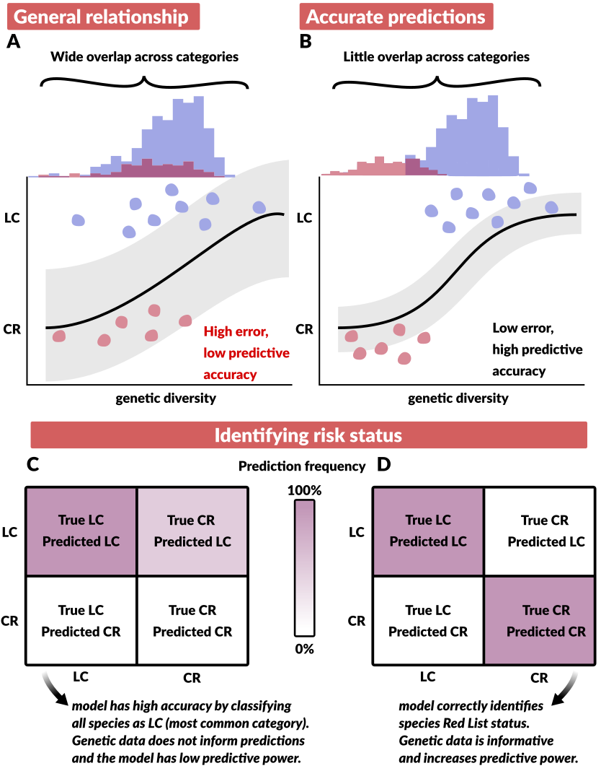
Figure 1. A toy comparison of a model that identifies general trends in data but does not make accurate predictions (A) and a model that both captures trends and predicts species risk status well (B). Models can usefully capture general trends while at the same time having poor predictive accuracy (A, C). General relationships between species Red List status and genetic diversity have been detected, but to date their predictive accuracy has not been assessed. Models need to predict well if they are to be considered good conservation tools. With high overlapping levels of genetic diversity between Red List categories (Least Concern, LC, and Critically Endangered, CR) models may be able to detect lower genetic diversity in CR than LC species, but these models perform poorly when used to predict CR species (confusion matrix, C). With less overlap across categories (B), models would be better able to correctly classify species’ risk status (D). The large variance in genetic diversity and prevalence of Least Concern species suggests that Red List status is not related to genetic diversity in a way that is informative for conservation policy.
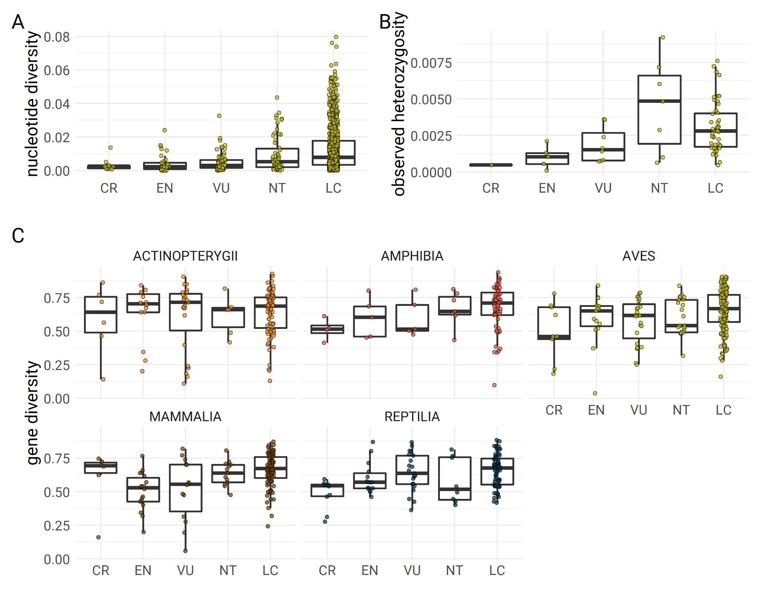
Figure 2. Relationship of avian mitochondrial genetic diversity (a) whole-genome genetic diversity (b), and microsatellite genetic diversity (c) to IUCN Red List categories (CR = critically endangered; EN = endangered; VU = vulnerable; NT = near-threatened; LC = least concern). Most species are classified as Least Concern. The genetic diversity of least concern species is extremely variable and generally encompasses the entire range of genetic diversity across all Red List categories for all genetic markers.

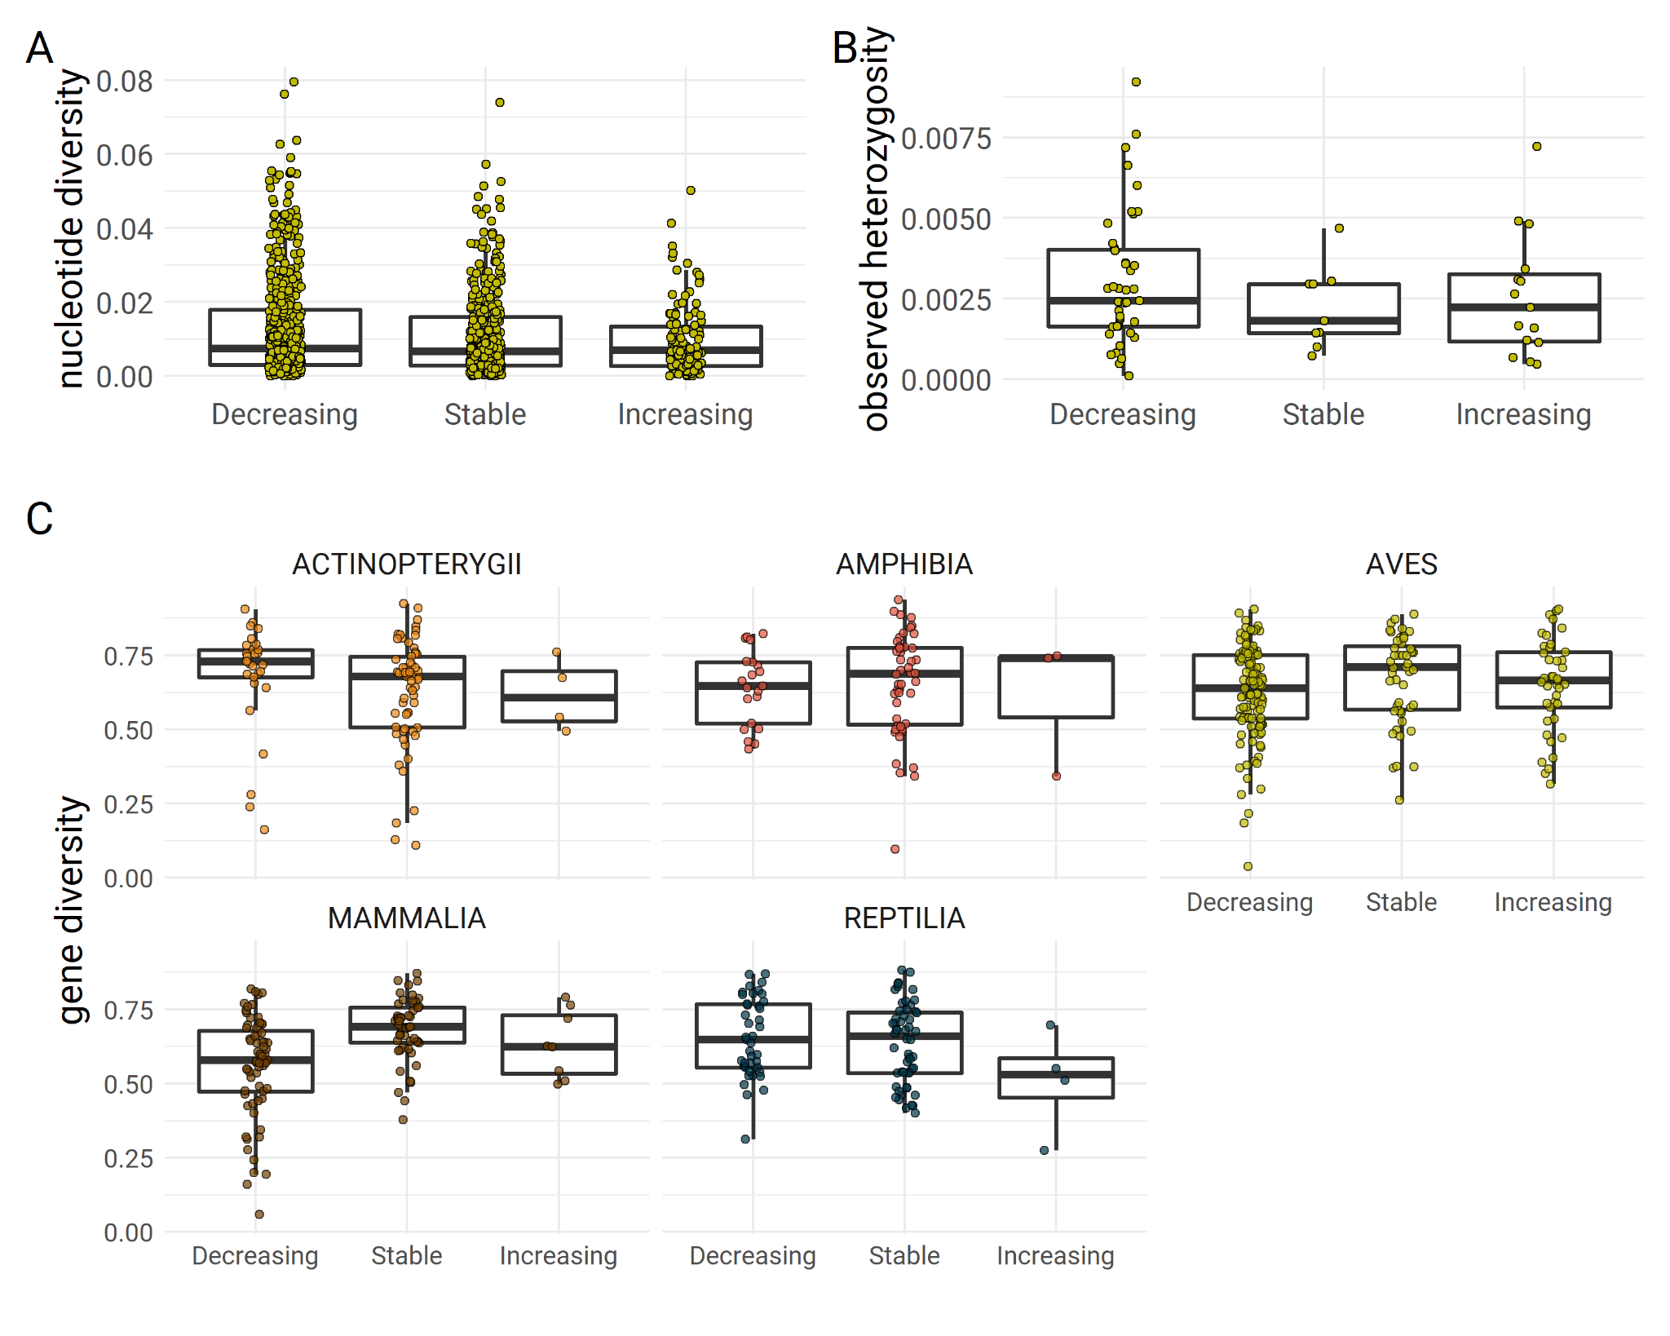
Figure 3. Relationship of mitochondrial genetic diversity (a), whole-genome genetic diversity (b), and microsatellite genetic diversity (c) to IUCN Red List population trend categories. IUCN population trends are unrelated to species genetic diversity.

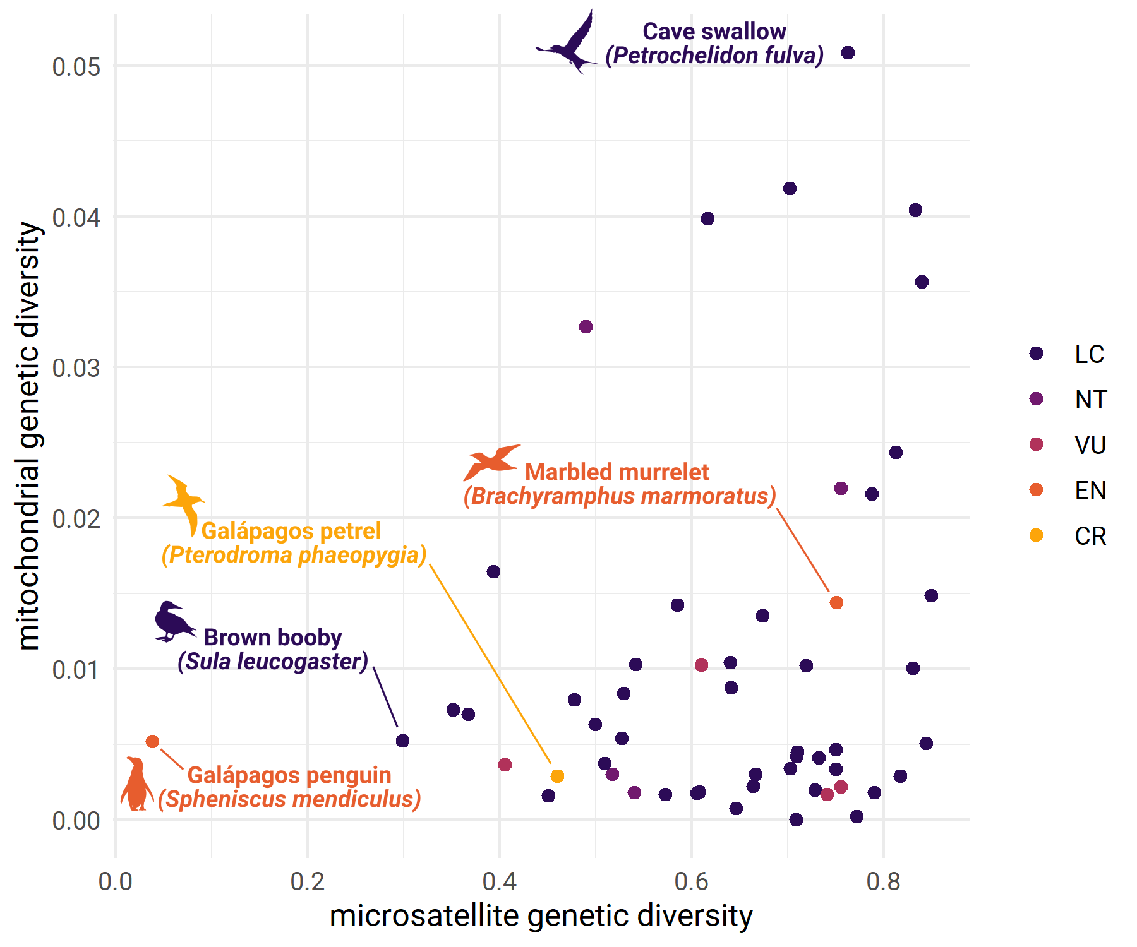
Figure 4. Mitochondrial genetic diversity (nucleotide diversity; π) and microsatellite diversity (gene diversity) in birds are not correlated (r = 0.22; -0.05 – 0.46 95% CI; n = 54 species). Highlighted species show mismatches between mitochondrial genetic diversity, nuclear genetic diversity, and IUCN Red List conservation status. For example, the endangered Galápagos penguin has lower nuclear genetic diversity than other species in our data set, but mitochondrial diversity comparable to several other species. The Marbled murrelet is also endangered, yet has relatively high mitochondrial and nuclear diversity. Mitochondrial genetic diversity is thus not a reliable proxy for genome-wide diversity, which is a quantity of interest for conservation.

Supplementary information for: The IUCN Red List is not sufficient to protect genetic diversity
Figs. S1-S3

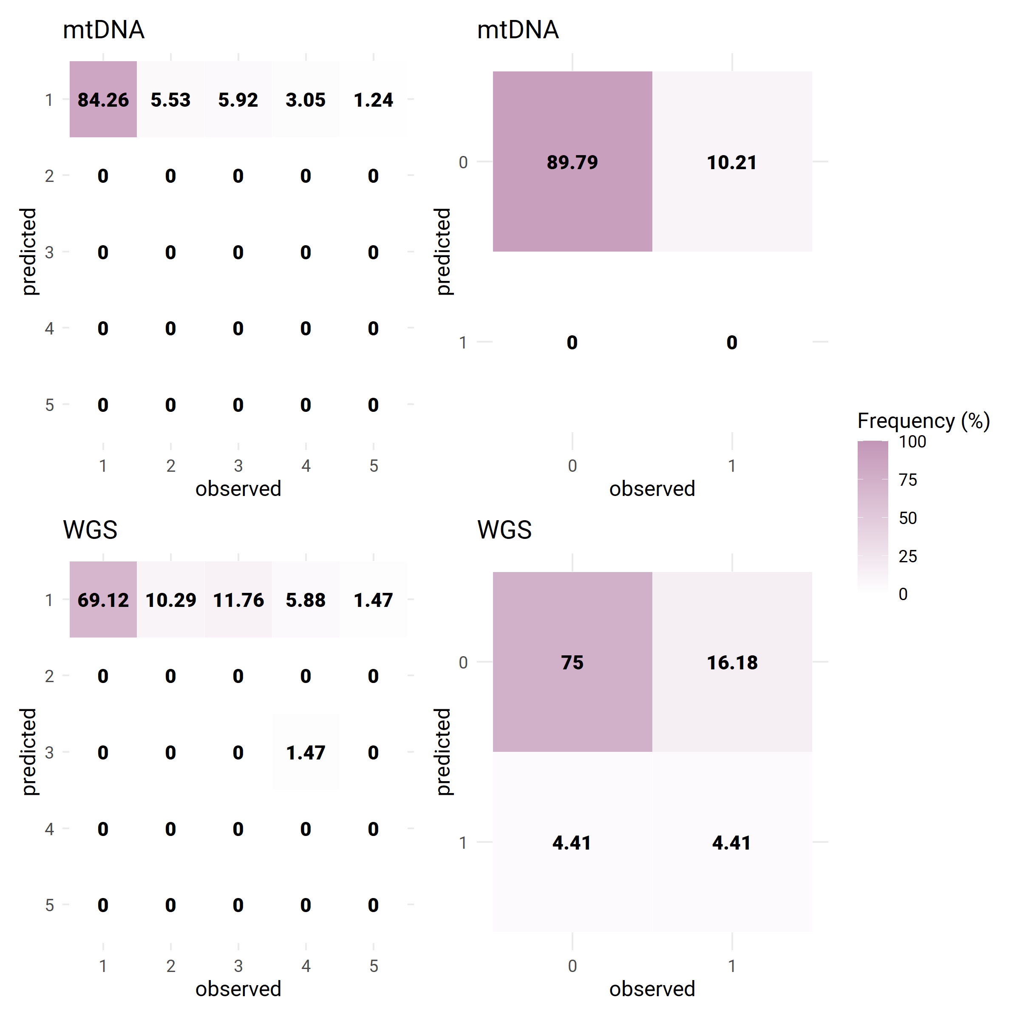
Figure S1. Confusion matrices for ordinal (left column) and binary (right column) logistic regressions for mitochondrial (mtDNA) and whole genome sequence (WGS) data for birds. For all models, Least concern (1; left) or non-threatened (0; right) were the best-predicted categories.

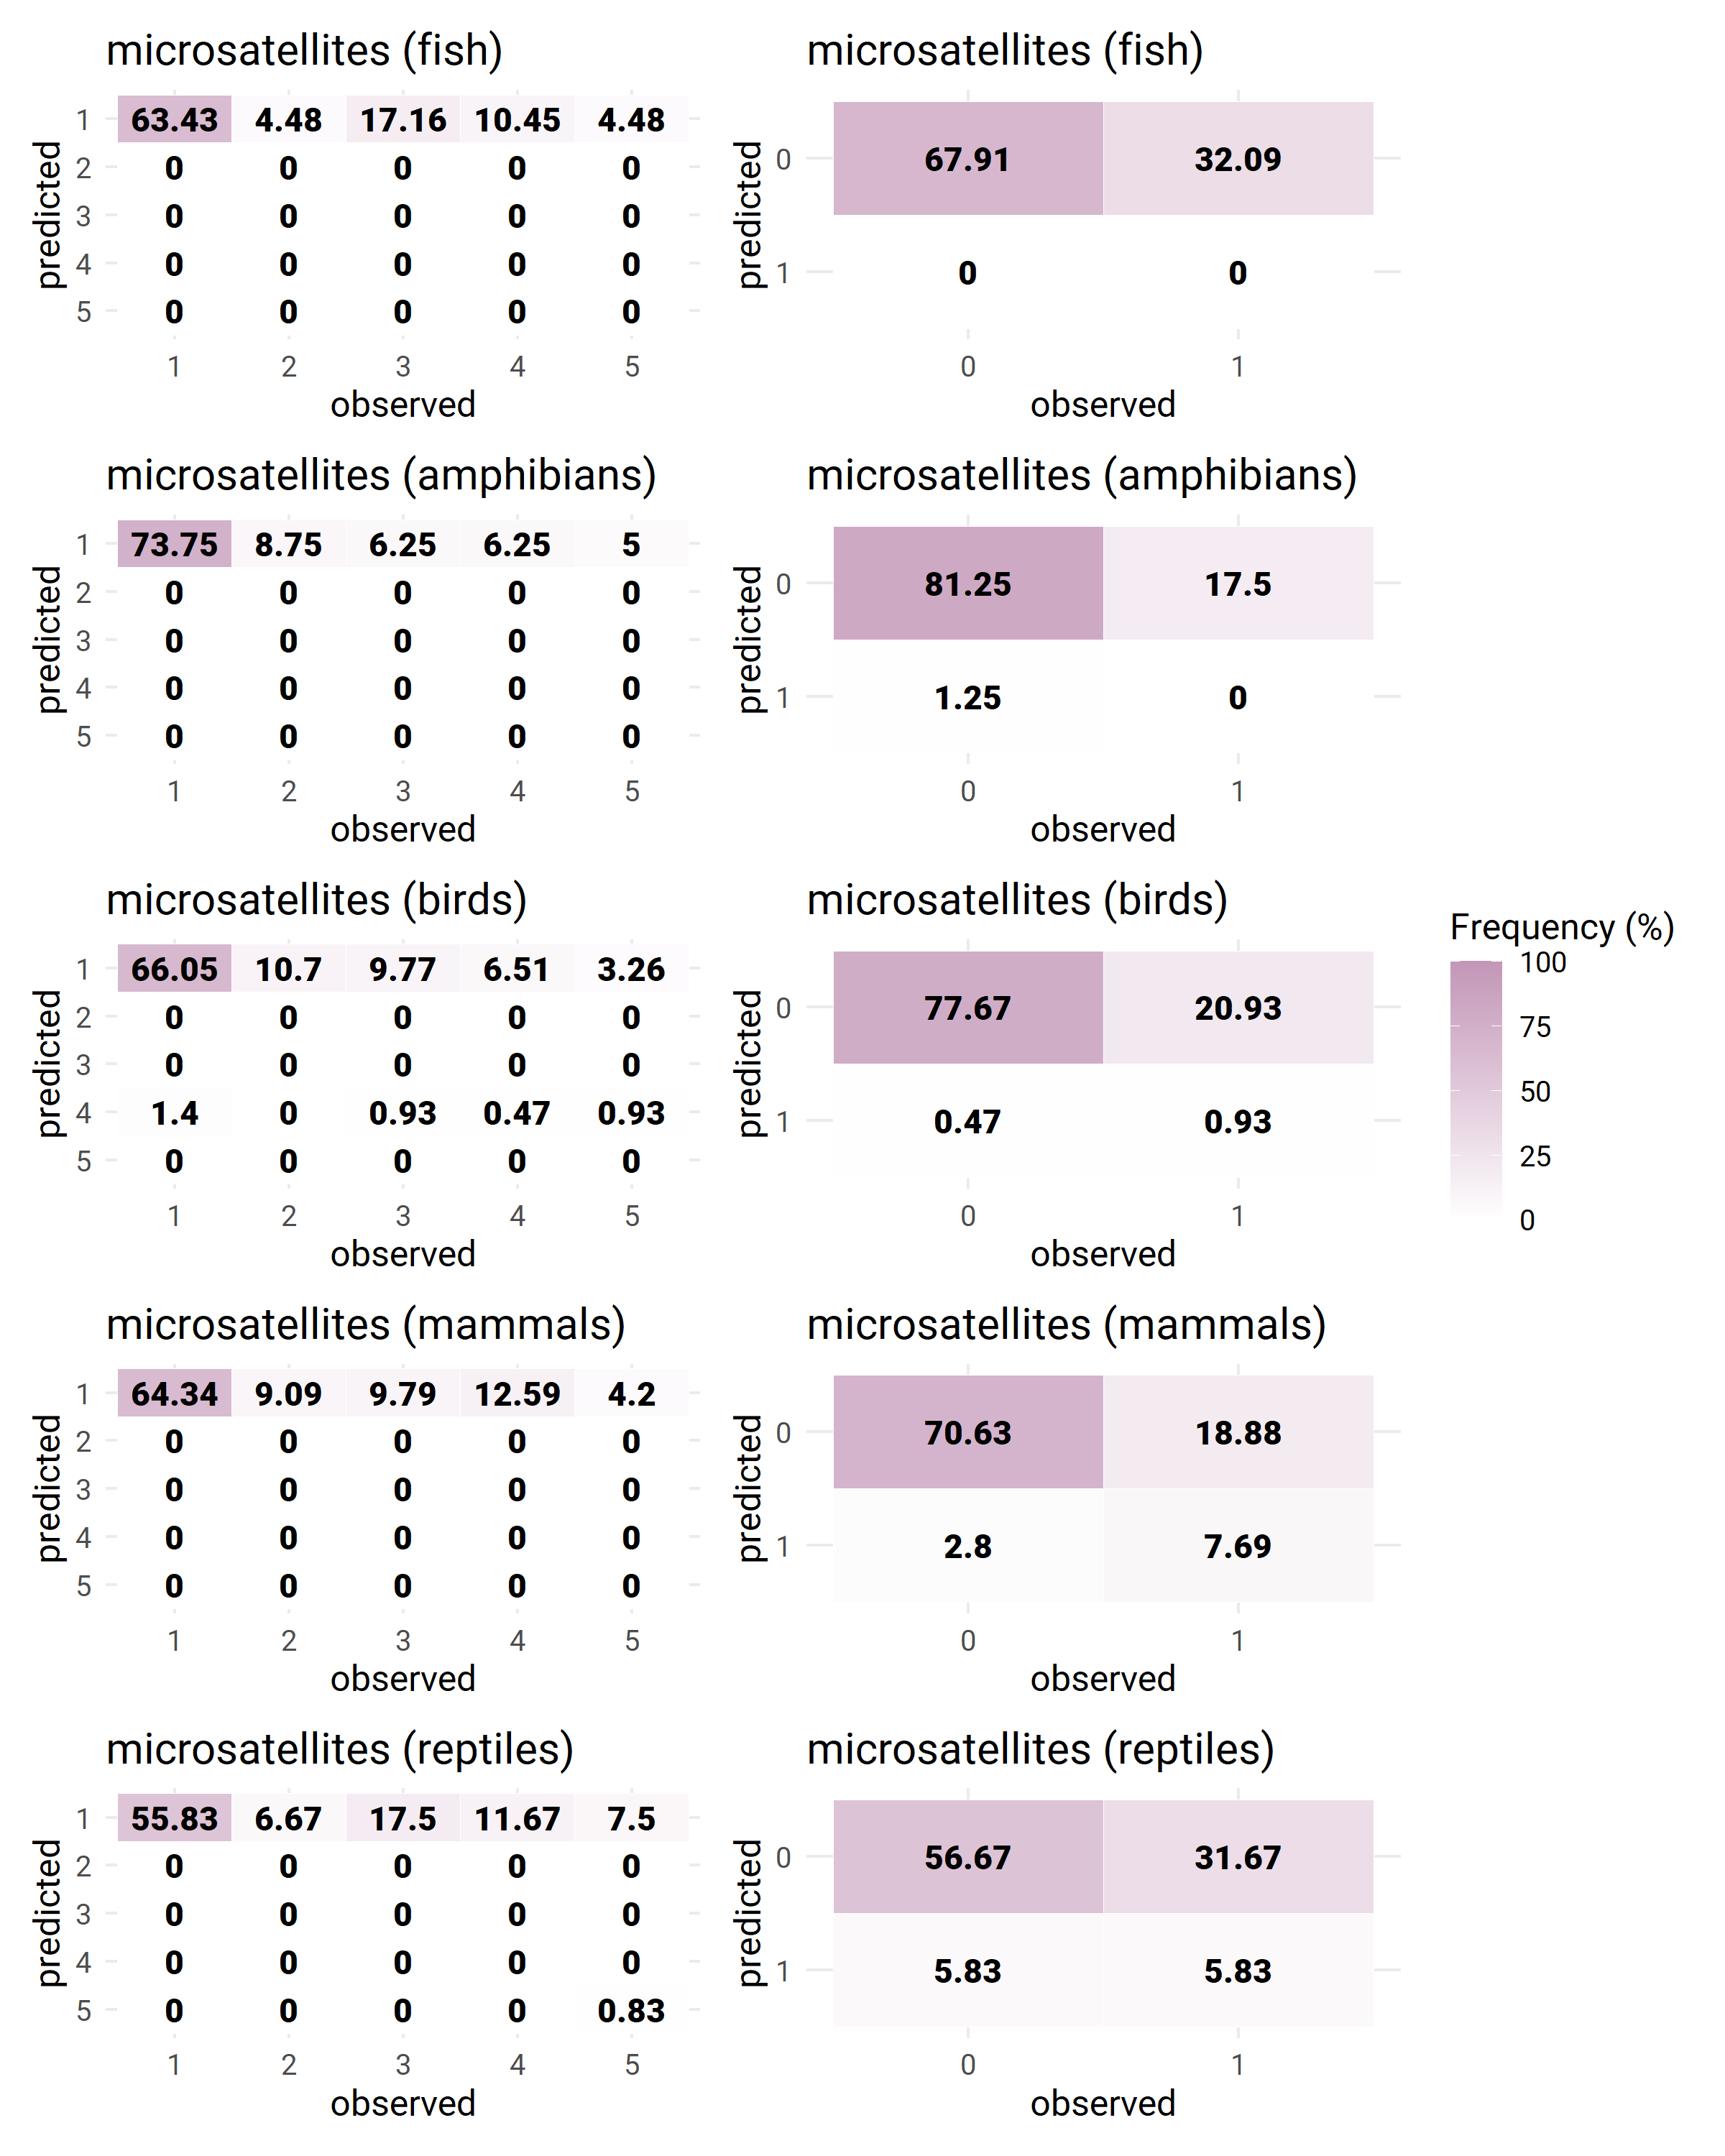
Figure S2. Confusion matrices for ordinal (left column) and binary (right column) logistic regressions for microsatellite data. For all models, Least concern (1; left) or non-threatened (0; right) were the best-predicted categories.
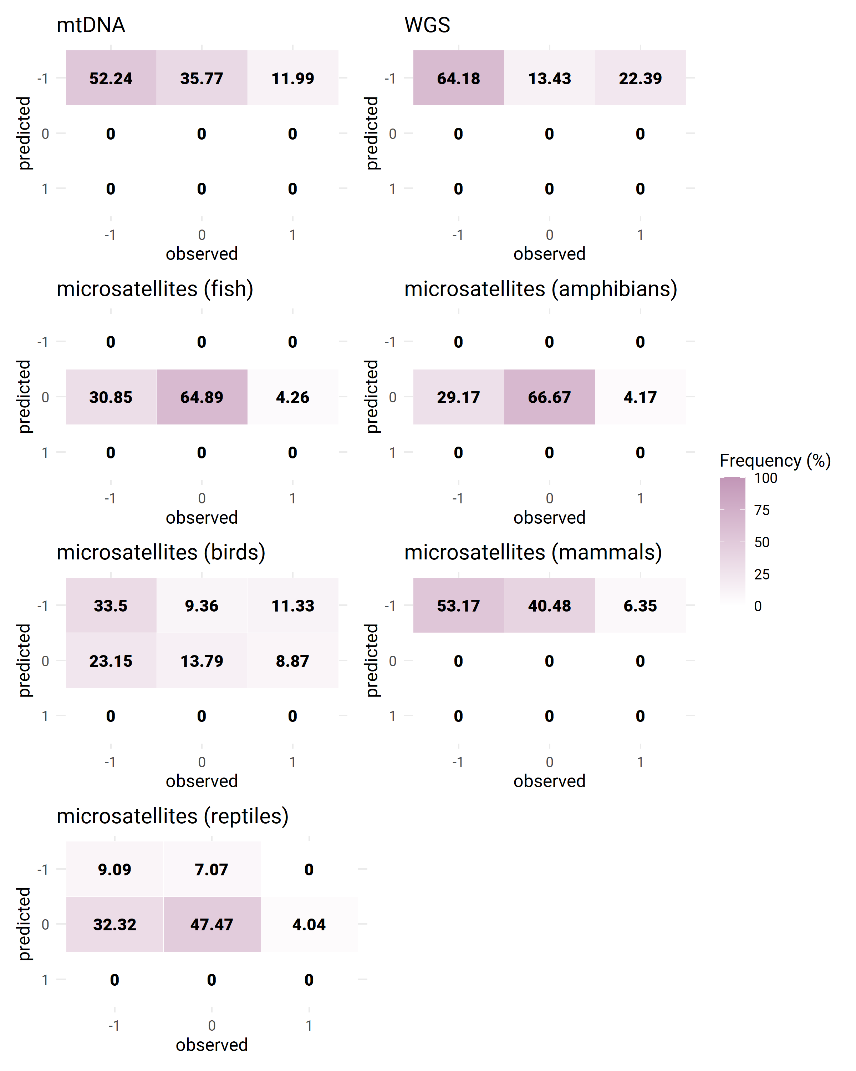
Figure S3. Confusion matrices for population trend models (Decreasing population trend = -1 ; Stable = 0; Increasing = 1). The best predicted classes are the most common ones (mtDNA, WGS, mammals, and birds: Decreasing is most common; fish, amphibians, reptiles: Stable).

