Dog days are over: climate change is predicted to cause population collapse in a cooperative breeder

Authors: D. Rabaiotti,^{1,2}, Tim Coulson³, Rosie Woodroffe^{1,2}
1. Institute of Zoology, Zoological Society of London
2. Centre for Biodiversity and Environment Research, Department of Genetics, Evolution and Environment, Division of Biosciences, University College London
3. Department of Zoology, University of Oxford

Keywords: climate change, temperature, Lycaon pictus, demographics, population, Individual based model
Article Type: Research Article

Abstract
It has been suggested that animals may have evolved co-operative breeding strategies in response to extreme climatic conditions. Climate change, however, may push species beyond their ability to cope with extreme climates, and reduce the group sizes in co-operatively breeding species to a point where populations are no longer viable. Predicting the impact of future climates on these species is challenging as modelling the impact of climate change on their population dynamics requires information on both group and individual level responses to climatic conditions. Using an individual based model incorporating demographic responses to ambient temperature in an endangered species, the African wild dog Lycaon pictus, we show that there is a threshold temperature above which populations of the species are predicted to collapse. For simulated populations with carrying capacities equivalent to the median size of real-world populations (nine packs), this temperature threshold falls close to the best-case climate warming scenario (Representative Concentration Pathway (RCP) 2.6). The threshold is higher (between RCP 4.5 and RCP 6.0) for larger simulated populations (30 packs), but 84% of real-world populations number <30 packs. Simulated populations collapsed because, at high temperatures, juvenile survival was so low that it depressed pack size, with consequent reductions in adult survival, litter size, and the number of dispersers leaving to form new packs. This work highlights the risk that climate change poses to this endangered species, and the importance of social dynamics in determining impacts of climatic variables on social species. Individual based models parameterised on long term data can shed new light on population viability under climate change, and should play a key role in directing conservation interventions that may increase population viability under future climatic conditions.

Introduction
Despite the identification of climate change as a causal factor in a number of contemporary extinctions of both populations (Cahill et al., 2012) and species (Waller et al., 2017), predicting the extinction risk of species under future climate regimes still proves challenging. Ultimately, climate driven extinction is a consequence of weather-related impacts on demographic rates, whether they be decreased survival or reproductive success, which are severe enough that the population declines to extinction. This means that detailed population models, incorporating climate change impacts on all elements of species’ populations, are helpful to predict species’ likelihood of persistence under climate change. While earlier studies of the demographic impacts of high temperature tended to focus on ectothermic species in which the impacts of temperature on demography operate through a direct physiological mechanism (e.g., Hulin et al., 2009; Mitchell et al., 2010), there is growing evidence of demographic impacts of climate change on endotherms (Paniw et al., 2021), with climate change posing a particularly acute risk to large bodied mammal species (Hetem et al., 2014).
Predicting the impact of environmental change on social species is particularly challenging, because they require complex models to capture demographic feedbacks both within and between social groups (Marescot et al., 2012). Reproductive success, survival, and dispersal probability are commonly impacted by group characteristics such as group size and group composition (T. Clutton-Brock & Sheldon, 2010; Marescot et al., 2012). These demographic variables also vary between group members depending on their dominance status (Armitage, 1987; Rood, 1990), sex (Ewen et al., 2001; Kingma et al., 2017; Lawson Handley & Perrin, 2007), or age (Marjamäki et al., 2013; Woodroffe, O’Neill, et al., 2020). At an extreme, in some co-operatively breeding species, dominant individuals monopolise breeding completely, with subdominant individuals helping to raise the dominants individuals’ offspring (Gaston, 2015). This behaviour means that the loss of a specific group member will have a different impact on group dynamics, and therefore rates of reproduction, depending on whether the individual is dominant or subdominant.
Long term individual based studies are essential to informing population models of social species, as they are the only way to obtain empirical data on the structure and dynamics of social groups (T. Clutton-Brock & Sheldon, 2010; Grimm et al., 2003). As there are few such long-term studies, models of environmental impacts on social species have been limited to a relatively small number of taxa, including meerkats (Suricata suricatta) (Bateman et al., 2012, 2013)and the Southern fiscal (Lanius collaris) (Cunningham et al., 2013), for which long term individual level demographic data exist.
It has been suggested that cooperative breeding is a reproductive strategy that increases population viability under variable and extreme climatic conditions (Lukas & Clutton-Brock, 2016; Rubenstein & Lovette, 2007; Smaldino et al., 2015). Social species, and in particular co-operative breeders, exhibit both high levels of behavioural plasticity and social learning, which may both facilitate survival in extreme climates (Komdeur & Ma, 2021). In addition to this, a loss of energy reserves for nonbreeding subdominant individuals has a lower impact on population recruitment, and therefore their contribution to the persistence of the population is limited (Komdeur & Ma, 2021). Thus, populations of co-operatively breeding species may be able to buffer climate induced food shortages by supporting dominant individuals with a higher reproductive output.
Despite having lower reproductive outputs, or, in some cases, forgoing reproduction all together, however, subdominant individuals play a key role in group level reproductive output. Reproductive success has been found to be positively correlated with group sizes across a wide variety of species, including meerkats (Bateman et al., 2011, 2012), Arabian babblers (Turdoides squamiceps) (Keynan & Ridley, 2016) and African wild dogs (Woodroffe et al 2017). Similarly, individuals in larger groups of many co-operatively breeding species have also been found to have higher survival rates (Brown & Brown, 2004; Clutton-Brock et al., 2001; Rabaiotti et al., 2021; Robinette et al., 1995). This has led to the prediction that smaller groups of co-operatively breeding species are less likely to persist, and therefore populations consisting of smaller groups will have lower growth rates (Angulo et al., 2013; Courchamp et al., 2000). This is known as a group level demographic Allee effect (Courchamp et al., 2000). If this prediction were upheld, environmental changes resulting in higher mortality, lower reproduction, or increased dispersal might change group dynamics in ways that lead social group sizes to decrease to a point where there are not enough subordinate individuals to assist in activities on which groups survival is dependent, such as defense against predators, foraging or raising offspring. This would further reduce population growth rates until groups die out due to low recruitment rates. If this were the case, we would expect extreme environmental conditions to drive smaller group sizes, in turn lowering survival and reproductive success further, eventually leading to population collapse.
The demographic responses of co-operatively breeding species to climatic conditions have been found to be variable, and dependent on both group composition and size (Bateman et al., 2013; Koenig et al., 2011; Paniw et al., 2019). Assessing the impact of climatic variables on both group- and individual-level parameters is therefore key to predicting the impact of climate change on populations of social species. For larger bodied species artificially manipulating the climate the live in is less feasible, as there are fewer microclimates available to them on account of their larger body size. As a result, understanding the impact of climatic conditions on shorter term population trends is essential in providing insight into how these species will respond to rising temperatures in the future. Despite the unparalleled understanding into social species’ climate change resilience such studies would provide, no research to date has integrated the impact of climatic conditions on multiple aspects of social species’ population dynamics into projections of population viability under climate change.
One social species that experiences multiple demographic impacts of high temperature is the African wild dog (Lycaon pictus), a co-operatively breeding canid historically found throughout most of sub-Saharan Africa. The species has a very distinctive coat pattern that is unique to each individual, meaning that long term studies across multiple sites have been able to monitor individuals throughout their lifetime (Creel & Creel, 2002; Woodroffe et al., 2017). Using such data, researchers have been able to estimate rates of recruitment (Woodroffe et al., 2017), survival (Rabaiotti et al., 2021; Woodroffe, 2011a; Woodroffe et al., 2007), and dispersal (Behr et al., 2020; Woodroffe, O’Neill, et al., 2020; Woodroffe, Rabaiotti, et al., 2020) for the species. Studies have shown that African wild dog vital rates are impacted by high temperatures, with lower adult (Rabaiotti et al., 2021) and juvenile (Woodroffe et al., 2017) survival at higher temperatures. The time between one litter and the next (the inter-birth interval) has also been observed to be longer at higher temperatures at a site with aseasonal breeding (Woodroffe et al., 2017).
Here we use a novel individual based population model of African wild dogs, parameterised using long term field data, to investigate how the effects of temperature on both recruitment rate and adult survival may impact population dynamics and persistence under future climate change scenarios.

Materials and Methods

African wild dog life history
The African wild dog is an obligate cooperative breeder, with packs made up of a dominant breeding pair, known as alphas, and between two and 28 subdominant individuals that assist in raising their offspring (Creel & Creel, 2002; Malcolm & Marten, 1982). Across most of their geographic range, African wild dogs breed seasonally at the coolest time of the year, but they breed aseasonally near the equator (McNutt et al., 2019). African wild dogs typically raise litters of between 2 and 18 pups (Creel & Creel, 2002). Single sex dispersal groups leave established packs and search for unrelated mates and new territories (McNutt, 1996). Those that successfully find another dispersal group will then go on to form a new pack (Behr et al., 2020; Woodroffe et al., 2020a; Woodroffe, et al., 2020b). Reproduction, mortality risk and dispersal dynamics are all linked to pack composition (Rabaiotti et al., 2021; Woodroffe et al., 2017; Woodroffe, Rabaiotti, et al., 2020).
The life history parameters used in the study were obtained from long term demographic data collected by the Samburu-Laikipia Wild Dog Project, in a study area which covers Laikipia County, Kenya, and parts of the neighbouring counties of Samburu, Isiolo, and Baringo. African wild dogs were monitored between the years 2001 and 2017 using a combination of GPS collars, radio collars and visual observation (Woodroffe, 2011). The number of adults (individuals aged ≥ 12 months) and juveniles (individuals aged <12 months) in each pack, litter sizes, births, deaths and dispersal events were recorded by researchers throughout the course of the project. Temperature data from a weather station within the study site (Gitonga, & Martins, 2019) were used to investigate how temperature correlated with recruitment, survival, and dispersal.
Litter size, inter-birth interval, juvenile survival, adult survival, and dispersal parameters were obtained through re-analysing data from published papers using a monthly time-step (Woodroffe et al 2017, Rabaiotti et al 2021, Woodroffe et al 202b). Full details of these datasets and the models used to estimate the demographic parameters can be found in Annex S1.

Individual based model

State variables and scales
Four hierarchical levels make up the individual based model: Individual, territory, population, and environment. Individuals are characterised by their dominance status – dominant or subdominant, and their age – adult (a) or juvenile (j). Within the model, juveniles are defined as individuals between three and 12 months. Juvenile classification begins at three months as opposed to zero as this is the age at which pups start to move with the pack and can be reliably counted (Woodroffe, 2011). Juveniles older than 11 months become adults. Adult and juvenile wild dogs are in separate age categories due to differences in survival rates and temperature impacts (Rabaiotti et al., 2021; Woodroffe et al., 2017). Due to the social dynamics of the species, in which only the dominant pair breeds and the pack dynamics are strongly influenced by survival of dominant individuals (Woodroffe et al., 2020), breeding individuals are built into the model as a separate dominance category. The model is female only, therefore the dominant category contains a single individual, and no individuals move into this category unless the existing dominant individual has died.
A territory can be occupied by one pack of wild dogs, which consists of one dominant female along with a number of subdominant adults, and any juveniles born to that pack that have not yet reached 12 months of age. A territory is characterised by: its identity number, the size of the pack (number of adult females) present, time since the pack formed, the size of the current pack’s last litter (number of juveniles), and time since the current pack’s since the birth of the pack’s last litter. If there are no individuals in the territory it is classified at ‘empty’.
The population is composed of multiple territories and a number of packs. For the purposes of this analysis two different territory numbers are used: 30 territories, which is the maximum number of packs recorded at our study site, and nine territories, which is the median number of packs per population within the species’ remaining range throughout Africa (Woodroffe & Sillero-Zubiri, 2012). Each population is characterised by its size (the number of adult and juvenile individuals) and the number of packs. Outside of this population (and not included in the total population size) there is a dispersal pool which comprises individuals that have dispersed from their packs but have not yet occupied a territory and formed a pack. When the number of packs in the population is 0 the population is classed as extinct.
Abiotic environment is the highest hierarchical level in the model. As African wild dog recruitment and survival is impacted by mean daily maximum temperature, this is how the abiotic environment is characterised. Temperature, in degrees Celsius, is centred on the mean throughout, therefore the average temperature is represented by 0. The temperature variable represents the mean daily maximum temperature during the time-step, in line with the empirical findings of Woodroffe et al 2017, Woodroffe et al 2020b and Rabaiotti et al 2021, which all found that maximum temperature influenced wild dog demography.

Process overview and scheduling
The model proceeds in monthly time steps. Within each time-step six phases occur in the following order: mortality, dispersal, aging, births, pack fate (consisting of three levels: inheritance of dominance status (the dominant individual dies and is replaced), pack break up (the dominant individual dies and the pack breaks up and become dispersers), or pack continuity (the dominant individual survives)), re-colonisation of vacant territories.

Design concepts

Emergence
Pack and population level dynamics emerge from individual behaviour in the model, the timing of breeding, and number of territories available. Individual’s life histories and behaviours within the model are defined by empirical rules describing aging, as well as mortality and dispersal probabilities. Adaptation and fitness seeking are not explicitly modelled. They should be captured by the model, however, particularly through the rules describing dispersal, as the higher probability of dispersing at higher pack sizes is likely driven by likelihood of reproduction, and therefore individual fitness (Woodroffe et al., 2019a).

Sensing
Individuals are assumed to know their dominance status, age class (juvenile or adult) and pack size in order to inform their dispersal probability. They are also assumed to know the mortality status of the dominant female, which informs their ability to change dominance status, and informs whether the pack breaks up.

Interactions
The interactions modelled explicitly in the models are: adult survival and juvenile survival decrease at higher temperatures, the inter-birth-interval is longer at higher temperatures (Woodroffe et al., 2017), adult survival increases with pack size (Rabaiotti et al., 2021; Woodroffe et al., 2019a), litter size increases with pack size (Woodroffe et al., 2019b), dispersal probability increases with pack size (Woodroffe, Rabaiotti, et al., 2020), the inter birth interval increases with litter size (Woodroffe et al., 2017), and juvenile survival increases with litter size (Woodroffe et al., 2017). Interactions implicitly modelled are: litter size and dispersal probability are both lower at higher temperatures.

Stochasticity
Mean daily maximum temperature for each month-long time step is drawn from a normal distribution to mimic the stochastic variation in temperature observed in the field (Gitonga &Martins, 2017). All demographic parameters (Table 1, Table 2) are drawn from a truncated normal distribution with the bounds representing ± the standard error of the parameter estimates (Table 2). In order to determine death a random number is drawn from a uniform distribution between 1 and 0 and if the number is higher than the probability of survival the individual dies, if it is lower the individual survives. The same occurs for dispersal, but with dispersal probability as opposed to survival probability. When dominant females die, the fate of their surviving pack members is determined by drawing a random number from a uniform distribution between 0 and 100 and if the number is less than or equal to 40, dominant status is inherited by a subdominant pack member, and if it is over 40 and all subdominant individuals leave the territory and enter the dispersal pool. A 40% probability is used as this is the percentage of pack break-up (as opposed to pack inheritance) observed in the field (Woodroffe, Rabaiotti, et al., 2020).

Observation
For the purposes of model testing, each individual is observed process by process. For model analysis, only pack and population level variables are recorded, namely: pack size, pack inter-birth interval, pack litter size, pack longevity (the period between a pack occupying a territory and breaking up or dying), number of dispersers (the total number of individuals in the dispersal pool in any one time-step), number of packs, population size, and time to population extinction.

Initialisation
Each territory is initially occupied by one dominant female and a number of subdominants, determined by selecting a number from a Poisson distribution with a lambda of 3 (the rounded mean number of subdominant females in a pack from the field data (Woodroffe et al., 2019b). The time until the first litter emerges is determined by selecting a random number from truncated normal distribution with a minimum value of 3, maximum value of 11 and a mean of 6 (the rounded mean inter-birth-interval (in months) from the field data) (Woodroffe, et al., 2019a). The model is then run for 100 months at a mean (centred) temperature of 0, after which the evaluation of the first run starts.

Inputs
Temperature is selected from a normal distribution with a mean of 0, representing the centred mean daily maximum temperature over a period of 30 days in ◦C, with variance ($Ω$ matching temperature variance from the weather station at the study site.
$$T_{t} N\left(0,Ω\right)$$

Table 1: Symbols used in the models. Temperature refers to mean daily maximum temperature throughout.
Symbol | Variable | Unit
h  i  H | Individual identity  group identity.  Number of territories in the model | individual identifier  group identifier  n individuals
$$N_{t}$$ | Total number of individuals (adult and juvenile) at time t | n individuals
$$N_{a,t}$$ | Number of adults (dominant and subdominant) in the population at time t | n individuals
$$N_{h,t}$$ | Number of subdominant adults in the population at time t | n individuals
$$N_{i,t}$$ | Number of individuals (adult and juvenile) in pack i at time t | n individuals
$$N_{ia,t}$$ | Number of adults (dominant and subdominant) in pack i at time t | n individuals
$$N_{D,t}$$ | Total number of dispersing individuals in the dispersal pool at time t | n individuals
$$N_{iD,t}$$ | Number of dispersers leaving pack i at time t (n individuals) | n individuals
$$N_{id,t}$$ | Number of adult deaths in pack i at time t (n individuals) | n individuals
b_{i,t} | Whether pack i has a litter at time t | binary
α, β, γ, δ, ε, $ζ$, θ, λ, μ, ξ, σ, ɸ, υ, φ, ω | Input parameters. Further details in Table 2.
$$r_{i}$$ | Inter birth interval for pack i | n timesteps
t_{i,r-1} | The timestep of the previous breeding attempt for pack i | n timesteps
t_{i,r} | The timestep of the next breeding attempt for pack i , calculated as $t_{i,r−1}+r_{i}$ | n timesteps
$$l_{i,t}$$ | Litter size for pack i at time t | n individuals
$$l_{i,tr−1}$$ | Litter size of pack i in the most recent breeding event | n individuals
$$T_{t}$$ | Temperature at time t | ℃ (centered)
$$T_{i,tr−1}$$ | Mean temperature across the three time steps prior to the first count of 3-month old juveniles in pack calculated as $\left(\frac{\left(T_{t−2}+T_{t−1}+T_{t}\right)}{3}\right)$ at time tr-1 | ℃ (centered)
$$S_{j,t}$$ | Juvenile survival probability for an individual at time t | 0-1
$$S_{a,t}$$ | Adult survival probability for an individual at time t | 0-1
m_{t} | Age of an individual (in months) at time t | n timesteps
v_{t} | Dominance status of an individual at time t: 0 for subdominant individuals and 1 for dominant individuals | binary
$$P_{D,t}$$ | Probability of dispersal of an individual at time t | 0-1
$$P_{ip,t}$$ | Probability that dispersal group i will occupy an empty territory at time t | 0-1
x,y | Random numbers drawn from a uniform distribution between 1 and 0 | 0-1

Submodels
Pack size, that is, the number of adult and juvenile female African wild dogs in each pack ($N_{i,t}$) in the model at time step t ($N_{t}$) is a function of the number of individuals present in each pack in the previous time step ($N_{i,t−1}$) , the number of deaths in each pack during time step t ($N_{id,t}$); the number of dispersals from that pack in time step t ($N_{iD,t}$); and the number of births in each pack in that time step $\left(N | | ib,t\right)$. The population size (N_{t}) is the sum across each pack in the model.
$$N_{t}=\sum_{i=1}^{H}{\left[N_{i,t−1} | | −N_{id,t}−N_{iD,t}+N_{ib,t}\right]}$$
If a pack goes extinct $\left(N | | i,t=0\right)$ then the territory is empty. If there is a group of dispersing individuals in the dispersal pool they can occupy the vacant territory, form a new pack, and join the population.

Model parameters (Table 2) were estimated from empirical data (as described in Annex S1), and functions determining the variables within the individual based model took the same form as the statistical models from which the parameter estimates were derived: Cox proportional hazard models (adult survival ($S_{a}$, and probability of dispersal ($P_{D}$)), a generalised linear model with a Poisson distribution (litter size (l)), a generalised linear model with a binomial distribution (juvenile survival ($S_{j}$), and a generalised linear model with a Gaussian distribution (inter-birth interval (r_{i})). Full details of model parameter estimation can be found in Annex S1.
Table 2: Input parameters in the submodels and their values. Each was drawn from a normal distribution truncated at ± one standard error.
Variable | Coefficient | Symbol | Value | SE
Inter-birth interval | Intercept | Α | 9.1015 | 0.6213
Inter-birth interval | Impact of temperature | Β | 0.9156 | 0.3349
Inter-birth interval | Impact of litter size | Γ | 0.5198 | 0.1645
Litter size | Intercept | Δ | 0.9751 | 0.1368
Litter size | Impact of pack size | Ε | 0.0457 | 0.0232
Juvenile survival | Intercept | $$ζ$$ | -1.4871 | 0.6465
Juvenile survival | Impact of temperature | Θ | -0.7057 | 0.2937
Juvenile survival | Impact of litter size | Λ | 0.5482 | 0.1565
Adult survival | Intercept | Μ | 0.0265 | 0.0002
Adult survival | Impact of temperature | Ξ | 0.2718 | 0.0064
Adult survival | Impact of pack size | Σ | -0.1405 | 0.0222
Adult survival | Impact of age | ɸ | 0.0162 | 0.0011
Adult survival | Impact of dominance | Υ | 0.3529 | 0.3529
Dispersal | Intercept | Φ | 0.0064 | 0.0002
Dispersal | Impact of pack size | Ω | 0.1059 | 0.0239

Reproduction
Number of litters produced by a pack (b_{i}) is dependent on the timing of the previous breeding attempt ($t_{i,r−1}$) and the inter-birth interval $\left(r | | i\right)$:
$b_{i}=\left\{\begin{aligned}l_{i},if{t=t}_{ir−1}+r_{i} \\ 0,otherwise\end{aligned}\right.$
The inter birth interval is dependent on the temperature during the previous denning period ($T_{i,r−1}$) and the size of that previous litter ($l_{i,r−1}$), where $t_{i,r−1}$ is the timestep when the previous litter was 3 months old. Temperature during the previous denning period ($T_{i,r−1}$) was calculated from the temperature over the three months prior to the previous litter leaving the den at $t_{i,r−1}$.
$$\left(\frac{T_{t−2}+T_{t−1}+T_{t}}{3}\right)$$
The inter birth interval is defined by a function of the temperature ($T_{i,r−1}$) and litter size ($l_{i,r−1}$) of the previous denning period:
$$r_{i}=α+{βT}_{i,r−1}+γl_{i,r−1}$$
α, β and γ are constants estimated from the generalized linear model of inter birth interval (Annex S1).
The estimate of inter birth interval in months $\left(r_{i}\right)$ is rounded to the nearest whole number to give the number of time steps between one breeding attempt and the next.
The litter size ($l_{i,t}$) in this model, representing the number of juveniles at three months of age, was determined by the number of adults in the pack at the time ($N_{i,t_{r}}$). The formula used to calculate the litter size is below, and symbol definitions can be found in Table 1:
$${l_{i,t}=e}^{δ+εN_{i,t}}$$
δ and ε are constants defined by the Poisson generalised linear model describing litter size. The resulting number was then rounded up to the nearest individual to give a whole number.

Number of deaths
Number of deaths ($N_{dt}$ is dependent on the survival probability in both adults ($S_{a}$ and juveniles ($S_{j}$, characterised together as S:
$$N_{dt}=\sum_{h=1}^{N_{t−1}}{}$$
The probability of an individual juvenile’s survival at each time-step ($S_{j,t}$ is dependent on the size of that individual’s birth litter at the time they permanently left the den ($l_{i,tr−1}$) and the mean daily maximum temperature when that individual was in the den ($T_{i,tr−1}$). As the data from which the survival rate was estimated only contained the number of juveniles at 3 and 12 months of age, the 9th root was taken to obtain monthly survival rates.
$$S_{j,t}={\left(\frac{ζ+θT_{i,tr−1}+λl_{i,tr−1}}{1+ζ+θT_{i,tr−1}+λl_{i,tr−1}}\right)}^{\frac{1}{9}}$$
$ζ$ , θ and λ are constants defined by the binomial generalised linear model describing juvenile survival (Table 2).
The probability of adult wild dog survival, at time-step t ($S_{a,t}$ is dependent on pack size $\left(N | | i,t\right)$ and dominance (v_{t}) at the time, and average temperature over the three previous timesteps $\frac{T_{t}+T_{t−1}+T_{t−2}}{3}$. For dominant individuals, survival is also dependant on age ($m_{t}$). The formula used to calculate the probability of survival for each individual adult is below:
$$S_{a,t}=1−μ\left(e^{{ξT}_{t}+{σN}_{i,t}+v+v{ɸm}_{t}}\right)$$
µ, ξ, σ, υ and ɸ are constants defined by the Cox proportional hazards model of adult survival (Table 2, Annex S1).

Dispersal
Within the model, only subdominant adults could disperse, as this is what is observed in the field(Woodroffe, et al., 2020a). Number of dispersers ($N_{D}$ was dependent on the probability of dispersal ($P_{D}$:
$$\sum_{h=1}^{N_{h,t−1}}{}$$
Individual dispersal probability at each time step ($P_{D,t}$) was dependent on pack size in that timestep ($N_{i,t}$. The formula for individual dispersal probability is shown below, and symbol definitions can be found in Tables 1 and 2:
$$P_{D,t}=φ\left(e^{ωN_{i,t}}\right)$$
φ and ω are constants defined by the Cox proportional hazards model of dispersal probability.
Once an individual disperses it enters a dispersal pool. If more than one individual disperses at the same timestep from the same pack they form a dispersal group. Individuals in the model are lost from the model after two months in the dispersal pool. This time period was chosen because, while empirical data indicate that wild dogs dispersed for a mean time of 19.4 days(range 3-68 days) (Woodroffe et al., 2020b), this mean is likely to under represent longer dispersals as, the longer an individual disperses for, the more likely it is to be lost to monitoring, and individuals have reappeared in the study population after much longer periods of time (Woodroffe et al 2020b). In the model, individuals also disperse if the pack breaks up after the dominant individual’s death. When this happens all juveniles in the pack die.

Territory inheritance
If any of the packs within the model break up, leaving an empty territory, a dispersal group can then occupy that territory, starting a new pack. Each individual has an equal probability of occupying a territory and therefore larger dispersal groups have a higher chance of occupying an empty territory. Although empirical data on this process are scarce, without this rule pack sizes do not reflect those observed in the field. If an empty territory is available at time t, the formula for the probability that a dispersal group would occupy it ($P_{p}$_{,t}) is shown below, and symbol definitions can be found in Table 1:
$$P_{p,t}=N_{iD,t}\left(\frac{1}{N_{D,t}}\right)$$
If there is more than one empty territory the process is repeated until all territories are filled, or there are no more dispersal groups left in the dispersal pool. A diagram of the positive and negative relationships between the parameters and demographic variables is shown in Figure S4.

Assessing model performance
Before projecting the impact of future climate change on the simulated population, model outputs were visually compared with the empirical data to assess fit (Fig. 1, Table S1). For assessment purposes, we recalculated the input parameters excluding data from the two consecutive years with the highest and lowest mean maximum temperatures. The model was then run 1000 times at the mean maximum temperature during the hottest years, and 100 times at the mean maximum temperature during the coldest years for 100,000 timesteps. Pack size, dispersal group size, inter-birth-interval and litter size predicted from the model were then compared with the empirical data from the two excluded years. We also performed sensitivity and elasticity testing on the model to explore which demographic parameters and inputs most impacted population dynamics (detailed in Appendix S2 and S3).

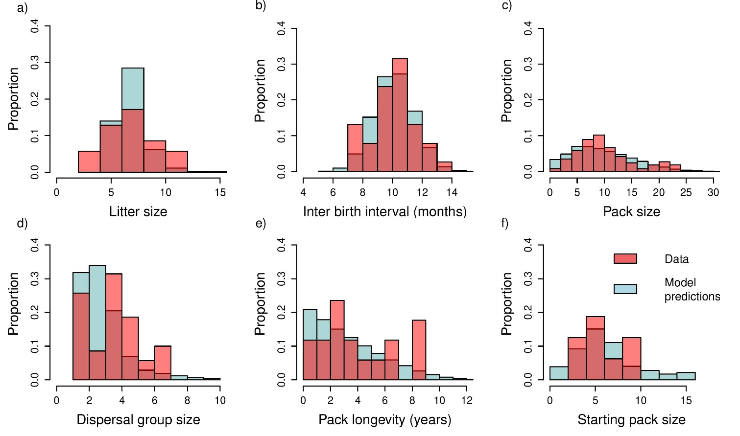
Figure 1: Histograms of empirical data from compared with predictions from the population model. As the model is single sex, model predictions of litter size and pack size have been doubled.

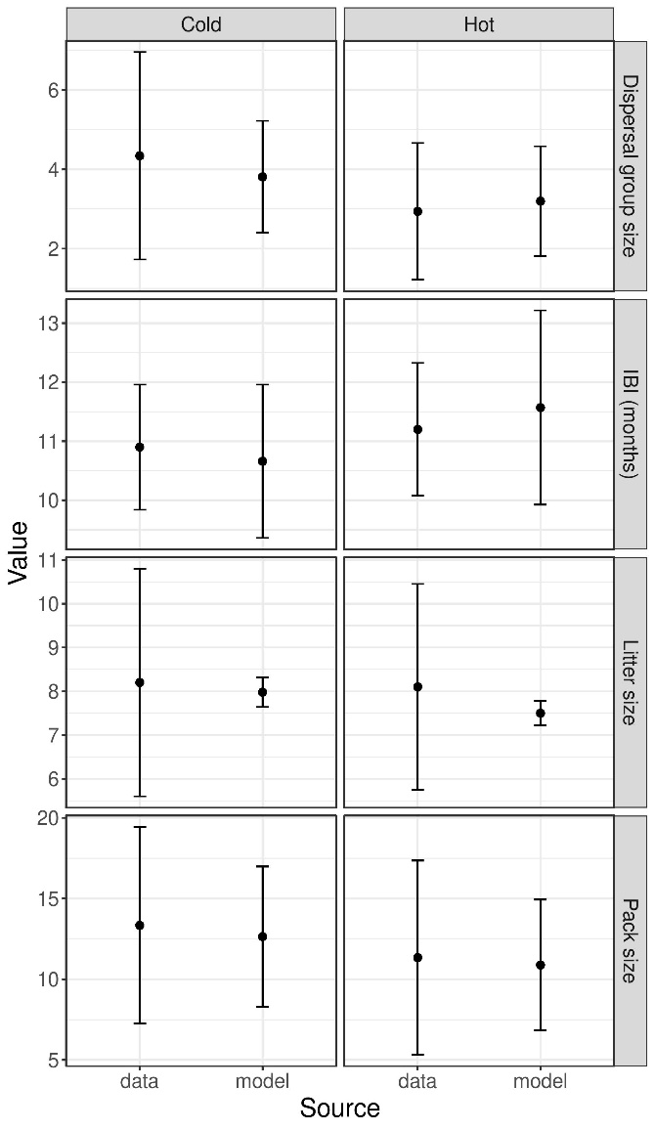
Figure 2: Comparison between the data and model estimates for the two consecutive hottest and coldest years. IBI stands for Inter birth interval.
The model predictions matched the field data adequately, with the predicted distributions of pack size, inter birth interval, dispersal group size and the size of the pack at formation approximately matching the distribution of the data (Fig. 1). Short lived packs were over-represented in the model predictions due to the fact the model was single sex and therefore small dispersal groups were assumed to form small packs, whereas in reality small female groups may bond with large male groups, and vice versa (REF). The predicted distribution of litter sizes was narrower than the observed distribution (Fig. 1) due to the number of juveniles having to be rounded to the nearest whole number. When used to predict the pack dynamics under conditions of the hottest and coldest years, the outputs from the model matched the data well, with no detectable differences in observed and predicted values (Fig.2).

Future projections
In order to determine the levels of warming to be experienced by model populations in the future scenarios, we calculated how much the study site is predicted to warm between current times and 2070. Rasters of current (1975-2013) mean daily maximum temperature estimates from across the study site were obtained at a resolution of 30 arc seconds from the WorldClim climatic dataset (Hijmans et al., 2005). Raster layers of future mean daily maximum temperature projections (from the HADGEM-2-ES climate models) for 2070 under repesentative concentration pathways (RCPs) 2.6, 4.5, 6.0 and 8.5 were also obtained from WorldClim (Hijmans et al., 2005) at the same resolution. We defined the study area by drawing minimum convex polygons around locations obtained from GPS-collared individuals monitored by the Samburu Laikipia Wild Dog Project, and then merging them to generate a single polygon. We then calculated mean projected future warming across the study site under each of the four emissions scenarios, and used these as the temperature variable in the models. The variance was kept consistent. Mean daily maximum temperatures across the study site were projected to rise between 1.6°C and 3.9°C by 2070, depending on the RCP scenario.
We ran the model under warming of 0.5-5 degrees at 0.1 degree intervals, for the model constructed with 9 and 30 territories, in order to investigate the effect of increased mean daily maximum temperature on the population. We estimated the population extinction risk within 600 timesteps (approximately 10 generations (Woodroffe & Sillero-Zubiri, 2012)) at these temperatures, and also ran the model for 6000 time steps (approximately 100 generations) to estimate time to extinction. To investigate the drivers behind changes in population dynamics at high temperatures we ran the model for 600 time-steps under warming of 0.5-5 degrees at 0.1 degree intervals with the impacts of temperature on adult survival, juvenile survival and inter birth interval removed sequentially. The model was run 1000 times to obtain all estimates of pack and population characteristics, extinction risks and time to extinction.

Results

The impact of warming on population dynamics
The model predicted that litter size, pack size and pack longevity, would all decrease at higher temperatures, while interbirth interval would increase (Figure 3). The number of packs was predicted to remain approximately stable at warming scenarios below 2.5°C above current temperatures but, above this threshold, small increases in temperature were associated with large reductions in the predicted number of packs (Figure 3).

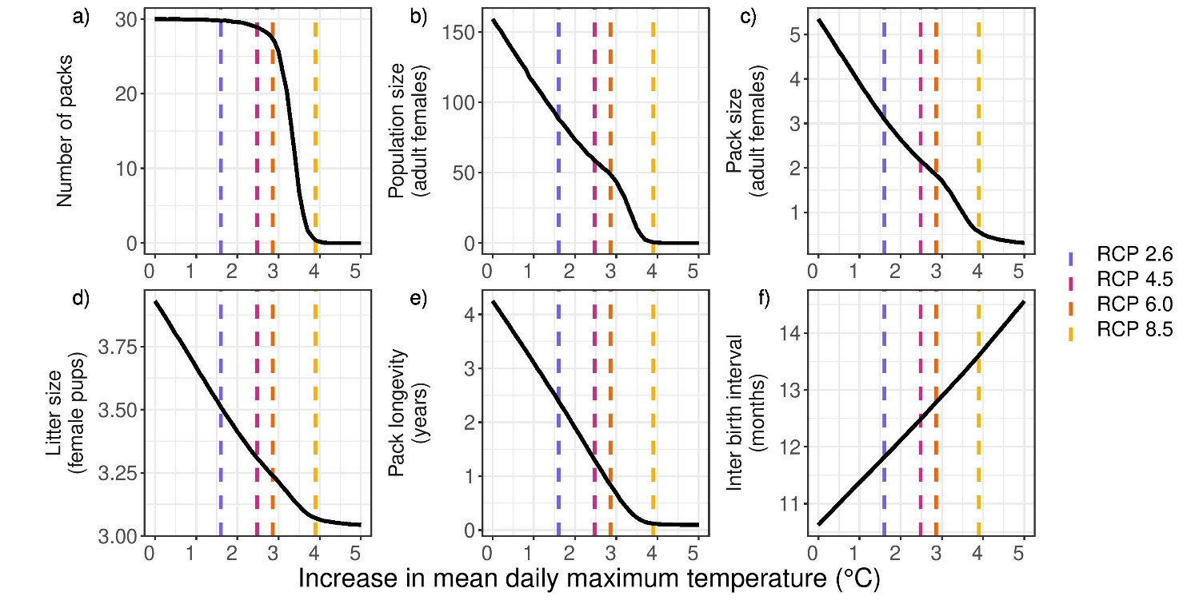
Figure 3: The impact of temperature increase (°C) on estimated mean population and pack variables for a simulated population with a carrying capacity of 30 packs over ten generations. Curves are splines through predictions made for 0.1 degree intervals of increase in temperature. Predicted warming by 2070 at the study site under the four representative concentration pathways are marked with vertical dashed lines.

In the best case scenario (RCP 2.6, equivalent to a 1.6°C increase in local mean daily maximum temperature), average pack size in the model was predicted to fall from 5.2 to 3.1 adult females relative to current climate conditions, with the average pack longevity falling from 4.15 to 2.25 years (Fig. 3). Despite the average number of packs in the population remaining unchanged in the best case climate scenario, the average population size was predicted to fall by 45% (Fig. 3) reflecting the reduction in pack size. There was little predicted difference in litter size between predictions at current temperatures and those under the best case climate scenario (Fig. 3).
Under RCP 4.5 (equivalent to 2.5°C increase in local mean daily maximum temperature) the mean pack size was predicted to fall as low as 2 adult females per pack, with the population size reduced by 64% compared to predictions under current temperatures (Fig. 3). The number of packs in the population was predicted to remain high, however (Fig. 3). Under RCP 6.0 (2.8°C increase in local mean daily maximum temperature) average pack longevity was predicted to fall below one year, and average pack size to fall below 2 adult females. (Fig. 3). Alongside this, at this level of warming the predicted number of packs in the population began to fall (Fig. 3). Under the worst case scenario, RCP 8.5 (3.9°C increase in local mean daily maximum temperature), the average pack duration was predicted to be under one year, and inter birth interval was predicted to be 13.5 months, causing breeding rates to collapse (Fig. 3). The average litter size was predicted to fall to 3 female juveniles, and the average number of both packs and individuals was predicted to be very low (Fig. 3).

The impact of warming on population persistence
Extinction risk was predicted to remain at 0 for levels of warming below 1.8°C above current mean daily maximum temperatures for a population with nine available territories, and until warming was simulated to be 2.8°C higher than current temperatures for a population with 30 available territories (Fig. 4). Above these threshold levels of warming, small increases in temperature were associated with large increases in extinction risk. For populations occupying up to nine territories, a 1.4C increase in warming (from 1.8°C to 3.2°C above current temperatures) was sufficient to transition the 10-generation extinction risk from 0 to 1. For populations occupying up to 30 territories, this transition was predicted to occur across just 1°C of warming (from 2.8°C to 3.8°C above current levels) (Figure 4). Patterns of predicted time to extinction mirrored that of extinction risk, remaining at 100 generations (persistence until the end of the model runs) at temperatures of up to 2.8°C in a population with 30 territories available before reducing to under 5 generations at 3.8°C of warming. The same pattern was predicted for a population of 9 available territories, but with the time to extinction falling at temperatures 1.8°C above current levels.

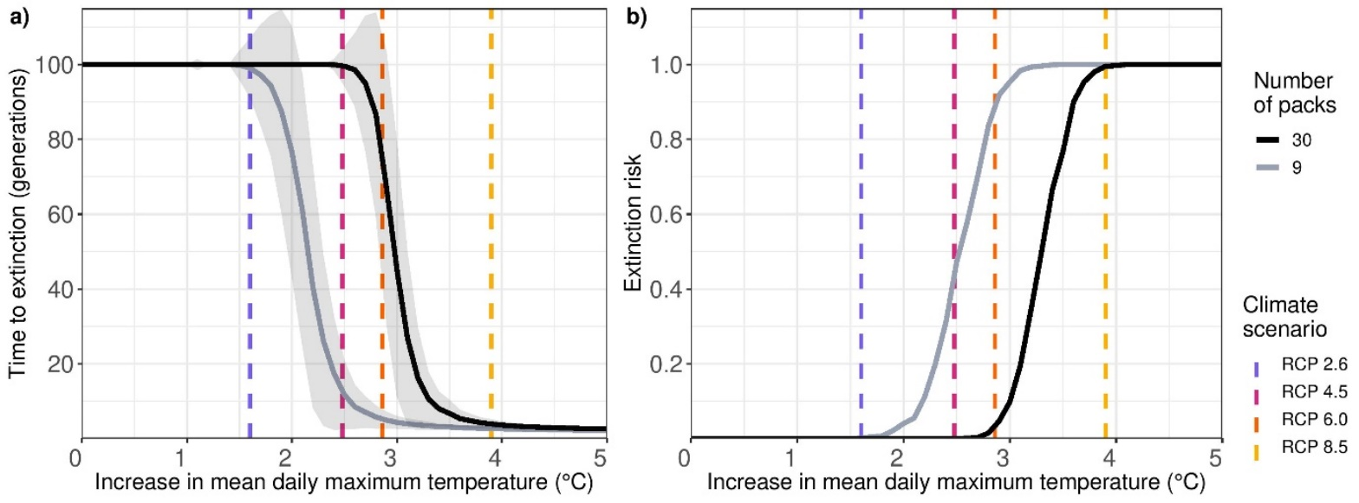
Figure 4: The impact of temperature increase (°C) on a) estimated time to extinction over 100 generations and b) Extinction risk over 10 generations. Curves are splines through predictions made for 0.1 degree intervals of increase in temperature. Predicted warming by 2070 at the study site under the four representative concentration pathways are marked with vertical dashed lines.

Drivers of declines
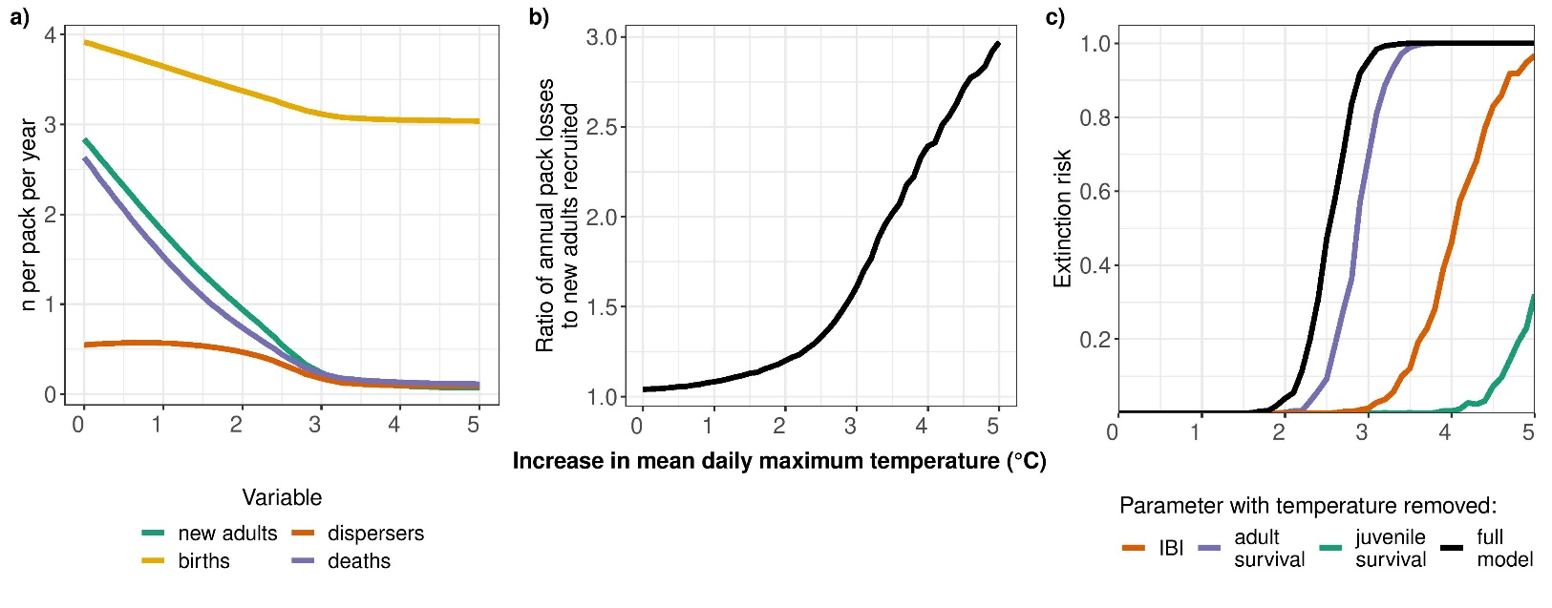
Population collapse at high temperatures was driven primarily by falls in recruitment within packs (Fig. 5). Whilst the number of individuals dying and dispersing in each pack did fall at higher temperatures, this was due to a decrease in pack size (Fig. 3, Fig. 5). At higher temperatures, the number of individuals lost to packs through death and dispersal was predicted to become increasingly larger than the number of new adults recruited through birth and juvenile survival (Fig. 5). The decrease in juvenile survival at high temperatures contributed more to the predicted fall in recruitment than the decreased number of births (Fig. 5). This pattern is illustrated by the small fall in births at high temperatures, compared to the large fall in juvenile survival, and also by the finding that removing the impact of temperature on juvenile survival resulted in the largest reduction in climate driven extinction risk. Removing the impact of temperature on juvenile survival in the model increased the threshold for accelerating extinction risk from 1.8℃ (in the model with all temperature impacts present) to 4℃ (with effects on juvenile survival removed). Removing the impact of temperature on the inter birth interval also had a relatively large impact on extinction risk, increasing the threshold at which extinction risk is predicted to rise from 1.8℃ to 3℃ (Fig. 5). Removing the impact of temperature on adult survival had little impact on extinction risk, with the threshold at which extinction risk is predicted to rise only increasing by 0.2℃ (Fig. 5).
Figure 5: Underlying drivers of population trends as temperatures rise. a) the simulated number of births, new adults, dispersals, and deaths per pack, per year, at 0.1 degree interval increases in temperature b) the ratio of new pack members to pack losses at 0.1 degree interval increases in temperature and c) extinction risk of a population of 9 packs at 0.1 degree interval increases in temperature with the impact of temperature on different demographic variables removed. Curves further to the right indicate a larger reduction in extinction risk. IBI stands for inter birth interval.

Discussion
Our model predicts the extreme sensitivity of African wild dog populations to climate change. Strong threshold effects suggest that increasing mean daily maximum temperature by just 1°C can cause predicted extinction risk to transition from 0% to 100%. These threshold effects are cause for concern because, had long-term study not revealed the demographic impacts of temperature, population collapse would be likely to occur too fast for conservation action to prevent extinction. Knowing that such threshold effects can occur may be essential for the conservation of other, less well-studied, species.
We have shown previously that mean daily maximum temperature during the breeding season increased by an average of 0.134°C per year between 1989 and 2012 at a long term study site in Botswana (Woodroffe et al., 2017). At this rate, a 1°C increase in daily maximum temperature during the breeding season, the climatic variable that drives the fall in juvenile survival at high temperatures, would occur over approximately eight years. Increases in local mean maximum temperature across most of the African continent are predicted to be much greater than increases in the global mean temperature used to characterise climate change in policy settings (Barros et al., 2014). As a result, an additional 1°C increase in the mean maximum temperature during African wild dog breeding season across most of their remaining range reflects a much smaller increase in global temperatures. Thus, even temperature rises in line in the best case climate scenario, RCP 2.5, which represents a 2°C rise in global temperatures by 2100, may cause increases in population extinction risk across much of the species’ range.
This work highlights the importance of group level dynamics in determining the persistence of cooperative species under climate change. The species’ social structure buffers impacts of rising temperatures on extinction risk under low levels of warming in the model, by maintaining the number of packs, and therefore breeding individuals, in the population. Under warming in line with the middle and worst case scenarios, however, the population is predicted to collapse. This collapse is driven primarily by the impact of temperature on recruitment, with no juveniles from the previous breeding season surviving until the next litter, meaning that there are too few animals remaining in the population to replace the breeding pair when they die. Whilst a high number of territories within a population reduces the impacts of high temperatures, a 230% increase in carrying capacity of a population (from nine to 30 packs) increases the temperature resilience of the population by less than one degree.
In contrast to the prediction that reduced group sizes due to environmental change would cause demographic Allee effects and population collapse (Courchamp et al., 2000), at 2°C warming there is predicted to be little to no increase in extinction risk in the population despite a 50% reduction in pack size. Our model predicts that African wild dog populations can maintain the same number of packs, and therefore the same number of breeding pairs, despite climate change driven reductions in the number of subdominant individuals. Instead, the predicted population collapse is driven by a fall in recruitment – with the number of juveniles that become adults falling to below one new adult per pack per year, leading to pack collapse and population extinction. Removing temperature effects from the demographic variables highlights that this fall in recruitment was primarily driven by a fall in juvenile survival and exacerbated by the climate-driven increase in inter-birth interval (Fig. 5). Despite the link between pack size and litter size, and the predicted fall in pack size at high temperatures (Fig. 3), litter size changed to a lesser extent at high temperatures, and therefore made a smaller contribution to the temperature-related fall in recruitment (Fig 5).
As our model represents females only, the predicted impacts of high temperatures on the population are likely to be conservative, as the presence of male dispersers with which the females could start new packs was assumed. In reality, an unrelated group of males may often not be present in the population at the time that females disperse, preventing pack formation. Inbreeding avoidance is very strong in wild dogs, and packs have been observed to cease breeding if there are no unrelated mates (Becker et al., 2012). The model also ignores the impact that the death of the dominant male may have on a pack; packs within a real population would be expected to break up when the dominant male dies if there were no males unrelated to the dominant female to take over. In addition to this, many other threats to wild dogs are likely to be exacerbated by the year 2070, including habitat loss (Williams et al., 2020), disease (Carlson et al., 2022), and conflict with people due to human encroachment into natural habitat in response to changing climatic conditions (Milán-García et al., 2021), none of which are explicitly incorporated into the model. This means that the simulated populations may be more stable than real African wild dog populations, as evidenced by the 0% extinction risk predicted at current temperatures for populations with carrying capacities of both nine and 30 packs. For this reason, our model predictions are likely to under-estimate population extinction risk, both now and under future climatic conditions.
Although our model was parameterised using data from a single study population in Kenya, we have previously shown impacts of temperature on wild dog survival at other sites in Africa(Rabaiotti et al., 2021; Woodroffe et al., 2017). Removing temperature impacts on juvenile survival, which have been found to occur across three separate wild dog populations to date (Woodroffe et al., 2017), virtually eliminated climate driven increases in extinction risk, even under the smaller population size and worst case climate scenario. This observation indicates that, in order to mitigate climate change impacts on African wild dog populations, conservation programmes would ideally focus their efforts on mitigating the impacts of temperature on juvenile survival rates.
Our observation that removing the impact of high temperatures on adult survival did little to decrease projected impacts on populations suggests that novel conservation interventions are likely to be needed. Impacts of temperature on adult mortality (Rabaiotti et al., 2021) appear to be driven primarily by increases in deaths due to disease and human-wildlife conflict (Rabaiotti et al, 2021). While conservation interventions such as vaccination schemes and community programmes may therefore also mitigate the impacts of high temperature on adult survival, the impact of such interventions on juvenile survival (and hence extinction risk under climate change) are less certain. Identifying the mechanisms leading to low juvenile survival at high temperatures should be a key research focus to establish which interventions might prevent population decline under climate change.
The sharp rise in extinction risk at temperatures above a specific threshold indicates there is a ‘tipping point’ above which juvenile survival is so low that packs are no longer recruiting subdominant individuals, there are no longer any dispersers produced, and therefore new packs are no longer being formed. When there is no breeding pair to replace those that are lost, reproduction ceases and the population rapidly collapses. This has implications not only for wild dogs, but for other co-operatively breeding species where there is no subdominant breeding, where dispersal is crucial for the replacement of the breeding pair, such as the Arabian pied babbler (Nelson-Flower et al., 2011) and the naked mole rat (Faulkes et al., 1997). Even for species that appear able to withstand extreme climatic conditions by maintaining the number of breeding pairs, impacts on recruitment can reach a point where the population is no longer viable. Beyond social species, it is clear that the temperature at which recruitment is reduced to a point that the population of breeding individuals falls is a threshold above which the population will rapidly decline, and subsequently go extinct. Identifying these thresholds allows conservation practitioners to identify where populations will likely go extinct under climate change, and under which climate change scenarios.
This work demonstrates the crucial role of long term field data in parameterising models that predict the impact of environmental change on social species. Population models such as these can be used to identify how much environmental change a species is resilient to, determining “tipping points” after which populations are likely to go extinct. The findings of this study highlight the importance of taking into account individual and group characteristics when predicting the impact of climatic conditions on social species, and highlight the extent to which relatively simple mechanistic population models can be used to predict the impacts of climate change on population viability. Our findings also raise concerns about declines in long term field based studies across conservation biology as a whole (Hughes et al., 2017) as, without long term monitoring across a range of weather conditions, predictions such as these are not possible. In cases where long term field data are available, individual based population models can shed new light on climate change threats, and enable predictions of future population trends of species.

Angulo, E., Rasmussen, G. S. A., Macdonald, D. W., & Courchamp, F. (2013). Do social groups prevent Allee effect related extinctions?: The case of wild dogs. Frontiers in Zoology, 10(1), 11. https://doi.org/10.1186/1742-9994-10-11
Armitage, K. B. (1987). Social dynamics of mammals: Reproductive success, kinship and individual fitness. Trends in Ecology and Evolution, 2(9), 279–284. https://doi.org/10.1016/0169-5347(87)90037-1
Barros, V. R., Field, C. B., Dokken, D. J., Mastrandrea, M. D., Mach, K. J., Bilir, T. E., Chatterjee, M., Ebi, K. L., Estrada, Y. O., Genova, R. C., Girma, B., Kissel, E. S., Levy, A. N., MacCracken, S., Mastrandrea, P. R., & White, L. L. (2014). IPCC, 2014: Climate Change 2014: Impacts, Adaptation, and Vulnerability. Part A: Global and Sectoral Aspects. Contribution of Working Group II to the Fifth Assessment Report of the Intergovernmental Panel on Climate Change. Cambridge University Press.
Bateman, A. W., Coulson, T., & Clutton-Brock, T. H. (2011). What do simple models reveal about the population dynamics of a cooperatively breeding species? Oikos, 120(5), 787–794. https://doi.org/10.1111/j.1600-0706.2010.18952.x
Bateman, A. W., Ozgul, A., Coulson, T., & Clutton-Brock, T. H. (2012). Density dependence in group dynamics of a highly social mongoose, Suricata suricatta. Journal of Animal Ecology, 81(3), 628–639. https://doi.org/10.1111/j.1365-2656.2011.01934.x
Bateman, A. W., Ozgul, A., Nielsen, J. F., Coulson, T., & Clutton-Brock, T. H. (2013). Social structure mediates environmental effects on group size in an obligate cooperative breeder, Suricata suricatta. Ecology, 94(3), 587–597. https://doi.org/10.1890/11-2122.1
Becker, P. A., Miller, P. S., Gunther, M. S., Somers, M. J., Wildt, D. E., & MaldonadoJesú, J. E. (2012). Inbreeding Avoidance Influences the Viability of Reintroduced Populations of African Wild Dogs (Lycaon pictus). PLOS ONE, 7(5), e37181. https://doi.org/10.1371/JOURNAL.PONE.0037181
Behr, D., McNutt, J., Ozgul, A., & Cozzi, G. (2020). When to stay and when to leave? Proximate causes of dispersal in an endangered social carnivore. Journal of Animal Ecology, 0–2. https://doi.org/10.1111/1365-2656.13300
Brown, C. R., & Brown, M. B. (2004). Group size and ectoparasitism affect daily survival probability in a colonial bird. Behavioral Ecology and Sociobiology 2004 56:5, 56(5), 498–511. https://doi.org/10.1007/S00265-004-0813-6
Cahill, A. E., Aiello-Lammens, M. E., Fisher-Reid, M. C., Hua, X., Karanewsky, C. J., Yeong Ryu, H., Sbeglia, G. C., Spagnolo, F., Waldron, J. B., Warsi, O., & Wiens, J. J. (2012). How does climate change cause extinction? Proceedings of the Royal Society B: Biological Sciences, 280(1750), 20121890–20121890. https://doi.org/10.1098/rspb.2012.1890
Carlson, C. J., Albery, G. F., Merow, C., Trisos, C. H., Zipfel, C. M., Eskew, E. A., Olival, K. J., Ross, N., & Bansal, S. (2022). Climate change increases cross-species viral transmission risk. Nature 2022, 1–1. https://doi.org/10.1038/s41586-022-04788-w
Caylor K.K., Gitonga, J., Martins, D. J. (2007). Meteorological and Hydrological Dataset [Datafile]. Mpala Research Centre.
Clutton-Brock, T. H., Russell, A. F., Sharpe, L. L., Brotherton, P. N. M., McIlrath, G. M., White, S., & Cameron, E. Z. (2001). Effects of Helpers on Juvenile Development and Survival in Meerkats. Science, 293(5539), 2446–2449. https://doi.org/10.1126/SCIENCE.1061274
Clutton-Brock, T., & Sheldon, B. C. (2010). Individuals and populations: the role of long-term, individual-based studies of animals in ecology and evolutionary biology. Trends in Ecology & Evolution, 25(10), 562–573. https://doi.org/10.1016/J.TREE.2010.08.002
Coulson, T., Macnulty, D. R., Stahler, D. R., Wayne, R. K., & Smith, D. W. (2011). Modeling Effects of Environmental Change on Wolf Population Dynamics, Trait Evolution, and Life History. 334(December), 2009–2012. https://doi.org/10.1126/science.1209441
Courchamp, F., Clutton-Brock, T., & Grenfell, B. (2000). Multipack dynamics and the Allee effect in the African wild dog, Lycaon pictus. Animal Conservation, 3, 277–285.
Creel, S., & Creel, N. M. (2002). The African Wild Dog: Behavior, Ecology, and Conservation. Princeton University Press. http://books.google.com/books?hl=en&lr=&id=ys4ZSof2BnMC&pgis=1
Cunningham, S. J., Martin, R. O., Hojem, C. L., & Hockey, P. A. R. (2013). Temperatures in Excess of Critical Thresholds Threaten Nestling Growth and Survival in A Rapidly-Warming Arid Savanna: A Study of Common Fiscals. PLoS ONE, 8(9). https://doi.org/10.1371/journal.pone.0074613
Ewen, J. G., Clarke, R. H., Moysey, E., Boulton, R. L., Crozier, R. H., & Clarke, M. F. (2001). Primary sex ratio bias in an endangered cooperatively breeding bird, the black-eared miner, and its implications for conservation. Biological Conservation, 101(2), 137–145. https://doi.org/10.1016/S0006-3207(01)00022-2
Faulkes, C. G., Abbott, D. H., O’Brien, H. P., Lau, L., Roy, M. R., Wayne, R. K., & Bruford, M. W. (1997). Micro- and macrogeographical genetic structure of colonies of naked mole-rats Heterocephalus glaber. Molecular Ecology, 6(7), 615–628. https://doi.org/10.1046/J.1365-294X.1997.00227.X
Gaston, A. J. (2015). The Evolution of Group Territorial Behavior and Cooperative Breeding. Https://Doi.Org/10.1086/283348, 112(988), 1091–1100. https://doi.org/10.1086/283348
Grimm, V., Dorndorf, N., Frey-Roos, F., Wissel, C., Wyszomirski, T., & Arnold, W. (2003). Modelling the role of social behavior in the persistence of the alpine marmot Marmota marmota. Oikos, 102(1), 124–136. https://doi.org/10.1034/J.1600-0706.2003.11731.X
Hetem, R. S., Fuller, A., Maloney, S. K., & Mitchell, D. (2014). Responses of large mammals to climate change. Temperature, 1(2), 115–127. https://doi.org/10.4161/temp.29651
Hughes, B. B., Beas-Luna, R., Barner, A. K., Brewitt, K., Brumbaugh, D. R., Cerny-Chipman, E. B., Close, S. L., Coblentz, K. E., de Nesnera, K. L., Drobnitch, S. T., Figurski, J. D., Focht, B., Friedman, M., Freiwald, J., Heady, K. K., Heady, W. N., Hettinger, A., Johnson, A., Karr, K. A., … Carr, M. H. (2017). Long-Term Studies Contribute Disproportionately to Ecology and Policy. BioScience, 67(3), 271–281. https://doi.org/10.1093/biosci/biw185
Hulin, V., Delmas, V., Girondot, M., Godfrey, M. H., & Guillon, J.-M. (2009). Temperature-dependent sex determination and global change: are some species at greater risk? Oecologia, 160(3), 493–506. https://doi.org/10.1007/s00442-009-1313-1
Keynan, O., & Ridley, A. R. (2016). Component, group and demographic Allee effects in a cooperatively breeding bird species, the Arabian babbler (Turdoides squamiceps). Oecologia, 182(1), 153–161. https://doi.org/10.1007/S00442-016-3656-8/FIGURES/5
Kingma, S. A., Komdeur, J., Burke, T., & Richardson, D. S. (2017). Differential dispersal costs and sex-biased dispersal distance in a cooperatively breeding bird. Behavioral Ecology, 28(4), 1113–1121. https://doi.org/10.1093/BEHECO/ARX075
Koenig, W. D., Walters, E. L., & Haydock, J. (2011). Variable helper effects, ecological conditions, and the evolution of cooperative breeding in the acorn woodpecker. American Naturalist, 178(2), 145–158. https://doi.org/10.1086/660832/ASSET/IMAGES/LARGE/FG6.JPEG
Komdeur, J., & Ma, L. (2021). Keeping up with environmental change: The importance of sociality. Ethology, 127(10), 790–807. https://doi.org/10.1111/ETH.13200
Lawson Handley, L. J., & Perrin, N. (2007). Advances in our understanding of mammalian sex-biased dispersal. Molecular Ecology, 16(8), 1559–1578. https://doi.org/10.1111/J.1365-294X.2006.03152.X
Lukas, D., & Clutton-Brock, T. (2016). Climate and the distribution of cooperative breeding in mammals. Royal Society Open Science, 4(1). https://doi.org/10.1098/RSOS.160897
Malcolm, J. R., & Marten, K. (1982). Natural selection and the communal rearing of pups in African wild dogs (Lycaon pictus). Behavioral Ecology and Sociobiology 1982 10:1, 10(1), 1–13. https://doi.org/10.1007/BF00296390
Marescot, L., Gimenez, O., Duchamp, C., Marboutin, E., & Chapron, G. (2012). Reducing matrix population models with application to social animal species. Ecological Modelling, 232, 91–96. https://doi.org/10.1016/J.ECOLMODEL.2012.02.017
Marjamäki, P. H., Contasti, A. L., Coulson, T. N., & Mcloughlin, P. D. (2013). Local density and group size interacts with age and sex to determine direction and rate of social dispersal in a polygynous mammal. Ecology and Evolution, 3(9), 3073–3082. https://doi.org/10.1002/ECE3.694
McNutt, J. W. (1996). Sex-biased dispersal in African wild dogs, Lycaon pictus. Animal Behaviour, 52(6), 1067–1077. https://doi.org/10.1006/anbe.1996.0254
McNutt, J. W., Groom, R., & Woodroffe, R. (2019). Ambient temperature provides an adaptive explanation for seasonal reproduction in a tropical mammal. Journal of Zoology, jzo.12712. https://doi.org/10.1111/jzo.12712
Milán-García, J., Caparrós-Martínez, J. L., Rueda-López, N., & de Pablo Valenciano, J. (2021). Climate change-induced migration: a bibliometric review. Globalization and Health, 17(1), 1–10. https://doi.org/10.1186/S12992-021-00722-3/FIGURES/4
Mitchell, N. J., Allendorf, F. W., Keall, S. N., Daugherty, C. H., & Nelson, N. J. (2010). Demographic effects of temperature-dependent sex determination: will tuatara survive global warming? Global Change Biology, 16(1), 60–72. https://doi.org/10.1111/j.1365-2486.2009.01964.x
Nelson-Flower, M. J., Hockey, P. A. R., O’Ryan, C., Raihani, N. J., du Plessis, M. A., & Ridley, A. R. (2011). Monogamous dominant pairs monopolize reproduction in the cooperatively breeding pied babbler. Behavioral Ecology, 22(3), 559–565. https://doi.org/10.1093/BEHECO/ARR018
Paniw, M., James, T. D., Ruth Archer, C., Römer, G., Levin, S., Compagnoni, A., Che-Castaldo, J., Bennett, J. M., Mooney, A., Childs, D. Z., Ozgul, A., Jones, O. R., Burns, J. H., Beckerman, A. P., Patwary, A., Sanchez-Gassen, N., Knight, T. M., & Salguero-Gómez, R. (2021). The myriad of complex demographic responses of terrestrial mammals to climate change and gaps of knowledge: A global analysis. Journal of Animal Ecology, 90(6), 1398–1407. https://doi.org/10.1111/1365-2656.13467
Paniw, M., Maag, N., Cozzi, G., Clutton-Brock, T., & Ozgul, A. (2019). Life history responses of meerkats to seasonal changes in extreme environments. Science, 363(6427), 631–635. https://doi.org/10.1126/SCIENCE.AAU5905/SUPPL_FILE/AAU5905_R_SCRIPTS_S1_TO_S3_AND_DATA_S1_TO_S17.ZIP
Rabaiotti, D., Groom, R., McNutt, J. W., Watermeyer, J., O’Neill, H. M. K., & Woodroffe, R. (2021). High temperatures and human pressures interact to influence mortality in an African carnivore. Ecology and Evolution, 11(13), 8495–8506. https://doi.org/10.1002/ECE3.7601
Robinette, K. W., Andelt, W. F., & Burnham, K. P. (1995). Effect of Group Size on Survival of Relocated Prairie Dogs. The Journal of Wildlife Management, 59(4), 867. https://doi.org/10.2307/3801968
Rood, J. P. (1990). Group size, survival, reproduction, and routes to breeding in dwarf mongooses. Animal Behaviour, 39(3), 566–572. https://doi.org/10.1016/S0003-3472(05)80423-3
Rubenstein, D. R., & Lovette, I. J. (2007). Temporal Environmental Variability Drives the Evolution of Cooperative Breeding in Birds. Current Biology, 17(16), 1414–1419. https://doi.org/10.1016/J.CUB.2007.07.032/ATTACHMENT/D064A308-4A1B-42BF-AB16-D1535BEF78F5/MMC1.PDF
Smaldino, P. E., Schank, J. C., & McElreath, R. (2015). Increased Costs of Cooperation Help Cooperators in the Long Run. Https://Doi.Org/10.1086/669615, 181(4), 451–463. https://doi.org/10.1086/669615
Waller, N. L., Gynther, I. C., Freeman, A. B., Lavery, T. H., & Leung, L. K.-P. (2017). The Bramble Cay melomys Melomys rubicola (Rodentia : Muridae): a first mammalian extinction caused by human-induced climate change? Wildlife Research, 44(1), 9. https://doi.org/10.1071/WR16157
Williams, D. R., Clark, M., Buchanan, G. M., Ficetola, G. F., Rondinini, C., & Tilman, D. (2020). Proactive conservation to prevent habitat losses to agricultural expansion. Nature Sustainability 2020 4:4, 4(4), 314–322. https://doi.org/10.1038/s41893-020-00656-5
Woodroffe, R. (2011a). Demography of a recovering African wild dog (Lycaon pictus) population. Journal of Mammalogy, 92(2), 305–315. https://doi.org/10.1644/10-MAMM-A-157.1
Woodroffe, R. (2011b). Ranging behaviour of African wild dog packs in a human-dominated landscape. Journal of Zoology, 283(2), 88–97. https://doi.org/10.1111/j.1469-7998.2010.00747.x
Woodroffe, R., Davies-Mostert, H., Ginsberg, J., Graf, J., Leigh, K., McCreery, K., Robbins, R., Mills, G., Pole, A., Rasmussen, G., Somers, M., & Szykman, M. (2007). Rates and causes of mortality in Endangered African wild dogs Lycaon pictus: lessons for management and monitoring. Oryx, 41(02), 215. https://doi.org/10.1017/S0030605307001809
Woodroffe, R., Groom, R., & McNutt, J. W. (2017). Hot dogs: High ambient temperatures impact reproductive success in a tropical carnivore. Journal of Animal Ecology, 86(6), 1329–1338. https://doi.org/10.1111/1365-2656.12719
Woodroffe, R., O’Neill, H. M. K., & Rabaiotti, D. (2019a). Within- and between-group dynamics in an obligate cooperative breeder. Journal of Animal Ecology.
Woodroffe, R., O’Neill, H. M. K., & Rabaiotti, D. (2019b). Within- and between-group dynamics in an obligate cooperative breeder. Journal of Animal Ecology.
Woodroffe, R., O’Neill, H. M. K., & Rabaiotti, D. (2020). Within- and between-group dynamics in an obligate cooperative breeder. Journal of Animal Ecology, 89(2). https://doi.org/10.1111/1365-2656.13102
Woodroffe, R., Rabaiotti, D., Ngatia, D. K., Smallwood, T. R. C., Strebel, S., & O’Neill, H. M. K. (2020). Dispersal behaviour of African wild dogs in Kenya. African Journal of Ecology, 58(1). https://doi.org/10.1111/aje.12689
Woodroffe, R., & Sillero-Zubiri, C. (2012). “Lycaon pictus.” IUCN Red List of Threatened Species, IUCN 2012(2012.2).

Supplementary information

Annex S1 - Submodel parameterisation

Reproduction

Inter-birth Interval
The parameters for inter-birth interval – the intercept (α), impact of temperature (β) and impact of litter size (γ) – were estimated using the dataset originally published as part of Woodroffe et al 2017 (Woodroffe et al 2018). This dataset consists of 38 records of African wild dog litters from across 16 packs, collected between 2001 and 2011 in Laikipia, Samburu, and Isiolo counties Kenya. Parameters were estimated using a GLM with a Gaussian error distribution. Inter-birth interval, in months (unrounded), was the response variable. Centred mean daily maximum temperature (in °C) over the previous three month denning period, and the number of pups that were counted at three months of age in the previous litter, were the explanatory variables. The explanatory variables were chosen based on the variables found to be associated with inter birth interval in Woodroffe et al 2017. The GLM was run in R version 3.6.0 in the package nlme (Pinheiro et al 2020).

Number of pups
The parameters for the number of pups that left the den at three months of age – the intercept (δ) and the impact of pack size (ε) – were estimated using the same data from Woodroffe et al 2018. Parameters were estimated using a GLM with a Poisson error distribution, with the number of pups that left the den at three months old as the response variable and pack size (number of adults) as the explanatory variable. The explanatory variable was chosen based on the variable found to be associated with the number of pups counted at the den at three months of age in Woodroffe et al 2017. As our model was single sex, the intercept was divided by two. The GLM was run in R version 3.6.0 in the package nlme (Pinheiro et al 2020).

Deaths

Juvenile survival
The parameters in the submodel determining the number of juveniles that survived in each time-step – the intercept (ζ), the impact of temperature during the denning period (θ), and the impact of litter size (λ) – were estimated using data on juvenile survival published as part of Woodroffe et al 2017 on the survival to 12 months of 137 individuals from 21 litters counted at three months of age. Parameters were estimated using a binomial GLM with monthly survival (0 or 1) as the dependant variable and centred mean daily maximum temperature (in °C) over the three month denning period, and the number of pups that were counted leaving the den at 3 months of age in the birth litter, as the explanatory variables. The explanatory variables were chosen based on the variables found to be associated with juvenile survival in Woodroffe et al 2017. The GLM was run in R version 3.6.0 in the package nlme (Pinheiro et al 2020).

Adult survival
The parameters in the submodel determining the number of adults that survived in each time-step – the baseline hazard (µ), the impact of temperature (ξ), the impact of pack size (σ), the impact of age (ɸ), and the impact of dominance status (υ) – were estimated using data on adult survival published as part of Rabaiotti et al (2021b). The dataset contained survival and pack characteristics on 130 African wild dogs from 41 packs, collected between 2001 and 2016. Data were analysed using a Cox proportional hazards model with monthly survival (0 or 1) as the response variable, and centred mean maximum temperature (in °C) over the preceding three month period, dominance, pack size, pack status (resident or dispersing), and age as the explanatory variables. Explanatory variables were chosen based on the variables found to be associated with adult survival in Rabaiotti et al (2021a). The Cox Proportional Hazard models was run in R version 3.6.0 in the package survival (Therneau et al 2020).

Dispersal
The parameters in the submodel determining the number of adults that disperse in each time-step – the baseline hazard (φ), and the impact of pack size (ω) – were determined using the same dataset as the parameters of adult survival, as this also looked at impacts of dispersal on mortality and therefore contained dispersal dates. Data were analysed using a Cox proportional hazards model with monthly dispersal (0 or 1) as the response variable, and pack size as the explanatory variable. Explanatory variables were chosen based on the variables found to be associated with dispersal in Woodroffe et al (2020a). The Cox Proportional Hazard models was run in R version 3.6.0 in the package survival (Therneau et al 2020).

Comparison table between model estimates and data
Table S1: Mean population and pack pvariables predicted by the model at mean temperatures across 1000 model runs of 100,000 time steps with nine territories, compared with pack chracteristics from the field data. Italics indicates that the values were halved to make the empirical data comparable to the results of the model, as it is single sex.
Variable | Model predicted value (± SD) | Value from data (±SD)
Pack size | 5.29 (±2.79) | 5.26 (±2.68)
Pack size on formation | 3.94 (±1.94) | 3.12 (±1.22)
Litter size | 3.92 (±0.68) | 3.62 (± 1.24)
Inter birth interval (months) | 10.69 (±1.37) | 10.52 (±1.62)
Pack longevity (years) | 3.40 (±3.03) | 3.93 (±2.72)
Dispersal group size | 3.80 (±1.83) | 3.49 (±1.79)

Annex S2: Elasticity Analysis
We performed an elasticity analysis by independently increasing each of the demographic variables (inter-birth interval, litter size, juvenile mortality, subdominant and dominant adult mortality, and dispersal probability) by 1% (Coulson et al., 2011). We ran the model for 100,000 months, before altering the next variable. By independently perturbing each variable, we aimed to determine which variable contributed the most to the demography of the African wild dog, by observing changes in the output variables of interest (pack size, inter-birth interval, litter size, pack longevity, number of dispersers, number of packs, population size and time to extinction). Extinction risk and the number of packs in the model were particularly robust to 1% changes in the demographic parameters, showing no change in response to any of the parameters being shifted (Fig S1). Pack longevity was the most elastic outcome variable, and was the most sensitive to adult survival due to the link between adult survival, dominant survival, and pack break up. Pack size was more sensitive to changes in recruitment variables (inter birth interval, litter size, and juvenile survival) and dispersal than to changes in adult survival (either dominant or subdominant) (Fig S1). This finding indicates that pack size is more strongly regulated by recruitment and dispersal than by adult mortality. Population size was most elastic to litter size and inter-birth interval, reflecting the feedback loop between reproduction, pack size, and population size (Fig S1).
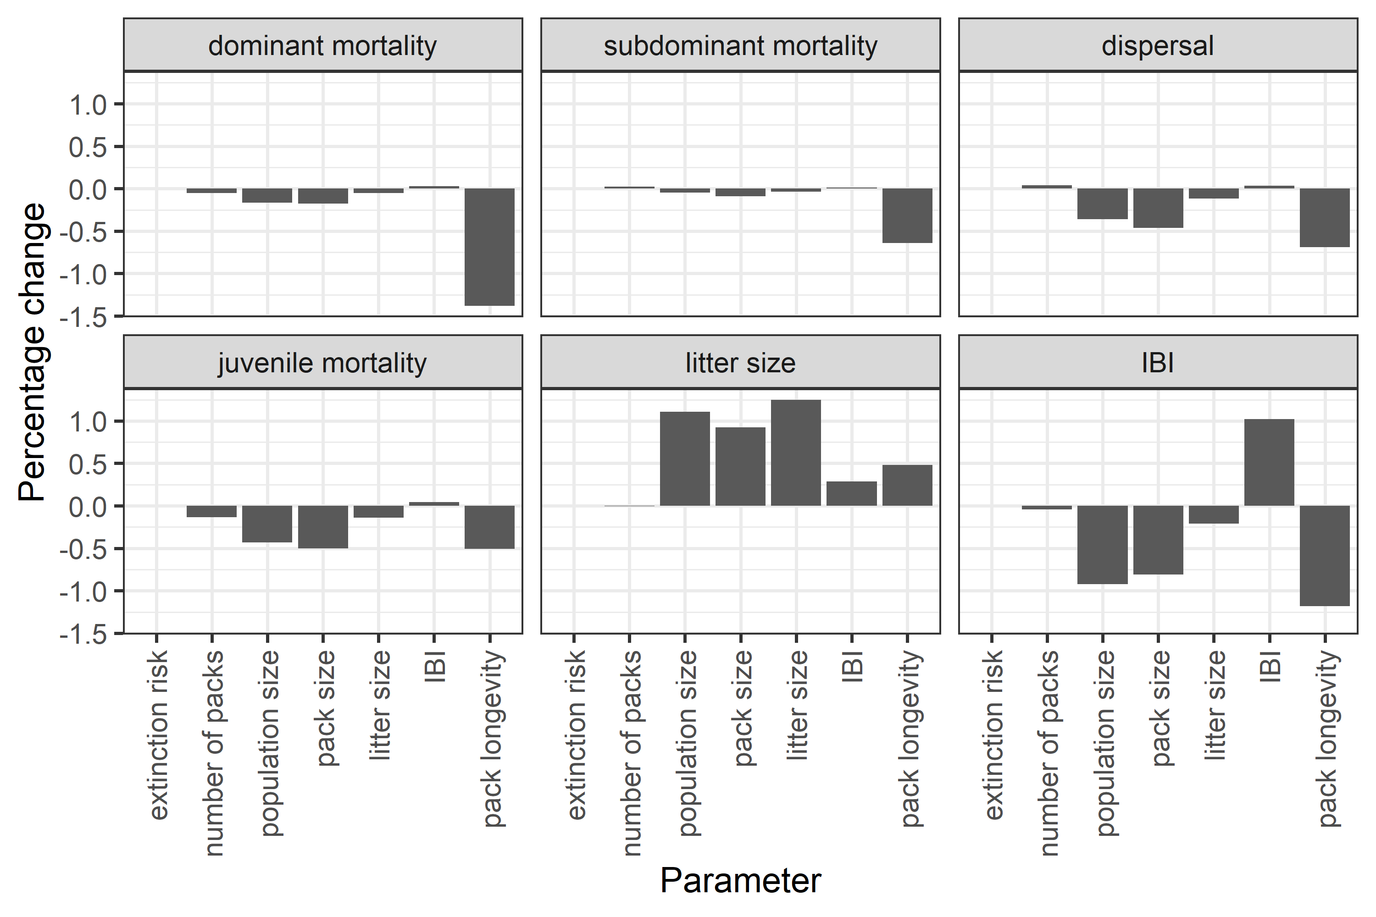
Figure S1. Change in each model variable in the elasticity analysis. Grey banners at the top of each plot indicate which demographic variable was increased by 1% and bars indicate the resulting change in the outcome variable on the x axis.

Annex S3: Sensitivity Analysis
We carried out a sensitivity analysis in order to assess the impact of parameter uncertainty. Each input variable had been estimated as a point estimate with an associated 95% confidence interval (Annex N), with the point estimates used to parameterise the main model. For each iteration of the sensitivity analysis, we varied the value of one input parameter within its 95% confidence interval, replacing the point estimate with one of 10 values equally-spaced from the lower to the upper 95% confidence limit. For example, if the point estimate for a parameter value had been 10, with a 95% confidence interval of 5-15, we would have explored the impact on model outputs of changing that parameter value to 5, 6, 7, 8, 9, 11, 12, 13, 14, and 15. The model was run 100 times for 10 generations (600 time steps).
Parameters that were varied were:
- The intercept (Μ), pack size effect (Σ), temperature effect (Ξ), age effect (ɸ ), and dominance effect (Υ) on adult mortality
- The intercept (Φ), and pack size effect (Ω) of dispersal
- The intercept (Α), litter size effect (Γ), and temperature effect (Β) on inter birth interval
- The intercept ($ζ$), litter size effect (Λ), and temperature effect (Θ) on juvenile mortality
- The intercept (Δ) and pack size effect (Ε) on litter size
The sensitivity analysis was carried out under both current mean maximum temperatures (Figure S3) and under four degrees of warming (Figure S4).
Most population level variables, particularly extinction risk and number of packs in the population, were very insensitive to changes in the input parameters within the model up to a level of ± 1 CI of the estimates (Fig. S2). Population size was more sensitive to changes to the intercept ($ζ$) and effect (λ) of litter size on juvenile survival, and the effect of pack size on litter size (ε), as these also impact pack size (Fig S4). The insensitivity of population level variables to changes in input parameters suggests that the model is relatively robust to errors in the parameter estimates, and that future projections are not reliant on the accuracy of the input parameter estimates.

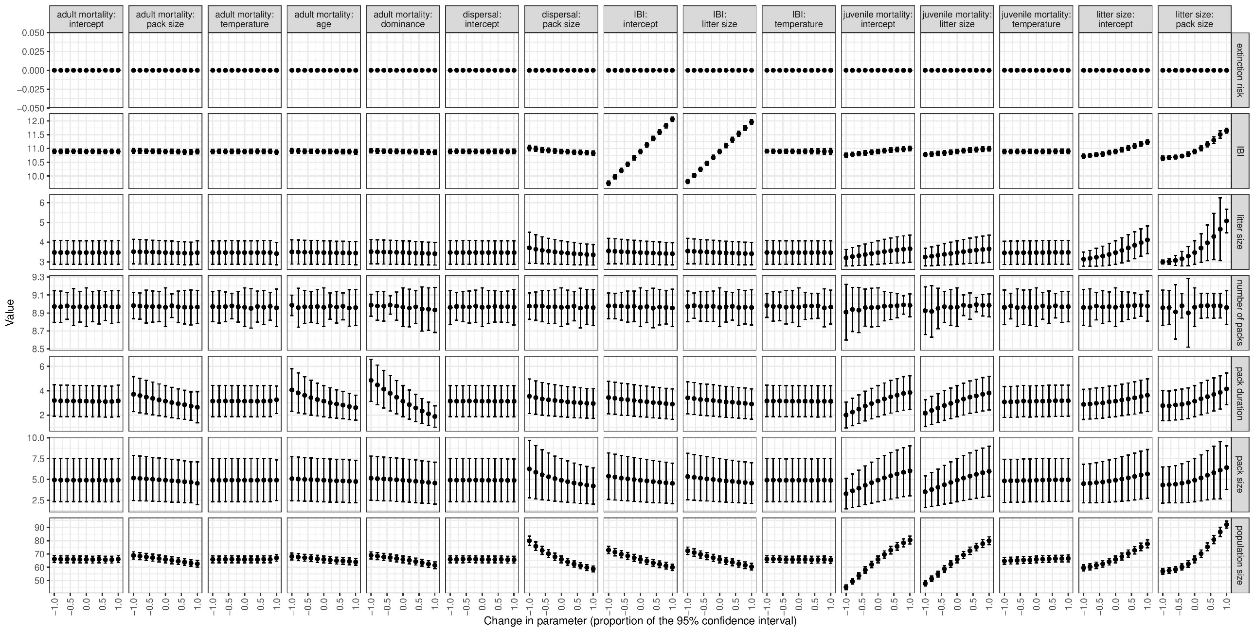
Figure S2: Responses of demographic variables to perturbation of parameter estimates within the sensitivity analysis under current climatic conditions. Grey banners above the plots indicate the parameter that was perturbed in the plots in that column, and grey banners to the right of the plots indicate which variable output that row of plots displays. Litter size denotes number of females emerging from the den at three months of age, pack size denotes number of adult females and population size denotes number of adult females.

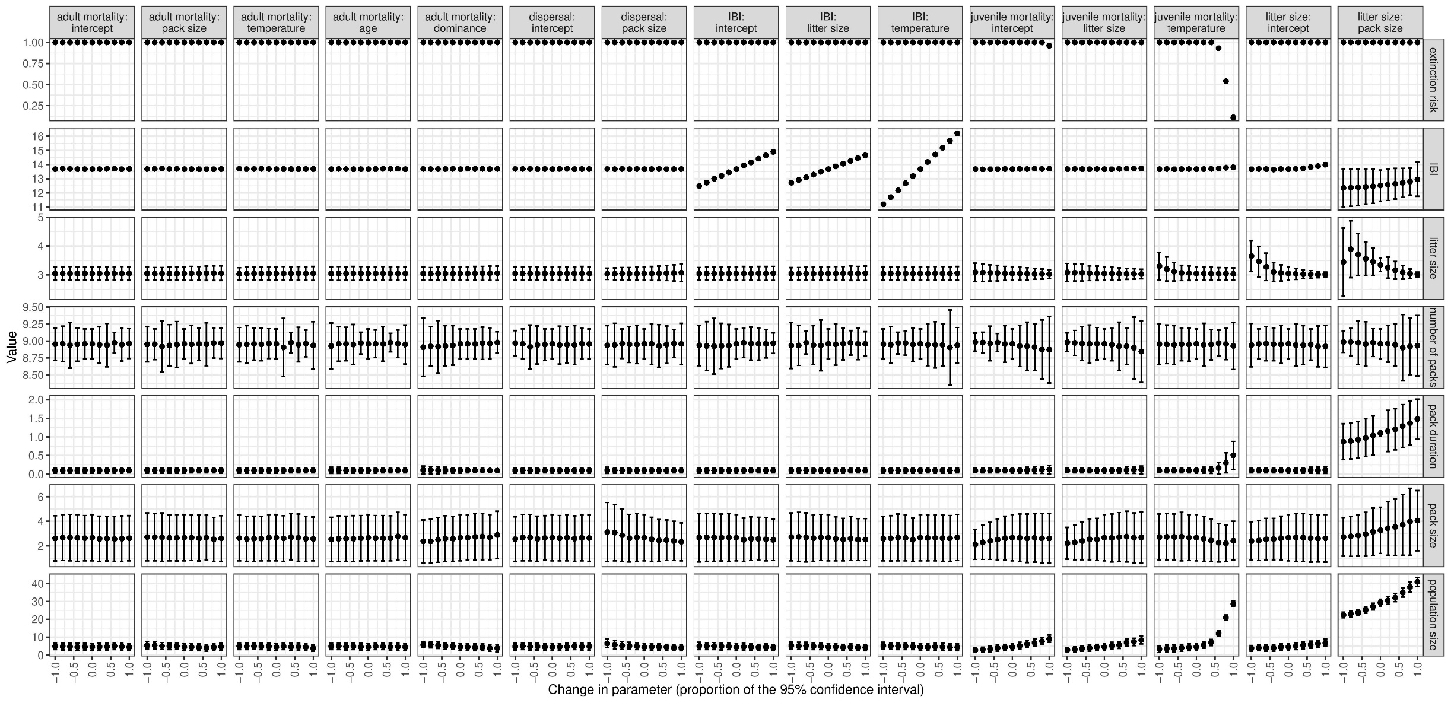
Figure S3: Response of demographic variables to perturbation of parameter estimates within the sensitivity analysis in the full model at four degrees of warming. Grey banners above the plots indicate the parameter that was perturbed in the plots in that column, and grey banners to the right of the plots indicate which variable output that row of plots displays. Litter size denotes number of females emerging from the den at three months of age, pack size denotes number of adult females and population size denotes number of adult females.
Pack size
Adult survival
Dispersal probability
Litter size
Juvenile
Survival
Inter birth
interval
Temperature
Positive Impact
Negative Impact

Figure S4 : Positive and negative feedbacks in the model
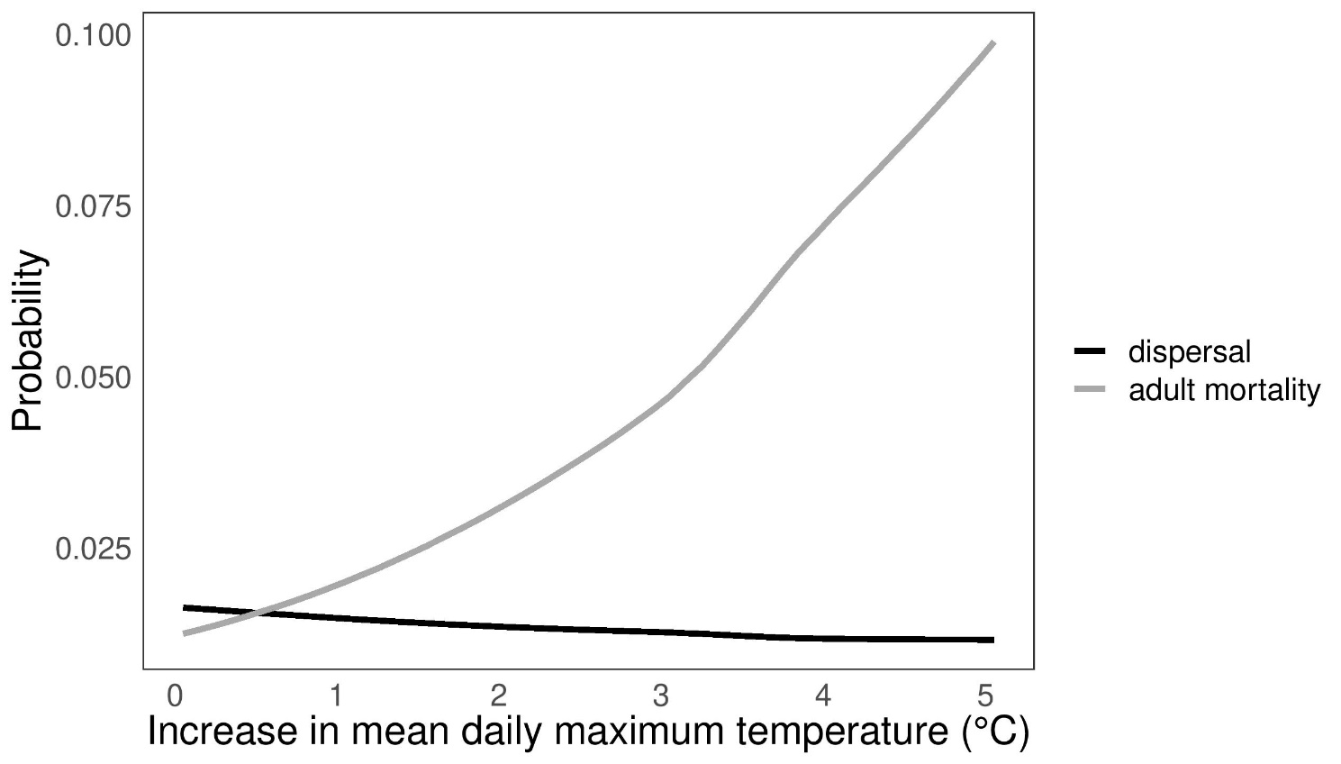
Figure S5: The probability of adult mortality and dispersal at the mean pack sizes predicted by the model between zero and five degrees of warming.

Citations
Coulson, T., MacNulty, D.R., Stahler, D.R., VonHoldt, B., Wayne, R.K. and Smith, D.W., 2011. Modeling effects of environmental change on wolf population dynamics, trait evolution, and life history. Science, 334(6060), pp.1275-1278.
Pinheiro J, Bates D, DebRoy S, Sarkar D, R Core Team (2021). nlme: Linear and Nonlinear Mixed Effects Models. R package version 3.1-152, URL:https://CRAN.R-project.org/package=nlme
Rabaiotti, D., Groom, R., McNutt, J.W., Watermeyer, J., O'Neill, H.M. and Woodroffe, R., (2021) High temperatures and human pressures interact to influence mortality in an African carnivore. Ecology and Evolution.
Rabaiotti, Daniella et al. (2022), High temperatures and human pressures interact to influence mortality in an African carnivore, Dryad, Dataset, https://doi.org/10.5061/dryad.4j0zpc8b9
Therneau T (2020). A Package for Survival Analysis in R. R package version 3.2-7, URL:https://CRAN.R-project.org/package=survival
Woodroffe, R., Groom, R., & McNutt, J. W. (2017). Hot dogs: High ambient temperatures impact reproductive success in a tropical carnivore. Journal of Animal Ecology, 86(6), 1329-1338.
Woodroffe, Rosie; Groom, Rosemary; McNutt, J. Weldon (2018), Data from: Hot dogs: high ambient temperatures impact reproductive success in a tropical carnivore, Dryad, Dataset, https://doi.org/10.5061/dryad.779qv

