Using integrated multispecies occupancy models to map co-occurrence between bottlenose dolphins and fisheries in the Gulf of Lion, French Mediterranean Sea.
Valentin Lauret$​^{1}$, Hélène Labach$​^{2}$, Léa David$​^{3}$, Matthieu Authier$​^{4,5}$, Olivier Gimenez$​^{1}$
- CEFE, Univ Montpellier, CNRS, EPHE, IRD, Montpellier, France
- MIRACETI, Connaissance et conservation des cétacés, Place des traceurs de pierres, 13500 La Couronne, France
- EcoOcéan Institut, 18 rue des Hospices, 34090 Montpellier
- Observatoire Pelagis, UAR 3462, CNRS-La Rochelle Université, 17000 La Rochelle, France
- Adera, 162 Avenue Albert Schweitzer. CS 60040 – 33608 Pessac CEDEX, France
Abstract: In the Mediterranean Sea, interactions between marine species and human activities are prevalent. The coastal distribution of bottlenose dolphins (Tursiops truncatus) and the predation pressure they put on fishing stocks lead to regular interactions with fisheries. Multispecies occupancy models allow mapping co-occurrence between two (or more) species while accounting for false negatives and potential interspecific dependance. Here, we illustrated how to extend multispecies occupancy model to integrate multiple datasets to quantify spatial co-occurrence between trawlers and bottlenose dolphins in the Gulf of Lion, French Mediterranean Sea. We combined bottlenose dolphin and trawler detections and non-detections from both aerial surveys and boat surveys in the Gulf of Lion and map potential interactions. Possibility to integrate several datasources into multipsecies occupancy models opens promising avenues in the study of interactions between human activities and marine mammals that occur at large spatial scales.
Keywords: cetaceans, human-animal interaction, NIMBLE, odontocetes, trawlers

Introduction
The Mediterranean Sea, being on the busiest seaway on Earth, is especially affected by anthropic pressures (Coll et al. 2012, Giakoumi et al. 2017). In particular, there are increasing interactions between marine species and human activities. Among marine mammals, odontocetes frequently forage in the proximity of fishing vessels (Bonizzoni et al. 2022). Despite facilitating access to prey, foraging behind trawlers leads to depredation or by-catch interactions that pose conservation concerns (Lewison et al. 2004, Snape et al. 2018, Santana-Garcon et al. 2018, Bonizzoni et al. 2020, 2022). The coastal ecology of common bottlenose dolphins (Tursiops truncatus, hereafter bottlenose dolphins) and the depredation pressure they put on fishing stocks lead to regular interactions with human recreational activities and fisheries (Bearzi et al. 2009, Queiros et al. 2018, Leone et al. 2019). Bottlenose dolphins are often reported in close proximity to fishing activities, and are known to forage behind trawlers in multiple locations worldwide, including the Mediterranean Sea (Allen et al. 2017, Bonizzoni et al. 2022). Following mortality events that have been documented about bottlenose dolphins (Manlik et al. 2022), interactions have raised conservation concerns and mitigation measures trialed thus far have not proven effective (Snape et al. 2018, Bonizzoni et al. 2020). Interactions between bottlenose dolphins and fisheries have largely been studied via in-situ observations (Santana-Garcon et al. 2018), passive acoustic monitoring (Bonizzoni et al. 2022), and using trawlers data as covariate on dolphin distribution models (Pirotta et al. 2015), but not in multispecies modelling to our knowledge.
Mapping human-wildlife interactions is a preliminary step to better understand and manage conservation conflicts. This is usually achieved by calculating and mapping the overlap between the distribution of a species and human pressure(s). This overlapping approach raises two issues. First, when modelling species distributions, failure to account for interspecific interactions between co-occurring species may lead to biased inference, which arises when modelling only abiotic and habitat associations (Rota et al. 2016b). In particular, one need to account for biotic effects when mapping potential interactions between marine mammals and fisheries as we know that cetaceans can forage in association to trawling vessels (Jourdain & Vongraven 2017, Allen et al. 2017). Second, another challenge when quantifying species interactions is to account for imperfect detection, e.g. when species do co-occur but one or several of the species involved go undetected by sampling (Rota et al. 2016a, Fidino et al. 2019). Ignoring imperfect detection leads to the underestimation of species distribution and imprecise or even inaccurate quantification of species interactions (MacKenzie 2006). To account for these issues, multispecies occupancy models have been developed to estimate occupancy probabilities of two or more interacting species while accounting for imperfect detection (Rota et al. 2016b, Fidino et al. 2019). One caveat of multispecies models is that they require substantial data for robust ecological inference (Clipp et al. 2021). To overcome data scarcity, several authors have suggested to combine multiple datasets into an integrated modelling framework (see Kéry & Royle (2020), Chapter 10, for a review). In that spirit, we previously developed a single-species integrated occupancy model to map the distribution of bottlenose dolphins over the Northwestern Mediterranean Sea (Lauret et al. 2021).
Here, we extend this single-species integrated occupancy model to an integrated multispecies occupancy model aiming to study interactions between bottlenose dolphins and fisheries in the Gulf of Lion (French Mediterranean Sea). Our objective was to provide a statistical framework for mapping co-occurrence between fisheries and bottlenose dolphins while integrating multiple datasets.

Material and Methods

Data
We combined bottlenose dolphin and fisheries data extracted from two large-scale monitoring programs. First, we used Aerial Surveys of Marine Megafauna (SAMM in French) conducted in 2011 and 2012 in the French Mediterranean sea and Italian waters of the Pelagos Sanctuary (Laran et al. 2017). These aerial surveys aimed to collect data on human activities, seabirds, fish, and marine mammals (Baudrier et al. 2018, Lambert et al. 2020). We used detections and non-detections data of bottlenose dolphins and of fishing trawlers from the 2011-2012 SAMM surveys. The second monitoring program targeted bottlenose dolphin habitats in the French Mediterranean Sea using a photo-identification protocol between 2013 and 2015 (Labach et al. 2021). We focused our attention on the Gulf of Lion and used data collected by EcoOcean Institut. We extracted detections of bottlenose dolphins and trawlers. We only used data on trawlers seen fishing as we focused on fishing areas and not traveling routes between harbour and fishing areas.
We divided the Gulf of Lion study area into 397 5’ × 5’ contiguous Mardsen grid-cells (WGS 84) for statistical analysis. We calculated the sampling effort as the transect length (in km) of each monitoring program for each grid-cell per time unit. To model spatial variation in occupancy of bottlenose dolphins and trawlers, we used depth as an environmental covariate.

Integrated multispecies occupancy model
Several assumptions need to be met to safely apply multispecies occupancy models: i) geographic and demographic closure of grid-cells and of the study area (i.e. individuals do not move in and out the grid-cell, and no birth or death event occur during the sampling period), ii) independence of the detections over space and time, iii) accurate identification (i.e. no misidentification) (Rota et al. 2016b). In our case study, dolphins and trawlers moved in and out grid-cells during the sampling period making the geographic closure unlikely to be respected. Thus, we interpreted occupancy as “space-use”, that is the probability that the species uses the grid-cell given it is present in the study area. In this article, we presented an extension of multispecies occupancy models to integrate multiple datasets. Then, to ensure clarity of the intergrated multispecies occupancy model we did not perform a deep investigation of ecological predictors.

Latent ecological process
We followed Rota et al. (2016a) to formulate the ecological model describing the occupancy process. Ignoring the grid-cell index, our multispecies occupancy model estimated 4 occupancy probabilities.
- $ψ_{3}$ is the probability that both dolphins and trawlers use the grid-cell;
- $ψ_{2}$ is the probability that trawlers use the grid-cell and dolphins do not;
- $ψ_{1}$ is the probability that dolphins use the grid-cell and trawlers do not;
- $ψ_{0}$ is the probability that neither dolphins nor trawlers use the grid-cell, which corresponds to the probability that none of the previous events occurs, with $ψ_{3}+ψ_{2}+ψ_{1}+ψ_{0}=1$.
We modeled the occupancy state of each grid-cell $z$ as a multinomial draw in vector $π=\left(ψ_{0},ψ_{1},ψ_{2},ψ_{3}\right)$ :
$$z∼Multinomial\left(1,π\right)$$
We modeled occupancy probabilities $ψ_{1}$, $ψ_{2}$, and $ψ_{3}$ as a linear function of depth and non-parametric functions geographical coordinates X and Y with Generalized Additive Models (GAMs) (Wood 2006):
$$\text{logit}\left(ψ\right)=α_{0}+α_{1} \text{depth}+s\left(\text{X,Y}\right)$$
where $s\left(.\right)$ is a smooth function (see Supplementary Information), and $α_{0}$ and $α_{1}$ were to be estimated.

Observation process
We considered 4 sampling occasions $j$ with similar sampling effort for each monitoring program (winter, spring, summer, and autumn). We extended the observation process of the multispecies occupancy model of Rota et al. (2016a) to integrate two datasets in the spirit of Lauret et al. (2021). We considered dataset $A$ (i.e. aerial line transects), and dataset $B$ (i.e. boat photo-id surveys). In both monitoring programs, detection and non-detection data on bottlenose dolphins and trawlers were collected. Each “species” had a different detection probability depending on the monitoring program considered, which led to four different detection probabilities:
- $p_{d}^{B}$ that is the probability of detecting dolphins by boat photo-id surveys;
- $p_{d}^{A}$ that is the probability of detecting dolphins by aerial surveys;
- $p_{t}^{B}$ that is the probability of detecting trawlers by boat photo-id surveys;
- $p_{t}^{A}$ that is the probability of detecting trawlers by aerial surveys.
For each grid-cell $i$ and each sampling occasion $j$, we modeled the detection probability $p_{i,j}$ as a logit-linear function of sampling effort. For example :
$$\text{logit}\left(p_{d}^{B}\left(i,j\right)\right)=β_{0d}^{B}+β_{1d}^{B}{\text{sampling effort}}_{i,j}^{B}$$
where $β_{0d}^{B}$, and $β_{1d}^{B}$ were to be estimated for the probability of detectiong bottlenose dolphins by boat photo-id surveys.
From the four detection probabilities, 16 observation ‘events’ $y$ can occur. We coded them as follow:
- 1 for none “species” detected neither by B nor A
- 2 for dolphins detected by B, nothing by A
- 3 for trawlers detected by B, nothing by A
- 4 for both “species” detected by B, nothing by A
- 5 for none “species” detected by B, dolphins detected by A
- 6 for dolphins detected by B and by A
- 7 for trawlers detected by B, dolphins detected by A
- 8 for both “species” detected by B, dolphins detected by A
- 9 for none “species” detected by B, trawlers detected by A
- 10 for dolphins detected by B, trawlers detected by A
- 11 for trawlers detected by B, trawlers detected by A
- 12 for both “species” detected by B, trawlers detected by A
- 13 for none “species” detected by B, both “species” detected by A
- 14 for dolphins detected by B, both “species” detected by A
- 15 for trawlers detected by B, both “species” detected by A
- 16 for both “species” detected by B, both “species” detected by A.
Then, with 4 ecological states (in columns) and 16 observation events (in rows), we got the observation process with the following (transposed) 4x16 matrix.
$$t\left(θ\right)=\left[\begin{matrix}1 & \left(1−p_{D}^{B}\right)\left(1−p_{D}^{A}\right) & \left(1−p_{T}^{B}\right)\left(1−p_{T}^{A}\right) & \left(1−p_{T}^{B}\right)\left(1−p_{T}^{A}\right)\left(1−p_{D}^{A}\right)\left(1−p_{D}^{B}\right) \\ 0 & p_{D}^{B}\left(1−p_{D}^{A}\right) & 0 & \left(1−p_{T}^{A}\right)\left(1−p_{D}^{A}\right)p_{D}^{B}\left(1−p_{T}^{B}\right) \\ 0 & 0 & p_{T}^{B}\left(1−p_{T}^{A}\right) & \left(1−p_{T}^{A}\right)\left(1−p_{D}^{A}\right)p_{T}^{B}\left(1−p_{D}^{B}\right) \\ 0 & 0 & 0 & \left(1−p_{T}^{A}\right)\left(1−p_{D}^{A}\right)p_{D}^{B}p_{T}^{B} \\ 0 & p_{D}^{A}\left(1−p_{D}^{B}\right) & 0 & p_{D}^{A}\left(1−p_{T}^{A}\right)\left(1−p_{D}^{B}\right)\left(1−p_{T}^{B}\right) \\ 0 & p_{D}^{B}p_{D}^{A} & 0 & p_{D}^{A}\left(1−p_{T}^{A}\right)p_{D}^{B}\left(1−p_{T}^{B}\right) \\ 0 & 0 & 0 & p_{D}^{A}\left(1−p_{T}^{A}\right)p_{T}^{B}\left(1−p_{D}^{B}\right) \\ 0 & 0 & 0 & p_{D}^{A}\left(1−p_{T}^{A}\right)p_{D}^{B}p_{T}^{B} \\ 0 & 0 & 0 & p_{T}^{A}\left(1−p_{D}^{A}\right)\left(1−p_{D}^{B}\right)\left(1−p_{T}^{B}\right) \\ 0 & 0 & p_{T}^{B}p_{T}^{A} & p_{T}^{A}\left(1−p_{D}^{A}\right)p_{D}^{B}\left(1−p_{T}^{B}\right) \\ 0 & 0 & 0 & p_{T}^{A}\left(1−p_{D}^{A}\right)p_{T}^{B}\left(1−p_{D}^{B}\right) \\ 0 & 0 & 0 & p_{T}^{A}\left(1−p_{D}^{A}\right)p_{T}^{B}p_{D}^{B} \\ 0 & 0 & 0 & p_{D}^{A}p_{T}^{A}\left(1−p_{T}^{B}\right)\left(1−p_{D}^{B}\right) \\ 0 & 0 & 0 & p_{D}^{A}p_{T}^{A}p_{D}^{B}\left(1−p_{T}^{B}\right) \\ 0 & 0 & 0 & p_{D}^{A}p_{T}^{A}p_{T}^{B}\left(1−p_{D}^{B}\right) \\ 0 & 0 & 0 & p_{T}^{B}p_{T}^{A}p_{D}^{B}p_{D}^{A}\end{matrix}\right]$$
Each observation $y$ was linked to the ecological state $z$ via a Categorical distribution in vector of length 16, $θ_{z}=\left(Pr\left(y=1\right),Pr\left(y=2\right),...,Pr\left(y=16\right)\right)$, where $θ_{z}$ also corresponded in the $θ$ matrix to the 16 columns of the row refering to the ecological state $z$.
$$y|z∼\text{Categorical}\left(θ_{z}\right)$$
### Assessing the benefit of data integration
To investigate the benefit of the integrated model, we ran multispecies occupancy models with each dataset separately. We compared the precision associated with occupancy probabilities for each model (See supplementary materials).

Implementation in NIMBLE
We used the jagam() function in the mgcv R package to implement GAM (Wood 2019). We ran all models using three Markov Chain Monte Carlo chains with 200,000 iterations and 20,000 burnin each in the NIMBLE R package (Valpine et al. 2017). We reported posterior mean and 80% credible intervals (CI) for each parameter. Data and codes are available on GitHub at https://github.com/valentinlauret/fisheries-tursiops-multispeciesoccupancy.

1 Results
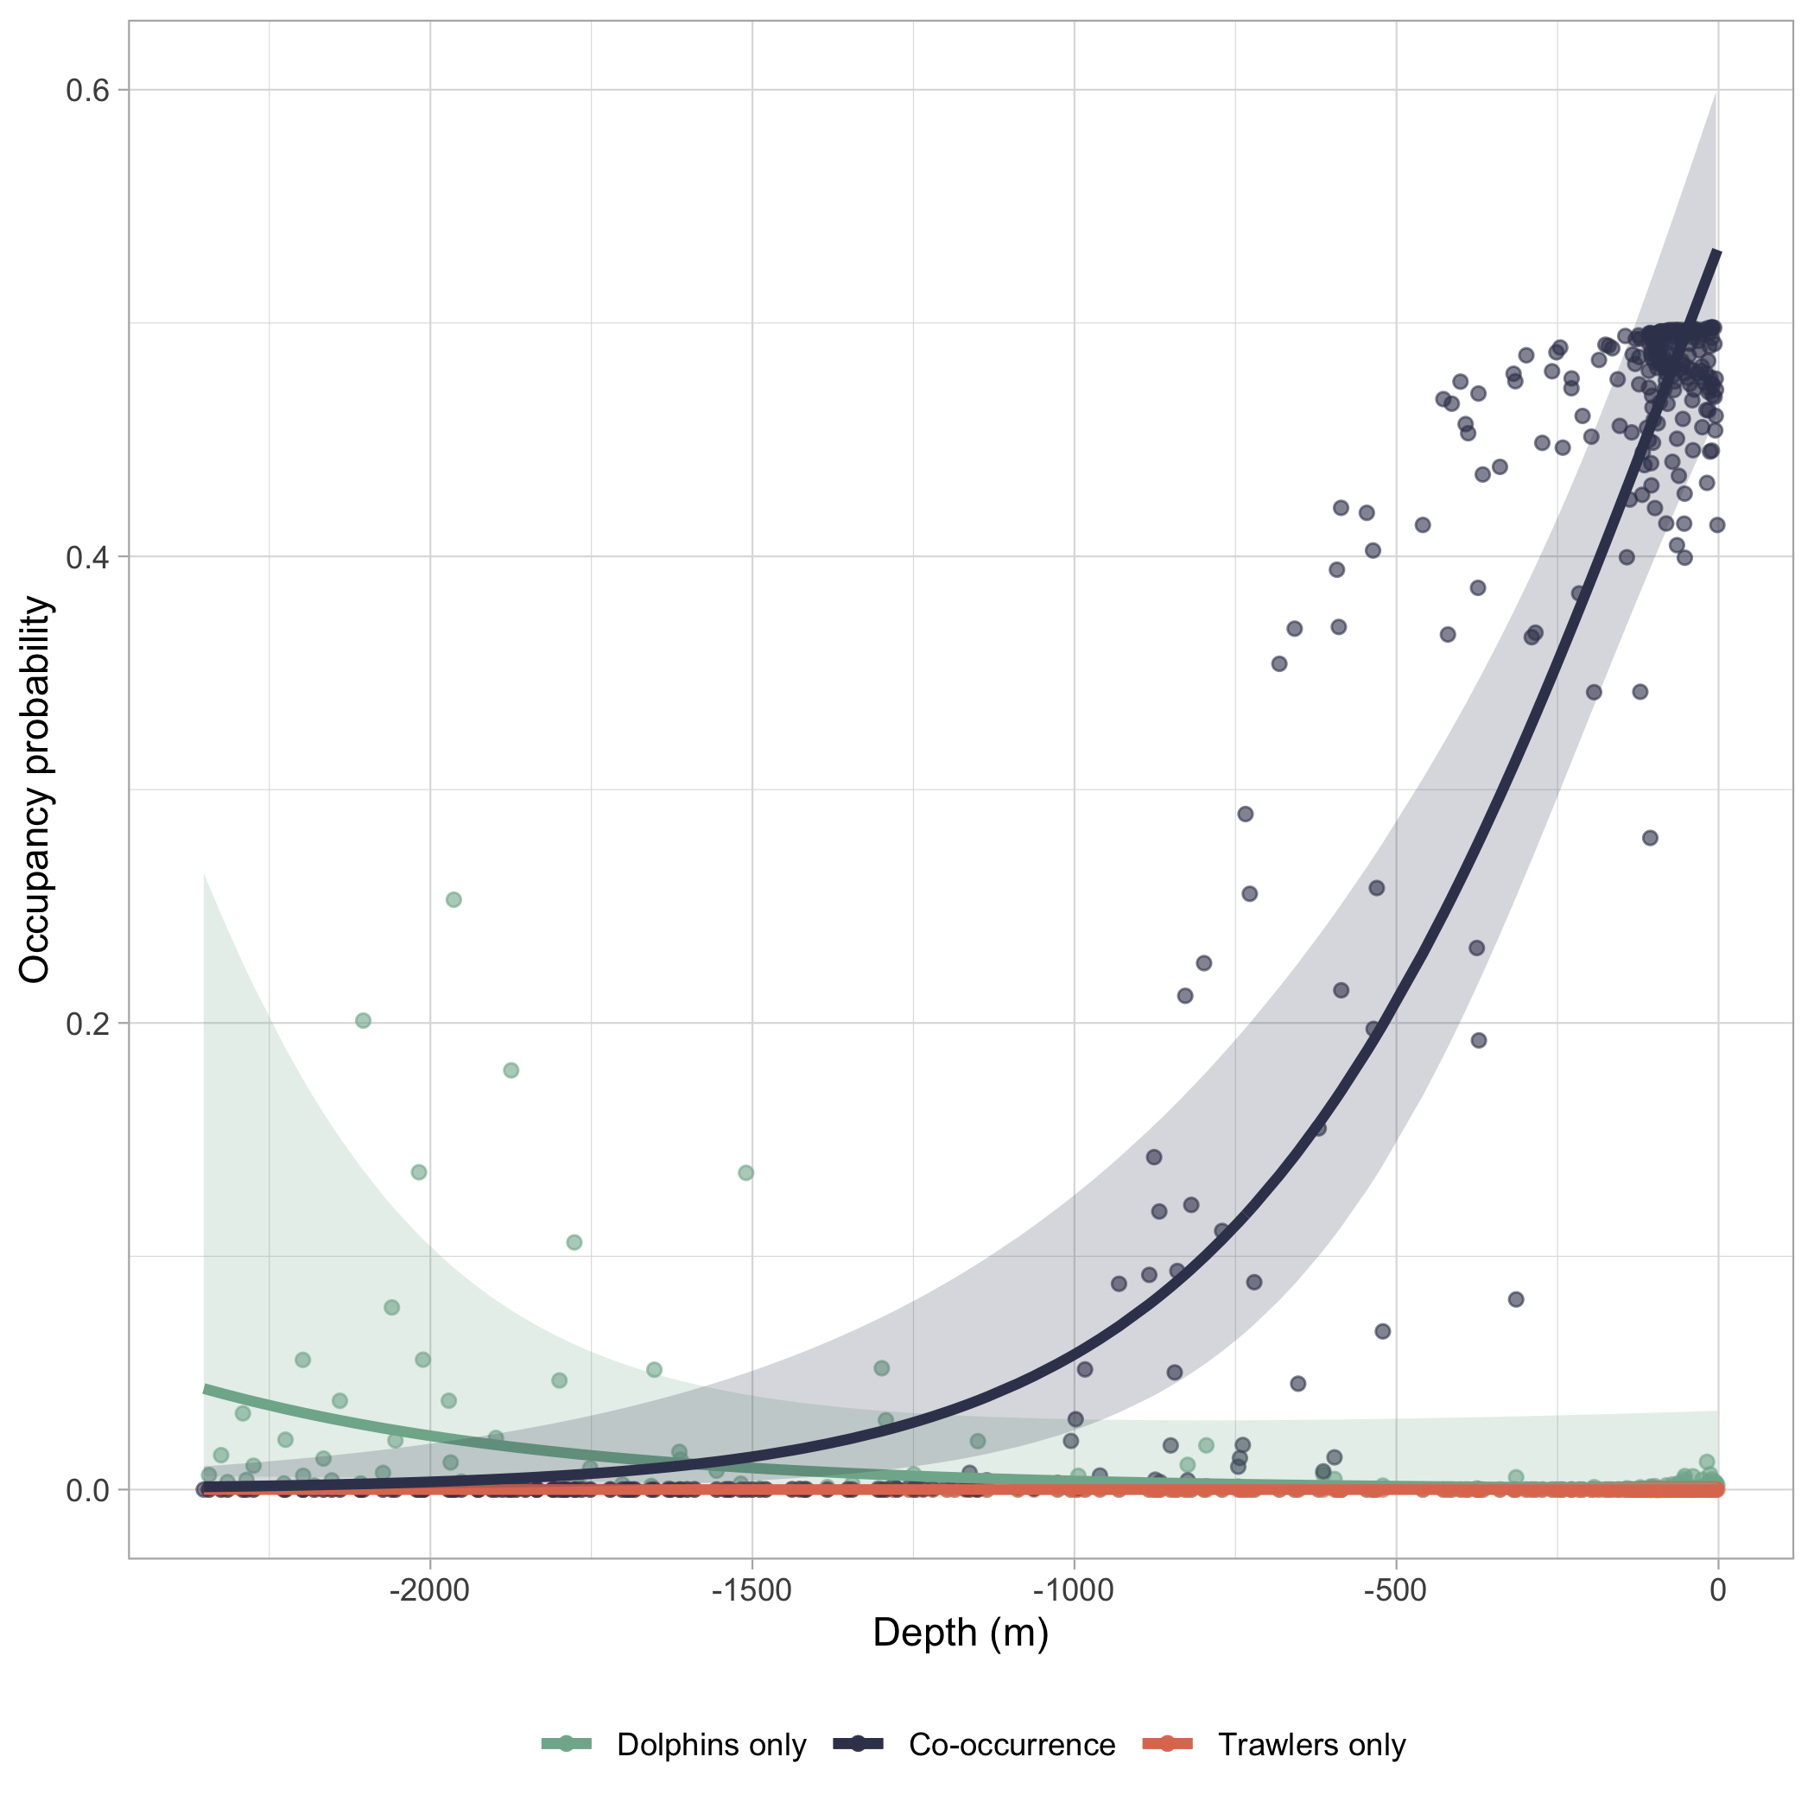
Figure 1.1: Occupancy probabilities estimated from the integrated multispecies model as function of depth (in meters) Green points and lines represent Psi1, the probability that only bottlenose dolphins used the space. Orange points and lines represent Psi2, the probability that only fishing trawlers used the space. Blue points and lines represent Psi3, the probability that both bottlenose dolphins and fishing trawlers used the space, i.e. co-occurrence. We represented 95% credible interval in shaded areas
We detected 60 trawlers, and 18 groups of bottlenose dolphins by aerial surveys, while we detected 71 trawlers and 30 groups of bottlenose dolphins by boat photo-id surveys.
Overall, the probability that trawlers only or that trawlers only use the grid-cell was lower than the co-occurrence probability (Figure 1). Co-occurrence probability increased with decreasing depth (Figure 1 & 2), and both trawlers and dolphins used the coastal space more than the pelagic seas (Figure 2, and Supplementary Information). Although, dolphins space-use probability in pelagic seas appeared to be higher than trawlers space-use probability in Figure 1, the difference is not significant.
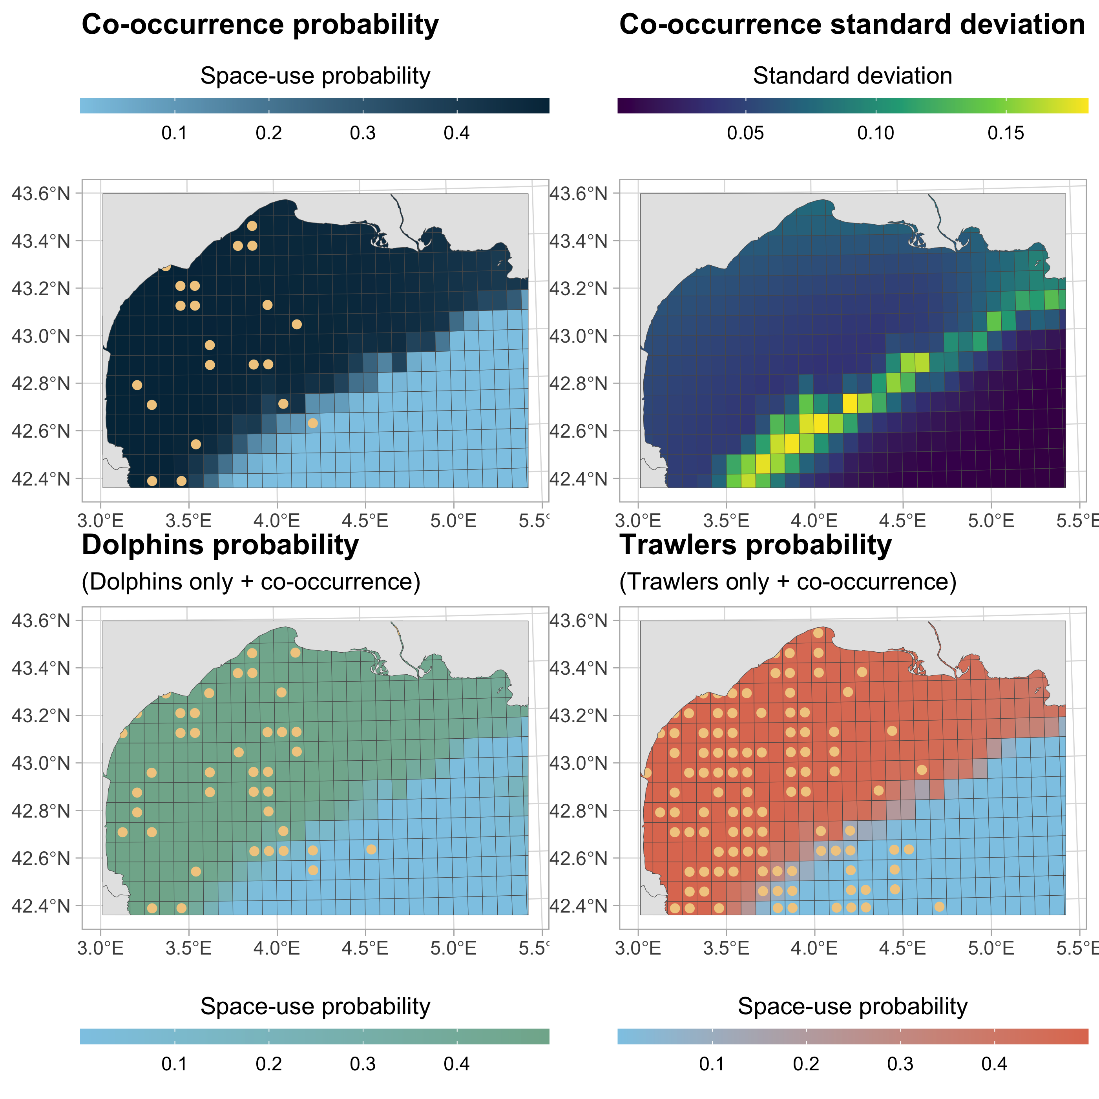
Figure 1.2: Probability of co-occurrence between dolphins and trawlers in the Gulf of Lion (Northwestern Mediterranean Sea) and associated standard deviation (upper panel). Lower panel shows dolphins and tralwers space-use probabilities. Yellow dots reflect locations of detections of trawlers, dolphins, or both in the case of co-occurrence.
Both dolphins and trawlers detection probabilities increased with increasing sampling effort. Boat photo-id monitoring had higher detection probabilities than aerial surveys (Figure 3). Trawlers were more easily detected than bottlenose dolphins for both monitoring programs.
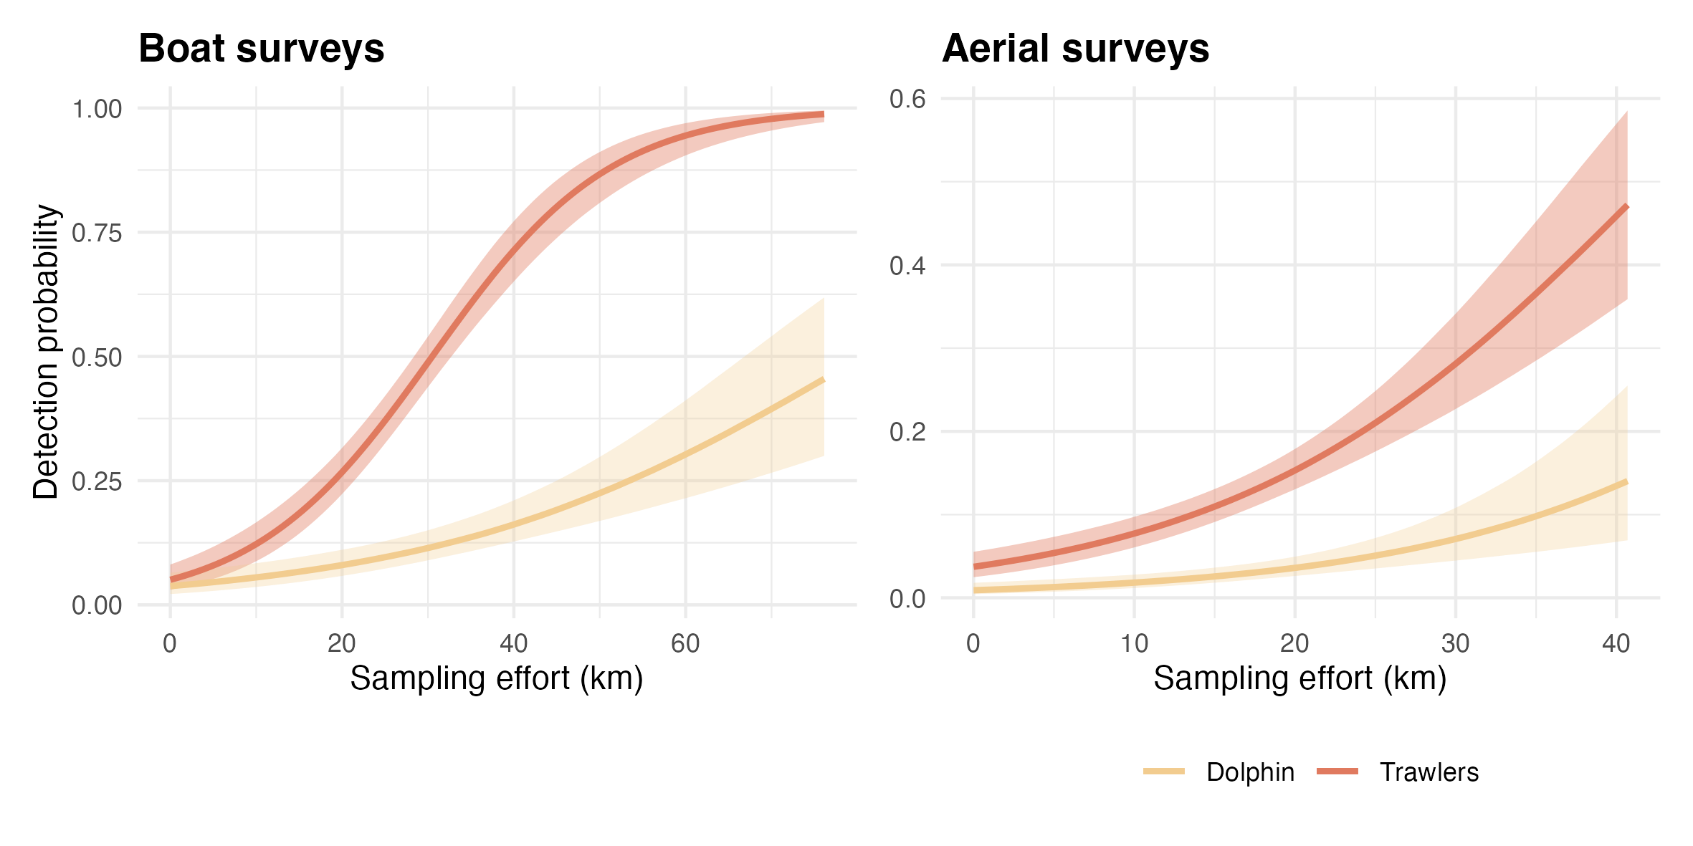
Figure 1.3: Estimated detection probability of dolphins and trawlers as a function of sampling effort for each monitoring program. We provide posterior medians (solid line) and 80% credible intervals (shaded area).
Integrated multispecies occupancy model estimated more precise co-occurrence probability than multispecies occupancy models using datasets in isolation (Supplementary materials).

Discussion
We showcase an integrated multispecies occupancy models to map the probability of co-occurrence between French fisheries and bottlenose dolphins in the Gulf of Lion waters (Figure 2). Our integrated multispecies occupancy models estimated a 0.40 probability of co-occurrence between trawlers and bottlenose dolphins in the coastal seas of the Gulf of Lion. However, we emphasize that we inferred co-occurrence probability and not interactions between dolphins and trawlers. This means that, despite the fact that interactions can occur, dolphins and trawlers also use the same space without interacting. Mapping co-occurrence, we include potential interactions such as depredations or bycatch, and co-occurrence without interactions.
Mutlispecies occupancy models require substantial amount of data to precisely estimate co-occurrence (Clipp et al. 2021) and integrated approaches provide stronger inferences compared to an analysis of each dataset in isolation (Zipkin et al. 2019, Lauret et al. 2021). While having a limited amount of data, our integrated multispecies occupancy model helped to overcome data scarcity and provided more precise estimation of co-occurrence probabilities than multispecies models with sparated datasets (Supplementary materials). Through our integrated approach, we emphasized that integrated extension can be particularly promising for multispecies occupancy models.
Our approach echoes recent work integrating human activities into multispecies occupancy models to identify and quantify threats of anthropic pressures on the environment (Marescot et al. 2020). Beyond the Gulf of Lion case study, integrated multispecies occupancy models can be leveraged to provide robust maps of co-occurrence between marine megafauna and anthropogenic activities while integrating several data sources. Additional presence-absence data, e.g. from scientific fishing campaigns, aerial surveys for tuna stock assessment (Bauer et al. 2015), or Automatic Indentification System for fishing vessels would further allow to better delineate fishing areas and hence areas of potential interactions.
The ability to predict areas of human-wildlife potential interactions is of critical importance to implement conservation measures as required under conservation legislation (e.g. the European Union Marine Strategy Framework Directive). To mitigate marine mammal depredation and/or bycatch, acoustic deterrents are implemented worldwide despite raising ethical and conservation concerns (Santana-Garcon et al. 2018, Bonizzoni et al. 2022). Using multispecies occupancy models to map potential hotspots of depredation may help to reduce the deployment of acoustic deterrents and minimize the associated negative impacts (Estabrook et al. 2016, Snape et al. 2018). Similarly, fin whales (Balaenoptera physalus) and sperm whales (Physeter macrocephalus) are at high risk of collision with ferries in the Northwestern Mediterranean Sea and in particular in the Pelagos Sanctuary Marine Protected Area (Ham et al. 2021, David et al. 2022). Mapping collision risk with mutlispecies occupancy models can ultimately direct the measures of speed limitation. Overall, integrated multispecies occupancy models are promising tools to understand and map human-cetacean interactions hotspots, with the aim to help in designing areas of particular conservation focus and directing specific mitigation measures.

References
Allen SJ, Pollock KH, Bouchet PJ, Kobryn HT, McElligott DB, Nicholson KE, Smith JN, Loneragan NR (2017) Preliminary Estimates of the Abundance and Fidelity of Dolphins Associating with a Demersal Trawl Fishery. Scientific Reports 7:4995.
Baudrier J, Lefebvre A, Galgani F, Saraux C, Doray M (2018) Optimising French Fisheries Surveys for Marine Strategy Framework Directive Integrated Ecosystem Monitoring. Marine Policy 94:10–19.
Bauer RK, Fromentin J-M, Demarcq H, Brisset B, Bonhommeau S (2015) Co-Occurrence and Habitat Use of Fin Whales, Striped Dolphins and Atlantic Bluefin Tuna in the Northwestern Mediterranean Sea. PLOS ONE 10:e0139218.
Bearzi G, Fortuna CM, Reeves RR (2009) Ecology and Conservation of Common Bottlenose Dolphins Tursiops Truncatus in the Mediterranean Sea. Mammal Review 39:92–123.
Bonizzoni S, Furey NB, Bearzi G (2020) Bottlenose Dolphins (Tursiops Truncatus) in the North‐western Adriatic Sea: Spatial Distribution and Effects of Trawling. Aquatic Conservation: Marine and Freshwater Ecosystems:aqc.3433.
Bonizzoni S, Hamilton S, Reeves RR, Genov T, Bearzi G (2022) Odontocete Cetaceans Foraging Behind Trawlers, Worldwide. Reviews in Fish Biology and Fisheries.
Clipp H L, Evans AL, Kessinger BE, Kellner K, Rota CT (2021) A Penalized Likelihood for Multi-Species Occupancy Models Improves Predictions of Species Interaction. Ecology In press.
Coll M, Piroddi C, Albouy C, Lasram FBR, Cheung WWL, Christensen V, Karpouzi VS, Guilhaumon F, Mouillot D, Paleczny M, Palomares ML, Steenbeek J, Trujillo P, Watson R, Pauly D (2012) The Mediterranean Sea Under Siege: Spatial Overlap Between Marine Biodiversity, Cumulative Threats and Marine Reserves. Global Ecology and Biogeography 21:465–480.
David L, Arcangeli A, Tepsich P, Di‐Meglio N, Roul M, Campana I, Gregorietti M, Moulins A, Rosso M, Crosti R (2022) Computing Ship Strikes and Near Miss Events of Fin Whales Along the Main Ferry Routes in the Pelagos Sanctuary and Adjacent West Area, in Summer.
Estabrook B, Ponirakis D, Clark C, Rice A (2016) Widespread Spatial and Temporal Extent of Anthropogenic Noise Across the Northeastern Gulf of Mexico Shelf Ecosystem. Endangered Species Research 30:267–282.
Fidino M, Simonis JL, Magle SB (2019) A Multistate Dynamic Occupancy Model to Estimate Local Colonization–Extinction Rates and Patterns of Co‐occurrence Between Two or More Interacting Species. Methods in Ecology and Evolution 10:233–244.
Giakoumi S, Scianna C, Plass-Johnson J, Micheli F, Grorud-Colvert K, Thiriet P, Claudet J, Di Carlo G, Di Franco A, Gaines SD, García-Charton JA, Lubchenco J, Reimer J, Sala E, Guidetti P (2017) Ecological Effects of Full and Partial Protection in the Crowded Mediterranean Sea: A Regional Meta-Analysis. Scientific Reports 7.
Ham GS, Lahaye E, Rosso M, Moulins A, Hines E, Tepsich P (2021) Predicting Summer Fin Whale Distribution in the Pelagos Sanctuary (North-Western Mediterranean Sea) to Identify Dynamic Whale–Vessel Collision Risk Areas. Aquatic Conservation: Marine and Freshwater Ecosystems 31:2257–2277.
Jourdain E, Vongraven D (2017) Humpback Whale (Megaptera Novaeangliae) and Killer Whale (Orcinus Orca) Feeding Aggregations for Foraging on Herring (Clupea Harengus) in Northern Norway. Mammalian Biology 86:27–32.
Kéry M, Royle J (2020) Applied hierarchical modeling in ecology: Analysis of distribution, abundance and species richness in r and bugs: Volume 2: Dynamic and advanced models, 1st ed. Elsevier, Cambridge.
Labach H, Azzinari C, Barbier M, Cesarini C, Daniel B, David L, Dhermain F, Di-Méglio N, Guichard B, Jourdan J, Lauret V, Robert N, Roul M, Tomasi N, Gimenez O (2021) Distribution and Abundance of Common Bottlenose Dolphin (Tursiops Truncatus) over the French Mediterranean Continental Shelf. Marine Mammal Science n/a.
Lambert C, Authier M, Dorémus G, Laran S, Panigada S, Spitz J, Van Canneyt O, Ridoux V (2020) Setting the Scene for Mediterranean Litterscape Management: The First Basin-Scale Quantification and Mapping of Floating Marine Debris. Environmental Pollution 263:114430.
Laran S, Pettex E, Authier M, Blanck A, David L, Dorémus G, Falchetto H, Monestiez P, Van Canneyt O, Ridoux V (2017) Seasonal Distribution and Abundance of Cetaceans Within French Waters- Part I: The North-Western Mediterranean, Including the Pelagos Sanctuary. Deep Sea Research Part II: Topical Studies in Oceanography 141:20–30.
Lauret V, Labach H, Authier M, Gimenez O (2021) Using Single Visits into Integrated Occupancy Models to Make the Most of Existing Monitoring Programs. Ecology:848663.
Leone AB, Bonanno Ferraro G, Boitani L, Blasi MF (2019) Skin Marks in Bottlenose Dolphins (Tursiops Truncatus) Interacting with Artisanal Fishery in the Central Mediterranean Sea. PLOS ONE 14:e0211767.
Lewison RL, Crowder LB, Read AJ, Freeman SA (2004) Understanding Impacts of Fisheries Bycatch on Marine Megafauna. Trends in Ecology & Evolution 19:598–604.
MacKenzie DI (ed) (2006) Occupancy estimation and modeling: Inferring patterns and dynamics of species. Elsevier, Amsterdam ; Boston.
Manlik O, Lacy RC, Sherwin WB, Finn H, Loneragan NR, Allen SJ (2022) A Stochastic Model for Estimating Sustainable Limits to Wildlife Mortality in a Changing World. Conservation Biology 36:e13897.
Marescot L, Lyet A, Singh R, Carter N, Gimenez O (2020) Inferring Wildlife Poaching in Southeast Asia with Multispecies Dynamic Occupancy Models. Ecography 43:239–250.
Pirotta E, Thompson PM, Cheney B, Donovan CR, Lusseau D (2015) Estimating Spatial, Temporal and Individual Variability in Dolphin Cumulative Exposure to Boat Traffic Using Spatially Explicit Capture-Recapture Methods: Variability in Wildlife Exposure to Disturbance. Animal Conservation 18:20–31.
Queiros Q, Fromentin J, Astruc G, Bauer R, Saraux C (2018) Dolphin Predation Pressure on Pelagic and Demersal Fish in the Northwestern Mediterranean Sea. Marine Ecology Progress Series 603:13–27.
Rota CT, Ferreira MAR, Kays RW, Forrester TD, Kalies EL, McShea WJ, Parsons AW, Millspaugh JJ (2016a) A Multispecies Occupancy Model for Two or More Interacting Species. Methods in Ecology and Evolution 7:1164–1173.
Rota CT, Wikle CK, Kays RW, Forrester TD, McShea WJ, Parsons AW, Millspaugh JJ (2016b) A Two-Species Occupancy Model Accommodating Simultaneous Spatial and Interspecific Dependence. Ecology 97:48–53.
Santana-Garcon J, Wakefield CB, Dorman SR, Denham A, Blight S, Molony BW, Newman SJ (2018) Risk Versus Reward: Interactions, Depredation Rates, and Bycatch Mitigation of Dolphins in Demersal Fish Trawls. Canadian Journal of Fisheries & Aquatic Sciences 75:2233–2240.
Snape RTE, Broderick AC, Çiçek BA, Fuller WJ, Tregenza N, Witt MJ, Godley BJ (2018) Conflict Between Dolphins and a Data-Scarce Fishery of the European Union. Human Ecology 46:423–433.
Valpine P de, Turek D, Paciorek CJ, Anderson-Bergman C, Lang DT, Bodik R (2017) Programming with Models: Writing Statistical Algorithms for General Model Structures with NIMBLE. Journal of Computational and Graphical Statistics 26:403–413.
Wood S (2019) Mgcv: Mixed GAM Computation Vehicle with Automatic Smoothness Estimation. R-Package Version 1.8–31.
Wood SN (2006) Generalized Additive Models: An Introduction with R. Chapman; Hall/CRC, New York.
Zipkin EF, Inouye BD, Beissinger SR (2019) Innovations in Data Integration for Modeling Populations. Ecology:e02713.

