Invasion dynamics of quagga mussels (Dreissena rostriformis bugensis) within a reservoir and its spatially intermittent watershed: Lake Piru and the Santa Clara River, California, USA
Michael T. Booth
University of Cincinnati, Department of Biological Sciences, Rieveschl Hall 820D, PO Box 210006, Cincinnati, OH 45221-0006
Carolynn S. Culver
California Sea Grant Extension Program, Scripps Institution of Oceanography, University of California, San Diego, California 92093, USA; and Marine Science Institute, University of California, Santa Barbara, California 93106, USA
Corresponding author: michael.booth@uc.edu
Keywords: Dreissenid mussels, population dynamics, veligers, invasive species

Introduction
Since its discovery in Lake Mead in 2007 (Stokstad, 2007), the invasive quagga mussel (Dreissena rostriformis bugensis) has rapidly spread throughout the lower Colorado River drainage, including water conveyance structures and reservoirs throughout southern California that receive water from the Colorado River (Benson et al., 2021; Wong and Gerstenberger, 2011). Although the introduction to Lake Mead is thought to be a result of contaminated bilge water transported from the Great Lakes, the rapid spread throughout the region was likely due to the artificially connected nature of many regional waterways (Wong and Gerstenberger, 2011) which allows the movement of the planktonic veliger stage. Despite efforts to educate boaters and prevent the spread of nuisance species (Mangin, 2001), boats remain a significant risk to the spread of quagga mussels (Dalton and Cottrell, 2013). In December 2013, quagga mussels were first observed at Lake Piru, a reservoir in the Santa Clara River watershed of Ventura County, California, marking the first known invasion and established population in the state that was not associated with diversions from the Colorado River. Quagga mussels have subsequently been observed downstream of Lake Piru in Piru Creek (established) and the Santa Clara River (intermittent observations). Mussels have also been observed in upstream reservoirs, Pyramid Lake (2016) and Castaic Lake (2021) but whether populations have established remains unknown.
The invasion of dreissenid mussels leads to substantial costs and ongoing maintenance to water infrastructure as well as operational challenges for preventing further spread of the species (Western Regional Panel on Aquatic Nuisance Species, 2010). In addition, invasion by dreissenid mussels may have negative ecosystem-level impacts (e.g., nutrient and oxygen dynamics, harmful algal blooms; Nalepa, 2010; Turner, 2010), particularly during the initial “boom” phase when populations first establish. Long-term effects are less predictable and have been predominantly studied in lakes and reservoirs (Karatayev et al., 2015), but are frequently identified as a cause for concern, particularly for management of sport fishes and endangered species (Western Regional Panel on Aquatic Nuisance Species, 2010). The presence of critical habitat for the endangered Southern California Steelhead (Oncorhynchus mykiss) downstream of Lake Piru (National Marine Fisheries Service and NMFS, 2012) makes this invasion of particular management concern and greatly complicates potential management scenarios (e.g., changes in stream flow from the lake or application of molluscides within the lake).
Although population persistence of quagga mussels requires lotic environments for reproduction (Hasler et al., 2019), concerns over the downstream spread of mussels and potential for colonization of agricultural and drinking water infrastructure were the impetus for an expansive monitoring program both in Lake Piru and the Santa Clara River watershed downstream. Large portions of the mainstem Santa Clara River and its tributaries are spatially and seasonally intermittent, while other reaches are typically perennial due to upwelling groundwater (Beller et al., 2011). The confluence of Piru Creek (which flows from Lake Piru) and the Santa Clara River is seasonally intermittent except during periods following storm events and out-of-season flow releases for groundwater recharge.
This study aims to describes monitoring and mitigation efforts at Lake Piru and within the Santa Clara River watershed during the first eight years since quagga mussels were observed and synthesize implications for management of this population.

Methods
Study System
Lake Piru is a man-made warm, monomictic, mesotrophic lake and water storage reservoir formed by Santa Felicia Dam on Piru Creek in the upper Santa Clara River watershed of Southern California (Figure 1). Typically, the reservoir fills during the winter from precipitation, but it also receives limited out-of-season water releases from upstream via Pyramid Lake as part of the State Water Project storage and delivery system. Water from Lake Piru is conveyed downstream to Piru Creek and the Santa Clara River during the dry season through out-of-season water releases (September – December) which recharge aquifers and deliver water resources to other areas. The dam also contains two turbine units in its small hydropower facility, which was recommissioned in November 2016. Although the turbine units are suggested to increase shear stress (and potential veliger mortality) at some flows (United Water Conservation District, 2018a, 2017), the turbines can only be operated when flows exceed ≈ 0.3 m³/s and their total capacity is ≈ 0.7 m³/s, and any additional flow must be routed through other outlets.
A number of monitoring and management activities were conducted since the invasion. The types, number of sites, timing and frequency of the activities are summarized in Table 1. Details of each activity follow.

Physical Property Measurements
Water quality vertical profile data were collected throughout the study using a multi-parameter water quality meter every two weeks at five locations in Lake Piru (Figure 1). Temperature, dissolved oxygen, turbidity, specific conductance and pH were measured at 0.6 -1.2 m depth intervals from the surface to 35 m depth. Lake level and creek flow data were collected from USGS gages (#11109700 and #11109800, respectively) using the dataRetrieval package (De Cicco et al., 2018) in Program R. Mean temperature for the epilimnion, hypolimnion, and whole lake, as well as the thermocline depth were calculated using the rLakeAnalyzer package (Winslow et al., 2019) in Program R. Bathymetric data for 2005, 2015, and 2020 were provided by UWCD.

Lake Mussel Density and Biomass

Natural and artificial hard substrates.— Beginning in 2014, divers collected mussels 3-5 times per year (Figure 2) from a 0.125 m² quadrat on natural hard substrates of primarily vertical walls at 4 sites (Cow Cove, Sugarloaf, SE rock wall, dam rip rap) and on infrastructure surfaces at 3 sites (docks, pump barge and floating restrooms) prior to mechanical removal of mussels to determine mussel density. For each quadrat sample, either the entire sample or a subsample of approximately 300 mussels were weighed (to the nearest g) and measured (shell height from umbo to midpoint of shell valve to the nearest 5 mm using a caliper) to determine biomass, density and size structure. When subsamples were taken, the entire sample was also weighed to determine the total biomass, and used to calculate the total number of mussels.
Benthic fines.— Beginning in November 2015, fixed photoplots were designated at six locations on the lake bottom in fines habitat using rebar stakes. A 0.5 m x 0.5 m quadrat was placed on the bottom and a digital image was captured at 3 non-overlapping locations adjacent to the rebar stake when visibility was sufficient to collect a clear image. Images were de-fisheyed using the wide-angle correction tool in Adobe Photoshop CS6 and percent cover of mussels was estimated within each quadrat using digital imaging software (Fiji/Image J; Schindelin et al., 2012).

Mussel Removals
Divers physically removed all accessible mussels from the 1) floating restroom, 2) pump barge and 3) marina docks quarterly from 2015 to present. Quagga mussels were removed from the submerged surfaces by manually scraping the hard surfaces of the underside of the structures using plastic spatulas. Mussels were collected by hand into either a 0.5mm mesh-lined collection bag or vacuumed using an engine powered pump. Collected mussels were placed into a topside mesh-lined (0.5 mm) receiving drum (208 L) allowing mussels to be retained, but not water. The drum was weighed and the total area where the removal occurred was estimated from the surface dimensions of the structures to calculate biomass removed. Mussels were buried in a landside pit on the lake premises per state-approved disposal procedures.

Recruitment and Growth
Monthly assessments of mussel recruitment and growth also began in January 2015. Lines containing artificial substrates (herein called ‘sampler’) were deployed throughout the lake (Figure 1). The number of locations with samplers varied over time, ranging from 4 to 9 locations with a median of 7 sites, due to loss of samplers from weather or vandalism. The samplers were deployed 1-2 m from the lake bottom at sites shallower than 7-9 m total depth, and at approximately 8 m below the water surface in deeper areas. Samplers were composed of three 0.2 m x 0.2 m polyvinyl chloride plates - one for recruitment, two for growth - suspended on a threaded rod. A grid was drawn on the growth plates dividing them into six equal-sized cells (n = 12 cells). Each month, mussels were carefully removed from the entire surface of the recruitment plate (0.08 m²) using a plastic putty knife to avoid damaging the shells and then frozen until processed. Mussels also were collected from a single grid cell of one of the growth plates monthly, with previously sampled cells scraped to remove any newly recruited mussels. Mussel settlement and growth also was assessed from the data generated by the previously described quarterly dive surveys.
In the laboratory, frozen samples were thawed, washed on a 153 μm sieve, and mussels were measured to the nearest 5 mm using a ruler or caliper and counted. For both dive surveys and artificial substrates, recruitment was calculated as the number of mussels per m² of sampled area and divided by the number of days since last sampled. For mussels collected during quarterly dive surveys, maximum growth was estimated as the 90th percentile size class divided by the number of days since removal. For artificial substrates, a random subset of 75 mussels >5mm were measured to the nearest 0.01 mm using digital calipers, all mussels <5mm were counted, and additionally the 10 largest mussels were measured. Growth for mussels >5 mm was estimated as the difference in modal lengths within the sample. Modes, i.e., cohort mean size, were identified by taking the second derivative of the probability density function of mussel size in Program R (R Core Team, 2022). Modes were not always clearly defined and so probability density plots were visually examined to remove or estimate the value of extraneous modes. Growth was estimated as the difference between mean cohort size in the subsequent month.

Veliger Abundance
Veliger abundance was first measured in February and April 2016 at four sites within Lake Piru. Beginning in May 2016, veliger abundance was measured monthly at five locations within Lake Piru (Figure 1). Depth-integrated vertical tows (2 m less than total water column depth) were performed at each site using a plankton net (63 micron mesh, 30 cm diameter) to achieve a minimum of 1000 L total tow volume (total tow length > 15 m). When multiple tows were required to achieve the sample volume (i.e., sites < 17 m depth), all tows were combined into a single sample for analysis. Unpreserved, unbuffered samples were transported on ice to the laboratory. From April 2016 to June 2018, samples were shipped on dry ice to the Burton Lab at Scripps Institution of Oceanography, University of California, San Diego. Samples were refrigerated until analysis and processed within 1-2 days of delivery. From May 2018 to present, veliger samples were processed at the UWCD laboratory within 72 hours of collection. Samples were processed following the Reclamation Detection Laboratory for Invasive and Native Species protocol (2013). In brief, samples were poured into Imhoff cones and allowed to settle for 18 hours. Five 15 mL subsamples were collected from the settled sample, and for each subsample, 1 mL was placed into a Sedgewick Rafter slide and all veligers were enumerated using a polarizing filter. To account for potential differences in handling and processing between the two labs, during May and June 2018 seven replicated samples were processed independently in each lab and United’s veliger counts were rescaled using a linear regression (Veligers_{scripps} = 14.45*Veligers_{united} + 0; adjusted R² =0.86 t = 6.568, p < 0.001).

Downstream Mussel Densities
Monthly surface surveys were conducted on lower Piru Creek 1) 0- 500 m downstream of Santa Felicia dam (beginning February 2016), 2) on Rancho Temescal at sites 0.8 km, 2.3 km, and 3.3 km downstream (beginning February 2018) and 3) 14.5 km downstream, at the confluence of Piru Creek and the Santa Clara River (beginning February 2016). Based on locations with access and typically perennial flow, an additional four sites along the Santa Clara River were surveyed quarterly. Surveyors collected a minimum of 10 to 20 randomly selected cobble-sized substrates (surface area mean ± s.d., 0.02 ± 0.05 m²), measured their size along the intermediate axis, assessed presence/absence of quagga mussels, and, when present, recorded the estimated number of quagga mussels visually determined to be in one of three size classes (<5 mm, 5-10 mm, >10 mm) and noting if any mussels were > 20 mm. The surface area of individual cobbles was calculated as the rock intermediate axis squared.

Statistical Analyses
To examine the relationship between 1) reproductive mussels (>5mm) and veliger abundance and 2) veliger abundance and recruitment in the lake, we constructed a set of linear mixed effects models using the lmer function in the lme4 package (Bates et al., 2015). Lake region was included in models as a random effect and a variety of environmental covariates were considered as fixed effects, including metalimnion water temperature (7.3 to 9.8 m), Specific Conductivity, Turbidity, DO % saturation, lake elevation, and lake fill status (years where lake filled in winter and was drained in summer/fall). Prior to defining potential models, model parameters were assessed for evidence of collinearity using linear regression. For each pairwise regression, I calculated Variance Inflation Factor (VIF) equivalent to 1/1- R². Values greater than 3 indicate strong collinearity (Zuur et al. 2010). Specific conductivity, lake elevation, and lake fill status were significantly correlated and had VIF higher than 3. Although we expect that both lake elevation and specific conductivity could influence reproduction and recruitment for different reasons, high conductivity only occurred during dry years when the lake elevation was low. Instead, we used binary annual lake fill status as a proxy for specific conductivity and lake elevation.
Since mussels were frequently removed from infrastructure and veligers were spatially variable within the lake but not consistently different among sites, only the density of reproductive mussels on natural substrates was included in analysis 1.
To account for the lifecycle of quagga mussels, we incorporated temporal lags into the model for veliger abundance and recruitment in the lake. Autocorrelation and crosscorrelation functions require equally spaced data with no missing values. As described previously in the recruitment section, some recruitment plates were lost or vandalized. To assess suitable lags for veligers, we used only a subset of the data from the marina and Santa Felicia Cove to generate time-series, and used the “acf” and “ccf” functions in R to generate autocorrelation and cross-correlation plots. For model generation, we used the complete dataset (all recruitment plate sites), but omitted missing values (i.e., where lagged values were not available).
We used an Information Theoretic Model Comparison procedure to identify best performing models (Burnham and Anderson, 2004). Model comparison was performed using the “dredge” function in the MuMIn package (Barton, 2022). We used the Akaike information criterion, adjusted for small sample size (AICc) and ΔAICc to rank models. Where ΔAICc < 2, all models were considered functionally similar and parameter importance was compared by the proportion of top ranked models that included each term. To assess the overall explanatory power of the models and predictors, we computed generalized and partial R² for mixed models following the framework of Jager et al (2017) and Nakagawa and Schielzeth (2013) using the r2beta function in the r2glmm package (Jaeger, 2017).

Results

Physical properties
Lake elevation was consistently low during the initial invasion period (300 ± 5.7 m, mean ± s.d.; spillway elevation 321.5 m) and remained below the spillway elevation throughout the study period (Figure 3A). Lake Piru filled rapidly and substantially (≈10-20 m) during storms in early 2017, 2019, and 2020 and was drawn down (≈8-15 m) for water resource purposes in those years. Piru Creek flows are regulated releases from Lake Piru and typically base flow was held constant at 0.2 m³ s⁻¹. In years with substantial winter rainfall, monthly base flow was elevated (0.3 - 0.6 m³ s⁻¹) depending on rainfall triggers, which occurred in 2017, 2019, and 2020. During the steelhead migration season (January 1 – May 31) occasional short duration higher flows (<1 week, 5.7 m³ s⁻¹) occurred (2017, 2019, 2020). Extended (weeks-months), high magnitude (<14.6 m³ s⁻¹) out-of-season water releases occurred during fall 2015, 2017, 2018, 2019, 2020 to replenish downstream groundwater basins (Figure 2, 3B). Except during winter storms and the extended high magnitude out-of-season releases, water from Piru Creek percolated subsurface at the confluence with the Santa Clara River and upstream of the Torrey Rd bridge (Figure 1).
Despite substantial water level fluctuations, whole lake temperature remained relatively consistent within the study period, ranging from 9 to 26 °C (Figure 3C). Lake temperatures were always greater than the lower spawning threshold for quagga mussels (9 °C; Garton et al., 2014), but whole lake temperatures slightly exceeded the upper limit (24 °C) during several months each year. Temperatures were always below the upper thermal limit (28 °C; Garton et al., 2014). A thermocline typically formed at approximately 10 m and the lake remained stratified from March to September, though the strength and duration of stratification varied among years. Bottom DO levels ranged from 0 – 12 mg/L (6.5 ± 3.0, mean ± s.d.), but typically were greater than the hypoxia threshold of PO₂ > 2.13 kPa (Garton et al., 2014), estimated as 0.85 mg/L assuming salinity of 500 ppm, 1 atm, 25 °C (Figure 3D). Shallow areas of the lake (<6.5 m) were above the hypoxia threshold except on two monitoring dates (Figure 3D). Comparison of lake bathymetry between 2015 and 2020 show patches of 0.3 to > 3.3 m of sediment deposition along the southeast shoreline, adjacent to the marina, within Santa Felicia Cove, and within the delta formed as Piru Creek enters the reservoir. Dive surveys indicate that this deposition occurred during the periods of rapid lake filling in 2017 and 2019, and that deposition of sediment occurred throughout the lake, even in patches where the bathymetric survey did not report measurable sediment accumulation.

Density and biomass
Mussels were present on all hard substrates within the lake during all surveys in 2014. Mussel density on natural substrates rapidly increased subsequent to the initial detection in December 2013 and peaked in late July/early August 2014 (Figure 5A; 27069 ± 6964 mussels m⁻², mean ± s.e.). Mussel density fluctuated, but remained high through September 2016, then dramatically declined during 2017 and has remained at approximately at 24% of initial mean mussel density. Mussel biomass on natural substrates was not measured until 2015. Biomass peaked in mid-2016 (4126 ± 1161 g m⁻², mean + s.e.; Figure 5B), then declined during 2017 to approximately 13% of the 2015-2016 level. The density of reproductive mussels (>5 mm) on infrastructure was initially reduced to low levels after mussel removals were implemented, but peaked again in mid-2016, before returning to low abundance (Figure 5C). Reproductive mussel density on natural substrates was 2-10 times higher than on infrastructure until late 2017, when density crashed and remained low relative to the initial invasion period (Figure 5C), with an additional spike in summer 2020.
Mussels were occasionally observed in fine sediment areas of the lake (primarily attached to debris or shells of Asian clam or dead quagga mussels) during dive surveys in 2014 and 2015, but were not quantified. Only one site (dam) had high percent cover (66-94%) of mussels on fine sediments during the initial surveys in November 2015 and January 2016, however this site also rapidly declined while the other locations were increasing (Figure 5D). For all other sites, mussel cover within fixed photoplots rapidly increased in 2016 and reached approximately 25-75% cover during the fall and winter of 2016 (Figure 5D). Sediment deposition during the fill event in early 2017 covered the lake bottom and mussels were not detectable within the fixed photoplots on fine sediment throughout 2018 to 2020.

Mussel Removals
Divers removed 283 ± 393 kg wet weight (mean ± s.d., range: 10 – 1680) of quagga mussels from infrastructure during each quarterly management activity and the frequency of mussel removals kept biomass on infrastructure at reduced levels relative to the initial invasion (Figure 1).

Settlement and growth
Mussel settlement rates were seasonally variable over several orders of magnitude (Figure 5A, B). Settlement peaked in July 2015 (Figure 5A; 6368 ± 5226 mussels m⁻² d⁻¹, mean ± s.e.) on artificial settling plates and total biomass accumulation on infrastructure (Figure 5C; 14.2 g m⁻² d⁻¹). Settling rates were lowest in March 2017 on artificial substrates (none detected), however, settlement was observed on all other sample dates, and settled mussels were observed during the removal efforts on infrastructure in March and May 2017 (Figure 5C). On infrastructure, annual minimum settling rates occurred prior to the November/December removal efforts in 2016, 2017, 2018, 2019, and 2020. Although rates varied spatially over time, there was no significant difference in settlement rates among the lake regions sampled (ANOVA, df = 4, 529, F = 2.161, p = 0.07).
The size structure of the mussel population on natural substrates changed over time (Figure 7), with mean mussel size declining significantly over time (ANOVA, df = 1, 64791, F=3393, p < 0.0001). Mean size declined most dramatically between 2017 and 2018 (-4.17 ± 0.09 mm, t=48.1, p<0.001) due to the reduction in settlement rates in 2017 and mortality of large mussels. Mussels greater than 30 mm were rare (13 out of 117,161 measured, 0.01%) and were only collected up until the first fill event in 2017. After management efforts began in 2015, mussels >10 mm were rarely found on infrastructure (due to the frequency of removal) and composed 1.4 ± 0.34 % (mean ± s.e.) of the total mussels removed.
Maximum growth rates, estimated from mussels removed from infrastructure, were 0.17 ± 0.02 mm d⁻¹ (mean ± se). Mean cohort growth rates, estimated from artificial settling plates, were 0.095 ± 0.006 mm d⁻¹ (mean ± se). Growth was not significantly related to month (ANOVA, df = 10, 24, F=0.915, p = 0.54), however, there was a trend towards increased growth rates between January and June, and measured growth rates were highly variable from August to December (Figure 8).

Veligers
Veliger abundance in Lake Piru was spatially and seasonally variable, but veligers were present continuously in the lake during the monitoring period. There were no significant differences in veliger abundance between sites within Lake Piru (ANOVA, df =4, 275, F = 0.128, p > 0.05). However, the timing of veliger abundance was not consistent from year to year (Figure 9A), with peaks in April (2016, 30.3 ± 8.2, mean ± se), August (2017, 13.1 ± 7.5; 2020, 3.9 ± 0.9), May (2018, 7.7 ± 2.9), and November (2019, 3.9 ± 1.1 veligers). Veliger abundance in upper Piru Creek was typically much lower than in the lake (15.7% ± 19.8% of lake abundance, mean ± s.d.) and frequently below detection in at least one of the sites (Figure 9B). However, during two sampling periods, veligers were more abundant downstream of the dam. In December 2016, maximum veliger abundance in Piru Creek was 4.7 veligers L⁻¹ while lake abundance was 0.1 veligers liter⁻¹ during operations associated with testing of the hydropower infrastructure and occurred when water was released from the dam penstock (a large pipe which only has flow when dam releases exceed approximately 0.7 m³ s⁻¹). In February 2017, multiple sites in the lake were below detection while veliger abundance in Piru Creek below SFD was 0.03 veligers liter⁻¹. Veliger abundance was higher immediately below the dam (SFD upstream) than at the site 500 m downstream (SFD downstream), except on two dates (Figure 9C). In lower Piru Creek near the confluence with the Santa Clara River, veligers were only detected in 2020 and at low abundance (0.15 to 0.03 veligers liter⁻¹). All positive detections at the confluence site were subsequent to periods of elevated flow releases (relative to typical 0.2 m³ s⁻¹ base flows from Lake Piru), with 5 out of 6 positive detections occurring during the fall out-of-season flow releases for groundwater recharge (August to November 2020).

Surface surveys
Mussel densities in the 500 m reach below Santa Felicia dam were similar to and broadly tracked the trends observed on natural substrates within the lake (Figure 4, 10), declining dramatically in 2018 and remaining low until late 2019, then rebounding to 2016 levels. However, mussels downstream of the lake were consistently small, with only 217 mussels > 20 mm out of 187,309 mussels counted. Mussels under 10 mm were most abundant until 2017 in the reach immediately below the dam (Figure 10A).
Monitoring at Rancho Temescal did not begin until 2018, and mussels were present at low abundance (6.1 ± 3.9 mussels m⁻², mean ± s.d.) throughout the monitoring period (0.8 km and 2.3 km downstream; Figure 9B-C). Mussels were not observed in Piru Creek at Rancho Temescal 3.3 km downstream. Mussels were not observed at the confluence of Piru Creek and the Santa Clara River (14.5 km downstream) until October 2017 (Figure 9C). Mussel density at the confluence peaked in fall 2017 and spring 2018 (primarily composed of mussels < 10 mm), but mussels were consistently present once established (14.1 ± 49.6 mussels m⁻², mean ± s.d.).
Mussels were only found in sites along the Santa Clara River downstream of the confluence with Piru Creek during two monitoring periods in 2017, all on cement bridge abutments (Table 1; Torrey Rd Bridge (16.7 km downstream): one mussel observed in August 2017, 12th St Bridge in Santa Paula (40 km downstream): <15 mussels observed in August and September, 4 mussels in November). Mussels were never observed on natural substrates at either bridge site or at the Hanson property.

Population and environmental controls on reproduction and recruitment
For model 1, assessing the relationship between reproductive mussels (>5mm) and veliger abundance the two top models (ΔAICc <2) both included lake fill status, temperature, and dissolved oxygen, but the simplest model did not include reproductive mussel density (Table 2). For the model with the least parameters (log10.1.Veliger.per.Liter ~ DOsat + Fill + Temp.C) the full model R² = 0.335 (95% confidence limits, 0.431-0.248), with partial R² = 0.208 (0.302-0.124) for fill status, 0.161 (0.252-0.084) for temperature, and 0.023 (0.077-0.001) for dissolved oxygen percent saturation.
For model 2, assessing the relationship between veliger abundance and recruitment in the lake, veligers exhibited significant autocorrelation (i.e., ACF greater than the confidence interval) with a lag of one month, and significant cross-correlation with recruits with a lag of 2 months in the subset of data from the marina and Santa Felicia Cove. Since values lagged by 1 month were correlated, including both current and lagged values would result in models with confounded variables. Instead, we used a 3 month rolling average consisting of current veliger abundance and 1 and 2 month lagged values. All of the top 5 models included the 3 month rolling average of veliger abundance, with two models including dissolved oxygen percent saturation or temperature, and one model including turbidity (Table 2). The simplest model included only the 3 month rolling average of veliger abundance as a fixed effect, with a full model R² = 0.303 (95% confidence limits, 0.419-0.193).

Discussion
Lake Piru is the first known reservoir in California that does not receive water from the Colorado River to be colonized by quagga mussels. Understanding population dynamics in this reservoir is particularly crucial both for lake management and understanding the potential for spread within its spatially intermittent watershed. Lake Piru’s temperature, oxygen, and water chemistry conditions were consistently within preferred bounds for quagga mussels (Garton et al., 2014), and it contains substantial rocky habitat for colonization. There was an initial boom period in the first year after colonization, with the highest densities and settlement rates similar to patterns observed by Strayer et al. (2019). Between 2014 and 2017, the lake level consistently remained low with minimal level fluctuations due to minimal winter precipitation within the watershed and the population remained high, with seasonal fluctuations. Although lake stratified during this period, dissolved oxygen levels remained well above the hypoxia lower limit for all of 2015 and most of 2016. These conditions likely allowed mussel populations to rapidly expand, initially on hard substrates (including rock walls and infrastructure) and eventually onto soft sediments as mussels attached to debris and each other. The peak settlement rate (June 2015, 1.9 x 10⁵ mussels m⁻² month⁻¹) in Lake Piru was within the range observed in Lake Mead (1 x 10⁴ – 1 x 10⁶ mussels m⁻² month⁻¹) during the initial invasion, but typically settlement was 10-100 times lower than rates observed in Lake Mead. Despite these lower settling rates, within 2 years of detection (late 2015), mussels were regularly found on soft sediments, similar to patterns observed in Lake Erie (Dermott and Kerec, 1997; Dermott and Munwari, 1993) and Lake Mead (Wittmann et al., 2010).
However, in contrast to Lake Mead (which has relatively low sedimentation rates after the closure of Glen Canyon Dam; Rosen et al., 2012), Lake Piru is relatively small and located in a highly eroding watershed. The lake regularly experiences localized sediment deposition during storm-related fill events. The fill event in 2017 dramatically increased water levels (about 12 m within a month), and the combination of low initial lake level and high inflows lead to substantial sediment deposition, which likely smothered many of the mussels on soft sediments and reduced the overall mussel population relative to the lake volume. Veligers (and settlement rates) were extremely low during the initial fill period, but increased later in 2017, despite relatively low levels of reproductive mussels observed in the lake. Large mussels were rare in 2018-2019, likely due to increased mortality during 2017, and the size distribution remained biased towards small size classes into 2021.
Our models found that environmental conditions (particularly fill status and water temperature), rather than adult density, appear to be the primary driver of veliger abundance in this system, while recruitment was primarily explained by veliger abundance. This suggests that the production of veligers can be sustained even during periods when adult abundance is relatively low. In addition, recruitment is likely to occur whenever propagules are present. It is worth noting that both model had substantial unexplained variance, suggesting that other factors are likely in play in controlling both reproduction and recruitment in Lake Piru.
Mussel density and biomass had not returned to early infestation levels and measureable recolonization of soft sediments had not reoccurred as of 2021. Despite lower veliger abundance, settlement and recruitment rates were seasonally variable, but remained relatively stable from year to year. In contrast, density and biomass on natural substrates remained relatively low compared to the initial invasion period. The lower density and biomass of mussels on natural substrates is potentially due to fluctuating water levels (both rapid water level rise in spring and rapid draw down in fall during out of season water releases), which potentially “burys” adults below the thermocline during the summer where growth rates are reduced (Karatayev et al., 2018), and then dewaters new colonists that recruited over the summer to the consistently oxygenated epilimnion. This pattern is consistent with the observed change in size structure (greater abundance of small size classes) and suggests that mortality rates may be high for large mussels. Growth rates in Lake Piru were similar to those observed in Lake Mead (Wong et al., 2012) and indicate that settled mussels can reach reproductive size within 3-5 months and conditions permit continued growth throughout the year.
Veliger densities in Lake Piru (0 – 30 veligers L⁻¹) were similar to those observed in Lake Mead (Gerstenberger et al., 2011). Compared to Lake Piru, veliger densities were much lower in Piru Creek, and declined downstream as found in other systems (Churchill and Quigley, 2018; Horvath and Lamberti, 1999). Veligers were below detection at the Santa Clara River confluence except on four dates in 2020. On some occasions, no veligers were observed in the creek immediately below the dam, but were observed 500 m downstream of the dam outlet, suggesting that flow or habitat complexity in streams may influence detection probability, particularly at low veliger densities. Although veliger density was generally low relative to the lake, by early 2016 mussel densities in Piru Creek immediately below the dam were similar to those observed in the lake, likely due to the high flux of new colonists relative to the stationary waters of the lake.
Under typical summer base flow conditions, very little surface water arrives at the Piru Creek – Santa Clara River confluence (due to diversion, percolation, and evaporation). However, in-stream flow requirements triggered by winter rainfall (Santa Felicia Dam Federal Energy Regulatory Commission permit P-2153), resulted in several years with continuously elevated base flows for much of the year. Mussels were first observed at the Piru Creek – Santa Clara River confluence in late 2017, suggesting that this extended period of elevated flows facilitated recruitment at downstream sites. Consistent with this hypothesis, in two years with elevated baseflow mussels were found further downstream: in 2017, mussels were observed at downstream sites in the Santa Clara River and in 2020, veligers were observed at the Piru Creek - Santa Clara River confluence, concurrent with the highest veliger densities in the lake and in Piru Creek.
Changes in discharge and velocity can generate contrasting impacts on quagga mussels – with high velocities reducing veliger survival (Horvath and Lamberti, 1999) and reducing density and growth of settled mussels, but high discharge positively correlated with growth in a drought impacted river (Hasler et al., 2019). Adult densities immediately below the dam dropped dramatically during 2017, potentially due to high velocities and reduced veliger flux from the reservoir. Conversely, recruitment at the Piru Creek – Santa Clara River confluence did not begin until late 2017. The mussel size distribution in the creek has remained skewed towards small mussels, suggesting that although recruitment consistently occurs, there is relatively high mortality in the creek. An additional possibility is that growth rates (which were not measured in the creek) are lower in the creek, since the creek temperature is typically 1-3 C (mean) cooler and up to 7.5 C (max) colder than the lake epilimnion due to the dam’s water intake location near the bottom of the lake.

Management implications
Management activities have removed a substantial quantity of mussels and are critical for the ongoing use of infrastructure, but are impractical to perform at a lake scale, particularly on complex natural substrates. While these removals generally have kept reproductive populations low on infrastructure, there is little evidence to suggest these removals impact lake-wide reproduction or recruitment in the lake as a whole. Despite regular and substantial removals, the population remained relatively stable until the lake filled in 2017 and settlement rates on infrastructure generally have followed overall settlement patterns within the lake. This is unsurprising, as the removal area is small relative to the natural habitat available in the lake. However, some of the infrastructure (e.g., docks) are located in areas that are predominantly soft sediment and adjacent to boat launch ramps, so at least in the short term, removals could minimize potential for colonization of soft sediments and transfer of mussels out of the lake. Similarly, initial positive detections for dreissenid mussels typically occur at marinas/boat launches (Hosler, 2017), indicating that these regions are of particular relevance for population control.
In contrast to direct mussel removals, lake level fluctuations and storm-associated sediment deposition (assuming that sufficient rainfall occurs for the lake to refill during winter) appear to reduce mussel populations throughout the lake. Unfortunately, rainfall in the region has been exceptionally low during the historic megadrought (Williams et al., 2022) and the lake has not reached its full capacity since mussels were detected. During wet periods, lake level modifications may be an important tool to control the mussel population and could also be combined with other management strategies (e.g., chemical treatment) to reduce or attempt to eradicate the overall population. However, limited inflows as well as permitting and engineering constraints on dam operations restrict the broad potential for lake level fluctuations as a management tool. In addition, more information is needed regarding depth-specific recruitment and growth to directly assess the potential impact of lake level fluctuations on the population and determine the most effective timing/magnitude of fluctuation.
While lake level fluctuations have potential to control the mussel population in the lake to some extent, with current infrastructure, lowering lake levels requires extended periods of elevated base flow as well as out-of-season water releases. These elevated water releases expand the distribution of veligers into the creek and lead to downstream recruitment, particularly when veliger abundance is high (e.g., Fall 2017, 2019, 2020). It seems relatively unlikely that quaggas will establish and reproduce in the Santa Clara River itself due to the unstable bed, highly fluctuating flows, and lack of lentic habitat needed for reproduction. However, extended periods of connectivity transports veligers downstream (e.g., high flux in 2020), allowing periodic colonization within the river, and potentially leading to infestations in water systems that directly take in raw river water. It is also important to recognize that colonization was not consistent longitudinally downstream. This is clearly evident in the absence of mussels at the most downstream site in Rancho Temescal and presence downstream at the Piru confluence, as well as the observations of mussels on the bridge abutments at two sites on the Santa Clara River (but not on natural substrates in those areas or at sites between the bridges). Veligers can be transported long distances by flowing waters (Wong and Gerstenberger, 2011) and thus have potential to colonize new habitats (e.g., off channel reservoirs) even if they do not establish within the river system.
The potential for veliger spread and downstream colonization from Lake Piru highlights a major management challenge in the Santa Clara River system. Elevated base flows are intended to provide improved habitat conditions in lower Piru Creek for the endangered Southern California Steelhead (United Water Conservation District, 2012), however the timing and duration of these flows also provide opportunities for spread of the mussels within the watershed. Although modeling (United Water Conservation District, 2018a) suggests that infrastructure elements like the hydropower facility may generate levels of shear stress that kill veligers, operational limitations (flow capacity) and challenges (e.g., flow transitions between outlet pipes as discharge volume changes) limit the potential for controlling veliger fluxes downstream, as seen in the higher than lake level veliger output observed during initial operation of the facility. In addition, ceasing water releases from the dam into Piru Creek to contain the mussel in the lake is not permitted under the current FERC permit (United Water Conservation District, 2018b) and any modification of the flow release plan would require evaluation of potential impacts to Steelhead under the Endangered Species Act. Similar evaluations would be required for any management activities within the lake that could impact Steelhead critical habitat in Piru Creek (e.g., addition of molluscides, filtration of released water).
One troubling finding of this study is that although the veliger sampling methods used in this project were consistent with those of other studies (e.g., Churchill and Quigley, 2018; Gerstenberger et al., 2011), they were not sensitive enough to detect veligers at what appear to be ecologically relevant levels for recruitment in downstream habitats. In 2017, no veligers were detected at the confluence when veligers were 0.5-1 veliger/L at the dam, but settlement occurred at the confluence during this period. This highlights the need for further investigation of appropriate sampling volumes and sample replication may be necessary to adequately estimate when and how far veligers are transported downstream.

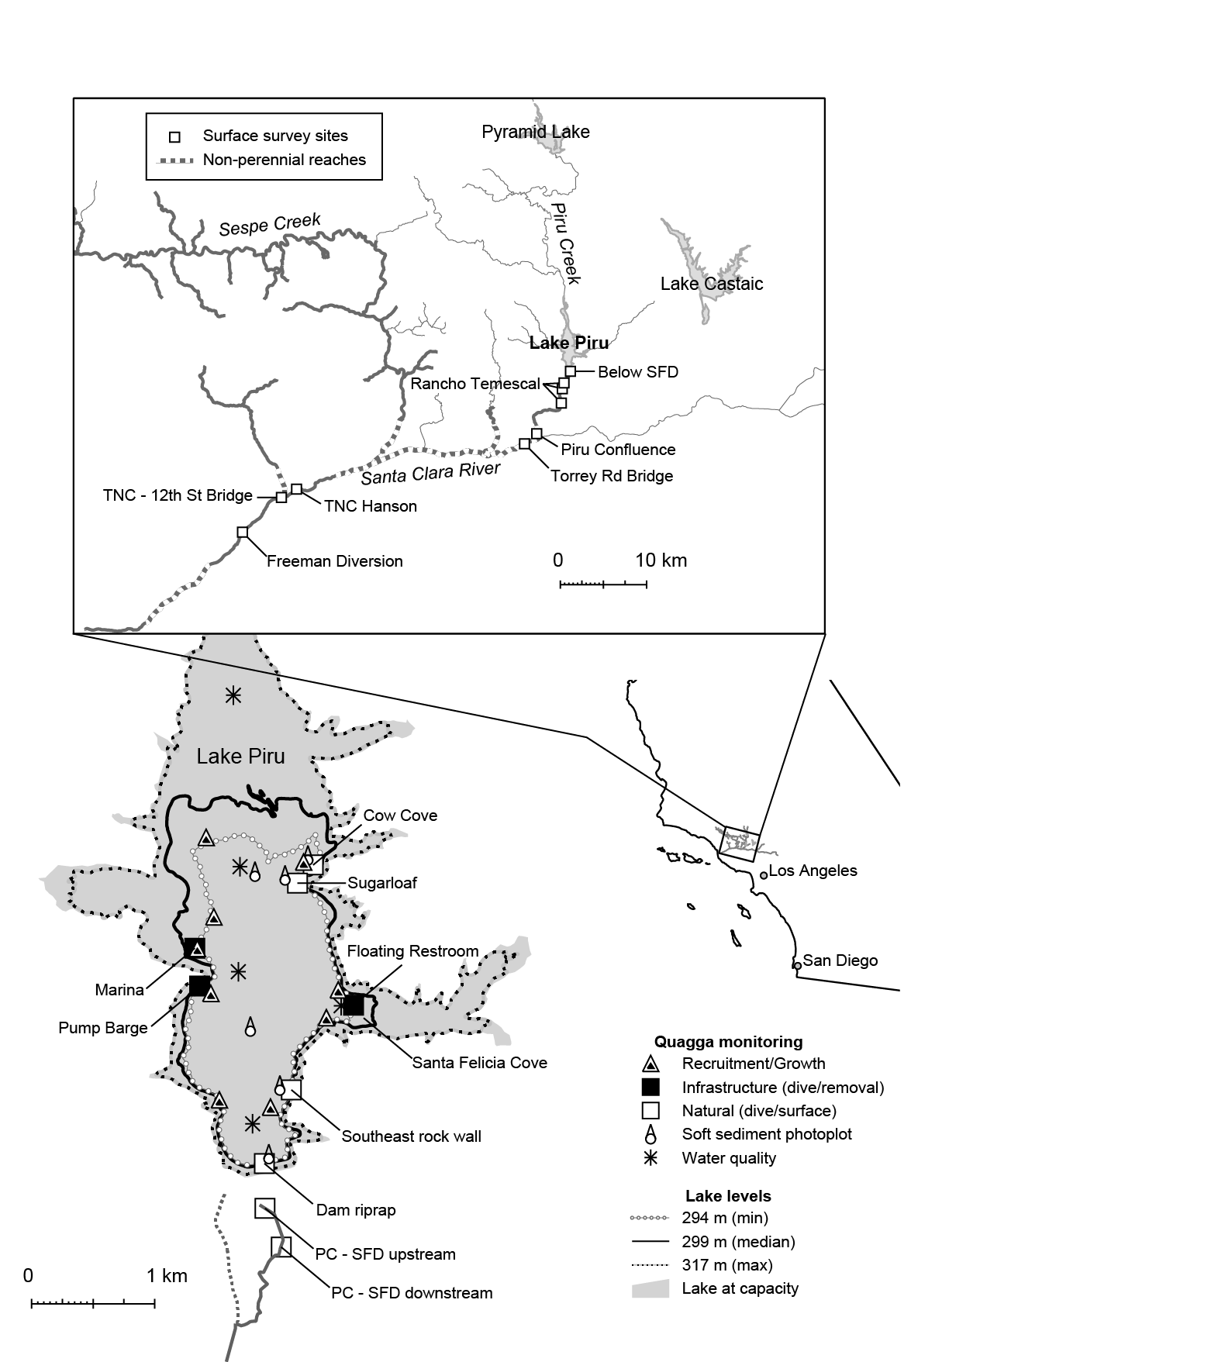
Figure 1. Location of Lake Piru and the Santa Clara River watershed in southern California. The inset shows sites in Piru Creek and the Santa Clara River surveyed for quagga mussels (monthly or quarterly). Monitoring locations within Lake Piru and relevant locations of infrastructure or repeated sampling. Lake shorelines at various lake levels are shown to highlight the dramatic changes in inundated area during the course of the study. Monitoring sites were only sampled when inundated.
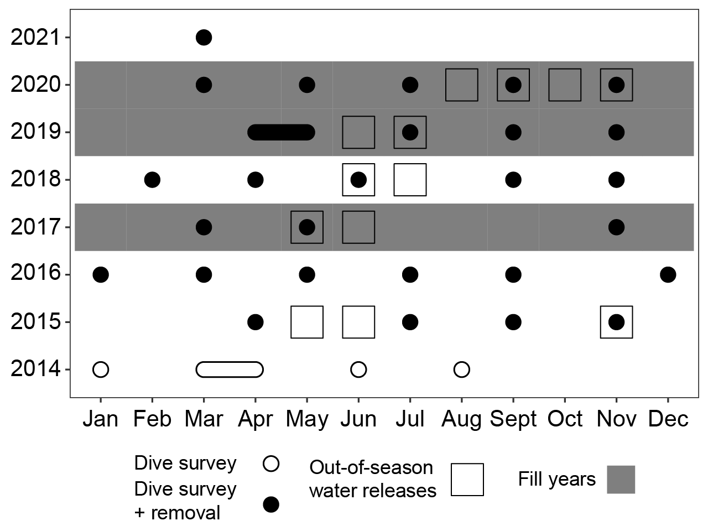
Figure 2.Graphical timeline of dive surveys (population assessment and removals on infrastructure) in relation to out-of-season water releases and years where Lake Piru filled significantly during the winter wet season.
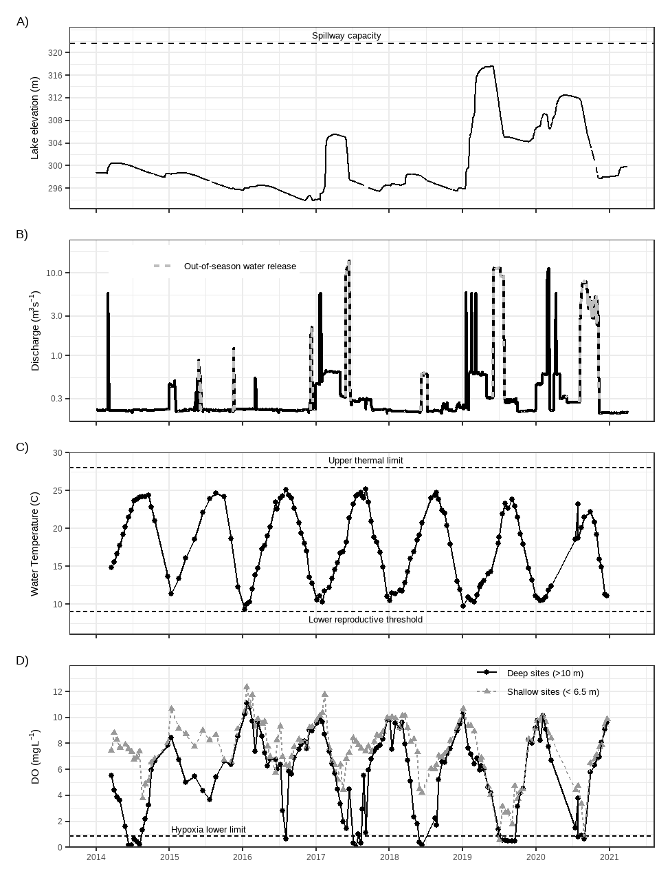
Figure 3. Physical parameters for Lake Piru and Piru Creek. A) Lake water surface elevation (mean sea level datum) as reported at USGS gage #11109700. B) Discharge in Piru Creek below Santa Felicia dam, USGS gage #11109800. The solid line indicates standard flow operations, including those intended for steelhead migration and linked to regional rainfall, while the dashed line indicates water releases intended to convey water downstream for water resource purposes and occur outside of the rainy season. Note that the y-axis is log scale to highlight periods of elevated baseflow.. C) Whole lake mean temperature calculated from vertical temperature profiles using RLakeAnalyzer,, and D) mean dissolved oxygen levels adjacent to the bottom of the lake (bottom 3 m) for monitoring sites in deep (>10 m) and shallow (<6.5 m) regions of the lake.
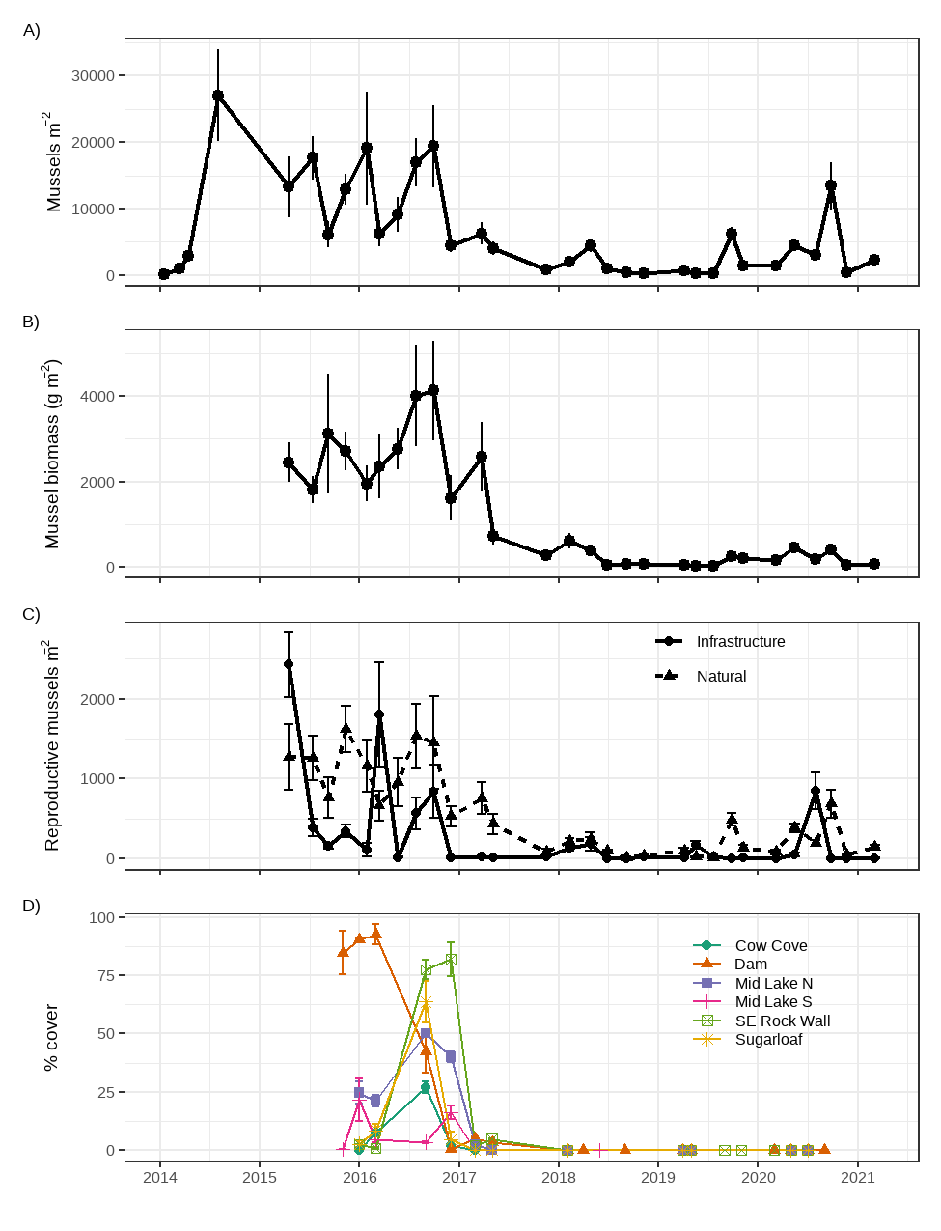
Figure 4. A) Mussel density on natural substrates, B) mussel biomass on natural substrates, C) Density of potentially reproductive mussels (>5 mm) on infrastructure and natural substrates. All mussels were removed from infrastructure subsequent to the sampling, but mussels were not managed on natural surfaces. D) Percent surface cover of mussels on fine sediments estimated from fixed photoplots at six locations throughout the lake. All points are mean ± s.e. Values are separated by location to highlight differing trajectories among sites (e.g., percent cover at the dam peaked and crashed several months prior to all other sites. For B), C), D), sampling did not begin until 2015
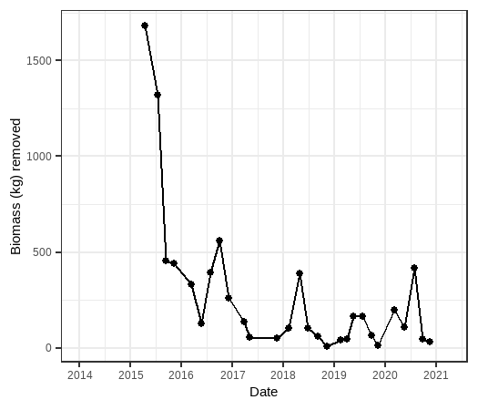
Figure 5. Wet biomass of quagga mussels removed during management activities on Lake Piru infrastructure (docks, water intake structures). The total treatment area ranged between 1056 and 1125 m², data shown are normalized to 1056 m².

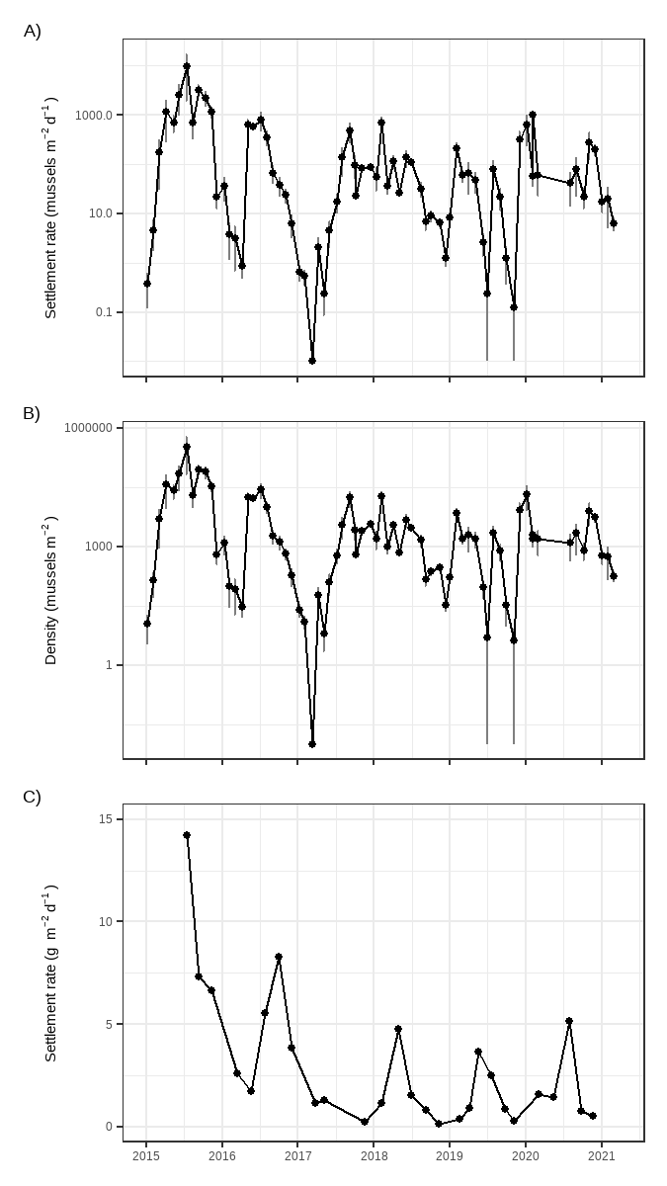
Figure 6. Settling rates of mussels in Lake Piru. A) Settlement rate and B) mussel density on artificial plate samplers, and C) settling rate as biomass, estimated from mussel removals from infrastructure. Note that the y-axis for A) and B) are logarithmic and data shown are means ± s.e., while C) are single point estimates. Note that recruitment was not quantified prior to 2015.
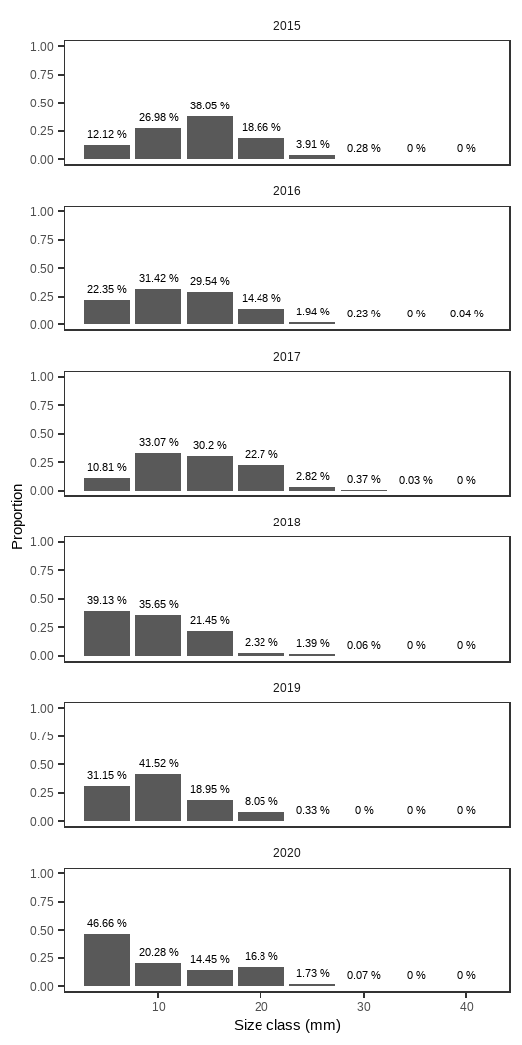
Figure 7. Overall size distribution of mussels collected from natural substrates in Lake Piru for each year. Value labels over the bars represent the percent of the sample observed within the size class (e.g., 0-5 mm, 5-10 mm) since some bars are too small to be visualized.
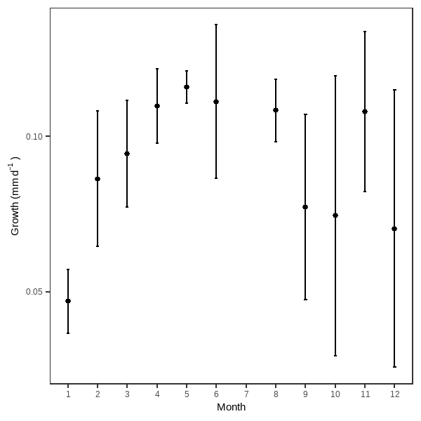
Figure 8. Growth rates for quagga mussels estimated as the difference in mean cohort length between subsequent months. Data shown are means ± s.e.,
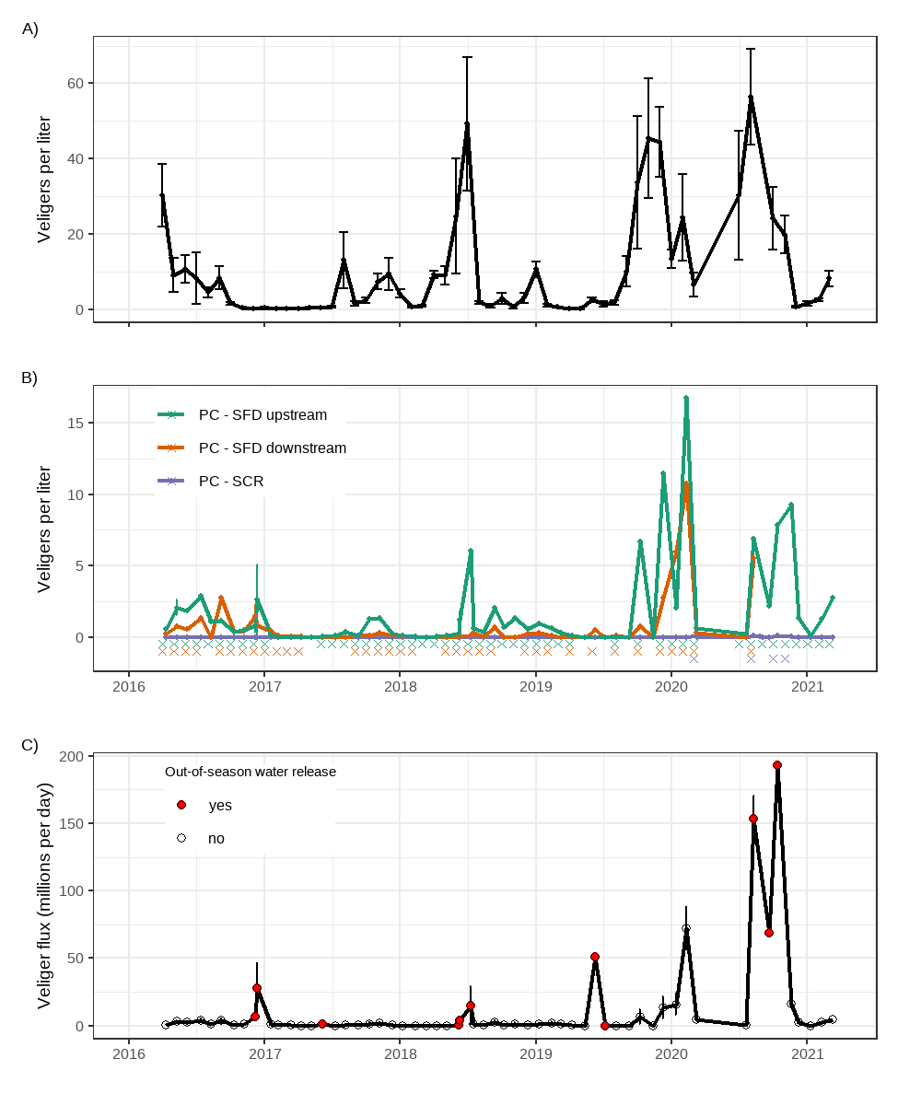
Figure 9. Mean veligers abundance from A) vertically integrated tows of at least 1000L at multiple sites (n = 4 or 5) within Lake Piru and B) timed drift net deployments of at least 1000L at 3 sites in Piru Creek (PC). Santa Felicia Dam (SFD) upstream is 100m below the outlet works, SFD downstream is approximately 500m downstream of the dam, and the Santa Clara River (SCR) is approximately 10 km downstream of SFD. Data shown are means ± s.e., however, for most dates in Piru Creek, only a single sample was collected from each site. X marks below the graph indicate dates when veligers were detected (to highlight dates with low abundance, but positive detection.). C) Mean veliger flux (concentration * discharge) below Santa Felicia Dam, with both SFD locations combined. Due to lack of available analytical facilities, veliger quantification did not begin until 2016.
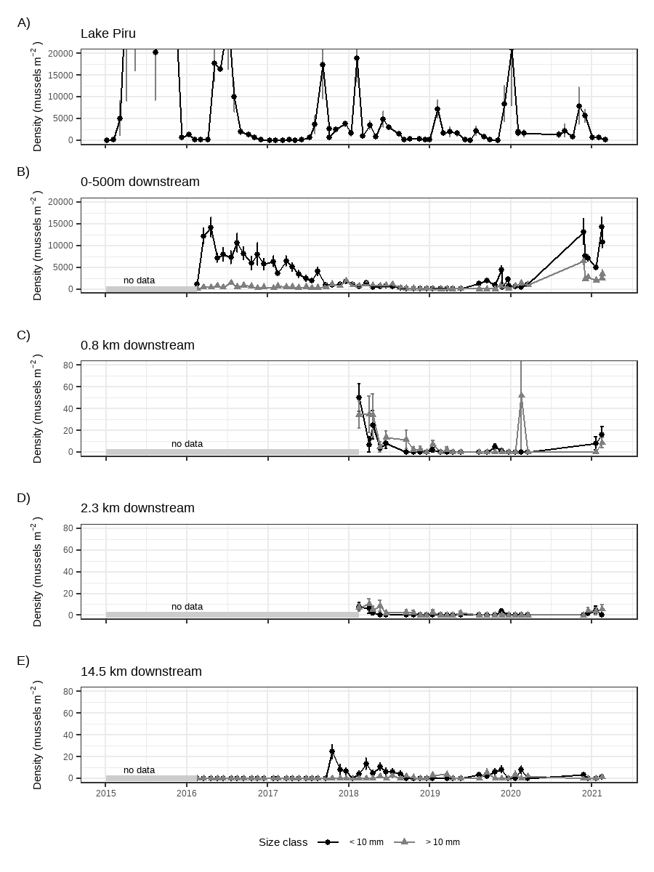
Figure 10. Comparison of settled mussel density within A) Lake Piru (complete data shown in Figure 6B) and surface surveys (enumeration of mussels on the surface of >=10 cobbles) at sites downstream of Santa Felicia Dam B) 0-500 m from Santa Felicia Dam to the Rancho Temescal property boundary, C) 0.8 km downstream in Rancho Temescal, D) 2.3 km downstream in Rancho Temescal and E) 14.5 km downstream at the confluence of Piru Creek and the Santa Clara River. Data shown are means ± s.e. Note that surveys were also completed in Rancho Temescal at 3.3 km downstream, however, no mussels were observed during the study period.
Table 1. Combined results of semiquarterly supplemental surface surveys at sites on the mainstem Santa Clara River downstream of Piru Creek. Distances for each site listed are relative to Santa Felicia Dam. Q1 is January-March, Q2 is April-June, Q3 is July-September, Q4 is October-December.
Site | 2017 |  | 2018 |  |  | 2019 |  |  | 2020 |  | 2021
 | Q3 | Q4 | Q1 | Q2 | Q3 | Q2 | Q3 | Q4 | Q1 | Q4 | Q1
Torrey Rd Bridge  (15.7 km) | Detected | Not Detected | - | Not Detected | - | Not Detected | Not Detected | - | Not Detected |  | Not Detected
TNC – Hanson  (38 km) | Not Detected | - | - | - | - | - | - | Not Detected | Not Detected | Not Detected | Not Detected
TNC - 12th St. Bridge  (40 km) | Detected | Detected | Not Detected | Not Detected | Not Detected | - | Not Detected | - | Not Detected |  | Not Detected

Table 2. (Pdf) Linear mixed models parameterized to relate 1) the relationship between reproductive mussels (>5mm) and veliger abundance and 2) the relationship between veliger abundance and mussel recruitment in Lake Piru. The top 10 or 11 models are shown, shown in order of the best fit model from AIC criteria.

Acknowledgements
All data collection efforts were funded by United Water Conservation District as part of their Quagga Mussel Management and Control Plan. We particularly thank United employees who collected or provided these data: Evan Lashly, Katherine Ayres, Cherie Windsor, Dan Detmer, Greg DeJarnette, and many others.

References
Barton, K., 2022. MuMIn: Multi-Model Inference.
Bates, D., Mächler, M., Bolker, B., Walker, S., 2015. Fitting Linear Mixed-Effects Models Using {lme4}. J. Stat. Softw. 67, 1–48. https://doi.org/10.18637/jss.v067.i01
Beller, E., Grossinger, R., Micha, S., Dark, S., Stein, E., Orr, B., Downs, P., Longcore, T., Coffman, G., Whipple, A., Askevold, R., Stanford, B., Beagle, J., 2011. Historical Ecology of the lower Santa Clara River, Ventura River, and Oxnard Plain: an analysis of terrestrial, riverine, and coastal habitats, SFEI Publication #641. Oakland, CA.
Benson, A.J., Richerson, M.M., Maynard, E., Larson, J., Fusaro, A., Bogdanoff, A.K., Neilson, M.E., Elgin, A., 2021. Dreissena rostriformis bugensis (Andrusov, 1897): U.S. Geological Survey, Nonindigenous Aquatic Species Database, Gainesville, FL [WWW Document]. URL https://nas.er.usgs.gov/queries/FactSheet.aspx?speciesID=95
Burnham, K.P., Anderson, D.R., 2004. Multimodel inference: Understanding AIC and BIC in model selection. Sociol. Methods Res. 33, 261–304. https://doi.org/10.1177/0049124104268644
Churchill, C.J., Quigley, D.P., 2018. Downstream dispersal of zebra mussels (Dreissena polymorpha) under different flow conditions in a coupled lake-stream ecosystem. Biol. Invasions 20, 1113–1127. https://doi.org/10.1007/s10530-017-1613-z
Dalton, L.B., Cottrell, S., 2013. Quagga and zebra mussel risk via veliger transfer by overland hauled boats. Manag. Biol. Invasions 4, 129–133. https://doi.org/10.3391/mbi.2013.4.2.05
De Cicco, L.A., Lorenz, D., Hirsch, R.M., Watkins, W., 2018. dataRetrieval: R packages for discovering and retrieving water data available from U.S. federal hydrologic web services. https://doi.org/10.5066/P9X4L3GE
Dermott, R., Kerec, D., 1997. Changes to the deepwater benthos of eastern Lake Erie since the invasion of Dreissena: 1979-1993. Can. J. Fish. Aquat. Sci. 54, 922–930. https://doi.org/10.1139/cjfas-54-4-922
Dermott, R., Munwari, M., 1993. Invasion of Lake Erie Offshore Sediments by Dreissena, and its Ecological Implications. Can. J. Fish. Aquat. Sci. 50, 2298–2304.
Garton, D.W., McMahon, R., Stoeckmann, A.M., 2014. Limiting environmental factors and competitive interactions between zebra and quagga mussels in North America, in: Nalepa, T.F., Schlosser, D.W. (Eds.), Quagga and Zebra Mussels: Biology, Impacts, and Control, Second Edition. CRC Press, Boca Raton, pp. 383–402. https://doi.org/10.1201/b15437
Gerstenberger, S.L., Mueting, S.A., Wong, W.H., 2011. Veligers of Invasive Quagga Mussels (<em>Dreissena rostriformis bugensis </em> , Andrusov 1897) in Lake Mead, Nevada — Arizona. J. Shellfish Res. 30, 933–938. https://doi.org/10.2983/035.030.0335
Hasler, C.T., Leathers, J., Ducharme, A., Casson, N.J., 2019. Biological effects of water velocity and other hydrodynamic characteristics of flow on dreissenid mussels. Hydrobiologia 837, 1–14. https://doi.org/10.1007/s10750-019-03976-6
Horvath, T.G., Lamberti, G.A., 1999. Mortality of zebra mussel, Dreissena polymorpha, veligers during downstream transport. Freshw. Biol. 42, 69–76. https://doi.org/10.1046/j.1365-2427.1999.00462.x
Hosler, D., 2017. Where is the body? Dreissenid mussels, raw water testing, and the real value of environmental DNA. Manag. Biol. Invasions 8, 335–341. https://doi.org/10.3391/mbi.2017.8.3.07
Jaeger, B., 2017. r2glmm: Computes R Squared for Mixed (Multilevel) Models.
Jaeger, B.C., Edwards, L.J., Das, K., Sen, P.K., 2017. An R2 statistic for fixed effects in the generalized linear mixed model. J. Appl. Stat. 44, 1086–1105. https://doi.org/10.1080/02664763.2016.1193725
Karatayev, A.Y., Burlakova, L.E., Padilla, D.K., 2015. Zebra versus quagga mussels: a review of their spread, population dynamics, and ecosystem impacts. Hydrobiologia 746, 97–112. https://doi.org/10.1007/s10750-014-1901-x
Karatayev, A.Y., Karatayev, V.A., Burlakova, L.E., Rowe, M.D., Mehler, K., Clapsadl, M.D., 2018. Food depletion regulates the demography of invasive dreissenid mussels in a stratified lake. Limnol. Oceanogr. 63, 2065–2079. https://doi.org/10.1002/lno.10924
Mangin, S., 2001. The 100th Meridian Initiative: A Strategic Approach to Prevent the Westward Spread of Zebra Mussels and Other Aquatic Nuisance Species. Washington, D.C.
Nakagawa, S., Schielzeth, H., 2013. A general and simple method for obtaining R2 from generalized linear mixed-effects models. Methods Ecol. Evol. 4, 133–142. https://doi.org/10.1111/j.2041-210x.2012.00261.x
Nalepa, T.F., 2010. An Overview of the Spread, Distribution, and Ecological Impacts of the Quagga Mussel, Dreissena rostriformis bugensis, with Possible Implications to the Colorado River System. Proc. Color. River Basin Sci. Resour. Manag. Symp. Novemb. 18–20, 2008, Scottsdale, Arizona Coming Together Coord. Sci. Restor. Act. Color. River Ecosyst. 113–121.
National Marine Fisheries Service, NMFS, 2012. Southern California Steelhead Recovery Plan. Long Beach, Ca. https://doi.org/10.1577/1548-8659(1934)64[248:cse]2.0.co;2
R Core Team, 2022. R: A language and environment for statistical computing.
Reclamation Detection Laboratory for Invasive and Native Species, 2013. Improving Accuracy in the Detection of Dreissenid Mussel Larvae. Denver, CO.
Rosen, M.R., Turner, K., Goodbred, S.L., Miller, J.M. (Eds.), 2012. A synthesis of aquatic science for management of Lakes Mead and Mohave, U. S. Geological Survey Circular 1381.
Schindelin, J., Arganda-Carreras, I., Frise, E., Kaynig, V., Longair, M., Pietzsch, T., Preibisch, S., Rueden, C., Saalfeld, S., Schmid, B., Tinevez, J.Y., White, D.J., Hartenstein, V., Eliceiri, K., Tomancak, P., Cardona, A., 2012. Fiji: An open-source platform for biological-image analysis. Nat. Methods 9, 676–682. https://doi.org/10.1038/nmeth.2019
Stokstad, E., 2007. Feared quagga mussel turns up in western United States. Science (80-. ). 315, 453. https://doi.org/10.1126/science.315.5811.453
Strayer, D.L., Adamovich, B. V., Adrian, R., Aldridge, D.C., Balogh, C., Burlakova, L.E., Fried-Petersen, H.B., G.-Tóth, L., Hetherington, A.L., Jones, T.S., Karatayev, A.Y., Madill, J.B., Makarevich, O.A., Marsden, J.E., Martel, A.L., Minchin, D., Nalepa, T.F., Noordhuis, R., Robinson, T.J., Rudstam, L.G., Schwalb, A.N., Smith, D.R., Steinman, A.D., Jeschke, J.M., 2019. Long-term population dynamics of dreissenid mussels (Dreissena polymorpha and D. rostriformis): a cross-system analysis. Ecosphere 10. https://doi.org/10.1002/ecs2.2701
Turner, C.B., 2010. Influence of zebra (Dreissena polymorpha) and quagga (Dreissena rostriformis) mussel invasions on benthic nutrient and oxygen dynamics. Can. J. Fish. Aquat. Sci. 67, 1899–1908. https://doi.org/10.1139/F10-107
United Water Conservation District, 2018a. Quagga Mussel Monitoring and Control 2017 Annual Report. Santa Paula, CA.
United Water Conservation District, 2018b. Draft Quagga Mussel Monitoring and Control Plan. Santa Paula, CA.
United Water Conservation District, 2017. Quagga Mussel Monitoring and Control 2016 Annual Report. Santa Paula, CA.
United Water Conservation District, 2012. Santa Felicia Water Release Plan: Santa Felicia Project FERC License No. 2153.
Western Regional Panel on Aquatic Nuisance Species, 2010. Quagga-Zebra Mussel Action Plan for Western U.S. Waters.
Williams, A.P., Cook, B.I., Smerdon, J.E., 2022. Rapid intensification of the emerging southwestern North American megadrought in 2020–2021. Nat. Clim. Chang. 12, 232–234. https://doi.org/10.1038/s41558-022-01290-z
Winslow, L., Read, J., Woolway, R., Brentrup, J., Leach, T., Zwart, J., Albers, S., Collinge, D., 2019. rLakeAnalyzer: Lake Physics Tools.
Wittmann, M.E., Chandra, S., Caires, A., Denton, M., Rosen, M.R., Wong, W.H., Teitjen, T., Turner, K., Roefer, P., Holdren, G.C., 2010. Early invasion population structure of quagga mussel and associated benthic invertebrate community composition on soft sediment in a large reservoir. Lake Reserv. Manag. 26, 316–327. https://doi.org/10.1080/07438141.2010.519855
Wong, W.H., Gerstenberger, S., Baldwin, W., Moore, B., 2012. Settlement and growth of quagga mussels (Dreissena rostriformis bugensis Andrusov, 1897) in Lake Mead, Nevada-Arizona, USA. Aquat. Invasions 7, 7–19. https://doi.org/10.3391/ai.2012.7.1.002
Wong, W.H., Gerstenberger, S.L., 2011. Quagga mussels in the western united states: Monitoring and management. Aquat. Invasions 6, 125–129. https://doi.org/10.3391/ai.2011.6.2.01

